|  |
| --- |
|  |
|  |
| INTERNSHIP APPLICATION SYSTEM (INTERNSEEK) FOR UNDERGRADUATE STUDENTS USING REACT.JS, INERTIA.JS AND LARAVEL |
|  |
|  |
|  |
|  |
| SHO MING KANG |
|  |
|  |
|  |
|  |
|  |
|  |
| BACHELOR OF COMPUTER SCIENCE  (SOFTWARE ENGINEERING) WITH  HONOURS |
|  |
| UNIVERSITI MALAYSIA PAHANG  AL-SULTAN ABDULLAH |
|  |

UNIVERSITI MALAYSIA PAHANG AL-SULTAN ABDULLAH

DECLARATION OF THESIS AND COPYRIGHT

|  |  |  |
| --- | --- | --- |
| Author’s Full Name | : | SHO MING KANG |
| Date of Birth | : | 25/12/2001 |
| Title | : | INTERNSHIP APPLICATION FOR UNIVERSITY STUDENTS IN MAJORING COMPUTER SCIENCE (INTERNSEEK) |
| Academic Session | : | SEMESTER II 2023/2024 |

I declare that this thesis is classified as:

|  |  |  |
| --- | --- | --- |
|  | CONFIDENTIAL | (Contains confidential information under the Official Secret Act 1997)* |
|  | RESTRICTED | (Contains restricted information as specified by the organization where research was done)* |
|  | OPEN ACCESS | I agree that my thesis to be published as online open access (Full Text) |

I acknowledge that Universiti Malaysia Pahang Al-Sultan Abdullah reserves the following

rights:

1. The Thesis is the Property of Universiti Malaysia Pahang Al-Sultan Abdullah

2. The Library of Universiti Malaysia Pahang Al-Sultan Abdullah has the right to make copies of the thesis for the purpose of research only.

3. The Library has the right to make copies of the thesis for academic exchange.

Certified by:

|  |  |
| --- | --- |
| Kang  _____________________  (Student’s Signature)  __011225060041_________  New IC/Passport Number  Date: 11/03/2024 | _______________________  (Supervisor’s Signature)  _______________________  Name of Supervisor  Date: |
|  |  |

NOTE : * If the thesis is CONFIDENTIAL or RESTRICTED, please attach a thesis declaration letter.



SUPERVISOR’s DECLARATION

I/We* hereby declare that I/We* have checked this thesis/project* and in my/our* opinion, this thesis/project* is adequate in terms of scope and quality for the award of the degree of *Doctor of Philosophy/ Master of Science.

_______________________________  
 (Supervisor’s Signature)

Full Name :

Position :

Date :

_______________________________  
 (Co-supervisor’s Signature)

Full Name :

Position :

Date :



STUDENT’S DECLARATION

I hereby declare that the work in this thesis is based on my original work except for quotations and citations which have been duly acknowledged. I also declare that it has not been previously or concurrently submitted for any other degree at Universiti Malaysia Pahang Al-Sultan Abdullah or any other institutions.

Kang

_______________________________  
 (Student’s Signature)

Full Name : SHO MING KANG

ID Number : CB21065

Date : 11 MARCH 2024

|  |
| --- |
|  |
|  |
| INTERNSHIP APPLICATION SYSTEM (INTERNSEEK) FOR UNDERGRADUATE STUDENTS USING REACT.JS, INERTIA.JS AND LARAVEL |
|  |
|  |
|  |
| Sho Ming Kang |
|  |
|  |
| Thesis submitted in fulfillment of the requirements  for the award of the degree of  Bachelor of Computer Science (Software Engineering) with Honours |
|  |
|  |
|  |
| Faculty of Computing |
|  |
| UNIVERSITI MALAYSIA PAHANG AL-SULTAN ABDULLAH |
|  |
| 2024 |
|  |
|  |

ACKNOWLEDGEMENTS

Firstly, I would like to express my deepest gratitude to my supervisor, Madam Ku Saimah Binti Ku Ibrahim, for her unwavering support, invaluable guidance, insightful feedback throughout the entire process. Her expertise and dedication have been played a crucial role in shaping the direction and quality of this thesis, making its completion possible.

Additionally, I am deeply thankful to the lecturers at the Faculty of Computing, UMPSA. Their knowledge, expertise, and constructive criticism significantly improved my understanding of the subject matter and helped me in refining this thesis.

Lastly, I am grateful to my family and friends for their encouragement, patience, and belief in my abilities throughout this journey. Their patience, support, encouragement, and motivation are the key in overcoming challenges and persisting through this journey.

ABSTRAK

Tesis ini membentangkan reka bentuk dan pembangunan Internseek, sistem aplikasi latihan yang merupakan platform yang direka untuk menghubungkan pelajar universiti dengan peluang latihan yang disiarkan oleh penyedia. Internseek ialah platform mesra pengguna di mana pelajar boleh mencari dan memohon latihan amali dengan mudah yang selaras dengan matlamat kerjaya dan bidang pengajian mereka, manakala penyedia latihan boleh menyiarkan peluang dan mengurus permohonan latihan dengan cekap. Proses pembangunan menggunakan metodologi air terjun, memastikan pendekatan berstruktur dan sistematik terhadap keperluan, reka bentuk, pelaksanaan, ujian dan penggunaan. Ciri utama Internseek termasuk pengurusan aplikasi latihan, pengurusan pengeposan latihan, penjanaan resume automatik berdasarkan profil pelajar, keupayaan pemesejan dan fungsi lain. Ia membenarkan pentadbir untuk meluluskan atau menolak permohonan pendaftaran majikan dan pengeposan latihan, memastikan kesahihan profil majikan dan peluang latihan serta mengekalkan Internseek sebagai platform yang boleh dipercayai. Internseek memperkemas dan memudahkan proses permohonan latihan untuk pelajar universiti dengan menyediakan ciri pemesejan di mana pelajar boleh berkomunikasi secara langsung dengan majikan dalam platform tanpa menavigasi banyak e-mel untuk menjejaki status permohonan latihan mereka. Internseek ialah platform terpusat untuk pelajar mencari latihan amali mereka, menghapuskan keperluan untuk mengakses pelbagai platform untuk meneroka latihan amali yang berpotensi.

ABSTRACT

This thesis presents the design and development of Internseek, an internship application system that is a platform designed to connect university students with internship opportunities posted by providers. Internseek is a user-friendly platform where students can easily search for and apply to internships that align with their career goals and field of study, while employers can post opportunities and manage internship applications efficiently. The development process utilizes waterfall methodology, ensuring a structured and systematic approach to requirements, design, implementation, testing, and deployment. The key features of Internseek include internship application management, internship posting management, automated resume generation based on student profiles, messaging capabilities, and other functionalities. It allows the administrator to approve or reject employer registration and internship posting requests, ensuring the legitimacy of employer profiles and internship opportunities and maintaining Internseek as a trustworthy platform. Internseek streamlines and simplify the internship application process for university students by providing a messaging feature through which students can directly communicate with employers within the platform without navigating the numerous emails to track their internship application status. Internseek is a centralized platform for students to find their internships, eliminating the need to access various platforms to explore potential internships.

TABLE OF CONTENT

DECLARATION

TITLE PAGE

ACKNOWLEDGEMENTS ii

ABSTRAK iii

ABSTRACT iv

TABLE OF CONTENT v

LIST OF TABLES ix

LIST OF FIGURES xi

LIST OF ABBREVIATIONS xxx

LIST OF APPENDICES xxxi

CHAPTER 1 INTRODUCTION 1

1.1 Introduction 1

1.2 Problem Statement 2

1.3 Objective 5

1.4 Scope 6

1.5 Thesis Organization 7

CHAPTER 2 LITERATURE REVIEW 8

2.1 Introduction 8

2.2 Existing Systems/ Works 8

2.2.1 MYNext 9

2.2.2 Prosple 32

2.2.3 Internsheeps 53

2.3 Analysis/ Comparison of Existing System 66

2.3.1 Analysis of comparison on existing system 66

2.3.2 Relevance of comparison with project title 75

2.4 Summary 78

CHAPTER 3 METHODOLOGY 80

3.1 Introduction 80

3.2 Software Process Model/Methodology 81

3.2.1 Waterfall Methodology 81

3.2.2 Gantt Chart 87

3.3 Project Requirements 89

3.3.1 Functional Requirements 89

3.3.2 Non-Functional Requirements 105

3.3.3 Constraints and Limitations 106

3.3.4 Use Case Diagram 108

3.3.5 Use Case Description 112

3.3.6 Sequence Diagram 180

3.4 Proposed Design 250

3.4.1 Context Diagram 250

3.4.2 General Architecture 251

3.4.3 Package Diagram 253

3.4.4 Activity Diagram 292

3.5 Data Design 312

3.5.1 Entity-Relationship Diagram 312

3.5.2 Data Dictionary 313

3.6 Proof of Concept 343

3.6.1 Prototype 343

3.6.2 Package Structure in Implementation + API + Middleware or Library Use 454

3.7 Testing Plan / Validation Plan 479

3.7.1 Unit Testing 479

3.7.2 Integration Testing 479

3.7.3 System Testing 480

3.7.4 User Acceptance Testing 480

3.8 Potential Use of Proposed Solution 486

CHAPTER 4 IMPLEMENTATIOS, RESULTS, AND DISCUSSIONS 487

4.1 Introduction 487

4.2 Implementation 488

4.2.1 Development Environment 488

4.2.2 Database Implementation 490

4.2.3 Interface Implementation 492

4.2.4 Functional Testing 596

4.2.5 System Deployment 757

4.2.6 User Acceptance Testing 759

CHAPTER 5 CONCLUSION 796

5.1 Introduction 796

5.2 Objective Revisited 796

5.3 Project Limitations 797

5.4 Future Works 799

REFERENCES 800

APPENDICES 803

LIST OF TABLES

Table 2‑1: System Specification for MYNext 13

Table 2‑2: System Specification for Prosple 37

Table 2‑3: System Specification for Internsheeps 57

Table 2‑4: Comparison of the Specification of Existing Systems 67

Table 2‑5: Comparison with Project Title 73

Table 3‑1: Functional Requirements 90

Table 3‑2: Use Case Description (Register Account) 114

Table 3‑3: Use Case Description (Manage Login) 118

Table 3‑4: Use Case Description (Manage Company Registration) 122

Table 3‑5: Use Case Description (Manage User Profile) 128

Table 3‑6: Use Case Description (View Internship Listing) 147

Table 3‑7: Use Case Description (View Company Listing) 151

Table 3‑8: Use Case Description (Manage Internship Application) 153

Table 3‑9: Use Case Description (Manage Internship Posting) 165

Table 3‑10: Use Case Description (Manage Analytics and Reporting) 171

Table 3‑11: Use Case Description (Manage Messaging Features) 177

Table 3‑12 Data Dictionary for students 308

Table 3‑13: Data Dictionary for addresses 310

Table 3‑14: Data Dictionary for experiences 311

Table 3‑15: Data Dictionary for educations 312

Table 3‑16: Data Dictionary for skills 314

Table 3‑17: Data Dictionary for accomplishments 315

Table 3‑18: Data Dictionary for referees 316

Table 3‑19: Data Dictionary for languages 317

Table 3‑20: Data Dictionary for companies 318

Table 3‑21: Data Dictionary for branch 321

Table 3‑22: Data Dictionary for site 322

Table 3‑23: Data Dictionary for employers 324

Table 3‑24: Data Dictionary for admins 326

Table 3‑25: Data Dictionary for internships 327

Table 3‑26: Data Dictionary for internship_applications 330

Table 3‑27: Data Dictionary for interviews 333

Table 3‑28: Data Dictionary for accepted_offers 334

Table 3‑29: Data Dictionary for clicks 336

Table 3‑30: Data Dictionary for bookmarks 337

Table 3‑31: Data Dictionary for messages 338

Table 3‑32: Data Dictionary for reports 339

Table 3‑33: Data Dictionary for notifications 341

Table 3‑34: Package Structure in Implementation 459

Table 3‑35: Middleware in Implementation 460

Table 3‑36: View (Pages/Dashboard) in implementation 461

Table 3‑37: View (Pages/ManageAnalyticsandReporting) in implementation 462

Table 3‑38: View (Pages/ManageCompanyRegistration) in implementation 463

Table 3‑39: View (Pages/ManageInternshipApplication) in implementation 464

Table 3‑40: View (Pages/ManageInternshipPosting) in implementation 465

Table 3‑41: View (Pages/ManageLogin) in implementation 466

Table 3‑42: View (Pages/ManageMessagingFeatures) in implementation 467

Table 3‑43: View (Pages/ManageUserProfile & Page/Notifications) in implementation 468

Table 3‑44: View (Pages/RegisterAccount & Pages/ViewCompanyListing & Pages/ViewInternshipListing) in implementation 469

Table 3‑45: View (package: components/applyInternship & components/changePassword) in implementation 470

Table 3‑46: View (package: components/companyListing & components/companyProfile & components/companyRegistration) in implementation 471

Table 3‑47: View (package: components/dashboard) in implementation 472

Table 3‑48: View (package: components/message) in implementation 472

Table 3‑49: View (package: components/industrialTraining & components/internshipApplication & components/internshipPosting & components/internshipListing) in implementation 473

Table 3‑50: View (package: components/my-internship & navbar) in implementation 474

Table 3‑51: View (package: components/studentProfile) in implementation 475

Table 3‑52: Controller Layer in implementation 478

Table 3‑53: Model Layer in implementation 479

Table 3‑54: Sample Questions for User Acceptance Testing (UAT) 482

LIST OF FIGURES

Figure 2‑1: Flowchart of MYNext (Intern Seeker) 11

Figure 2‑2: Flowchart of MYNext (Employer/Company) 12

Figure 2‑3: The home page of MYNext Website 14

Figure 2‑4: Login Page for the Registered Company 14

Figure 2‑5: Search for Existing Company Page 15

Figure 2‑6: Organisation Registration Form (Organization Details) 16

Figure 2‑7: Organization Registration Form (Add Contact Person) 17

Figure 2‑8: Company Dashboard 18

Figure 2‑9: Manage Internships Page 18

Figure 2‑10: Add a New Internship Page 19

Figure 2‑11: Payment Notification via Email 20

Figure 2‑12: Official Receipt 21

Figure 2‑13: Internship Posted Successfully 22

Figure 2‑14: Company Dashboard (Overview of internship count by status) 22

Figure 2‑15: Specific Internship Post Page (with an internship post) 23

Figure 2‑16: List of Applicants page for the specific internship 23

Figure 2‑17: Login Page for Intern Seekers 24

Figure 2‑18: Intern Seeker Account Registration Page 24

Figure 2‑19: Intern Seeker Dashboard 25

Figure 2‑20: Internship Listing Page with Internship Recommendation 25

Figure 2‑21: Filter Internship Listing with Scope of Study 26

Figure 2‑22: Internship Listing Page with all Internships 26

Figure 2‑23: Reset the filter to display all internships in a list 27

Figure 2‑24: Psychometric Assessments 27

Figure 2‑25: English Proficiency Test 28

Figure 2‑26: Specified Internship Details Page 28

Figure 2‑27: Pop-Up to ask Intern Seeker to review the internship application 29

Figure 2‑28: Applied Internships Page 29

Figure 2‑29: Favourites Internships Page 30

Figure 2‑30: CV Page 30

Figure 2‑31: Change password Page 31

Figure 2‑32: Flowchart of Prosple (Intern Seeker) 34

Figure 2‑33: Flowchart of Prosple (Employer/Company) 35

Figure 2‑34: The Company Registration Page of Prosple 37

Figure 2‑35: Login Page for Prosple Employer 37

Figure 2‑36: Employer Profile Page 38

Figure 2‑37: Internship Opportunities Listing Page 39

Figure 2‑38: Add an Internship Opportunity Page 40

Figure 2‑39: List of Applicants 41

Figure 2‑40: Search and sort feature in the Applicants List 42

Figure 2‑41: Update the status of the internship application of applicants 42

Figure 2‑42: Applicant’s Profile Page 43

Figure 2‑43: Main Page of Prosple 44

Figure 2‑44: Login Page for Intern Seeker (Prosple) 44

Figure 2‑45: Sign-Up Page for Intern Seeker (Prosple) 44

Figure 2‑46: After Login Page 45

Figure 2‑47: Internship Listing Page (Prosple) 45

Figure 2‑48: Sort Internship Listing with the study field 46

Figure 2‑49: Display Sorted Internship Listing 46

Figure 2‑50: Display internships that need to be applied for outside the application 47

Figure 2‑51: Display internships that need to be applied for within the Prosple platform 48

Figure 2‑52: Employer Listings page 48

Figure 2‑53: Company Profile Page 49

Figure 2‑54: Personal Profile Page 50

Figure 2‑55: Bookmark Listings Page 51

Figure 2‑56: Internship Application Page (Step 1) 52

Figure 2‑57: Internship Application Page (Step 2) 52

Figure 2‑58: Flowchart of Internsheeps (Intern Seeker) 55

Figure 2‑59: Main Page of Internsheeps 57

Figure 2‑60: Register Page 57

Figure 2‑61: Login Page 58

Figure 2‑62: Personal Profile Page (Part I) 59

Figure 2‑63: Personal Profile Page (Part II) 60

**Figure 2‑64: Generate Resume** 61

Figure 2‑65: Internship Listing Page 61

Figure 2‑66: Track Matched Jobs, Applied Jobs, Saved Jobs, and Walk-in Jobs Page 62

Figure 2‑67: Internship Application Page (Part I) 63

Figure 2‑68: Internship Application Page (Part II) 64

Figure 2‑69: Company Profile Page 64

Figure 2‑70: Top 100 Companies Page 65

Figure 3‑1: Waterfall Methodology (Kumar P, 2024) 82

Figure 3‑2: Gantt Chart 88

Figure 3‑3: Survey Result Part I 98

Figure 3‑4: Survey Result Part II 99

Figure 3‑5: Survey Result Part III 100

Figure 3‑6: Survey Result Part IV 101

Figure 3‑7: Survey Result Part V 102

Figure 3‑8: Survey Result Part VI 103

Figure 3‑9: Survey Result Part VII 104

Figure 3‑10: Use Case Diagram 108

Figure 3‑11: Use Case Diagram (Register Account) 112

Figure 3‑12: Use Case Diagram (Manage Login) 116

Figure 3‑13: Use Case Diagram (Manage Company Registration) 121

Figure 3‑14: Use Case Diagram (Manage User Profile) 127

Figure 3‑15: Use Case Diagram (View Internship Listing) 147

Figure 3‑16: Use Case Diagram (View Company Listing) 150

Figure 3‑17: Use Diagram (Manage Internship Application) 153

Figure 3‑18: Use Case Diagram (Manage Internship Posting) 164

Figure 3‑19: Use Case Diagram (Manage Analytics and Reporting) 170

Figure 3‑20: Use Case Diagram (Manage Messaging Features) 176

Figure 3‑21: Sequence Diagram (Basic Flow for university students to register account & Exception Flow for Invalid Email Address, Password and Confirm Password Incorrect, Invalid Password, and Email Address Already Exist) 180

Figure 3‑22: Sequence Diagram (Basic Flow for employers to register account & Exception Flow for Invalid Email Address, Password and Confirm Password Incorrect, Invalid Password, and Email Address Already Exist) 181

Figure 3‑23: Sequence Diagram (Alternative Flow: Alert Required Field Not Filled) 182

Figure 3‑24: Sequence Diagram (Basic Flow for university students to login into the system and exception flow for invalid email address and incorrect password) 183

Figure 3‑25: Sequence Diagram (Basic Flow for employers to login into the system and exception flow for invalid email address and incorrect password) 184

Figure 3‑26: Sequence Diagram (Basic Flow for administrators to login into the system and exception flow for invalid email address and incorrect password) 185

Figure 3‑27: Sequence Diagram (Basic Flow for university students to reset password if they forgot their password and Exception Flow for invalid email address, invalid password and password not same) 186

Figure 3‑28: Sequence Diagram (Basic Flow for employers to reset password if they forgot their password and Exception Flow for invalid email address, invalid password and password not same) 187

Figure 3‑29: Sequence Diagram (Basic Flow for administrators to reset password if they forgot their password and Exception Flow for invalid email address, invalid password and password not same) 188

Figure 3‑30: Sequence Diagram (Basic Flow for employers: Register New Company) 189

Figure 3‑31: Sequence Diagram (Basic Flow for employers: Search for Existing Company) 190

Figure 3‑32: Sequence Diagram (Basic Flow for employers: Edit Registration Details) 191

**Figure 3‑33: Sequence Diagram (Basic Flow for company admin: Review and Update Status of Employer Accounts)** 191

Figure 3‑34: Sequence Diagram (Alternative Flow: Alert Required Field Not Filled) 192

Figure 3‑35: Sequence Diagram (Basic Flow Review and Update Company Registration Status 192

Figure 3‑36: Sequence Diagram (Basic Flow for university students to edit their information) 193

Figure 3‑37: Sequence Diagram (Basic Flow for university students to add experience info) 194

Figure 3‑38: Sequence Diagram (Basic Flow for university students to edit experience info) 195

Figure 3‑39: Sequence Diagram (Alternative Flow for university students to delete experience info) 196

Figure 3‑40: Sequence Diagram (Basic Flow for university students to add education info) 197

Figure 3‑41: Sequence Diagram (Basic Flow for university students to edit education info) 198

Figure 3‑42: Sequence Diagram (Alternative Flow for university students to delete education info) 199

Figure 3‑43: Sequence Diagram (Basic Flow for university students to add skill) 200

Figure 3‑44: Sequence Diagram (Basic Flow for university students to edit skills) 201

Figure 3‑45: Sequence Diagram (Basic Flow for university students to delete skills) 202

Figure 3‑46: Sequence Diagram (Basic Flow for university students to add accomplishment) 203

Figure 3‑47: Sequence Diagram (Basic Flow for university students to edit accomplishment) 204

Figure 3‑48: Sequence Diagram (Alternative Flow for university students to delete accomplishment) 205

Figure 3‑49: Sequence Diagram (Basic Flow for university students to edit language) 206

Figure 3‑50: Sequence Diagram (Basic Flow for university students to add referee) 207

Figure 3‑51: Sequence Diagram (Basic Flow for university students to edit referee) 208

Figure 3‑52: Sequence Diagram (Alternative Flow for university students to delete referee) 209

Figure 3‑53: Sequence Diagram (Basic Flow for university students to edit profile picture) 210

Figure 3‑54: Sequence Diagram (Basic Flow for university students to remove profile picture) 211

Figure 3‑55: Sequence Diagram (Basic Flow for university students to add LinkedIn Public URL) 212

Figure 3‑56: Sequence Diagram (Basic Flow for university students to generate resume) 213

Figure 3‑57: Sequence Diagram (Basic Flow for university students to change password and exception flow for incorrect password and invalid password) 214

Figure 3‑58: Sequence Diagram (Basic Flow for university students to view personal profiling progress) 214

Figure 3‑59: Sequence Diagram (Basic Flow for university students to view notifications, mark all notifications as read, and clear all notifications) 215

Figure 3‑60: Sequence Diagram (Basic Flow for employers to edit company information) 216

Figure 3‑61: Sequence Diagram (Basic Flow for employers to edit employer information and change password and exception flow for incorrect password and invalid password) 217

Figure 3‑62: Sequence Diagram (Basic Flow for employers to view branch and site information, add branch, and edit branch information and Alternative flow for deleting branch) 218

Figure 3‑63: Sequence Diagram (Basic Flow for employers to view branch and site information, add site, and edit site information and Alternative flow for deleting site) 219

Figure 3‑64: Sequence Diagram (Basic Flow for employers to view notifications, mark all notifications as read, and clear all notifications) 220

Figure 3‑65: Sequence Diagram (Basic Flow for administrators to edit admin info and change password and exception flow for incorrect password and invalid password) 221

Figure 3‑66: Sequence diagram (Alternative Flow: Alert Required Field Not Entered) 222

Figure 3‑67: Sequence diagram (Exception Flow: Cancel Action) 222

Figure 3‑68: Sequence diagram (Basic Flow for university students with logged in to search/sort the internship listing, view internship details, bookmark internship, and report internship and exception flow for search keyword not found) 223

Figure 3‑69: Sequence diagram (Basic Flow for public users to search/sort the internship listing and view internship details, and exception flow for search keyword not found) 224

Figure 3‑70: Sequence diagram (Basic Flow for public users to search/sort the company listing and view the company details and exception flow for search keyword not found) 225

Figure 3‑71: Sequence diagram (Basic Flow for university students to apply internships) 226

Figure 3‑72: Sequence diagram (Exception Flow: Edit Basic Information Action) 227

Figure 3‑73: Sequence diagram (Exception Flow: Edit Profile Details Action) 227

Figure 3‑74: Sequence diagram (Basic Flow for university students to keep track of status of internship application with alternative flows: applied internships and need-to-interview internships) 228

Figure 3‑75: Sequence diagram (Basic Flow for university students to keep track of status of internship application with alternative flows: shortlisted internships and approved internships) 229

Figure 3‑76: Sequence diagram (Basic Flow for university students to view accepted offer details) 230

Figure 3‑77: Sequence Diagram (Basic Flow for employers to update status of the internship application with alternative flows: unsuccessful and need-to-interview) 231

Figure 3‑78: Sequence Diagram (Basic Flow for employers to edit interview details) 232

Figure 3‑79: Sequence diagram (Basic Flow for employers to update interview status with alternative flows: Approved, Unsuccessful, Another Interview, and Shortlisted) 233

Figure 3‑80: Sequence diagram (Basic Flow for employers to update shortlisted result and Alternative Flow: Approved, Unsuccessful, and Another Interview) 234

Figure 3‑81: Sequence diagram (Basic Flow for employers to update accepted offer details) 235

Figure 3‑82: Sequence diagram (Exception Flow: Cancel Action) 235

Figure 3‑83: Sequence diagram (Alternative Flow: Alert Not fill required field) 236

Figure 3‑84: Sequence Diagram (Basic Flow for employers to view internship postings list, post an internship, view internship posting, edit internship posting) 237

Figure 3‑85: Sequence Diagram (Basic Flow for employers to delete internship posting and handle the archived internship posting) 238

Figure 3‑86: Sequence Diagram (Basic Flow for administrators to handle internship problem reports made by university students) 239

Figure 3‑87: Sequence Diagram (Exception Flow: Cancel Action) 240

Figure 3‑88: Sequence Diagram (Alternative Flow: Alert Not fill required field) 240

Figure 3‑89: Sequence Diagram (Basic Flow: Display Top 3 Companies for public users) 241

Figure 3‑90: Sequence Diagram (Basic Flow for university students to view internship metrics in the My Internships page) 241

Figure 3‑91: Sequence Diagram (Basic Flow for employers to view monthly internship application report graph) 242

Figure 3‑92: Sequence Diagram (Basic Flow for employers to view employer dashboard metrics) 242

Figure 3‑93: Sequence Diagram (Basic Flow for administrators to view the overall system metrics) 243

Figure 3‑94: Sequence Diagram (Alternative Flow for university students to view Bookmark Internships) 243

Figure 3‑95: Sequence Diagram (Alternative Flow for university students to view Matched Internships) 244

Figure 3‑96: Sequence Diagram (Alternative Flow for administrators to view Registered University Students) 244

Figure 3‑97: Sequence Diagram (Alternative Flow for administrators to view Registered Employers & Update Rating) 245

Figure 3‑98: Sequence Diagram (Alternative Flow for administrators to view Available Internships) 245

Figure 3‑99: Sequence Diagram (Basic Flow for university students to send message to employers) 246

**Figure 3‑100: Sequence Diagram (Basic Flow for university students to view received message and reply message)** 247

**Figure 3‑101: Sequence Diagram (Basic Flow for employers to send message to applicants)** 248

**Figure 3‑102: Sequence Diagram (Basic Flow for employers to view received message and reply message)** 249

Figure 3‑103: Context Diagram 250

Figure 3‑104: General Architecture of Internship Application System (Internseek) 251

Figure 3‑105: Package Diagram (Register Account) 253

Figure 3‑106: Package Diagram (Manage Login) 255

Figure 3‑107: Package Diagram (Manage Company Registration) 258

Figure 3‑108: Package Diagram (Manage User Profile) 262

Figure 3‑109: Package Diagram (View Internship Listing) 269

Figure 3‑110: Package Diagram (View Company Listing) 272

Figure 3‑111: Package Diagram (Manage Internship Application) 274

Figure 3‑112: Package Diagram (Manage Internship Posting) 281

Figure 3‑113: Package Diagram (Manage Analytics and Reporting) 284

Figure 3‑114: Package Diagram (Manage Messaging Features) 288

Figure 3‑115: Package Diagram (Middleware) 291

Figure 3‑116: Activity Diagram (Student Account Registration) 292

Figure 3‑117: Register Account (Employer Account Registration) 293

Figure 3‑118: Activity Diagram (Manage Login for University Students) 294

Figure 3‑119: Activity Diagram (Manage Login for Employers) 295

Figure 3‑120: Activity Diagram (Manage Login for Administrators) 296

Figure 3‑121: Activity Diagram (Manage Company Registration for Employer) 297

Figure 3‑122: Activity Diagram (Manage Company Registration for Administrators) 298

Figure 3‑123: Activity Diagram (Manage User Profile: University Students) 299

Figure 3‑124: Activity Diagram (Manage User Profile: Employers) 300

Figure 3‑125: Activity Diagram (Manage User Profile: Administrators) 301

Figure 3‑126: Activity Diagram (View Internship Listing: University Students with or without logged-in) 302

Figure 3‑127: Activity Diagram (View Company Listing: University Students with or without logged-in) 303

Figure 3‑128: Activity Diagram (Manage Internship Application) 304

Figure 3‑129: Activity Diagram (Manage Internship Posting for Employer) 305

Figure 3‑130: Activity Diagram (Manage Internship Posting for Administrators) 306

Figure 3‑131: Activity Diagram (Manage Analytics and Reporting: University Students) 307

Figure 3‑132: Activity Diagram (Manage Analytics and Reporting: Employers) 308

Figure 3‑133: Activity Diagram (Manage Analytics and Reporting: Administrators) 309

Figure 3‑134: Activity Diagram (Manage Messaging Features: University Students) 310

Figure 3‑135: Activity Diagram (Manage Messaging Features: Employers) 311

Figure 3‑136: Entity-Relationship Diagram for Internseek 312

Figure 3‑137: The main page of Internseek 343

Figure 3‑138: Login Page for University Student/InternSeeker 344

Figure 3‑139: Forgot Password Page for University Students 345

Figure 3‑140: Password Reset Page for University Students 345

Figure 3‑141: University Student/Internseeker Account Registration Page 346

Figure 3‑142: Internships Listing Page Without Login 347

Figure 3‑143: View Internship Details Page Without Login 348

Figure 3‑144: Company Listing Page Without Login 349

Figure 3‑145: View Company Details Page without login 350

Figure 3‑146: Internships Listing Page after login 351

Figure 3‑147: View Internship Details Page After login 352

Figure 3‑148: Company Listing Page after login 353

Figure 3‑149: View Company Details Page after login 354

Figure 3‑150: Drop-Down Menu of the Navbar 355

Figure 3‑151: My Profile Page 356

Figure 3‑152: Edit Basic Information Modal 357

Figure 3‑153: Edit Experience Information Modal 358

Figure 3‑154: Add Experience Modal 359

Figure 3‑155: Edit Education Information Modal 360

Figure 3‑156: Add Education Modal 361

Figure 3‑157: Add Skill Modal 362

Figure 3‑158: Edit Skill Modal 363

Figure 3‑159: Edit Speaking Language Modal 364

Figure 3‑160: Add Accomplishment Modal 365

Figure 3‑161: Edit Accomplishment Modal 366

Figure 3‑162: Add Referee Modal 367

Figure 3‑163: Edit Referee Modal 368

Figure 3‑164: Edit Profile Picture Modal 369

Figure 3‑165: Generate Resume Modal 370

Figure 3‑166: Apply for Internship Page (1st step for apply for internship form) 371

Figure 3‑167: Apply for Internship Page (2nd step for apply for internship form) 372

Figure 3‑168: Apply for Internship Page (3rd step for apply for internship form) 373

Figure 3‑169: Apply for Internship Page (Successful Message) 374

Figure 3‑170: Report Internship Modal 375

Figure 3‑171: My Report page 375

Figure 3‑172: My Internships Page (Pre-Internships and Process-Internships) 376

Figure 3‑173: Pre-Internships Page (Matched Internships) 377

Figure 3‑174: Pre-Internships Page (Bookmark Internships) 378

Figure 3‑175: Process-Internships Page (Applied Internships) 379

Figure 3‑176: Process-Internships page (Need-to-interview internships) 380

Figure 3‑177: Process-Internships page (Shortlisted Internships) 380

Figure 3‑178: My Industrial Training Page 381

Figure 3‑179: Message Inbox and Chat-box Page 382

Figure 3‑180: Settings Page 383

Figure 3‑181: Login Page for Employer 384

Figure 3‑182: Forgot Password Page for Employer 385

Figure 3‑183: Password Reset Page for Employer 385

Figure 3‑184: The page after login for employers with pending registration status 386

Figure 3‑185: The page after login for employers with inquiry registration status 386

Figure 3‑186: Register Employer Page (Select company type) 387

Figure 3‑187: Register Employer Page (Step 1 for Small and Medium Enterprise) 388

Figure 3‑188: Register Employer Page (Step 1 for Multinational Corporation) 389

Figure 3‑189: Register Employer Page (Step 1 for Non-Governmental Organization) 390

Figure 3‑190: Register Employer Page (Step 1 for Government Agency) 391

Figure 3‑191: Register Employer Page (Step 1 for International Company) 392

Figure 3‑192: Register Employer Page (Step 1 for Government Company) 393

Figure 3‑193: Register Employer Page (Step 2) 394

Figure 3‑194: Register Employer Page (Step 3) 395

Figure 3‑195: Register Employer Page (Step 3: Add Branch) 396

Figure 3‑196: Register Employer Page (Step 3: Add Site) 397

Figure 3‑197: Register Employer Page (Step 4) 398

Figure 3‑198: Register Employer Page (Success Message) 399

Figure 3‑199: Employer Dashboard 400

Figure 3‑200: Employer Dashboard with Drop-Down Menu 401

Figure 3‑201: My Report 402

Figure 3‑202: Internship Postings List page 403

Figure 3‑203: Post an Internship Page 404

Figure 3‑204: View Internship Posting Details page 405

Figure 3‑205: Edit Internship Posting Details page (Approved) 406

Figure 3‑206: Edit Internship Posting Details page (Archived) 407

Figure 3‑207: Delete internship posting confirmation dialog 408

Figure 3‑208: Contact Person Details page 409

Figure 3‑209: Edit Contact Person Details 410

Figure 3‑210: Company Profile Details page 411

Figure 3‑211: Edit Company Profile Details 412

Figure 3‑212: Branch and Site Information Page 413

Figure 3‑213: Edit Branch and Site Information 414

Figure 3‑214: Add Branch Page 415

Figure 3‑215: Add Site Page 415

Figure 3‑216: Applicants List page 416

Figure 3‑217: View Internseek Resume (Modal) 417

Figure 3‑218: View Basic Information (Modal) 418

Figure 3‑219: Interview List page 419

Figure 3‑220: Edit Interview Details Modal 420

Figure 3‑221: Shortlisted Applicants List page 421

Figure 3‑222: Accepted Applicants List page 421

Figure 3‑223: Rejected Applicants List page 422

Figure 3‑224: Update application status page 422

Figure 3‑225: Update Status of Applicant (Need-To-Interview) 423

Figure 3‑226: Select Interview Method (Face-to-face interview) 423

Figure 3‑227: Select Interview Method (Online Interview) 424

Figure 3‑228: Update Interview Status page 424

Figure 3‑229: Update interview status (Successful) 425

Figure 3‑230: Update Accepted Offer/Industrial Training Details Page 425

Figure 3‑231: Message Inbox and Chat-box Page 426

Figure 3‑232: Login page for Administrator 427

Figure 3‑233: Forgot Password Page for Administrators 428

Figure 3‑234: Password Reset Page for Administrators 428

Figure 3‑235: Admin Dashboard 429

Figure 3‑236: Admin Dashboard with Drop-Down Menu 430

Figure 3‑237: Internship Problem Reports List page (Pending Status) 431

Figure 3‑238: Update Internship Report Status Page 432

Figure 3‑239: Update Internship Report Status Page (Resolved) 433

Figure 3‑240: Update Internship Report Status Page (Solving) 434

Figure 3‑241: Internship Problem Reports List page (Solving Status) 435

Figure 3‑242: Update Internship Report Status (Current Status: Solving) 436

Figure 3‑243: Internship Problem Reports List page (Solving Status) 437

Figure 3‑244: Update Internship Report Status (Current Status: Resolved) 438

Figure 3‑245: Employer Registration Requests List page (Pending Status) 439

Figure 3‑246: Update Employer Registration Status 440

Figure 3‑247: Update Employer Registration Status (Inquiry) 441

Figure 3‑248: Employer Registration Requests List page (Inquiry Status) 442

Figure 3‑249: Update Employer Registration Status (Current Status: Inquiry) 443

Figure 3‑250: Employer Registration Requests List page (Approved Status) 444

Figure 3‑251: Update Employer Registration Status (Current Status: Approved) 445

Figure 3‑252: Registered Students List page 446

Figure 3‑253: View Registered Student Basic Information page 447

Figure 3‑254: Available Internships List page 448

Figure 3‑255: View Available Internship Details page 449

Figure 3‑256: Registered Employers List page 450

Figure 3‑257: Registered Employer Profile Details page 451

Figure 3‑258: My Profile page 452

Figure 3‑259: Edit Admin Info 453

Figure 3‑260: Package Structure Diagram with Middleware + API 454

Figure 3‑261: Package Structure in Implementation 458

Figure 3‑262: Middleware in Implementation 460

Figure 3‑263: View (Pages/Dashboard) in implementation 461

Figure 3‑264: View (Pages/ManageAnalyticsandReporting) in implementation 462

Figure 3‑265: View (Pages/ManageCompanyRegistration) in implementation 463

Figure 3‑266: View (Pages/ManageInternshipApplication) in implementation 464

Figure 3‑267: View (Pages/ManageInternshipPosting) in implementation 465

Figure 3‑268: View (Pages/ManageLogin) in implementation 465

Figure 3‑269: View (Pages/ManageMessagingFeatures) in implementation 466

Figure 3‑270: View (Pages/ManageUserProfile & Page/Notifications) in implementation 467

Figure 3‑271: View (Pages/RegisterAccount & Pages/ViewCompanyListing & Pages/ViewInternshipListing) in implementation 468

Figure 3‑272: View (package: components/applyInternship & components/changePassword) in implementation 469

Figure 3‑273: View (package: components/companyListing & components/companyProfile & components/companyRegistration) in implementation 470

Figure 3‑274: View (package: components/dashboard) in implementation 471

Figure 3‑275: View (Package: components/message) in implementation 471

Figure 3‑276: View (package: components/industrialTraining & components/internshipApplication & components/internshipPosting & components/internshipListing) in implementation 472

Figure 3‑277: View (package: components/my-internship & navbar) in implementation 473

Figure 3‑278: View (package: components/studentProfile) in implementation 474

Figure 3‑279: Controller Layer in implementation 476

Figure 3‑280: Model Layer in implementation 477

Figure 4‑1: System Architecture of Internseek 488

Figure 4‑2: XAMPP Control Panel 490

Figure 4‑3: Internseek Data Design 491

Figure 4‑4: Main Page of Internseek 492

Figure 4‑5: Sign Up Modal 493

Figure 4‑6: Sign In Modal 493

Figure 4‑7: Sign Up form (University Students) 494

Figure 4‑8: Sign In Form (University Students) 495

Figure 4‑9: Forgot Password Page (University Students) 495

Figure 4‑10: Reset Password Form (University Student) 496

Figure 4‑11: Company Listing Page Without Login 497

Figure 4‑12: Company Details Page Without Login 498

Figure 4‑13: Company Listing Page After Logging In 499

Figure 4‑14: Company Details Page After Logging In 500

Figure 4‑15: Internship Listing Page Without Logging in 501

Figure 4‑16: Internship Details Page Without Logging In 502

Figure 4‑17: Drop-Down Menu (University Students) 503

Figure 4‑18: Internship Listing Page After Logging In 504

Figure 4‑19: Internship Details Page After Logging In 505

Figure 4‑20: Report Internship Modal 506

Figure 4‑21: Bookmark Successful Message 507

Figure 4‑22: My Report Page 507

Figure 4‑23: Apply for Internship Page (1st step for apply for internship form) 508

Figure 4‑24: Apply for Internship Page (2nd step for apply for internship form) 509

Figure 4‑25: Apply for Internship Page (3rd step for apply for internship form) 510

Figure 4‑26: My Internships Page (Pre-Internships and Process-Internships) 511

Figure 4‑27: Notifications in drop-down view 512

Figure 4‑28: Notifications Listing Page 512

Figure 4‑29: Pre-Internships Page (Matched Internships) 513

Figure 4‑30: Pre-Internships Page (Bookmark Internships) 514

Figure 4‑31: Delete Bookmark Confirmation Message 515

Figure 4‑32: Process-Internship Page (Applied Internships) 516

Figure 4‑33: Process-Internships Page (Need-to-Interview) 517

Figure 4‑34: Process-Internships Page (Shortlisted) 518

Figure 4‑35: Process-Internships Page (Approved) 519

Figure 4‑36: My Industrial Training Page 520

Figure 4‑37: My Profile Page (University Students) 521

Figure 4‑38: My Profile without LinkedIn Public Profile URL 521

Figure 4‑39: Add LinkedIn Public Profile URL Modal 522

Figure 4‑40: My Profile Page with LinkedIn Public Profile URL 522

Figure 4‑41: Edit Basic Information Modal 523

Figure 4‑42: Add Experience Modal 524

Figure 4‑43: Edit Experience Modal 524

Figure 4‑44: Add Education Modal 525

Figure 4‑45: Edit Education Modal 526

Figure 4‑46: Add Skill Modal 526

Figure 4‑47: Edit Skill Modal 527

Figure 4‑48: Edit Speaking Language Modal 527

Figure 4‑49: Add Accomplishment Modal 528

Figure 4‑50: Edit Accomplishment Modal 529

Figure 4‑51: Add Referee Modal 529

Figure 4‑52: Edit Referee Modal 530

Figure 4‑53: Edit Profile Picture Modal 530

Figure 4‑54: Generate Resume Modal 531

Figure 4‑55: Settings Page 532

Figure 4‑56: Chatbox page 532

Figure 4‑57: Chatbox page after successfully sending message 533

Figure 4‑58: Message Inbox and Chat-box Page 533

Figure 4‑59: Sign Up Form (Employers) 534

Figure 4‑60: Sign In Form (Employer) 535

Figure 4‑61: Forgot Password Form (Employer) 535

Figure 4‑62: Reset Password Form (Employer) 536

Figure 4‑63: Employer Dashboard View (Newly Registered Employer) 536

Figure 4‑64: Search for Existing Company Page 537

Figure 4‑65: Search For Existing Company Page (With Search Results) 537

Figure 4‑66: Employer Dashboard (with Complete Your Profile Modal) 538

Figure 4‑67: Edit Employer Details Page 538

Figure 4‑68: Edit Employer Details Page (Input Fields Enabled) 539

Figure 4‑69: Employer Dashboard (Employer Account Status: Inactive) 539

Figure 4‑70: Manage Employer within the Company Page 540

Figure 4‑71: Company Registration Form (Step 1) 541

Figure 4‑72: Company Registration Form (Step 2) 542

Figure 4‑73: Company Registration Form (Step 3) 542

Figure 4‑74: Company Registration Submission Confirmation Message 543

Figure 4‑75: Employer Dashboard (Pending Company Registration Status) 543

Figure 4‑76: Edit Registration Details Page (Pending Status) 544

Figure 4‑77: Employer Dashboard (Inquiry Status) 545

Figure 4‑78: Edit Registration Details (Inquiry Status) 546

Figure 4‑79: Employer Dashboard 547

Figure 4‑80: Drop-Down Menu (Employer) 548

Figure 4‑81: Company Profile Details Page 549

Figure 4‑82: Company Profile Details Page (Enable for Editing) 549

Figure 4‑83: Employer Details and Change Password Page 550

Figure 4‑84: Branch and Site Information Page 551

Figure 4‑85: Add Branch Modal 552

Figure 4‑86: Edit Branch Modal 553

Figure 4‑87: Add Site Modal 554

Figure 4‑88: Edit Site Modal 555

Figure 4‑89: Post an Internship Page 556

Figure 4‑90: Internship Postings List Page 557

Figure 4‑91: View Internship Posting Details Page 558

Figure 4‑92: Edit Internship Posting Details Page 559

Figure 4‑93: Delete Internship Posting Confirmation Dialog 560

Figure 4‑94: Applicants List/ Pending Internship Application Page 560

Figure 4‑95: Update Internship Application Status Page (Need-to-Interview) 561

Figure 4‑96: Update Internship Application Status Page (Unsuccessful) 562

Figure 4‑97: Basic Information Modal 562

Figure 4‑98: Internseek’s Resume Modal 563

Figure 4‑99: Need-to-Interview Applicants List Page 564

Figure 4‑100: Edit Interview Details Modal 565

Figure 4‑101: Update Interview Result Page (Shortlisted) 565

Figure 4‑102: Update Interview Result Page (Approved) 566

Figure 4‑103: Chatbox Page 567

Figure 4‑104: Chatbox page (Successfully send message) 567

Figure 4‑105: Approved/Shortlisted Applicants List Page 568

Figure 4‑106: Update Shortlisted Result (Approved) 569

Figure 4‑107: Update Shortlisted Result (Need-to-interview) 569

Figure 4‑108: Update Shortlisted Result (Unsuccessful) 570

Figure 4‑109: Accepted Applicants List page 570

Figure 4‑110: Update Accepted Offer Details Page 571

Figure 4‑111: Rejected Applicants List 572

Figure 4‑112: My Reports Page 573

Figure 4‑113: Message Inbox and Chat-box Page 573

Figure 4‑114: Notifications in drop-down view (Employer) 574

Figure 4‑115: Notifications Listing Page (Employer) 575

Figure 4‑116: Sign In Form (Admin) 575

Figure 4‑117: Forgot Password Form (Admin) 576

Figure 4‑118: Reset Password Form (Admin) 576

Figure 4‑119: Admin Dashboard 577

Figure 4‑120: Drop-Down Menu (Admin) 578

Figure 4‑121: My Profile Page (Admin) 578

Figure 4‑122: Registered Student List Page 579

Figure 4‑123: View Registered Student Basic Information Page 580

Figure 4‑124: Company Registration Request List Page (Pending) 580

Figure 4‑125: Update Company Registration Status (Pending) 581

Figure 4‑126: Company Registration Request List Page (Inquiry) 582

Figure 4‑127: Update Company Registration Status (Inquiry) 583

Figure 4‑128: Update Company Registration Status (Approved) 584

Figure 4‑129: View Company Registration Request (Approved) 585

Figure 4‑130: Registered Companies List page 586

Figure 4‑131: View Registered Company Details page (Update Rating) 587

Figure 4‑132: Available Internships List page 588

Figure 4‑133: View Available Internship Details Page 589

Figure 4‑134: Internship Problem Reports List page (Reviewing) 590

Figure 4‑135: Update Internship Report Status page (Reviewing) 591

Figure 4‑136: Internship Problem Reports List page (Solving) 592

Figure 4‑137: Update Internship Report Status page (Solving) 593

Figure 4‑138: Internship Problem Reports List page (Resolved) 594

Figure 4‑139: Update Internship Report Status page (Resolved) 595

Figure 4‑141: Project Uploaded to cPanel 757

Figure 4‑142: Create New Database in cPanel 757

Figure 4‑143: PhpMyAdmin Interface From cPanel 758

Figure 4‑144: Create New Domain in cPanel 758

Figure 4‑145: University Student Register Test Result 759

Figure 4‑146: University Student Login with Registered Account Test Result 760

Figure 4‑147: University Student Login with LinkedIn Account Test Result 760

Figure 4‑148: University Student View & Edit Basic Info and Language Test Result 761

Figure 4‑149: University Student View, Edit, and Delete Experience, Education, Skill, Accomplishment, and Referee Test Result 761

Figure 4‑150: University Student Upload and Remove Profile Picture Test Result 762

Figure 4‑151: University Student Input and Access LinkedIn Public URL Test Result 762

Figure 4‑152: University Student View Personal Profiling Progress Test Result 763

Figure 4‑153: University Student Generate a Resume Test Result 763

Figure 4‑154: University Student Access and View Internship Listing Test Result 764

Figure 4‑155: University Student Access and View Internship Details Test Result 764

Figure 4‑156: University Student Access and View Company Listing Test Result 765

Figure 4‑157: University Student Access and View Company Details Test Result 765

Figure 4‑158: University Student Bookmark Internships Test Result 766

Figure 4‑159: University Student Report Internships Test Result 766

Figure 4‑160: University Student Apply for Internships Test Result 767

Figure 4‑161: University Student Check Internship Application Status Test Result 767

Figure 4‑162: University Student View Interview Details & Update Availability Test Result 768

Figure 4‑163: University Student Viewing Internship Ratings on Shortlisted, Need-to-Interview, and Applied Internships Listings Test Results 768

Figure 4‑164: University Students Accessing and Viewing Approved Internship Listings with Offer Acceptance or Rejection Test Result 769

Figure 4‑165: University Students View Accepted Offers Test Result 769

Figure 4‑166: University Students Cancel Accepted Offer Test Result 770

Figure 4‑167: University Students View the Top 3 Companies Chart Test Result 770

Figure 4‑168: University Students Viewing Internship Metrics (Applications, Clicks, Bookmarks) Test Result 771

Figure 4‑169: University Students View Matched Internship Listing Test Result 771

Figure 4‑170: University Students View Bookmarked Internship Listing 772

Figure 4‑171: University Students Send Message to Employers Test Result 772

Figure 4‑172: University Students Reply to Messages from Employers Test Result 773

Figure 4‑173: Employers Register Test Result 774

Figure 4‑174: Employers Login Test Result 774

Figure 4‑175: Employers Register New Company Test Result 775

Figure 4‑176: Employers Search for Existing Company Test Result 775

Figure 4‑177: Employers Edit Company Registration Details Test Result 776

Figure 4‑178: Employers Receive Company Registration Status Email Notification Test Result 776

Figure 4‑179: Employers (Company Admin) Manage Employers who request to add themselves to the Company Test Result 777

Figure 4‑180: Employers View and Edit Company Details Test Result 777

Figure 4‑181: Employers Add Branch and Site Test Result 778

Figure 4‑182: Employers Edit and Delete Branch and Site Test Result 778

Figure 4‑183: Employers Edit Employer Details Test Result 779

Figure 4‑184: Employers View and Access the Internship Posting List Test Result 779

Figure 4‑185: Employers Create an Internship Posting Test Result 780

Figure 4‑186: Employers Edit and Delete the Posted Internship Test Result 780

Figure 4‑187: Employers Receive Internship Posting is Archived In-App Notification Test Result 781

Figure 4‑188: Employers View and Access the Internship Applications List with a Reviewing Status Test Result 781

Figure 4‑189: Employers View Applicant Details Test Result 782

Figure 4‑190: Employers Update Internship Application Status Test Result 782

Figure 4‑191: Employers Access and View the Internship Application List with a “Need-to-Interview” Status Test Result 783

Figure 4‑192: Employers Reschedule the Interview Test Result 783

Figure 4‑193: Employers Update Interview Result and Rating Test Result 784

Figure 4‑194: Employers Access and View the Internship Application Listing with Shortlisted and Approved Status Test Result 784

Figure 4‑195: Employers Update Shortlisted Result Test Result 785

Figure 4‑196: Employers View the Applicant List who have rejected the Offer Test Result 785

Figure 4‑197: Employers View the Applicant List who have accepted the Offer Test Result 786

Figure 4‑198: Employers Update Offer Details Test Result 786

Figure 4‑199: Employers Access and View My Report Page Test Result 787

Figure 4‑200: Employers View the Internship Metrics (Applications, Clicks, Bookmarks) Internship Posting Test Result 787

Figure 4‑201: Employers Send Message to Applicants Test Result 788

Figure 4‑202: Employers Reply Messages from Student Test Result 788

Figure 4‑203: Website Design Responsive Test Result (University Students) 789

Figure 4‑204: Website Design Responsive Test Result (Employers) 789

Figure 4‑205: University Students Satisfaction Level 790

Figure 4‑206: Employers Satisfaction Level 791

Figure 4‑207: Suggestions for Improvement from University Students 792

Figure 4‑208: Suggestions for Improvement from Employers 794

LIST OF ABBREVIATIONS

|  |  |
| --- | --- |
| Internseek | Internship Application System |
| UAT | User Acceptance Testing |
| SDLC | Software Development Life Cycle |
| UCD | Use Case Description |
| CV | Curriculum Vitae |
| HR | Human Resource |
| API | Application Programming Language |
| SAL | Student Application Letter |
| ERD  SMEs  NGOs | Entity Relationship Diagram  Small and Medium Enterprises  Non-Governmental Organizations |
| MNCs  SPA | Multinational Corporations  Single-Page Application |
| UI | User Interface |

LIST OF APPENDICES

Appendix A: Interview Questions for HR Personnel 625

Appendix B: Interview Questions for University Student 626

Appendix C: Survey Questions Form 627

# INTRODUCTION

## Introduction

Most university students need to be involved in industrial training before they graduate from university. Industrial training is an essential course for university students, although it is not mandatory for all programs. Industrial training is known as internship which is the placement of students in the industry or organization related to their study field is compulsory to fulfill the requirement of Ministry of Higher Education policy. (Abdullah et al., 2018) No matter if they are diploma students or degree students, they are expected to participate in industrial training if their program requires industrial training. The purpose of industrial training is to provide opportunities for students to develop and enhance their skills in a real-world working environment. Through industrial training, university students can enhance their skills-set in the area of their expertise and convert their theoretical learning into practical experience. (Institute, 2020) In the industrial training program, university students can gain practical experience, develop their skills, and prepare for their future careers by applying theoretical knowledge gained in college or university to real work situations. University students can improve their technical skills that relevant to their field of study and soft skills such as communication, teamwork, and problem-solving when adapting to the real-work situation.

University students usually apply for their desired internship through various channels, such as company websites, online job application systems, or email. University students are required to navigate through multiple platforms to check the progress of internship applications, which present significant challenges in terms of organization and oversight. Without a centralized platform, it is difficult for university students to manage their internship applications and keep track of their status since they need to check the emails in their inbox one by one or navigate to different websites to check the progress of their applications. It is time-consuming and inefficient for students to apply for their desired internship. University students often receive multiple offers from different companies when they apply for internships from various organizations. They need to navigate through rejecting internship offers on different platforms and selecting one of the internships they desire. Unfortunately, the current practice requires students to manually send rejection emails to each employer individually, resulting in a time-consuming and error-prone process.

The proposed solution, Internseek aims to address inefficiencies in the current internship application process by offering a centralized platform for university students. Internseek is a convenient and user-friendly platform that allows students to manage their internship applications, track progress, receive timely updates, and efficiently reject offers within the platform to eliminate the need for individual rejection emails. Additionally, verified employers can post opportunities on Internseek, enhancing visibility for students. By automating procedures and facilitating seamless communication, Internseek aims to improve the internship application experience for university students, employers, and administrators.

## Problem Statement

Industrial training or internship is an important part of a study program for all university students in Malaysia. (Ibrahim et al., 2018) The current process of applying for internships presents numerous challenges and inefficiencies for university students in Malaysia. Students generally seek internship opportunities using email, the company website, and online job application systems. It is sometimes disjointed and labor-intensive to seek internship opportunities using these ways. However, this fragmented technique leads to difficulties in managing and tracking internship applications. Without a centralized system, students must spend significant time and effort navigating multiple platforms to find suitable internships. Consequently, there is an urgent need to consider a centralized internship application system that combines all available internship opportunities, making it easier for students to search for students and eliminating the need to access many websites to find their desired internship.

The lack of a centralized system results in inefficiencies and delays in the internship application process. University students often spend much time searching for relevant internship opportunities across different platforms, such as company websites and online job application systems. It is both time-consuming and overwhelming for university students. By centralizing all the internship opportunities on a platform, university students can save time since they only need to explore this platform to find their desired internships, and there is no need to navigate various platforms to apply for their internships.

University students seeking internships often utilize different methods, such as email, company websites, and job application systems, to apply for internship opportunities. This fragmented approach leads to challenges in effectively managing and tracking internship applications. Without a centralized system, university students struggle to keep track of the internships they have applied for and lack visibility into the status of their applications. This requires them to check emails daily and navigate multiple platforms to monitor their internship applications. As a result, there is a need for a centralized internship application system to keep track of the internships students have applied for and the status of the internship application.

In the current internship application process, university students are required to reject internship offers individually via email when they receive more than one offer and need to accept one of the offers received. It will result in inefficiencies and delays. This manual approach wastes significant time and effort and increases error-proneness and inconsistencies in communication. In addition, university students may face challenges in managing multiple rejection emails effectively, leading to potential oversight and miscommunication with employers. There is a need for an automated system that enables students to efficiently reject multiple internship offers simultaneously, streamlining the communication process and ensuring clear and timely notifications to employers to overcome this issue.

In conclusion, the current internship application process for university students in Malaysia presents many inefficiencies and challenges. It is time-consuming, students cannot manage and track internship applications effectively, and students need to navigate multiple platforms such as email, company websites, and online job application systems to find their desired internship. There is a critical need to propose an internship application system called Internseek that provides all available internship opportunities within this system to streamline the internship search process. Internseek aims to simplify the application process, minimize delays, and enhance overall efficiency. Students can easily access internship listings, track internship applications, and generate resumes. With Internseek, students can efficiently manage multiple internships offers to ensure clear communication with employers. This inventive approach has the potential to completely transform the current internship process by using Internseek.

## Objective

The main objective of this project is to develop an Internship Application System (Internseek) that provides the opportunities university students in majoring computer science to find their desired internship for the industrial training program. There are three objectives in this project needed to be fulfilled to reach the objective which are stated below:

1. To study the existing Internship Application Process for university students by identifying any challenges encountered during the application process.
2. To develop a web-based Internship Application System (Internseek) to help university students find and apply for their desired internship.
3. To test and evaluate the functionality of the Internship Application System (Internseek) using appropriate testing methods such as functional testing and User Acceptance Testing (UAT).

## Scope

This system is mainly developed for the use of all university student who study computer science only. The project scope is categorised into three (3) types which are listed as shown below:

**Target User:**

1. This system is developed for university students who study computer science to apply for their desired internship.
2. This system is developed for employers to post internship opportunities for university students and manage internship applications.
3. This system is developed for system administrators to verify the validity of companies seeking to post internships and manage internship listings.

**System Scope:**

1. This system is fully in English Language.
2. This system covered the internship application activities for university students who study computer science only.
3. This system is a web-based application.

**Development Scope:**

1. The hardware used to develop and test this system is a laptop.
2. The software used in this project are Figma, Microsoft 360 and DrawIO, and Visual Studio Code.
3. The system is built using Laravel for the backend, with Inertia.js connecting React on the frontend, and MySQL as the database.Inertia.js serves as a link between Laravel and React to build a single-page application (SPA) by directly sharing data between the backend and frontend without needing a separate API, enabling seamless page transitions and UI updates. The programming language used in developing Internseek is HTML, CSS, PHP, and JavaScript.

## Thesis Organization

This thesis contains five chapters. Chapter 1 discusses the introduction to the project, which consists of the background, problem statement, objectives, scopes, and thesis organization of the project. This chapter clearly defines the current problem of the internship application process and highlights the efficiency of a centralized platform for university students to apply for internships.

Chapter 2 explains and discusses the literature review of three related existing systems that relate to this project. This chapter highlights the features provided by each existing system and the pros and cons of the existing system and makes a comparison. This chapter will provide the necessary features to include in the Internseek project based on exploring and analyzing these existing systems.

Chapter 3 defines the methodology used for this project and the structure, architecture, and functionality of the Internship Application System (Internseek). Furthermore, Chapter 3 also describes the software and hardware specifications. Chapter 3 explains the design details by illustrating various diagrams such as a use case diagram, activity diagram, context diagram, and so on, and a storyboard to provide understanding to users of how the web application works.

# LITERATURE REVIEW

## Introduction

This chapter analyses and reviews three existing systems that are comparable to the Internship Application System (Internseek). The literature review provides a detailed explanation of three existing systems that can support this project's development. Therefore, this chapter will highlight various features, technologies, the significance of the analysis, and the advantages and disadvantages of the selected existing systems.

## Existing Systems/ Works

This section highlights three existing systems that are related to the Internship Application System (Internseek). These systems are useful to generate ideas for this project because their functionality is similar to the project. The functionalities of these three existing systems can be compared to the functionality of Internseek. This section will describe the features, user interfaces, and user experience of these three existing systems. Based on reviewing and analyzing these systems, current ideas are improved through modification to ensure this project can solve the problem of the current internship application process.

### MYNext

The requirement elicitation techniques to gather the requirements for MYNext are document analysis, interface analysis, and feature analysis. The elicitation process starts with identifying the key stakeholders involved in the internship process, such as students seeking internships and companies offering internships. Next, the flowchart of MYNext for companies and students is studied to gain insights into the sequence of actions performed by users and the system itself, which helps in understanding the overall structure and functionality of MYNext. The next step is to analyze the user guide provided by MYNext. The user guide contains detailed information about the features, functionalities, and user interactions. By studying and analyzing the user guide and flowchart, specific requirements related to user roles, system capabilities, and user interface design can be identified. Lastly, through the exploration of the MYNext system from the perspective of an intern seeker to validate the gathered requirements, gain a deeper understanding of how the system operates and the transitions and interactions within a user interface, and gain valuable insights into usability from the perspective of an intern seeker, It is not allowed to access the company site of MYNext. Through studying the company guidelines, relevant information about the features provided by MYNext for the company is gathered. By applying document analysis, interface analysis, and feature analysis, a deeper understanding of the system is gained, and the requirements and features of the system are successfully gathered. The system specification, features, and introduction of MYNext and the experience of using MYNext are described below.

MYNext is a platform that provides internship opportunities for students and connects them with companies looking for interns. (TalentCorp, 2023) MYNext is developed by TalentCorp Malaysia. Users can access MYNext via multiple platforms and devices with internet connectivity using IOS, Android, website, and devices such as laptops, tablets, and smartphones.

MYNext provides personalized recommendations for internship listing based on the scope of study of the student. Besides, MYNext allows users to apply for internships directly within the MYNext platform. In addition, MYNext allows users to input the CV details required for applying for internships that the employer will view. Moreover, Students are required to fill in their personal profile details before applying for internships. Students can track the status of their internship applications, whether they are shortlisted, approved, and need to interview or not. MYNext allows users to save internships into their favourite internship listings and view the listing. MYNext provides the ability to search and sort available internships, allowing students to explore available internships within the MYNext platform easily. MYNext allow employers to manage internship applications by providing a list of applicants. Employers can update the status of the applicants after viewing their profile details.

MYNext provides insights and analytics related to internships for students and employers. For students, MYNext displays the number of applied internships, favorite internships, and offered internships. For employers, MYNext displays the number of total applicants, offered internships, applicants that accepted the offer, and applicants that are pending verifications. MYNext allows students to generate professional industrial standard CVs after students input all the required information. MYNext allows companies to post internship opportunities within the system. Lastly, MYNext includes assessments to enhance employability and assists users in understanding their strengths and interests.

Flowchart (Intern Seeker)

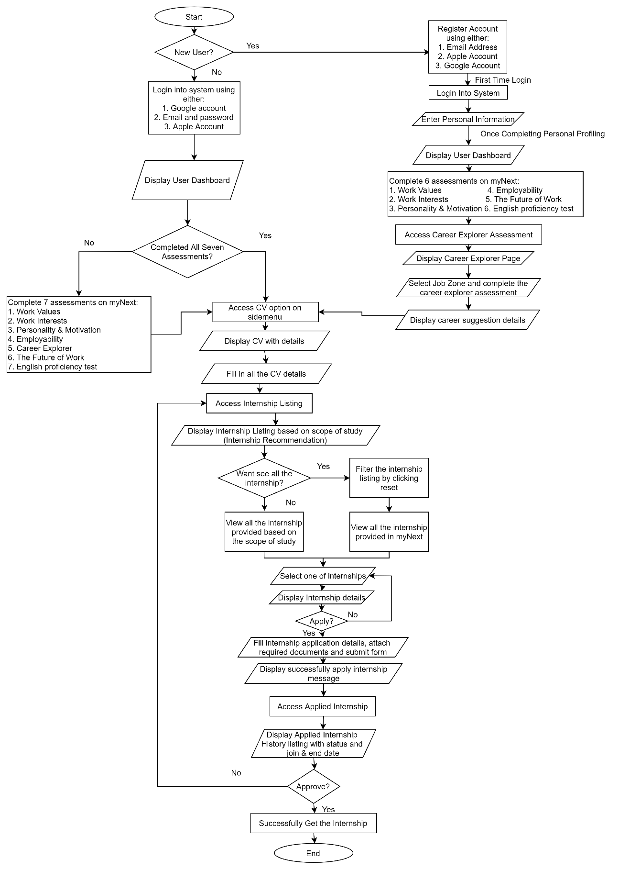

Figure 2‑1: Flowchart of MYNext (Intern Seeker)

**Flowchart (Employer/Company)**

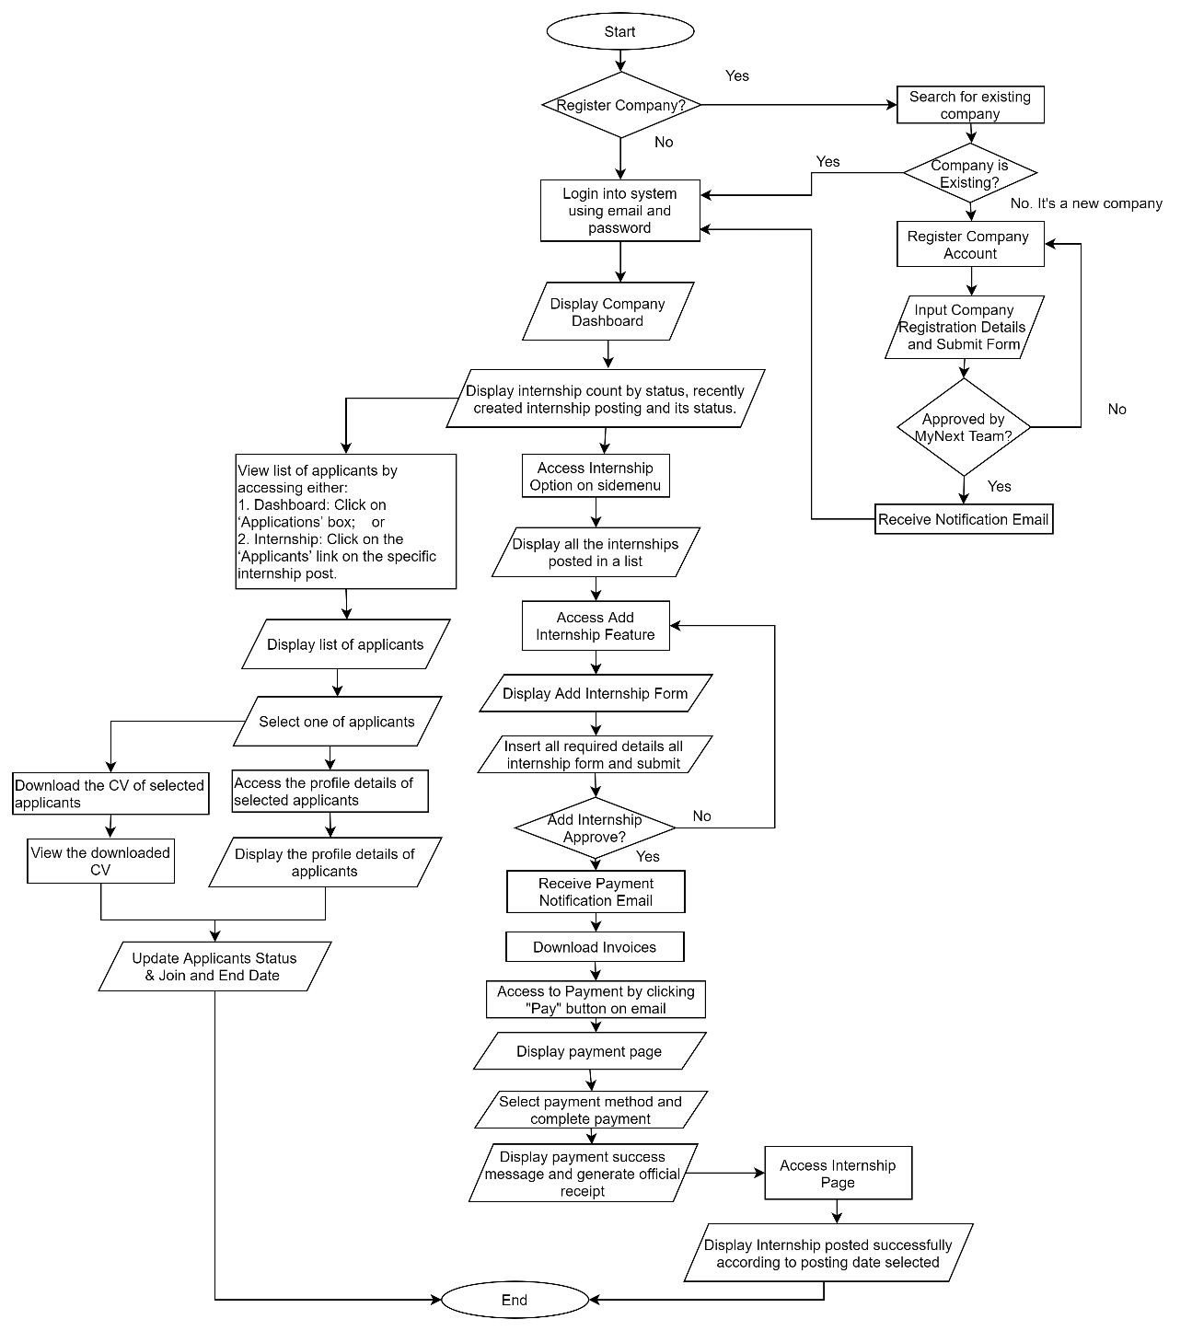

Figure 2‑2: Flowchart of MYNext (Employer/Company)

**System Specification**

Table 2‑1: System Specification for MYNext

|  |  |
| --- | --- |
| **System Name** | MYNext |
| **User Scope** | Intern Seekers (Include university students), Companies (Employer) |
| **Platform** | Web Application & Mobile Application |
| **User Interface** | * Intuitive interactions * Easier navigation and accessible * Readability and engagement |
| **Function Provided** | * Provide personalized Internship Recommendations based on the student's scope of study. * Allow students to apply for internships within the platform. * Allow students to input CV details required for internship applications. * Allow students to manage their personal profile details. * Allow students to track the status of their internship applications. * Allow students to save internships into their favourite listings for easy access. * Display the internship listing with the search and sort feature for students. * Display applied, favourite, and offered internships for students. Display total applicants, offered internships, accepted offers, and pending verifications for companies. * Allow students to generate professional standard CVs. * Allow companies to post internship opportunities. * Allow companies to manage the internship applications. * Include assessments to enhance the chance students of getting an internship. * Allow companies to manage company details. * Allow companies to view the profile of students. |
| **Source** | <https://www.mynext.my/> |

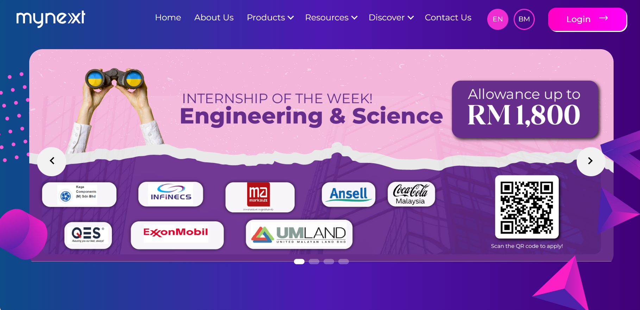

Figure 2‑3: The home page of MYNext Website

Figure 2-3 shows the main page of the MYNext Website.

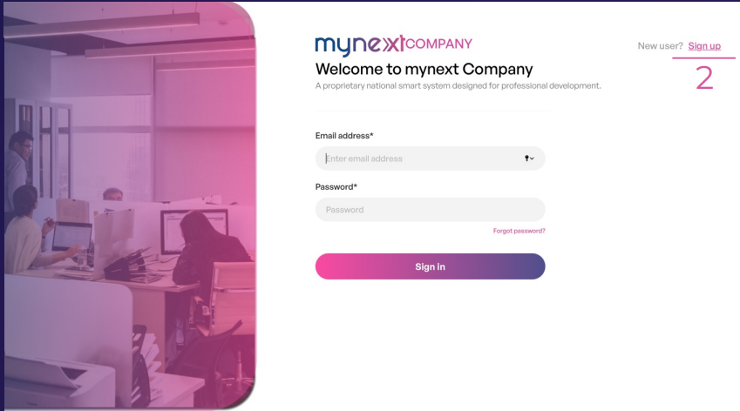

Figure 2‑4: Login Page for the Registered Company

Figure 2-4 shows the login page for the registered company. The company can enter the registered email and password to login into the system. If is a new company, the employer can click the <<Sign Up>> button. If the employer forgot the password of company, the employer can click <<Forgot Password>> button.

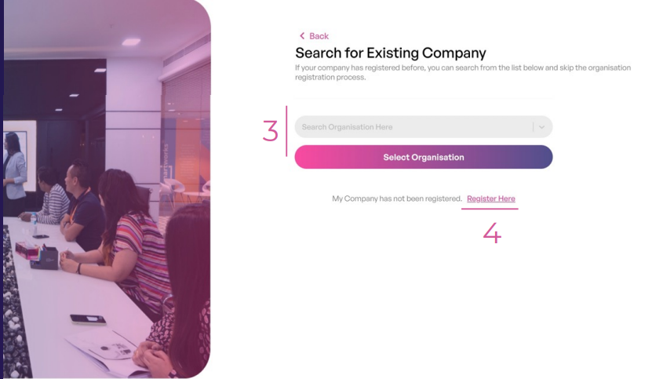

Figure 2‑5: Search for Existing Company Page

Figure 2-5 shows the page for the employer to search whether the name of organization is existing or not. If the name of the company is not existing, the employer can proceed to company registration.

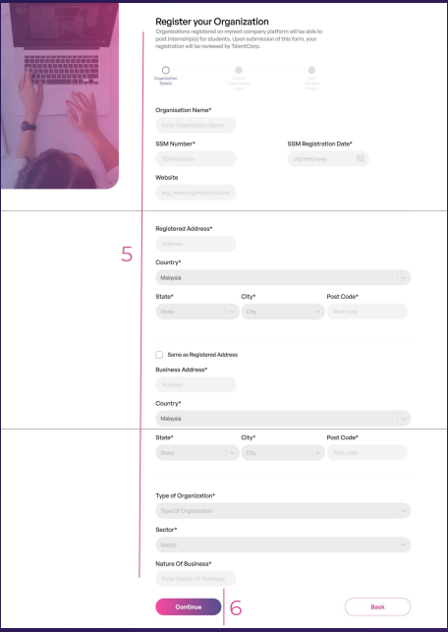

Figure 2‑6: Organisation Registration Form (Organization Details)

Figure 2-6 shows the page for the employer to register their organization on the MYNext platform. This page illustrates the first part of the company registration form, in which the employer needs to enter the details of the organization. The organization registration consists of three parts, in which the employer needs to enter the details of the organization, upload the organization logo, and add a contact person. Once the employer enters all the organization details, the employer needs to click the <<Continue>> button to proceed to the next step: uploading the organization logo.

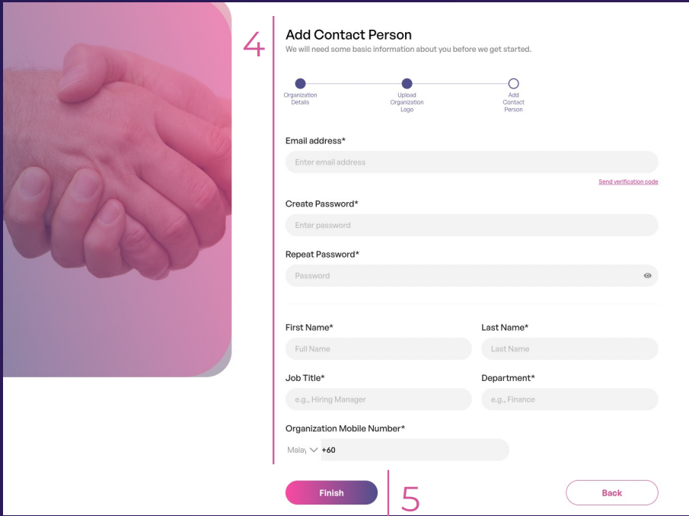

Figure 2‑7: Organization Registration Form (Add Contact Person)

Figure 2-7 shows the page for the employer to register their organization on the MYNext platform. This page illustrates the third part of the company registration form, to which the employer needs to add a contact person. Once the employer enters all the details of the contact person, the employer needs to click the <<Finish>> button to complete the company registration. Once the employer completes the registration, a pop-up message will appear. The employer needs to wait for the registration to be approved by the MYNext Team. Once the organization registration has been approved, the employer will get a notification email along with login details for the first time.

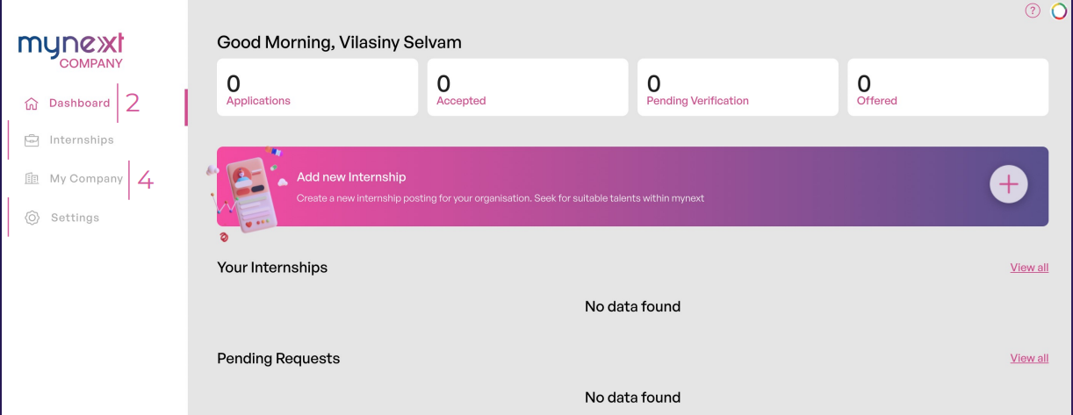

Figure 2‑8: Company Dashboard

Figure 2-8 shows the company dashboard after the employer logs into the system. The company dashboard shows the number of total applicants, offered internships, applicants that accepted the offer, applicants that are pending verifications, recently created internship postings, and the pending request for internship postings. The employer can add a new internship by clicking the add new internship button.

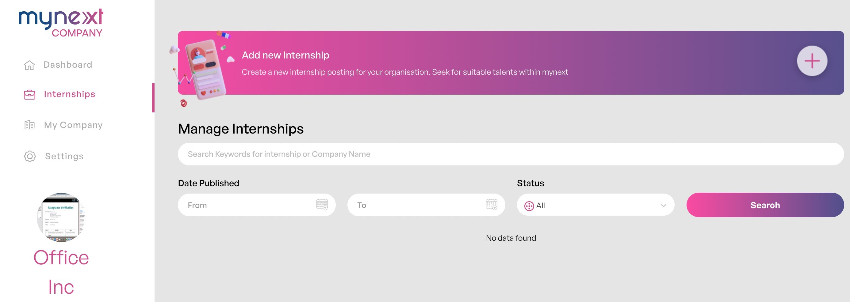

Figure 2‑9: Manage Internships Page

Figure 2-9 shows the manage internships page when the employer clicks on the internships option on the side menu. The employer can view, add, edit, and delete internship postings on this page. This figure shows that currently there are not any internship postings published by the company. The published internship postings will be displayed in a list. The employer can search and sort the listings to manage the internship postings effectively and efficiently.

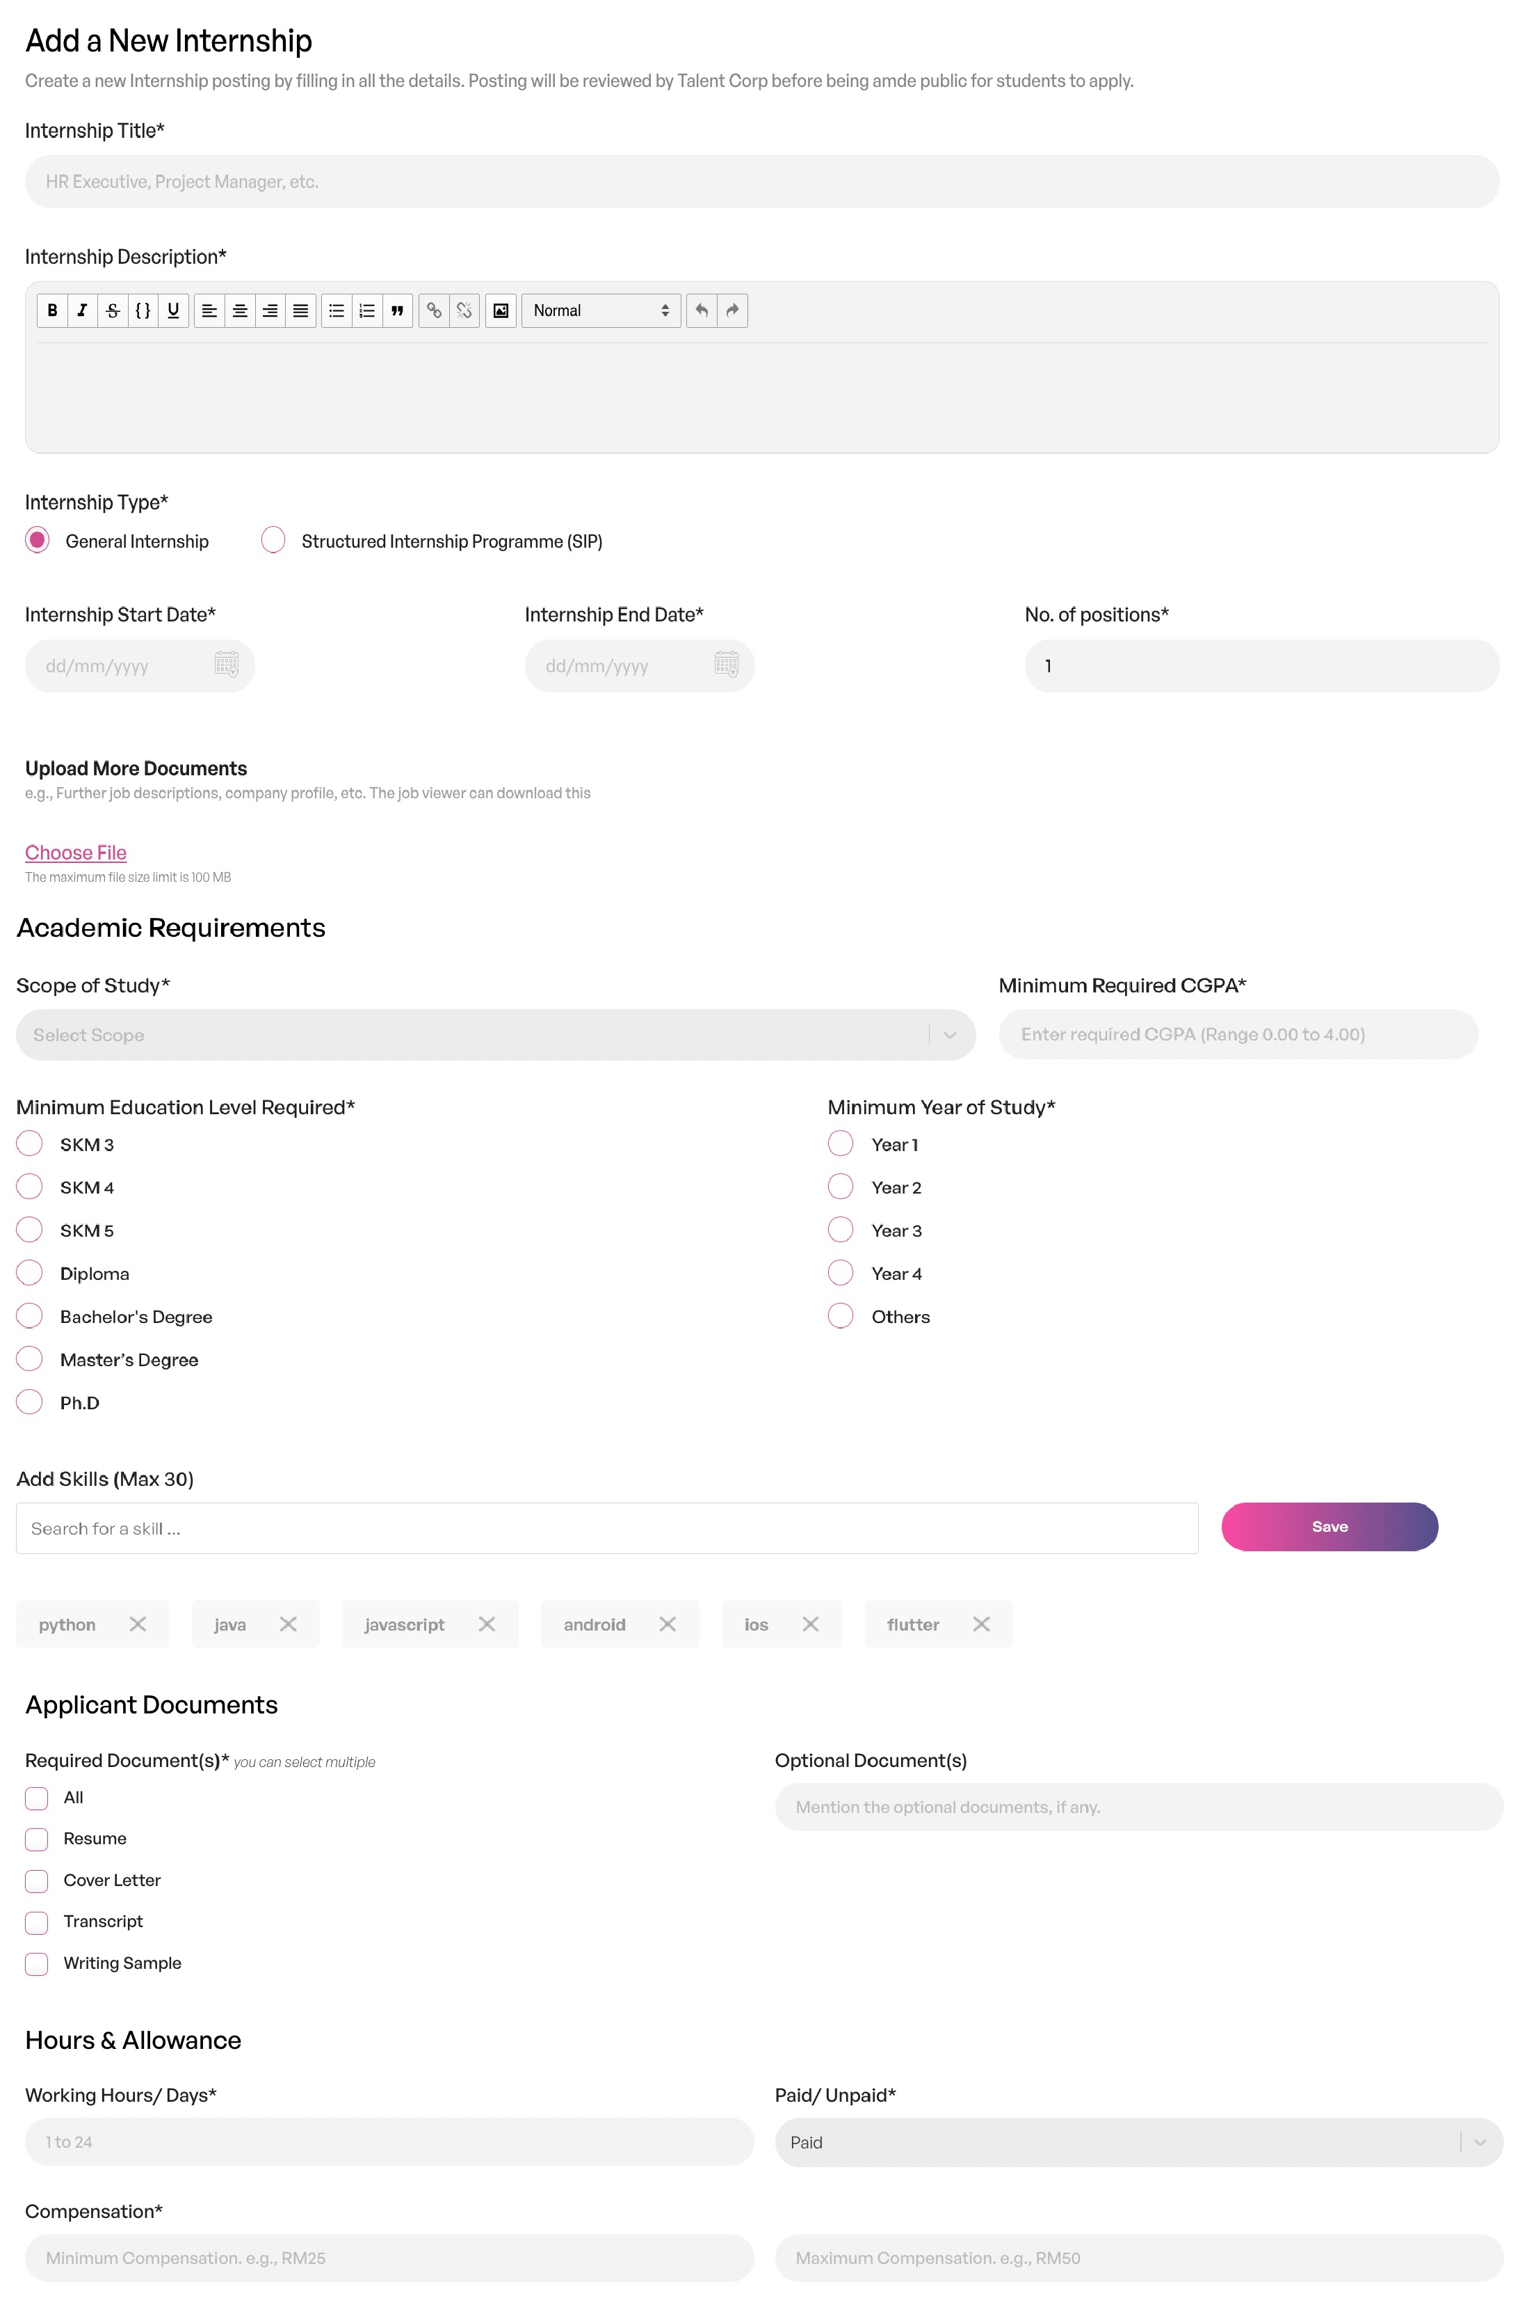

Figure 2‑10: Add a New Internship Page

Figure 2-10 shows the add a new internship page when the employer clicks on the add new internship on the manage internships page. The employer needs to fill in all details of the new internship in the add a new internship form such as internship title, internship description, academic requirement skills required, applicant documents need to be uploaded by applicants, and hours and allowance.

|  |  |
| --- | --- |
|  |  |

Figure 2‑11: Payment Notification via Email

Figure 2-11 shows the payment notification via email received by the employer once the internship posting application has been approved by the MYNext Team. The employer can download the invoices by clicking on the ‘Download Invoice’ button and make a payment via online banking, e-wallet, or credit or debit card by clicking on the ‘Pay’ button in the email or ‘Proceed to Online Payment’ on the invoice. Once the employer makes the payment, a payment success message will display along with an official receipt.

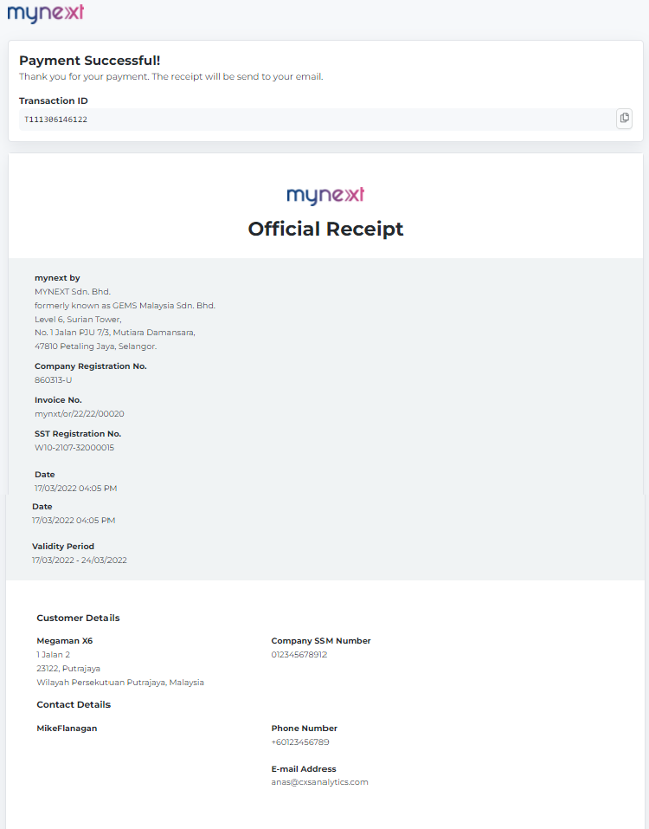

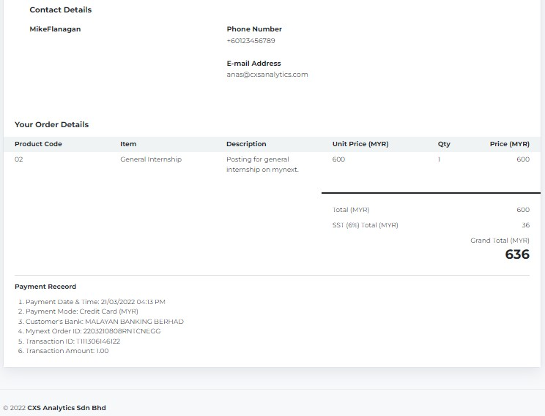

Figure 2‑12: Official Receipt

Figure 2-12 shows the official receipt for the employer as proof that the payment has been made for posting the internship within the MYNext platform.

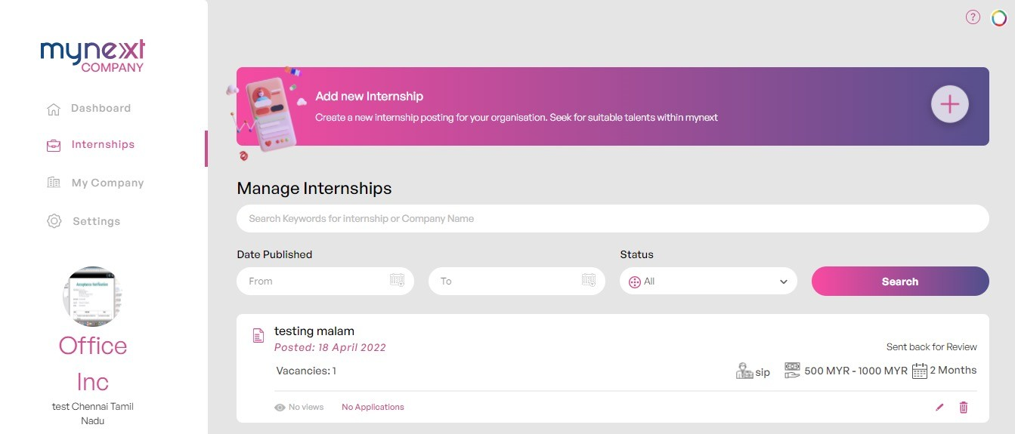

Figure 2‑13: Internship Posted Successfully

Figure 2-13 shows the internship posted successfully according to the posting date selected. The employer can view the internship posting on the manage internships page.

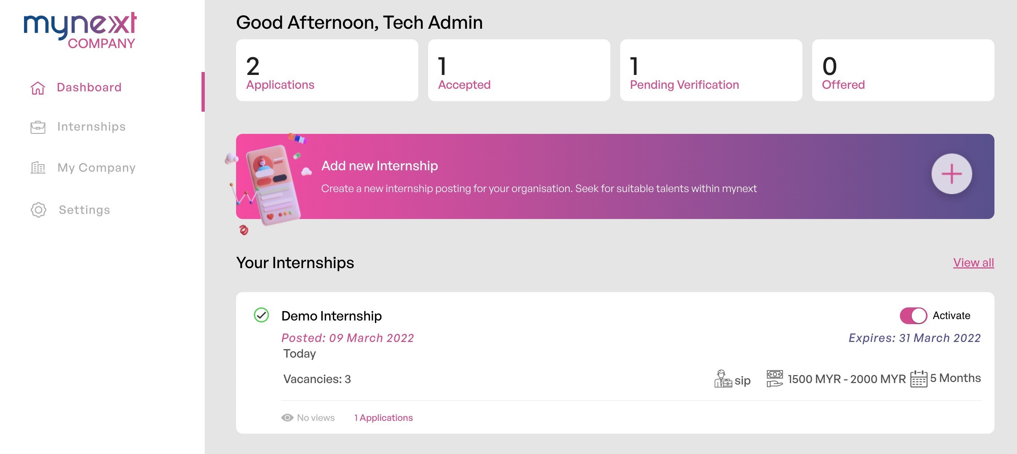

Figure 2‑14: Company Dashboard (Overview of internship count by status)

Figure 2-14 shows the company dashboard with two internship applications made by the applicant, one applicant accepted the internship offer, one applicant is still pending verifications, and zero offered an internship. The employer can view the list of applicants applied for specific internship by clicking on ‘Applications’ box.

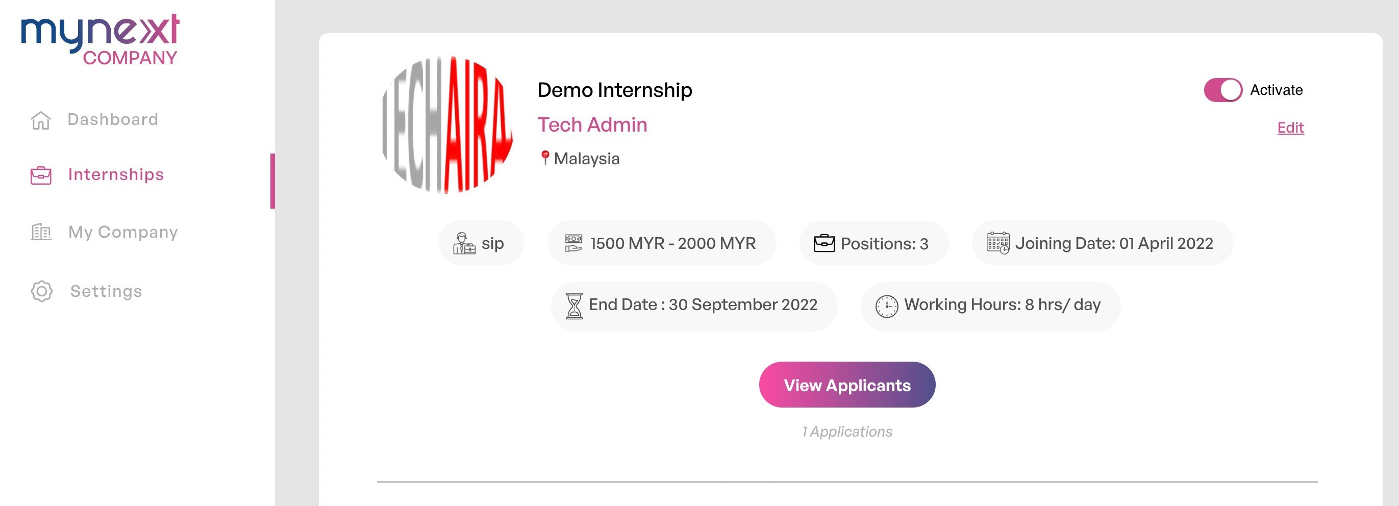

Figure 2‑15: Specific Internship Post Page (with an internship post)

Figure 2-15 shows the specific internship post page once the employer selects an internship post. The employer can view the list of applicants for the specific internship by clicking on the ‘View Applicants’ button.

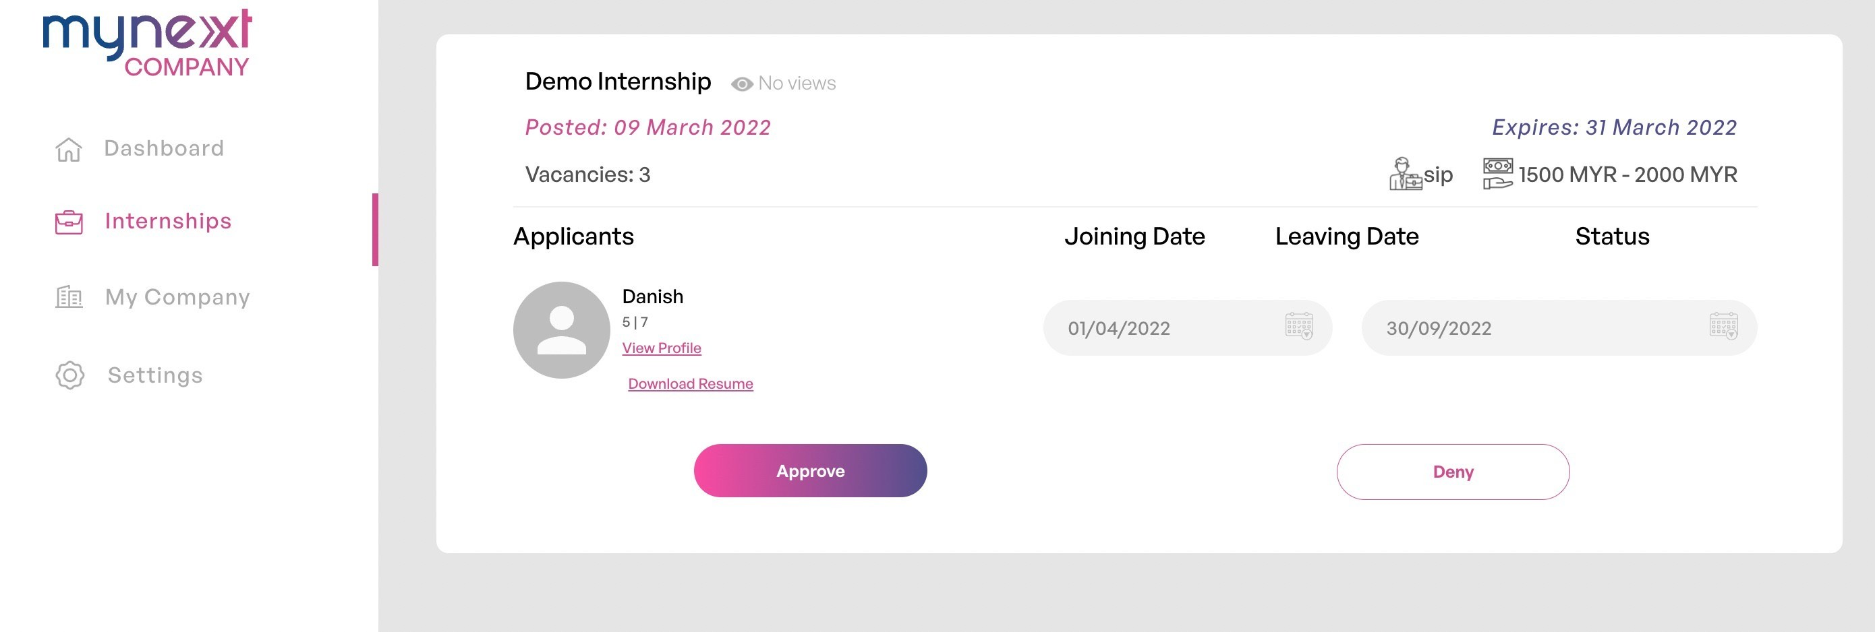

Figure 2‑16: List of Applicants page for the specific internship

Figure 2-16 shows the list of applicants page for the specific internship post once the employer clicks on the ‘Applications’ box on the company dashboard or clicks on the ‘View Applicants’ button on the specific internship post page. The employer can select the applicants' expected joining date and leaving date and update their internship status by clicking on the ‘Approve’ or ‘Deny’ button.

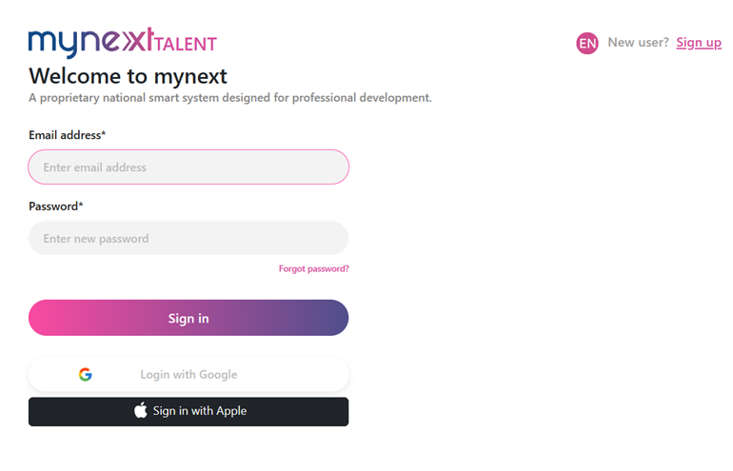

**Figure 2‑17: Login Page for Intern Seekers**

Figure 2-17 shows the login page for intern seekers. Intern Seekers can log in to the system using a Google Account, an Apple Account, or an email and password. If the intern seeker is a new user, the intern seeker needs to click on the 'Sign Up' link to register an account. If the intern seeker has an account but forgets the password, the intern seeker needs to click the 'Forgot Password' link to recover the password.

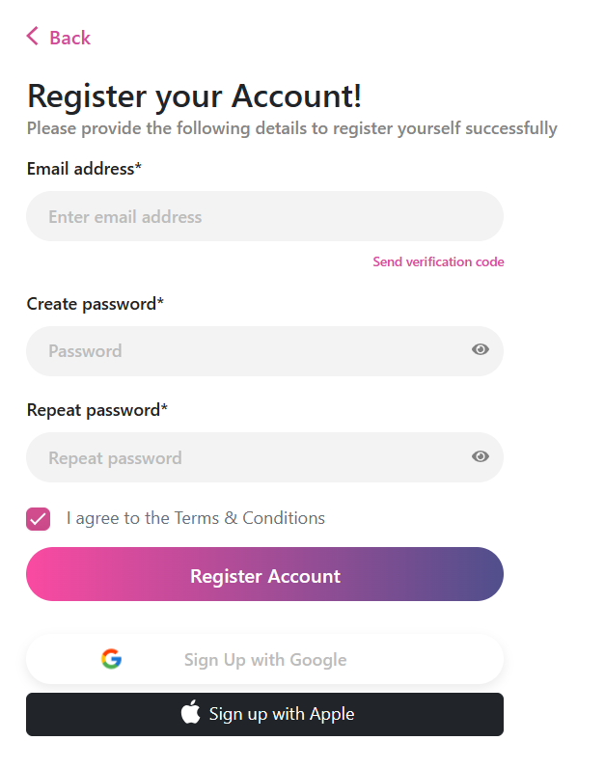

Figure 2‑18: Intern Seeker Account Registration Page

Figure 2-18 displays the account registration page for intern seekers to sign up for an account to access the features of the MYNext platform. Intern seekers can sign up for their account using their email address, Google account, or Apple account.

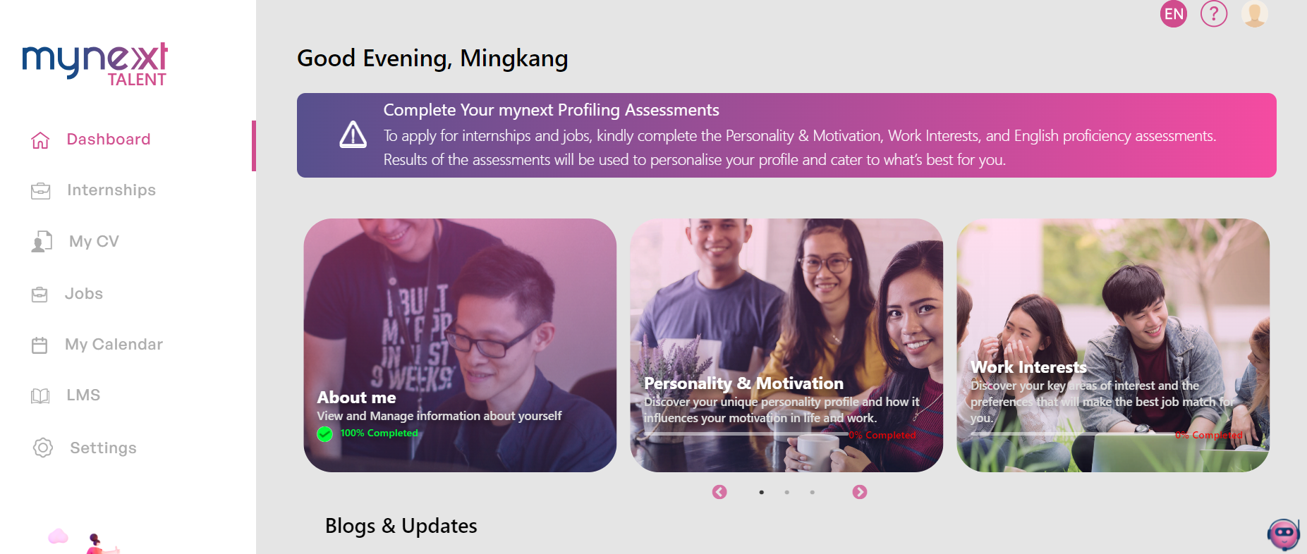

Figure 2‑19: Intern Seeker Dashboard

Figure 2-19 shows the dashboard for intern seekers. The dashboard consists of internships, my CV, settings, About Me, psychometric assessments, English proficiency tests, and blog updates. Intern seekers can access these options.

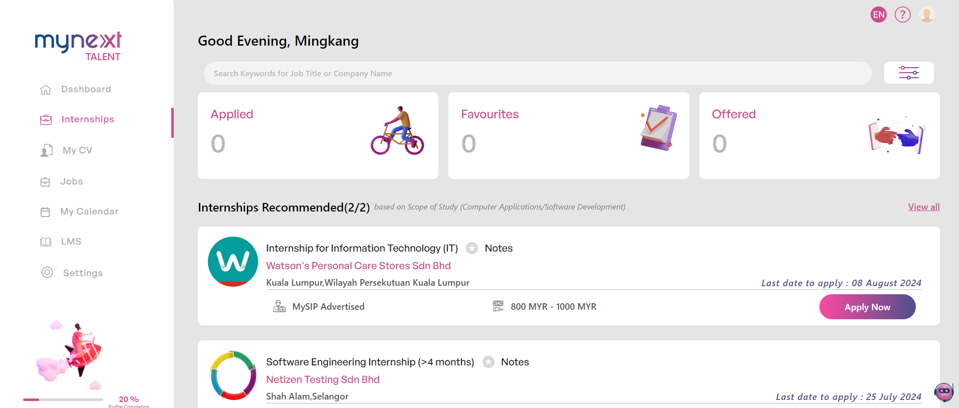

Figure 2‑20: Internship Listing Page with Internship Recommendation

Figure 2-20 shows the internship listing page with internship recommendation once the intern seekers click on the internships option on the side menu. The internship listing will display based on the scope of study of intern seekers.

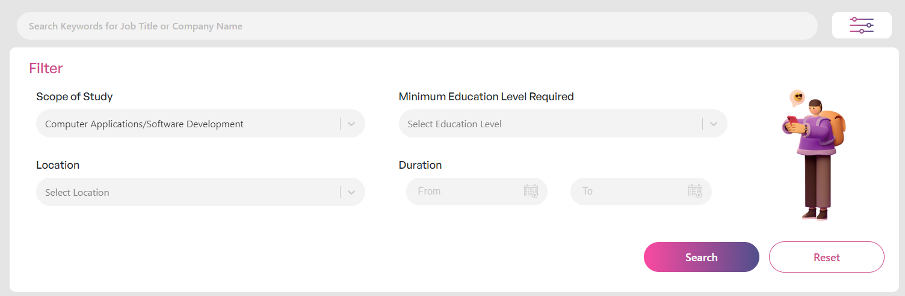

Figure 2‑21: Filter Internship Listing with Scope of Study

Figure 2-21 shows the internship recommendation displayed by filtering the listing with the scope of study of the intern seeker. It is easy for the intern seeker to find an internship according to their study scope.

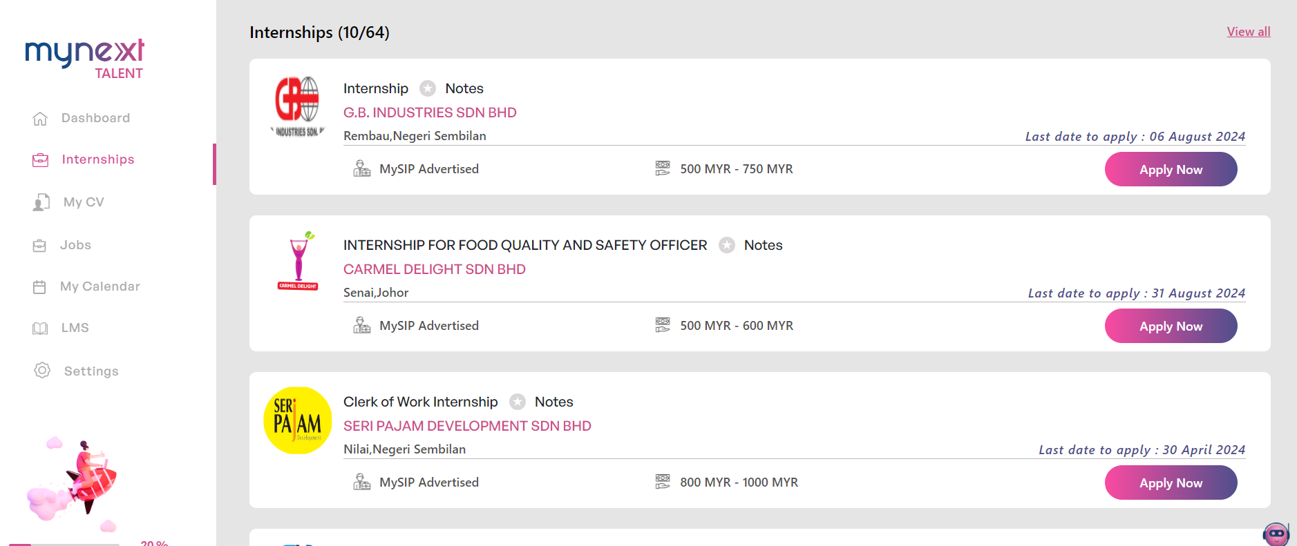

Figure 2‑22: Internship Listing Page with all Internships

Figure 2-22 shows the internship listing page with all the internships without internship recommendations once the intern seekers click the <<Reset>> button on the filter part. All the internships will be displayed in a list.

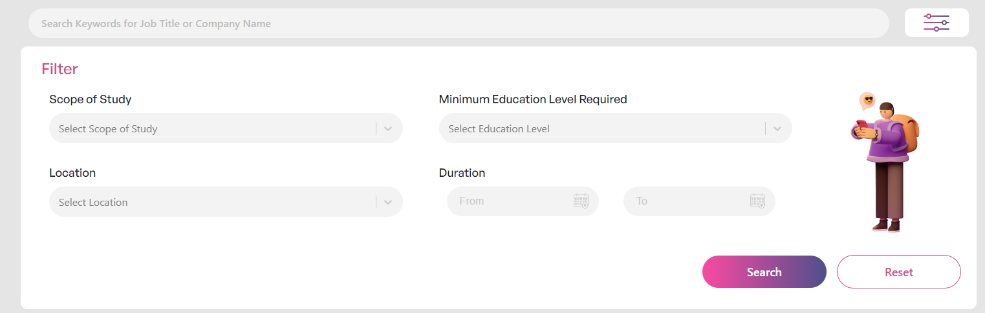

Figure 2‑23: Reset the filter to display all internships in a list

Figure 2-23 shows the internship listing is displayed with all the internships instead of the internship recommendation once the intern seeker resets the filter.



Figure 2‑24: Psychometric Assessments

Figure 2-24 shows six psychometric assessments that need to be taken by the intern seeker before applying for the internship within the MYNext platform. These assessments are work values, work interests, personality and motivation, employability, career exploration, and the future of work.



Figure 2‑25: English Proficiency Test

Figure 2-25 shows the English Proficiency Test that needs to be taken by the intern seeker before applying for the internship within the MYNext platform.

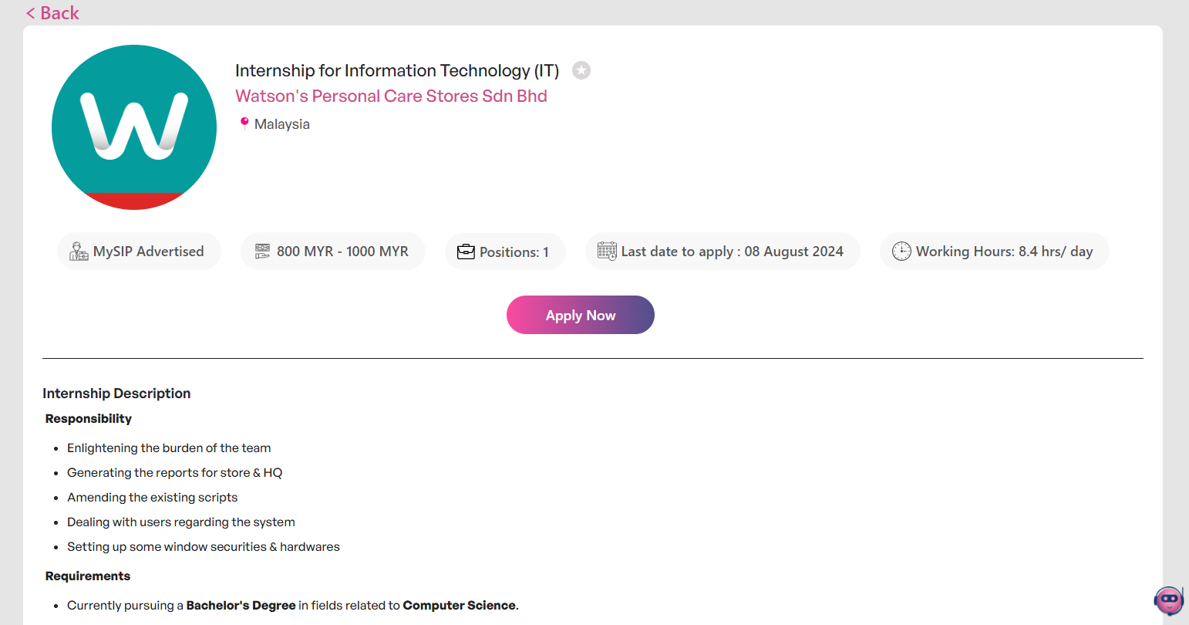

Figure 2‑26: Specified Internship Details Page

Figure 2-26 shows the specified internship details page once the intern seeker clicks on the box of the internship in the internship listing page. The intern seeker can view the requirements of the internship, the documents required for applying for this internship, and the responsibilities of this internship. The intern seeker can apply for the internship by clicking the <<Apply Now>> button.

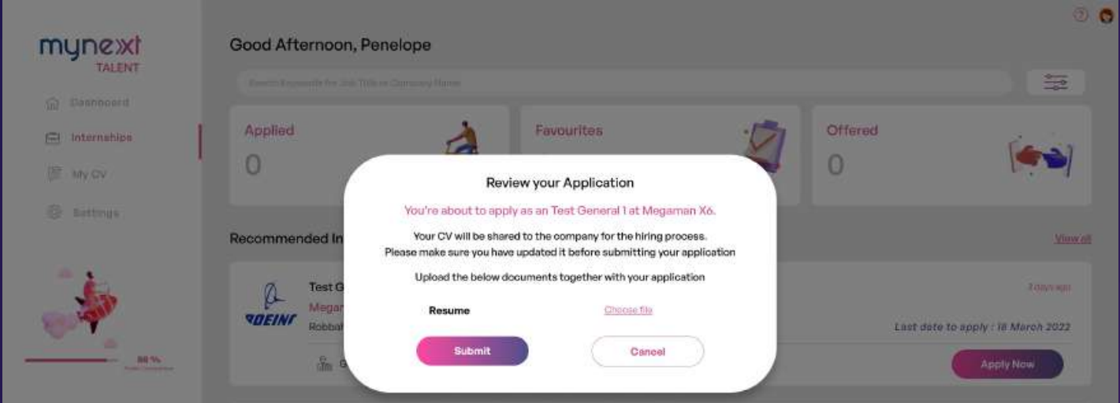

Figure 2‑27: Pop-Up to ask Intern Seeker to review the internship application

Figure 2-27 shows the pop-up to ask the intern seeker to review the internship application once the intern seeker clicks the <<Apply Now>> button. The intern seeker needs to attach the required documents and click the <<Submit>> button to complete the internship application process.

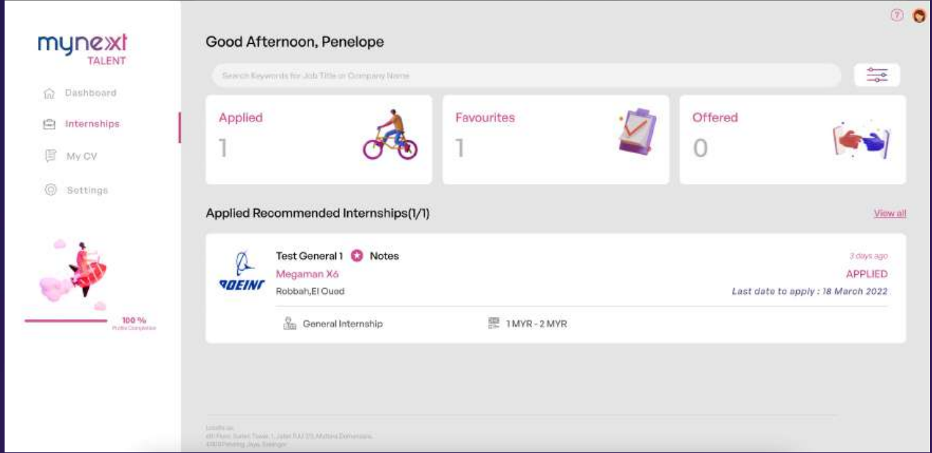

Figure 2‑28: Applied Internships Page

Figure 2-28 shows the applied internships page once the intern seeker clicks the ‘Applied’ box. The intern seeker can view the internships that they have applied for in a list. The ‘Applied’ box tracks the number of applied internships, the ‘Favourite’ box tracks the number of favourite internships, and the ‘Offered’ box tracks the number of offered internships.

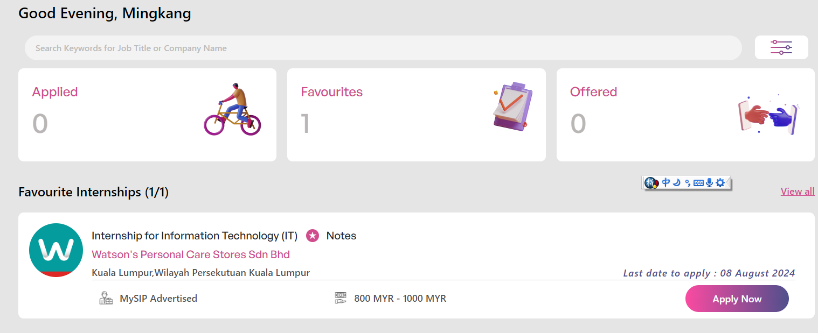

Figure 2‑29: Favourites Internships Page

Figure 2-29 shows the favourites internships page once the intern seeker clicks the ‘Favourites’ box. The intern seeker can view their starred and favourite internships in a list.

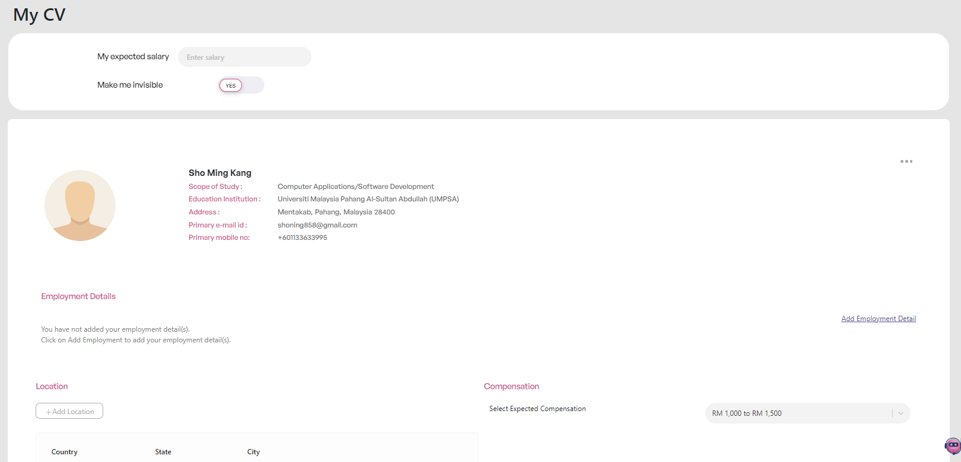

Figure 2‑30: CV Page

Figure 2-30 shows the CV page once the intern seeker clicks the My CV option on the side menu. The intern seeker needs to fill in the details of their CV. The CV consists of personal details, employment details, education, compensation, location, internship, event, and custom skills. Once the intern seeker enters the details required, they can download the CV. The intern seeker can edit the details of the CV.

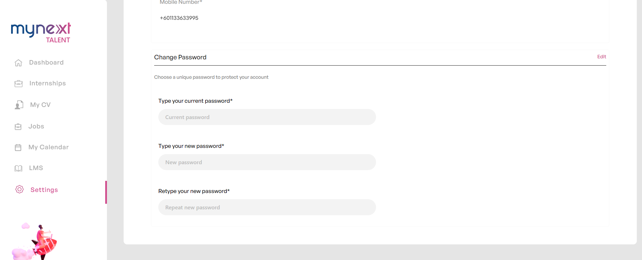

Figure 2‑31: Change password Page

Figure 2-31 shows the change password page once the intern seeker clicks the Settings option on the side menu. The intern seeker can change the current password with a new password if they want to change the password.

### Prosple

The requirement elicitation techniques to gather the requirements for Prosple are document analysis, interface analysis, and feature analysis. The elicitation process starts with identifying the key stakeholders involved in the internship process, such as students seeking internships and companies offering internships. Prosple only provides a guide for employers. The next step is to analyze the employer guidance provided by Prosple. The employer guide contains details about the features, functionalities, user interface, and user interactions for the employer site. It is not allowed to access the employer site. These guidelines are studied and analyzed to identify specific requirements related to user interface design and system capabilities. Lastly, through the exploration of the Prosple system from the perspective of an intern seeker, how the system works and the transitions and interactions within a user interface are understood, valuable insight into usability from the perspective of an intern seeker is gained, and the requirements when interacting with the system are gathered. By applying these techniques, a deeper understanding of how the system operates is gained, and the requirements of Prosple are gathered. The system specification, features, and introduction of Prosple and the experience of using Prosple are described below.

Prosple is an Australian-based company in leading organizations and universities to connect students with employment and education opportunities. (Prosple., 2014) Prosple is a web-based system that provides internship opportunities for students seeking internships and connects with companies looking for interns.

Prosple provides the internship listing with search and sort functionality for intern seekers. In addition, Prosple allows students to apply for internships within the platform or outside the platform. Besides, Prosple allows employers to post internship opportunities. Before applying for the internship, intern seekers complete their profiles by entering all the details. Students need to enter all the details and upload a cover letter and a resume during the internship application. The function of a cover letter is to show that they must undergo industrial training for academic purposes. Prosple allows intern seekers to save internships they are interested in for easy access. Prosple allows employers to edit the company details if some details are incorrect. Prosple provides a list of applicants for the internship posted for employers to manage the internship application. Prosple allows can view the profile of applicants and update the status of the internship application. Prosple displays a list of employers for students to explore with the sort feature. Intern seekers can view the company details, the job opportunities published, and the events.

Flowchart (Intern Seeker)

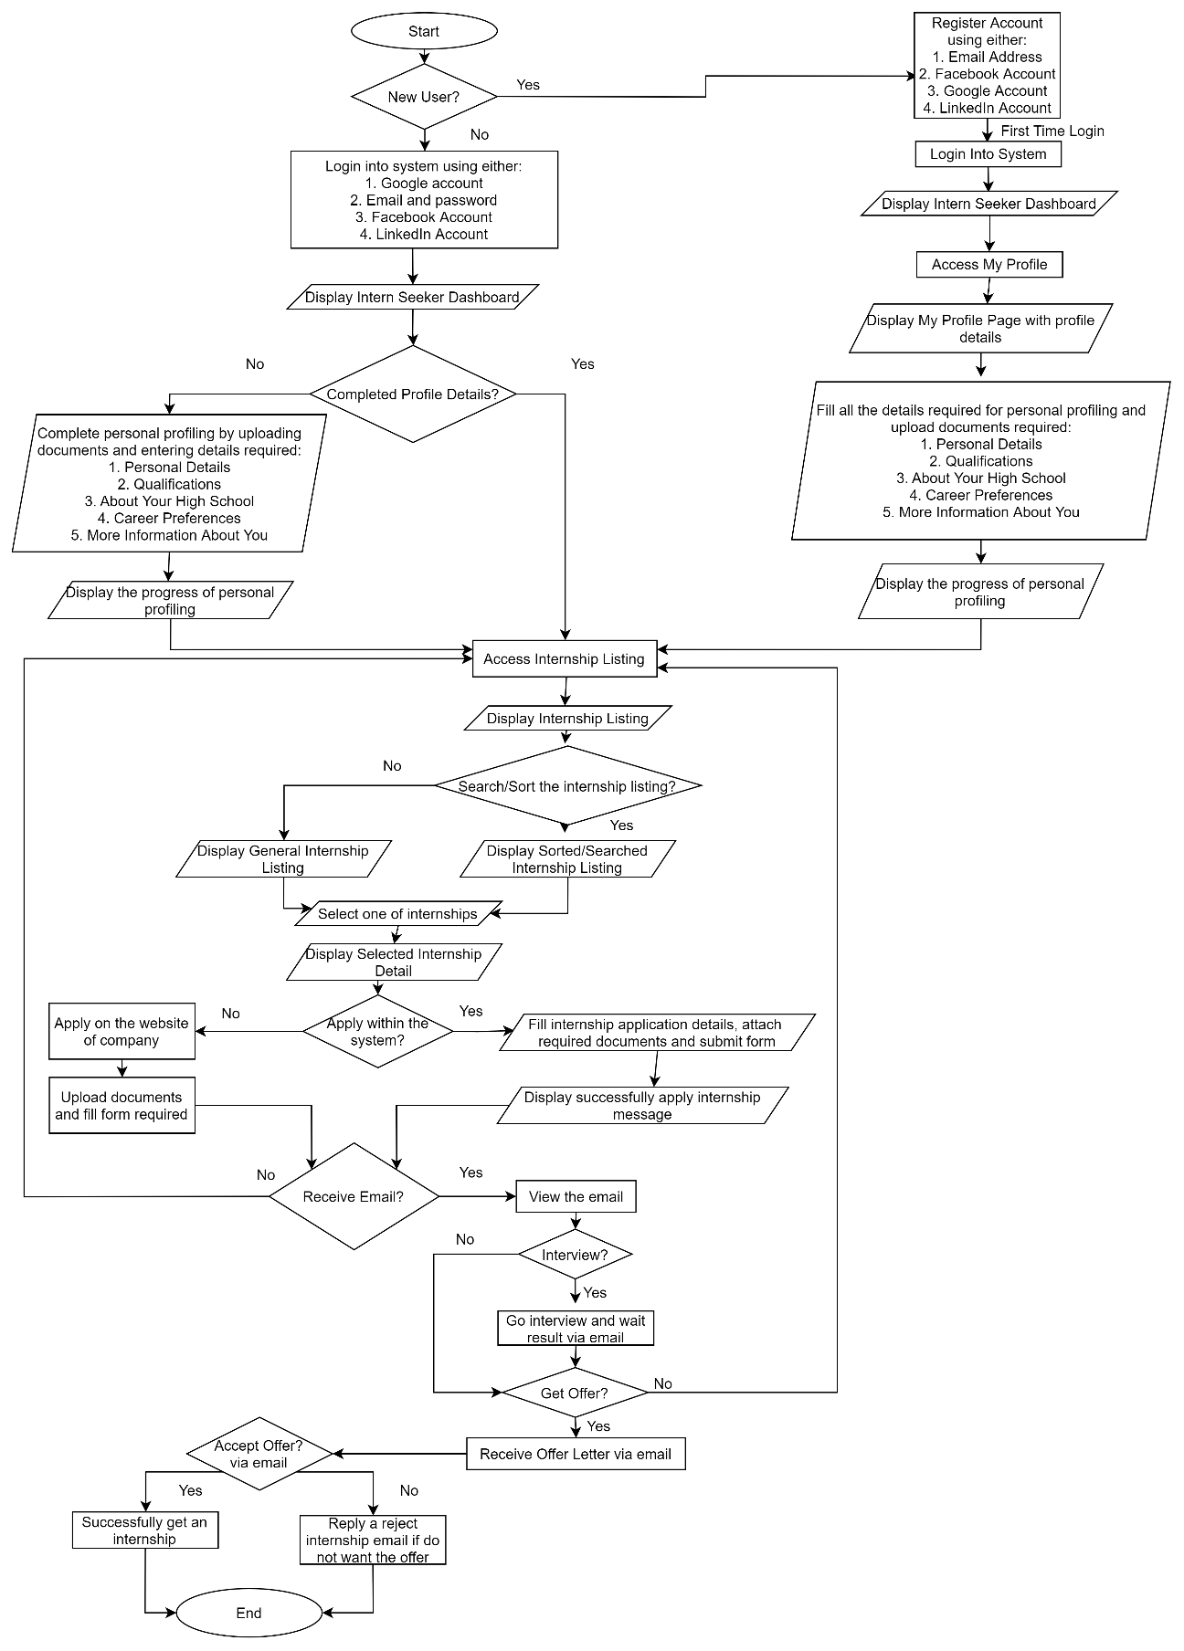

Figure 2‑32: Flowchart of Prosple (Intern Seeker)

**Flowchart (Employer/Company)**

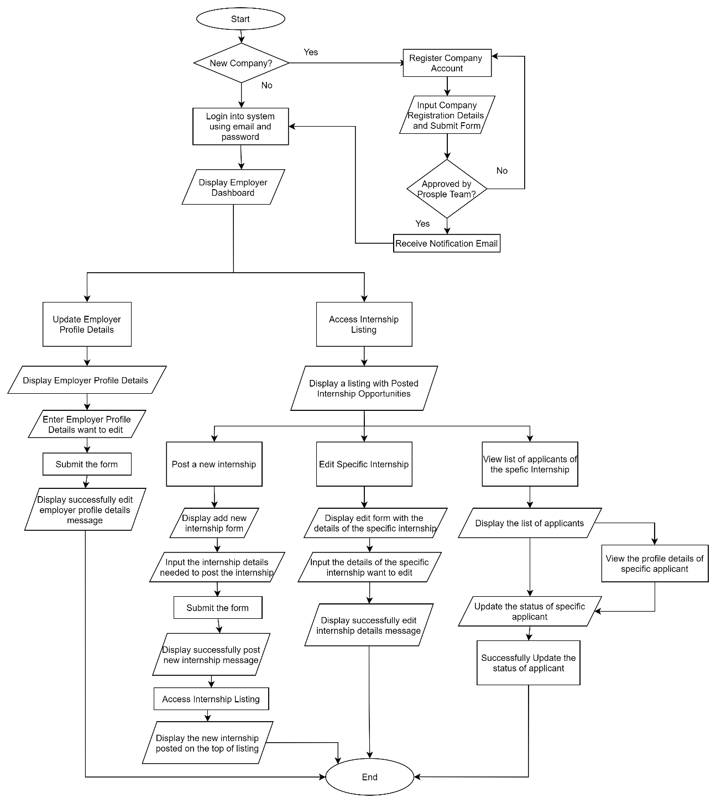

Figure 2‑33: Flowchart of Prosple (Employer/Company)

**System Specification**

Table 2‑2: System Specification for Prosple

|  |  |
| --- | --- |
| **System Name** | Prosple |
| **User Scope** | Intern seekers (Include university students), Employer |
| **Platform** | Web Application |
| **User Interface** | Intuitive interactions  Clear visual design  Consistency |
| **Function Provided** | Allow students to apply for internships within the platform or outside the platform.  Allow students to manage their personal profile details.  Allow students to save internships into their saved jobs listings for easy access.  Display the internship listing with the search and sort feature for students.  Allow students to upload cover letter to prove that they need to undergo industrial training for academic purposes.  Allow students to upload their resumes.  Allow employers to post internship opportunities.  Allow employers to manage internship application.  Allow employers to manage company details.  Allow employers to view the profile of students.  Allow students to view the profile details of company.  Display employer listings for students with sort functionality. |
| **Source** | <https://prosple.com/> |

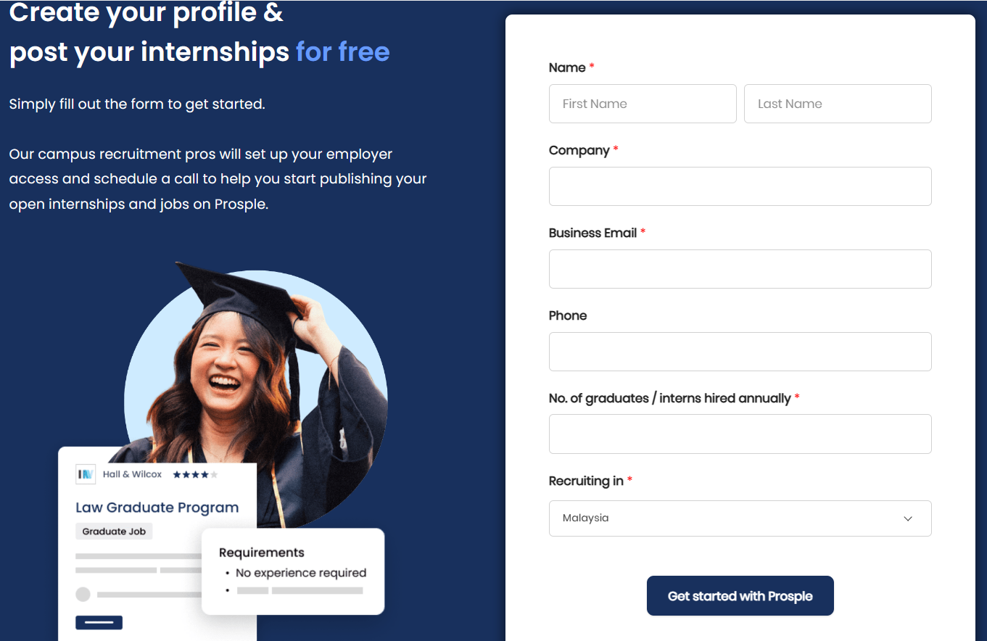

Figure 2‑34: The Company Registration Page of Prosple

Figure 2-34 shows the company registration page of Prosple. If it is a new company, the employer needs to fill in the details required in the company registration form and click the <<Get started with Prosple>> button.

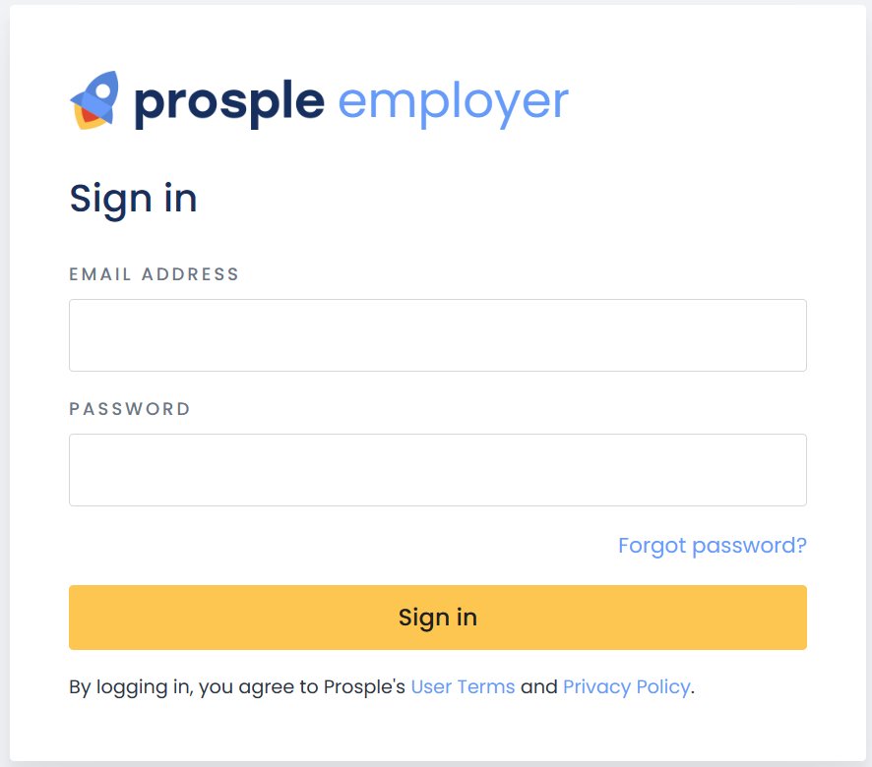

Figure 2‑35: Login Page for Prosple Employer

Figure 2-35 shows the login page for the employer. The employer needs to enter the email address and password to login into the system. If the employer forgets the password, they may click the forgot password link to recover the password.

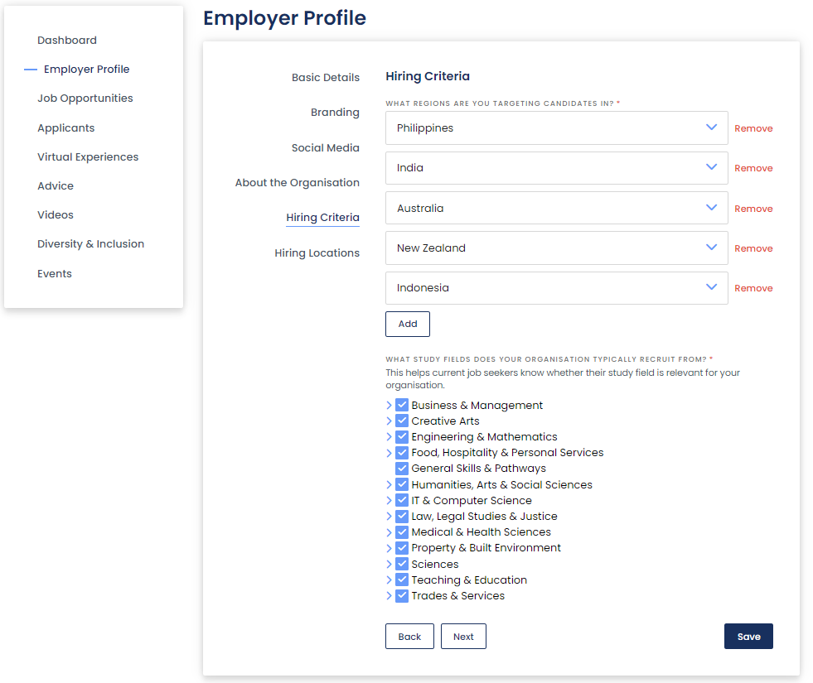

Figure 2‑36: Employer Profile Page

Figure 2-36 shows the employer profile page with the details of employers once the employer clicks on the employer profile option on the side menu. The employer profile consists of Basic Details, Branding, Social Media, About the Organization, Hiring Criteria, and Hiring Locations. The employer can update the profile details by entering the details they want to edit and clicking the save button.

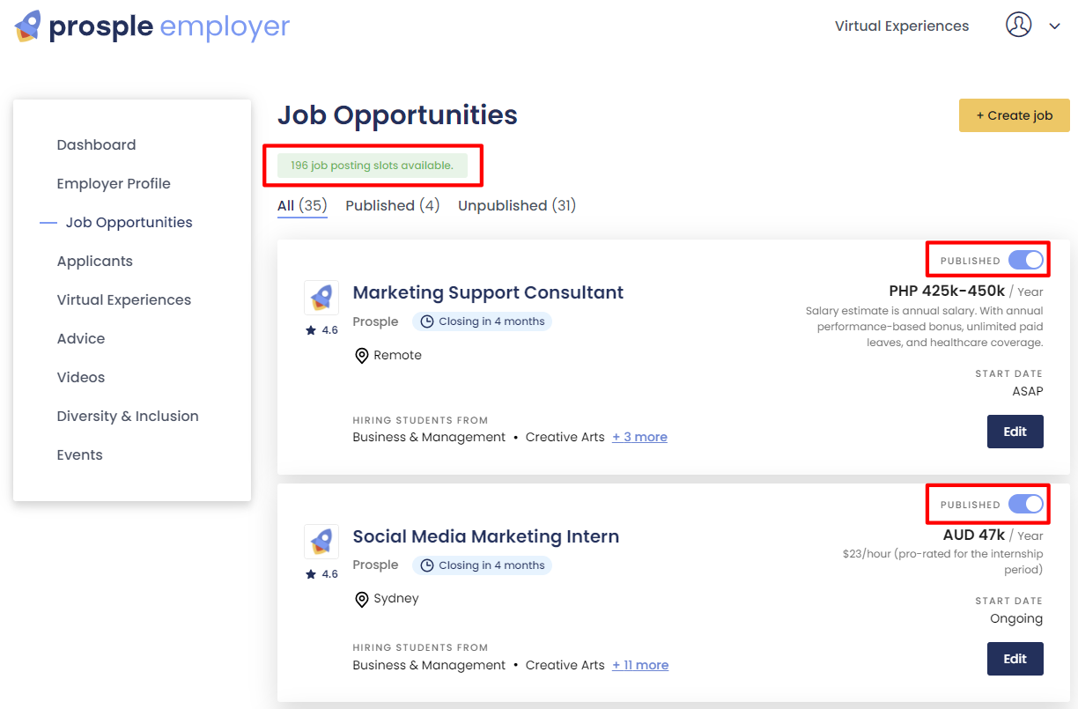

Figure 2‑37: Internship Opportunities Listing Page

Figure 2-37 shows the page that displays all the internship opportunities posted by the employer that have been published or unpublished. The employer can view and edit the details of internship opportunities posted that have been published or unpublished. The employer can create an internship by clicking the Create Job button. The employer can publish or unpublish the internship by clicking the toggle switch button.

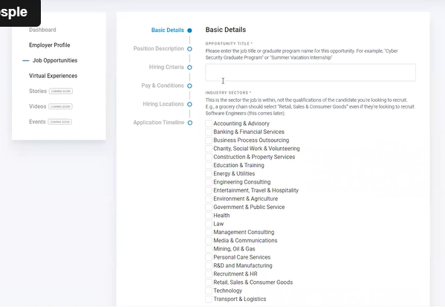

Figure 2‑38: Add an Internship Opportunity Page

Figure 2-38 shows the page for the employer to add an internship opportunity. The add internship form consists of Basic Details, Position Description, Hiring Criteria, Pay and Conditions, Hiring Locations, and Application Timeline. The employer needs to enter all the details required in the add internship form to create a new internship opportunity for intern seekers.

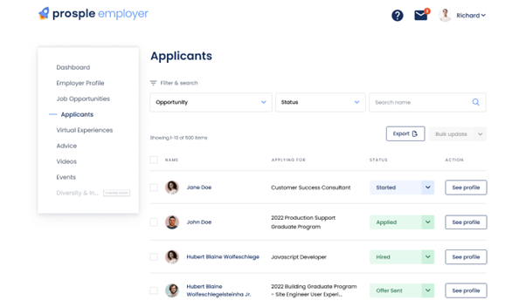

Figure 2‑39: List of Applicants

Figure 2-39 shows the list of applicants who apply for internships posted by the employer. The employer can view the profile of applicants and the positions they apply for and update the status of internship applications for students. Prosple allows the employer to search and sort the list of applicants to manage the internship application easily.

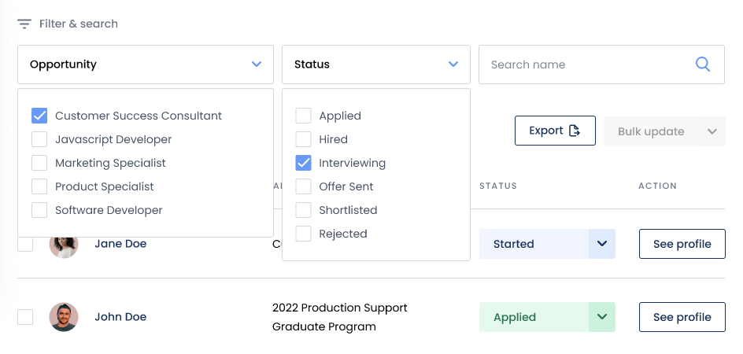

Figure 2‑40: Search and sort feature in the Applicants List

Figure 2-40 shows the applicant's list consisting of a search and sort feature for the employer to explore and find desired applicants for the position. This figure illustrates the employer sorts the list of applicants by internship opportunities provided and the status of internship applications.

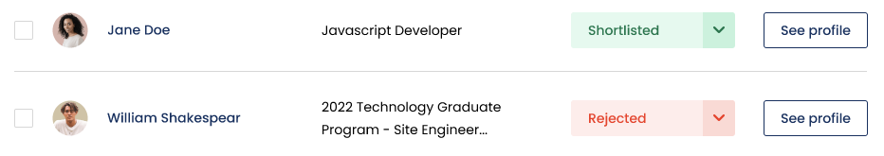

Figure 2‑41: Update the status of the internship application of applicants

Figure 2-41 shows the employer update on the status of internship applications of applicants. The employer can edit the status of internship applications of applicants with Applied, Hired, Interviewing, Offer Sent, Shortlisted, or Rejected.

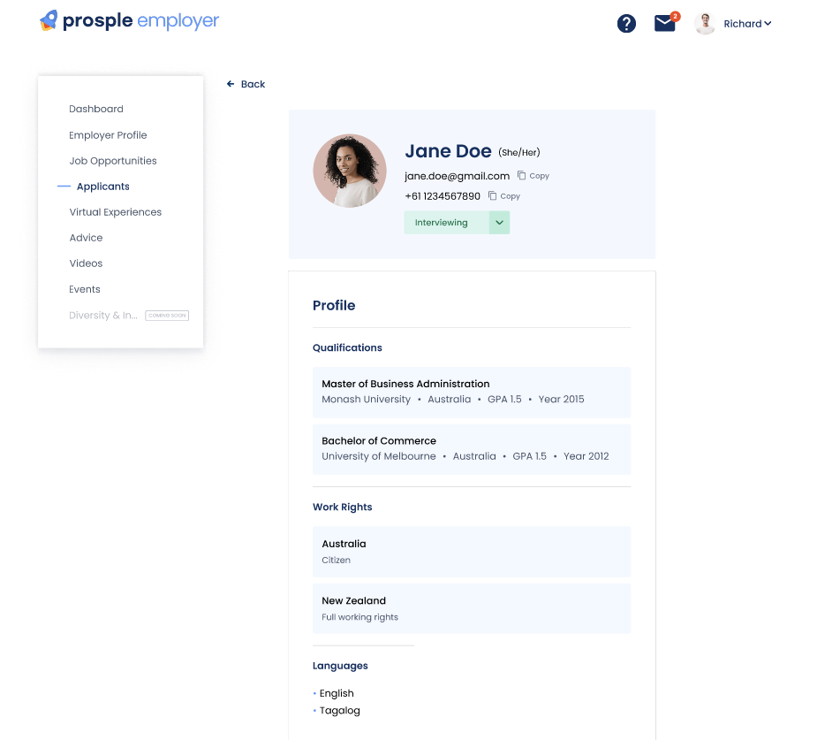

Figure 2‑42: Applicant’s Profile Page

Figure 2-42 shows the page of the applicant's profile once the employer clicks the See Profile button on the list of applicants page. The employer can know the personal details, qualifications, work rights, language, and skills of the applicant by viewing the profile of the applicant.

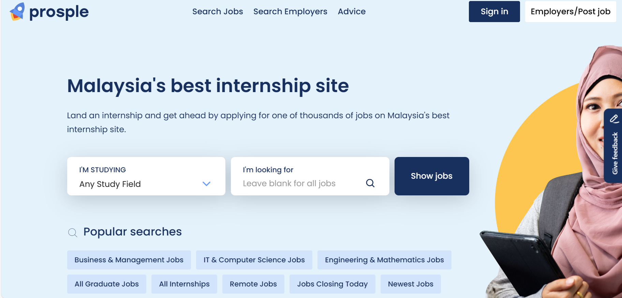

Figure 2‑43: Main Page of Prosple

Figure 2-43 shows the main page of Prosple website.

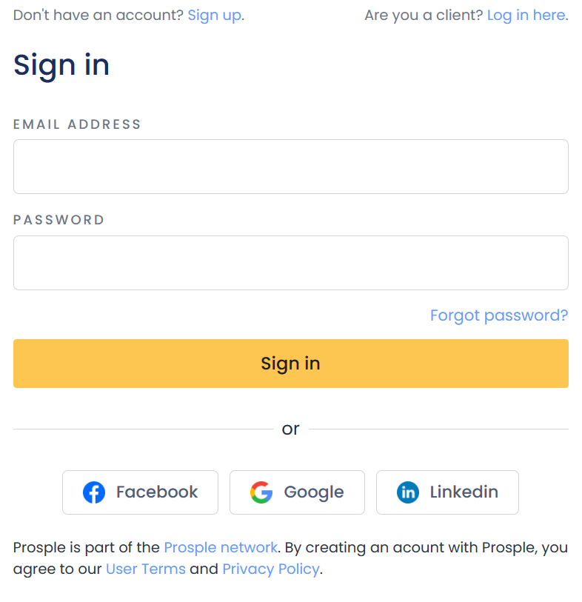

Figure 2‑44: Login Page for Intern Seeker (Prosple)

Figure 2-44 shows the login page of Prosple for intern seekers. Intern Seekers can log in to the system using a Google Account, a Facebook Account, a LinkedIn email or an email and password. If the intern seeker is a new user, the intern seeker needs to click on the 'Sign Up' link to register an account. If the intern seeker has an account but forgets the password, the intern seeker needs to click the 'Forgot Password' link to recover the password.

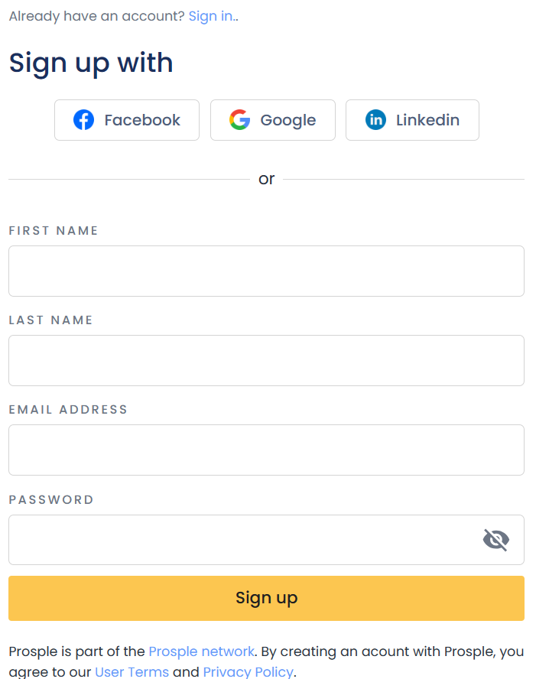

Figure 2‑45: Sign-Up Page for Intern Seeker (Prosple)

Figure 2-45 illustrates the sign-up page for intern seekers to register for an account to access the features of the Prosple platform. Intern seekers can sign up for their account using their email address, Google account, Facebook Account, or LinkedIn account.

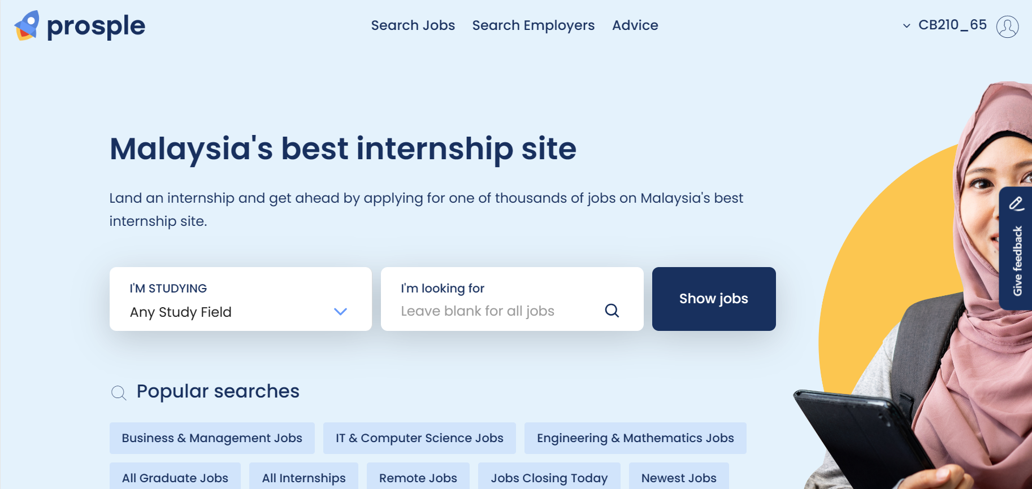

Figure 2‑46: After Login Page

Figure 2-46 displays the page after the intern seeker login into the Prosple. The intern seeker can click the “My Profile” button for the personal profiling process. The intern seeker can view the employer list or internship list by clicking the “Search Employers” button or “Search Jobs” button on the navigation bar. The intern seeker can select their study field and enter the jobs they want to find, then the system will display a list of jobs based on their input.

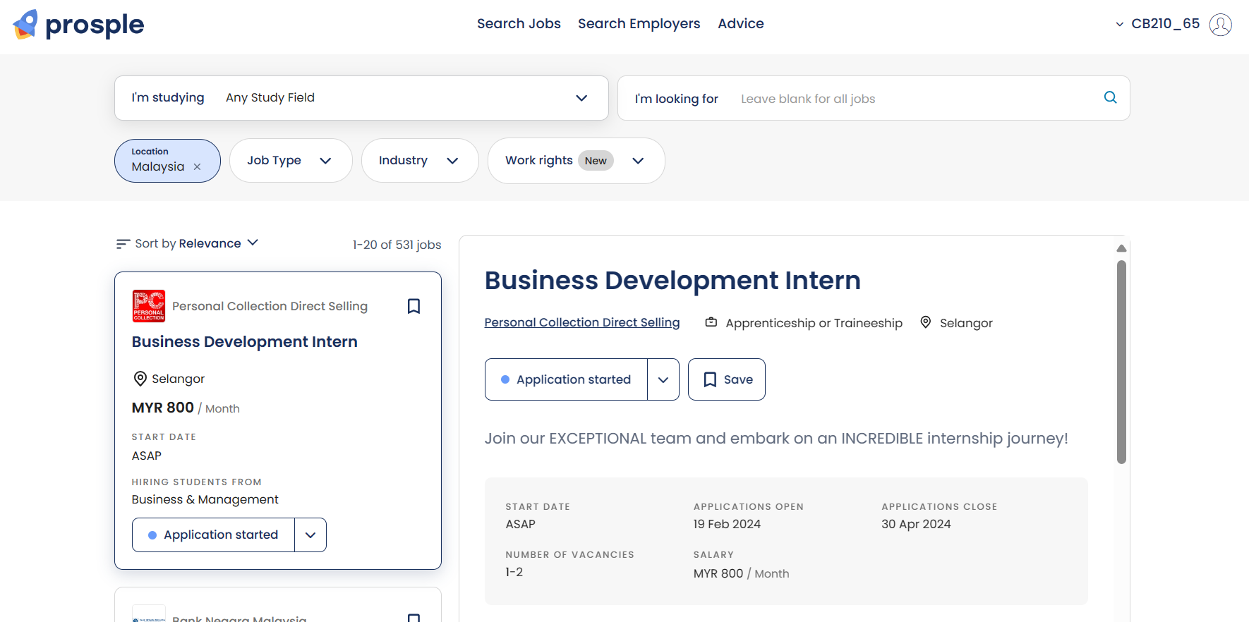

Figure 2‑47: Internship Listing Page (Prosple)

Figure 2-47 shows the page of internship listings once the intern seeker clicks the ‘Search Jobs’ button on the navigation bar. The intern seeker can easily find their desired internship since Prosple provides the sort and search internships feature. The intern seeker can click on the details of the internship by clicking on the specific internship card, and the details of the internship will be displayed on the right side. The details include the working location, internship title, internship description, starting date, application start date, application close date, salary, and hiring criteria. The intern seeker can save the internship by clicking the 'Save' button if they need time to think about applying for the internship.

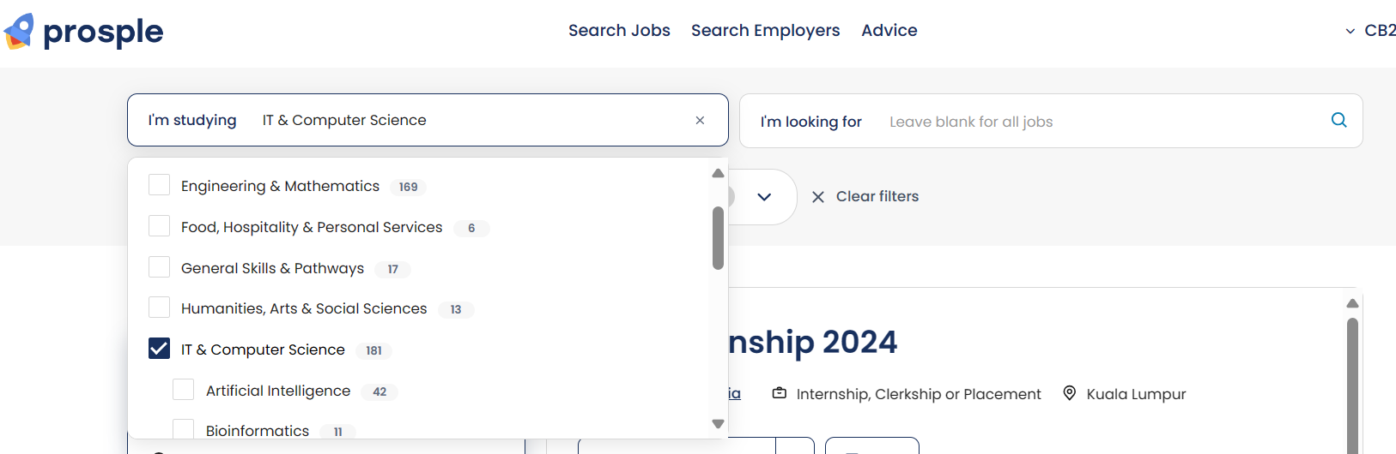

Figure 2‑48: Sort Internship Listing with the study field

Figure 2-48 displays the internship listing sorted by the study field. This figure shows the internship listing sorted by IT and computer science.

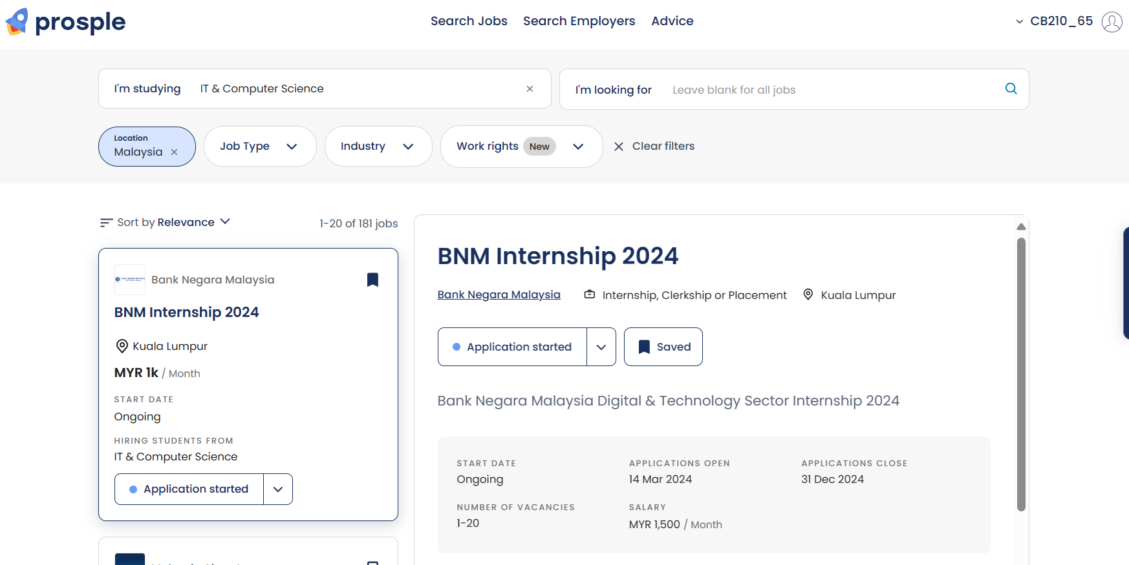

Figure 2‑49: Display Sorted Internship Listing

Figure 2-49 displays the sorted internship listing based on the study field the intern seeker selects. This figure shows the sorted internship listings related to the IT and Computer Science study fields.

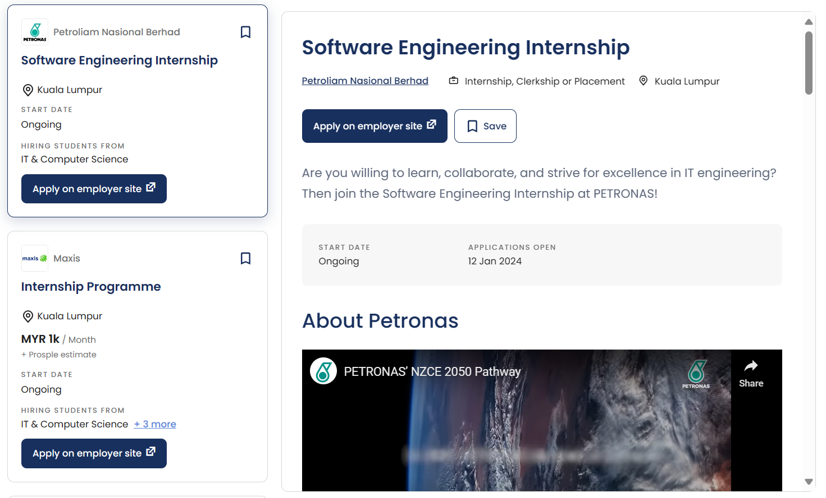

Figure 2‑50: Display internships that need to be applied for outside the application

Figure 2-50 illustrates the internship listing of Prosple consisting of internships that need to be applied by intern seekers outside the application. The intern seeker needs to apply for these internships on the company website.

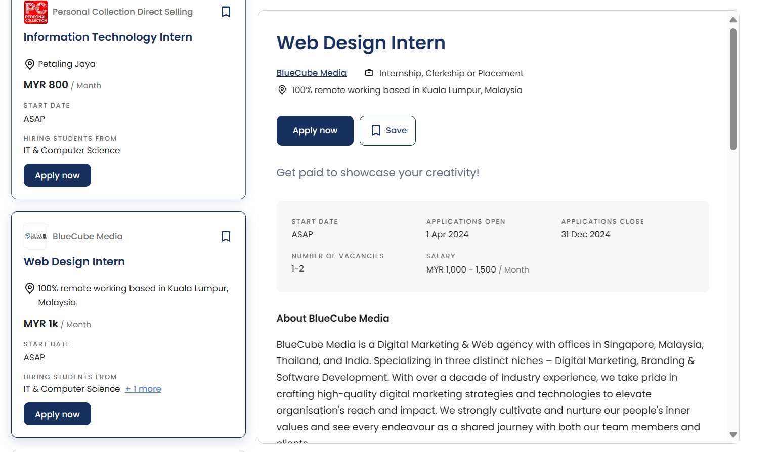

Figure 2‑51: Display internships that need to be applied for within the Prosple platform

Figure 2-51 illustrates the internship listing of Prosple consisting of internships that need to be applied by intern seekers within the application. The intern seeker can directly apply for these internships by clicking the ‘Apply now’ button.

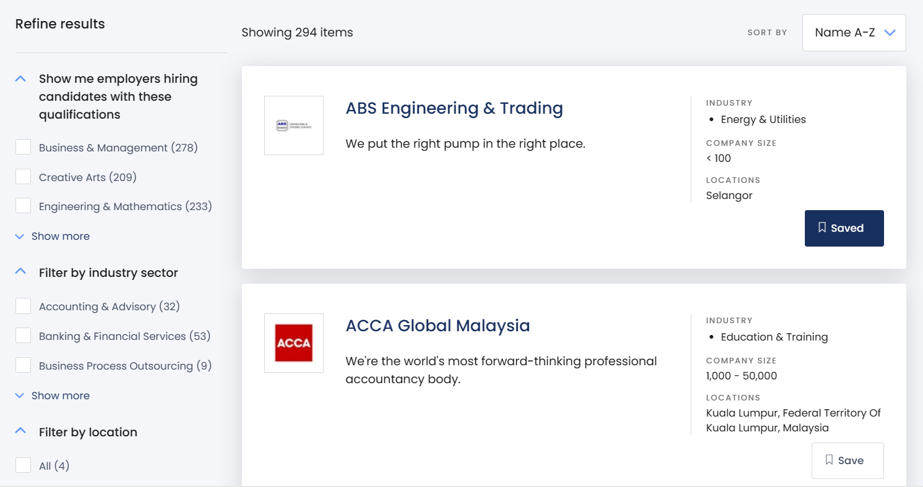

Figure 2‑52: Employer Listings page

Figure 2-52 illustrates the employer listings page once the intern seeker clicks the ‘Search Employer’ button on the navigation bar. The intern seeker can easily view the employer they want to find since Prosple provides the sorting feature in the employer listings. The intern seeker views the company profile by clicking the specific company card. The intern seeker can also save the employer by clicking the 'Save' button.

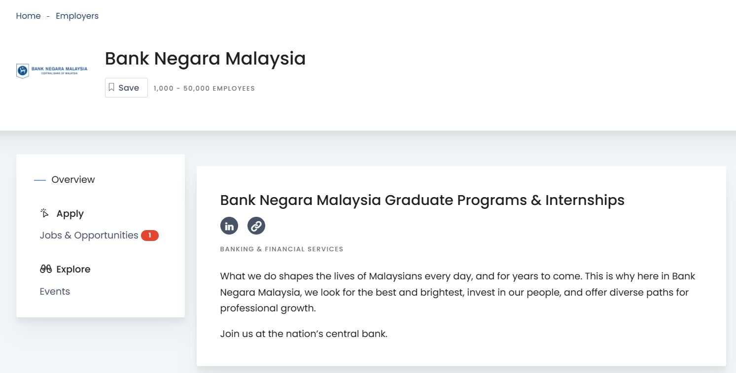

Figure 2‑53: Company Profile Page

Figure 2-53 shows the company profile page. The intern seeker can view the details of the company, the jobs and opportunities published by the employer, and the events of the company. The intern seeker can access the company's LinkedIn page by clicking the 'LinkedIn' icon.

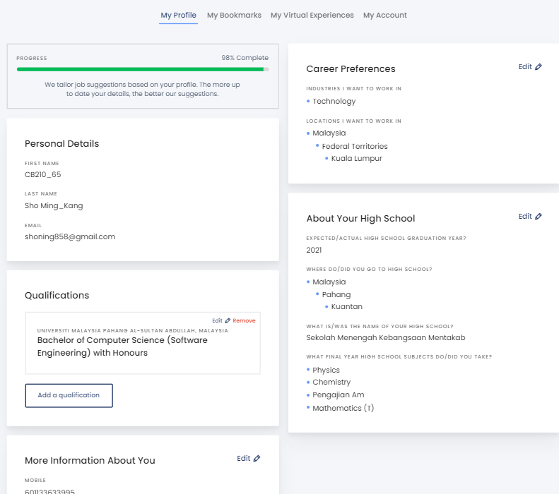

Figure 2‑54: Personal Profile Page

Figure 2-54 shows the personal profile page of the intern seeker. The personal profile consists of five types of information: personal details, qualifications, more information about you, career preferences, and high school. The intern seeker can view and update the personal profile by filling in the details and uploading the resume in the section ‘More Information About You’. The percentage of personal profiling is calculated and displayed based on completion by the intern seeker.

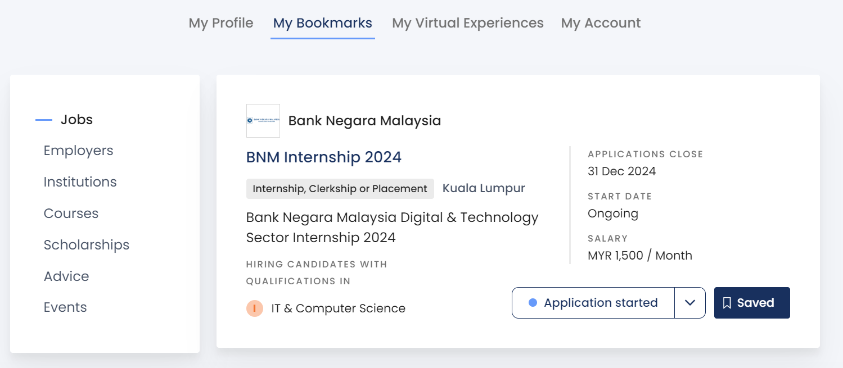

Figure 2‑55: Bookmark Listings Page

Figure 2-55 shows the bookmark internship listing saved by the intern seeker. The intern seeker can bookmark internships and employers they want to save.

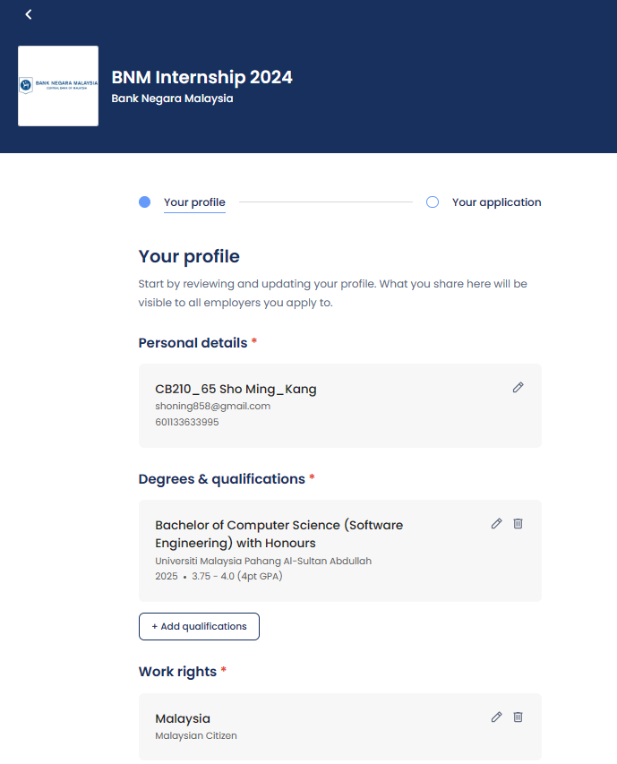

Figure 2‑56: Internship Application Page (Step 1)

Figure 2-56 shows the internship application page that displays the profile details of the intern seeker once the intern seeker clicks the ‘Apply now’ button on the specific internship. The internship application consists of two steps. Firstly, the internship needs to double-confirm that the profile details are correct. They may change the profile details if the details are incorrect. If the profile details are correct, they can proceed to the next step.

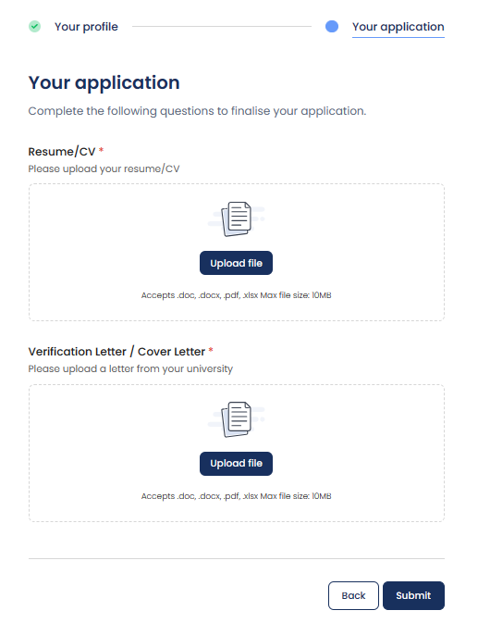

Figure 2‑57: Internship Application Page (Step 2)

Figure 2-57 shows the internship application page that the intern seeker needs to upload the resume and cover letter once the intern seeker finishes checking and double-confirming the profile details is correct.

### Internsheeps

The requirement elicitation techniques to gather the requirements for Internsheeps are feature analysis and interface analysis. The elicitation process starts with identifying the key stakeholders involved in the internship process, such as students seeking internships. Internsheeps does not provide a guide for intern seekers. Through the exploration of the Internseek system from the perspective of an intern seeker, how the system works and the transitions and interactions within a user interface are understood, and the requirements for interacting with the system are gathered. By applying these two techniques, a deeper understanding of how the system operates and valuable insight into usability from the perspective of an intern seeker are gained, and the requirements of interns are gathered. The system specification, features, and introduction of Internsheeps and the experience of using Internsheeps are described below.

Internsheeps is a web-based platform connecting students looking for internships and companies offering internship opportunities in various industries in Malaysia, enabling practical experience and career development. Internsheeps is owned by AJobThing company. AJobThing system allows companies to post jobs to MauKerja, Ricebowl, and Internsheeps platforms. (AJobThing., 2013) Companies can track applicants for the job posted from different platforms like Maukerja, Ricebowl, and Internsheeps in the AJobThing system. Thus, Internsheeps operates independently as a system focused on intern seekers. It provides features according to the needs of students seeking practical experience and career development opportunities.

Internsheeps provides matched jobs based on the work experience and skills of the intern seeker. Besides, Internsheeps allows intern seekers to apply for internships directly within the Internsheeps platform. Moreover, intern seekers are required to fill in their personal profile details before applying for internships. In addition, Internsheeps can track the status of their internship applications, whether they are shortlisted, approved, and need to be interviewed or not and intern seekers can view it on the applied job tab. Internsheeps allows users to save internships into their favorite internship listings and view the listing. Internsheeps provides the ability to search and sort the internship listing, allowing students to explore internships within the platform easily. Internsheeps provides insights for intern seekers by the number of company views on the intern seeker, the number of companies interested in the intern seeker, the percentage of profile completion, and the number of uploaded resumes. Internsheeps allows students to generate resumes based on the profile details once students input all the required information. Internsheeps allows users to view the profile details of the company. Internsheeps can display the top 100 companies for intern seekers to view. Lastly, Internsheeps allows users to upload their resumes instead of those generated by Internsheeps.

Flowchart (Intern Seeker)

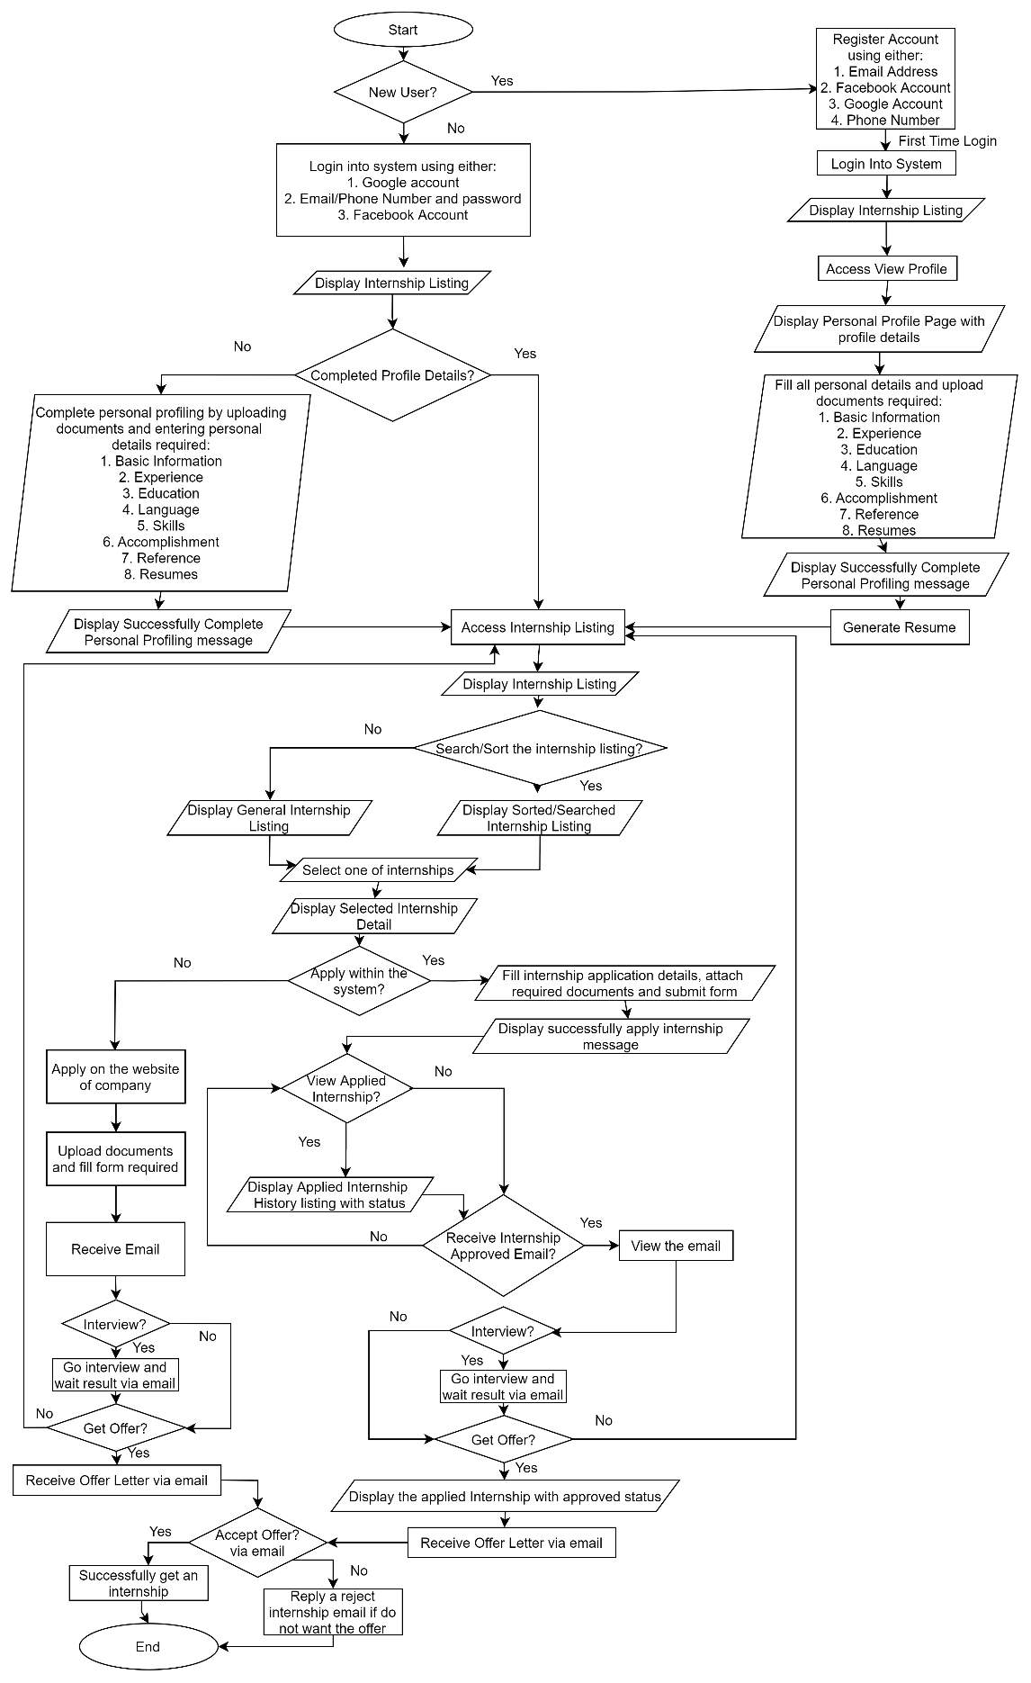

Figure 2‑58: Flowchart of Internsheeps (Intern Seeker)

**System Specification**

Table 2‑3: System Specification for Internsheeps

|  |  |
| --- | --- |
| **System Name** | Internsheeps |
| **User Scope** | Intern seekers (Include university students) |
| **Platform** | Web Application |
| **User Interface** | * Easier navigation * User friendly * Ease to use |
| **Function Provided** | * Allow users to apply for internships within the platform. * Provide matched jobs based on the work experience and skills of the student. * Allow users to manage their personal profile details. * Allow users to track the status of their internship applications. * Allow users to save internships into their saved jobs listings for easy access. * Display the internship listing with the search and sort feature for students. * Display applied, saved, walk-in and matched internships for students. * Allow users to generate resume based on their personal profile details. * Allow users to upload their resumes instead of those generated by Internsheeps during internship application. * Allow users to view the profile details of company. * Display top 100 companies for users to view. |
| **Source** | <https://www.internsheeps.com/> |

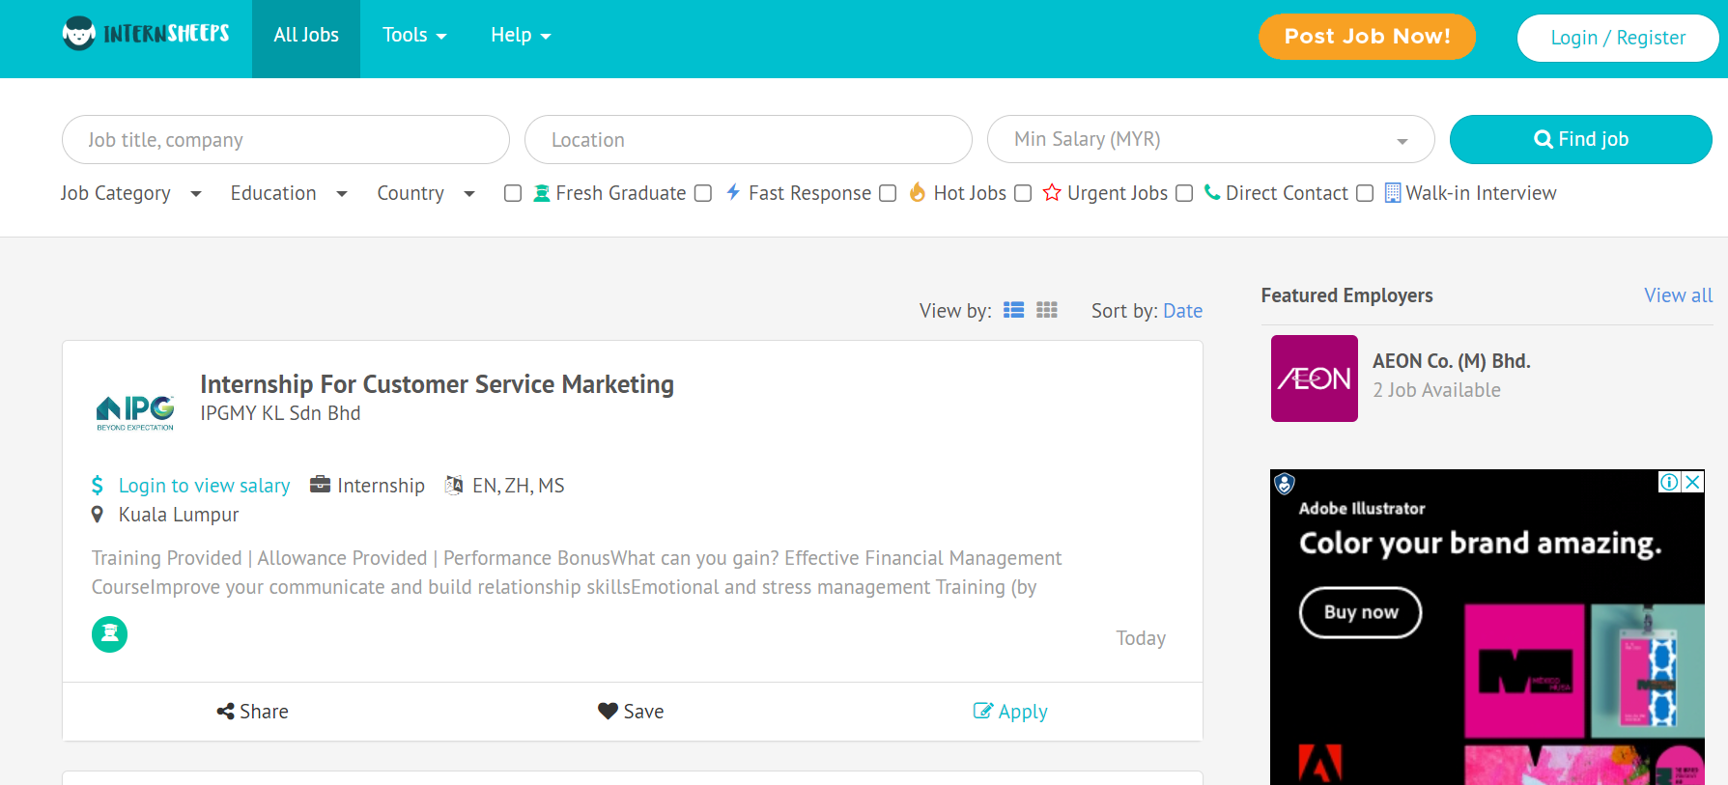

Figure 2‑59: Main Page of Internsheeps

Figure 2-59 shows the main page of Internsheeps. The main page of Internsheeps displays the listing of internships. Students can view the internship listings to find their desired internship.

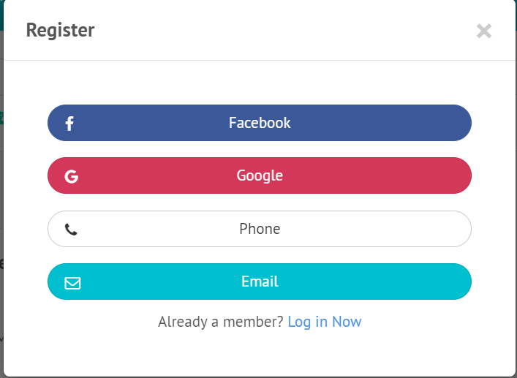

Figure 2‑60: Register Page

Figure 2-60 shows the account registration page for intern seekers. Intern seekers can register an account by using their Facebook account, Google Account, Phone, or Email.

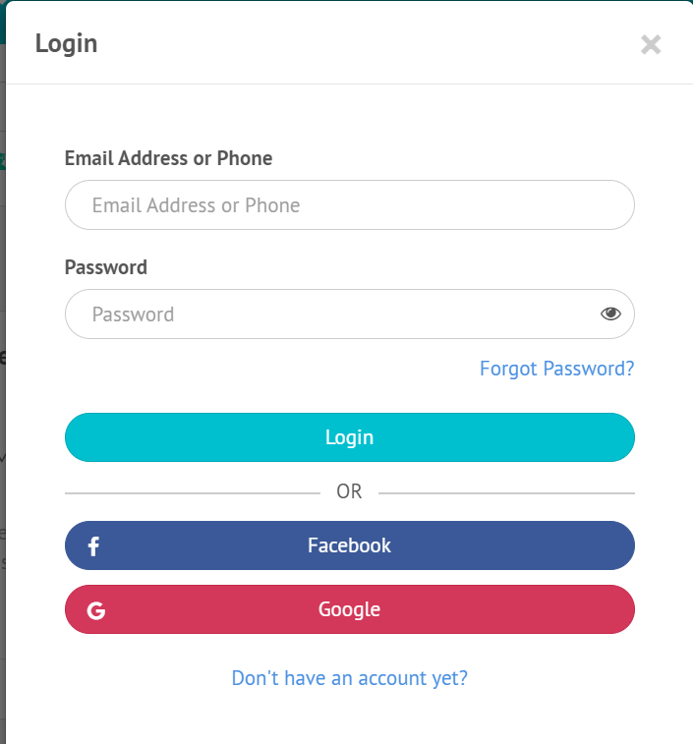

Figure 2‑61: Login Page

Figure 2-61 shows the login page of Internsheeps. The intern seekers can login into the system by using their Facebook account, Google Account, email address with a password, or phone number with a password.

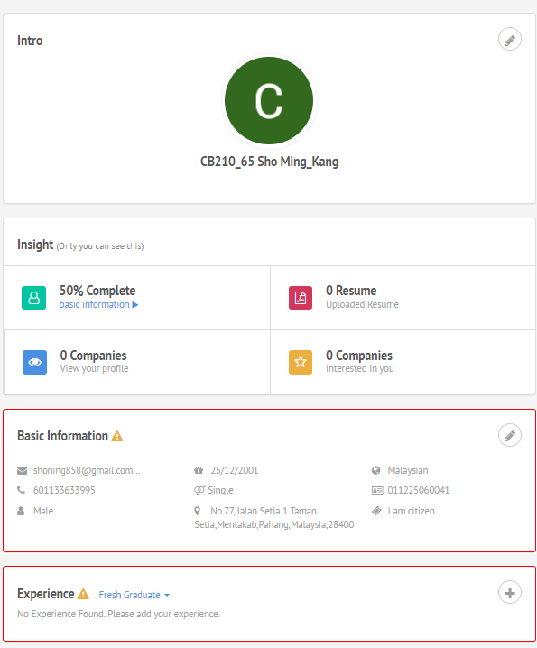

Figure 2‑62: Personal Profile Page (Part I)

Figure 2-62 shows the personal profile page of the intern seeker. The intern seeker can view and update the profile details. Intern seekers need to complete personal profiling because it can increase their chances of getting an internship. The percentage of the profile is calculated and displayed for the intern seeker based on the completion of the profile. The intern seeker can view whether the company has an interest in the intern seeker, and the company can view the intern seeker's profile since the system can track it. The personal profile page consists of seven types of information: introduction, basic information, experience, education, accomplishment, resume language, skills, and reference. This figure shows the intro, basic information, experience, and insight of the intern seeker.

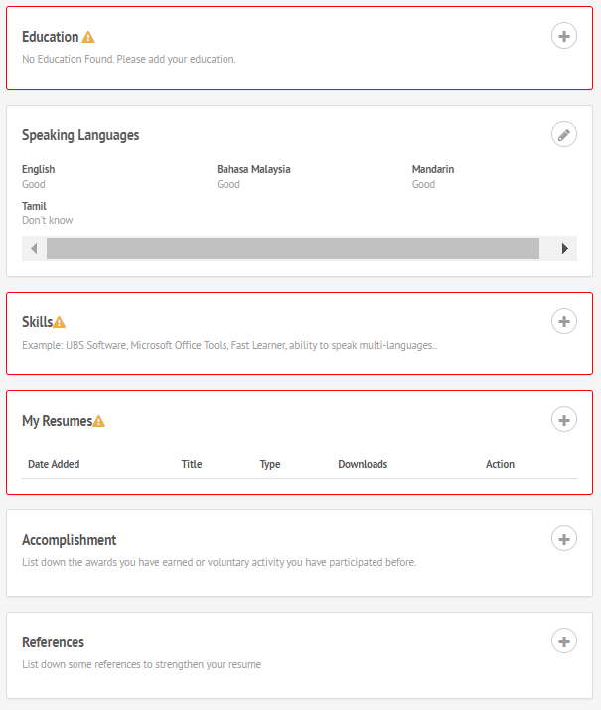

Figure 2‑63: Personal Profile Page (Part II)

Figure 2-63 shows the personal profile of the intern seeker, which consists of information about education, speaking language, accomplishment, resumes, skills, and references. The intern seeker can edit this information.

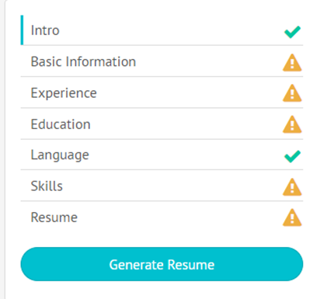

Figure 2‑64: Generate Resume

Figure 2-64 shows the generate resume feature based on the personal profile details of the intern seeker. Once the intern seeker completes entering all the profile details required for generating a resume, they can generate a resume by clicking the ‘Generate Resume’ button.

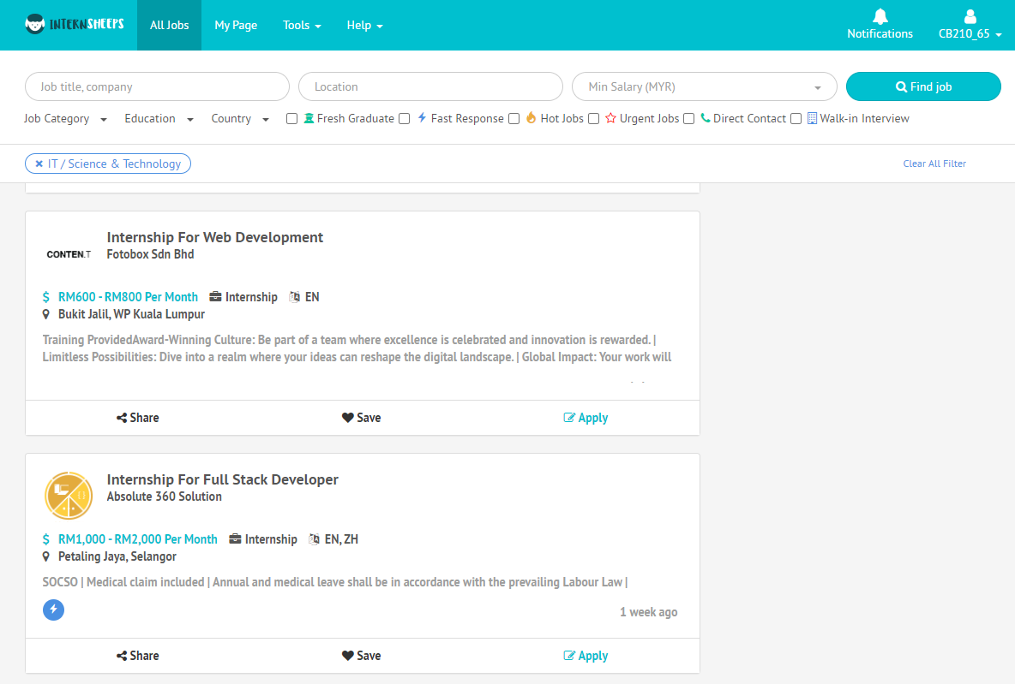

Figure 2‑65: Internship Listing Page

Figure 2-65 shows the internship listing page once the intern seeker clicks the ‘All Jobs’ button on the navigation bar and sorts the internship listing with the IT/ Science and Technology category. The intern seeker can easily find their desired internship since the internship listing has a searching and sorting feature. The intern seeker can save the specific internship by clicking the ‘Save’ button. If the intern seeker is interested in that internship, they may click on the internship title to learn more about the details of the internship. They can also directly apply for that internship by clicking the ‘Apply’ button.

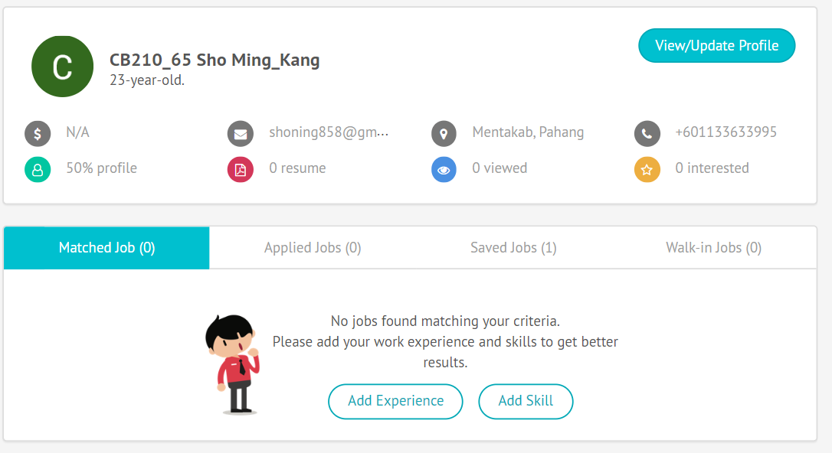

Figure 2‑66: Track Matched Jobs, Applied Jobs, Saved Jobs, and Walk-in Jobs Page

Figure 2-66 shows the track of the matched jobs, applied jobs, saved jobs, and walk-in jobs page once the intern seeker clicks ‘My Page’ on the navigation bar. The intern seeker can view the matched jobs related to the work experience and skills of the intern seeker once the intern seeker clicks the ‘Matched Job’ button. The intern seeker can view the internship they already have applied for to know the status of the internship application once the intern seeker clicks the ‘Applied Job’ button. The intern seeker can view the internship they have saved when they access the internship listing to find an internship once the intern seeker clicks the ‘Saved Jobs’ button. The internship seeker can view the internship that needs an interview by clicking the ‘Walk-In Jobs’ button.

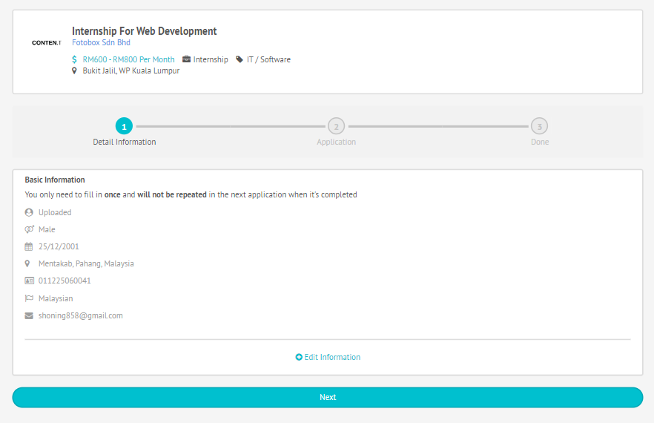

Figure 2‑67: Internship Application Page (Part I)

Figure 2-67 shows the internship application page that displays the basic information of the intern seeker once the intern seeker clicks the ‘Apply’ button on the specific internship. The internship application consists of two steps. Firstly, the internship needs to double-confirm that the basic information is correct. They may change the basic information if the details are incorrect. If the basic information is correct, they can proceed to the next step.

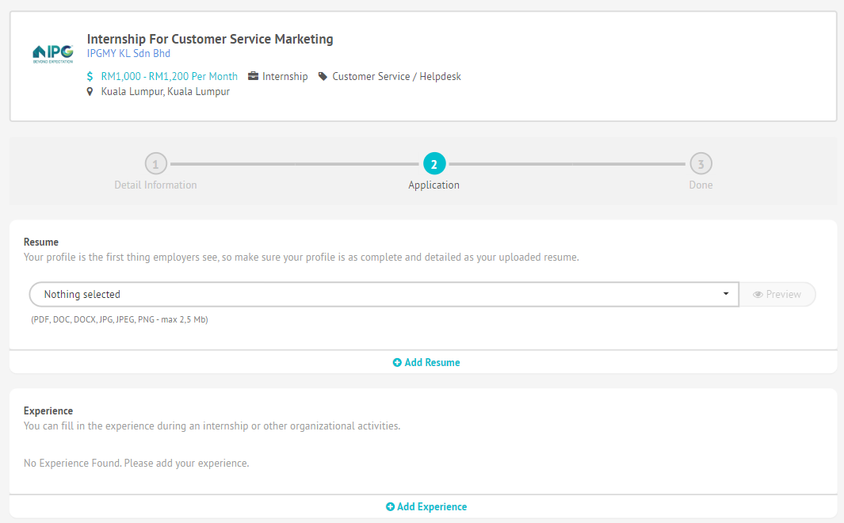

Figure 2‑68: Internship Application Page (Part II)

Figure 2-68 shows the internship application page that requires the intern seeker to upload a resume and fill in the details required. They must enter the required details in experience, language, internship details, availability, and expected salary fields. Once the intern seeker submits the form, the internship application is done.

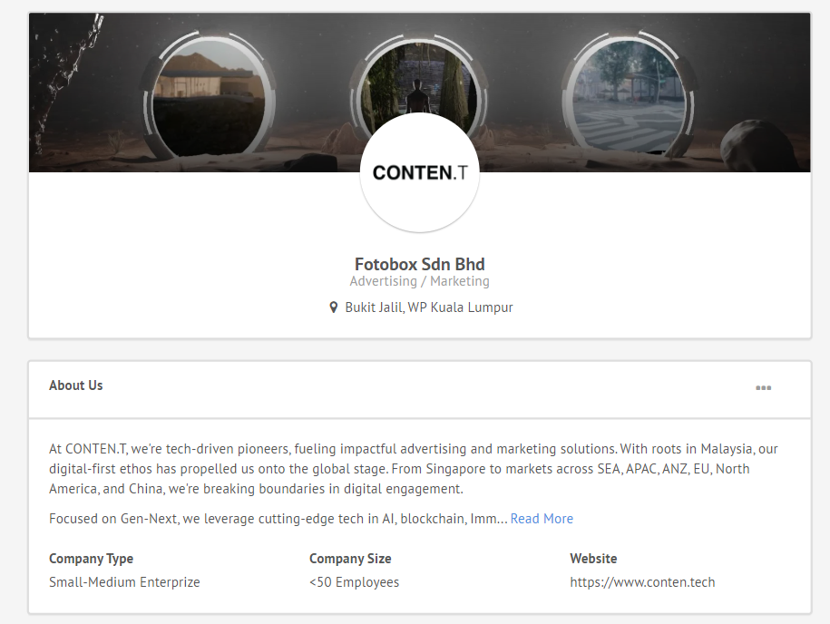

Figure 2‑69: Company Profile Page

Figure 2-69 shows the company profile page with company details. The intern seeker can view the company profile details by clicking the company name in the internship box they are interested in.

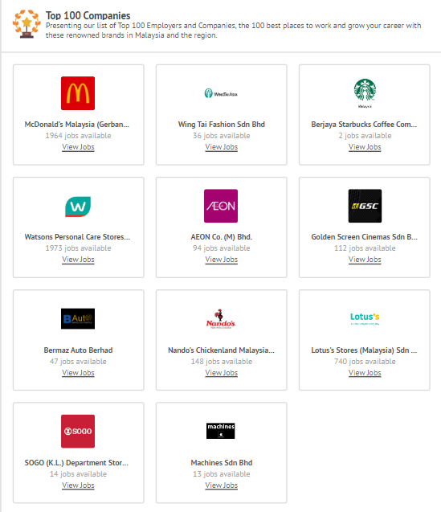

Figure 2‑70: Top 100 Companies Page

Figure 2-70 shows the Top 100 Companies page. The intern seeker can explore the internships posted by these companies.

## Analysis/ Comparison of Existing System

This section describes the output from conducting a comparative analysis of the three existing systems: MYNext, Prosple, and Internsheeps. After identifying the important aspects of three existing systems, it is significant to conduct a comparison between these three existing systems and this project.

### Analysis of comparison on existing system

This section describes the comparison of the specifications of three existing systems analyzed in this project. The user scope, platform, pros, cons, and features are listed below.

Table 2‑4: Comparison of the Specification of Existing Systems

|  |  |  |  |
| --- | --- | --- | --- |
| **System**  **Aspect** | **MYNext** | **Prosple** | **Internsheeps** |
| **Platform** | Web Application, Mobile Application | Web Application | Web Application |
| **User Scope** | Intern Seekers, Companies | Intern Seekers, Employers | Intern Seekers |
| **Internship Listing** | * Display the internship listing with the search and sort feature for students. * Allow students to save internships into their favourite listings for easy access. | * Display the internship listing with the search and sort feature for students. * Allow students to bookmark internships into their bookmarked jobs listings for easy access. | * Display the internship listing with the search and sort feature for students. * Allow users to save internships into their saved jobs listings. |
| **Internship Recommendations Feature** | Provide personalized Internship Recommendations based on the student’s scope of study. | Does not provide any internship recommendations. | Provide matched jobs based on the work experience and skills of the students. |
| **Apply for internships** | * Allow students to apply for internships within the platform. * It is difficult to apply for internships within the platform as a novice user since it is required to complete seven assessments for applying for internships. * The internship application process is complex. | * Allow students to apply for internships within or outside the platform. * It is easy to use as a first-time user since the user only needs to fill out the internship application form and upload the documents required to apply for the internship. * During the internship application, students need to upload cover letter to prove that they need to undergo industrial training for academic purposes and their resumes. | * Allow users to apply for internships within the platform. * During the internship application, students are allowed to upload their resumes instead of those generated by Internsheeps during internship application. * It is easy to use as a first-time user since the user only needs to fill out the internship application form and upload the documents required to apply for the internship. |
| **Manage Profile Details** | Students needs to explore the MY CV tab to view and update their profile details. | Allow students to manage their personal profile details. | Allow users to update their personal profile details. |
| **Generate CV/ Resume** | Allow students to input CV details required for internship applications and generate professional standard CVs. | Students cannot generate resume/CV based on the user input in the personal profiling. | Allow users to generate resume based on their personal profile details. |
| **User Guidance** | Detailed user guidance provided for intern seekers and companies. | Provide user guidance for employers only. | Does not provide any user guidance. |
| **Support Language** | Support Bahasa Malaysia and English language | Only support English language | Only support English language |
| **Keep track the status of internship applications** | Allow students to track the status of their internship applications on the internship tab. | Does not provide the feature of keep tracking the status of internship applications for students. | Allow users to track the status of their internship applications on the applied job tab. |
| **Access the company/employer listings** | * Provide a company listing for students to access. * Allow students to view the employer profile details. | * Provide an employer listing for students to access. * Allow students to view the employer profile details. | * Display top 100 companies for users to view. * Allow students to view the company profile details. |
| **Analytics and Reporting Features** | * Display applied, favourite, and offered internships for students. * Display total applicants, offered internships, accepted offers, and pending verifications for companies. | * Provide analytics and reporting features for employers regarding internships posted and the applications submitted by applicants. * Does not provide analytics and reporting features for students. | * Display applied, saved, walk-in and matched internships for students. * Display the number of company views on the intern seeker, the number of company interest in the intern seeker the percentage of profile completion, and the number of uploaded resumes for students. |
| **Messaging Feature** | Does not provide a messaging feature for students and employers. | Does not provide a messaging feature for students and employers. | Does not provide a messaging feature for students and employers. |
| **Post Internships** | * Allow companies to post an internship within the system. * Allow companies to view, edit, and delete the internship posting. | * Allow employers to post an internship within the system. * Allow employers to view, edit, and delete the internship posting. | The end-user of Internsheeps is intern seekers only. |
| Manage Internship Application | * Companies can access and view the list of applicants for the specific internship to manage the internship application. * Employers can update the status of the applicants after viewing their profile details. | * Employers can access and view the list of applicants for the specific internship to manage the internship application. * Employers can update the status of the applicants after viewing their profile details. | The end-user of Internsheeps is intern seekers only. |
| Update company details | Allow companies to update their profile details. | Allow employers to update their company profile details. | The end-user of Internsheeps is intern seekers only. |

Table 2-5 shows a comparative analysis of systems based on the target user portals of each system, features for intern seekers or students, features provided for employers, and the technology used for each system. In the table, the tick symbol means the system consists of that aspect, while the false symbol means the system does not consist of that aspect.

* Target User Portals: This category outlines the availability of user portals for different stakeholders, including intern seekers, employers, and administrators.
* Features for Intern Seekers or Students: This category lists features relevant to intern seekers or students, such as applying for internships within the application, updating personal profiles, and tracking internship applications.
* Features Provided for Employers: This category highlights the features relevant to employers, or companies such as posting internships, managing company profiles, and accessing applicant lists.

Table 2‑5: Comparison with Project Title

|  |  |  |  |  |
| --- | --- | --- | --- | --- |
| **System**  **Aspect** | **MYNext** | **Prosple** | **Internsheeps** | **Proposed System** |
| User Portal (Intern Seeker) | **🗸** | **🗸** | **🗸** | **🗸** |
| Employer Portal | **🗸** | **🗸** | **🗴** | **🗸** |
| Admin Portal | **🗸** | **🗸** | **🗴** | **🗸** |
| **Intern Seekers/Students:** | | | | |
| Apply for Internship within application | **🗸** | **🗸** | **🗸** | **🗸** |
| Internship Recommendation/ Provide Matched Internships | **🗸** | **🗴** | **🗸** | **🗸** |
| Apply internship outside application | **🗴** | **🗸** | **🗴** | **🗴** |
| Update Personal Profile Details | **🗸** | **🗸** | **🗸** | **🗸** |
| Tracking Internship Application | **🗸** | **🗴** | **🗸** | **🗸** |
| Bookmark Internship | **🗸** | **🗸** | **🗸** | **🗸** |
| Display the internship listing with search and sort feature | **🗸** | **🗸** | **🗸** | **🗸** |
| Analytic and reporting feature | **🗸** | **🗴** | **🗸** | **🗸** |
| Upload Resume/ CV | **🗸** | **🗸** | **🗸** | **🗸** |
| Upload Cover Letter | **🗴** | **🗸** | **🗴** | **🗸** |
| Generate Resume/ CV | **🗸** | **🗴** | **🗸** | **🗸** |
| MYNext Assessments features | **🗸** | **🗴** | **🗴** | **🗴** |
| Messaging features | **🗴** | **🗴** | **🗴** | **🗸** |
| Provide Employer Listing/ Display Top 100 companies | **🗸** | **🗸** | **🗸** | **🗸** |
| View Employer Profile | **🗸** | **🗸** | **🗸** | **🗸** |
| Provide User Guidance | **🗸** | **🗴** | **🗴** | **🗸** |
| **Employer/Company:** | | | | |
| Provide Internship Posting feature | **🗸** | **🗸** | **🗴** | **🗸** |
| Manage Company Profile Details | **🗸** | **🗸** | **🗴** | **🗸** |
| Analytic and Reporting Features | **🗸** | **🗸** | **🗴** | **🗸** |
| Manage Internship Application by updating the status of applicant (Access List of Applicants) | **🗸** | **🗸** | **🗴** | **🗸** |
| Provide Employer/Company Guidance | **🗸** | **🗸** | **🗴** | **🗸** |
| View the profile of applicant | **🗸** | **🗸** | **🗴** | **🗸** |
| Messaging Features | **🗴** | **🗴** | **🗴** | **🗸** |

### Relevance of comparison with project title

Some pros and cons of each existing system can help decide which specific features and techniques need to be applied and avoided in the Internseek project. Internsheeps, Prosple, and MYNext allow intern seekers to update their profile details for applying for the internship.

MYNext, Prosple, and Internsheeps allow intern seekers to access and view the internship listing to find their desired internship. MYNext, Prosple, and Internsheeps include the search and sort feature in the internship listing for intern seekers to explore the listing. Internsheeps, MYNext, and Prosple allow intern seekers to bookmark or save the internships into a list. One of the pros of Internsheeps is it provides insight for the intern seeker about the percentage of profile completion the company's interest in the intern seeker, the number of applied internships, saved internships, Walk-In jobs, and matched jobs, and the company can view the intern seeker's profile. Prosple only provides insight on the percentage of profile completion, while MYNext provides insight on the number of applied internships, saved internships, and offered internships. MYNext and Prosple offer employer listings and Internsheeps top 100 companies for intern seekers. Intern seekers can view the company/employer profile on the MYNext, Prosple, and Internsheeps platforms.

One of the strengths of Prosple is that it allows intern seekers to apply for internships both within and outside the platform, while MYNext and Internsheeps can only apply within the platform. Another strength of Prosple is it includes uploading a cover letter to prove that the student needs to undergo industrial training for academic purposes, while MYNext and Internsheeps do not include this feature. It is required for intern seekers to upload their resumes when applying for internships in Prosple, MYNext, and Internsheeps. However, Prosple does not provide any recommendations, while MYNext provides internship recommendations based on the study scope of the intern seeker, and Internsheeps provides matched jobs based on the experience and skills of the intern seeker. Prosple does not keep track of the status of their internship applications, so intern seekers need to wait for the email to know the status of internship applications.

One of the weaknesses of MYNext compared to the other two existing systems is the intern seeker needs to finish the seven assessments provided in the MYNext before applying for an internship. It is easier for novice users to apply for internships in Prosple and Internsheeps compared to MYNext because MYNext because it makes the internship application process within the MYNext platform more complex. Another weakness of MYNext is the profile details of the intern seeker are on the My CV tab. It confuses intern seekers about the place to access and update the profile details.

MYNext and Prosple consist of an administrator portal, which is private. Internsheeps only focus on the intern seeker portal, the employer portal, and the admin portal of the AJobThing system, which is private. MYNext and Prosple have the employer/company portal. MYNext provides user guidance for intern seekers and employers, Prosple only guides employers, and Internsheeps does not provide a guide.

This project should include the administrator portal to manage the company registration. For company registration, administrators need to verify whether the company is valid or not. If the company is valid, administrators may approve the company registration Prosple and MYNext allow employers to post internship opportunities in the system. There is a payment charged for posting internships within the platform. Prosple and MYNext allow employers to update the company profile details. Prosple and MYNext allow employers to manage internship applications by providing a list of applicants. Employers can update the status of the applicants after viewing their profile details and resumes. Prosple and MYNext provide analytic and reporting features for employers regarding internships posted and the applications submitted by applicants.

The three existing systems have the same weakness, which is they do not consist of messaging features. The messaging feature enables applicants to inquire about the status of their applications and seek updates from employers. In addition, it allows applicants to ask questions about the internship, clarify job responsibilities, and express their interest in the position. It provides real-time communication between applicants and employers. Lastly, the analytic and reporting features should be included in the project to provide insight for intern seekers and employers.

The assessment feature is unnecessary for the proposed system (Internseek) because the target users of the system are university students who study computer science and already have skills and knowledge, so focus on managing internship applications, managing internship listings, managing user profiles, managing employer listings, managing messaging features, managing internship postings, and analytics and reporting. Applying for internships outside the platform is inconvenient for intern seekers because they have to rely on email communication to track the status of their applications. The proposed system (Internseek) includes applying for internships within the platform enough for intern seekers because they do not need to rely on email communication to track the status of their applications.

In conclusion, the comparative analysis plays a significant role in determining the project direction and ensuring the suitable alignment and technology used in this project. It offers valuable information and insights for developing an effective and user-friendly Internship Application System.

## Summary

In Chapter 2, the three existing internship application systems—MYNext, Prosple, and Internsheeps—are analyzed and compared. Through the analysis of these three systems, the advantages and disadvantages of these systems were summarized in tables. By comparing these three existing systems, there are some essential features and critical aspects that need to be included in Internseek to improve the potential of the proposed system. Firstly, the system shall allow university students who study computer science to apply for internships within the Internseek platform to save their time by going through various platforms to apply for internships and applying for internships using email or job application systems. Besides, the system shall provide the internship listing with searching and sorting to streamline the process of finding relevant internships. Students can search for internships using keywords related to their desired field or position, while the sorting feature enables students to easily find internships that are related to their field of study. In addition, the system shall allow students to fill out personal details containing essential information for internship applications and generate a resume based on the profile details. In addition, the system shall enable students to track the status of internship applications, view past internship applications, and receive notifications about interview invitations and offers. Furthermore, the system includes the feature of uploading a resume or CV if students do not prefer to use the auto-generated resume. Moreover, during the internship application, students may need to upload a cover letter, known as a Student Application Letter (SAL), as evidence of their need to undergo industrial training for academic purposes. The system shall allow employers to post internship opportunities and manage the internship applications from applicants by updating the status of each application such as under review, rejected, shortlisted, and accepted, and providing feedback to applicants. The system shall allow administrators to verify whether the registered company exists or not to avoid invalid companies posting fake internship opportunities for students. The system shall allow students to access the company listing and view the company profile to learn more about the company's backgrounds, cultures, and available positions. The system should include analytics and reporting for employers about the internship posted and the internship applied by students and for students about the insight of the internship application. The system should provide messaging features between students and employers to enable direct communication between applicants and employers. Employers can directly update the status of the application and students can ask questions about the internship, clarify job responsibilities, and demonstrate their interest in the position with the messaging feature.

Finally, the user interface of the proposed system should be user-friendly and simple to use because the high complexity of the user interface will affect the interest of users in using the system. The proposed system should have straightforward features and functionalities that make it easy for students to apply for internships.

# METHODOLOGY

## Introduction

This chapter describes the methodology applied in my project by providing a clear explanation of why the waterfall model is the selected methodology and each stage of the water model to provide a roadmap for the project and implementation. Subchapter 3.3 describes the details of functional requirements, non-functional requirements, and constraints of the proposed system (Internseek) by constructing a use case diagram, a use case description, and a sequence diagram. Subchapter 3.4 explains the general architecture design, package diagram, and class diagram that represent the system architecture design. In sub-chapter 3.5, an entity-relationship diagram and a data dictionary are constructed. Subchapter 3.6 defines the package structure in implementation, integrates necessary APIs, and establishes the Framework Environment setup, and user interfaces for the project with explanation. In addition, Chapter 3 will also describe the testing plan that will continue after developing the project. Lastly, a Gantt chart will be provided in this chapter to show the activities throughout the project with the duration for each phase.

## Software Process Model/Methodology

The software process model used in this project is the waterfall model, which is a linear, sequential approach to the software development lifecycle (SDLC) that is popular in software engineering and product development. (Lutkevich & Lewis, 2022) This software process can be super-effective for the Internseek project because of its detailed planning and linear implementation.

### Waterfall Methodology

The decision to use the waterfall methodology for developing the Internship Application System (Internseek) is because the waterfall model is structured and sequential, which aligns well with this project's objectives and constraints. It is suitable for the nature of the internship application system (Internseek), in which the requirements are well-defined and unlikely to undergo significant changes throughout the development process. The primary focus of Internseek is to provide a centralized platform for university students studying computer science to browse and apply for internship opportunities. Therefore, the waterfall model is suitable for providing the necessary structure to ensure successful project development within the schedule constraints.

By applying the waterfall methodology to this project, the development process for Internseek will proceed systematically and sequentially. The waterfall model prioritizes comprehensive preparation at the start of a project. It includes gathering and documenting all requirements and specifications before proceeding to the next development phase, ensuring that the project team clearly understands the project scope, objectives, and deliverables from the beginning. Once finishing the requirements phase, the waterfall model will proceed sequentially through the various stages of development, which include design, implementation, testing, deployment, and maintenance. The waterfall model can reduce the risk of deviations from the initial plan as development progresses by defining a proper plan at the earliest stage of this project. The linear and sequential nature of the waterfall model fosters better project management by providing clearly defined progress milestones and deliverables at each development stage.

Furthermore, the Waterfall methodology encourages thorough documentation at all stages of the development process. The Internship Application System is a complex system that requires detailed documentation to ensure clarity, consistency, and traceability in design and implementation. Developers, testers, and stakeholders will refer to the detailed documentation including requirement specifications, design documents, test plans, and user manuals throughout the project lifecycle. This documentation can enable easy maintenance and future enhancements to the system.

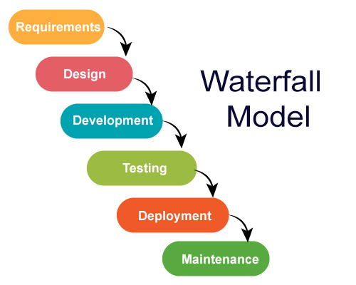

Figure 3‑1: Waterfall Methodology (Kumar P, 2024)

Figure 3-1 shows the methodology used in this project, which is the Waterfall Methodology. This methodology mainly consists of 6 phases which are Requirements, Design, Development, Testing, Deployment, and Maintenance. The Requirements phase and Design phase will be completed in PSM 1. Then, the Development, Testing, Deployment and Maintenance will be continued in PSM 2.

##### Requirement

The first phase of the waterfall methodology is the requirements phase. In this phase, the primary focus is gathering and analyzing the requirements from stakeholders to clearly define a guideline for the development of the Internseek application, ensuring that all stakeholders have a clear understanding of the objectives and scope of Internseek. The process starts with gathering requirements from various stakeholders using different techniques such as interviews, surveys, and observation to gather the requirements. The gathered requirements will be analyzed and arranged to ensure they are clear and feasible, and then these requirements will be converted into functional requirements and non-functional requirements. While analyzing the gathered requirements, some may be ambiguous and unclear, so the development team needs to communicate with stakeholders to resolve the ambiguous requirements. The finalized requirements will be documented in section 3.3 Project Requirement and section 3.4 Propose Design.

The techniques used in gathering the requirements for the Internship Application System (Internseek) are a survey, interviews, and analysis of three existing systems. A survey will be conducted among university students who study computer science to analyze their demands for the proposed system and gather essential requirements for the proposed system. Interview sessions have been carried out with the HR department of a company and a university student involved in industrial training who studies computer science to identify the functional requirements required for an internship application system. The relevant features needed to implement into the Internship Application System (Internseek) are determined by analyzing three current systems: Prosple, myNext Talent, and Internships.

##### Design

The second phase of the waterfall methodology is the design phase. The requirements shall be clear before moving to the design phase. (Balaji & Murugaiyan, 2012) The design phase aims to provide a clear blueprint for the development team by defining the structure, architecture, and functionality of the Internship Application System (Internseek). The design phase will transform previously defined specifications and requirements of system into detailed design documents which includes the system architecture design, data design, user interface design, proof of concept and project requirements design.

The project requirements design describes the details of functional requirements, non-functional requirements, and constraints of the Internship Application System (Internseek) by constructing a use case diagram, a use case description, and a sequence diagram. The proposed design involves the general architecture design, package diagram, and class diagram, which represent the system architecture design. The data design defines the database schema and the structure of the data that will be stored and managed by the system by constructing an entity-relationship diagram and a data dictionary. The prototype will be developed to illustrate the functionality and user interactions of the Internship Application System (Internseek), successfully representing the essence of the user interface design. The prototype will give stakeholders a clear representation of how the system works, allowing them to see and experience it. The proof of concept defines the package structure in implementation, integrates necessary APIs, and establishes the Framework Environment setup. The package structure in the system implementation is designed based on identified modules, frameworks, and APIs used in development; the module depends on the specific use case of Internseek.

##### Development

After completing the design phase, the project will proceed with the development phase. The development phase involves writing code for front-end and back-end to meet the specifications, models and requirements that were outlined in the previous phases. (Editorial Team, 2023) The development phase includes the actual implementation of the system based on the detailed design documents. The development team needs to code Internseek based on the design specifications, system architecture, and other relevant documents created during the design phase.

The development team implements the functionalities and features defined in the design documents. It involves writing code for both the front-end and back-end components of the system to ensure that they work seamlessly together to deliver the expected functionalities of Internseek. This project uses React.js for the front end and Laravel for the back end. React.js facilitates the creation of user interface components, including forms, interactive elements, and navigation features, allowing the development of responsive and visually appealing that meet the design specifications. The user interfaces are built using React.js and styled with Tailwind CSS, while Laravel facilitates server-side logic through its integration with Inertia.js, enabling user authentication, handling requests, interacting with the database, and executing business logic for the Internseek platform. The project's data is securely stored and efficiently managed in a MySQL database. The development team must follow coding standards and best practices to ensure code quality and readability throughout the coding process. They also thoroughly test the code to discover and address any flaws or defects before proceeding to the testing phase.

##### Testing

In the testing phase, a test plan is executed to verify the functionality, performance, and reliability of the Internship Application System (Internseek) using various testing types, such as unit testing, integration testing, system testing, and user acceptance testing (UAT). Each component is tested to ensure it meets the specified requirements. Any defects or bugs are addressed before deployment. Functionality testing is performed to verify that core features, such as user registration, internship posting, application submission, and messaging, work as intended without errors.

##### Deployment

Once successfully finishing the testing phase and resolving all identified defects, the project will proceed with the deployment phase. In the deployment phase, the Internship Application System (Interseek) is deployed to the production environment. The deployment phase involves installing Internseek on the target servers or cloud infrastructure, configuring Internseek based on the production environment specifications and making Internseek accessible to users. The deployment phase requires careful planning and coordination to reduce the downtime of Internseek and ensure a seamless transition from the development environment to the live production environment.

##### Maintenance

After deploying Internseek into the live production environment, Internseek will enter the maintenance phase. In the maintenance phase, the maintenance activities involve identifying and resolving the bugs or effects discovered during the operation of Interseek, applying patches and updates to overcome security vulnerabilities to protect Internseek from potential cyberattacks, monitoring the performance of Internseek, identifying enhancements needed to improve performance, enhance efficiency, and reduce response time, providing ongoing support to users who have issues or questions using the system, and implementing updates required to ensure Internseek adapted to the latest technology. The maintenance phase is important for ensuring long-term success and a positive user experience for all stakeholders.

### Gantt Chart

This section discusses the Gantt Chart to represent the project scheduling and planning.

|  |  |  |  |  |
| --- | --- | --- | --- | --- |
| **Task name / Title** | | **Duration**  **(days)** | **Start date**  **(mm-dd-yyyy)** | **End date**  **(mm-dd-yyyy)** |
| **1 Requirement Planning** | | **34** | **3/4/2024** | **4/10/2024** |
| 1.1 | Brainstorming Idea | 2 | 3/4/2024 | 3/5/2024 |
| 1.2 | Discussion with Supervisor | 1 | 3/6/2024 | 3/6/2024 |
| 1.3 | Identify Internseek Stakeholder | 2 | 3/7/2024 | 3/8/2024 |
| 1.4 | Identify Scope and Objective | 2 | 3/11/2024 | 3/12/2024 |
| 1.5 | Compare Existing System | 7 | 3/13/2024 | 3/19/2024 |
| 1.6 | Decide Project Methodology | 2 | 3/20/2024 | 3/21/2024 |
| 1.7 | Conduct Survey and Internview | 8 | 3/22/2024 | 3/29/2024 |
| 1.8 | Develop System Plan | 9 | 4/1/2024 | 4/9/2024 |
| 1.9 | Review with Supervisor | 1 | 4/10/2024 | 4/10/2024 |
| **2 Design** | | **69** | **4/11/2024** | **6/20/2024** |
| 2.1 | Project Requirements Design | 12 | 4/11/2024 | 4/22/2024 |
| 2.2 | Data Design | 8 | 4/23/2024 | 4/30/2024 |
| 2.3 | User Interface & Prototype Design | 14 | 5/1/2024 | 5/14/2024 |
| 2.4 | System Architecture Design | 8 | 5/15/2024 | 5/22/2024 |
| 2.5 | Proof of Concept | 5 | 5/23/2024 | 5/27/2024 |
| 2.6 | Testing Plan | 3 | 5/28/2024 | 5/30/2024 |
| 2.7 | Review with supervisor | 1 | 5/31/2024 | 5/31/2024 |
| 2.8 | Design Improvement and Refinement | 11 | 6/3/2024 | 6/13/2024 |
| 2.9 | Finalize Thesis | 7 | 6/14/2024 | 6/20/2024 |
| **3 Development** | | **86** | **9/11/2024** | **12/11/2024** |
| 3.1 | Front End Development | 27 | 9/11/2024 | 10/7/2024 |
| 3.2 | Review with Supervisor | 1 | 10/8/2024 | 10/8/2024 |
| 3.3 | Front End Refinement | 3 | 10/9/2024 | 10/11/2024 |
| 3.4 | Back End Development | 46 | 10/14/2024 | 11/28/2024 |
| 3.5 | Review with Supervisor | 1 | 11/29/2024 | 11/29/2024 |
| 3.6 | Back End Refinement | 5 | 12/2/2024 | 12/6/2024 |
| 3.7 | Integrated Testing | 3 | 12/9/2024 | 12/11/2024 |
| **4 Testing** | | **33** | **12/12/2024** | **1/15/2025** |
| 4.1 | Functional Testing | 7 | 12/12/2024 | 12/18/2024 |
| 4.2 | User Acceptance Testing | 9 | 12/19/2024 | 1/7/2025 |
| 4.3 | Document and Finalize Testing Result | 8 | 1/8/2025 | 1/15/2025 |
| **5 System Deployment** | | **8** | **1/16/2025** | **1/23/2025** |
| **6 Finalize Thesis** | | **6** | **1/24/2025** | **1/29/2025** |
| **7 Maintenance** | | **9** | **1/30/2025** | **2/7/2025** |

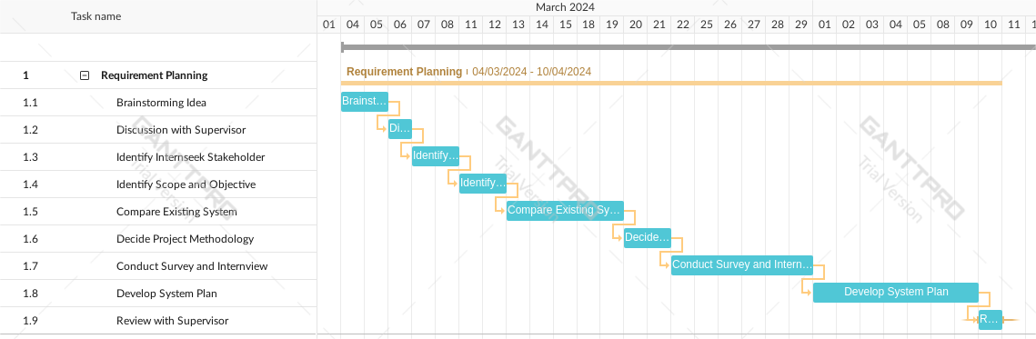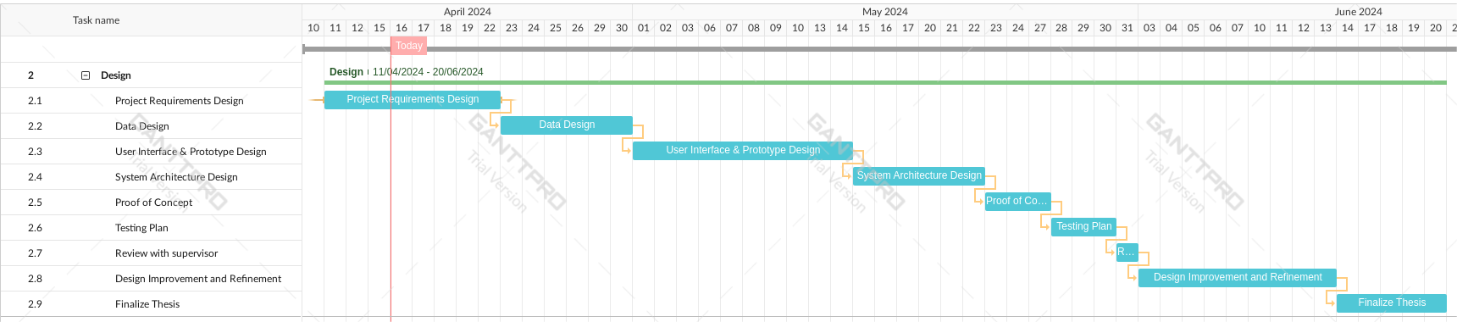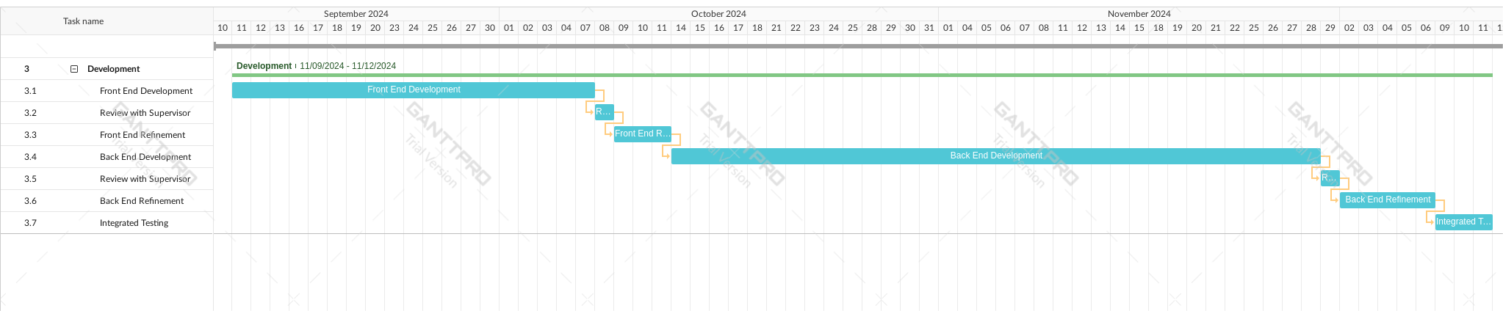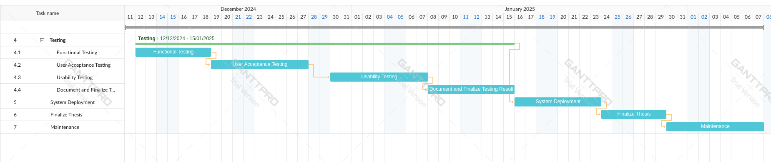

Figure 3‑2: Gantt Chart

## Project Requirements

The project requirements for the Internship Application System (Internseek) have been identified, including functional requirements, non-functional requirements, constraints, and limitations.

### Functional Requirements

Table 3‑1: Functional Requirements

|  |  |
| --- | --- |
| **Users** | **Functional Requirements** |
| **University Students** | * The system shall allow university students to register an account. * The system shall allow university students to view the internship listing. * The system shall allow university students to access and view the employer listing. * The system shall allow university students to view the employer profile. * The system shall allow university students to login into the system with a registered account. * The system shall allow university students to manage their profile details. * The system shall provide university students with the ability to generate a resume based on profile details. * The system shall provide internship recommendations based on the study scope of students for university students. * The system shall allow university students apply for internships within the platform. * The system shall allow university students to upload their cover letters, such as the Student Application Letter (SAL), and their own resumes during the internship application process. * The system shall allow university students to track the status of internship applications. * The system shall enable university students to view, edit, and cancel their internship applications. * The system shall provide a messaging feature for university students, allowing them to inquire about the status of internship applications, seek updates from employers, and ask questions about the internship and job responsibilities. * The system shall allow students to bookmark internships. * The system shall provide analytics and reporting features on the number of internship applications of the student and successful internship applications, the completion percentage of profiles, and the total number of applications, clicks, and bookmarks of the internship for university students. |
| **Employers** | * The system shall allow employers to register an account. * The system shall allow employers to login into the system with a registered account. * The system shall allow employers search for an existing company or register a new company in the system. * The system shall allow employers to edit company registration details. * The system shall allow employers to manage the company profile details. * The system shall allow employers to post internship opportunities. * The system shall allow employers to view, edit, delete the internship opportunities they post. * The system shall allow employers to update the status of internship applications submitted by university students. * The system shall allow employers to view the resume generated based on the applicant profile and the information provided and documents uploaded by students during the internship application process. * The system shall provide a messaging feature for employers to respond to student inquiries and notify students when the status of their applications has been updated. * The system shall provide analytics and reporting features for employers to track the number of internship postings, total internship applicants, accepted applicants, applicants need to be interviewed, approved applicants, and applicants that reject the offer. |
| **Administrators** | * The system shall allow administrators login into system using an admin account. * The system shall allow administrators to verify the company registration; if the company is valid, administrators shall have the authority to approve the company registration. * The system shall allow administrators to manage reports made by users regarding internships and take appropriate action if there are any issues with the internships. * The system shall provide analytics and reporting features for administrators to track the number of total internships available, total registered company, and total registered students. * The system shall allow administrators to update the rating of the company. |
| **Public (all type of users without login)** | * The system shall allow public users to search, sort, and view the internship listing and company listing. * The system shall allow public users to view the internship details and company details. * The system shall allows public users to view the Top 3 Companies Chart. |

**Requirement Gathering 1: Summary of Interview with Human Resource Recruiter**

The interview questions for HR personnel are attached in Appendix A. There is an interview conducted with a human resources recruiter from Genting Malaysia Berhad. The interviewee is Mr. Chong Sze Foong.

**Question 1**: How the current internship application process works within our organization?

He mentions that their internship opportunities and jobs are posted on the company website and popular job application platforms like JobStreet and Maukerja. Interested candidates can find job and internship details and submit their applications through these platforms or directly on our website.

**Question 2**: What are some of the challenges you have observed and realized in the current internship application process?

One of the challenges they face is the high volume of applications they receive. It is challenging to review and process each job or internship application efficiently, despite the conveniences of using platforms like JobStreet and Maukerja. In addition, it is critical to ensure that internship posts reach a wide group of candidates.

**Question 3**: Have your company used any internship/job application system to post internship opportunities? If yes, what is the app your company used before?

He says that Genting Malaysia Berhad has utilized job applications like JobStreet and Maukerja to post internships and job opportunities.

**Question 4**: What do you think about the existing system that you used before?

He mentions that JobStreet and Maukerja have served their purpose effectively, and these platforms are user-friendly and efficient, particularly in terms of analytics and reporting features, candidate tracking, and messaging features.

**Question 5**: What is your opinion on how to improve the existing system?

He also mentions that the current platforms of JobStreet and Maukerja are perfect, and he is satisfied with the current functionalities of JobStreet and Maukerja and believes that no improvements are needed for the existing systems.

**Question 6**: How do you currently manage and track internship applications from potential candidates?

He mentions that they currently manage and track internship applications from platforms like JobStreet and Maukerja through the application tracking feature provided in these systems to manage these applications effectively. The applicants for the job or internship on the company website will be tracked and displayed in a list with search and sort features to effectively manage the internship application within the company website.

**Question 7**: What criteria do you typically use to evaluate and select candidates for internships?

He mentions that the criteria for evaluating candidates for internships or jobs remain consistent; they evaluate candidates based on their academic background, relevant skills, previous experience (if any), and enthusiasm for the industry.

**Question 8**: In your opinion, what features or functionalities would be most beneficial in an internship application system?

He suggests that an ideal internship application system will include features like internships posting, analytics and reporting features, messaging features, keeping track of the application status, and real-time application status updates.

**Question 9**: Do you think an internship application system will provide convenience to your company and intern seekers?

He thinks that using an internship application system will provide convenience to their company and internship seekers. It streamlines the application process, saves time, and ensures a smoother and better experience for all parties involved.

**Question 10**: How do you communicate with candidates throughout the internship application process, from initial application to final selection?

Lastly, he states that they communicate with candidates throughout the internship application process via the messaging feature provided on platforms like JobStreet and Maukerja and email, depending on whether candidates apply on the platform or via email. It is essential to inform the candidate to ensure a positive experience when seeking internships or jobs.

**Requirement Gathering 2: Summary of Interview with University Student**

The interview questions for University Student are attached in Appendix B. An interview is conducted with a student currently undergoing industrial training who studies computer science at Universiti Sains Malaysia. The interviewee's name is Mr. Lim Jing Chun.

**Question 1**: Can you share your experience with how you applied for your internship? via email, the company website, or the job application system?

He applies for internships through multiple channels, including company websites, job boards, and email if a direct contact email is available. Each method has its pros and cons, but I prefer using internship or job application systems such as Internsheeps, JobStreet, and Indeed, which provide a centralized location for browsing and applying to multiple internship opportunities.

**Question 2**: What are the challenges you face when applying for your internship?

One of the main challenges he faces when applying for internships via email and the company website is the lack of visibility into the status of his applications. He states that it can be challenging to know whether it has been under-reviewed, approved, shortlisted, or accepted after applying. He states that his application didn't get a response from some potential employers, and it is unclear whether they have received or reviewed the applications. It can cause frustration and anxiety, especially when awaiting responses from potential employers.

**Question 3**: How do you find and discover internship opportunities?

He discovered internship opportunities using job or internship application systems and company websites. He states that job or internship application systems provide a wide range of internship opportunities for computer science. Besides, he also explores company websites directly if I have specific organizations in mind.

**Question 4**: What information do you consider essential when evaluating internship opportunities? Are there specific criteria or features you look for in an internship listing?

He states that he will consider several factors, including the company's reputation, the nature of the work, potential learning and growth, location, and compensation when evaluating internship opportunities. He also considers job descriptions and requirements to ensure his skills and interests suit the role.

**Question 5**: How do you prefer to submit internship applications? Do you prefer using an online platform, email, or other methods?

He mentions that he prefers to use job or internship application systems to submit his applications. He prefers to use these platforms for submitting internship applications to streamline the application process by allowing him to upload his resume and cover letter, track the status of his applications, and easily apply to many internships with minimal effort.

**Question 6**: What features or functionalities would you like to see in an internship application system to make the process more efficient and user-friendly?

He states that he would like to see features such as messaging features for asking the employer about the application status, keeping track of the internship application, personalized recommendations based on his study scope, viewing company profile details, analytics and reporting features, and a user-friendly interface that makes it easy to browse and apply to internships.

**Question 7**: How important is it for you to have visibility into the status of your internship applications, such as knowing when they've been received, reviewed, or accepted?

He mentions that having visibility into the status of internship applications is crucial for him since it can help me plan accordingly, and knowing whether an application has been received, reviewed, or accepted allows him to follow up appropriately and make informed decisions about his next steps.

**Question 8**: Do you think an ideal internship application system can help you find and apply for internship opportunities effectively?

An ideal internship application system will streamline the application process, improve communication between students and employers, and provide valuable insights into the status of applications. It will enhance the efficiency and effectiveness of finding and applying for internships, providing features such as keeping track of the internship application, messaging features, and personalized recommendations.

**Requirement Gathering 3: Survey Result**

The objective of conducting this survey is to gather feedback from university students studying computer science who are either undergoing industry training or will begin industrial training the following semester regarding their experience in applying for internships via job application systems, company websites, or email and their opinion on the proposed system, which is an internship application system (Internseek). A total of 70 respondents finished the survey. The survey question form is attached in Appendix C.

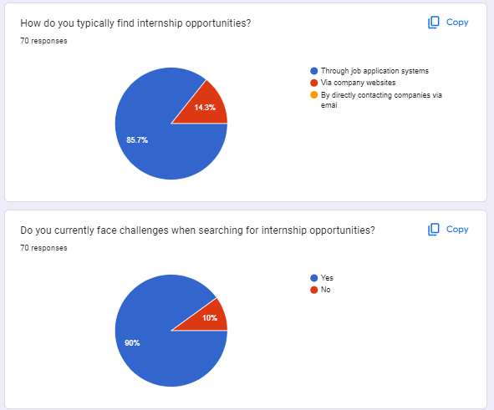

Figure 3‑3: Survey Result Part I

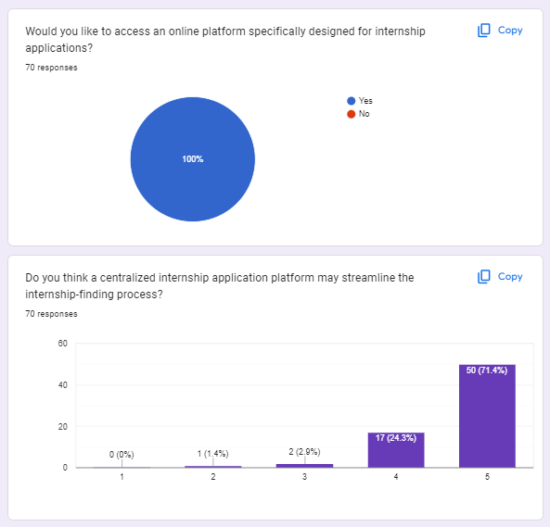

Figure 3‑4: Survey Result Part II

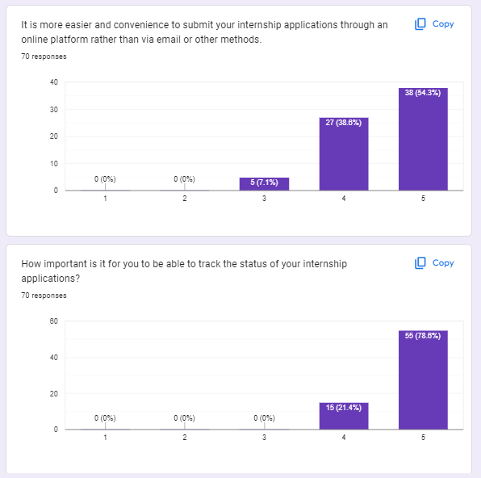

Figure 3‑5: Survey Result Part III

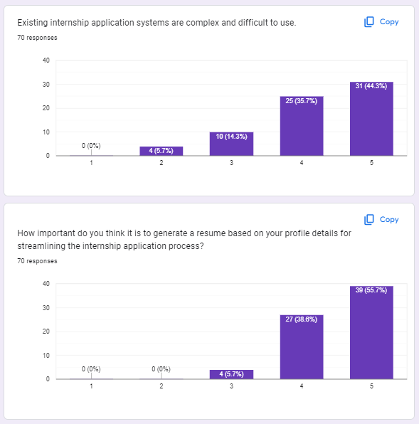

Figure 3‑6: Survey Result Part IV

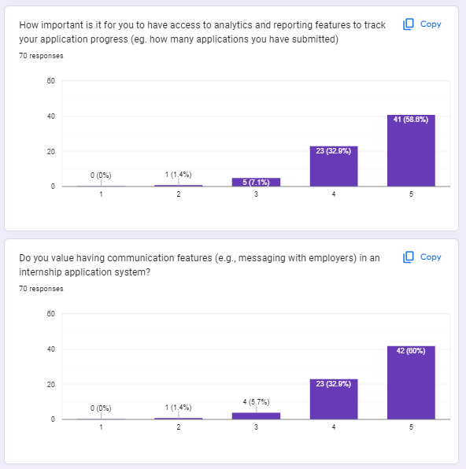

Figure 3‑7: Survey Result Part V

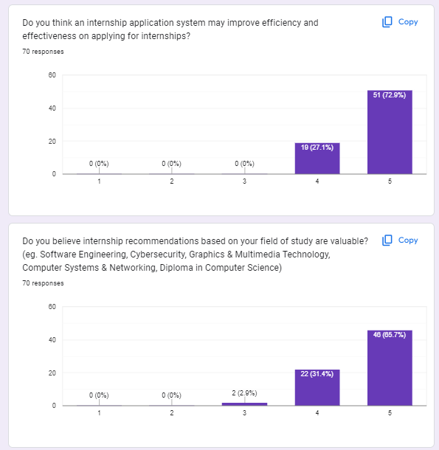

Figure 3‑8: Survey Result Part VI

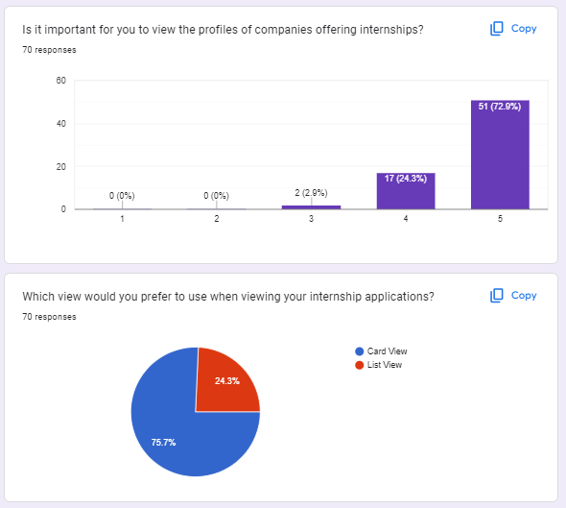

Figure 3‑9: Survey Result Part VII

The survey reveals that the majority of respondents, approximately 85.7%, find their internship opportunities via job application systems, while 14.3% of participants find their internship opportunities via company websites. It highlights the importance of the job application system. 90% of participants encounter challenges when finding internship opportunities. All participants in the survey would like to explore an online platform designed for internship applications. 95.7% of respondents think that a centralized internship application platform can help them find internships easily, 2.9% of respondents neither agree nor disagree, and 1.4% of respondents disagree. 92.9% of respondents agree that it is easier and more convenient to submit their internship applications through an online platform rather than via email or other methods, whereas 7.1% of respondents neither agree nor disagree. All participants in the survey think it is significant to track the status of their internship applications, and the internship application system will improve efficiency and effectiveness in applying for internships. 80% of respondents agree that existing internship application systems are complex and difficult to use, 14.3% of respondents neither agree nor disagree, and 5.7% of respondents disagree. The respondents agreed that generating a resume based on their profile details can streamline the internship application process since 94.3% of respondents agreed. The respondents think that analytics and reporting features are important to track their application progress since 91.5% of respondents agreed. Most respondents, approximately 92.9%, agree that having communication features in an internship application system is valuable. Most respondents believe that internship recommendations based on their field of study are valuable, approximately 97.1%. Many respondents, approximately 97.2%, agree that viewing the profiles of companies offering internships is important. Lastly, 75.7% of respondents like to access their internship applications in card view, while 24.3% of respondents like to access their internship applications in list view.

In summary, the survey results indicated all respondents are willing to access the proposed system (Internseek). An Internship Application System can streamline the process and improve the effectiveness and efficiency of finding and applying for internships for university students with a messaging feature, generating a resume, analytic report feature, providing internship recommendations based on their study scope, internship application submission within the system, and the ability to view the company profile and keep track of internship applications. The respondents like to view the internship applications in a card view.

### Non-Functional Requirements

Non-functional requirements, also known as quality requirements, are a set of specifications that describe the system’s properties, operations capabilities, and constraints. (Rana, 2021) Non-functional requirements describe how well the systems perform, which are not the same as functional requirements. Non-functional requirements evaluate the software system based on its overall performance, security, reliability, usability, and maintainability. The non-functional requirements of this project Internseek are listed as below:

Usability

* The user interface of Internseek must be easy to use and user-friendly.
* The user interface of Internseek should be able to navigate with simple interaction for users to achieve their goals.
* Each UI element, such as a button, text, image, and input field, must be worked properly.

Performance

* The response time of the system cannot exceed than 3 seconds.
* The system should be available 24/7.
* The system should be able to deal with multiple user requests simultaneously.

Security

* The system must protect the sensitive information of users against unauthorized access.
* The system should verify the identity of users before enabling them to access the system.

Reliability

* The system must handle errors and exceptions, providing users with relevant error messages.
* The system must quickly recover and restore the software system after a malfunction, failure, or outage.
* The system must maintain consistent performance and availability when processing high user demands.

Maintainability

* The documentation of the system must be complete and concise.
* The system should be easy to maintain, with clear code and comments for each function.

### Constraints and Limitations

The amount of time available for the system's development, testing, and deployment is insufficient.

The system requires Internet connection while using the system.

The system may not be able to handle high volume of data, traffic, or users over time.

Any browser can be used to access the system.

Not all companies will use the internship application system to post internship opportunities and hire applicants; some companies may post their internships via the job application system or company website for recruitment purposes.

### Use Case Diagram

This section describes the use case diagram of the internship application system. Figure 3-14 shows the use case diagram that describes the graphically and functionality of a system in terms of actors, use cases, and relations. (Bonilla-Morales, Crespo, & Clunie, 2012) This use case diagram includes the functional requirements of the Internship Application System (Internseek) that must be followed and provided to the end-users.

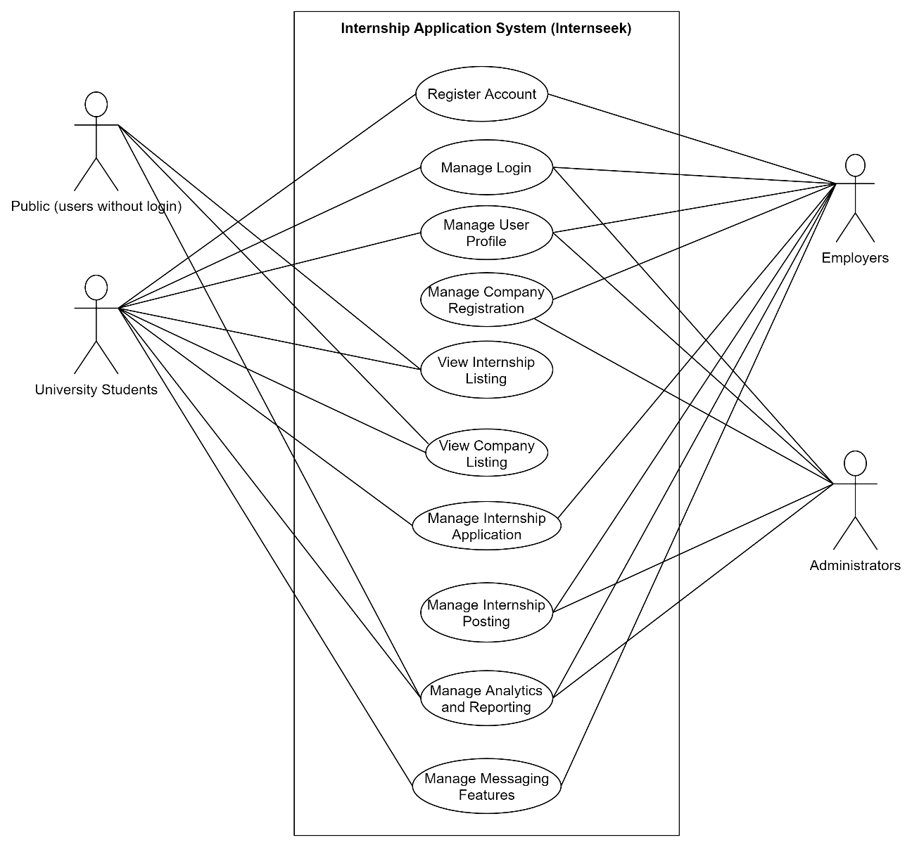

Figure 3‑10: Use Case Diagram

**Register Account**

* University students should be able to register an account using their email address with other related detailed information.
* Employers should be able to register an account using their email address and with their related detailed information.

**Manage Login**

* University Students, Employers, Administrators should be able to login to the system with a registered account.
* University Students, Employers, Administrators should be able to change their password via email when they forget password.

**Manage Company Registration**

* Authenticated employers can register a new company or search for an existing company.
* For new company registrations, administrators have the authority to update the status of the registration request submitted by employers.
* For existing companies, employers must wait for the company administrator to update the status of their registration.

**Manage User Profile**

* University Students, Employers, Administrators should be able to view, edit their account information such as email address, phone number and password.
* University Students should be able to view and update their profile details required such as education, accomplishment, skills, language, and experience to generate a resume.
* University Students can generate a resume based on their profile details.
* University Students should be able to view the progress of personal profiling.
* Employers should be able to view and update their company details like company location, about us, mission, vision, company size and company logo, branch info, site info.
* Employers should be able to update their own details and change their password.
* Admin should be able to update admin information and change their password.

**View Internship Listing**

* Public users, including administrators, employers, and university students, should be able to access and view the internship listings posted by employers in the system without requiring a login.
* University Students should be able search for internships by entering the keyword and sort the internship listings based on location and study scope.
* University Students should be able to view the details of the internship.
* Authenticated university students should be able to report internships if there are issues after login into the system.
* Authenticated university students should be able to bookmark internships after login into the system.
* University Students should be able to view the total number of applications, clicks, and bookmarks of the internships.

**View Company Listing**

* Public users, including administrators, employers, and university students, should be able to access and view the company listings posted by employers in the system without requiring a login.
* University Students should be able search for employers by entering the keyword and sort the employer listings based on location.
* University Students should be able to view the employer profile.

**Manage Internship Application**

* University Students should be able to apply for internships within the platform.
* University Students should be able to upload their cover letters, such as the Student Application Letter (SAL), transcripts, cover letters and their own resumes during the internship application process.
* University Students should be able to view, edit, and cancel their internship applications.
* University Students should be able to keep track the status of internship applications.
* Employers should be able to update the status of internship applications submitted by university students.
* Employers to view the resume generated based on the applicant profile and the information provided and documents uploaded by students during the internship application process.
* Employers should be able to update the interview details and accepted offer details.

**Manage Internship Posting**

* Employers should be able to post internship opportunities within the system.
* Employers should be able to view, edit, delete the internship opportunities posted within the system.
* Administrators should be able to manage the internship problem reports made by university students and take appropriate actions.

**Manage Analytics and Reporting**

* University Students should be able to access and view internship recommendations based on the study scope of students for university students.
* Public users, including administrators, employers, and university students, should be able to view the Top 3 Companies Chart.
* University Students should be able to view the report of the number of internship applications of the student and successful internship applications.
* Administrators should be able to view the number the report of total internships available, total registered company, and total registered students.
* Administrators should be able to update the rating of company.
* Employers should be able to view the report of the number of internship postings, total internship applicants, accepted applicants, applicants that need to interview, applicants that reject the offer, and shortlisted applicants.

**Manage Messaging Feature**

* University Students should be able to inquire about the status of internship applications, seek updates from employers, and ask questions about the internship and job responsibilities.
* Employers should be able to respond to student inquiries and notify students when the status of their applications has been updated.

### Use Case Description

##### Register Account

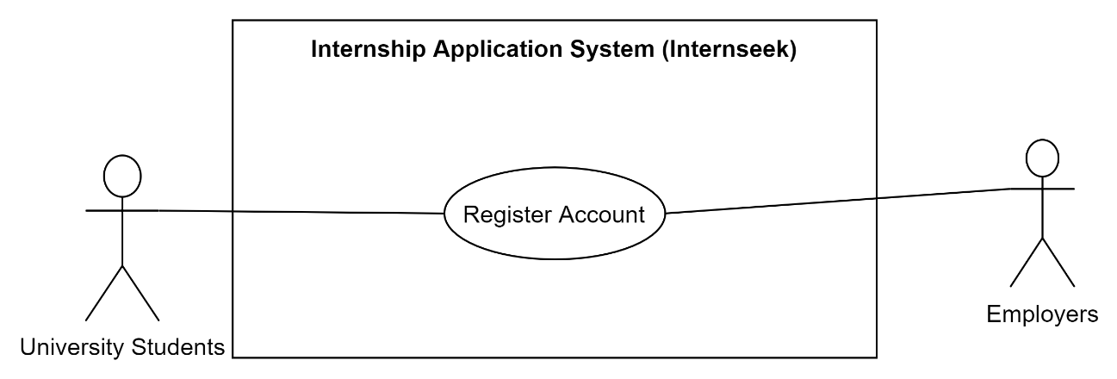

Figure 3‑11: Use Case Diagram (Register Account)

Table 3‑2: Use Case Description (Register Account)

|  |  |
| --- | --- |
| **Use Case Name** | Register Account |
| **Brief Description** | This use case allows the university students and employer to register an account in the Internseek system. |
| **Actor** | University Students, Employers |
| **Pre-Conditions** | University Students and Employers must on the homepage. |
| **Basic Flow** | **Register Student**  **Actor: University Students**   1. University students click the <<Sign Up>> button in the navbar on the homepage. 2. The system presents two options in modal: Student Registration and Employer Registration. 3. University students select the Student Registration option. 4. The system displays the InternSeeker registration form. 5. University Students enter the information required in the registration form. 6. University Students click the <<Sign Up>> button to submit the form. **[A1: Notify Required Field Not Entered] [E1: Invalid Email Address] [E2: Password and Confirm Password Incorrect] [E3: Invalid Password] [E4: Email Address already exists]** 7. The system verifies information and saves it to the database. 8. University Students are redirected to the internship listing page once they successfully register the account. 9. Use Case ends.   **Register Employer**  **Actor: Employers**   1. Employers click the <<Sign Up>> button in the navbar on the homepage. 2. The system presents two options in modal: Student Registration and Employer Registration. 3. Employers select the Employer Registration option. 4. The system displays the employer registration form. 5. Employers insert the details required in the form and click the <<Sign Up>> button. 6. The system validates the data inserted. **[A1: Notify Required Field Not Entered] [E1: Invalid Email Address] [E2: Password and Confirm Password Incorrect] [E3: Invalid Password] [E4: Email Address already exists]** 7. The system saves data inserted into the database. 8. Employers are redirected to the employer dashboard once successfully register the account. 9. Use Case ends. |
| **Alternative Flow** | **[A1: Alert Required Field Not Entered]**   1. This flow starts when university students and employers submit the form with the required field not entered. 2. The system informs required fields are not filled. 3. The system prompts the user to enter the empty field. 4. The flow continues with university students and employers filling in the registration form in the basic flow. |
| **Exception Flow** | **[E1: Invalid Email Address]**   1. The system displaysan error message “Invalid Email Address” for users. 2. The use case continues with step 3 in the basic flow for the student account registration and employer account registration.   **[E2: Password and Confirm Password Incorrect]**   1. The system displaysan error message “Password and Confirm Password are not match” for users. 2. The use case continues with step 3 in the basic flow for the student account registration and step 9 for the employer account registration.   **[E3: Invalid Password]**   1. The system displays an error message “Password must be strong and must have at least 8 characters with at least one symbol, at least one uppercase letter, one lowercase letter, and one digit”. 2. The use case continues with step 3 in the basic flow for the student account registration and step 9 for the employer account registration.   **[E4: Email Address already exists]**   1. The system displays an error message “Email Address already exists” for users. 2. The use case continues with step 3 in the basic flow for the student account registration and employer account registration. |
| **Post-Conditions** | **Register Account**  University Students and Employers successfully registered their account. |
| **Rules** | **[R1: Correct Data Type]**   1. The data inserted in the registration form must be compatible with the data type required.   **[R2: Password must have at least 8 characters, including at least one symbol, one uppercase letter, one lowercase letter, and one digit]**   1. The password reset by users must be strong and must have at least 8 characters, including at least one symbol, one uppercase letter, one lowercase letter, and one digit. |
| **Constraints** | **[C1: Unique Email Address]**   1. Users are not allowed to register multiple accounts in the system. Each user must have a unique email address. |

##### Manage Login

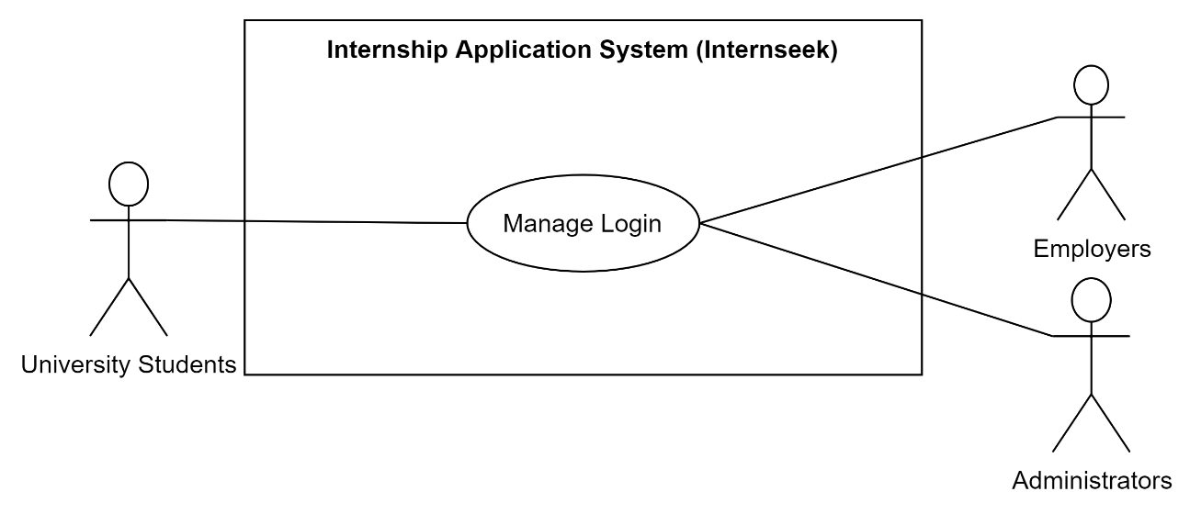

Figure 3‑12: Use Case Diagram (Manage Login)

Table 3‑3: Use Case Description (Manage Login)

|  |  |
| --- | --- |
| **Use Case Name** | Manage Login |
| **Brief Description** | This use case allows University Students, Employers, and Administrators to login into Internseek system with a registered account. |
| **Actor** | University Students, Employers, Administrators |
| **Pre-Conditions** | University Students, Employers, Administrators must have a valid registered account. |
| **Basic Flow** | **Actor: University Students**  **Login With Email and Password**   1. University Students click the <<Login>> button on the navbar. 2. The system displays three options in modal: Student Login, Employer Login, and Admin Login. 3. University Students select the Student Login option. 4. The system displays a student login form. 5. University Students enter their email address and password. 6. University Students click the Sign In button. **[A1: Forgot Password]** 7. The system validates the login details by the system. **[E1: Invalid Email Address] [E2: Incorrect password]** 8. The system displays the internship listing page for the students. 9. Use Case ends.   **Login with LinkedIn Account**   1. University Students click the <<Login>> button on the navbar. 2. The system displays three options in modal: Student Login, Employer Login, and Admin Login. 3. University Students select the Student Login option. 4. The system displays a student login form. 5. University Students click the <<Sign In with LinkedIn>> button. 6. The system redirects the student to LinkedIn's authentication page for login. 7. University Students enters LinkedIn account email and password. 8. The system validates the login credentials with LinkedIn's authentication service. **[E5: Invalid LinkedIn Login Credentials]** 9. The system displays the internship listing page for the students. 10. Use Case ends.   **Actor: Employers**   1. Employers click the <<Login>> button on the navbar. 2. The system displays three options in modal: Student Login, Employer Login, and Admin Login. 3. Employers select the Employer Login option. 4. The system displays an employer login form. 5. Employers enter their email address and password. 6. Employers click the Sign In button. **[A1: Forgot Password]** 7. The system validates the login details by the system. **[E1: Invalid Email Address] [E2: Incorrect password]** 8. The system displays the employer dashboard for the employers. 9. Use Case ends.   **Actor: Administrators**   1. Administrators click the <<Login >> button on the navbar. 2. The system displays three options in modal: Student Login, Employer Login, and Admin Login. 3. Administrators select the Admin Login option. 4. The system displays an administrator login form. 5. Administrators enter their email address and password. 6. Administrators click the Sign In button. **[A1: Forgot Password]** 7. The system validates the login details by the system. **[E1: Invalid Email Address] [E2: Incorrect password]** 8. The system displays the administrator dashboard for the administrators. 9. Use Case ends. |
| **Alternative Flow** | **[A1: Forgot Password]**   1. Users click the <<Forgot Password>> navigation link in their login form. 2. The system displays the forgot password form. 3. Users enter their email address. 4. Users click the <<Submit>> button. 5. The system validates the email address. **[E1: Invalid email address]** 6. The system sends the password reset link via email. 7. Users click the password reset link received via email. 8. The system displays the password reset form. 9. Users enter the new password and confirm password and click the <<Submit>> button. 10. The system validates the password. **[E3: Invalid password] [E4: Password not same]** 11. The system updates the new password in the database. 12. The system displays a successful the password has been successfully updated message for users. 13. Use case end. |
| **Exception Flow** | **[E1: Invalid Email Address]**   1. The system displays an error message “Invalid Email Address”. 2. The use case continues with step 3 in basic flow or step 3 in alternative flow A1.   **[E2: Incorrect Password]**   1. The system displays an error message “Incorrect Password”. 2. The use case continues with step 3 in basic flow.   **[E3: Invalid Password]**   1. The system displays an error message “Password must be strong and must have at least 8 characters with at least one symbol, at least one uppercase letter, one lowercase letter, and one digit”. 2. The use case continues with step 8 in alternative flow A1.   **[E4: Password Not Same]**   1. The system displays an error message “The new password and confirm password are not the same”. 2. The use case continues with step 8 in alternative flow A1.   **[E5: Invalid LinkedIn Login Credentials]**   1. The system displays an error message “User not found”. 2. The use case continues with step 7 in basic flow of Login with LinkedIn Account. |
| **Post-Conditions** | * University Students, Employers, and Administrator successfully log into the system. * University Students, Employers, and Administrator successfully reset password. |
| **Rules** | **[R1: Password must have at least 8 characters, including at least one symbol, one uppercase letter, one lowercase letter, and one digit]**   1. The password reset by users must be strong and must have at least 8 characters, including at least one symbol, one uppercase letter, one lowercase letter, and one digit.   **[R2: Not Null Required Field]**   1. The required fields must be entered when resetting password and logging into the system.   **[R3: Correct Data Type]**   1. The data inserted in the login form and reset password form must be compatible with the data type required. |
| **Constraints** | None |

##### Manage Company Registration

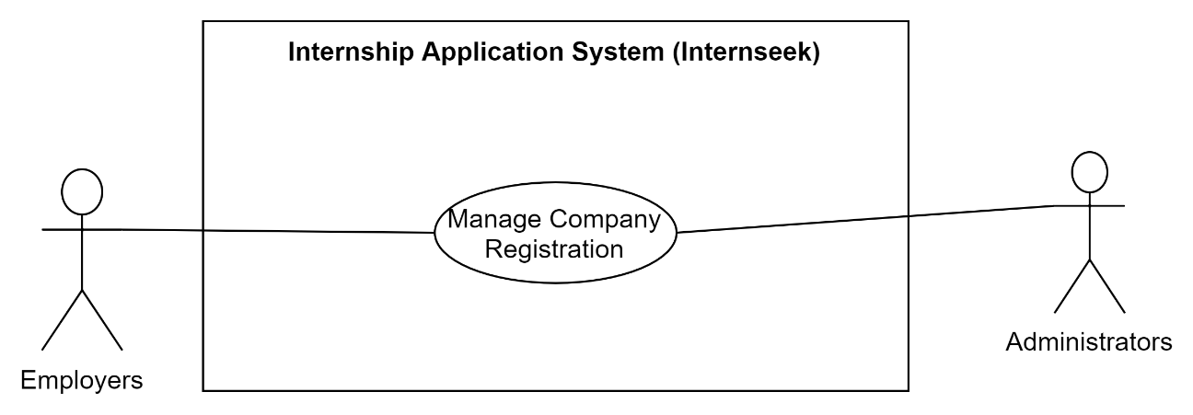

Figure 3‑13: Use Case Diagram (Manage Company Registration)

Table 3‑4: Use Case Description (Manage Company Registration)

|  |  |
| --- | --- |
| **Use Case Name** | Manage Company Registration |
| **Brief Description** | This use case allows employers to register a new company if it does not already exist in the system or to search for an existing company and request to join it. Administrators will review and approve employer registration requests, while the company admin (an employer with admin user type) will review and approve requests from employers attempting to join the company to verify whether the individual is the employee of the organization or potentially a scammer. |
| **Actor** | Employers, Administrators |
| **Pre-Conditions** | Employers and Administrators must log into the system with a registered account. |
| **Basic Flow** | All actors  Actors: Employers  **Register New Company**   1. Employers login into the system. 2. The system detects that the employer does not have company information in their profile. 3. The system displays the dashboard with two options for the employer:  * "Register New Company": To register a new company if they do not have an existing one. * "Search for Existing Company": To search for an existing company and join it.  1. Employer selects the "Register New Company" option if they want to create a new company. 2. The system displays the company registration form. 3. Employer fills out the required fields and attaches the necessary documents. 4. Employer submits the registration form. 5. The system verifies the inserted data and attached documents. **[A1: Alert for Missing Required Fields]** 6. The system saves the new company details as pending registration into database. 7. The use case ends.   **Search for Existing Company**   1. Employer logs in to the system. 2. The system detects that the employer does not have company information in their profile. 3. The system displays the dashboard with two options for the employer: 4. "Register New Company": To register a new company if they do not have an existing one. 5. "Search for Existing Company": To search for an existing company and join it. 6. Employer selects the "Search for Existing Company" option. 7. The system displays the "Search Existing Company" page. 8. Employer enters the company name and clicks the search button. 9. The system verifies and searches for the entered company name. **[E1: The company name does not match any existing companies in the system] [A1: Alert for Missing Required Fields]** 10. The system displays the available companies within the system. 11. Employer clicks the "Add" button next to the company name in the result row to add themselves to the company. 12. The system verifies the action and displays a successful message to inform the employer that their request to join the company has been sent for approval. 13. The system saves the details required into databases. 14. The system redirects the employer back to the dashboard, informing them to wait for the approval of the company admin. 15. The use case ends.   **Edit Registration Details**   1. Employer logs in to the system. 2. The system detects that the employer has completed company registration, but the registration status is still pending or inquiry. 3. The system displays the dashboard with an "Edit Company Registration Details" button. 4. Employers click the "Edit Company Registration Details" button.  * If the registration status is "Inquiry", employers can make changes to the company details based on the comments provided by the admin. * If the registration status is "Pending", the employer can still make changes, but the registration will remain pending until the admin reviews the updates.  1. The system retrieves the company registration details from the database. 2. The system displays the edit form pre-filled with the current company registration details. 3. Employers make the necessary edits to the company registration details. 4. Employers submit the changes. 5. The system verifies the inserted data. **[A1: Alert for Missing Required Fields]** 6. The system updates the data in the database. 7. The system displays a successful message, confirming that the company registration details were successfully edited. 8. The use case ends.   Actors: Employers (Company Admin)  **Review and Update Status of Employer Accounts**   1. Company Admin logs in to the system. 2. The system displays the employer dashboard. 3. Company Admin navigates to the "User List" page by selecting the "User List" option from the drop-down menu. 4. The system retrieves the list of employers who have attempted to add themselves to the company. 5. Company Admin reviews the account details of the employer trying to join the company. 6. Company Admin updates the account status to one of the following: 7. Active: The employer can access all the features provided for the company. 8. Inactive or Suspend: The employer cannot access any features or interact with the company resources. 9. The system sends an email notification to the employer informing them of the updated account status (whether it is Active, Inactive, or Suspended). 10. The system displays a success message to the company admin, confirming that the account status has been successfully updated. 11. Use case ends.   Actors: Administrators  **Review and Update Company Registration Status**   1. Administrator logs in to the system. 2. The system authenticates the administrator. 3. The system displays the admin dashboard with a company registration requests section. 4. Administrator clicks "View All". 5. The system retrieves and displays a list of pending company registration requests. 6. The system displays the list of company registration requests. 7. Administrator reviews each registration by clicking "View Details" next to a specific request. 8. The system displays the full company registration details. 9. Administrator reviews and verifies the company details. 10. Administrator updates the registration status:  * If the registration is approved, the administrator selects the Approved option. * If the registration is inquiry, the administrator selects Inquiry and enters comments to guide the employer to make necessary changes (e.g., missing information or documents).  1. The system updates the company registration status based on the administrator's selection (Approved, Inquiry, or Rejected). 2. The system sends an email notification to the employer regarding the updated registration status. 3. The system displays a successful message confirming that the status has been updated and the email has been sent. |
| **Alternative Flow** | **[A1: Alert for Missing Required Fields]**   1. The required fields must be entered when filling out the form. |
| **Exception Flow** | **[E1: The company name does not match any existing companies in the system]**   1. The system displaysan error message “No company found” for employers. 2. The use case continues with step 8 in the basic flow for the Search for Existing Company. |
| **Post-Conditions** | * The employer is now associated with the newly registered company. * The employer is successfully added to the company they selected. |
| **Rules** | **[R1: Status change email notification]**   1. The employer will receive email notification once the company registration status is updated by admins. 2. For the employer who have attempted to add themselves to the company, once the status is updated (Active, Inactive, or Suspended) by company admin, an email notification is immediately sent to the employer regarding the updated status. |
| **Constraints** | None |

##### Manage User Profile

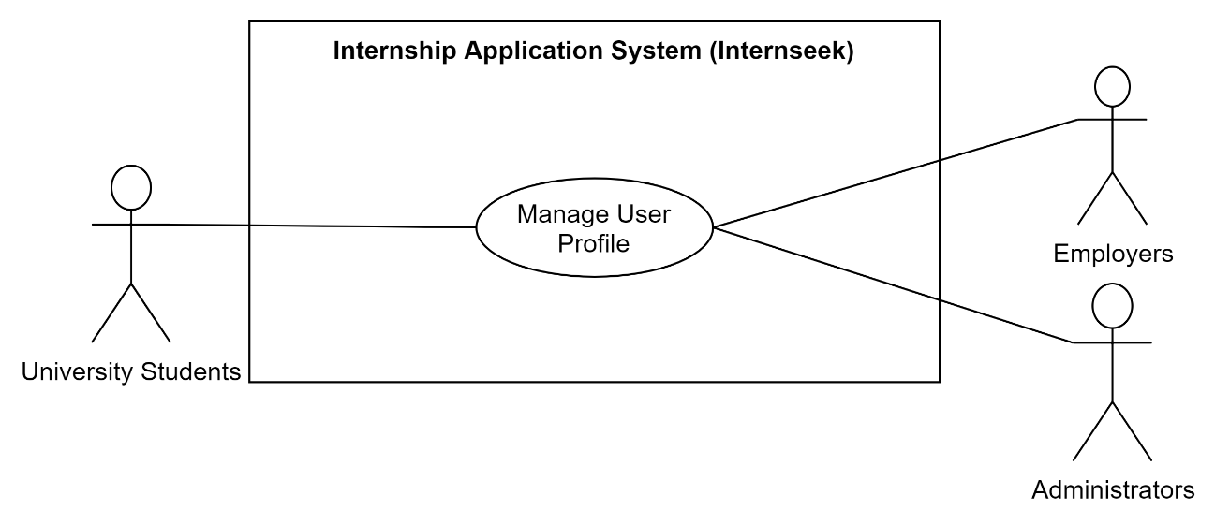

Figure 3‑14: Use Case Diagram (Manage User Profile)

Table 3‑5: Use Case Description (Manage User Profile)

|  |  |
| --- | --- |
| **Use Case Name** | Manage User Profile |
| **Brief Description** | This use case allows university students, employers, and administrators to manage their profiles such as edit their profile details and change password. |
| **Actor** | University Students, Employers, Administrators |
| **Pre-Conditions** | Users must log into the system with a registered account and visit the profile page. |
| **Basic Flow** | **Actor: University Students**   1. University students click the <<My Profile>> button. 2. The system displays the profile page with the profile details of university students in seven sections: basic information, experience, education, speaking language, skill, referee, and accomplishment.   **Edit Basic Information**   1. University students click the edit icon in the basic information section. 2. The system retrieves the current basic information about university students. 3. The system displays a modal dialog, including the edit basic information form with the current basic information of university students. 4. University students enter the basic information they want to edit. 5. University students click the <<Edit>> button. **[E1: Cancel Action]** 6. The system validates the data edited and updates the data in the database. **[A1: Alert Required Field Not Entered]** 7. The system displays a successfully edited basic information message for university students. 8. Use Case ends.   **Add Experience**   1. University students click the plus icon in the experience section to add their job or internship experience. 2. The system displays a modal dialog, including the add experience form. 3. University students enter the details required in the add experience form. 4. University students click the <<Submit>> button. **[E1: Cancel Action]** 5. The system validates the data inserted and saves the data into the database. **[A1: Alert Required Field Not Entered]** 6. The system displays a successfully created experience message for university students. 7. Use Case ends.   **Edit Experience**   1. University students click the edit icon of the specific experience details. 2. The system retrieves the current experience details of university students. 3. The system displays a modal dialog, including the edit experience form with the current experience details of university students. 4. University students enter the experience details they want to edit. 5. University students click the <<Edit>> button. **[E1: Cancel Action] [A2: Delete Experience Action]** 6. The system validates the data edited and updates the data in the database. **[A1: Alert Required Field Not Entered]** 7. The system displays a successfully edited experience message for university students. 8. Use Case ends.   **Add Education**   1. University students click the plus icon in the education section to add the education they achieved. 2. The system displays a modal dialog, including the add education form. 3. University students enter the details required in the add education form. 4. University students click the <<Submit>> button. **[E1: Cancel Action]** 5. The system validates the data inserted and saves the data into the database. **[A1: Alert Required Field Not Entered]** 6. The system displays a successfully created education message for university students. 7. Use Case ends.   **Edit Education**   1. University students click the edit icon of the specific education details. 2. The system retrieves the current education details of university students. 3. The system displays a modal dialog, including the edit experience form with the current education details of university students. 4. University students enter the education details they want to edit. 5. University students click the <<Edit>> button. **[E1: Cancel Action] [A3: Delete Education Action]** 6. The system validates the data edited and updates the data in the database. **[A1: Alert Required Field Not Entered]** 7. The system displays a successfully edited education message for university students. 8. Use Case ends.   **Add Skills**   1. University students click the plus icon in the skill section to add the skill they have or master. 2. The system displays a modal dialog, including the add skill form. 3. University students enter the skill they have and select the proficiency level in the form. 4. University students click the <<Submit>> button. **[E1: Cancel Action]** 5. The system validates the data inserted and saves the data into the database. **[A1: Alert Required Field Not Entered]** 6. The system displays a successfully created skill message for university students. 7. Use Case ends.   **Edit Skills**   1. University students click the edit icon of the specific skill details. 2. The system retrieves the current skill details of university students. 3. The system displays a modal dialog, including the edit skill form with the current skill details of university students. 4. University students enter the skill details they want to edit. 5. University students click the <<Edit>> button. **[E1: Cancel Action] [A4: Edit Skills Action]** 6. The system validates the data edited and updates the data in the database. **[A1: Alert Required Field Not Entered]** 7. The system displays a successfully edited skills message for university students. 8. Use Case ends.   **Add Accomplishment**   1. University students click the plus icon in the accomplishment section to add the accomplishment they achieved. 2. The system displays a modal dialog, including the add accomplishment form. 3. University students enter the details required in the add accomplishment form. 4. University students click the <<Submit>> button. **[E1: Cancel Action]** 5. The system validates the data inserted and saves the data into the database. **[A1: Alert Required Field Not Entered]** 6. The system displays a successfully created accomplishment message for university students. 7. Use Case ends.   **Edit Accomplishment**   1. University students click the edit icon of the specific accomplishment details. 2. The system retrieves the current accomplishment details of university students. 3. The system displays a modal dialog, including the edit accomplishment form with the current accomplishment details of university students. 4. University students enter the accomplishment details they want to edit. 5. University students click the <<Edit>> button. **[E1: Cancel Action] [A5: Delete Accomplishment Action]** 6. The system validates the data edited and updates the data in the database. **[A1: Alert Required Field Not Entered]** 7. The system displays a successfully edited accomplishment message for university students. 8. Use Case ends.   **Edit Language**   1. University students click the edit icon in the speaking language section. 2. The system retrieves the current proficiency level data of each language spoken of university students. 3. The system displays a modal dialog, including the edit language form with the current proficiency level of each language of university students. 4. University students update the current proficiency of each speaking language by selecting the radio button. 5. University students click the <<Edit>> button. **[E1: Cancel Action]** 6. The system validates the data edited and updates the data in the database. 7. The system displays a successfully edited language message for university students. 8. Use Case ends.   **Add Referee**   1. University students click the plus icon in the referee section to add the referee. 2. The system displays a modal dialog, including the add referee form. 3. University students enter the details required in the add referee form. 4. University students click the <<Submit>> button. **[E1: Cancel Action]** 5. The system validates the data inserted and saves the data into the database. **[A1: Alert Required Field Not Entered]** 6. The system displays a successfully created referee message for university students. 7. Use Case ends.   **Edit Referee**   1. University students click the edit icon of the specific referee details. 2. The system retrieves the current referee details of university students. 3. The system displays a modal dialog, including the edit referee form with the current referee details of university students. 4. University students enter the referee details they want to edit. 5. University students click the <<Edit>> button. **[E1: Cancel Action] [A6: Delete Referee Action]** 6. The system validates the data edited and updates the data in the database. **[A1: Alert Required Field Not Entered]** 7. The system displays a successfully edited referee message for university students. 8. Use Case ends.   **Edit Profile Picture**   1. University students click the edit icon near their profile picture. 2. The system displays the edit profile picture modal. 3. University students click the upload profile picture button. **[E1: Cancel Action]** 4. The system indicates the profile photo section is in edit mode, appearing as a modal or overlay window for students to upload photos. 5. University students select the file and click the <<Save>> button. 6. The system validates the photo updated and updates it into database. 7. The system displays a successfully updated profile picture message. 8. The profile page refreshes to show the new profile picture. 9. Use Case ends.   **Remove Profile Picture**   1. The University Student clicks the Edit icon near their profile picture. 2. The system displays the Edit Profile Picture Modal. 3. The University Student clicks the Remove button. 4. The system searches for the profile picture associated with the user in the database. 5. The system deletes the profile picture file from storage and removes its reference from the database. 6. The system displays a successful message: "Profile picture successfully deleted." 7. The University Student closes the Edit Profile Picture Modal. 8. Use case ends.   **Add LinkedIn Public URL**   1. University Students click the Add LinkedIn Public URL button. 2. The system displays the Add LinkedIn Public URL. 3. University Students enter the URL in the input field. 4. University Students click the Submit button. **[E1: Cancel Action]** 5. The system validates the entered URL and save it into the database.   **Generate Resume**   1. University students click the <<Generate Resume>> button on the My Profile page. 2. The system retrieves and compiles the information from the seven sections into a resume format. 3. The system displays a confirmation dialog to ask whether university students want to download the resume or not. **[E1: Cancel action]** 4. The system generates the resume in PDF format for download. 5. University students successfully downloaded the resume in PDF format. 6. The use case ends.   **Change Password**   1. University students click the <<Settings>> button. 2. The system displays the settings page with the change password form. 3. University students enter the new password and confirm password. 4. University students click the <<Submit>> button. 5. The system validates the changed password and updates the password in the database. **[E2: New & Confirm Password are not matched] [E3: Same as current password]** 6. The system displays a successfully changed password message. 7. Use case ends.   **View Personal Profiling Progress**   1. University students click the <<My Profile>> button. 2. The system retrieves the progress of personal profiling of university students. 3. The system displays the percentage of personal profiling progress. 4. Use Case ends.   **View Notifications**   1. University students click the notification icon in the navbar. 2. The system retrieves a list of recent notifications for the student and displays them in a dropdown. 3. University students click "View All Notifications". 4. The system navigates to a page displaying all notifications in a detailed list view.   **Mark All Notification as Read**   1. University students click "Mark All as Read". 2. The system marks each notification in the list as "Read". 3. **The system removes the red dot notification indicator** indicating that all notifications have been marked as read.   **Clear All Notifications**   1. University student clicks “Clear All.” 2. The system deletes all notification data for the student from the database. 3. The system displays an **empty notification list** to indicate that no notifications remain. 4. Use case ends.   **Actor: Employers**  **Edit Company Information**   1. Employers click the <<Company Profile>> button. 2. The system displays the company profile page with the company profile details. 3. Employers click the <<Edit>> button. 4. The system displays the edit company profile information form. 5. Employers enter the profile information they want to edit. 6. Employers click the <<Save Changes>> button. **[E1: Cancel action]** 7. The system validates the edited company profile information and updates the information in the database. **[A1: Alert Required Field Not Entered]** 8. The system displays a successfully edited company profile information message.   **Edit Employer Information**   1. Employers click the <<Employer Details>> button. 2. The system displays the employer details page with the details of the employer. 3. Employers click the <<Edit>> button. 4. The system displays the edit employer information form. 5. Employers enter the employer information they want to edit. 6. Employers click the <<Save Changes>> button. **[E1: Cancel action]** 7. The system validates the edited employer information and updates the information in the database. **[A1: Alert Required Field Not Entered]** 8. The system displays a successfully edited employer information message. 9. Use case ends.   **Change Password**   1. Employers click the <<Employer Details>> button. 2. The system displays the employer details page with the change password form. 3. Employers enter the new password and confirm password. 4. Employers click the <<Submit>> button. 5. The system validates the changed password and updates the password in the database. **[E2: New & Confirm Password are not matched] [E3: Same as current password]** 6. The system displays a successfully changed password message. 7. Use case ends.   **View Branch Info & Site Info**   1. The employer clicks the Branch & Site info button. 2. The system retrieves the branch and site info from the database. 3. The system displays branch and site info.   **Add Branch Info**   1. The employer clicks the Add icon in the branch section. 2. The system displays the add branch modal. 3. The employer enters the branch details. 4. The employer clicks the <<Submit>> button. **[E1: Cancel action]** 5. The system validates the entered details and saves the details into the database. **[A1: Alert Required Field Not Entered]** 6. The system displays a successfully added branch message. 7. Use Case ends.   **Edit Branch Info**   1. The employer clicks the <<Edit>> icon of the specific branch. 2. The system retrieves the branch details from database. 3. The system displays the edit branch modal with details. 4. The employer enters the details they want to edit. 5. The employer clicks the <<Edit>> button. **[E1: Cancel action] [A7: Delete Branch Action]** 6. The system validates the edited branch information and updates the information in the database. **[A1: Alert Required Field Not Entered]** 7. The system displays a successfully edited branch message. 8. Use Case ends.   **Add Site Info**   1. The employer clicks the Add icon in the branch section. 2. The system displays the add site form. 3. The employer enters the site details. 4. The employer clicks the <<Submit>> button. **[E1: Cancel action]** 5. The system validates the entered details and saves the details into the database. **[A1: Alert Required Field Not Entered]** 6. The system displays a successfully added site message. 7. Use Case ends.   **Edit Site Info**   1. The employer clicks the <<Edit>> icon of the specific site. 2. The system retrieves the site details from database. 3. The system displays the edit site modal with details. 4. The employer enters the details they want to edit. 5. The employer clicks the <<Edit>> button. **[E1: Cancel action] [A8: Delete Site Action]** 6. The system validates the edited site information and updates the information in the database. **[A1: Alert Required Field Not Entered]** 7. The system displays a successfully edited site message. 8. Use Case ends.   **View Notifications**   1. Employers click the notification icon in the navbar. 2. The system retrieves a list of recent notifications for the student and displays them in a dropdown. 3. Employers click "View All Notifications". 4. The system navigates to a page displaying all notifications in a detailed list view.   **Mark All Notification as Read**   1. Employers click "Mark All as Read". 2. The system marks each notification in the list as "Read". 3. **The system removes the red dot notification indicator** indicating that all notifications have been marked as read.   **Clear All Notifications**   1. Employers click “Clear All.” 2. The system deletes all notification data for the student from the database. 3. The system displays an **empty notification list** to indicate that no notifications remain. 4. Use case ends.   **Actor: Administrators**  **Change Password**   1. Administrators click the <<My Profile>> button. 2. The system displays the admin profile page with the change password form. 3. Administrators enter the new password and confirm password. 4. Administrators click the <<Submit>> button. 5. The system validates the changed password and updates the password in the database. **[E2: New & Confirm Password are not matched] [E3: Same as current password]** 6. The system displays a successfully changed password message. 7. Use case ends.   **Edit Admin Info**   1. Administrators click the <<My Profile>> button. 2. The system displays the admin profile page with profile details. 3. Administrators click the <<Edit>> button. 4. The system displays the edit profile details form. 5. Administrators enter the details they want to edit. 6. Administrators click the <<Save Changes>> button. **[E1: Cancel action]** 7. The system validates the edited profile details and updates the profile details in the database. **[A1: Alert Required Field Not Entered]** 8. The system displays a successfully edited administrator info message. 9. Use case ends. |
| **Alternative Flow** | All actors  **[A1:** **Alert Required Field Not Entered]**   1. This flow starts when users submit the form with the required field not entered. 2. The system informs required fields are not filled. 3. The system prompts users to enter the empty field. 4. The flow continues with users filling in the form in the basic flow.   Actor: University Students  **[A2: Delete Experience Action]**   1. University Students click the <<Delete>> button on the edit experience form. 2. The system displays a confirmation dialog to confirm the deletion. 3. University Students confirm the deletion. **[E1: Cancel Action]** 4. The system deletes the specific experience from the database. 5. The system displays a success message indicating the experience has been deleted. 6. Use Case ends.   **[A3: Delete Education Action]**   1. University Students click the <<Delete>> button on the edit education form. 2. The system displays a confirmation dialog to confirm the deletion. 3. University Students confirm the deletion. **[E1: Cancel Action]** 4. The system deletes the specific education from the database. 5. The system displays a success message indicating the experience has been deleted. 6. Use Case ends.   **[A4: Delete Skills]**   1. University Students click the <<Delete>> button on the edit skill form. 2. The system displays a confirmation dialog to confirm the deletion. 3. University Students confirm the deletion. **[E1: Cancel Action]** 4. The system deletes the specific skill from the database. 5. The system displays a success message indicating the skill has been deleted. 6. Use Case ends.   **[A5: Delete Accomplishment Action]**   1. University Students click the <<Delete>> button on the edit accomplishment form. 2. The system displays a confirmation dialog to confirm the deletion. 3. University Students confirm the deletion. **[E1: Cancel Action]** 4. The system deletes the specific accomplishment from the database. 5. The system displays a success message indicating the accomplishment has been deleted. 6. Use Case ends.   **[A6: Delete Referee Action]**   1. University Students click the <<Delete>> button on the edit referee form. 2. The system displays a confirmation dialog to confirm the deletion. 3. University Students confirm the deletion. **[E1: Cancel Action]** 4. The system deletes the specific referee from the database. 5. The system displays a success message indicating the referee has been deleted. 6. Use Case ends.   **[A7: Delete Branch Action]**   1. The employer clicks the <<Delete>> button. 2. The system displays a confirmation dialog to confirm the deletion. 3. The employer confirmed the deletion. **[E1: Cancel Action]** 4. The system deletes the specific branch from the database. 5. The system displays a success message indicating the branch has been deleted. 6. Use Case ends.   **[A8: Delete Site Action]**   1. The employer clicks the <<Delete>> button. 2. The system displays a confirmation dialog to confirm the deletion. 3. The employer confirmed the deletion. **[E1: Cancel Action]** 4. The system deletes the specific site from the database. 5. The system displays a success message indicating the site has been deleted. 6. Use Case ends. |
| **Exception Flow** | **[E1: Cancel Action]**   1. This flow starts when users click on the <<Cancel>> button or the cross icon. 2. The system will terminate the process that users are currently doing and redirect users to the previous page. 3. End.   **[E2: New & Confirm Password are not matched]**   1. The system displays the error message “**New Password and Confirm Password are not matched**”. 2. The use case continues with step 3 in the basic flow of changing password.   **[E3: Same as current password]**   1. The system displays the error message “The new password cannot same as the current password.” 2. The use case continues with step 3 in the basic flow of changing password. |
| **Post-Conditions** | * University students, employers, and administrators successfully updated their profile details and changed their passwords. * University students can generate resumes based on the profile details they input and download resumes in pdf format. |
| **Rules** | **[R1: Complete Sections Required]**   1. University Students need to fill out all seven sections: basic information, experience, education, speaking language, skill, referee, and accomplishment to generate a resume.   **[R2: Not Null Required Field]**   1. The required fields must be entered when filling the edit and add details form or change password form.   **[R3: Correct Data Type]**   1. The data inserted in the edit or create details form and change password form must be compatible with the data type required.   **[R4: Accurate Data Compilation]**   1. The systems shall accurately compile the information from seven sections into the resume format. |
| **Constraints** | **[C1: Resume in pdf format only]**   1. The generated resume is only available for download in PDF format. No other formats are provided.   **[C2: Unique Email Address]**   1. Users cannot use an email address already registered to another account. |

##### View Internship Listing

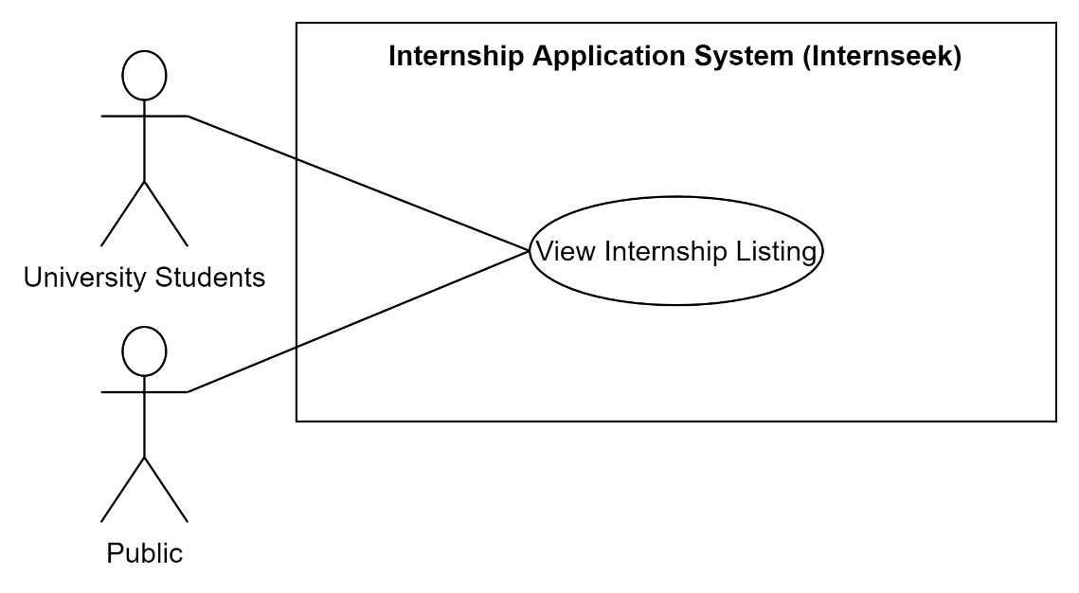

Figure 3‑15: Use Case Diagram (View Internship Listing)

Table 3‑6: Use Case Description (View Internship Listing)

|  |  |
| --- | --- |
| **Use Case Name** | View Internship Listing |
| **Brief Description** | This use case describes how public users and university students can view internship listings on the Internseek website. |
| **Actor** | Public, University Students |
| **Pre-Conditions** | **Actor: University Students**  The user is logged in as a university student.  The user is not logged in. |
| **Basic Flow** | **Actor: University Students (Logged In):**   1. University students log into the system. 2. The system retrieves available internships’ data including the number of clicks, applications, and bookmarks and displays them in a list. 3. University students can browse internship listings and view the number of people who have viewed, applied for, and bookmarked each internship.   **Search/Sort the Internships Listing**   1. University students can filter or search for specific internships by location, study field, and keywords. 2. The system validates the entered keyword. **[E1: Search Keyword not found]** 3. The system retrieves and displays specific internships based on filters. 4. University students view the filtered internships listing.   **View Internship Details**   1. University students click on a specific internship card to view details. 2. The system retrieves and displays internship details. 3. University students view internship details.   **Bookmark Internships**   1. University students can bookmark the internship by clicking the bookmark button/icon. 2. The system saves the bookmarked internship. 3. The bookmark button/icon turns blue to indicate that the internship is bookmarked. 4. Use Case ends.   **Report Internships**   1. University Students click the report button. 2. The system displays a modal dialog, including the report internship form. 3. University Students describe the problems and click the <<Submit>> button. 4. The system validates the details and saves them in the database. 5. The system displays a message 'Thank you for reporting'. 6. Use Case ends.   **View Report Internship List**   1. University students can click the "My Report" option from the dropdown menu in the navbar. 2. The system displays a list detailing each student's internship reports. 3. University students can view the latest status of their reports. 4. Use case ends.   **Actor: Public**   1. Public users access the Internseek website and click the search internships button on the navbar. 2. The system retrieves available internships’ data including the number of clicks, applications, and bookmarks and displays them in a list. 3. Public users can browse internship listings and view the number of people who have viewed, applied for, and bookmarked each internship.   **Search/Sort the Internships Listing**   1. Public users can filter or search for specific internships by location, study field, and keywords. 2. The system validates the entered keyword. **[E1: Search Keyword not found]** 3. The system retrieves and displays specific internships based on filters. 4. Public users view the filtered internships listing.   **View Internship Details**   1. Public users click on a specific internship card to view details. 2. The system retrieves and displays internship details. 3. Public users view internship details. 4. Use Case ends. |
| **Alternative Flow** | None |
| **Exception Flow** | **[E1: Search Keyword not found]**   1. This flow occurs when the university students enter the specific keyword that cannot be found in the internship listing. 2. The system displays the message ‘Search Keyword was not found’. 3. Continue with step 4 in the basic flow. |
| **Post-Conditions** | * Public users and university students have access to view internship listings. * Filtered or searched results of internship listing are displayed accurately for students. * University Students with logging in bookmarked preferred internships for future reference. * University Students with logging in have the access to report the internship if they find it suspicious. |
| **Rules** | None |
| **Constraints** | None |

##### View Company Listing

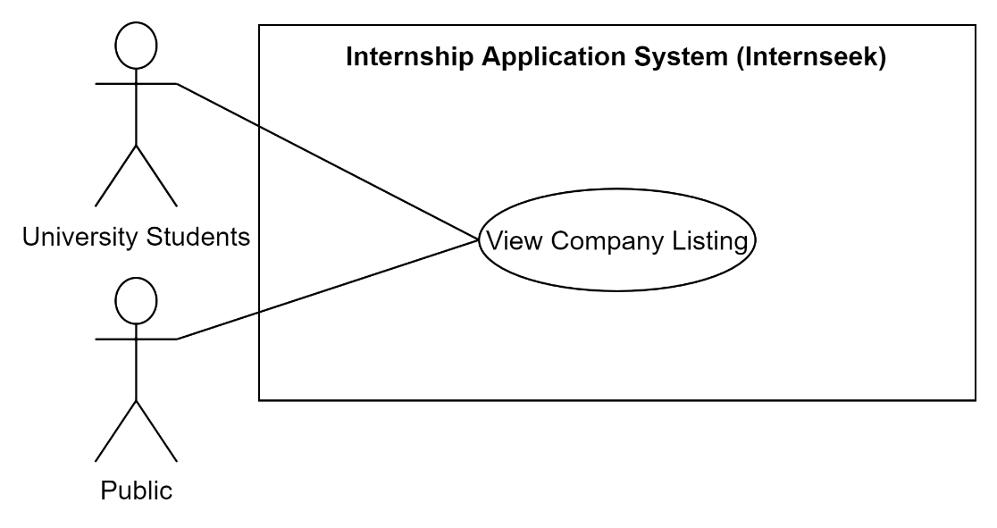

Figure 3‑16: Use Case Diagram (View Company Listing)

Table 3‑7: Use Case Description (View Company Listing)

|  |  |
| --- | --- |
| **Use Case Name** | View Company Listing |
| **Brief Description** | This use case allows university students and public users to browse and view listings of companies within the system. |
| **Actor** | University Students |
| **Pre-Conditions** | **Actor: University Students**  The user is logged in as a university student.  The user is not logged in. |
| **Basic Flow** | **Actor: University Students (Logged In):**   1. University students log into the system. 2. University students click the <<Search Company>> button on the navbar. 3. The system retrieves available company listings and displays them on the company listing page. 4. University students browse and view company listings.   **Search/Sort the Companies Listing**   1. University students can filter or search for specific companies by location and keywords. 2. The system retrieves and displays specific companies based on filters and keyword entered. **[E1: Search keyword not found]** 3. University students view the filtered company listing.   **View the Company Details**   1. University students click on a specific company card to view details. 2. The system retrieves and displays company details. 3. Use Case ends.   **Actor: Public**   1. Public users access the Internseek website and click the search company button on the navbar. 2. The system retrieves available companies and displays them in a list. 3. Public users browse and view company listings.   **Search/Sort the Company Listing**   1. Public users can filter or search for specific companies by location and keywords. 2. The system retrieves and displays specific companies based on filters. **[E1: Search keyword not found]** 3. Public users view the filtered companies listing.   **View the Company Details**   1. Public users click on a specific company card to view details. 2. The system retrieves and displays company details. 3. Public users view company details. 4. Use Case ends. |
| **Alternative Flow** | None |
| **Exception Flow** | **[E1: Search keyword not found]**   1. This flow occurs when the university students enter the specific keyword that cannot be found in the company listing. 2. The system displays the message ‘Search Keyword was not found’. 3. Continue with step 4 in the basic flow. |
| **Post-Conditions** | * University students have viewed company listings. * Filtered or searched results of company listings are displayed accurately for students. |
| **Rules** | None |
| **Constraints** | None |

##### Manage Internship Application

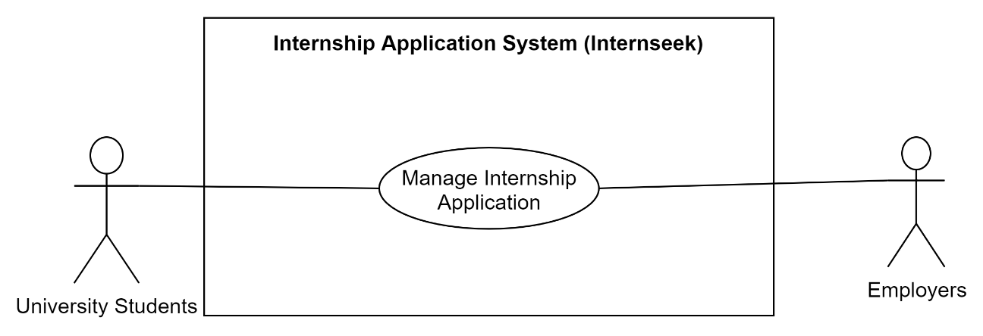

Figure 3‑17: Use Diagram (Manage Internship Application)

Table 3‑8: Use Case Description (Manage Internship Application)

|  |  |
| --- | --- |
| **Use Case Name** | Manage Internship Application |
| **Brief Description** | This use case allows the university students to apply for internships within the system and send the internship applications to employers. |
| **Actor** | University Students, Employers |
| **Pre-Conditions** | University students and Employers are logged in to the system. |
| **Basic Flow** | **Actor: University Students**  **Apply Internships**   1. University Students click the <<Apply Now>> button on the internship card. 2. The system displays the first section of the internship application form. 3. University students enter details required in the form and check the basic information is correct or not and click ‘Next’ button. **[E1: Edit Basic Information Action] [E3: Cancel Action]** 4. The system displays the second section of the internship application form. The second section of the form is the resume generated based on the profile details of the university students. 5. University students click the <<Next>> button if the resume details are correct. **[E2: Edit Profile Details Action] [E3: Cancel Action]** 6. The system displays the third section of the internship application form. 7. University students upload the cover letter, the transcript, the Student Application Letter (SAL) and the resume (optional) and click <<Submit>> button. **[E3: Cancel Action]** 8. The system validates the document uploaded. 9. The system prompts university students to confirm the correctness of their internship application data; they cannot edit it after submission. 10. University students confirm the submission. **[E3: Cancel Action]** 11. The system validates the details inserted and documents uploaded by university students. **[A1: Alert Not fill required field]** 12. The system saves all the details inserted into the database and the documents uploaded into the database. 13. The system displays a message “Your internship application has been submitted to the employer.”. 14. Use Case ends.   **Keep track of the status of internship applications**   1. University students click the <<My Internships>> button on the navbar. 2. The system retrieves the relevant data regarding internship applications of the student from the database. 3. The system displays my internships page and organizes the relevant data into two sections: pre-internships and process-internships. 4. The system organizes matched and bookmarked internships in the "Pre-Internships" section, while applied, shortlisted, and need-to-interview internships are displayed in the "Process Internships" section. 5. University students click the <<Applied Internships>>, <<Shortlisted Internships>>, or <<Need-to-interview Internships>> button. **[A2: Applied Internships] [A3: Shortlisted Internships] [A4: Need-to-interview internships] [A5: Approved Internships]** 6. Use Case ends.   **View Accepted Offer Details**   1. The university student selects the industrial training option from the drop-down menu in the navbar. 2. The system retrieves accepted offers data from database and displays the accepted offers in a list. 3. The university student views the accepted offer details updated by employers. 4. The university student can cancel the offer they previously accepted. 5. The system displays a confirmation dialog asking the student to provide a reason for the rejection. 6. The student enters the rejection reason and clicks “Confirm” button. 7. The system updates the accepted offer status to “Rejected.” 8. The system removes the rejected offer from the list. 9. Use Case ends.   **Actor: Employers**  **Update Status**   1. Employers click the <<Internship Application>> card button on the employer dashboard or <<Applicants>> button on the navbar. 2. The system retrieves the applicants that applied to the internships posted by the employer. 3. The system displays the applicant list with the details and documents submitted by applicants when applying for internships. 4. Employers update the status after evaluating the applicants based on the details, the resume of the applicant generated based on the applicant’s profile details, and documents submitted. 5. Employers click the <<Update Status>> button. 6. The system displays the updated internship application status form. **[A5: Unsuccessful] [A6: Need-to-Interview]** 7. The system displays a successfully updated internship application status message. 8. Use Case Ends.   **Edit Interview Details**   1. Employers click the <<Interview>> card button on the employer dashboard or <<Interview List>> button on the navbar. 2. The system retrieves the applicants that need to be interviewed. 3. Employers click the <<Edit Interview Details>> button. 4. The system retrieves the interview details. 5. The system displays the edit interview details form. 6. Employers enter the details they want to edit and click the <<Update>> button. 7. The system validates and saves the details into the database. **[A1: Alert Not fill required field]** 8. The system displays a successfully edited interview details message. 9. Use Case ends.   **Update Interview Status**   1. Employers click the <<Interview>> card button on the employer dashboard or <<Interview List>> button on the navbar. 2. The system retrieves the applicants that need to be interviewed. 3. The system displays applicants that need to be interviewed and lists the details and documents submitted by applicants when applying for internships. 4. Internship provide clicks the <<Update Status>> button after conducting interview session. 5. The system displays the update interview status form. 6. Employers select the status as one of the following options: **[A6: Unsuccessful], [A8: Another Interview], [A9: Shortlisted],** or **[A10: Approved].** 7. Employers rate the interview based on performance, overall rating, soft skills, and technical skills, and provide comments. 8. The system displays a successfully updated interview status message. 9. Use Case ends.   **Update Shortlisted Result**   1. Employers click the <<Shortlisted/Approved >> card button on the employer dashboard. 2. The system retrieves the shortlisted and approved applicants. 3. The system displays a button in the shortlisted card for employer to update the shortlisted result. 4. Employers click the <<Update Status>> button. 5. The system displays the update shortlisted result form. 6. Employers select the status as one of the following options: **[A6: Unsuccessful], [A8: Another Interview],** or **[A10: Approved].** 7. The system displays a successfully updated shortlisted status message. 8. Use Case ends.   **Update Accepted Offer Details**   1. Employers click the <<Accepted>> card button on the employer dashboard. 2. The system displays all the applicants who accept the offer. 3. Employers click the <<Update Details>> button on the specific applicant card. 4. The system displays the update accepted offer details form. 5. Employers enter the details and click the <<Update>> button. 6. The system validates and saves the details into the database. **[A1: Alert Not fill required field]** 7. The system displays a successfully updated accepted offer details message. 8. Use Case ends. |
| **Alternative Flow** | **[A1: Alert Not fill required field]**   1. The required fields must be entered when filling out the internship application form.   **Actor: University Students**  **[A2: Applied Internships]**   1. University students click the <<Applied Internships>> button. 2. The system retrieves and displays the relevant internship details along with their status. 3. University students view the status of the internship applications, which includes both still reviewing and unsuccessful statuses. 4. If the status of applied internships is still being reviewed, university students can cancel the internship application. 5. University students click the <<Cancel>> button. 6. The system displays a confirmation dialog to confirm the cancellation of the internship application. 7. University students confirm the cancellation. **[E3: Cancel Action]** 8. The system searches for the internship application id. 9. The system deletes the internship application. 10. The system displays a message “Your internship application has been cancelled.”. 11. The flow continues with step 5 in the basic flow ‘Keep track of the status of internship applications’.   **[A3: Shortlisted Internships]**   1. University students click the <<Shortlisted Internships>> button. 2. The system retrieves and displays the relevant internship details and the shortlisted status, indicating they are entered for final selection. 3. University students view the status of the internship applications and internship details. 4. The flow continues with step 5 in the basic flow: ‘Keep track of the status of internship applications.’   **[A4: Need-to-interview internships]**   1. University students click the <<Need-to-interview Internships>> button. 2. The system retrieves and displays the relevant internship details and interview details, which includes ‘Need to interview’ status. 3. University students view the status of the internship applications, interview details, and internship details. 4. University students click the available or not available button to update their availability. 5. The system updates the interview status based on the input in the database. 6. The flow continues with step 5 in the basic flow ‘Keep track of the status of internship applications.’   **[A5: Approved Internships]**   1. University students click the <<Approved Internships>> button. 2. The system retrieves and displays the relevant internship details and the offer letter uploaded by employers, which include approved status. 3. University students view the status of the internship applications, interview details, and internship details. 4. University students approve or reject the offer by clicking the relevant button. 5. The system updates the status of internship applications to accept or reject them. 6. The flow continues with step 5 in the basic flow ‘Keep track of the status of internship applications.’   **Actor: Employers**  **[A6: Unsuccessful]**   1. Employers select the status as unsuccessful status and click the <<Submit>> button. **[E3: Cancel Action]** 2. The system validates the data and updates it in the database. 3. The flow continues with step 7 in the basic flow ‘Update Internship Application Status’.   **[A7: Need-to-Interview]**   1. Employers select the status as ‘Need-to-Interview’ status and click the <<Submit>> button at update status form. 2. The system displays the interview method field. 3. Employers select the interview method. 4. If employers select face-to-face interview method, the system displays interview location field. 5. If employers select an online interview method, the system displays the interview meeting link field. 6. Employers enter the location or meeting link and click the <<Submit>> button. **[E3: Cancel Action]** 7. The system validates the data and updates it in the database. 8. The flow continues with step 7 in the basic flow ‘Update Internship Application Status’.   **[A8: Another Interview]**   1. Employers select the status as ‘Need-to-Interview’ status and click the <<Submit>> button at update interview result and shortlisted result form. 2. The system displays the interview method and rating field. 3. Employers select the interview method. 4. If employers select face-to-face interview method, the system displays interview location field. 5. If employers select an online interview method, the system displays the interview meeting link field. 6. Employers enter the location or meeting link and click the <<Submit>> button. **[E3: Cancel Action]** 7. The system validates the data and updates it in the database. 8. The flow continues with step 7 in the basic flow ‘Update Interview Result’ or ‘Update Shortlisted Result’.   **[A9: Shortlisted]**   1. Employers select the status as shortlisted status and click the <<Submit>> button. **[E3: Cancel Action]** 2. The system validates the data and updates it in the database. 3. The flow continues with step 7 in the basic flow ‘Update Interview Result’ or ‘Update Shortlisted Result’.   **[A10: Approved]**   1. Employers select the status as Approved status and click the <<Submit>> button. **[E3: Cancel Action]** 2. The system validates the data and updates it in the database. 3. The flow continues with step 7 in the basic flow ‘Update Interview Result’ or ‘Update Shortlisted Result’. |
| **Exception Flow** | **[E1: Edit Basic Information Action]**   1. This flow starts when users click on the edit icon button on the basic section section in the first section of the internship application form. 2. The system will terminate the internship application process and redirect university students to my profile page to edit the basic information. 3. End.   **[E2: Edit Profile Details Action]**   1. This flow starts when users click on the edit icon button on the resume generated by Internseek. 2. The system will terminate the internship application process and redirect university students to my profile page to edit profile details. 3. End.   **[E3: Cancel Action]**   1. This flow starts when users click on the <<Cancel>> button or the cross icon. 2. The system will terminate the process that users are currently doing and redirect users to the previous page. 3. End. |
| **Post-Conditions** | * Internship applications are successfully submitted or cancelled. * University students can track the status of their internship applications. * Employers can update the status of internship applications and interviews. |
| **Rules** | **[R1: Cannot Edit Internship Application once submission]**   1. University students cannot edit internship application data after submission.   **[R2: Not Null Required Field]**   1. The required fields must be entered when applying for internships.   **[R3: Correct Data Type]**   1. The data insert must be compatible with the data type required. |
| **Constraints** | **[C1: Cancel Internship Application Constraint]**   1. Only internship applications with the 'Reviewing' status can be cancelled by the university students.   **[C2: Edit Constraint]**   1. University students must ensure all required details in the internship application form are correct before submission since they cannot be edited afterward. |

##### Manage Internship Posting

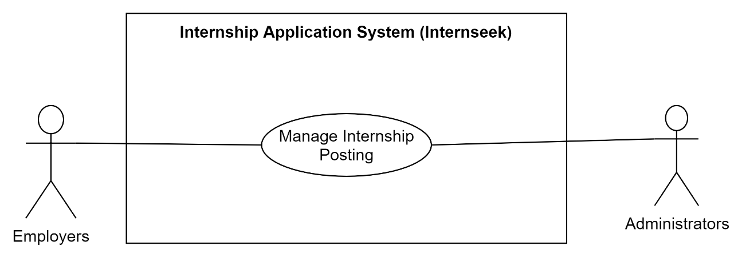

Figure 3‑18: Use Case Diagram (Manage Internship Posting)

Table 3‑9: Use Case Description (Manage Internship Posting)

|  |  |
| --- | --- |
| **Use Case Name** | Manage Internship Posting |
| **Brief Description** | This use case allows employers to post internships within the system and allows administrators to manage these reports and take appropriate actions. |
| **Actor** | Employers, Administrators, University Students |
| **Pre-Conditions** | Employers and Administrators are logged in to the system. |
| **Basic Flow** | **Actor: Employers**  **View Internship Posting List**   1. Employers click the <<Internships Posted>> button on the navbar or the <<View All>> button on the internship section of the employer dashboard. 2. The system retrieves the internships posted by the employer or another employer within the same company from the database. 3. The system displays the internship posting in a list, including the number of clicks, applications, and bookmark for each internship posting. 4. Employers can browse and view each internship posting. 5. The use case ends.   **Post an Internship**   1. Employers click the <<Post an internship>> button. 2. The system displays the post internship form. 3. Employers enter the details required in the form. 4. Employers click the <<Submit>> button. **[E1: Cancel Action]** 5. The system validates the details inserted and saves the details into the database. **[A1: Alert Not fill required field]** 6. The system displays a message ‘Your internship posting request has been submitted to the administrator to review, please be patient to wait for the result.’ 7. The system redirects employers to the internship posting list page. 8. The use case ends.   **View Internship Posting**   1. Employers click the view icon button of the specific internship posting. 2. The system retrieves selected internship posting data from the database. 3. The system displays the selected internship posting details. 4. The use case ends.   **Edit Internship Posting**   1. Employers click the edit icon button of the specific internship posting. 2. The system retrieves selected internship posting data from the database. 3. The system displays the edited internship form with selected internship posting details. 4. Employers enter the details they want to edit. 5. Employers click the <<Submit> button. **[E1: Cancel Action]** 6. The system validates the details edited and updates the details in the database. **[A1: Alert Not fill required field]** 7. The system displays a successfully edited internship posting message. 8. The use case ends.   **Delete Internship Posting**   1. Employers click the delete icon button of the specific internship posting. 2. The system retrieves the selected internship posting data from the database. 3. The system displays a confirmation dialog to confirm the deletion of the internship posting. 4. Employers confirm the deletion. **[E1: Cancel Action]** 5. The system deletes the internship posting from the database. 6. The system displays a message: "The internship posting has been successfully deleted." 7. The use case ends.   **Handle the archived internship posting**   1. The employer clicks the view all link on the "Internship Posting List" section in the dashboard. 2. The system displays all the internship postings with status. 3. The employer clicks the edit button and selects the archived internship post to review the details and the reason for archiving. 4. The system retrieves the internship details and displays the edit form with the internship details and the reason for archiving. 5. The employer makes the necessary corrections to the internship post based on the reason for archiving given. 6. The employer clicks the <<Update>> button. **[E1: Cancel Action]** 7. The system validates and updates the edited details in the database. 8. The system notifies the administrator to review and either reactivate or reject the updated post. 9. The system displays a successfully edited internship posting message. 10. Use Case ends.   **Actor: Administrators**  **Handle internship problem reports made by university students**   1. The administrator logs into the system using their email and password. 2. The system displays the admin dashboard. 3. The administrator clicks the view all link on the "Internship Problem Reports" section in the dashboard. 4. The system displays all the internship problem reports in a list. 5. The administrator clicks the view details link to view the report submitted by a university student to review the problem. 6. The system displays the internship posting details and the problem description. 7. The administrator investigates the reported issue by checking the details of the internship post. 8. Based on the investigation, the administrator takes appropriate action and updates the status of the reported issue:    * **Archive** the internship post, provide the reason for archiving, and notify the employer to make necessary corrections. Update the report status as the solving status and inform the student that the issue is being addressed.    * **Mark as Valid** if the report is invalid. Update the report status as resolved and inform the student that the issue is unreal.    * **Unarchive the internship post,** after resolving the reported issues, the administrator unarchives the internship post, the administrator clicks the <<Update>> button.   **[E1: Cancel Action]**   1. The system validates and updates the details entered by the admin in the database. 2. The system notifies the reporting student about the action taken on their report. 3. The system displays a successfully updated internship report status and action message. 4. Use Case ends. |
| **Alternative Flow** | **[A1: Alert Not fill required field]**   1. The required fields must be entered when filling out the internship application form. |
| **Exception Flow** | **[E1: Cancel Action]**   1. This flow starts when users click on the <<Cancel>> button or the cross icon. 2. The system will terminate the process that users are currently doing and redirect users to the previous page. 3. End. |
| **Post-Conditions** | * Internship postings are successfully created, viewed, edited, or deleted by employers. * Administrators can approve or reject internship postings. * Employers can track the status of their internship posts. |
| **Rules** | **[R1: Not Null Required Field]**   1. The required fields must be entered when posting the internship.   **[R2: Correct Data Type]**   1. The data insert must be compatible with the data type required. |
| **Constraints** | None |

##### Manage Analytics and Reporting

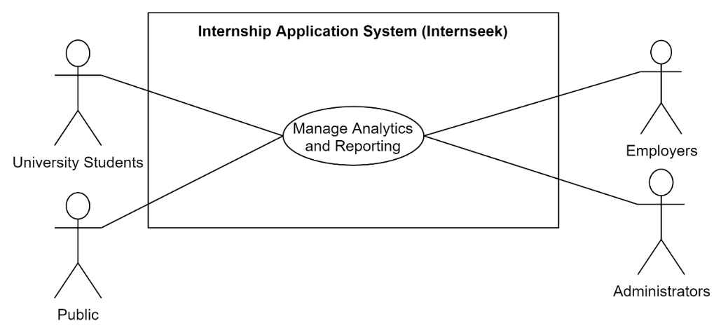

Figure 3‑19: Use Case Diagram (Manage Analytics and Reporting)

Table 3‑10: Use Case Description (Manage Analytics and Reporting)

|  |  |
| --- | --- |
| **Use Case Name** | Manage Analytics and Reporting |
| **Brief Description** | This use case allows University Students, Employers, and Administrators to access and view various analytics and reports related to internships and user activities on the Internseek system. |
| **Actor** | Public, University Students, Employers, Administrators |
| **Pre-Conditions** | University Students, Employers, and Administrators must log into the system to access various internship-related analytics and reports, while public users can view the Top 3 Companies Chart. |
| **Basic Flow** | Actor: Public  **Top 3 Companies**   1. Users access the main page of the system. 2. The system displays the top 3 companies on the main page. 3. Use case ends.   Actor: University Students  **View Internship Metrics**   1. University students click the <<My Internships>> button on the navbar. 2. The system calculates the number of bookmarked internships, matched internships, applied internships, internships where the student is required to attend an interview, and shortlisted internships. 3. The system displays the My Internships page with the number of bookmarked internships, matched internships, applied internships, internships requiring an interview, shortlisted internships, and approved internships beside each heading. 4. University Students can view detailed analytics by clicking <<Matched Internships>> or <<Bookmark Internships>> button. **[A1: View Bookmark Internships] [A2: View Matched Internship]** 5. Use case ends.   **Actor: Employers**  **Employer Dashboard Metrics**   1. Employers log into the system. 2. The system retrieves the total number of internship applications, internship posting, shortlisted applicants, rejected applicants, accepted applicants, and interview applicants. 3. The system displays the number of internship applications received. 4. The system displays the employer dashboard page with the total number of internship applications, shortlisted applicants, rejected applicants, accepted applicants, and interview applicants. These totals are as individual card buttons, but the number of total internship postings is represented in text. 5. Employers can access the detailed listings of each metric by clicking on the specific card button. 6. Use case ends.   **Monthly Internship Application Report Graph**   1. Employers click the <<My Report>> button. 2. The system calculates the total number of internship applications based on the month. 3. The system displays a graph based on the total number of applications per month. 4. Employers view the graph.   **Actor: Administrators**  **Overall System Metrics**   1. Administrators log into the system. 2. The system retrieves the total number of available internships, registered university students, and registered companies. 3. The system displays the admin dashboard page with the total number of available internships, registered university students, and registered companies. These totals are as individual card buttons. 4. Administrators can access detailed listings for available internships, registered university students, and registered companies by clicking on the respective card buttons. **[A3: View Available Internships] [A4: View Registered University Students] [A5: View Registered Companies & Update Rating]** 5. Use Case ends. |
| **Alternative Flow** | **Actor: University Students**  **[A1: View Matched Internships]**   1. University students click the <<Matched Internship>> button. 2. The system retrieves the internships that match the study scope of university students. 3. The system displays matched internships in a list with the internship details. 4. University Students click the internship card to view the detailed information about the internship. 5. The system retrieves the selected internship details. 6. The system displays the selected internship details. 7. The use case ends.   **[A2: View Bookmark Internships]**   1. University students click the <<Bookmark Internships>> button. 2. The system retrieves the internships that were previously bookmarked by university students. 3. The system displays bookmark internships in a list with their details. 4. University Students click the internship card to view detailed information about the internship. 5. The system retrieves the selected internship details. 6. The system displays the selected internship details. 7. The use case ends.   **Actor: Administrators**  **[A3: View Available Internships]**   1. The administrator clicks the <<Available Internship>> card button or the <<Internships List>> button on the navbar. 2. The system retrieves available internships data. 3. The system displays the available internships in a list. 4. The administrator can browse and view the internships list. 5. If the administrator wants to view the details of the internships, the administrator can click on the view details button corresponding to the specific internship. 6. The system retrieves the specific available internship details. 7. The system displays detailed information about the available internship. 8. The administrator views the details of the available internships. 9. Use Case ends.   **[A4: View Registered University Students]**   1. The administrator clicks the << Registered Internseekers>> card button or clicks the <<Internseekers List>> button on the navbar. 2. The system retrieves the registered internseekers data. 3. The system displays the registered internseekers in a list. 4. The administrator can browse and view the internseekers list. 5. If the administrator wants to view the details of the internseeker, the administrator can click on the view details button corresponding to the specific internseeker. 6. The system retrieves the specific available internseeker details. 7. The system displays detailed information about the registered internseeker. 8. The administrator views the details of the registered internseeker. 9. Use Case ends.   **[A5: View Registered Companies & Update Rating]**   1. The administrator clicks the <<Registered Companies>> card button or clicks the <<Company List>> button on the navbar. 2. The system retrieves all registered companies from the database. 3. The system displays all registered companies in a list. 4. The administrator can browse and view the companies list. 5. If the administrator wants to view the details of the company, the administrator can click on the view details button corresponding to the specific company. 6. The system retrieves the specific registered company details. 7. The system displays detailed information about the registered company details. 8. The administrator reviews the details of the registered company. 9. The administrator selects the rating of the company. 10. The administrator clicks the <<Update>> button. 11. The system validates and updates the rating given in the database. 12. Use Case ends. |
| **Exception Flow** | None |
| **Post-Conditions** | * University students can access detailed analytics about their internship activities. * University students can view matched internships based on their study scope and internships that were previously bookmarked by university students. * Employers can view detailed reports about internship applications. * Administrators can monitor the overall activity of the Internseek system. * Public users can view the top 3 companies. |
| **Rules** | None |
| **Constraints** | None |

##### Manage Messaging Features

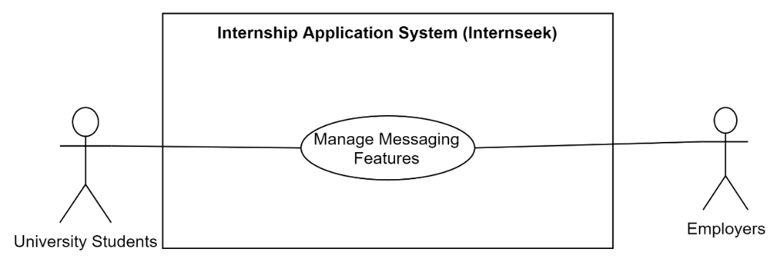

Figure 3‑20: Use Case Diagram (Manage Messaging Features)

Table 3‑11: Use Case Description (Manage Messaging Features)

|  |  |
| --- | --- |
| **Use Case Name** | Manage Messaging Features |
| **Brief Description** | This use case enables university students and employers to access and use messaging features within the system to facilitate communication between university students and employers. |
| **Actor** | University Students, Employers |
| **Pre-Conditions** | University Students and Employers must login into the system. |
| **Basic Flow** | Actor: University Students  **Send Message**   1. University Students navigate to the internship details page or the employer profile. 2. While viewing the details, University Students click the message button. 3. The system displays a message interface. 4. University Students enter their message in the text field provided. 5. Optionally, University Students may attach photos or documents. 6. After entering the message and attaching files, University Students click the send button. 7. The system validates the message content and attachments and saves the message and attachments. 8. The system displays message details and attachments on the message chat with the date and time the message was created. 9. University Students can view the sent message in the message chat, indicating that their message has been sent successfully. 10. Use Case ends.   **View Received Message and Reply Message**   1. University students click the message icon on the navigation bar. 2. If there are unread messages, the message icon displays a red badge with a number representing the count of unread messages. 3. The system retrieves the received messages from the database. 4. The system navigates university students to the message inbox page with the received messages. 5. University students view the received messages. 6. University students can click on a specific message. 7. The system retrieves and displays the specific message detail. 8. University students view the specific message details. 9. University students can enter the message in the text field to reply to the employer. 10. Optionally, university students can attach documents or photos. 11. University students click the <<Send>> Button. 12. The system validates the message content and attachments and saves the message and attachments. 13. The system displays message details and attachments on the message chat with the date and time the message was created. 14. University students can view the sent message in the message chat, indicating that their message has been sent successfully. 15. Use Case ends.   Actor: Employers  **Send Message**   1. Employers navigate to the applicants list page. 2. While viewing the applicant details, employers click the message button. 3. The system displays a message interface. 4. Employers enter their message in the text field provided. 5. Optionally, employers may attach photos or documents. 6. After entering the message and attaching files, employers click the send button. 7. The system validates the message content and attachments and saves the message and attachments. 8. The system displays message details and attachments on the message chat with the date and time the message was created. 9. Employers can view the sent message in the message chat, indicating that their message has been sent successfully. 10. Use Case ends.   **View Received Message and Reply Message**   1. Employers click the message icon on the navigation bar. 2. If there are unread messages, the message icon displays a red badge with a number representing the count of unread messages. 3. The system retrieves the received messages from the database. 4. The system navigates employers to the message inbox page with the received messages. 5. Employers view the received messages. 6. Employers can click on a specific message. 7. The system retrieves and displays the specific message detail. 8. Employers view the specific message details. 9. Employers can enter the message in the text field to reply to the student. 10. Optionally, employers can attach documents or photos. 11. Employers click the <<Send>> Button. 12. The system validates the message content and attachments and saves the message and attachments. 13. The system displays message details and attachments on the message chat with the date and time the message was created. 14. Employers can view the sent message in the message chat, indicating that their message has been sent successfully. 15. Use Case ends. |
| **Alternative Flow** | None |
| **Exception Flow** | None |
| **Post-Conditions** | Sent messages are visible in the message chat and saved into the system.  Received messages are displayed in the message inbox. |
| **Rules** | **[R1:** **Supported File Types]**   1. Only allow attaching files in PNG, jpg, jpeg, and pdf formats. |
| **Constraints** | None |

### Sequence Diagram

##### Register Account

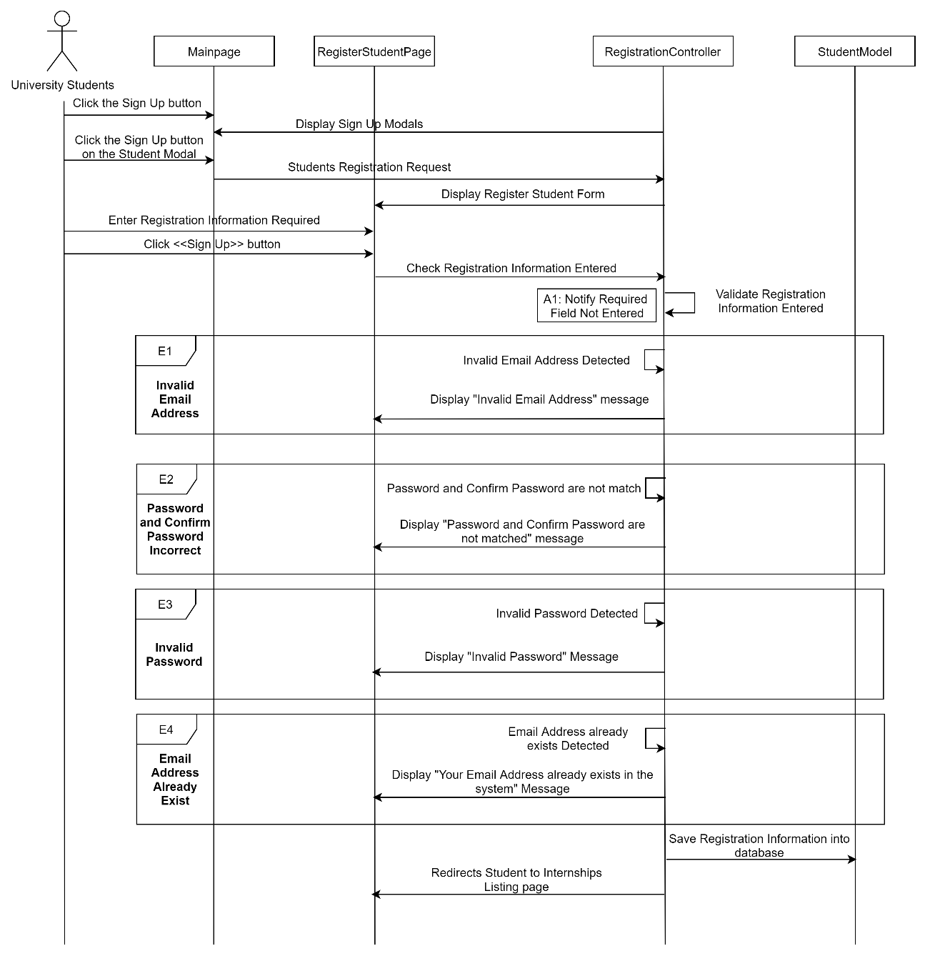

Figure 3‑21: Sequence Diagram (Basic Flow for university students to register account & Exception Flow for Invalid Email Address, Password and Confirm Password Incorrect, Invalid Password, and Email Address Already Exist)

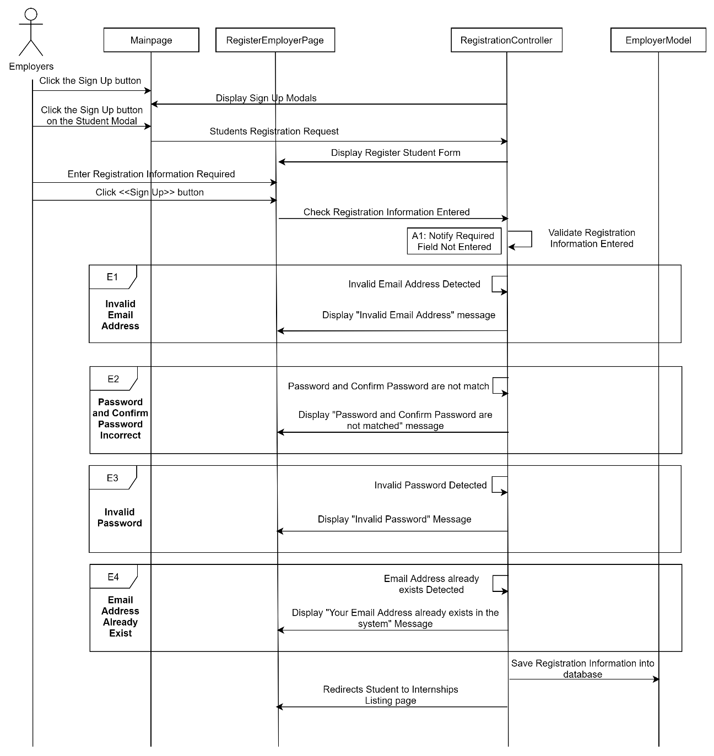

Figure 3‑22: Sequence Diagram (Basic Flow for employers to register account & Exception Flow for Invalid Email Address, Password and Confirm Password Incorrect, Invalid Password, and Email Address Already Exist)

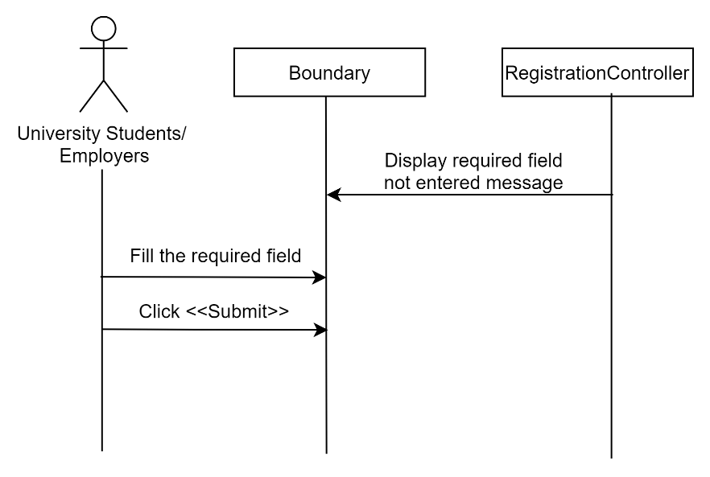

Figure 3‑23: Sequence Diagram (Alternative Flow: Alert Required Field Not Filled)

##### Manage Login

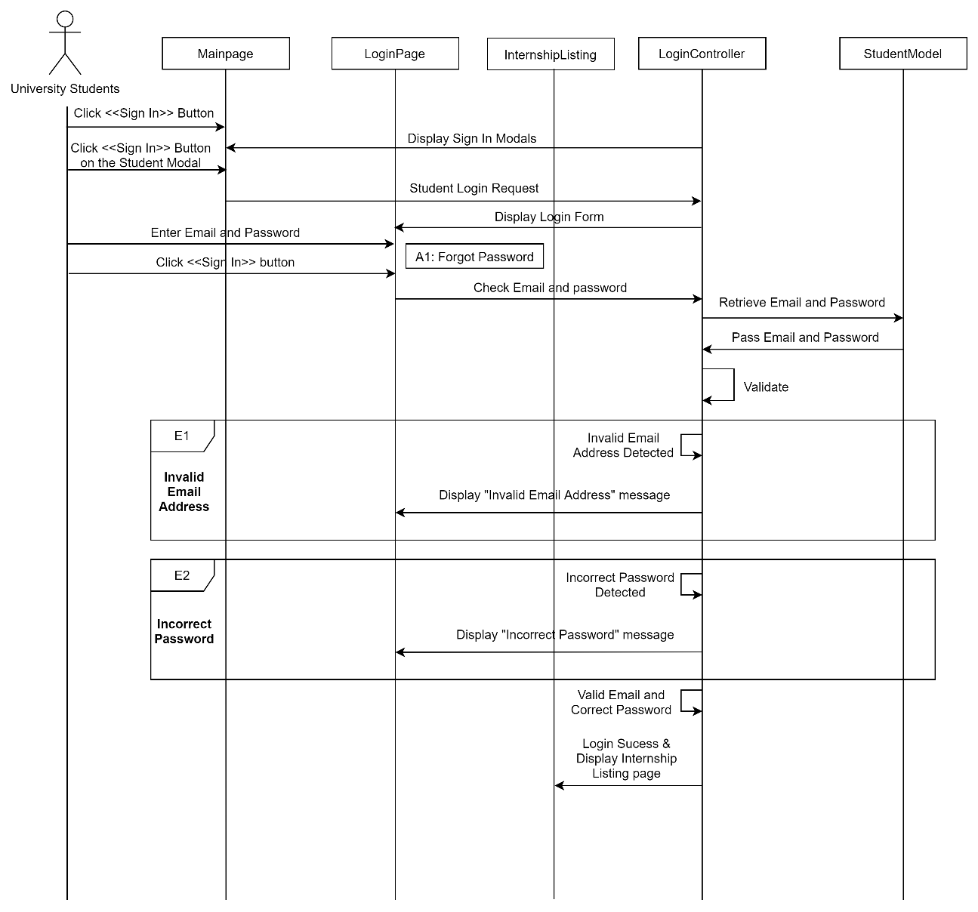

Figure 3‑24: Sequence Diagram (Basic Flow for university students to login into the system and exception flow for invalid email address and incorrect password)

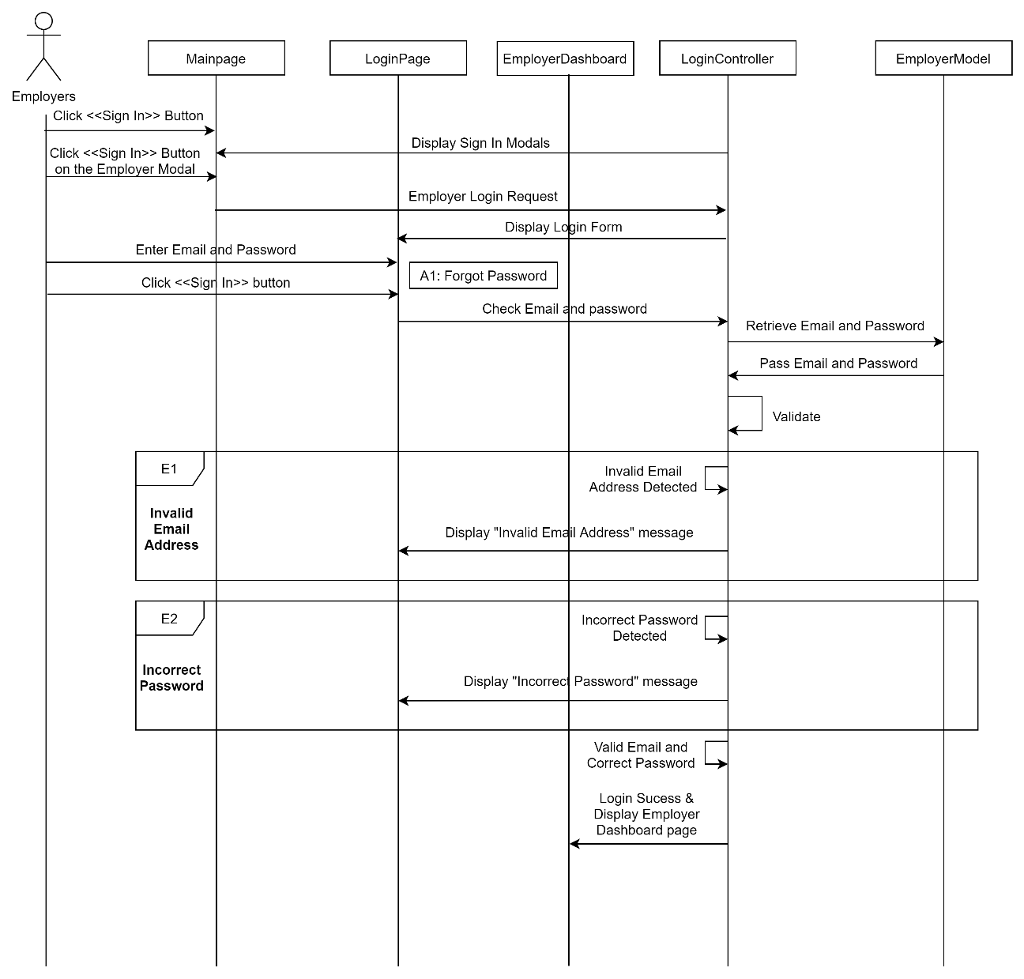

Figure 3‑25: Sequence Diagram (Basic Flow for employers to login into the system and exception flow for invalid email address and incorrect password)

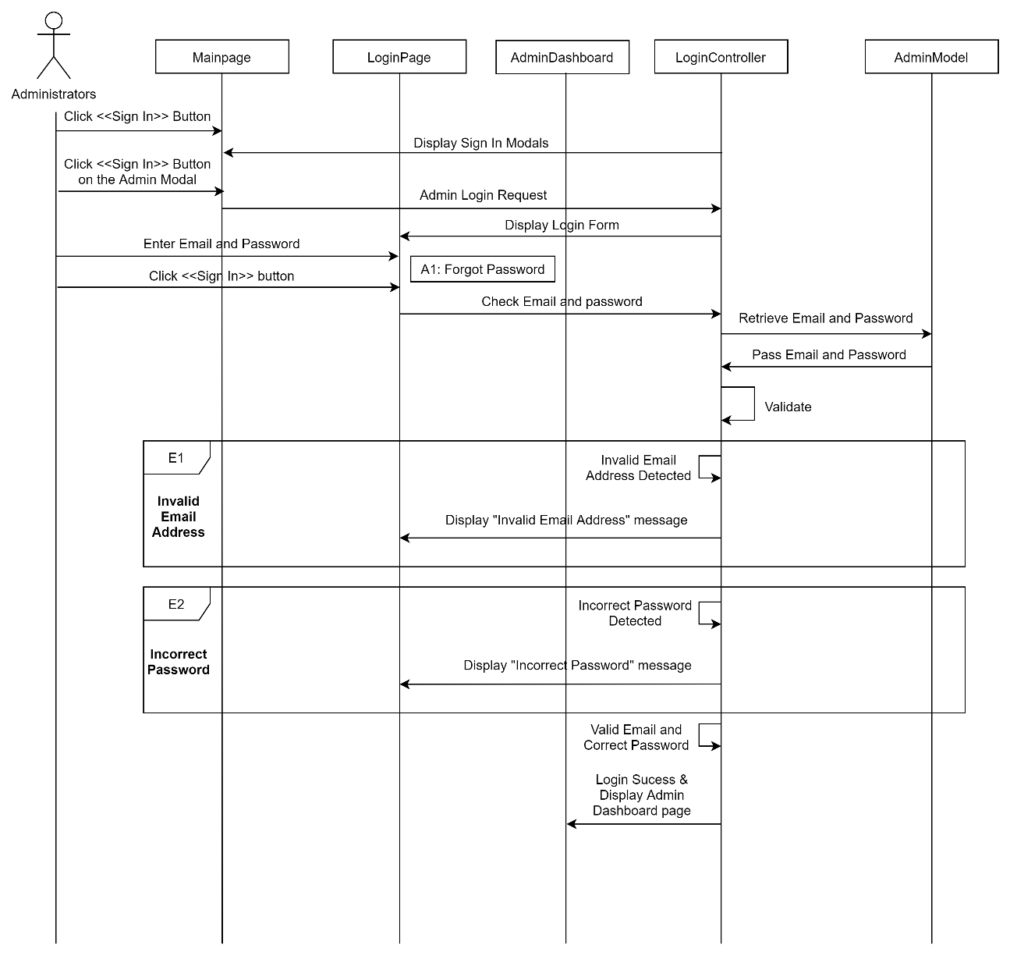

Figure 3‑26: Sequence Diagram (Basic Flow for administrators to login into the system and exception flow for invalid email address and incorrect password)

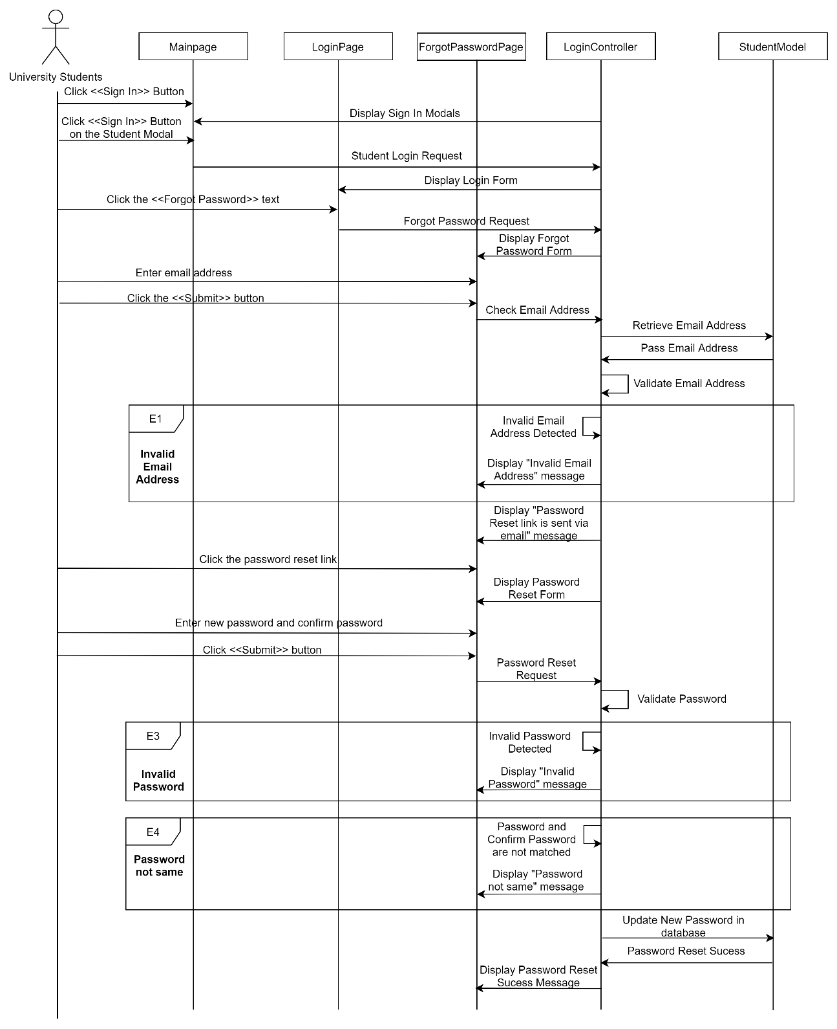

Figure 3‑27: Sequence Diagram (Basic Flow for university students to reset password if they forgot their password and Exception Flow for invalid email address, invalid password and password not same)

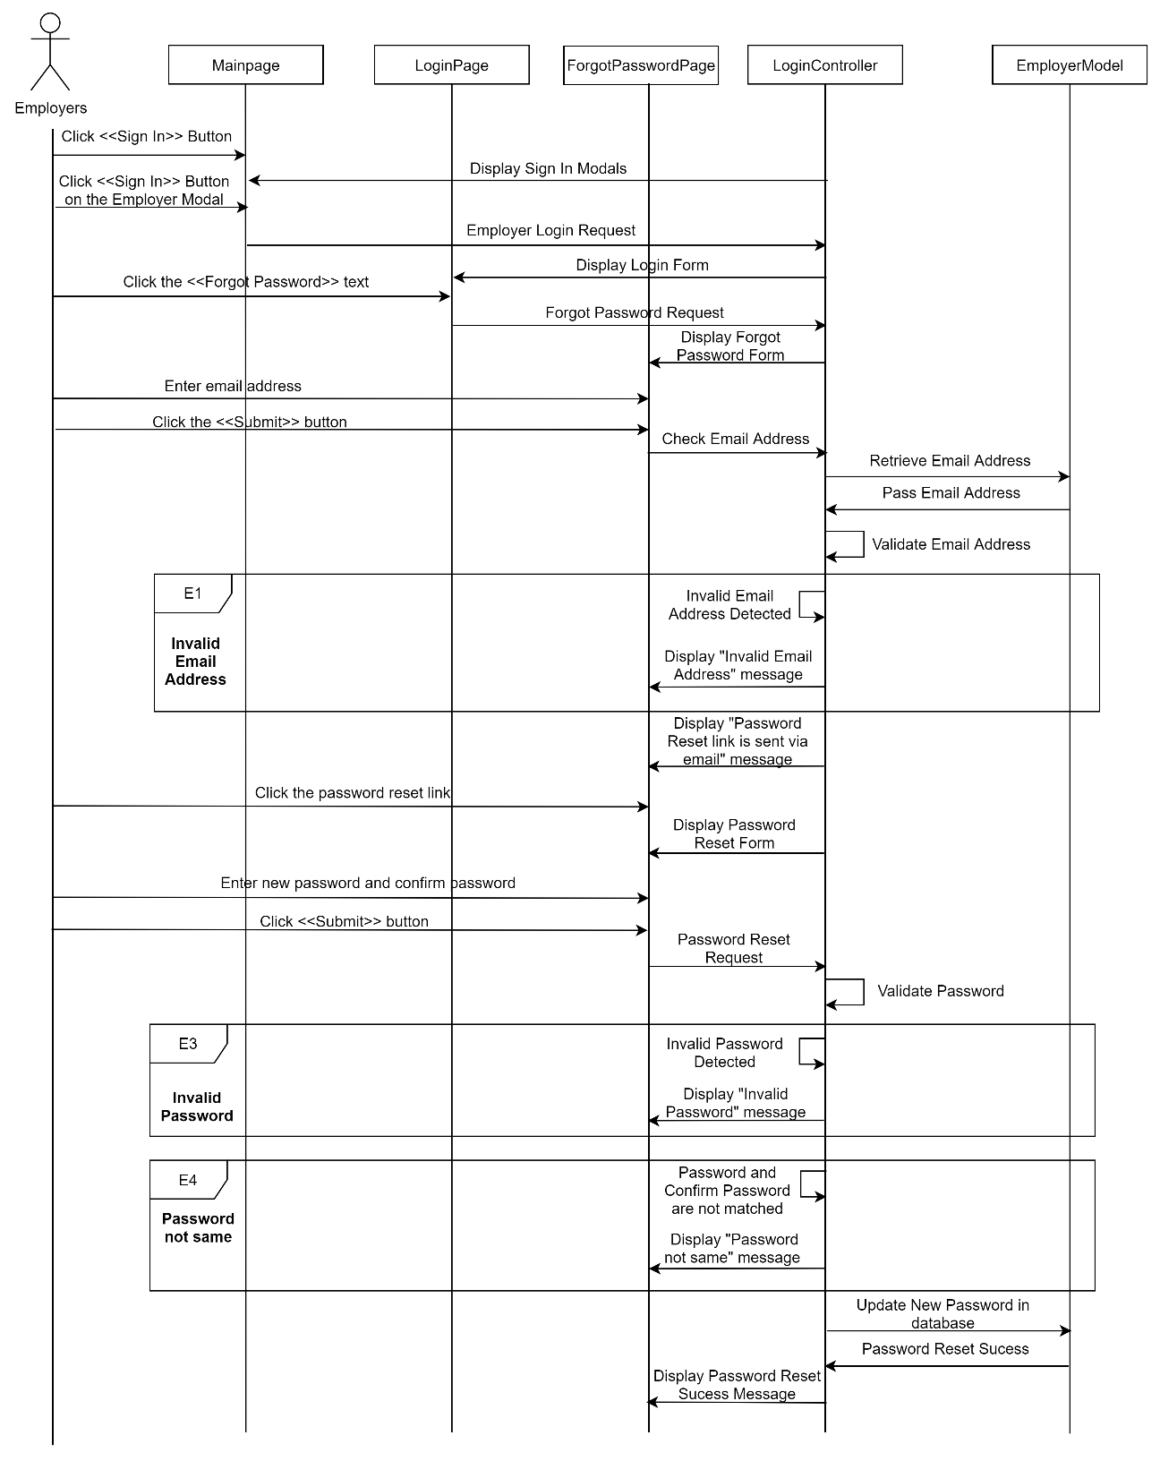

Figure 3‑28: Sequence Diagram (Basic Flow for employers to reset password if they forgot their password and Exception Flow for invalid email address, invalid password and password not same)

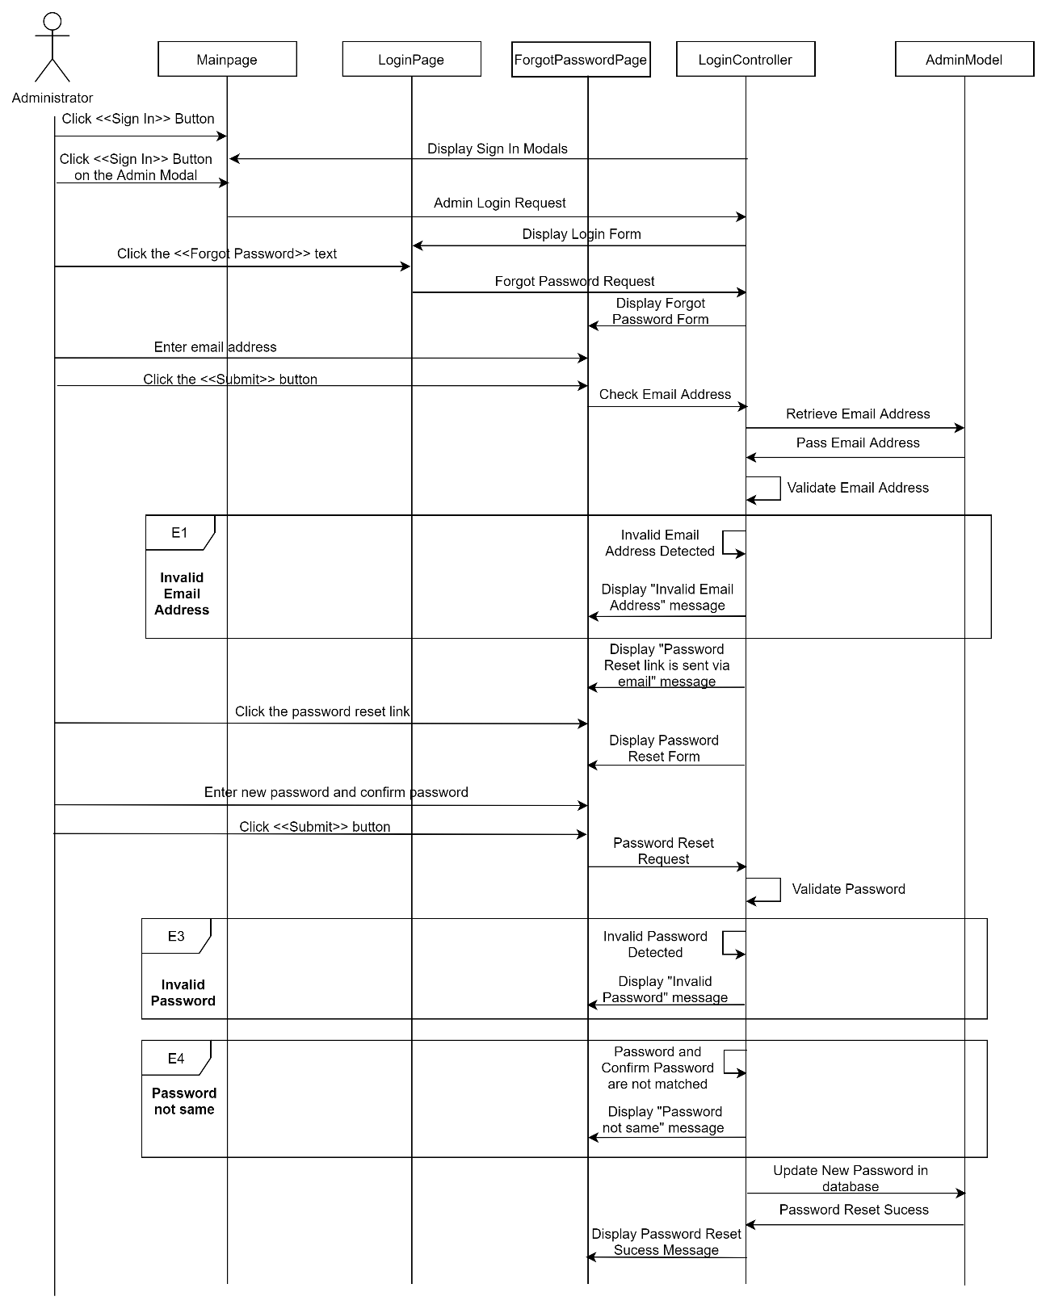

Figure 3‑29: Sequence Diagram (Basic Flow for administrators to reset password if they forgot their password and Exception Flow for invalid email address, invalid password and password not same)

##### Manage Company Registration

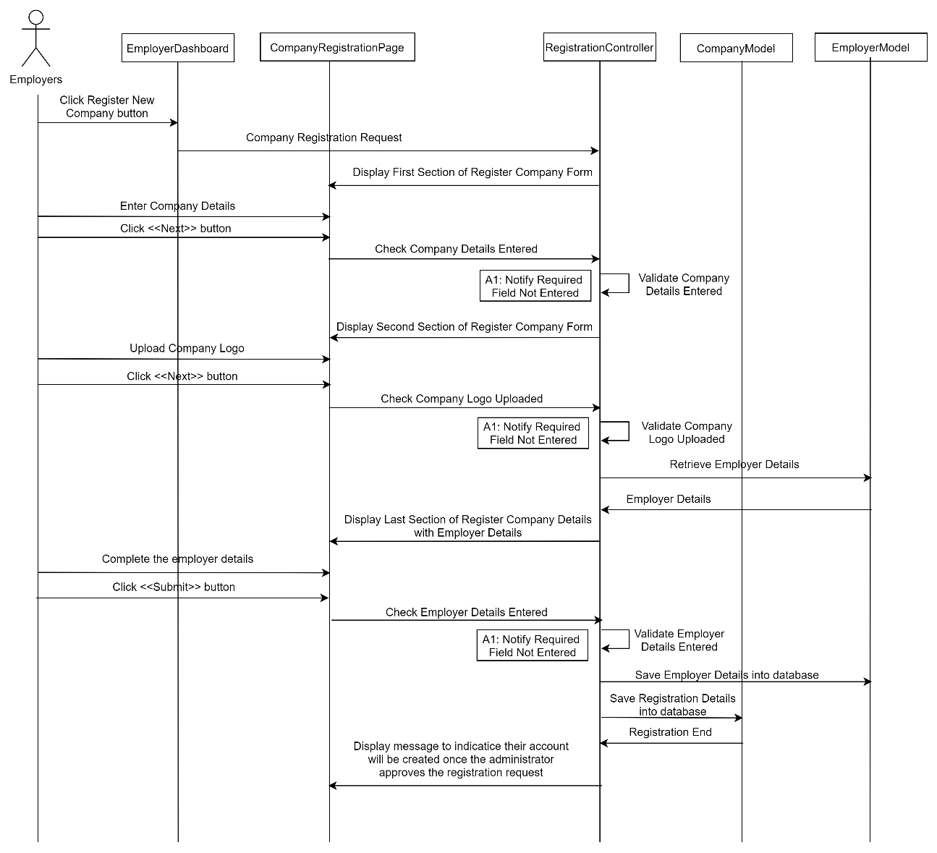

Figure 3‑30: Sequence Diagram (Basic Flow for employers: Register New Company)

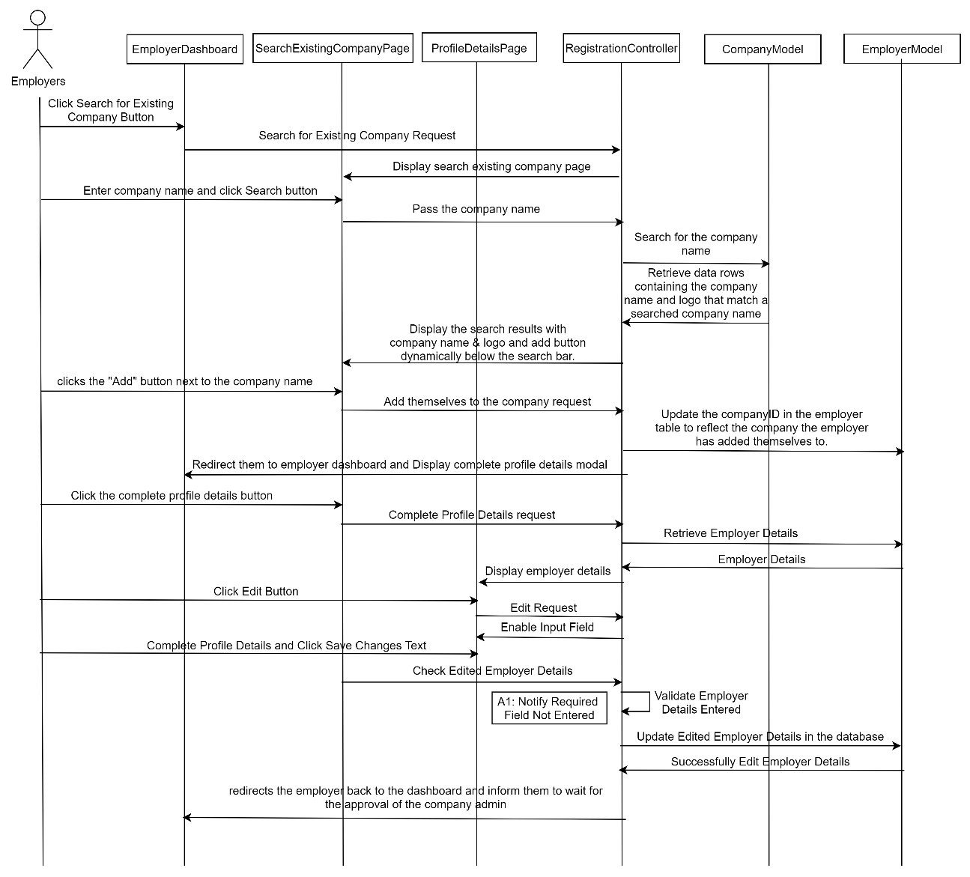

Figure 3‑31: Sequence Diagram (Basic Flow for employers: Search for Existing Company)

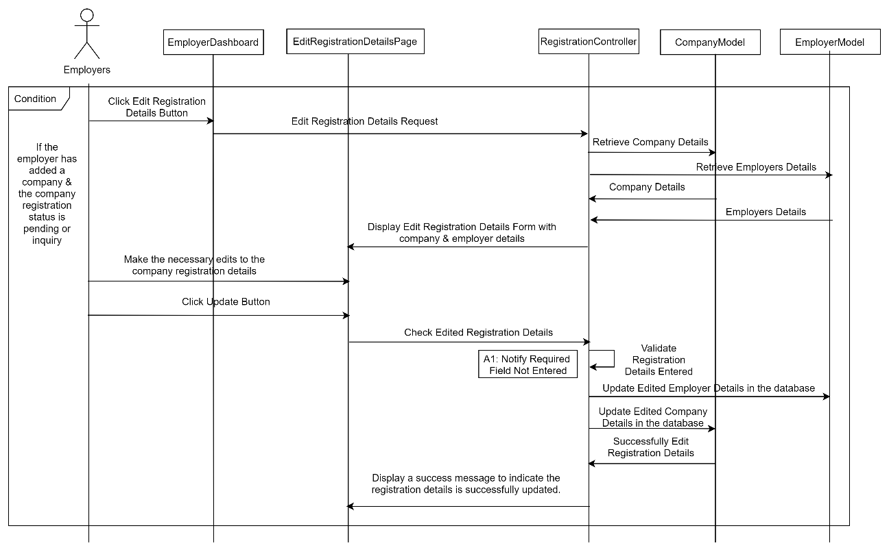

Figure 3‑32: Sequence Diagram (Basic Flow for employers: Edit Registration Details)

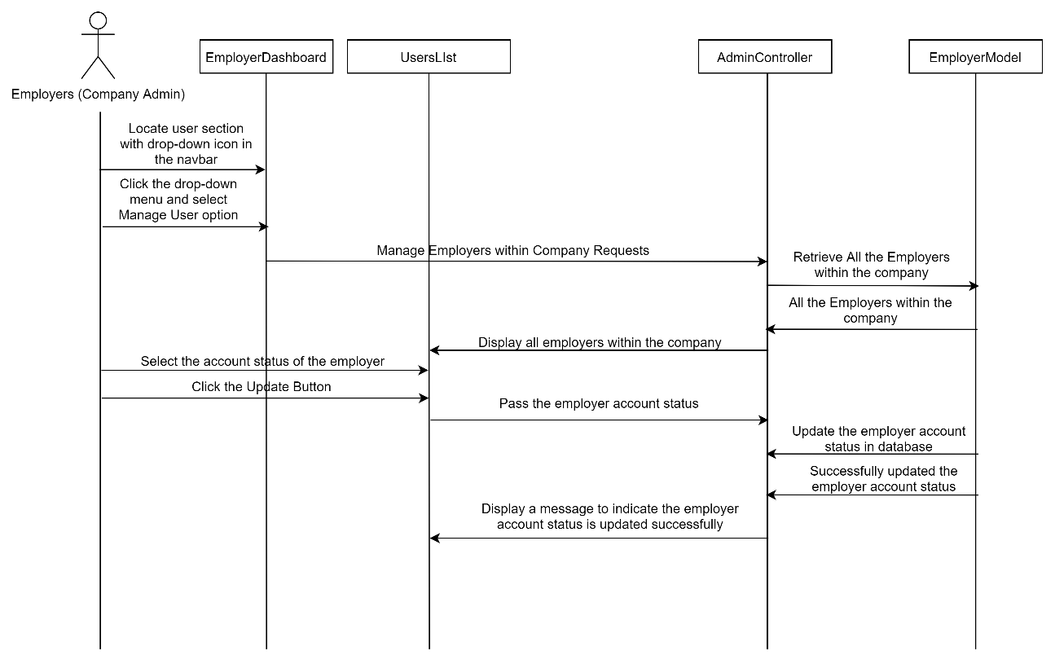

**Figure 3‑33: Sequence Diagram (Basic Flow for company admin: Review and Update Status of Employer Accounts)**

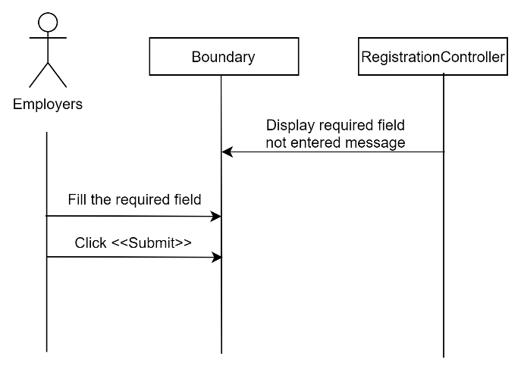

Figure 3‑34: Sequence Diagram (Alternative Flow: Alert Required Field Not Filled)

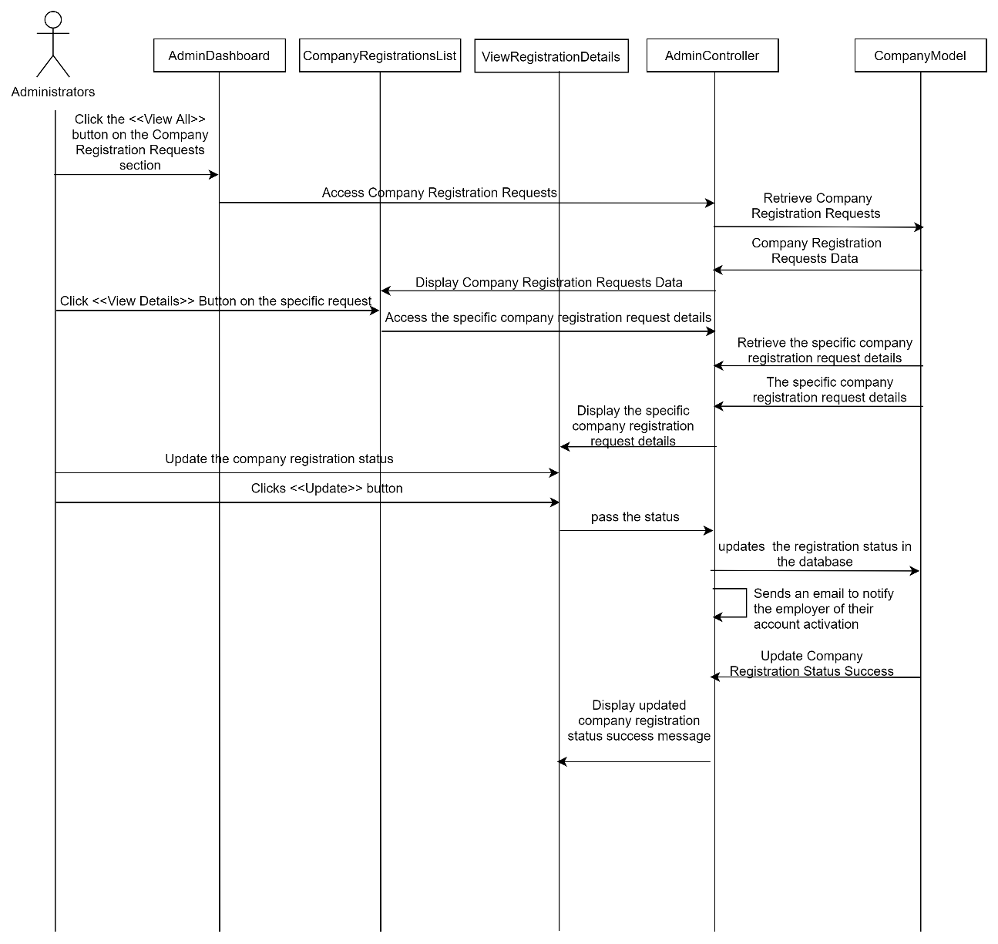

Figure 3‑35: Sequence Diagram (Basic Flow Review and Update Company Registration Status

##### Manage User Profile

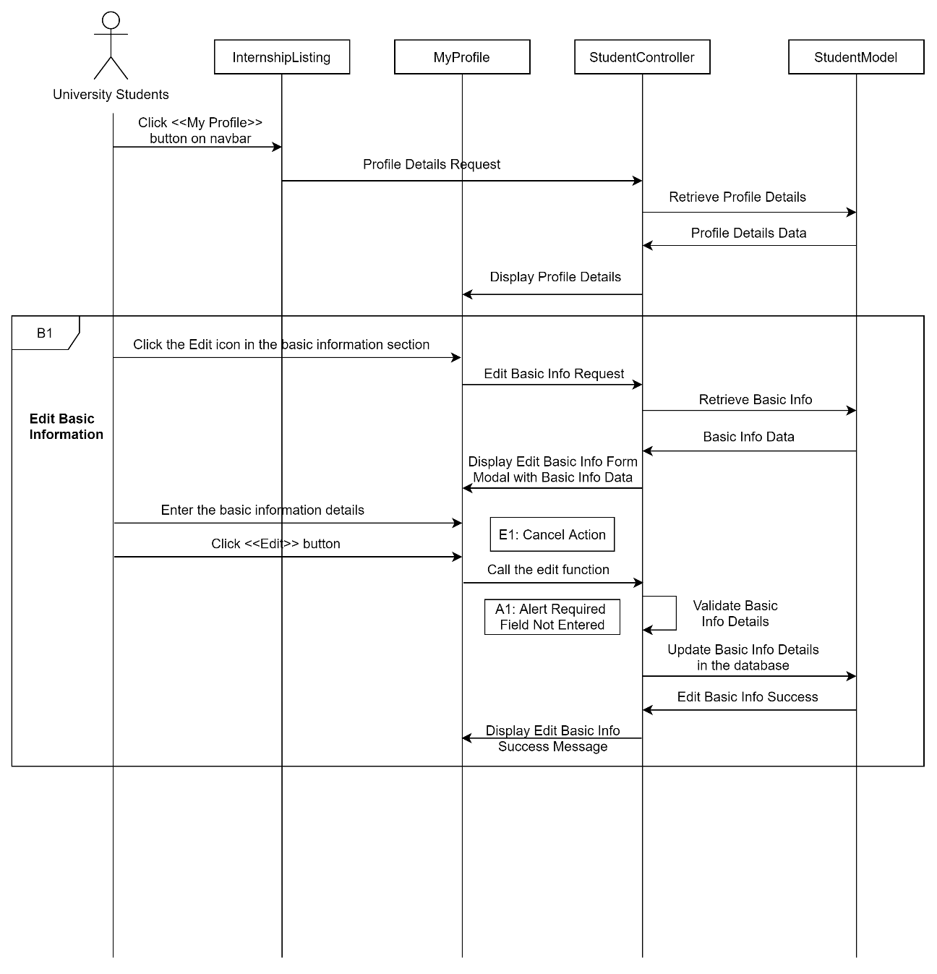

Figure 3‑36: Sequence Diagram (Basic Flow for university students to edit their information)

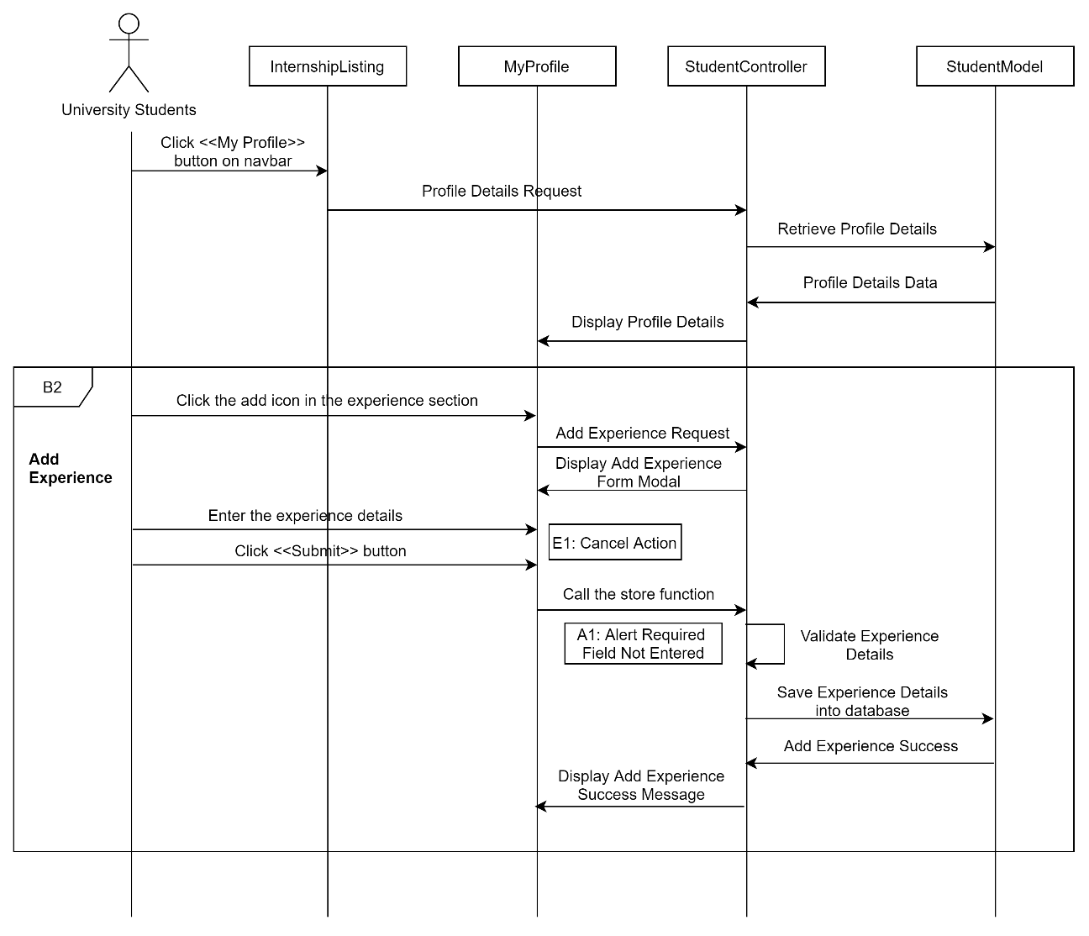

Figure 3‑37: Sequence Diagram (Basic Flow for university students to add experience info)

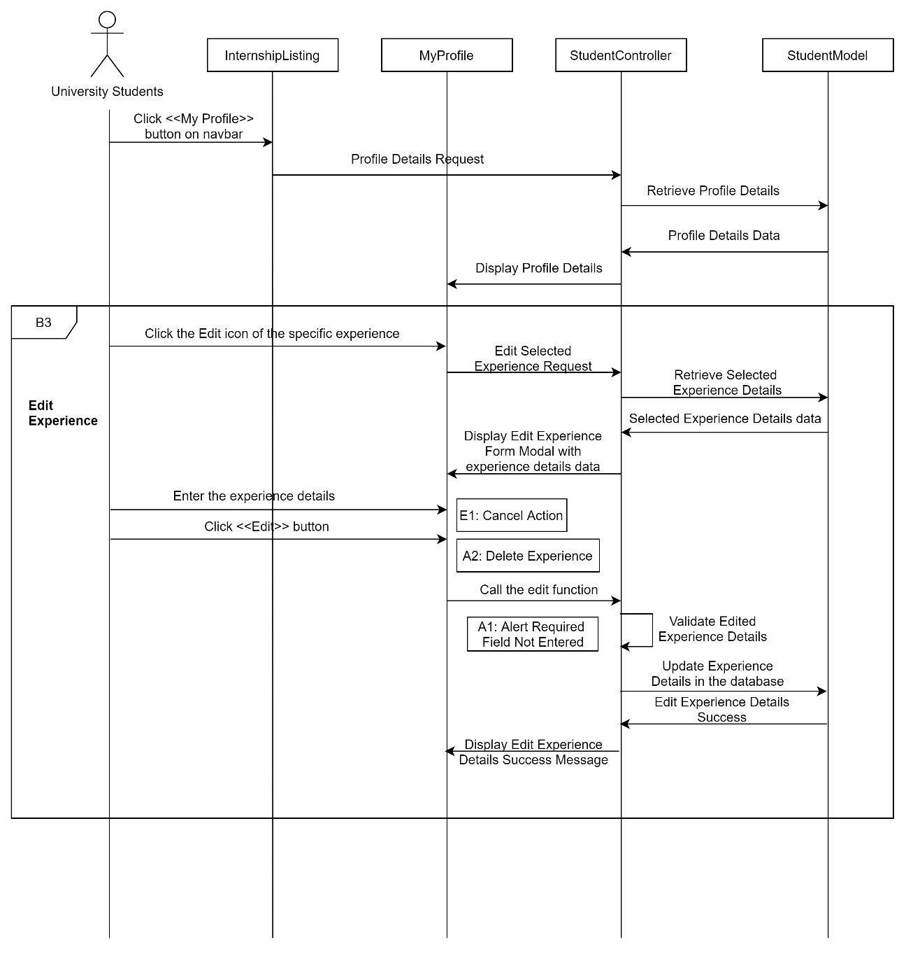

Figure 3‑38: Sequence Diagram (Basic Flow for university students to edit experience info)

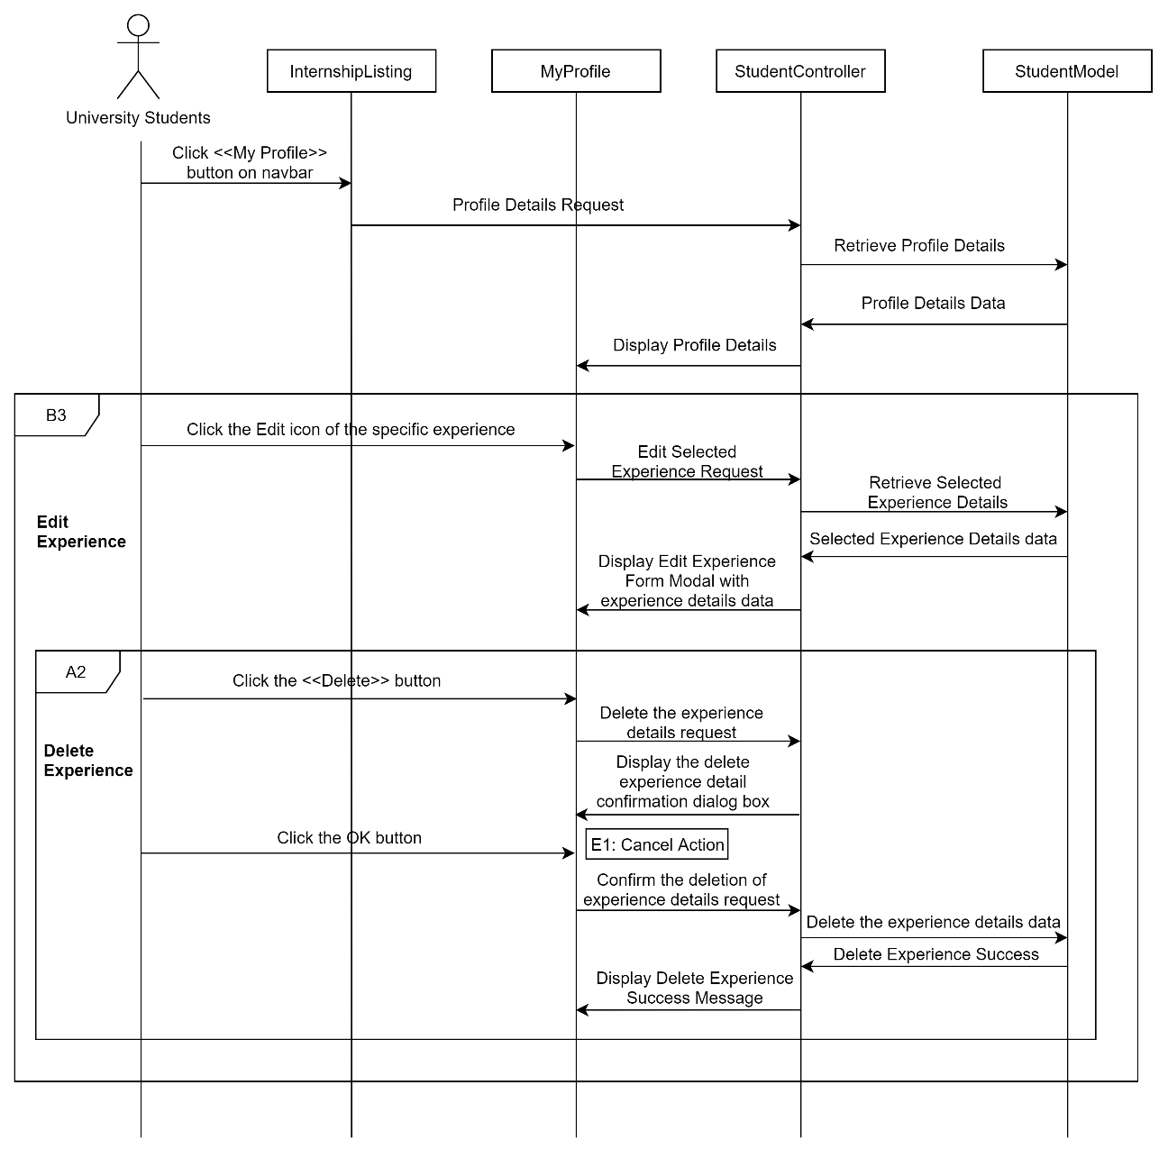

Figure 3‑39: Sequence Diagram (Alternative Flow for university students to delete experience info)

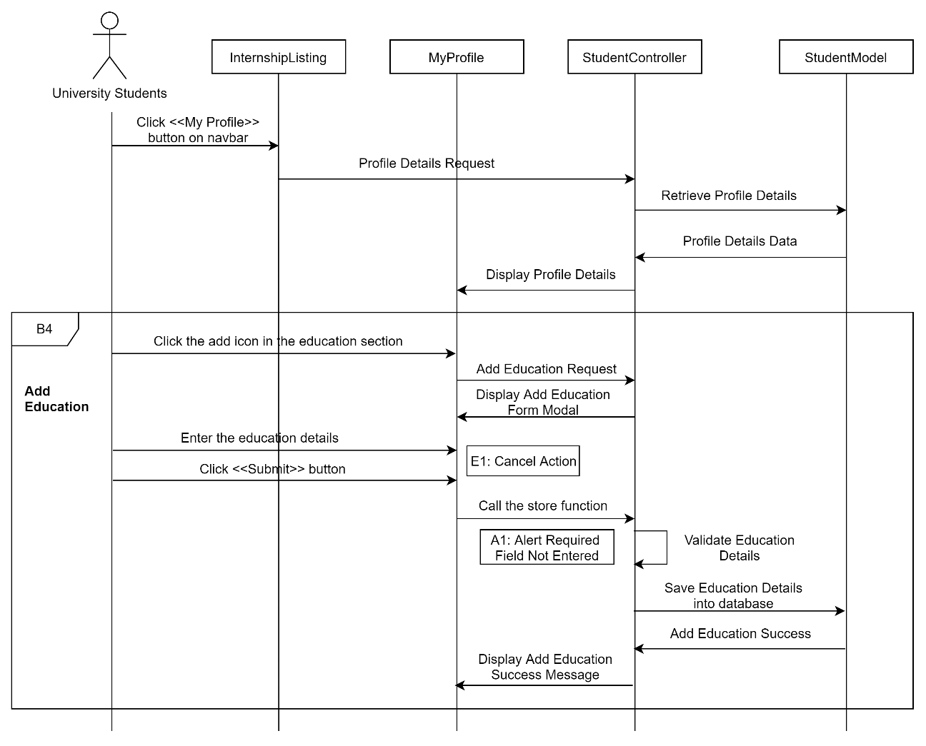

Figure 3‑40: Sequence Diagram (Basic Flow for university students to add education info)

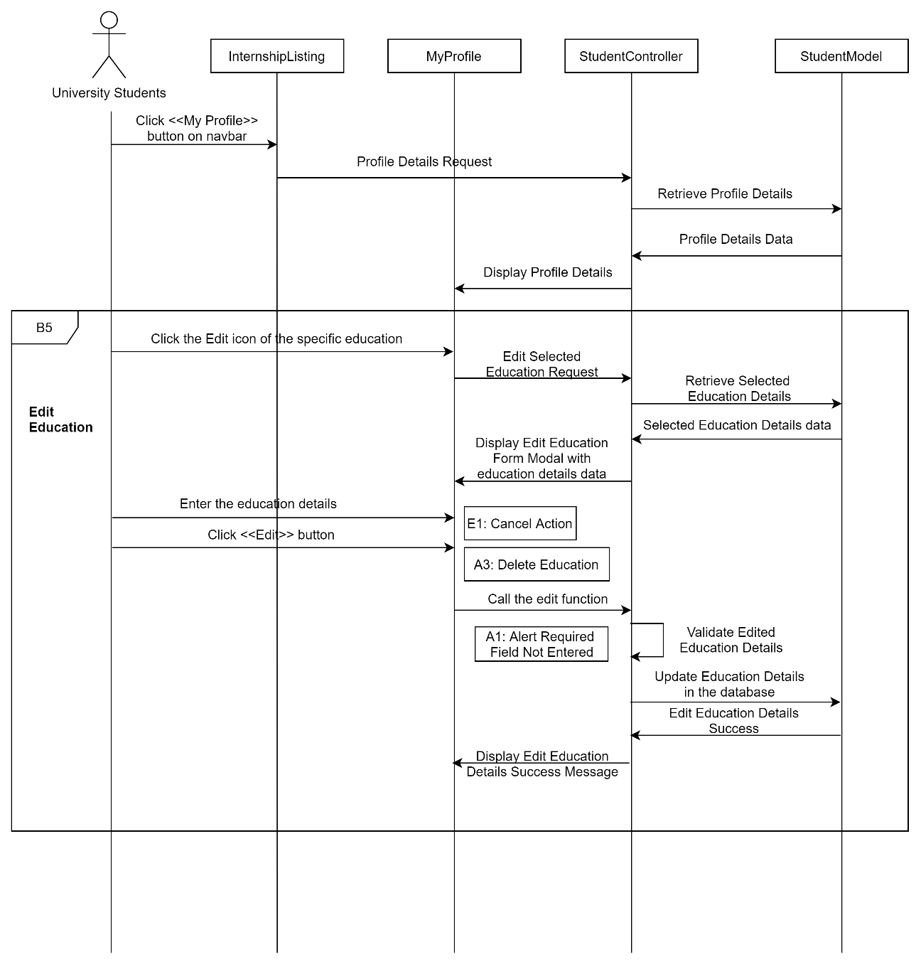

Figure 3‑41: Sequence Diagram (Basic Flow for university students to edit education info)

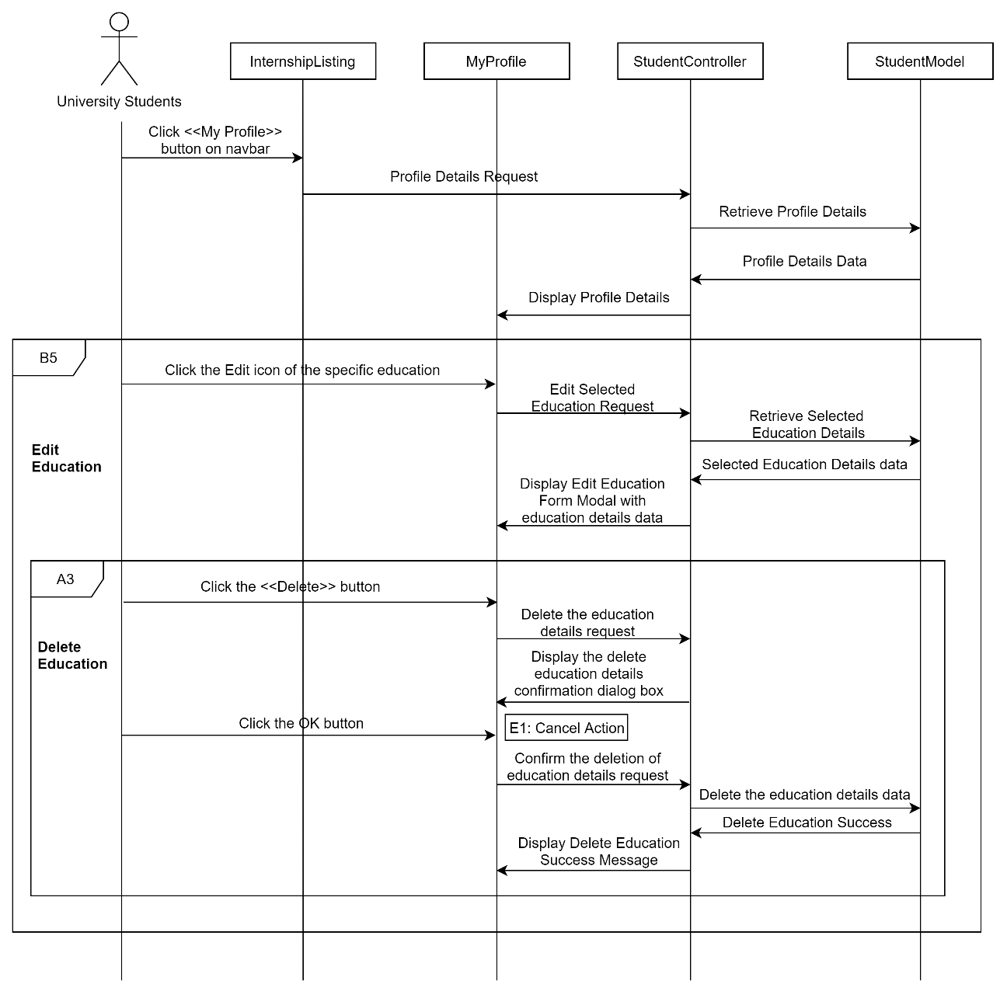

Figure 3‑42: Sequence Diagram (Alternative Flow for university students to delete education info)

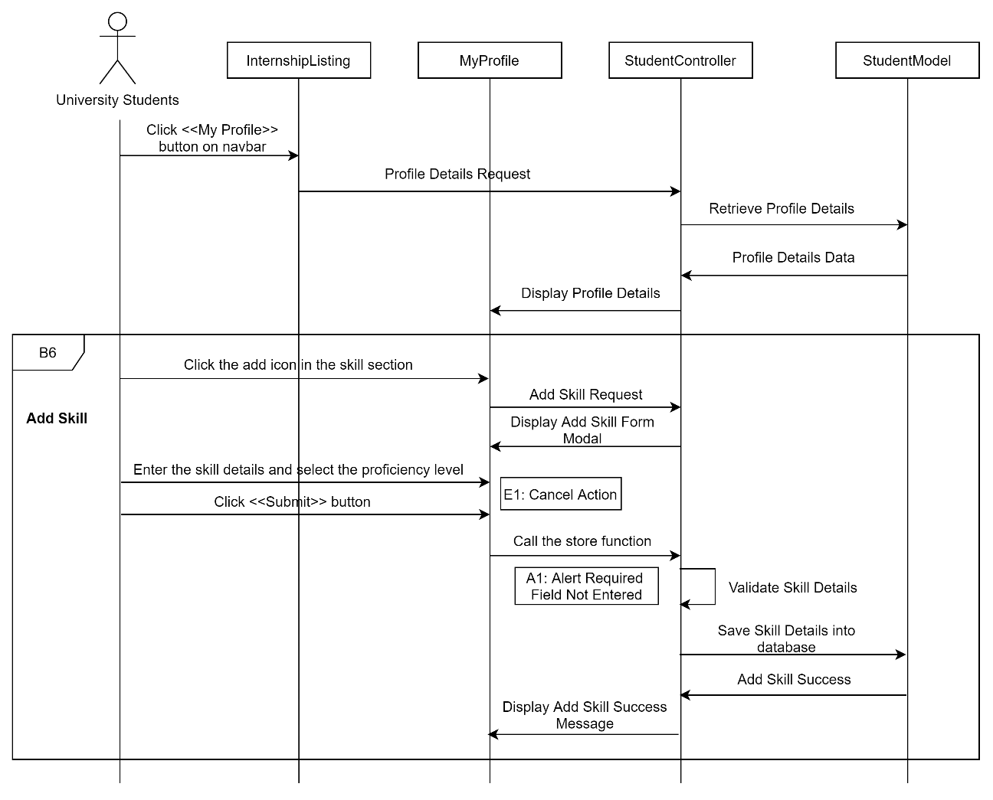

Figure 3‑43: Sequence Diagram (Basic Flow for university students to add skill)

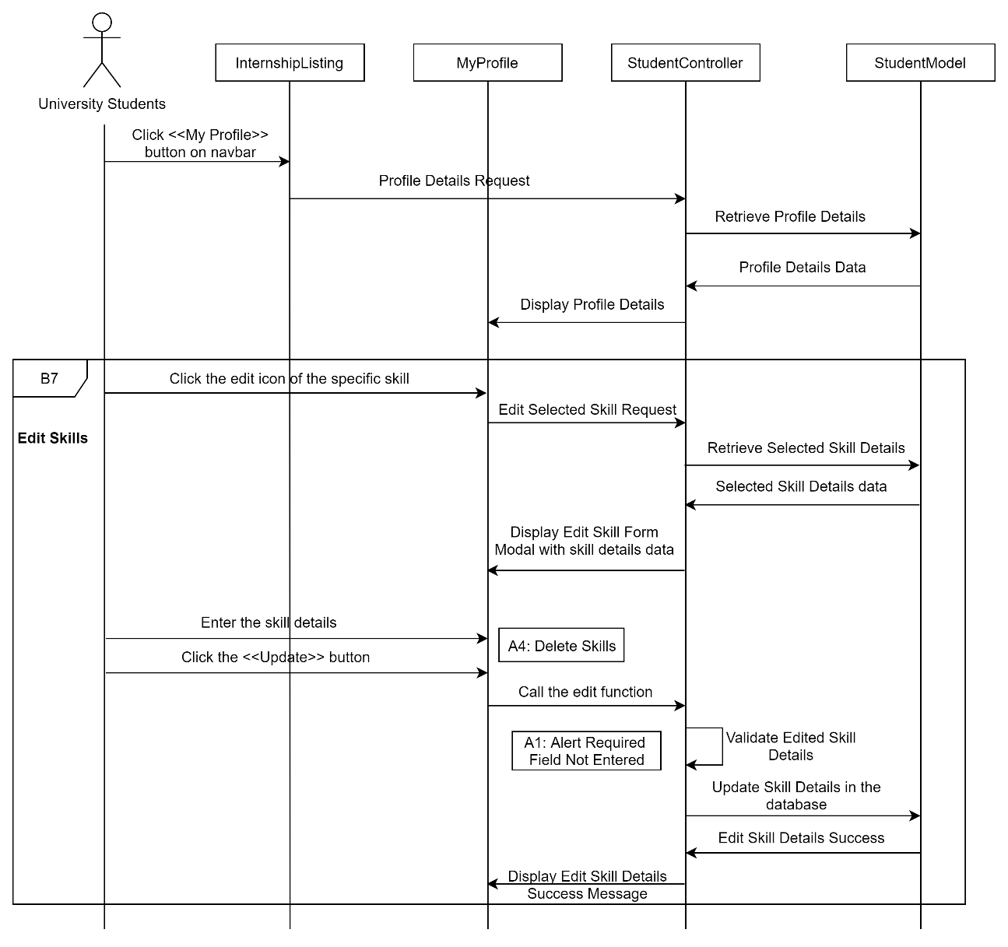

Figure 3‑44: Sequence Diagram (Basic Flow for university students to edit skills)

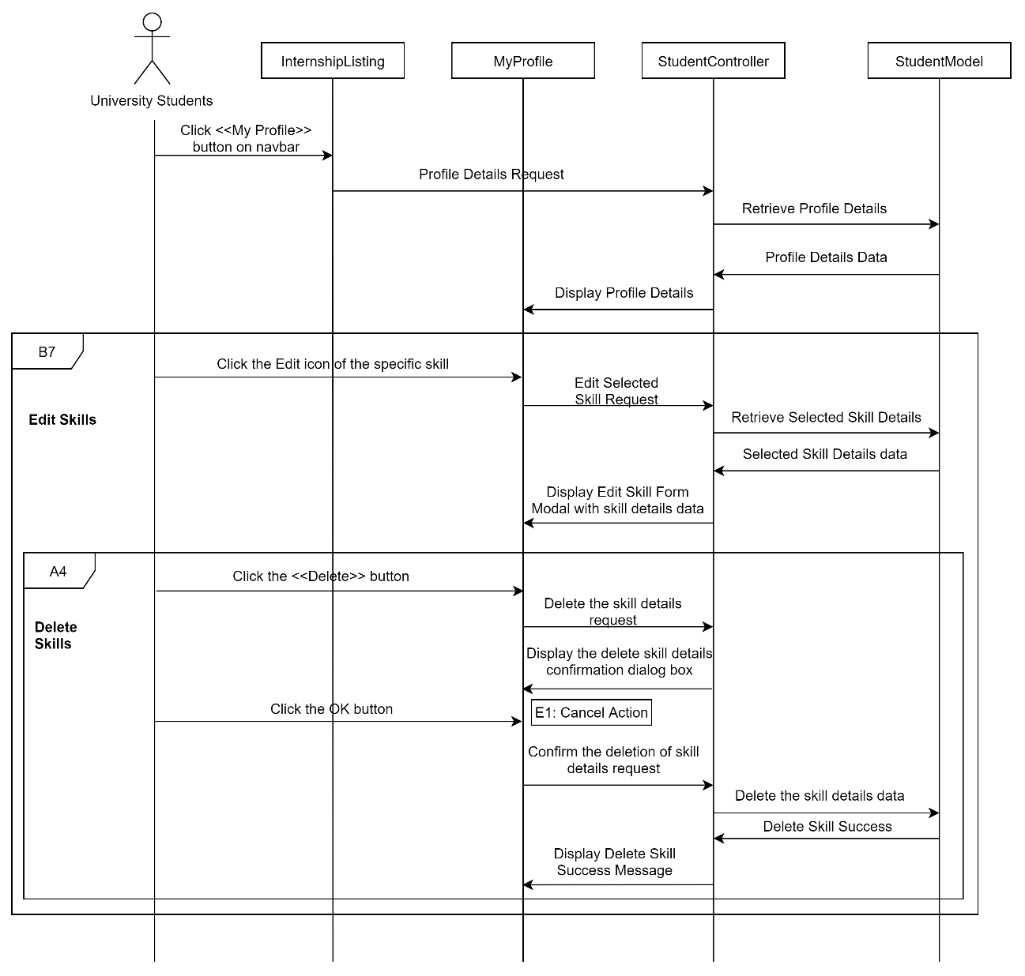

Figure 3‑45: Sequence Diagram (Basic Flow for university students to delete skills)

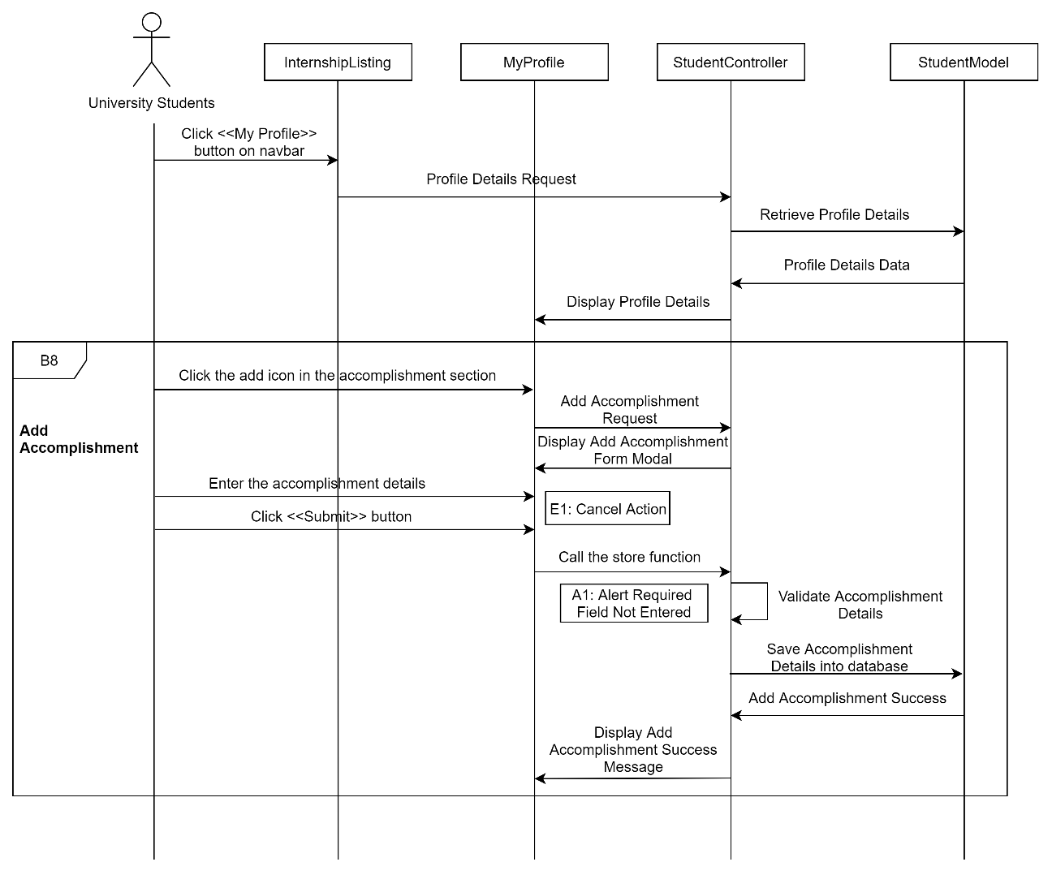

Figure 3‑46: Sequence Diagram (Basic Flow for university students to add accomplishment)

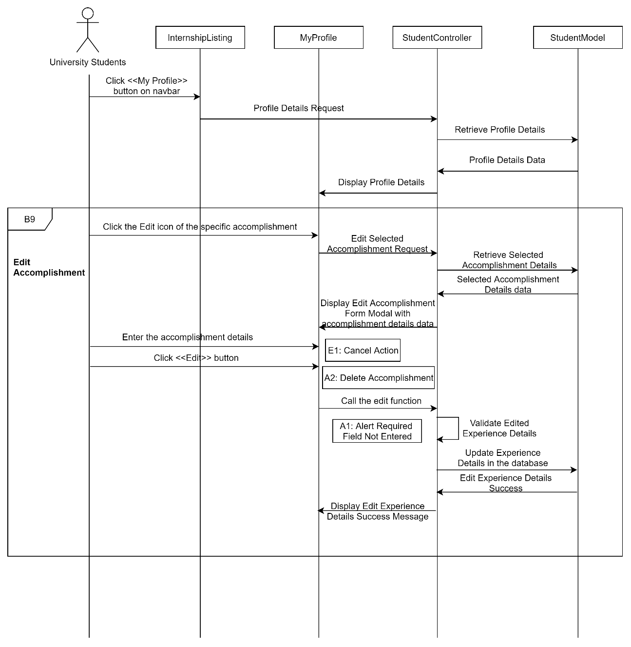

Figure 3‑47: Sequence Diagram (Basic Flow for university students to edit accomplishment)

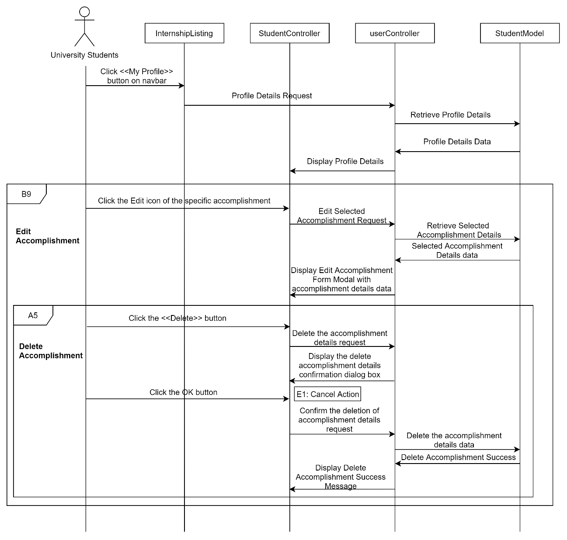

Figure 3‑48: Sequence Diagram (Alternative Flow for university students to delete accomplishment)

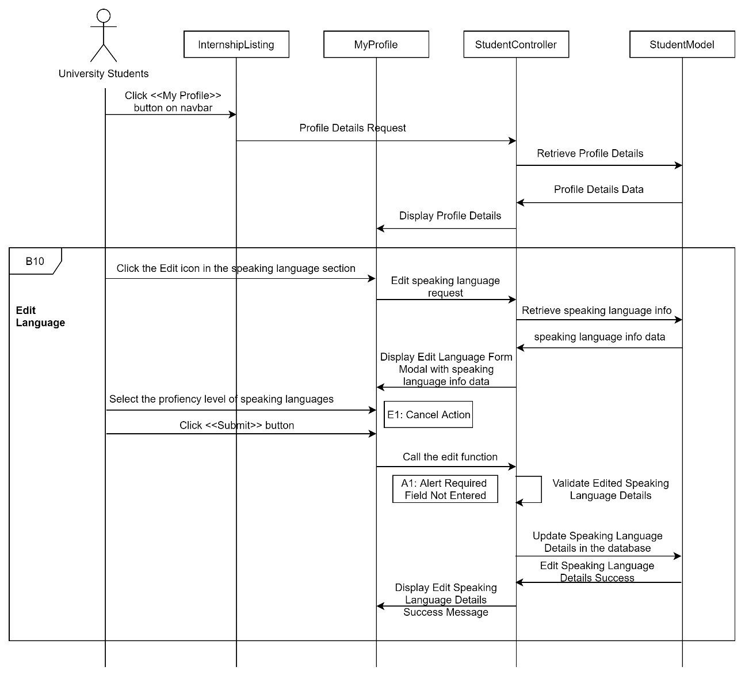

Figure 3‑49: Sequence Diagram (Basic Flow for university students to edit language)

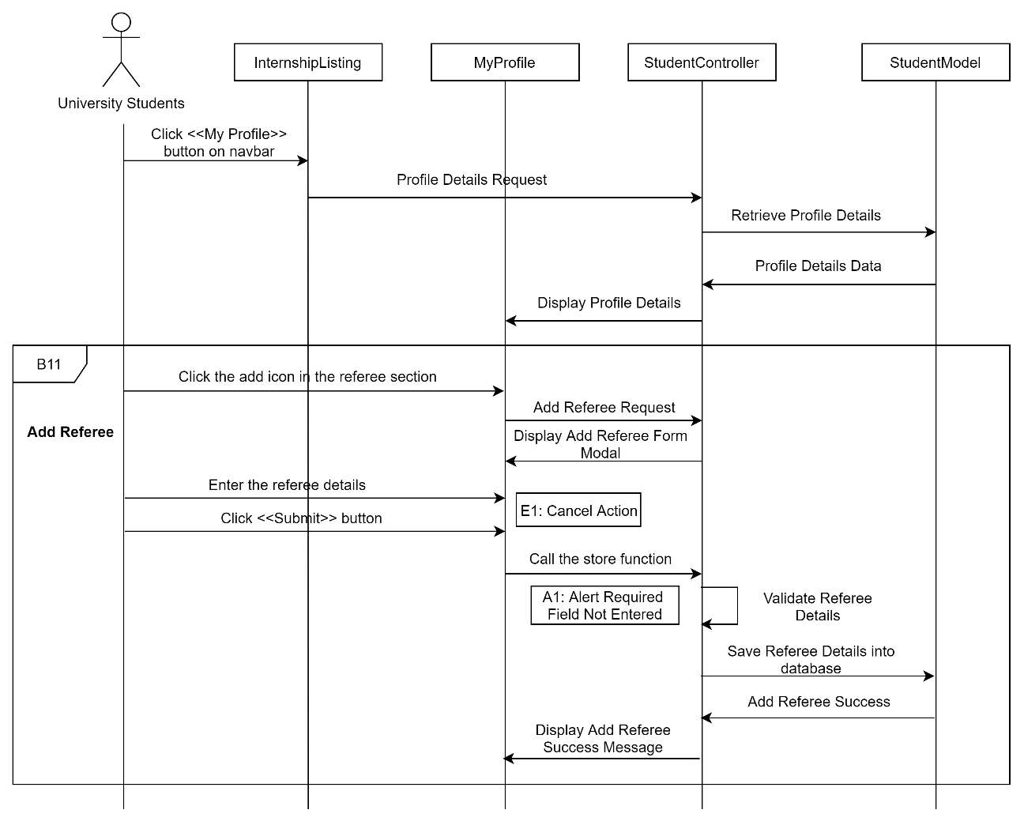

Figure 3‑50: Sequence Diagram (Basic Flow for university students to add referee)

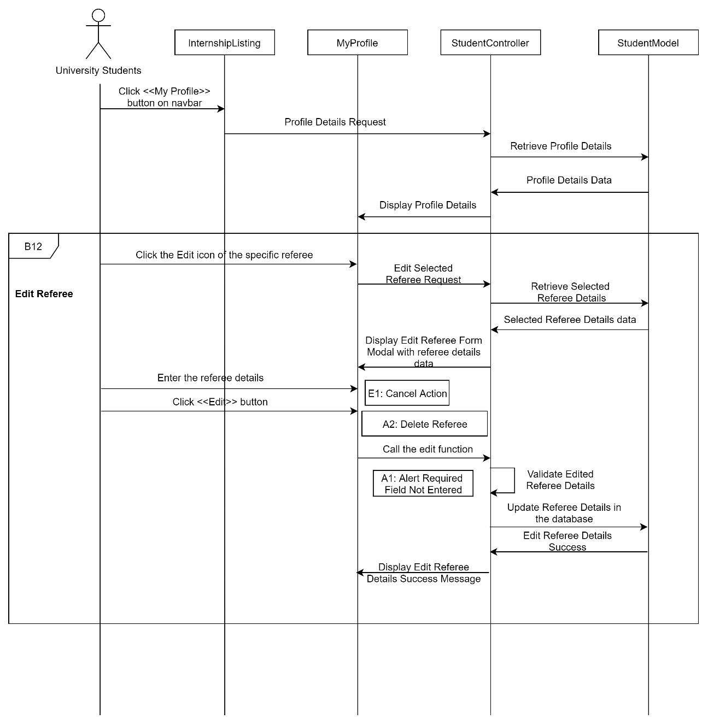

Figure 3‑51: Sequence Diagram (Basic Flow for university students to edit referee)

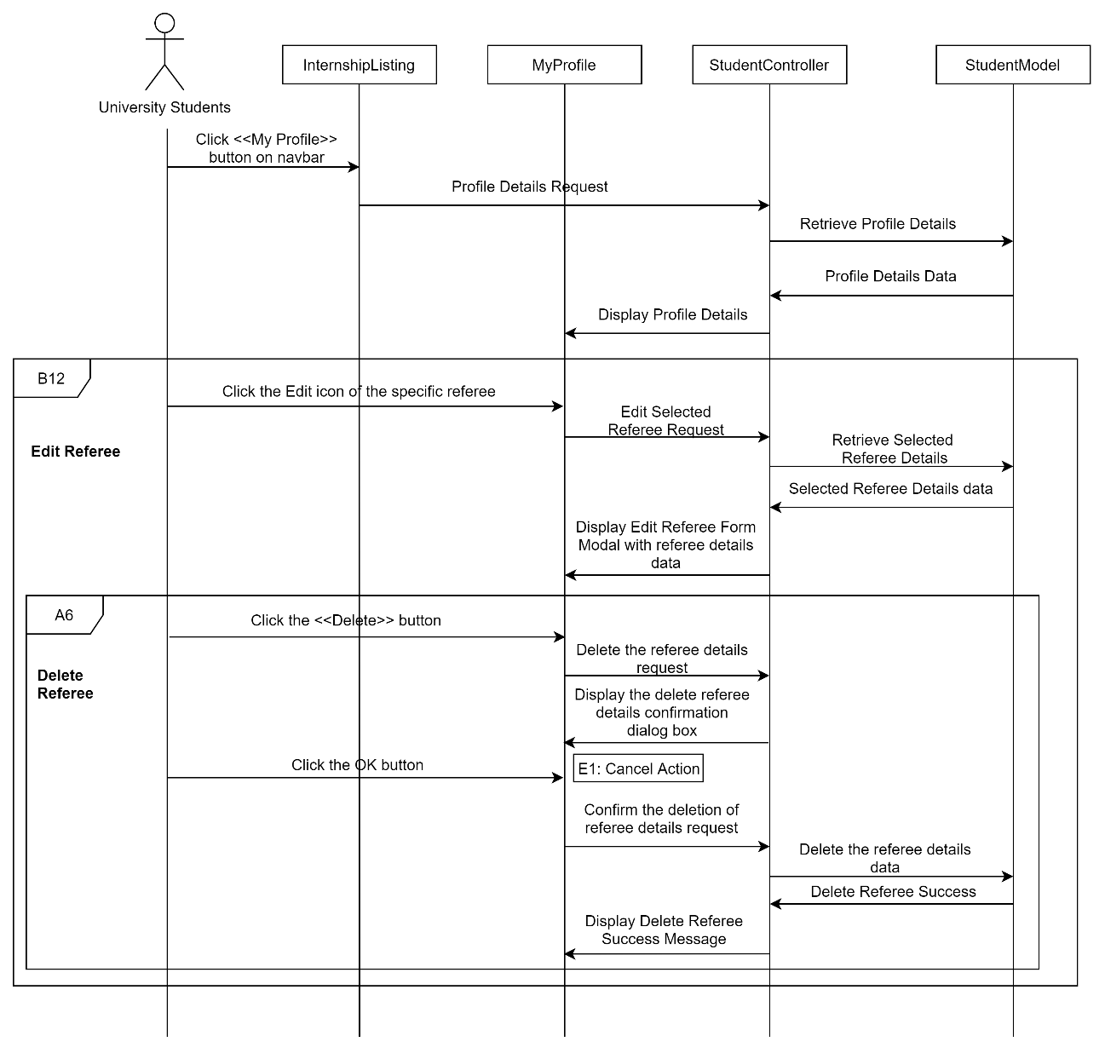

Figure 3‑52: Sequence Diagram (Alternative Flow for university students to delete referee)

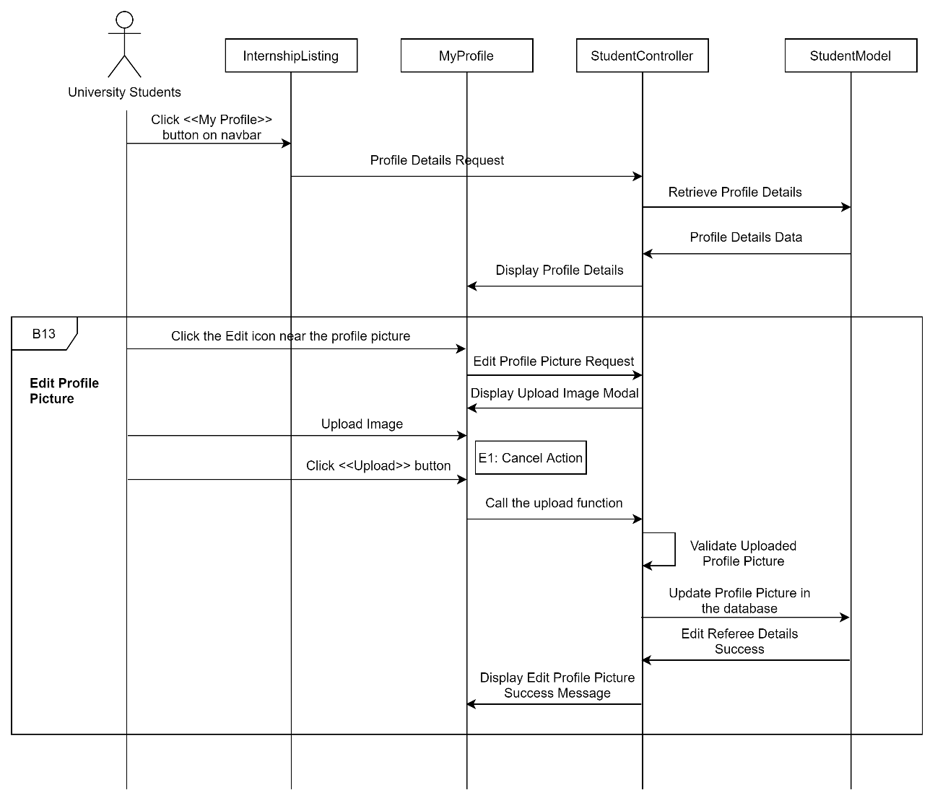

Figure 3‑53: Sequence Diagram (Basic Flow for university students to edit profile picture)

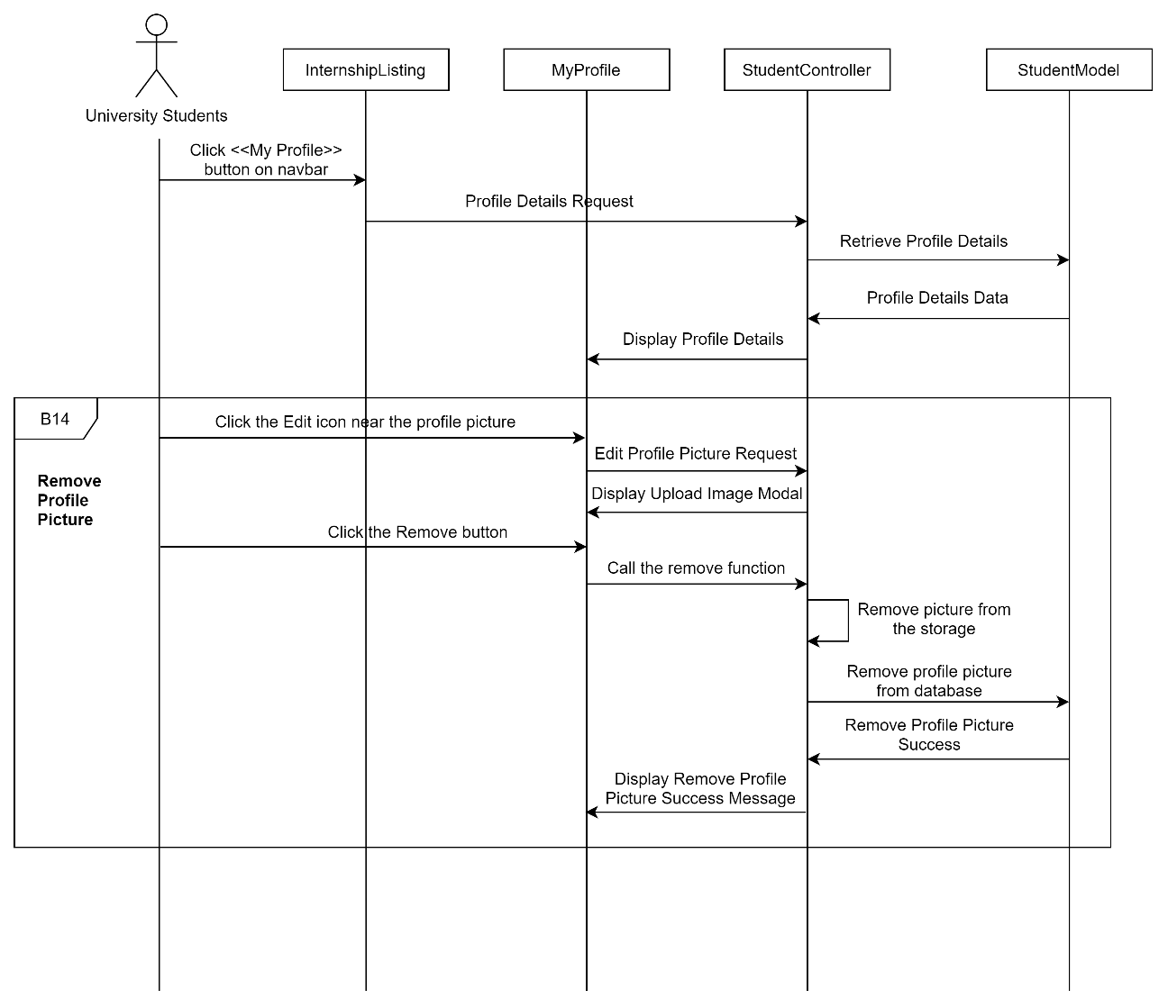

Figure 3‑54: Sequence Diagram (Basic Flow for university students to remove profile picture)

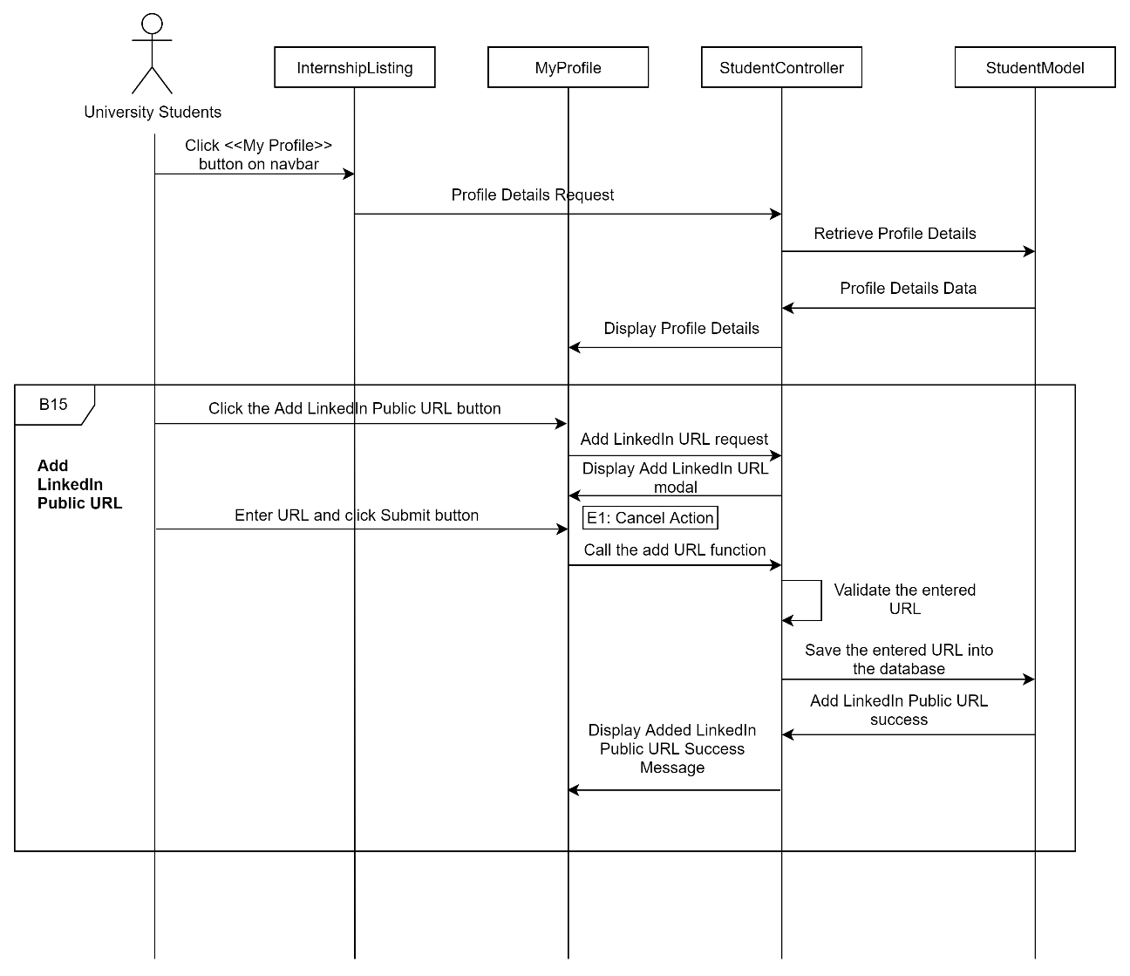

Figure 3‑55: Sequence Diagram (Basic Flow for university students to add LinkedIn Public URL)

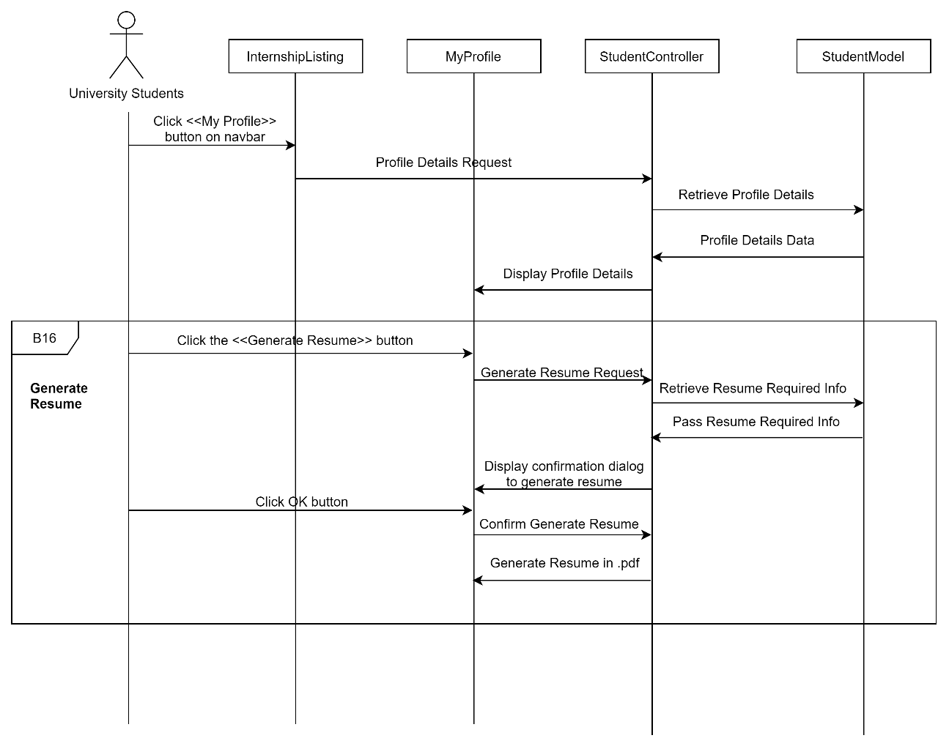

Figure 3‑56: Sequence Diagram (Basic Flow for university students to generate resume)

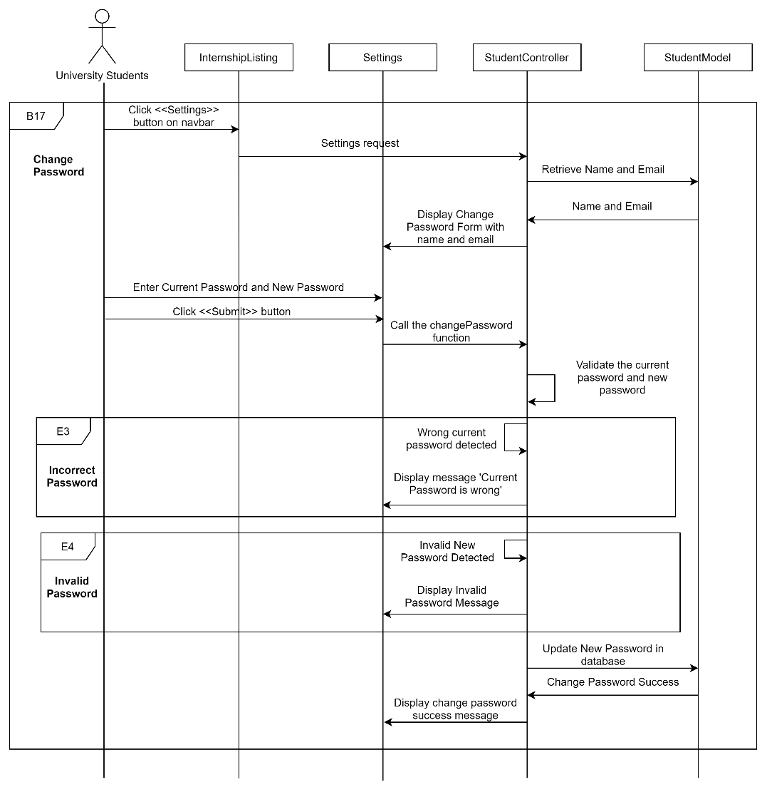

Figure 3‑57: Sequence Diagram (Basic Flow for university students to change password and exception flow for incorrect password and invalid password)

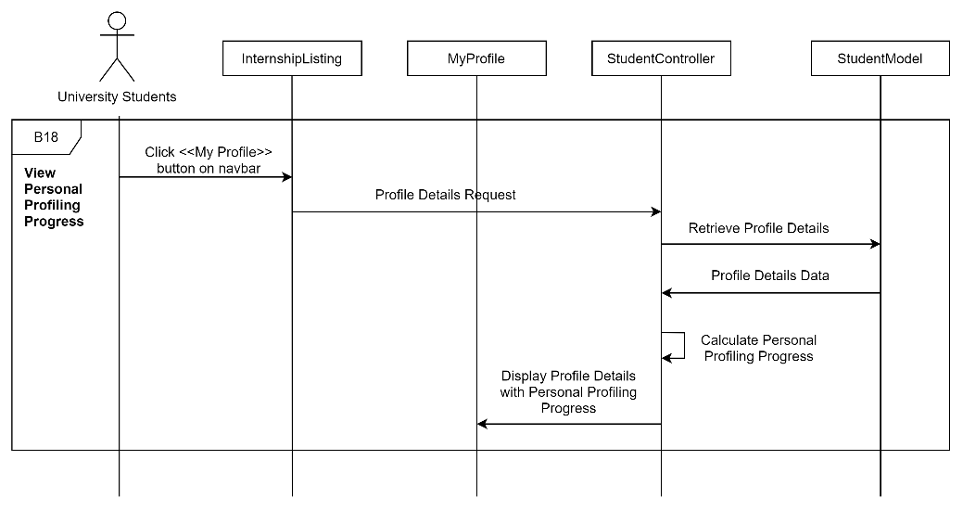

Figure 3‑58: Sequence Diagram (Basic Flow for university students to view personal profiling progress)

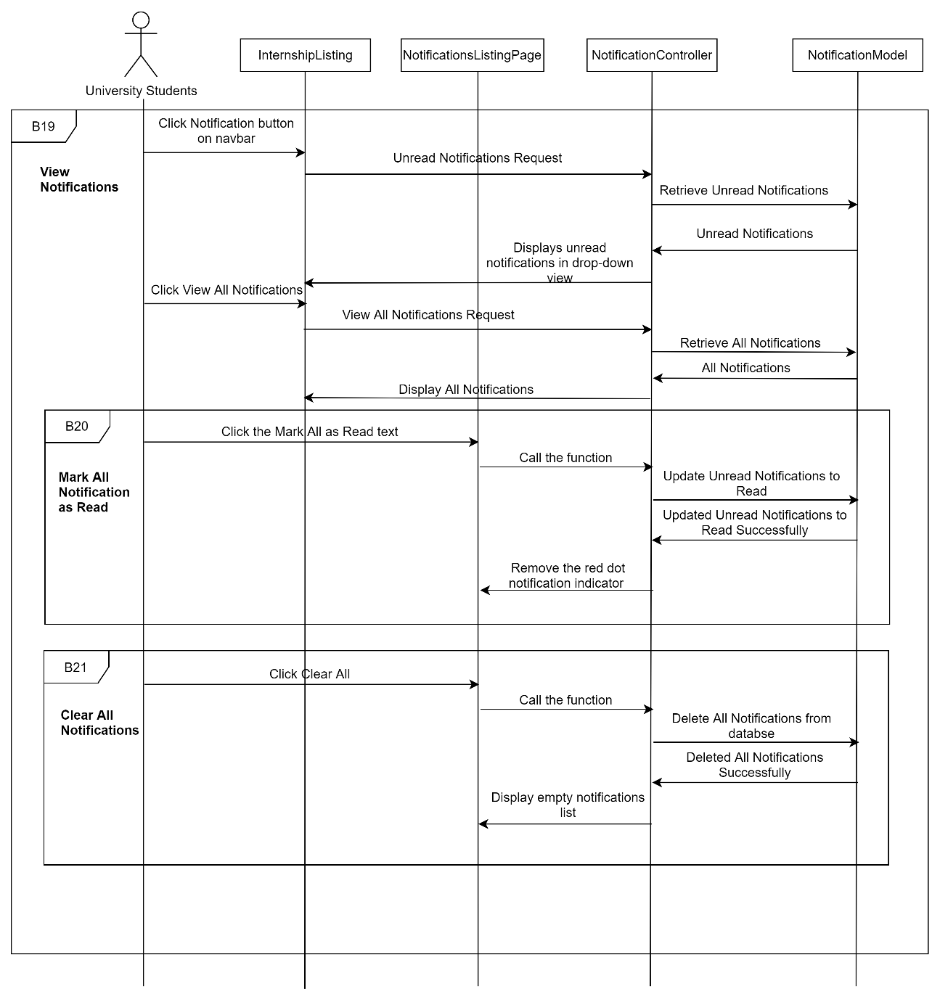

Figure 3‑59: Sequence Diagram (Basic Flow for university students to view notifications, mark all notifications as read, and clear all notifications)

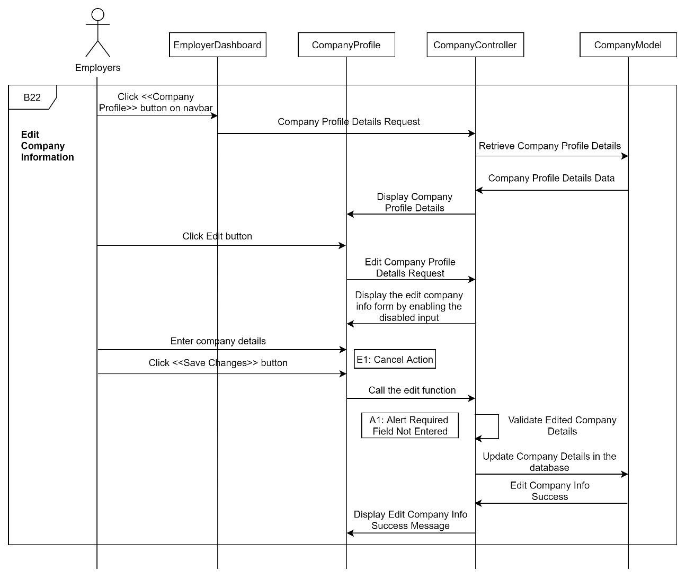

Figure 3‑60: Sequence Diagram (Basic Flow for employers to edit company information)

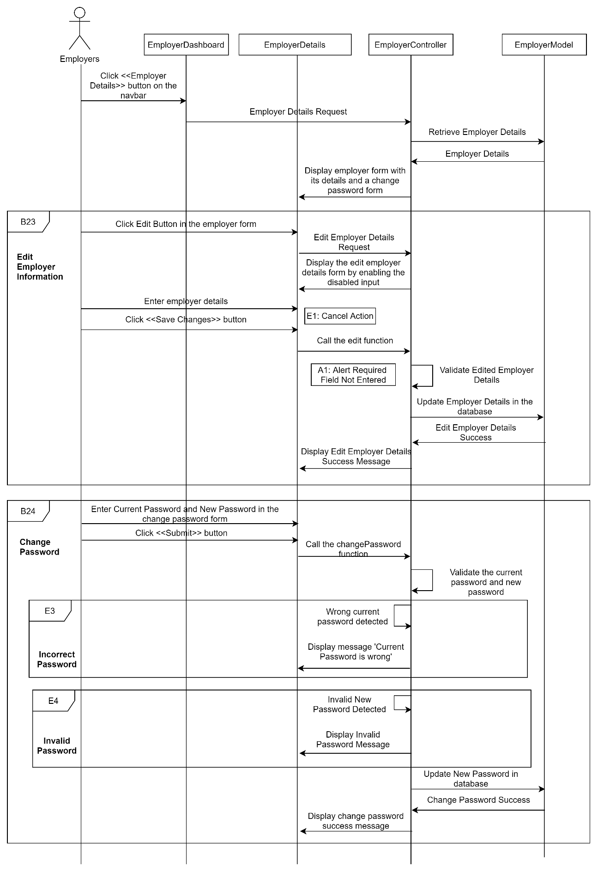

Figure 3‑61: Sequence Diagram (Basic Flow for employers to edit employer information and change password and exception flow for incorrect password and invalid password)

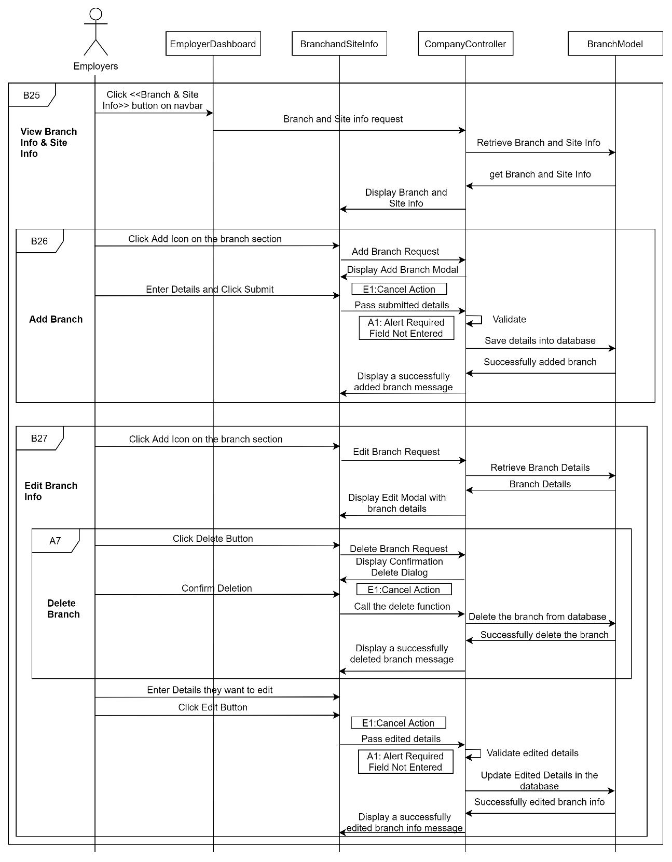

Figure 3‑62: Sequence Diagram (Basic Flow for employers to view branch and site information, add branch, and edit branch information and Alternative flow for deleting branch)

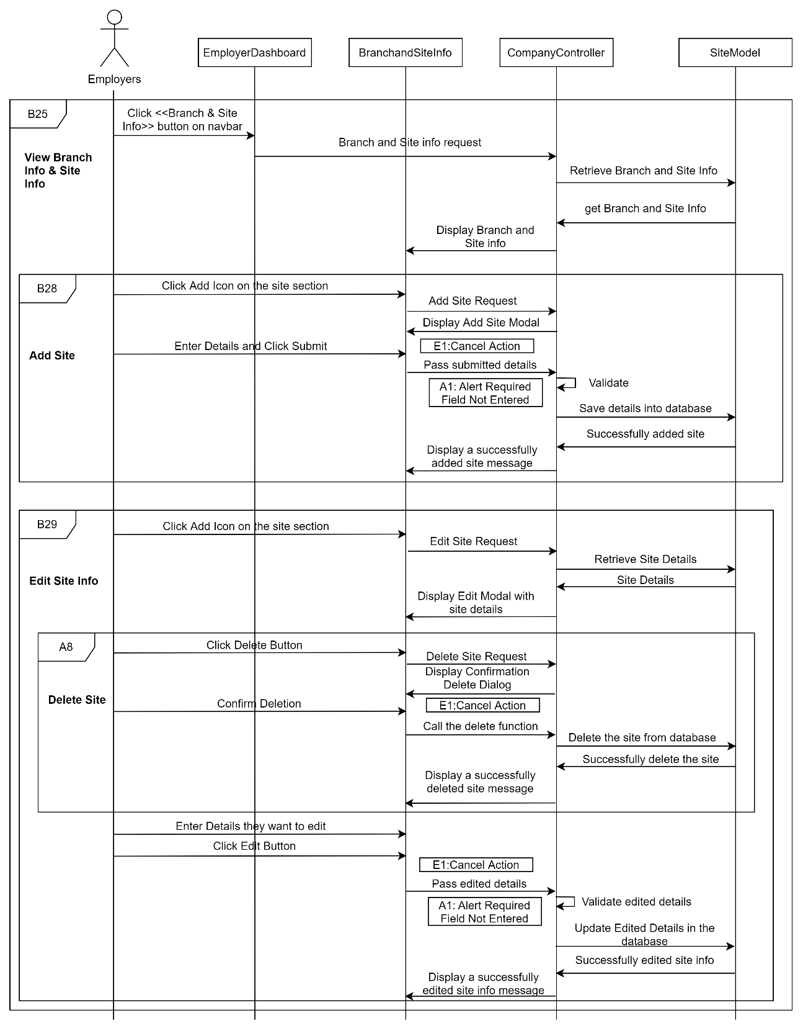

Figure 3‑63: Sequence Diagram (Basic Flow for employers to view branch and site information, add site, and edit site information and Alternative flow for deleting site)

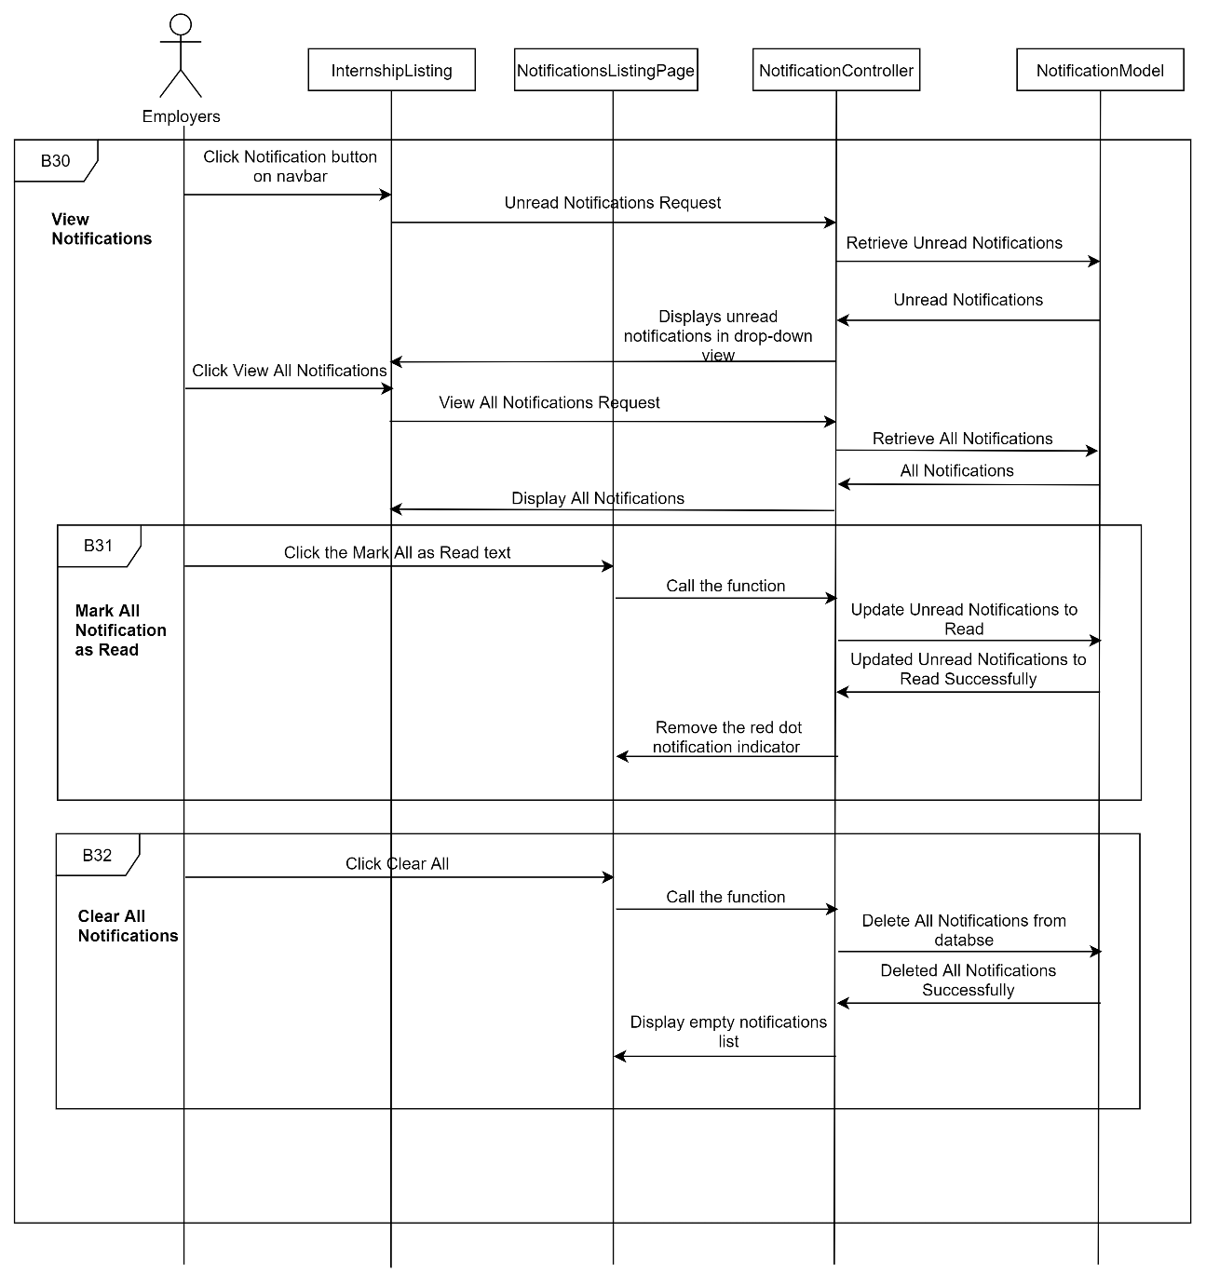

Figure 3‑64: Sequence Diagram (Basic Flow for employers to view notifications, mark all notifications as read, and clear all notifications)

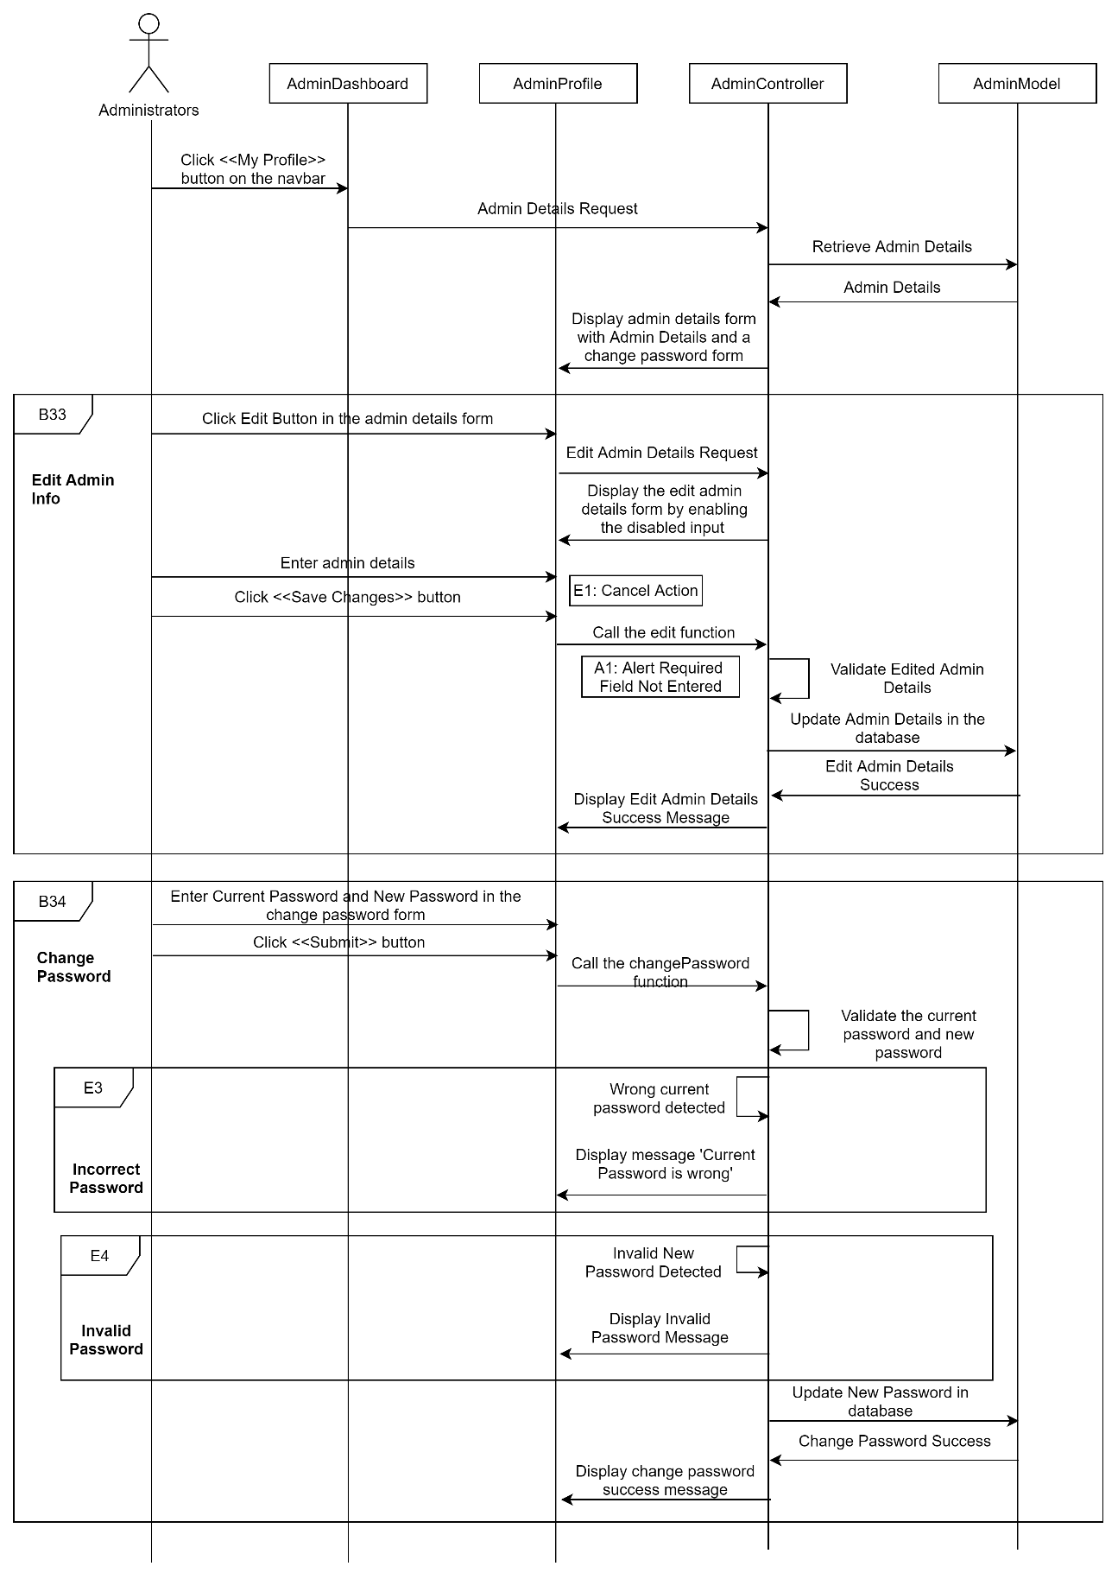

Figure 3‑65: Sequence Diagram (Basic Flow for administrators to edit admin info and change password and exception flow for incorrect password and invalid password)

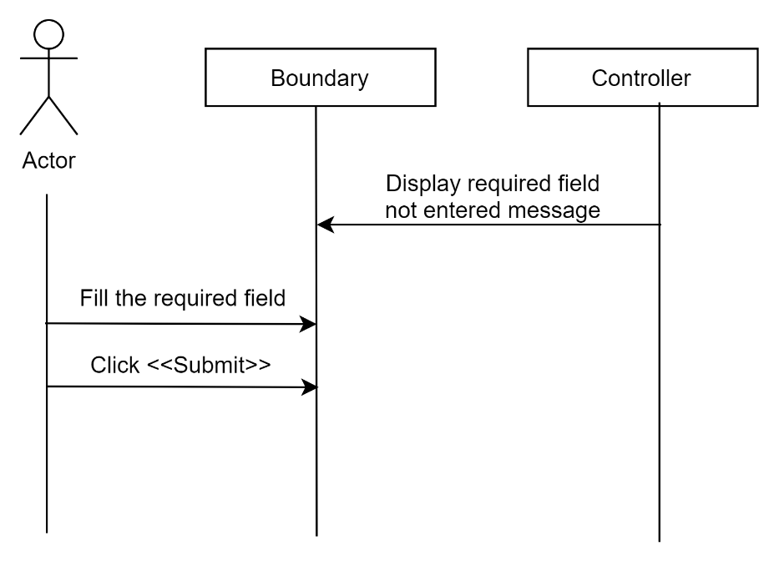

Figure 3‑66: Sequence diagram (Alternative Flow: Alert Required Field Not Entered)

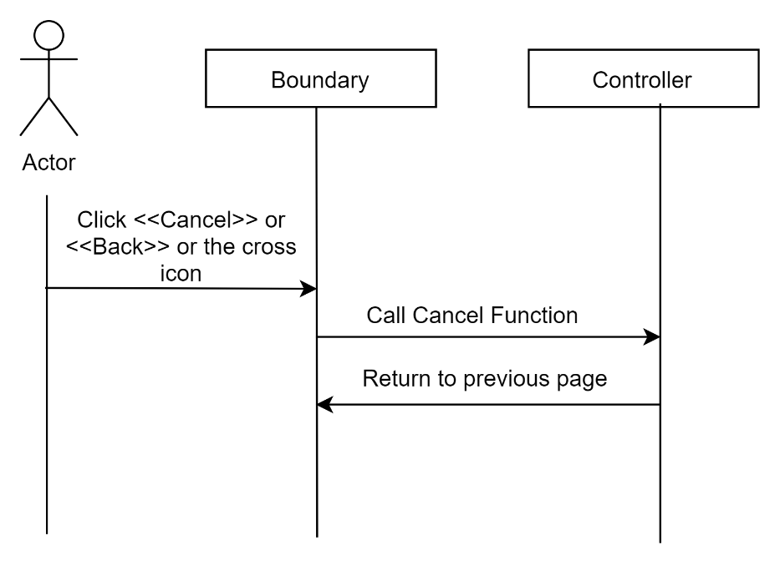

Figure 3‑67: Sequence diagram (Exception Flow: Cancel Action)

##### View Internship Listing

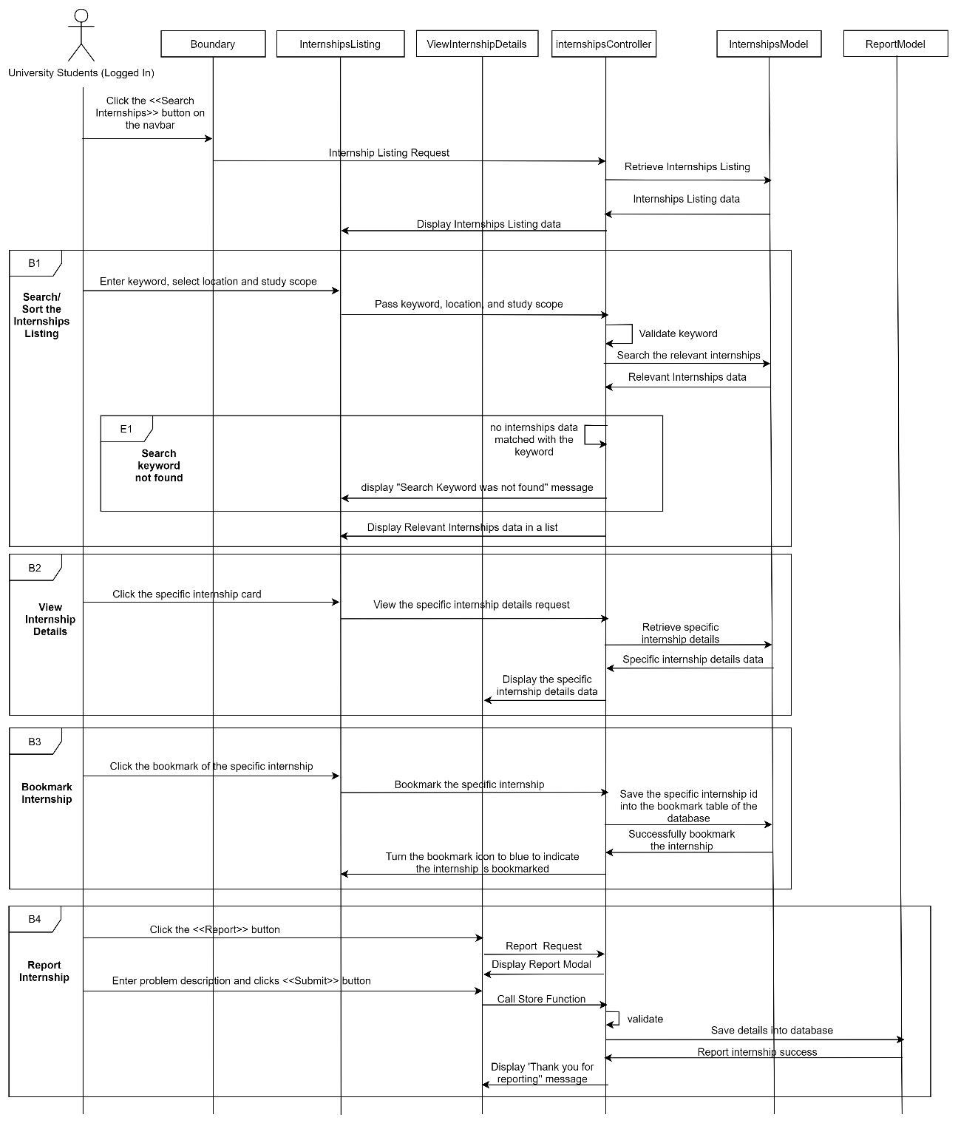

Figure 3‑68: Sequence diagram (Basic Flow for university students with logged in to search/sort the internship listing, view internship details, bookmark internship, and report internship and exception flow for search keyword not found)

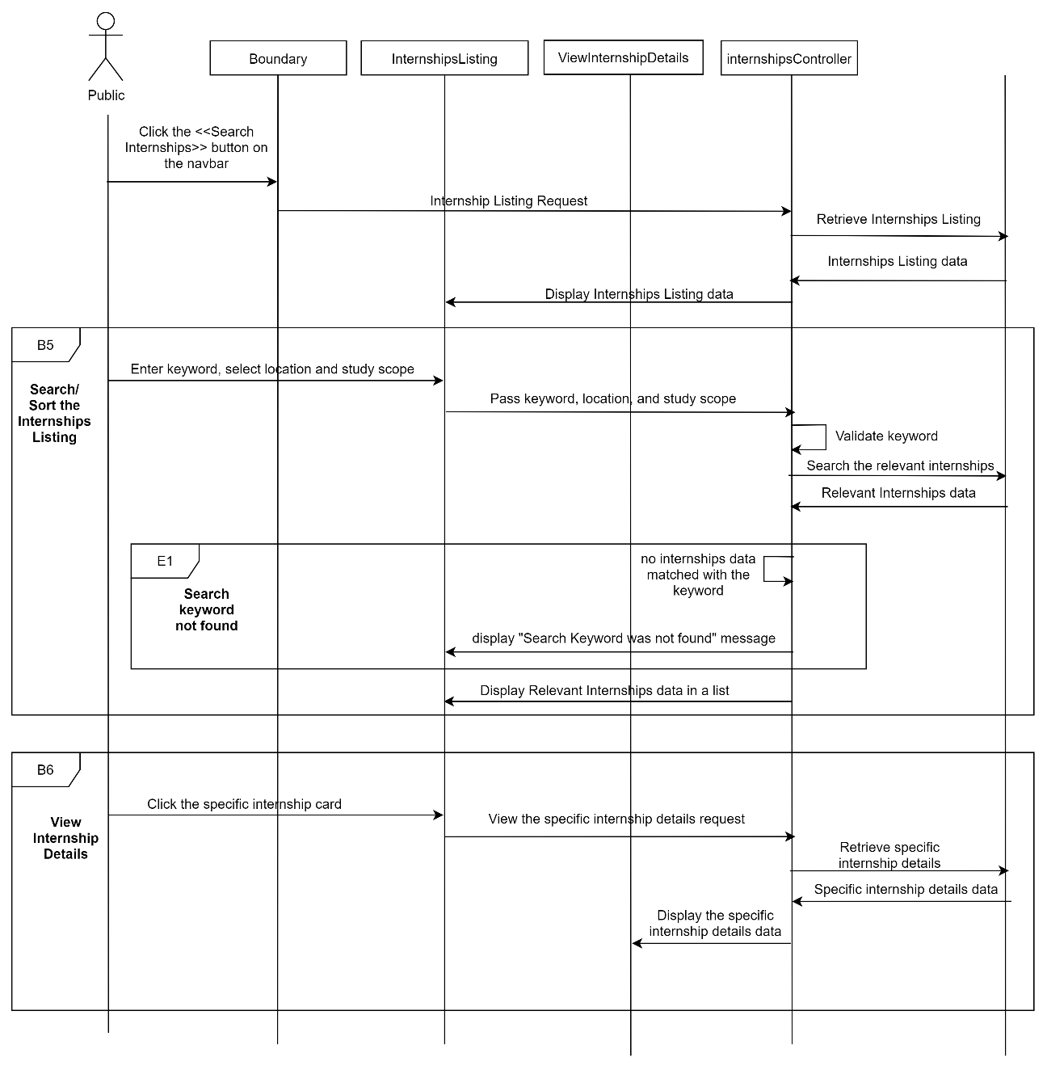

Figure 3‑69: Sequence diagram (Basic Flow for public users to search/sort the internship listing and view internship details, and exception flow for search keyword not found)

##### View Company Listing

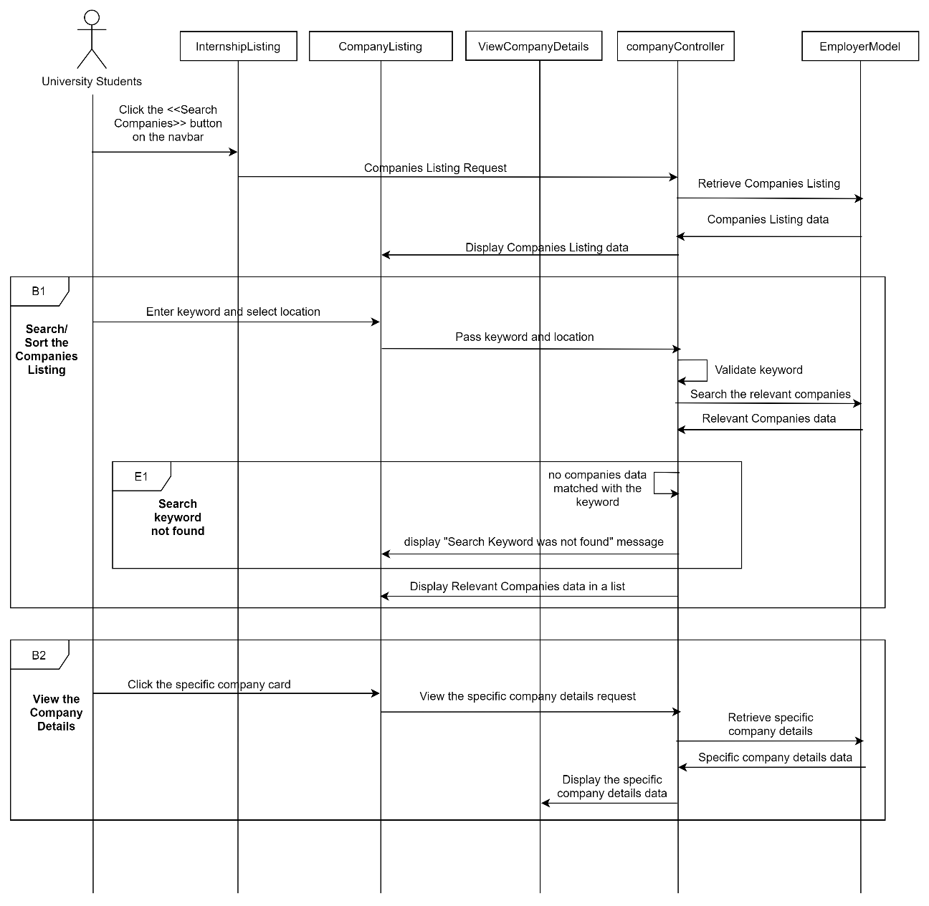

Figure 3‑70: Sequence diagram (Basic Flow for public users to search/sort the company listing and view the company details and exception flow for search keyword not found)

##### Manage Internship Application

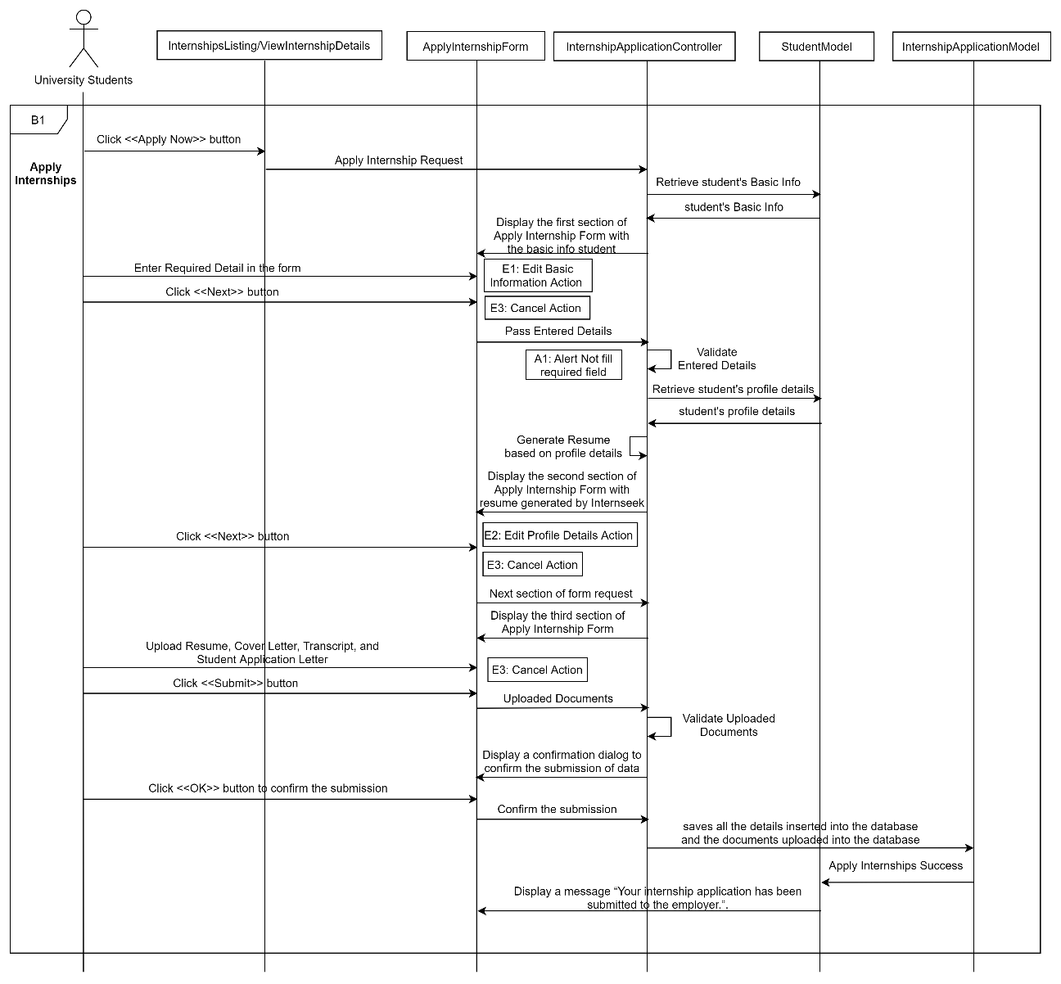

Figure 3‑71: Sequence diagram (Basic Flow for university students to apply internships)

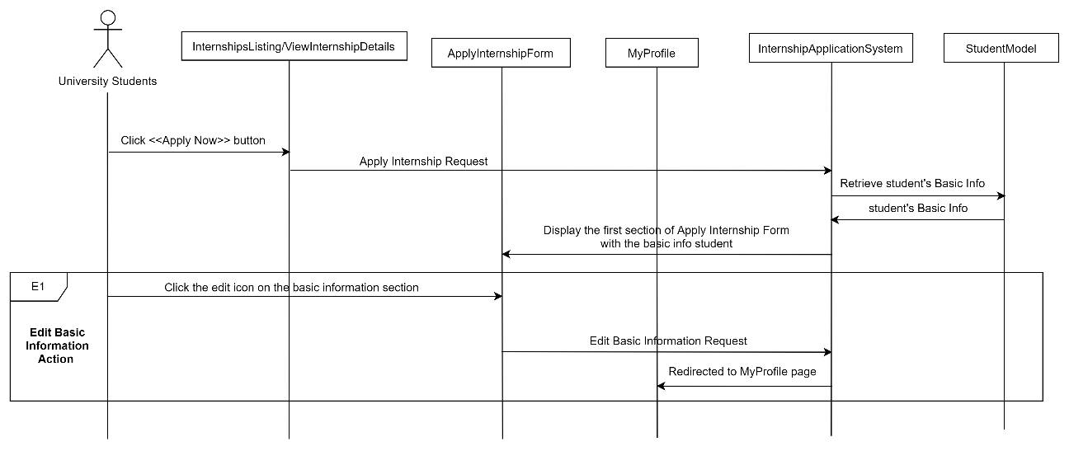

Figure 3‑72: Sequence diagram (Exception Flow: Edit Basic Information Action)

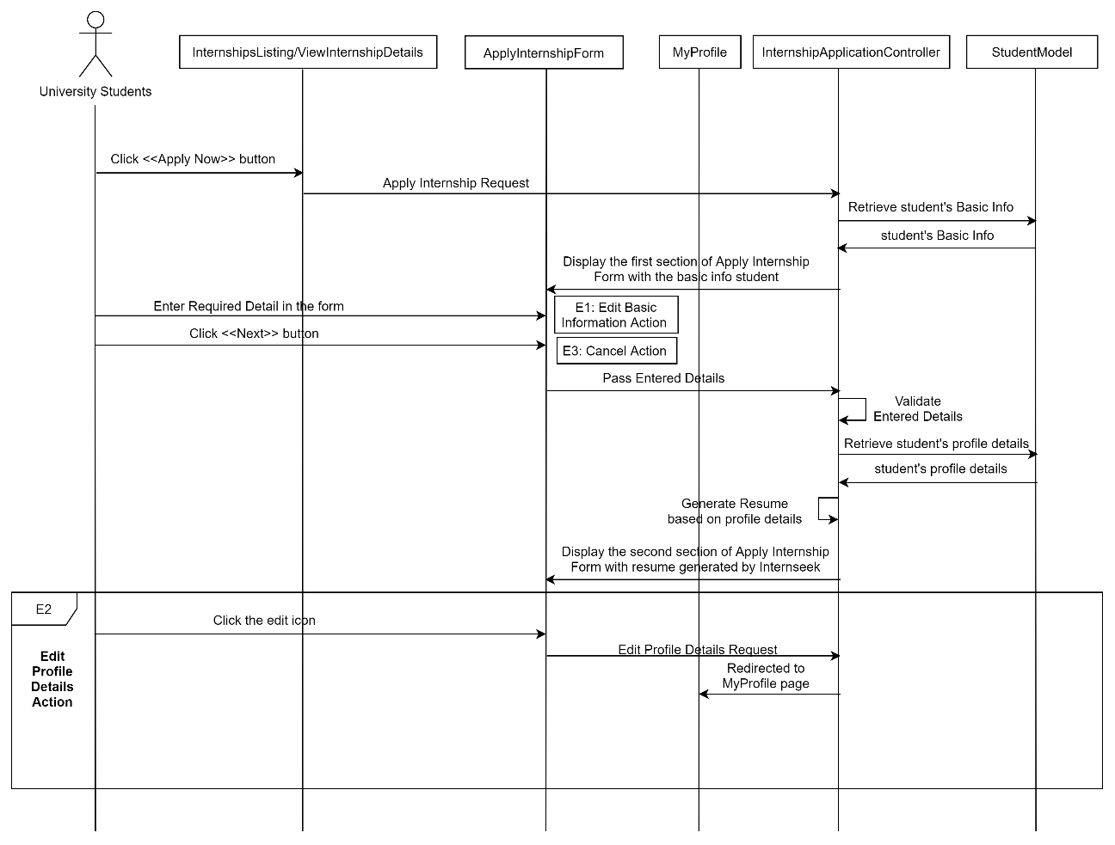

Figure 3‑73: Sequence diagram (Exception Flow: Edit Profile Details Action)

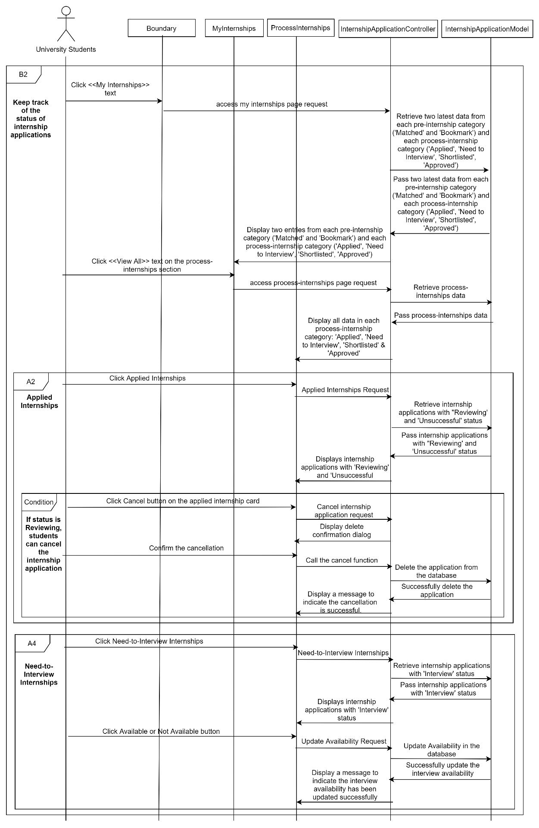

Figure 3‑74: Sequence diagram (Basic Flow for university students to keep track of status of internship application with alternative flows: applied internships and need-to-interview internships)

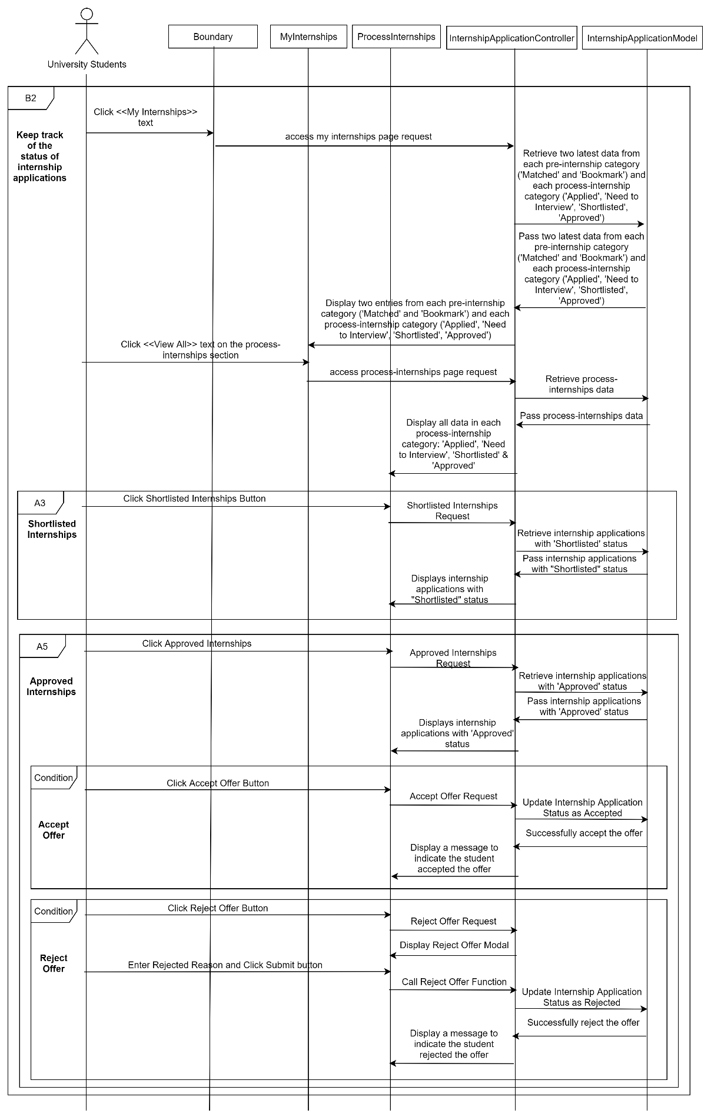

Figure 3‑75: Sequence diagram (Basic Flow for university students to keep track of status of internship application with alternative flows: shortlisted internships and approved internships)

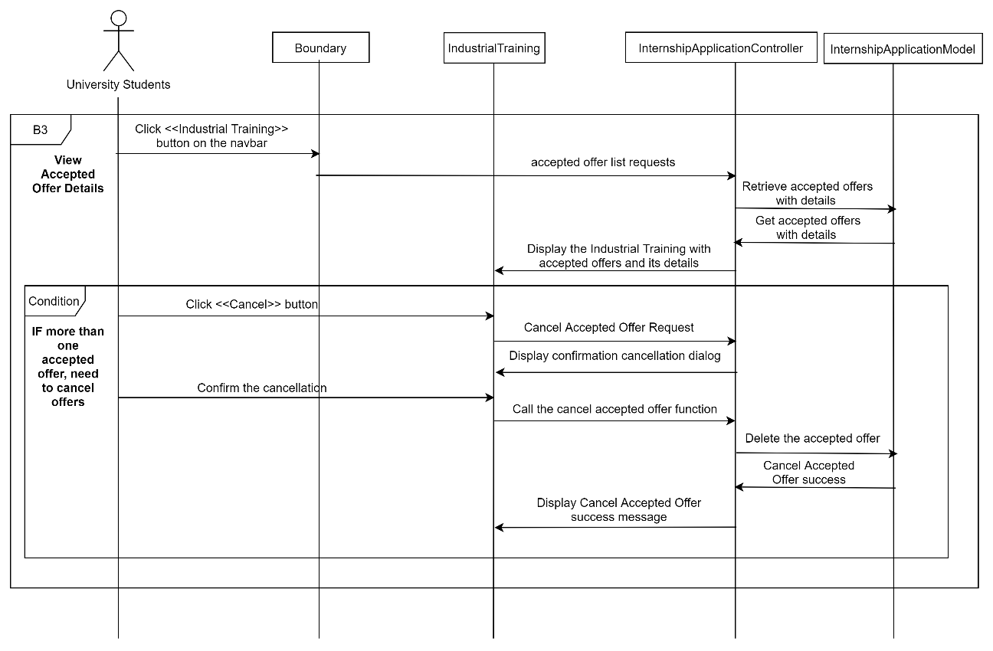

Figure 3‑76: Sequence diagram (Basic Flow for university students to view accepted offer details)

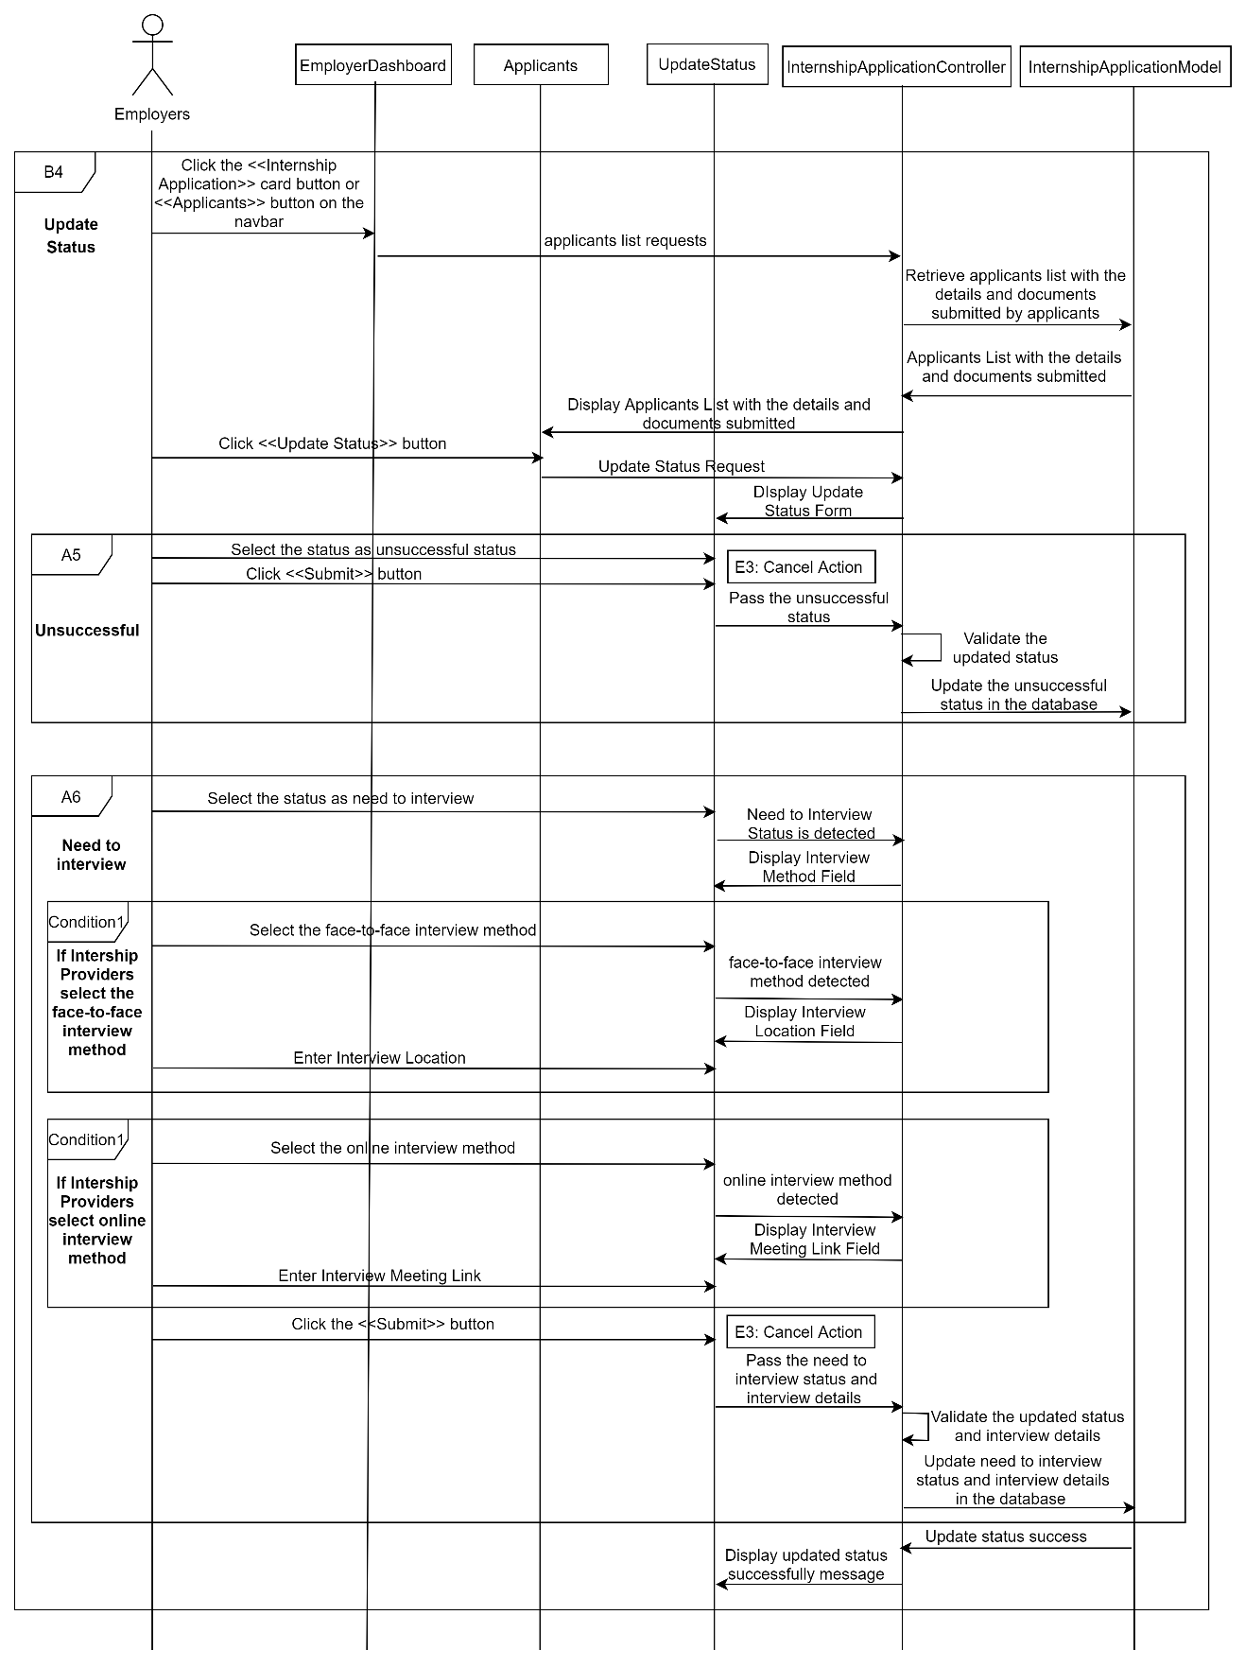

Figure 3‑77: Sequence Diagram (Basic Flow for employers to update status of the internship application with alternative flows: unsuccessful and need-to-interview)

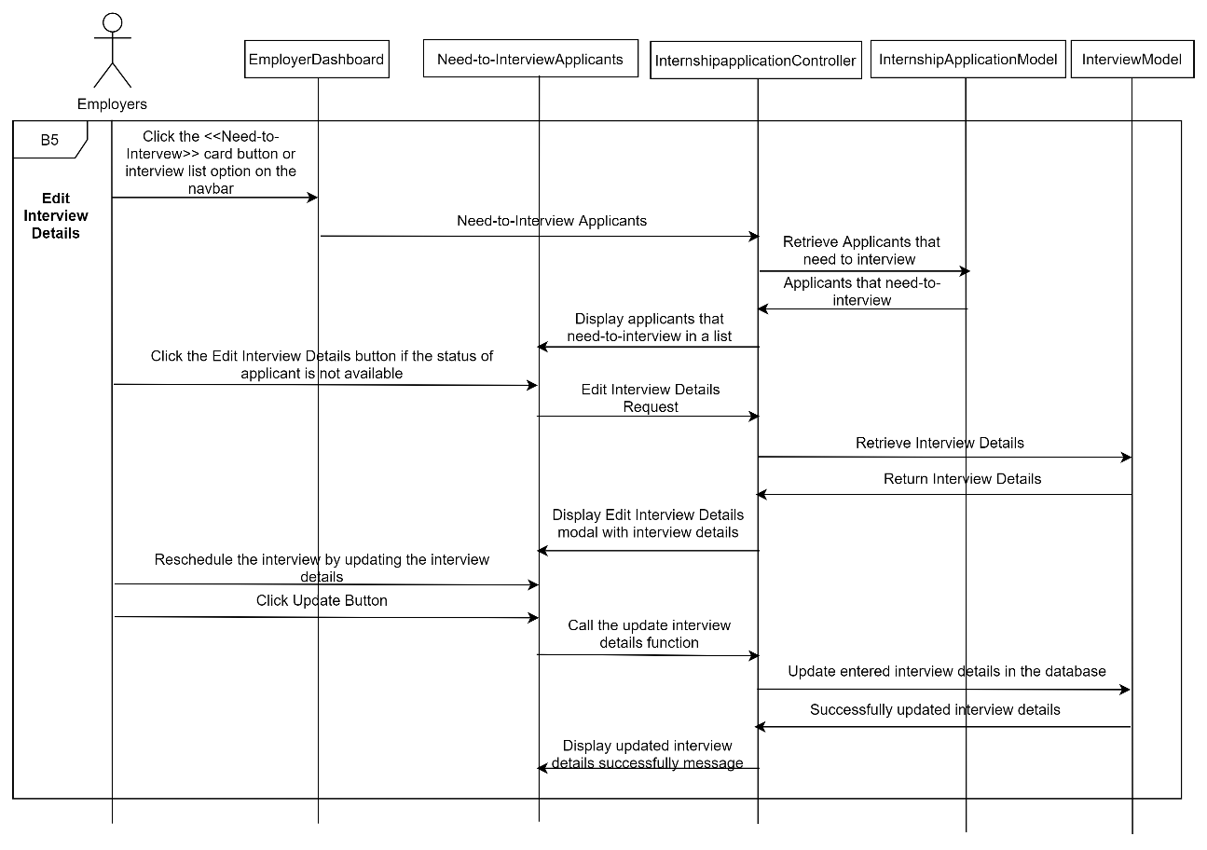

Figure 3‑78: Sequence Diagram (Basic Flow for employers to edit interview details)

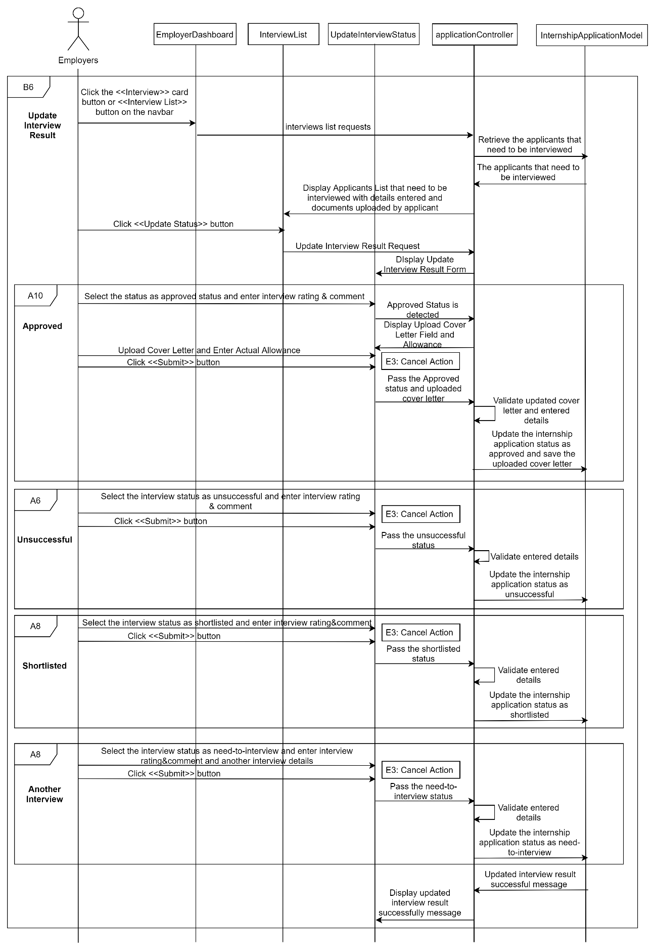

Figure 3‑79: Sequence diagram (Basic Flow for employers to update interview status with alternative flows: Approved, Unsuccessful, Another Interview, and Shortlisted)

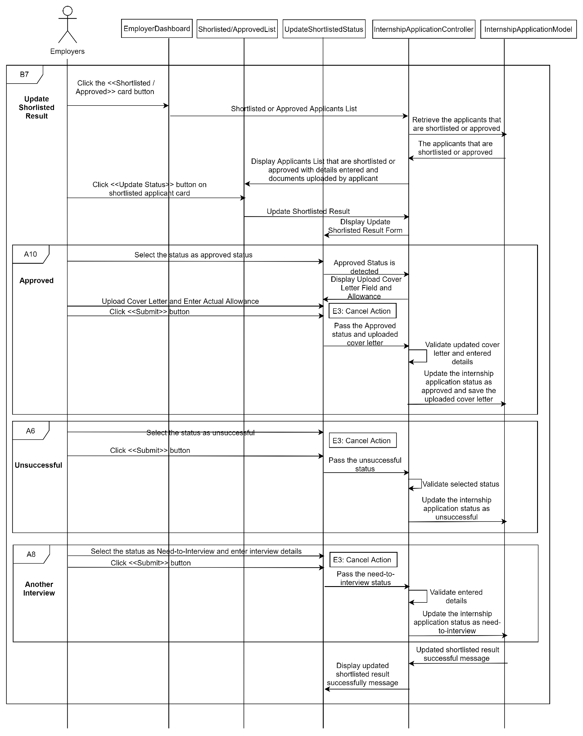

Figure 3‑80: Sequence diagram (Basic Flow for employers to update shortlisted result and Alternative Flow: Approved, Unsuccessful, and Another Interview)

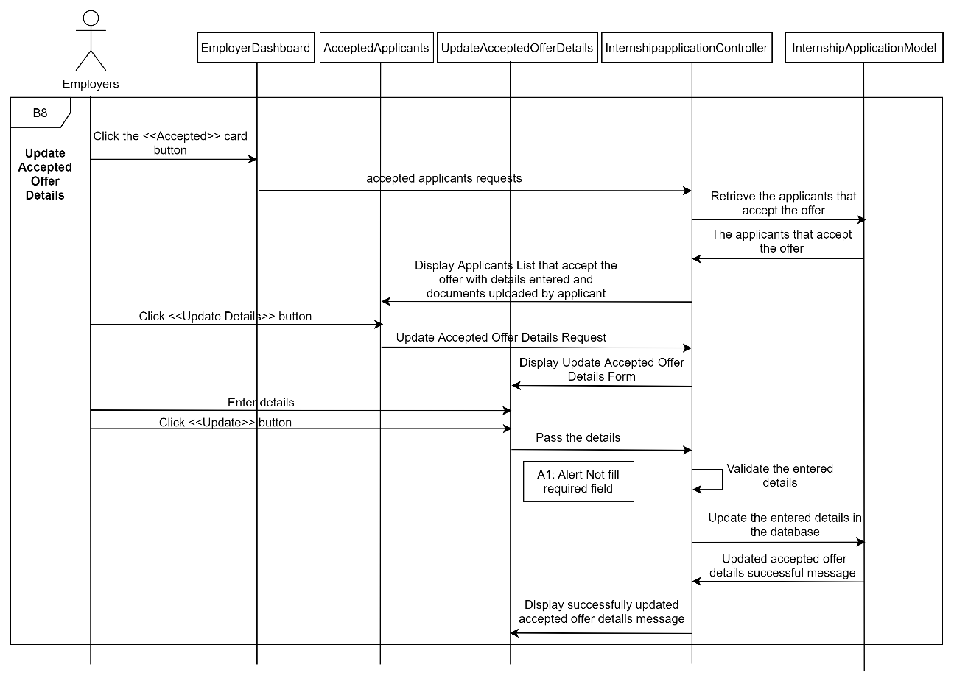

Figure 3‑81: Sequence diagram (Basic Flow for employers to update accepted offer details)

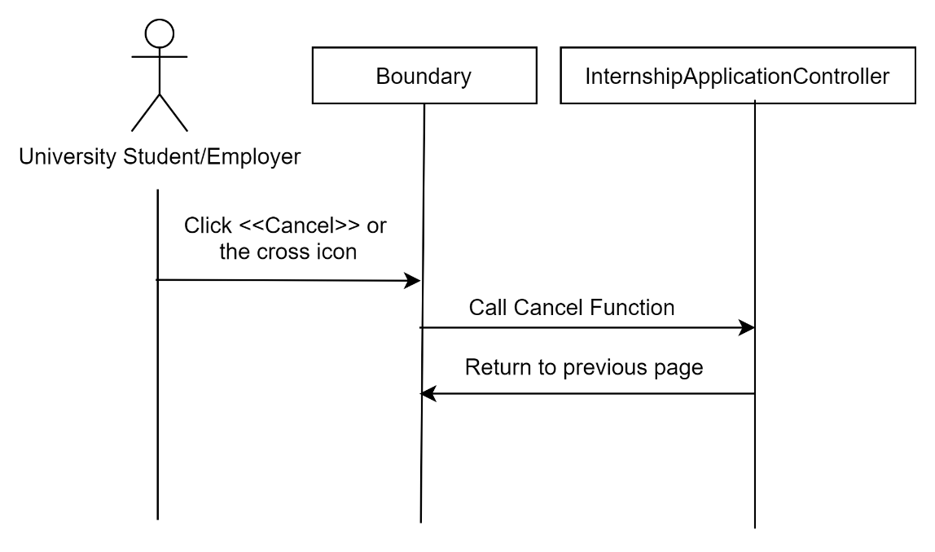

Figure 3‑82: Sequence diagram (Exception Flow: Cancel Action)

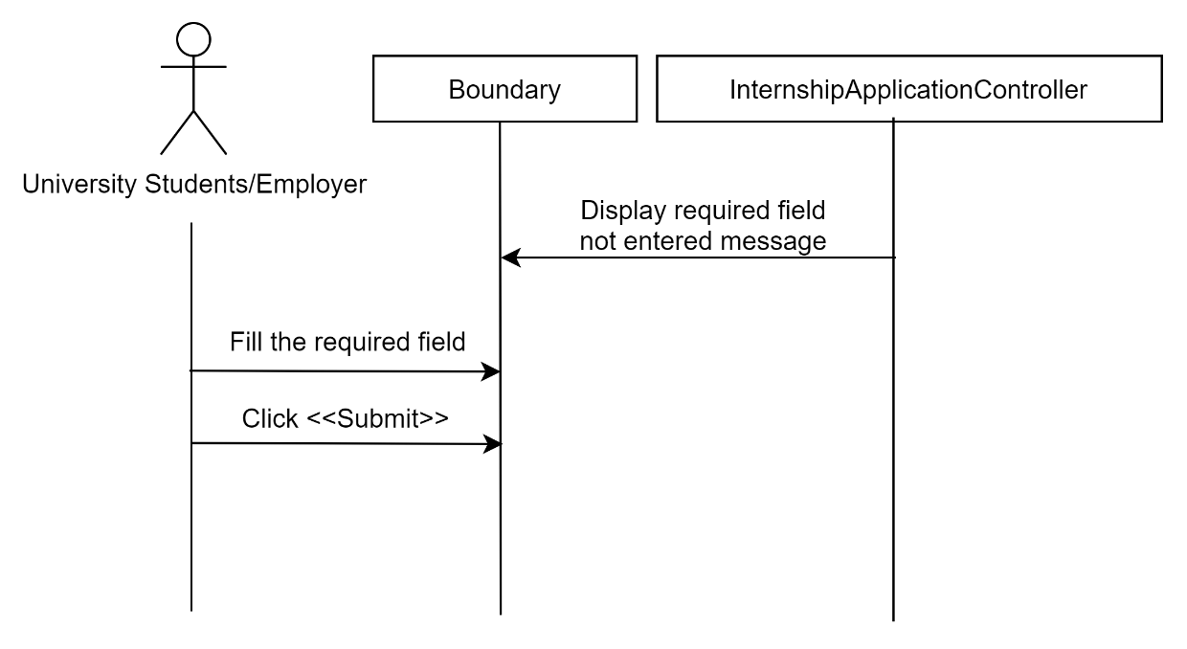

Figure 3‑83: Sequence diagram (Alternative Flow: Alert Not fill required field)

##### Manage Internship Posting

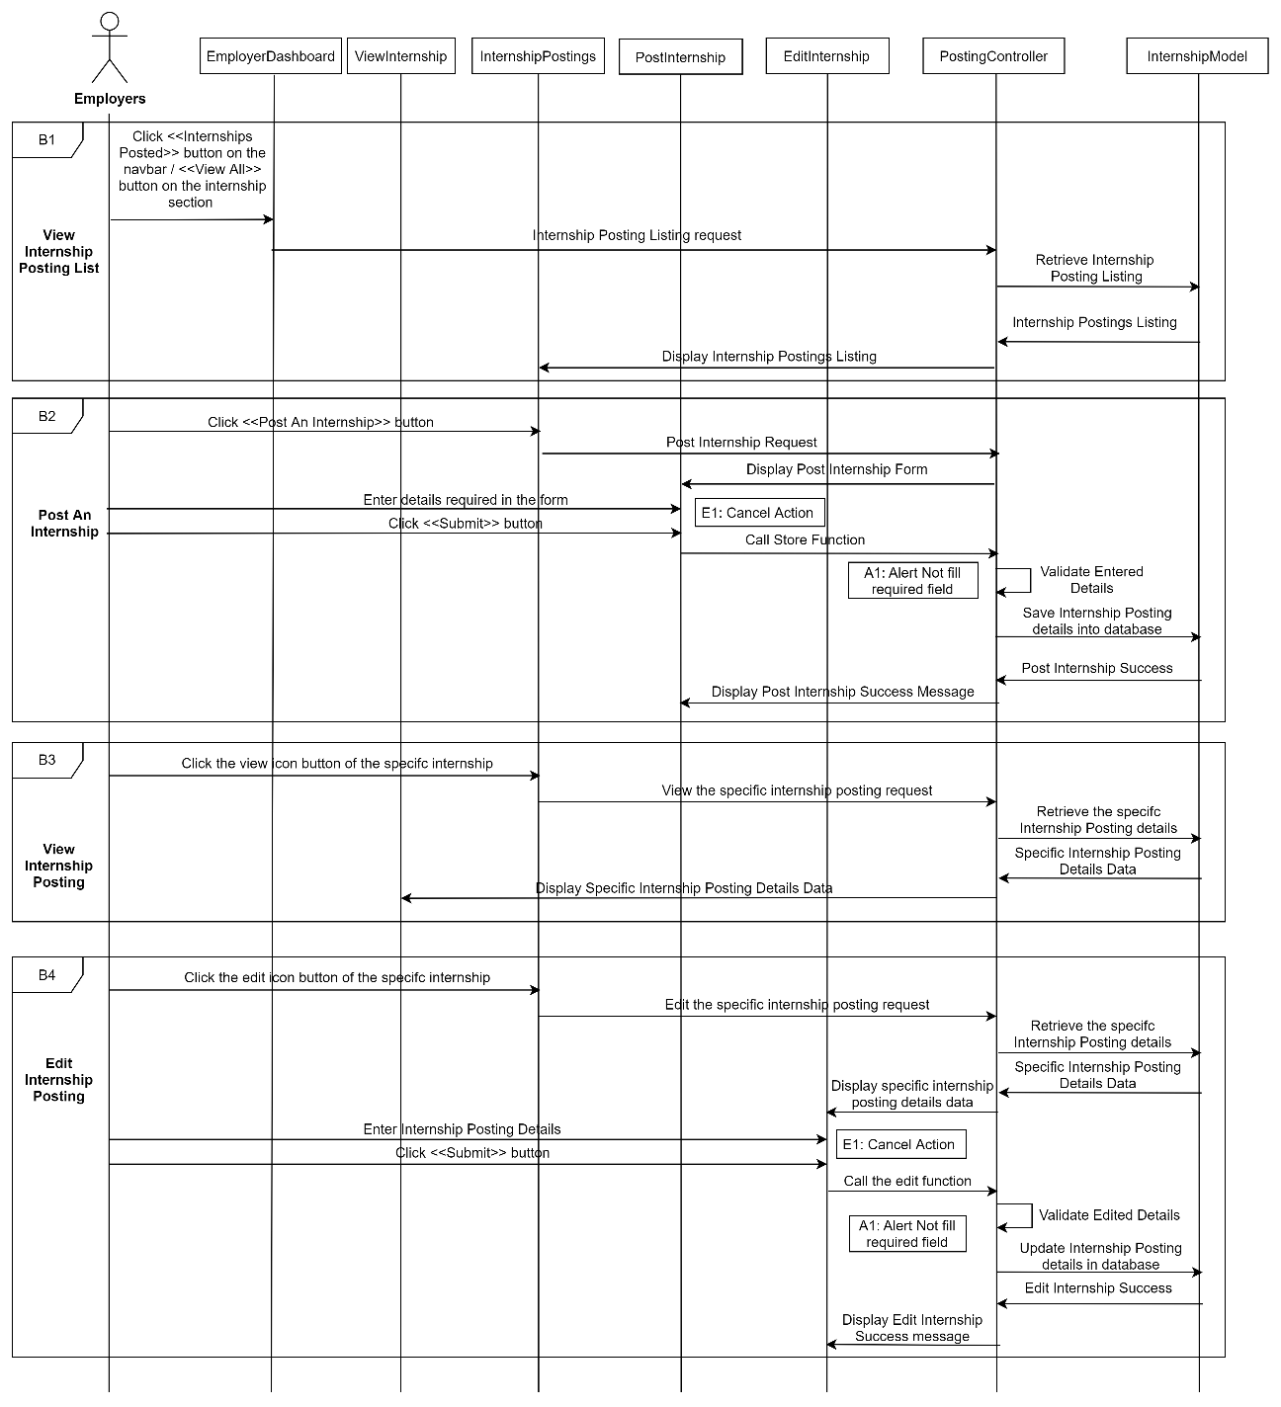

Figure 3‑84: Sequence Diagram (Basic Flow for employers to view internship postings list, post an internship, view internship posting, edit internship posting)

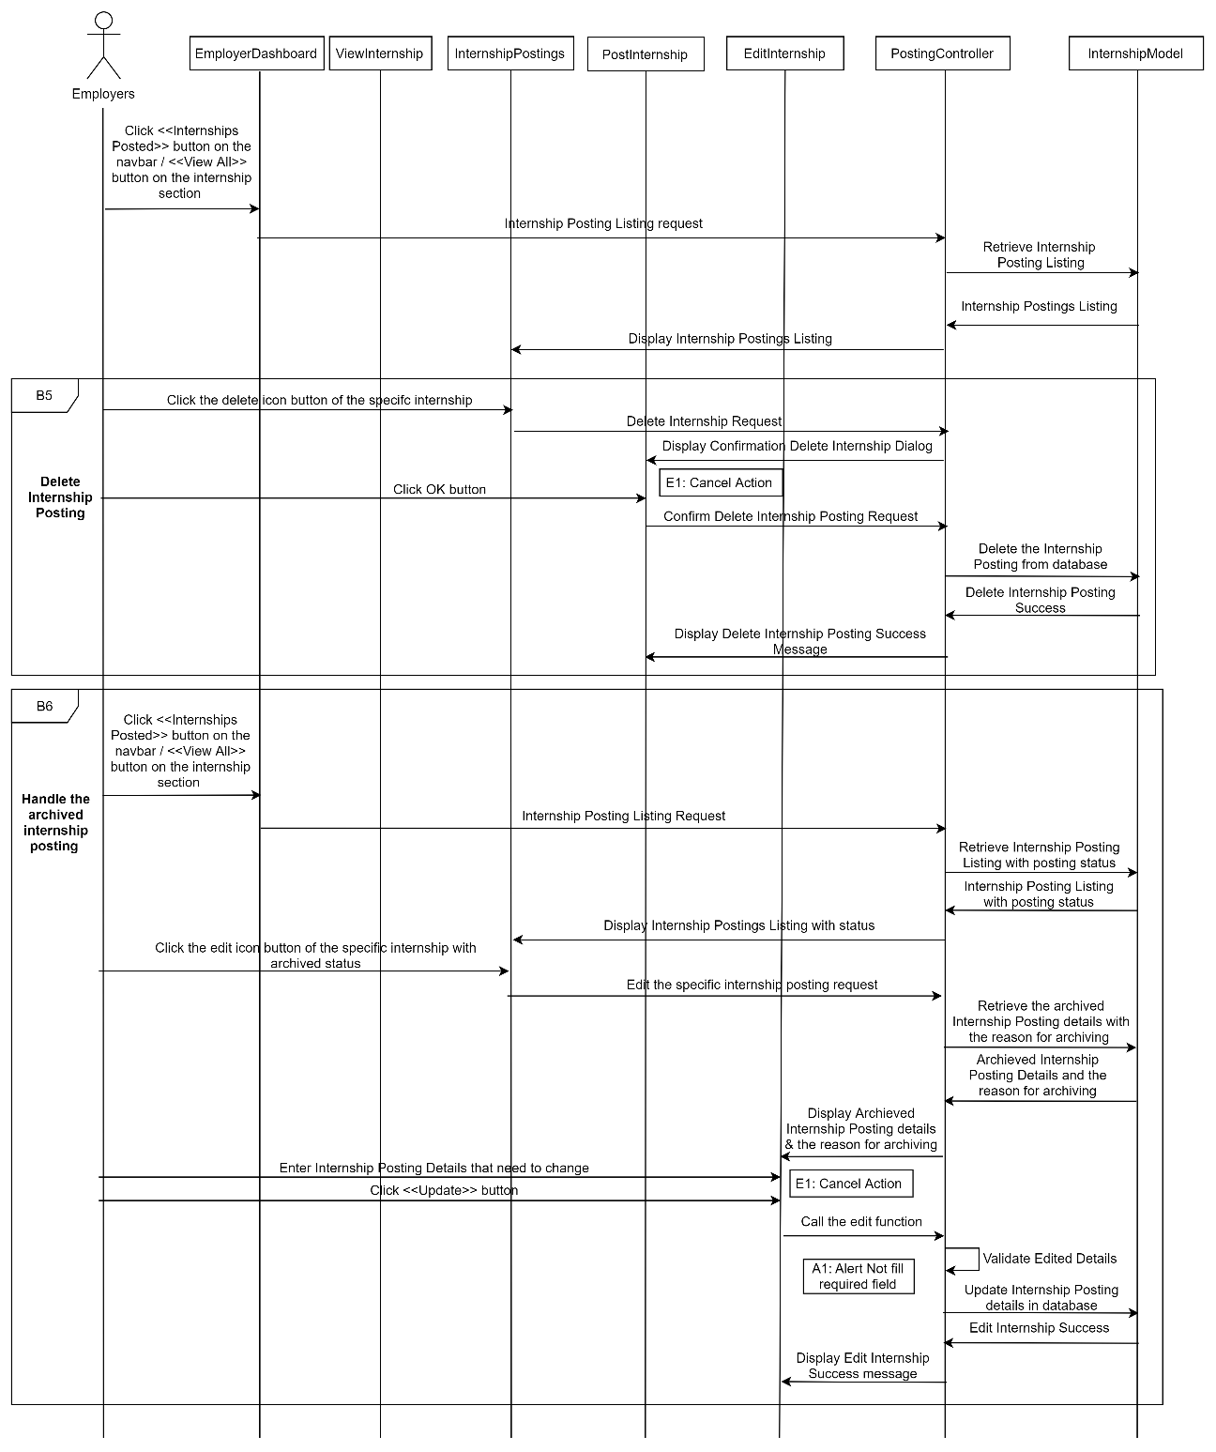

Figure 3‑85: Sequence Diagram (Basic Flow for employers to delete internship posting and handle the archived internship posting)

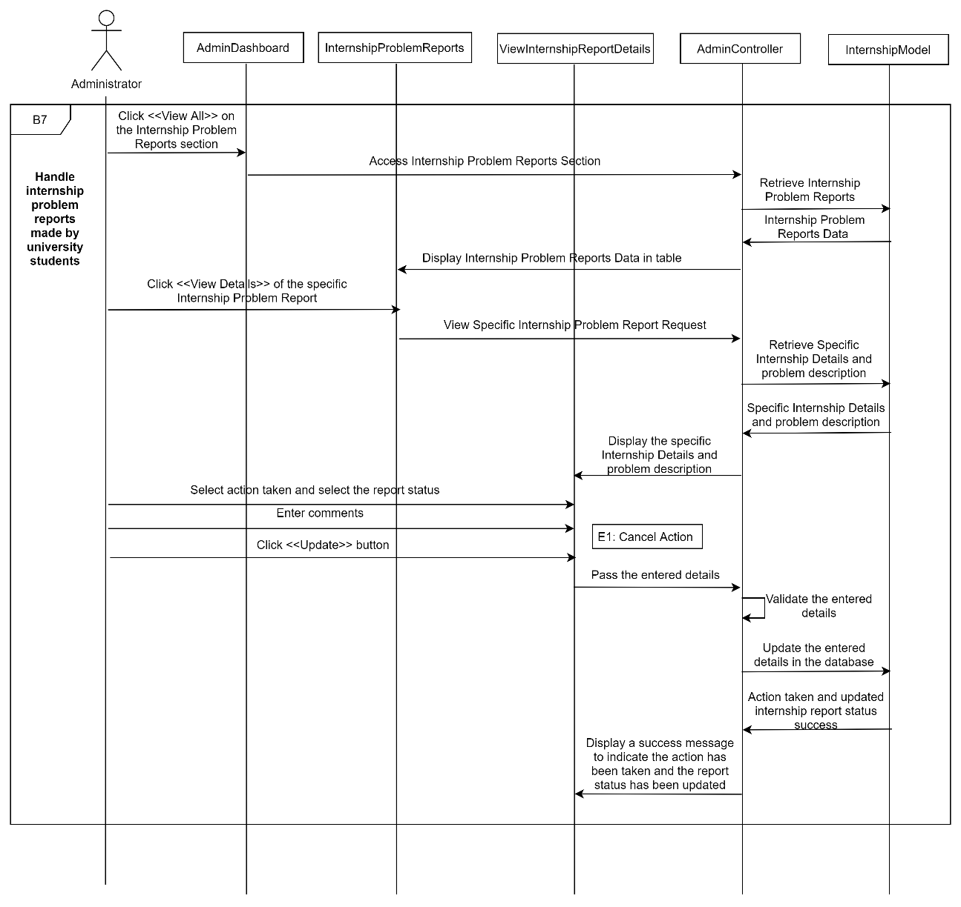

Figure 3‑86: Sequence Diagram (Basic Flow for administrators to handle internship problem reports made by university students)

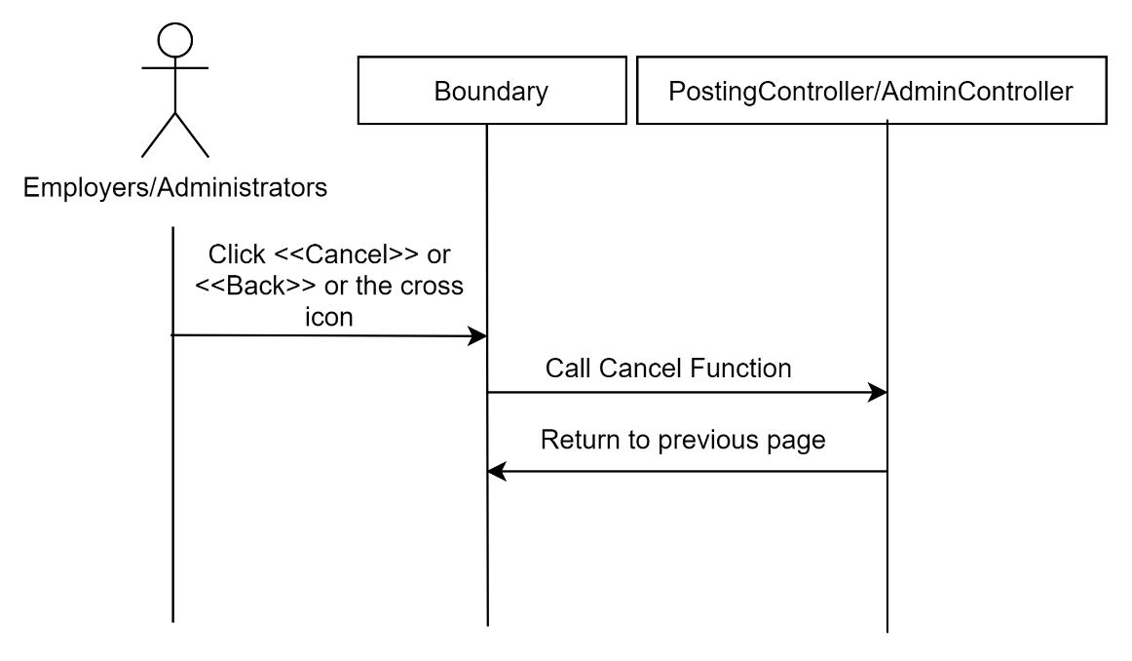

Figure 3‑87: Sequence Diagram (Exception Flow: Cancel Action)

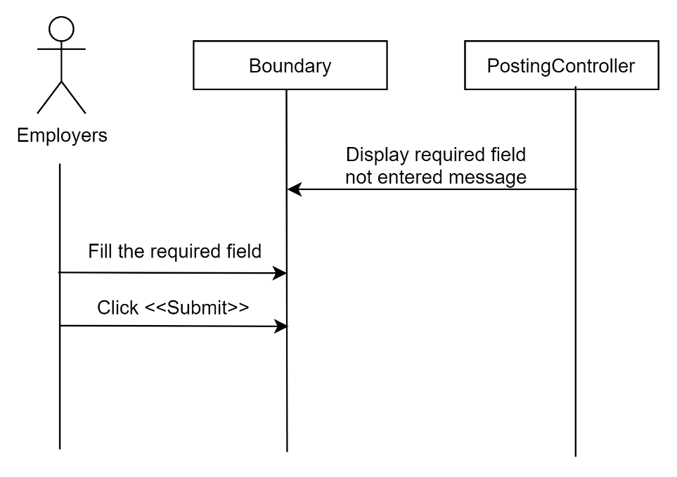

Figure 3‑88: Sequence Diagram (Alternative Flow: Alert Not fill required field)

##### Manage Analytics and Reporting

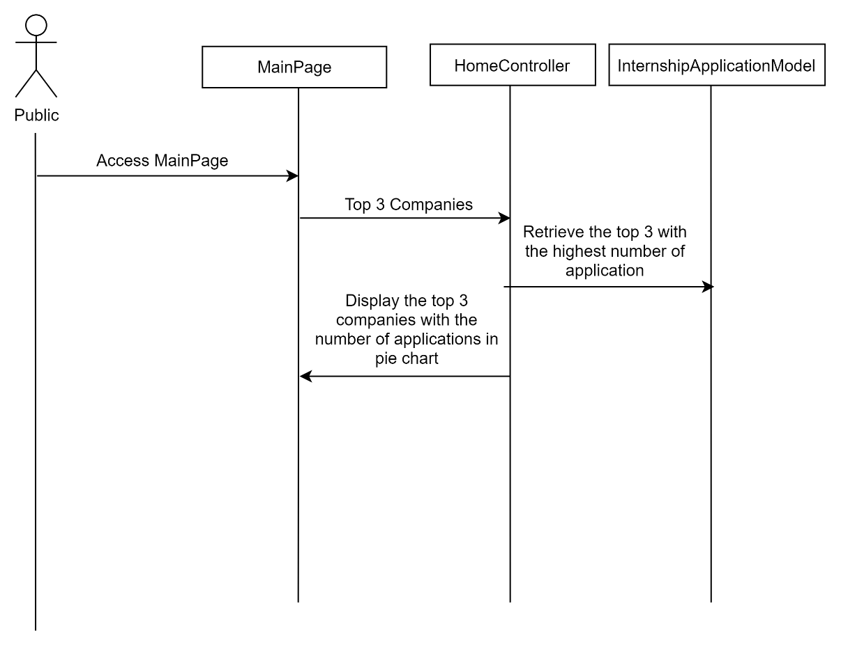

Figure 3‑89: Sequence Diagram (Basic Flow: Display Top 3 Companies for public users)

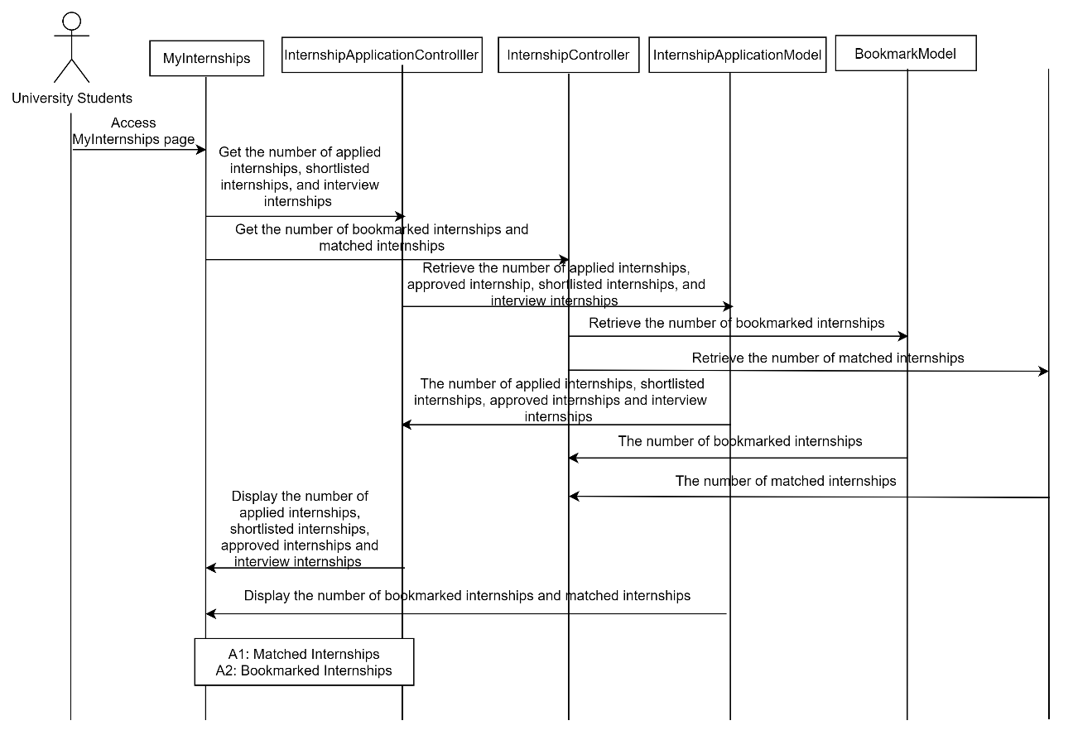

Figure 3‑90: Sequence Diagram (Basic Flow for university students to view internship metrics in the My Internships page)

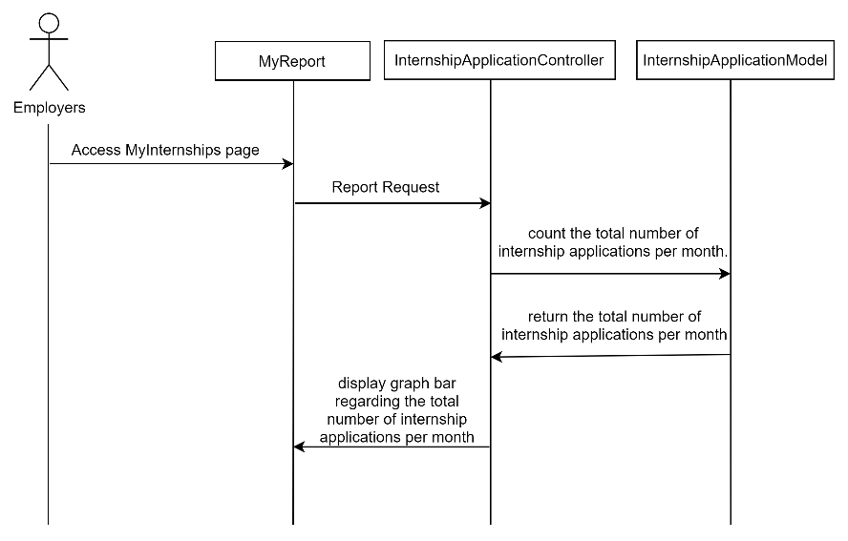

Figure 3‑91: Sequence Diagram (Basic Flow for employers to view monthly internship application report graph)

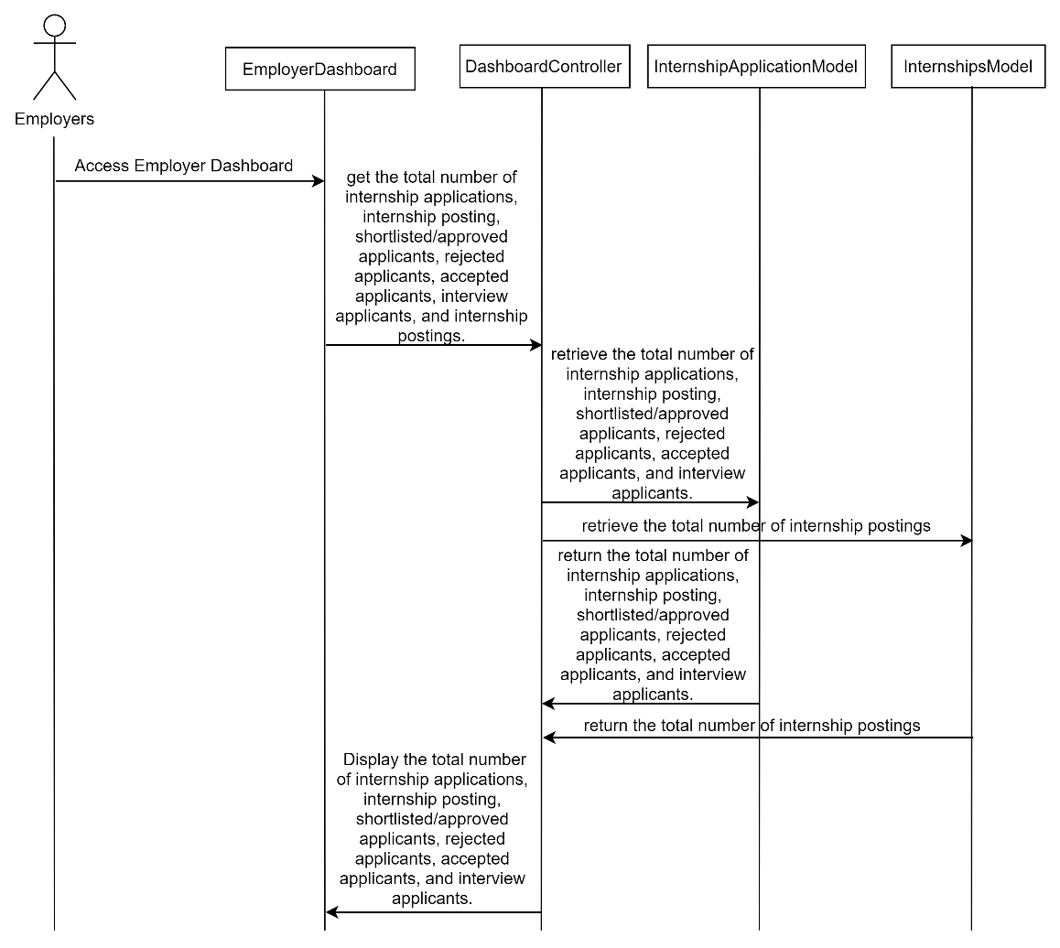

Figure 3‑92: Sequence Diagram (Basic Flow for employers to view employer dashboard metrics)

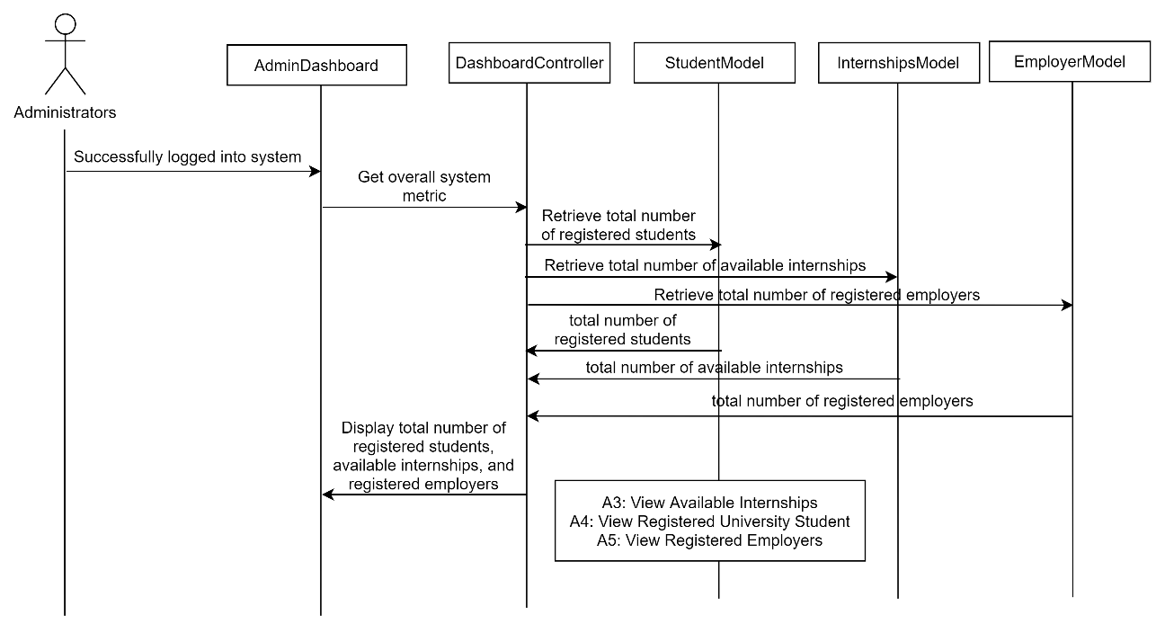

Figure 3‑93: Sequence Diagram (Basic Flow for administrators to view the overall system metrics)

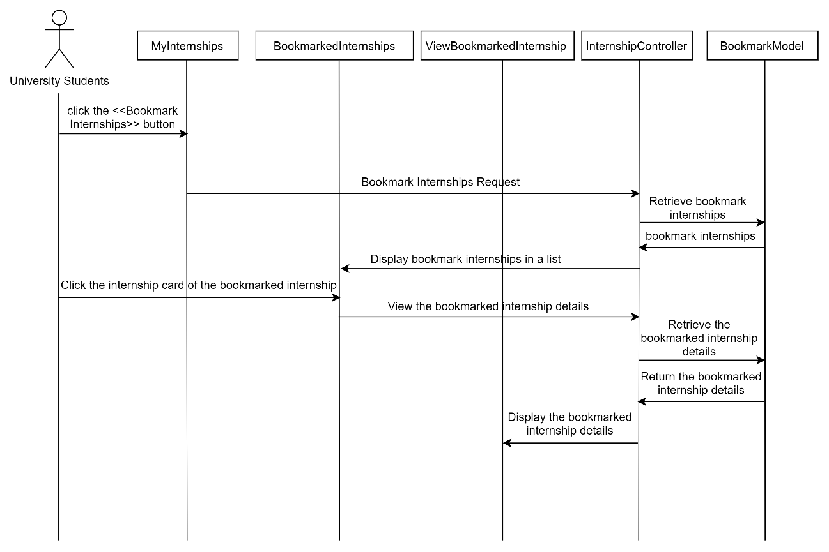

Figure 3‑94: Sequence Diagram (Alternative Flow for university students to view Bookmark Internships)

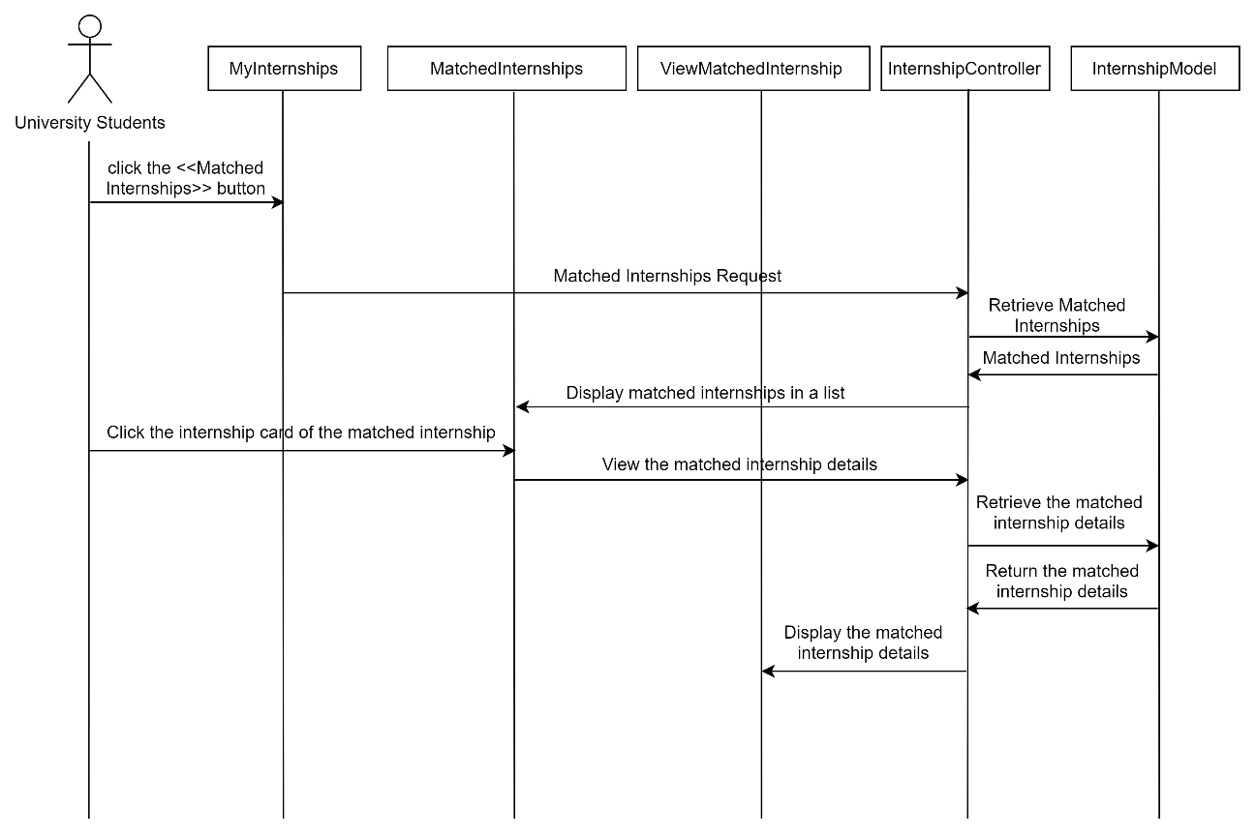

Figure 3‑95: Sequence Diagram (Alternative Flow for university students to view Matched Internships)

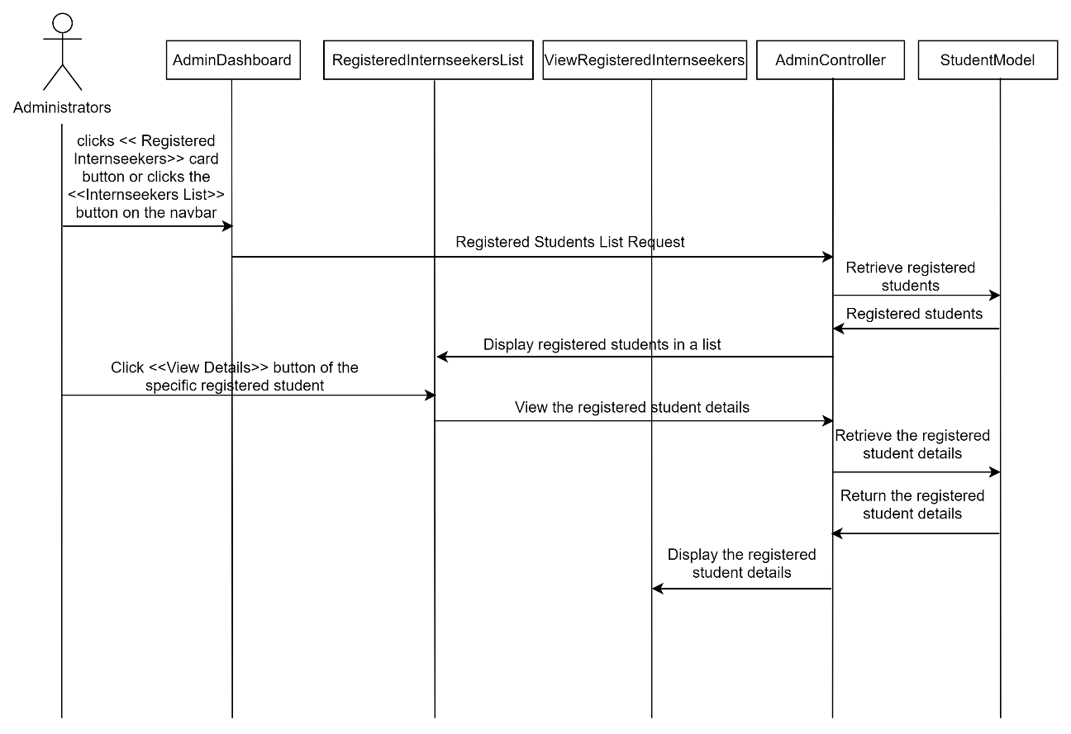

Figure 3‑96: Sequence Diagram (Alternative Flow for administrators to view Registered University Students)

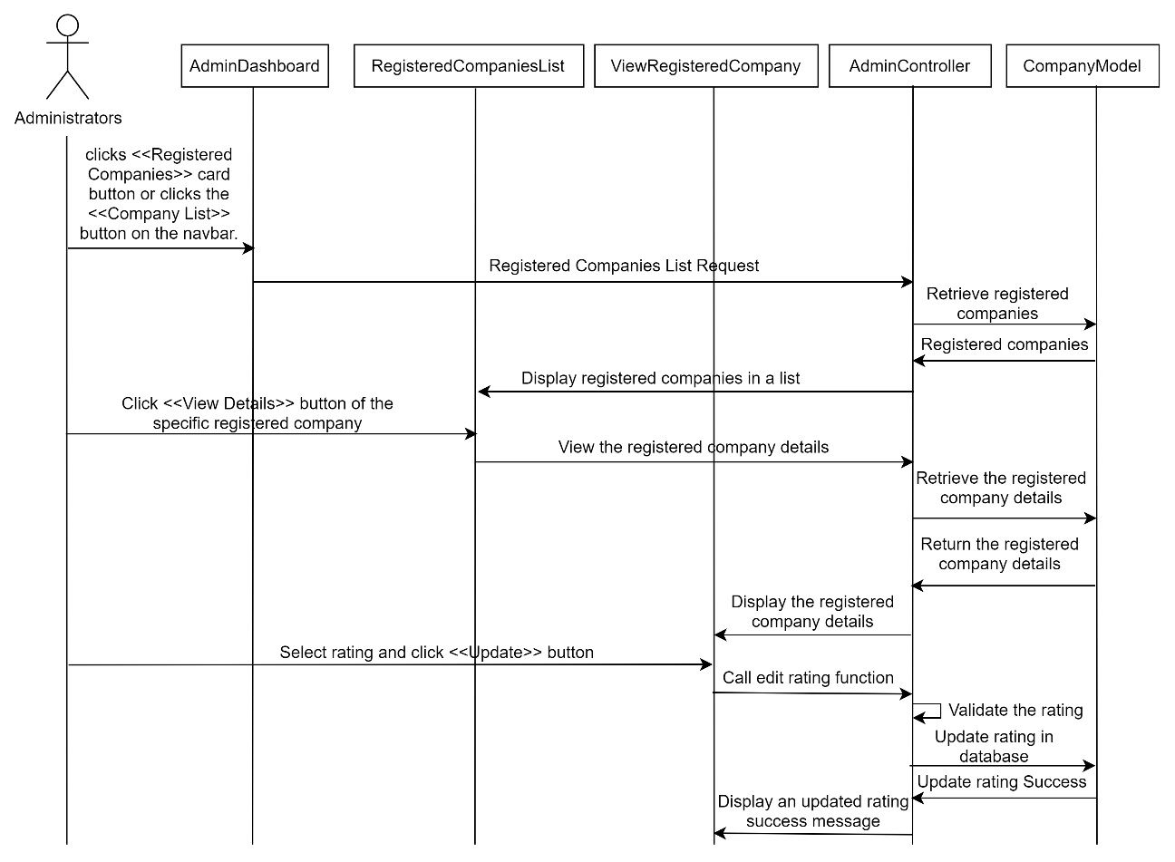

Figure 3‑97: Sequence Diagram (Alternative Flow for administrators to view Registered Employers & Update Rating)

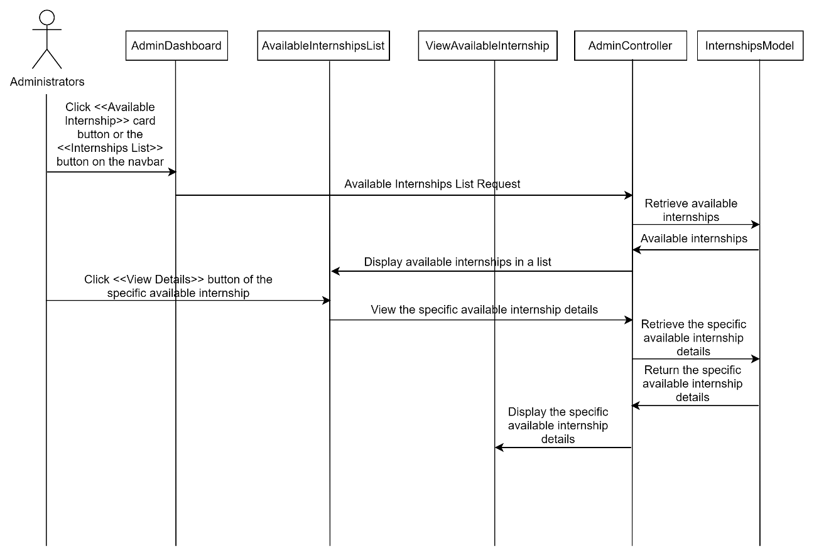

Figure 3‑98: Sequence Diagram (Alternative Flow for administrators to view Available Internships)

##### Manage Messaging Features

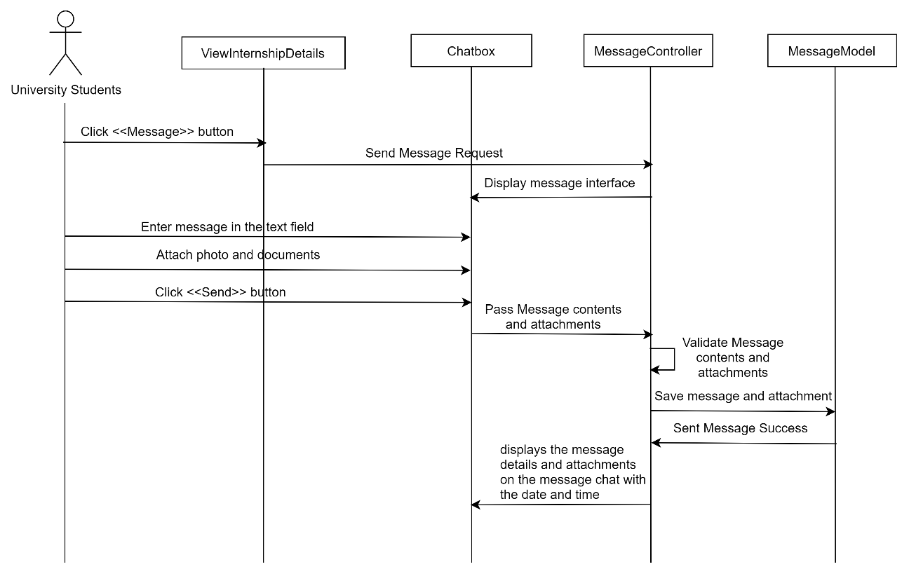

Figure 3‑99: Sequence Diagram (Basic Flow for university students to send message to employers)

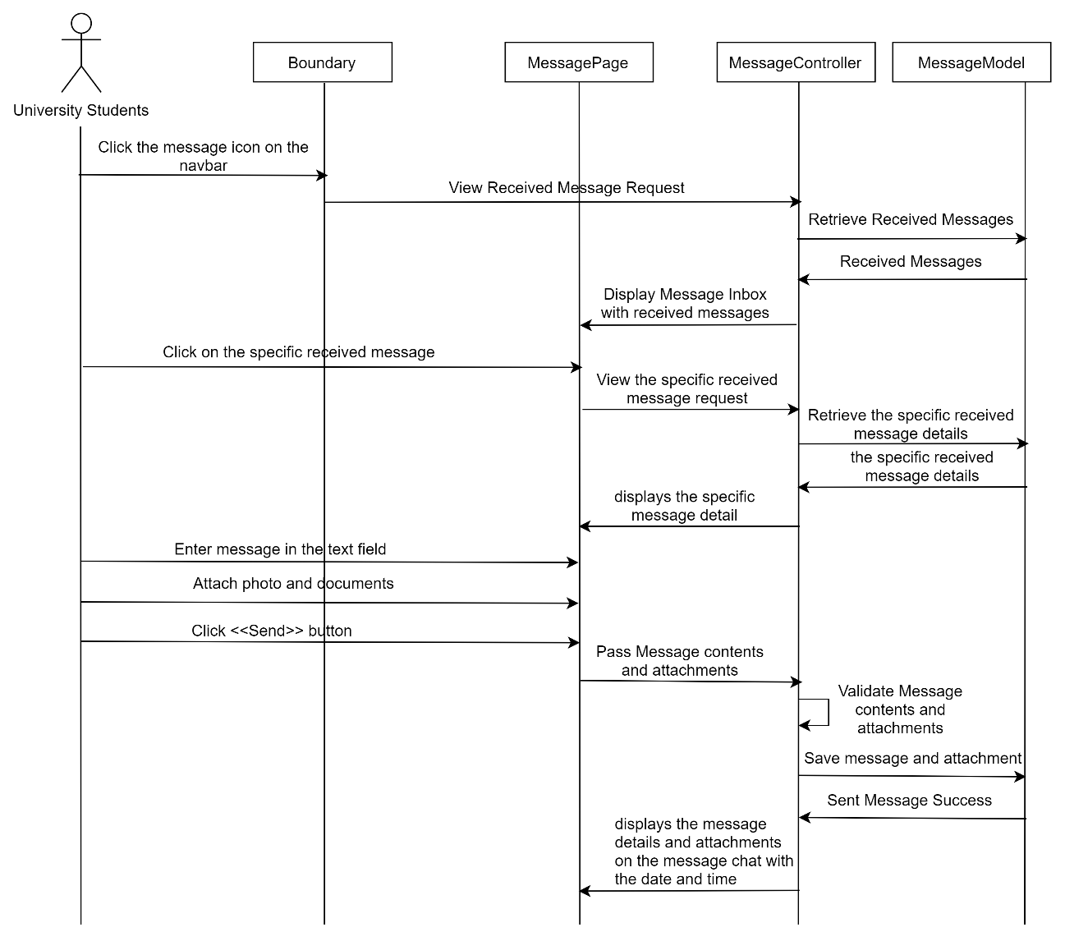

**Figure 3‑100: Sequence Diagram (Basic Flow for university students to view received message and reply message)**

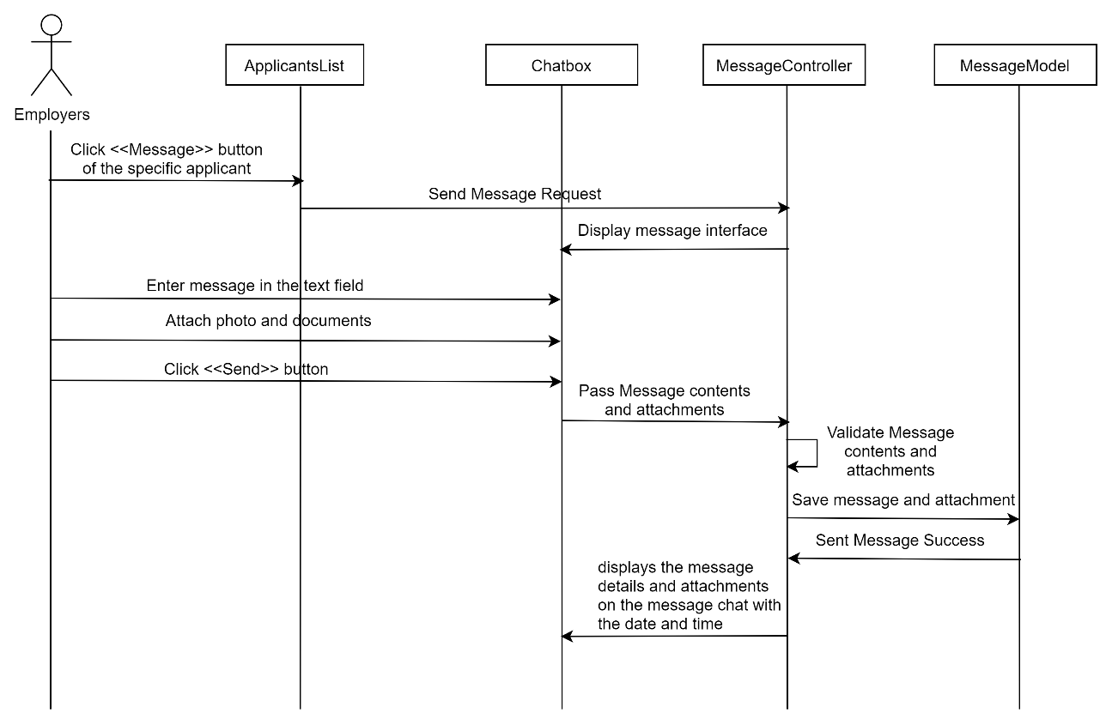

**Figure 3‑101: Sequence Diagram (Basic Flow for employers to send message to applicants)**

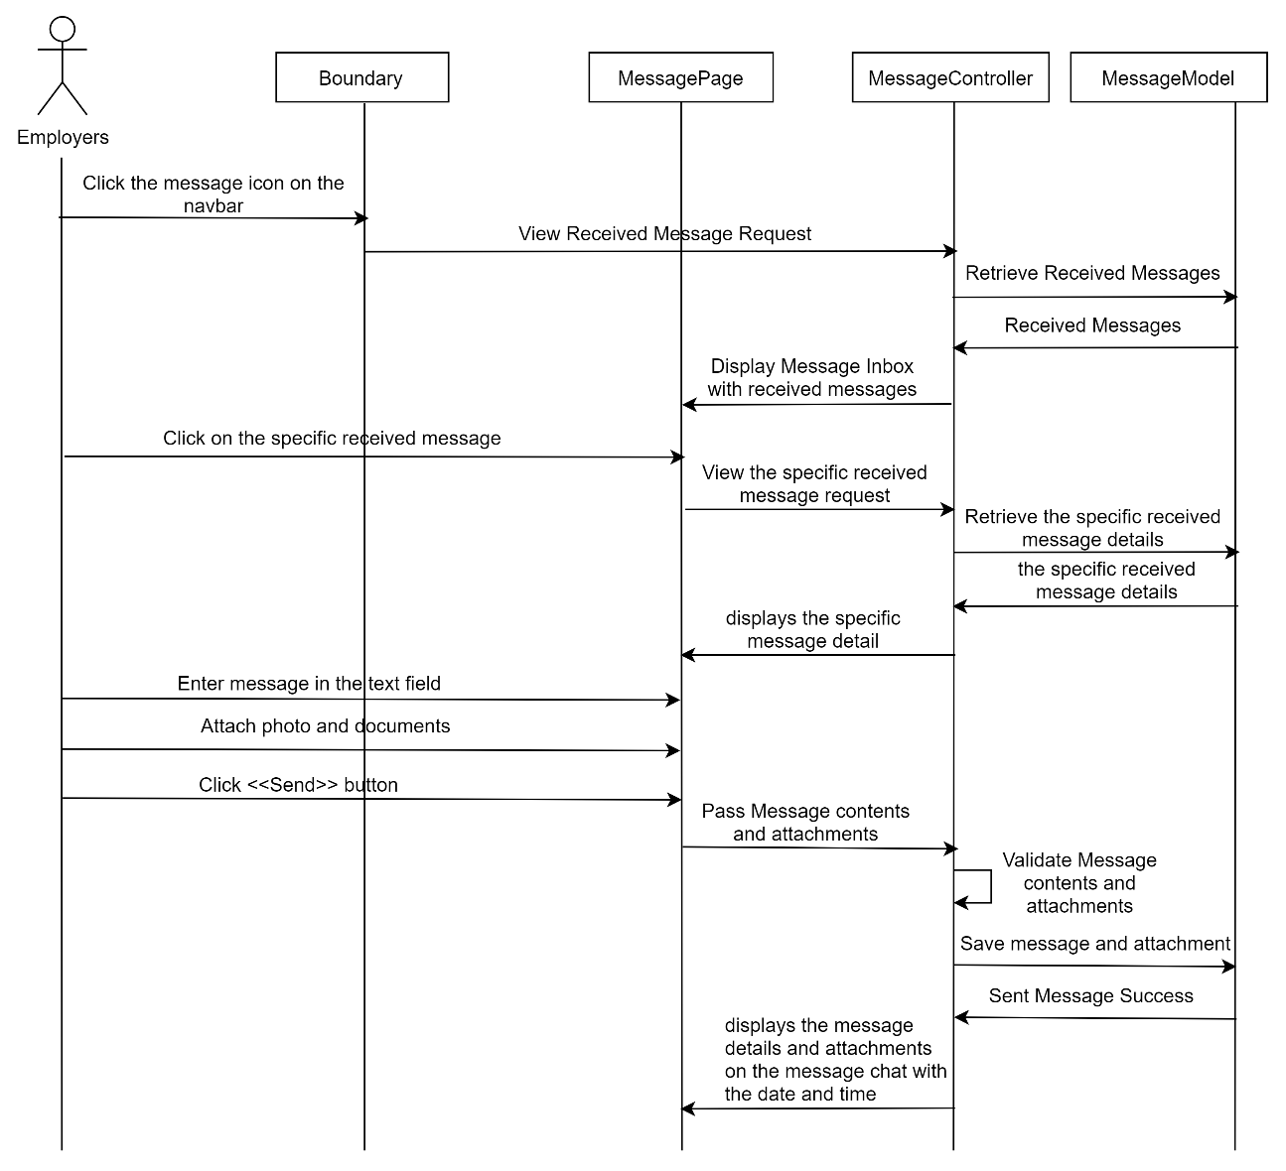

**Figure 3‑102: Sequence Diagram (Basic Flow for employers to view received message and reply message)**

## Proposed Design

### Context Diagram

The figure 3-92 shows the context diagram of the Internship Application System (Internseek), which represents the interaction between the system and the two actors (university students and employers).

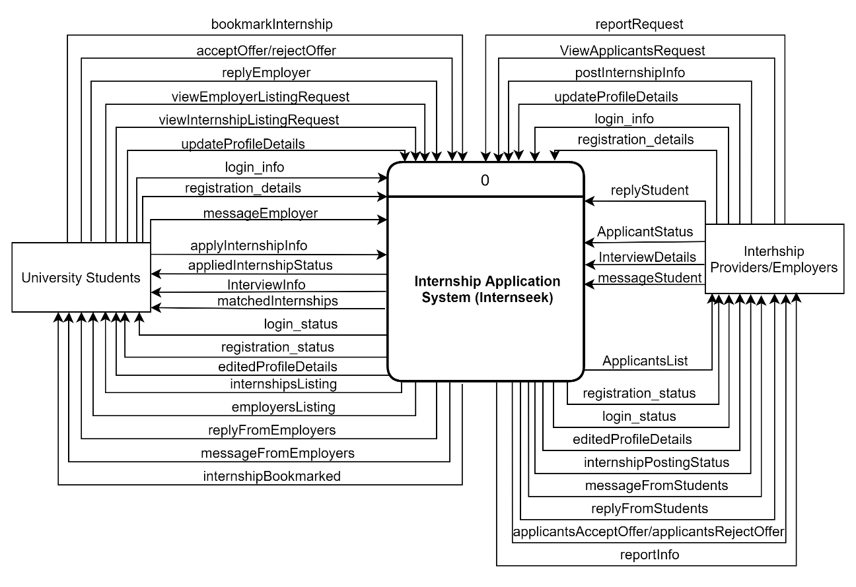

Figure 3‑103: Context Diagram

### General Architecture

The figure below shows the general architecture of the Internship Application System (Internseek).

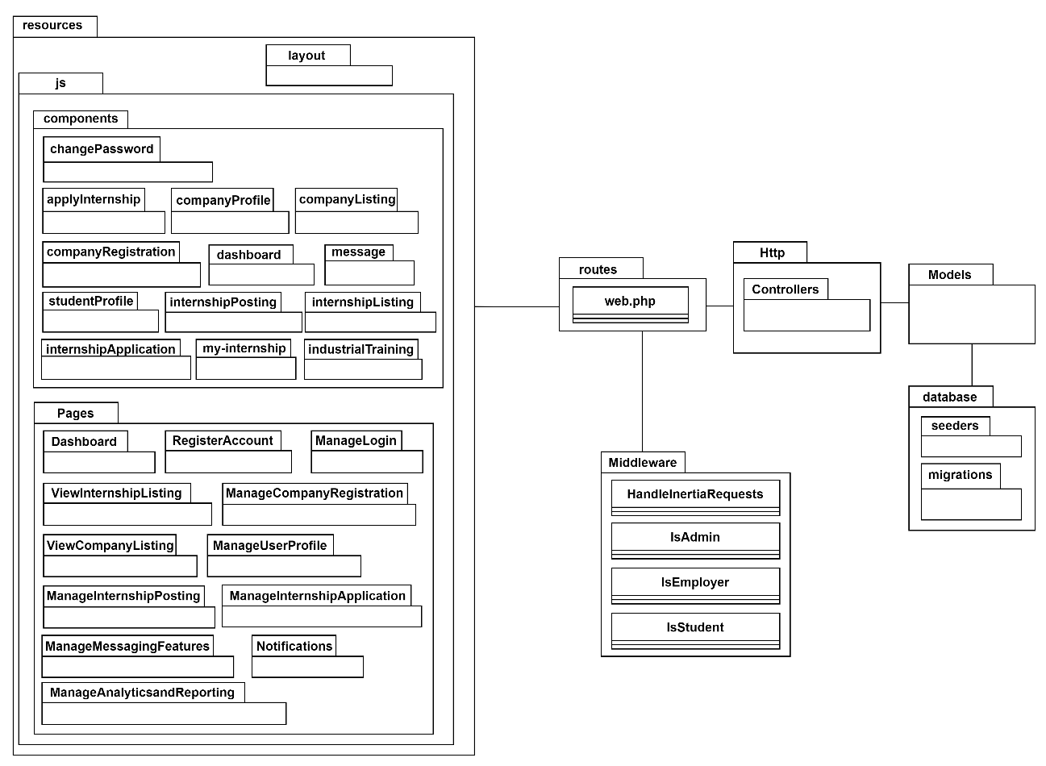

Figure 3‑104: General Architecture of Internship Application System (Internseek)

The Internship Application System is developed using Laravel, React.js and Inertia.js. The general architecture of the Internship Application System is following MVC design pattern.

1. Model (/Models):

* This layer is responsible for interacting with the database.

2. Controller (/Controllers):

* This layer is used to handle business logic and data processing.
* Handle HTTP requests and responses.

3. View (/components and /Pages):

* This layer is responsible for the user interface.
* Components are reusable UI elements.
* Pages are made up of components that represent various views in the application.

4. Middleware (/Middleware):

* Used to process requests before they reach the actual route handlers.
* Perform tasks such as authentication, logging, rate limiting.

5. Routes (/routes)

* Defines the URLs of the application in the web.php file and maps them to specific controllers.

6. Database

* Consists of migration scripts in the /migrations folder, which define the database schema.
* Consists of seeder scripts in the /seeders folder, which help populate data for development or testing.

### Package Diagram

##### Register Account

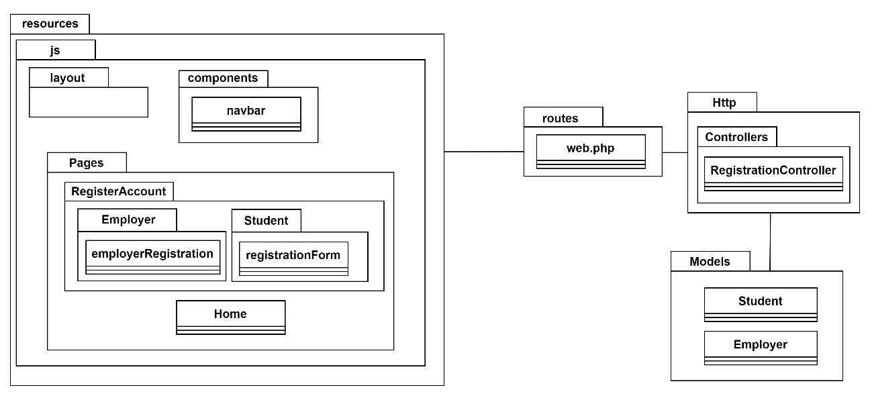

Figure 3‑105: Package Diagram (Register Account)

View Layer (/components)

| **Component** | **Explanation** |
| --- | --- |
| navbar | The Navbar component includes a "Register Account" button. When this button is clicked, a modal appears, prompting the user to select their user type (e.g., student or employer). Based on the selection, the user is then directed to the appropriate registration page. |

View Layer (/Pages)

| **Page** | **Explanation** |
| --- | --- |
| Employer/employerRegistration | Page that allows employers to register an account by filling out the required details in the form. |
| Student/registrationForm | Page that allows students to register an account by filling out the required details in the form. |
| Home | The homepage of the Internseek system features a navbar for easy navigation, including a register button for users to register an account. |

Controller Layer (/Controllers)

| **Controller Class** | **Explanation** |
| --- | --- |
| RegistrationController | This controller manages communication between the user interface of the Register Account module and the backend. It receives input from the employerRegistration and registrationForm for students, processes the data, and interacts with the Student and Employer models to create user accounts. After successful registration, it redirects employers to the employer dashboard, while students to the internship listing, ensuring a seamless transition and experience for both employers and students. |

Model Layer (/Models)

| **Model Class** | **Explanation** |
| --- | --- |
| Student | This model stores the student registration details into the database. |
| Employer | This model stores the employer registration details into the database. |

##### Manage Login

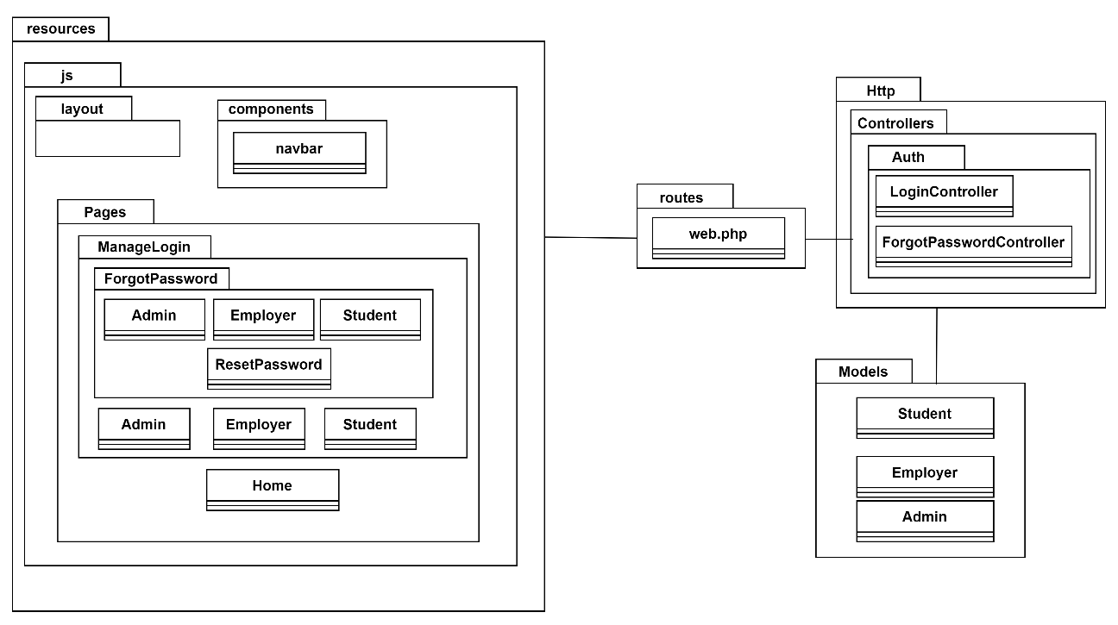

Figure 3‑106: Package Diagram (Manage Login)

View Layer (/Components)

| **Component** | **Explanation** |
| --- | --- |
| navbar | This component includes a "Login" button. When this button is clicked, a modal appears, prompting the user to select their user type (e.g., student or employer). Based on the selection, the user is then directed to the appropriate login page. |

**View Layer (/Pages)**

| **Page** | **Explanation** |
| --- | --- |
| /ManageLogin/ForgotPassword/ Admin | A page for admins to start the password recovery process by requesting a password reset. |
| /ManageLogin/ForgotPassword/ Employer | A page for employers to start the password recovery process by requesting a password reset. |
| /ManageLogin/ForgotPassword/ Student | A page for students to start the password recovery process by requesting a password reset. |
| /ManageLogin/ForgotPassword/ ResetPassword | The page where users (admin, employer, or student) set a new password after clicking a password reset link in the email. |
| /ManageLogin/Admin | A login page tailored for admins to login into the system. |
| /ManageLogin/Employer | A login page tailored for employers to login into the system. |
| /ManageLogin/Student | A login page tailored for students to login into the system. |

Controller Layer (/Controllers)

| **Controller Class** | **Explanation** |
| --- | --- |
| LoginController | The controller handles the login functionality for different user roles (such as Admin, Employer, and Student). It includes methods to authenticate users, redirect them to their respective dashboards/pages upon successful login, and manage session data based on user roles. This controller ensures each type of user can securely access the correct page with their credentials. |
| ForgotPasswordController | This controller manages the password recovery process for users (such as Admin, Employer, and Student) who have forgotten their passwords. It includes methods to send password reset emails, validate reset requests, and setting a new password. This controller ensures that Admins, Employers, and Students can initiate and complete password recovery securely and efficiently. |

Model Layer (/Models)

| **Model Class** | **Explanation** |
| --- | --- |
| Student | This model supports login by verifying student credentials (email & password) and enables password recovery through reset tokens sent to the student’s email. |
| Employer | This model supports login by verifying employer credentials (email & password) and enables password recovery through reset tokens sent to the employer’s email. |
| Admin | This model supports login by verifying admin credentials (email & password) and enables password recovery through reset tokens sent to the admin’s email. |

##### Manage Company Registration

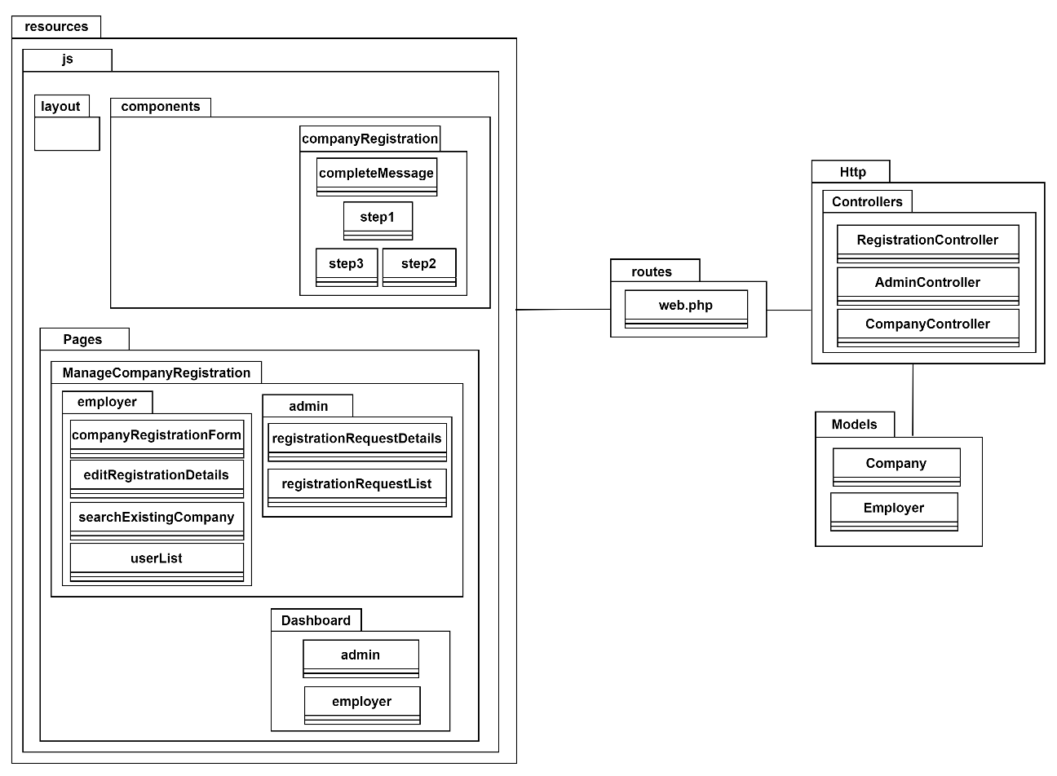

Figure 3‑107: Package Diagram (Manage Company Registration)

View Layer (/Components)

| **Component** | **Explanation** |
| --- | --- |
| /companyRegistration/step1 | This component includes the initial step of the company registration process, where employers enter their company details, such as the company name, email, and other details. |
| /companyRegistration/step2 | This component handles the second step of the registration process, allowing employers to upload company logo. |
| /companyRegistration/step3 | This component handles the third step of the registration process, allowing employers to insert their position and department within the company. |
| /companyRegistration/ completeMessage | This component displays a confirmation message once the company registration process is completed, informing the employer that their registration has been successfully submitted and is being processed. |

**View Layer (/Pages)**

| **Page** | **Explanation** |
| --- | --- |
| /Dashboard/admin | This page consists of a section for managing company registration requests, where the admin can review on pending or inquiry status requests. |
| /Dashboard/employer | This page offers two options for the employer: register a new company or search for an existing company if they already have one in the system. If the employer already has a company, they can search for it; if not, they can register a new company. If the company registration is still pending, the employer can edit their registration details using the provided edit button. If the registration is in inquiry status, the employer must follow the admin's comments and make the necessary changes as instructed. |
| /ManageCompanyRegistration/employer/ companyRegistrationForm | This page allows employers to register with a new company by filling out the 3-step company registration form. |
| /ManageCompanyRegistration/employer/ editRegistrationDetails | This page enables employers to edit the details of their company registration if the registration is still pending or inquiry status which requires updates based on the comment given by admin. |
| /ManageCompanyRegistration/employer/ searchExistingCompany | This page allows employers to search for an existing company and add themselves into the company in the system if they already have one registered. |
| /ManageCompanyRegistration/employer/userList | This page allows the company administrator to review and approve requests for employers to be added to the company in the system. |
| /ManageCompanyRegistration/admin/ registrationRequestDetails | This page allows the admin to view the details of a specific company registration request, including the submitted information and any supporting documents, enabling the admin to evaluate the request. |
| /ManageCompanyRegistration/admin/registrationRequestList | This page displays a list of all pending and processed company registration requests. |

Controller Layer (/Controllers)

| **Controller Class** | **Explanation** |
| --- | --- |
| RegistrationController | This controller handles actions related to the company registration process, including registering new companies, updating existing company registration details, searching for existing companies, and allowing employers to add themselves to a company. |
| AdminController | This controller is responsible for handling company registration requests, including approving or rejecting company registration requests. |
| CompanyController | This controller retrieves the user list for the company admin, allowing them to approve or reject employers attempting to join an existing company by interacting with the Employer and Company models. |

Model Layer (/Models)

| **Model Class** | **Explanation** |
| --- | --- |
| Company | This model stores and retrieves information related to companies. |
| Employer | This model stores and manages employer-specific information. |

##### Manage User Profile

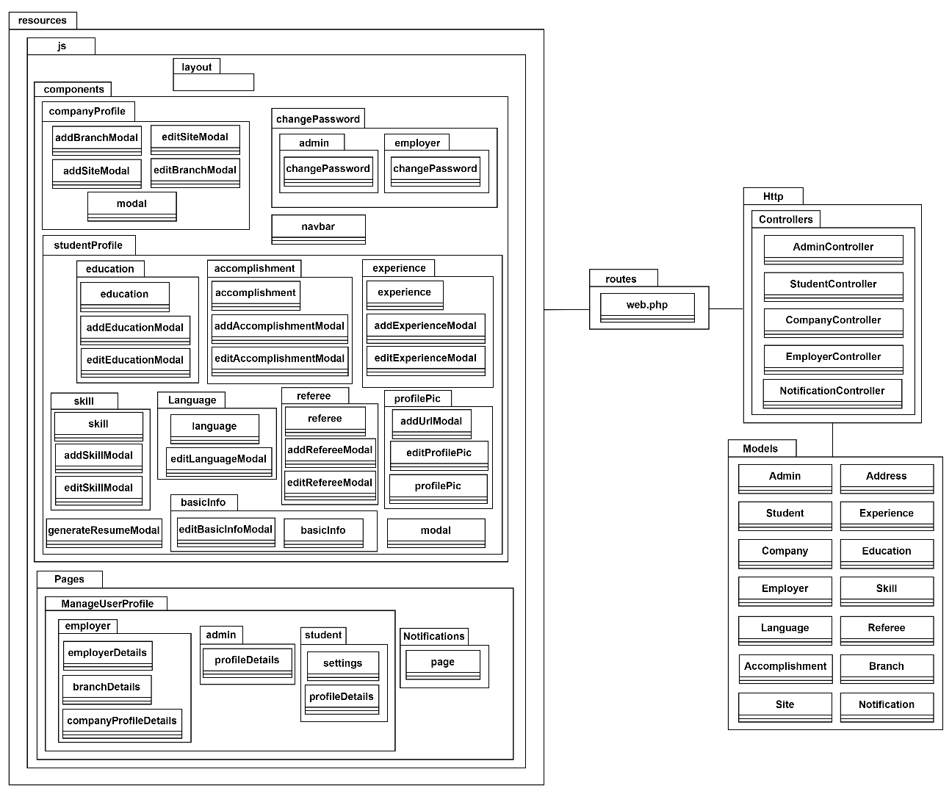

Figure 3‑108: Package Diagram (Manage User Profile)

View Layer (/Components)

| **Component** | **Explanation** |
| --- | --- |
| navbar | This component features a role-based drop-down menu with options for employers (Company Profile, Branch & Site Details, Employer Details), students (My Profile, Settings), and admins (Admin Profile). It also includes a notification icon with a red dot showing unread notifications for employers and students. |
| /companyProfile/ addBranchModal | This modal component allows employers to add a new branch to their company profile. |
| /companyProfile/ editBranchModal | This modal component allows employers to edit or delete existing branch details associated with their company. |
| /companyProfile/ addSiteModal | This modal component allows employers to add a new site to a specific branch of their company profile. |
| /companyProfile/ editSiteModal | This modal component allows employers to edit or delete existing site details associated with their company. |
| /companyProfile/modal | This component defines the layout and structure for modals used to manage company-related details, ensuring consistent user experience. |
| /changePassword/admin/ changePassword | This form component allows admins to securely update their password. |
| /changePassword/employer/ changePassword | This form component allows employers to securely update their password. |
| /studentProfile/education/ editEducationModal | This modal component allows students to edit or delete education details in their profile. |
| /studentProfile/education/ addEducationModal | This modal component allows students to add new education information to their profile. |
| /studentProfile/education/ education | This component displays the student's education information, including details such as the institution name, level of study, field of study, start and end dates, and other relevant details. |
| /studentProfile/ accomplishment/ editAccomplishmentModal | This modal component allows students to edit or delete accomplishment details in their profile. |
| /studentProfile/ accomplishment/ addAccomplishmentModal | This modal component allows students to add new accomplishment information to their profile. |
| /studentProfile/ accomplishment/ accomplishment | This component displays the student's education information, including details such as the name, year, and description of each accomplishment. |
| /studentProfile/experience/ addExperienceModal | This modal component allows students to add new experience information to their profile. |
| /studentProfile/experience/ editExperienceModal | This modal component allows students to edit or delete existing experience details in their profile. |
| /studentProfile/experience /experience | This component displays the student's experience information, including job title, company name, start and end dates, and job descriptions. |
| /studentProfile/skill/skill | This component displays the student's skill information, including skill description and proficiency level. |
| /studentProfile/skill/ addSkillModal | This modal component allows students to add new skill details to their profile. |
| /studentProfile/skill /editSkillModal | This modal component allows students to edit or delete existing skill details in their profile. |
| /studentProfile/Language/ editLanguageModal | This modal component allows students to select and update their language proficiency level. |
| /studentProfile/Language/ language | This component displays the student's language information, including languages and its proficiency level. |
| /studentProfile/referee/referee | This component displays the student's referee information, including details such as the referee's name, job title, company name, email, and phone number. |
| /studentProfile/referee/ addRefereeModal | This modal component allows students to add new referee details to their profile. |
| /studentProfile/referee/ editRefereeModal | This modal component allows students to edit or delete existing referee information in their profile. |
| /studentProfile/profilePic/ addUrlModal | This modal component allows students to insert the LinkedIn URL into their profile. |
| /studentProfile/profilePic/ editProfilePic | This component allows students to update their profile picture. |
| /studentProfile/profilePic/ profilePic | This component displays the student's profile picture, along with a LinkedIn tag that includes the student's name and a hidden public LinkedIn URL below the picture, as well as the profile progress bar. If no LinkedIn URL is provided, a button will appear, allowing the student to add their public LinkedIn URL. |
| /studentProfile/basicInfo/ editBasicInfoModal | This component allows students to edit their basic information such as personal information, training address, and home address. |
| /studentProfile/basicInfo/ basicInfo | This component displays the basic information of the student such as personal information, training address, and home address. |
| /studentProfile/modal | This component defines the layout and structure for modals used to manage student profile related details, ensuring consistent user experience. |
| /studentProfile/ generateResumeModal | This modal component allows students to generate a resume based on the profile details they have provided. Students can click the "Generate Resume" button to create and download their resume as a PDF. |

View Layer (/Pages)

| **Page** | **Explanation** |
| --- | --- |
| /ManageUserProfile/admin/ profileDetails | This page displays the admin's profile details, allowing the admin to view and update their account information, as well as change their password. |
| /ManageUserProfile/employer/ employerDetails | This page displays the employer's profile details, allowing the employer to view and update their account information, as well as change their password. |
| /ManageUserProfile/employer/ branchDetails | This page displays the branch and site details associated with the company, allowing the employer to view, update, or create new branches and sites for the company. |
| /ManageUserProfile/employer/ companyProfileDetails | This page displays the company's profile details, allowing employers to view and edit company profile details. |
| /ManageUserProfile/student/settings | This page allows students to securely update their password. |
| /ManageUserProfile/student/ profileDetails | This page displays the student's profile details, including basic information, education, experience, skills, languages, referees, and accomplishments. Students can generate resume based on profile details in this page. |
| /Notifications/page | This page displays a list of notifications for students and employers, such as new updates on applications and other relevant system alerts. Students and employers can mark all notifications as read or clear all notifications. |

Controller Layer (/Controllers)

| **Controller Class** | **Explanation** |
| --- | --- |
| AdminController | This controller handles actions related to managing admin profile, such as viewing and updating admin profile details, as well as changing the admin's password within the system. |
| StudentController | This controller handles actions related to managing student profile, including viewing and updating the student's profile, managing education, experience, skills, and other personal details, as well as changing the student's password within the system. |
| EmployerController | This controller handles actions related to managing employer profile, including viewing and updating the employer's profile details, as well as changing the employer's password within the system. |
| CompanyController | This controller handles actions related to managing company profile, including viewing and updating the company details within the system. |
| NotificationController | This controller is responsible for managing notifications for students and employers, such as retrieving, marking as read, and clearing notifications related to applications, messages, and other system events. |

Model Layer (/Models)

| **Model Class** | **Explanation** |
| --- | --- |
| Admin | This model stores and retrieves the admin profile details from the database. |
| Student | This model stores and retrieves the student’s personal details from the database. |
| Employer | This model stores and retrieves the employer’s personal details from the database. |
| Company | This model stores and retrieves the company details from the database. |
| Notification | This model stores and retrieves notifications within the system, tracking details such as the notification type, the receiver (either student or employer), and the notification status (read/unread). |
| Address | This model stores and retrieves the training address and home address of the student from the database. |
| Education | This model stores and retrieves the education history of the student from the database. |
| Experience | This model stores and retrieves the job experience of the student from the database. |
| Accomplishment | This model stores and retrieves the accomplishments achieved by the student from the database. |
| Skill | This model stores and retrieves the skills gained by the student from the database. |
| Language | This model stores and retrieves the languages known by the student from the database. |
| Referee | This model stores and retrieves the information of the student's referees from the database. |
| Branch | This model stores and retrieves information about the company's branch. |
| Site | This model soars and retrieves information related to the specific site associated with the branch. |

##### View Internship Listing

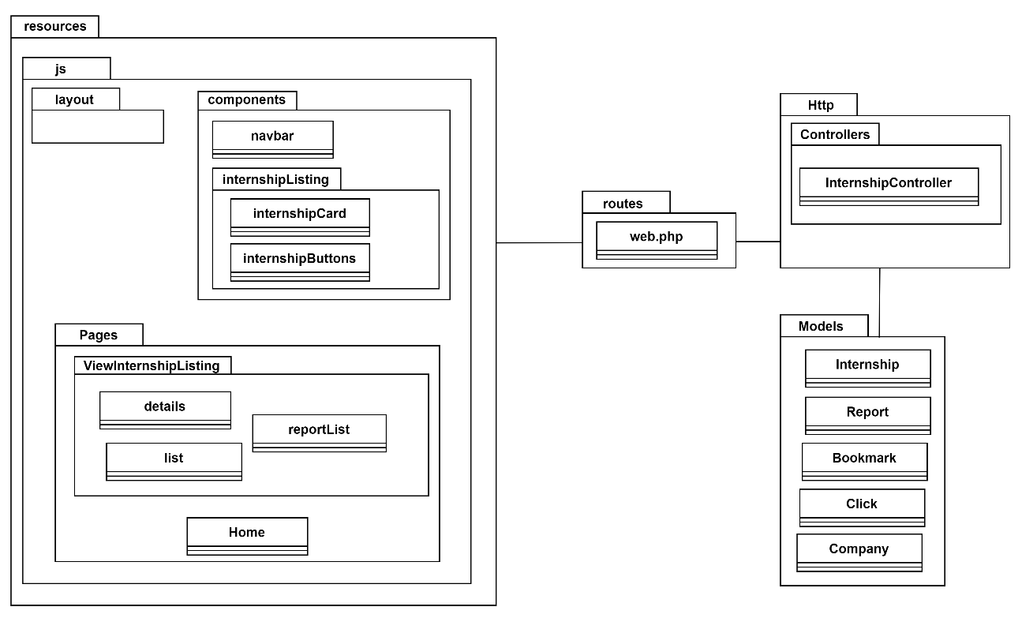

Figure 3‑109: Package Diagram (View Internship Listing)

View Layer (/components)

| **Components** | **Explanation** |
| --- | --- |
| navbar | This component includes a Search Internship option, which redirects users to the internship listing page when selected. |
| /internshipListing/internshipCard | This component represents a single internship in the form of a card and displays the general information about the internship. University students can view the detailed information by clicking the card. |
| /internshipListing/internshipButtons | This component provides essential buttons for each internship, including Apply, Bookmark, Message, and Report options. |

View Layer (/Pages)

| **Pages** | **Explanation** |
| --- | --- |
| /Home | Includes popular search options for students to select and view internships. It features a search keyword input, and a study field select field, which helps filter and display relevant internship opportunities based on the student's preferences. |
| /ViewInternshipListing/list | Displays a list of available internships, allowing users to browse and view internship opportunities by study field, location, or keywords. |
| /ViewInternshipListing/details | Shows detailed information about a specific internship, including its description, requirements, application deadlines, and the number of views, applications, and bookmarks. |
| /ViewInternshipListing/ reportList | Displays a list of internships that have been reported by students. |

Controller Layer (/Controllers)

| **Controller Class** | **Explanation** |
| --- | --- |
| InternshipController | This Controller handles the logic for managing internship-related actions in the Internseek system. It typically includes methods for displaying internship listings, showing details of a specific internship, bookmarking, and reporting internships. This controller interacts with the database to fetch available internships and their details within the system. |

Model Layer (/Models)

| **Model Class** | **Explanation** |
| --- | --- |
| Internship | This model handles retrieving internship data for listing and display from database. |
| Report | This model stores and retrieves information about reports made by students on specific internships. |
| Bookmark | This model manages the internships that students have bookmarked. |
| Click | This model tracks the number of times an internship listing is viewed. It is used to count and store the number of views for each internship. |
| Company | This model manages and retrieves the details of the company that posts internships, including essential company information linked to each internship. |

##### View Company Listing

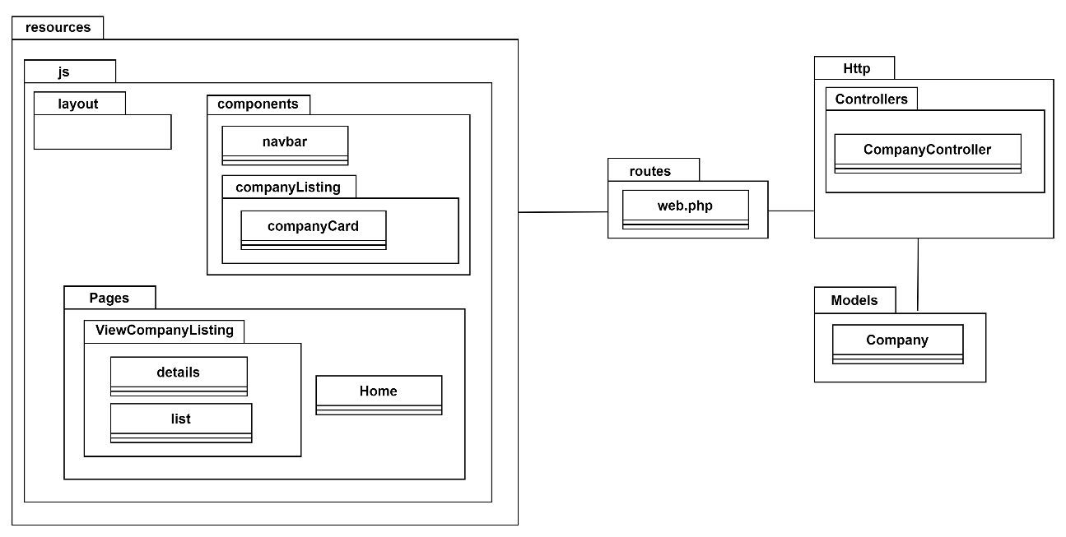

Figure 3‑110: Package Diagram (View Company Listing)

View Layer (/components)

| **Component** | **Explanation** |
| --- | --- |
| navbar | This component includes a Search Company option, which redirects users to the company listing page when selected. |
| /companyListing/companyCard | This component represents a single company in the form of a card and displays the general information about the company. University students can view the detailed information by clicking the company card. |

View Layer (/Pages)

| **Pages** | **Explanation** |
| --- | --- |
| /Home | This page includes the navbar component which redirects users to the company listing page when selected the Search Company Option. |
| /ViewCompanyListing/list | This page displays a list of registered companies in the system, allowing users to browse and view companies by location or keywords. |
| /ViewCompanyListing/details | A page with a card component that shows detailed information about a specific company. |

Controller Layer (/Controllers)

| **Controller Class** | **Explanation** |
| --- | --- |
| InternshipController | This controller handles the logic for managing company-related actions in the Internseek system. It typically includes methods for displaying company listings, showing company details. This controller interacts with the database to retrieve registered companies and their details within the system. |

Model Layer (/Models)

| **Model Class** | **Explanation** |
| --- | --- |
| Company | This model retrieves the company data from database. |

##### Manage Internship Application

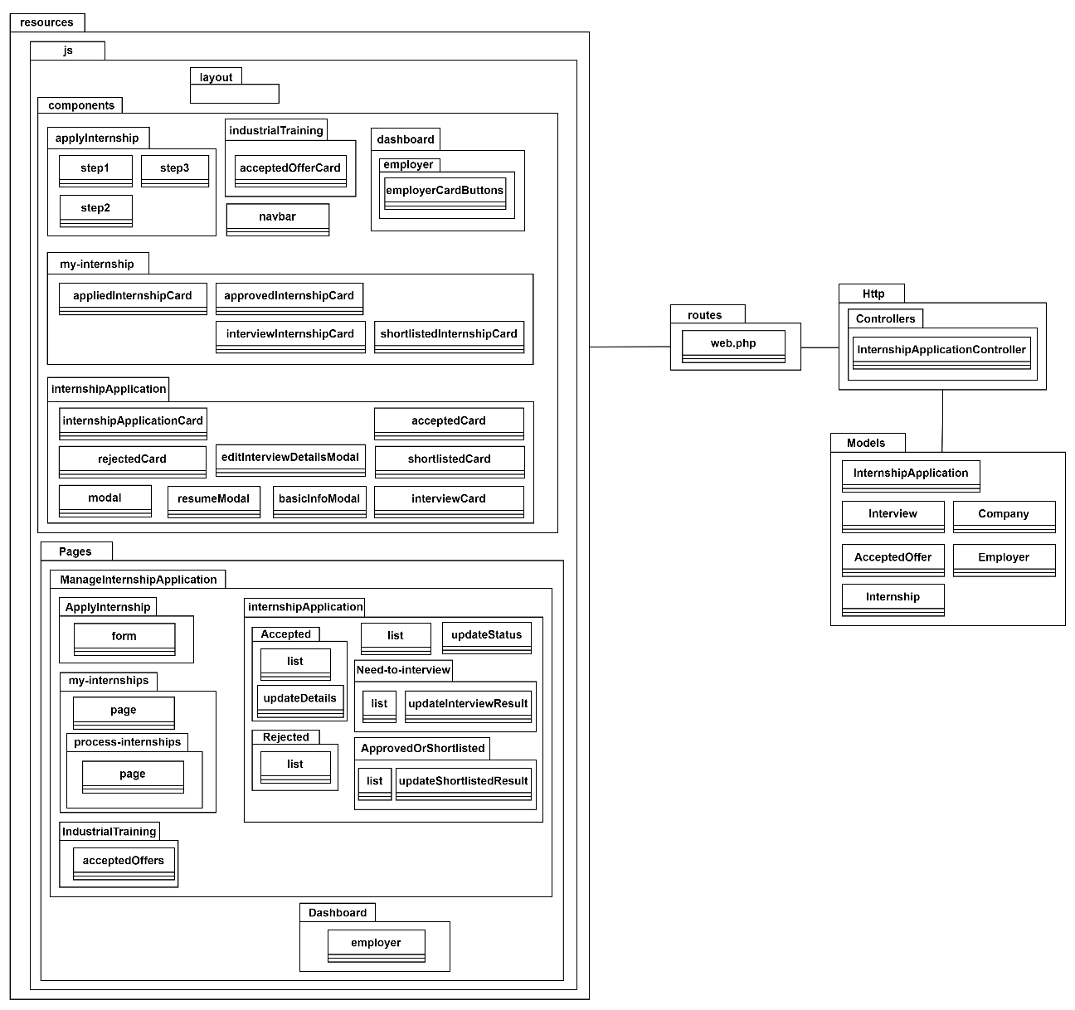

Figure 3‑111: Package Diagram (Manage Internship Application)

View Layer (/components)

| **Component** | **Explanation** |
| --- | --- |
| navbar | This component includes the "Applicants" and "Interview List" options in the navbar, allowing employers to navigate to sections related to internship applicants and scheduled interviews. |
| /applyInternship/step1 | This component includes the initial step of applying for an internship, where students provide essential details like expected allowance, availability, and the expected start and end dates. |
| /applyInternship/step2 | This component includes the second step of applying for an internship, where students review their generated resume, ensuring that the information from their profile is accurate before proceeding to the final step. |
| /applyInternship/step3 | This component represents the final step of the internship application process, where students upload required documents such as their resume (optional), cover letter, student application letter, and transcript. |
| /my-internship/ appliedInternshipCard | This component displays a card for internships that the student has applied for or has an unsuccessful status, showcasing details such as the company name, internship position, and the current application status. |
| /my-internship/ interviewInternshipCard | This component displays a card for internships where the student has been selected for an interview, showing interview details. The student can respond by clicking the "Available" or "Not Available" button. If the student selects "Not Available", the interview will be rescheduled. If it is a second interview, the first interview's rating and comments from the interviewer will be displayed. |
| /my-internship/ shortlistedInternshipCard | This component displays a card for internships where the student has been shortlisted, showing internship details along with the interview's rating and comments from the interviewer. |
| /my-internship/ approvedInternshipCard | This component displays a card for internships where the student has been approved, including the offered allowance, offer letter, and the interview's rating and comments from the interviewer. |
| /industrialTraining/ acceptedOfferCard | This component displays a card for internships where the student has accepted the offer, including supervisor details, working days, working hours, and other relevant information. If the student has accepted multiple offers, they need to decide which offer to keep, and the other offers must be cancelled. |
| /dashboard/employer/ employerCardButtons | This component includes card buttons for reviewing applicants, shortlisted or approved applicants, need-to-interview applicants, rejected applicants, and accepted applicants. |
| /internshipApplication/ internshipApplicationCard | This component displays a card with the details of an internship applicant in the "Reviewing" status, including relevant information such as the applicant's name, the internship position they applied for, and their current application status and a button to update application status. |
| /internshipApplication/ interviewCard | This component displays a card with the details of applicants who need to attend an interview, including the interview date, time, location, and the internship position applied for and a button to update the interview result. If the applicant is not available, employers can reschedule the interview. |
| /internshipApplication/ shortlistedCard | This component displays a card for applicants who have been shortlisted, including relevant applicant details, the applicant's name, the status of their application, and a button to update the shortlisted result. |
| /internshipApplication/ rejectedCard | This component displays a card for applicants who have been rejected, showing the internship position they applied for, their name, and the reason for rejection. |
| /internshipApplication/ acceptedCard | This component displays a card for applicants who have been accepted, including the internship position, the applicant's name, and the status of their application, with a button to update the accepted offer details. |
| /internshipApplication/ modal | This component defines the layout and structure for modals used to retrieve applicant related details, ensuring consistent user experience. |
| /internshipApplication/ editInterviewDetailsModal | This modal components allows employers to reschedule the interview if the student's response is unavailable. |
| /internshipApplication/ resumeModal | This modal component displays the resume generated based on the profile details of the applicant. It is triggered when the employer clicks the "View Internseek Resume". |
| /internshipApplication/ basicInfoModal | This modal component displays the basic information of the applicant when the employer clicks the "View Basic Info". |

View Layer (/Pages)

| **Pages** | **Explanation** |
| --- | --- |
| /Dashboard/employer | This page includes the employer card buttons component, which allows employers to access the applicant listings for reviewing, shortlisted or approved applicants, need-to-interview applicants, accepted applicants, and rejected applicants. |
| /ManageInternshipApplication/ApplyInternship/form | This page allows students to apply for internships by filling out the three step internship application form. |
| /ManageInternshipApplication /IndustrialTraining/ acceptedOffers | This page displays a list of all offers accepted by the student, with each offer represented as a card. |
| /ManageInternshipApplication/internshipApplication/list | This page displays a list of applicants with a "reviewing" status, showing relevant details of each applicant. |
| /ManageInternshipApplication/internshipApplication/ updateStatus | This page allows employers to update the status of internship applicants, changing their status “Need-to-Interview" or "Unsuccessful" based on the evaluation. |
| /ManageInternshipApplication/internshipApplication/Need-to-Interview/list | This page displays a list of applicants with a "Need-to-Interview" status, showing relevant details of each applicant along with the interview details. |
| /ManageInternshipApplication/internshipApplication/Need-to-Interview/ updateInterviewResult | This page also allows employers to update the interview result, changing the applicant's status to "Need-to-Interview," "Shortlisted," "Approved," or "Unsuccessful" after the interview. |
| /ManageInternshipApplication/internshipApplication/ ApprovedOrShortlisted/list | This page displays a list of applicants with a “Approved” or “Shortlisted” status, showing relevant details of each applicant. |
| /ManageInternshipApplication/internshipApplication/ ApprovedOrShortlisted/ updateShortlistedResult | This page allows employers to update the shortlisted result, changing the applicant's status to "Need-to-Interview," "Shortlisted," "Approved," or "Unsuccessful" after reviewing the application again. |
| /ManageInternshipApplication/internshipApplication/ Accepted/list | This page displays a list of applicants with an "Accepted" status, showing relevant details for each applicant who has accepted the offer. |
| /ManageInternshipApplication/internshipApplication/ Accepted/updateDetails | This page allows employers to update the details of accepted offers for applicants who have accepted the offer. |
| /ManageInternshipApplication/internshipApplication/ Rejected/list | This page displays a list of applicants with a "Rejected" status, showing relevant details for each applicant who was rejected, along with the reason for rejection. |
| /ManageInternshipApplication/my-internships/page | This page displays the two latest internships that are currently in process for the student (applied, shortlisted, need-to-interview, approved), showing relevant details for each internship. |
| /ManageInternshipApplication/my-internships/process-internships/page | This page displays the internships that are currently in process for the student (applied, shortlisted, need-to-interview, approved), showing relevant details for each internship. |

Controller Layer (/Controllers)

| **Controller Class** | **Explanation** |
| --- | --- |
| InternshipApplicationController | This controller manages the internship application process, handling tasks such as submitting applications, updating application statuses, scheduling interviews, updating interview result, and processing the acceptance or rejection of applications. It interacts with relevant models to retrieve and update information related to internship applications, including applicant details, interview scheduling, and accepted offers. |

Model Layer (/Models)

| **Model Class** | **Explanation** |
| --- | --- |
| InternshipApplication | This model stores and retrieves the internship application data from database. |
| Interview | This model stores and retrieves the interview data from database. |
| AcceptedOffer | This model stores and retrieves the accepted offer data from database. |
| Company | This model retrieves the company data from database. |
| Employer | This model retrieves the employer data from database. |
| Internship | This model retrieves the internship data from database. |

##### Manage Internship Posting

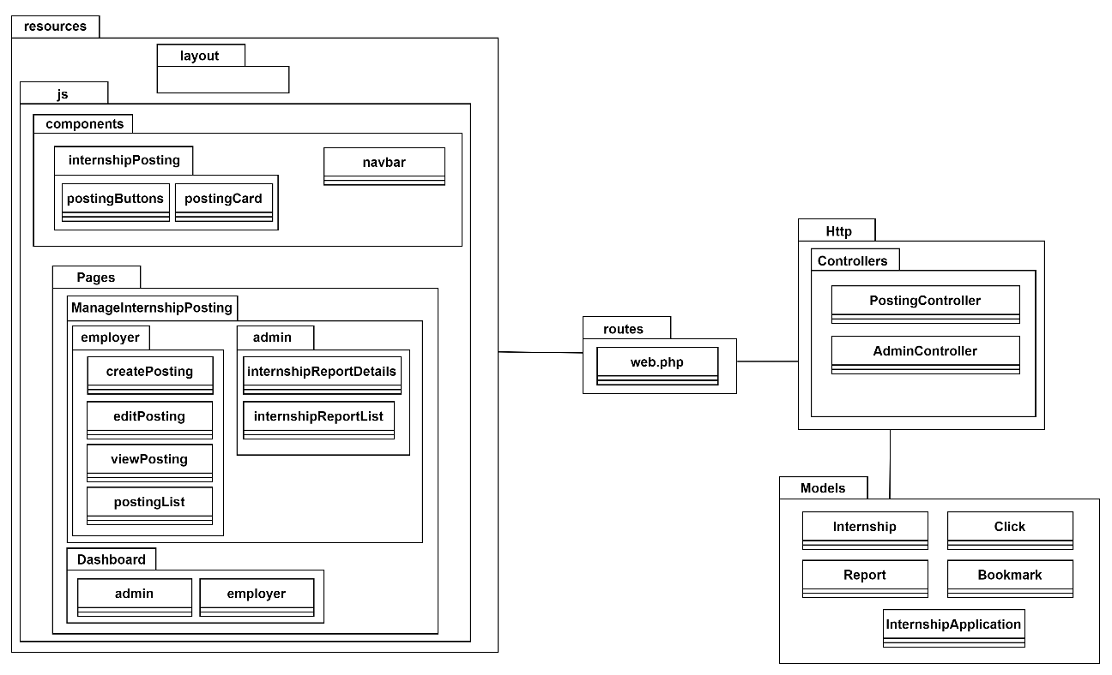

Figure 3‑112: Package Diagram (Manage Internship Posting)

View Layer (/components)

|  |  |
| --- | --- |
| **Component** | **Explanation** |
| navbar | This component includes an "Internship Posted" navigation link for managing internship postings. |
| /InternshipPosting/ postingButtons | This component in the view, edit, and delete buttons for viewing, editing, and deleting an internship posting. |
| /InternshipPosting/ postingCard | This component displays general information about the internship posting, including the title, start and end posting dates, and statistics for views, applications, and bookmarks. It also shows the user who created the internship posting and the last user who edited it. Additionally, it includes action buttons for viewing, editing, and deleting the posting. |

View Layer (/Pages)

| **Pages** | **Explanation** |
| --- | --- |
| /Dashboard/admin | This page includes an "Internship Problem Reports" section, where administrators can review reports submitted by students regarding internship postings. Admins have the option to take actions such as archiving the internship posting if necessary. |
| /Dashboard/employer | This page includes a "Recent Internships" section that displays the three latest internships posted by the company. |
| /ManageInternshipPosting/employer/ createPosting | This page allows employers to create a new internship posting within the Internseek system. |
| /ManageInternshipPosting/employer/ viewPosting | This page enables employers to view detailed information about a specific internship posting. |
| /ManageInternshipPosting/employer/ editPosting | This page allows employers to edit the details of an existing internship posting. |
| /ManageInternshipPosting/employer/ postingList | This page displays a list of all internships posted by the company, including those posted by different employers within the company. |
| /ManageInternshipPosting/admin/ internshipReportList | This page displays a list of internship reports submitted by students. The admin can view the full details of each report by clicking "View Details." |
| /ManageInternshipPosting/admin/ internshipReportDetails | This page displays the details of the internship report submitted by the student. The admin can update the report's status and record the action taken regarding the internship report. |

Controller Layer (/Controllers)

| **Controller Class** | **Explanation** |
| --- | --- |
| PostingController | This controller handles actions related to creating, viewing, editing, updating, and deleting internship postings. This controller typically interacts with the Internship model to perform CRUD (Create, Read, Update, Delete) operations. |
| AdminController | This controller handles actions related to managing internship reports submitted by students. It is primarily used by administrators to review and take appropriate actions on reports regarding internship postings. It interacts with the internship and report model to manage the status of internship postings and the status of reports submitted by students. |

Model Layer (/Models)

| **Model Class** | **Explanation** |
| --- | --- |
| Internship | This model stores and retrieves the internship data from database. |
| Report | This model retrieves the report data from database and updates the report data in database. |
| Click | This model retrieves the count of click data from database. |
| Bookmark | This model retrieves the count of bookmark data from database. |
| InternshipApplication | This model retrieves the count of internship applications from database. |

##### Manage Analytics and Reporting

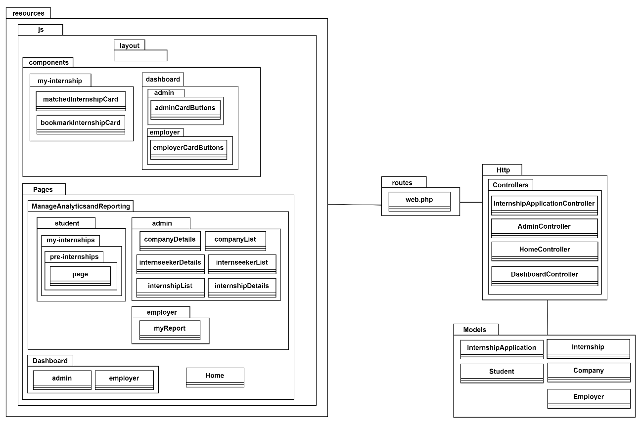

Figure 3‑113: Package Diagram (Manage Analytics and Reporting)

View Layer (/components)

| **Component** | **Explanation** |
| --- | --- |
| /dashboard/admin/ adminCardButtons | This component includes card buttons for the admin, each displaying a key metric for Internseek, such as the total number of registered companies, university students, and available internships. |
| /dashboard/employer/ employerCardButtons | This component includes card buttons for the employer, each displaying the count of applicants in reviewing, need-to-interview, shortlisted or approved, rejected, and accepted statuses. |
| /my-internship/ matchedInternshipCard | This component displays internship details in a card format, showcasing internships that match the student's study field. |
| /my-internship/ bookmarkInternshipCard | This component displays internship details in a card format, showcasing internships bookmarked by the student. |

View Layer (/Pages)

| **Pages** | **Explanation** |
| --- | --- |
| Home | This page displays a pie chart of the top three companies with the highest number of internship applications. |
| /Dashboard/admin | This page includes the admin card buttons component, each card button represents a key metric for Internseek, such as the total number of registered companies, registered university students, and available internships. |
| /Dashboard/employer | This page includes the employer card buttons component, each displaying the count of applicants in reviewing, need-to-interview, shortlisted or approved, rejected, and accepted statuses. |
| /ManageAnalyticsandReporting/student/ my-internships/pre-internships/page | This page includes listings for matched internships and bookmarked internships. Students can click the "Matched Internships" button to view internships that align with their study field. Students can click the "Bookmark Internship" button to view internships they have saved for later review. |
| /ManageAnalyticsandReporting/employer/ myReport | This page displays a bar graph showing the monthly internship applications within the company, along with the total applications and the average number of internship applications per month. |
| /ManageAnalyticsandReporting/admin/ companyDetails | This page displays the details of registered companies, with an option for the admin to update the company's rating. |
| /ManageAnalyticsandReporting/admin/ companyList | This page lists all registered companies along with their general details. |
| /ManageAnalyticsandReporting/admin/ internseekerList | This page lists all registered internseekers (students) within the system. |
| /ManageAnalyticsandReporting/admin/ internseekerDetails | This page displays the basic information of an individual internseeker. |
| /ManageAnalyticsandReporting/admin/ internshipList | This page displays a list of available internships within the system. |
| /ManageAnalyticsandReporting/admin/ internshipDetails | This page displays detailed information about a specific internship. |

Controller Layer (/Controllers)

| **Controller Class** | **Explanation** |
| --- | --- |
| InternshipApplicationController | This controller interacts with the InternshipApplication, Internship, and Company models to retrieve and count the number of monthly internship applications, total applications, and the average internship applications per month. |
| AdminController | This controller interacts with the Student, Company, Employer, and Internship models to retrieve details about students, companies with employers, and internships. |
| HomeController | This controller interacts with the InternshipApplication and Company models to retrieve and display the top three companies with the highest number of internship applications. |
| DashboardController | This controller retrieves and counts the number of applicants with statuses such as reviewing, shortlisted or approved, need-to-interview, accepted, and rejected for employers. It also retrieves and counts internship metrics, such as the number of registered companies, registered internseekers, and available internships for the admin. |

Model Layer (/Models)

| **Model Class** | **Explanation** |
| --- | --- |
| InternshipApplication | This model retrieves the internship application data from database. |
| Internship | This model retrieves the internship data from database. |
| Student | This model retrieves the student data from database. |
| Company | This model retrieves company data from the database and allows the update of the company's rating. |
| Employer | This model retrieves the employer data from database. |

##### Manage Messaging Features

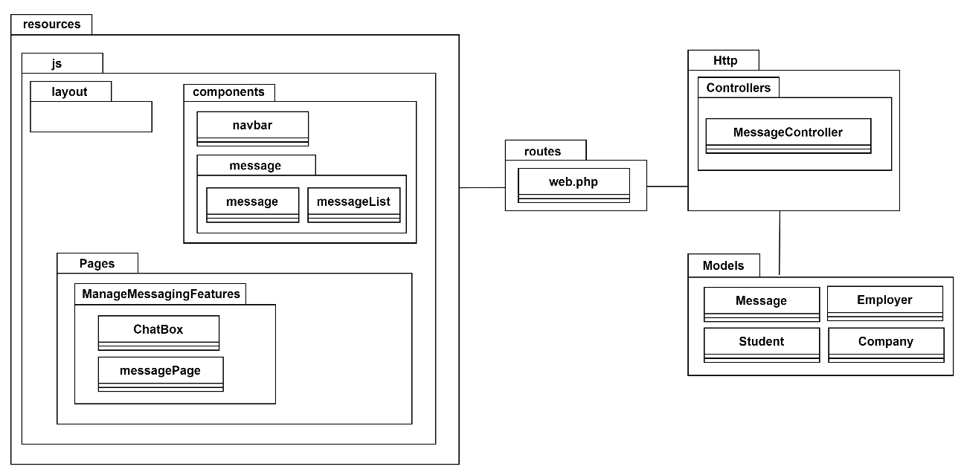

Figure 3‑114: Package Diagram (Manage Messaging Features)

View Layer (/components)

| **Component** | **Explanation** |
| --- | --- |
| navbar | This component displays a message icon that indicates the presence of unread messages. When unread messages are received, a red dot with a number appears next to the icon, showing how many unread messages are there. Both students and employers can click the icon to view the unread messages. |
| /message/message | This component represents a chat-box displayed beside the MessageList component. It shows the conversation history and allows employers or students to view previous messages and send new ones. |
| /message/messageList | This component displays a list of conversations, each representing a person. Conversations with unread messages are highlighted, and students or employers can click on each to view and interact with the messages. |

View Layer (/Pages)

| **Pages** | **Explanation** |
| --- | --- |
| /ManageMessagingFeatures/ChatBox | This page consists of a chat-box where students or employers can send messages to each other, with the interaction restricted to students messaging employers and employers messaging students. |
| /ManageMessagingFeatures/messagePage | This page consists of the MessageList and Message components, allowing users to view a list of conversations and interact with messages in a messaging interface. |

Controller Layer (/Controllers)

| **Controller Class** | **Explanation** |
| --- | --- |
| MessageController | This controller is responsible for managing the messaging functionality within the application. It handles the logic for sending, receiving, and retrieving messages between students and employers. It retrieves and organizes the list of conversations for a user, ensuring unread messages are highlighted. It also updates the status of messages when they are viewed, marking them as read to remove the unread indicator. |

Model Layer (/Models)

| **Model Class** | **Explanation** |
| --- | --- |
| Message | This model represents the messages exchanged between Student and Employer. This model will record information such the message content, sender and receiver IDs, timestamps, and read status for each message that is associated with a sender and receiver. |
| Student | This model represents the students who can send and receive messages from employers. A student can message an employer, and a student can also receive messages from employers. |
| Employer | This model represents employers who can message students. Employers can see messages sent by other employers within the same company, making it easier to manage communication. |
| Company | This model groups employers together. When an employer within the same company sends a message, other employers within that same company will have access to view these messages. |

##### Middleware

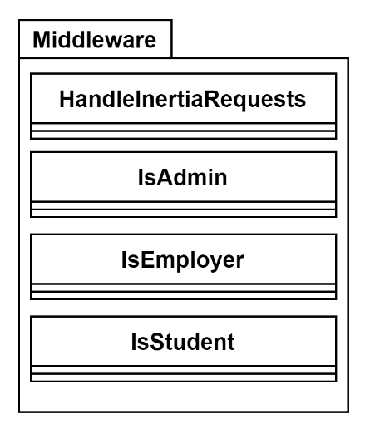

Figure 3‑115: Package Diagram (Middleware)

|  |  |
| --- | --- |
| **Class** | **Description** |
| HandleInertiaRequests.php | This middleware customizes shared data for Inertia.js requests, such as the authenticated user, their role, unread notifications, unread messages count, and flash messages. |
| IsAdmin.php | This middleware restricts access to routes only for authenticated admin. If the user is not authenticated as an admin, they are redirected to the admin login page. |
| IsEmployer.php | This middleware restricts access to routes only for authenticated employer. If the user is not authenticated as an employer, they are redirected to the employer login page. |
| IsStudent.php | This middleware restricts access to routes only for authenticated student. If the user is not authenticated as a student, they are redirected to the student login page. |

### Activity Diagram

This section will display the activity diagram for each use case.

##### Register Account

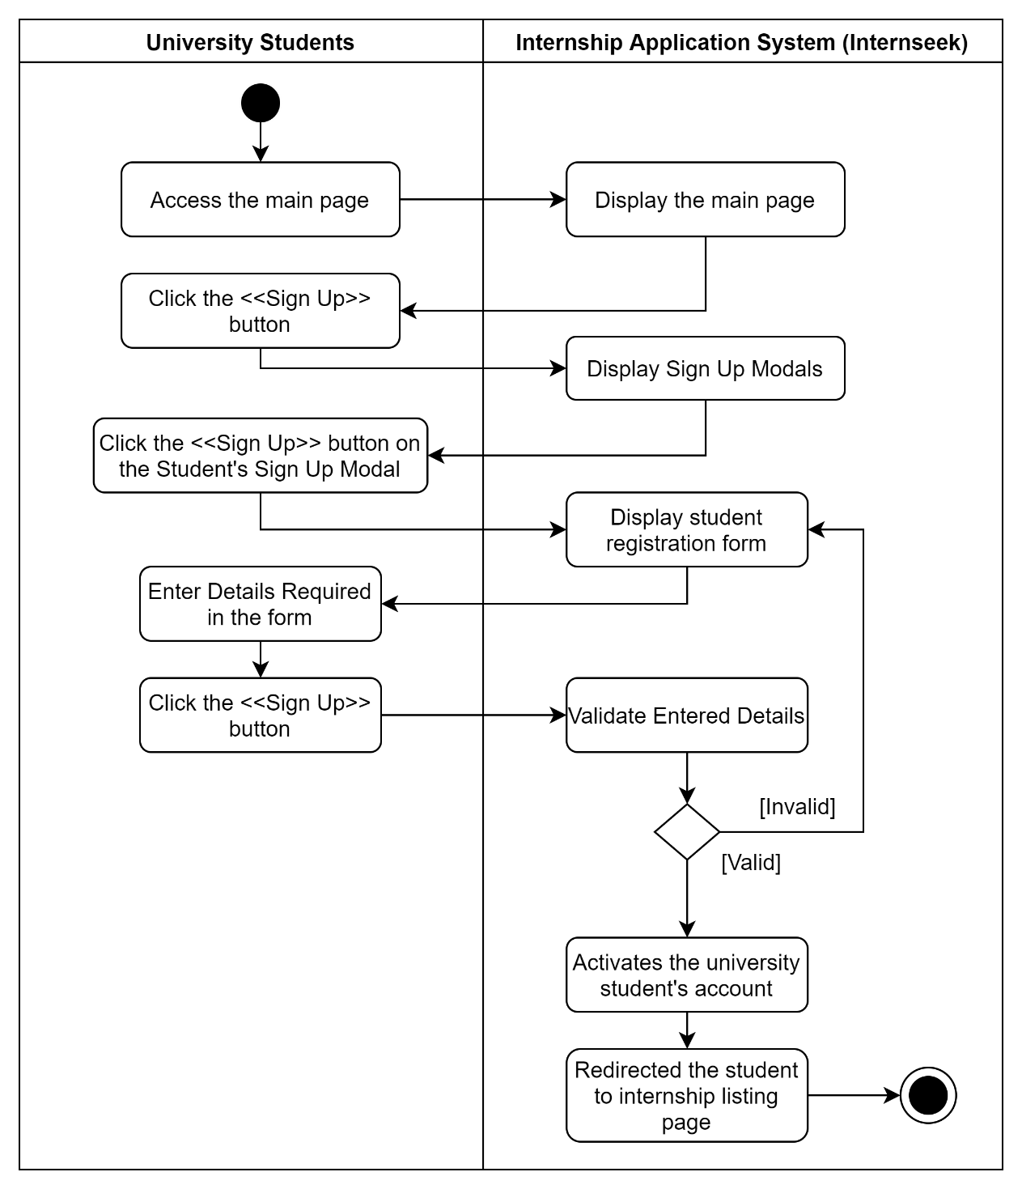

Figure 3‑116: Activity Diagram (Student Account Registration)

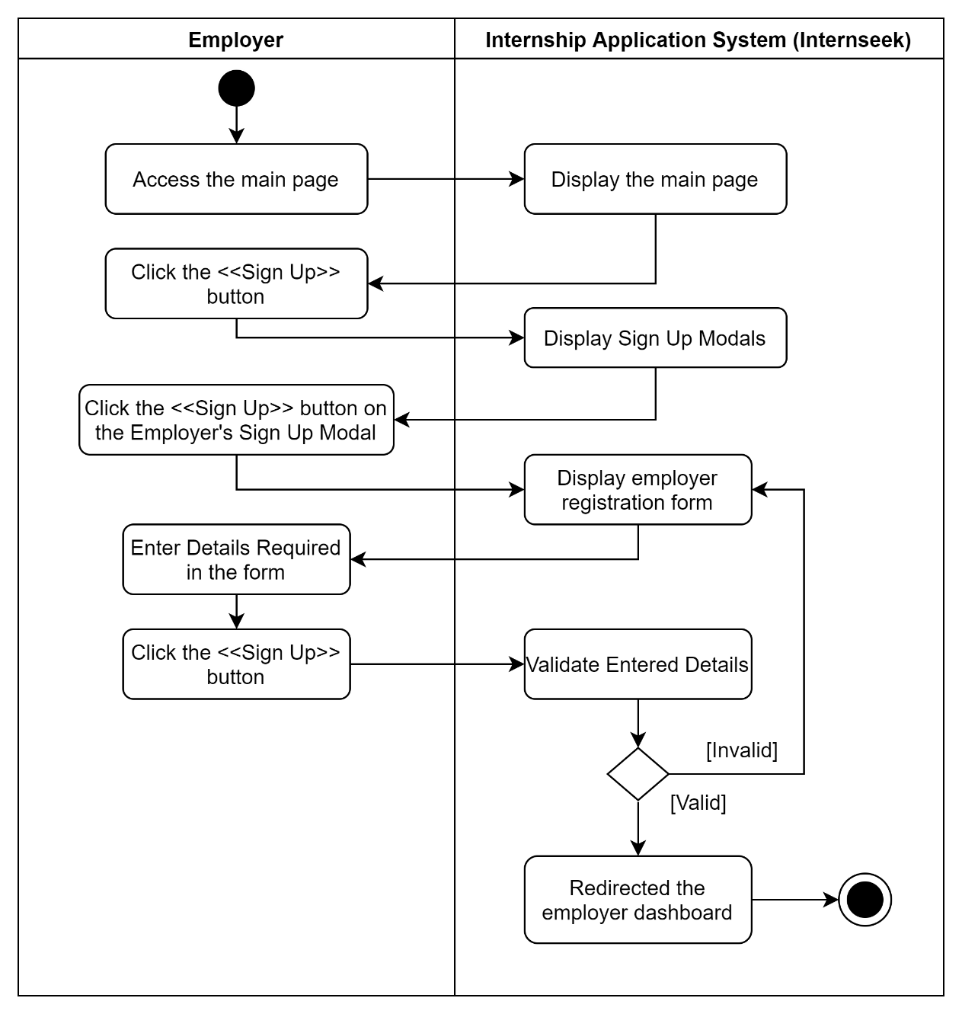

Figure 3‑117: Register Account (Employer Account Registration)

##### Manage Login

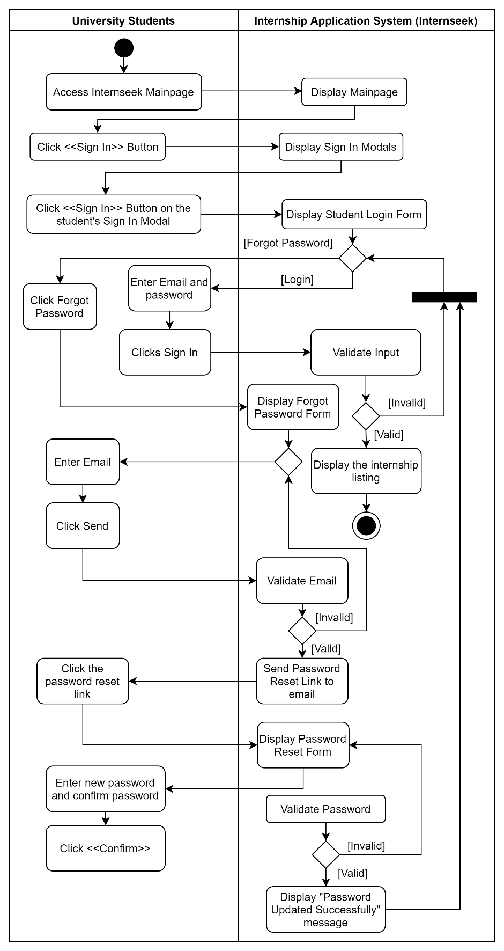

Figure 3‑118: Activity Diagram (Manage Login for University Students)

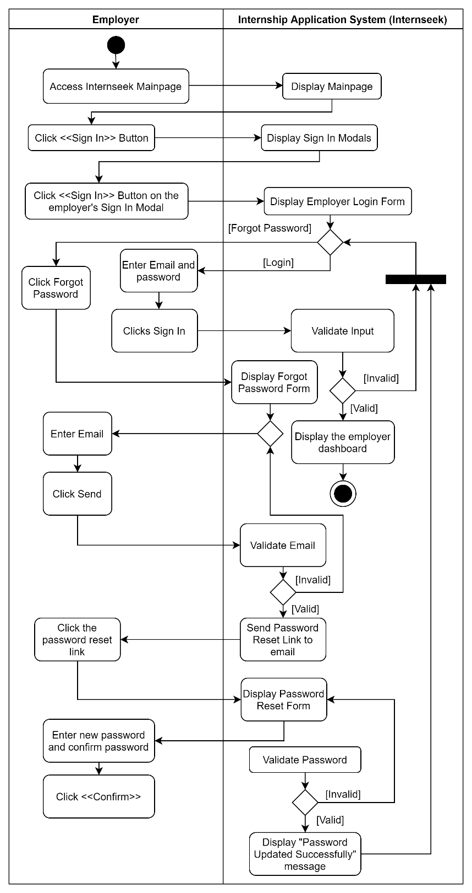

Figure 3‑119: Activity Diagram (Manage Login for Employers)

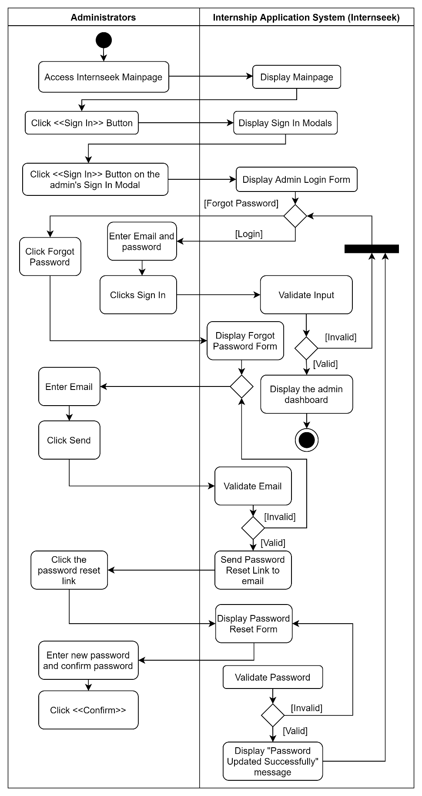

Figure 3‑120: Activity Diagram (Manage Login for Administrators)

##### Manage Company Registration

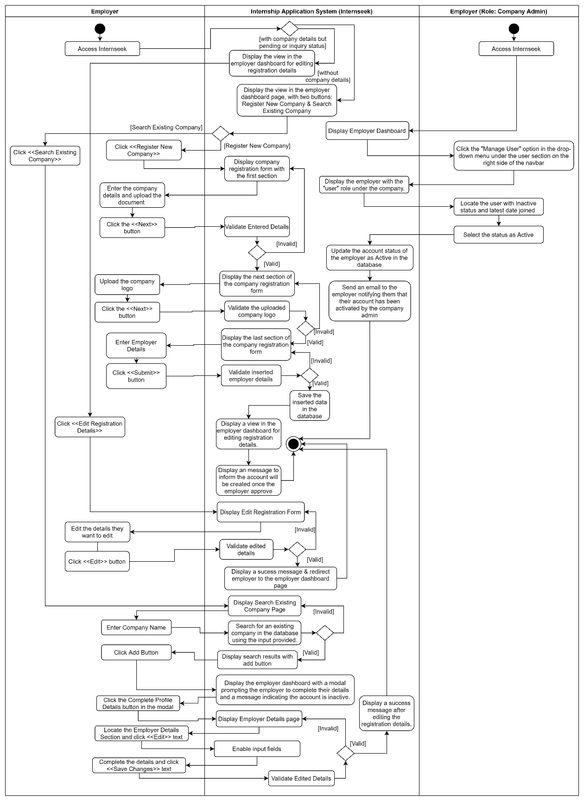

Figure 3‑121: Activity Diagram (Manage Company Registration for Employer)

The figure above illustrates the process for employers without company information, who must either register a new company or search for an existing one to associate with. Additionally, the Company Admin is responsible for updating the account status of employers trying to add themselves to the company.

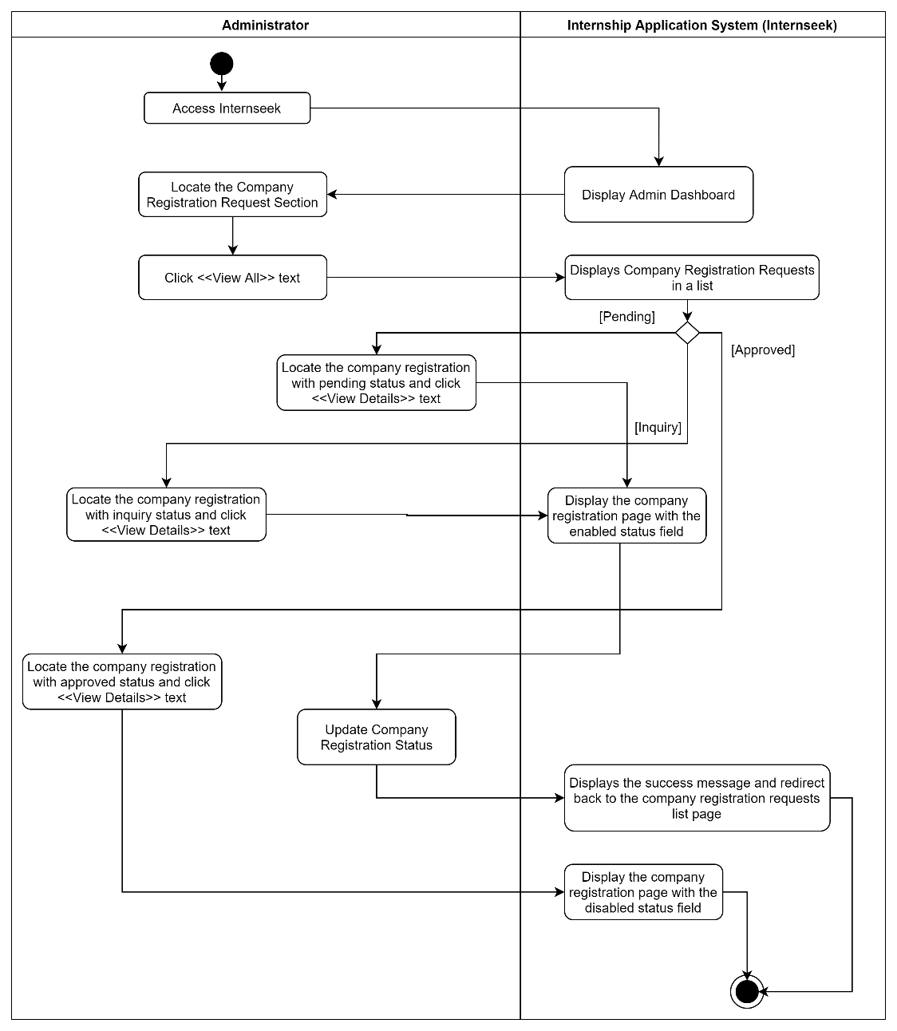

Figure 3‑122: Activity Diagram (Manage Company Registration for Administrators)

The figure above illustrates the process for administrators to update a company's registration status. If marked as 'Inquiry,' administrators must provide comments to inform the employer of necessary edits. If the status is 'Approved,' no updates can be made. For 'Pending' status, administrators can change it to either 'Inquiry' or 'Approved.

##### Manage User Profile

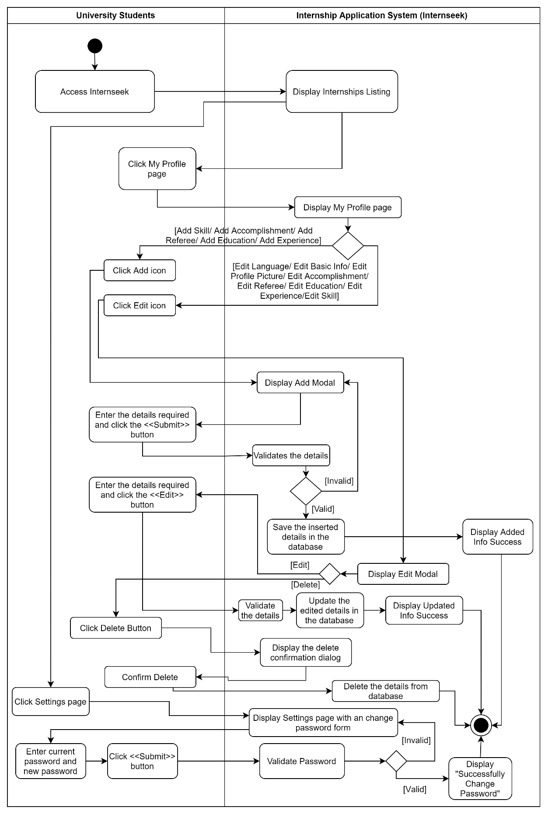

Figure 3‑123: Activity Diagram (Manage User Profile: University Students)

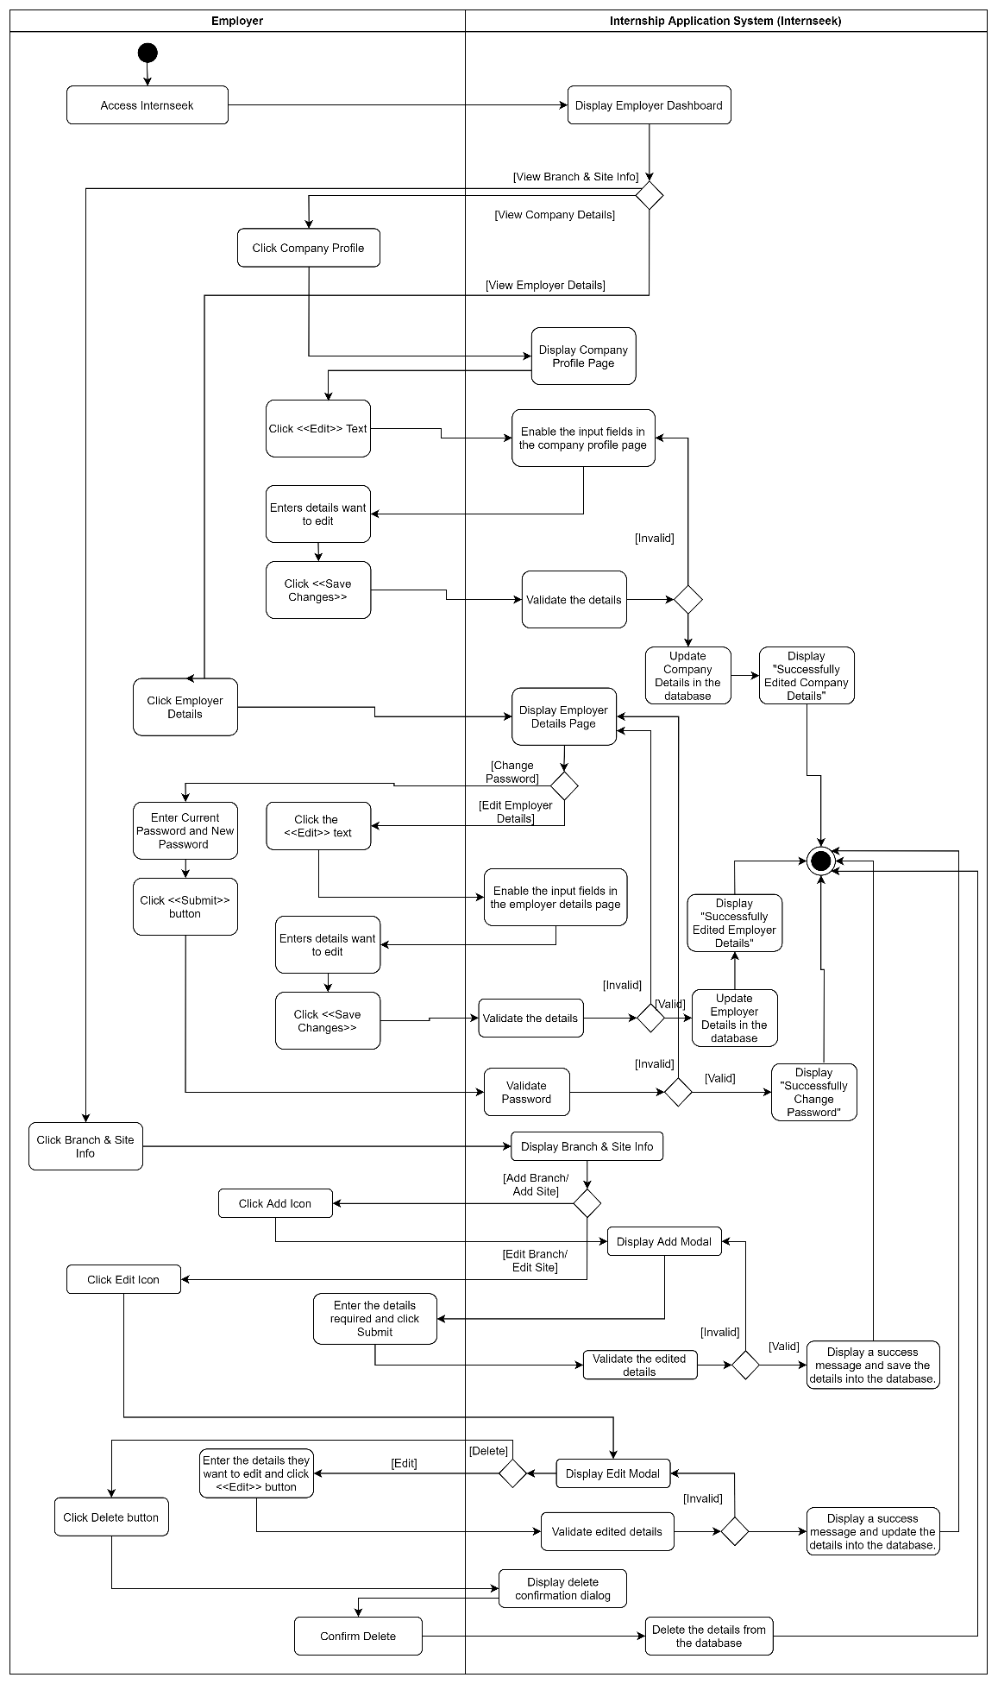

Figure 3‑124: Activity Diagram (Manage User Profile: Employers)

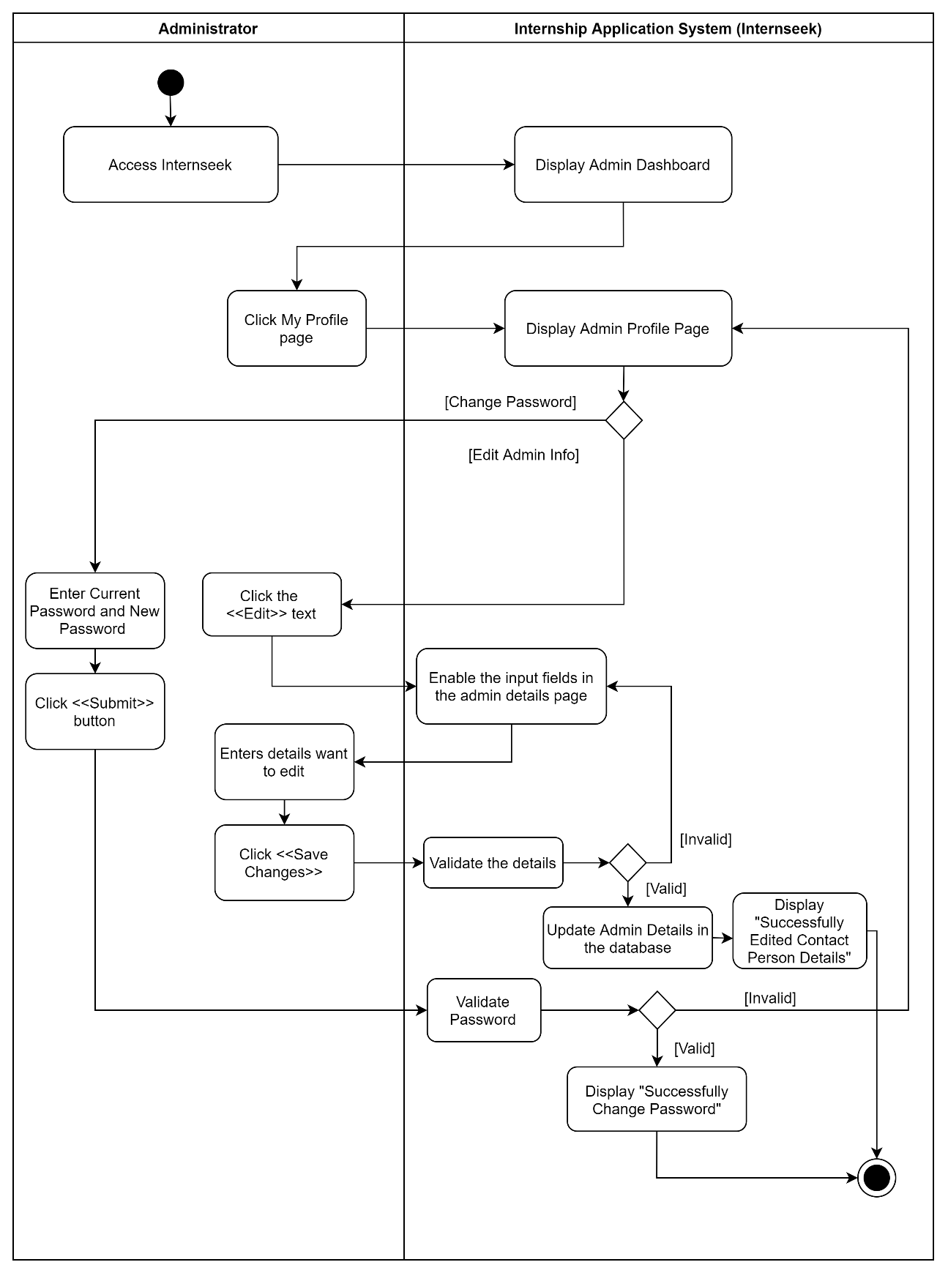

Figure 3‑125: Activity Diagram (Manage User Profile: Administrators)

##### View Internship Listing

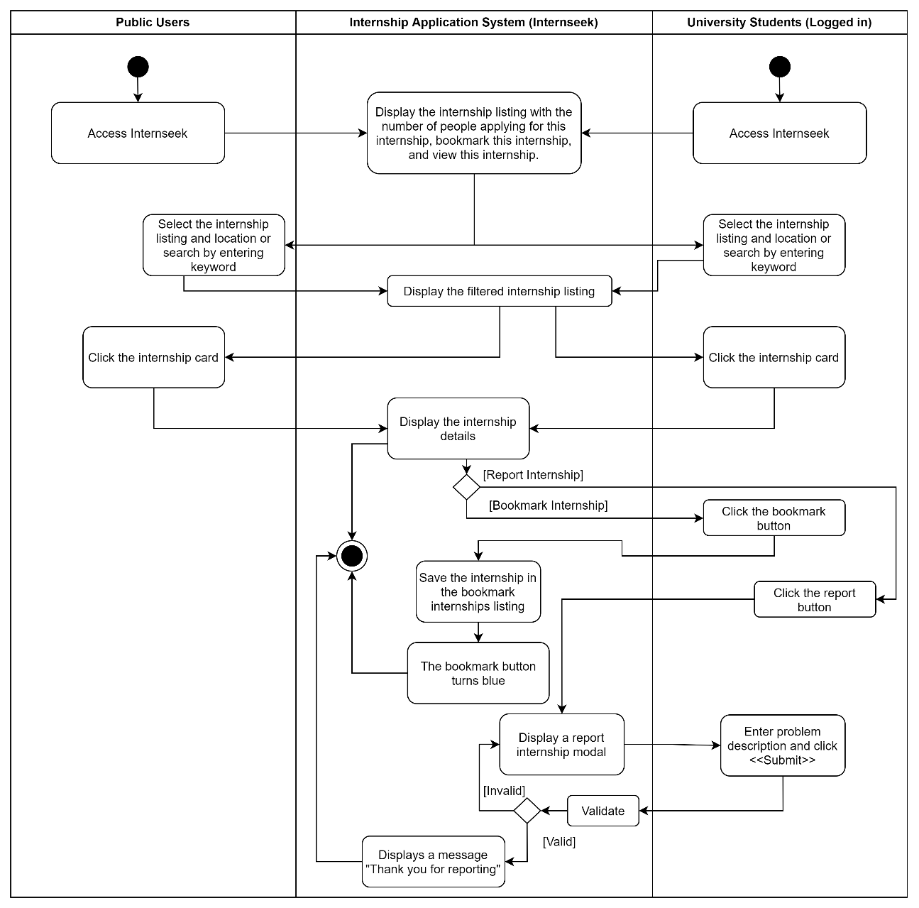

Figure 3‑126: Activity Diagram (View Internship Listing: University Students with or without logged-in)

##### View Company Listing

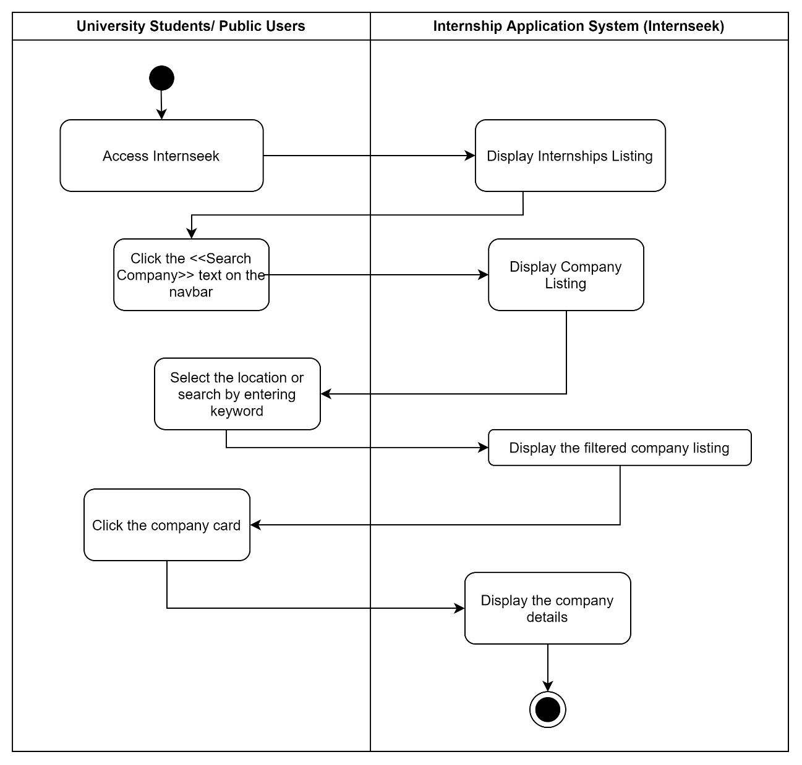

Figure 3‑127: Activity Diagram (View Company Listing: University Students with or without logged-in)

##### Manage Internship Application

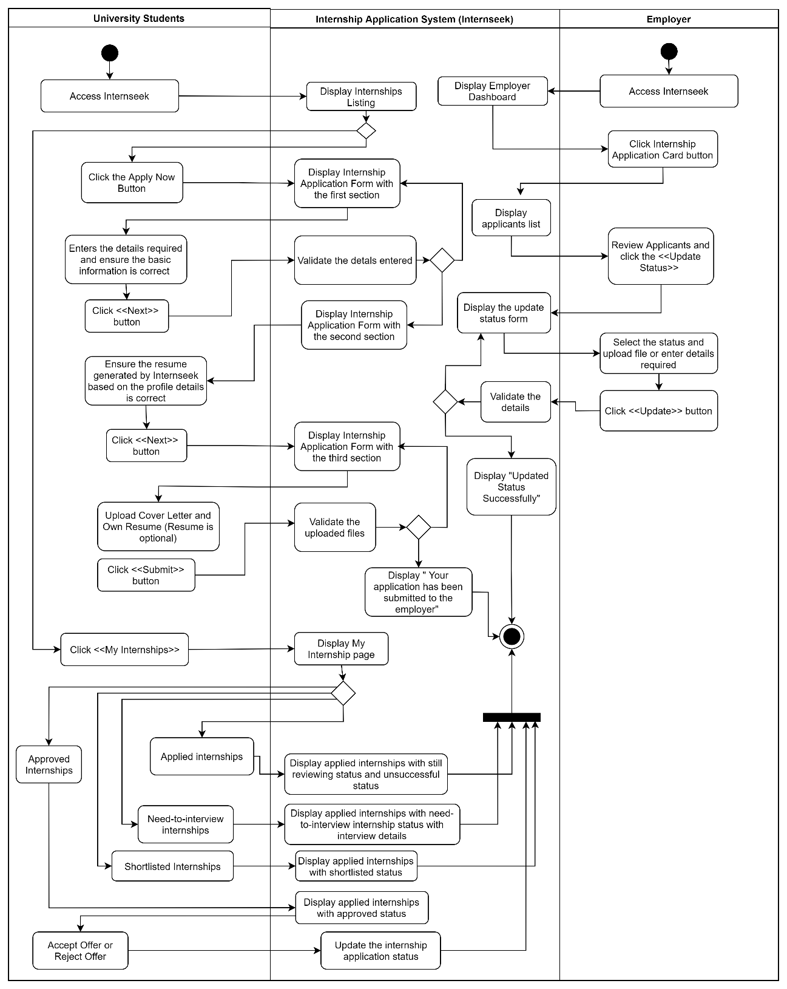

Figure 3‑128: Activity Diagram (Manage Internship Application)

##### Manage Internship Posting

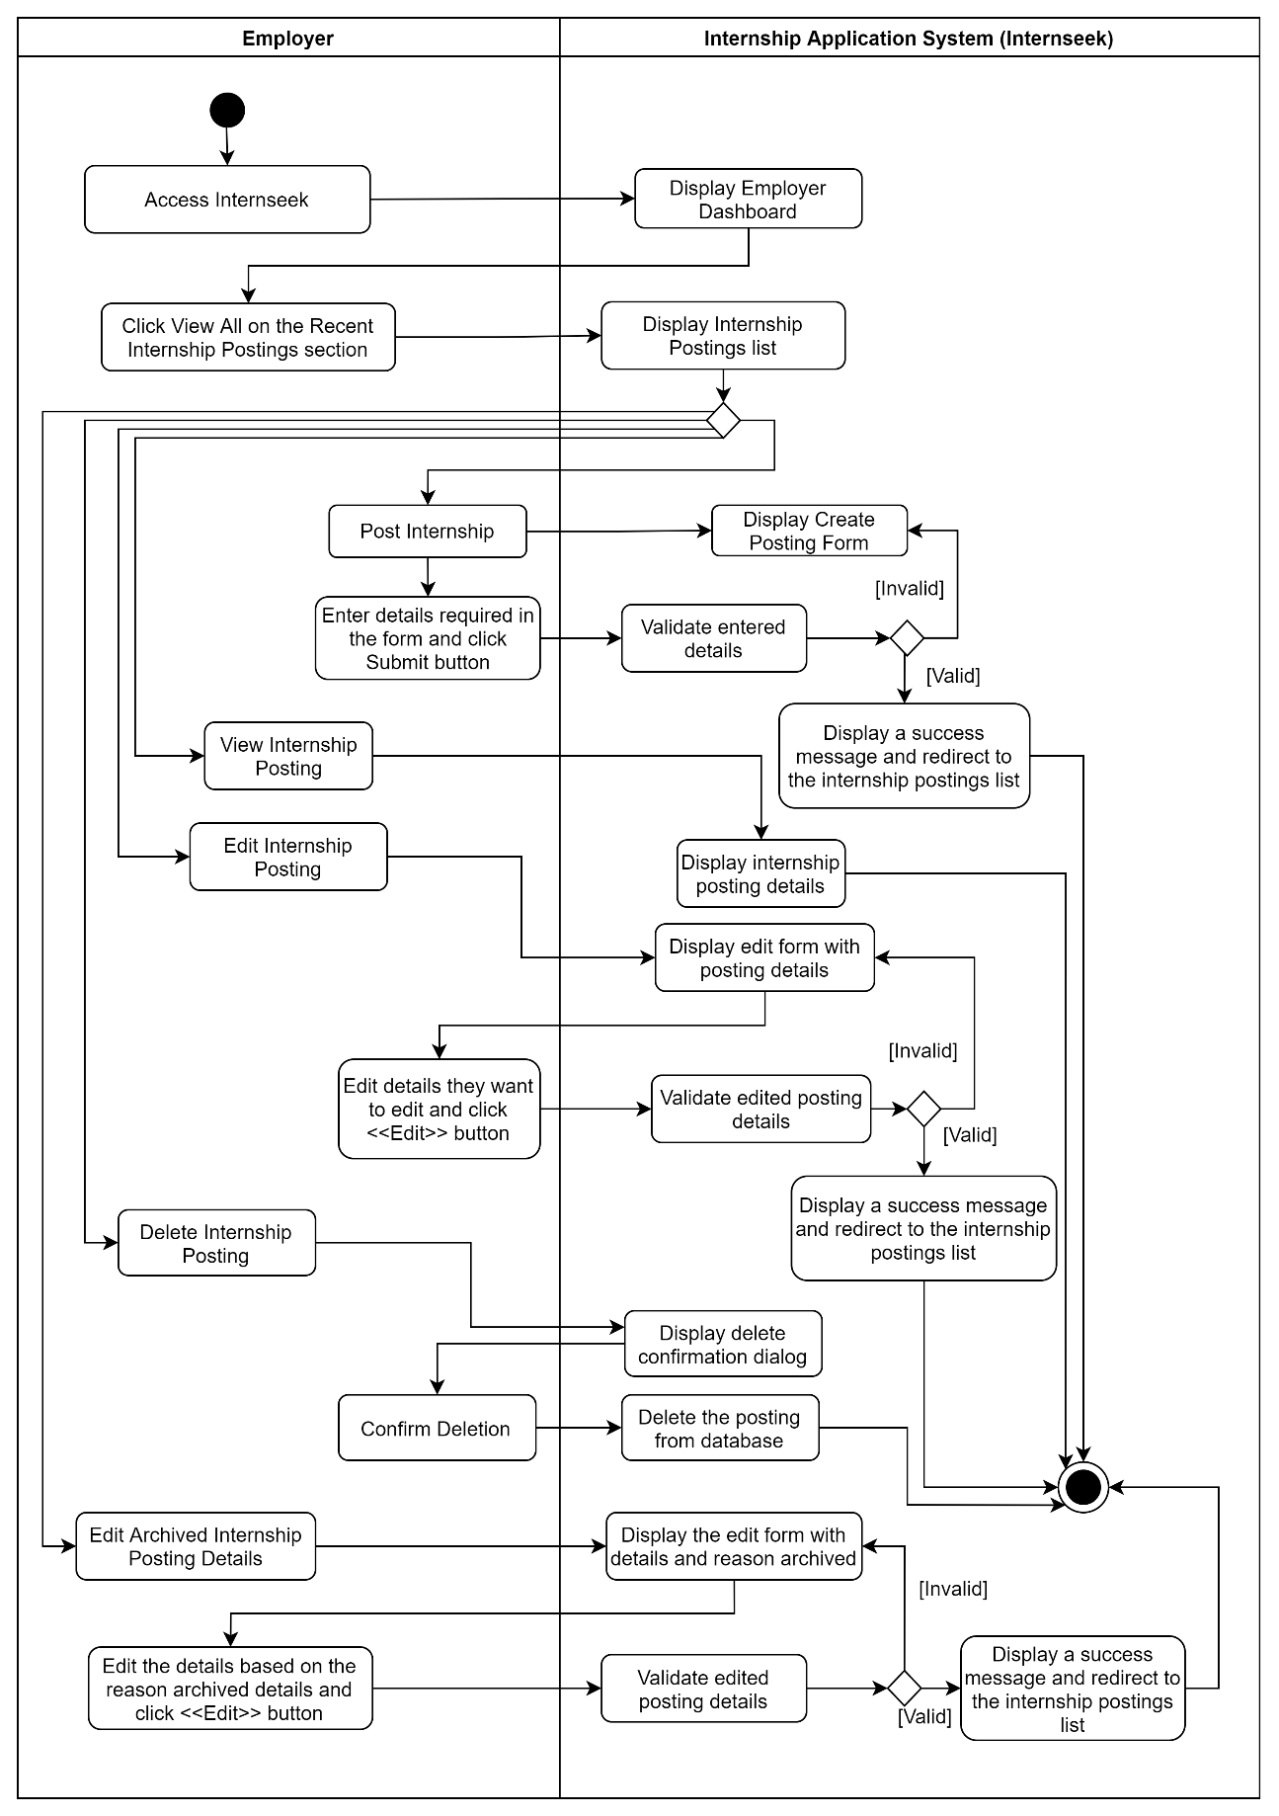

Figure 3‑129: Activity Diagram (Manage Internship Posting for Employer)

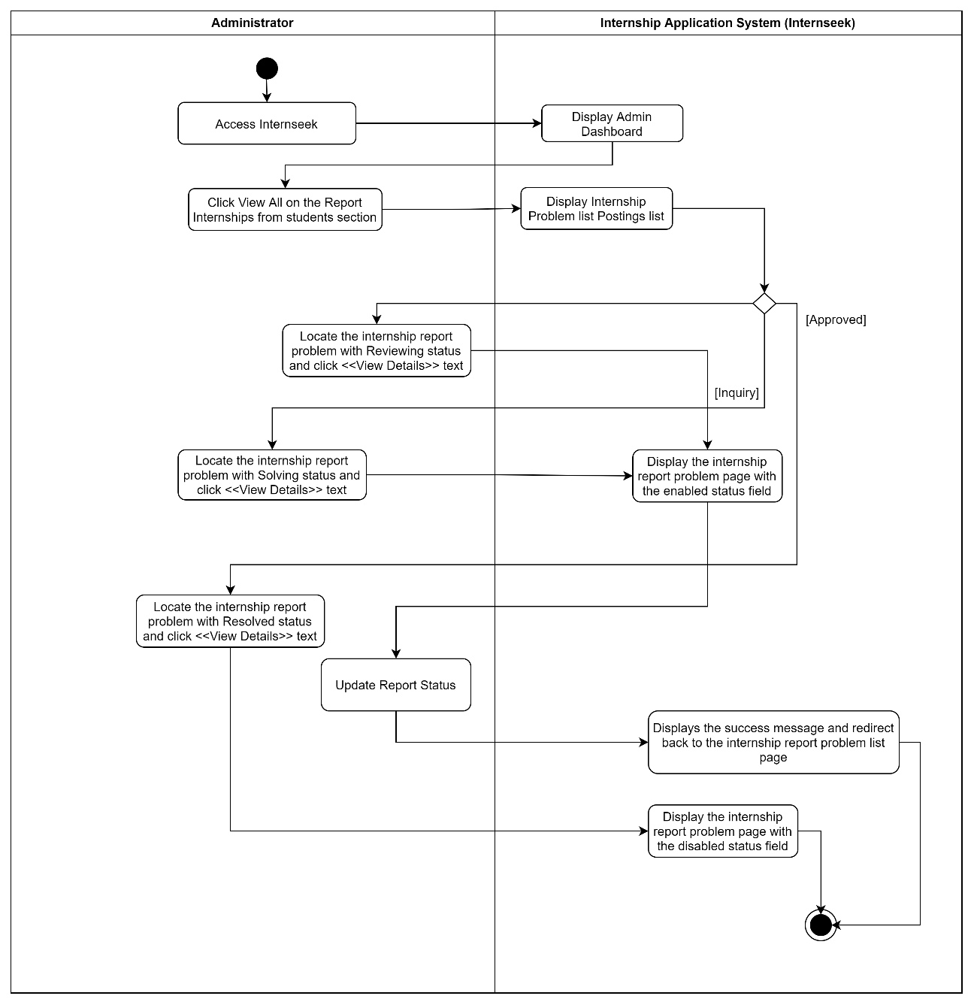

Figure 3‑130: Activity Diagram (Manage Internship Posting for Administrators)

##### Manage Analytics and Reporting

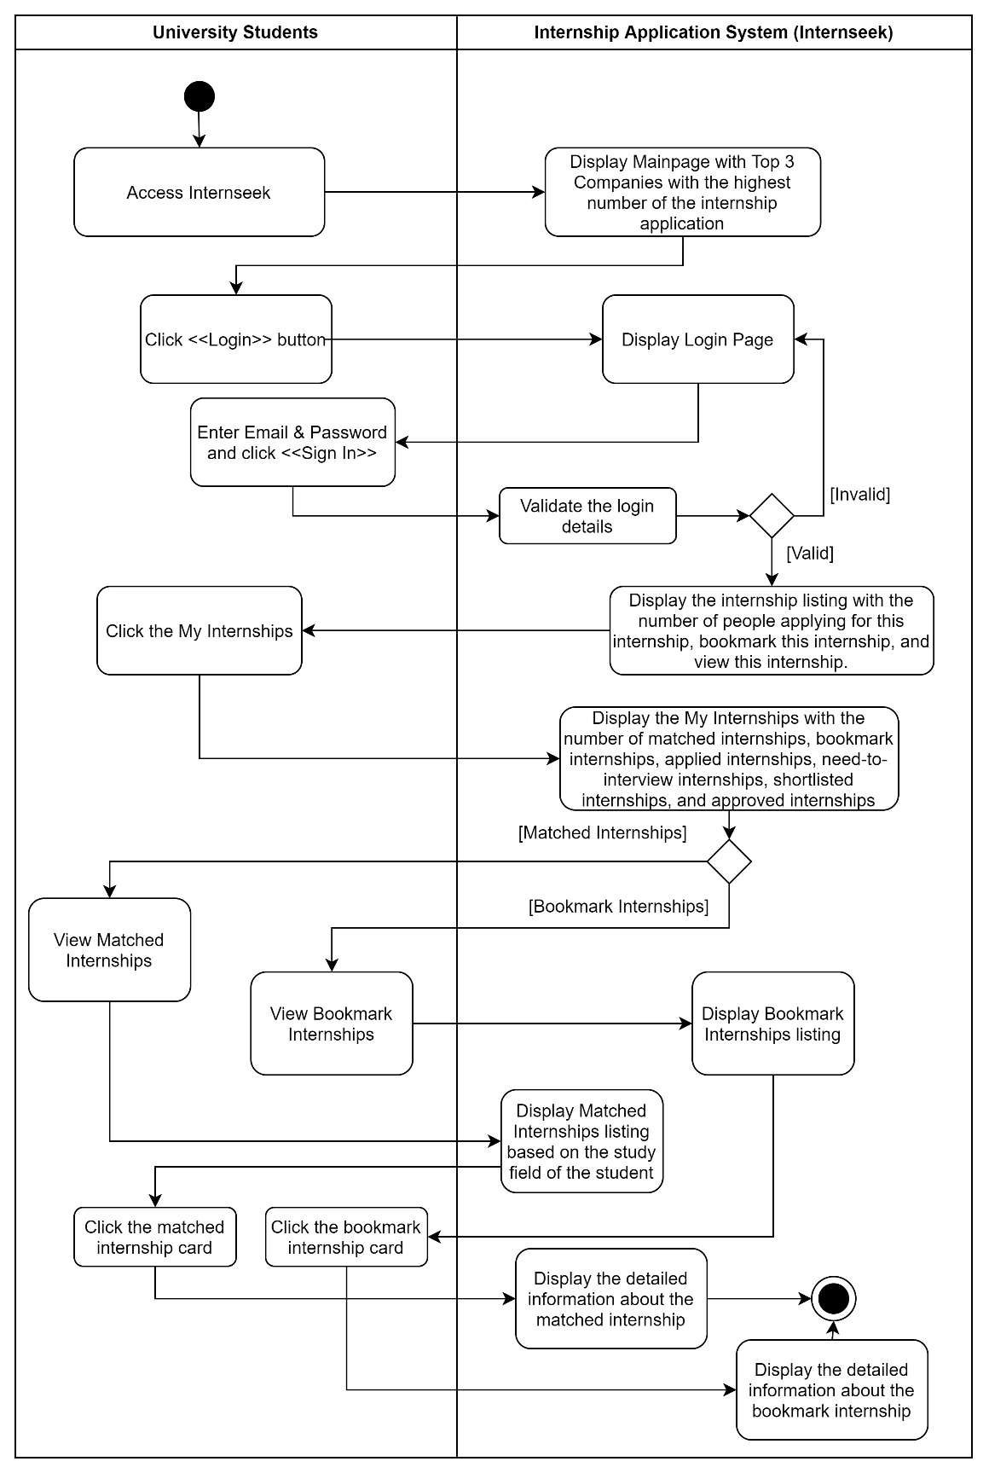

Figure 3‑131: Activity Diagram (Manage Analytics and Reporting: University Students)

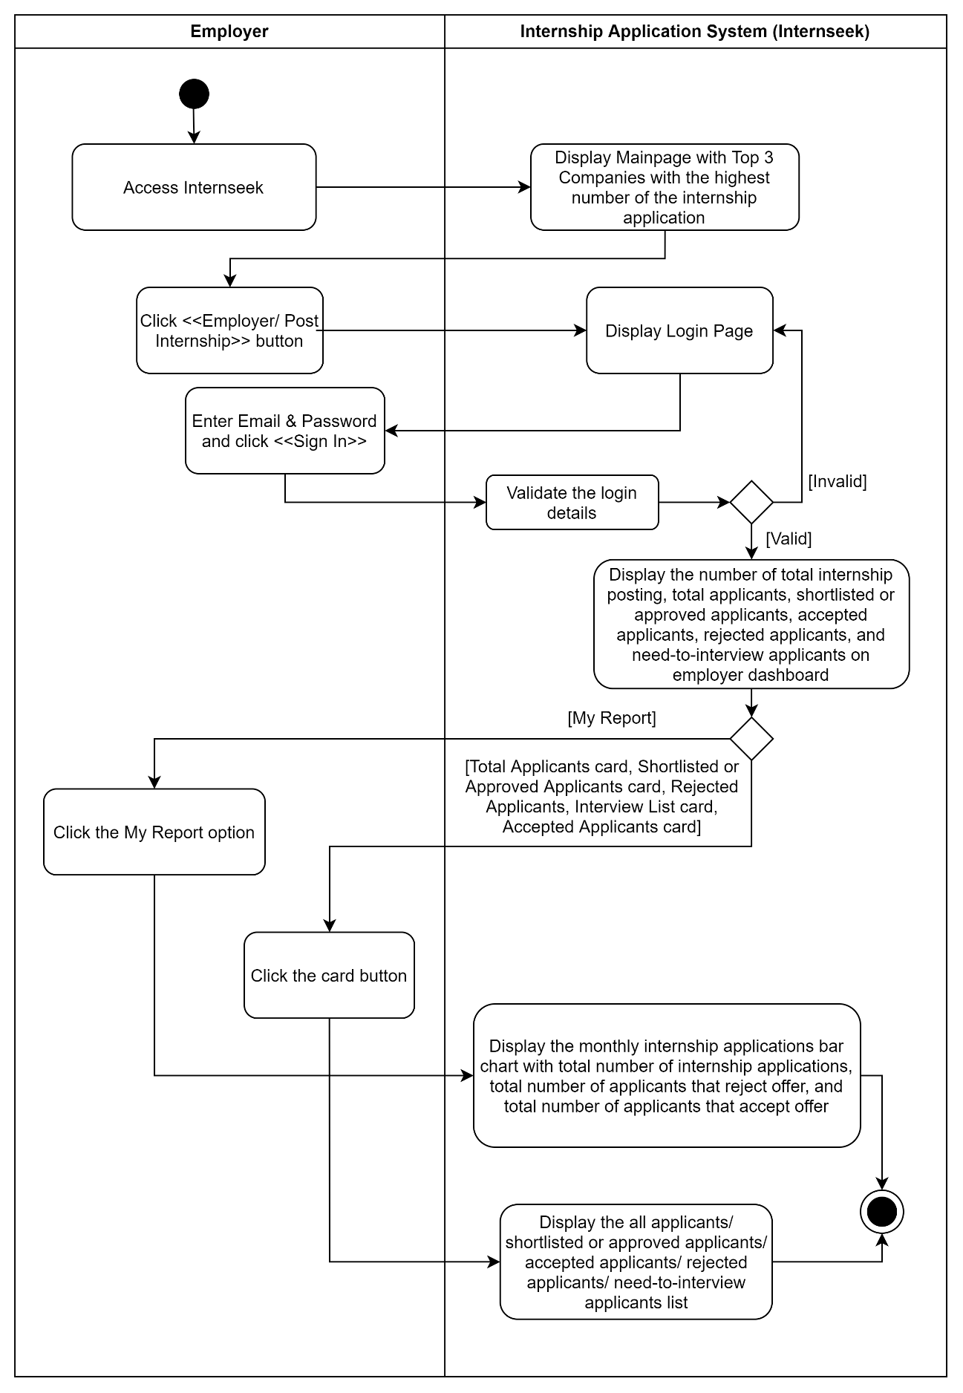

Figure 3‑132: Activity Diagram (Manage Analytics and Reporting: Employers)

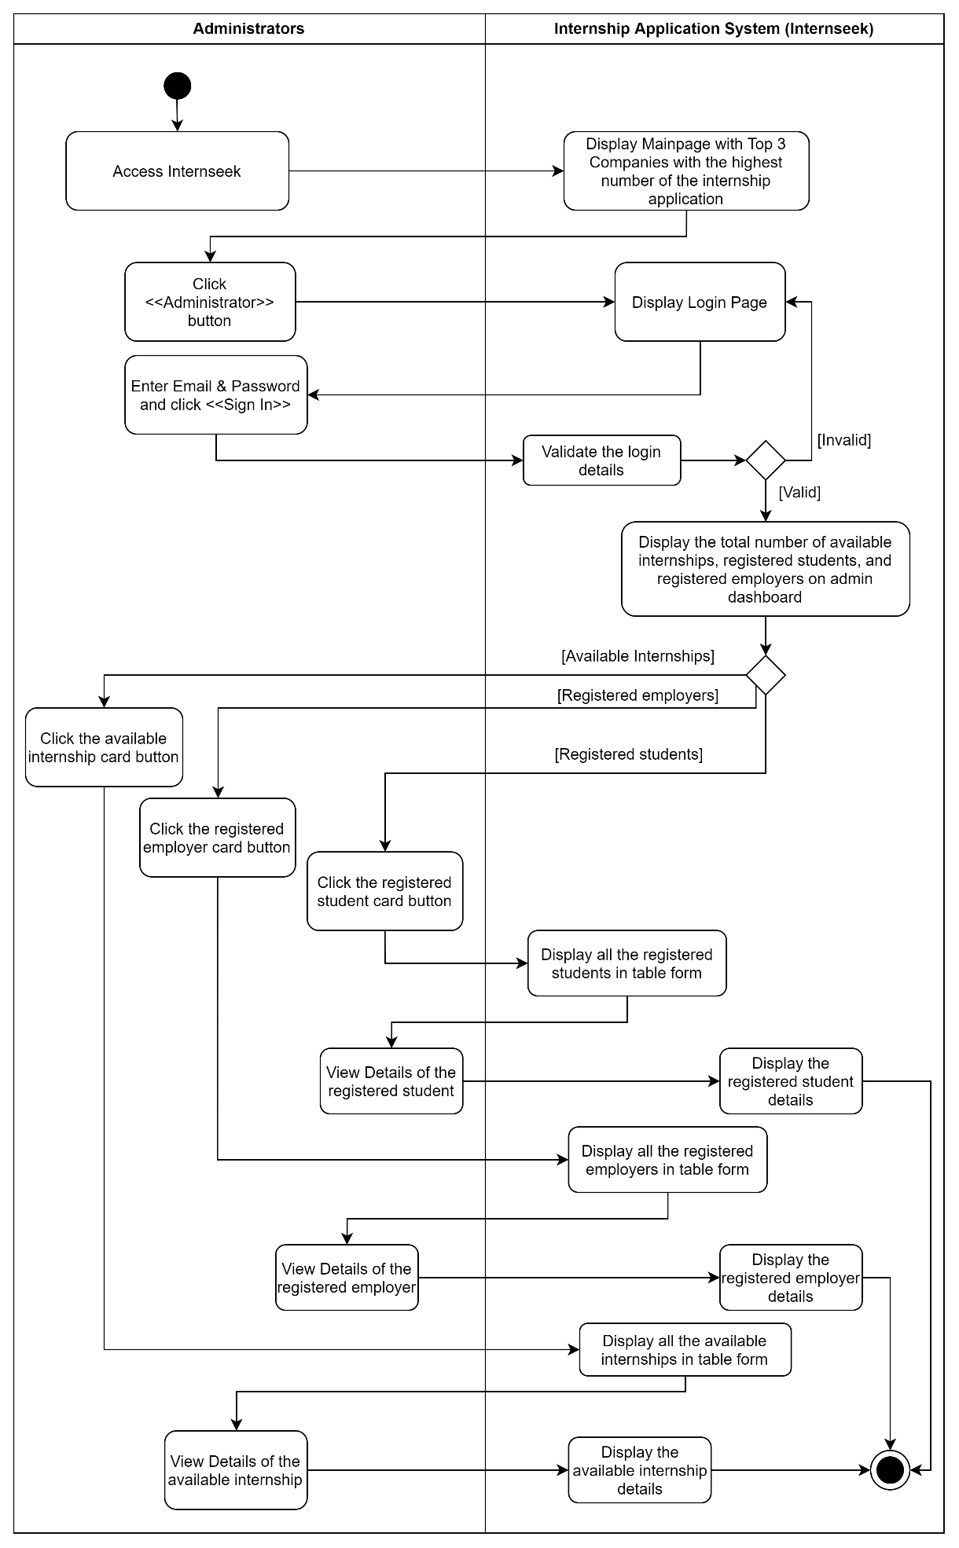

Figure 3‑133: Activity Diagram (Manage Analytics and Reporting: Administrators)

##### Manage Messaging Features

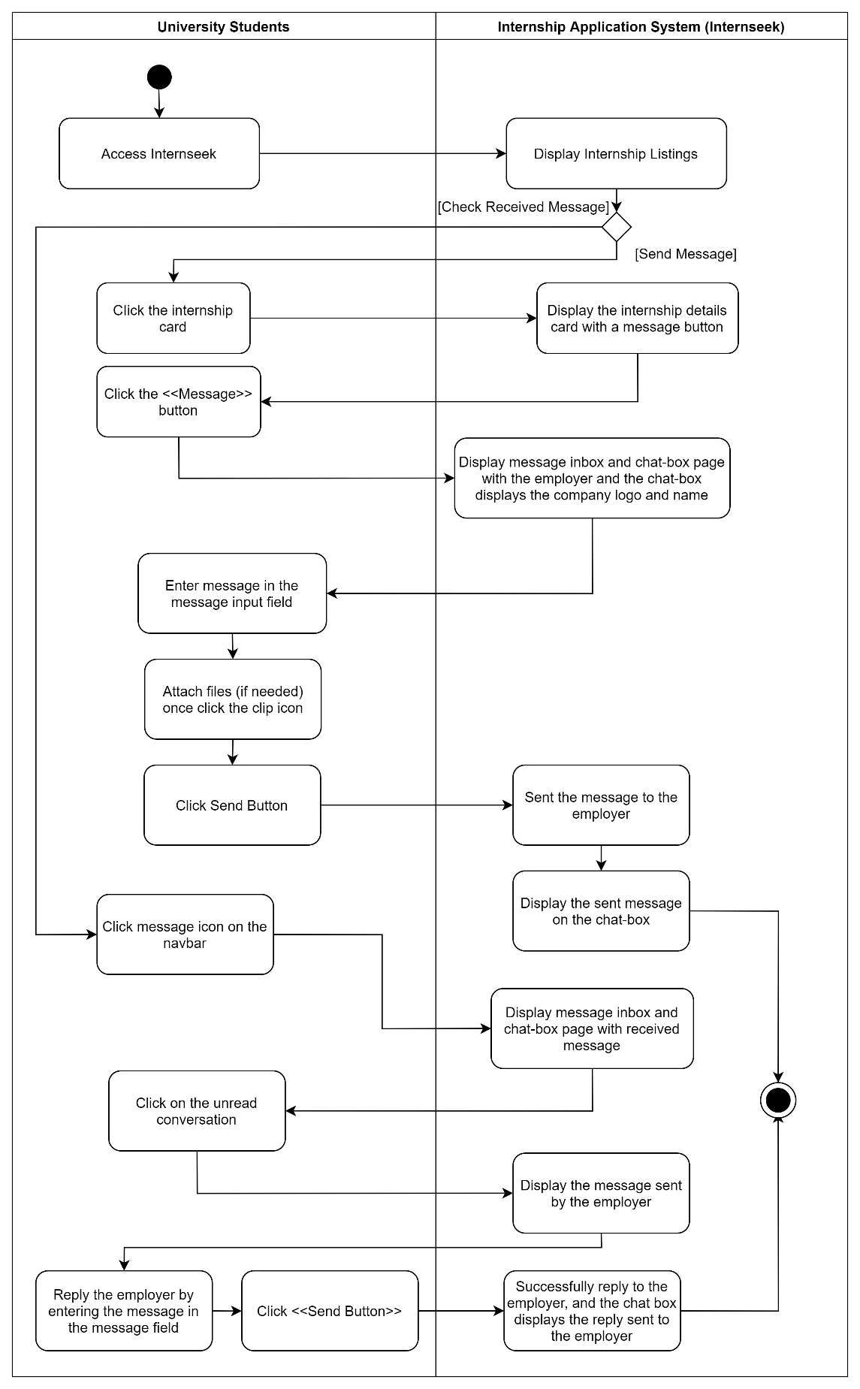

Figure 3‑134: Activity Diagram (Manage Messaging Features: University Students)

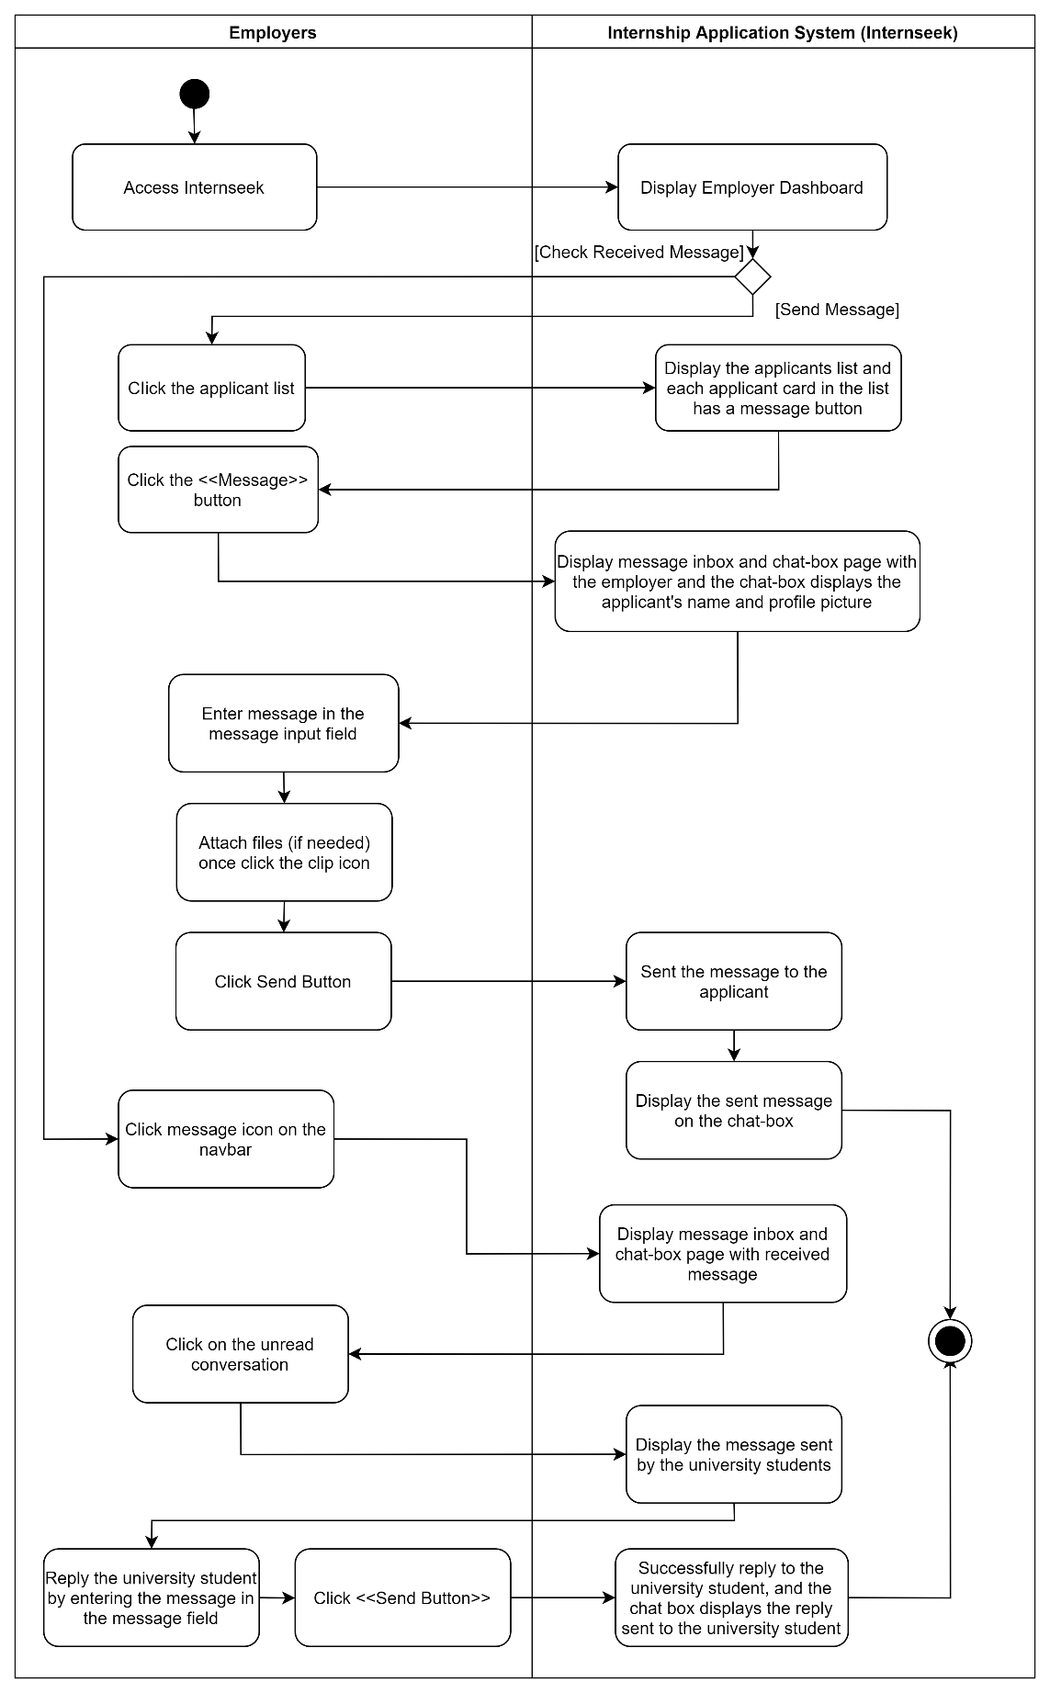

Figure 3‑135: Activity Diagram (Manage Messaging Features: Employers)

## Data Design

### Entity-Relationship Diagram

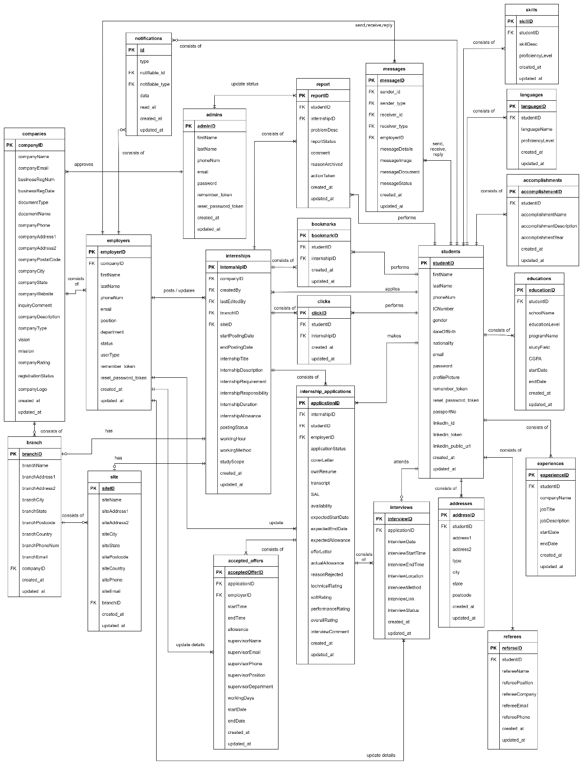

Figure 3‑136: Entity-Relationship Diagram for Internseek

### Data Dictionary

##### Students

Table 3‑12 Data Dictionary for students

| **Field Name** | **Data Type** | **Description** | **Constraint** |
| --- | --- | --- | --- |
| studentID | BIGINTEGER | The unique identifier for the student | PK, Unique, Not Null, Auto Increment |
| firstName | VARCHAR(50) | The first name of the student |  |
| lastName | VARCHAR(50) | The last name of the student |  |
| phoneNum | VARCHAR(15) | The phone number of the student |  |
| ICNumber | VARCHAR(12) | The identification card number of the student | Nullable |
| gender | ENUM(‘Male’, ‘Female’) | The gender of the student | Nullable |
| dateOfBirth | DATE | The birthday date of the student | Nullable |
| nationality | VARCHAR(50) | The nationality or citizenship status of the student | Nullable |
| email | VARCHAR(255) | The email of the student | Unique, Not Null |
| password | VARCHAR(255) | The password set by the student | Not Null |
| profilePicture | VARCHAR(500) | The filename of the profile picture of the student | Nullable |
| remember_token | VARCHAR(255) | The token used to remember the student’s session across browser sessions (Remember me feature) | Nullable |
| reset_password_token | VARCHAR(255) | The token used to verify password reset requests by the student | Nullable |
| passportNo | VARCHAR(20) | The passport number of the international student | Nullable |
| linkedin_id | VARCHAR(255) | The unique LinkedIn identifier of the student when the student logins with LinkedIn account. |  |
| linkedin_token | VARCHAR(500) | The OAuth token of the student used for authentication or data retrieval. |  |
| linked_public_url | VARCHAR(255) | The public LinkedIn profile URL of the student |  |
| created_at | TIMESTAMP | The time of creating the student account |  |
| updated_at | TIMESTAMP | The time of updating the profile details |  |

##### Addresses

Table 3‑13: Data Dictionary for addresses

| **Field Name** | **Data Type** | **Description** | **Constraint** |
| --- | --- | --- | --- |
| addresssID | BIGINTEGER | The unique identifier for the address | PK, Unique, Not Null, Auto Increment |
| studentID | BIGINTEGER | The unique identifier for the student | FK, NOT NULL |
| address1 | VARCHAR(255) | The first line of the student's address |  |
| address2 | VARCHAR(255) | The second line of the student's address |  |
| type | ENUM (“training”, “home”) | The type of address |  |
| city | VARCHAR(30) | The name of the city where the student stays |  |
| state | VARCHAR(30) | The name of the state where the student stays |  |
| postcode | VARCHAR(5) | The postcode of the student's address |  |
| created_at | TIMESTAMP | The time of creating the address |  |
| updated_at | TIMESTAMP | The time of updating the address |  |

##### Experiences

Table 3‑14: Data Dictionary for experiences

| **Field Name** | **Data Type** | **Description** | **Constraint** |
| --- | --- | --- | --- |
| experienceID | BIGINTEGER | The unique identifier for the experience | PK, Unique, Not Null, Auto Increment |
| studentID | BIGINTEGER | The unique identifier for the student | FK, Not Null |
| jobTitle | VARCHAR(100) | The title or position held by the student during the experience |  |
| companyName | VARCHAR(100) | The name of the company where the student experience in the job role |  |
| startDate | DATE | The start date of the student's experience in the job role |  |
| endDate | DATE | The end date of the student's experience in the job role |  |
| jobDescription | TEXT | The description of the responsibilities of the student associated with the job |  |
| created_at | TIMESTAMP | The time of creating the experience |  |
| updated_at | TIMESTAMP | The time of updating the experience |  |

##### Educations

Table 3‑15: Data Dictionary for educations

| **Field Name** | **Data Type** | **Description** | **Constraint** |
| --- | --- | --- | --- |
| educationID | BIGINTEGER | The unique identifier for the education | PK, Unique, Not Null, Auto Increment |
| studentID | BIGINTEGER | The unique identifier for the student | FK, Not Null |
| educationLevel | VARCHAR(255) | The level of education attained by the student |  |
| studyField | VARCHAR(255) | The area of study of the student during their education |  |
| programName | VARCHAR(255) | The name of the program studied by the student |  |
| schoolName | VARCHAR(100) | The name of the educational institution attended by the student |  |
| startDate | DATE | The start date of the student's education program |  |
| endDate | DATE | The end date of the student’s education program |  |
| CGPA | DOUBLE | The CGPA achieved by the student during their education |  |
| created_at | TIMESTAMP | The time of creating the education |  |
| updated_at | TIMESTAMP | The time of updating the education |  |

##### Skills

Table 3‑16: Data Dictionary for skills

|  |  |  |  |
| --- | --- | --- | --- |
| **Field Name** | **Data Type** | **Description** | **Constraint** |
| skillID | BIGINTEGER | The unique identifier for the skill | PK, Unique, Not Null, Auto Increment |
| skillDesc | VARCHAR(255) | The description of the skill the student is proficient in |  |
| proficiencyLevel | VARCHAR(30) | The proficiency level of the student in the skill |  |
| `studentID | BIGINTEGER | The unique identifier for the student | FK, Not Null |
| created_at | TIMESTAMP | The time of creating the skill |  |
| updated_at | TIMESTAMP | The time of updating the skill |  |

##### Accomplishments

Table 3‑17: Data Dictionary for accomplishments

|  |  |  |  |
| --- | --- | --- | --- |
| **Field Name** | **Data Type** | **Description** | **Constraint** |
| accomplishmentID | BIGINTEGER | The unique identifier for the accomplishment | PK, Unique, Not Null, Auto Increment |
| studentID | BIGINTEGER | The unique identifier for the student | FK, Not Null |
| accomplishmentName | VARCHAR(255) | The name of the accomplishment achieved by the student |  |
| accomplishmentYear | YEAR | The year in which the accomplishment was achieved by the student. |  |
| accomplishmentDescription | VARCHAR(255) | The descriptio of the accomplishment achieved by the student |  |
| created_at | TIMESTAMP | The time of creating the accomplishment |  |
| updated_at | TIMESTAMP | The time of updating the accomplishment |  |

##### Referees

Table 3‑18: Data Dictionary for referees

| **Field Name** | **Data Type** | **Description** | **Constraint** |
| --- | --- | --- | --- |
| refereeID | BIGINTEGER | The unique identifier for the referee | PK, Unique, Not Null, Auto Increment |
| studentID | BIGINTEGER | The unique identifier for the student | FK, Not Null |
| refereeName | VARCHAR(255) | The name of the referee |  |
| refereePosition | VARCHAR(100) | The position of the referee within their company |  |
| refereeCompany | VARCHAR(100) | The name of the company where the referee works |  |
| refereeEmail | VARCHAR(100) | The email address of the referee |  |
| refereePhone | VARCHAR(15) | The phone number of the referee |  |
| created_at | TIMESTAMP | The time of creating the referee |  |
| updated_at | TIMESTAMP | The time of updating the referee |  |

##### Languages

Table 3‑19: Data Dictionary for languages

|  |  |  |  |
| --- | --- | --- | --- |
| **Field Name** | **Data Type** | **Description** | **Constraint** |
| languageID | BIGINTEGER | The unique identifier for the language | PK, Unique, Not Null, Auto Increment |
| studentID | BIGINTEGER | The unique identifier for the student | FK, Not Null |
| languageName | VARCHAR(30) | The name of the language known by the student |  |
| proficiencyLevel | VARCHAR(30) | The proficiency level of the student in the language |  |
| created_at | TIMESTAMP | The time of creating the language |  |
| updated_at | TIMESTAMP | The time of updating the language |  |

##### Companies

Table 3‑20: Data Dictionary for companies

| **Field Name** | **Data Type** | **Description** | **Constraint** |
| --- | --- | --- | --- |
| companyID | BIGINTEGER | The unique identifier for the company | PK, Unique, Not Null, Auto Increment |
| companyName | VARCHAR(100) | The name of company | Unique |
| businessRegNum | VARCHAR(30) | The business registration number of the company | Unique |
| businessRegDate | DATE | The business registration date of the company |  |
| documentName | TEXT | The file name of the business registration document of the company |  |
| documentType | VARCHAR(100) | The type of the business registration document of the company |  |
| companyLogo | TEXT | The file name of company logo |  |
| companyEmail | VARCHAR(100) | The email of the company | Unique, Not Null |
| companyPhone | VARCHAR(20) | The company phone number |  |
| registrationStatus | ENUM (“Approved”, “Inquiry”, “Pending”) | The registration status of the company |  |
| companyAddress1 | VARCHAR(255) | The first line address of the company |  |
| companyAddress2 | VARCHAR(255) | The second line address of the company |  |
| companyPostalCode | BIGINTEGER | The postcode of the company's address |  |
| companyCity | VARCHAR(30) | The name of the city where the company locates |  |
| companyState | VARCHAR(30) | The name of the state where the company locates |  |
| companySize | VARCHAR(50) | The size of the company |  |
| companyType | Enum(‘SME’, ‘MNC’, ‘International’, ‘Government Agency’, ‘NGO’, ‘Government Company’) | The type of the company |  |
| companyDescription | TEXT | A brief description or overview of the company |  |
| companySector | VARCHAR(50) | The sector or industry to which the company belongs |  |
| companyCountry | VARCHAR(255) | The country of the company |  |
| mission | TEXT | The mission statement of the company |  |
| vision | TEXT | The vision statement of the company |  |
| companyRating | ENUM (“Highly Recommended”, “Recommended”, “Average”, “Shut Down”) | The rating of company given by the system administrator |  |
| inquiryComment | VARCHAR(255) | The comment given by the administrator when company registration status is inquiry | Nullable |
| companyWebsite | VARCHAR(255) | The company website | Nullable |
| created_at | TIMESTAMP | The time of creating the company |  |
| updated_at | TIMESTAMP | The time of editing the company details |  |

##### Branch

Table 3‑21: Data Dictionary for branch

| **Field Name** | **Data Type** | **Description** | **Constraint** |
| --- | --- | --- | --- |
| branchID | BIGINTEGER | The unique identifier for the company branch | PK, Unique, Not Null, Auto Increment |
| companyID | BIGINTEGER | The unique identifier for the company | FK, Not Null |
| branchName | VARCHAR(100) | The name of the company branch |  |
| branchAddress1 | VARCHAR(255) | The first line address of the company branch |  |
| branchAddress2 | VARCHAR(255) | The second line address of the company branch |  |
| branchPostcode | BIGINTEGER | The postcode of the company branch's address |  |
| branchCity | VARCHAR(30) | The name of the city where the company branch locates |  |
| branchState | VARCHAR(30) | The name of the state where the company branch locates |  |
| branchCountry | VARCHAR(50) | The country where the company branch locates |  |
| branchEmail | VARCHAR(255) | The email of the company branch |  |
| branchPhoneNum | VARCHAR(15) | The phone number of the company branch |  |
| created_at | TIMESTAMP | The time of creating the branch |  |
| updated_at | TIMESTAMP | The time of editing the branch details |  |

##### Site

Table 3‑22: Data Dictionary for site

| **Field Name** | **Data Type** | **Description** | **Constraint** |
| --- | --- | --- | --- |
| siteID | BIGINTEGER | The unique identifier for the site | PK, Unique, Not Null, Auto Increment |
| branchID | BIGINTEGER | The unique identifier for the company branch | FK, Not Null |
| siteName | VARCHAR(100) | The name of the site |  |
| siteAddress1 | VARCHAR(255) | The first line address of the site |  |
| siteAddress2 | VARCHAR(255) | The second line address of the site |  |
| sitePostcode | BIGINTEGER | The postcode of the site |  |
| siteCity | VARCHAR(30) | The name of the city where the site locates |  |
| siteState | VARCHAR(30) | The name of the state where the site locates |  |
| siteCountry | VARCHAR(50) | The country where the site locates |  |
| siteEmail | VARCHAR(255) | The email of the site |  |
| sitePhone | VARCHAR(15) | The phone number of the site |  |
| created_at | TIMESTAMP | The time of creating the site |  |
| updated_at | TIMESTAMP | The time of editing the site details |  |

##### Employers

Table 3‑23: Data Dictionary for employers

| Field Name | Data Type | Description | Constraint |
| --- | --- | --- | --- |
| employerID | BIGINTEGER | The unique identifier for the employer | PK, Unique, Not Null, Auto Increment |
| firstName | VARCHAR(50) | The first name of the employer |  |
| lastName | VARCHAR(50) | The last name of the employer |  |
| email | VARCHAR(100) | The email of the employer |  |
| password | VARCHAR(255) | The password set by the employer that will be stored in hash |  |
| position | VARCHAR(50) | The working position of the employer |  |
| department | VARCHAR(50) | The working department of the employer |  |
| status | ENUM(‘Active’, ‘Inactive’) | The account status of the employer |  |
| userType | ENUM(‘admin’, ‘user’) | The account type of the employer |  |
| created_at | TIMESTAMP | The time of creating the employer account |  |
| updated_at | TIMESTAMP | The time of editing the employer details |  |
| companyID | BIGINTEGER | The unique identifier for the company | FK, NOT NULL |
| remember_token | VARCHAR(255) | The token used to remember the employer’s session across browser sessions (Remember me feature) |  |
| reset_password_token | VARCHAR(255) | The token used to verify password reset requests by the employer |  |

##### Admins

Table 3‑24: Data Dictionary for admins

|  |  |  |  |
| --- | --- | --- | --- |
| **Field Name** | **Data Type** | **Description** | **Constraint** |
| adminID | BIGINTEGER | The unique identifier for the admin | PK, Unique, Not Null, Auto Increment |
| firstName | VARCHAR(50) | The first name of the administrator |  |
| lastName | VARCHAR(50) | The last name of the administrator |  |
| phoneNum | VARCHAR(15) | The phone number of the administrator |  |
| ICNumber | VARCHAR(12) | The identification card number of administrator |  |
| gender | ENUM (“male”, “female”) | The gender of the administrator |  |
| password | VARCHAR(255) | The password of the administrator that will be stored in hash |  |
| email | VARCHAR(100) | The email of the administrator |  |
| remember_token | VARCHAR(255) | The token used to remember the admin’s session across browser sessions (Remember me feature) |  |
| reset_password_token | VARCHAR(255) | The token used to verify password reset requests by admin |  |
| created_at | TIMESTAMP | The time of creating the admin account |  |
| updated_at | TIMESTAMP | The time of editing the admin details |  |

##### Internships

Table 3‑25: Data Dictionary for internships

| **Field Name** | **Data Type** | **Description** | **Constraint** |
| --- | --- | --- | --- |
| internshipID | BIGINTEGER | The unique identifier for the internship | PK, Unique, Not Null, Auto Increment |
| internshipTitle | VARCHAR(50) | The title of the internship |  |
| internshipAllowance | DOUBLE | The allowance of the internship |  |
| internshipDescription | TEXT | The description of internship title |  |
| internshipRequirement | TEXT | The requirements of applying the internship |  |
| internshipResponsibility | TEXT | The responsibility of the internship |  |
| branchID | BIGINTEGER | The unique identifier for the company branch | FK, Nullable |
| siteID | BIGINTEGER | The unique identifier for the company branch | FK, Nullable |
| postingStatus | ENUM (“Published”, “Archived” ,“Unpublished”, “Expired”) | The status internship posting |  |
| startPostingDate | DATE | The start date of the internship posting |  |
| endPostingDate | DATE | The end date of the internship posting |  |
| studyScope | ENUM('Software Engineering', 'Computer System & Networking', 'Cybersecurity', 'Graphic Design & Multimedia', 'Artificial Intelligence', 'Data Engineering') | The study scope of applicants who are applying for the internship |  |
| workingHour | INTEGER | The working hour of the internship |  |
| workingMethod | ENUM(‘Remote’, ‘Onsite’, ‘OnOffice’, ‘Hybrid’) | The working method of the internship |  |
| internshipDuration | VARCHAR(50) | The duration of the internship |  |
| companyID | BIGINTEGER | The unique identifier of the company | FK, Not Null |
| createdBy | BIGINTEGER | The unique identifier for the employer creates the internship | FK, Not Null |
| lastEditedBy | BIGINTEGER | The unique identifier for the employer edits the internship details | FK, Not Null |
| created_at | TIMESTAMP | The date of creating internship |  |
| updated_at | TIMESTAMP | The date of updating internship |  |

##### Internship_applications

Table 3‑26: Data Dictionary for internship_applications

| **Field Name** | **Data Type** | **Description** | **Constraint** |
| --- | --- | --- | --- |
| applicationID | BIGINTEGER | The unique identifier of the internship application | PK, Unique, Not Null, Auto Increment |
| studentID | BIGINTEGER | The unique identifier of the student | FK, Not Null |
| internshipID | BIGINTEGER | The unique identifier of the internship | FK, Not Null |
| employerID | BIGINTEGER | The unique identifier of the employer who updates the application status | FK, Not Null |
| expectedAllowance | DOUBLE | The expected allowance requested by the student for the internship |  |
| availability | VARCHAR(50) | The availability of the student for the internship, specifying the duration they can begin their internship, such as "within 1 month" or "immediately". |  |
| expectedStartDate | DATE | The expected start date of the internship as specified by the student |  |
| expectedEndDate | DATE | The expected end date of the internship as specified by the student |  |
| ownResume | TEXT | The file name of the resume uploaded by the student | Nullable |
| coverLetter | TEXT | The file name of the cover letter uploaded by the student |  |
| SAL | TEXT | The file name of the student application letter (SAL) uploaded by the student |  |
| transcript | TEXT | The file name of the transcript uploaded by the student |  |
| applicationStatus | VARCHAR(50) | The status of the internship application |  |
| offerLetter | TEXT | The file name of the offer letter uploaded by the employer | Nullable |
| actualAllowance | DOUBLE | The actual allowance given by the employer | Nullable |
| reasonRejected | VARCHAR(255) | The reason why the student rejects the offer | Nullable |
| technicalRating | TINYINT(5) | The technical rating given by the employer during the interview | Nullable |
| softRating | TINYINT(5) | The softskill rating given by the employer during the interview | Nullable |
| performanceRating | TINYINT(5) | The performance rating given by the employer during the interview | Nullable |
| overallRating | TINYINT(5) | The overall rating given by the employer during the interview | Nullable |
| interviewComment | VARCHAR(255) | The interview comment given by the employer | Nullable |
| created_at | TIMESTAMP | The time of creating the internship application |  |
| updated_at | TIMESTAMP | The time of updating the internship application |  |

##### Interviews

Table 3‑27: Data Dictionary for interviews

|  |  |  |  |
| --- | --- | --- | --- |
| **Field Name** | **Data Type** | **Description** | **Constraint** |
| interviewID | BIGINTEGER | The unique identifier for the interview | PK, Unique, Not Null, Auto Increment |
| interviewDate | DATE | The date of the interview |  |
| interviewStartTime | TIME | The start time of the interview |  |
| interviewEndTime | TIME | The end time of the interview |  |
| interviewMethod | ENUM (“Face-to-face”, “Online”) | The method of the interview |  |
| interviewLocation | VARCHAR(100) | The location of the interview | Nullable |
| interviewLink | TEXT | The meeting link for the interview | Nullable |
| interviewStatus | ENUM(‘Available’, ‘Not Available’ | The interview status updated by the student whether they attend the interview or not. | Nullable |
| created_at | TIMESTAMP | The time of scheduling interview |  |
| updated_at | TIMESTAMP | The time of updating interview details |  |
| applicationID | BIGINTEGER | The unique identifier for the internship application | FK, NOT NULL |

##### Accepted_offers

Table 3‑28: Data Dictionary for accepted_offers

|  |  |  |  |
| --- | --- | --- | --- |
| **Field Name** | **Data Type** | **Description** | **Constraint** |
| acceptedOfferID | BIGINTEGER | The unique identifier of the accepted offer | PK, Unique, Not Null, Auto Increment |
| applicationID | BIGINTEGER | The unique identifier of the internship application | FK, Not Null |
| employerID | BIGINTEGER | The unique identifier of the employer | FK, Not Null |
| supervisorName | VARCHAR(50) | The name of the supervisor | Nullable |
| supervisorEmail | VARCHAR(100) | The email of the supervisor | Nullable |
| supervisorPhone | VARCHAR(15) | The phone number of the supervisor | Nullable |
| supervisorPosition | VARCHAR(30) | The position of the supervisor | Nullable |
| supervisorDepartment | VARCHAR(30) | The department of the supervisor | Nullable |
| startTime | TIME | The start time of the internship | Nullable |
| endTime | TIME | The end time of the internship | Nullable |
| allowance | DOUBLE | The allowance of the internship | Nullable |
| startDate | DATE | The start working date of the internship | Nullable |
| endDate | DATE | The end working date of the internship | Nullable |
| workingDays | VARCHAR(100) | The working days of the internship | Nullable |
| created_at | TIMESTAMP | The time of the student accept the offer |  |
| updated_at | TIMESTAMP | The time of the employer updates the offer details |  |

##### Clicks

Table 3‑29: Data Dictionary for clicks

|  |  |  |  |
| --- | --- | --- | --- |
| **Field Name** | **Data Type** | **Description** | **Constraint** |
| clickID | BIGINTEGER | The unique identifier for the click | PK, Unique, Not Null, Auto Increment |
| studentID | BIGINTEGER | The unique identifier for the student | FK, Not Null |
| internshipID | BIGINTEGER | The unique identifier for the internship | FK, Not Null |
| created_at | TIMESTAMP | The time of the student clicked the internship post |  |
| updated_at | TIMESTAMP | The time of the student clicked the internship post |  |

##### Bookmarks

Table 3‑30: Data Dictionary for bookmarks

|  |  |  |  |
| --- | --- | --- | --- |
| **Field Name** | **Data Type** | **Description** | **Constraint** |
| bookmarkID | BIGINTEGER | The unique identifier for the bookmark internship | PK, Unique, Not Null, Auto Increment |
| studentID | BIGINTEGER | The unique identifier for the student | FK, Not Null |
| internshipID | BIGINTEGER | The unique identifier for the internship | FK, Not Null |
| created_at | TIMESTAMP | The time of the student bookmark the internship |  |
| updated_at | TIMESTAMP | The time of the student bookmark the internship |  |

##### Messages

Table 3‑31: Data Dictionary for messages

|  |  |  |  |
| --- | --- | --- | --- |
| **Field Name** | **Data Type** | **Description** | **Constraint** |
| messageID | BIGINTEGER | The unique identifier for the message | PK, Unique, Not Null, Auto Increment |
| sender_id | INTEGER | The sender’s identification number | FK, Not Null |
| sender_type | VARCHAR(255) | The sender type | FK, Not Null |
| receiver_id | INTEGER | The receiver’s identification number | FK, Not Null |
| receiver_type | VARCHAR(255) | The receiver type | FK, Not Null |
| messageDetails | TEXT | The content or details of the message exchanged between the student and the employer. |  |
| messageImage | VARCHAR(255) | The file name of the image sent by sender |  |
| messageDocument | VARCHAR(255) | The file name of the document sent by sender |  |
| messageStatus | ENUM(‘read’, ‘unread’) | The status of the message whether the receiver read the message or not |  |
| created_at | TIMESTAMP | The time of creating message |  |
| updated_at | TIMESTAMP | The time of the message receiver read the message |  |
| employerID | BIGINTEGER | The unique identifier for the employer who sends the message | FK, Nullable |

##### Reports

Table 3‑32: Data Dictionary for reports

|  |  |  |  |
| --- | --- | --- | --- |
| **Field Name** | **Data Type** | **Description** | **Constraint** |
| reportID | BIGINTEGER | The unique identifier for the report | PK, Unique, Not Null, Auto Increment |
| problemDesc | VARCHAR(255) | Description of the problem reported |  |
| internshipID | BIGINTEGER | The unique identifier for the internship | FK, Not Null |
| studentID | BIGINTEGER | The unique identifier for the student | FK, Not Null |
| reportStatus | ENUM (“Reviewing”, “Solving”, “Resolved”) | The status of the report |  |
| comment | TEXT | Admin comment on the report | Nullable |
| reasonArchived | TEXT | Reason for archiving the internship | Nullable |
| actionTaken | VARCHAR(50) | The action taken by the admin on the report | Nullable |
| created_at | TIMESTAMP | The time of the student creates report |  |
| updated_at | TIMESTAMP | The time of the employer updates the report status |  |

##### Notifications

Table 3‑33: Data Dictionary for notifications

|  |  |  |  |
| --- | --- | --- | --- |
| **Field Name** | **Data Type** | **Description** | **Constraint** |
| id | uuid | A unique identifier for each notification, stored as a universally unique identifier (UUID) | PK, Unique, Not Null, Auto Increment |
| type | VARCHAR(255) | Specifies the class or type of notification being sent |  |
| notifiable_id | INTEGER | The ID of the employer or student that will receive the notification | FK, Not Null |
| notifiable_type | VARCHAR(255) | The class name of employer or student that will receive the notification | FK, Not Null |
| data | TEXT | The JSON-encoded array or object that holds the notification's additional data |  |
| read_at | TIMESTAMP | The time of the receiver reads the notification |  |
| created_at | TIMESTAMP | The time of creating the notification |  |
| updated_at | TIMESTAMP | The time of last updating the notification |  |

## Proof of Concept

### Prototype

This section describes the prototype of the Internship Application System (Internseek). The explanation of the prototype will be specified in terms of the actors of the system: university student, employer, and administrator.

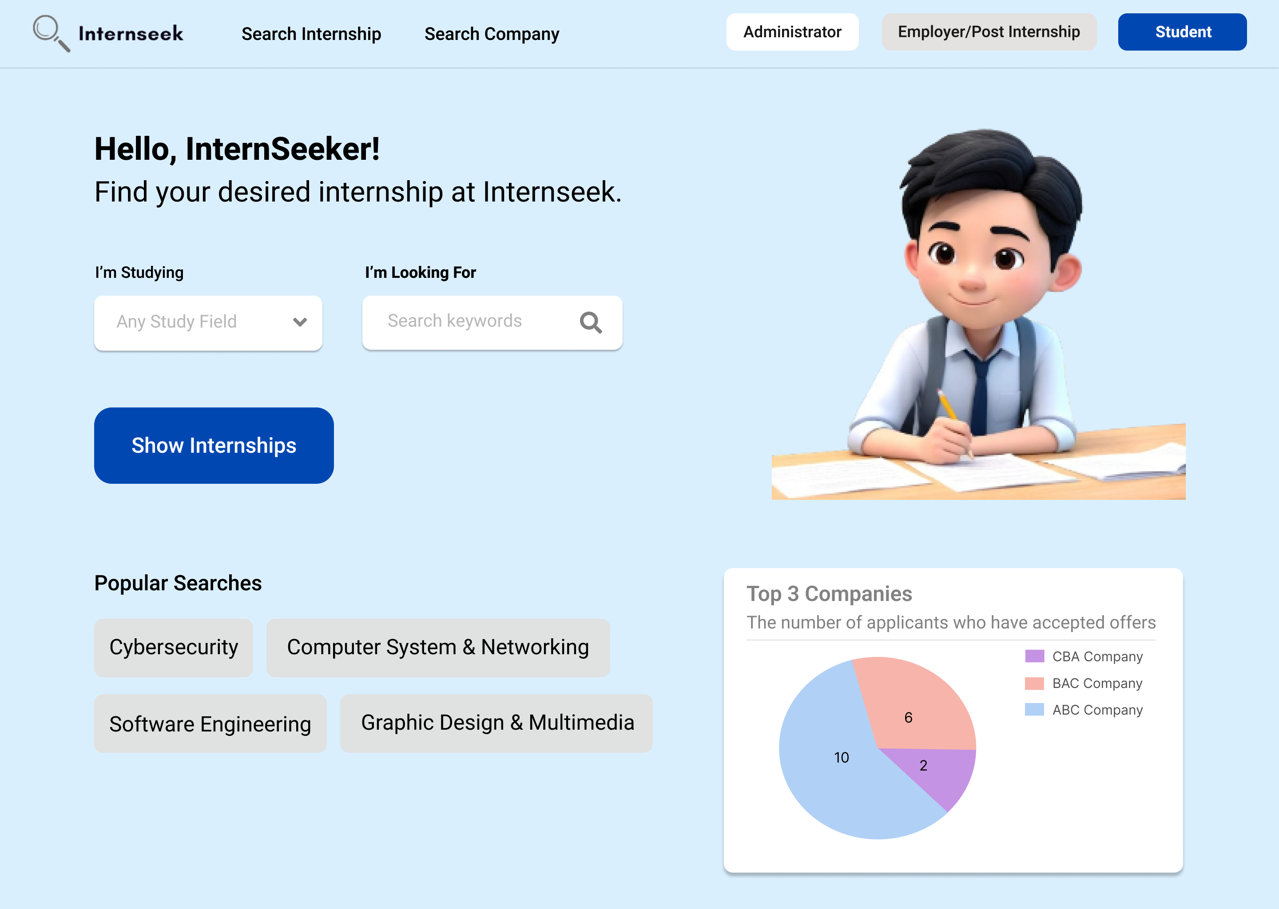

Figure 3‑137: The main page of Internseek

This figure shows the main page of Internseek. University students can click the <<Student>> button to access the system. University students can also search for internships by selecting their field of study, entering the keyword, and clicking the "Show Internships" button to filter the internship listings. They can also click the "Search Internships" button on the navbar to view all available internships or the "Search Companies" button to view all companies. Students can also click the "Popular Keyword" button to filter the internship listings based on the popular keyword. The main page also displays the top 3 companies, visible to university students, employers, and administrators. Employers can login by clicking the <<Employer/Post Internship>> button, while administrators can login by clicking the <<Administrator>> button.

##### University Student

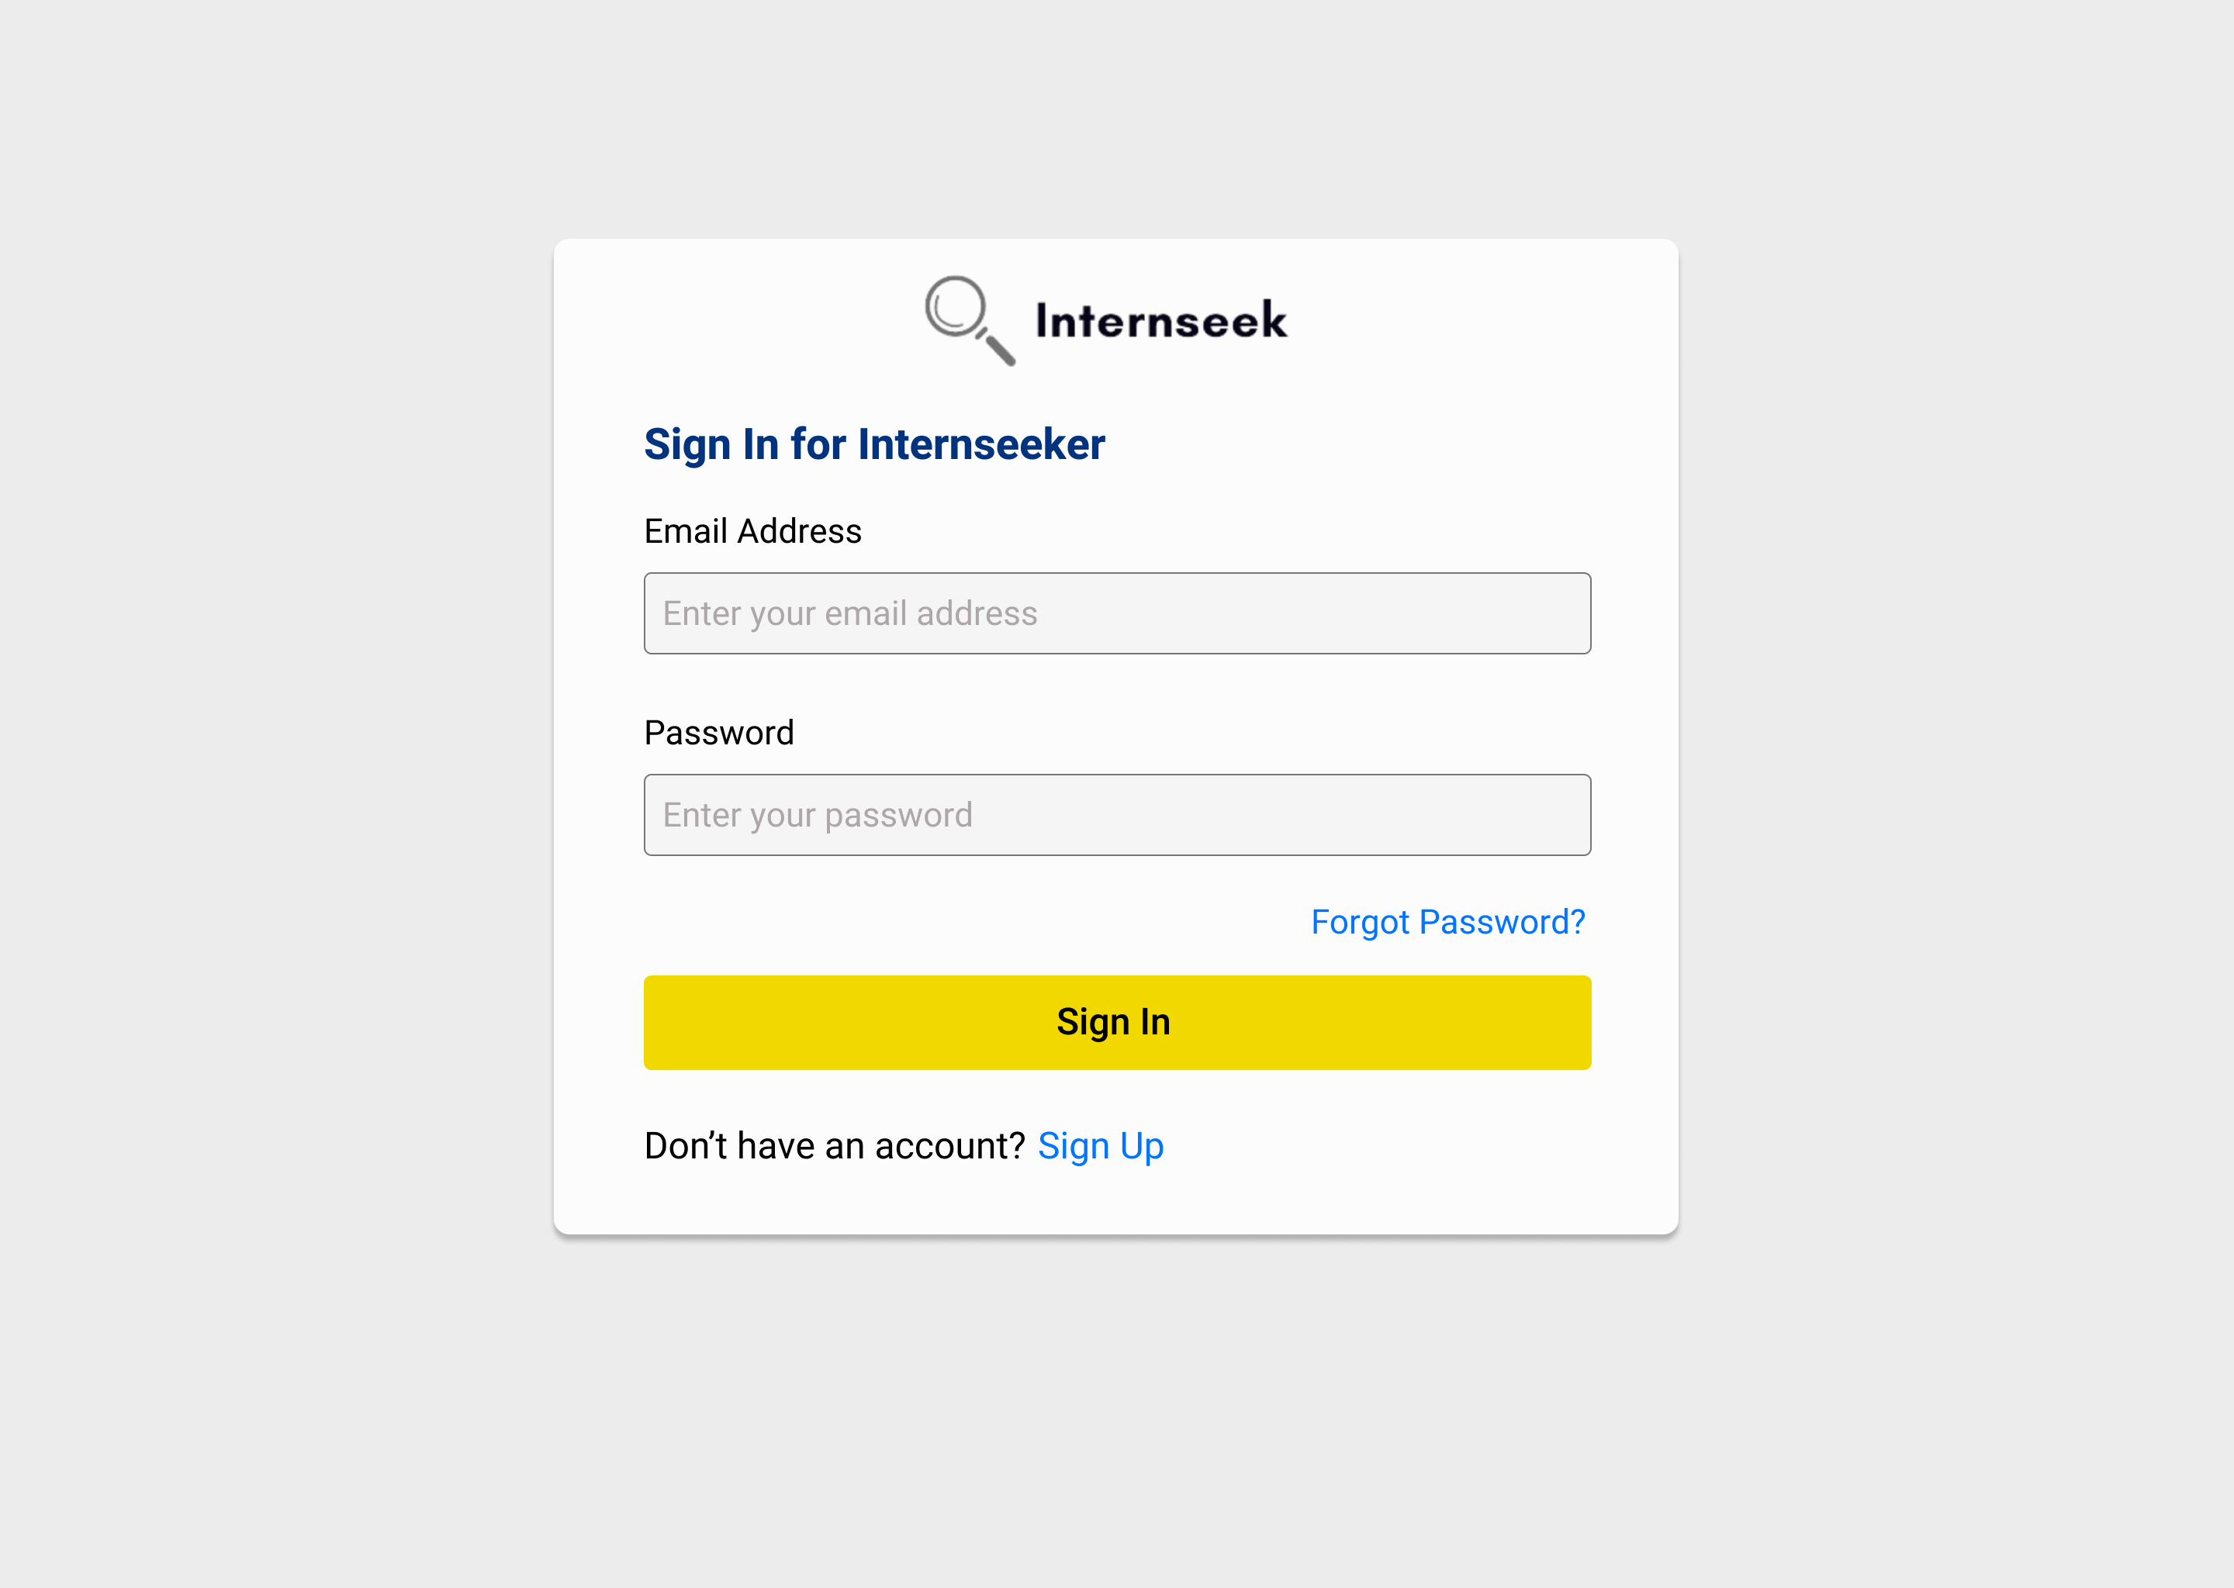

Figure 3‑138: Login Page for University Student/InternSeeker

This figure illustrates the login page for university students or interns. The university students need to enter their email address and password and click the <<Sign In>> button to login to the system. The university students can click the <<Sign Up>> text if they are first-time users. If the university students forget their account password, they need to click the <<Forgot Password?>> text to reset their password.

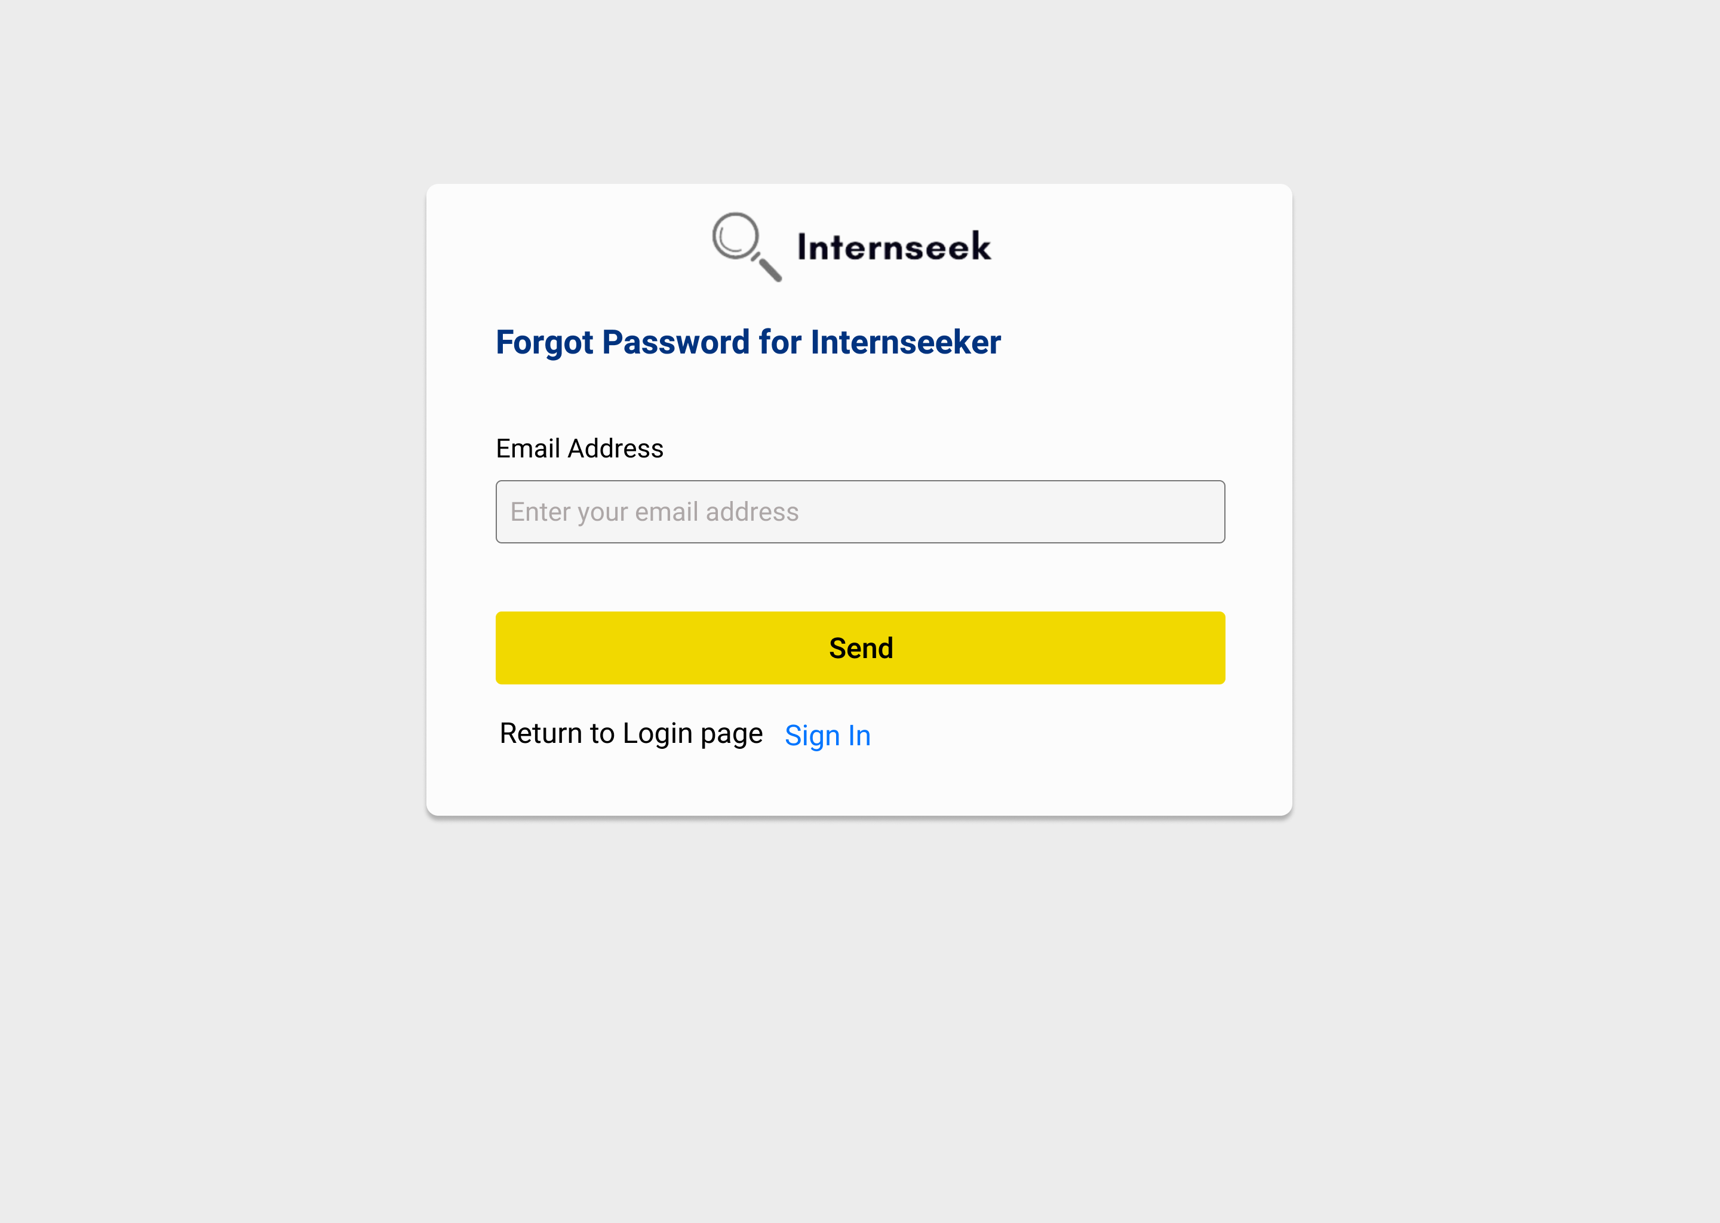

Figure 3‑139: Forgot Password Page for University Students

This figure illustrates the forgot password for university students if they forgot their password. The university students need to enter their email address and click the <<Send>> button to get the password reset link. If the university students want to back to login page, they may click the <<Sign In>> text.

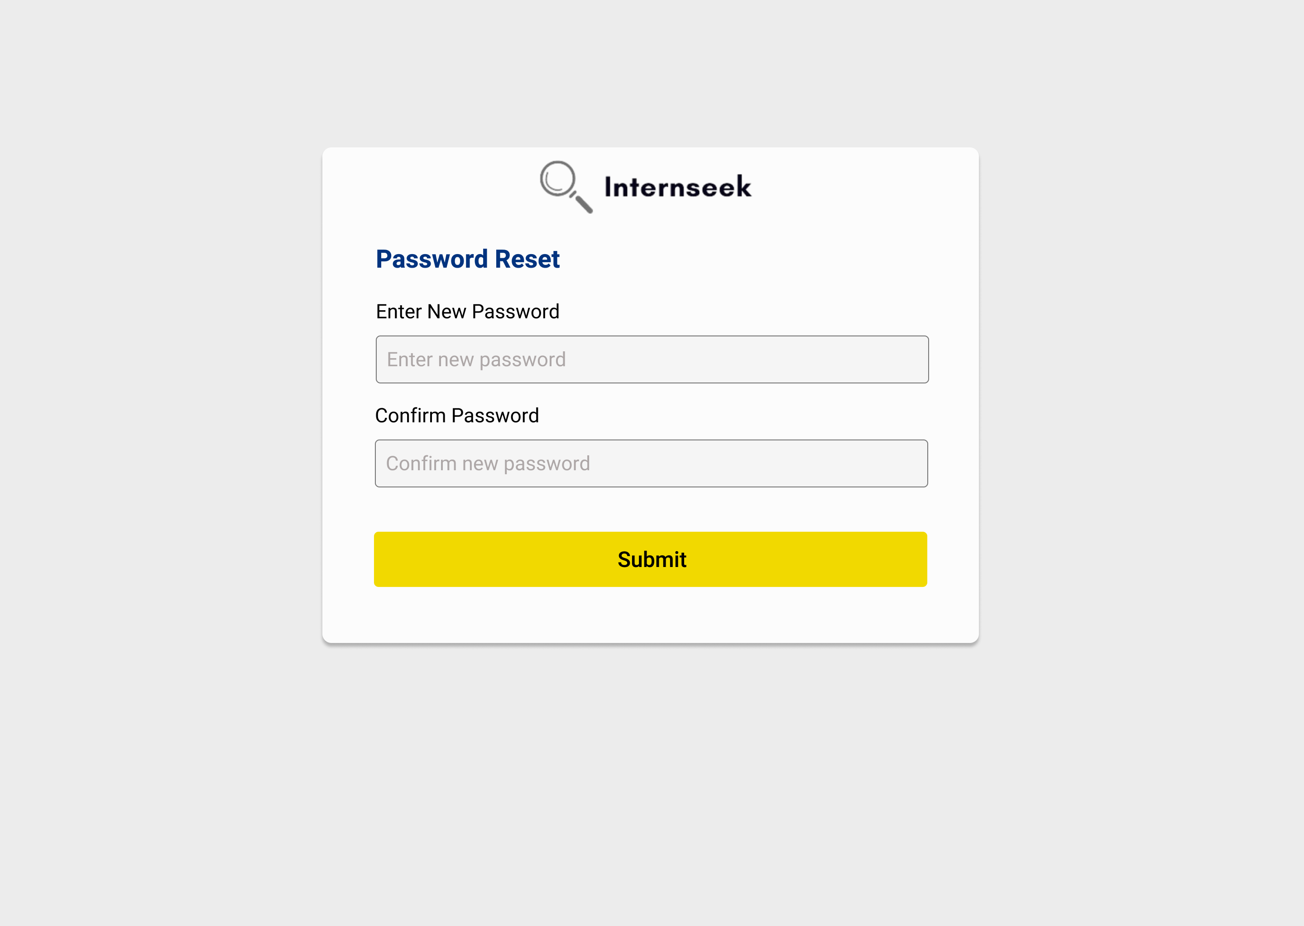

Figure 3‑140: Password Reset Page for University Students

This figure illustrates the password reset page for university students once they click the password reset link in the email they received. The university students need to enter their new password, confirm their password, and click the <<Submit>> button to reset their password.

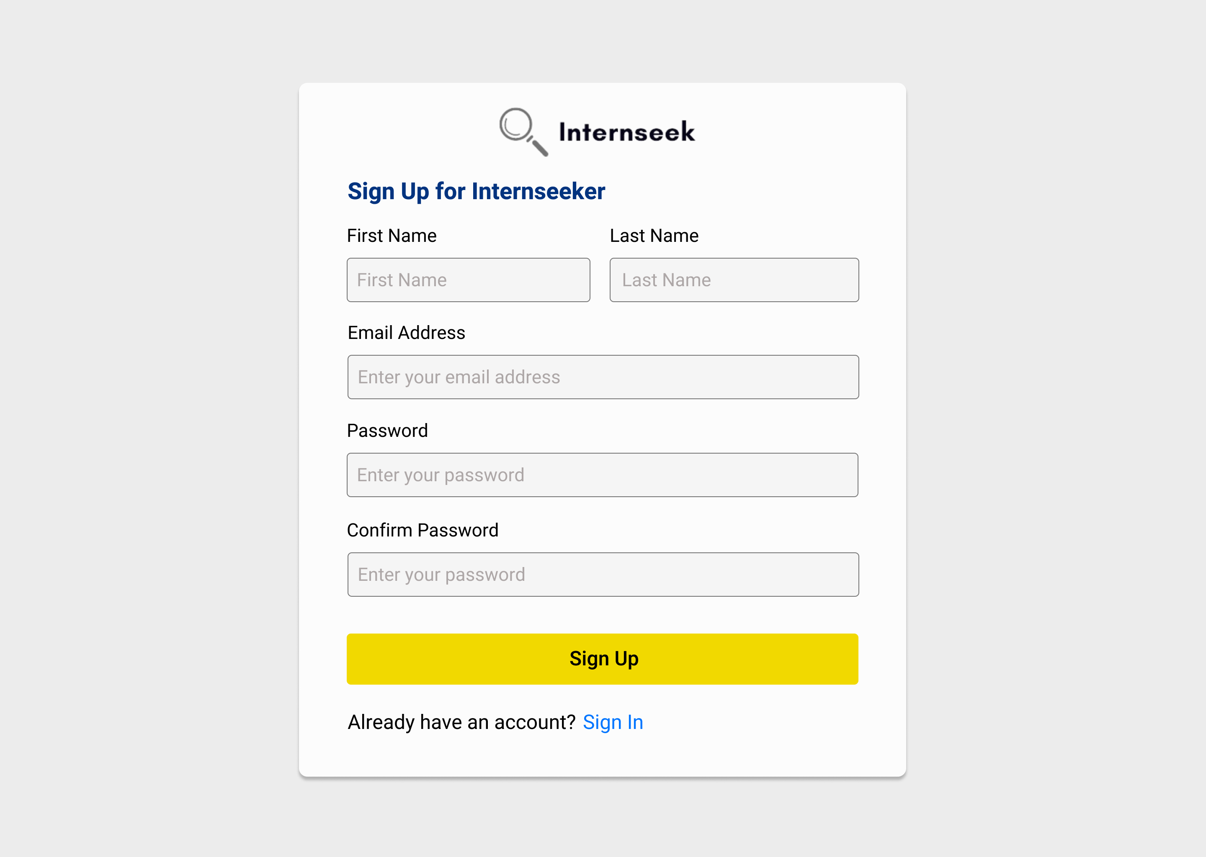

Figure 3‑141: University Student/Internseeker Account Registration Page

This diagram shows the registration page for university students on Internseek. To tegister an account, students need to enter their first name, last name, email address, password, and confirm the password, then click the <<Sign Up>> button. If they already have an account, they can click the <<Sign In>> text to log in to the system.

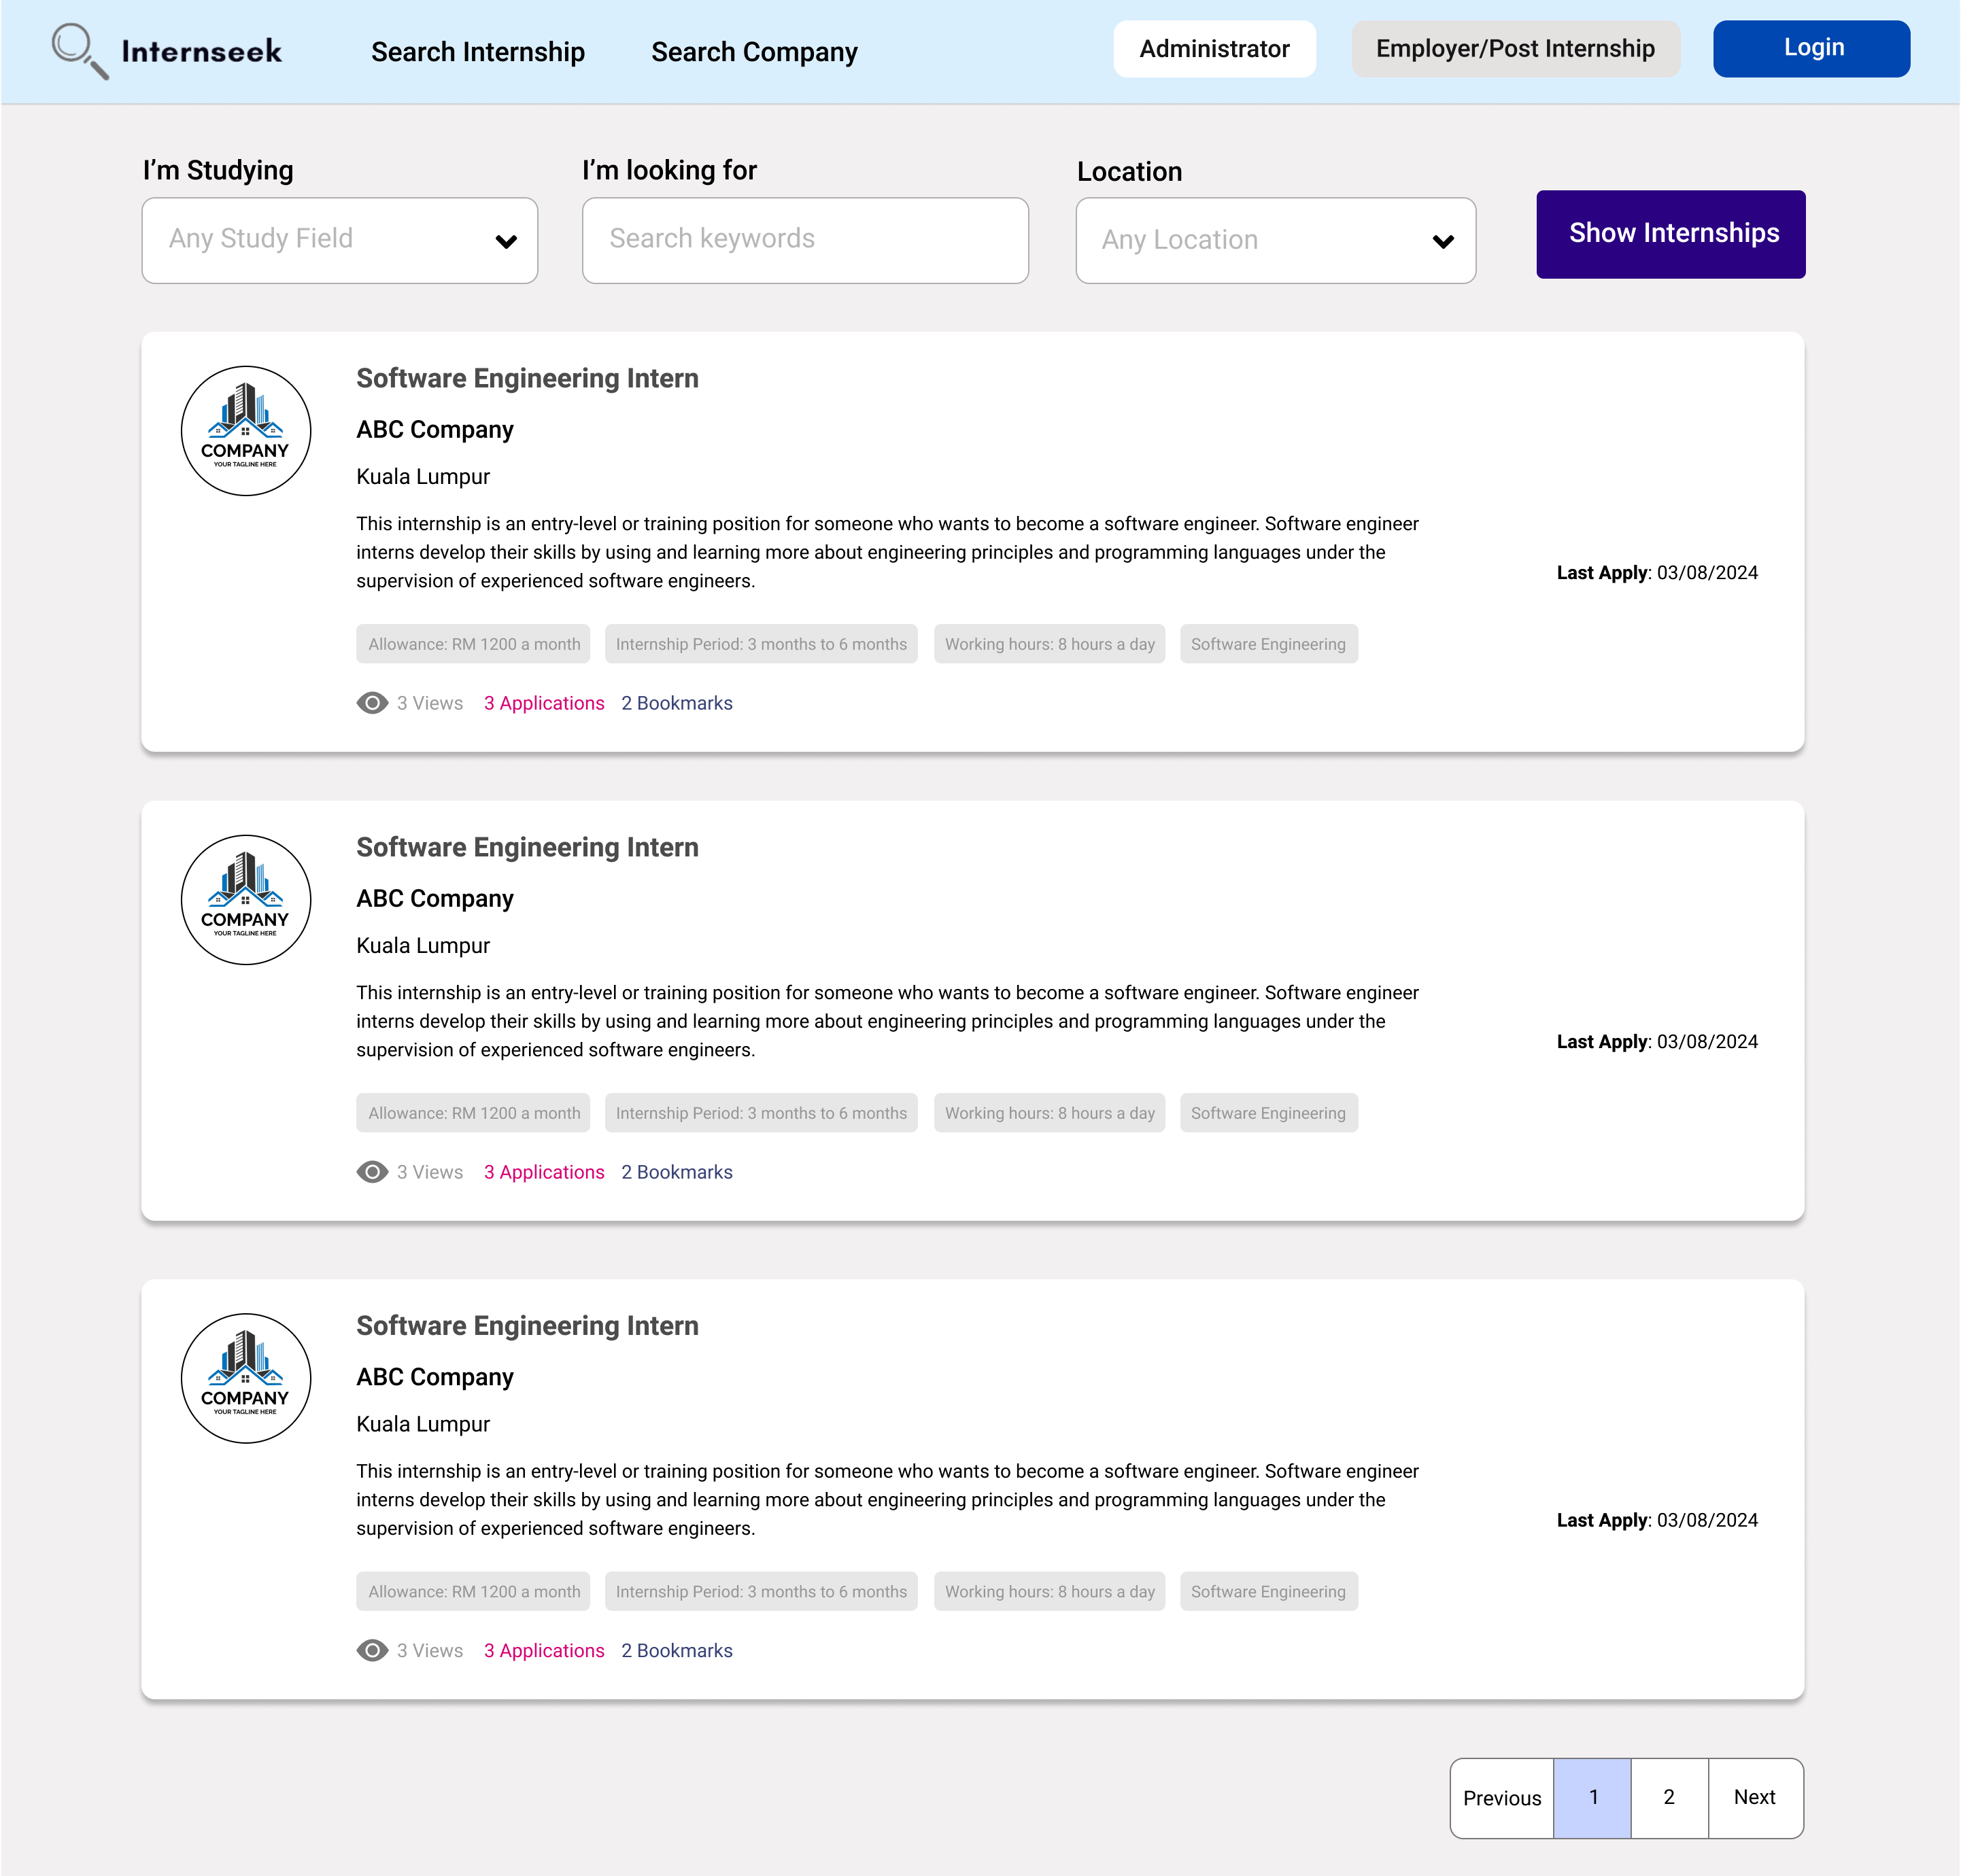

Figure 3‑142: Internships Listing Page Without Login

This figure displays a listing of all available internships that users can view without logging in. University students don't need to log in and create an account to browse through these internship opportunities. This allows university students to search for internships that match their interests and qualications and experience the features offered by Internseek before creating an account.

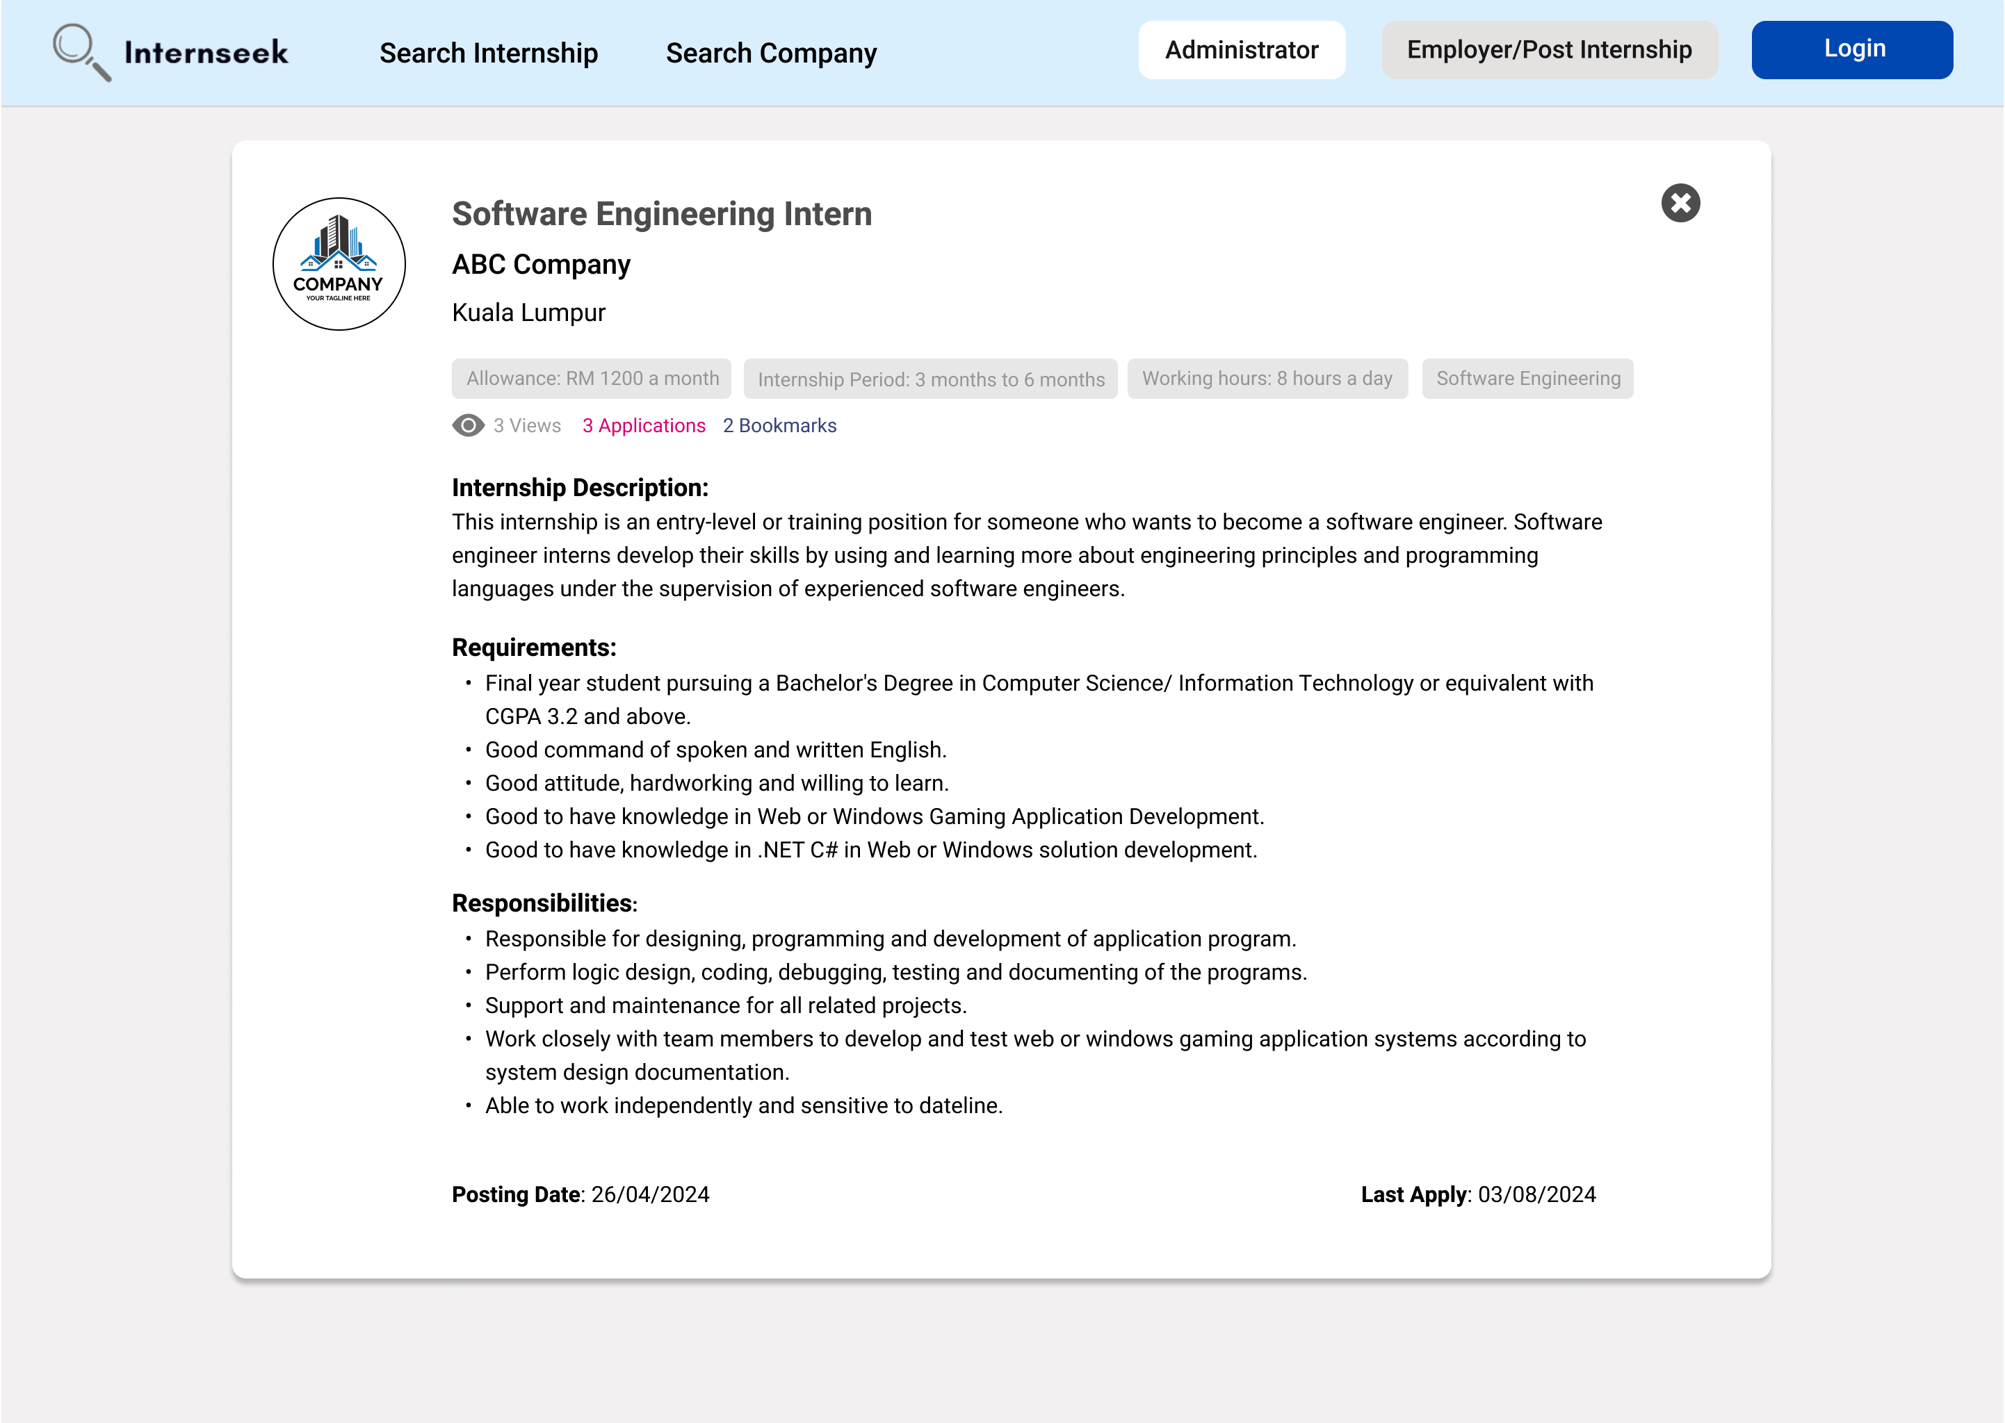

Figure 3‑143: View Internship Details Page Without Login

This figure shows the internship details page that university students can view before logging in. University students can see detailed information about each internship, including the internship description, requirements, and internship responsibilities. It can help university students determine whether the internship meets their interests and qualifications before signing up or logging into the system.

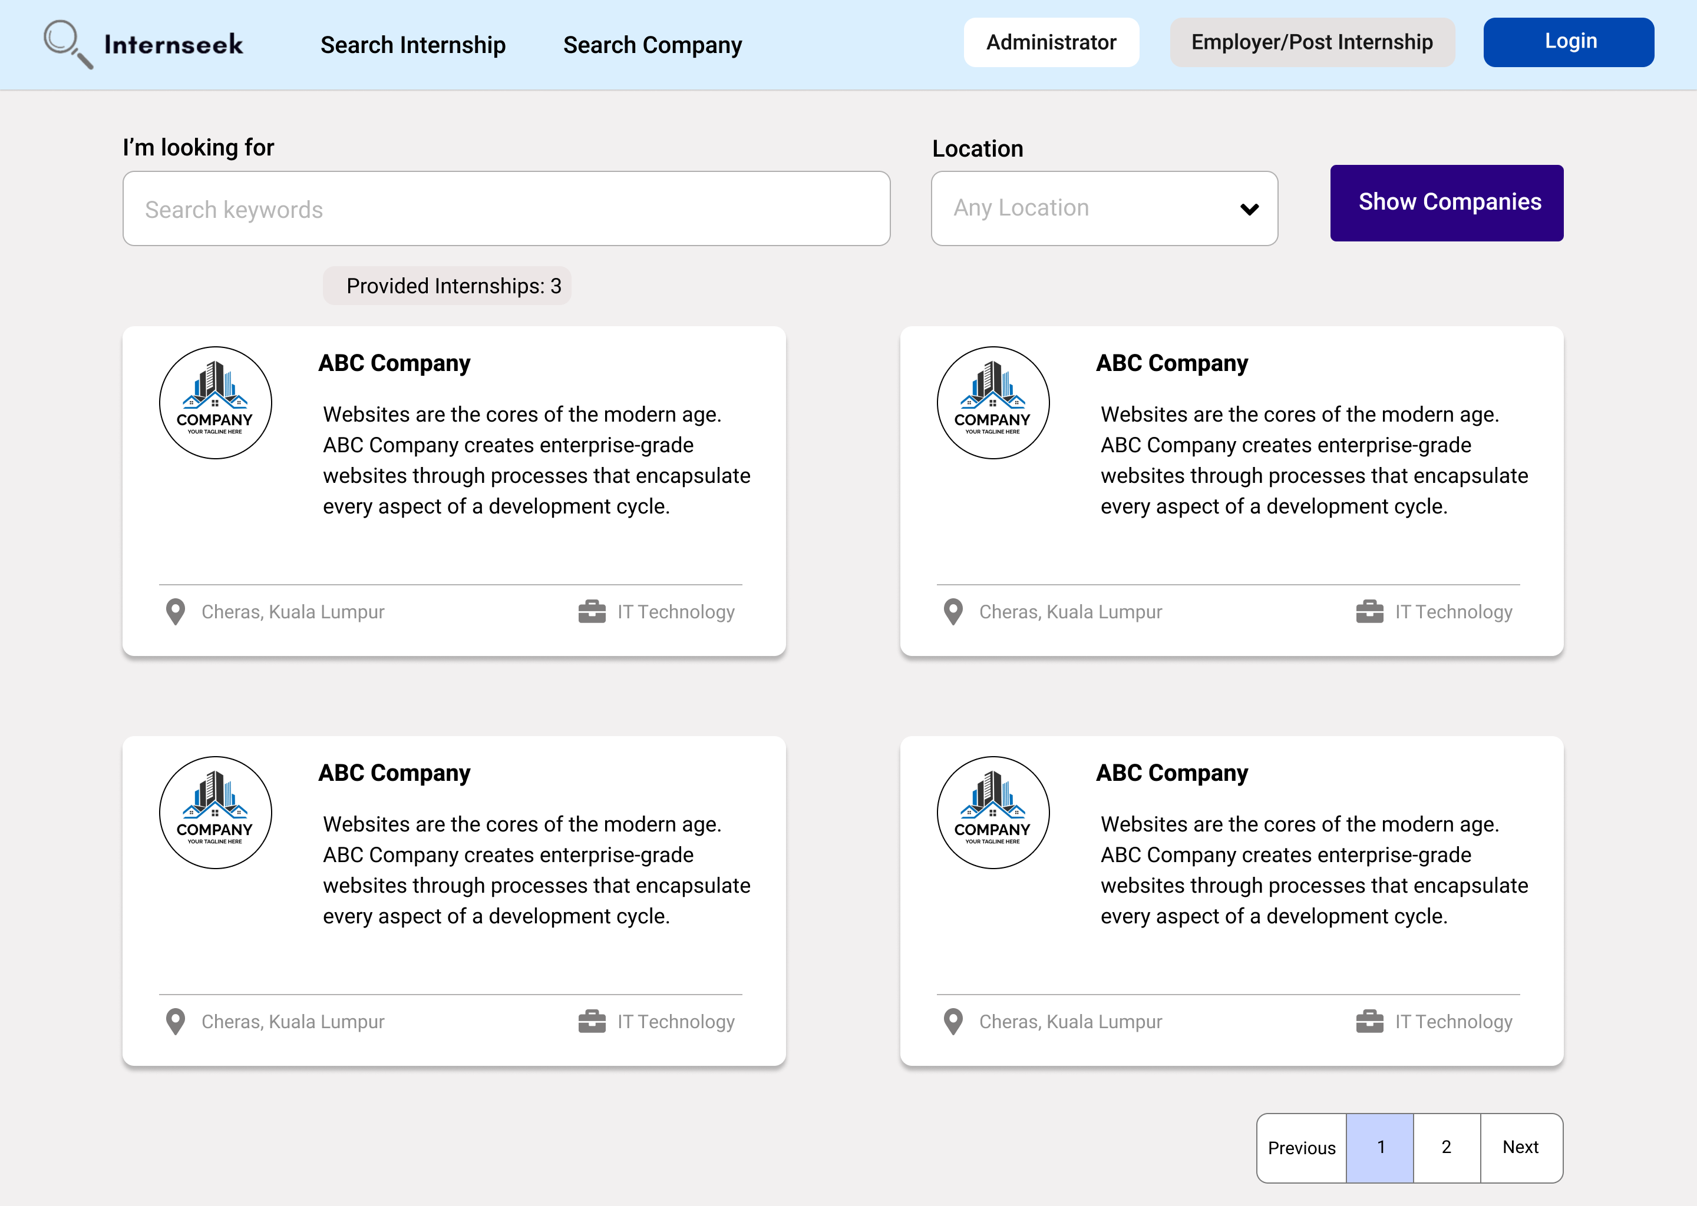

Figure 3‑144: Company Listing Page Without Login

This figure shows the company listing page that university students can view without logging in. University students can browse through a list of companies and view basic company information. This feature helps university students learn about the basic details of the company on the platform, allowing them to make informed decisions about signing up or logging in to Internseek.

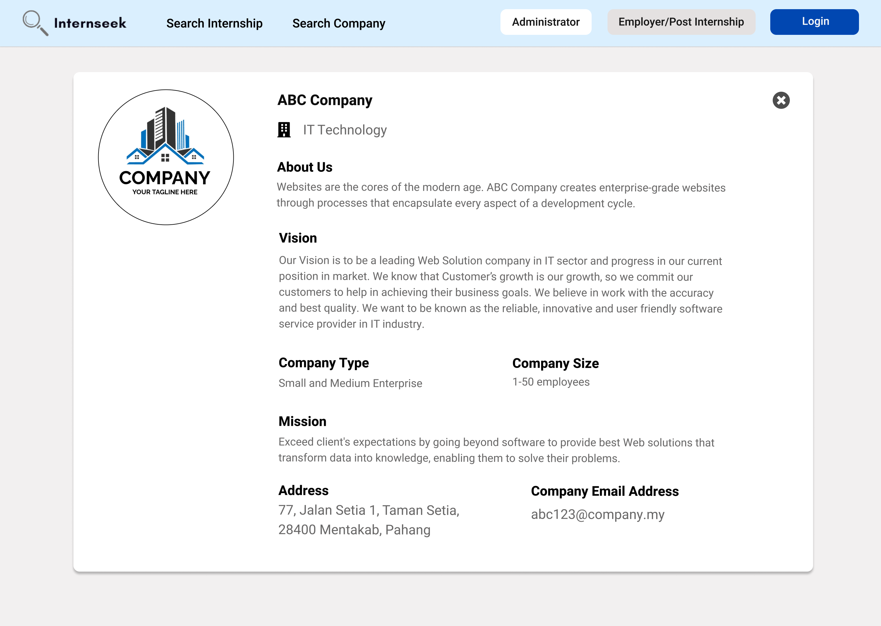

Figure 3‑145: View Company Details Page without login

This figure shows the company details page that university students can view without logging in. University students can access detailed information about the company, which helps them understand the company background. This feature allows university students to make informed decisions about signing up or logging in to Internseek.

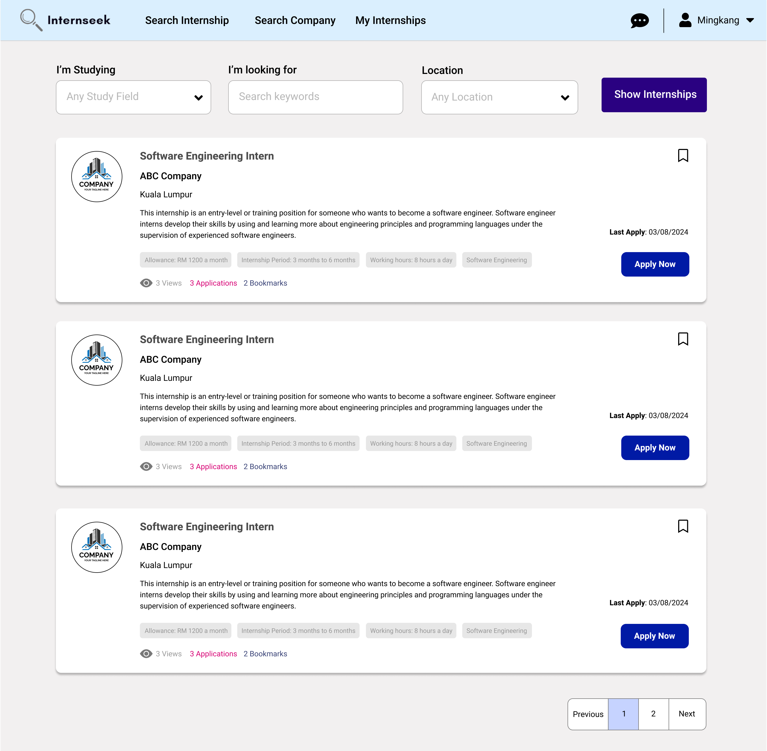

Figure 3‑146: Internships Listing Page after login

This figure displays a listing of all available internships after university students log in to the system. University students can browse through these internship opportunities to find internships that match their interests and qualifications. This page also displays the number of views (clicks), bookmarks, and applications submitted for each internship. This data helps university students gauge the level of competition for the internship opportunity, allowing them to make informed decisions about which internships they want to apply for. Each internship card includes a bookmark icon and an apply now button. If university students want to apply for the internship, they may click the <<Apply Now>> button. If university students have an interest in the internship, they may click the bookmark icon to save it to their list of internships.

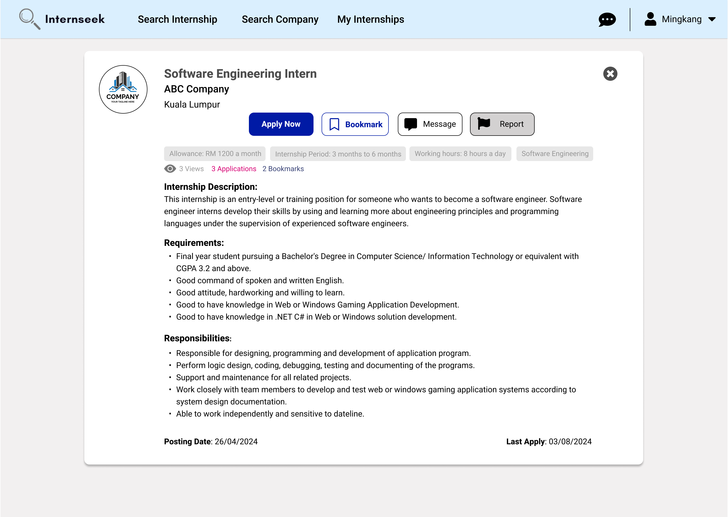

Figure 3‑147: View Internship Details Page After login

This figure displays the internship details page that university students can view after they log in to the system. University students can see detailed information about each internship and determine whether it meets their interests and qualifications, including the internship description, requirements, allowance, responsibilities, and so on. This page also displays the number of views (clicks), bookmarks, and applications submitted for the internship. It can help university students gauge the level of competition for the internship. The internship details card includes a bookmark button, a message button, a report button and an apply now button. If university students want to apply for the internship, they may click the <<Apply Now>> button. If university students have an interest in the internship, they may click the bookmark icon to save it to their list of internships. If university students want to know the details of the internship, they can click the message to inquire with the employer about the internship details. If university students find the internship got problem, they can click the <<Report>> button to report the internship.

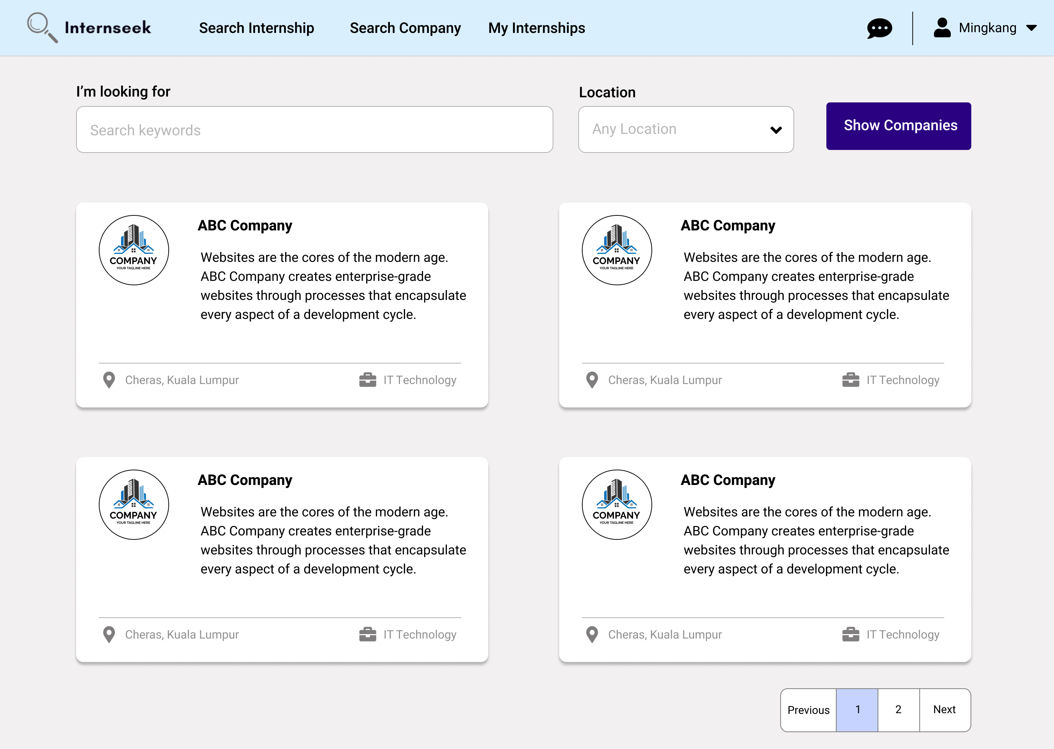

Figure 3‑148: Company Listing Page after login

This figure shows the company listing page that university students can view after logging in. University students can browse through a list of companies and view basic company information. This feature helps university students learn about the basic details of the company on the platform.

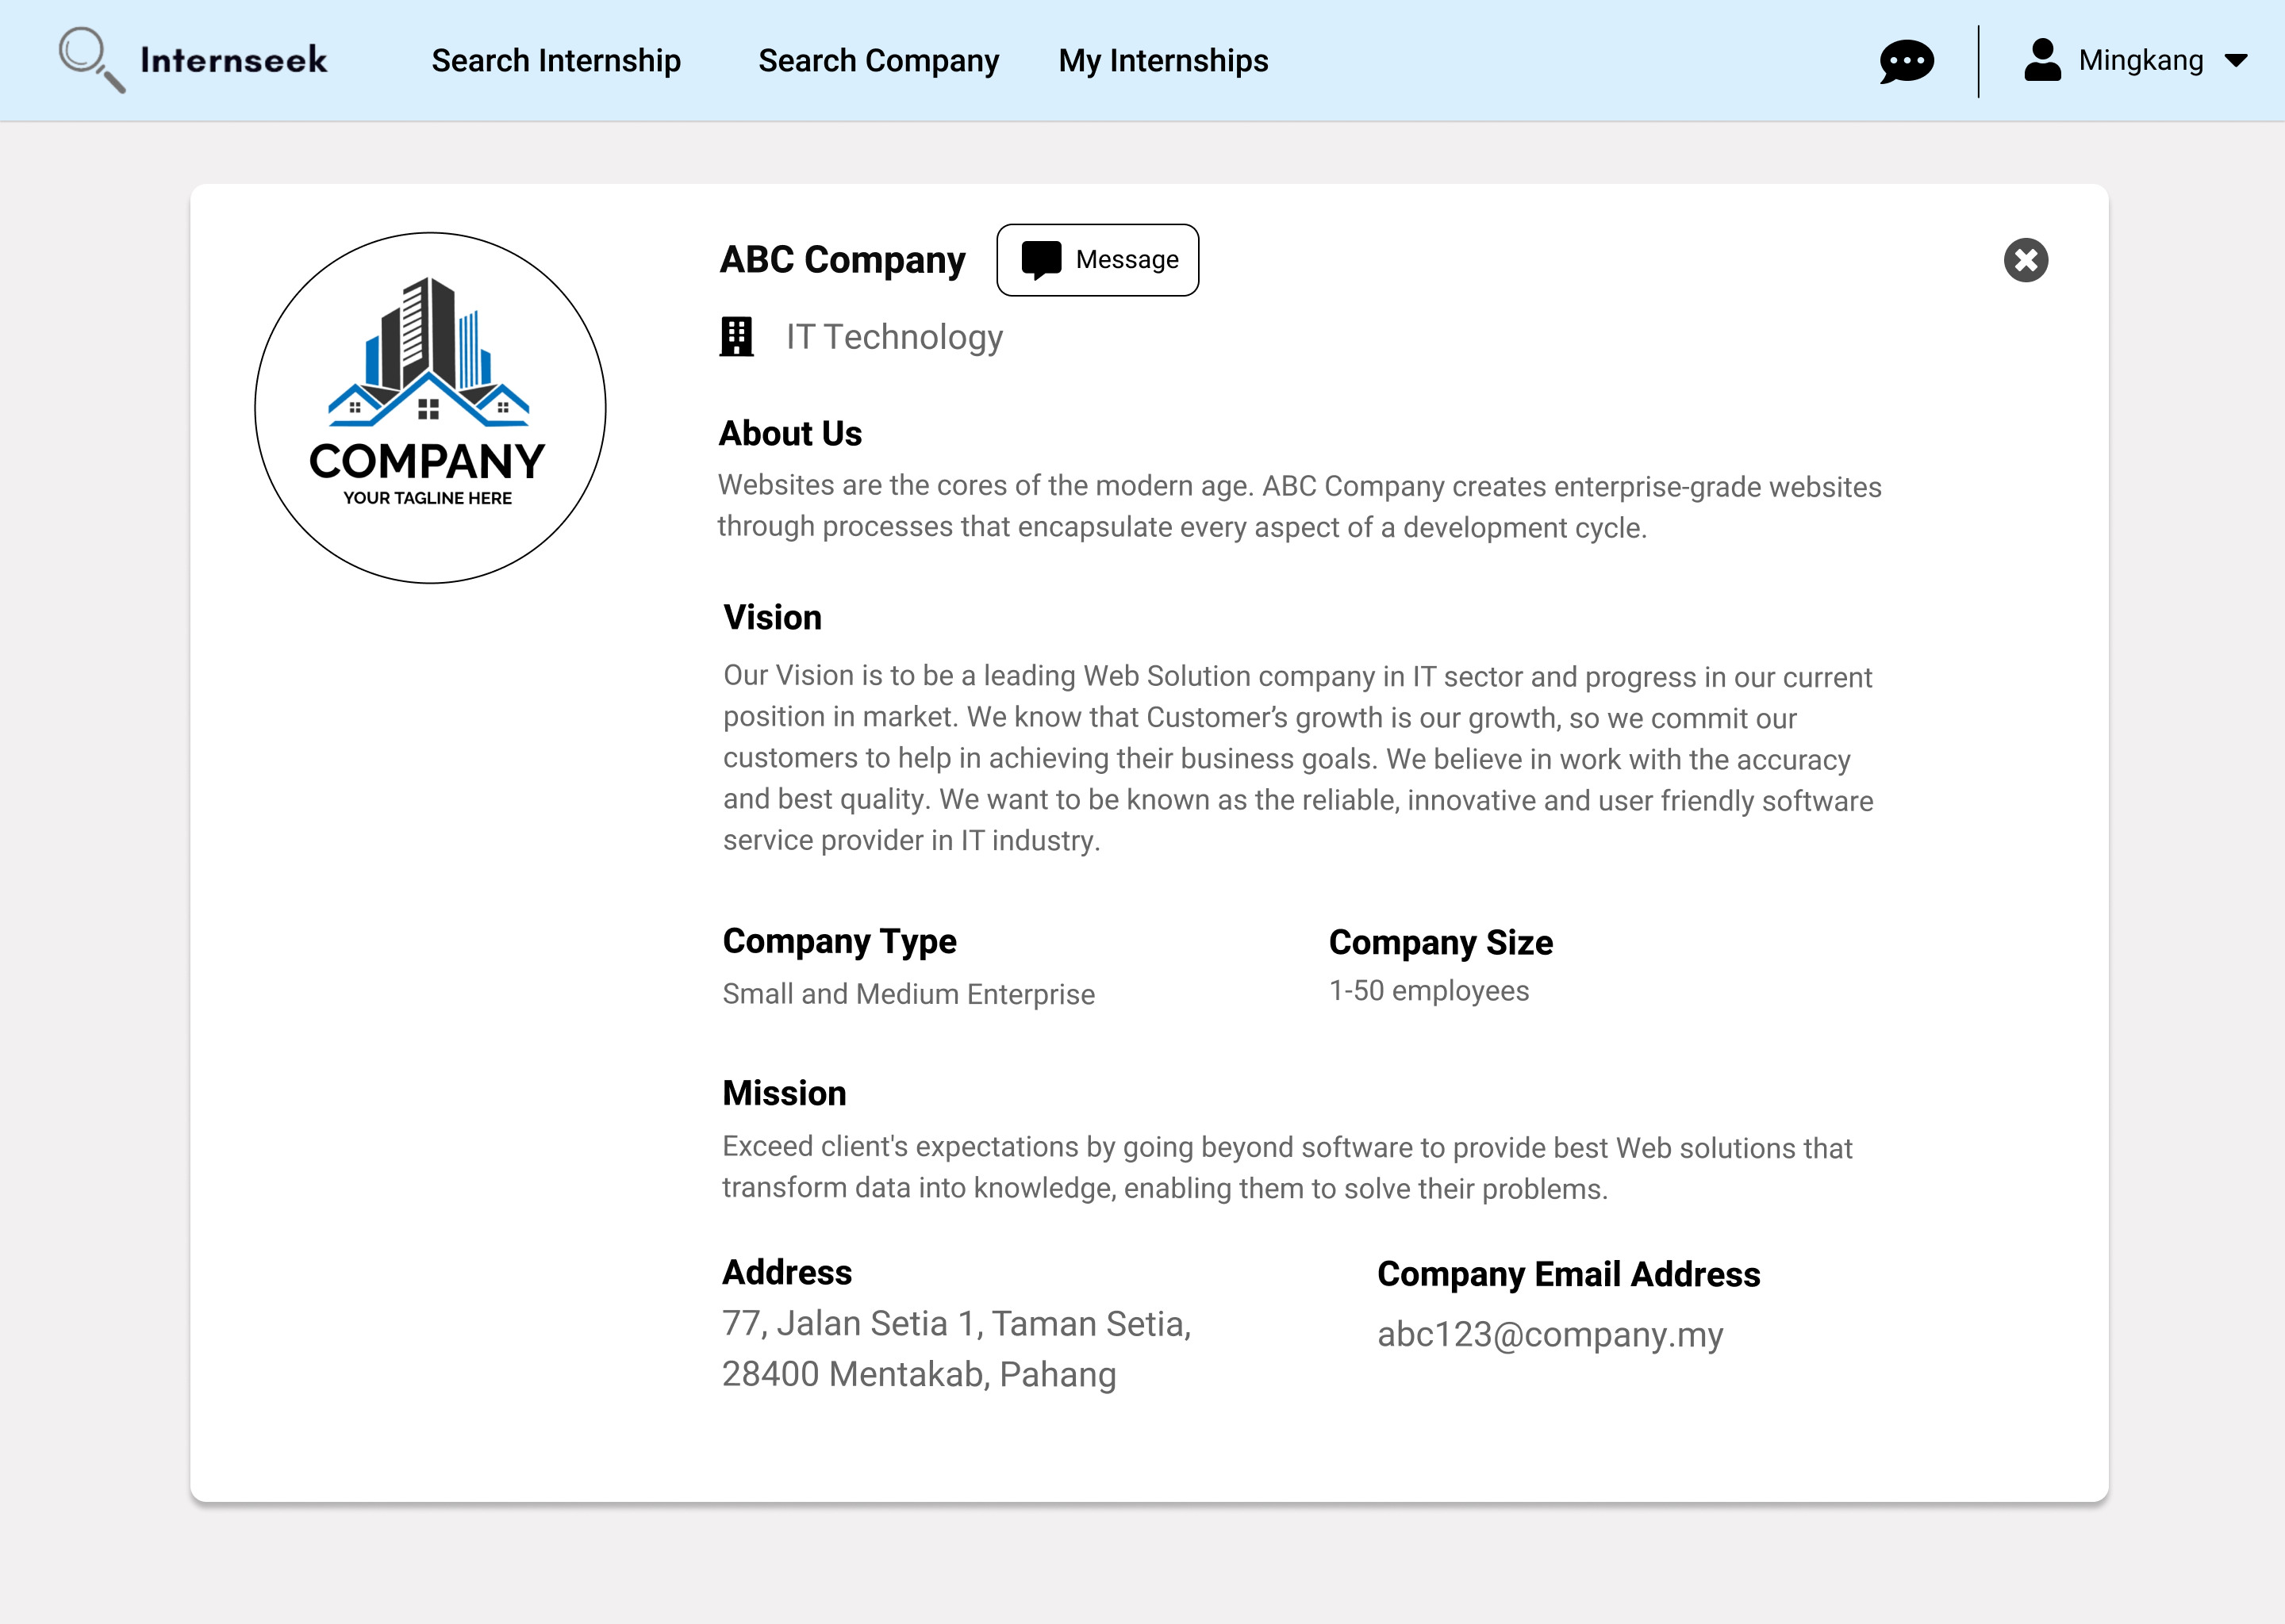

Figure 3‑149: View Company Details Page after login

This figure shows the company details page that university students can view after logging in. University students can access detailed information about the company, which helps them understand the company background.

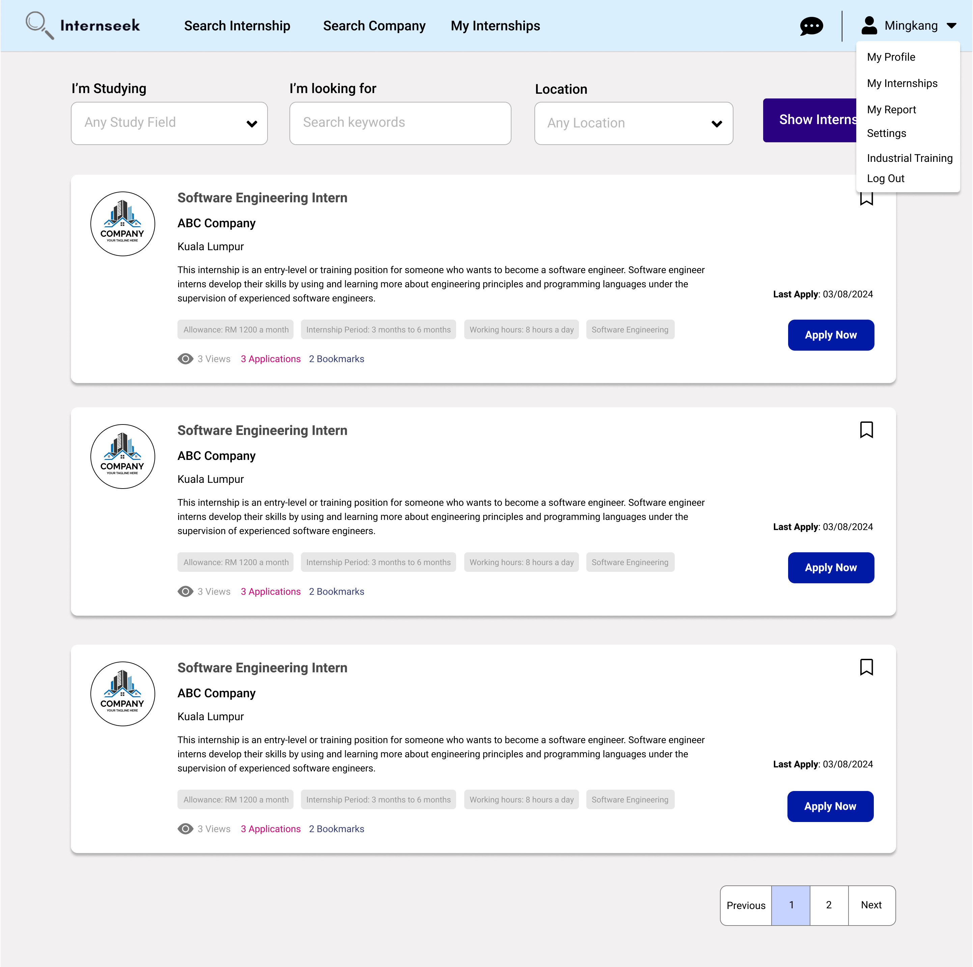

Figure 3‑150: Drop-Down Menu of the Navbar

This figure shows the internship listings page after university students log in. University students will be directed to the internship listings page after they successfully login to the system. This page shows the drop-down menu of the navigation bar, which consists of four options: My Profile, My Internships, My Report, Industrial Training, Settings, and Log Out. University students will be directed to the My Profile page once they select the My Profile option. University students will be directed to the My Internships page once they select the My Internships option. University students will be directed to the My Report page once they select the My Report option. University students will be directed to the My Industrial Training page once they select the Industrial Training option. University students will be directed to the Settings page once they select the Settings option. University students will be logged out of the system once they select the Log Out option.

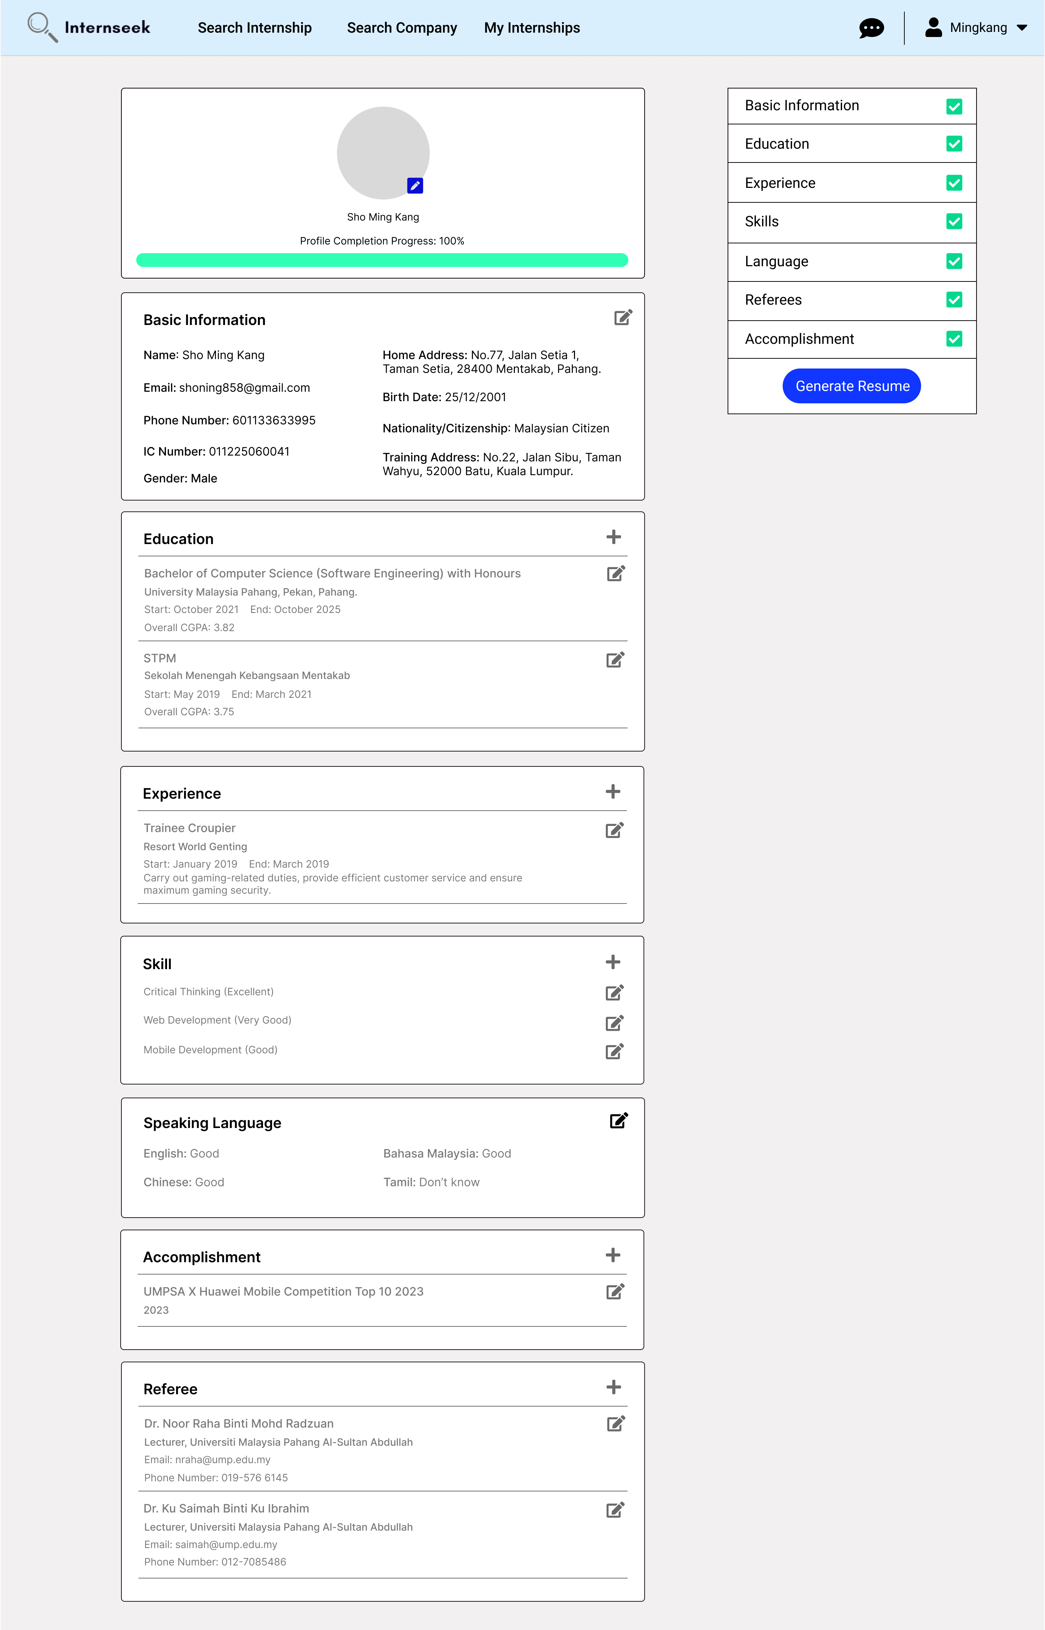

Figure 3‑151: My Profile Page

This page shows the profile details of the university student. This page categorizes the profile details of the university student into eight sections: profile picture, basic information, experience, education, skills, speaking languages, accomplishments, and referees. University students can add, edit, and delete their profile details on this page. Once the university students fill out all the profile details required completely, they can generate a resume by pressing the <<Generate Resume>> button. The page consists of a progress bar, which represents the percentage of profile completeness.

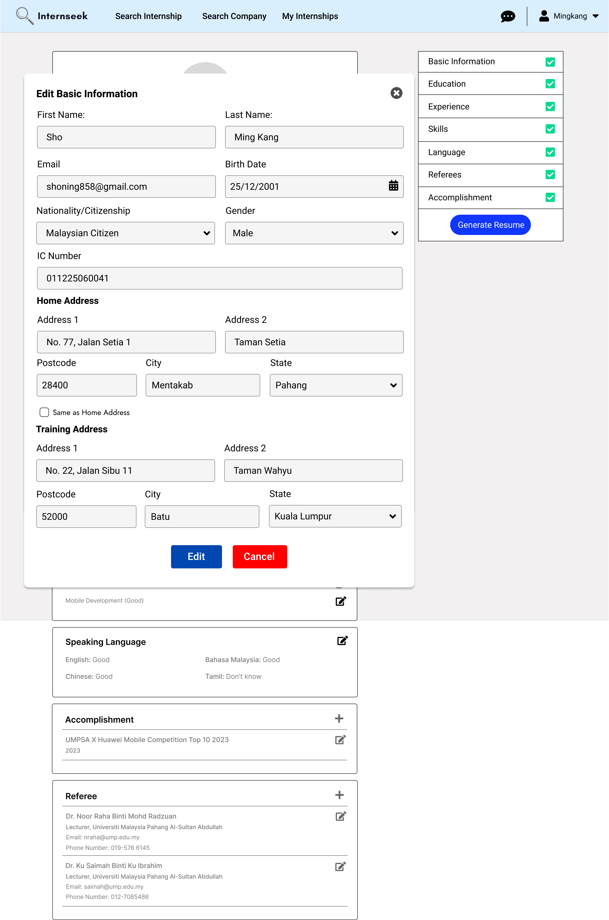

Figure 3‑152: Edit Basic Information Modal

This figure shows the edit basic information modal once the university student clicks the edit icon on the basic information section in My Profile Page. The university student can edit the basic information by entering the details they want to edit and click the <<Edit>> button. The university student can click the <<Cancel>> button and the cross icon if they do not want to edit the basic information.

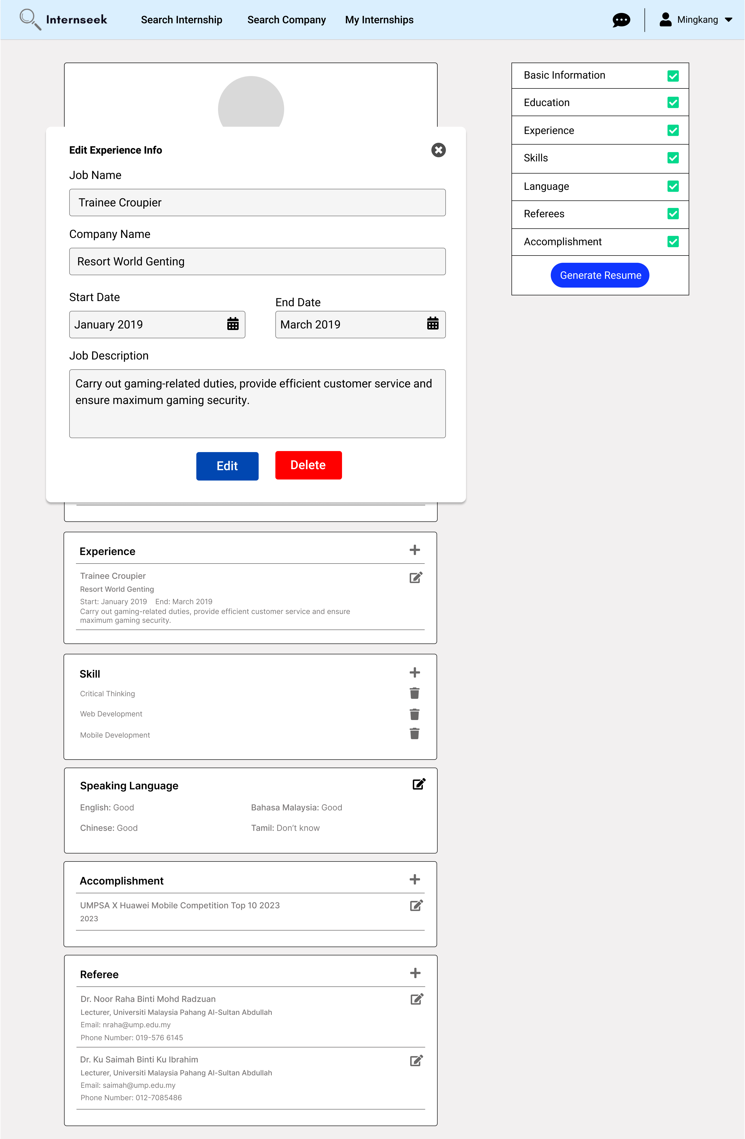

Figure 3‑153: Edit Experience Information Modal

This figure shows the edit experience information modal once the university student clicks the edit icon of the specific experience in the experience section of the My Profile Page. The university student can edit the specific experience details by entering the details they want to edit and clicking the <<Edit>> button. The university student can click the <<Delete>> button if they want to delete the experience. The university student can click the cross icon if they do not want to edit the specific experience details.

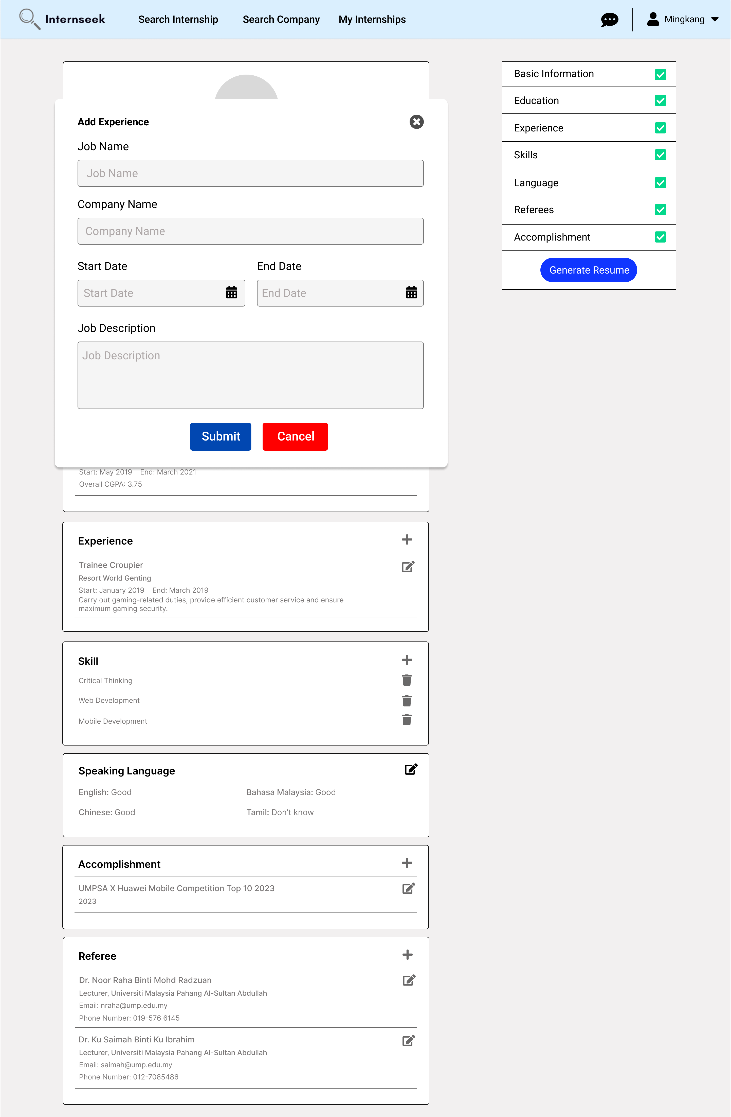

Figure 3‑154: Add Experience Modal

This figure shows the add-experience modal once the university student clicks the plus icon in the experience section of the My Profile Page. The university student enters the experience details required in the add-experience modal and click the <<Submit>> button. The university student can click the cross icon and the <<Cancel>> button if they do not want to add a new experience.

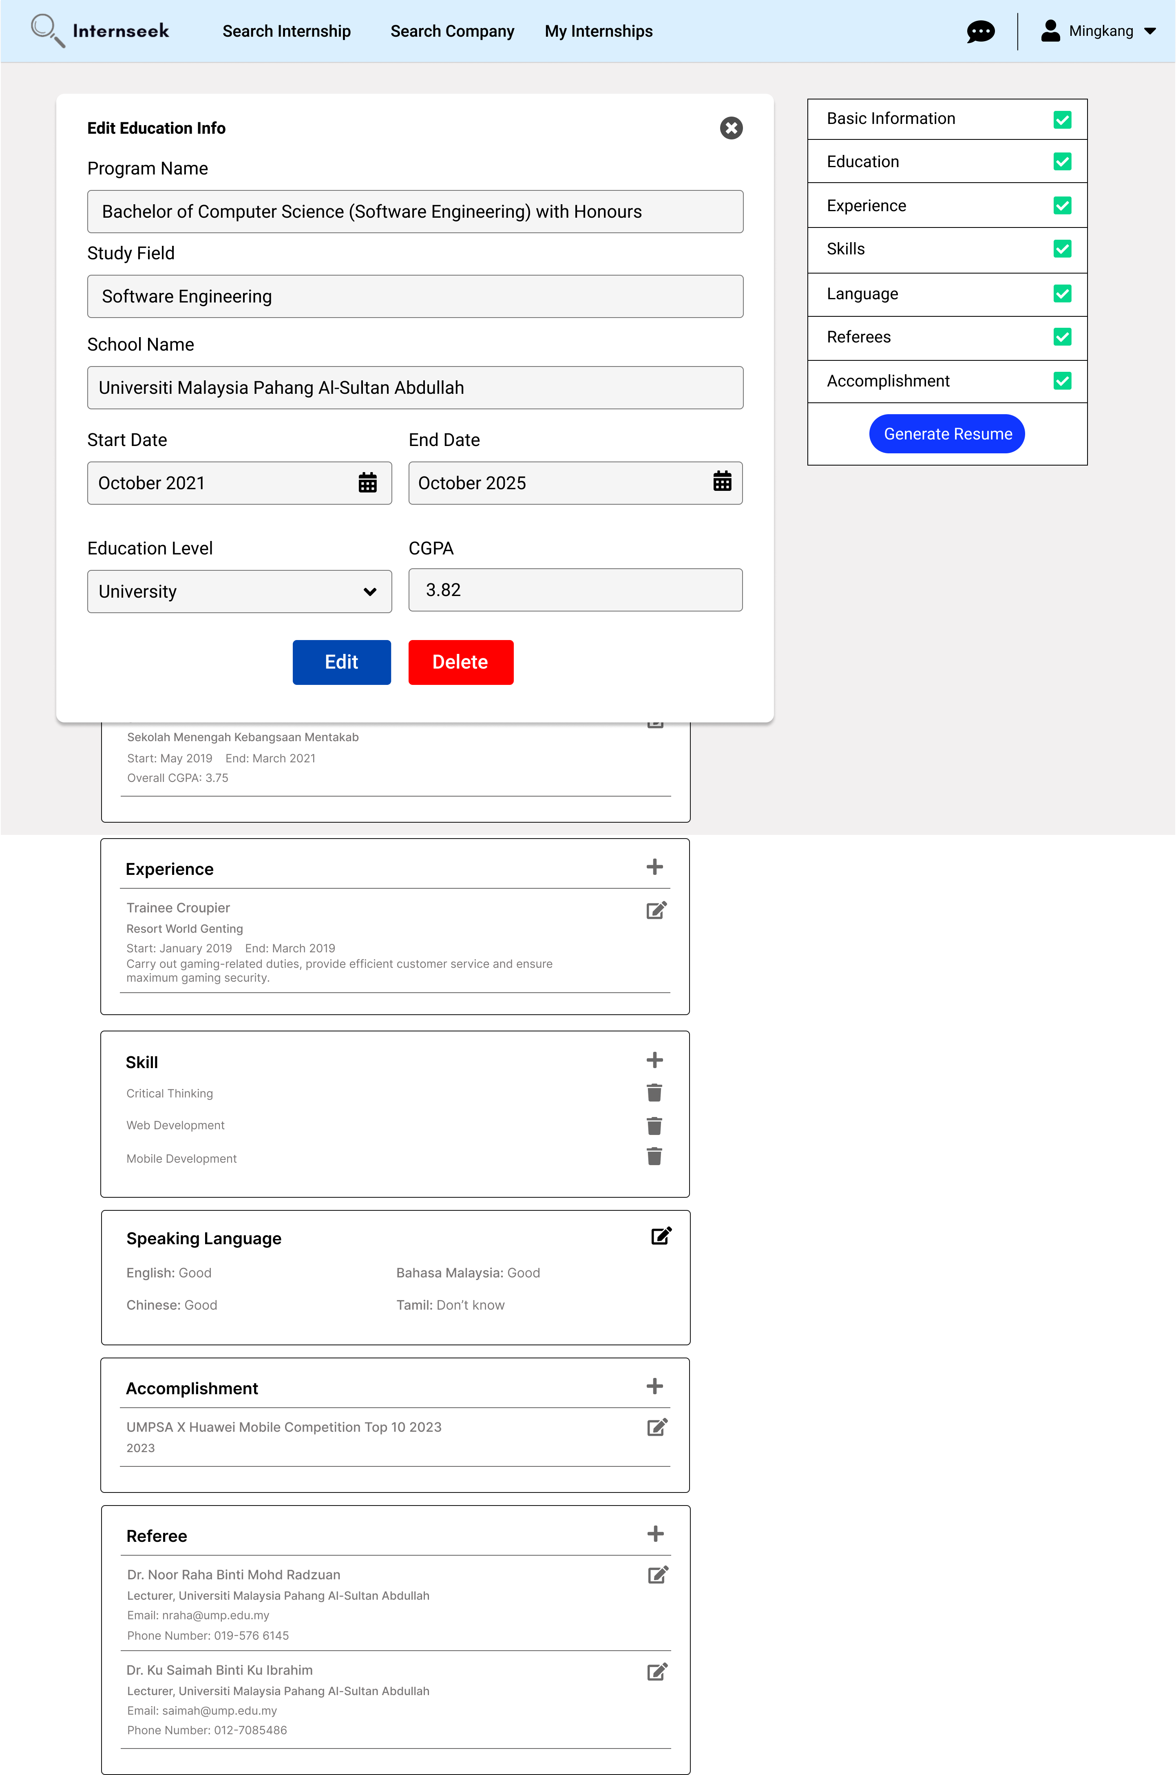

Figure 3‑155: Edit Education Information Modal

This figure shows the edit education information modal once the university student clicks the edit icon of the specific education in the education section of the My Profile Page. The university student can edit the specific education details by entering the details they want to edit and clicking the <<Edit>> button. The university student can click the <<Delete>> button if they want to delete the specific education. The university student can click the cross icon if they do not want to edit the specific education details.

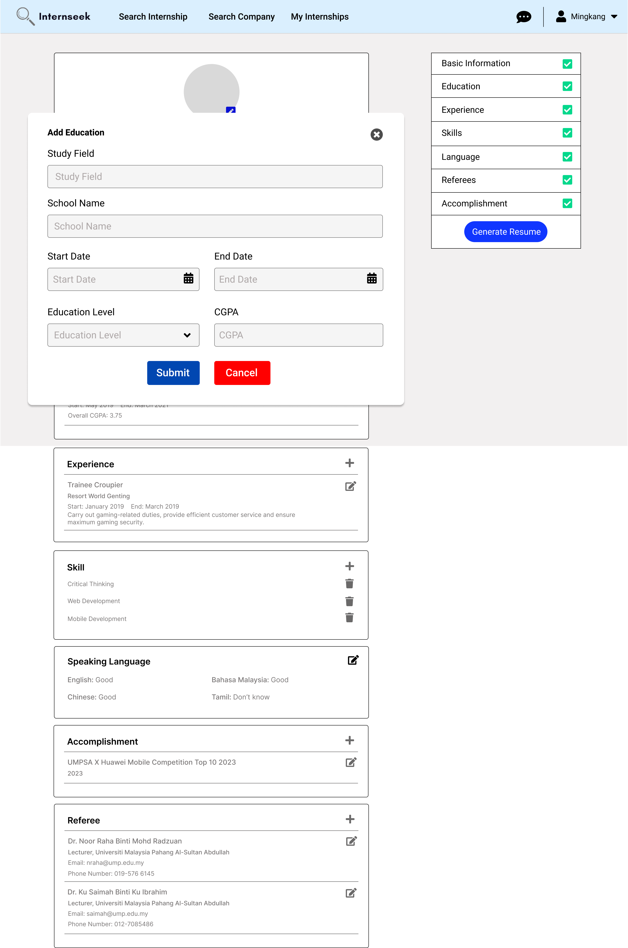

Figure 3‑156: Add Education Modal

This figure shows the add-education modal once the university student clicks the plus icon in the education section of the My Profile Page. The university student enters the education details required in the add-education modal and click the <<Submit>> button. The university student can click the cross icon and the <<Cancel>> button if they do not want to add a new education.

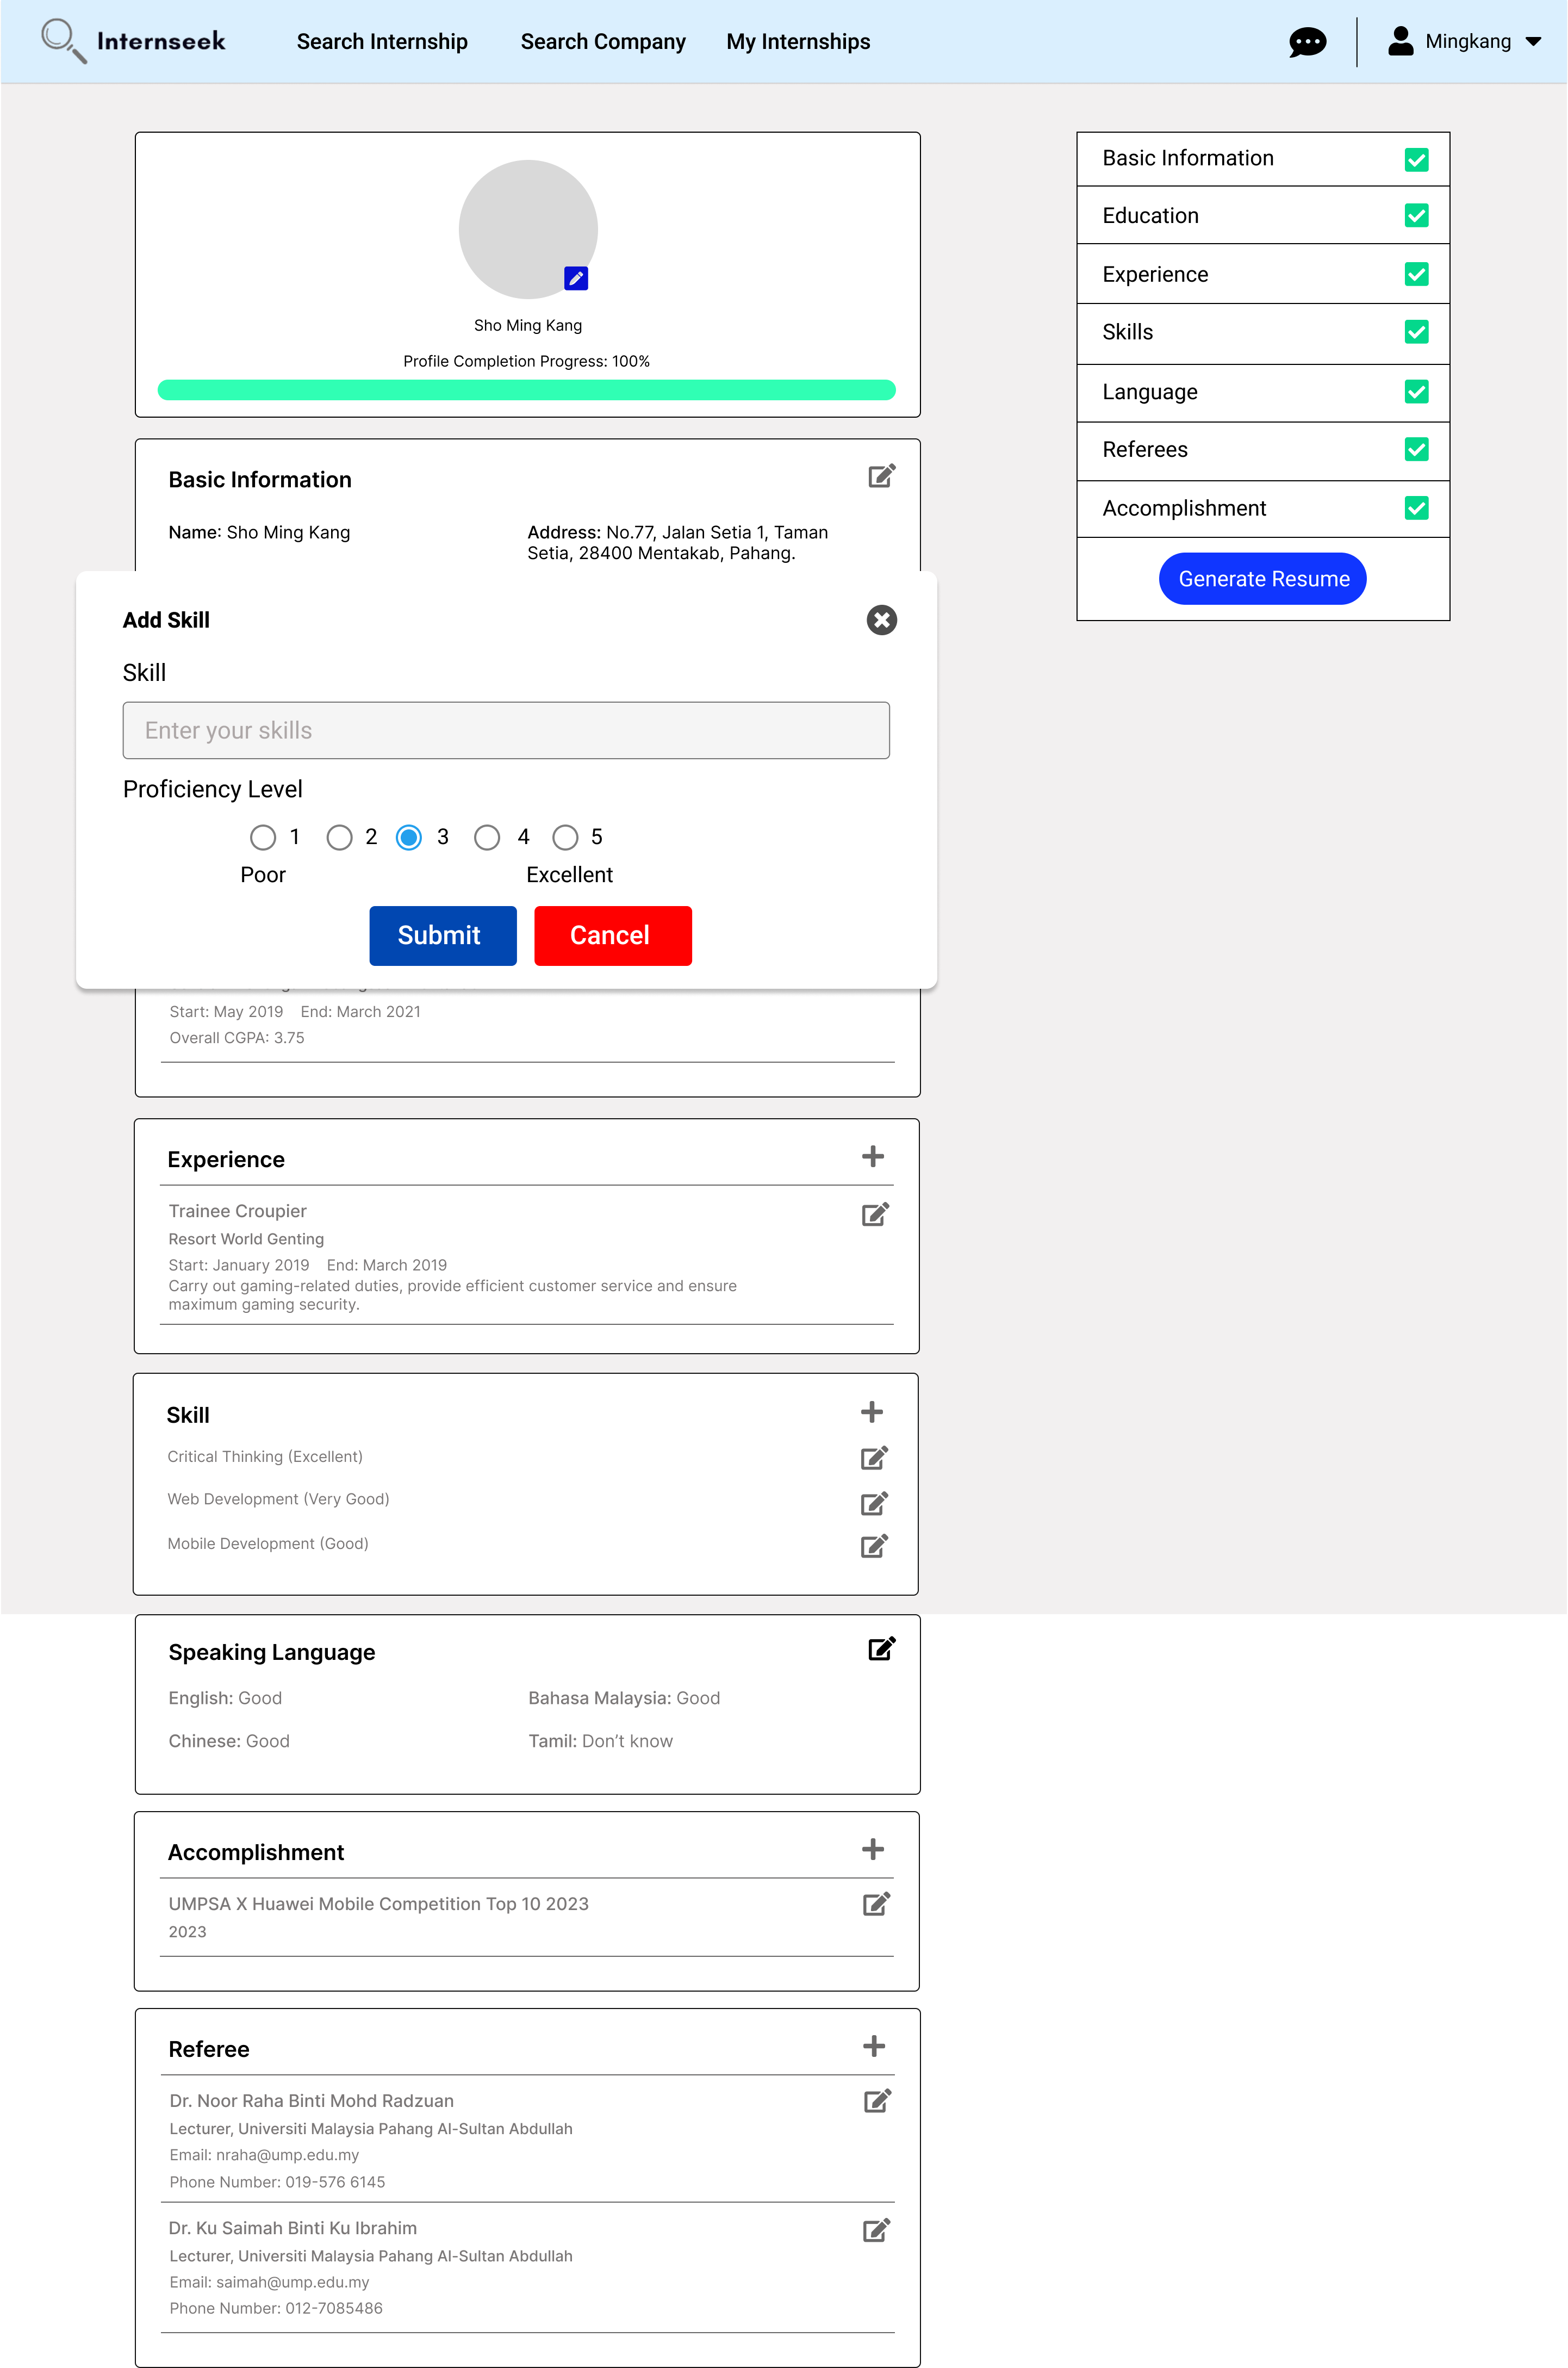

Figure 3‑157: Add Skill Modal

This figure shows the add-skill modal once the university student clicks the plus icon in the skill section of the My Profile Page. The university student enters the skill in the input field and selects the proficiency level in the add skill modal and clicks the <<Submit>> button. The university student can click the cross icon and the <<Cancel>> button if they do not want to add a new skill.

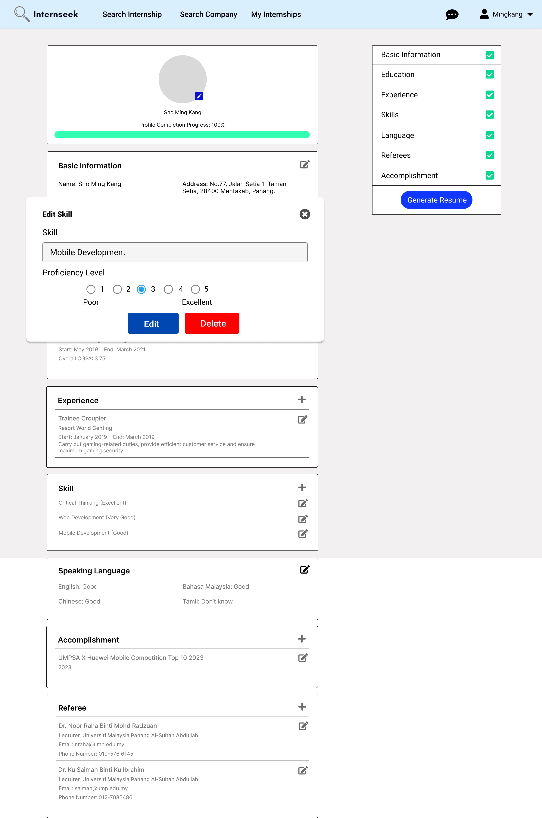

Figure 3‑158: Edit Skill Modal

This figure shows the edit skill information modal once the university student clicks the edit icon of the specific skill in the skill section of the My Profile Page. The university student can edit the specific skill details by entering the skill in the input field, selecting the proficiency level and clicking the <<Edit>> button. The university student can click the <<Delete>> button if they want to delete the specific skill. The university student can click the cross icon if they do not want to edit the specific skill details.

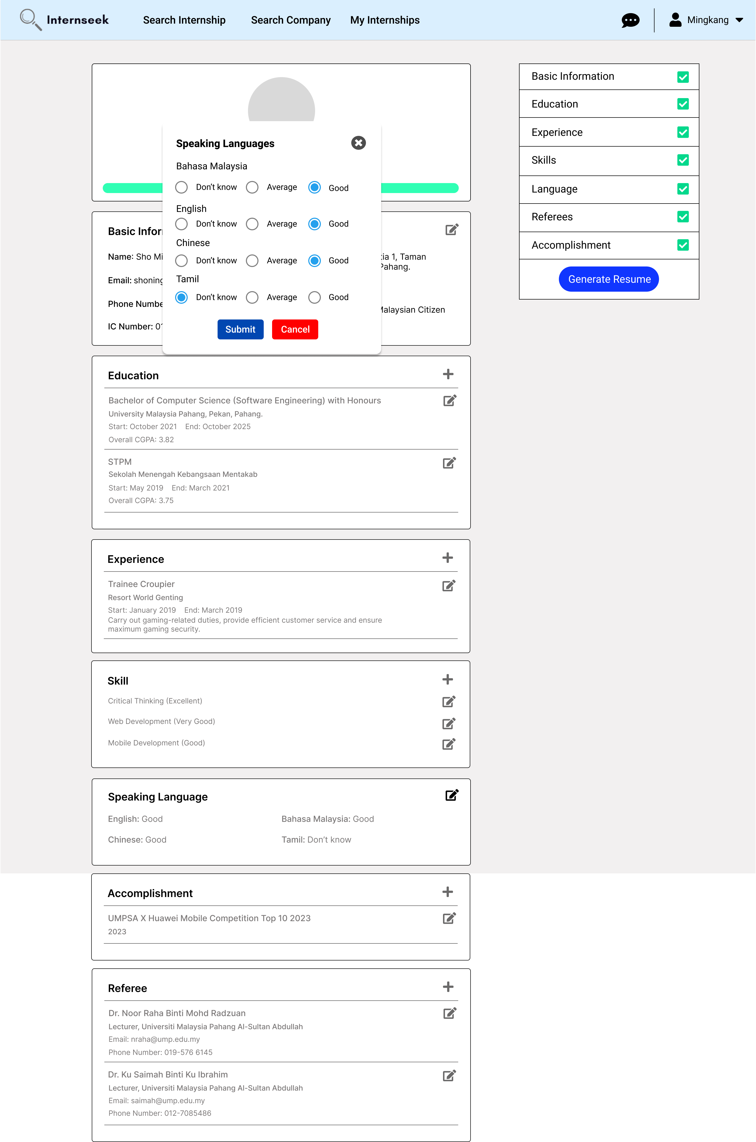

Figure 3‑159: Edit Speaking Language Modal

This figure displays the edit speaking language modal once the university student clicks the edit icon in the speaking language section of the My Profile page. The university student selects the proficiency level of Bahasa Malaysia, English, Chinese, and Tamil and clicks the <<Submit>> button. If the university student does not want to edit the proficiency level of their speaking language, they may click the <<Cancel>> button or the cross icon.

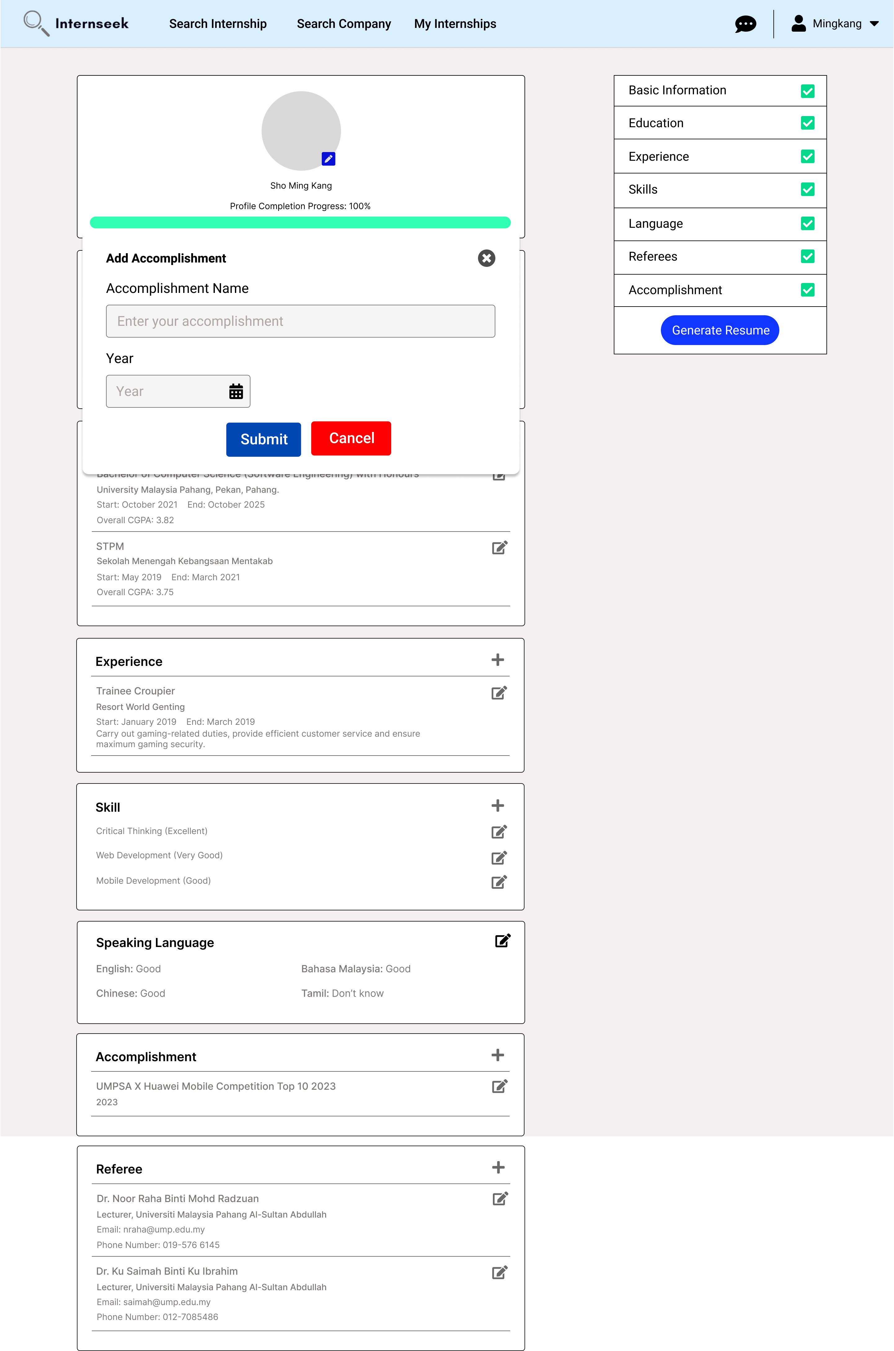

Figure 3‑160: Add Accomplishment Modal

This figure shows the add-accomplishment modal once the university student clicks the plus icon in the accomplishment section of the My Profile Page. The university student enters the accomplishment description, selects the accomplishment year, and clicks the <<Submit>> button. The university student can click the cross icon and the <<Cancel>> button if they do not want to add a new accomplishment.

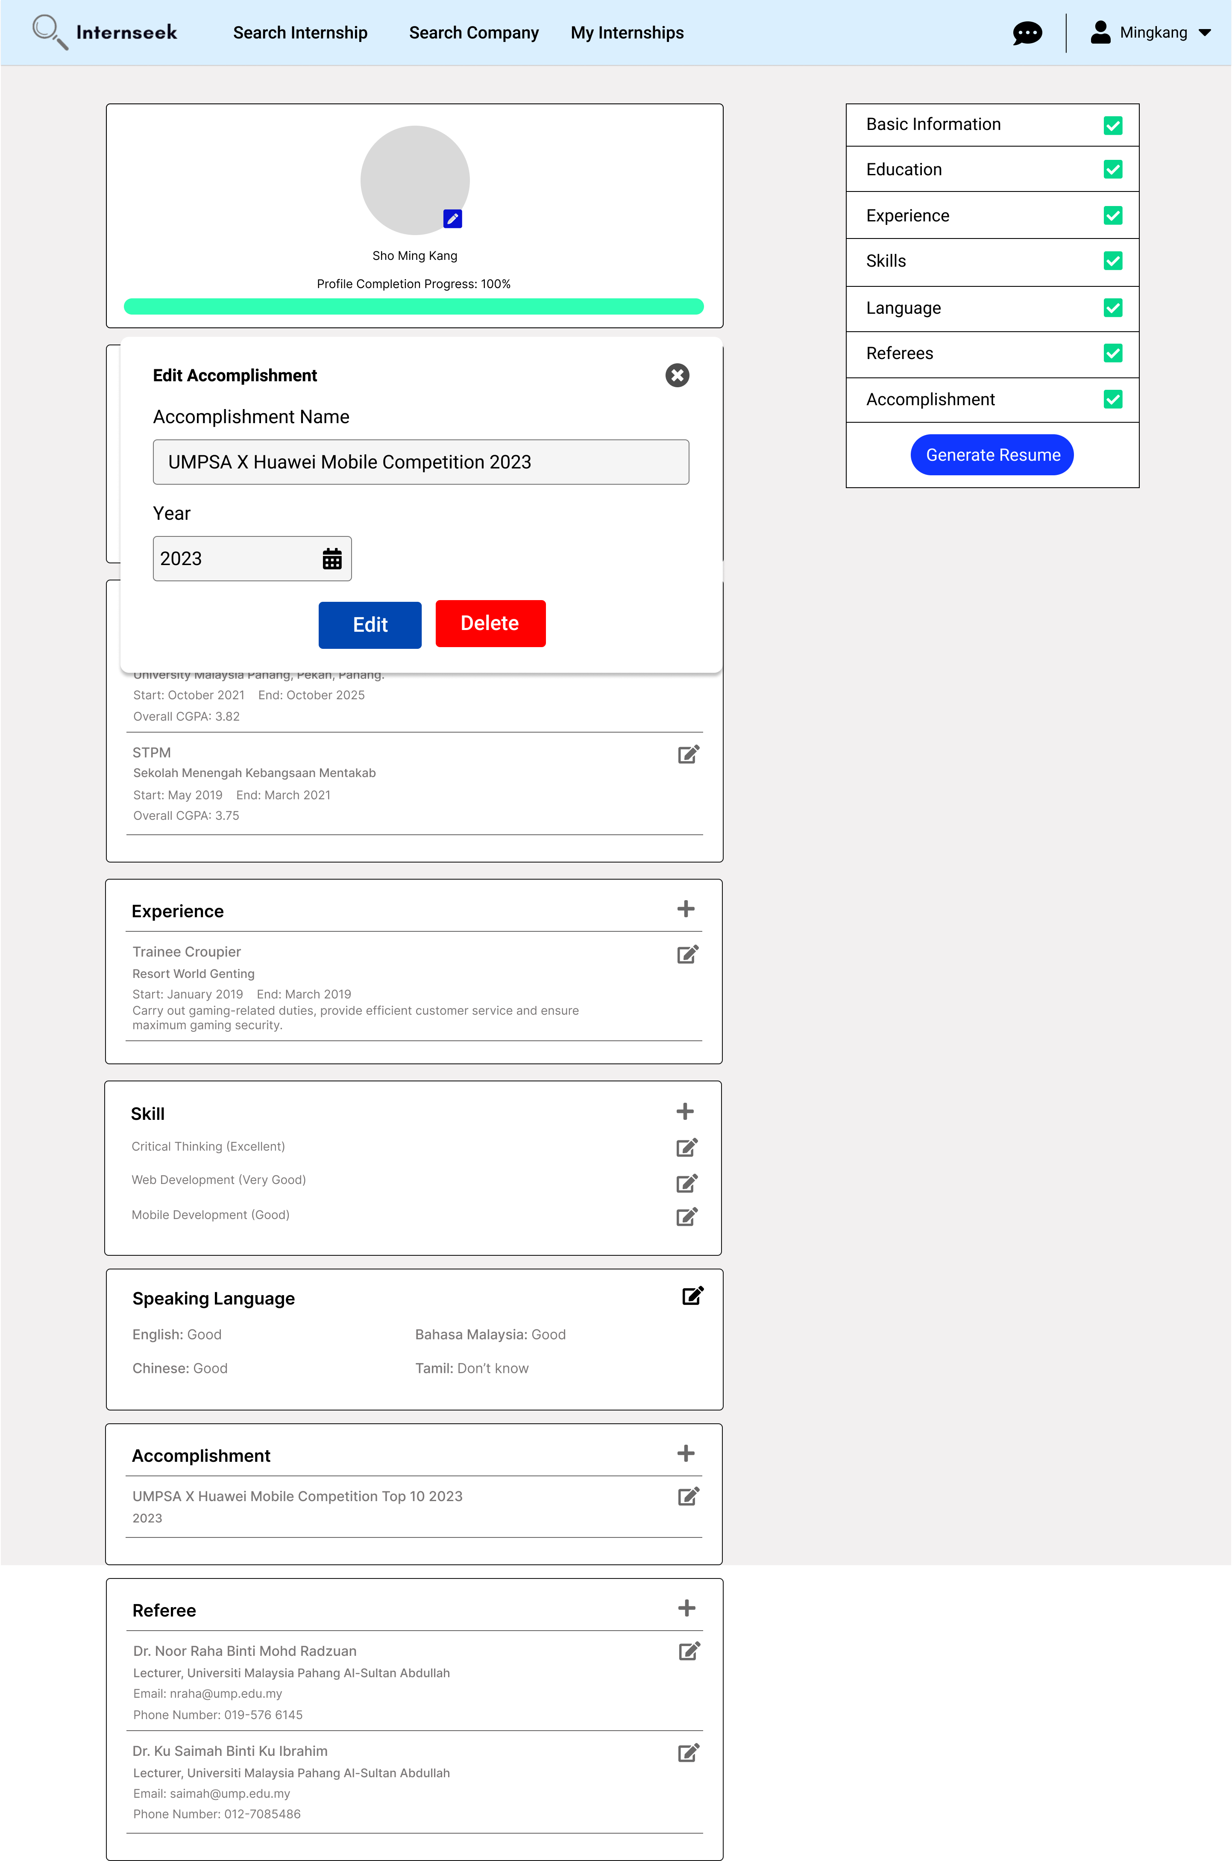

Figure 3‑161: Edit Accomplishment Modal

This figure shows the edit accomplishment modal once the university student clicks the edit icon of the specific accomplishment in the accomplishment section of the My Profile Page. The university student can edit the specific accomplishment details by entering the details they want to edit and clicking the <<Edit>> button. The university student can click the <<Delete>> button if they want to delete the specific accomplishment. The university student can click the cross icon if they do not want to edit the specific accomplishment details.

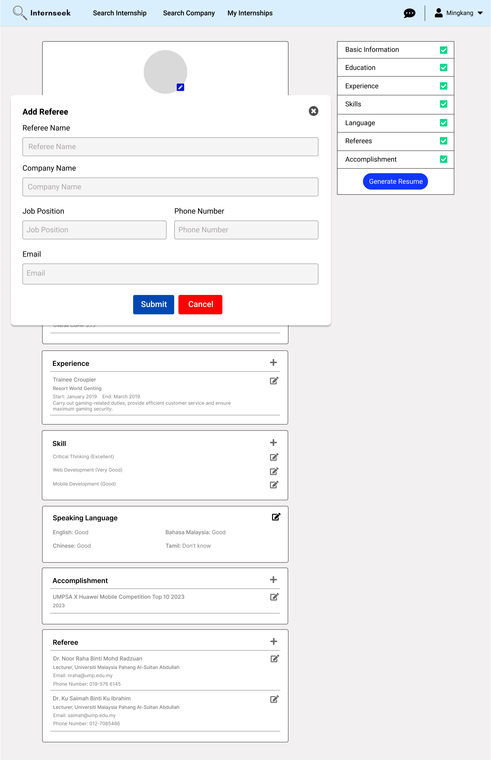

Figure 3‑162: Add Referee Modal

This figure shows the add-referee modal once the university student clicks the plus icon in the referee section of the My Profile Page. The university student enters the referee details required in the add-referee modal and clicks the <<Submit>> button. The university student can click the cross icon and the <<Cancel>> button if they do not want to add a new referee.

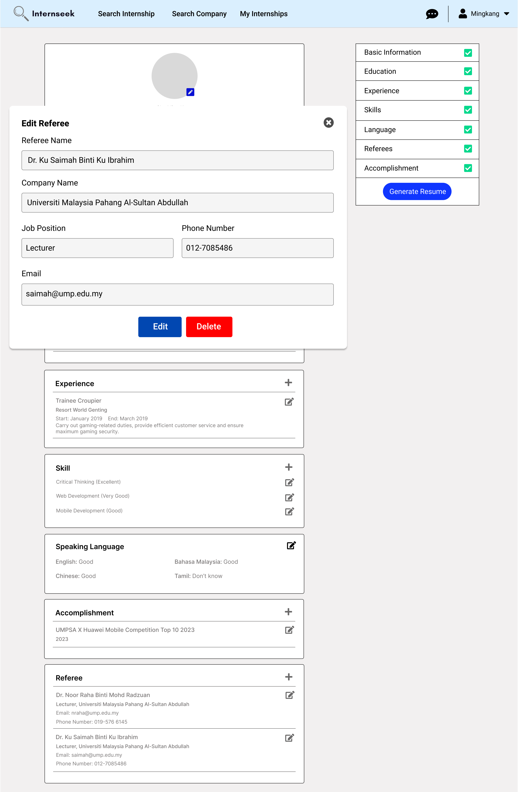

Figure 3‑163: Edit Referee Modal

This figure shows the edit referee modal once the university student clicks the edit icon of the specific referee in the referee section of the My Profile Page. The university student can edit the specific referee details by entering the details they want to edit and clicking the <<Edit>> button. The university student can click the <<Delete>> button if they want to delete the specific referee. The university student can click the cross icon if they do not want to edit the specific referee details.

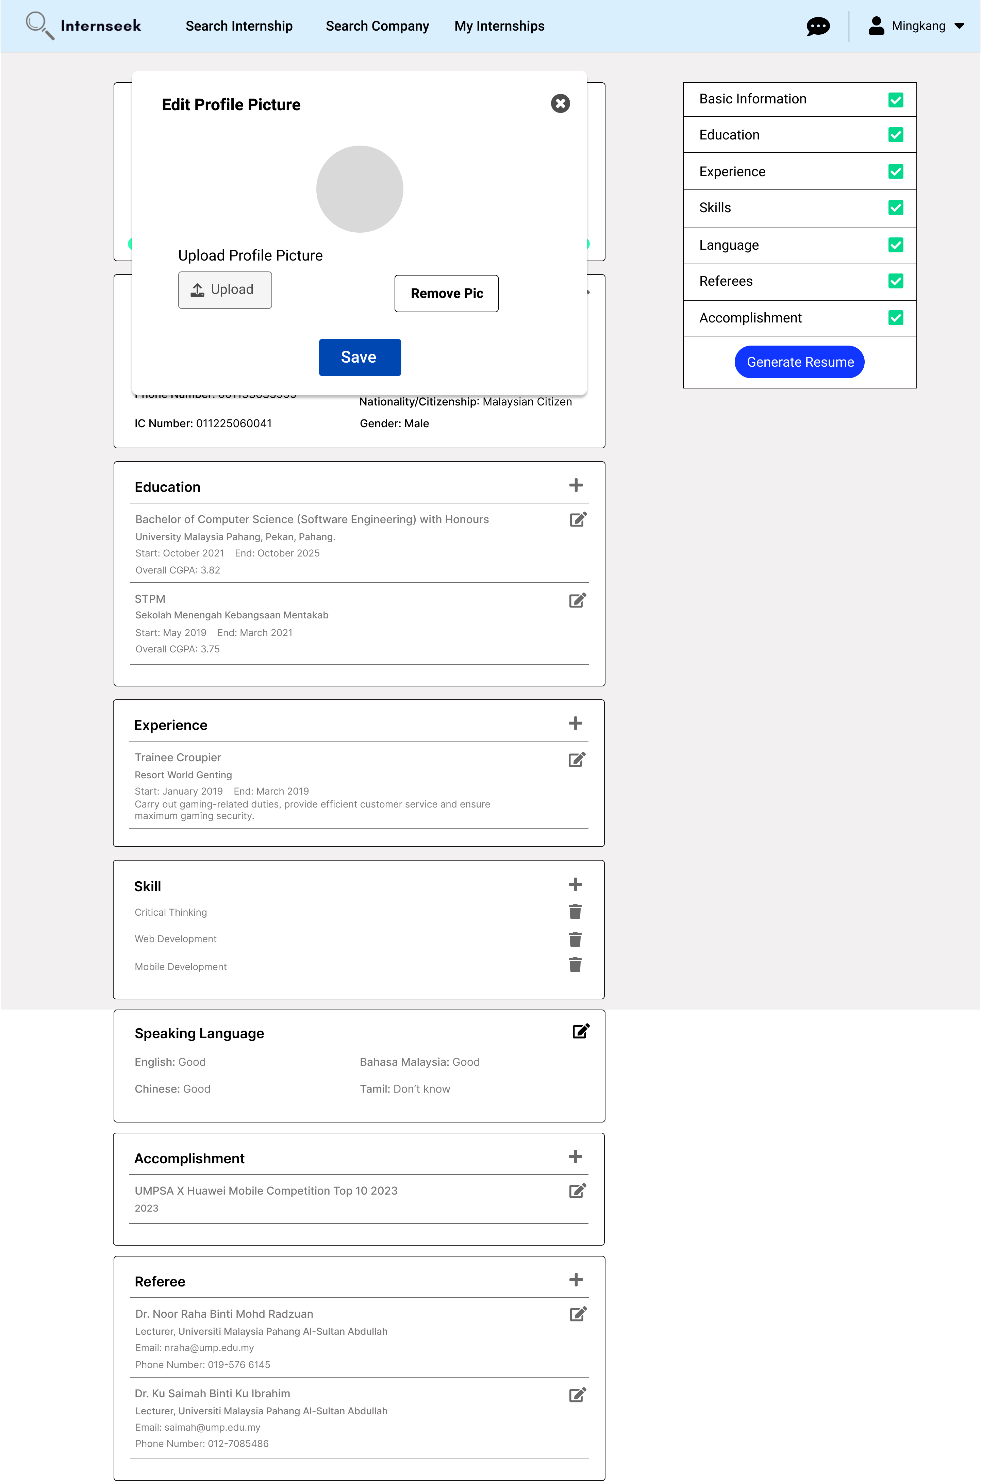

Figure 3‑164: Edit Profile Picture Modal

This figure displays the edit profile picture modal once the university student clicks the edit icon in the profile picture section of the My Profile page. They can click the <<Upload>> button and then upload the profile picture if they want to change the profile picture. Once the university student uploads the profile, the profile picture section will display the uploaded profile picture. Then, the university student clicks the <<Save>> button to successfully edit the profile picture. If the university student wants to remove the current profile picture, they may click the <<Remove Picture>> button. If the university student does not want to edit or remove the profile picture, they may click the cross icon.

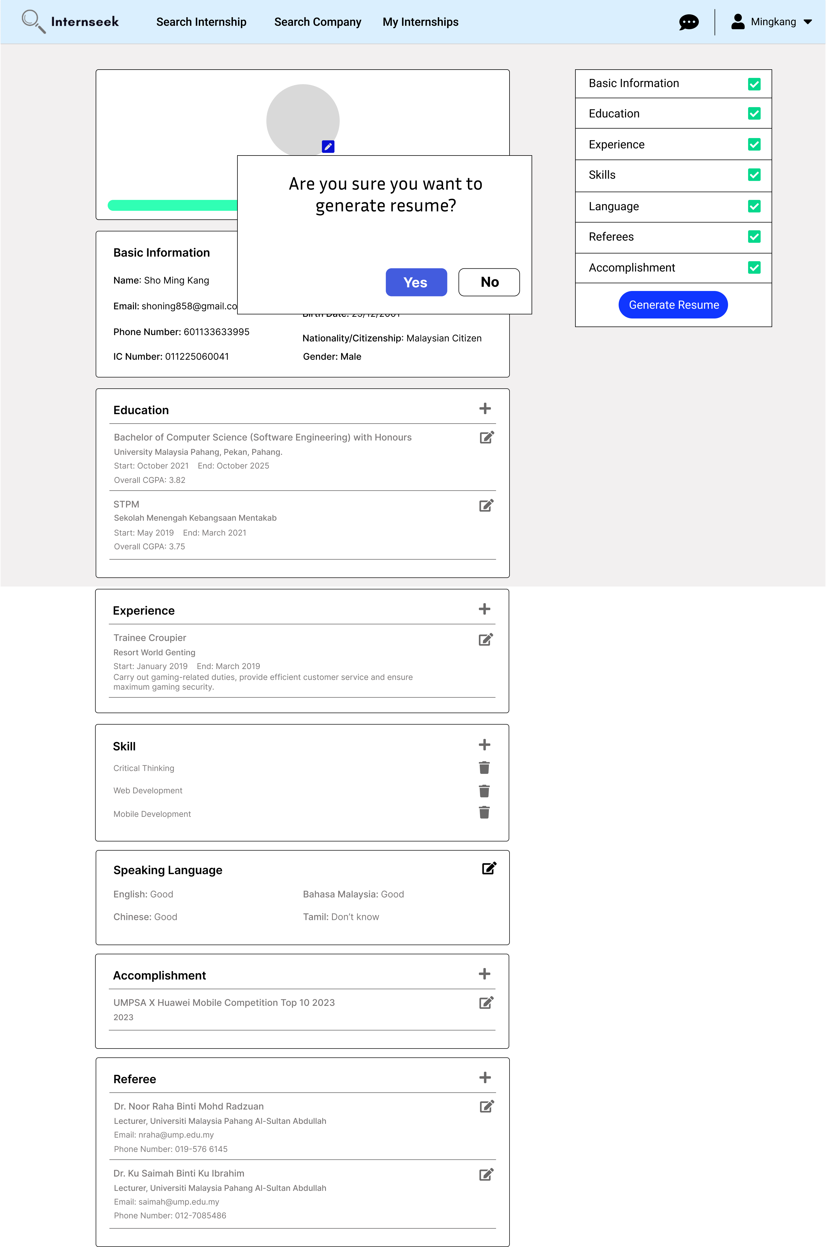

Figure 3‑165: Generate Resume Modal

This figure displays the generate resume modal once the university student clicks the <<Generate Resume>> button. If the university student wants to generate a resume in a.pdf file, the university student needs to click the <<Yes>> button. If the university student does not want to generate a resume, he or she needs to click the <<No>> button.

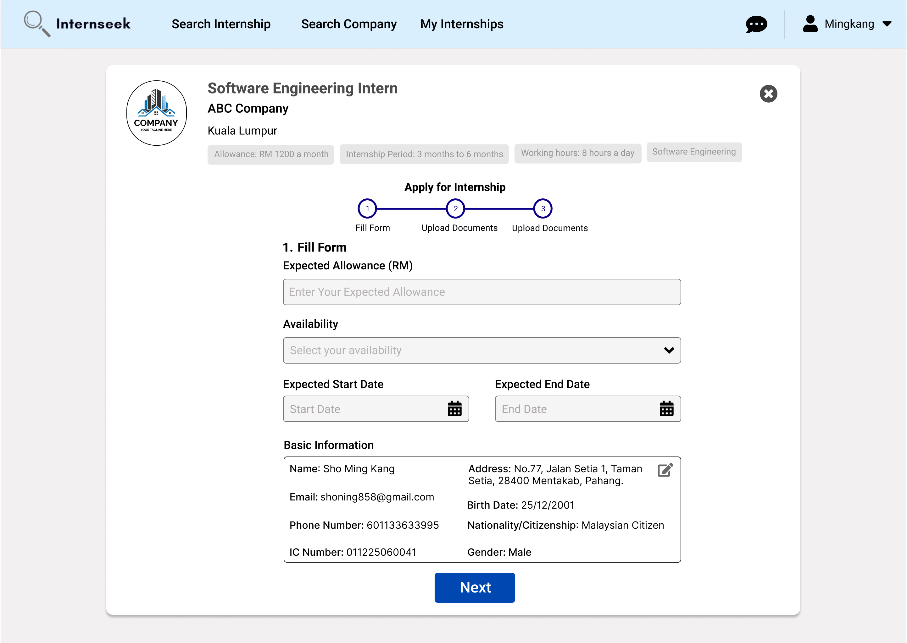

Figure 3‑166: Apply for Internship Page (1st step for apply for internship form)

This figure shows the page for the university student to apply for the internship once they click the <<Apply Now>> button on the internship card. This page shows step 1 of applying for the internship. The university student needs to enter the details required in the form, such as expected allowance, availability, expected start date, and expected end date, and check if their basic information is true or not. Once they enter all the details required and confirm their basic information is correct, they may click the <<Next>> button to proceed with the next step in the internship application. If the basic information is incorrect, the university student should click the edit button to edit the profile details.

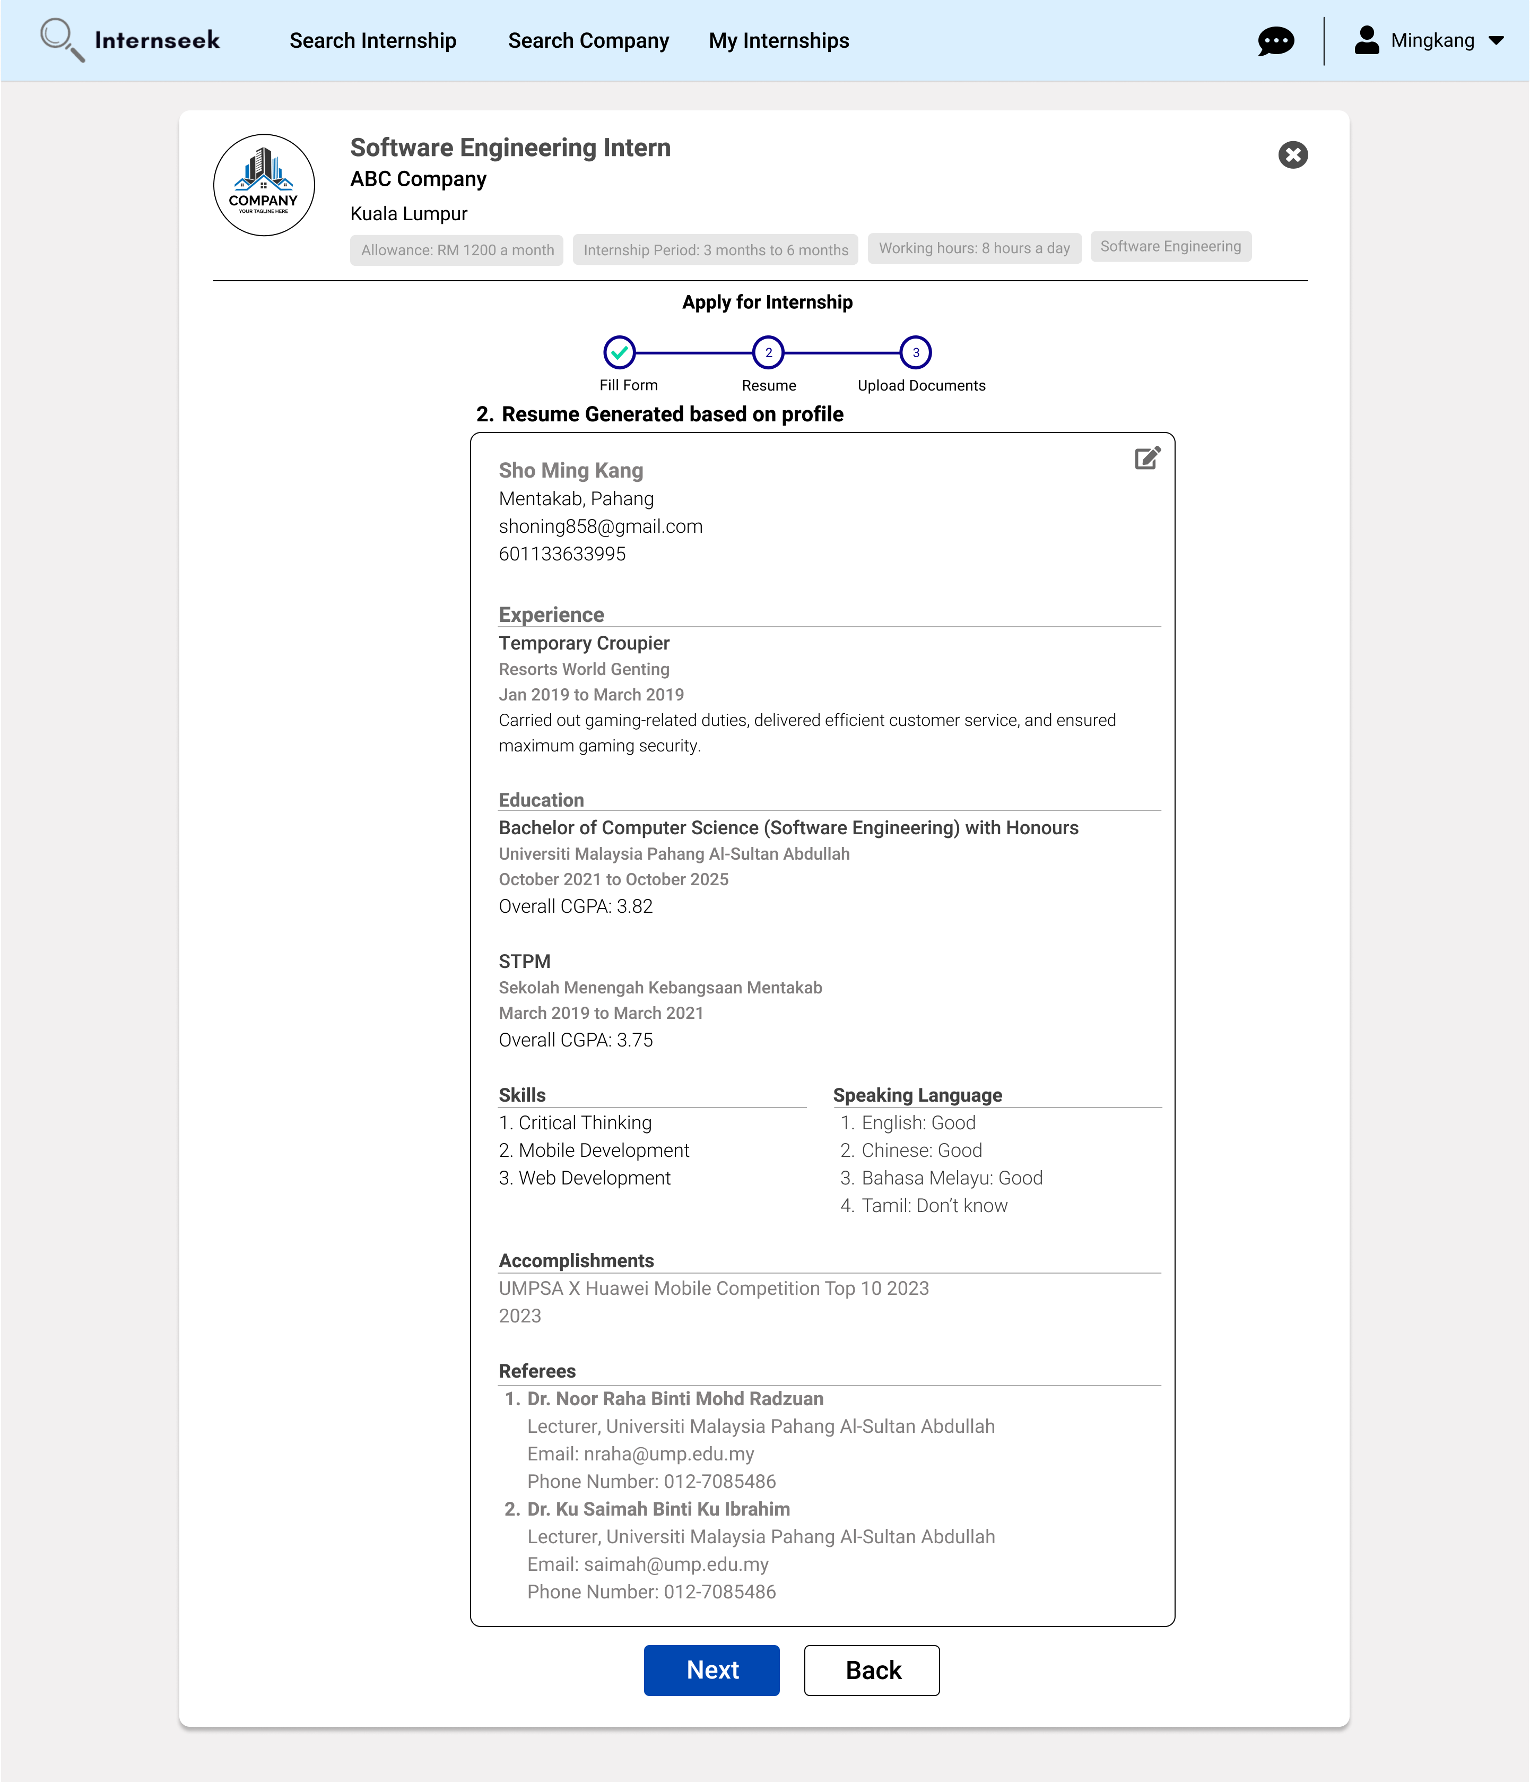

Figure 3‑167: Apply for Internship Page (2nd step for apply for internship form)

This figure displays the apply for internship page, which shows step 2 of applying for the internship. This page displays the resume generated by the system based on the profile details of the university student. If the university student finds some of the details in the resume are incorrect, they may click the edit icon button to edit the profile details. If the university student finds that all the details in the resume are correct, they may proceed to the next step by clicking the <<Next>> button. If the university student wants to return to the previous step, they may click the <<Back>> button.

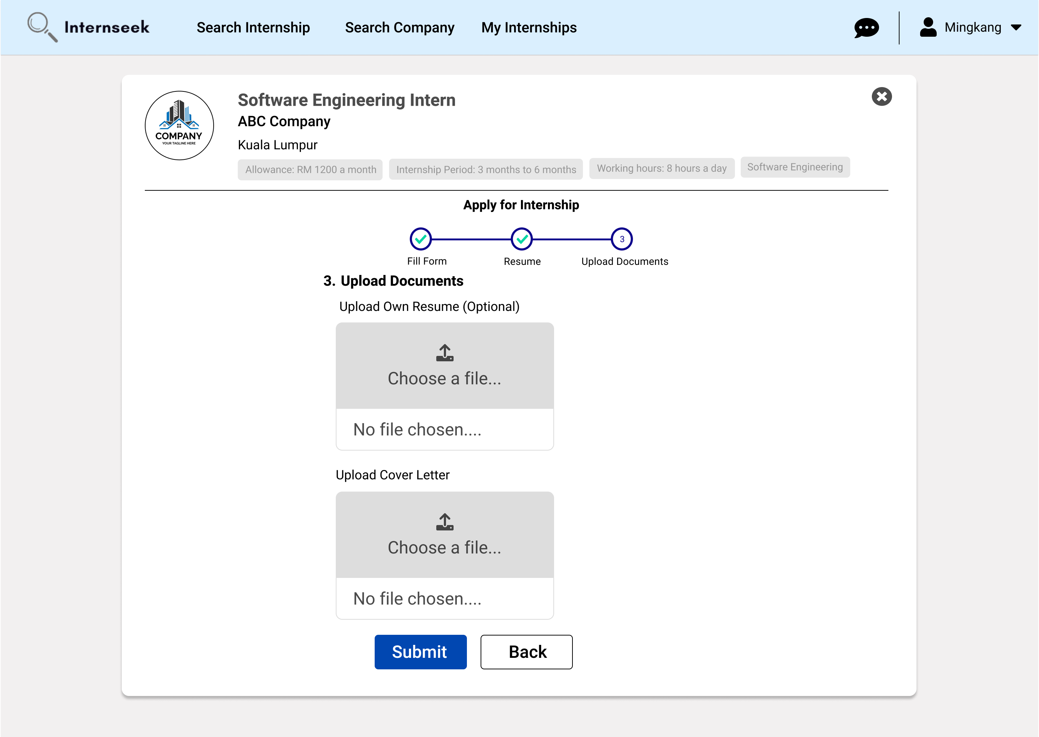

Figure 3‑168: Apply for Internship Page (3rd step for apply for internship form)

This figure displays the Apply for Internship page, highlighting step 3 of the application process. In this step, university students are required to upload a cover letter proving their need to undergo industrial training for academic purposes. In addition, the university student has the option to upload their own resume, but this is not compulsory. Once the university student uploads the cover letter, they may submit the internship application form. If the university student wants to return to the previous step, they may click the <<Back>> button.

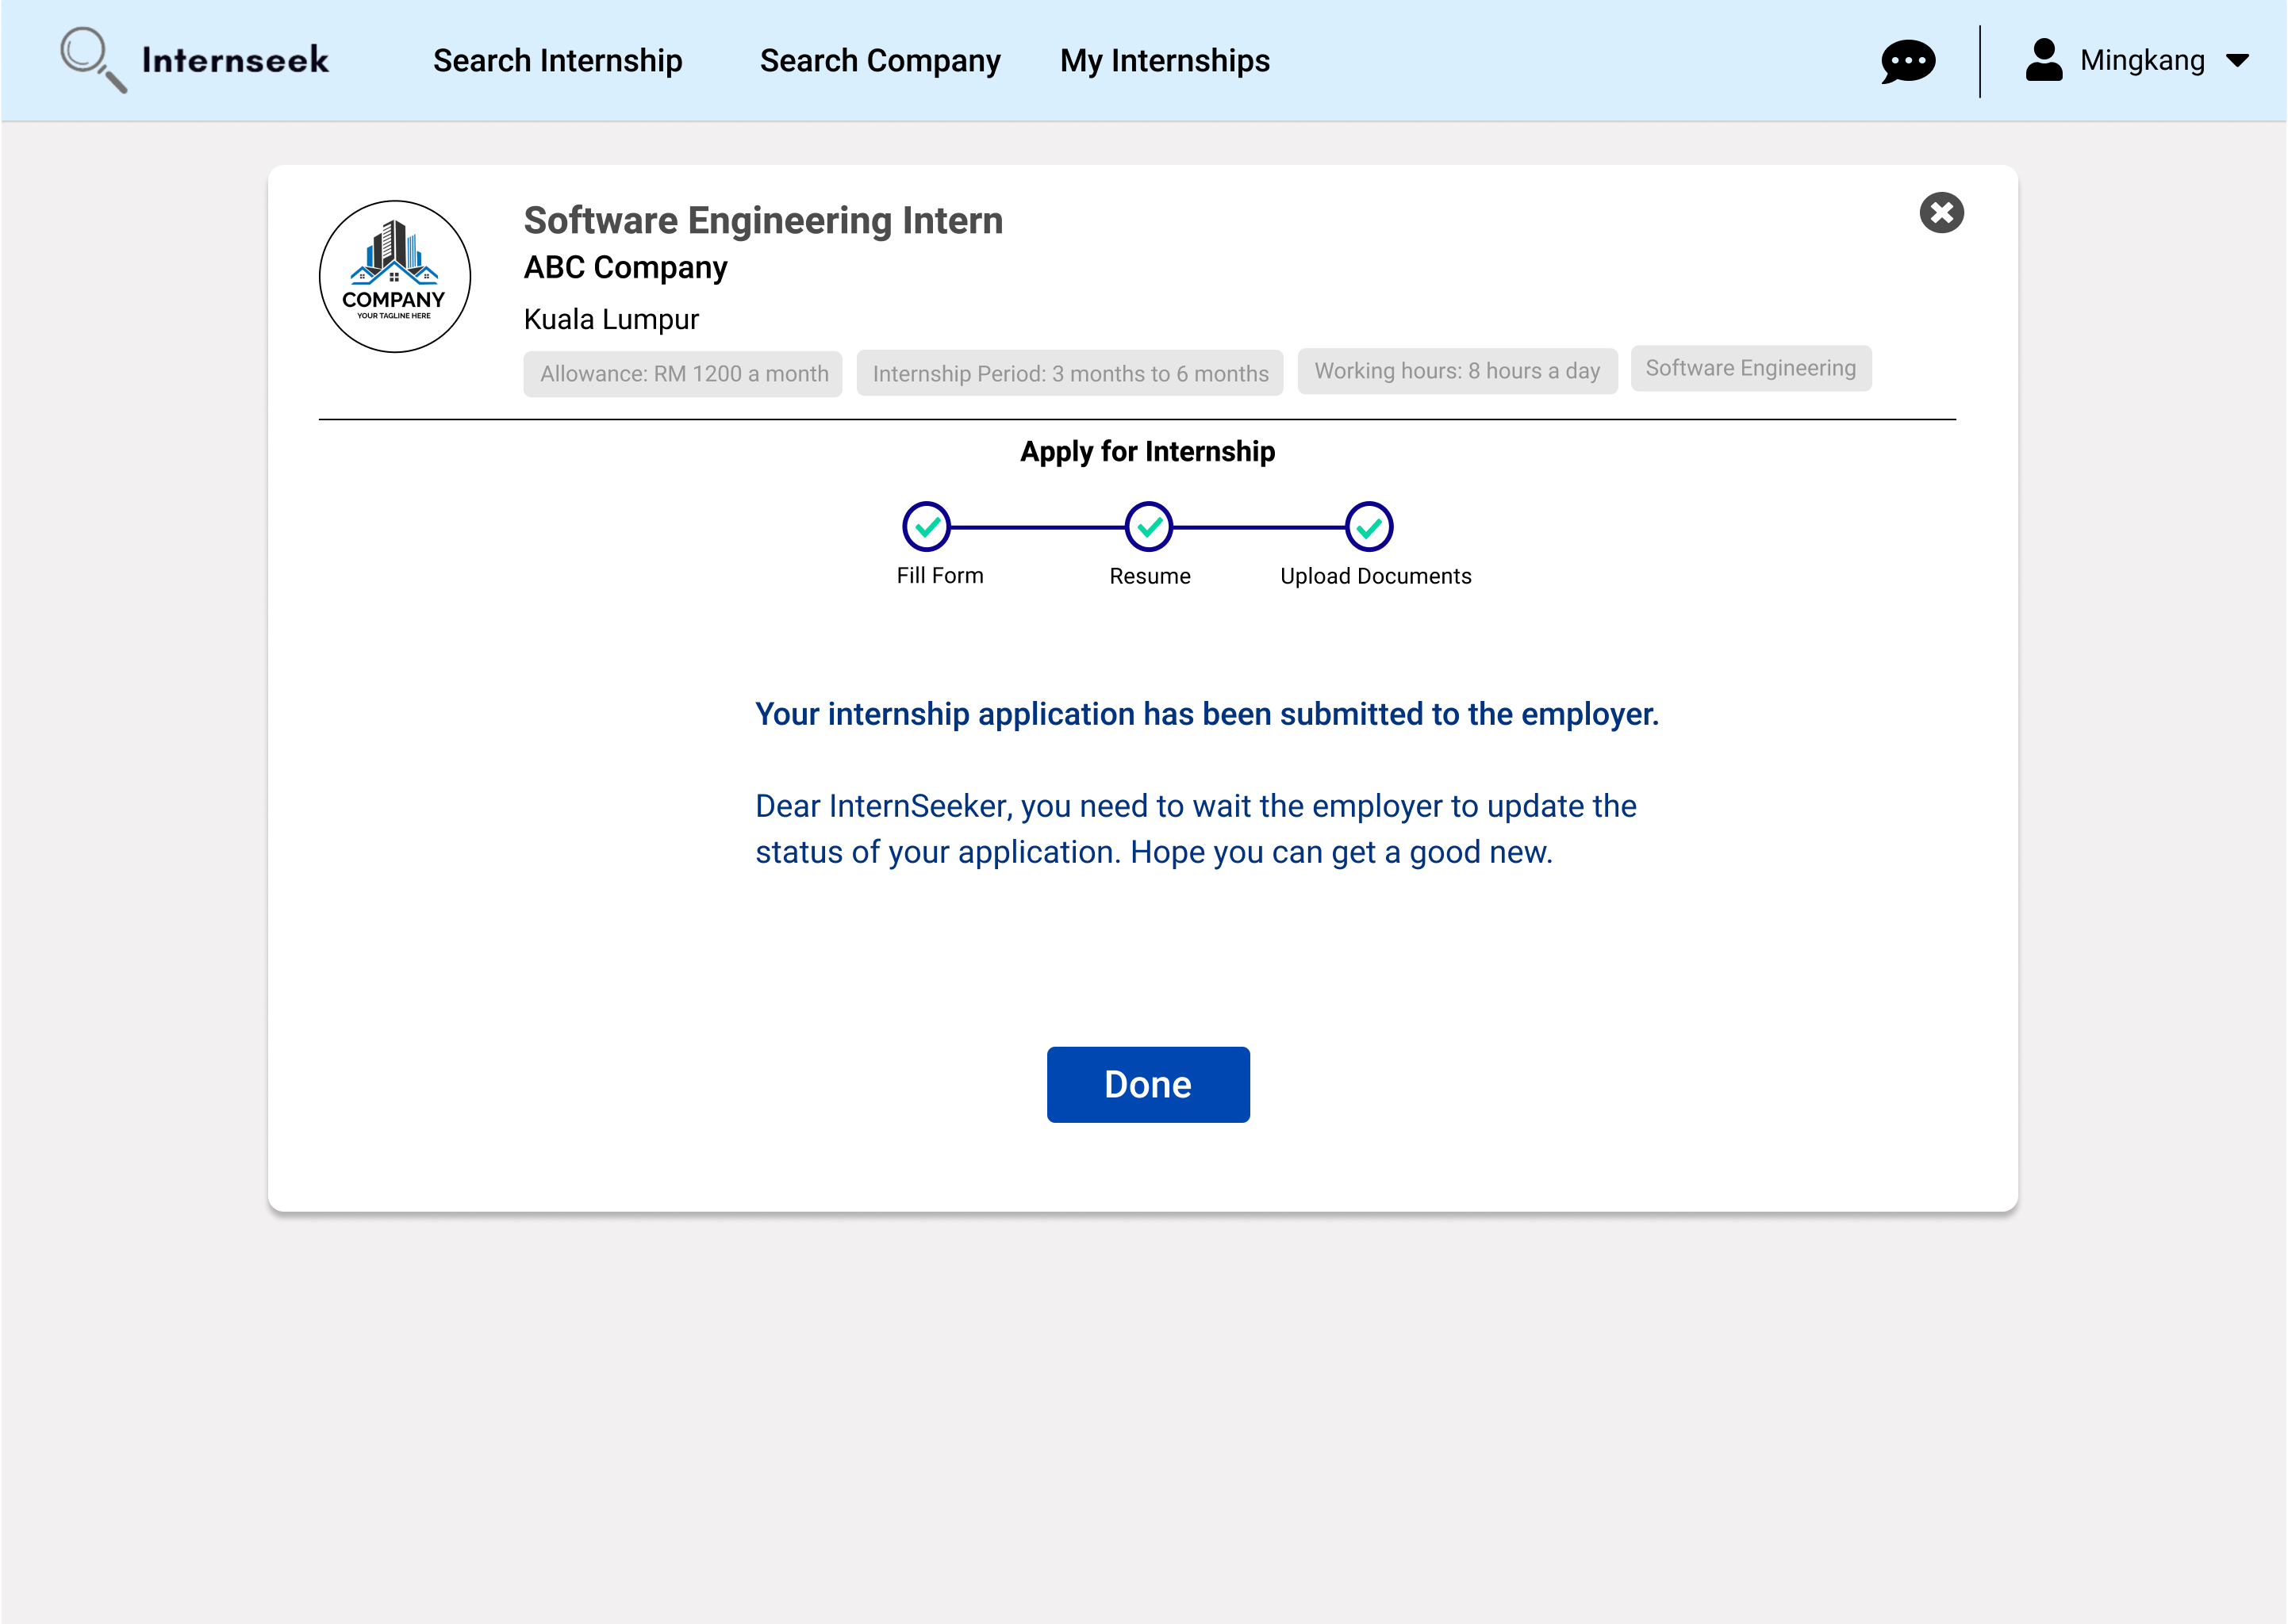

Figure 3‑169: Apply for Internship Page (Successful Message)

This figure shows the Apply for Internship page displays a successful message, indicating the university student successfully completes the internship application process and the internship application has been submitted to the employer.

\

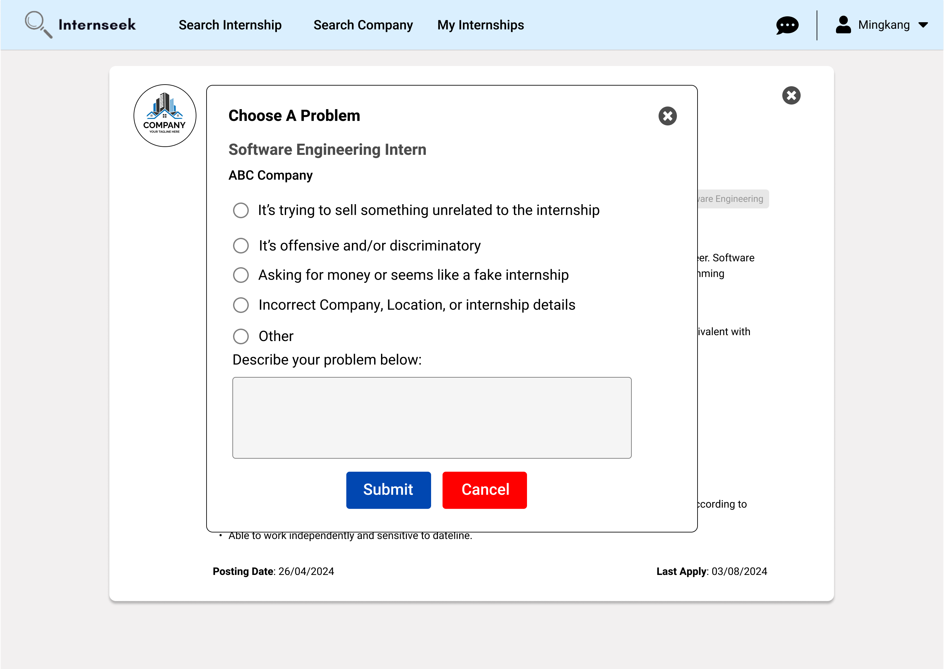

Figure 3‑170: Report Internship Modal

This figure displays the report internship modal once the university students click the <<Report>> button on the internship card. The university students may select a problem listed in the modal and click the <<Submit>> button; if the problem is others, they can describe it in the input field. If the university students do not want to report the internship, they may click the <<Cancel>> button or the cross icon.

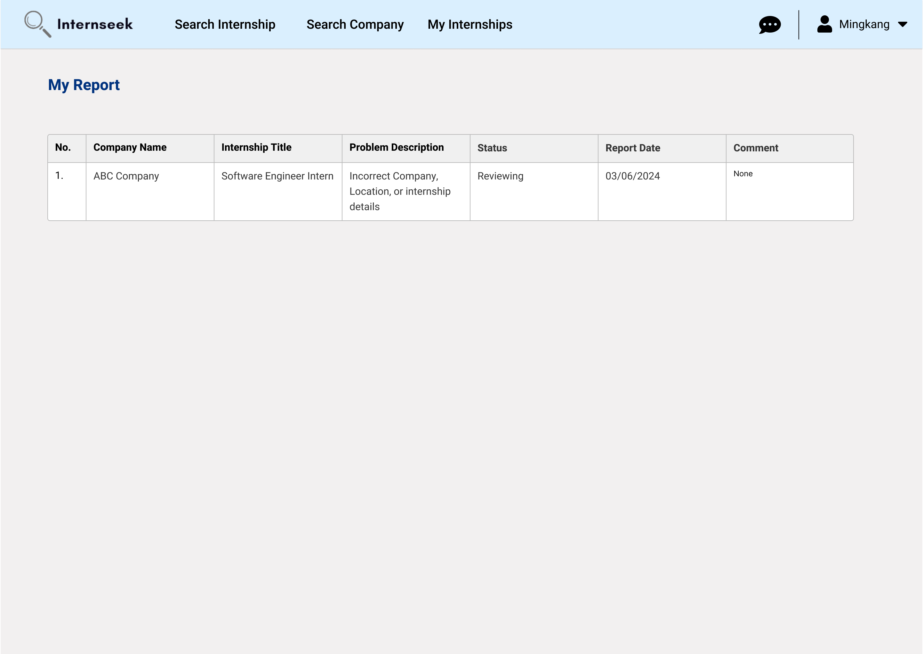

Figure 3‑171: My Report page

This figure shows the My Report page, which displays a list of internships reported by the university students. On this page, university students can view the status of each report and the comments provided by the system administrator.

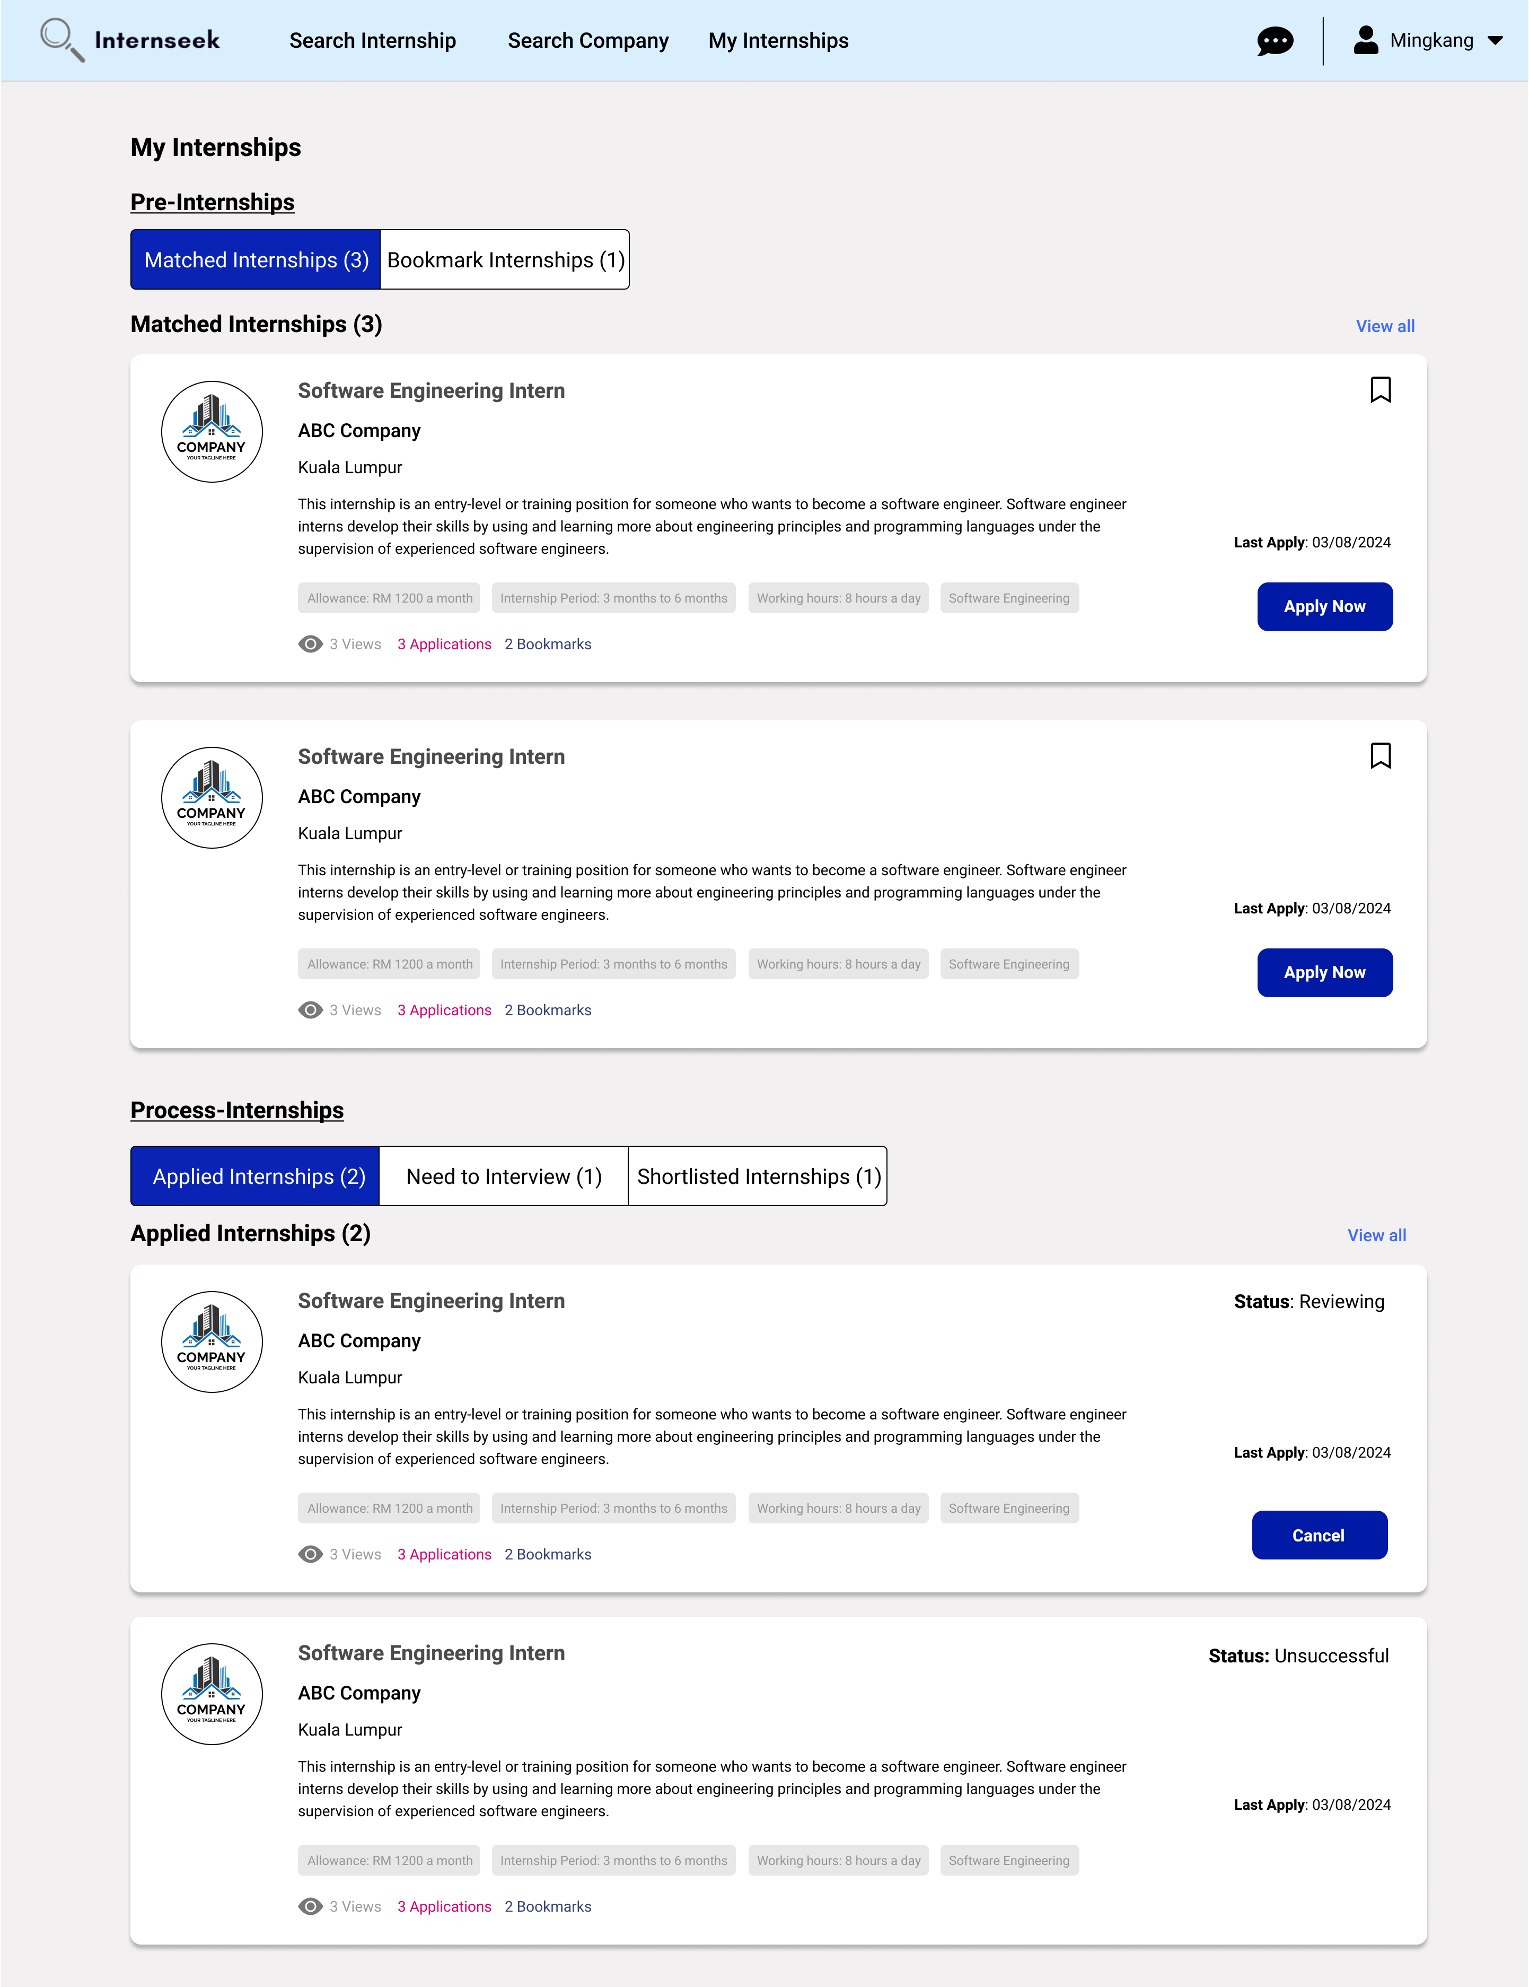

Figure 3‑172: My Internships Page (Pre-Internships and Process-Internships)

This figure shows the My Internships page once the university student clicks the <<My Internships>> link, which consists of two sections: Pre-Internships and Process-Internships. In the Pre-Internships section, there are two buttons: Matched Internships, which shows internships matched to the student's profile or preferences, and Bookmark Internships, which displays internships the student has bookmarked for later consideration. The Process-Internships section consists of three buttons: Applied Internships, listing internships to which the student has applied; Need-to-Interview Internships, showing internships where the student is required to attend an interview; and Shortlisted Internships, displaying internships where the student has been shortlisted by the employer. University students can view up to two internships from each category within these sections.

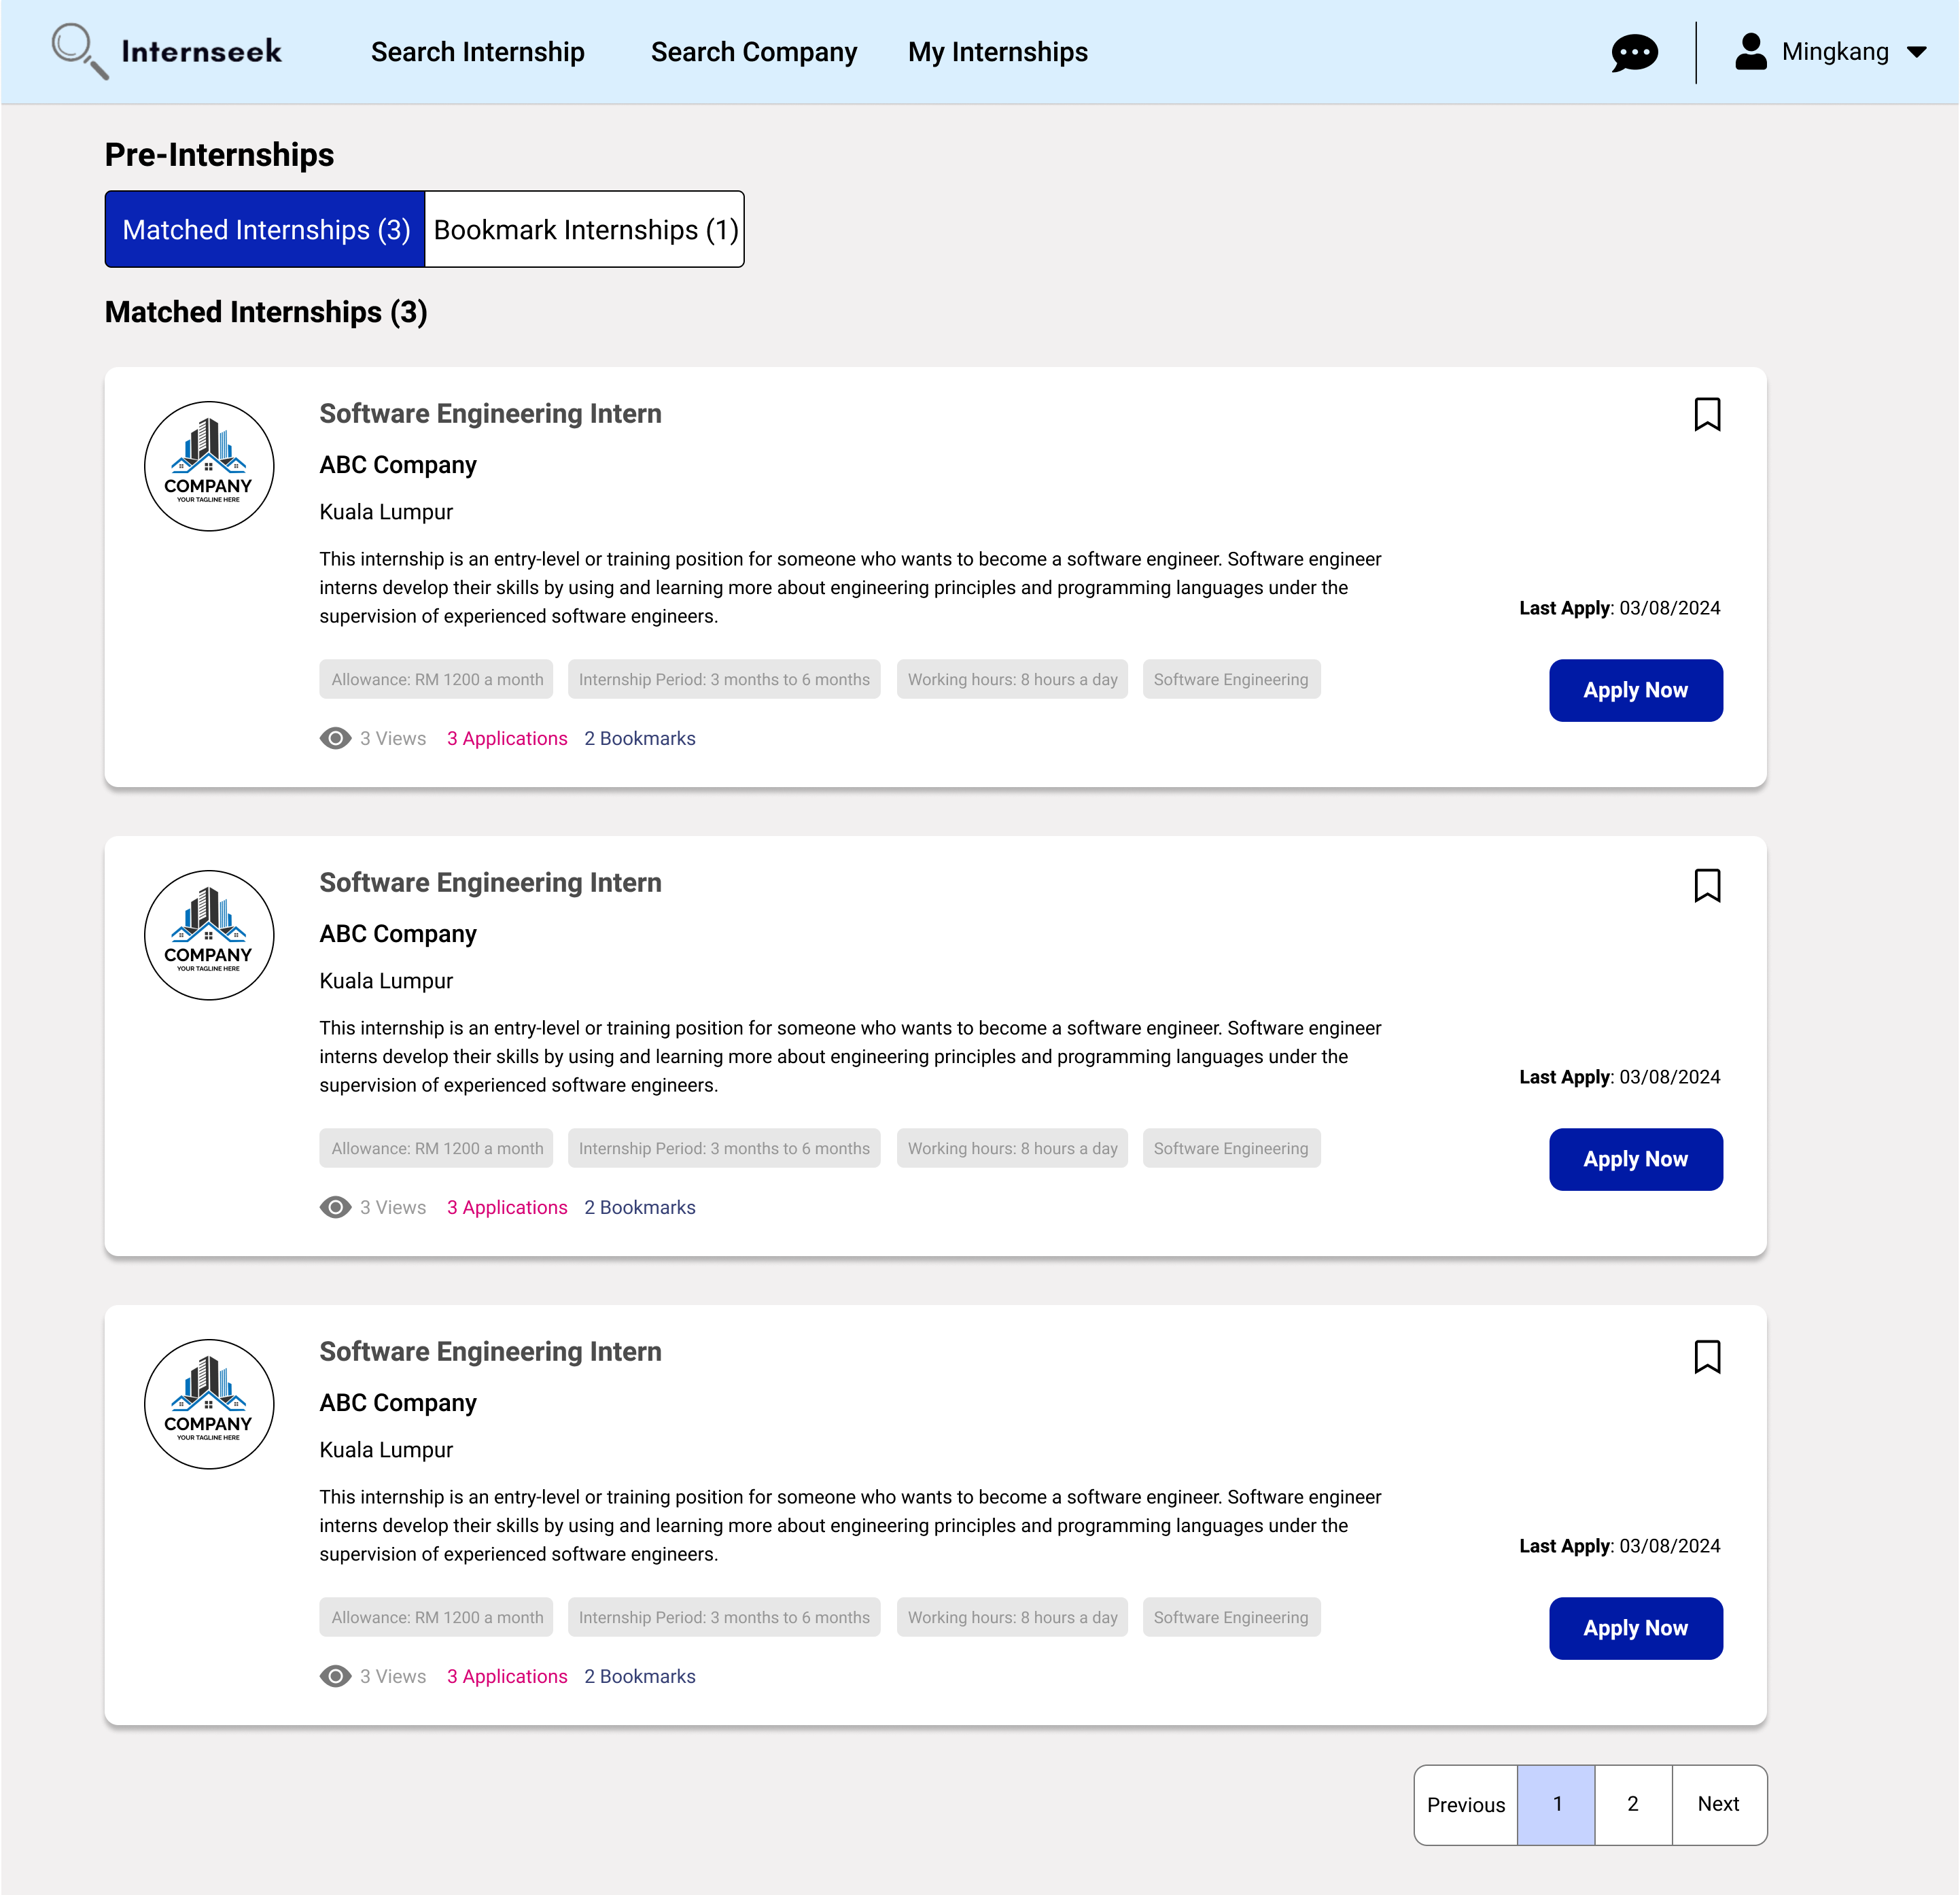

Figure 3‑173: Pre-Internships Page (Matched Internships)

This figure shows the Pre-Internships page, which displays a list of matched internships. The matched internships are retrieved based on the study field of the university student. The university student can browse through these internship opportunities to find their ideal internships that meet their career goals. This page also displays the number of views (clicks), bookmarks, and applications submitted for each internship. Each internship card includes a bookmark icon and an apply now button. If university students want to apply for the internship, they may click the <<Apply Now>> button. If university students have an interest in the internship, they may click the bookmark icon to save it to their list of internships.

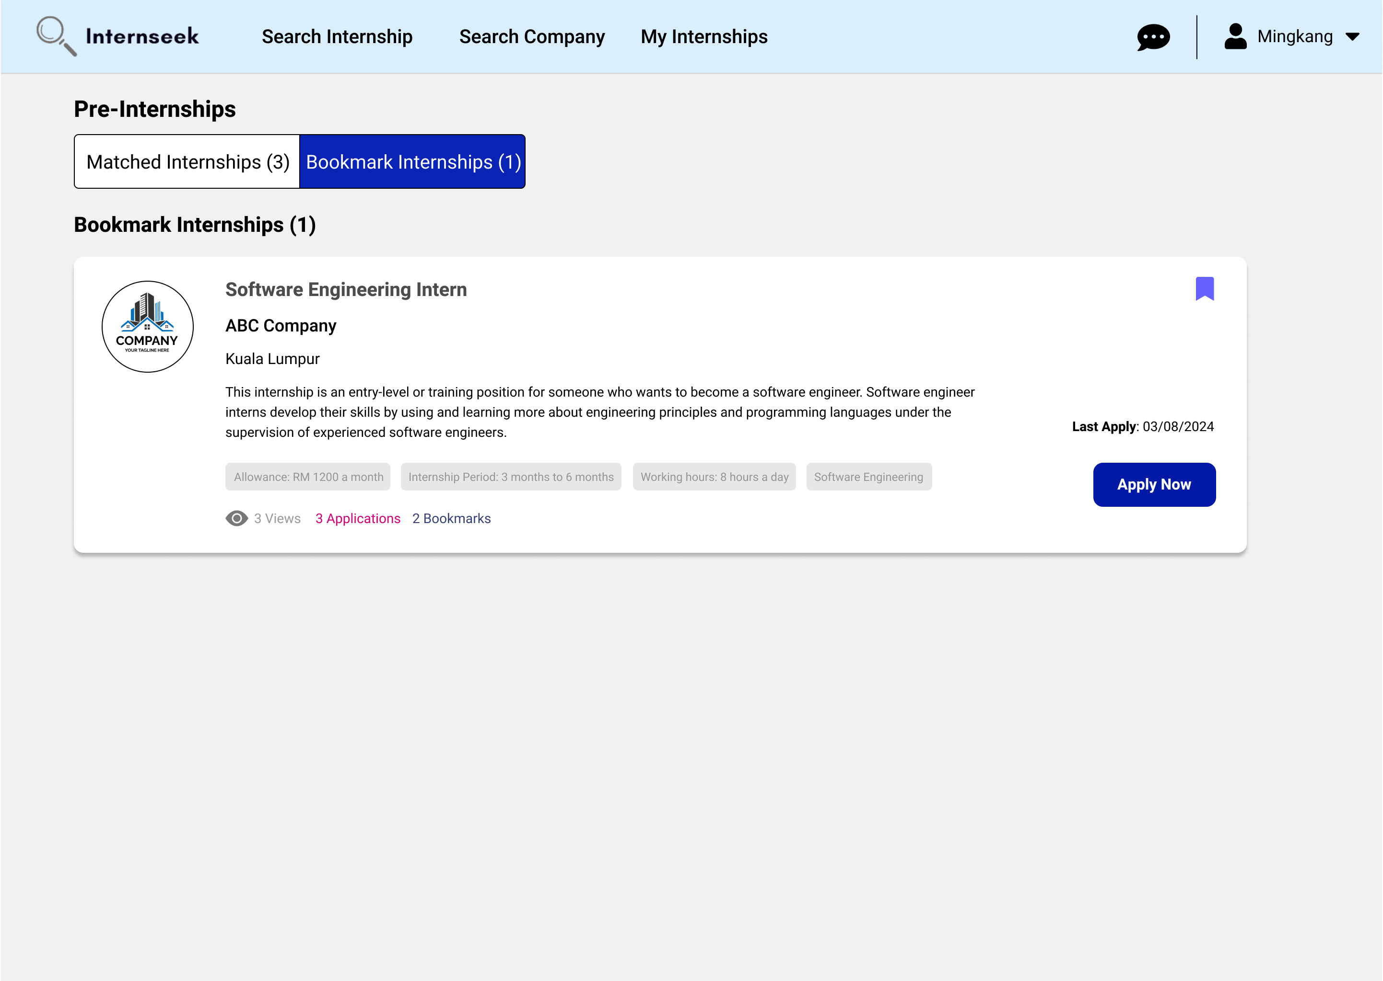

Figure 3‑174: Pre-Internships Page (Bookmark Internships)

This figure shows the My Pre-Internships page, which displays a list of internships bookmarked by the university student. The blue bookmark icon on the internship card represents that the university student has bookmarked this internship. The university student can browse through their bookmarked internship opportunities to make an informed decision about whether they want to apply for this internship or not. This page also displays the number of views (clicks), bookmarks, and applications submitted for each internship. The internship card includes an apply now button. If university students want to apply for the internship, they may click the <<Apply Now>> button.

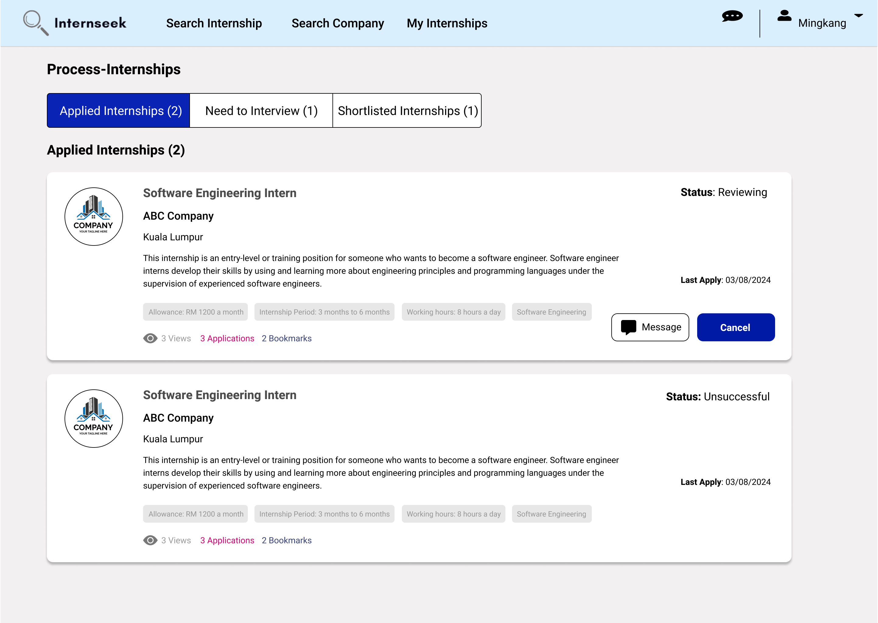

Figure 3‑175: Process-Internships Page (Applied Internships)

This figure shows the Process-Internships page, which displays a list of internships the university student has applied for. The listing includes only those internship applications that are still under review or unsuccessful. University students can cancel their applications that are still under review. University students may click the <<Message>> button to remind the employer to update the application status. This page also allows them to keep track of whether their internship applications are unsuccessful or not.

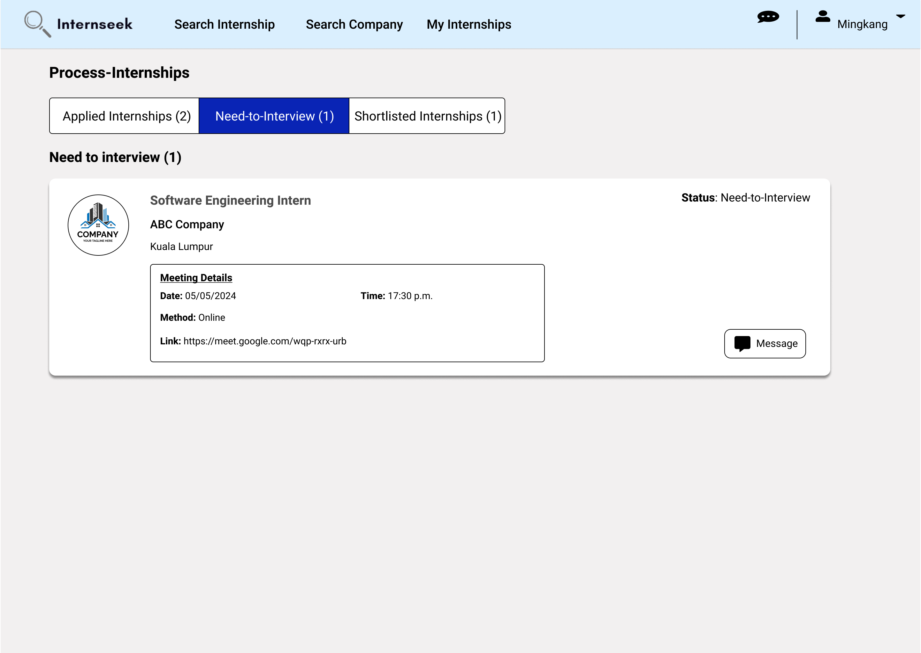

Figure 3‑176: Process-Internships page (Need-to-interview internships)

This figure shows the Process-Internships page, which displays a list of internships the university student has applied for with a status of 'need-to-interview'. The list includes interview details such as the method, date, time, and location for face-to-face interviews or an online meeting link for online interviews.

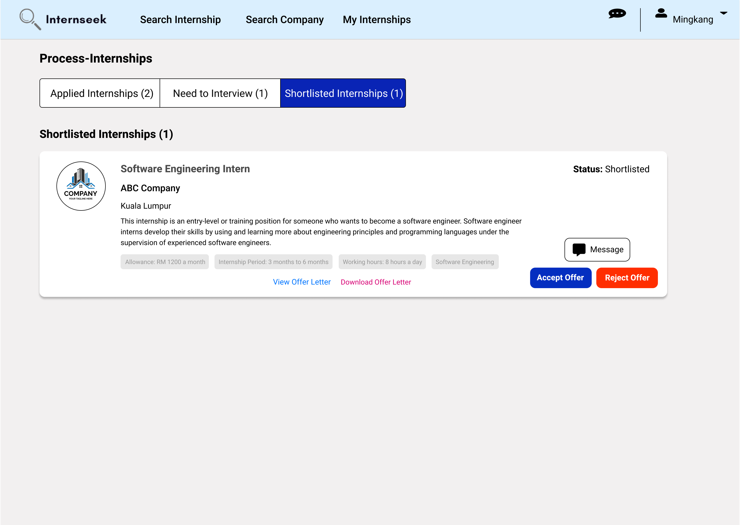

Figure 3‑177: Process-Internships page (Shortlisted Internships)

This figure shows the My Internships page, which displays a list of internships the university student has applied for with the status of "Approved" and an interview status of "Successful." Each approved internship card includes the offer letter uploaded by the employer, which the university student can view and download. The internship card includes <<Accept Offer>> and <<Reject Offer>> buttons, allowing the university student to decide whether to accept or reject the offer.

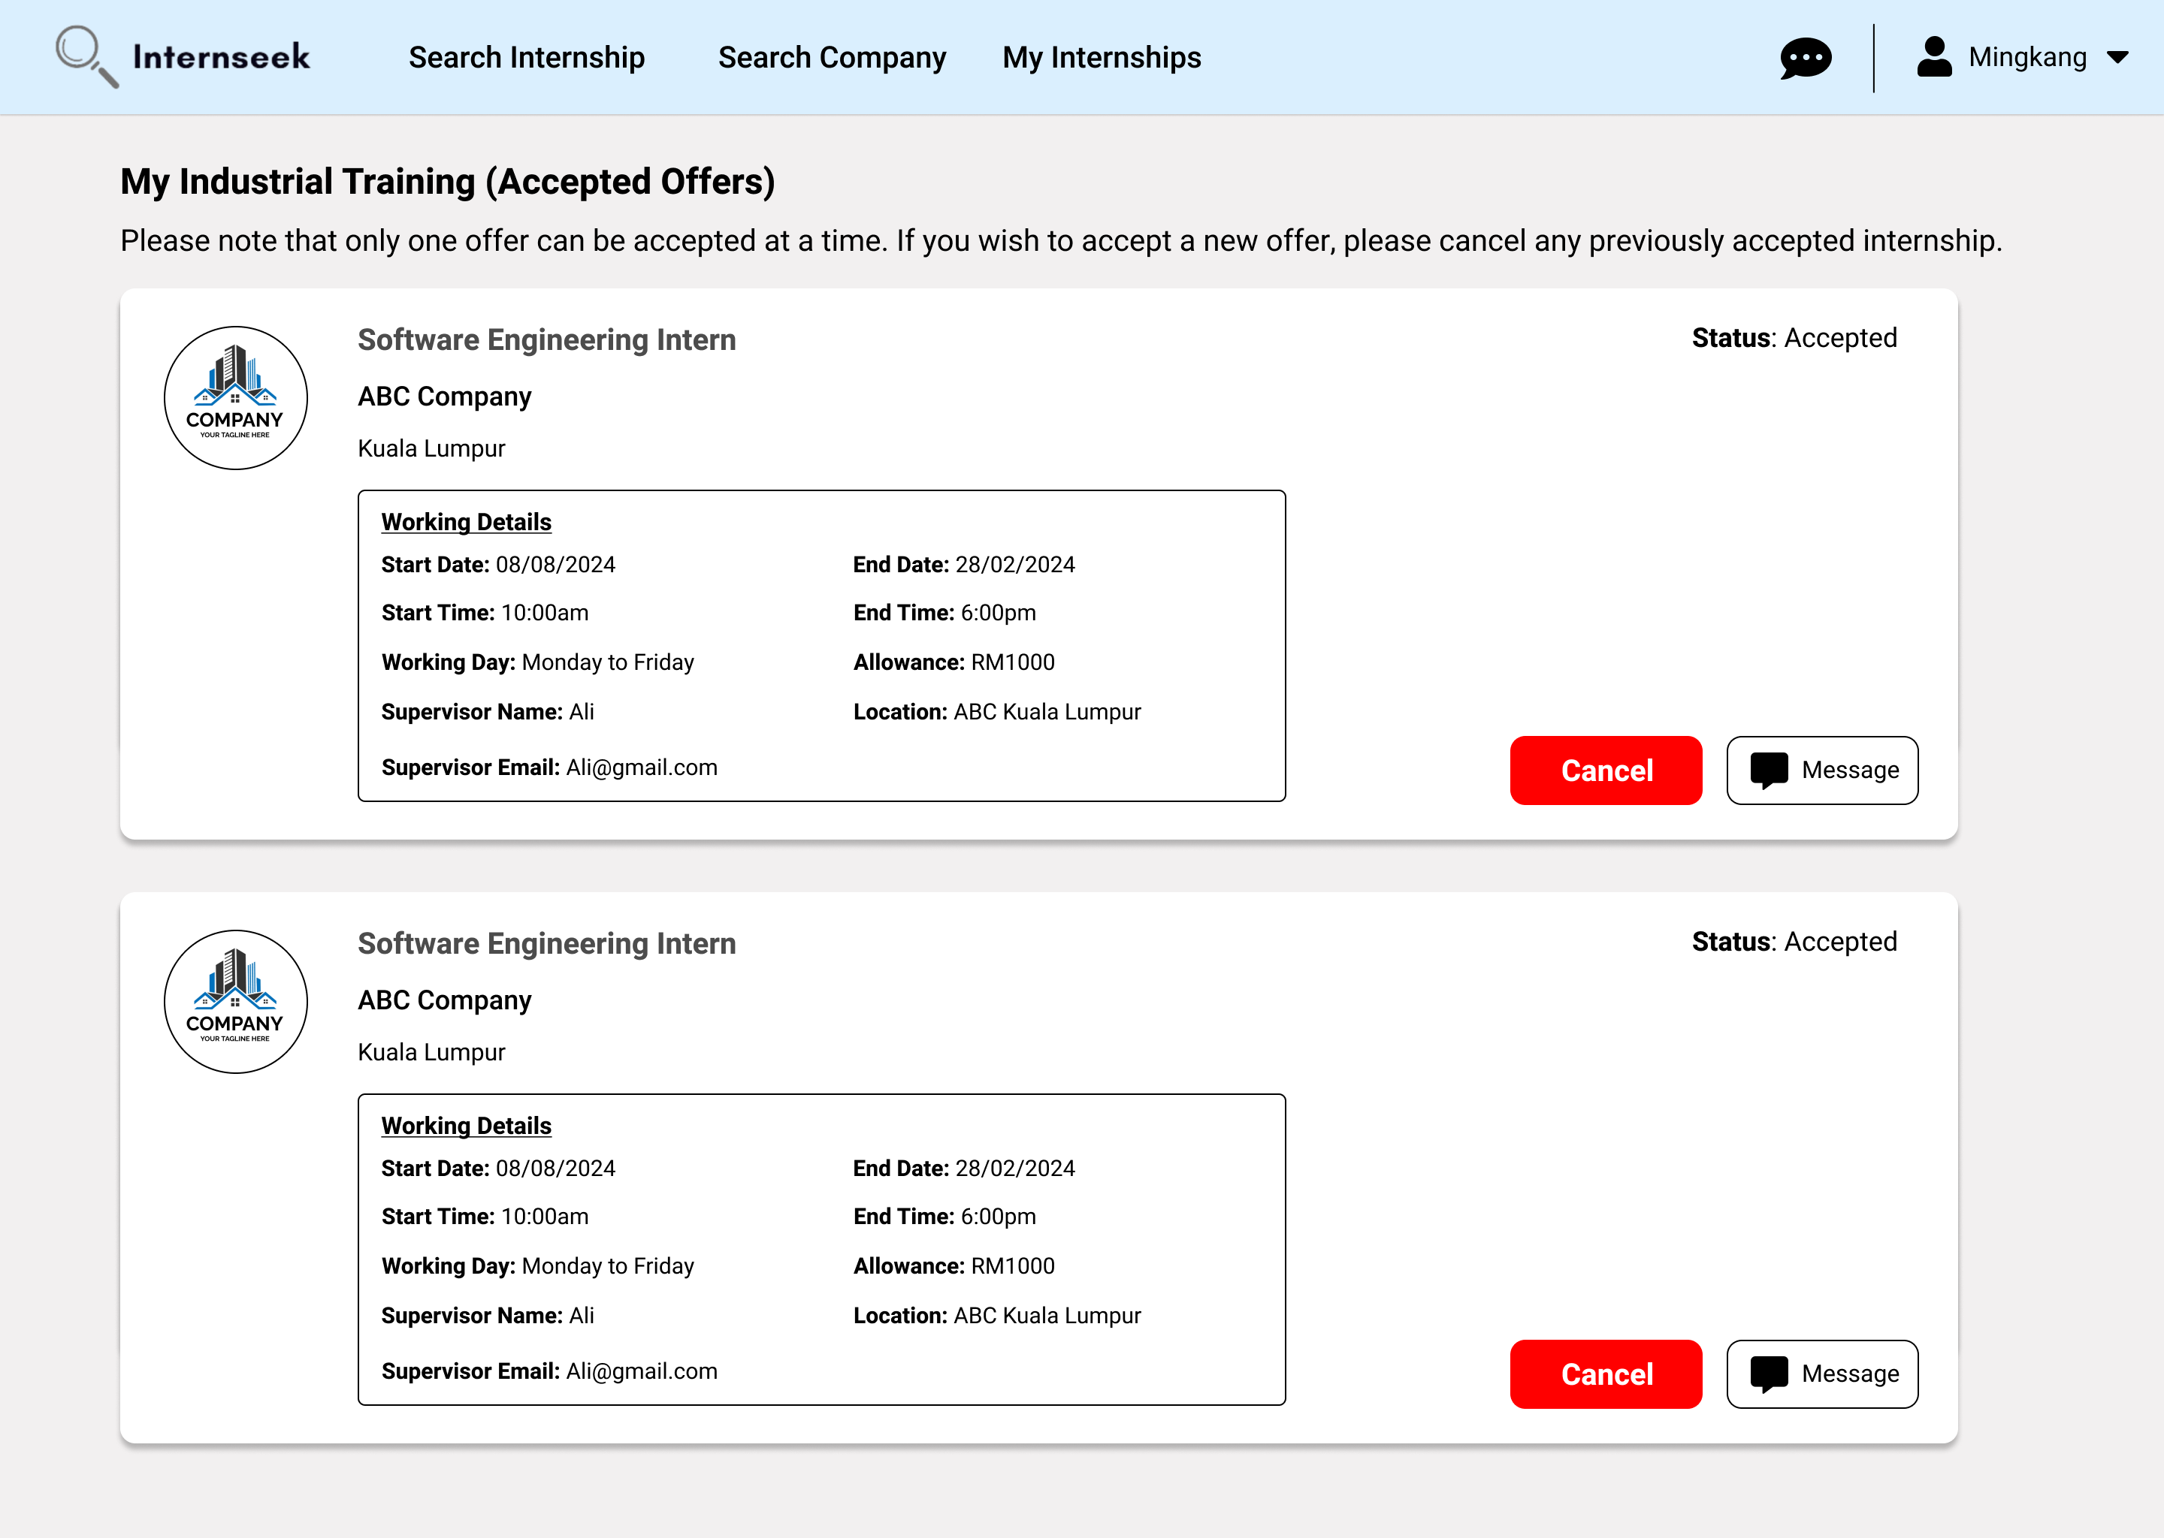

Figure 3‑178: My Industrial Training Page

This figure shows the list of internship offers accepted by the university student once they click the <<My Industrial Training>> option in the drop-down menu. On this page, university students can view details of the accepted offers, including the working start date, working end date, working day, working start time, working end time, supervisor name, supervisor email, and working location. If a university student accepts more than one offer, they need to cancel the offers they do not want by clicking the <<Cancel>> button. For more detailed information about an accepted offer, the student can message the employer by clicking the <<Message>> button.

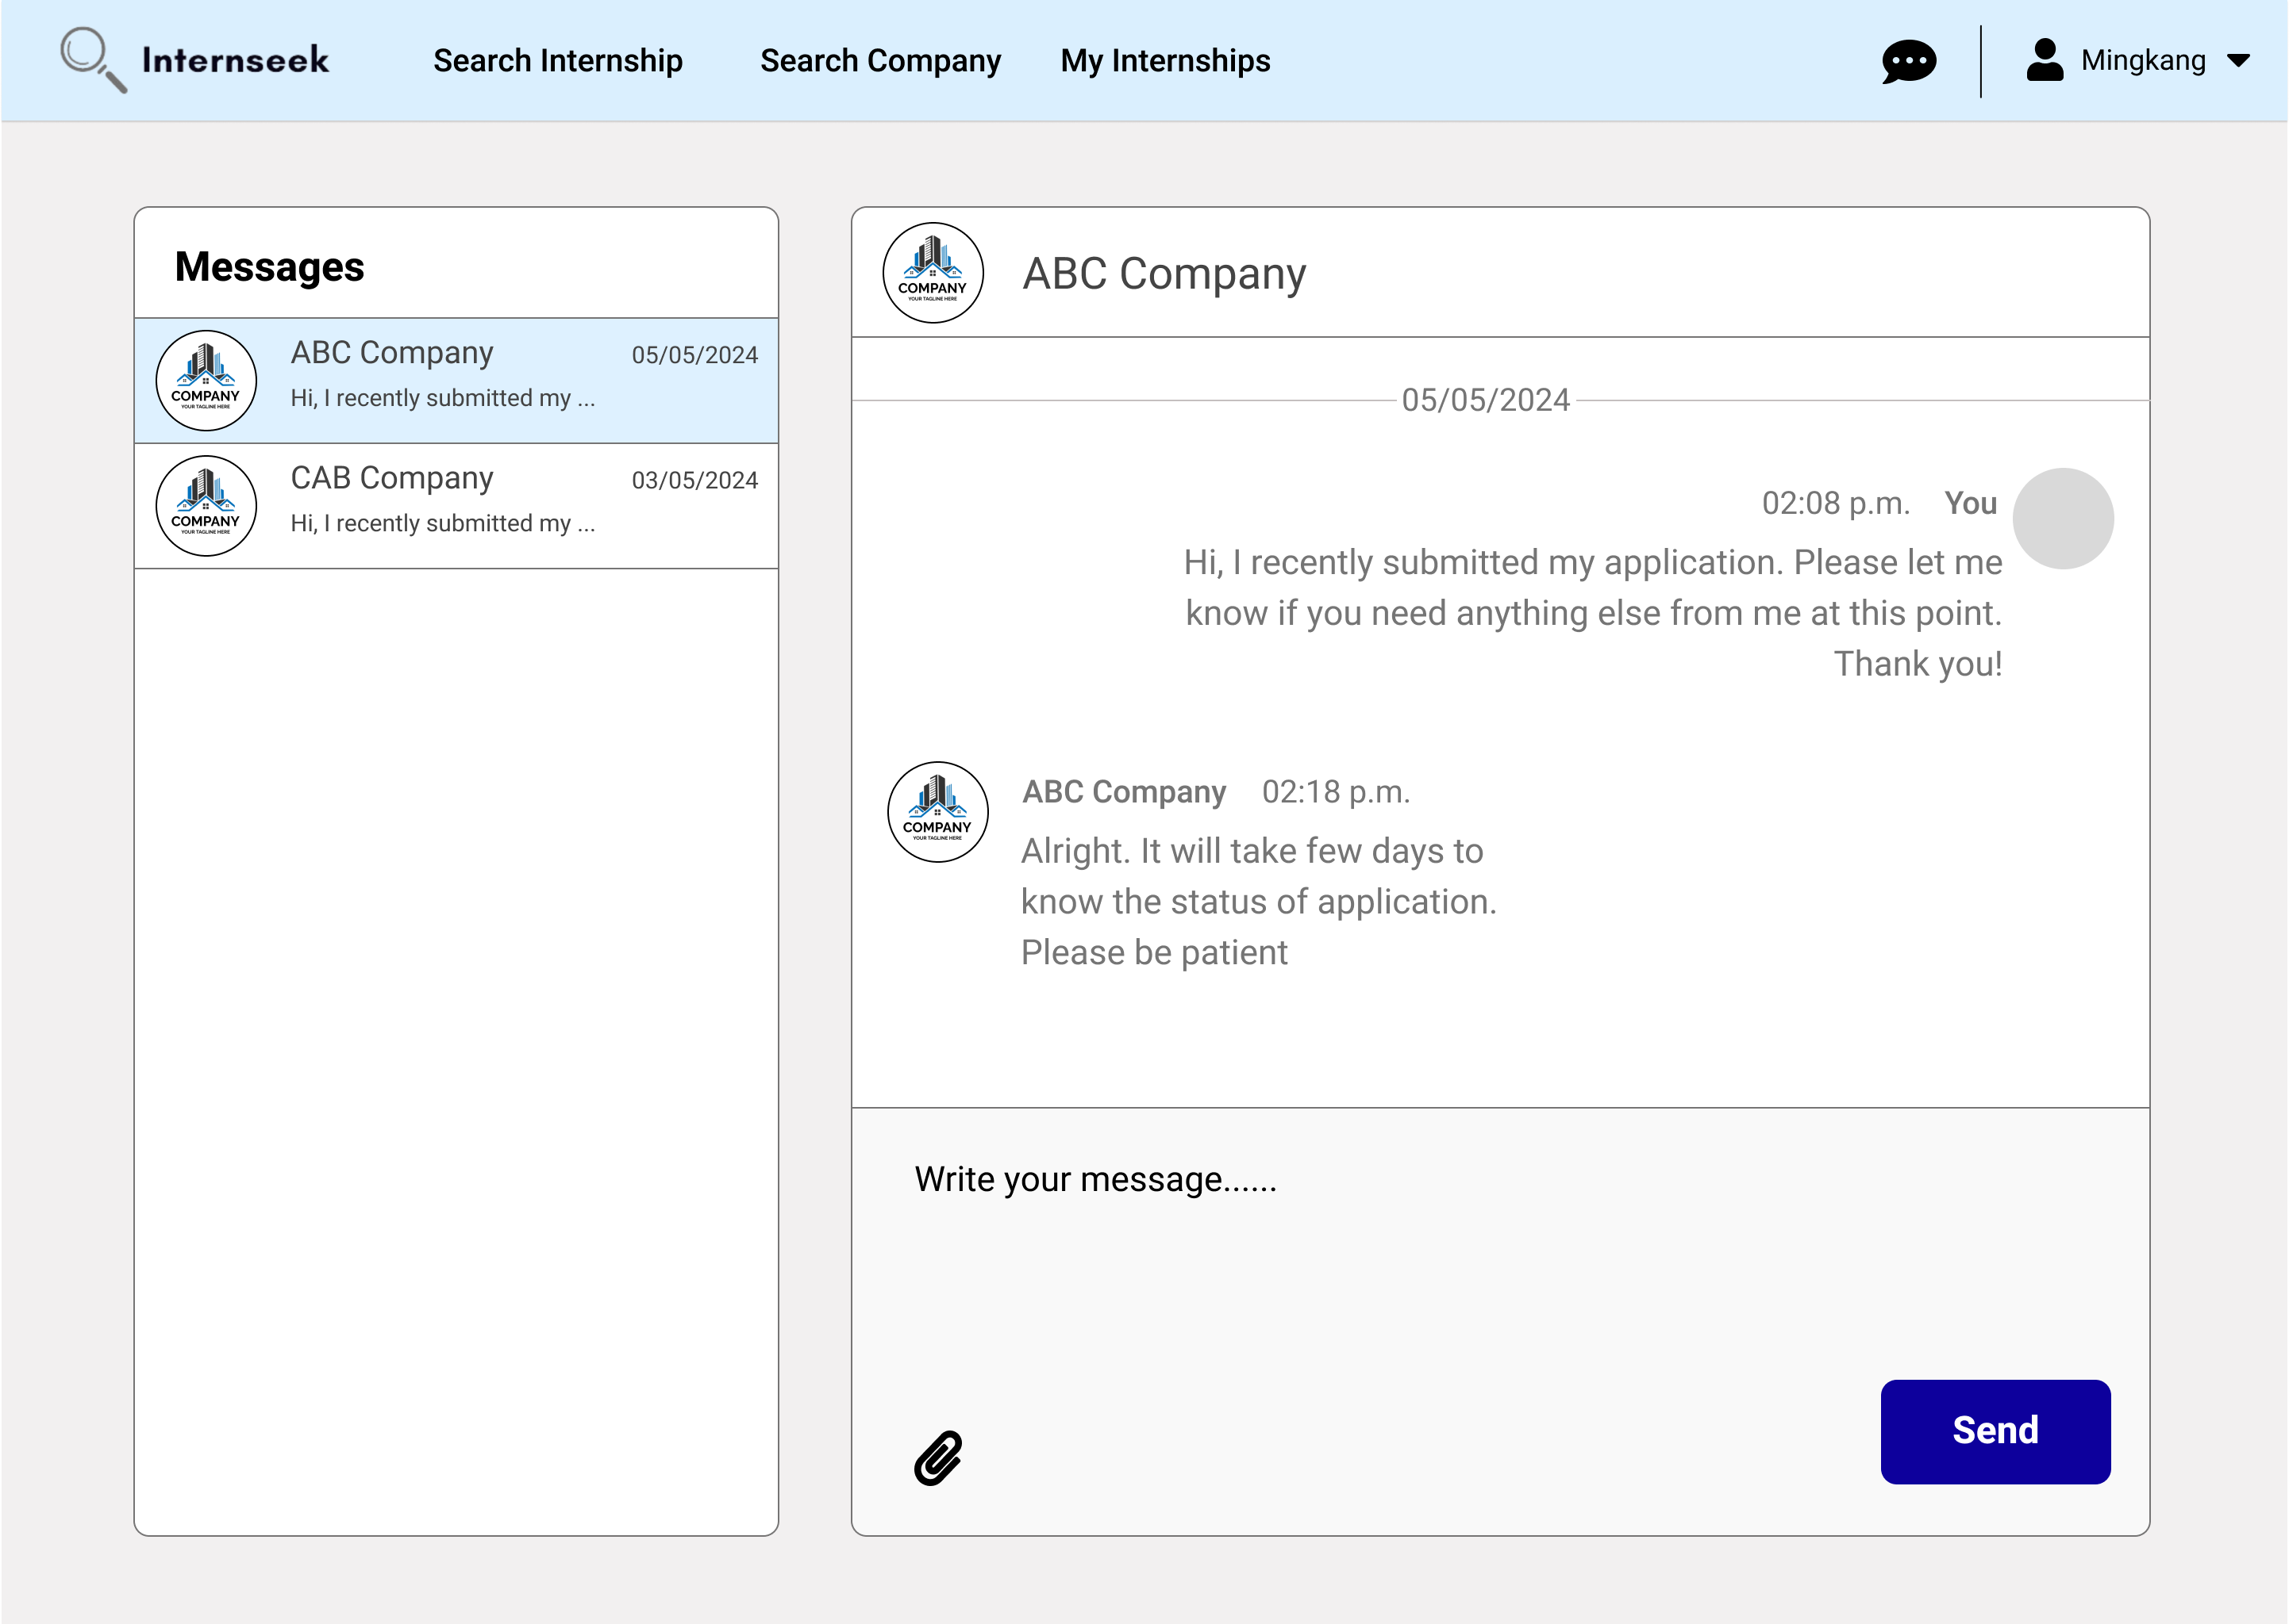

Figure 3‑179: Message Inbox and Chat-box Page

This figure displays the message inbox and chat-box page. The left-side interface represents the message inbox. The message inbox will display all the conversations with different employers. Unread messages are highlighted to differentiate them from read messages. The university student can scroll through the list to find a specific conversation. The right-side interface displays the selected conversation in detail. It shows the latest received messages and the full message history between the university student and the employer. At the bottom of the chat box, there is an input field where the university student can type a new message. After the university student types in a new message and attaches a file, they click the send button to send the message. The chat box updates in real-time, showing new messages they sent.

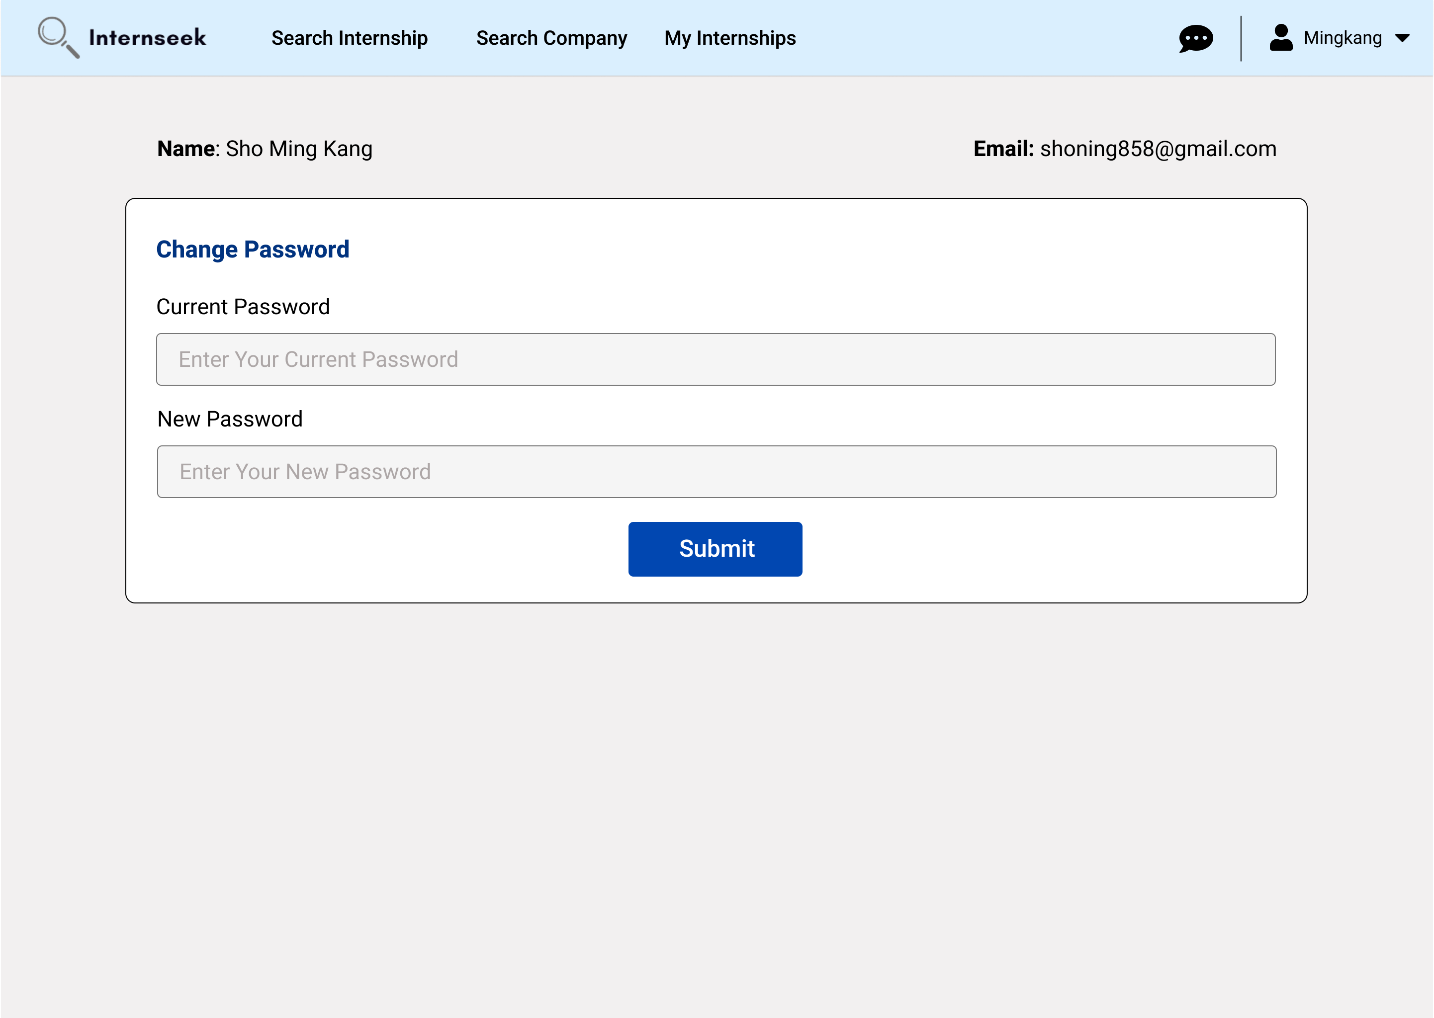

Figure 3‑180: Settings Page

This figure shows the settings page for the university student. The university student can change their password by inserting the current password and the new password. Once they enter the current password and the new password, they need to click the <<Submit>> button to change the password.

##### Employer

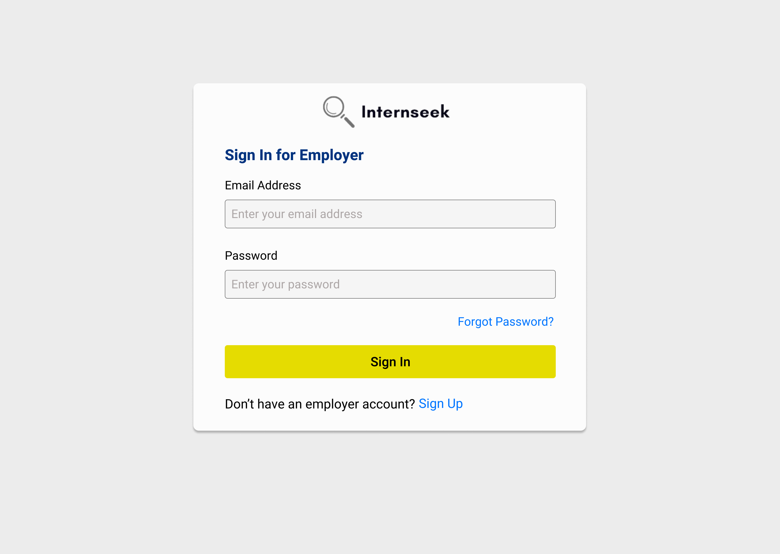

Figure 3‑181: Login Page for Employer

This figure illustrates the login page for employers. The employers need to enter their email address and password and click the <<Sign In>> button to login to the system. The employers can click the <<Sign Up>> text if they are first-time users. If the employers forget their account password, they need to click the <<Forgot Password?>> text to reset their password.

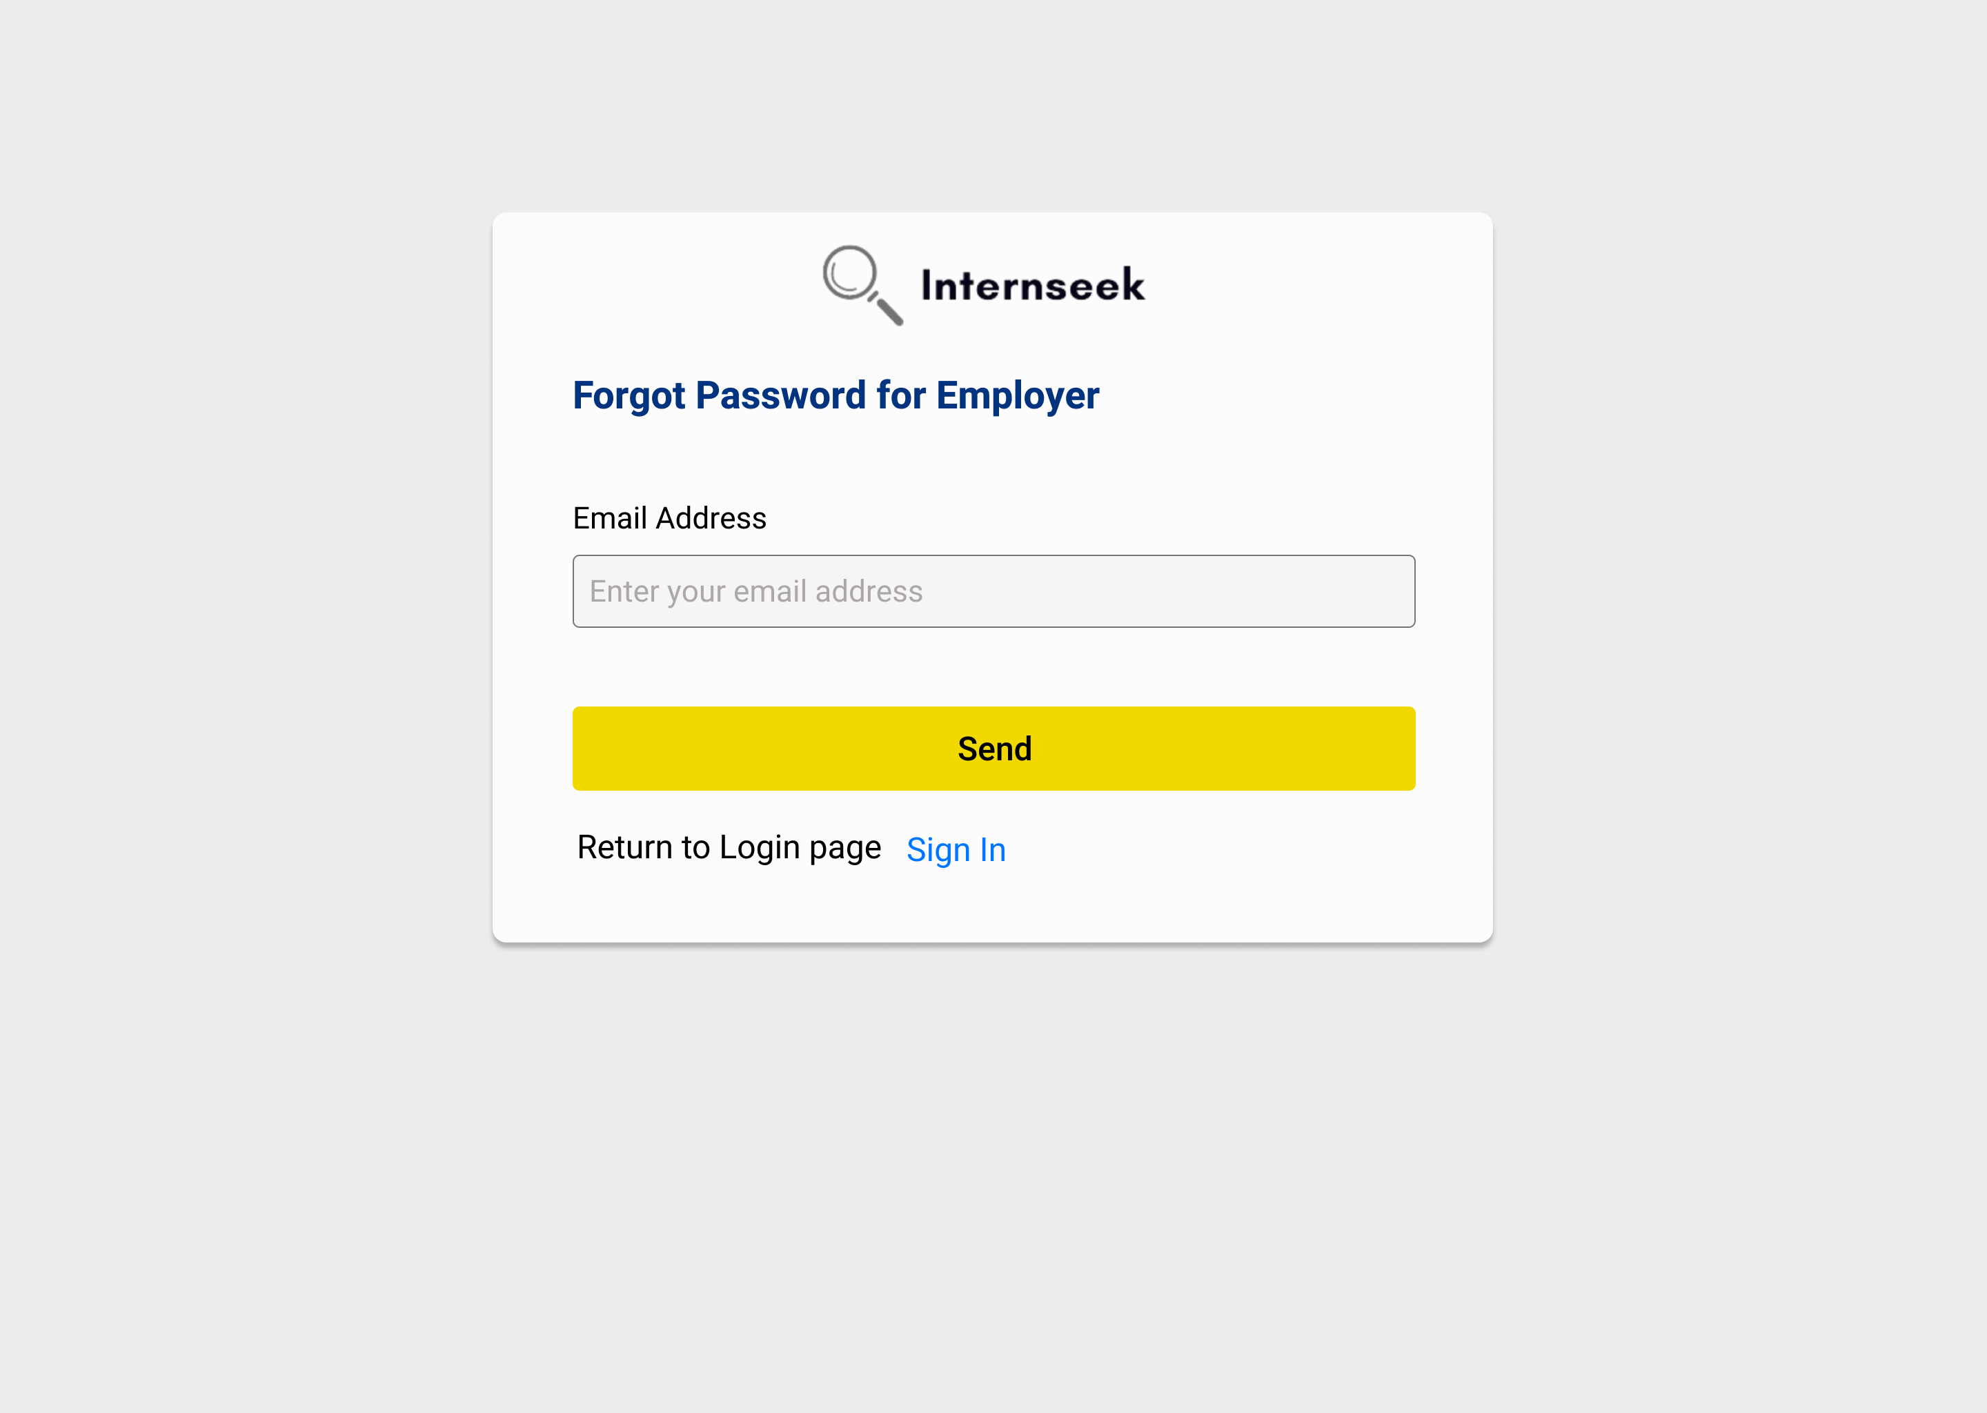

Figure 3‑182: Forgot Password Page for Employer

This figure illustrates the forgot password for employers if they forgot their password. The employers need to enter their email address and click the <<Send>> button to get the password reset link. If the employers want to back to login page, they may click the <<Sign In>> text.



Figure 3‑183: Password Reset Page for Employer

This figure illustrates the password reset page for employers once they click the password reset link in the email they received. The employers need to enter their new password, confirm their password, and click the <<Submit>> button to reset their password.

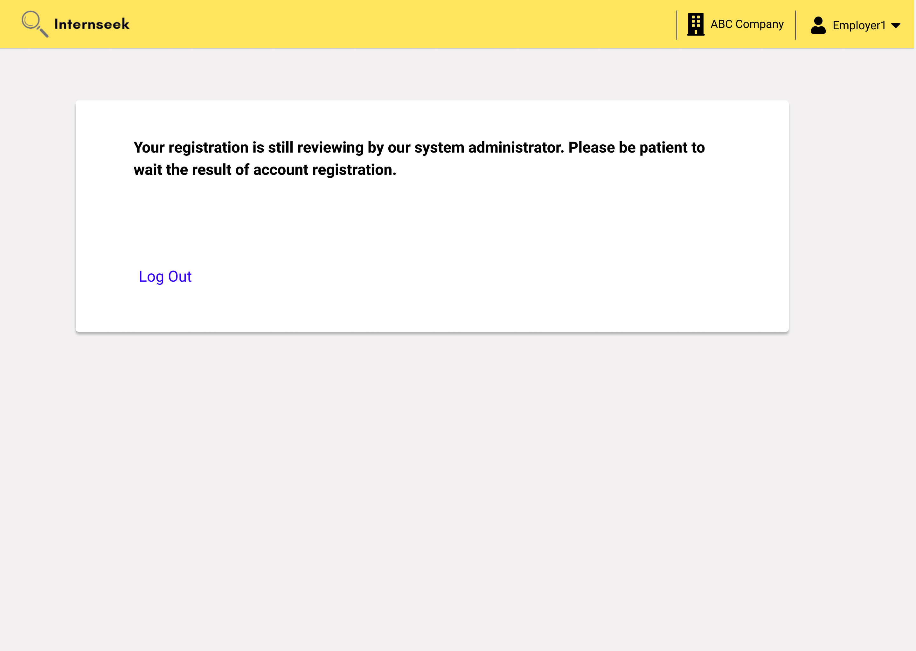

Figure 3‑184: The page after login for employers with pending registration status

This figure shows the page that appears once the employer logs into the system with a pending registration status. The page displays the current registration status and informs the employer to wait for the result of their account registration. Additionally, it provides a link for the employer to log out.

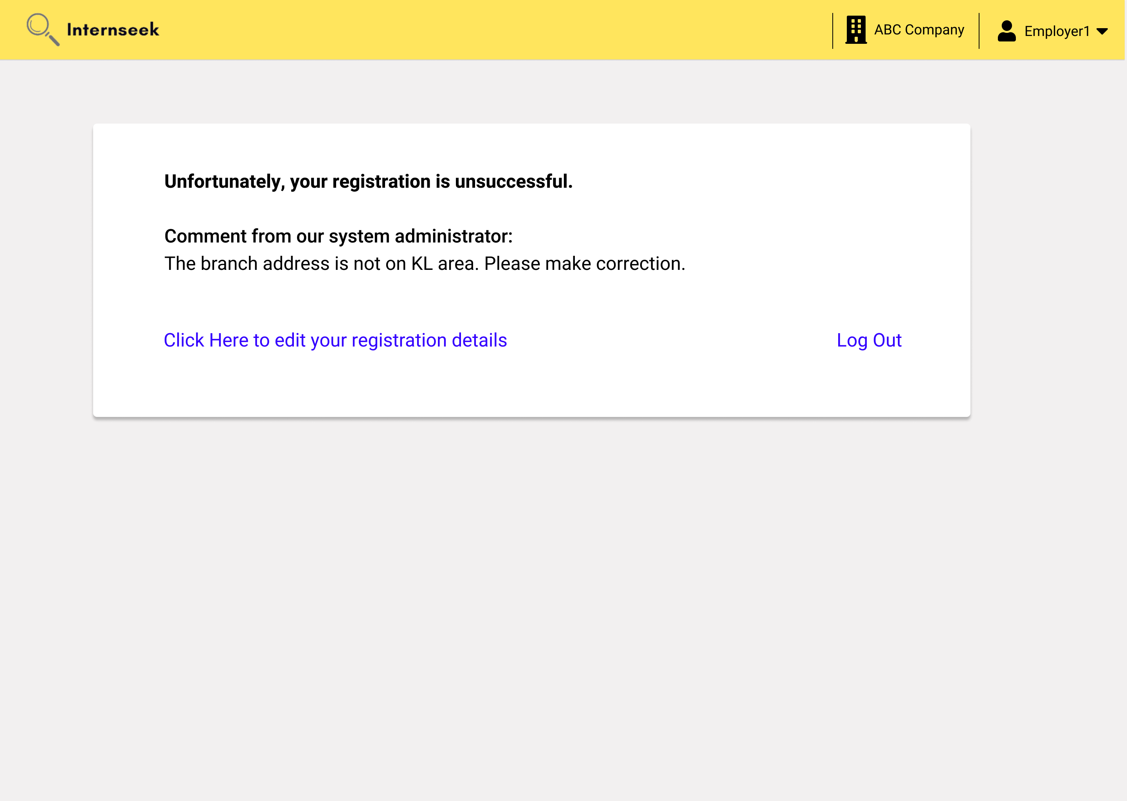

Figure 3‑185: The page after login for employers with inquiry registration status

This figure shows the page that appears once the employer logs into the system with an inquiry registration status. The page displays that the current registration status is unsuccessful and informs the employer to edit the registration details based on the provided comments. The employer can click the Edit Registration Details link to update their registration information. Additionally, the page provides a link for the employer to log out.

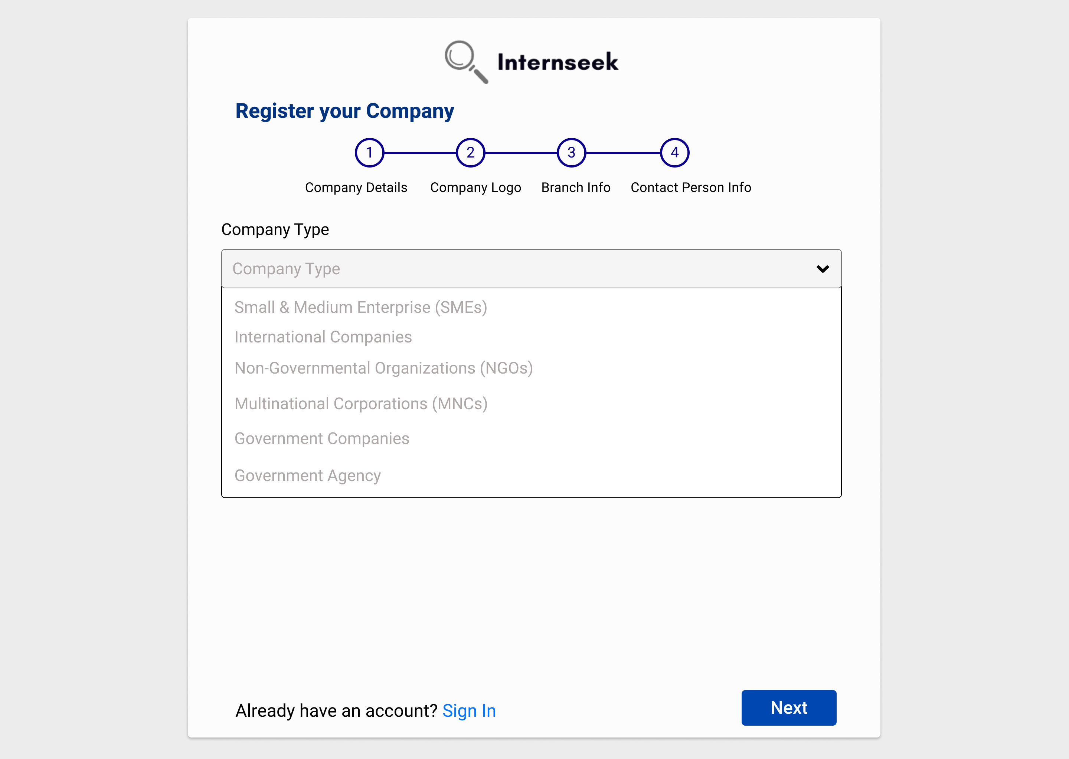

Figure 3‑186: Register Employer Page (Select company type)

This figure shows step 1 of the Register Employer page, where the employer is required to select the company type and enter the company details. The employer must select the company type before entering the company details and uploading the business registration document. Once the company type is selected, the relevant input fields for that company type will be displayed accordingly.

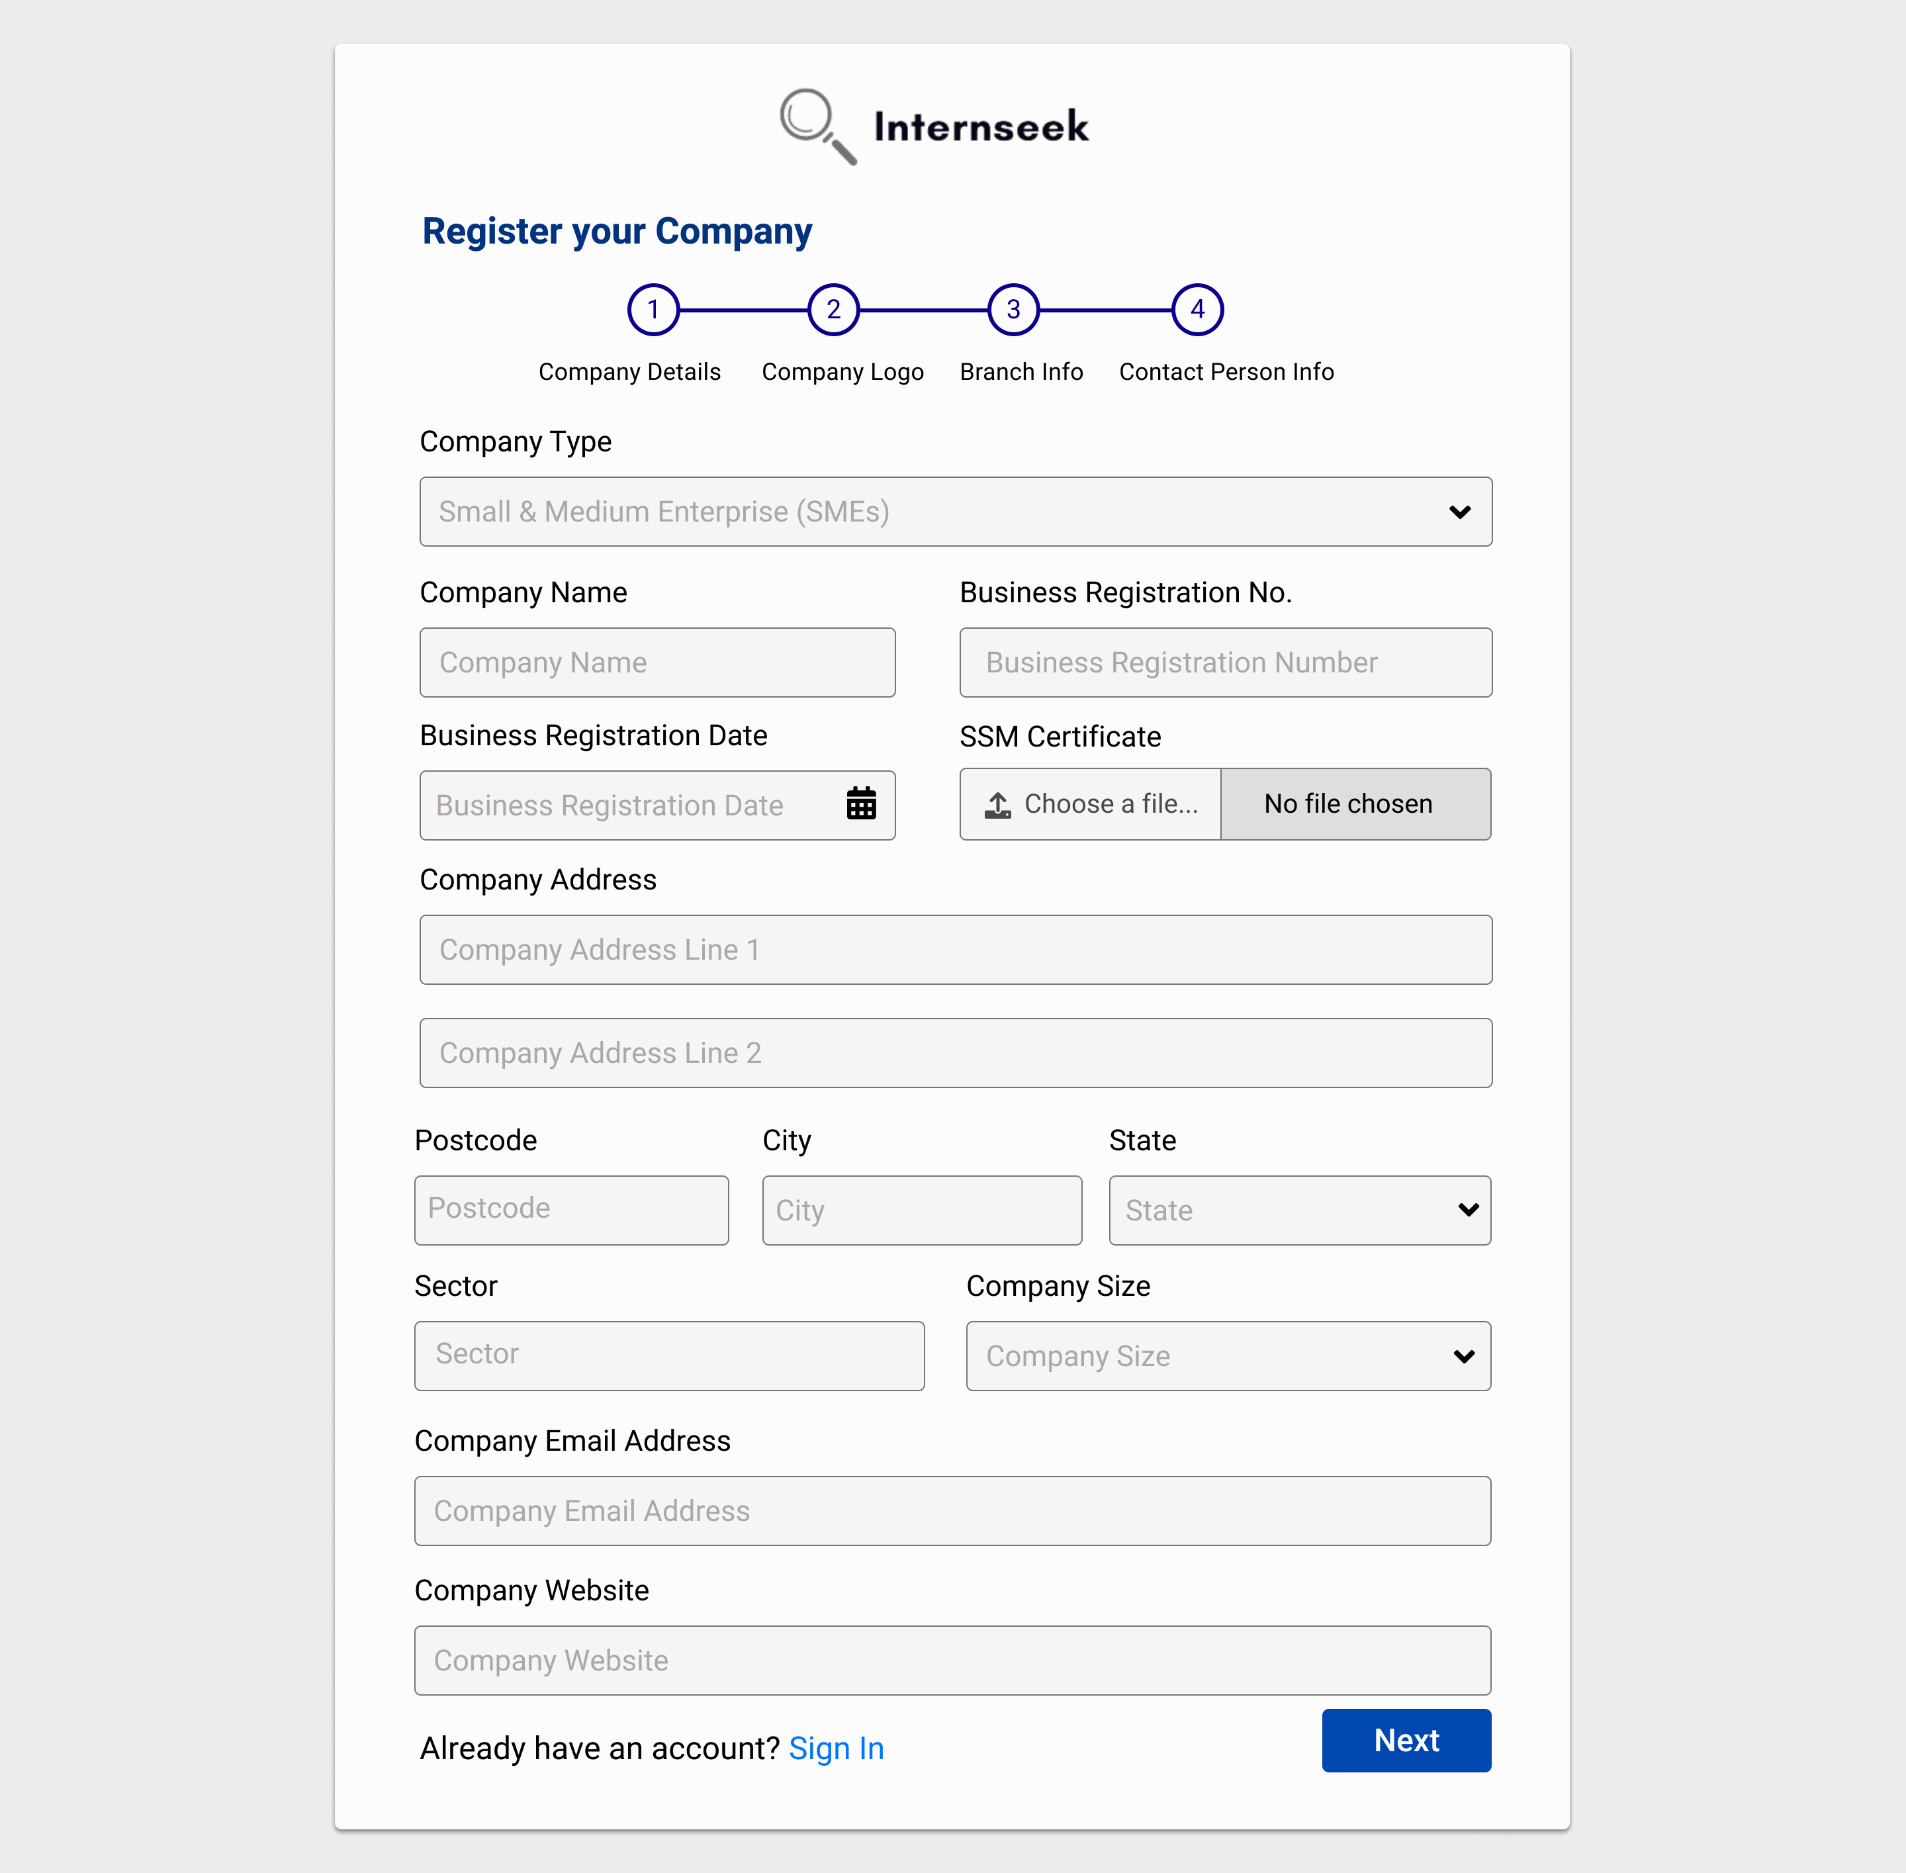

Figure 3‑187: Register Employer Page (Step 1 for Small and Medium Enterprise)

This figure shows step 1 of the Register Employer page, where the employer selects the company type as Small and Medium Enterprise (SME) and enters the company details. The employer needs to upload the SSM Certificate and complete the required company details in the form. Once all required details are filled out, the employer can click the <<Next>> button to proceed to the next step.

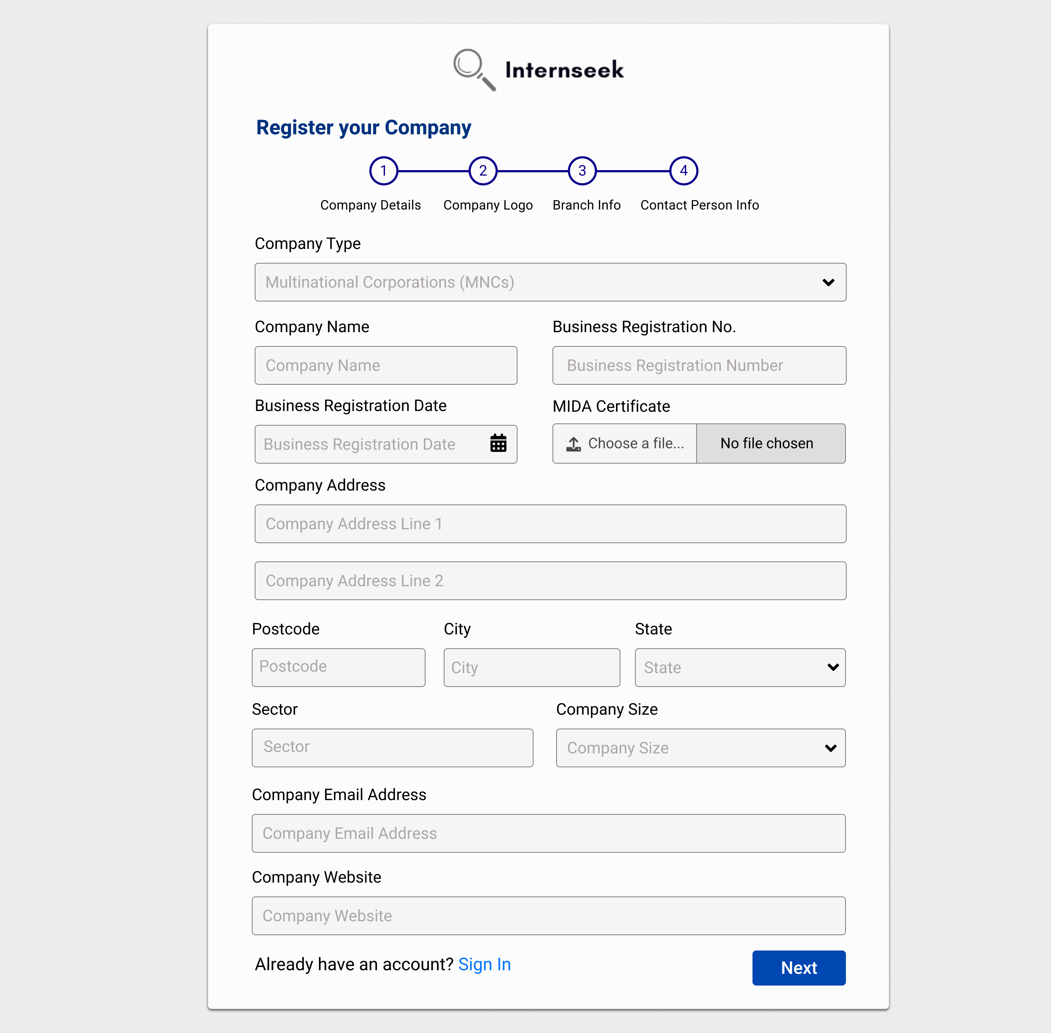

Figure 3‑188: Register Employer Page (Step 1 for Multinational Corporation)

This figure shows step 1 of the Register Employer page, where the employer selects the company type as Multinational Corporation (MNC) and enters the company details. The employer needs to upload the MIDA Certificate and complete the required company details in the form. Once all required details are filled out, the employer can click the <<Next>> button to proceed to the next step.

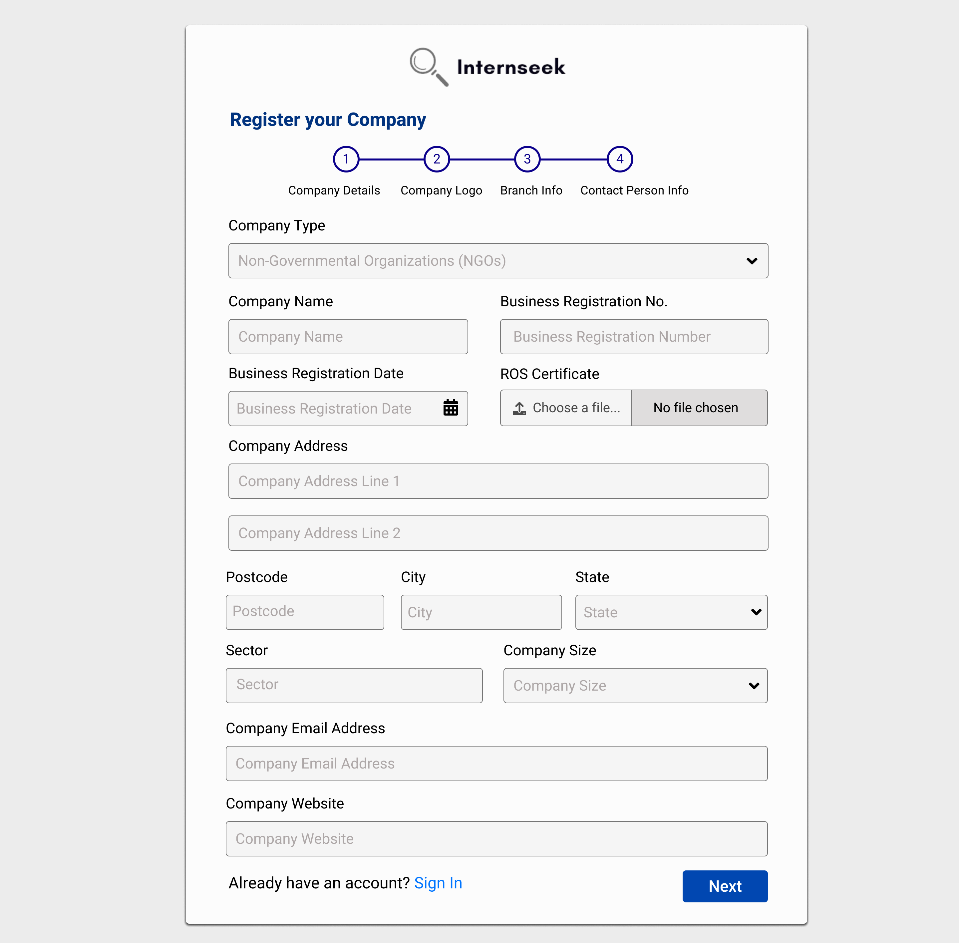

Figure 3‑189: Register Employer Page (Step 1 for Non-Governmental Organization)

This figure shows step 1 of the Register Employer page, where the employer selects the company type as Non-Governmental Organization (NGO) and enters the company details. The employer needs to upload the ROS Certificate and complete the required company details in the form. Once all required details are filled out, the employer can click the <<Next>> button to proceed to the next step.

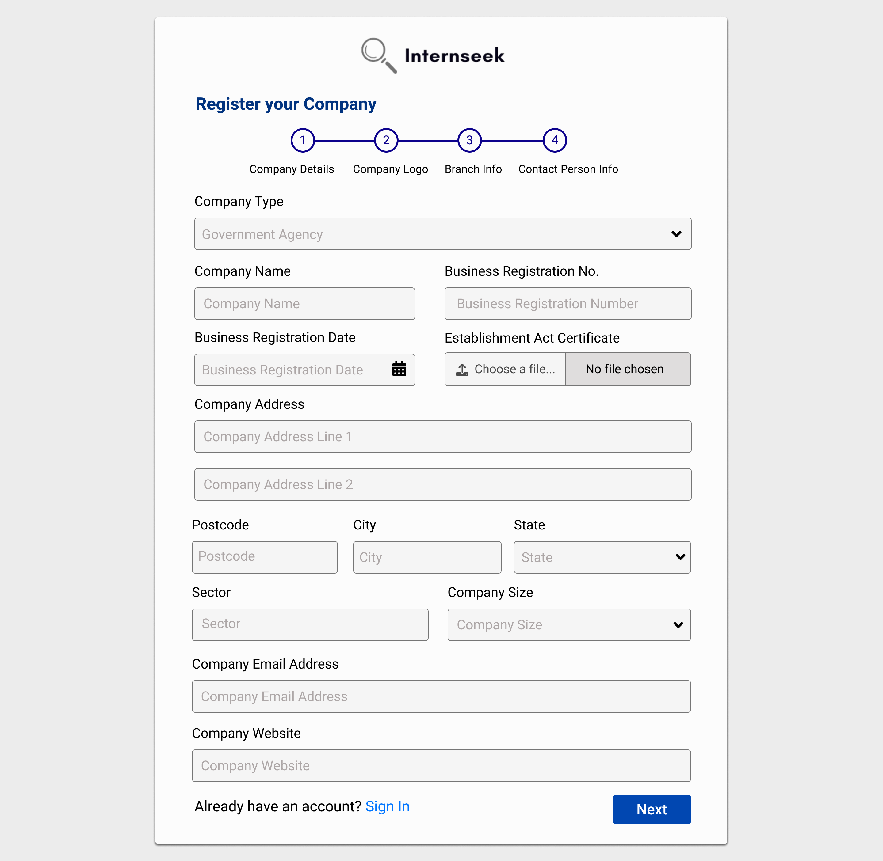

Figure 3‑190: Register Employer Page (Step 1 for Government Agency)

This figure shows step 1 of the Register Employer page, where the employer selects the company type as Government Agency and enters the company details. The employer needs to upload the Establishment Art Certificate and complete the required company details in the form. Once all required details are filled out, the employer can click the <<Next>> button to proceed to the next step.

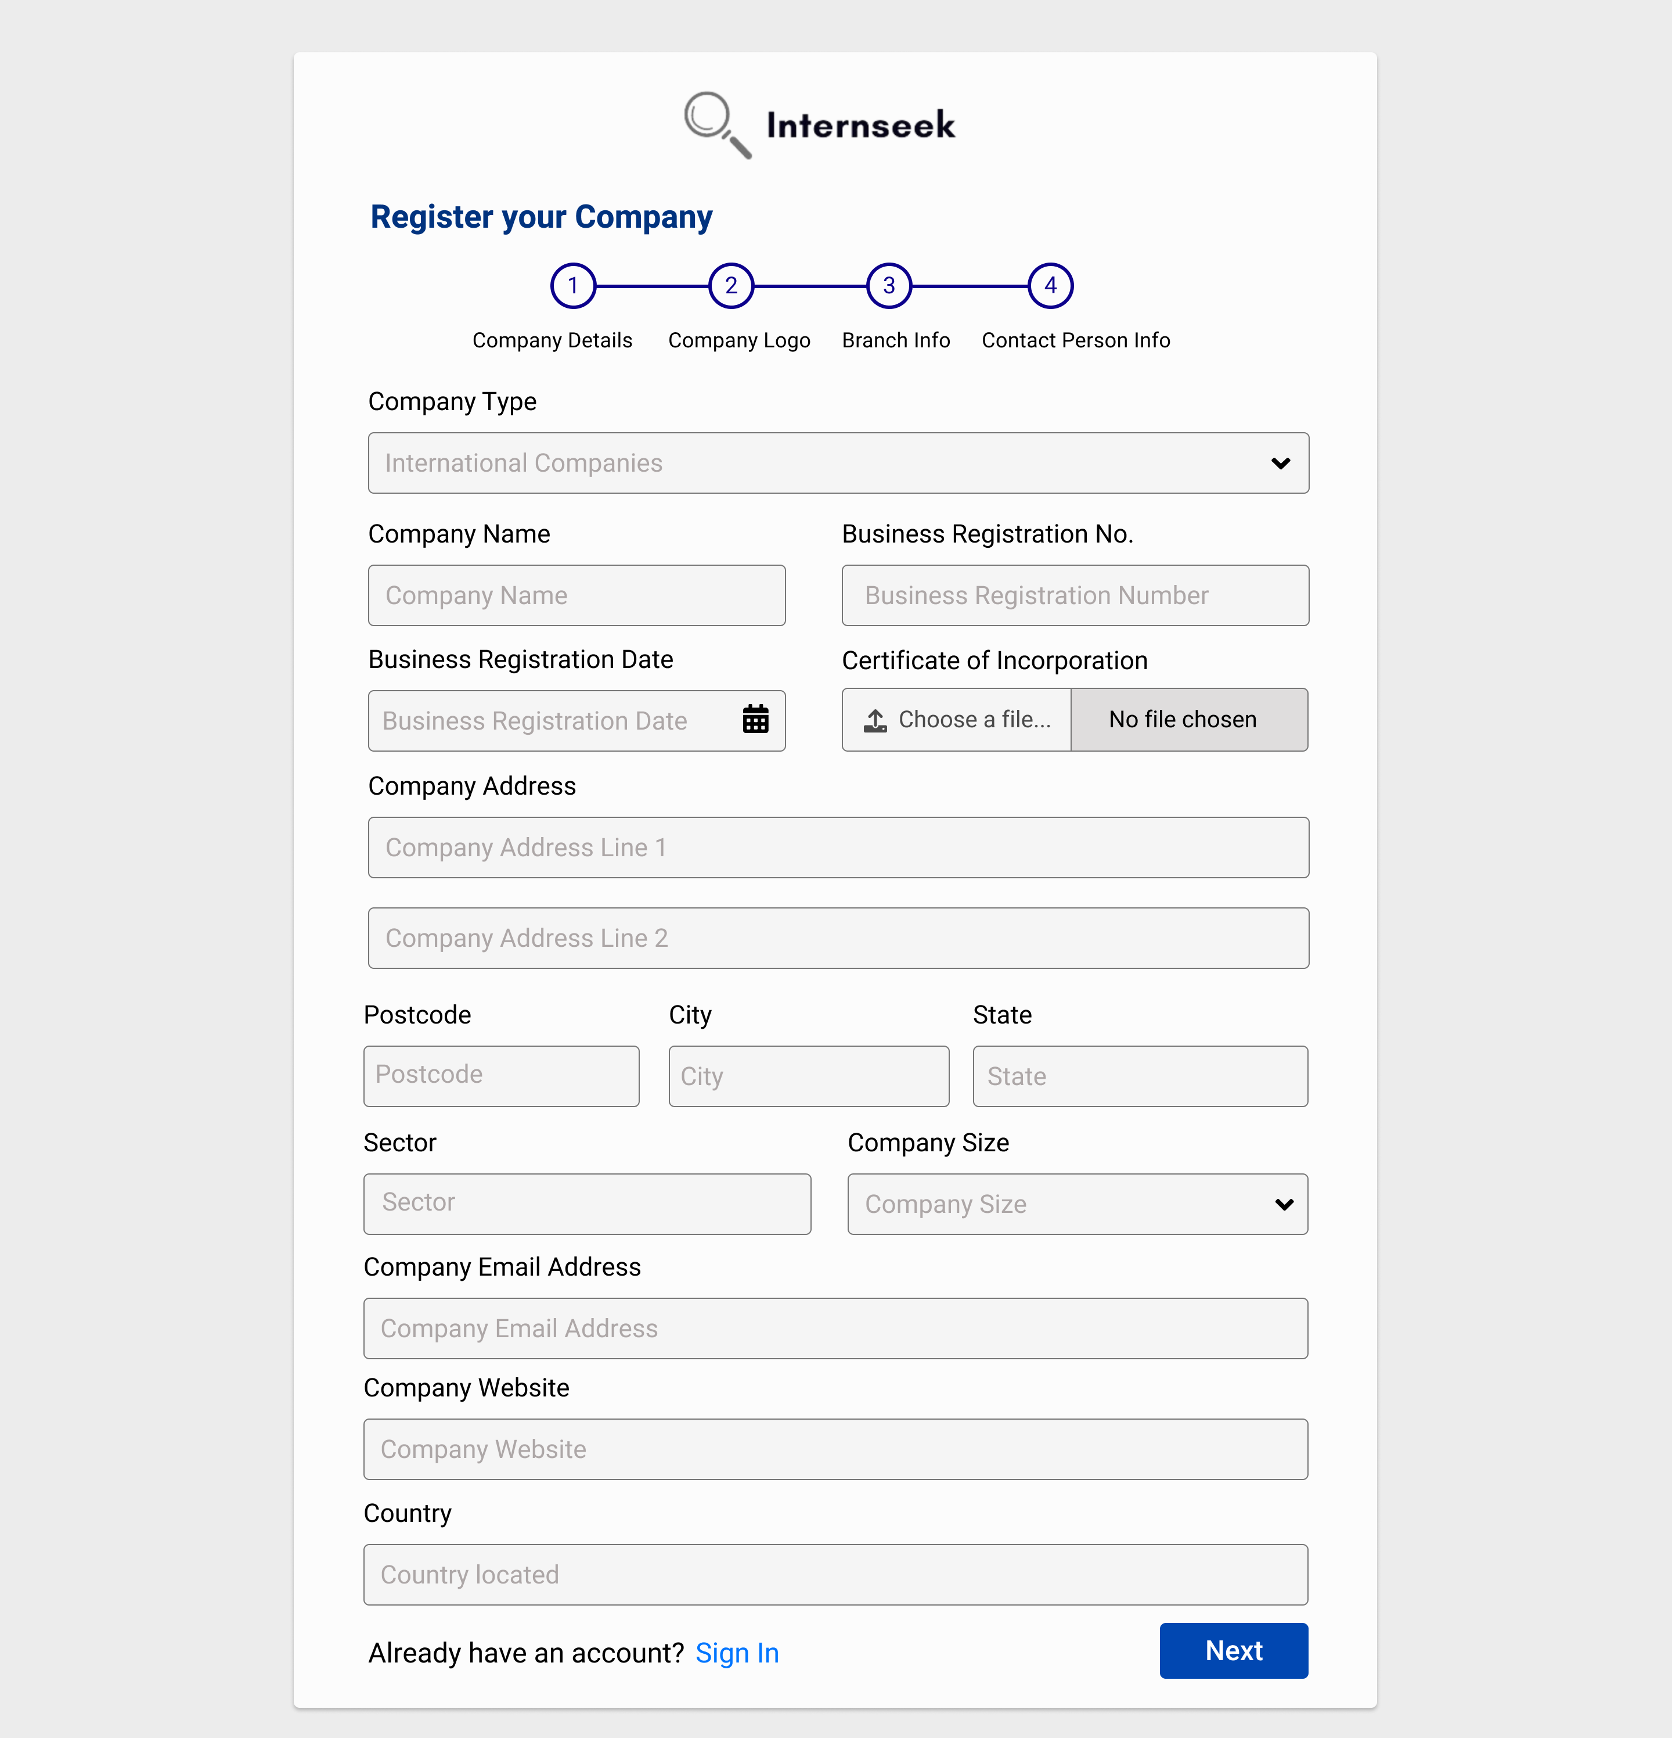

Figure 3‑191: Register Employer Page (Step 1 for International Company)

This figure shows step 1 of the Register Employer page, where the employer selects the company type as International Company and enters the company details. The employer needs to upload the Certificate of Incorporation and complete the required company details in the form. Once all required details are filled out, the employer can click the <<Next>> button to proceed to the next step.

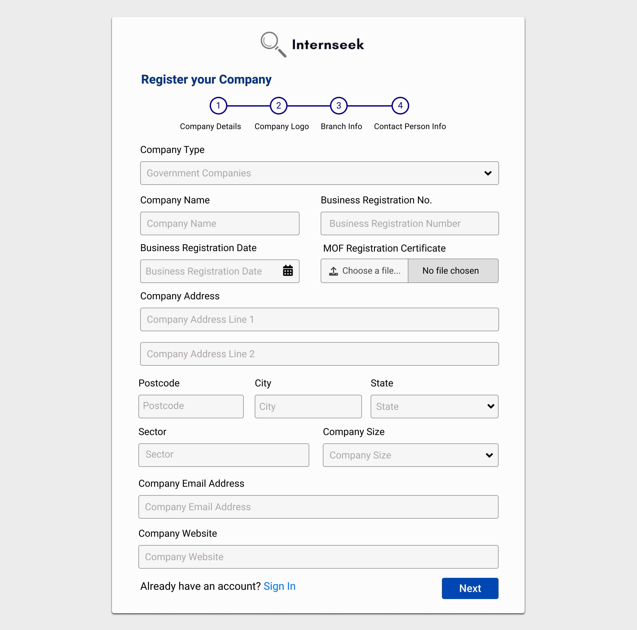

Figure 3‑192: Register Employer Page (Step 1 for Government Company)

This figure shows step 1 of the Register Employer page, where the employer selects the company type as Government Company and enters the company details. The employer needs to upload the MOF Registration Certificate and complete the required company details in the form. Once all required details are filled out, the employer can click the <<Next>> button to proceed to the next step.

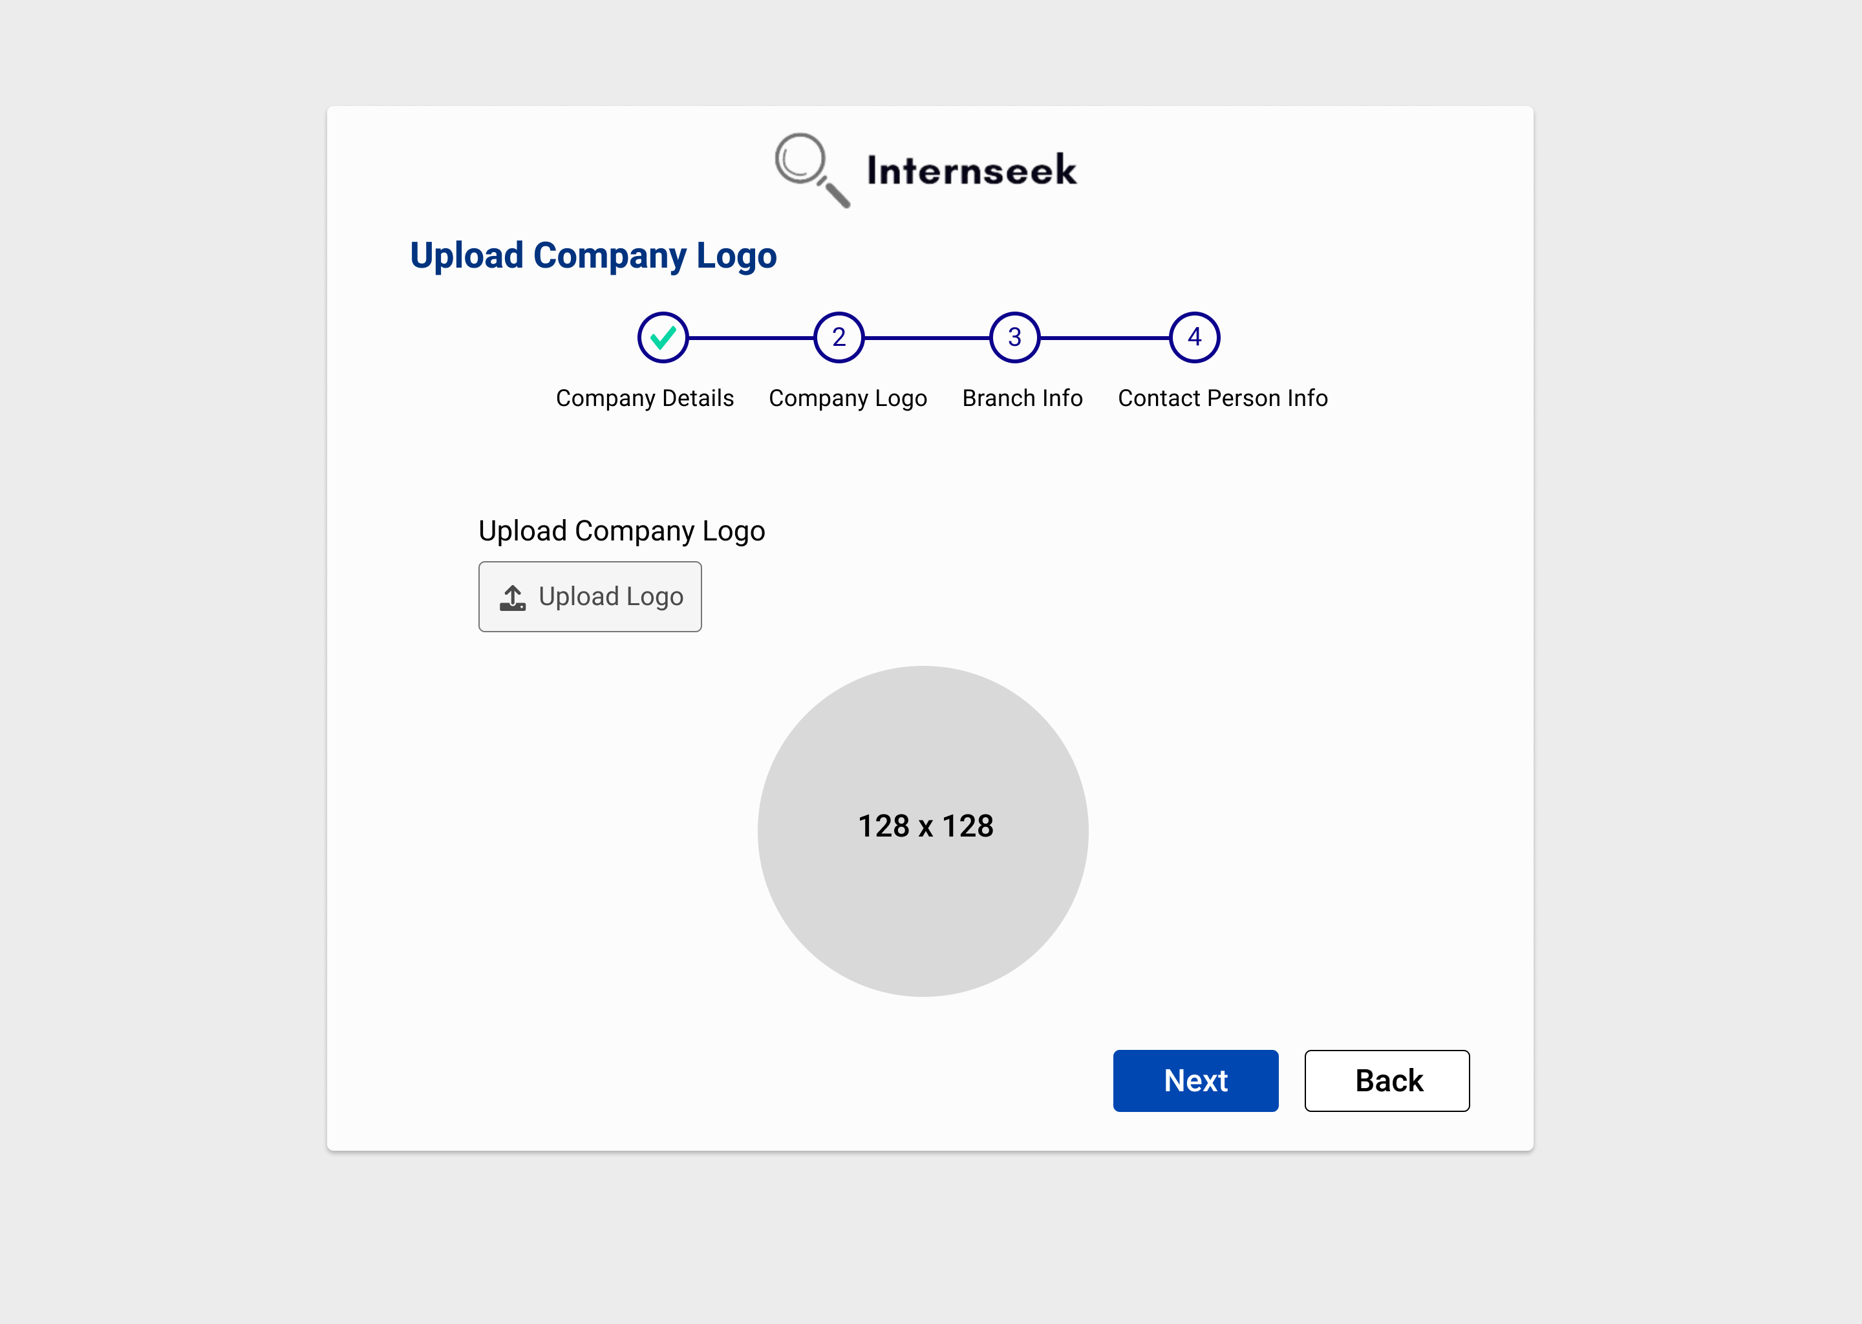

Figure 3‑193: Register Employer Page (Step 2)

This figure shows step 2 of the Register Employer page, which requires the employer to upload the company logo. Once the employer uploads the company logo, it will be displayed in the company logo section of the form. If there is no problem with the logo, they may click the <<Next>> button to proceed to the next step. If the employer wants to go back to the previous step, they can click the <<Back>> button.

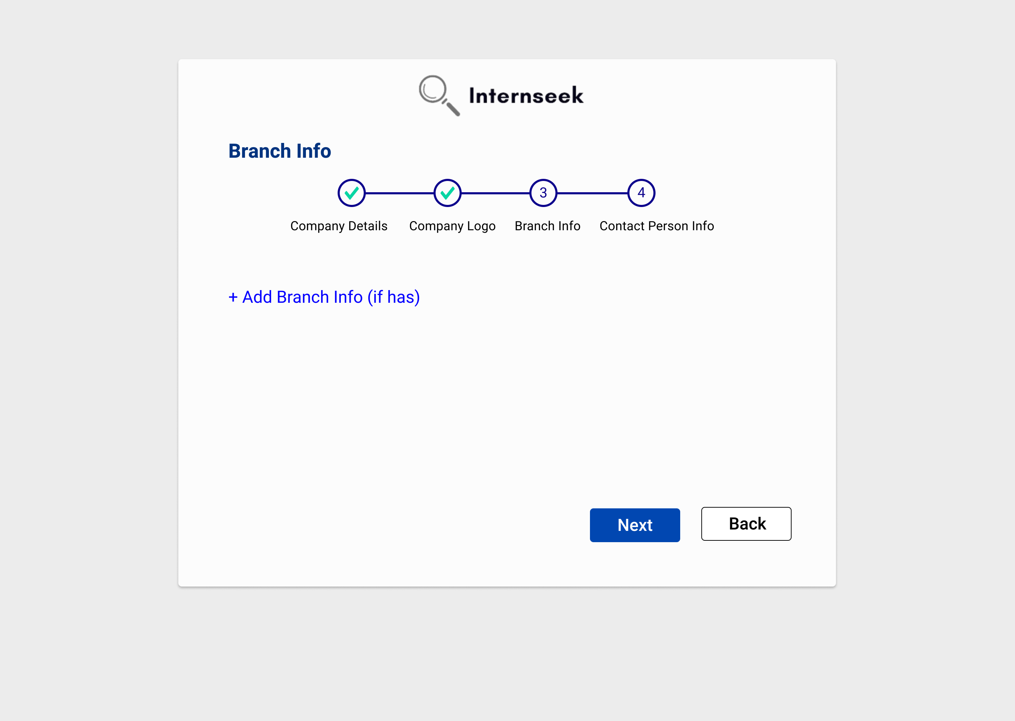

Figure 3‑194: Register Employer Page (Step 3)

This figure shows step 3 of the Register Employer page, which requires the employer to enter the branch information. If the employer does not have a branch, they may click the <<Next>> button to proceed to the next step. If the employer needs to add branch information, they can click the Add Branch Info link to provide the details. If the employer wants to go back to the previous step, they can click the <<Back>> button.

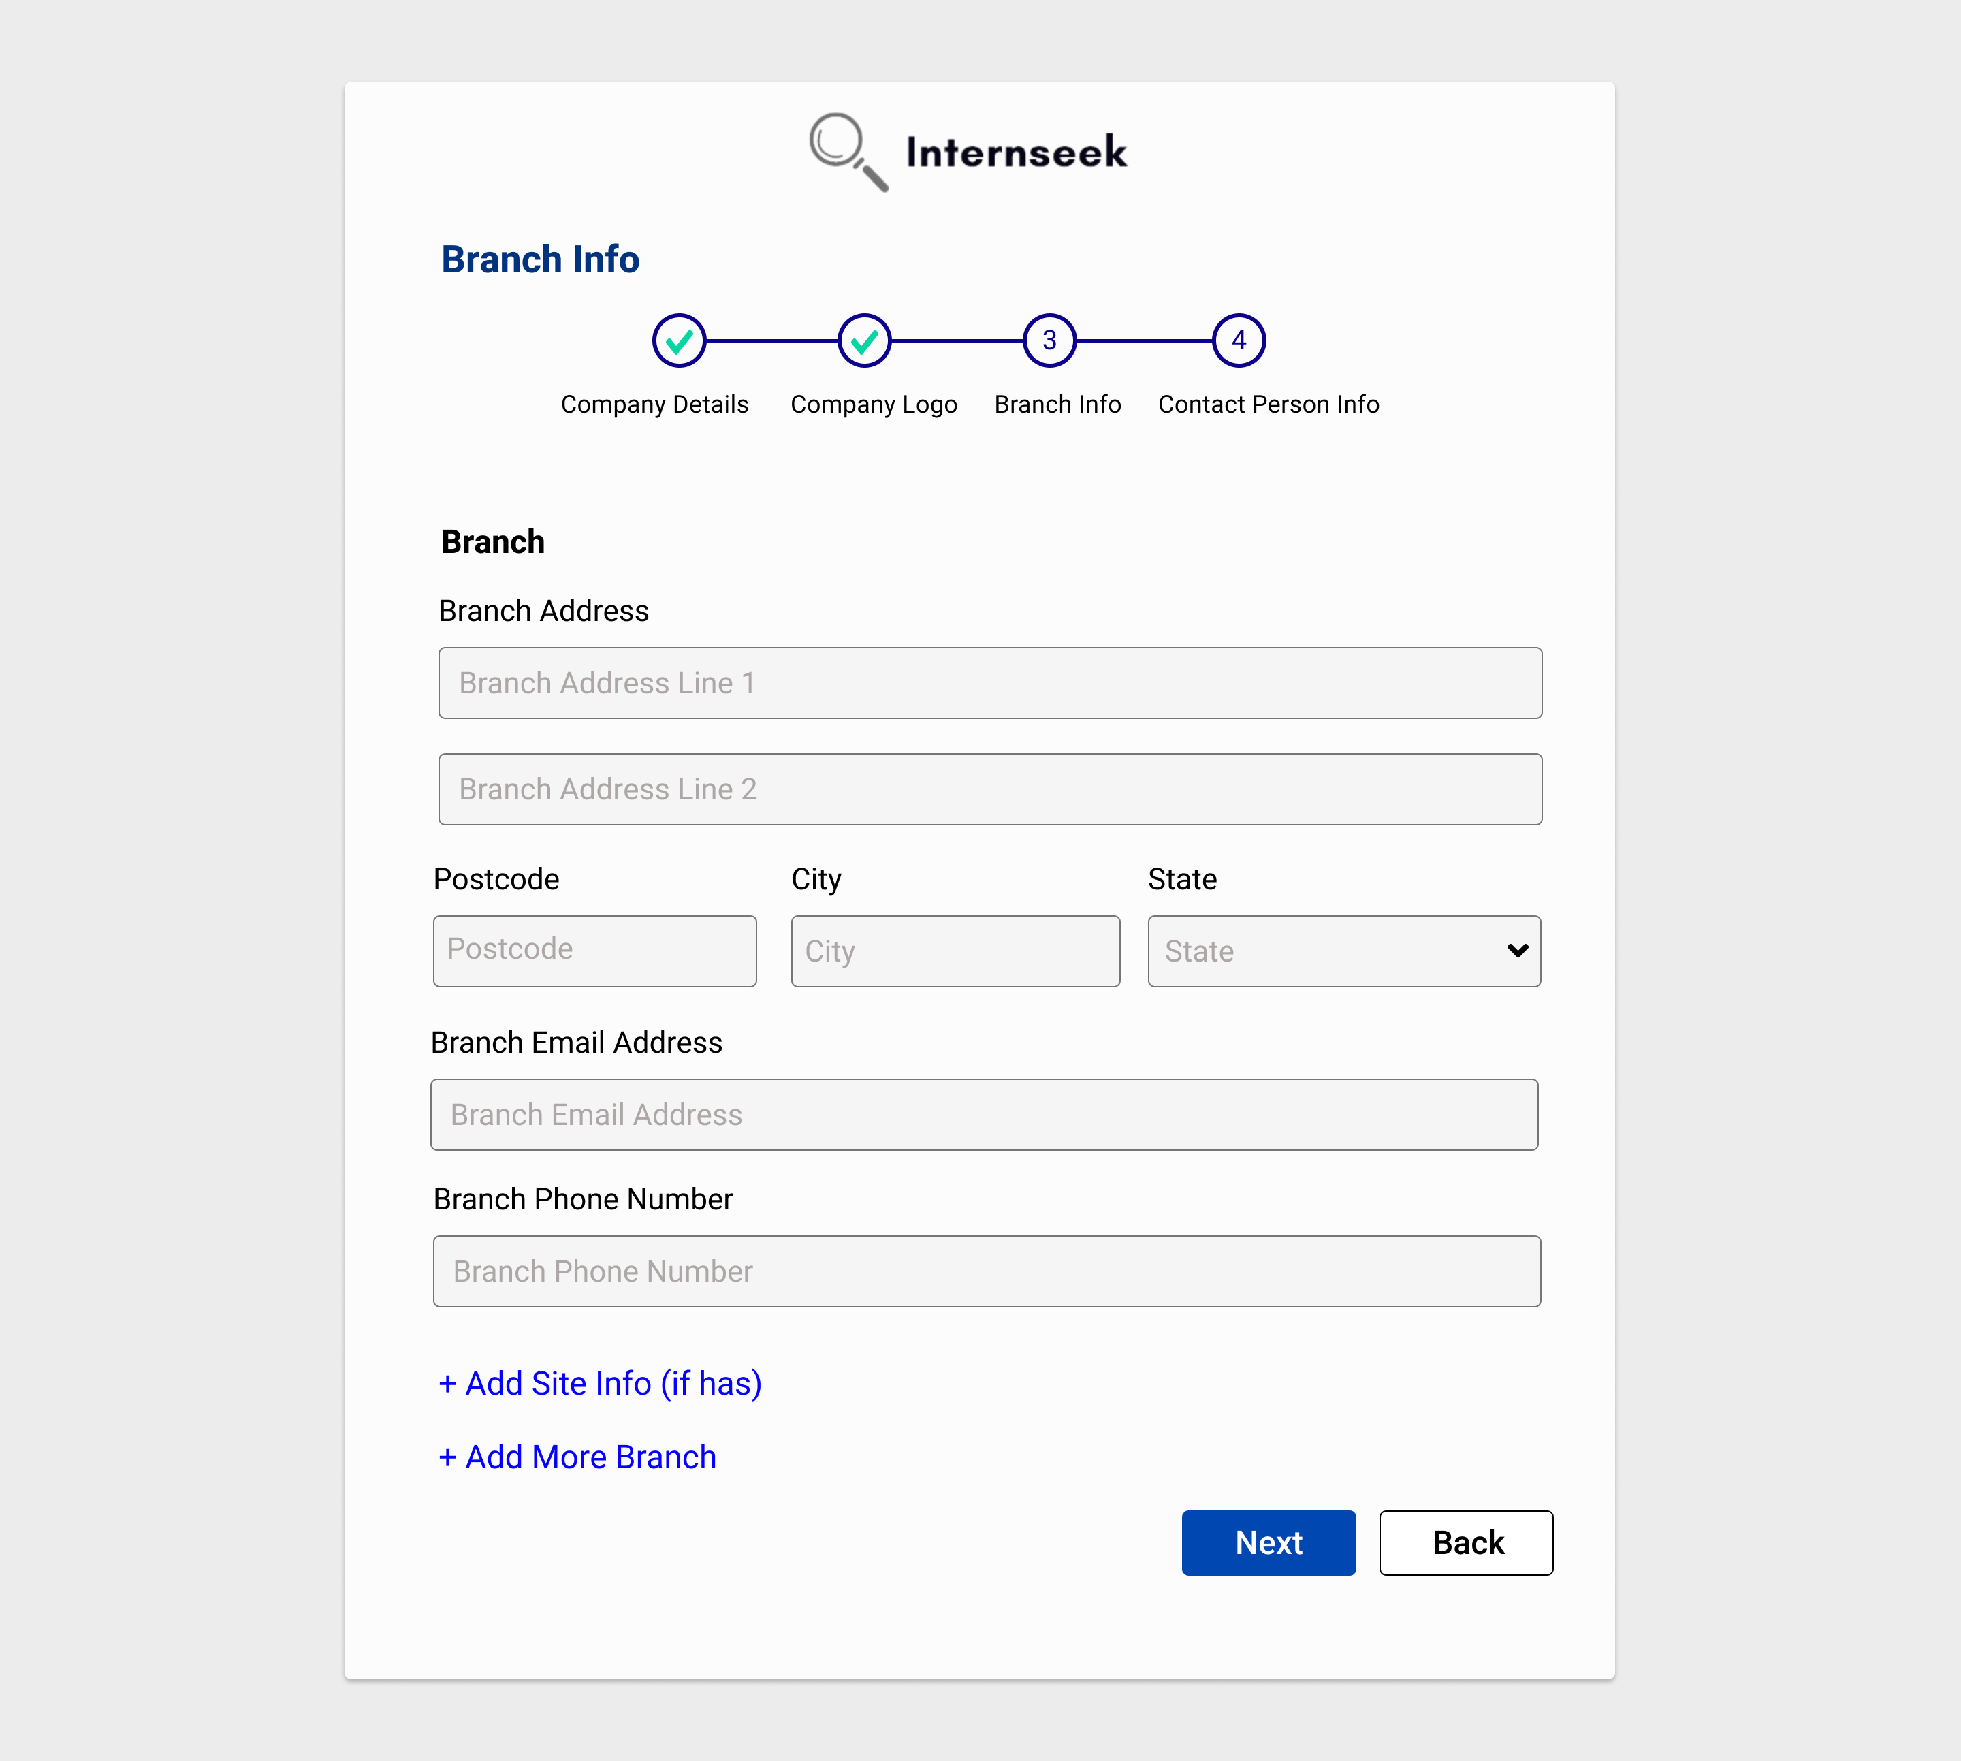

Figure 3‑195: Register Employer Page (Step 3: Add Branch)

This figure shows step 3 of the Register Employer page, where the employer clicks the Add Branch Info link, displaying the branch input fields. The employer then enters the required details in the provided input fields. If the employer needs to add site information, they can click the Add Site Info link. To add more branch information, the employer can click the Add More Branch link. After entering the branch information, they may click the <<Next>> button to proceed to the next step. To return to the previous step, the employer can click the <<Back>> button.

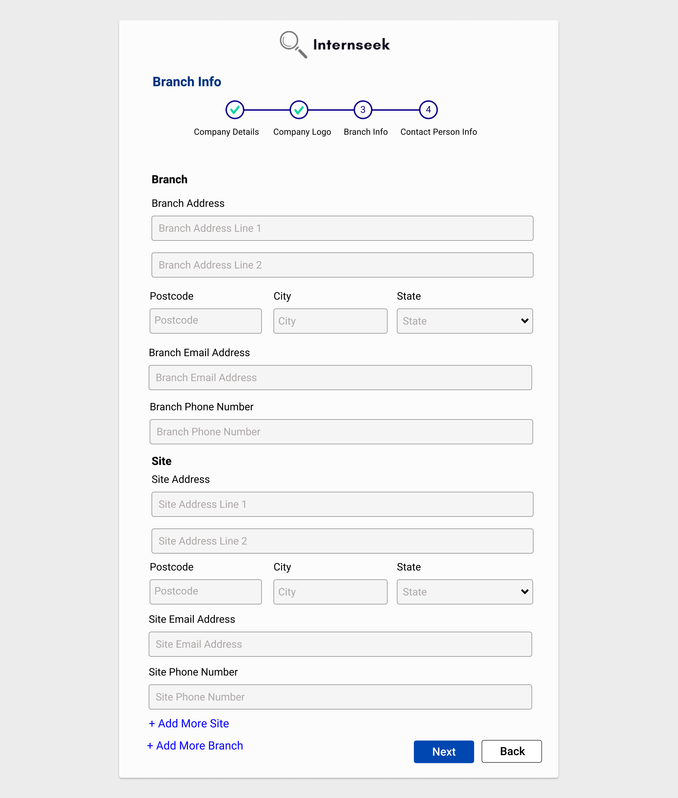

Figure 3‑196: Register Employer Page (Step 3: Add Site)

This figure shows step 3 of the Register Employer page, where the employer enters the branch info and clicks the Add Site Info link, displaying the site input fields. The employer then enters the required details in the provided input fields. If the employer needs to add another site information, they can click the Add More Site link. The employer can click the Add More Branch link to add more branch information. After entering the branch information, they may click the <<Next>> button to proceed to the next step. The employer can click the <<Back>> button to return to the previous step.

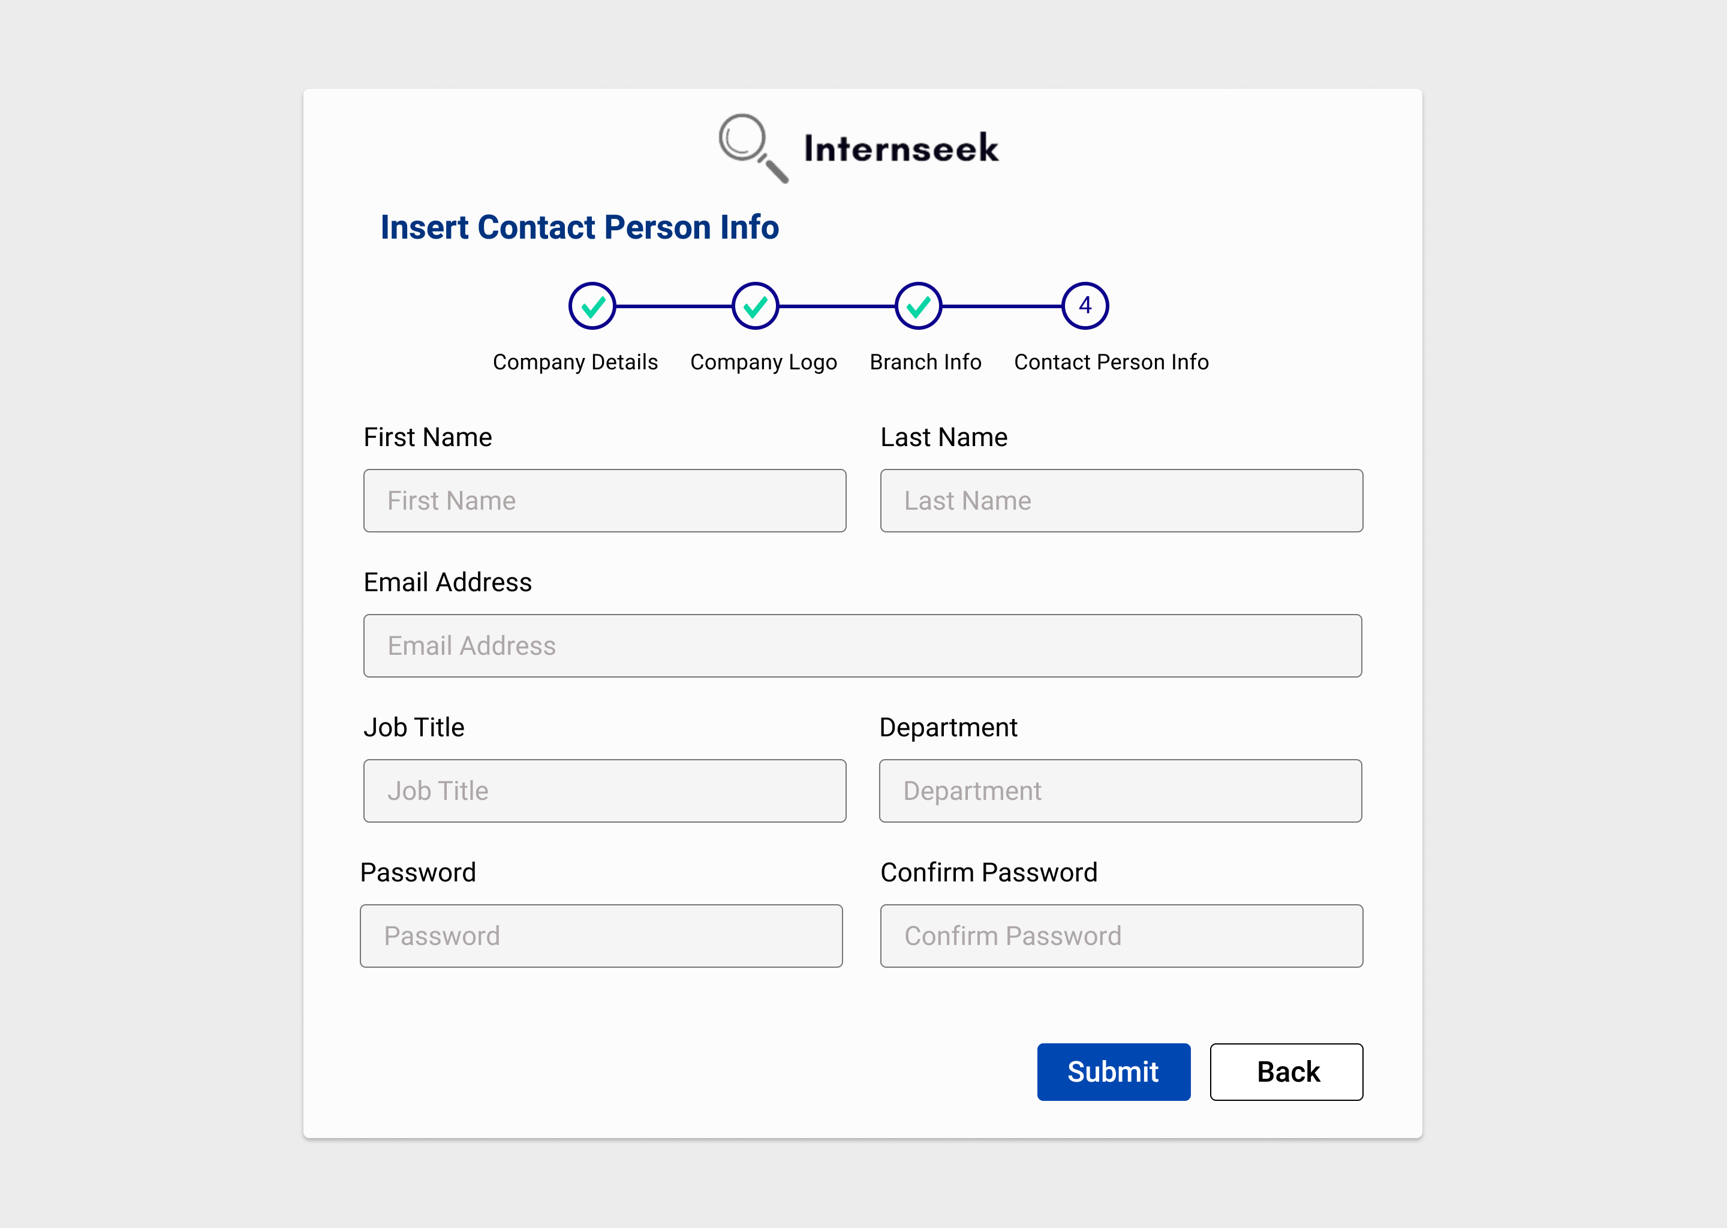

Figure 3‑197: Register Employer Page (Step 4)

This figure shows step 4 of the Register Employer page, which requires the employer to enter the contact person details. Once the employer enters the contact person details, they may click the <<Submit>> button to submit the account registration request. If the employer wants to go back to the previous step, they can click the <<Back>> button.

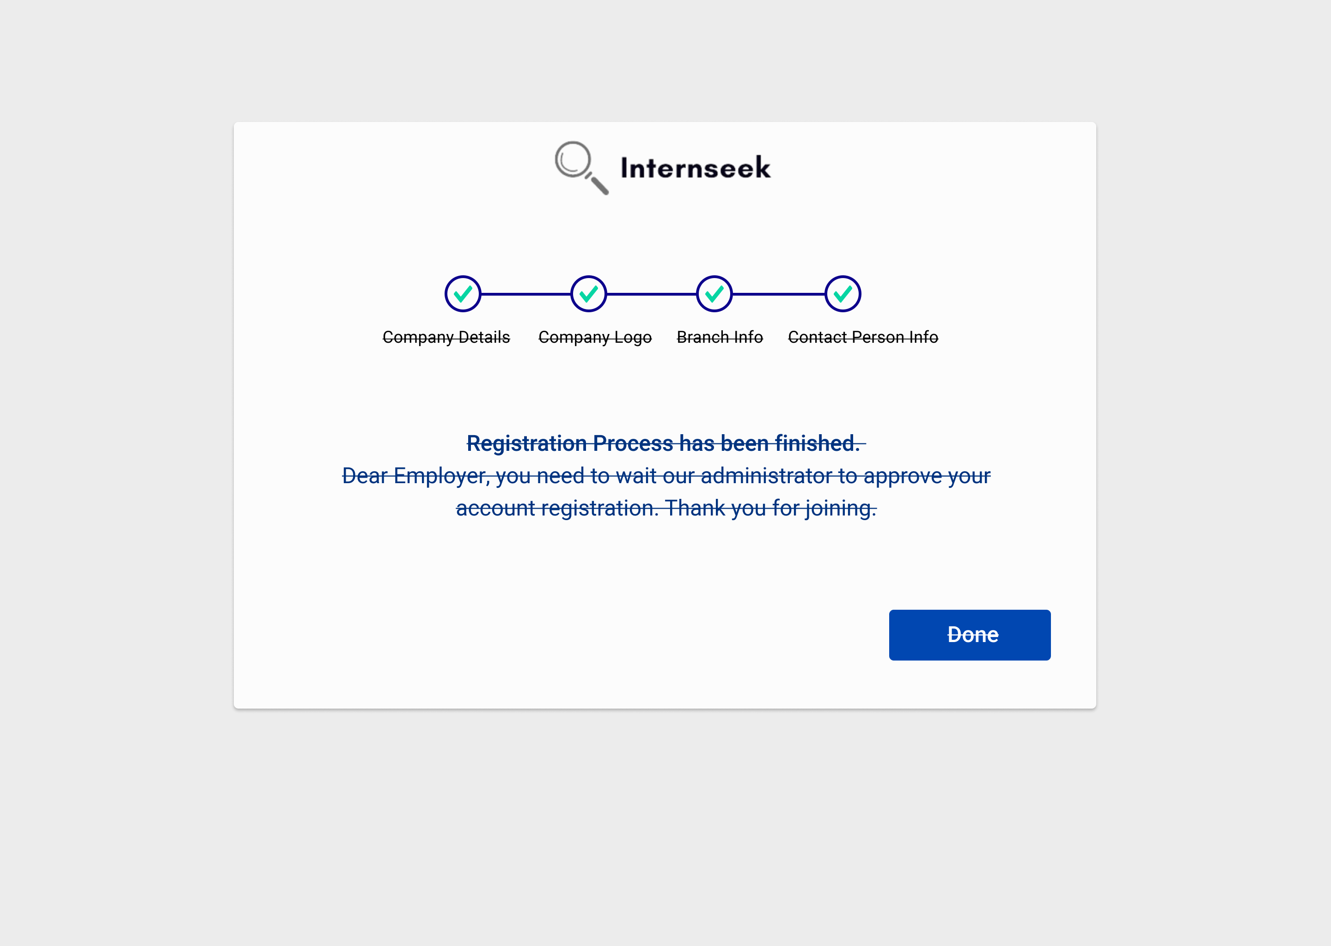

Figure 3‑198: Register Employer Page (Success Message)

This figure shows the Register Employer page displays a successful message, indicating the employer successfully completes the account registration process and the employer registration application has been submitted to the administrator.

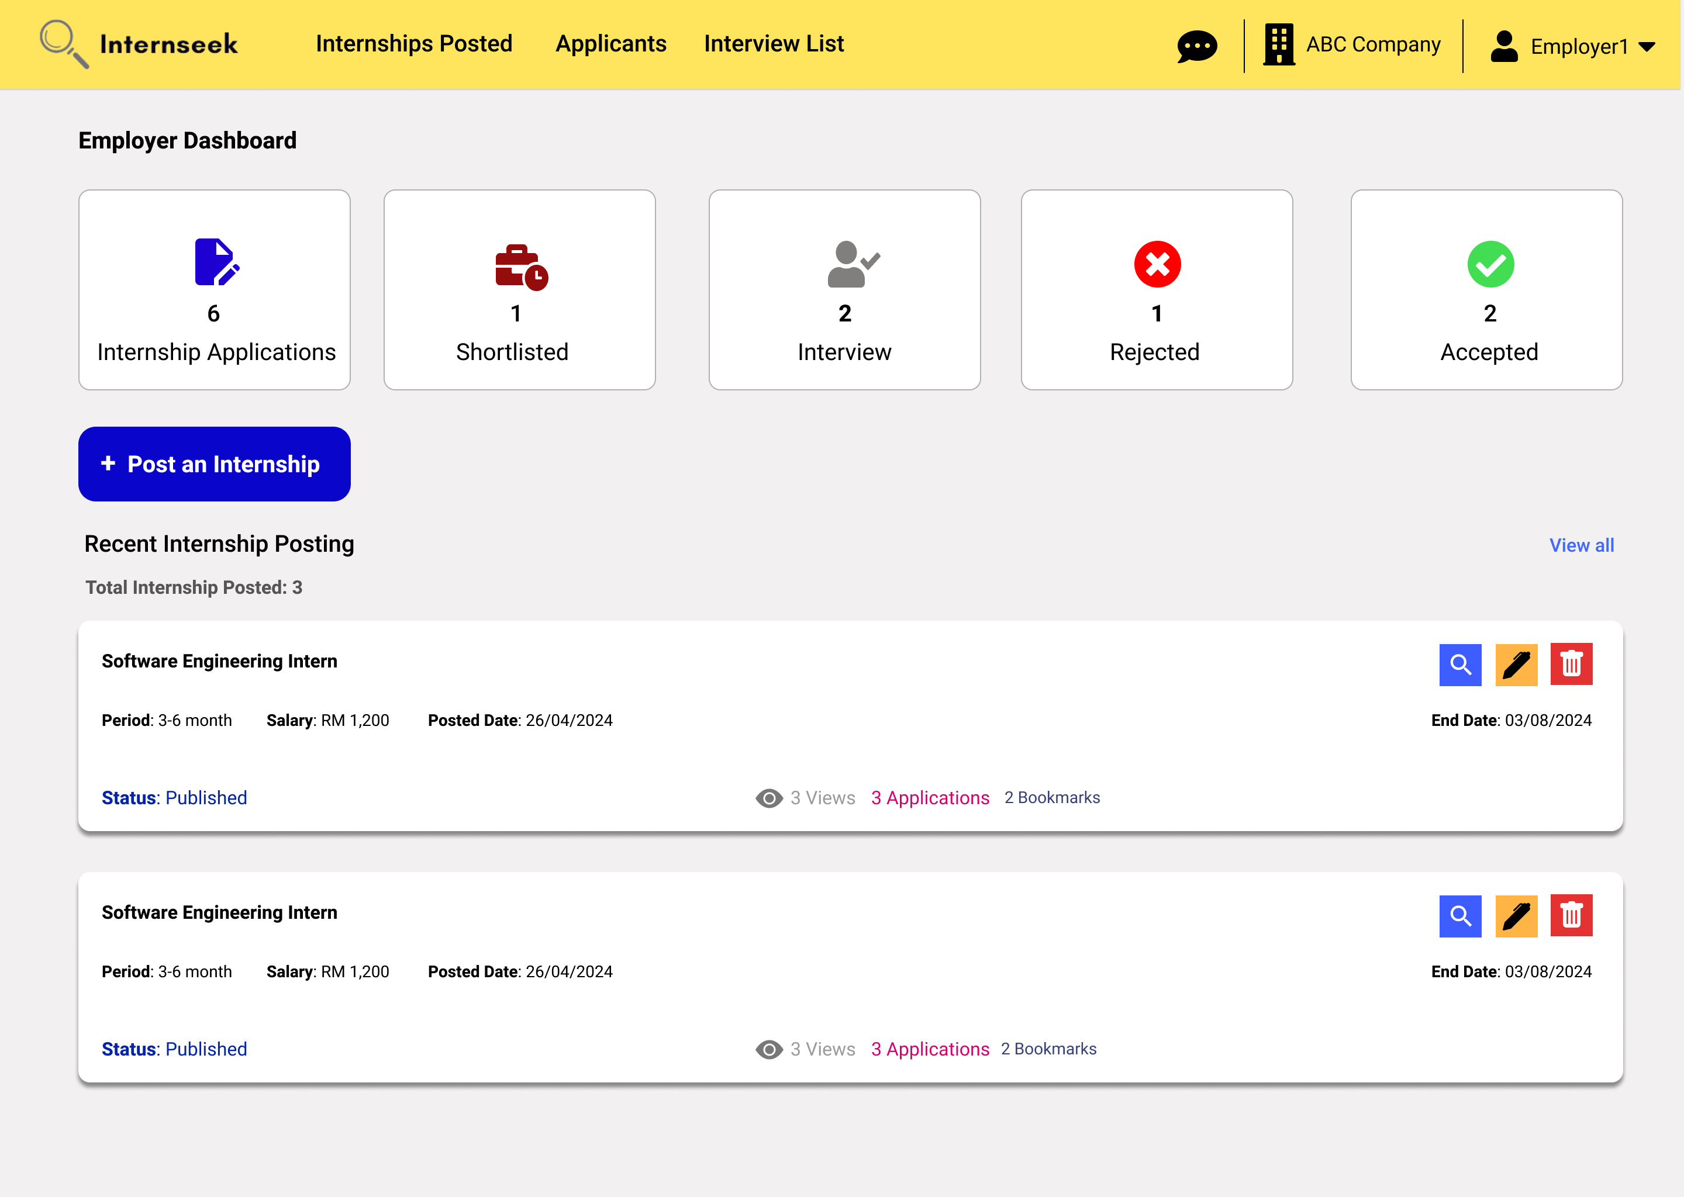

Figure 3‑199: Employer Dashboard

This figure shows the Employer Dashboard page once the employer successfully logs into the system. The employer dashboard displays the total number of applicants, the number of applicants who accept and reject the offer, shortlisted applicants, and need-to-interview applicants. These numbers represent a card. The employer dashboard also displays the recent internship postings created by the employer and the total internship postings created by the employer. The employer can click the <<view all>> button to access the created internship posting listing. The employer can click the <<Post an Internship>> button to create an internship posting. The employer can view or edit the specific recent internship posting details or delete the specific recent internship posting.

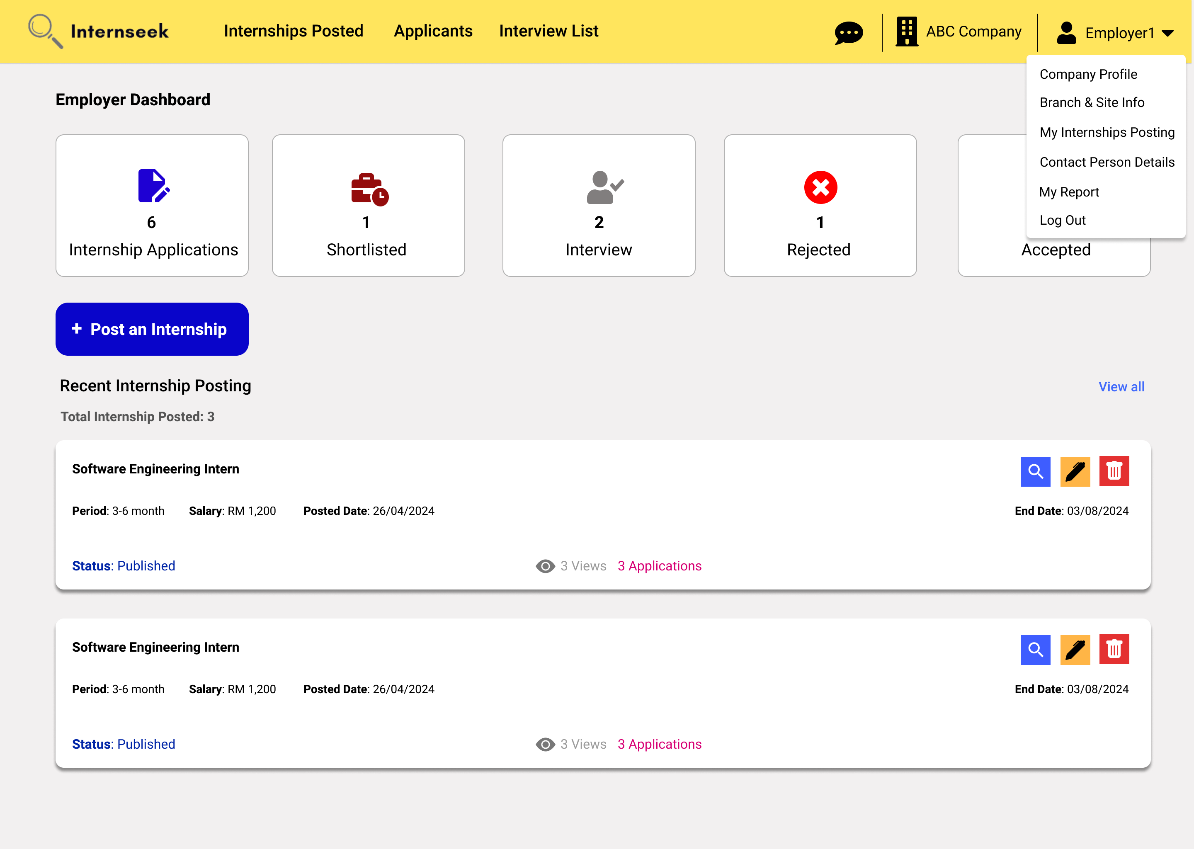

Figure 3‑200: Employer Dashboard with Drop-Down Menu

This figure displays the employer dashboard with the drop-down menu of the navigation bar, which consists of five options: Company Profile, Branch & Site Info, My Internship Posting, Contact Person Details, My Report, and Log Out. Employers will be directed to the My Report page once they select the My Report option. Employers will be directed to the company profile page once they select the company profile option. Employers will be directed to the branch & site info page once they select the Branch & Site Info option. Employers will be directed to the Contact Person Details page once they select the Contact Person Details page. Employers will be directed to the internship postings list page once they select the My Internship Posting option. Employers will be logged out of the system once they select the Log Out option.

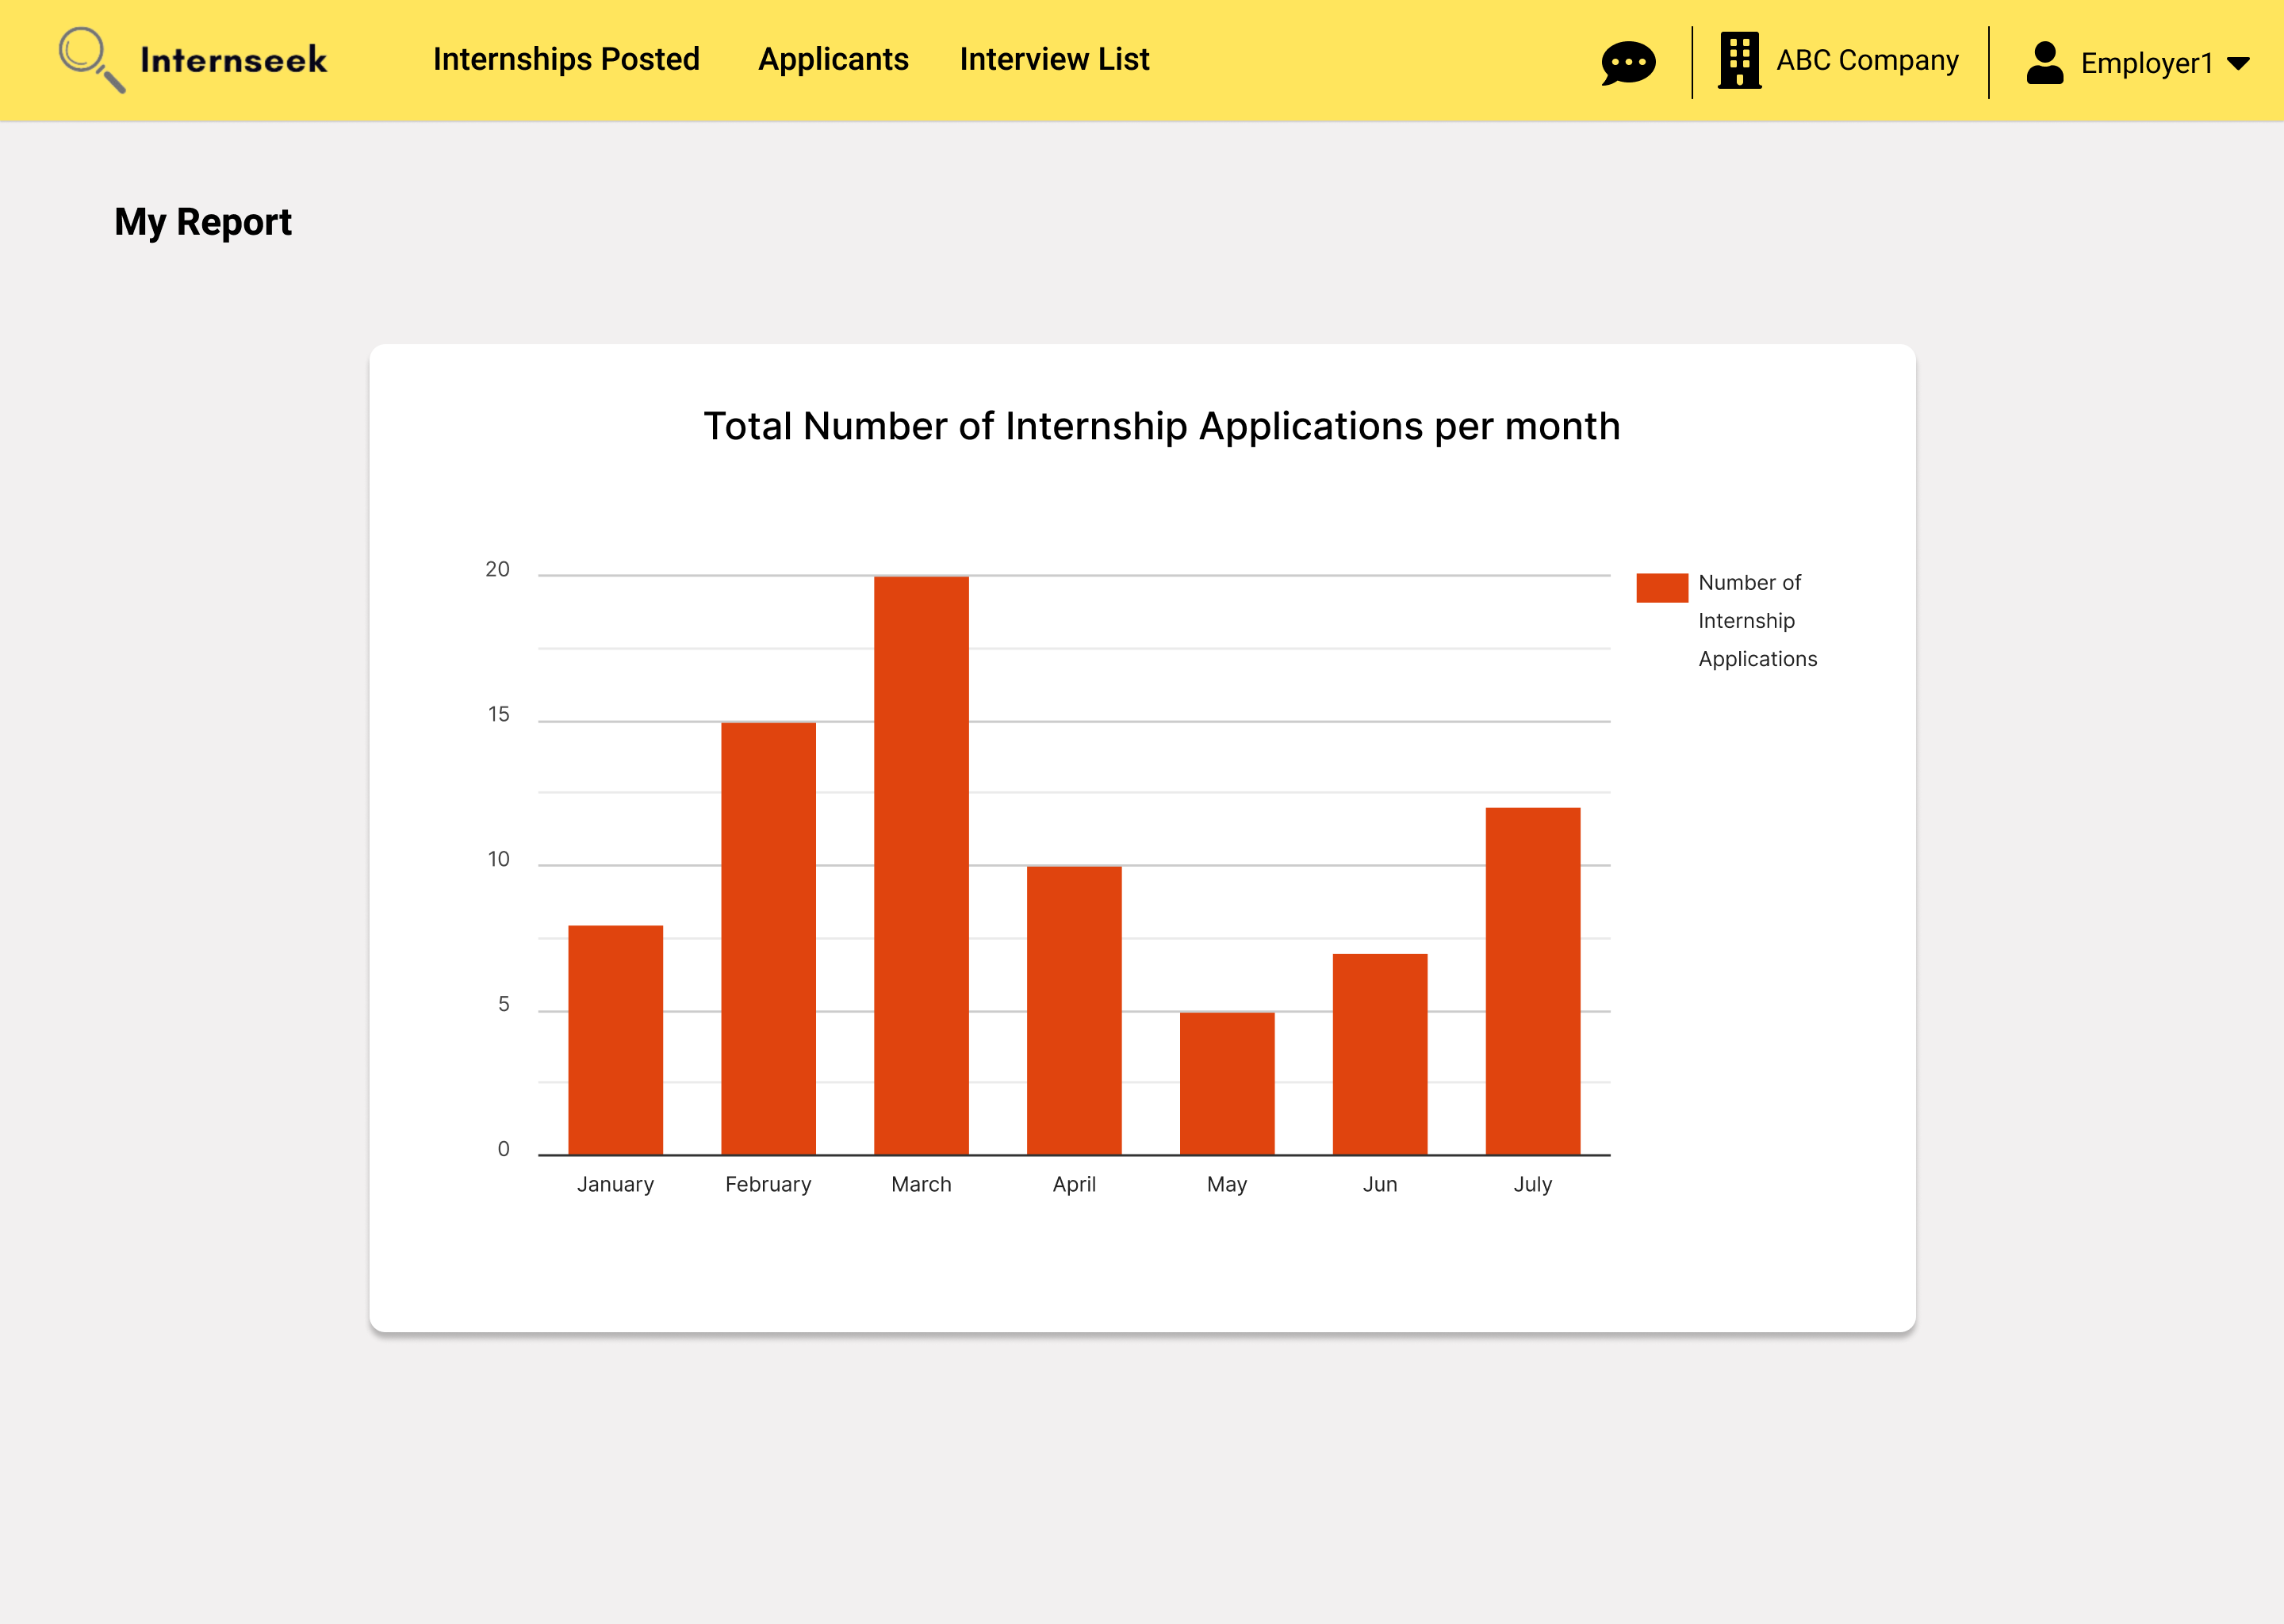

Figure 3‑201: My Report

This figure displays the My Report page. This page displays a graph bar regarding the total number of internship applications per month. The employer can observe how many applicants apply for internships each month. Based on the graph bar, the employer can determine which month has the most internship applications.

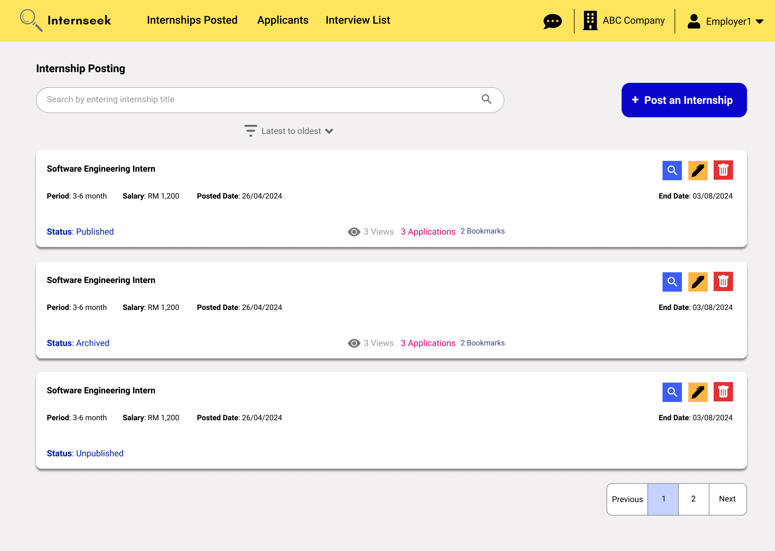

Figure 3‑202: Internship Postings List page

This figure shows the internship postings list page, which displays all the internships posted by the employer. On this page, the employer can keep track of the posting status of an internship. If the posting status is still being reviewed, it means the administrator still does not approve the posting. On this page, the employer can view the popularity of the internship they posted, such as how many people view it, how many people bookmark it, and how many people apply for it. The employer can view the internship posting details by clicking the view icon button. The employer can edit the internship posting details by clicking the edit icon button. The employer can delete the internship posting by clicking the delete icon button. The employer can create an internship posting by clicking the <<Post an internship>> button. The employer can search and sort the internship postings to find the relevant ones.

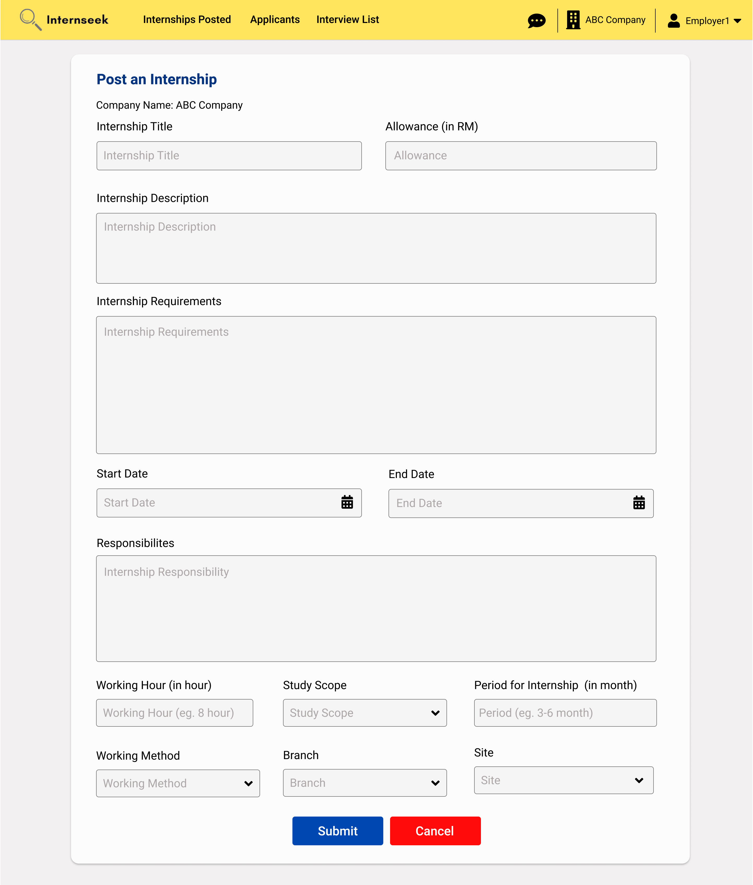

Figure 3‑203: Post an Internship Page

This figure shows the Post an Internship page once the employer clicks the <<Post an Internship>> button. Once the employer enters the internship posting details, they may click the <<Submit>> button to submit the internship posting request to the administrator. If the employer does not want to post an internship, they may click the <<Cancel>> button.

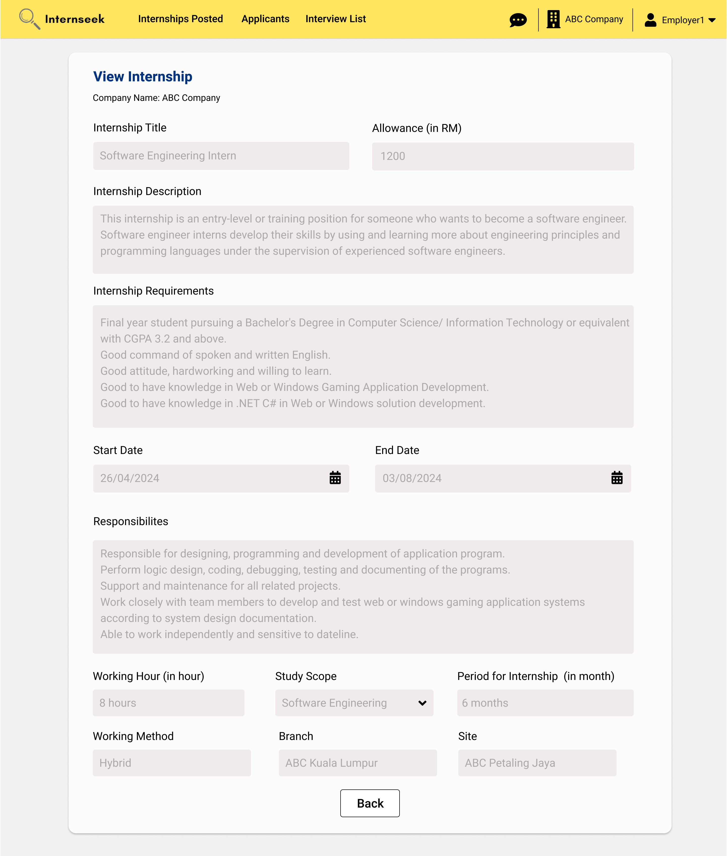

Figure 3‑204: View Internship Posting Details page

This figure shows the View Internship Posting Details page once the employer clicks the view icon button for the specific internship posting. The employer can view the internship posting details. Once they have completely viewed the internship posting details, they may click the <<Back>> button.

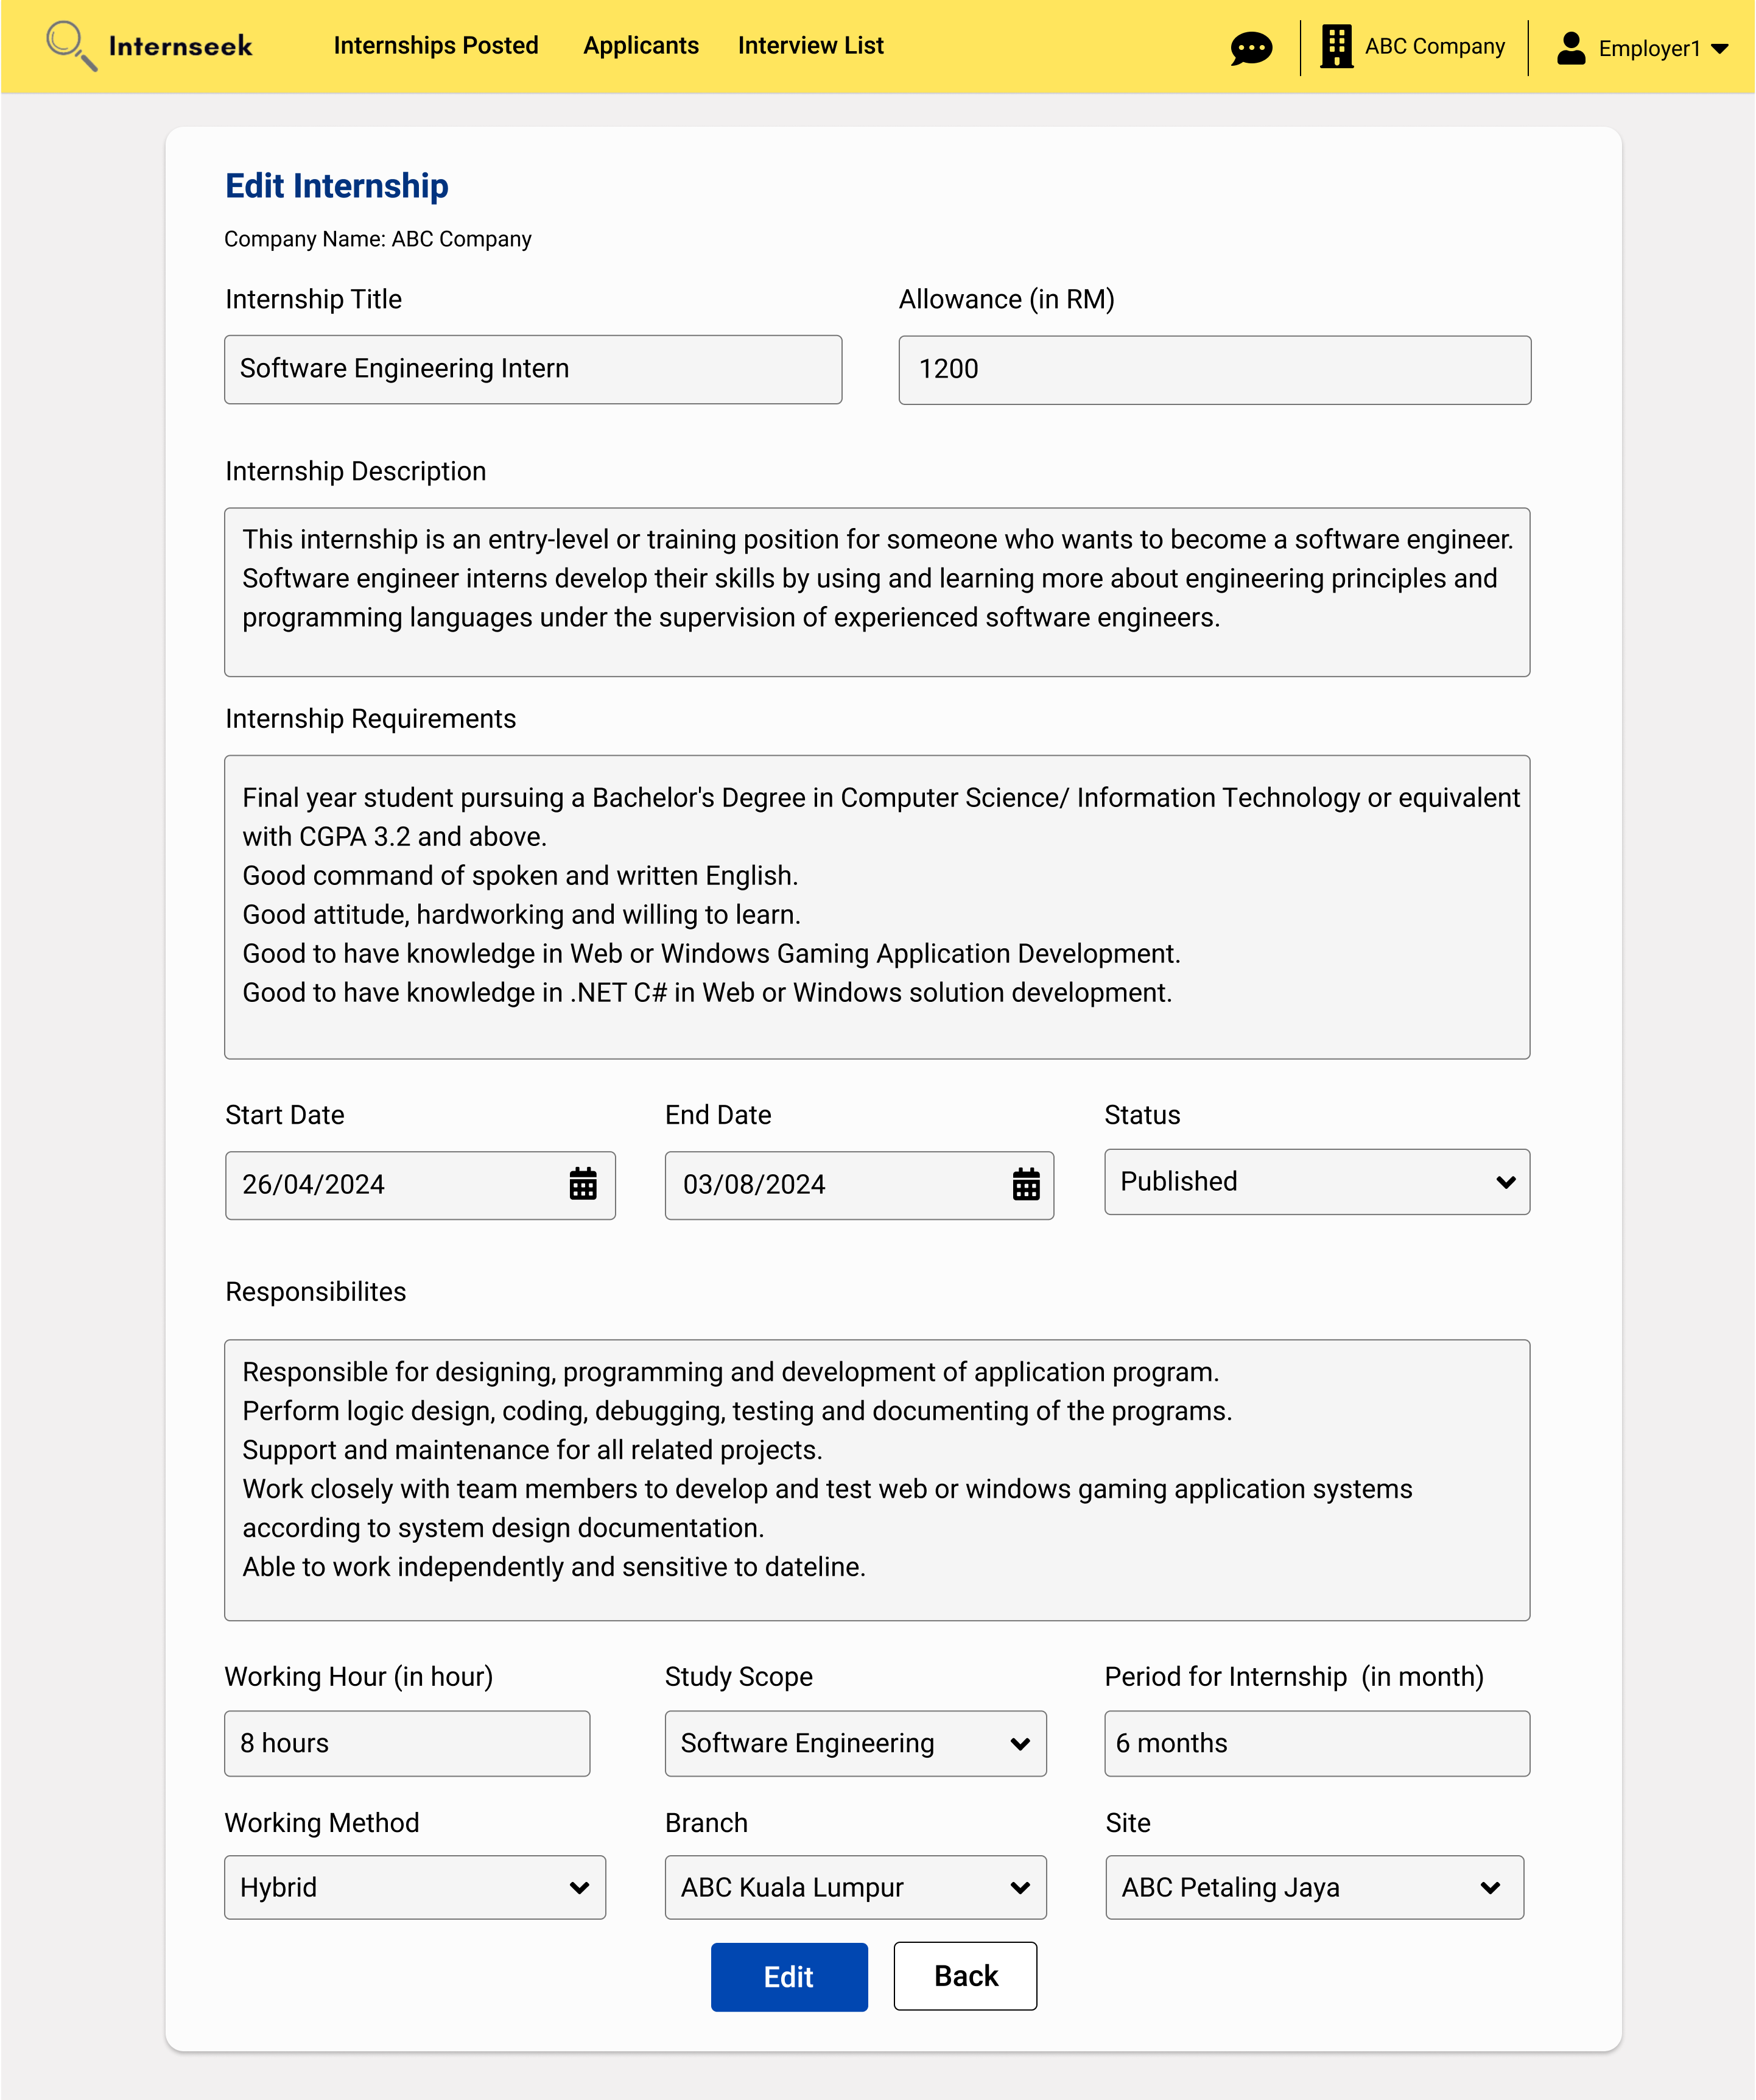

Figure 3‑205: Edit Internship Posting Details page (Approved)

This page displays the edit internship posting details page once the employer clicks the edit icon button for the specific internship posting. This page allows employers to modify various aspects of the internship posting. This page shows the internship posting with an approved status. Employers can update the status field to either published or unpublished. After making the necessary edits, employers can save the changes by clicking the <<Edit>> button. If the employer does not want to edit the internship posting details, they may click the <<Back>> button.

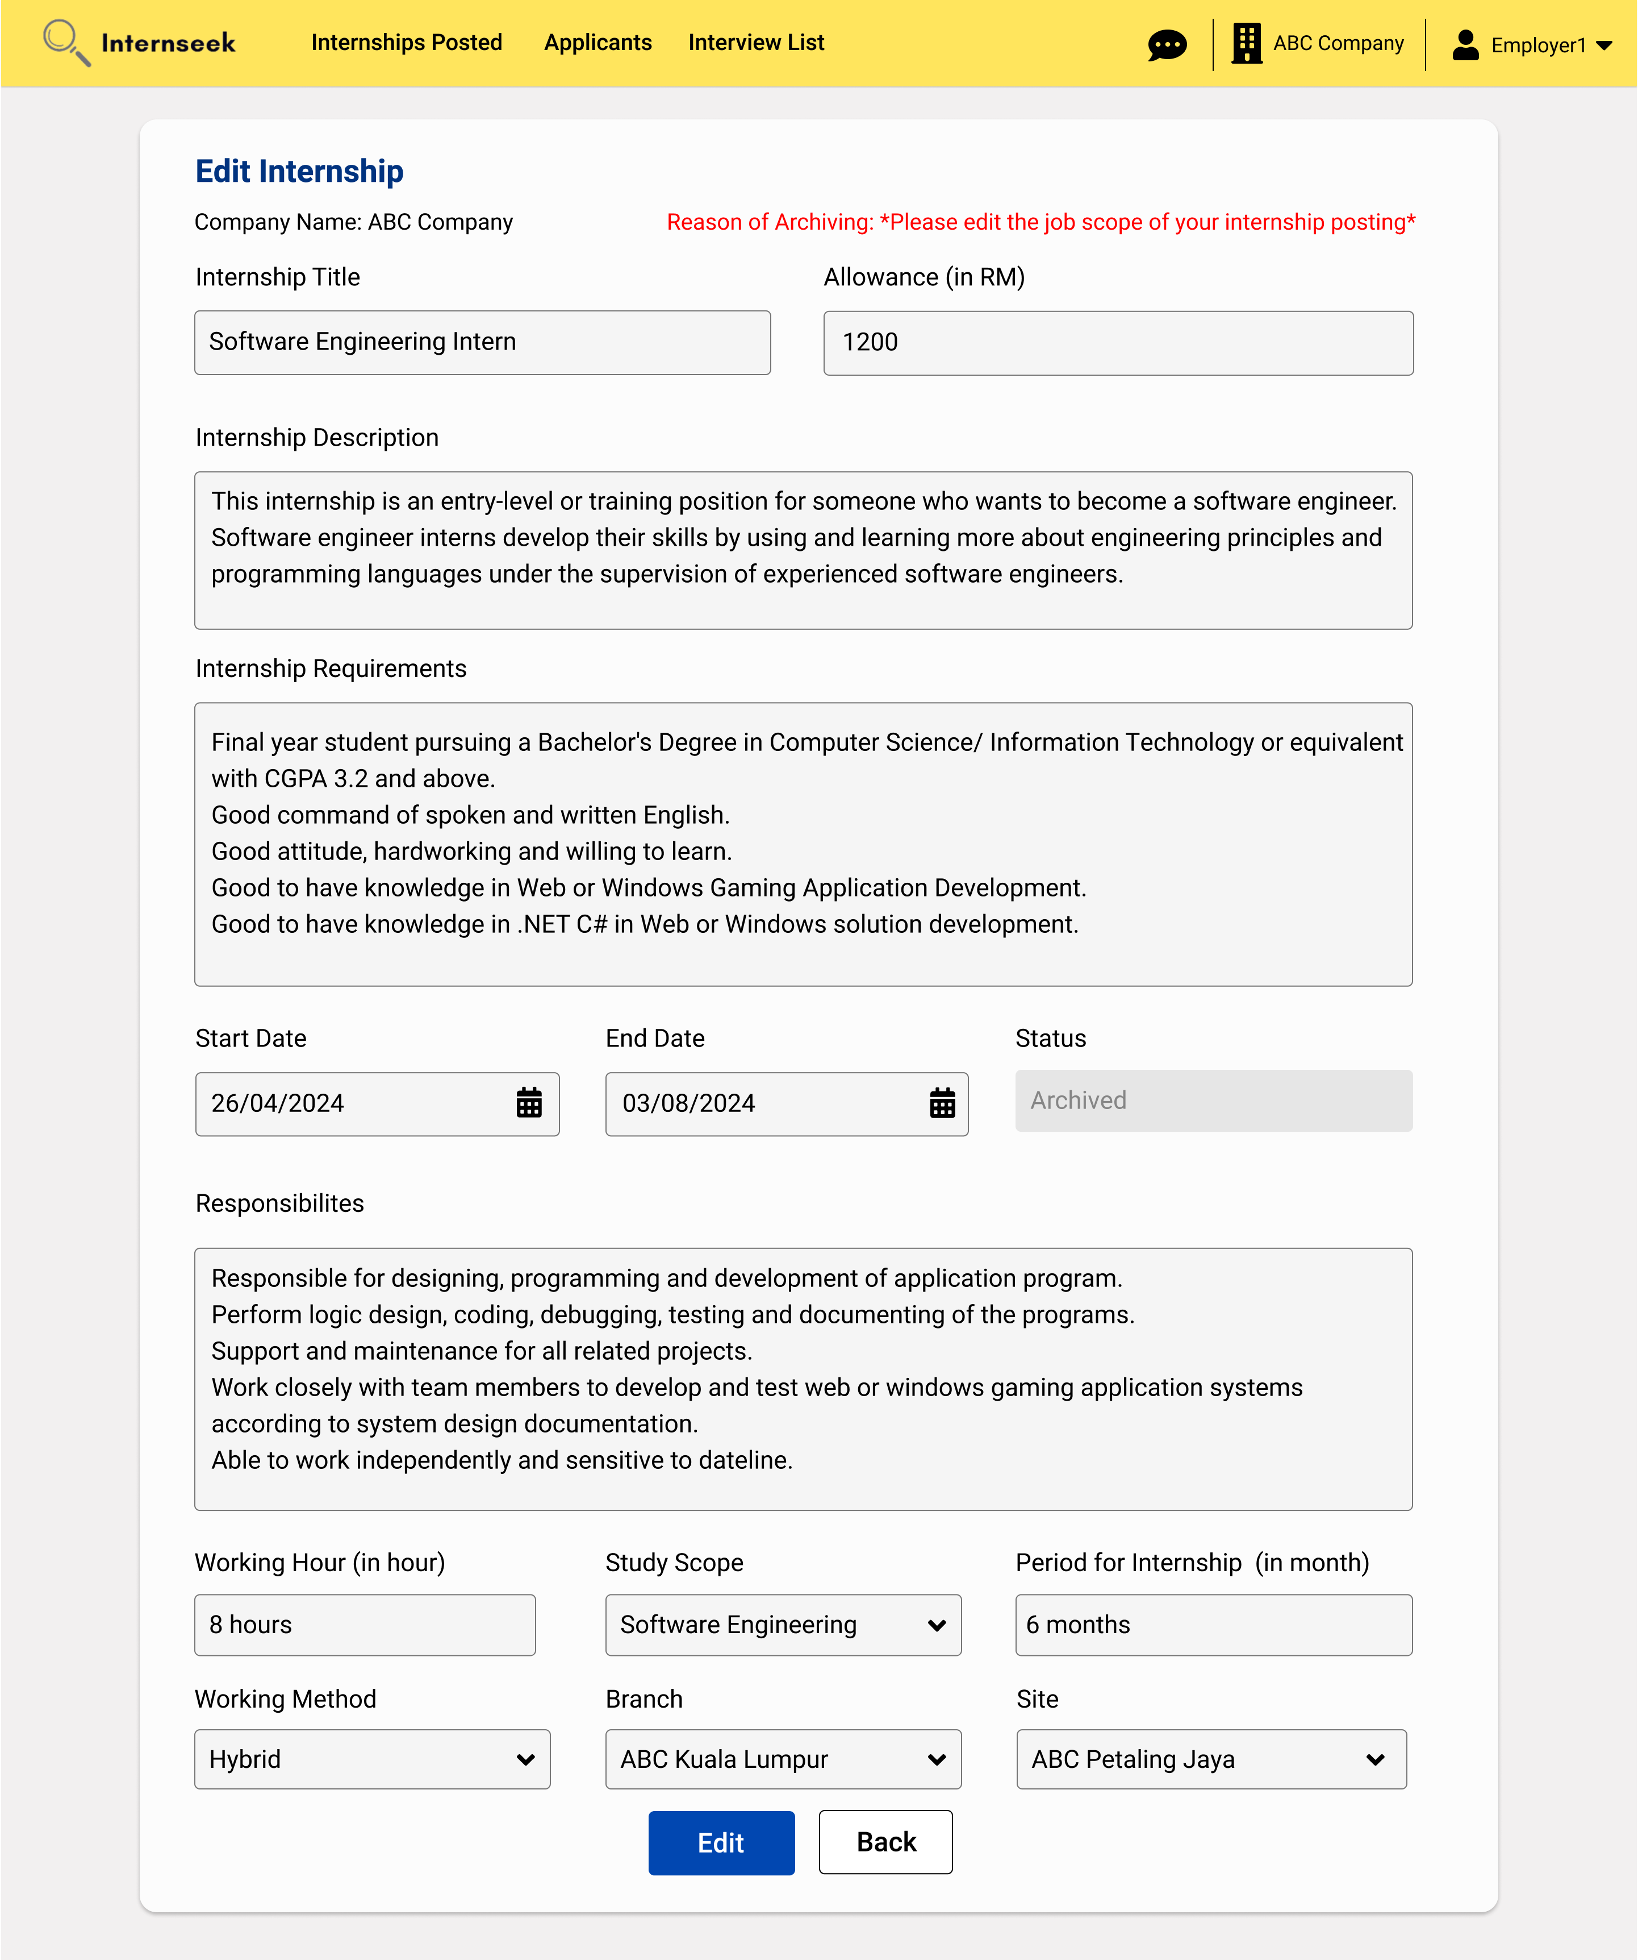

Figure 3‑206: Edit Internship Posting Details page (Archived)

This figure displays the edit internship posting details page when the employer clicks the edit icon button for the internship posting with the archived status. For postings with the archived status, employers need to view the reason provided by the system administrator for archiving the posting. Then, the employer must edit the information accordingly to allow the posting to be republished within the system until the posting end date.

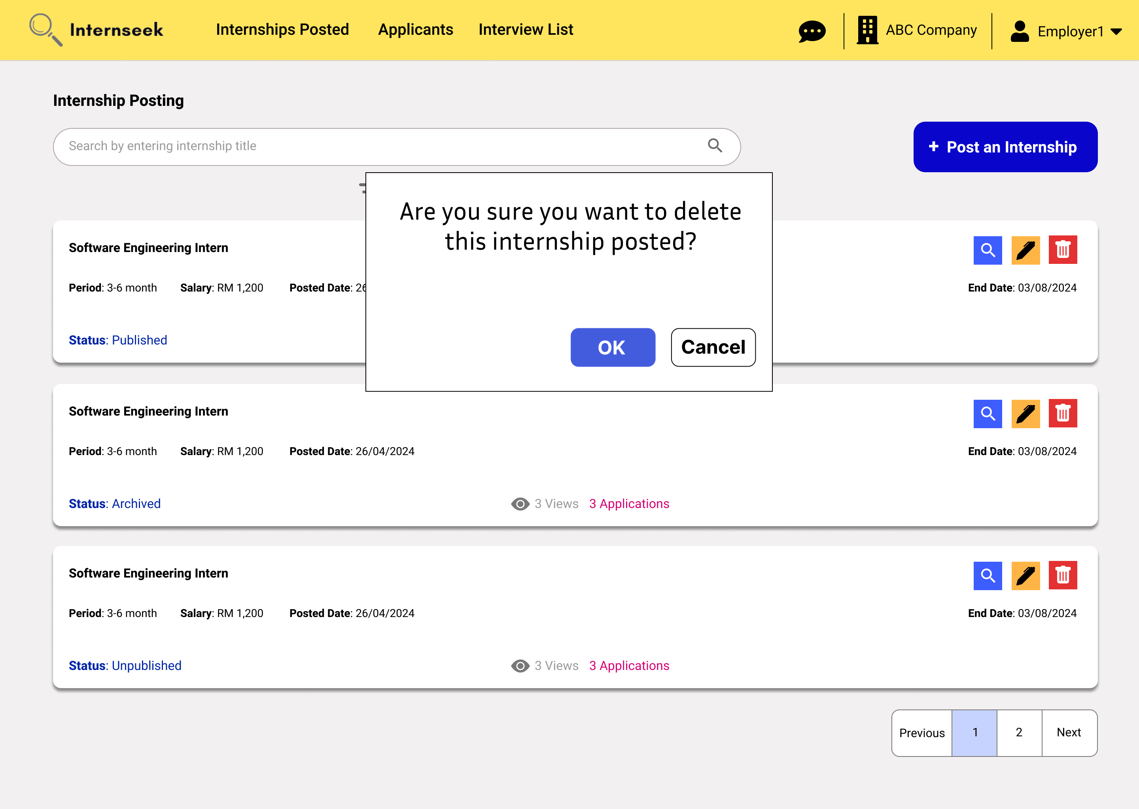

Figure 3‑207: Delete internship posting confirmation dialog

This figure displays the delete internship posting confirmation dialog to ask for confirmation of the deletion of the internship posting once the employer clicks the delete icon of the specific internship posting in the Internship Postings list page.

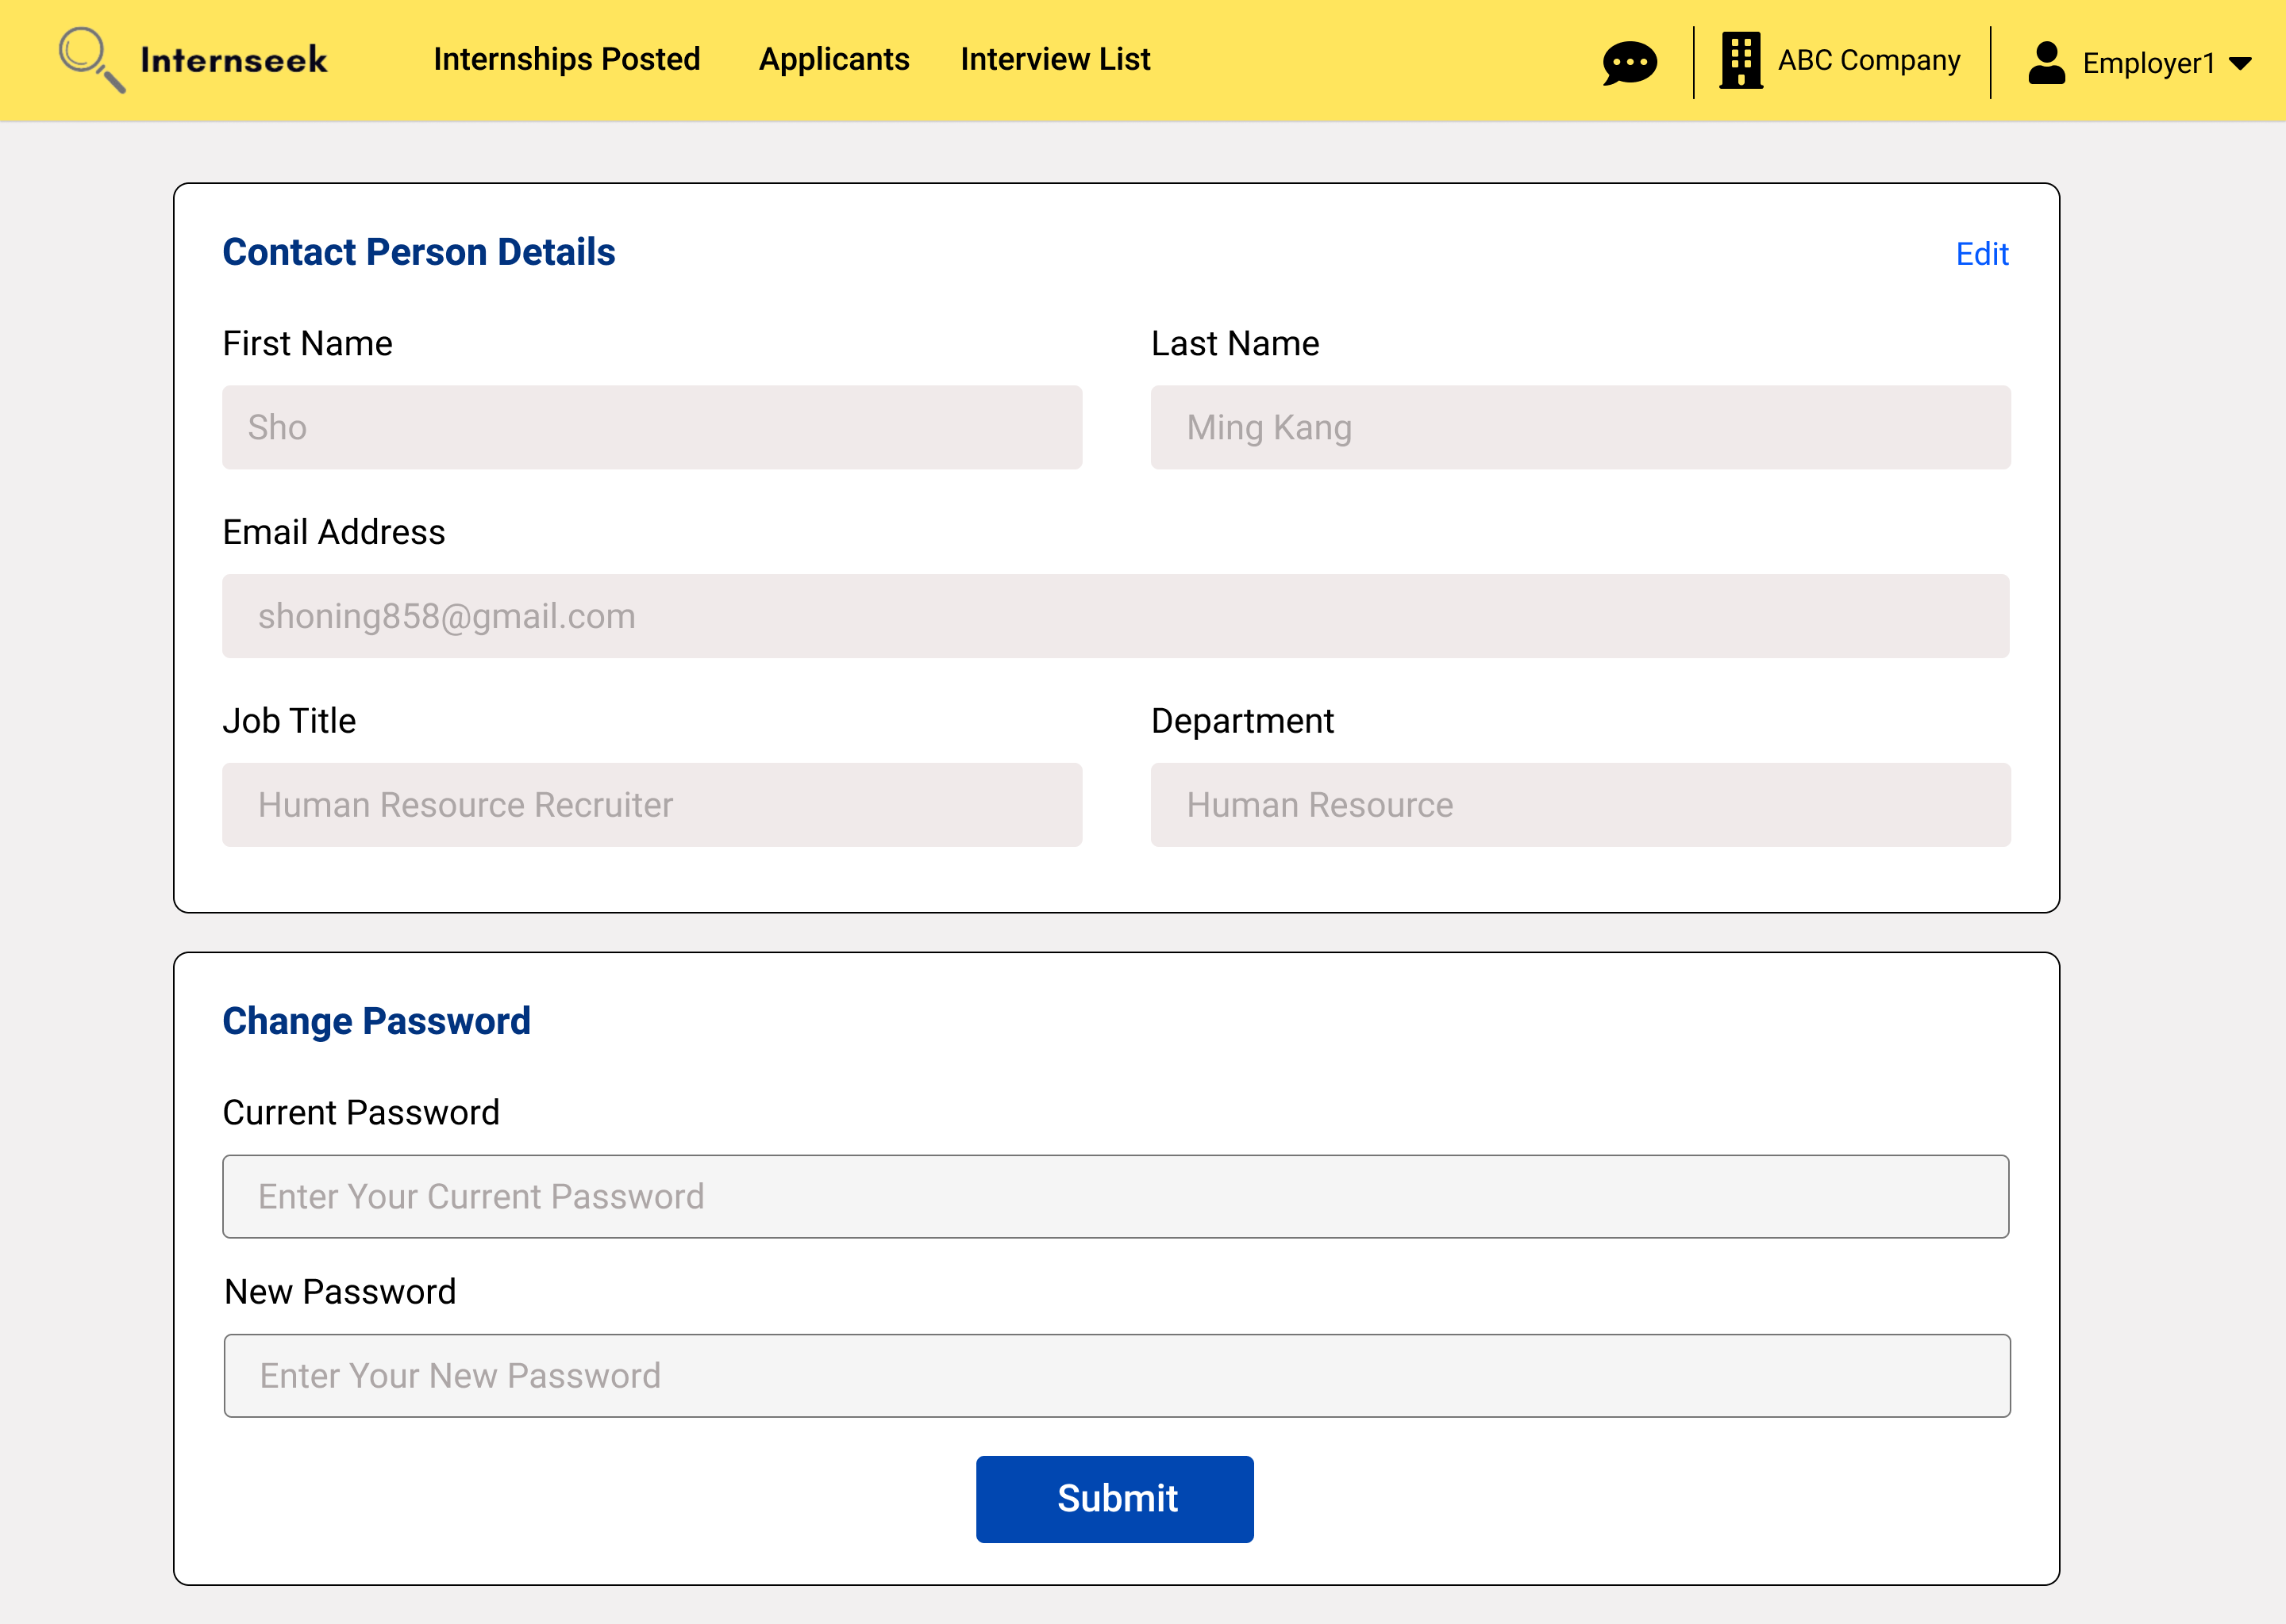

Figure 3‑208: Contact Person Details page

This figure displays the Contact Person Details page. This page consists of two forms: a form with contact person information and a change password form. The employer views the contact person details on this page. The employer can update their password after they enter the current password and the new password and click the <<Submit>> button in the change password form. The employer can also edit the contact person details on this page by clicking the <<Edit>> text to enable the input field.

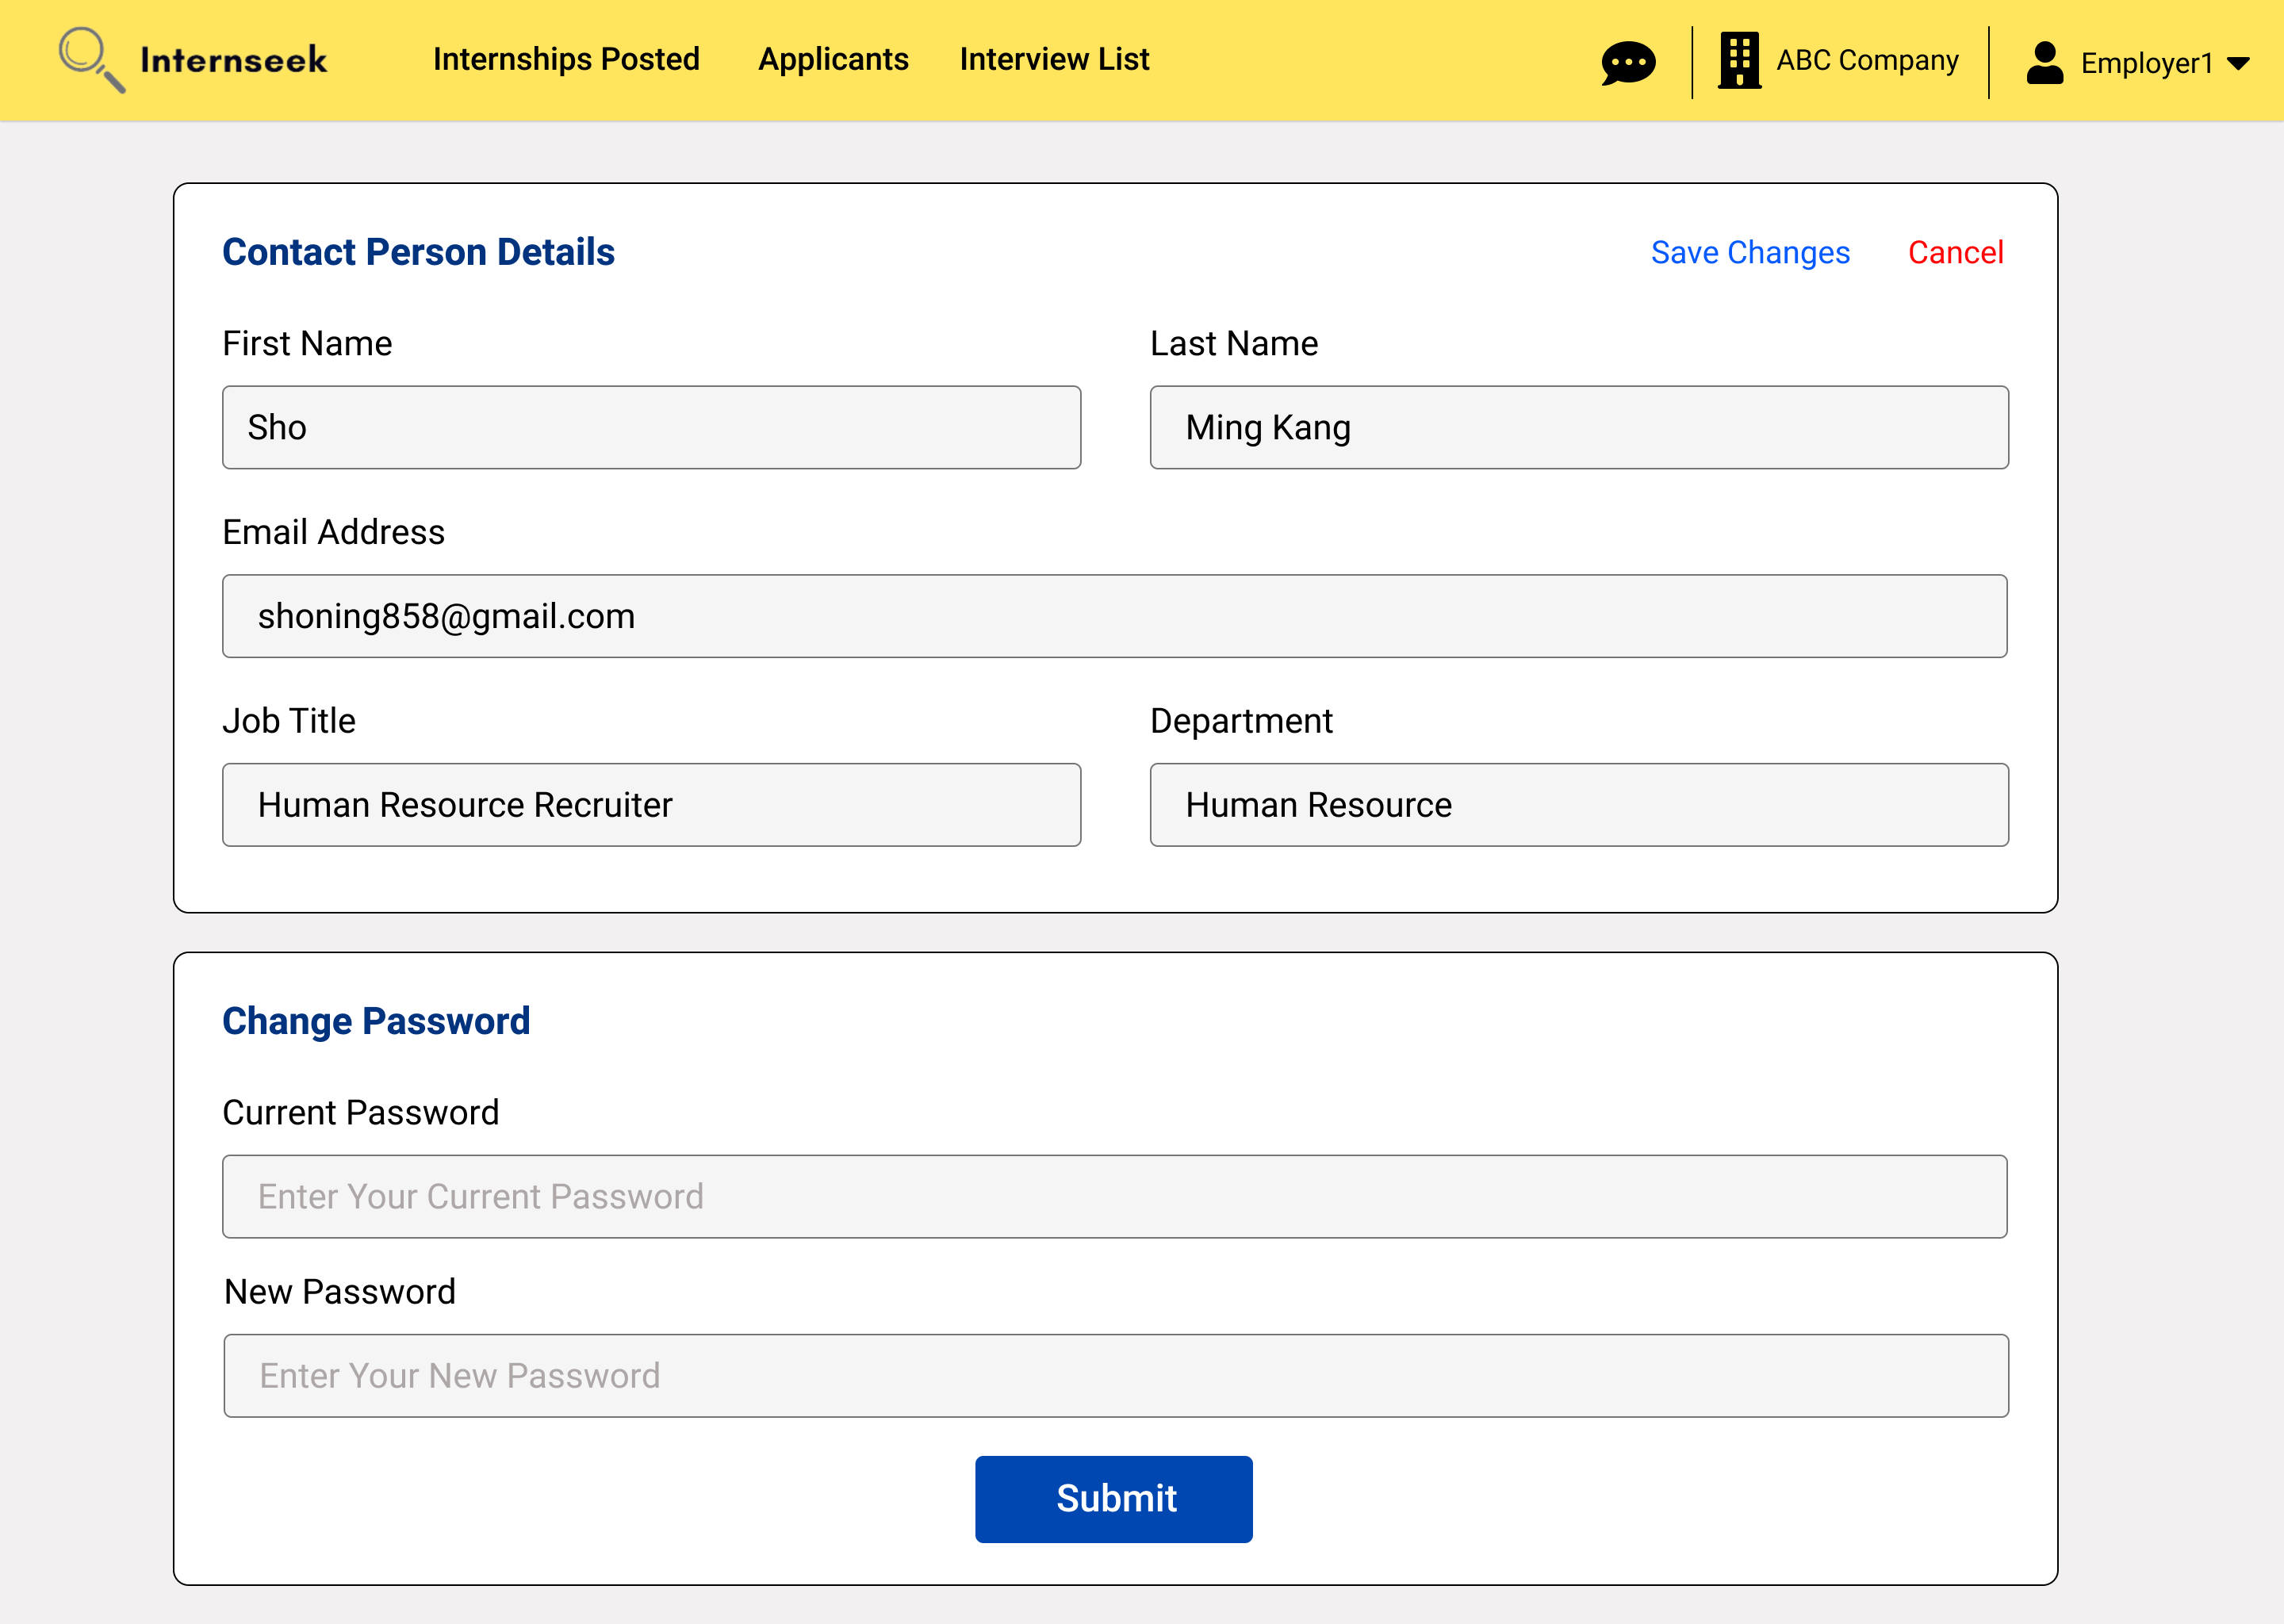

Figure 3‑209: Edit Contact Person Details

This figure displays the Contact Person Details page, where the employer can enter the contact person details they want to edit, then click the <<Save Changes>> text to update the contact person details. If the employer does not want to edit the contact person details, they may click the <<Cancel>> text.

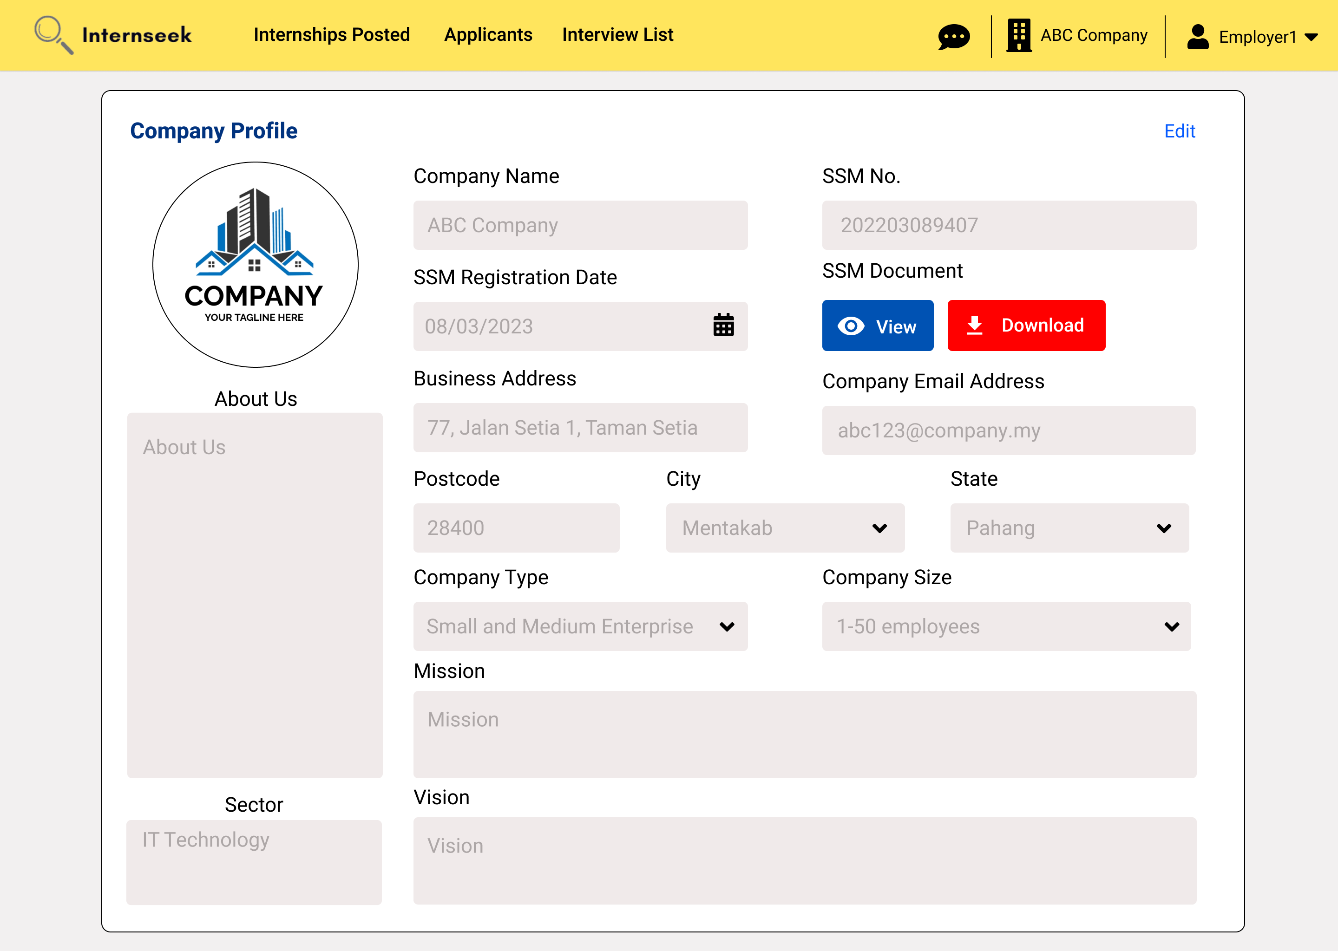

Figure 3‑210: Company Profile Details page

This page displays the Company Profile Details page. The employer views the company profile details on this page. The employer can edit the company profile details on this page by clicking the <<Edit>> text to enable the input field.

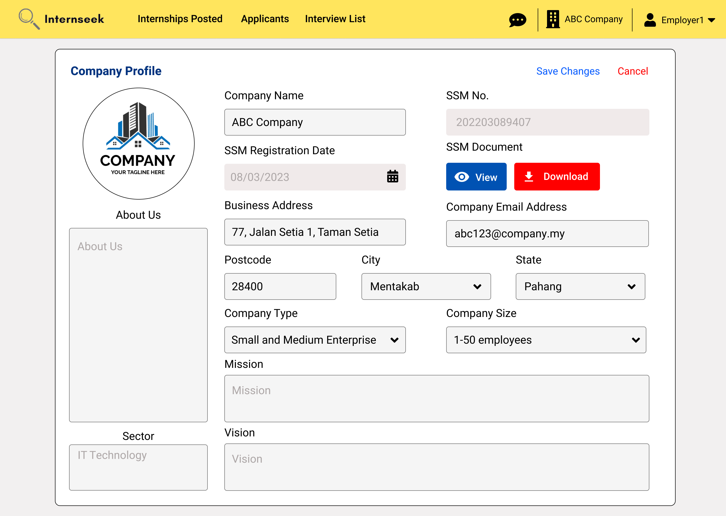

Figure 3‑211: Edit Company Profile Details

This figure displays the Company Profile Details page, where the employer can enter the company profile details they want to edit, then click the <<Save Changes>> text to update the company profile details. If the employer does not want to edit the company profile details, they may click the <<Cancel>> text.

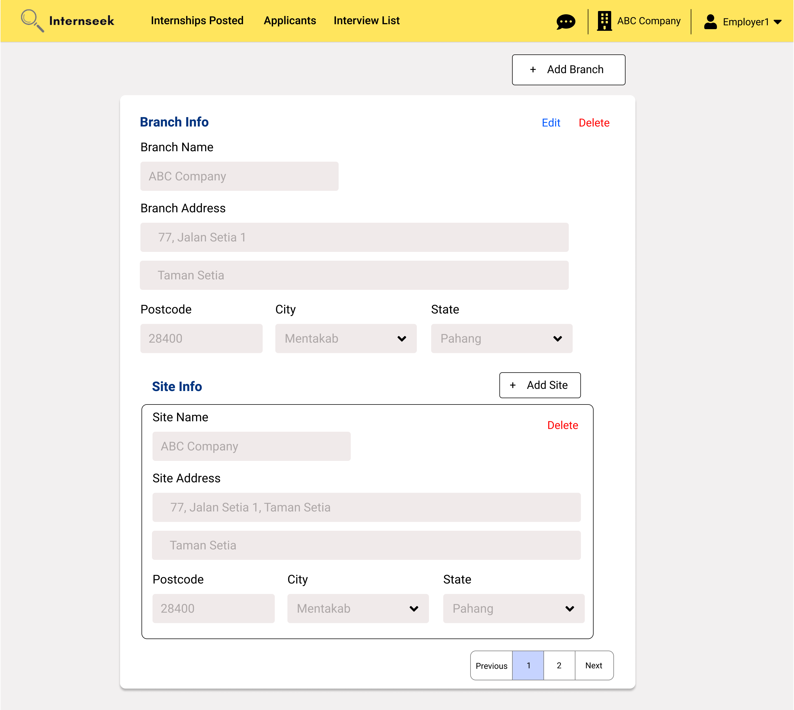

Figure 3‑212: Branch and Site Information Page

This figure displays the Branch and Site Information page. The employer views the branch and site details on this page. The employer can edit the branch and site details on this page by clicking the <<Edit>> text to enable the input field. The employer can also add a new branch by clicking the <<Add Branch>> button. The employer can click the <<Add Branch>> button to add a new site. The employer can click the delete text to delete the site or branch.

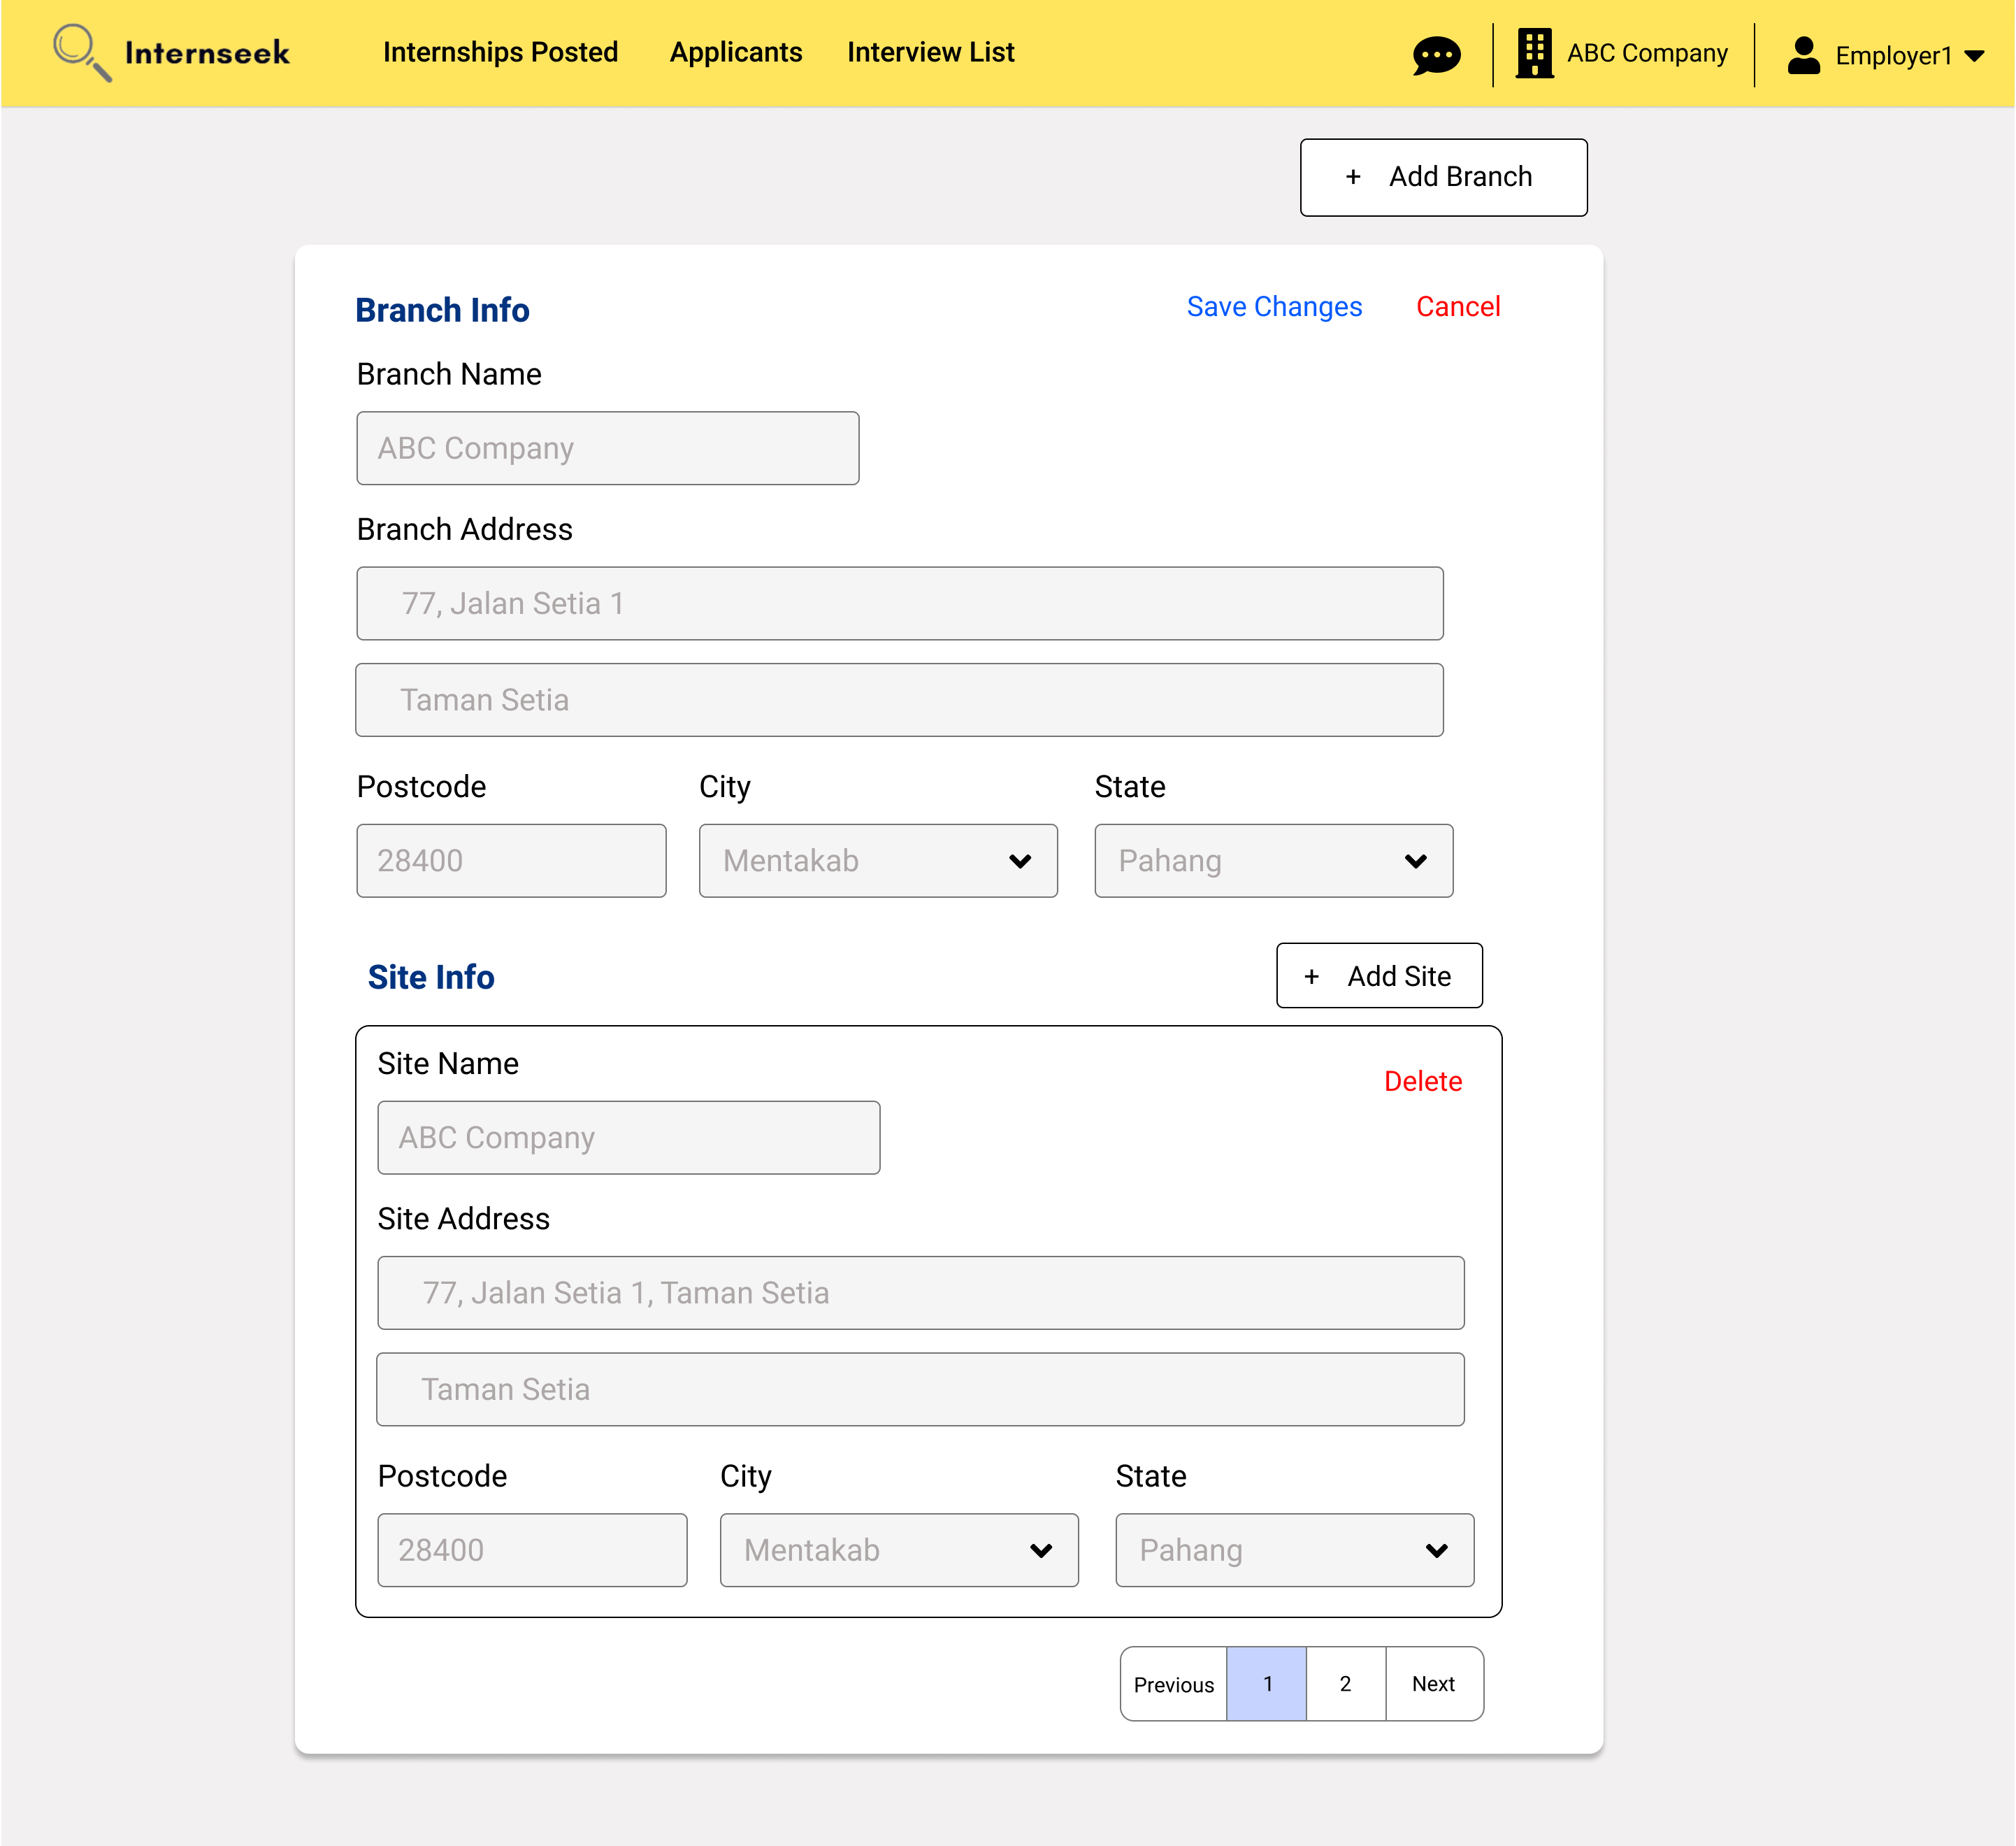

Figure 3‑213: Edit Branch and Site Information

This figure displays the Branch and Site Information page, where the employer can enter the branch and site details they want to edit, then click the <<Save Changes>> text to update the branch and site details. If the employer does not want to edit the branch and site details, they may click the <<Cancel>> text.

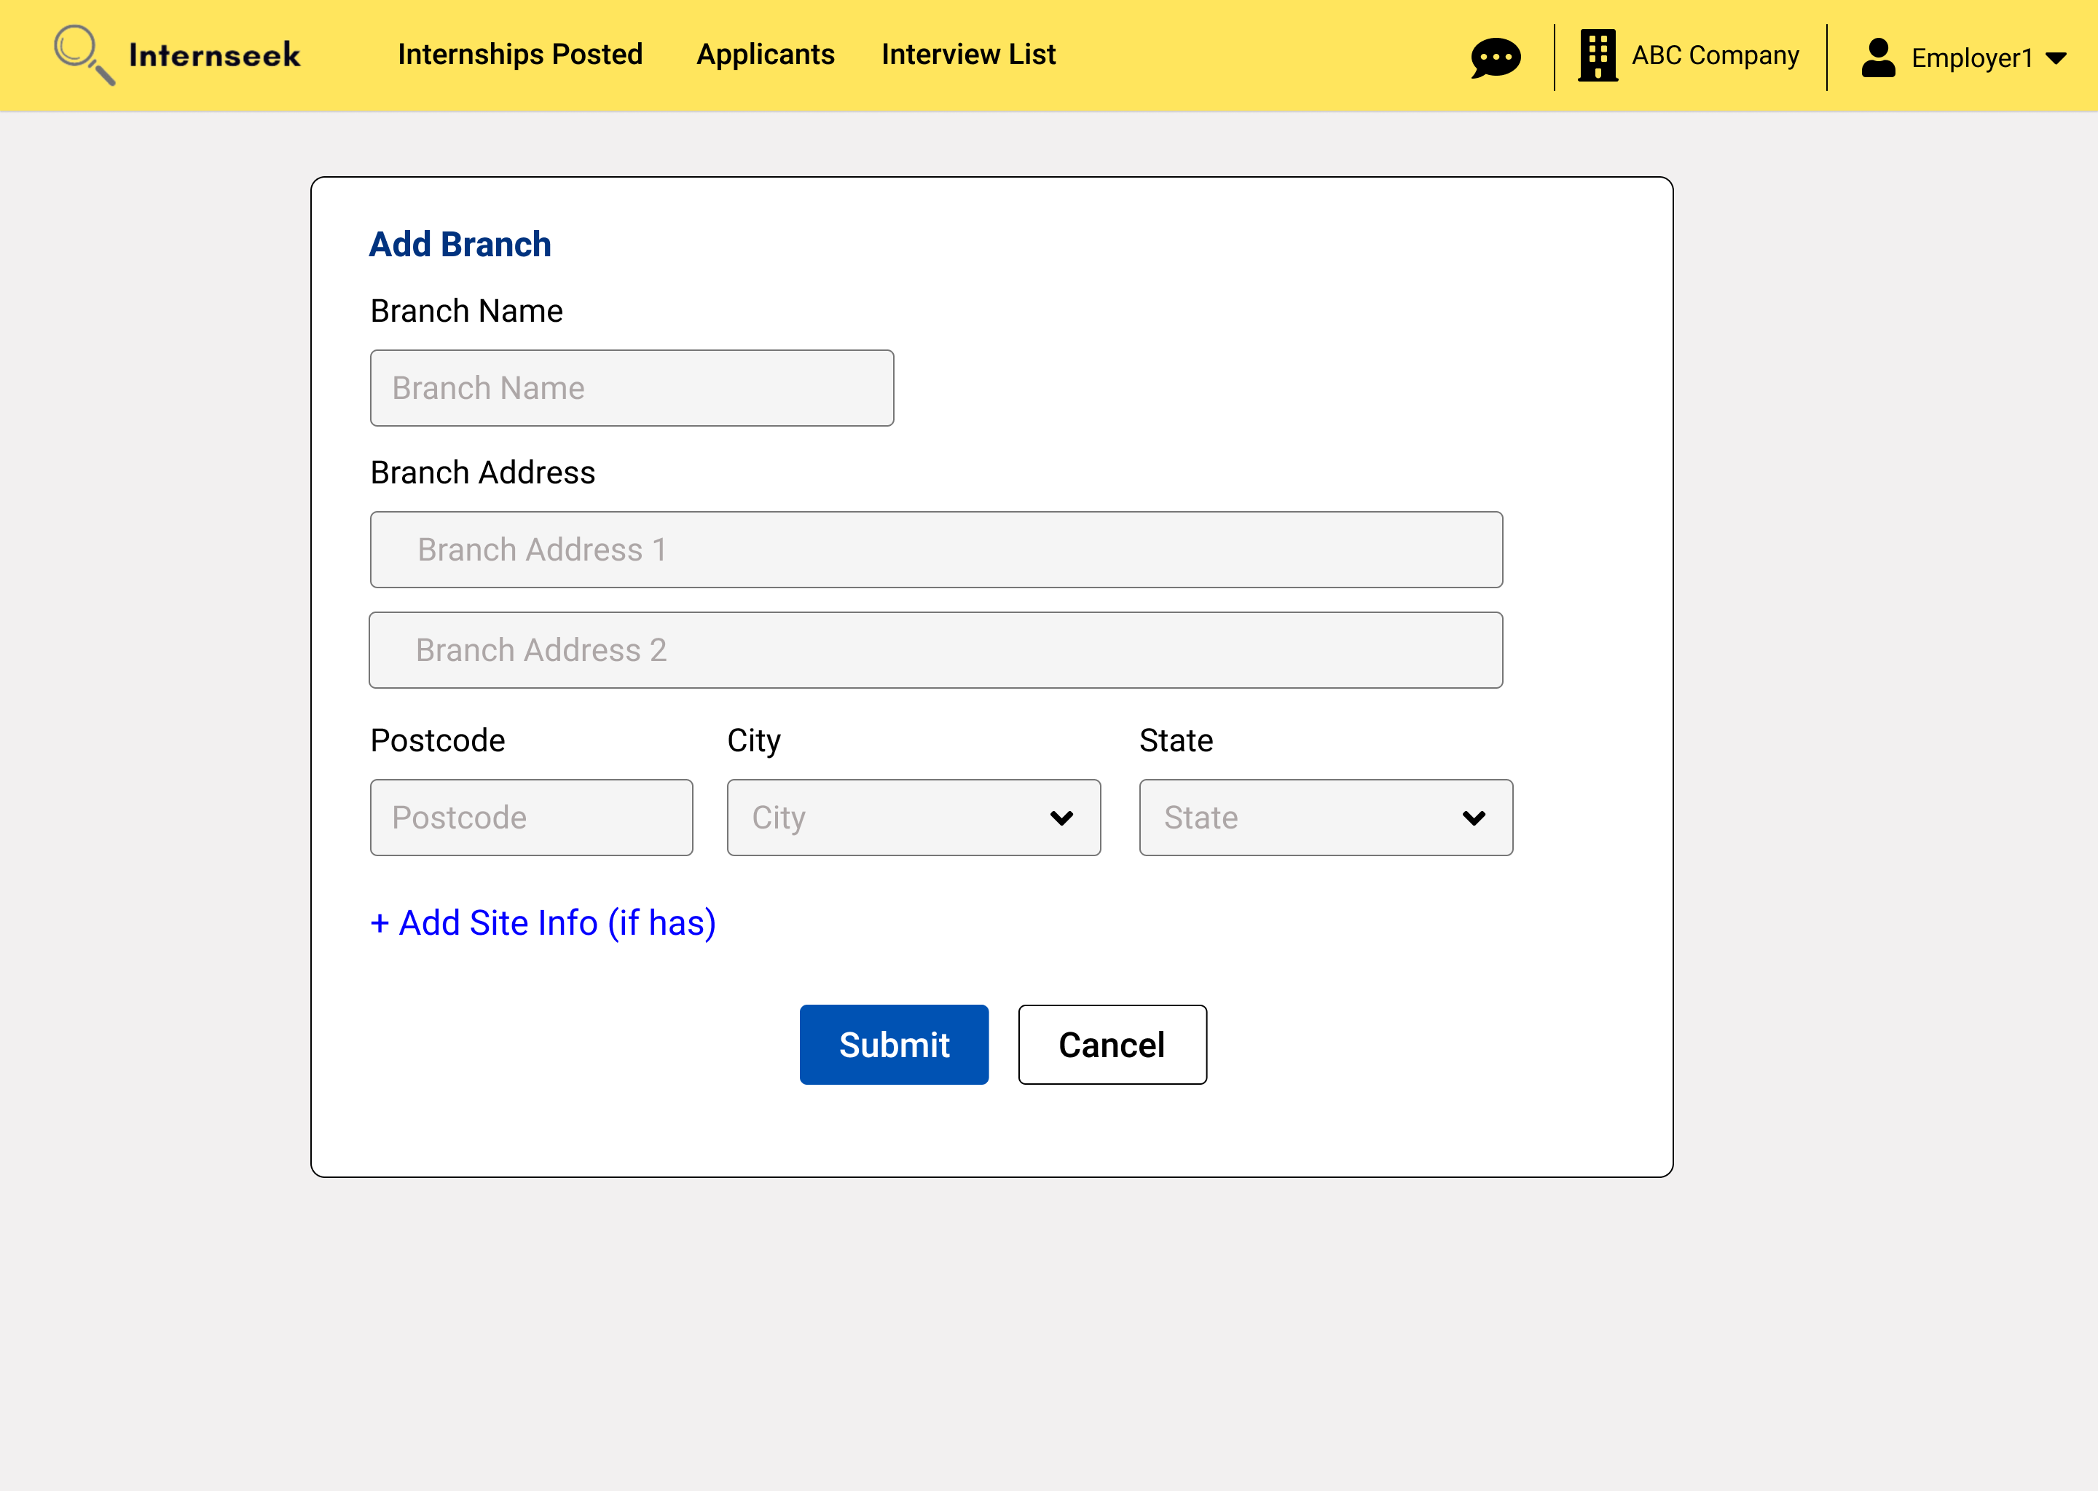

Figure 3‑214: Add Branch Page

This figure displays the Add Branch page, where the employer can add a new branch by entering the details in the input fields and then clicking the <<Submit>> button. If the new branch consists of site information, the employer may click the add site info text to enter the site info. If the employer does not want to add the new branch, they may click the <<Cancel>> button.

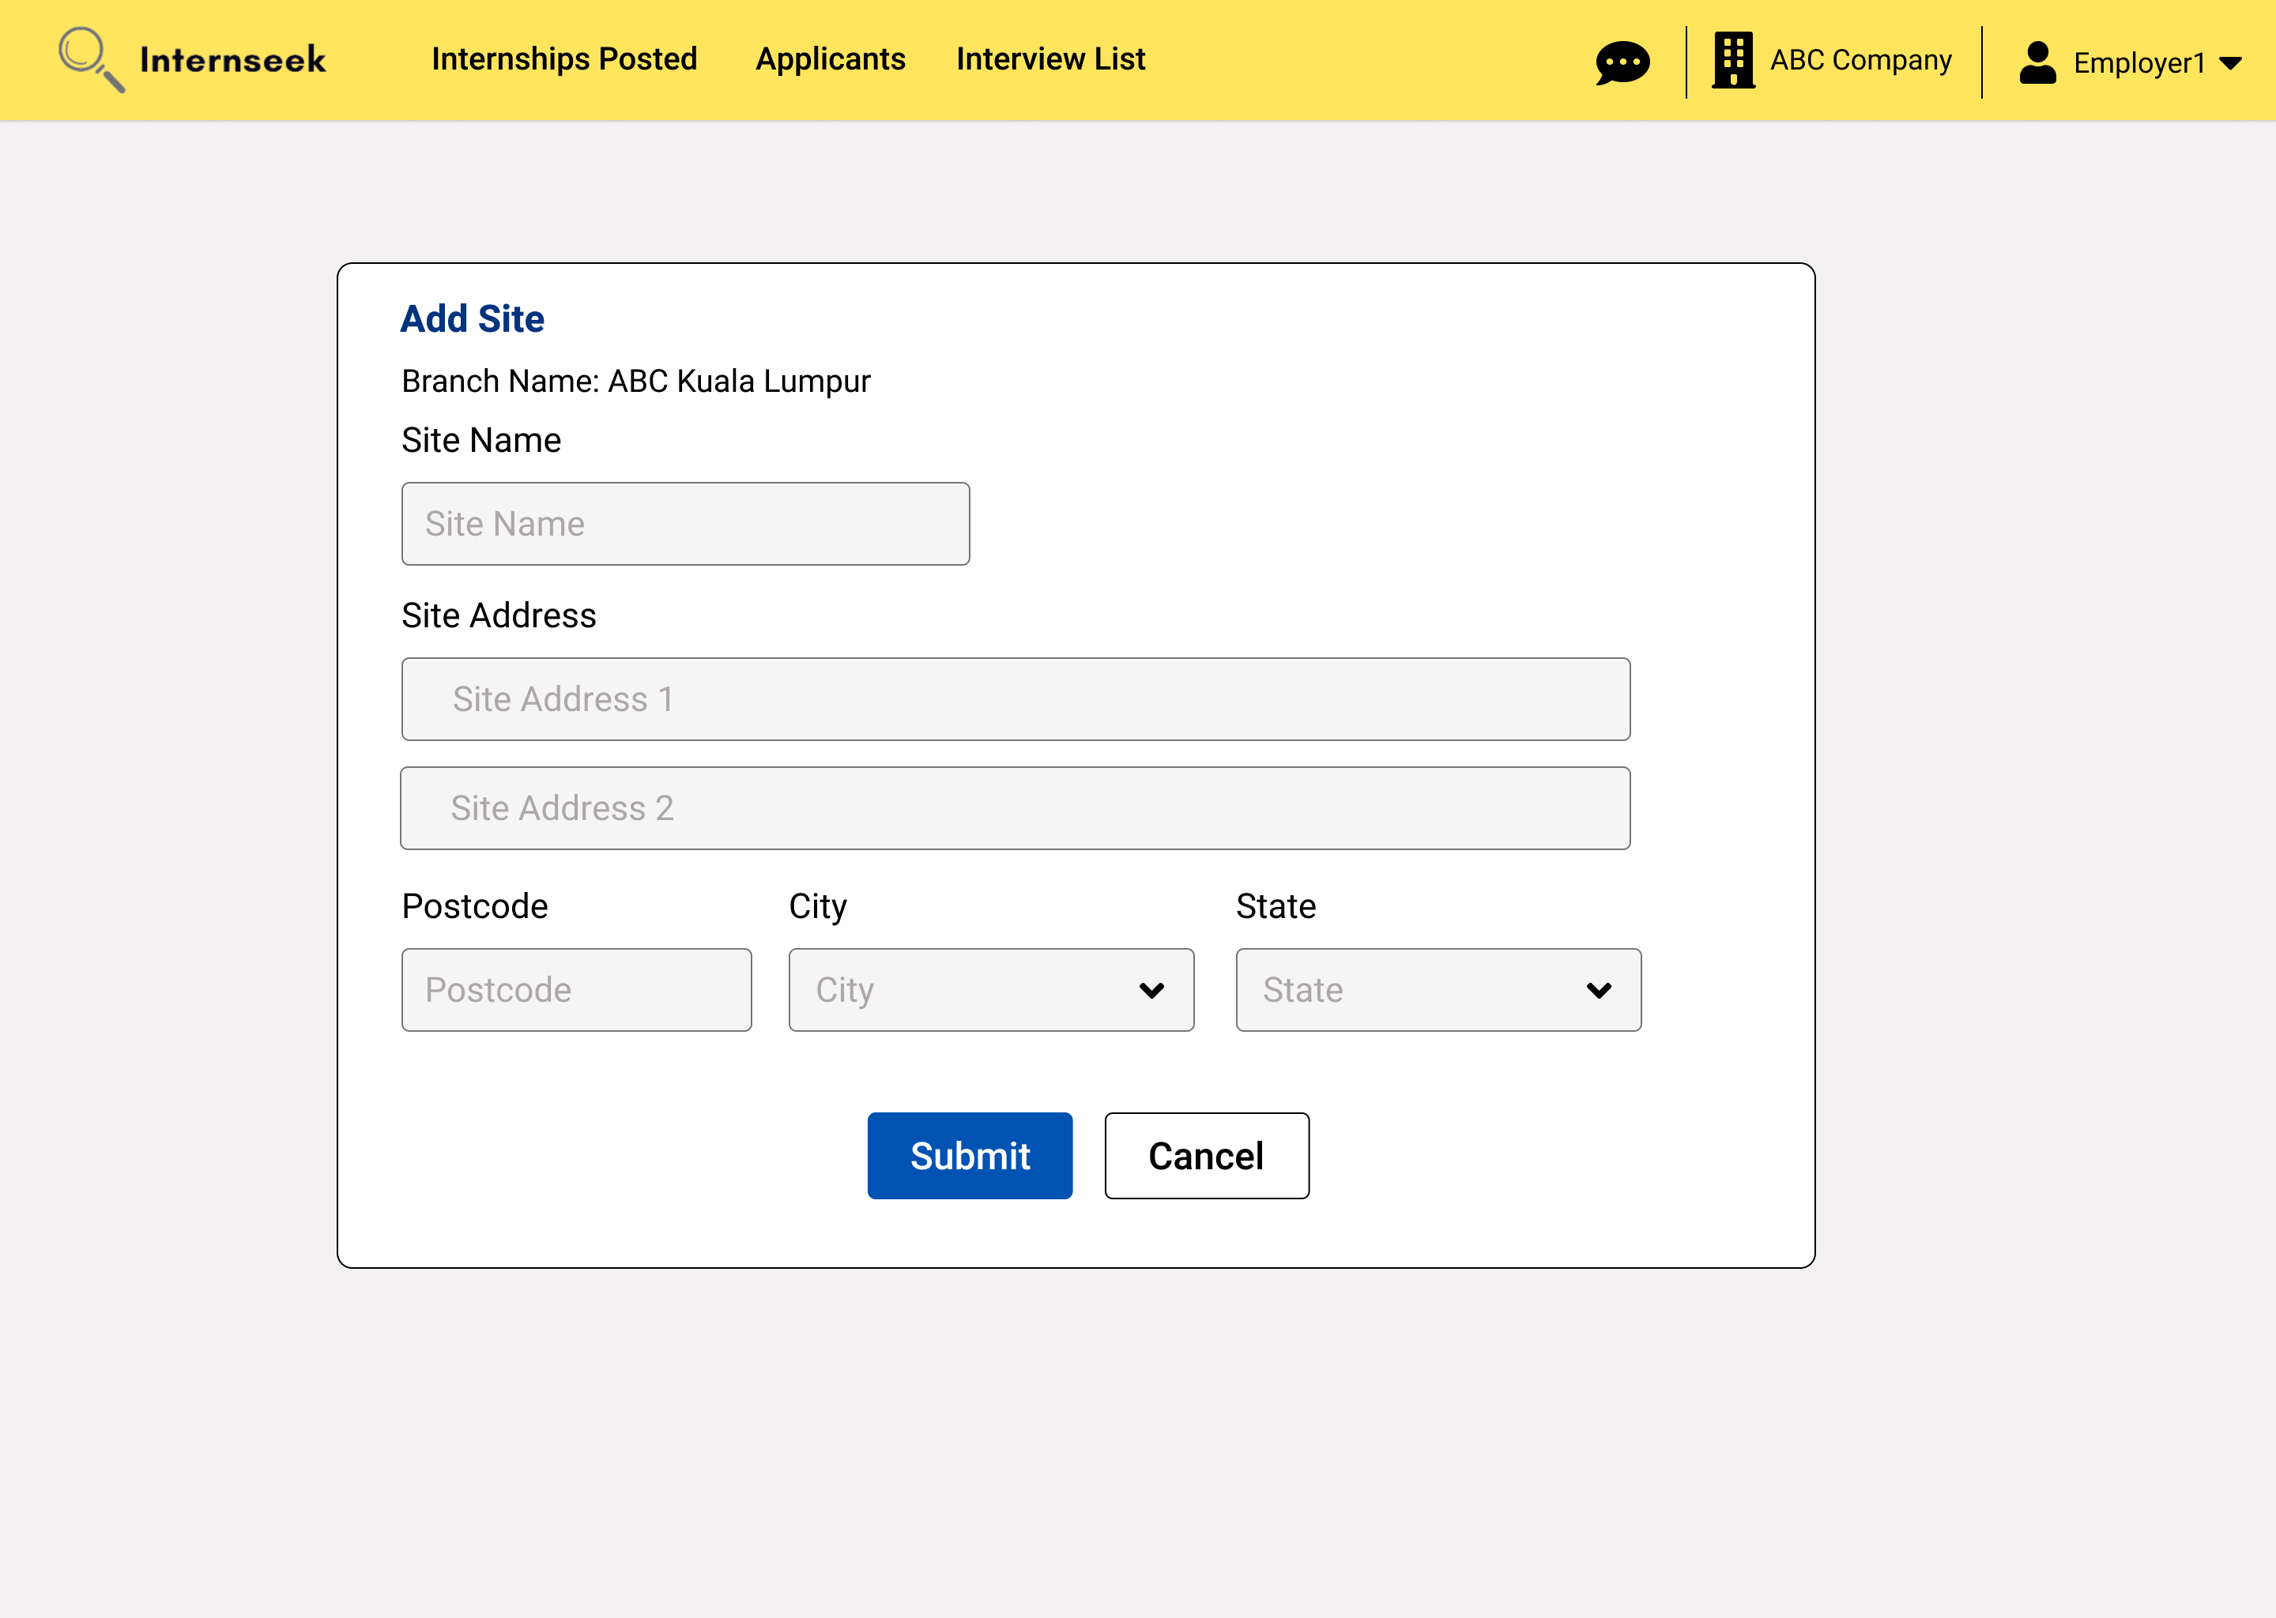

Figure 3‑215: Add Site Page

This figure displays the Add Site page, where the employer can add a new site by entering the details in the input fields and then clicking the <<Submit>> button. If the employer does not want to add the new site, they may click the <<Cancel>> button.

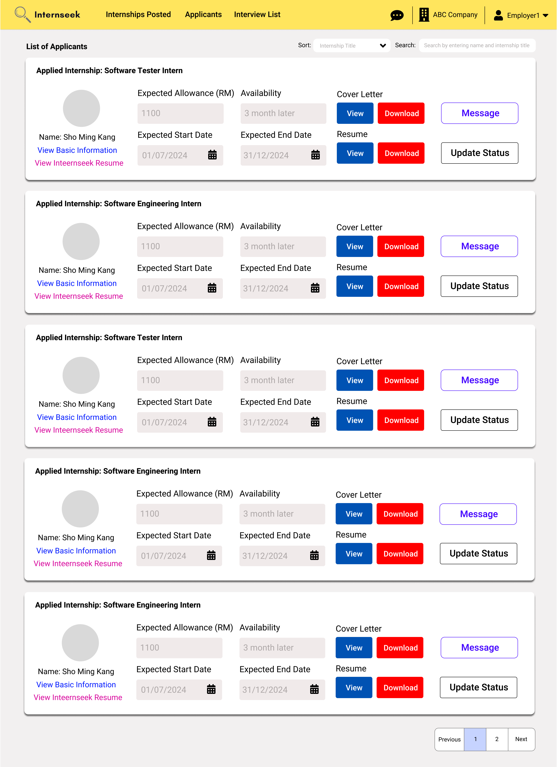

Figure 3‑216: Applicants List page

This figure displays the Applicants List page, where employers can review applicants' details, including the internship they applied for, expected allowance, availability, uploaded cover letter, uploaded resume, basic information, Internseek resume, expected start date, and expected end date. After reviewing the applicant's details, the employer can update the status of the applicant by clicking the <<Update Status>> button. The employer can also message the applicant by clicking the <<Message>> button.

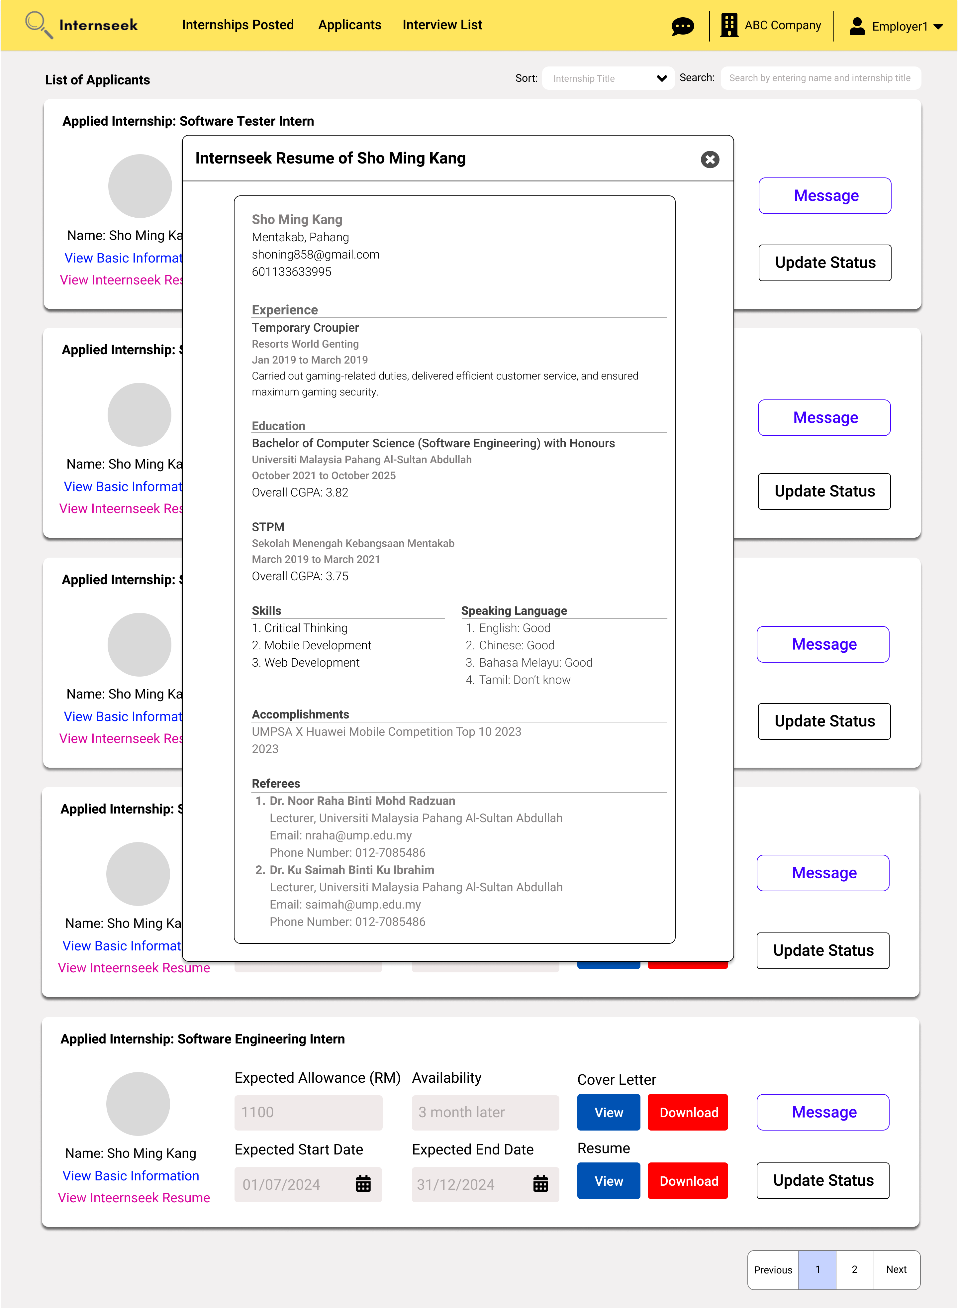

Figure 3‑217: View Internseek Resume (Modal)

This figure displays a modal that displays the resume generated by Internseek based on the profile details of the applicant once the employer clicks the <<View Internseek Resume>> link.

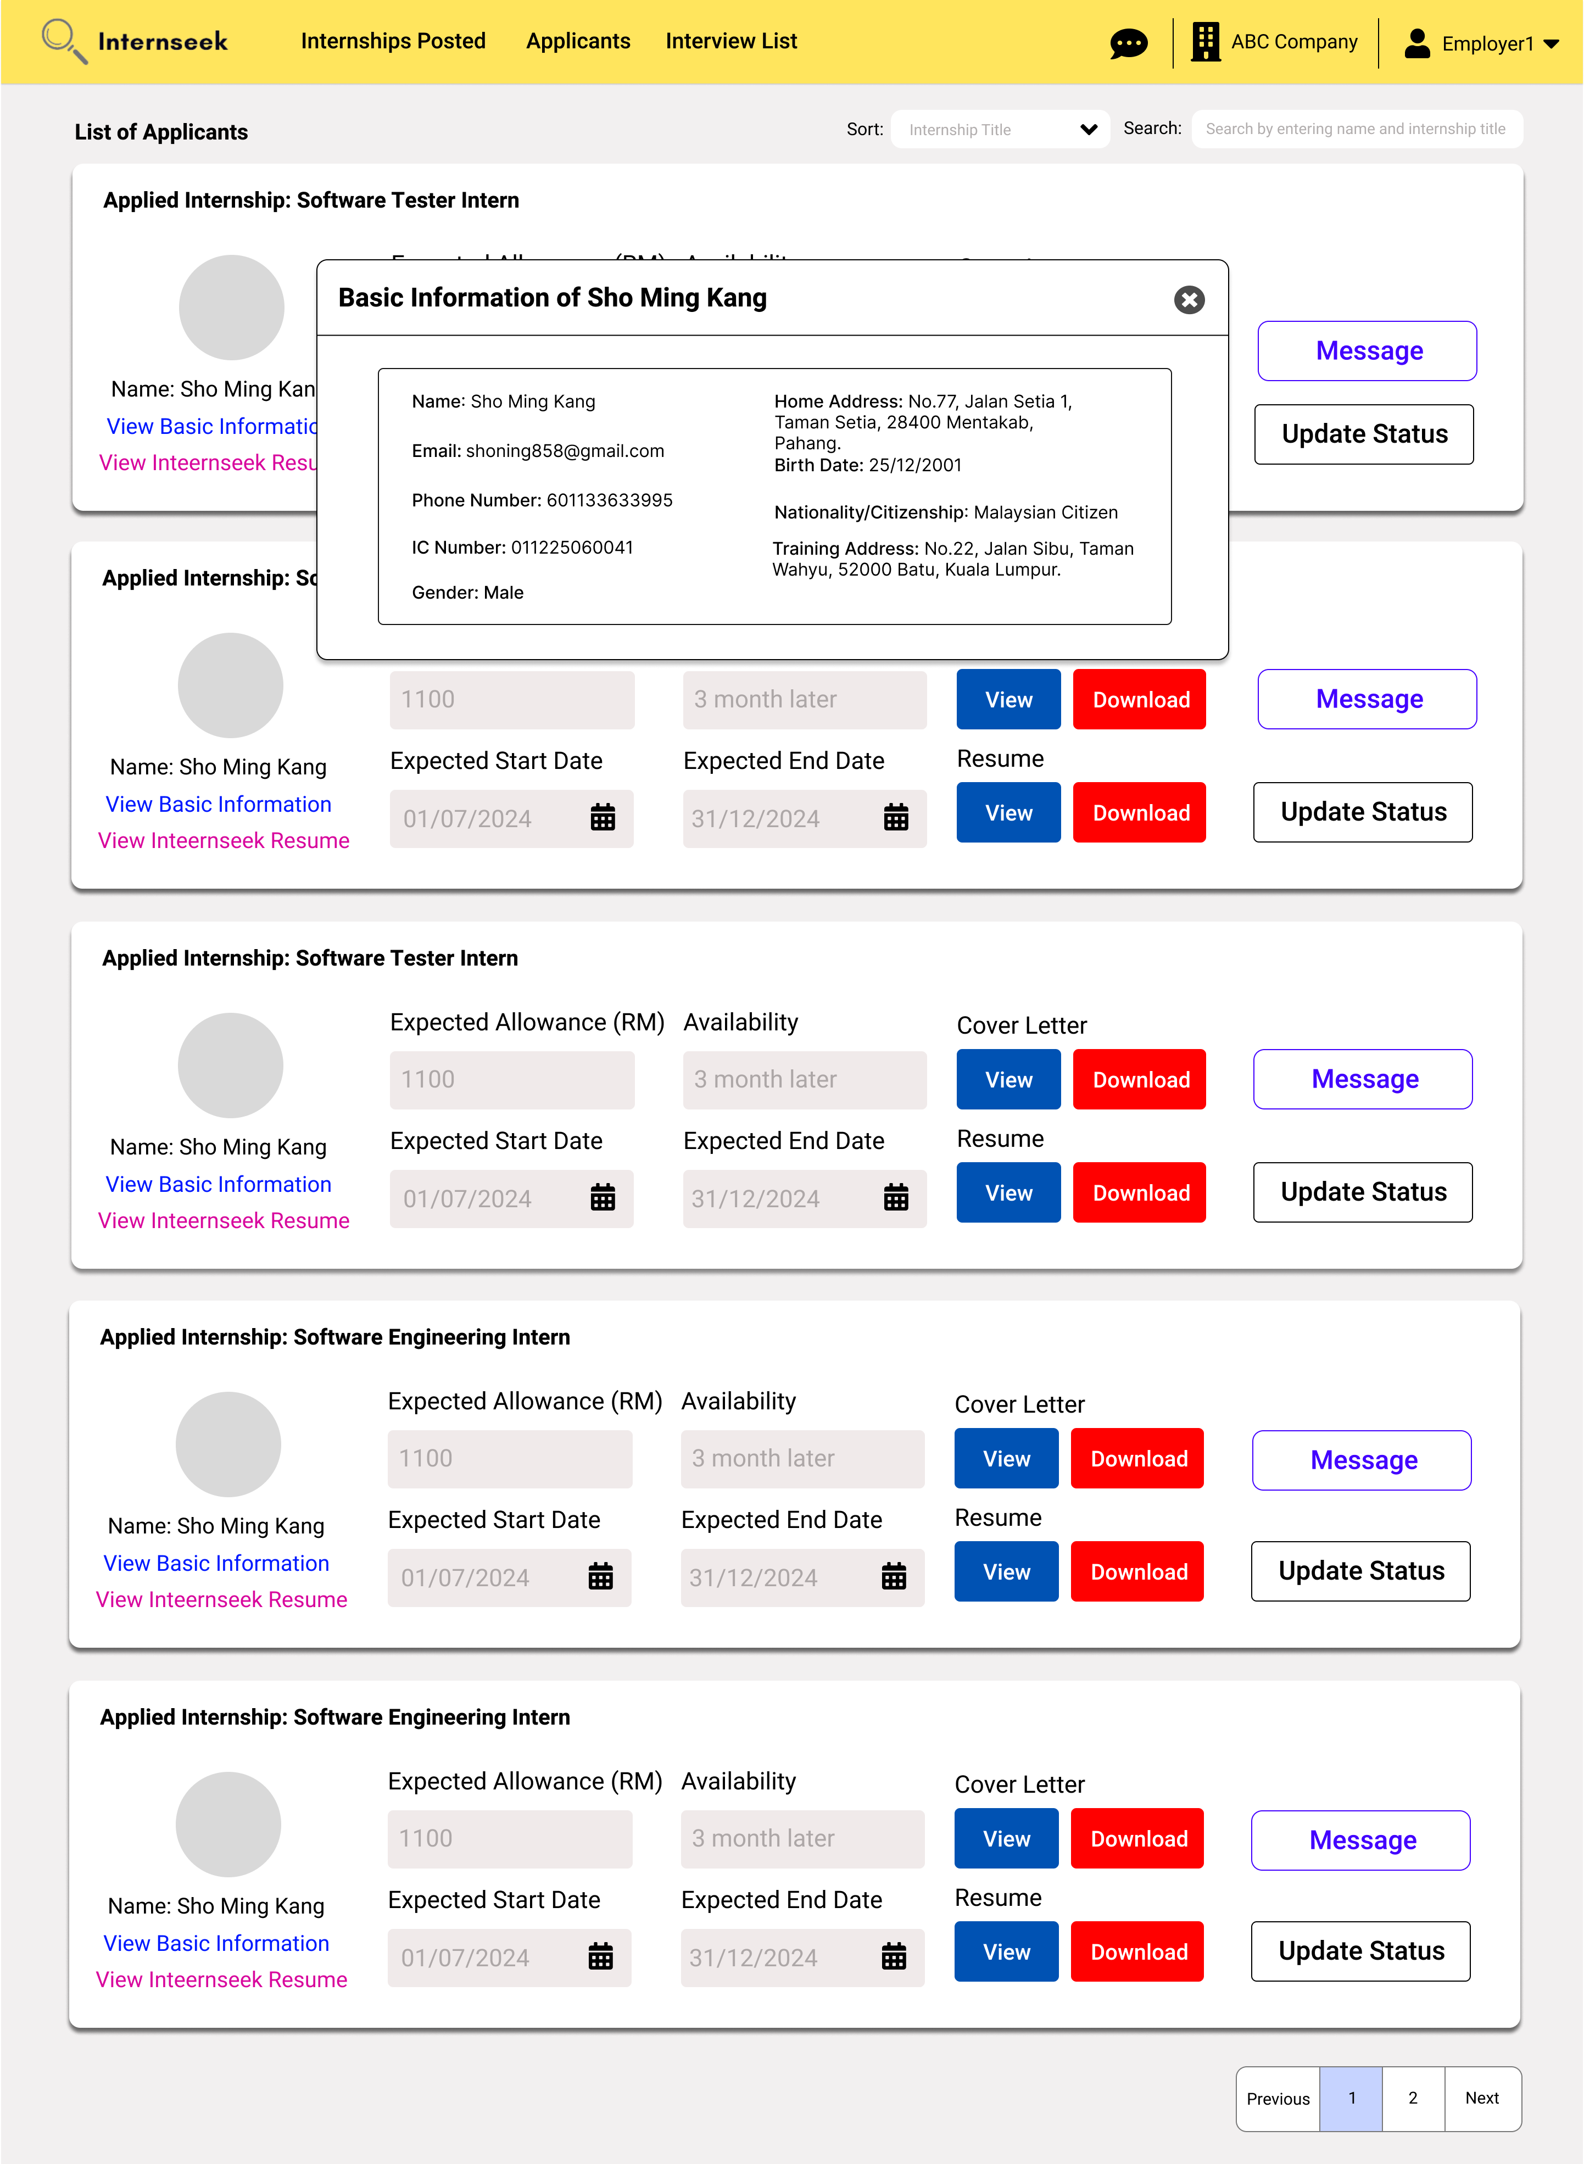

Figure 3‑218: View Basic Information (Modal)

This figure displays a modal that display the basic information of the applicant once the employer clicks the <<View Basic Information>> link.

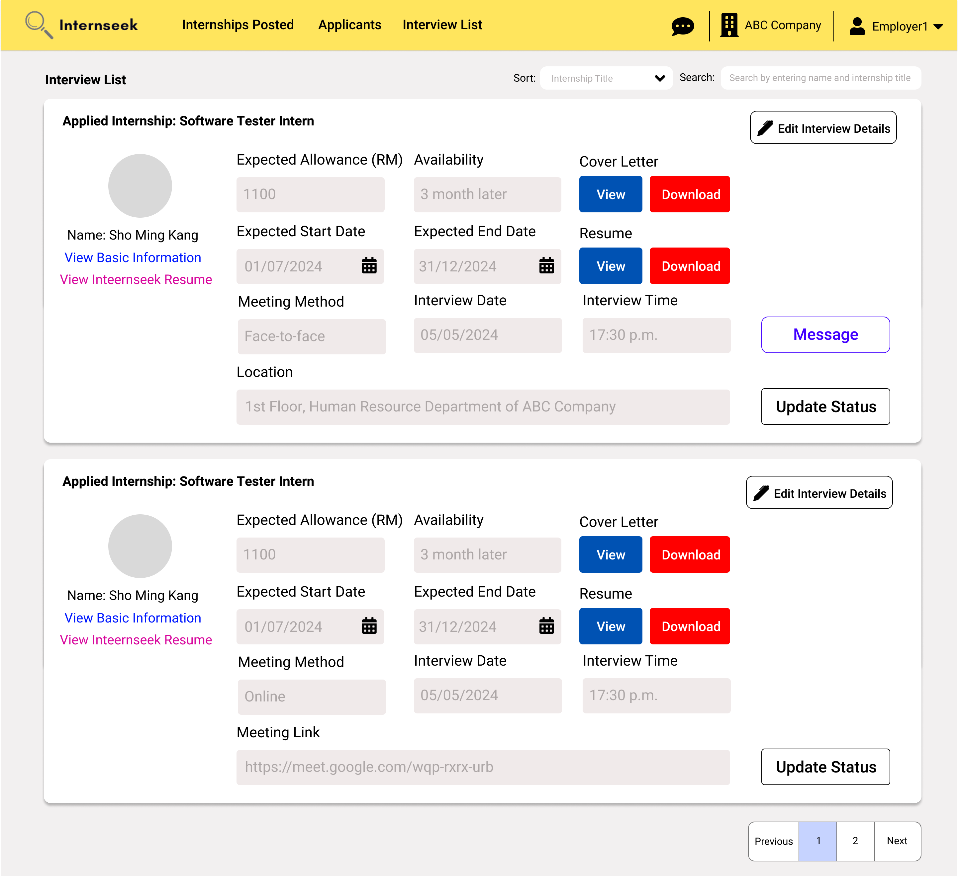

Figure 3‑219: Interview List page

This figure shows the Interview List page, which displays all the applicants who have the status of need-to-interview. The employer can view the applicant’s details and the interview details on this page. The employer can edit the interview details once they click the <<Edit Interview Details>> button. The employer can update the interview status once they have conducted the interview with the applicant by clicking the<<Update Status>> button. The employer can message the applicant by clicking the message button.

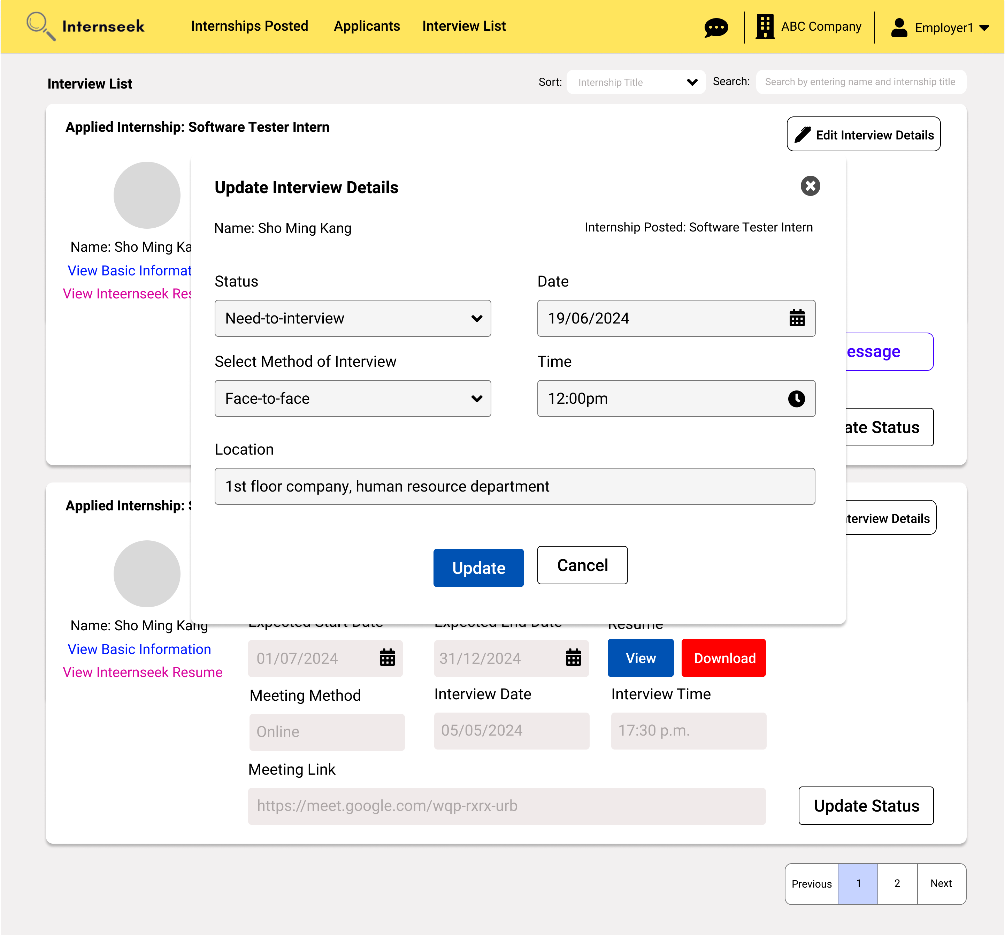

Figure 3‑220: Edit Interview Details Modal

This figure shows the edit interview details modal once the employer clicks the <<Edit Interview Details>> button. The employer can enter interview details they want to edit in the edit interview details modal and clicks the <<Update>> button to update the interview details. If the employer does not want to edit the interview details, they may click the <<Cancel>> button and the cross-icon.

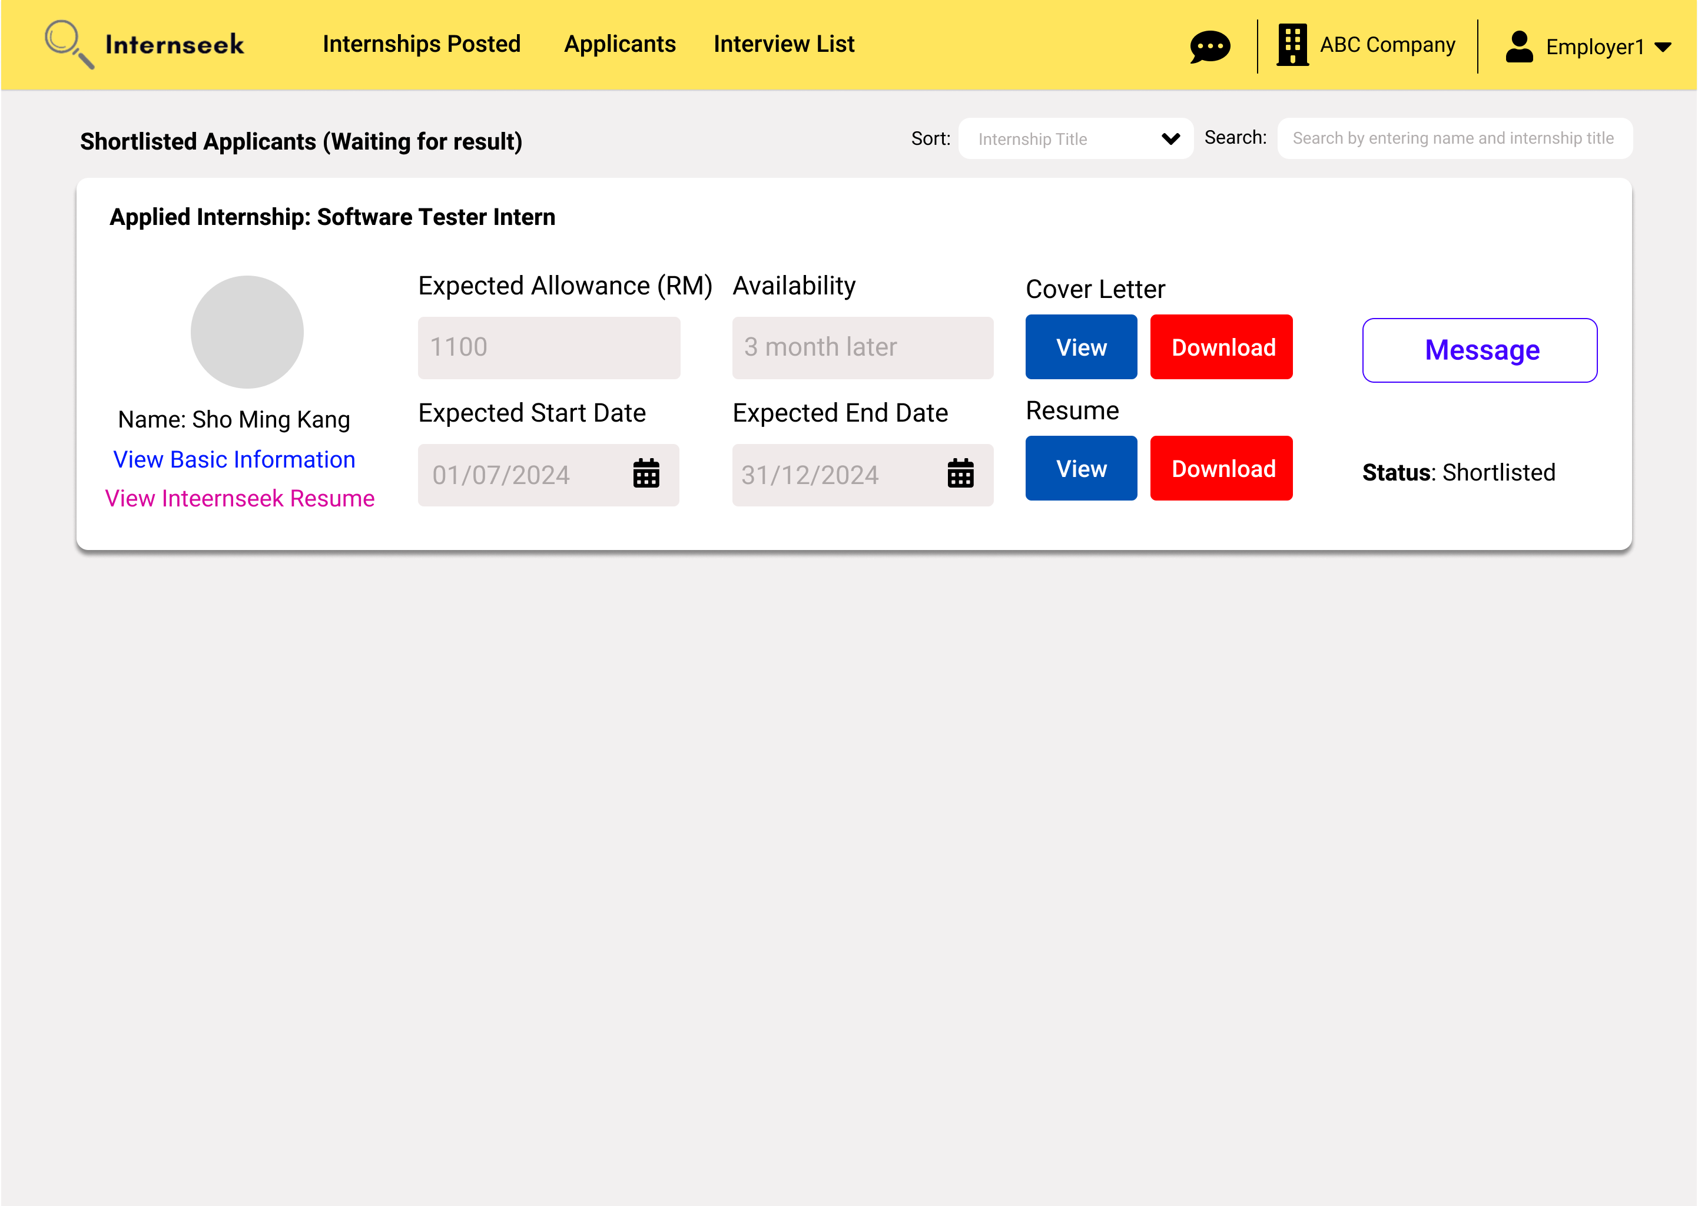

Figure 3‑221: Shortlisted Applicants List page

This figure shows the Shortlisted Applicants List page, which displays all the applicants who have the internship application status of shortlisted. The employer can view the applicant’s details on this page. The employer can message the applicant by clicking the message button.

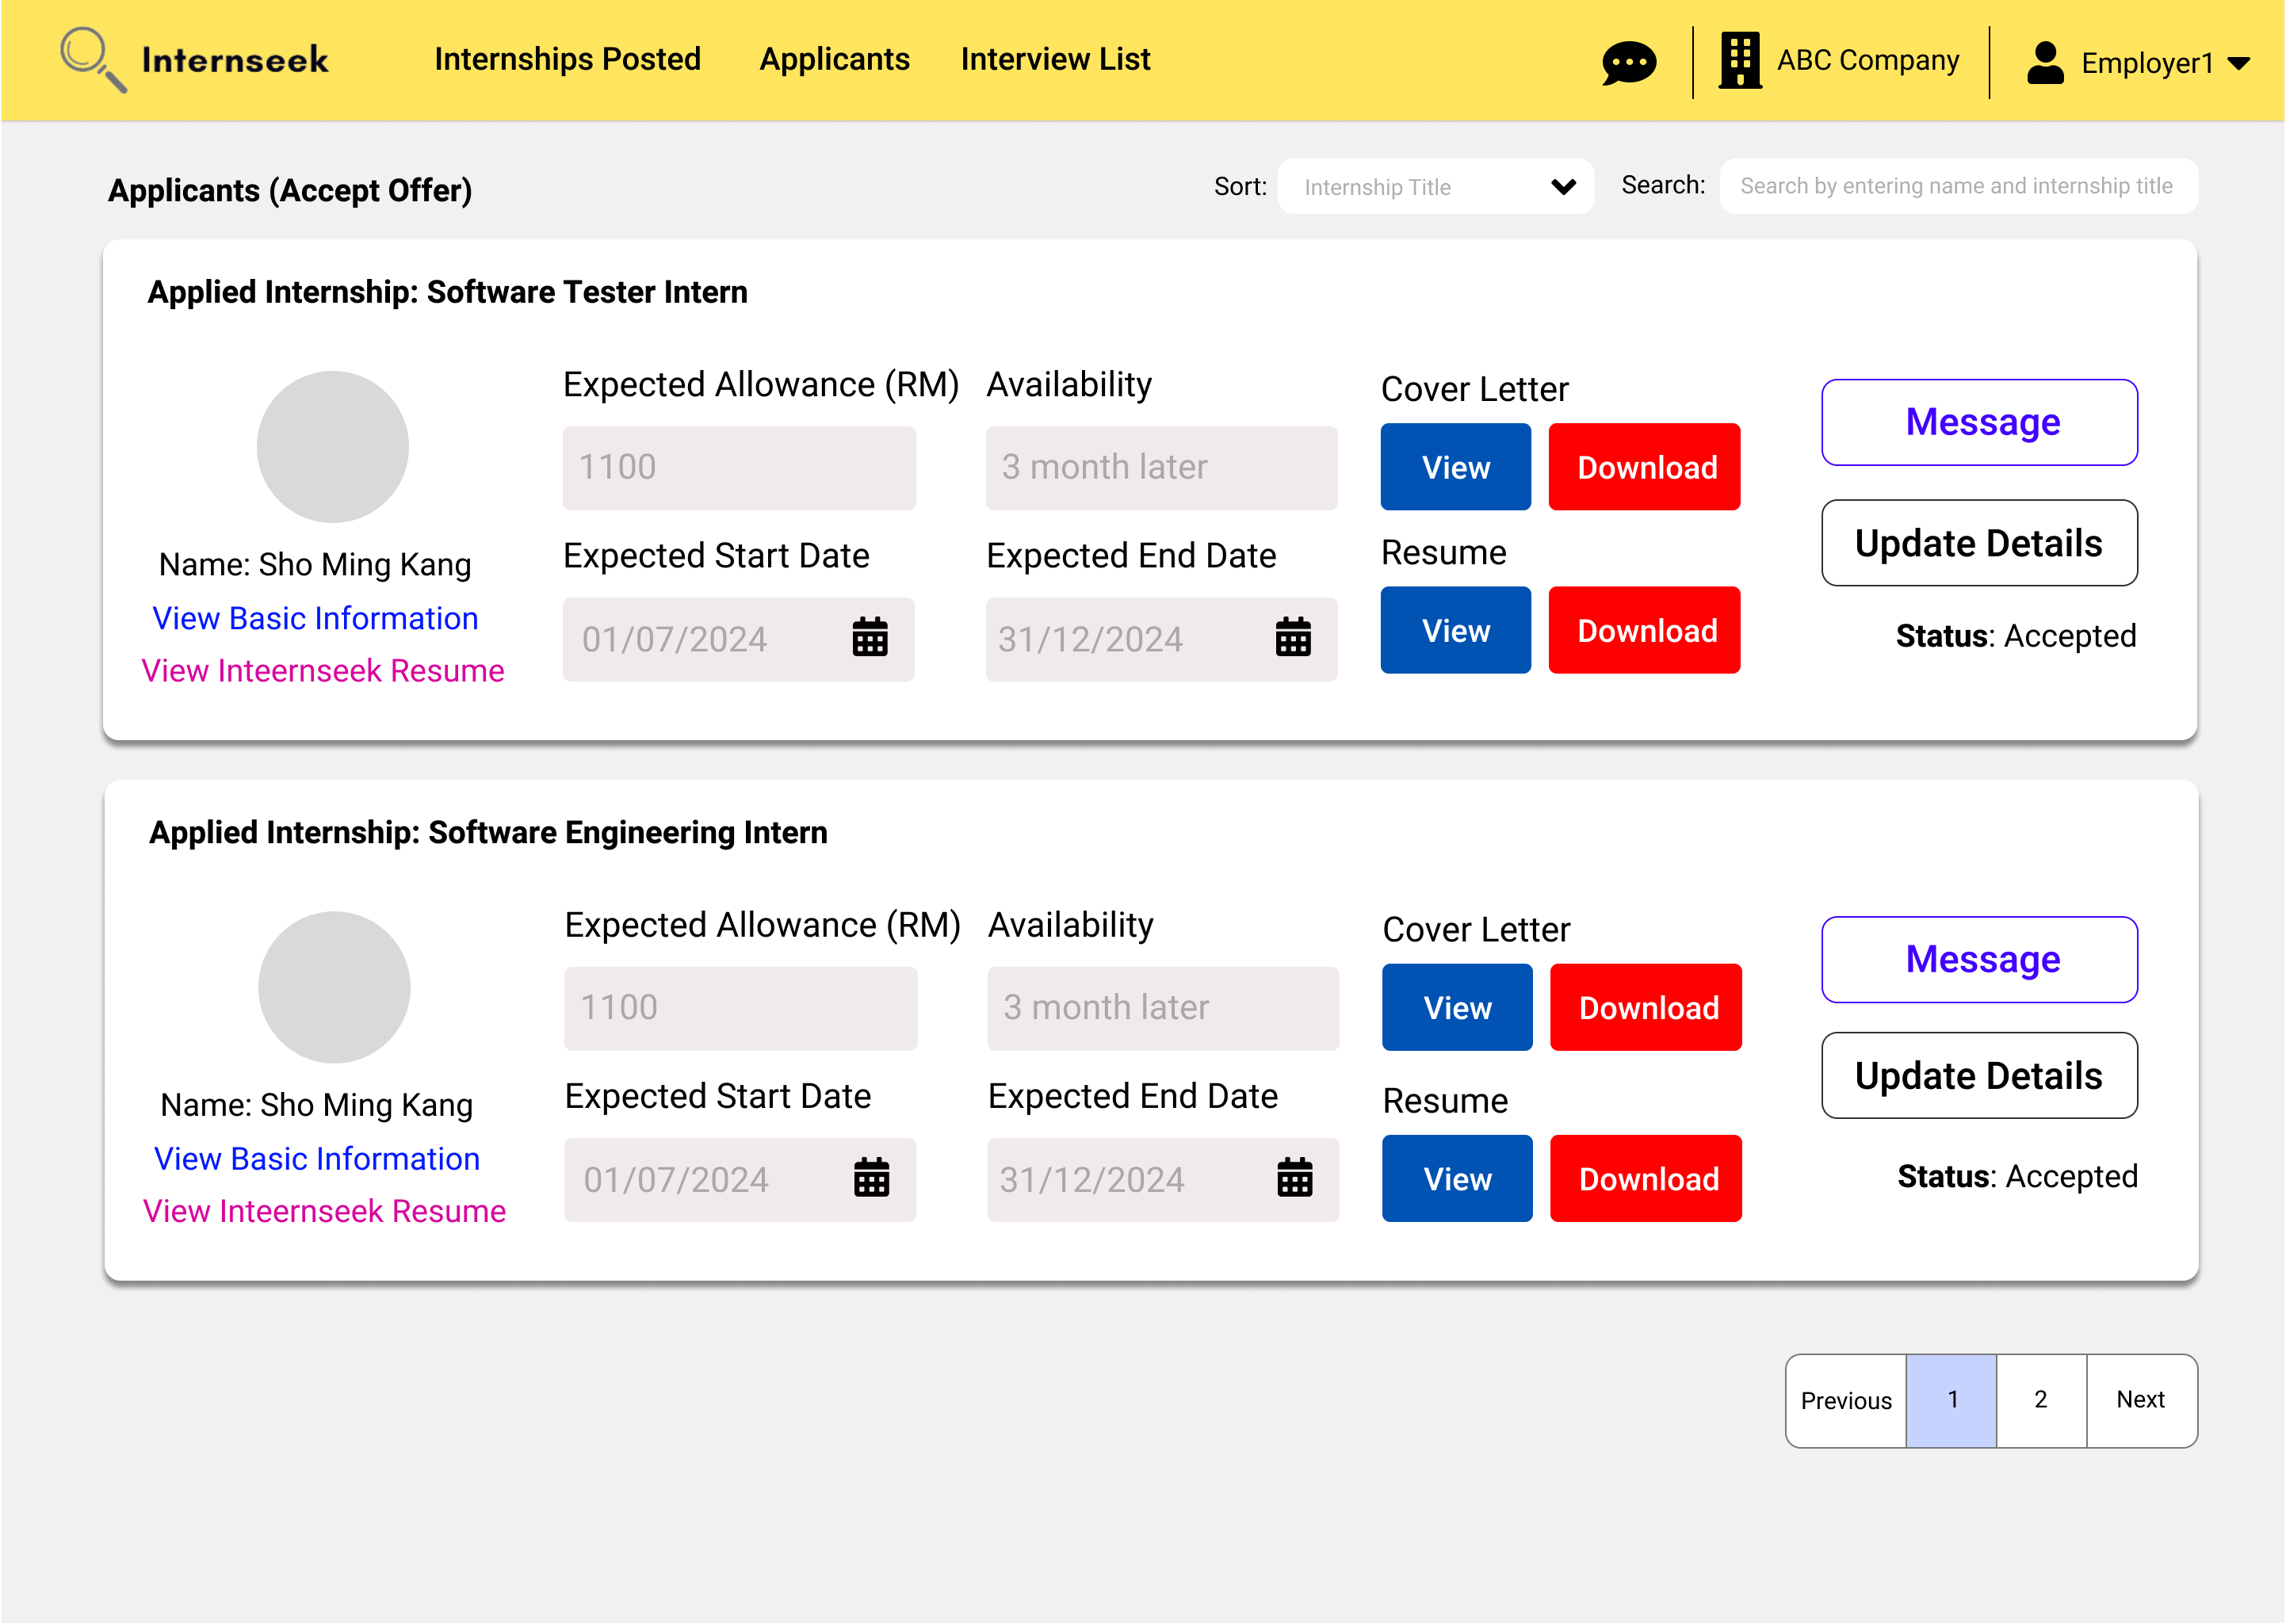

Figure 3‑222: Accepted Applicants List page

This figure shows the Accepted Applicants List page, which displays applicants who accepted the offer. The employer can view the applicant’s details on this page. The employer can message the applicant by clicking the message button. The employer can update the accepted offer details for the intern by clicking the <<Update Details>> button.

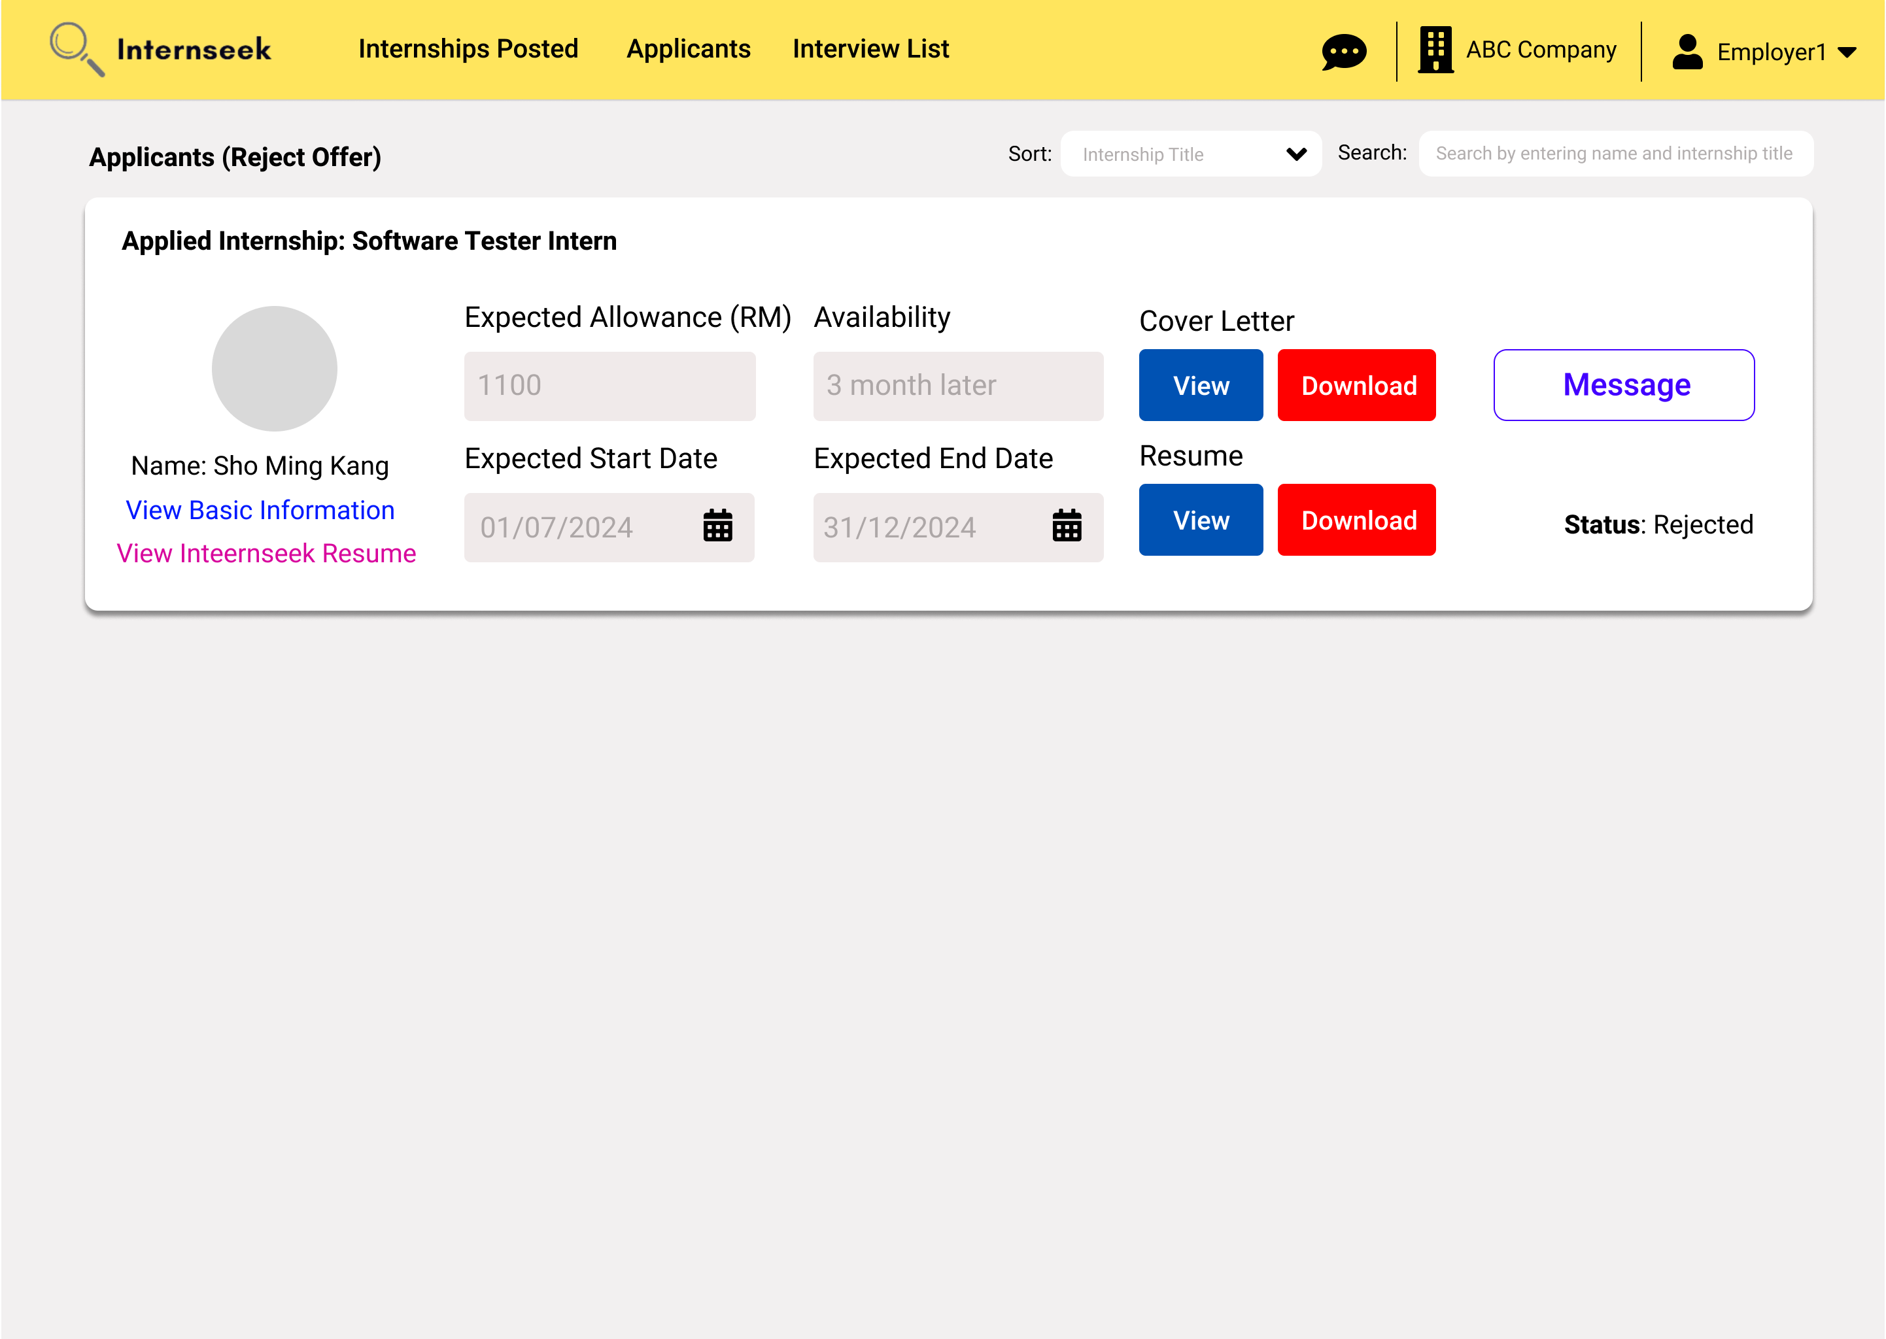

Figure 3‑223: Rejected Applicants List page

This figure shows the Rejected Applicants List page, which displays applicants who rejected the offer. The employer can view the applicant’s details on this page. The employer can message the applicant by clicking the message button.

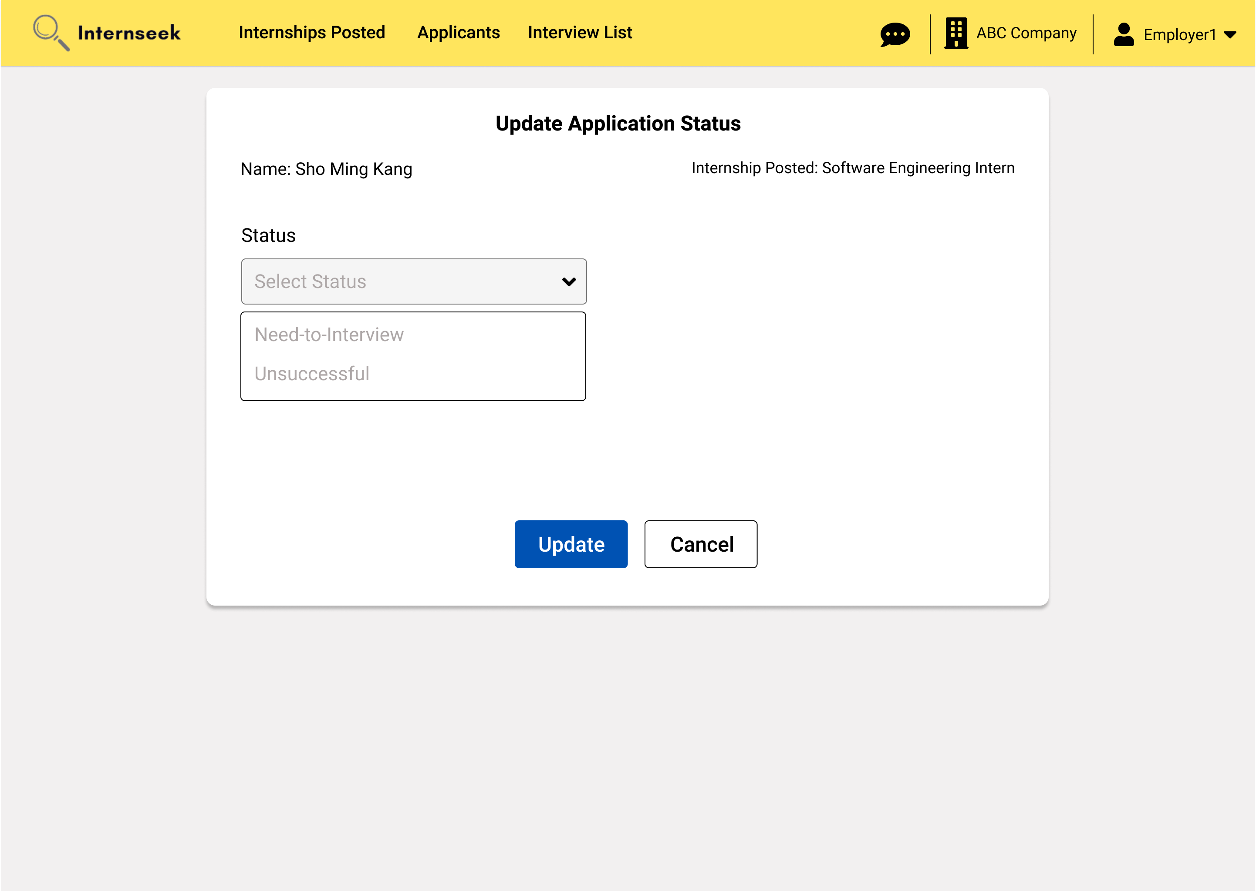

Figure 3‑224: Update application status page

This figure displays the page for the employer to update the application status of the applicant. There are two application statuses: need-to-interview and unsuccessful. The employer can click <<Cancel>> button if they do not want to update the application status of the applicant. If the employer selects the unsuccessful status, they can directly click the <<Update>> button to update the internship application status as unsuccessful.

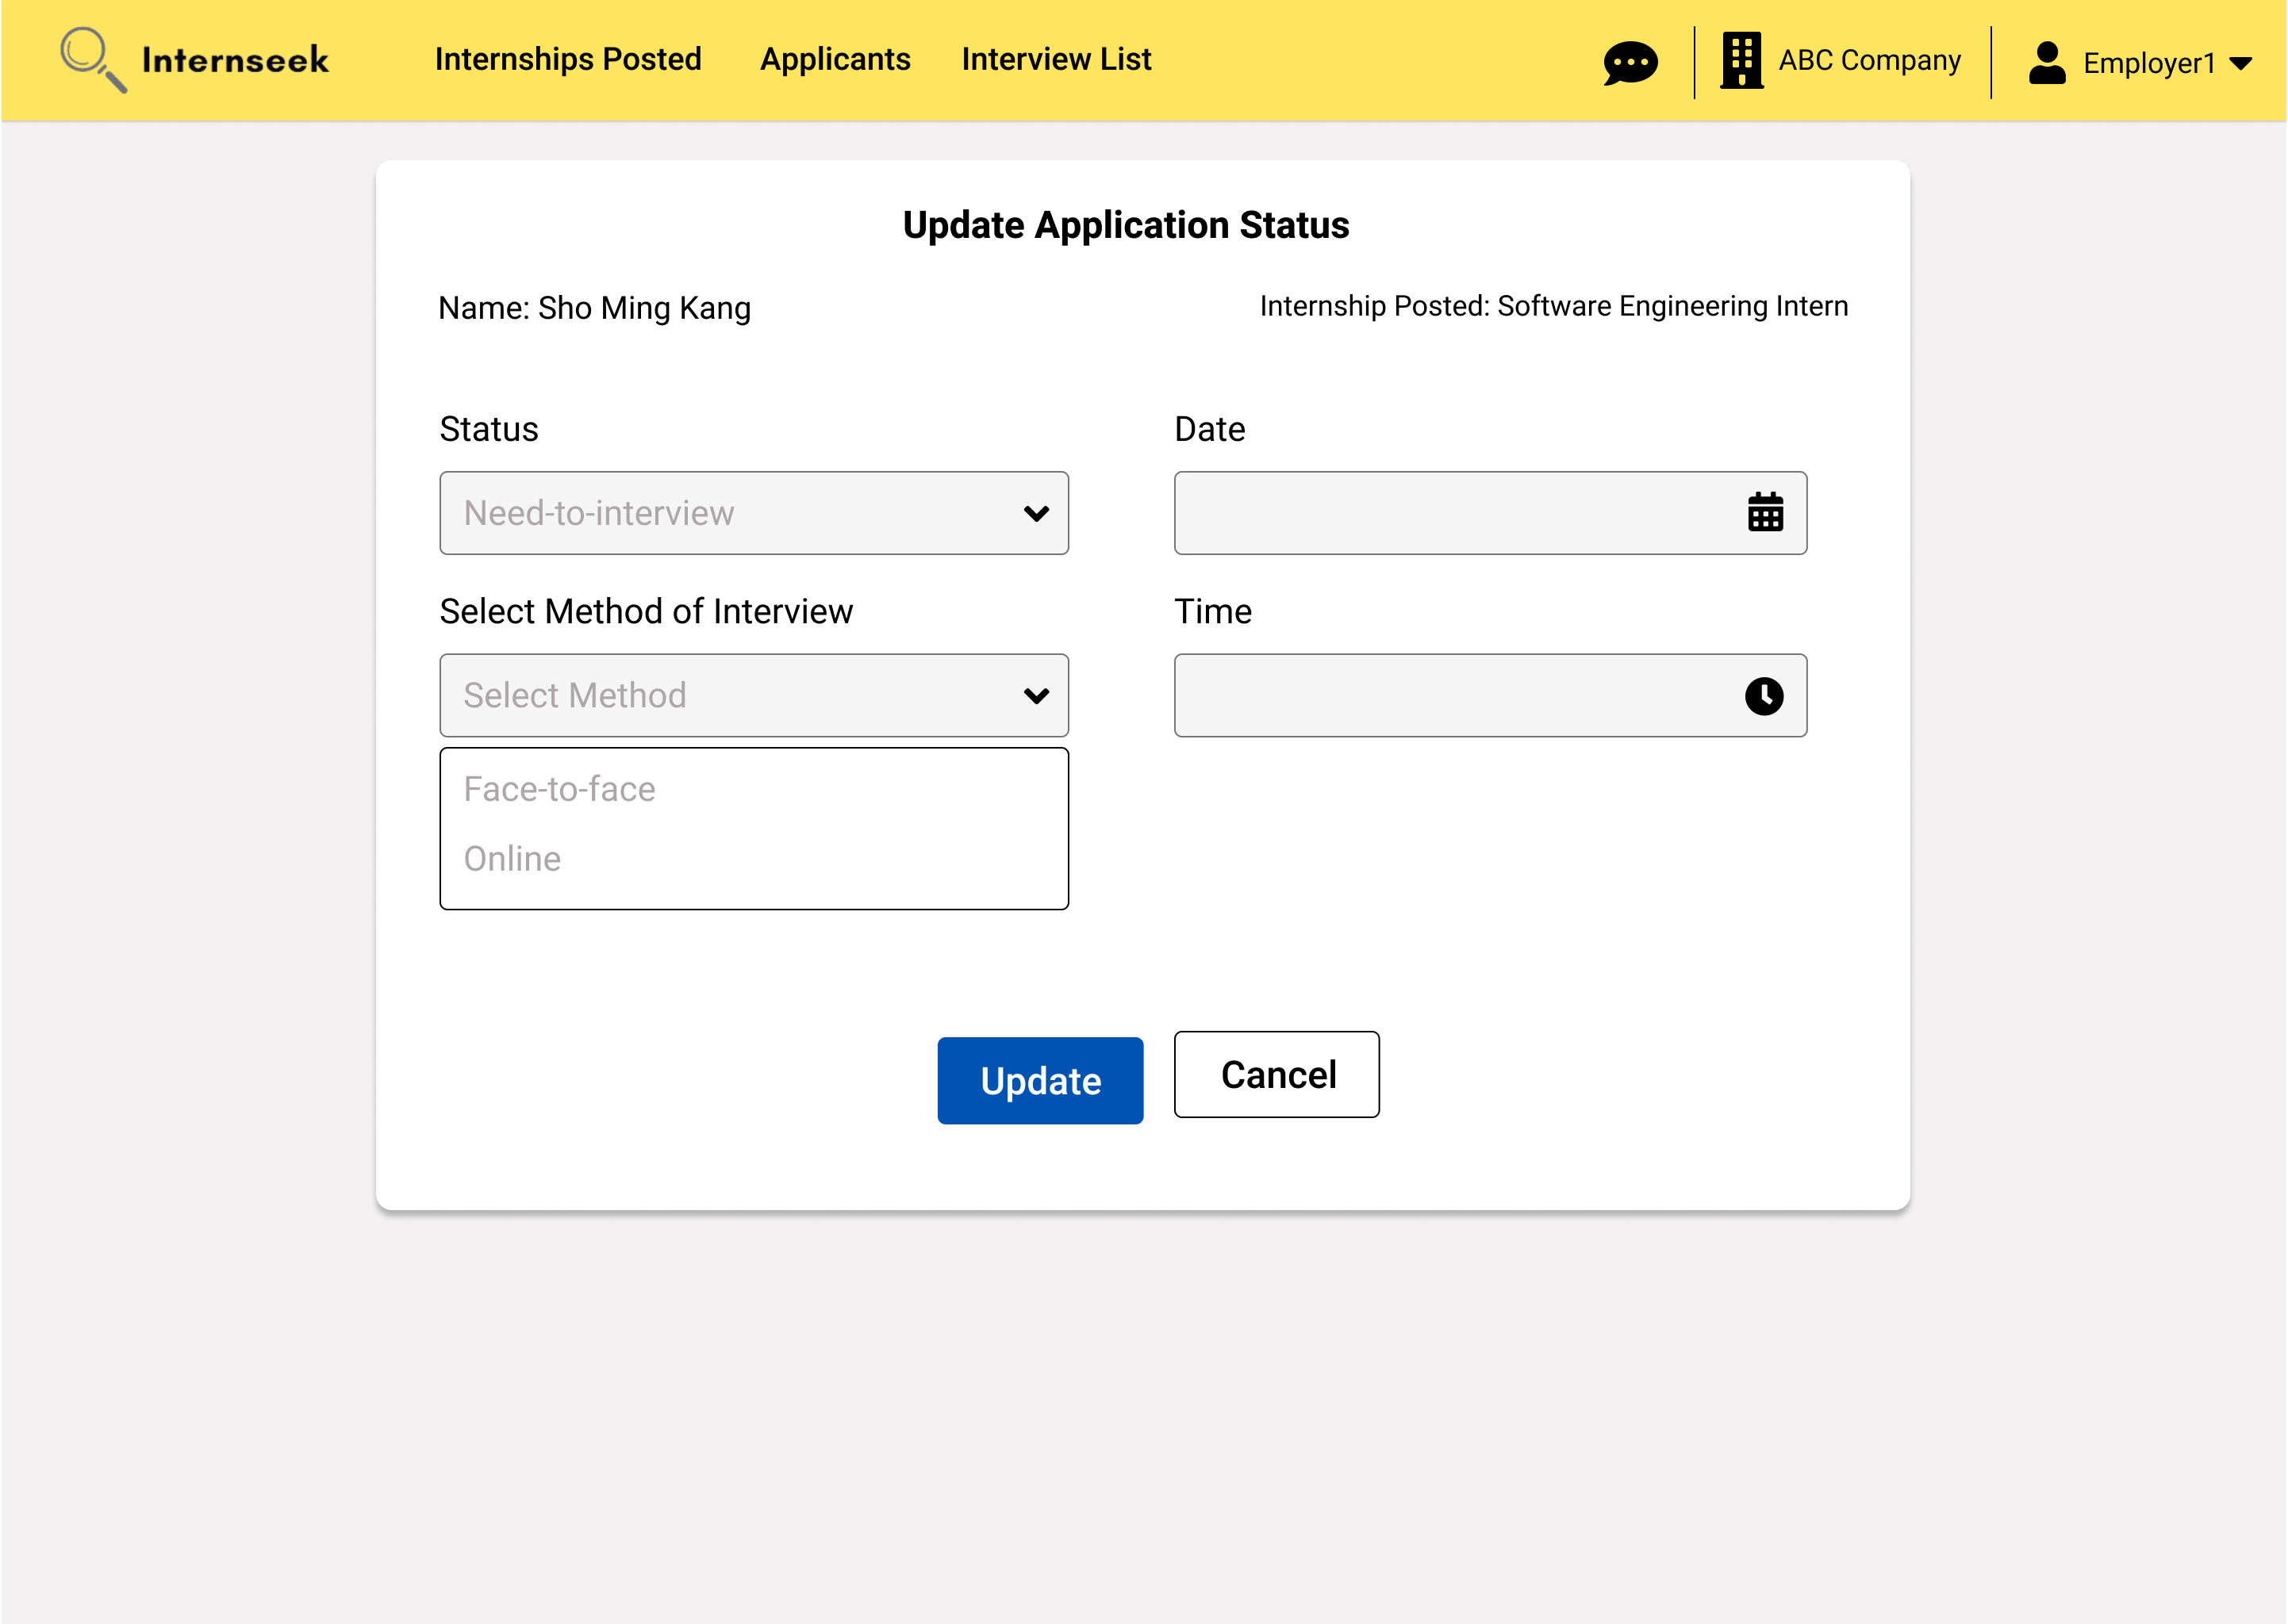

Figure 3‑225: Update Status of Applicant (Need-To-Interview)

This figure displays that once the employer selects the Need-To-Interview status, the field for interview date, interview time, and method of interview will be displayed.

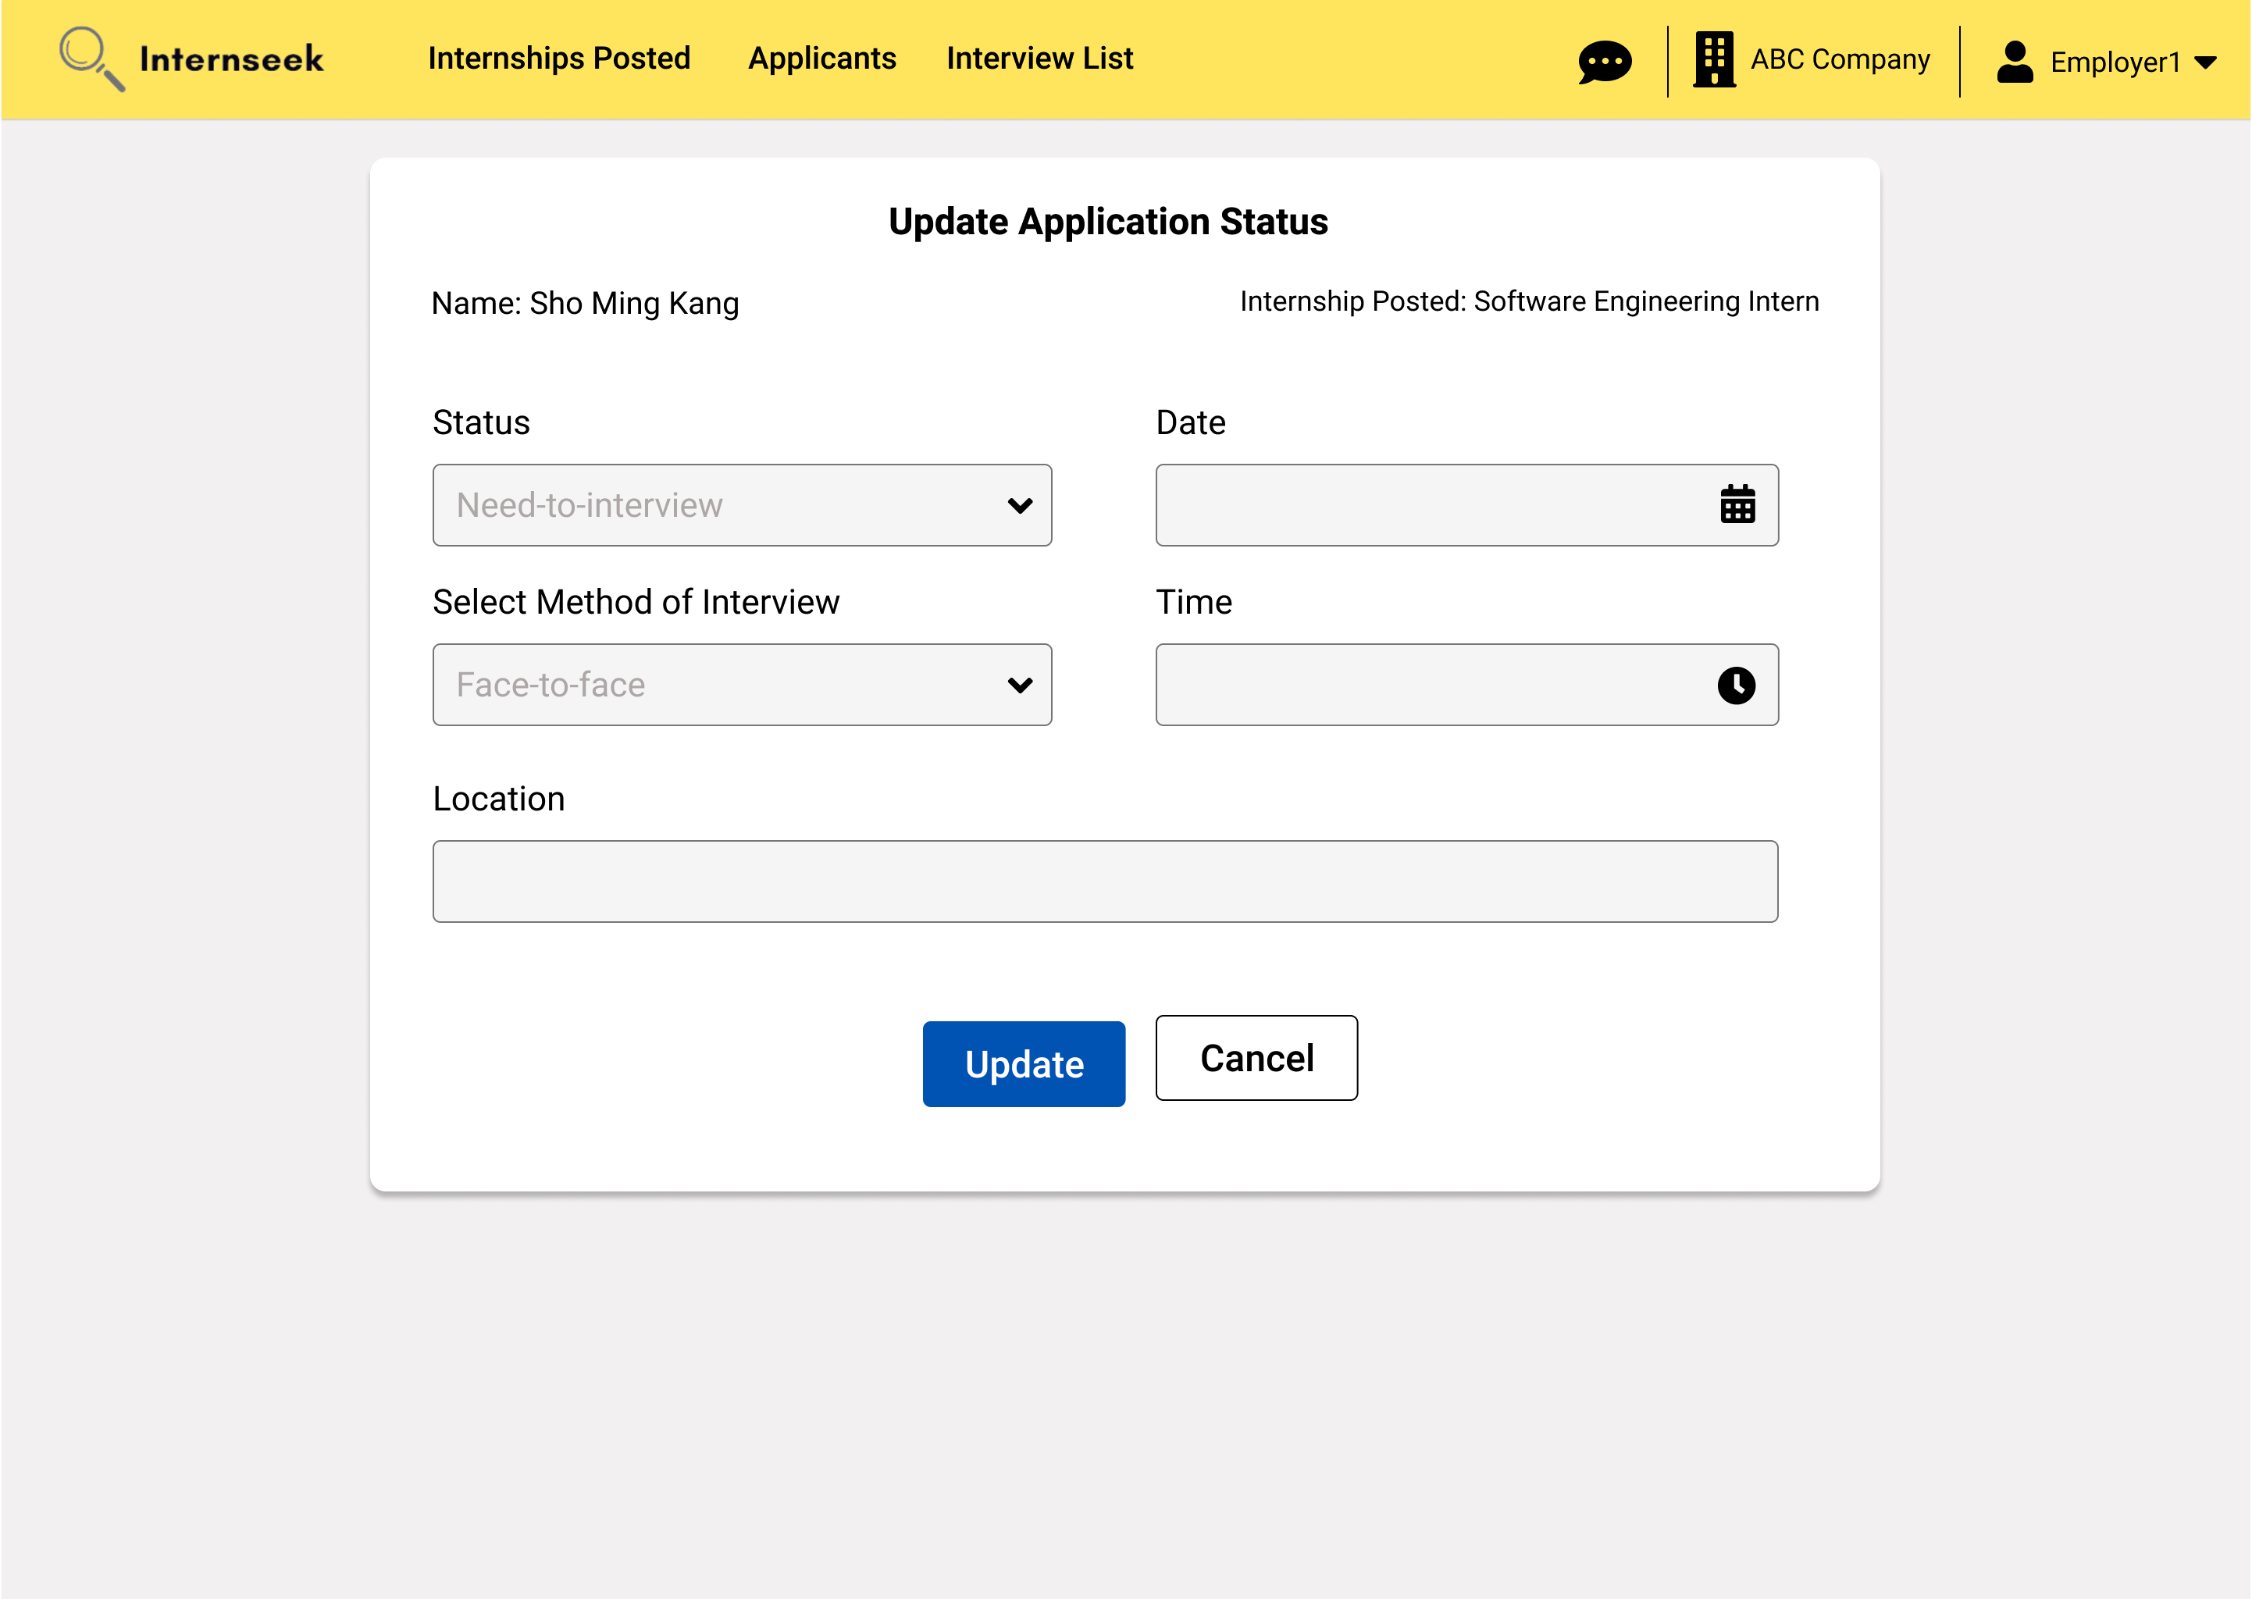

Figure 3‑226: Select Interview Method (Face-to-face interview)

This figure illustrates the employer selecting the Need-To-Interview status and the face-to-face interview method. Upon selecting the face-to-face interview method, the field for the interview location becomes visible. The employer needs to enter the interview details and click the <<Update>> button to update the application status and save the interview details.

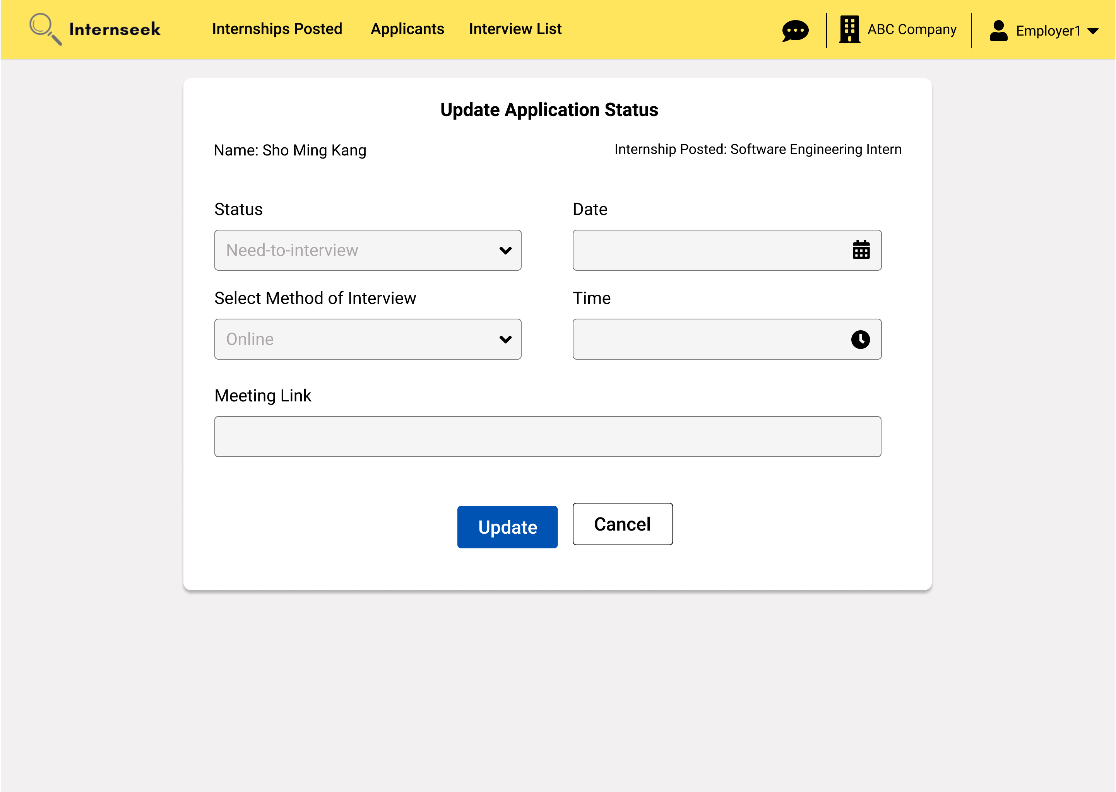

Figure 3‑227: Select Interview Method (Online Interview)

This figure illustrates the employer selecting the Need-To-Interview status and the online interview method. Upon selecting the online interview method, the field for the meeting link becomes visible. The employer needs to enter the interview details and click the <<Update>> button to update the application status and save the interview details.

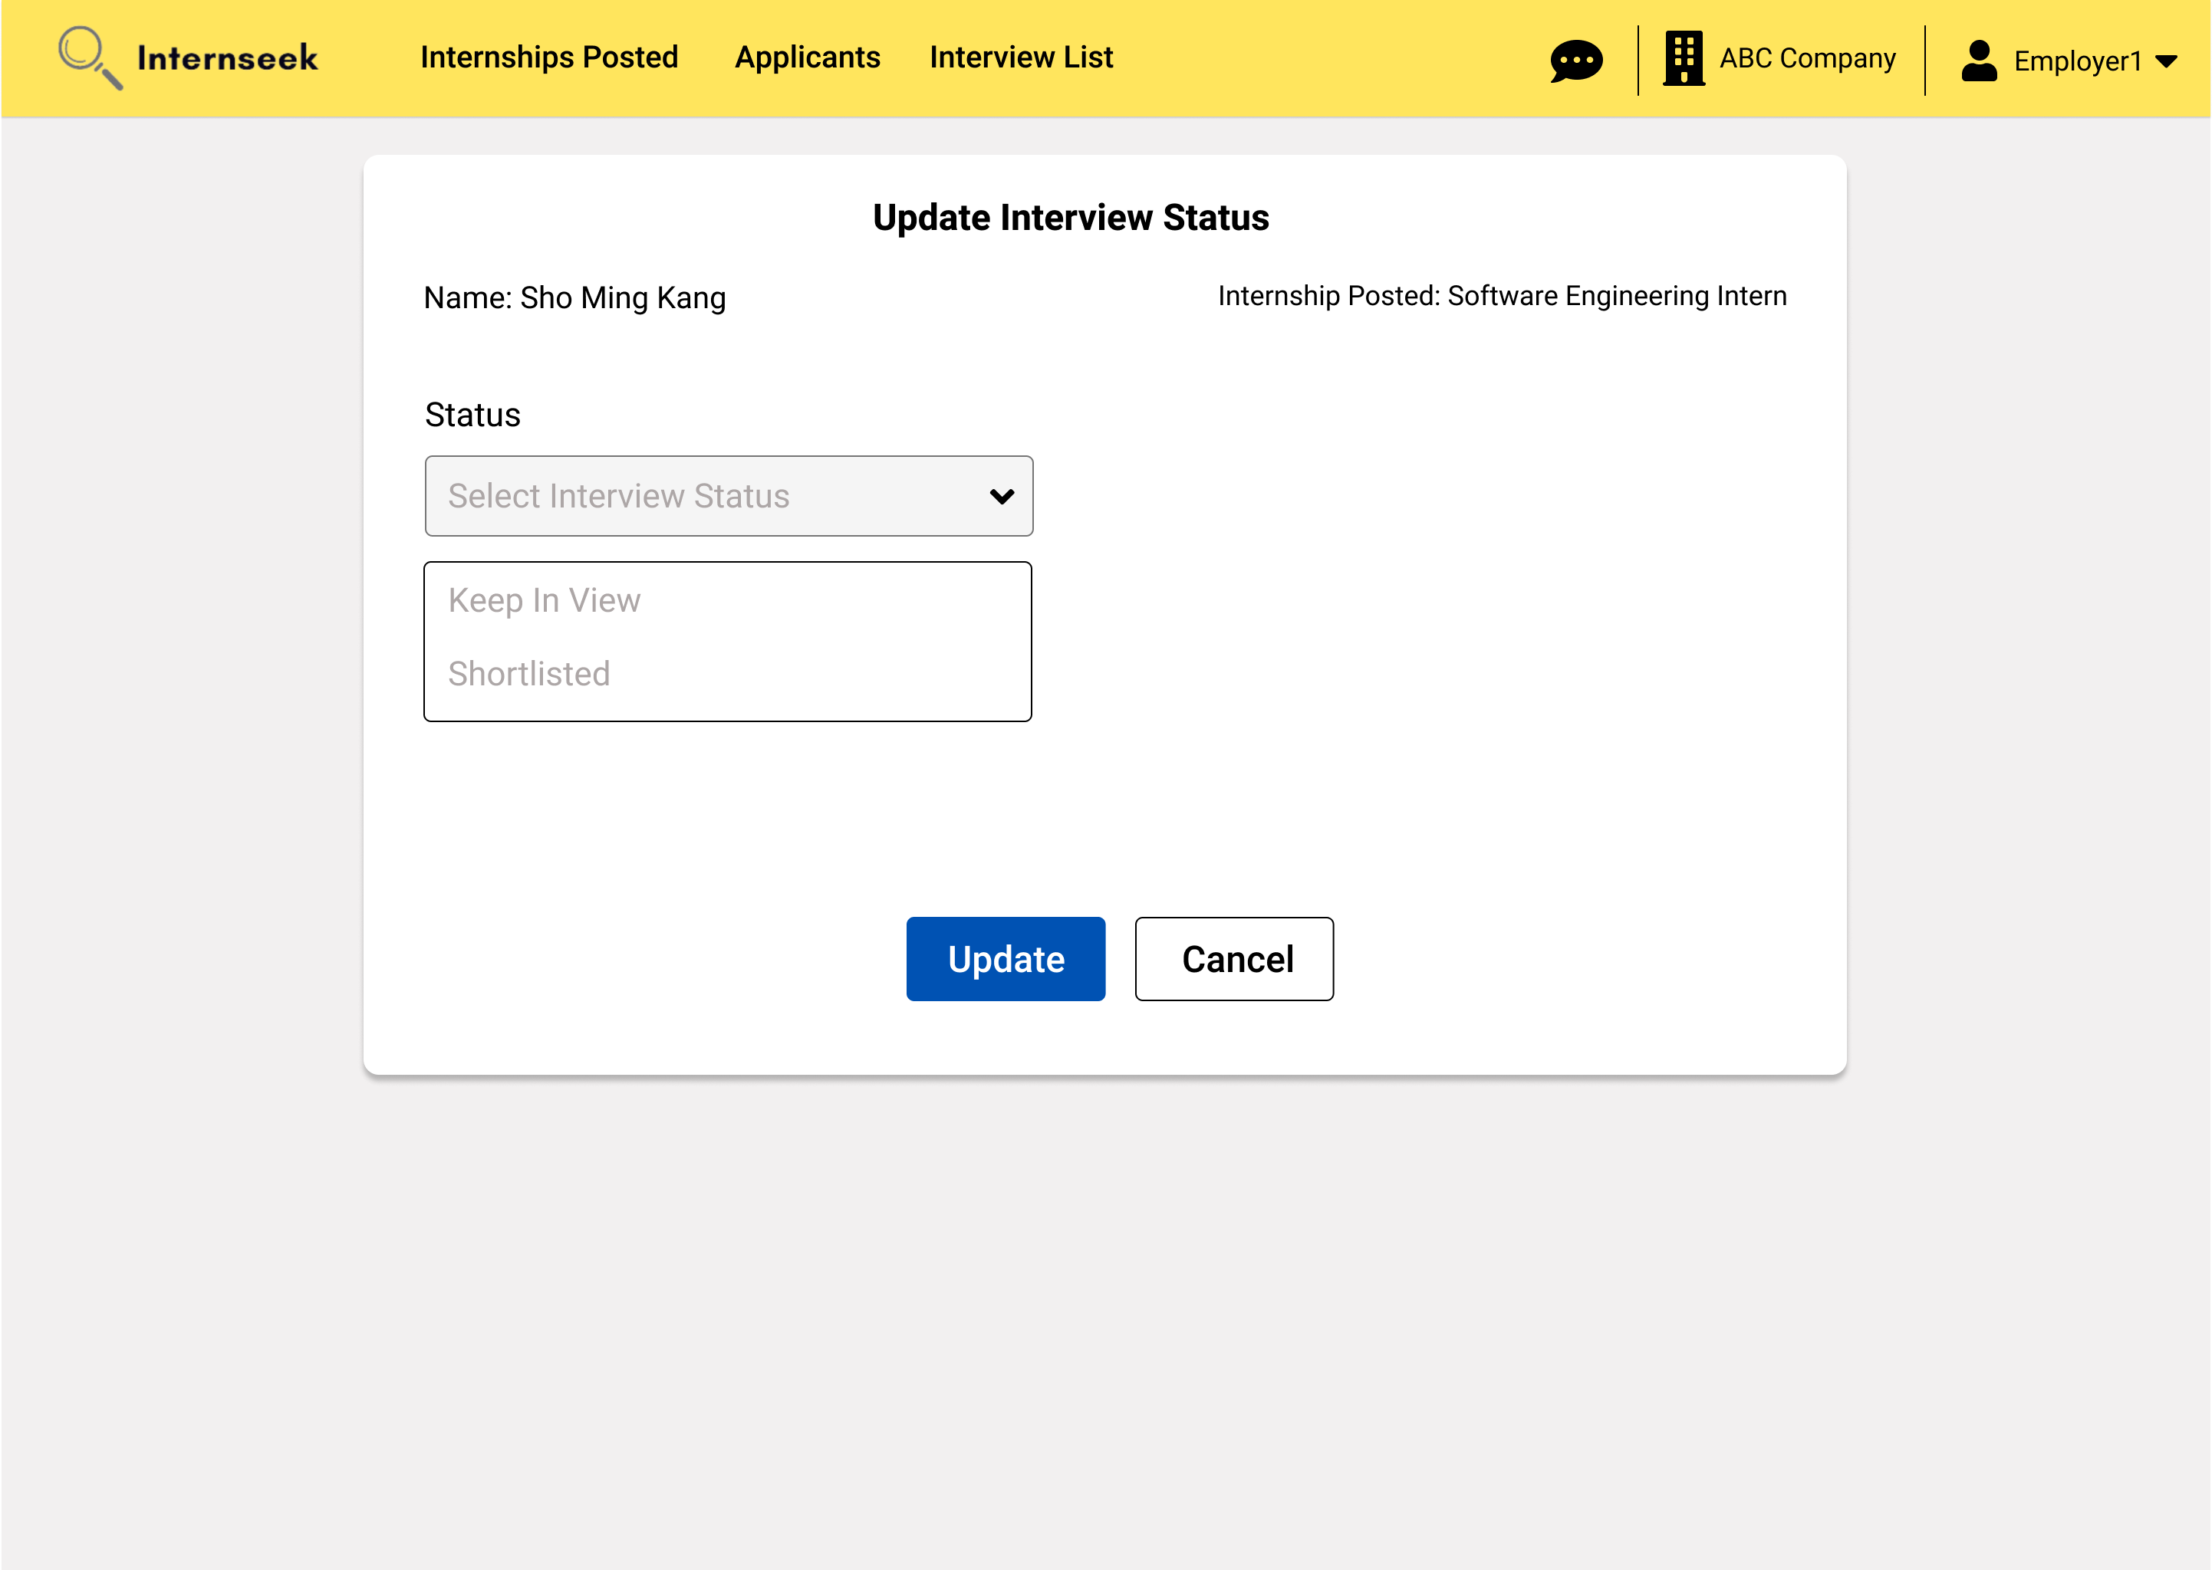

Figure 3‑228: Update Interview Status page

This figure displays the page for the employer to update the interview status of the applicant. There are two interview statuses: Keep In View and Shortlisted. The employer can click the <<Cancel>> button if they do not want to update the interview status of the applicant. If the employer selects the Keep In View status, they can directly click the <<Update>> button to update the internship application status as Keep In View.

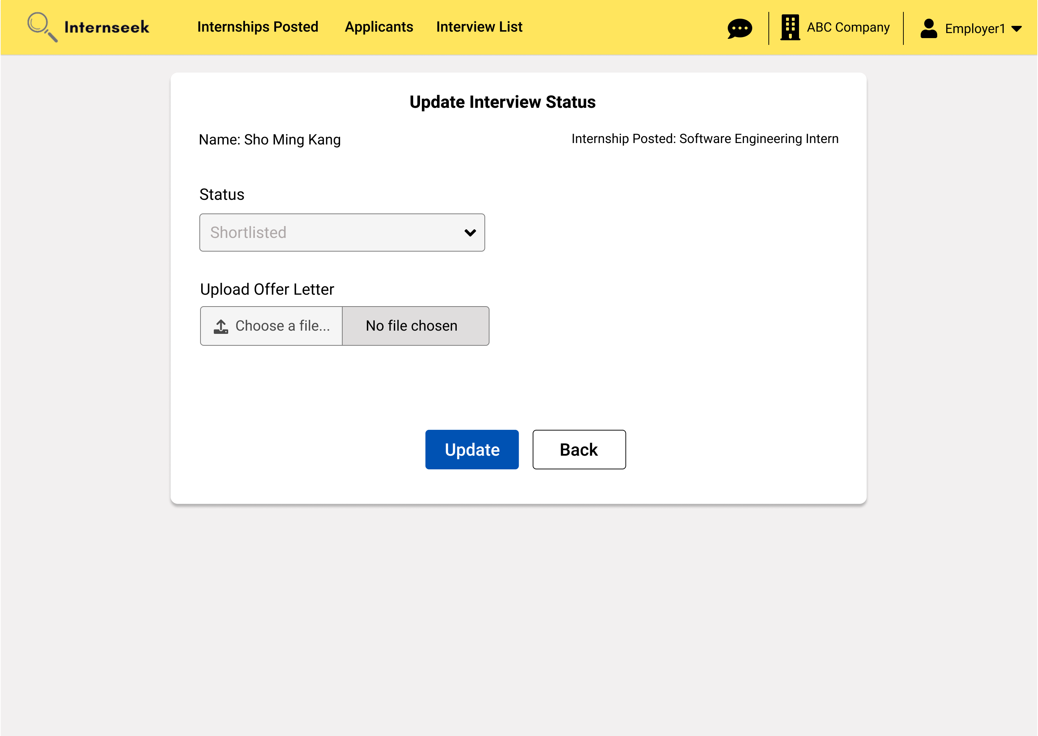

Figure 3‑229: Update interview status (Successful)

This figure illustrates the update interview status page, where the employer selects the shortlisted status. Upon selecting the shortlisted status, the field for the upload offer letter becomes visible. The employer needs to upload the offer letter and click the <<Update>> button to update the internship application status as shortlisted.

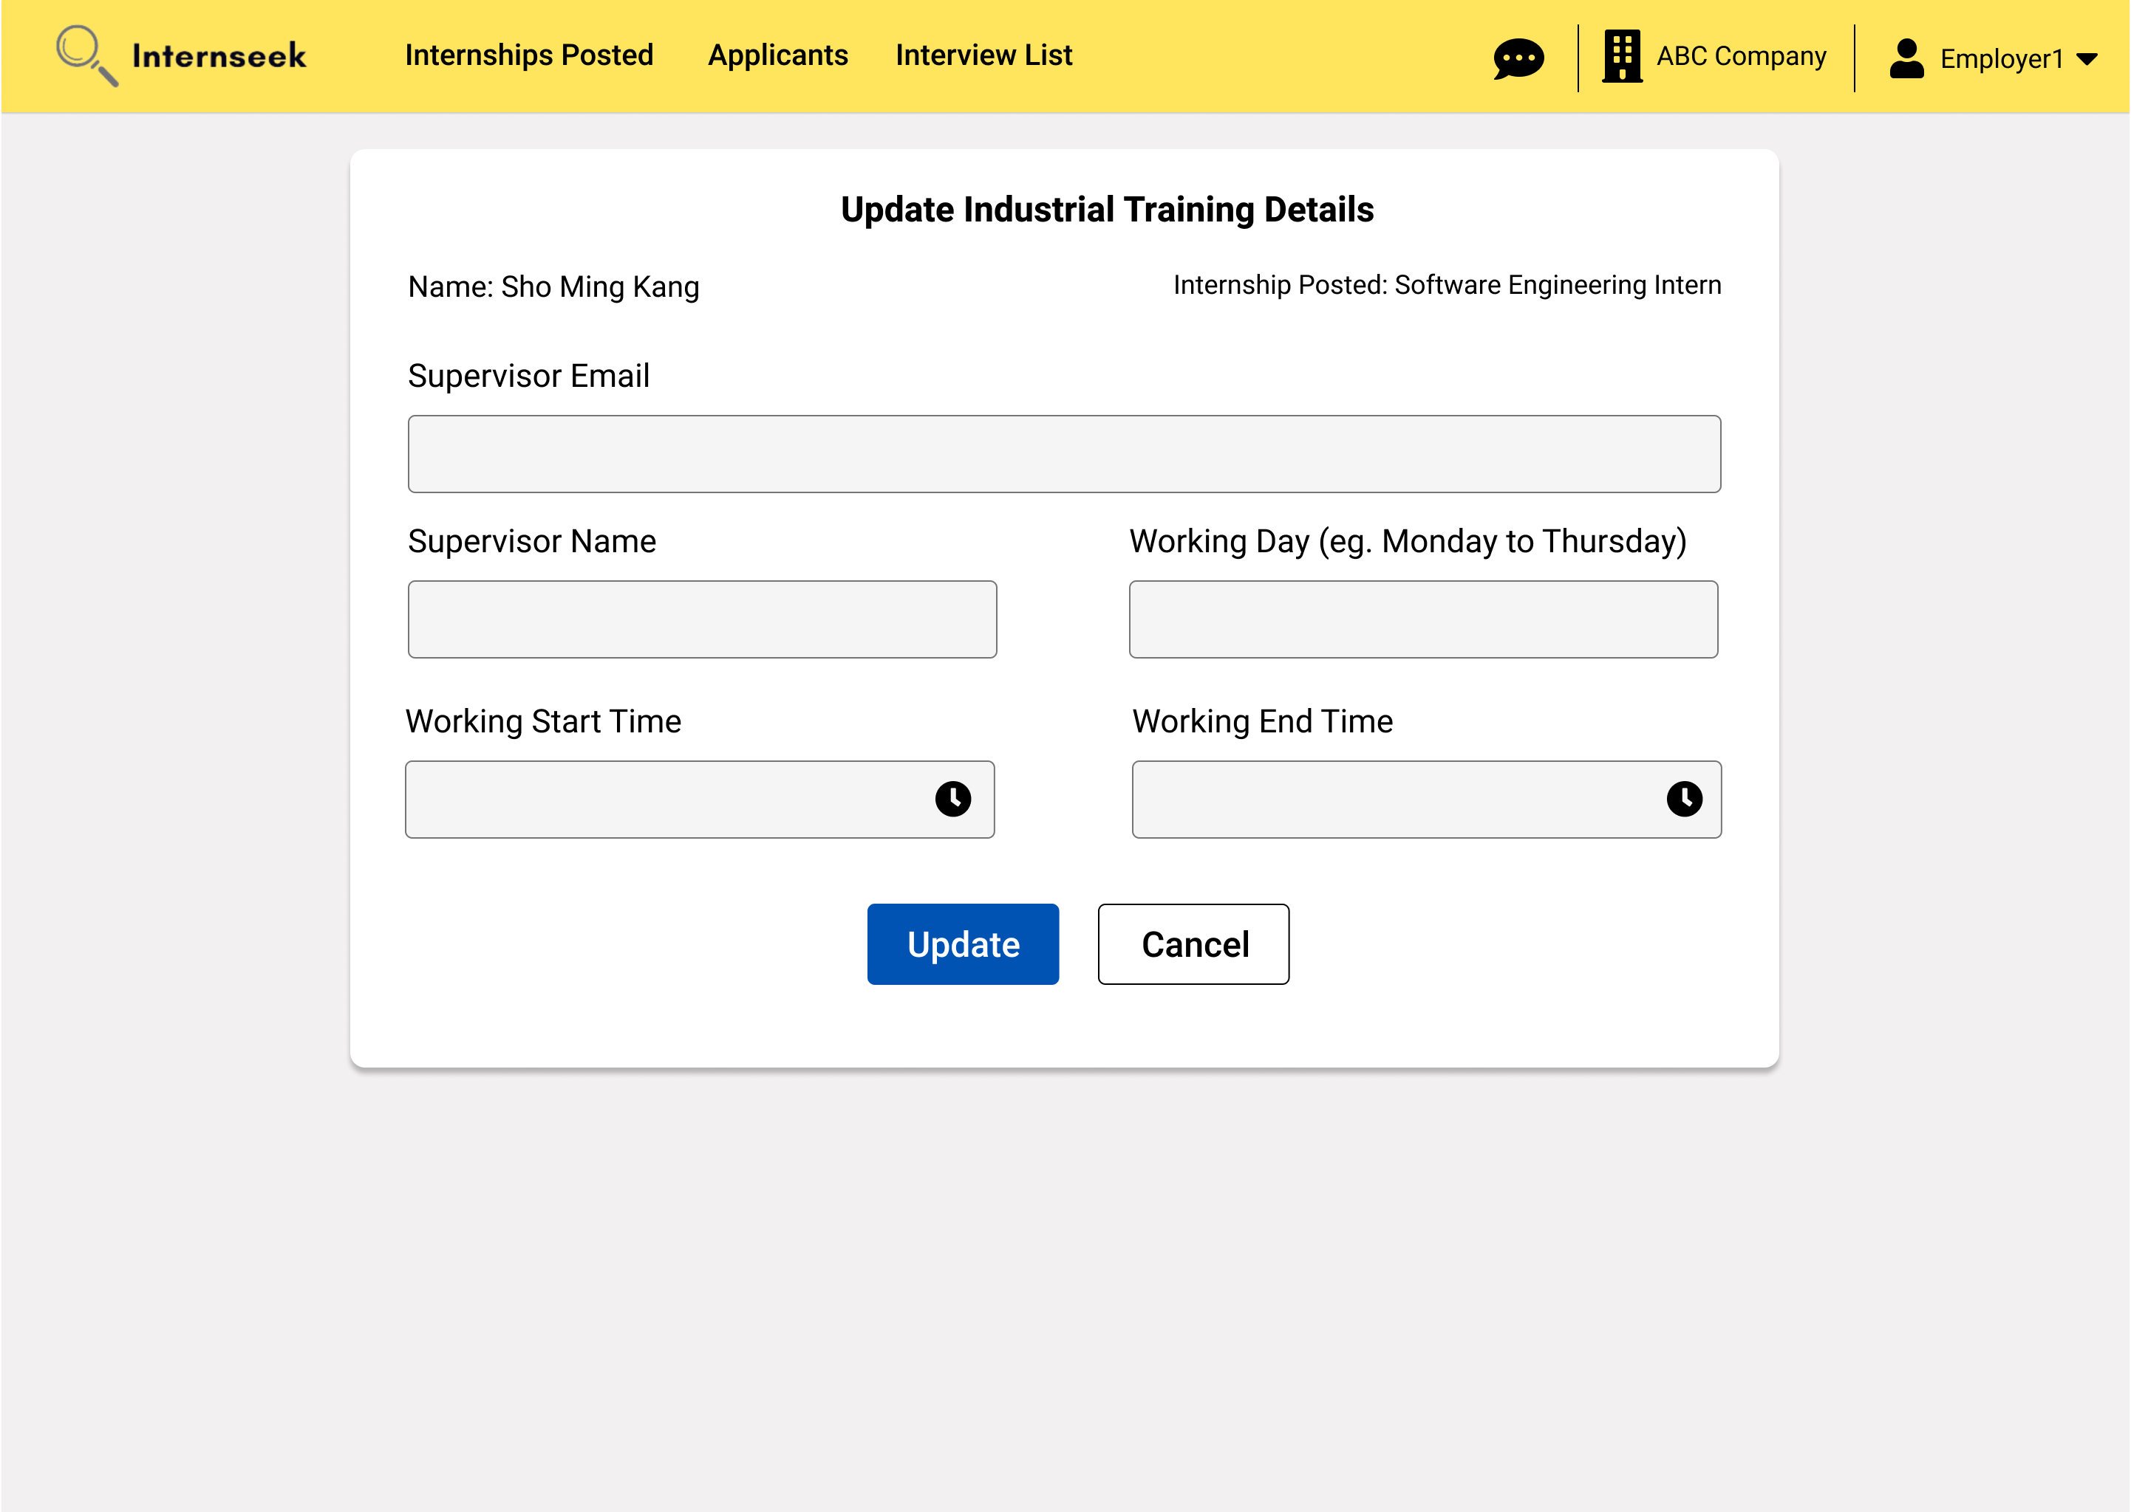

Figure 3‑230: Update Accepted Offer/Industrial Training Details Page

This figure shows the Update Industrial Training page, where the employer enters the accepted offer details and then clicks the <<Update>> button to update the industrial training information for applicants who accept the offer. If the employer does not want to update the details, they may click the <<Cancel>> button.

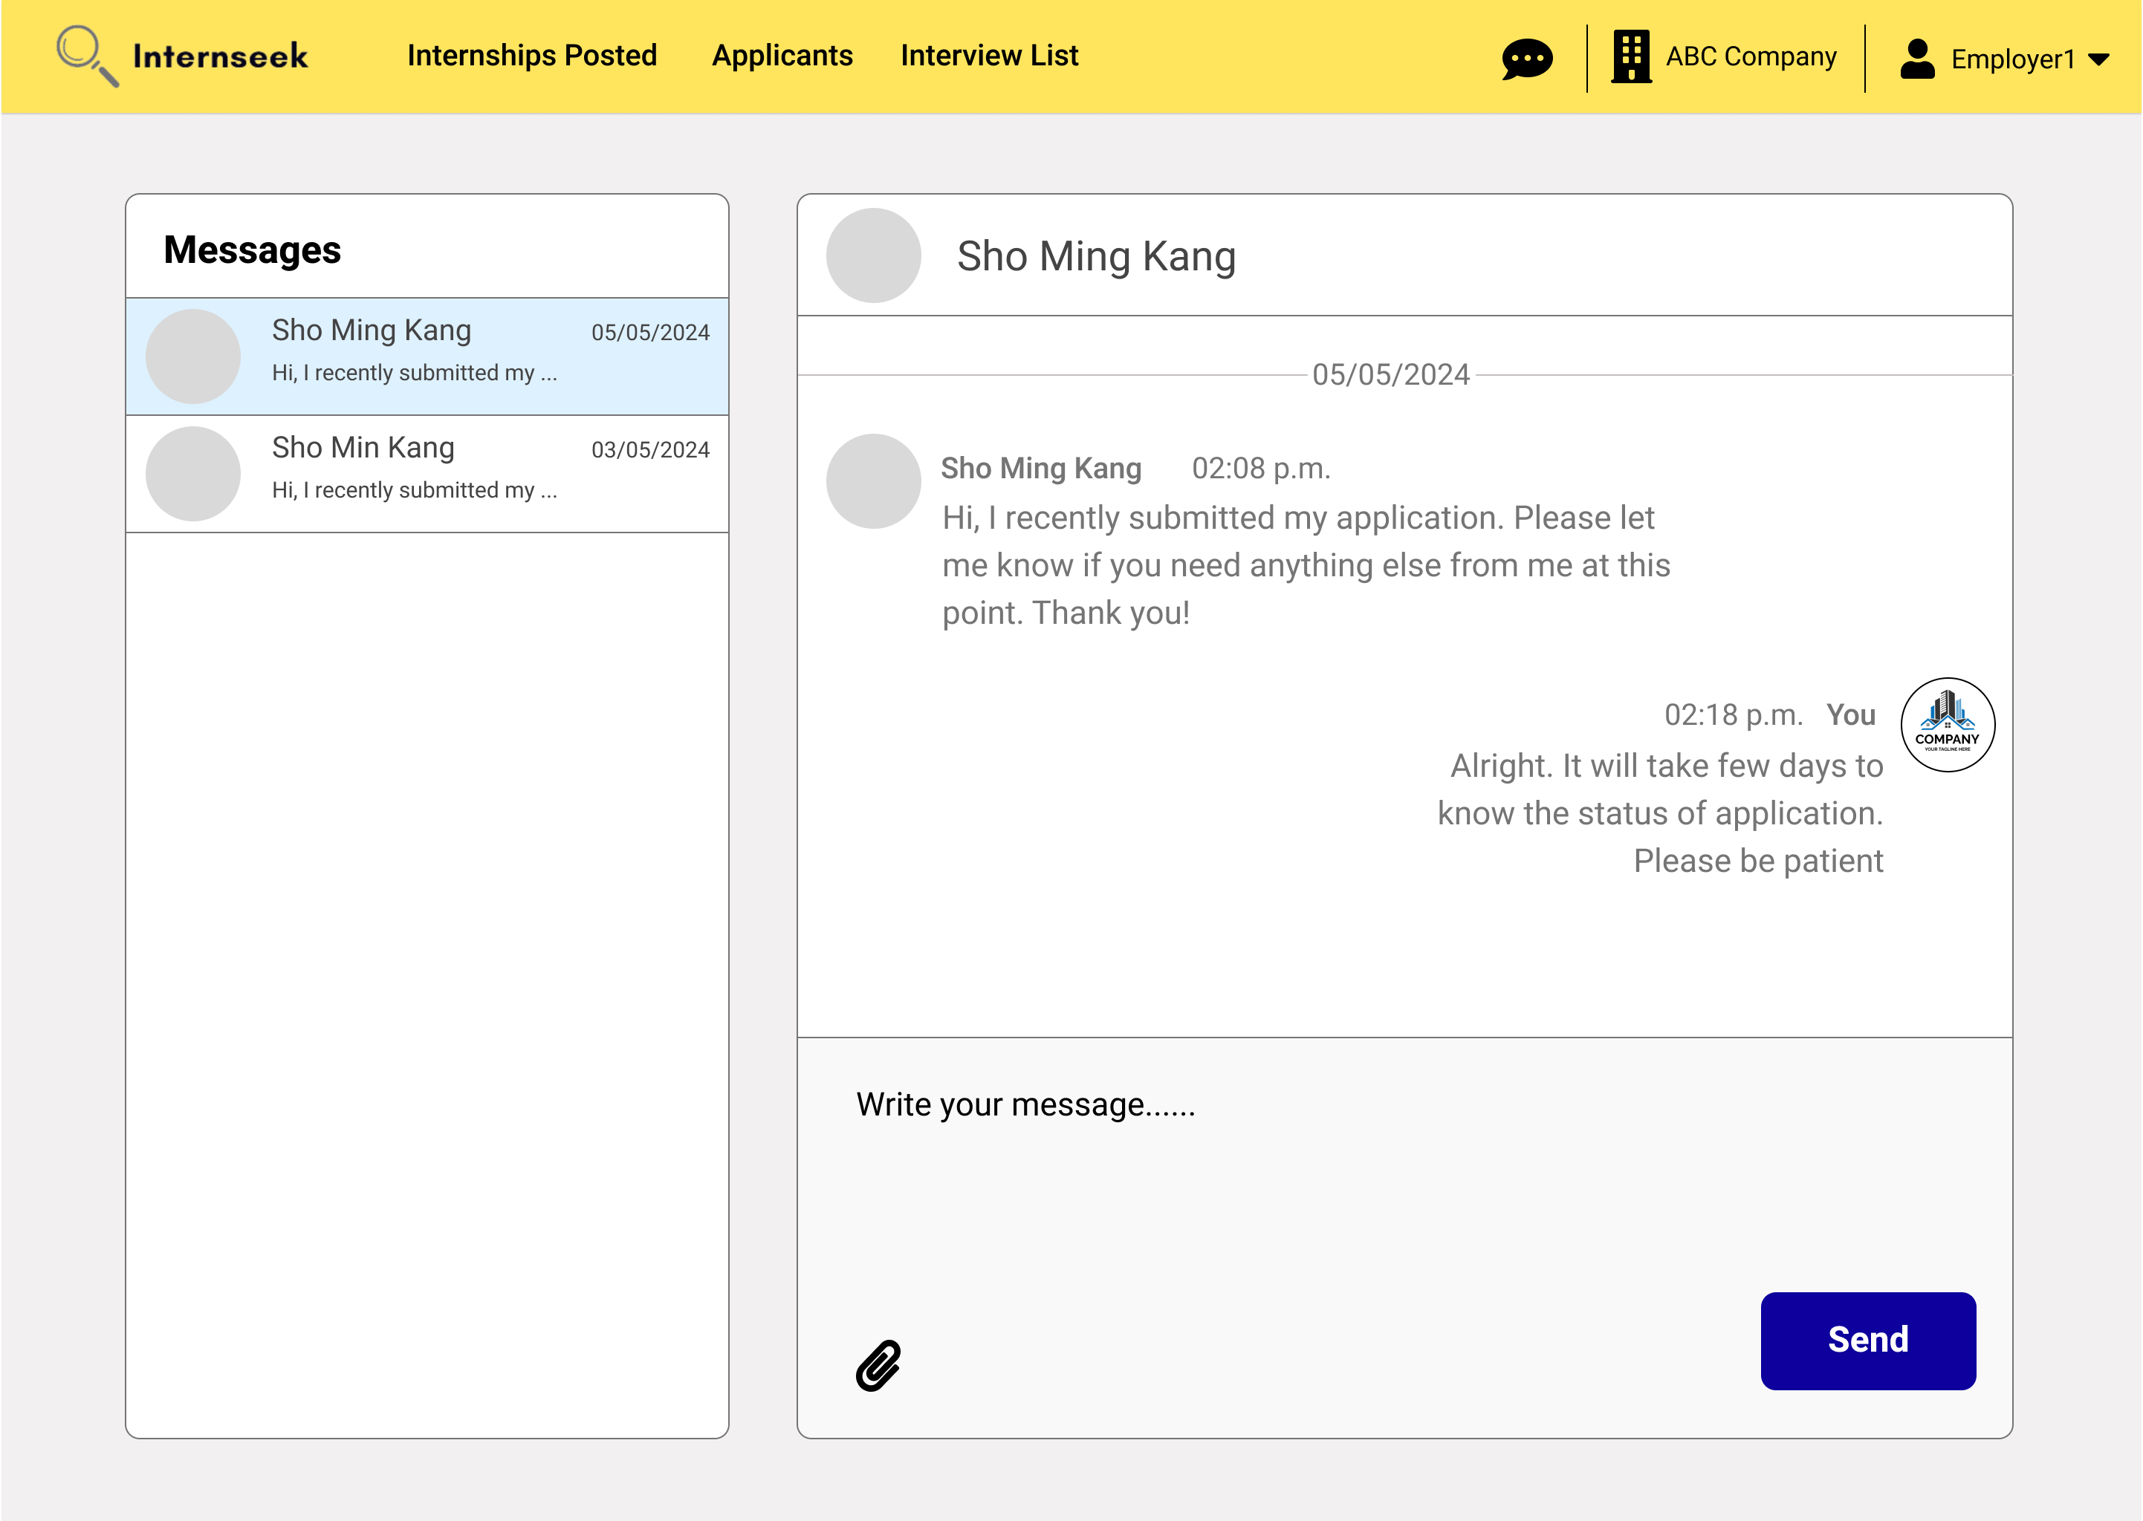

Figure 3‑231: Message Inbox and Chat-box Page

This figure displays the message inbox and chat-box page. The left-side interface represents the message inbox. The message inbox will display all the conversations with different applicants. Unread messages are highlighted to differentiate them from read messages. The employer can scroll through the list to find a specific conversation. The right-side interface displays the selected conversation in detail. It shows the latest received messages and the full message history between the university student and the employer. At the bottom of the chat box, there is an input field where the employer can type a new message. After the employer types in a new message and attaches a file, they click the send button to send the message. The chat box updates in real-time, showing new messages they sent.

##### Administrator

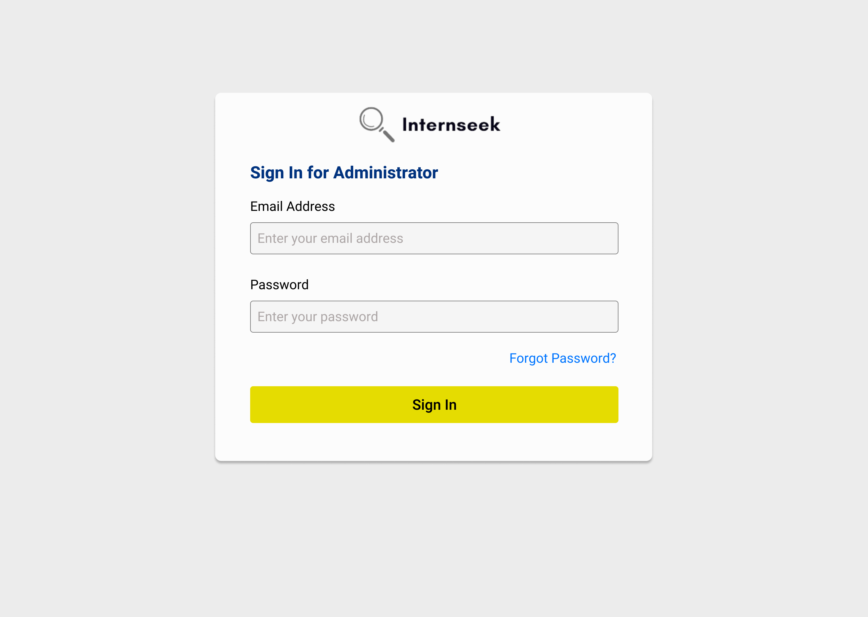

Figure 3‑232: Login page for Administrator

This figure illustrates the login page for administrators. The administrators need to enter their email address and password and click the <<Sign In>> button to login to the system. If the administrators forget their account password, they need to click the <<Forgot Password?>> text to reset their password.

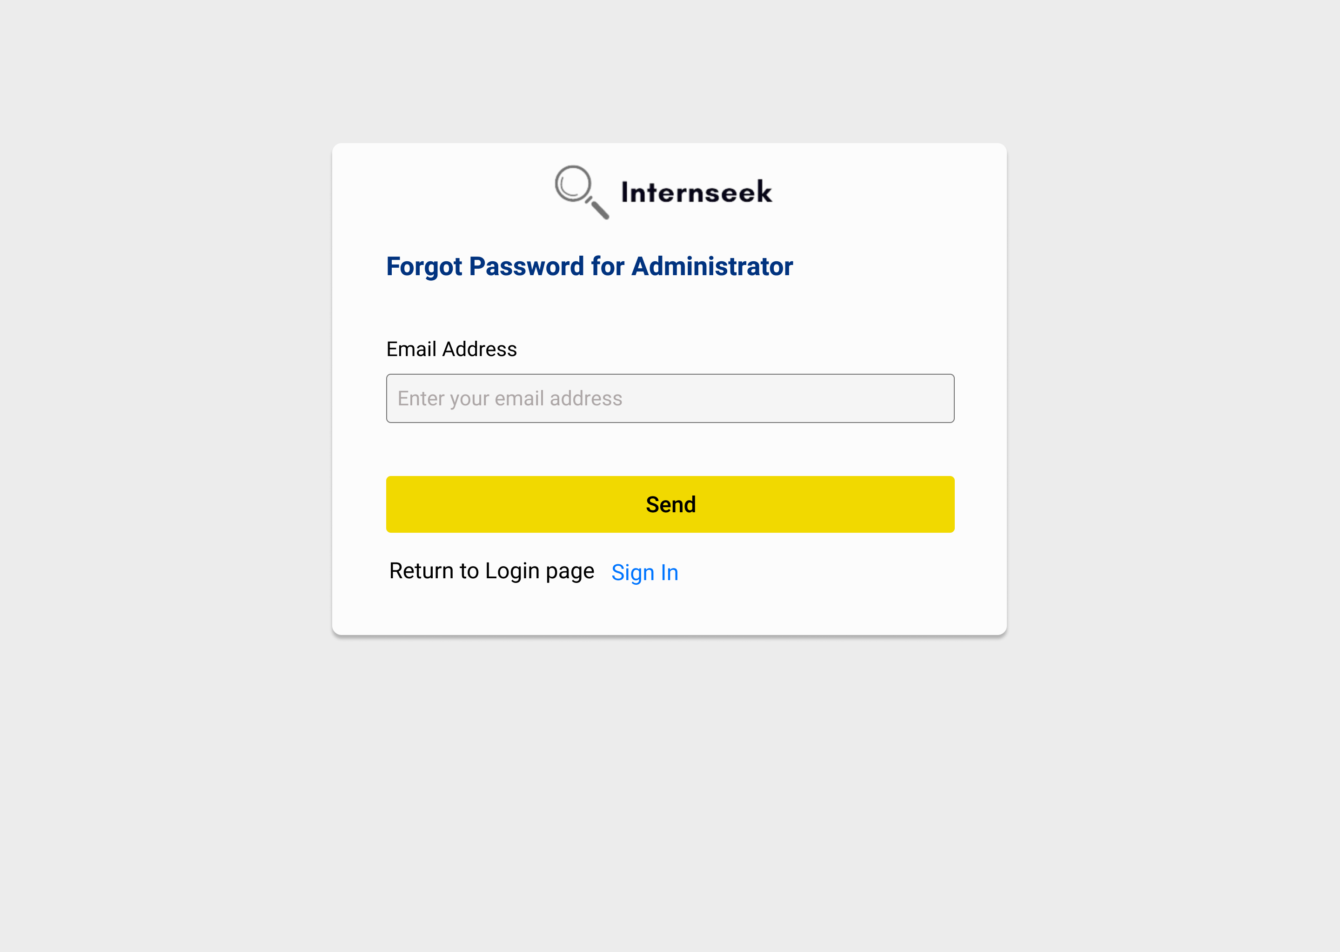

Figure 3‑233: Forgot Password Page for Administrators

This figure illustrates the forgot password for administrators if they forgot their password. The administrators need to enter their email address and click the <<Send>> button to get the password reset link. If the administrators want to back to login page, they may click the <<Sign In>> text.



Figure 3‑234: Password Reset Page for Administrators

This figure illustrates the password reset page for administrators once they click the password reset link in the email they received. The administrators need to enter their new password, confirm their password, and click the <<Submit>> button to reset their password.

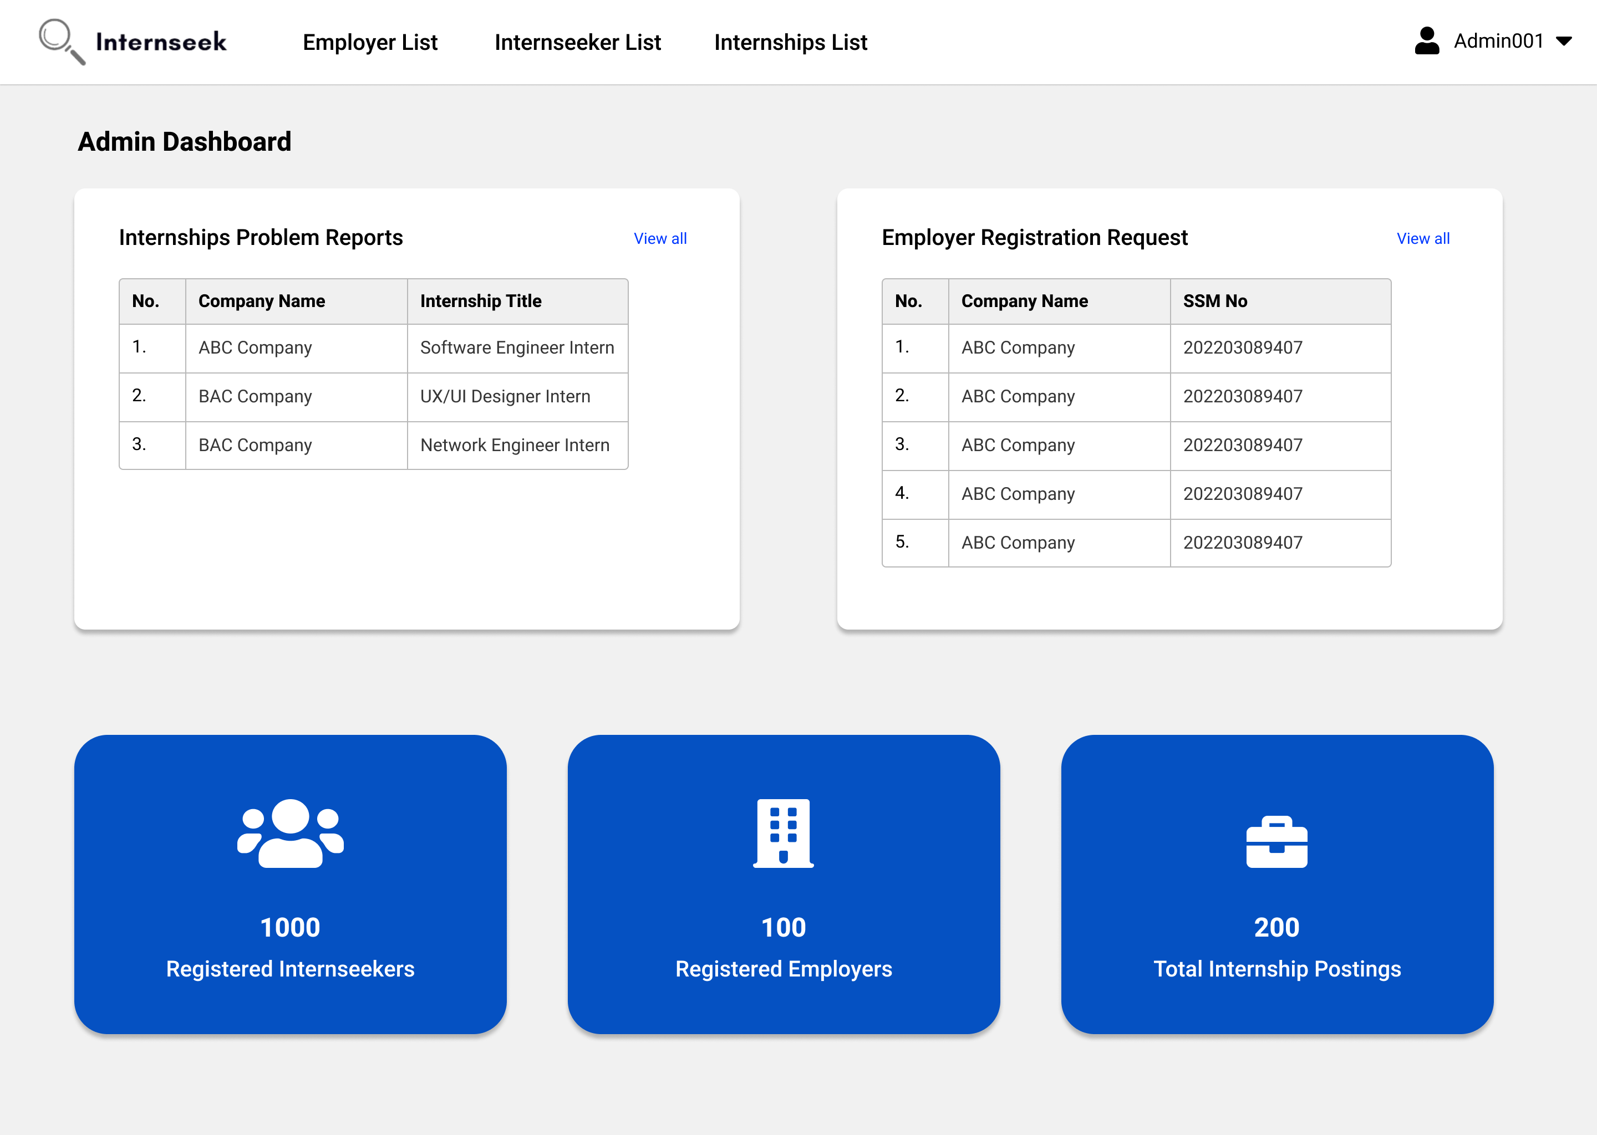

Figure 3‑235: Admin Dashboard

This figure shows the Admin Dashboard page once the administrator successfully logs into the system. The admin dashboard displays the total number of available internships, registered employers, and total internship postings. These numbers represent a card. The admin dashboard also displays the internship problem reports made by university students and the employer registration requests. The administrator can view the full list of the internship problem reports and the employer registration requests by clicking the <<View all>> text.

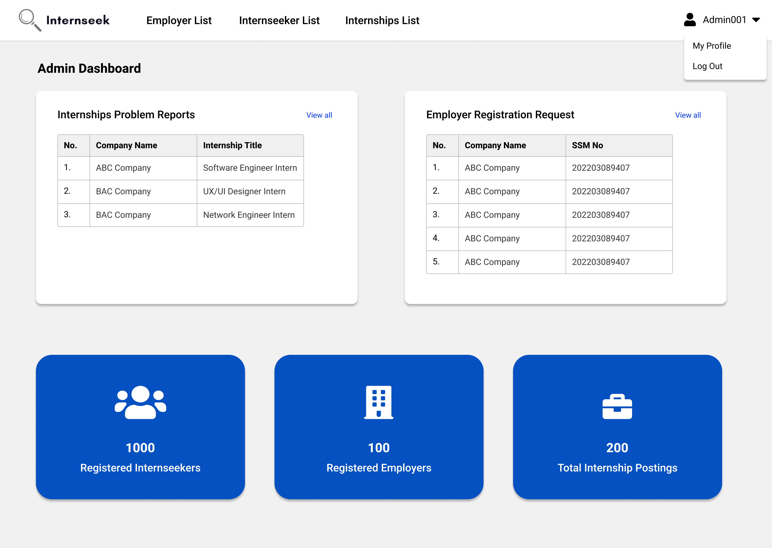

Figure 3‑236: Admin Dashboard with Drop-Down Menu

This figure shows the Admin Dashboard with the drop-down menu of the navigation bar, which consists of two options: My Profile, and Log Out. Administrators will be directed to the My Profile page once they select the My Profile option. Administrators will be logged out of the system once they select the Log Out option.

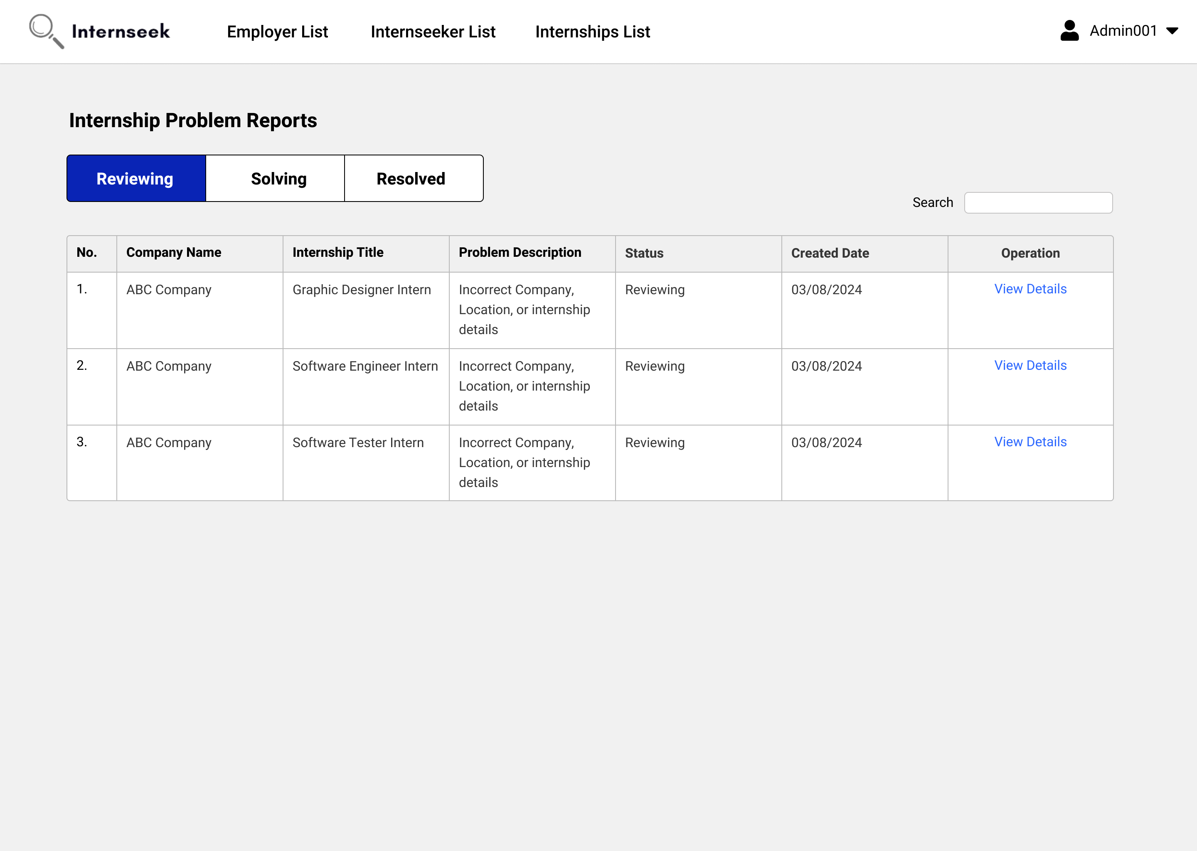

Figure 3‑237: Internship Problem Reports List page (Pending Status)

This figure shows the Internship Problem Reports List page once the administrator clicks the <<View all>> text in the internship problem reports section of the Admin Dashboard. This page displays all internship problem reports with a pending status in table form. Administrators can view the basic details of internship problem reports. If the administrator wants to view the detailed information about the internship problem reports, they may click the <<View Details>> text.

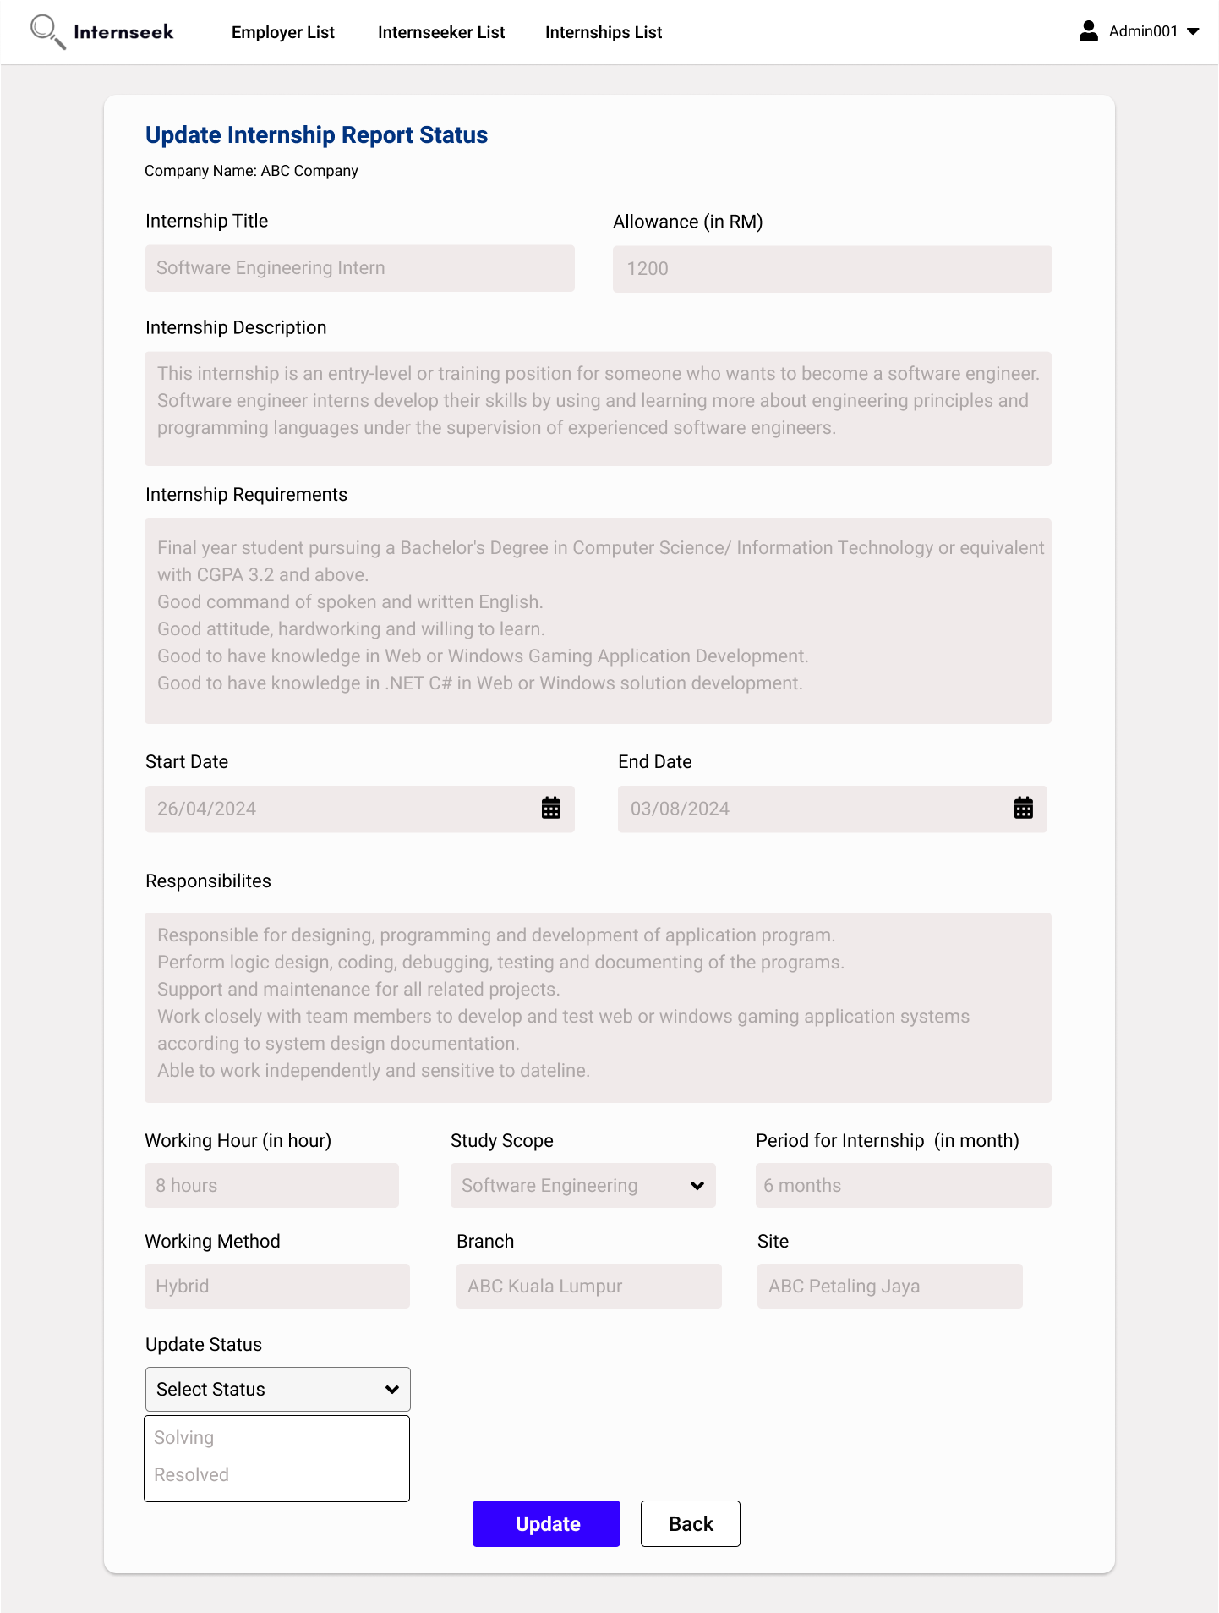

Figure 3‑238: Update Internship Report Status Page

This figure shows the Update Internship Report Status page that appears when the employer clicks the <<View Details>> text for a specific internship problem report on the Internship Problem Report List page. The administrator can update the report status from reviewing to solving or resolved status.

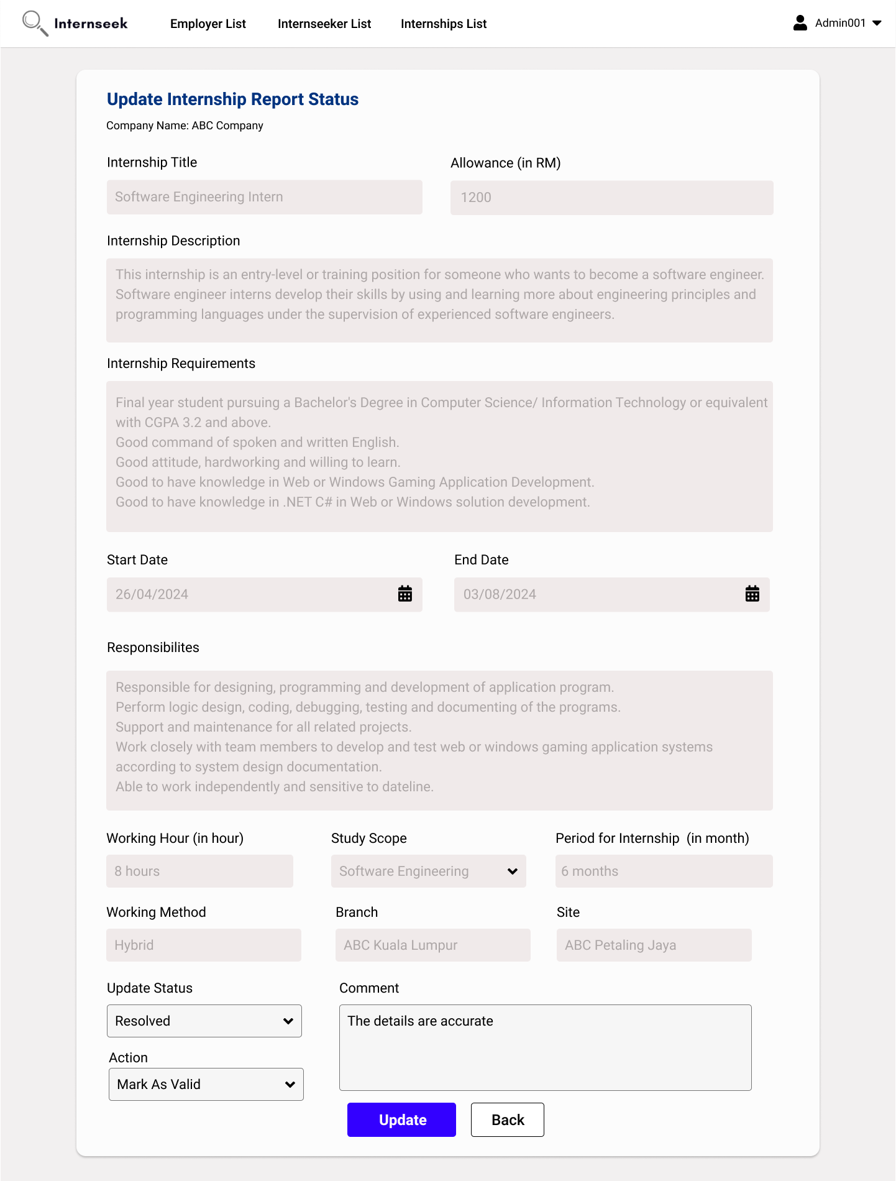

Figure 3‑239: Update Internship Report Status Page (Resolved)

This figure shows the Update Internship Report Status page, where the employer selects the report status as "resolved" and the comment and action input field are displayed. The administrator enters a comment, select an action in the input fields, and then clicks the <<Update>> button to update the comment and the report status for the student who made the report.

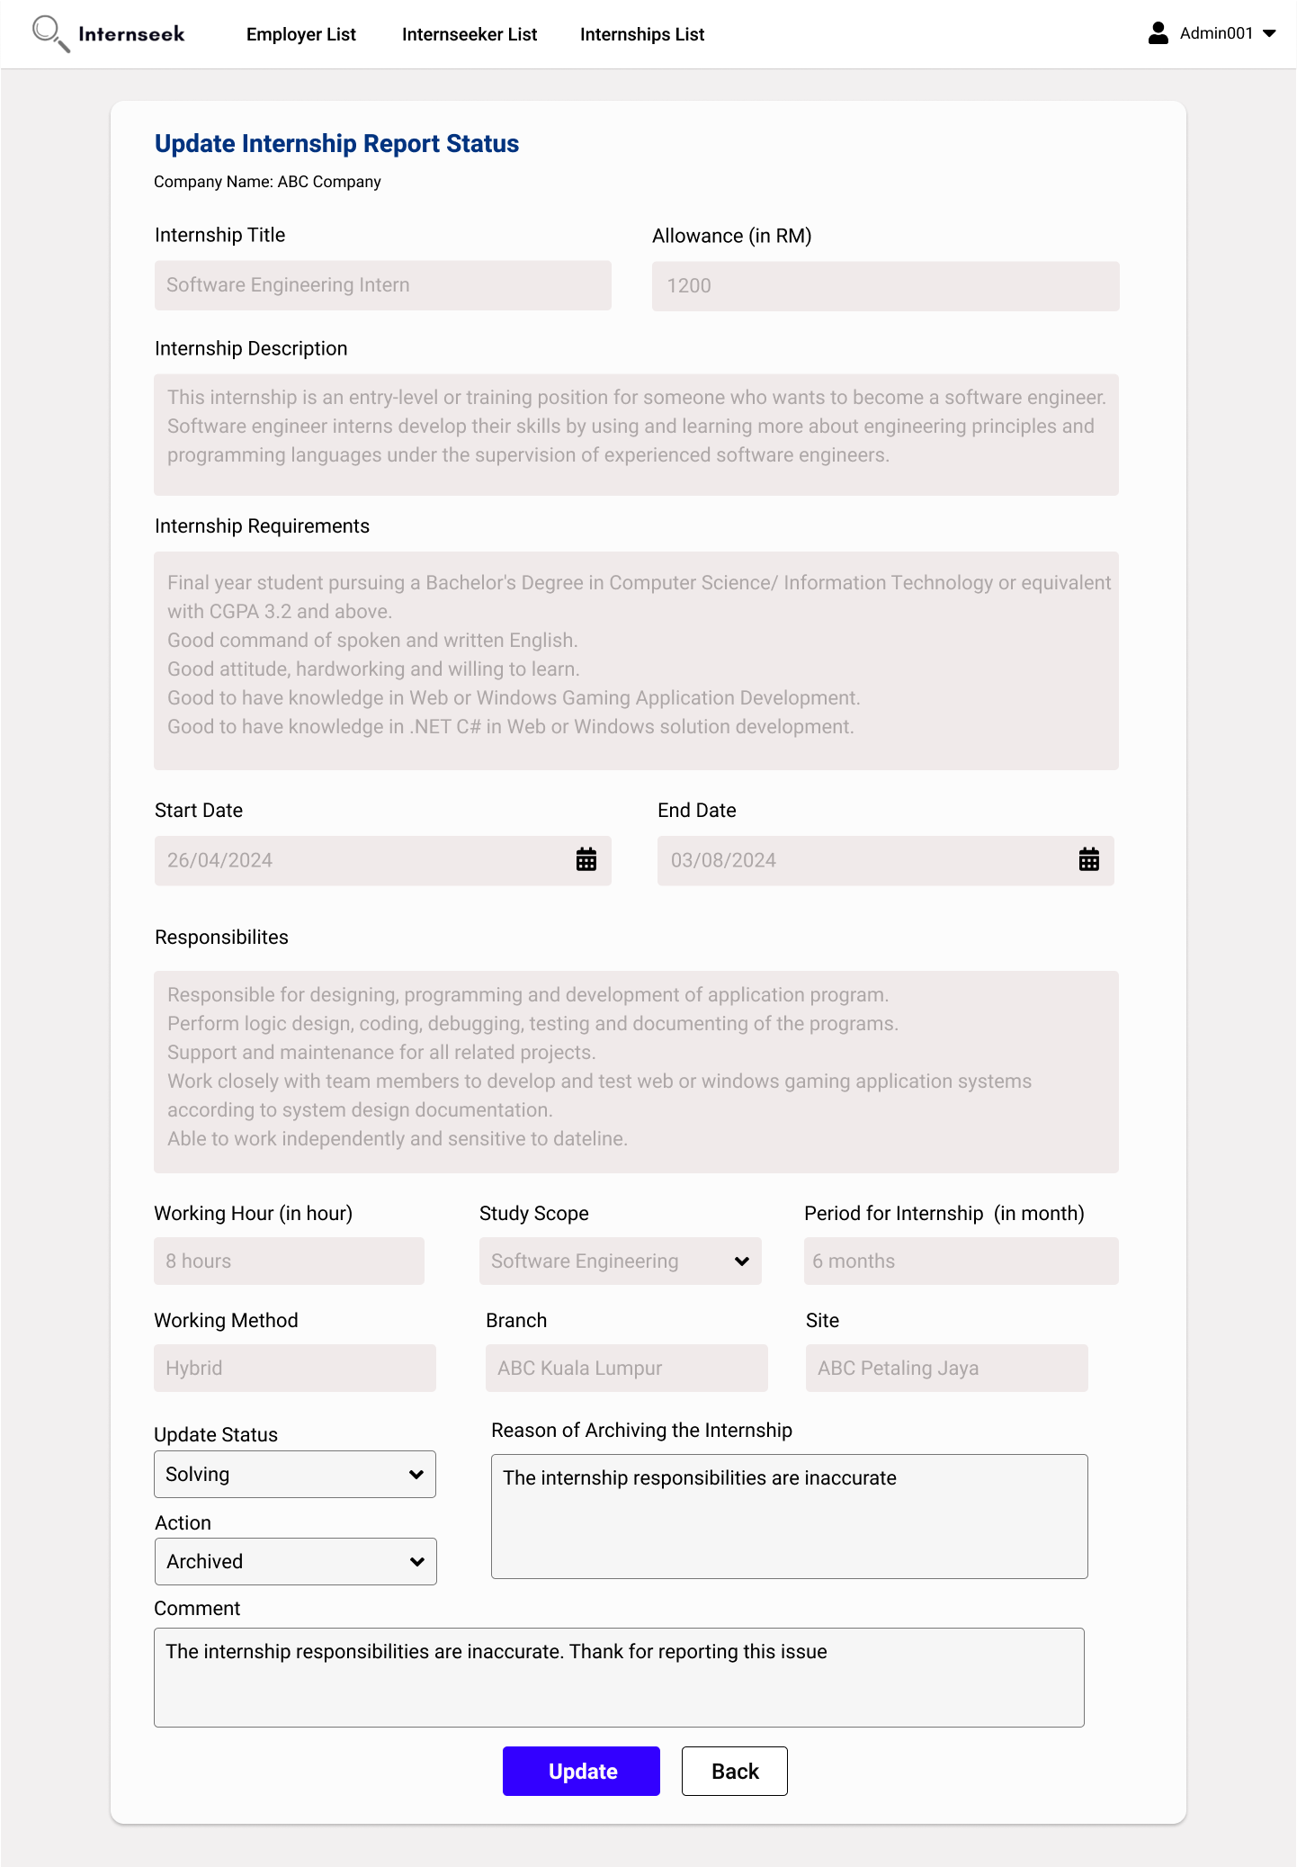

Figure 3‑240: Update Internship Report Status Page (Solving)

This figure shows the Update Internship Report Status page, where the administrator selects the report status as "Archived." The comment, action, and reason for archiving input fields are displayed. The administrator enters a comment, provides the reason for archiving, selects an action, and then clicks the <<Update>> button to update the report status and notify the student who made the report, as well as archive the internship.

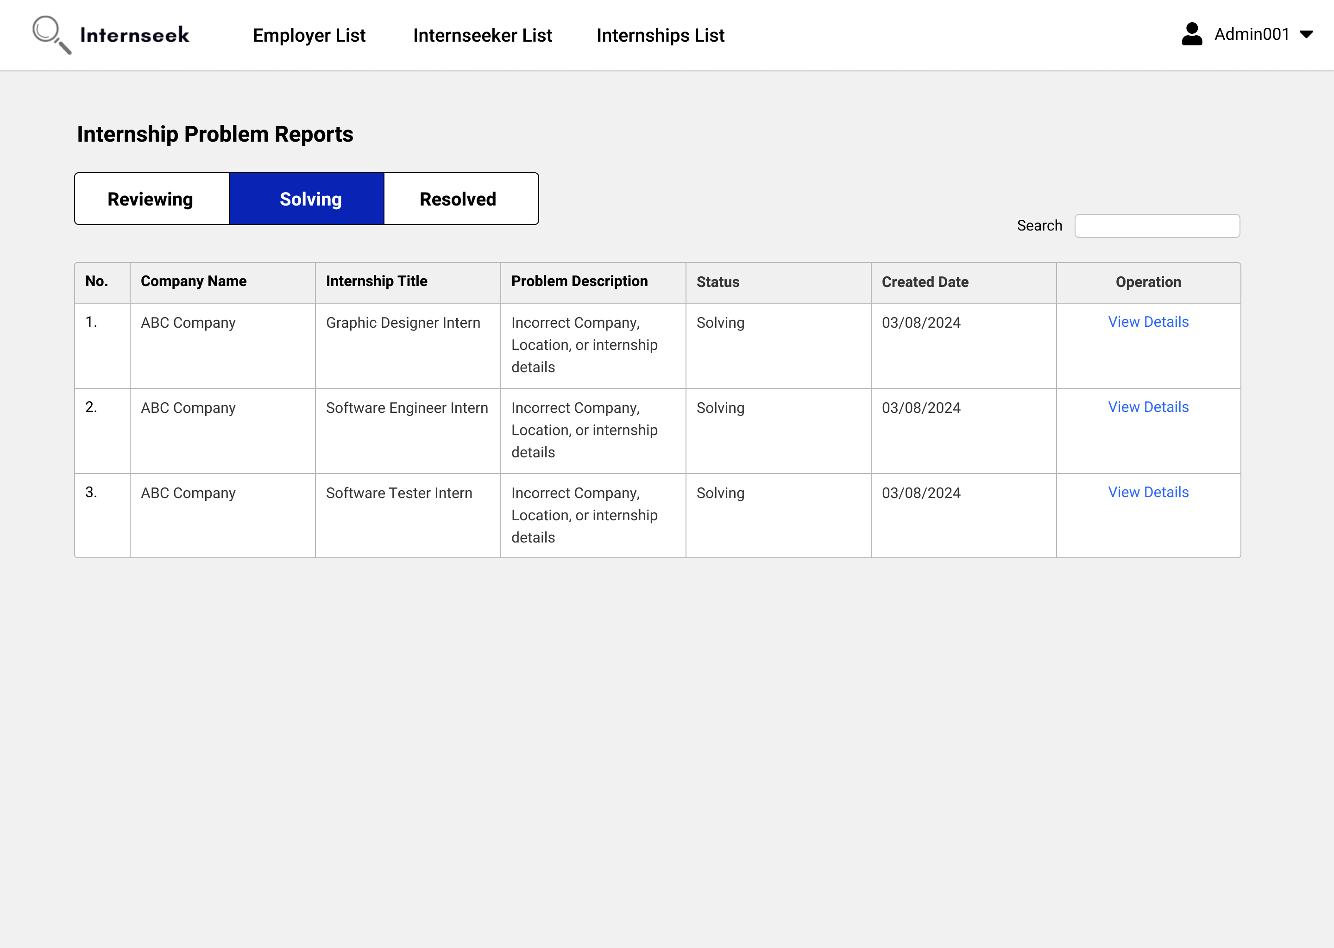

Figure 3‑241: Internship Problem Reports List page (Solving Status)

This figure shows the Internship Problem Reports List page once the administrator clicks the <<View all>> text in the internship problem reports section of the Admin Dashboard. This page displays all internship problem reports with a solving status in table form. Administrators can view the basic details of internship problem reports. If the administrator wants to view the detailed information about the internship problem reports, they may click the <<View Details>> text.

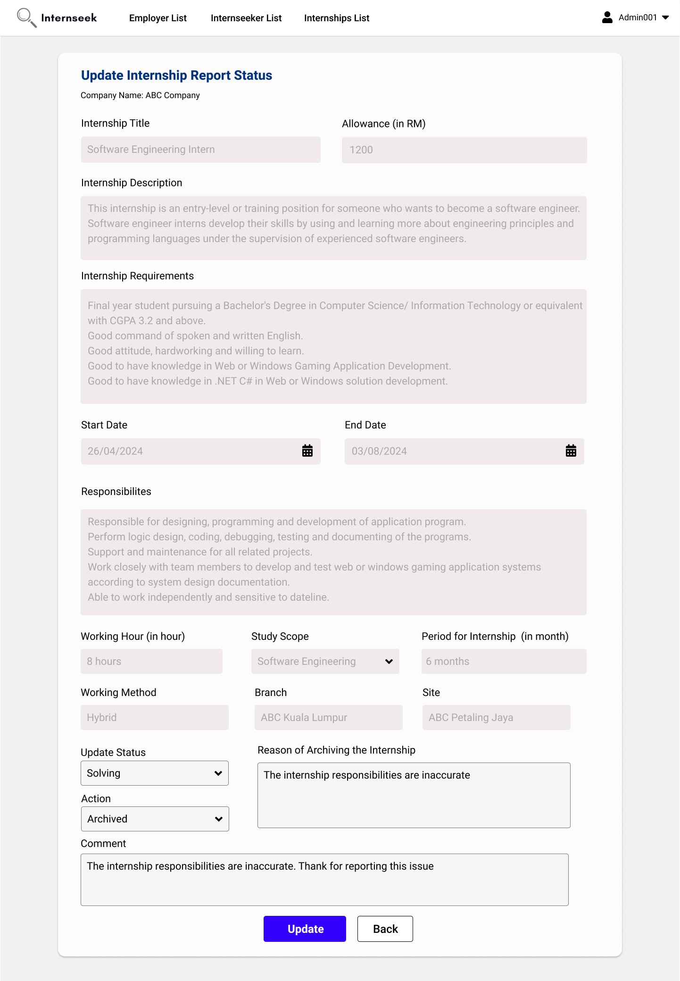

Figure 3‑242: Update Internship Report Status (Current Status: Solving)

This figure shows the Update Internship Report Status page, where the current report status is "solving". The administrator can enter a comment in the input field, update the report status to "resolved", and then click the <<Update>> button to update the report status after reviewing the internship details edited by the employer.

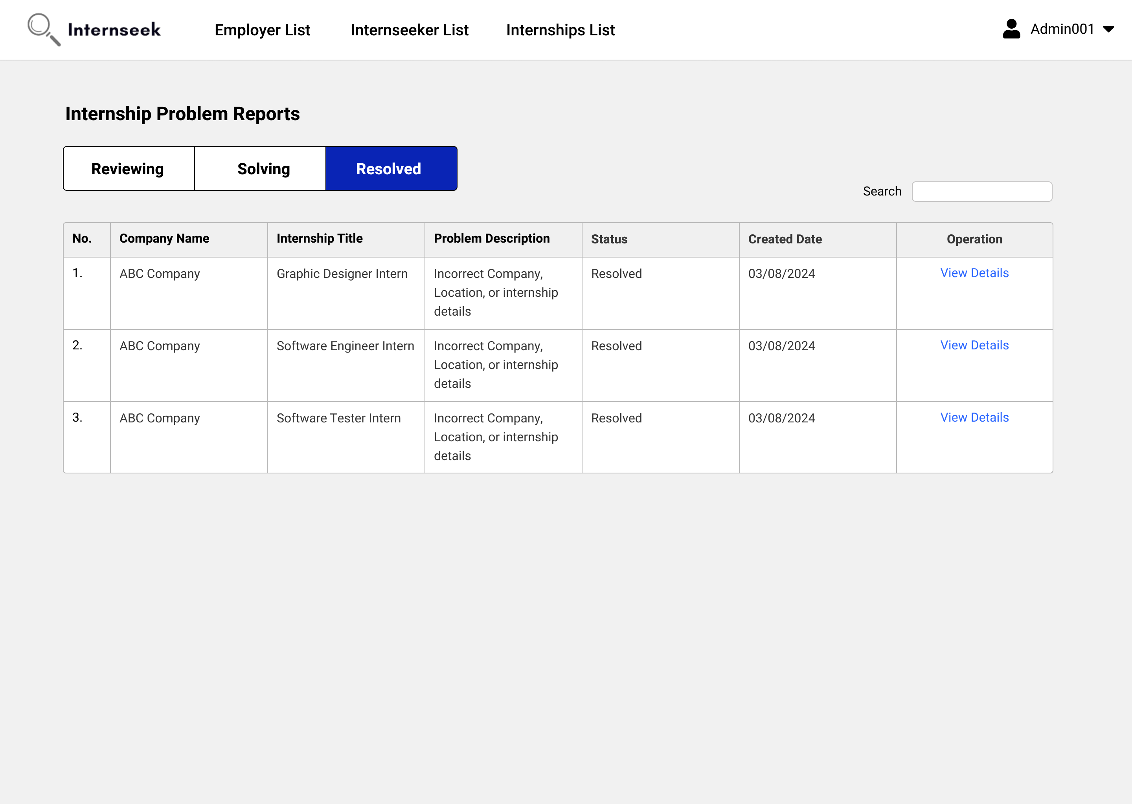

Figure 3‑243: Internship Problem Reports List page (Solving Status)

This figure shows the Internship Problem Reports List page once the administrator clicks the <<View all>> text in the internship problem reports section of the Admin Dashboard. This page displays all internship problem reports with a resolved status in table form. Administrators can view the basic details of internship problem reports. If the administrator wants to view the detailed information about the internship problem reports, they may click the <<View Details>> text.

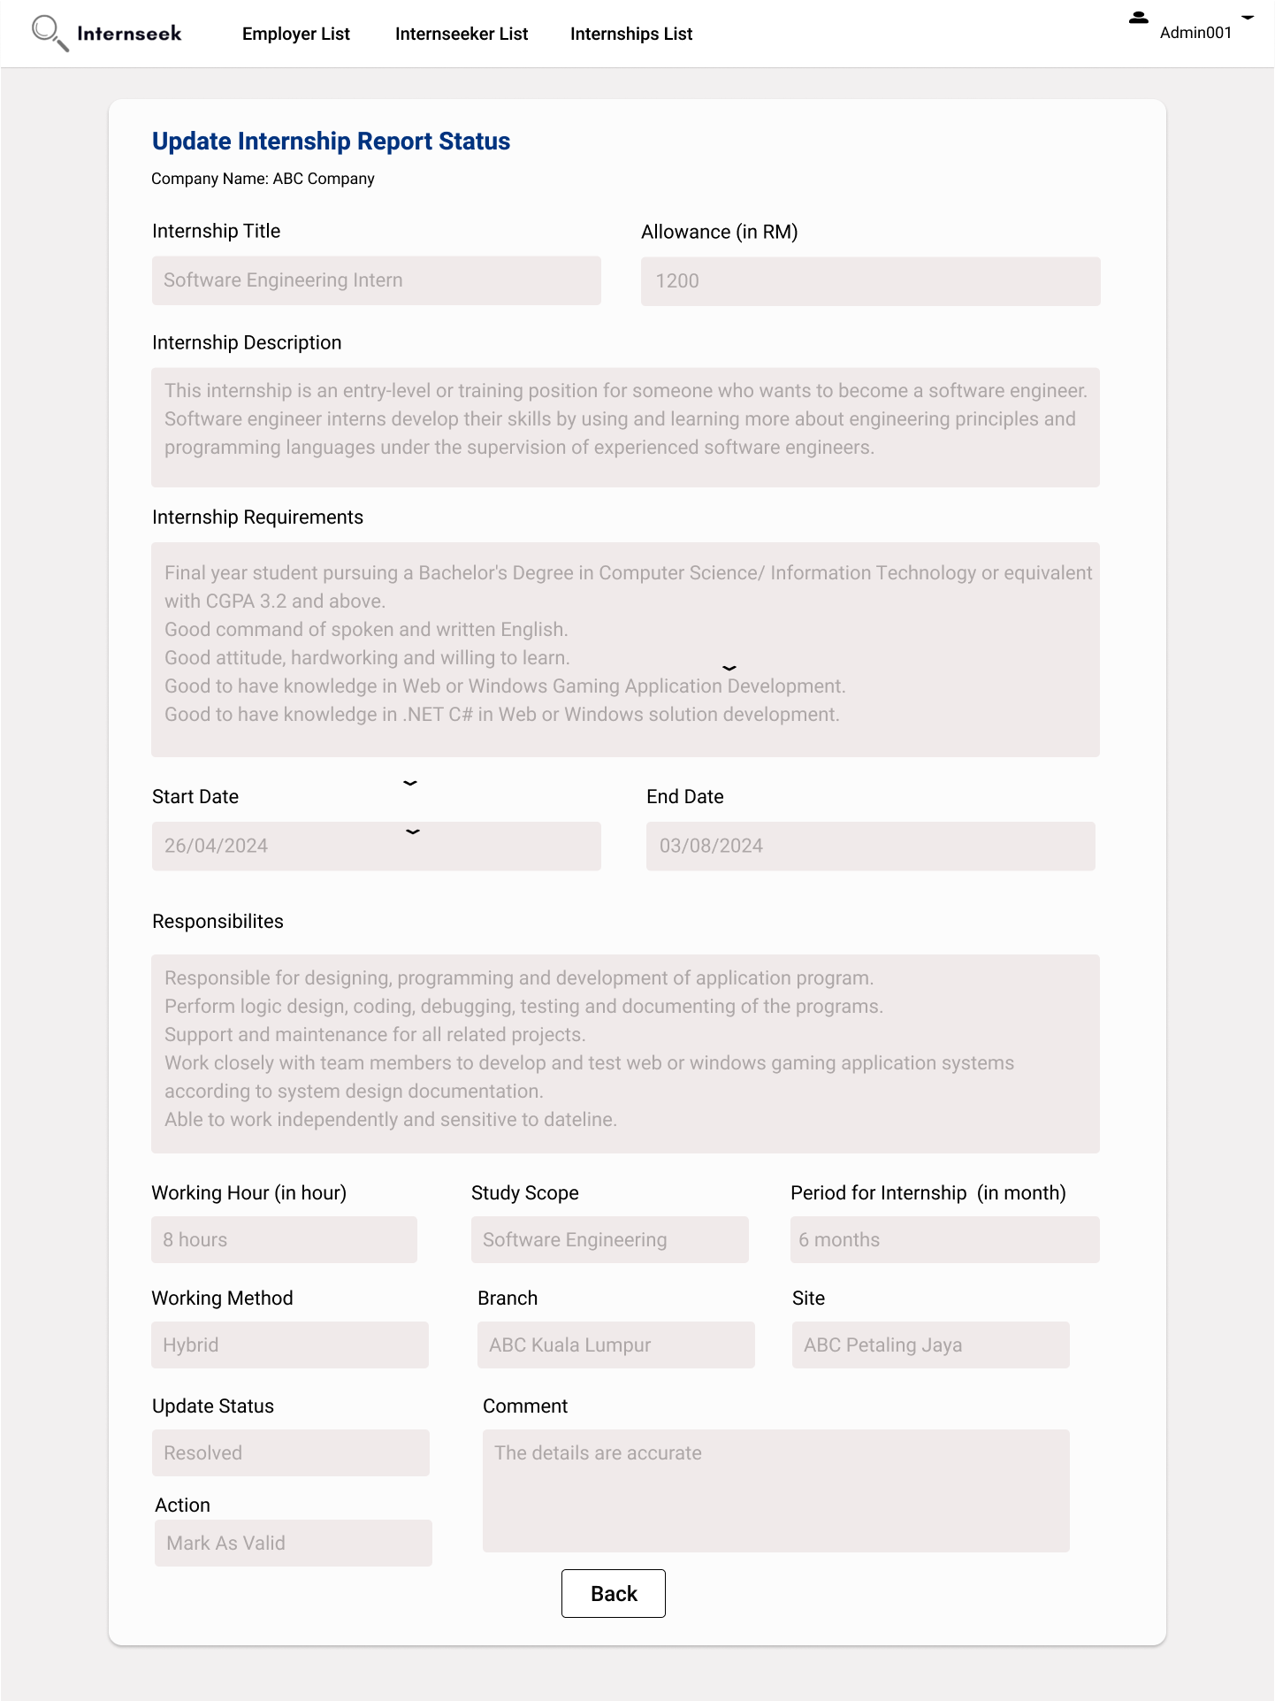

Figure 3‑244: Update Internship Report Status (Current Status: Resolved)

This figure shows the Update Internship Report Status page, where the current report status is "Resolved". The administrator can view the details but cannot edit the report status because the issue has been completely resolved.

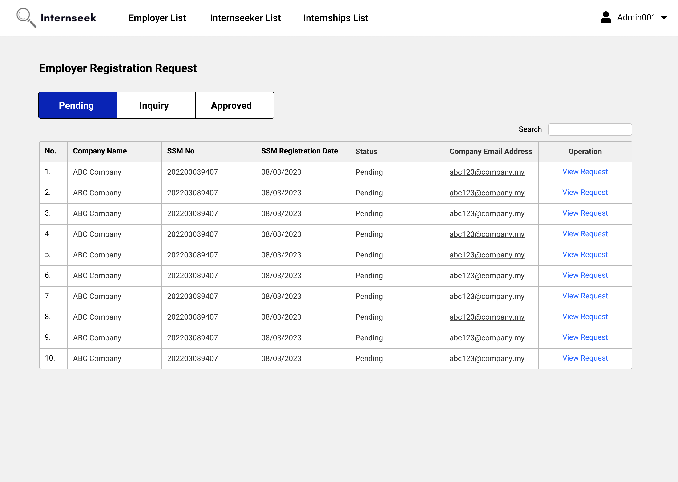

Figure 3‑245: Employer Registration Requests List page (Pending Status)

This figure shows the Employer Registration Requests List page once the administrator clicks the <<View all>> text in the employer registration request section of the Admin Dashboard. This page displays all the employer registration requests with the pending status in table form. Administrators can view the basic details of employer registration requests. If the administrator wants to view the detailed information about the employer registration request, they may click the <<View Request>> text.

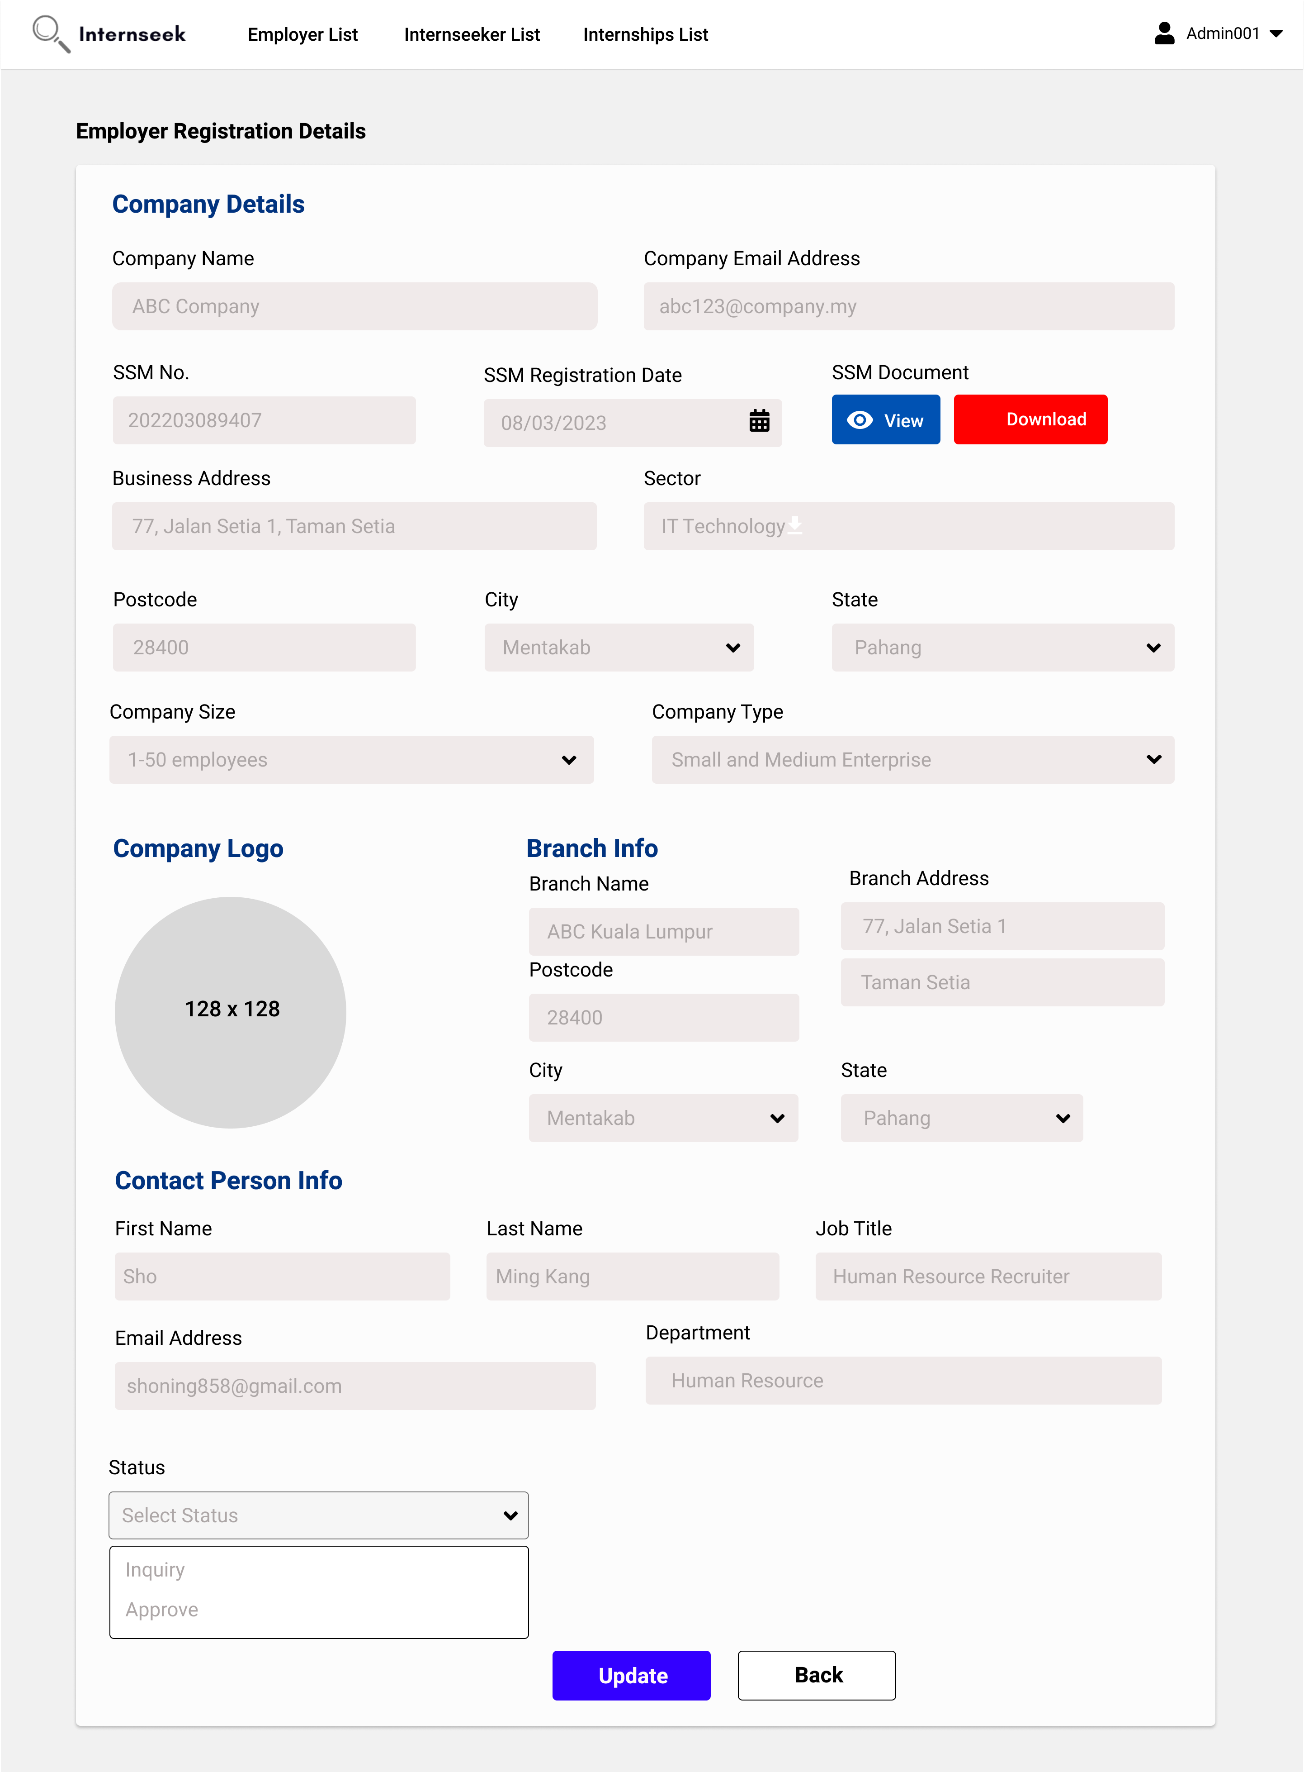

Figure 3‑246: Update Employer Registration Status

This figure displays the view employer registration request details page, where the admin can update the registration status after reviewing the registration details. The admin can update the registration status as inquiry or approved. If the admin selects the registration status as approved, the admin can directly click the <<Update>> button to update the registration status as approved.

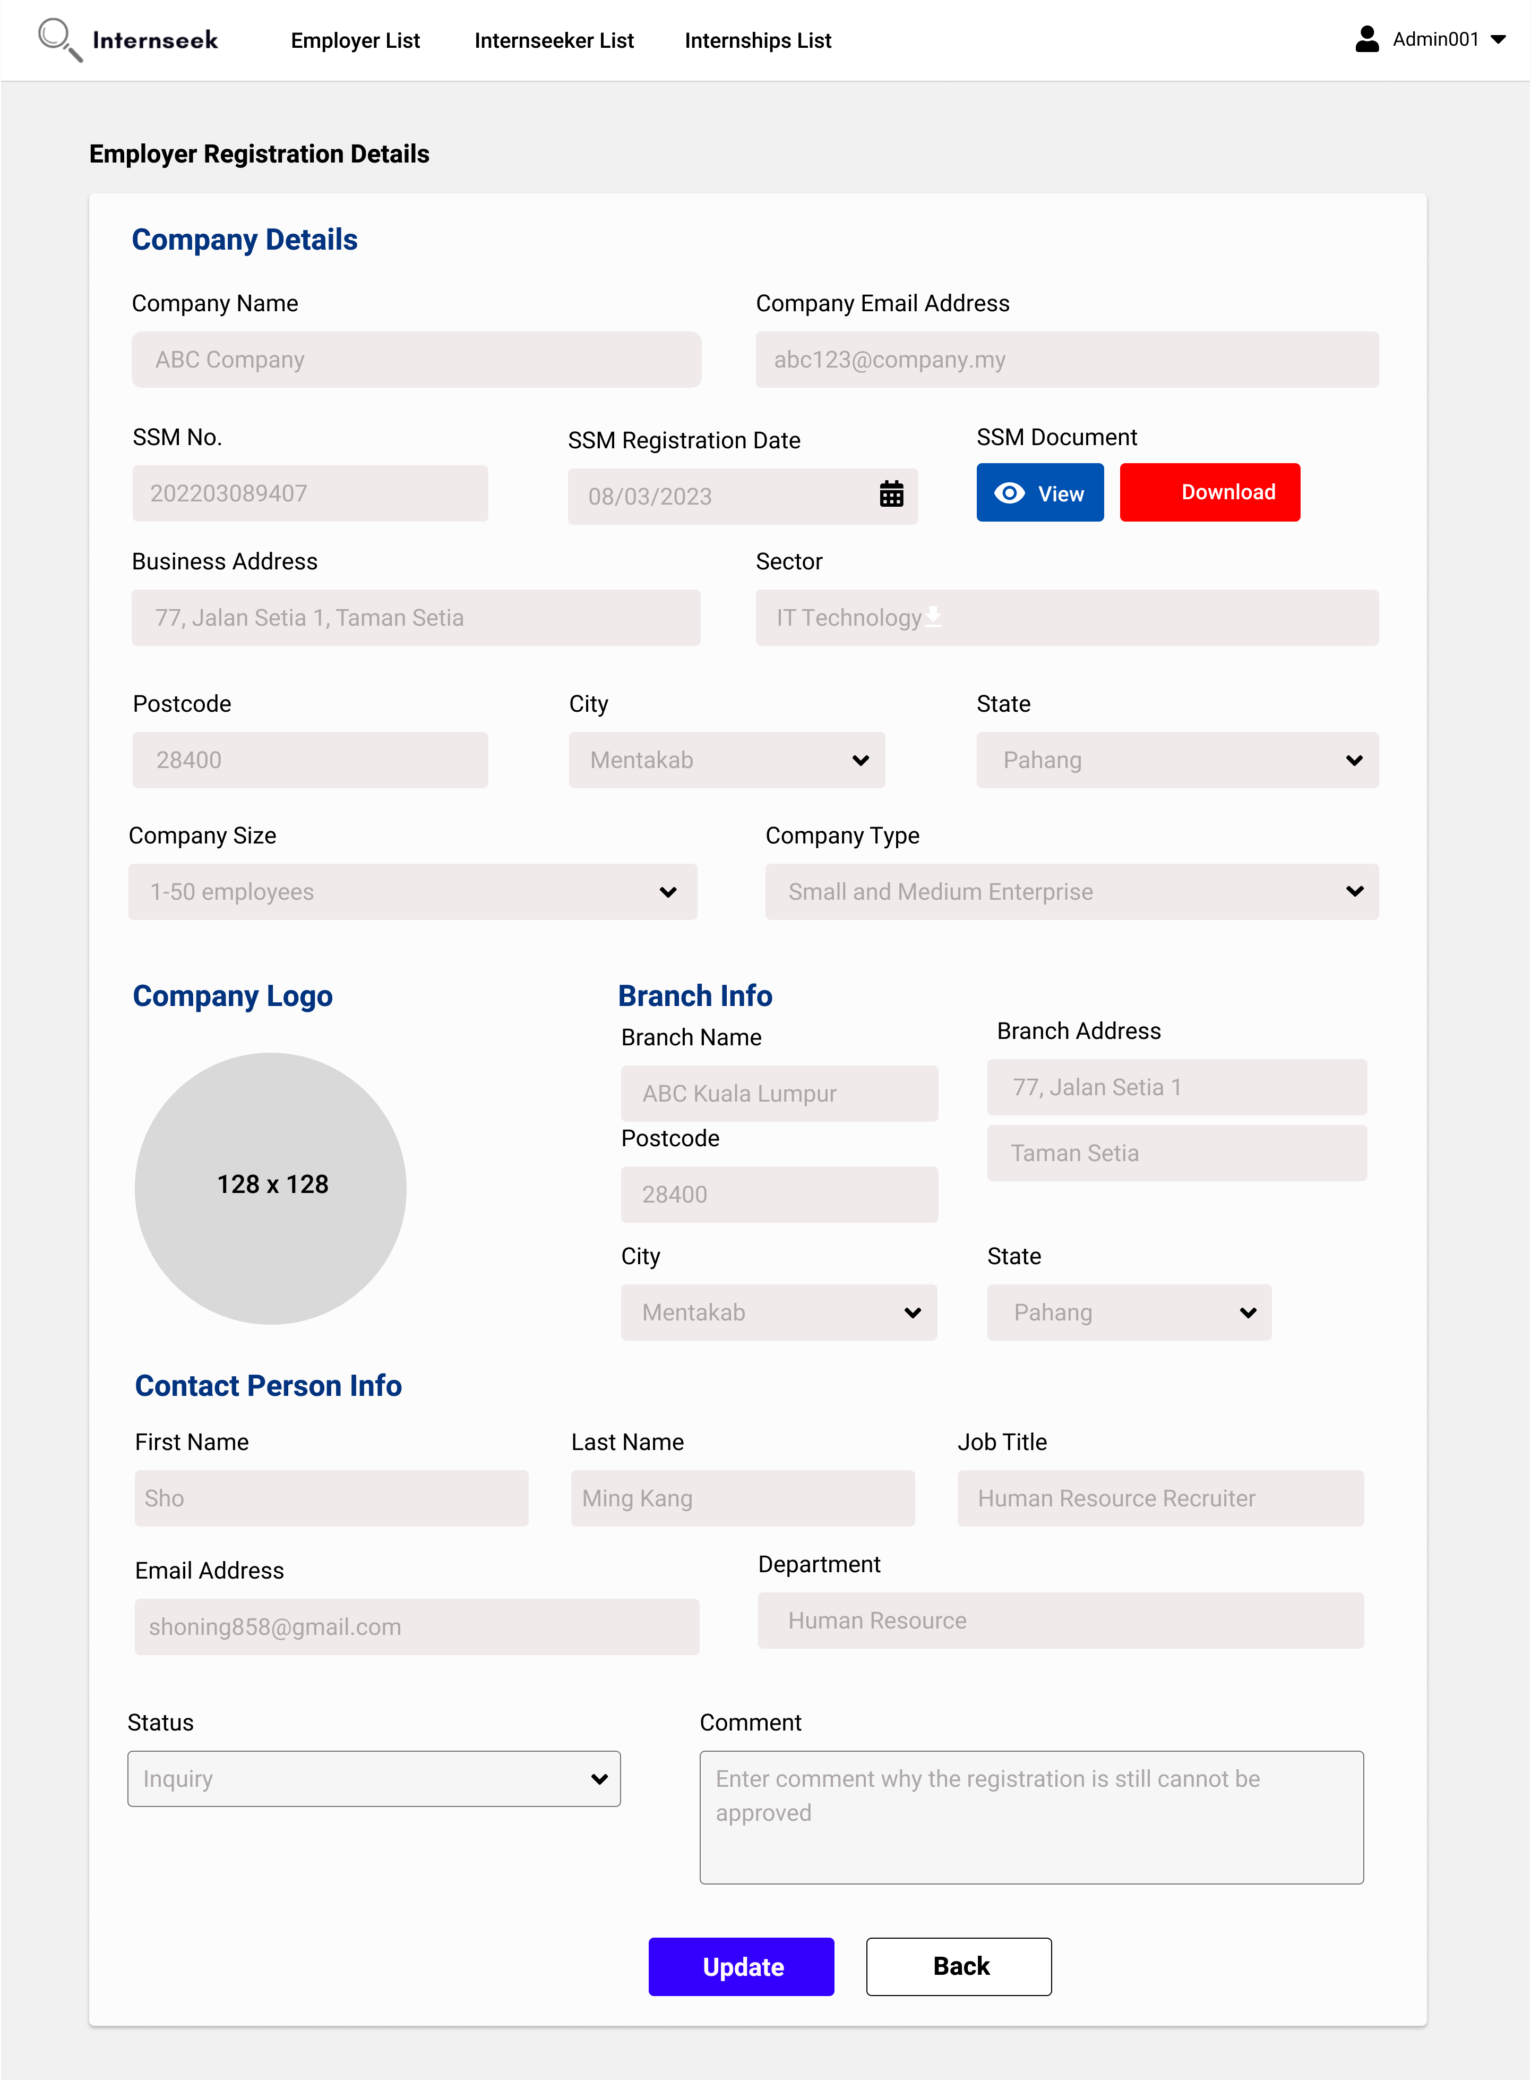

Figure 3‑247: Update Employer Registration Status (Inquiry)

This figure displays the view employer registration request details page, where the admin selects the registration status as inquiry, and the comment input field is displayed. The admin enters the comment and then clicks the <<Update>> button to update the registration status as inquiry and the comment.

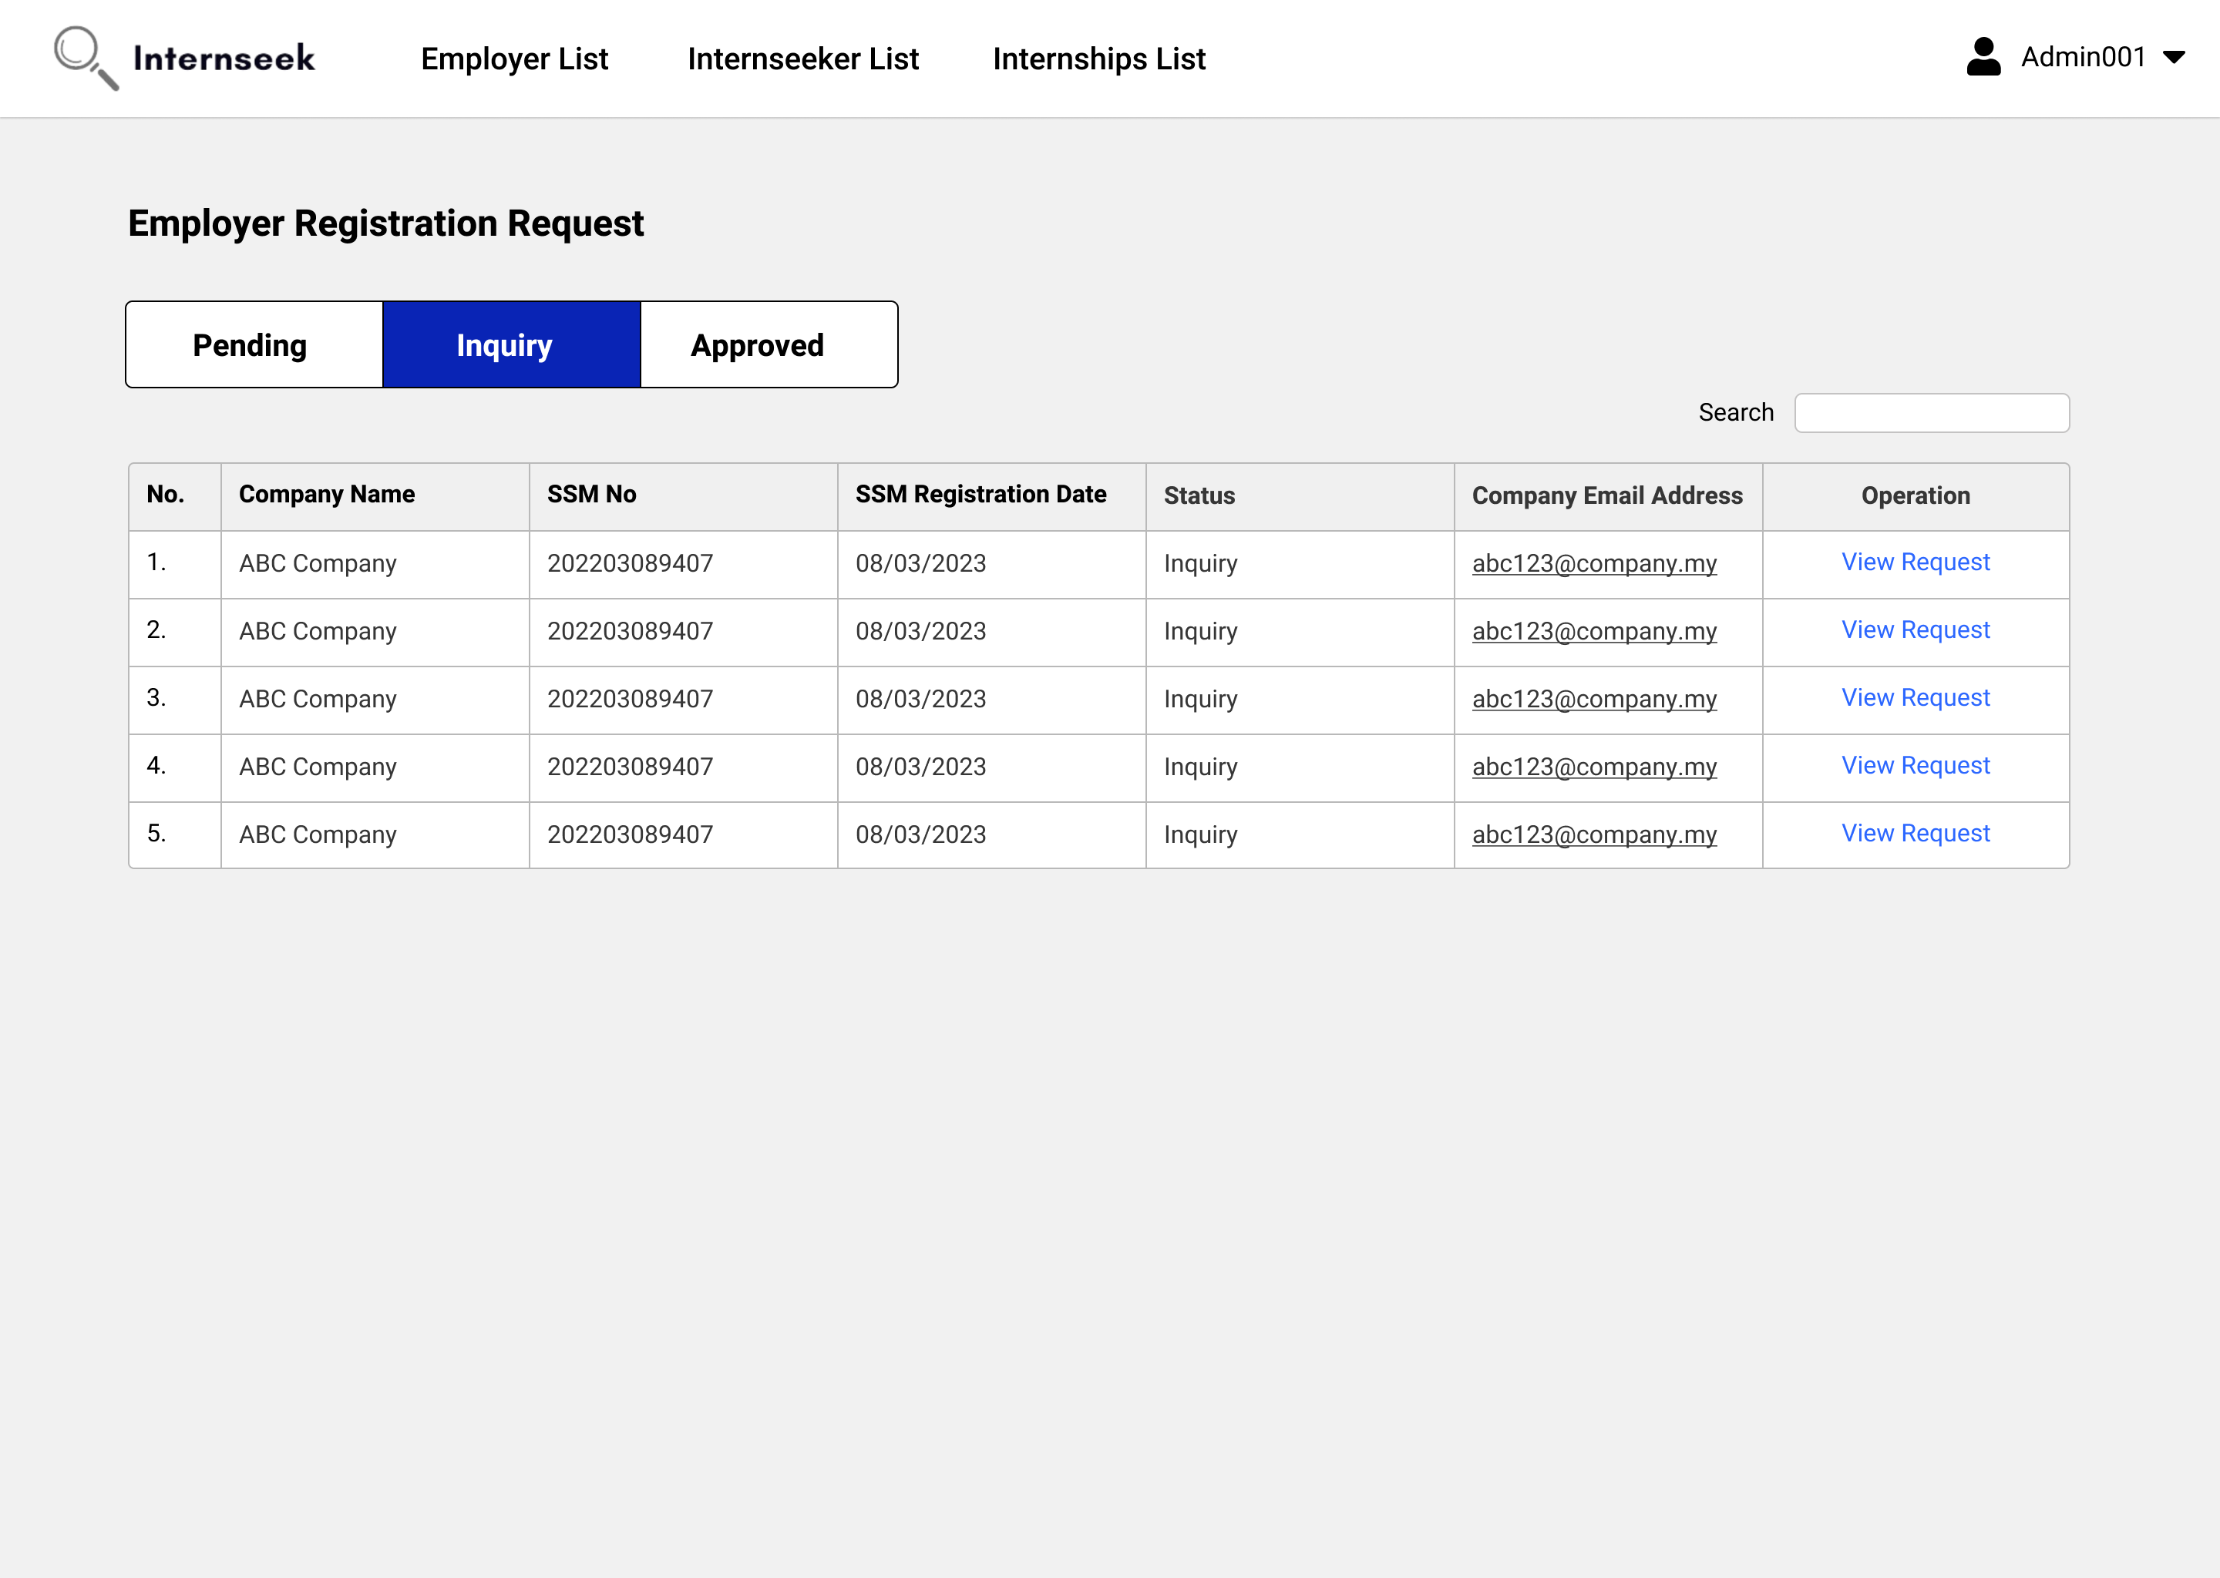

Figure 3‑248: Employer Registration Requests List page (Inquiry Status)

This figure shows the Employer Registration Requests List page once the administrator clicks the <<View all>> text in the employer registration request section of the Admin Dashboard. This page displays all the employer registration requests with the inquiry status in table form. Administrators can view the basic details of employer registration requests. If the administrator wants to view the detailed information about the employer registration request, they may click the <<View Request>> text.

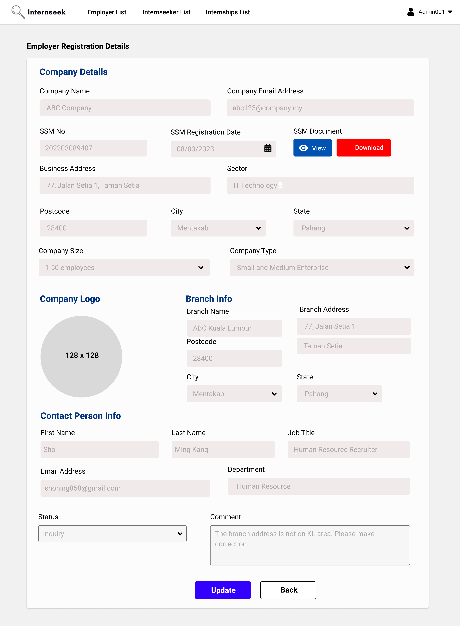

Figure 3‑249: Update Employer Registration Status (Current Status: Inquiry)

This figure shows the view employer registration request details page, where the current employer registration status is "inquiry". On this page, the administrator updates the report status from “inquiry” to "approve", and then clicks the <<Update>> button to update the report status after reviewing the registration details edited by the employer.

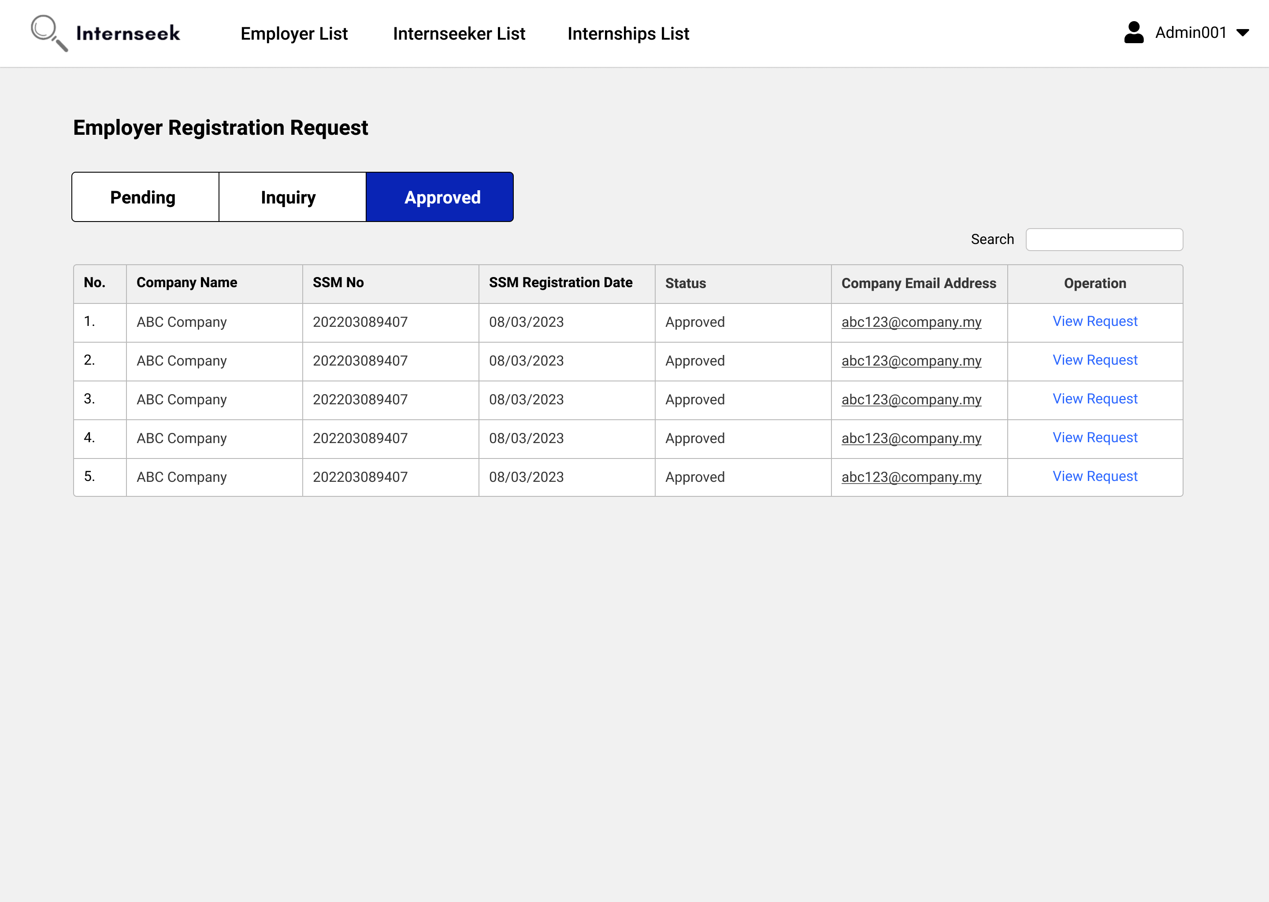

Figure 3‑250: Employer Registration Requests List page (Approved Status)

This figure shows the Employer Registration Requests List page once the administrator clicks the <<View all>> text in the employer registration request section of the Admin Dashboard. This page displays all the employer registration requests with the approved status in table form. Administrators can view the basic details of employer registration requests. If the administrator wants to view the detailed information about the employer registration request, they may click the <<View Request>> text.

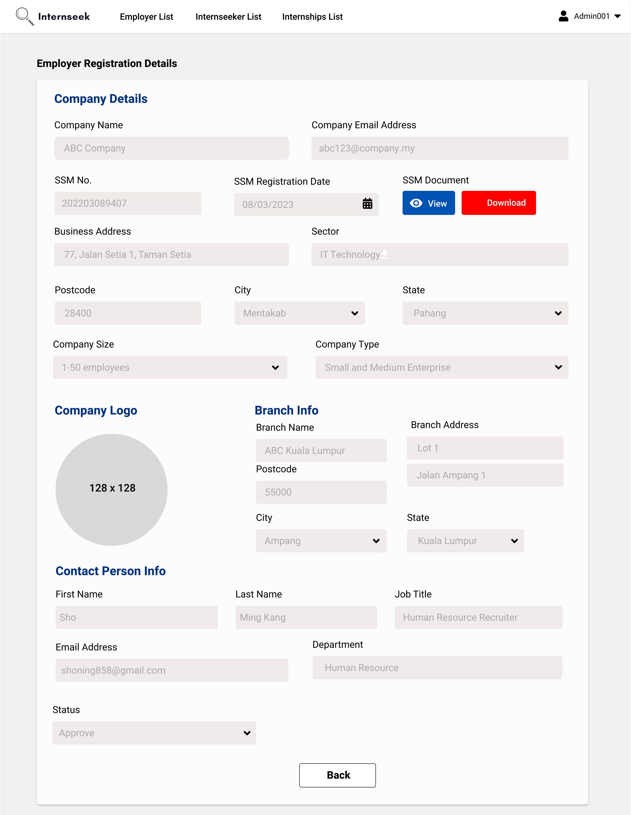

Figure 3‑251: Update Employer Registration Status (Current Status: Approved)

This figure shows the view employer registration request details page, where the current employer registration status is "Approved". The administrator can view the details but cannot edit the registration status because the employer account is activated.

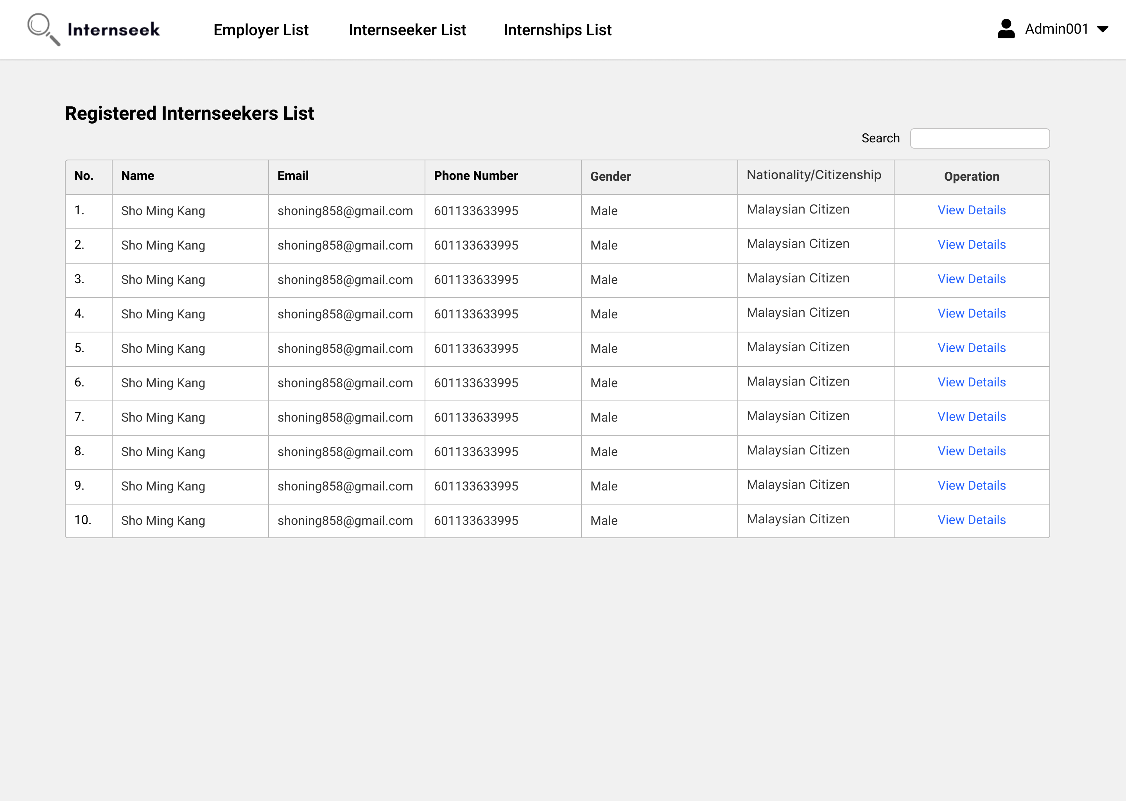

Figure 3‑252: Registered Students List page

This figure shows the Registered Student List page once the administrator clicks the registered students card button on the Admin Dashboard. This page displays all the registered students in table form. Administrators can view the general details of registered students. If the administrator wants to view the detailed basic information about the registered student, they may click the <<View Details>> text.

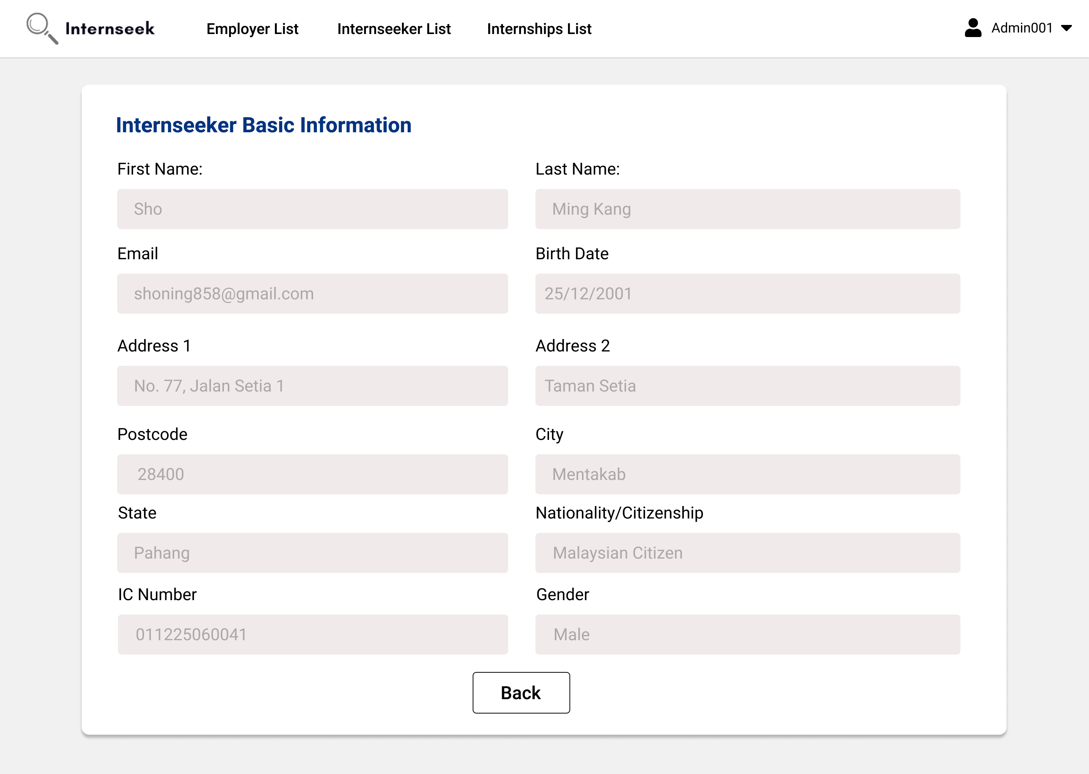

Figure 3‑253: View Registered Student Basic Information page

This figure shows the View Registered Student Basic Information page. This page displays detailed basic information about the registered student. Once the administrator finishes viewing the basic information about the registered student, they may click the <<Back>> button.

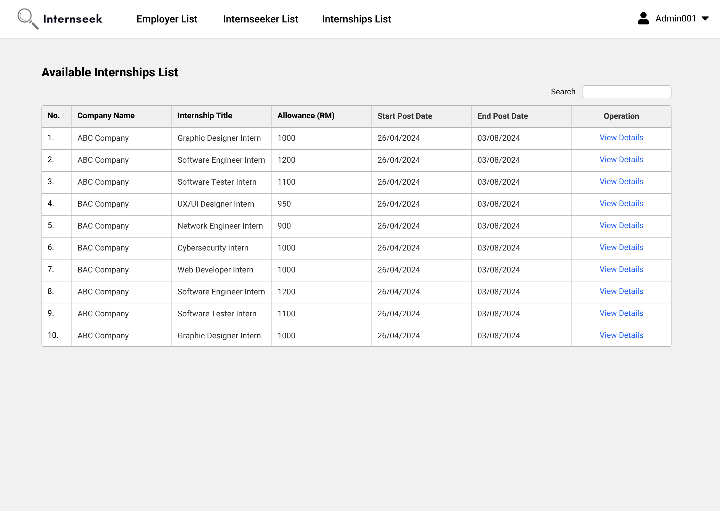

Figure 3‑254: Available Internships List page

This figure shows the Available Internships List page once the administrator clicks the available internships card button on the Admin Dashboard. This page displays all the available internships in table form. Administrators can view the general details of available internships. If the administrator wants to view the detailed information about the available internship, they may click the <<View Details>> text.

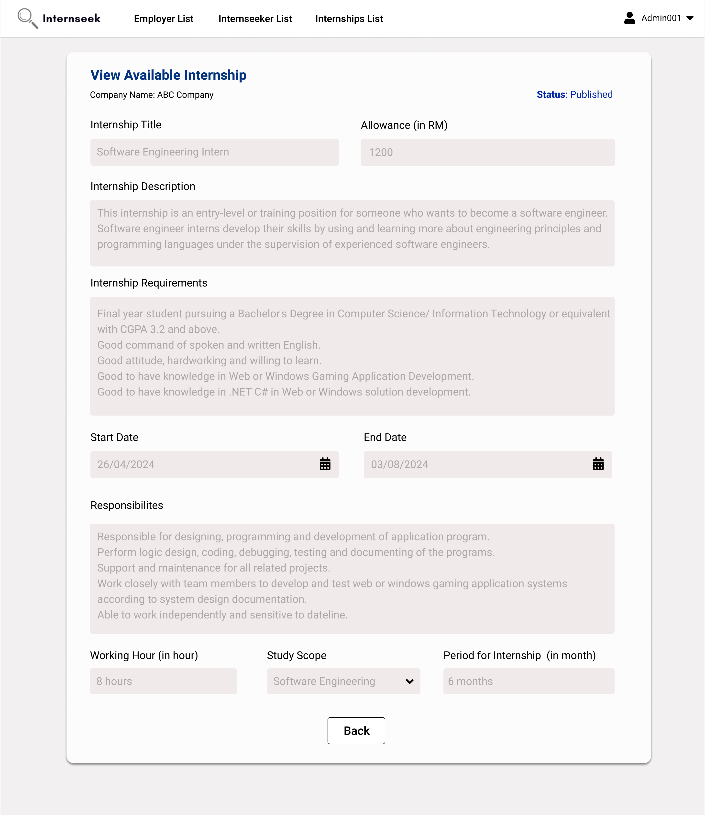

Figure 3‑255: View Available Internship Details page

This figure shows the View Available Internship Details page. This page displays detailed information about the available internship. Once the administrator finishes viewing the available internship details, they may click the <<Back>> button.

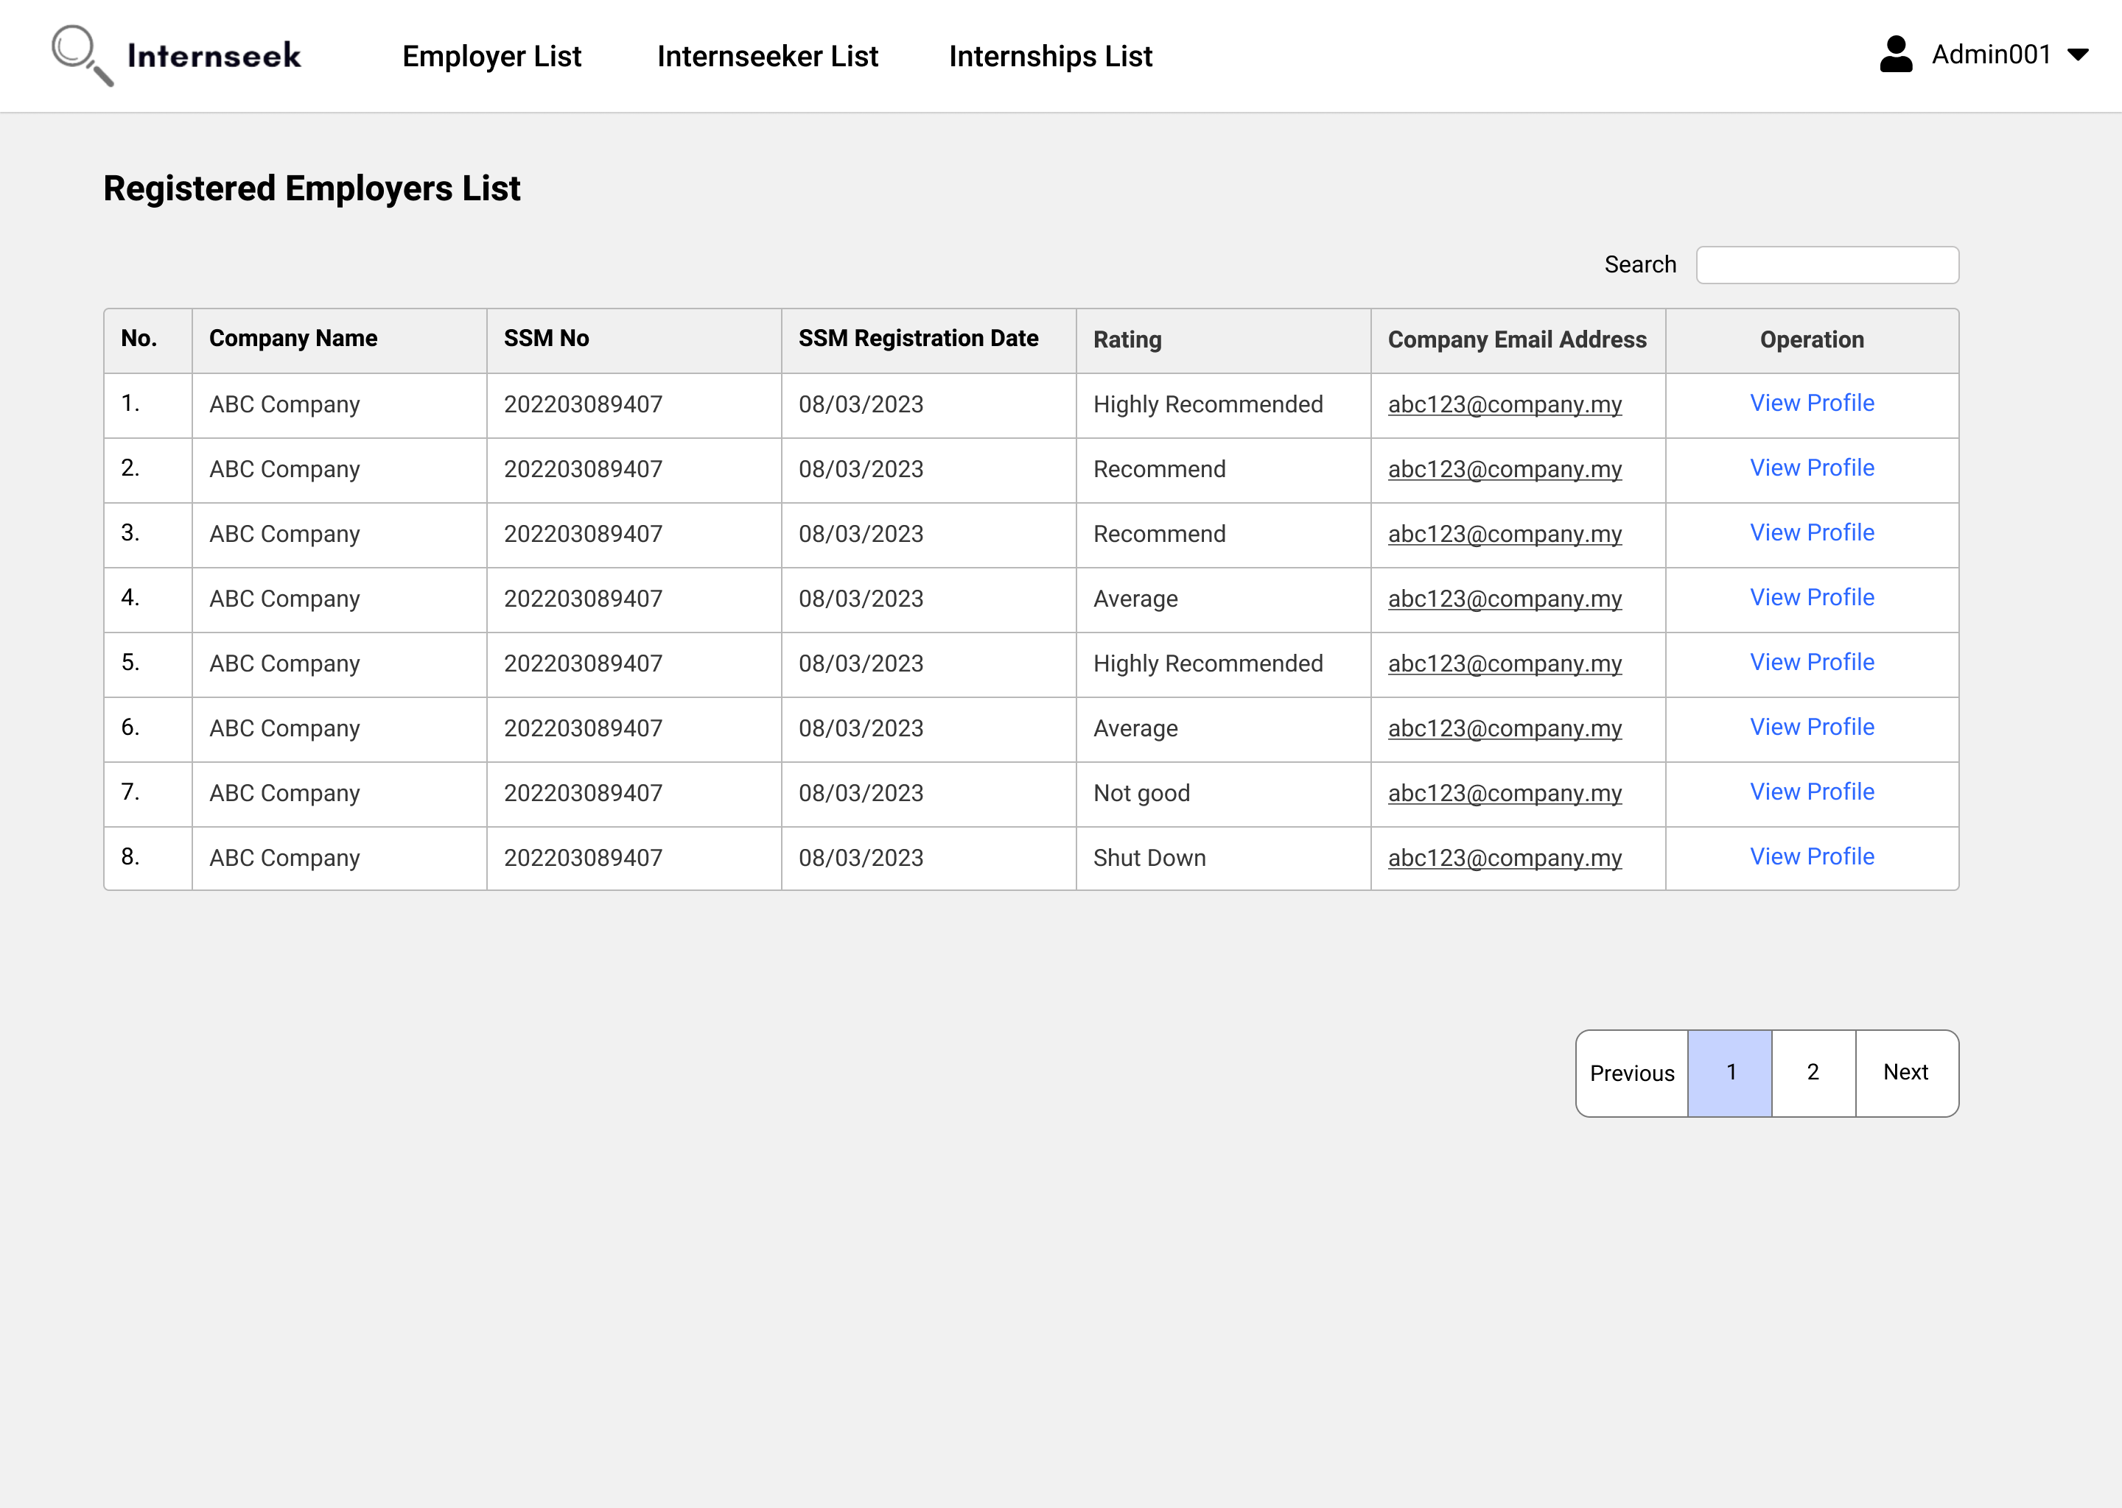

Figure 3‑256: Registered Employers List page

This figure shows the Registered Employers List page once the administrator clicks the registered employer card button on the Admin Dashboard. This page displays all the registered employers in table form. Administrators can view the general details of registered employers. If the administrator wants to view detailed information about the registered employer, they may click the <<View Details>> text.

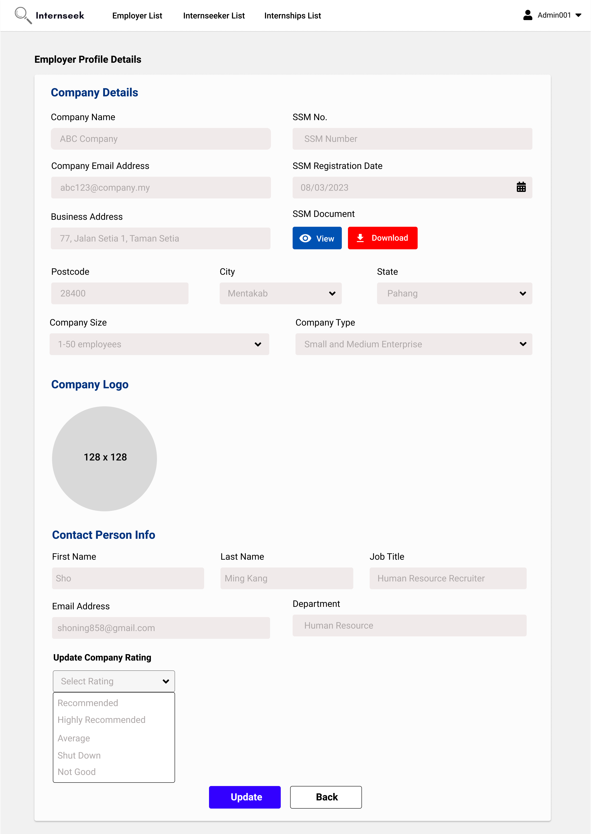

Figure 3‑257: Registered Employer Profile Details page

This figure shows the View Registered Employer Profile Details page. This page displays detailed profile information about the registered employer. Administrators can update the company rating on this page by selecting the rating and clicking the <<Update>> button. Once the administrator finishes viewing the registered employer profile details, they may click the <<Back>> button.

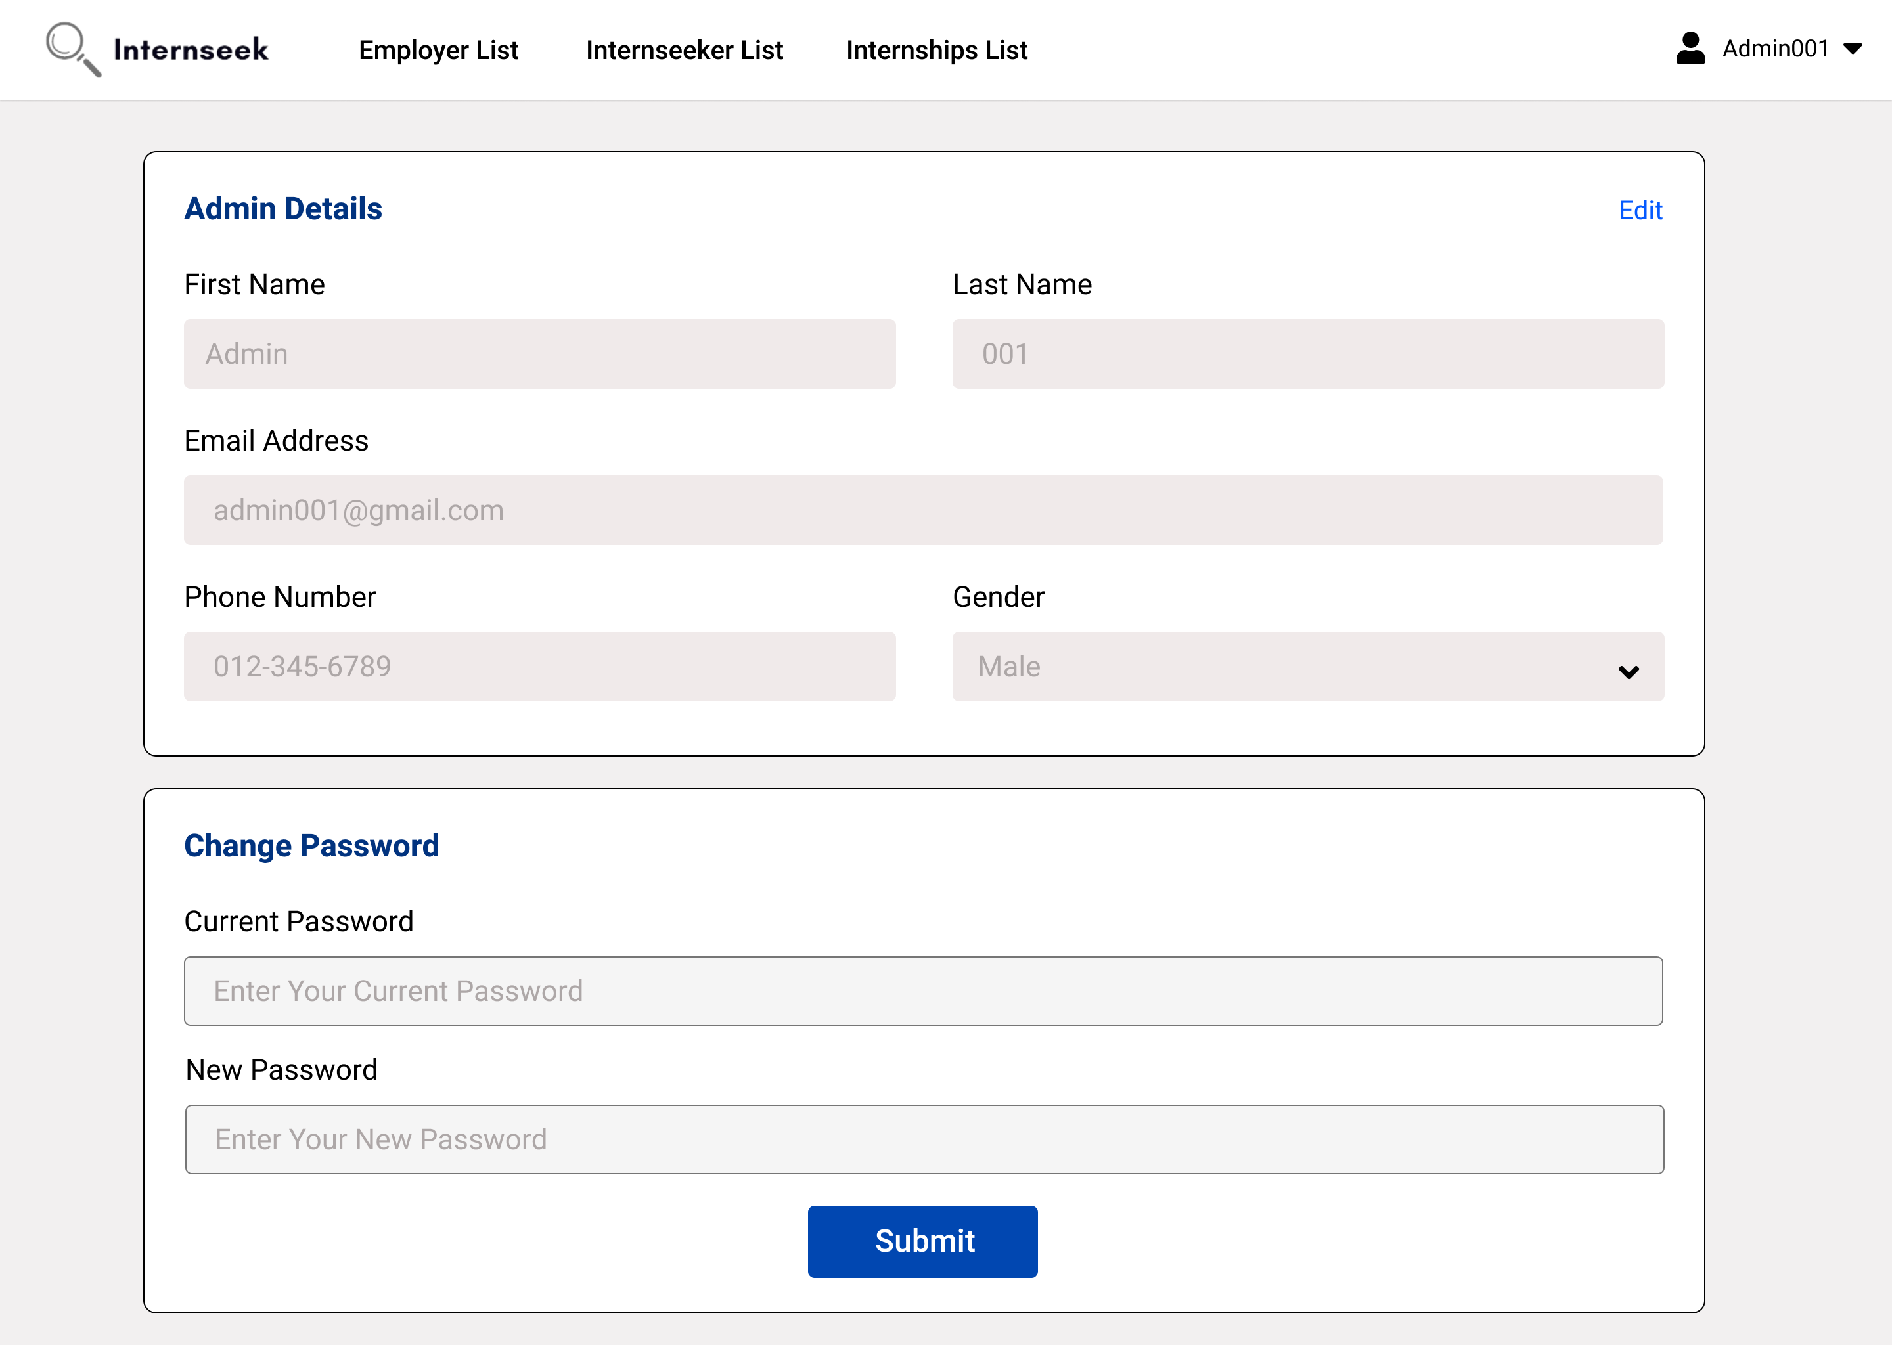

Figure 3‑258: My Profile page

This page displays the My Profile page. This page consists of two forms: a form with admin information and a change password form. The administrator views the admin information on this page. The administrator can update their password after they enter the current password and the new password and click the <<Submit>> button in the change password form. The administrator can also edit the admin details on this page by clicking the <<Edit>> text to enable the input field.

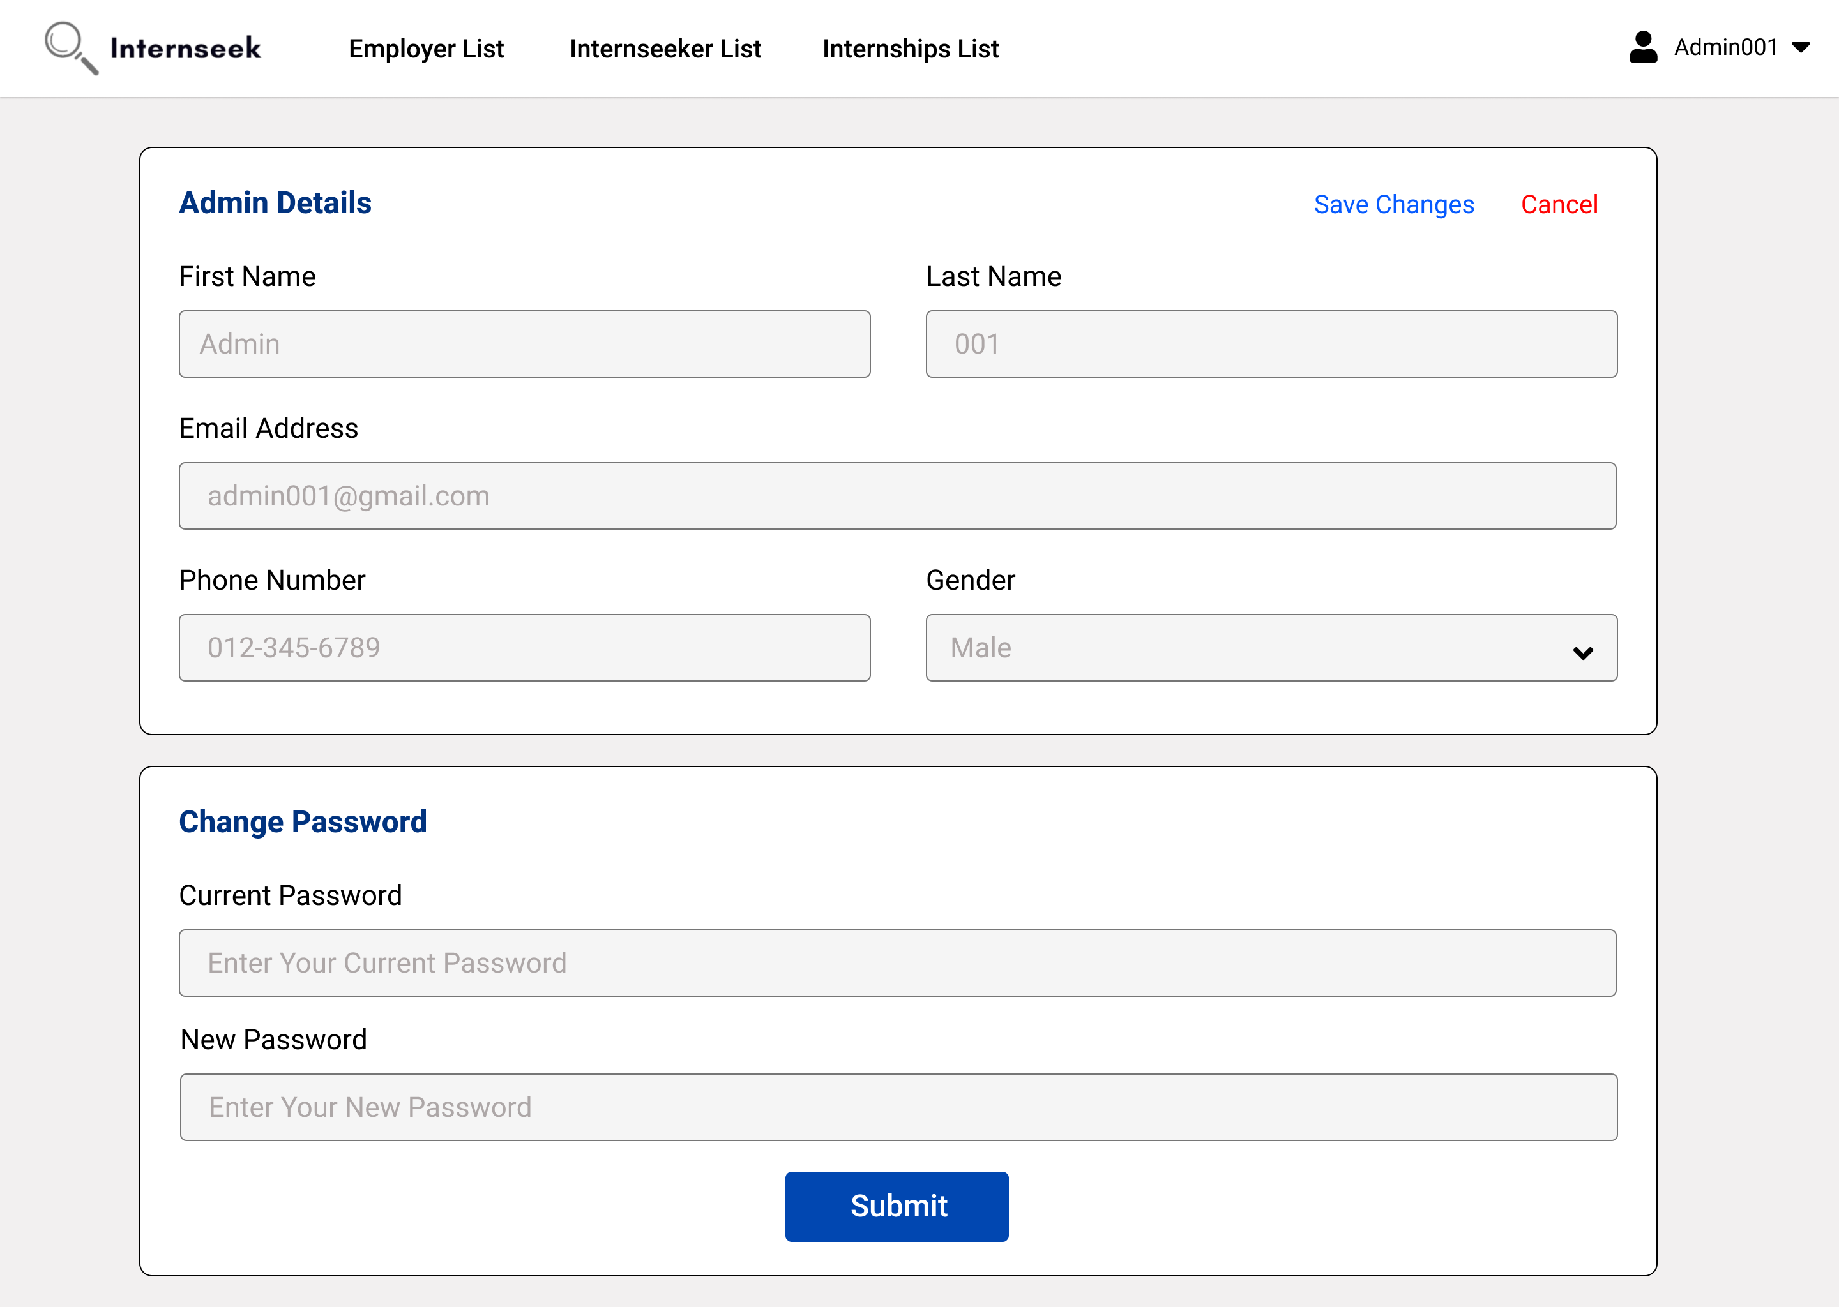

Figure 3‑259: Edit Admin Info

This figure displays the My Profile page of the administrator, where the administrator can enter the admin details they want to edit, then click the <<Save Changes>> text to update admin details. If the employer does not want to edit the admin details, they may click the <<Cancel>> text.

### Package Structure in Implementation + API + Middleware or Library Use

This section will describe the package structure of the Internship Application System (Internseek) in its implementation and the middleware and API used in this system.



Figure 3‑260: Package Structure Diagram with Middleware + API

| **Package** | **Description** |
| --- | --- |
| /Middleware | This package consists of middleware functions that are used to handle requests before they reach the actual route handlers. Middleware functions can perform tasks such as authentication, logging, rate limiting. Middleware functions are essential to ensuring that requests meet specific criteria before being handled by the application logic. |
| /routes/web.php | The /routes/web.php file defines the web routes for the application, mapping URLs to their respective controllers and handling HTTP requests for the web interface. |
| /Http/Controllers | This package includes the controllers responsible for processing incoming requests, managing data flow between models and views, and implementing the business logic for various features. |
| /js/layout | This package contains layout components used across various pages, providing a consistent structure and design for the application’s user interface. |
| /js/components | This package includes reusable React components that are used in the frontend development of Internseek. These components include basic UI elements like buttons, modals, and cards. |
| /js/Pages/Dashboard | This package includes employer dashboard and admin dashboard. |
| /js/Pages/RegisterAccount | This package includes the student registration page and employer registration page. |
| /js/Pages/ManageLogin | This package includes login pages for students, employers, and admins, as well as pages for password recovery and reset for each user type. |
| /js/Pages/ManageCompanyRegistration | This package includes the register new company pages and the search existing company pages. When an employer wants to add a new company that isn’t in the system, they can register a new company. If a company is already registered, the employer can use the "Search Existing Company" page to find it and request association as a company user, pending approval from the company’s admin. |
| /js/Pages/ManageUserProfile | This package includes a user profile page for each user type: student, employer, and admin. Students can edit their profile details and generate a resume based on their information. Employers can edit details for their company, branches, sites, and personal profile. Admins can edit their personal details. All user types (student, employer, and admin) have the option to change their password. |
| /js/Pages/ViewInternshipListing | This package includes pages related to internships. The Internships page includes internship listings for university students to browse, a detailed view of internships that students can access by clicking on an internship card from the list, and an application form that is only available and displayed when the student is logged into the system. |
| /js/Pages/ViewCompanyListing | This package includes pages that display company listings for university students to browse and a detailed view for each company that students can access by clicking on a company from the list. |
| /js/Pages/ManageInternshipPosting | This package includes pages for employers to post internship opportunities, view and manage their posted internships, and edit or delete internship postings. |
| /js/Pages/ManageInternshipApplication | This package includes pages for employers to manage applicants for their posted internships. Employers can view a list of applicants, review detailed application information, and update application statuses. Additionally, it provides pages for students to apply for internships and track the status of their applications. |
| /js/pages/ManageAnalyticsandReporting | This package includes a page for employers to analyse trends in internship applications. Additionally, it contains several pages for admins to view existing companies, students, and posted internships, as well as manage internships that have been reported by students. |
| /js/pages/ManageMessagingFeatures | This package contains the interfaces of the messaging feature. This messaging page has a chat-box and a message inbox. It allows university students and employers to communicate within the platform. |
| /Models | This package consists of the data models that represent Internseek's entities, defining the structure, relationships, and behaviours of the data used throughout the application. |
| /database | This package includes migration scripts located in the migrations folder, which are used to create and modify database tables, and seeder scripts in the seeder folder, which populate the database with initial data for development and testing purposes. |

##### Package Structure in Implementation

This section describes the general package structure in implementation.

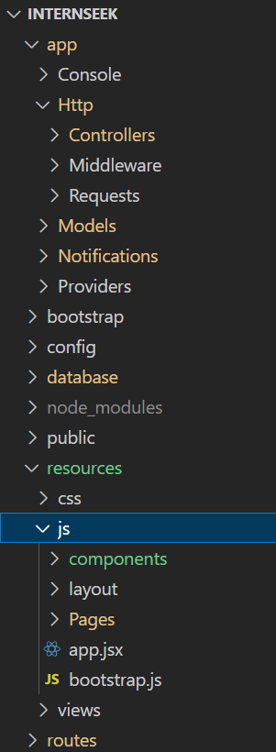

Figure 3‑261: Package Structure in Implementation

Both figures above show the package structure of the Internship Application System (Internseek) in implementation.

The table below will clearly show the Middleware, Model, View, and Controller layer based on the package path in implementation for the Internship Application System (Internseek).

Table 3‑34: Package Structure in Implementation

|  |  |  |  |  |
| --- | --- | --- | --- | --- |
| **System Name** | **Package Path** | | | **Layer** |
| Internseek | app | Http | Controllers | Controller |
| Middleware | Middleware |
| Models | | Model |
| resources | js | components | View |
| Pages | View |
| routes | | | - |

##### Middleware Layer in Implementation

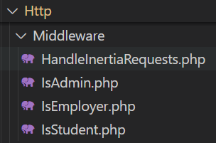

Figure 3‑262: Middleware in Implementation

The figure above shows the middleware package and its classes of the Internship Application System (Internseek) in implementation.

The table below shows the middleware layer with its package and the implemented classes.

Table 3‑35: Middleware in Implementation

|  |  |  |
| --- | --- | --- |
| **Layer** | **Package** | **Class** |
| Middleware | Middleware | HandleInertiaRequests  IsAdmin  IsEmployer  IsStudent |

##### View Layer in Implementation

The section describes the package structure in implementation for the view layer. The view layer consists of pages and components used in the page.

1. Page

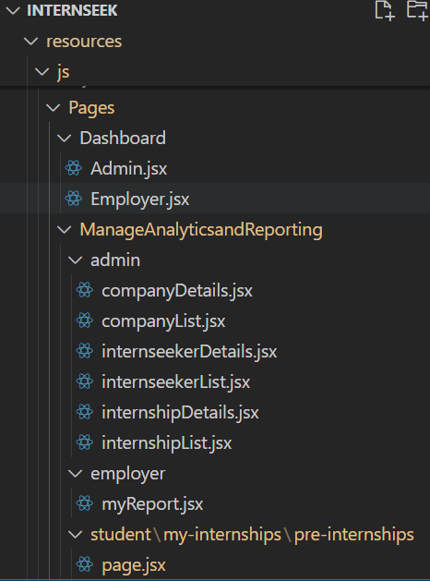

Figure 3‑263: View (Pages/Dashboard) in implementation

The figure above shows the Pages/Dashboard and its classes of the Internship Application System (Internseek) in implementation.

The table below shows the view layer, the Pages/Dashboard package and the implemented classes.

Table 3‑36: View (Pages/Dashboard) in implementation

|  |  |  |  |
| --- | --- | --- | --- |
| **Layer** | **Package** | | **Class** |
| View | Pages | Dashboard | Admin.jsx  Employer.jsx |

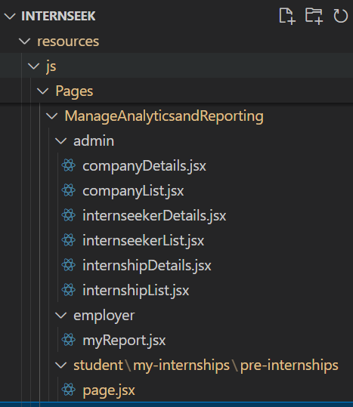

Figure 3‑264: View (Pages/ManageAnalyticsandReporting) in implementation

Table 3‑37: View (Pages/ManageAnalyticsandReporting) in implementation

|  |  |  |  |  |
| --- | --- | --- | --- | --- |
| **Layer** | **Package** | | | **Class** |
| View | Pages | ManageAnalytics andReporting | admin | companyDetails.jsx  companyList.jsx  internseekerList.jsx  internseekerDetails.jsx  internshipList.jsx  internshipDetails.jsx |
| employer | myReport |
| student | /my-internships/pre-internships/ page.jsx |

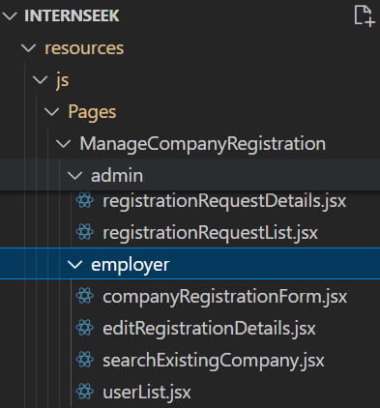

Figure 3‑265: View (Pages/ManageCompanyRegistration) in implementation

Table 3‑38: View (Pages/ManageCompanyRegistration) in implementation

|  |  |  |  |  |
| --- | --- | --- | --- | --- |
| **Layer** | **Package** | | | **Class** |
| View | Pages | Manage CompanyRegistration | admin | registrationRequestDetails.jsx  registrationRequestList.jsx |
| employer | companyRegistrationForm.jsx  editRegistrationDetails.jsx  searchExistingCompany.jsx  userList.jsx |

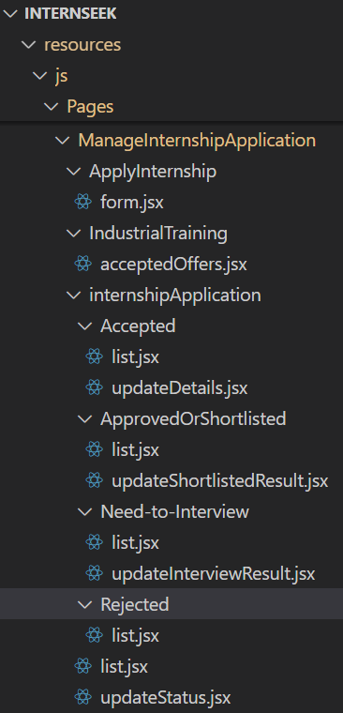 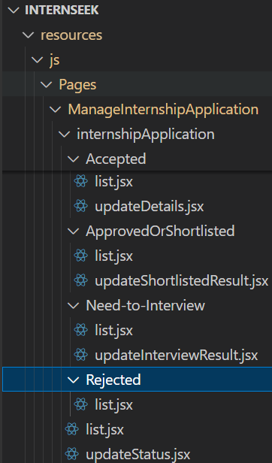 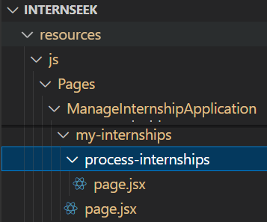

Figure 3‑266: View (Pages/ManageInternshipApplication) in implementation

Table 3‑39: View (Pages/ManageInternshipApplication) in implementation

|  |  |  |  |  |  |
| --- | --- | --- | --- | --- | --- |
| **Layer** | **Package** | | | | **Class** |
| View | Pages | Manage Internship Application | ApplyInternship | | form.jsx |
| IndustrialTraining | | acceptedOffers.jsx |
| internship Application | Accepted | list.jsx  updateDetails.jsx |
| Approved Or Shortlisted | list.jsx  updateShortlisted Result.jsx |
| Need-to-Interview | list.jsx  updateInterview Result.jsx |
| Rejected | list.jsx |
|  | list.jsx  updateStatus.jsx |
| my-internships | process-internships | page.jsx |
|  | page.jsx |

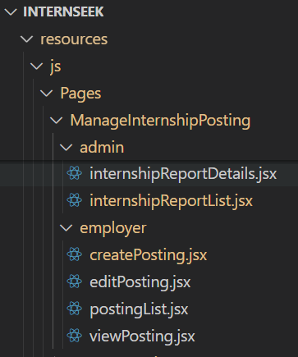

Figure 3‑267: View (Pages/ManageInternshipPosting) in implementation

Table 3‑40: View (Pages/ManageInternshipPosting) in implementation

|  |  |  |  |  |
| --- | --- | --- | --- | --- |
| **Layer** | **Package** | | | **Class** |
| View | Pages | ManageInternshipPosting | admin | internshipReportDetails.jsx  internshipReportList.jsx |
| employer | createPosting.jsx  editPosting.jsx  postingList.jsx  viewPosting.jsx |

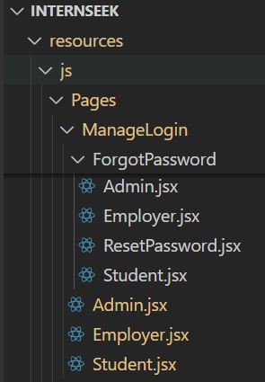

Figure 3‑268: View (Pages/ManageLogin) in implementation

Table 3‑41: View (Pages/ManageLogin) in implementation

|  |  |  |  |  |
| --- | --- | --- | --- | --- |
| **Layer** | **Package** | | | **Class** |
| View | Pages | ManageLogin | ForgotPassword | Admin.jsx  Employer.jsx  ResetPassword.jsx  Student.jsx |
|  | Admin.jsx  Employer.jsx  Student.jsx |

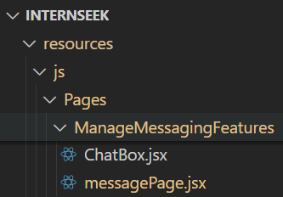

Figure 3‑269: View (Pages/ManageMessagingFeatures) in implementation

Table 3‑42: View (Pages/ManageMessagingFeatures) in implementation

|  |  |  |  |
| --- | --- | --- | --- |
| Layer | Package | | Class |
| View | Pages | ManageMessagingFeatures | ChatBox.jsx  messagePage.jsx |

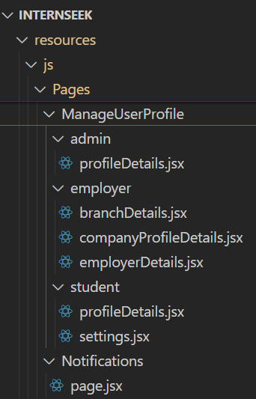

Figure 3‑270: View (Pages/ManageUserProfile & Page/Notifications) in implementation

Table 3‑43: View (Pages/ManageUserProfile & Page/Notifications) in implementation

|  |  |  |  |  |
| --- | --- | --- | --- | --- |
| **Layer** | **Package** | | | **Class** |
| View | Pages | ManageUserProfile | admin | profileDetails.jsx |
| employer | companyProfileDetails.jsx  branchDetails.jsx  employerDetails.jsx |
| student | profileDetails.jsx  settings.jsx |
| Notifications | | page.jsx |

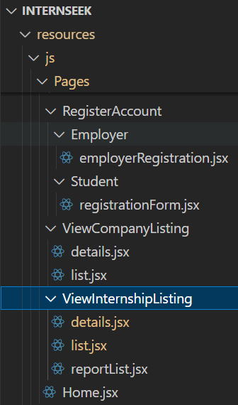

Figure 3‑271: View (Pages/RegisterAccount & Pages/ViewCompanyListing & Pages/ViewInternshipListing) in implementation

Table 3‑44: View (Pages/RegisterAccount & Pages/ViewCompanyListing & Pages/ViewInternshipListing) in implementation

|  |  |  |  |  |
| --- | --- | --- | --- | --- |
| **Layer** | **Package** | | | **Class** |
| View | Pages | RegisterAccount | Employer | registrationForm.jsx |
| Student | employerRegistration.jsx |
| ViewCompanyListing | | details.jsx  list.jsx |
| ViewInternshipListing | | details.jsx  list.jsx  reportList.jsx |
|  | | Home.jsx |

**2.** **Components**

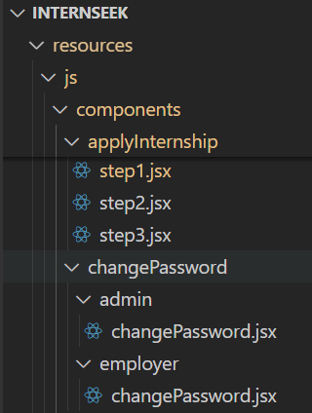

Figure 3‑272: View (package: components/applyInternship & components/changePassword) in implementation

Table 3‑45: View (package: components/applyInternship & components/changePassword) in implementation

|  |  |  |  |  |
| --- | --- | --- | --- | --- |
| **Layer** | **Package** | | | **Class** |
| View | components | applyInternship |  | step1.jsx  step2.jsx  step3.jsx |
| changePassword | admin | changePassword.jsx |
| employer | changePassword.jsx |

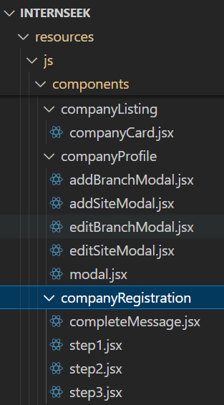

Figure 3‑273: View (package: components/companyListing & components/companyProfile & components/companyRegistration) in implementation

Table 3‑46: View (package: components/companyListing & components/companyProfile & components/companyRegistration) in implementation

|  |  |  |  |
| --- | --- | --- | --- |
| **Layer** | **Package** | | **Class** |
| View | components | companyListing | companyCard.jsx |
| companyProfile | addBranchModal.jsx  editBranchModal.jsx  addSiteModal.jsx  editSiteModal.jsx  modal.jsx |
| companyRegistration | completeMessage.jsx  step1.jsx  step2.jsx  step3.jsx |

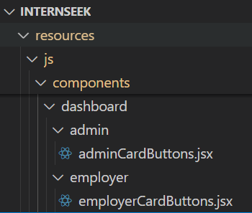

Figure 3‑274: View (package: components/dashboard) in implementation

Table 3‑47: View (package: components/dashboard) in implementation

|  |  |  |  |  |
| --- | --- | --- | --- | --- |
| **Layer** | **Package** | | | **Class** |
| View | components | dashboard | admin | adminCardButtons |
| employer | employerCardButtons |

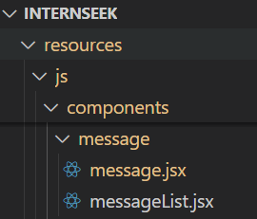

Figure 3‑275: View (Package: components/message) in implementation

Table 3‑48: View (package: components/message) in implementation

|  |  |  |  |
| --- | --- | --- | --- |
| **Layer** | **Package** | | **Class** |
| View | components | message | message.jsx  messageList.jsx |

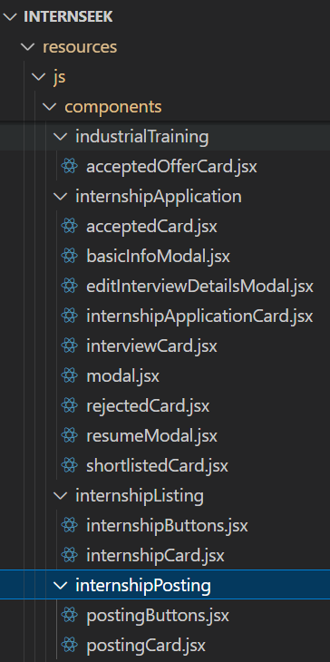

Figure 3‑276: View (package: components/industrialTraining & components/internshipApplication & components/internshipPosting & components/internshipListing) in implementation

Table 3‑49: View (package: components/industrialTraining & components/internshipApplication & components/internshipPosting & components/internshipListing) in implementation

|  |  |  |  |
| --- | --- | --- | --- |
| **Layer** | **Package** | | **Class** |
| View | components | industrialTraining | acceptedOfferCard.jsx |
| internshipApplication | acceptedCard.jsx  basicInfoModal.jsx  editInterviewDetailsModal.jsx  internshipApplicationCard.jsx  interviewCard.jsx  modal.jsx  rejectedCard.jsx  resumeModal.jsx  shortlistedCard.jsx |
| internshipListing | internshipButtons.jsx  internshipCard.jsx |
| internshipPosting | postingButtons.jsx  postingCard.jsx |

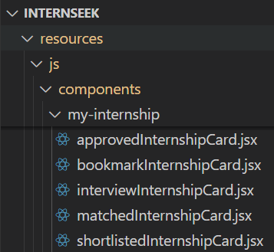 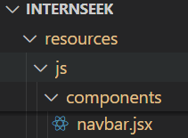

Figure 3‑277: View (package: components/my-internship & navbar) in implementation

Table 3‑50: View (package: components/my-internship & navbar) in implementation

|  |  |  |  |
| --- | --- | --- | --- |
| **Layer** | **Package** | | **Class** |
| View | components | my-internship | approvedInternshipCard.jsx  bookmarkInternshipCard.jsx  interviewInternshipCard.jsx  matchedInternshipCard.jsx  shortlistedInternshipCard.jsx |
|  | navbar |

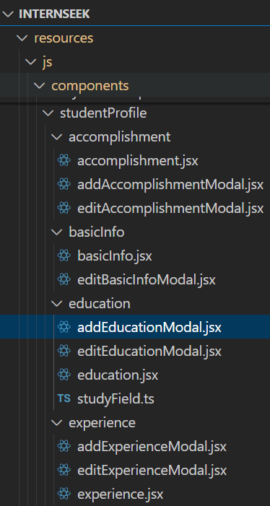 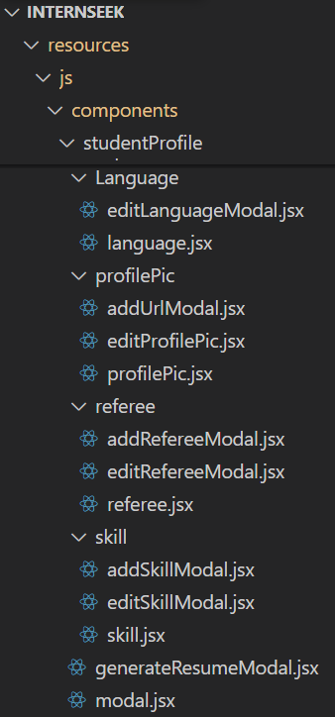

Figure 3‑278: View (package: components/studentProfile) in implementation

Table 3‑51: View (package: components/studentProfile) in implementation

|  |  |  |  |  |
| --- | --- | --- | --- | --- |
| **Layer** | **Package** | | | **Class** |
| View | components | Student Profile | accomplishment | accomplishment.jsx  addAccomplishmentModal.jsx  editAccomplishmentModal.jsx |
| basicInfo | basicInfo.jsx  editBasicInfoModal.jsx |
| education | addEducationModal.jsx  editEducationModal.jsx  education.jsx  studyField.ts |
| experience | addExperienceModal.jsx  editExperienceModal.jsx  experience.jsx |
| language | editLanguageModal.jsx  language.jsx |
| profilePic | addUrlModal.jsx  editProfilePic.jsxprofilePic.jsx |
| referee | editRefereeModal.jsx  addRefereeModal.jsx  referee.jsx |
| skill | addSkillModal.jsx  editSkillModal.jsx  skill.jsx |
|  | generateResumeModal.jsx  modal.jsx |

##### Controller Layer in Implementation

The section describes the package structure in implementation for the controller layer.

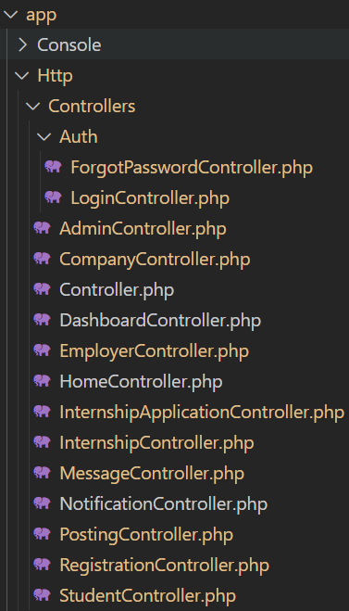

Figure 3‑279: Controller Layer in implementation

Table 3‑52: Controller Layer in implementation

|  |  |  |  |  |  |
| --- | --- | --- | --- | --- | --- |
| Layer | Package | | | | Class |
| Controller | app | Http | Controllers | Auth | LoginController  ForgotPasswordController |
|  | AdminController  CompanyController  DashboardController  EmployerController  HomeController  InternshipApplicationController  InternshipController  MessageController  NotificationController  PostingController  RegistrationController  StudentController |

##### Model Layer in Implementation

The section describes the package structure in implementation for the model layer.

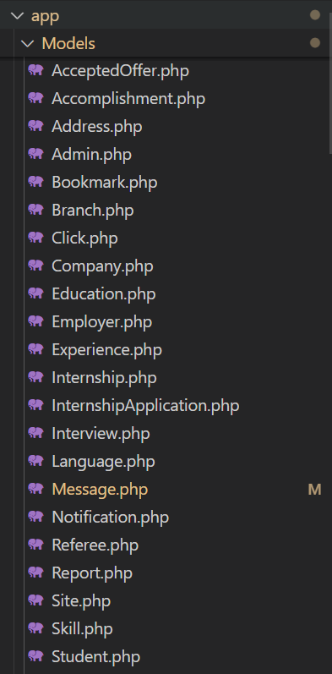

Figure 3‑280: Model Layer in implementation

Table 3‑53: Model Layer in implementation

|  |  |  |  |
| --- | --- | --- | --- |
| **Layer** | **Package** | | **Class** |
| Controller | app | Models | AcceptedOffer  Accomplishment  Address  Admin  Bookmark  Branch  Click  Company  Education  Employer  Experience  Internship  InternshipApplication  Interview  Language  Message  Notification  Referee  Report  Site  Skill  Student |

## Testing Plan / Validation Plan

Software testing ensures a system's quality, accuracy, and fulfillment of specified specifications. Testing is to identify system bugs, errors, or deviations from expected behavior. Software testing is one of the processes within the Software Development Lifecycle (SDLC) that ensures the software system works as intended and meets the requirements and expectations of its end users. (Hamilton, 2024) The testing phase will be conducted after the development phase, including functional testing and non-functional testing to ensure all the requirements meet the expectations of end-users. There are five tests will be carried out: unit testing, integration testing, system testing, user acceptance testing, and usability testing.

### Unit Testing

Unit testing is used to test individual units or components of software system to verify each unit of code behaves as expected and that all units work properly. Unit testing should perform static analysis, function test, logical test, and interface test, to improve the efficiency of software development and reduce the software bug rate (Sun, 2019). In this phase, white box tests will be applied to examine the internal structure of the code, including its implementation logic, data flows, and algorithms within the unit. White box tests focus on individual units or components, identifying defects and ensure that each part of the code work as intended and meet the defined requirements.

### Integration Testing

Integration testing is used to test the components that have already been integrated, although each functions properly in isolation. (Carpenter, 2024) Integration testing is important since it primarily focuses on the interaction between interfaces and data flow among modules to ensure the system functions properly and meets the functional requirements. Integration Testing helps to identify bugs or defects related to the interfaces and interactions between integrated components. Testers may need to apply test drivers and stubs, which are dummy data that function as missing modules and stimulate data exchange between modules.

### System Testing

System testing focuses on evaluating how the various components of an application interact in a fully and completely integrated system, ensuring that all components interact correctly and meet the specified requirements. (Hada, 2023) System testing verifies that the system functions as expected and checks for defects by examining it in a demo production environment closely like the actual production environment. This testing involves functional and non-functional tests to ensure the system's usability and reliability. Black box testing examines program details and focuses on the value of test objects' inputs and outputs without understanding the system's internal structure. Black box testing involves equivalence partitioning, boundary value analysis, and other methods to validate system functionality and quality.

### User Acceptance Testing

User Acceptance Testing (UAT) is a formal testing process that verifies whether a system meets the specified user needs, requirements, and business processes. (Goericke, 2020) UAT is conducted in real-world scenarios by involving end-users to ensure that the software system meets user requirements and expectations. It focuses on validating the system's functionality and overall suitability for the intended user community. A sample of questions for User Acceptance Testing (UAT) is listed below.

Table 3‑54: Sample Questions for User Acceptance Testing (UAT)

| **Module** | **Function** | **Status** | | **Comment** |
| --- | --- | --- | --- | --- |
| **Pass** | **Fail** |
| Register Account | Allow university students to register an Internseeker account. |  |  |  |
| Allow employers to register an employer account. |  |  |  |
| Allow administrators to approve or reject the company registration request. |  |  |  |
| Manage Login | Allow university students, employers, and administrators log in to the system. |  |  |  |
| Allow university students, employers, and administrators to reset their password if they forgot their password. |  |  |  |
| Prevent university students, employers, and administrators from logging in to the system if they enter an incorrect email and password. |  |  |  |
| Manage User Profile | Allow university students to edit their basic information and speaking language information. |  |  |  |
| Allow university students to add, edit, and delete experience, education, referee, skills and accomplishment information. |  |  |  |
| Allow university students to generate a resume based on their profile details. |  |  |  |
| Allow university students, employers, and administrators to change their password. |  |  |  |
| Allow employers to edit the company profile details and employer details. |  |  |  |
| Allow administrators to edit the admin profile details. |  |  |  |
| View Internship Listing | Allow university students to access and view the internship listings, both with and without logging in. |  |  |  |
| Allow university students to search for or sort the internship listings, both with and without logging in. |  |  |  |
| Allow university students to view the internship details, both with and without logging in. |  |  |  |
| Allow university students to bookmark the internship while logged in. |  |  |  |
| View Company Listing | Allow university students to access and view the company listings, both with and without logging in. |  |  |  |
| Allow university students to search for or sort the company listings, both with and without logging in. |  |  |  |
| Allow university students to view the company details, both with and without logging in. |  |  |  |
| Manage Internship Application | Allow university students to apply for internships within the system. |  |  |  |
| Allow university students to keep track of the status of applied internships. |  |  |  |
| Allow university students to view the interview details if the status of the internship application indicates the need to interview status. |  |  |  |
| Allow university students to view the offer letter, accept the offer, or reject the offer if the status of the internship application is approved. |  |  |  |
| Allow employers to update the status of internship applications from university students. |  |  |  |
| Allow employers to update the interview status after interviewing the applicants. |  |  |  |
| Manage Internship Posting | Allow employers to access and view the internship postings list. |  |  |  |
| Allow employers to post an internship. |  |  |  |
| Allow employers to view the internship posting details. |  |  |  |
| Allow employers to edit the internship posting details. |  |  |  |
| Allow employers to delete the internship posting. |  |  |  |
| Allow employers to keep track of the posting status of the internship. |  |  |  |
| Allow administrators to approve or reject the internship posting request from employers. |  |  |  |
| Manage Analytics and Reporting | Display a pie chart regarding the top 3 companies based on the highest number of internship applications from university students. |  |  |  |
| Display how many people have clicked on this internship, applied for this internship, and saved this internship for the employers and university students. |  |  |  |
| Display the progress of the personal profile process in percentage for university students. |  |  |  |
| Display the total number of applied internships, need-to-interview internships, matched internships, bookmark internships, and approved internships. |  |  |  |
| Allow university students to view the matched internships based on their study scope in a list and view the matched internship details. |  |  |  |
| Allow university students to view the bookmarked internships based on their study scope in a list and view the matched internship details. |  |  |  |
| Displays the total number of internship applications, internship postings, approved applicants, rejected applicants, accepted applicants, and interview applicants for employers. |  |  |  |
| Allow employers to view the graph bar regarding the number of internship applications per month. |  |  |  |
| Display the total number of available internships, registered university students, and registered companies in the admin dashboard. These totals are as individual card buttons. |  |  |  |
| Allow administrators to view the available internships within the system in a list and view the available internship details. |  |  |  |
| Allow administrators to view the registered university students within the system in a list and view the registered student details. |  |  |  |
| Allow administrators to view the registered companies within the system in a list and view the company details. |  |  |  |
| Manage Messaging Features | Allow university students to send messages with or without attachments to employers. |  |  |  |
| Allow university students to reply to messages from employers with or without attachments. |  |  |  |
| Allow employers to send messages with or without attachments to the applicant. |  |  |  |
| Allow employers to reply to messages from university students with or without attachments. |  |  |  |

### Functional Testing

Functional testing is an essential phase in the Waterfall methodology, conducted after the development phase to ensure the system operates according to the specified requirements. The primary goal of functional testing is to confirm that the system behaves in alignment with the functional requirements outlined during the design phase. (Hamilton, 2022) During this phase, each feature of the system is tested individually to verify that it performs as expected under various conditions. This includes checking if the system processes input correctly, outputs the expected results, and integrates smoothly with other components. This phase focuses on verifying that all features work as intended, including basic functionality as well as edge cases. Any issues or discrepancies identified during functional testing are reported back to the development team for resolution before proceeding to the User Acceptance Testing (UAT) phase.

## Potential Use of Proposed Solution

Internseek is a centralized platform designed to streamline the internship application process for university students. It allows students to apply for internships directly through the platform, eliminating the need to navigate multiple websites and email inboxes. Students can track the status of their internship applications in real time within the system. This feature saves time by reducing the need to check crowded email inboxes frequently. Internseek provides a matched internship listing based on the study scope of university students, increasing the chance of finding suitable internships. Internseek can generate a professional resume based on the university student's profile details. It simplifies the process of creating a resume, making it accessible to students with little experience in resume writing. Internseek allows employers to post internship opportunities, review applications, and communicate with applicants through the platform. It brings an efficient and effective hiring process for employers, making it easier to manage applications and communicate with potential interns. Internseek provides a messaging feature for students and employers to communicate directly, promoting better interaction and ensuring clear communication during the application process.

The system provides analytics and reporting features by offering valuable insights for university students by highlighting the top three companies with the highest number of applications. For employers, Internseek generates a graph bar with the number of internship applications per month, allowing them to track and analyze application trends. Internseek is designed with simplicity and ease of use for students and employers. By including a user-friendly interface, it can provide a smooth and intuitive user experience for students and employers and improve user engagement and satisfaction.

Until now, various companies have developed internship application systems by different companies, but the majority of these systems have failed to meet customer expectations. Therefore, Internseek is suitable and proposed to be user-friendly and easy to use, with useful functions like auto-generated resumes and messaging features for university students to find their desired internships and employers to find their potential interns.

# IMPLEMENTATIOS, RESULTS, AND DISCUSSIONS

## Introduction

Chapter 4 discussed the Internseek’s system design and implementation result. The system design is implemented and developed according to project requirements, proposed design, data design, and general architecture outlined in Chapter 3.

During this phase, functional testing will be conducted to verify and validate that all features in the Internseek system operate correctly and are free from errors. Additionally, user acceptance testing (UAT) will be performed to assess user satisfaction and ensure the system meets user expectations. Feedback and recommendations from users will be gathered to inform future improvements and updates to the Internseek system. In the final phase of development, the system will be deployed to the server and made publicly accessible.

## Implementation

This section provides an overview of the implementation of Internseek, a platform designed to facilitate the internship search and application process for university students. The implementation details include the development environment, database implementation, interface implementation, functional testing, system deployment, user acceptance testing (UAT).

### Development Environment

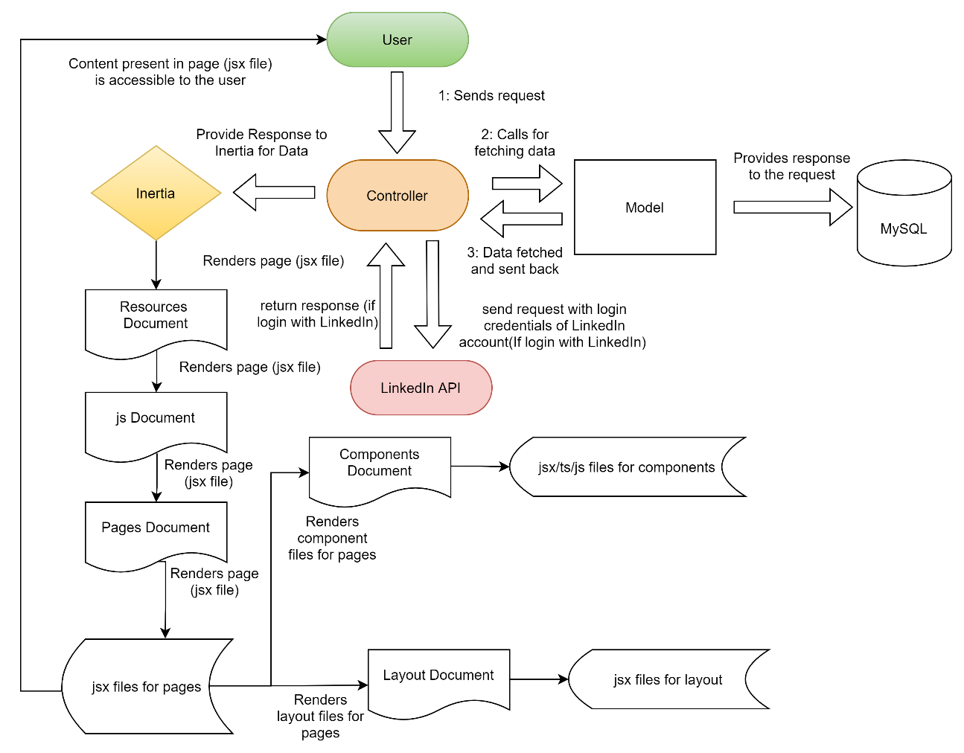

Figure 4‑1: System Architecture of Internseek

Internseek’s system architecture follows the Model-View-Controller (MVC) design pattern, with Inertia.js serving as a bridge between the server-side Laravel framework and the client-side React.js framework. User requests are initiated through the React.js frontend and routed to Laravel's controllers, which interact with models to retrieve or update data in the MySQL database before sending responses back. Inertia.js middleware processes these server responses into data suitable for React, determining the appropriate components to render on the client side. React dynamically renders the user interface using this data, ensuring a seamless and interactive experience. The application structure organizes React components, pages, and layouts in the resources/js directory, with pages being composed of reusable components and layouts. This integration of Laravel and React using Inertia.js allows Internseek to function as a unified monolithic application, eliminating the need for separate frontend and backend repositories and simplifying development and deployment.

For example, when the user clicks the "Login with LinkedIn" button, Inertia.js sends a request to the backend. The backend redirects the user to LinkedIn’s Authorization Endpoint, where the user is prompted to enter their LinkedIn login credentials. Once the user provides the credentials and clicks the "Sign In" button, LinkedIn checks the credentials. If valid, LinkedIn redirects the user back to the callback URL specified by the backend. Upon receiving this callback, the backend exchanges the authorization code for an access token, fetches the user's profile data via the LinkedIn API, and updates or stores the user details in the MySQL database. The frontend remains in sync with the backend through Inertia.js, providing a smooth user experience.

### Database Implementation

Internseek used the MySQL database to store all the system’s data. In the development phase, XAMPP managed Internseek's local database, which consisted of 22 tables. Internseek uses Inertia.js to interact with the Laravel backend, triggering CRUD operations by user actions within the system.

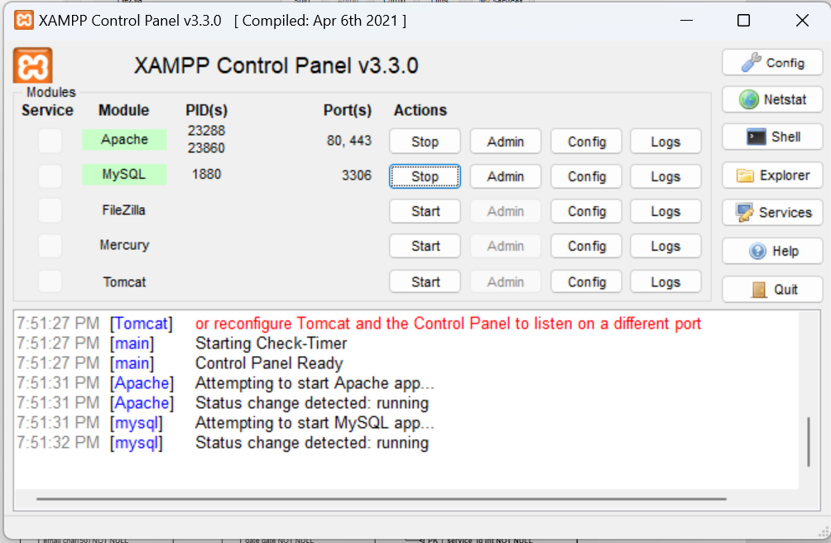

Figure 4‑2: XAMPP Control Panel



Figure 4‑3: Internseek Data Design

### Interface Implementation

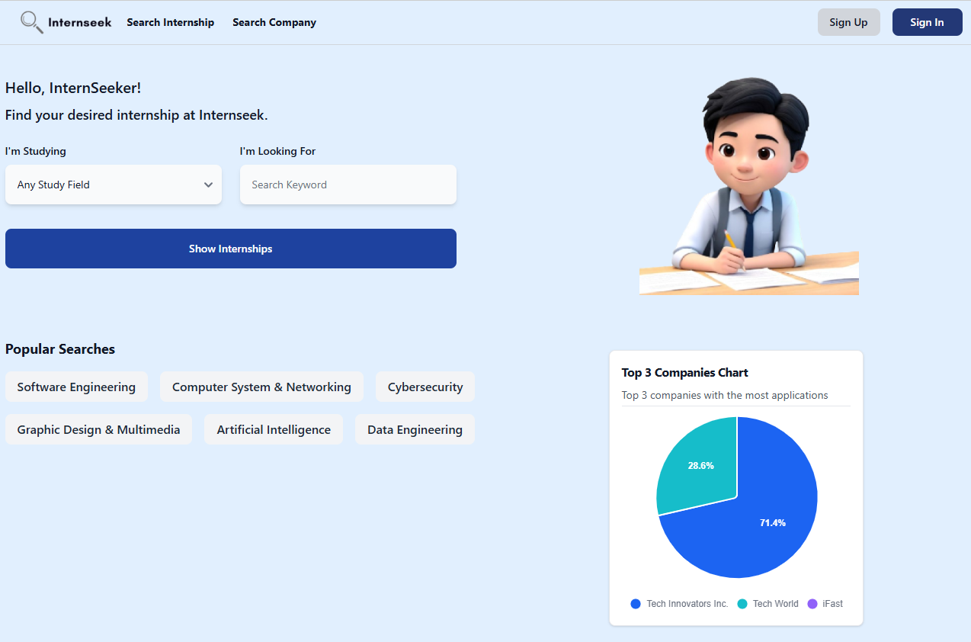

Figure 4‑4: Main Page of Internseek

This figure shows the main page of Internseek. University students and employers can register new account by clicking the <<Sign Up>> button. University students, employers, and administrators can click the <<Sign In>> button to login into the system. University students can also search for internships by selecting their field of study, entering the keyword, and clicking the "Show Internships" button to filter the internship listings. They can also click the "Search Internships" button on the navbar to view all available internships or the "Search Companies" button to view all companies. Students can also click the "Popular Keyword" button to filter the internship listings based on the popular keyword. The main page also displays the top 3 companies, visible to university students, employers, and administrators.

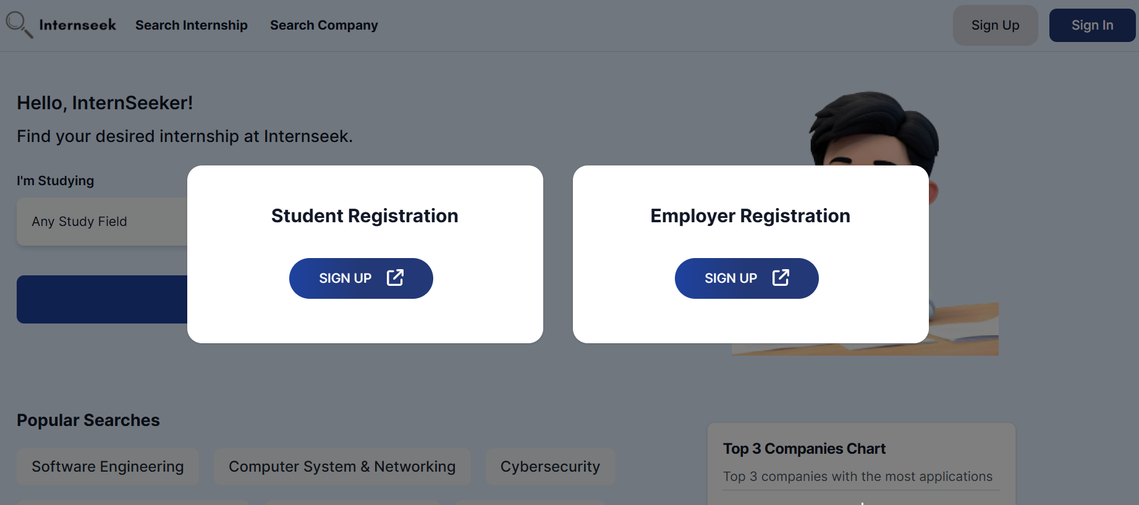

Figure 4‑5: Sign Up Modal

This figure shows the sign-up modal for both students and employers on Internseek, accessible after clicking the <<Sign Up>> button on the main page.

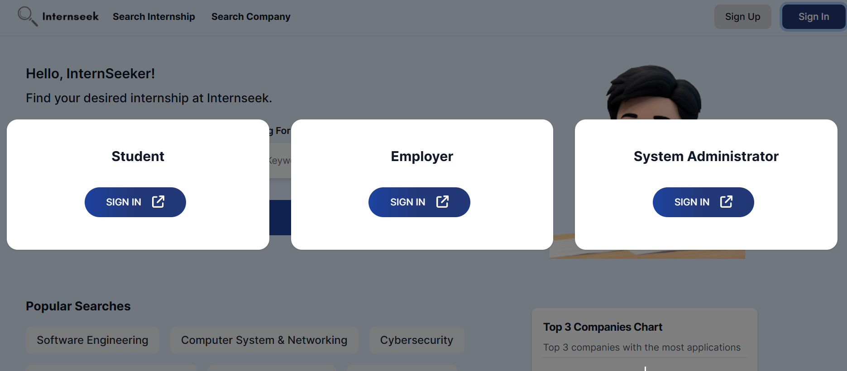

Figure 4‑6: Sign In Modal

This figure shows the sign-in modal for students, administrators and employers on Internseek, accessible after clicking the <<Sign In>> button on the main page.

##### Student

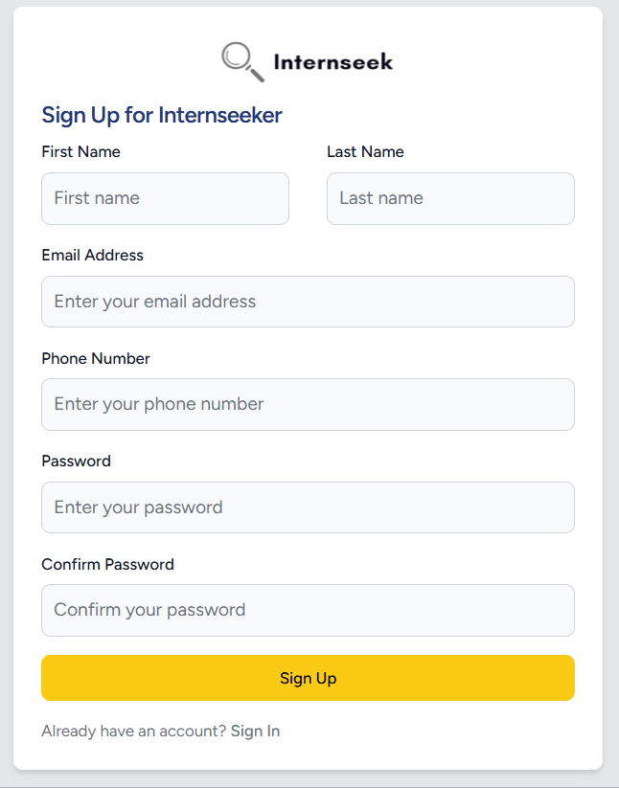

Figure 4‑7: Sign Up form (University Students)

This figure shows the student registration form for university students. To register an account, students need to enter their first name, last name, email address, phone number, password, and confirm the password, then click the <<Sign Up>> button. If they already have an account, they can click the <<Sign In>> text to log in to the system.

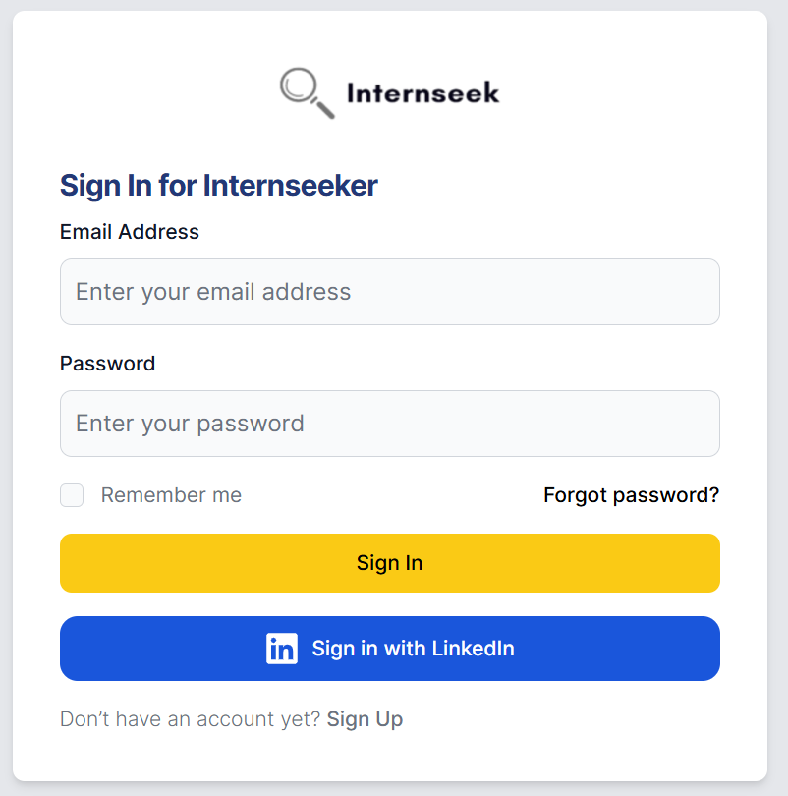

Figure 4‑8: Sign In Form (University Students)

This figure illustrates the login page for university students. The university student needs to enter their email address and password and click the <<Sign In>> button to login to the system. The university student can click the <<Sign Up>> text if they are first-time users. If the university student forgets their account password, they need to click the <<Forgot Password?>> text to reset their password. The university student can sign in with LinkedIn account by clicking <<Sign in with LinkedIn>> button. They can also select the "Remember me" checkbox to save their email address for easier sign-in next time.

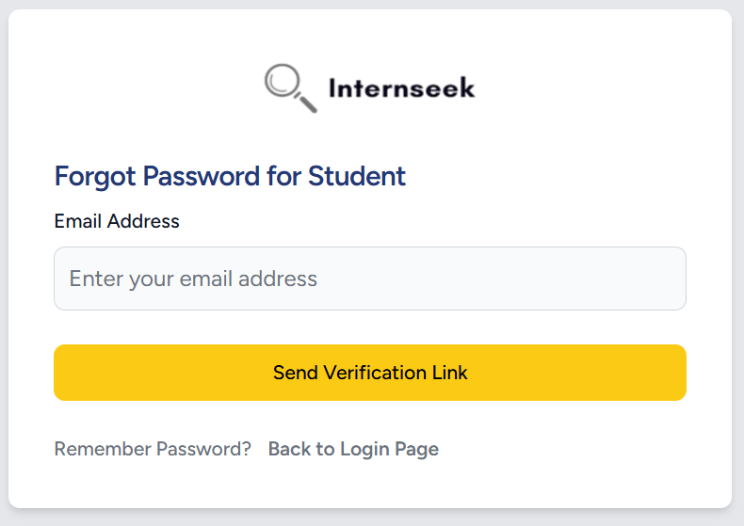

Figure 4‑9: Forgot Password Page (University Students)

This figure illustrates the forgot password page for university students if they forgot their password. The university students need to enter their email address and click the <<Send Verification Link>> button to get the password reset link. If the university students want to back to login page, they may click the <<Back to Login Page>> text.

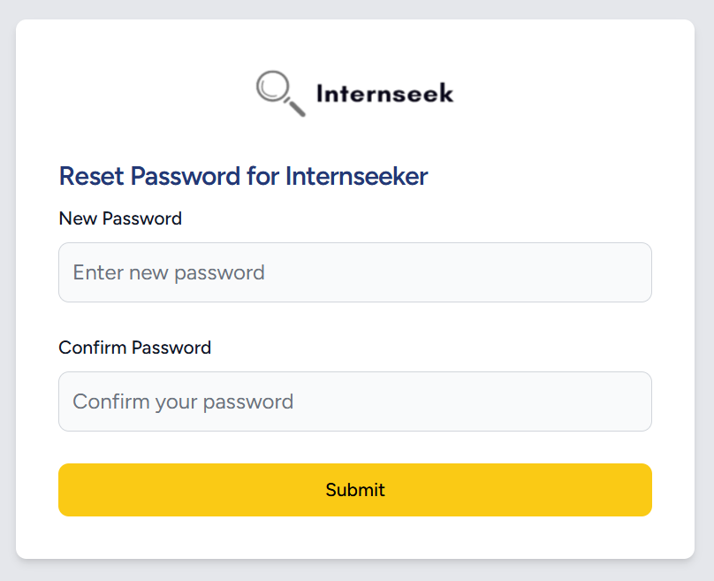

Figure 4‑10: Reset Password Form (University Student)

This figure illustrates the password reset page for university students once they click the password reset link in the email they received. The university students need to enter their new password, confirm their password, and click the <<Submit>> button to reset their password.

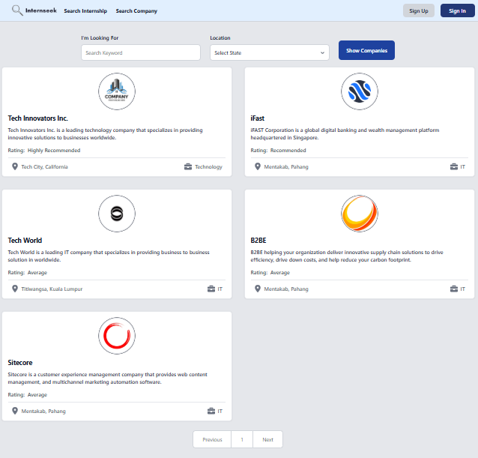

Figure 4‑11: Company Listing Page Without Login

This figure shows the company listing page that university students can view without logging in. University students can browse through a list of companies and view basic company information. This feature helps university students learn about the basic details of the company on the platform, allowing them to make informed decisions about signing up or logging in to Internseek.

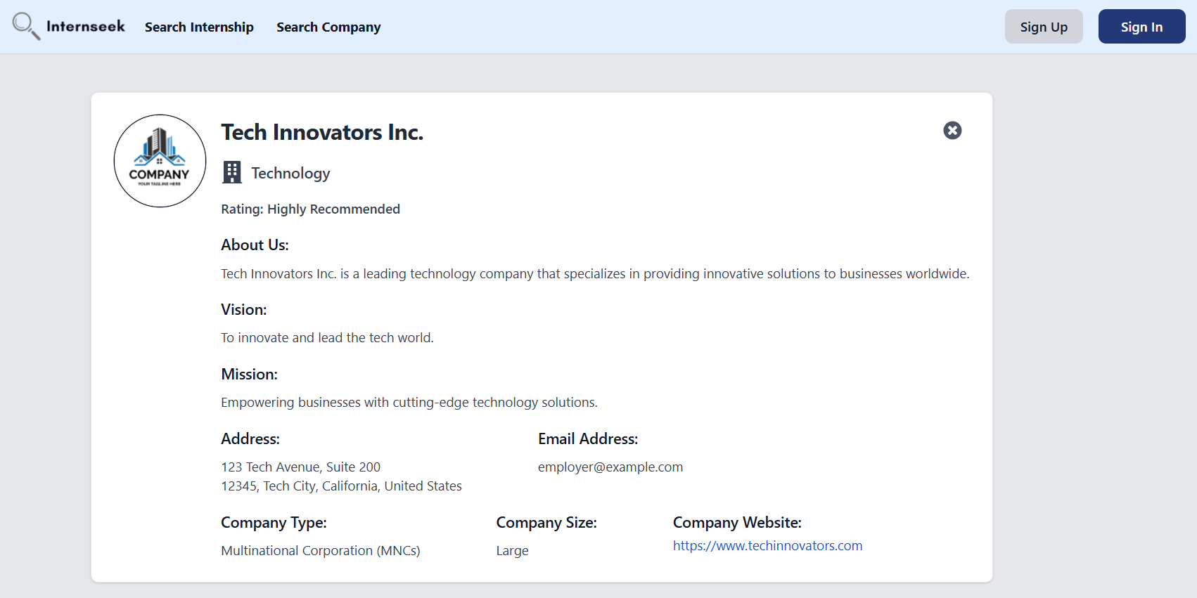

Figure 4‑12: Company Details Page Without Login

This figure shows the company details page that university students can view without logging in. University students can access detailed information about the company, which helps them understand the company background. This feature allows university students to make informed decisions about signing up or logging in to Internseek.

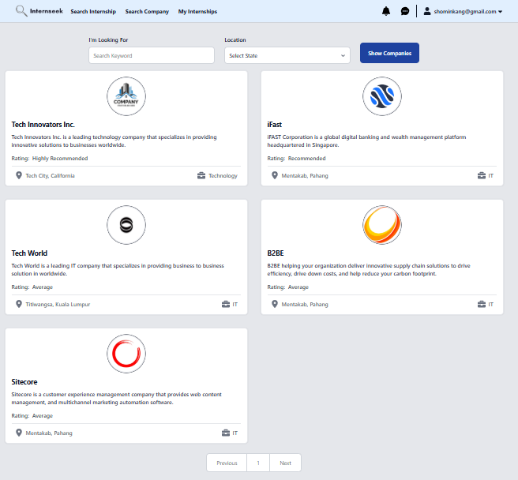

Figure 4‑13: Company Listing Page After Logging In

This figure shows the company listing page that university students can view after logging in. University students can browse through a list of companies and view basic company information. This feature helps university students learn about the basic details of the company on the platform.

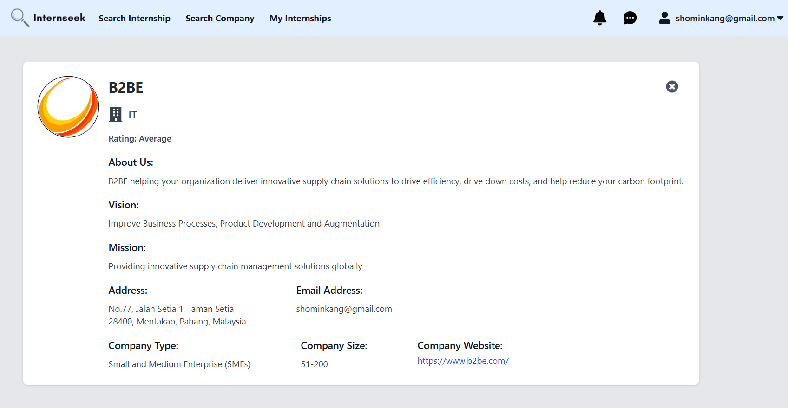

Figure 4‑14: Company Details Page After Logging In

This figure shows the company details page that university students can view after logging in. University students can access detailed information about the company, which helps them understand the company background.

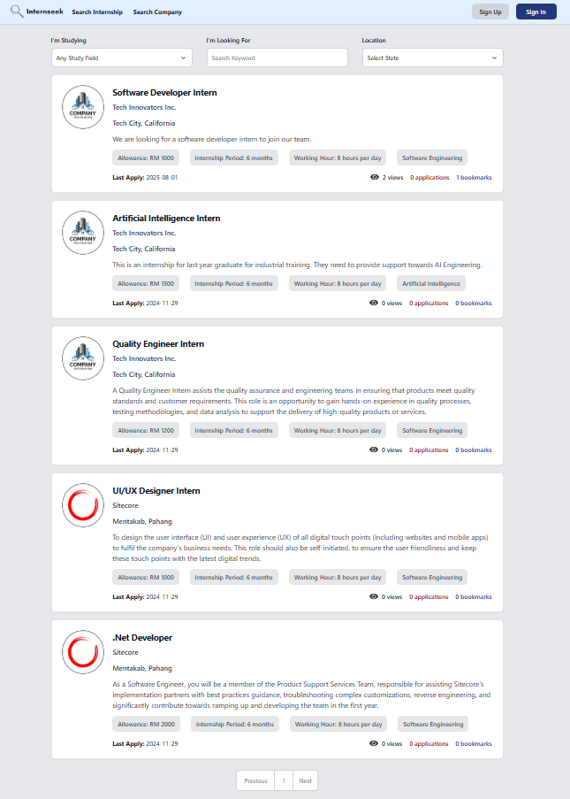

Figure 4‑15: Internship Listing Page Without Logging in

This figure displays a listing of all available internships that users can view without logging in. University students don't need to log in and create an account to browse through these internship opportunities. This allows university students to search for internships that match their interests and qualifications and experience the features offered by Internseek before creating an account.

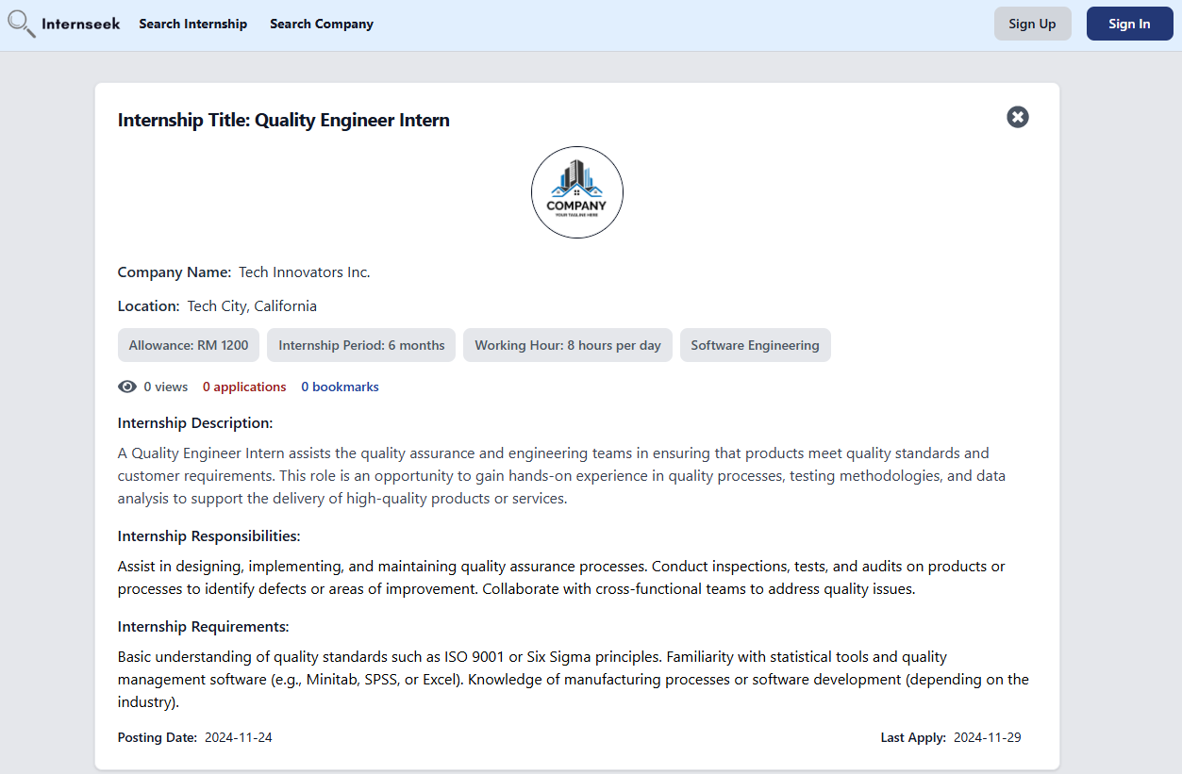

Figure 4‑16: Internship Details Page Without Logging In

This figure shows the internship details page that university students can view before logging in. University students can see detailed information about each internship, including the internship description, requirements, and internship responsibilities. It can help university students determine whether the internship meets their interests and qualifications before signing up or logging into the system.

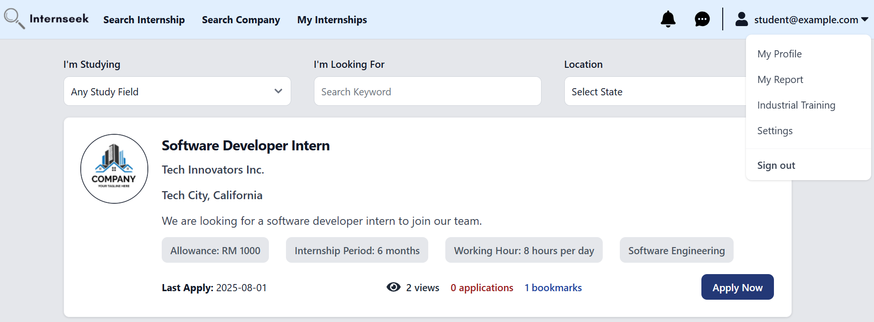

Figure 4‑17: Drop-Down Menu (University Students)

This figure shows the internship listings page with drop-down menu on the navbar section after university students log in. University students will be directed to the internship listings page after they successfully login to the system. This page shows the drop-down menu of the navigation bar, which consists of four options: My Profile, My Report, Industrial Training, Settings, and Sign Out. University students will be directed to the My Profile page once they select the My Profile option. University students will be directed to the My Report page once they select the My Report option. University students will be directed to the Industrial Training page once they select the Industrial Training option. University students will be directed to the Settings page once they select the Settings option. University students will be logged out of the system once they select the Sign Out option.

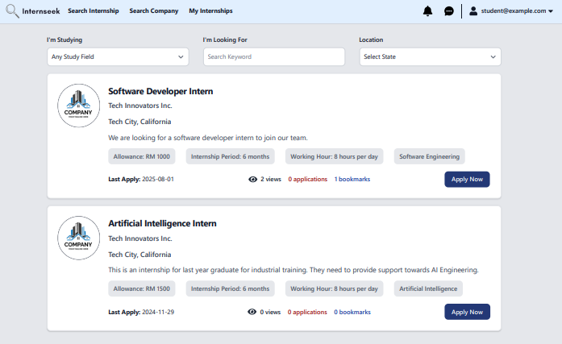

Figure 4‑18: Internship Listing Page After Logging In

This figure displays a listing of all available internships after university students log in to the system. University students can browse through these internship opportunities to find internships that match their interests and qualifications. This page also displays the number of views (clicks), bookmarks, and applications submitted for each internship. This data helps university students gauge the level of competition for the internship opportunity, allowing them to make informed decisions about which internships they want to apply for. Each internship card includes a bookmark icon and an apply now button. If university students want to apply for the internship, they may click the <<Apply Now>> button.

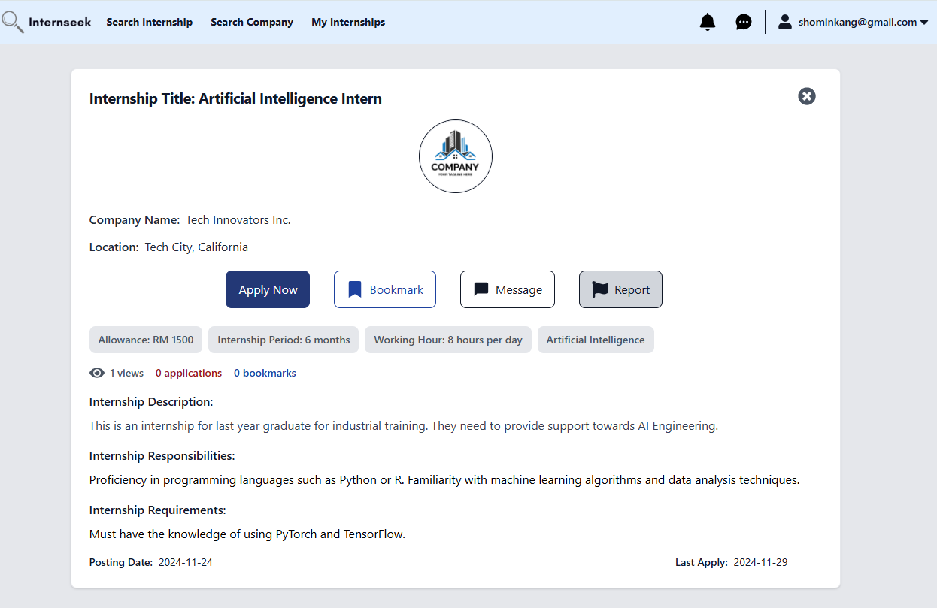

Figure 4‑19: Internship Details Page After Logging In

This figure displays the internship details page that university students can view after they log in to the system. University students can see detailed information about each internship and determine whether it meets their interests and qualifications, including the internship description, requirements, allowance, responsibilities, and so on. This page also displays the number of views (clicks), bookmarks, and applications submitted for the internship. It can help university students gauge the level of competition for the internship. The internship details card includes a bookmark button, a message button, a report button and an apply now button. If university students want to apply for the internship, they may click the <<Apply>> button. If university students have an interest in the internship, they may click the <<Bookmark>> button to save it to their list of internships. If university students want to know the details of the internship, they can click the <<Message>> button to inquire with the employer about the internship details. If university students find the internship got problem, they can click the <<Report>> button to report the internship.

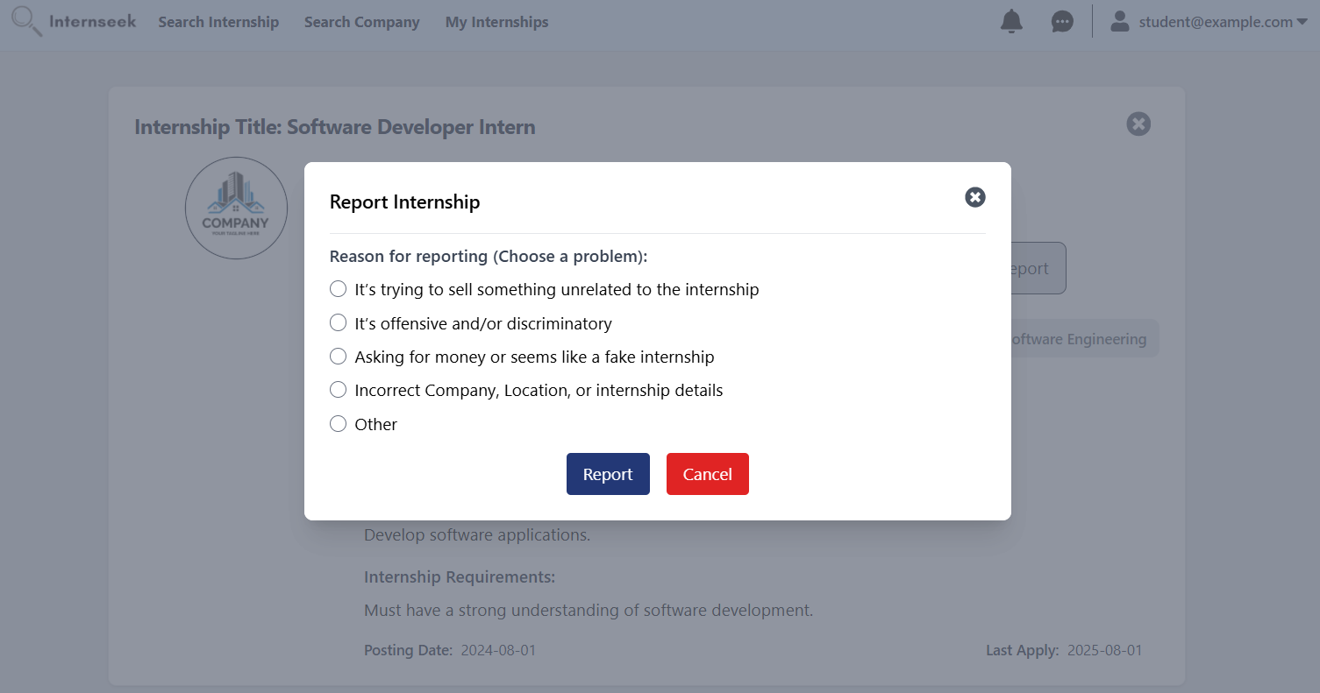

Figure 4‑20: Report Internship Modal

This figure displays the report internship modal once the university students click the <<Report>> button on the internship card. The university students may select a problem listed in the modal and click the <<Submit>> button; if the problem is others, they can describe it in the input field. If the university students do not want to report the internship, they may click the <<Cancel>> button or the cross icon.

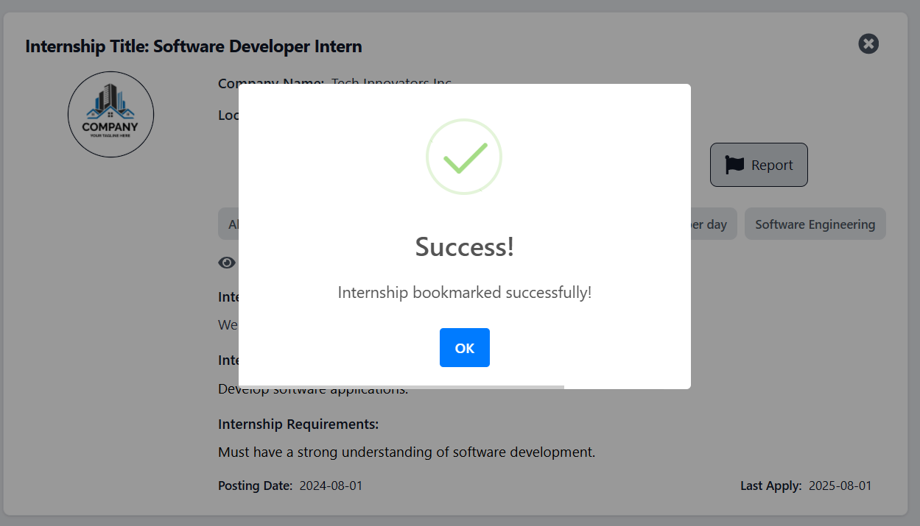

Figure 4‑21: Bookmark Successful Message

This figure shows the "bookmark successful" message that appears when the university student clicks the bookmark button for an internship they haven't bookmarked before.

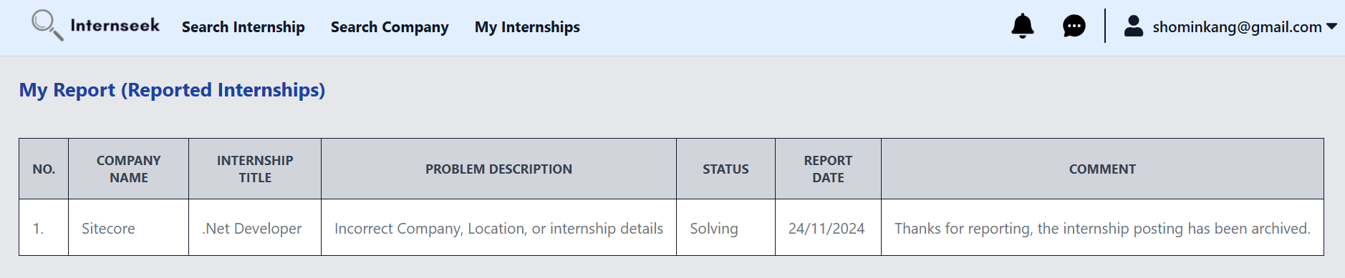

Figure 4‑22: My Report Page

This figure shows the My Report page, which displays a list of internships reported by the university students. On this page, university students can view the status of each report and the comments provided by the system administrator.

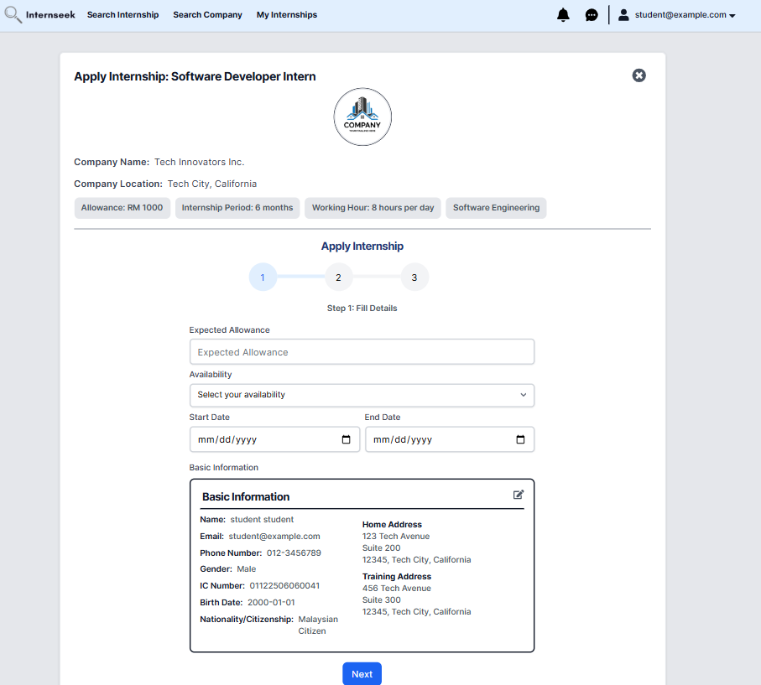

Figure 4‑23: Apply for Internship Page (1st step for apply for internship form)

This figure shows the page for the university student to apply for the internship once they click the <<Apply Now>> button on the internship card. This page shows step 1 of applying for the internship. The university student needs to enter the details required in the form, such as expected allowance, availability, expected start date, and expected end date, and check if their basic information is true or not. Once they enter all the details required and confirm their basic information is correct, they may click the <<Next>> button to proceed with the next step in the internship application. If the basic information is incorrect, the university student should click the edit button to edit the profile details.

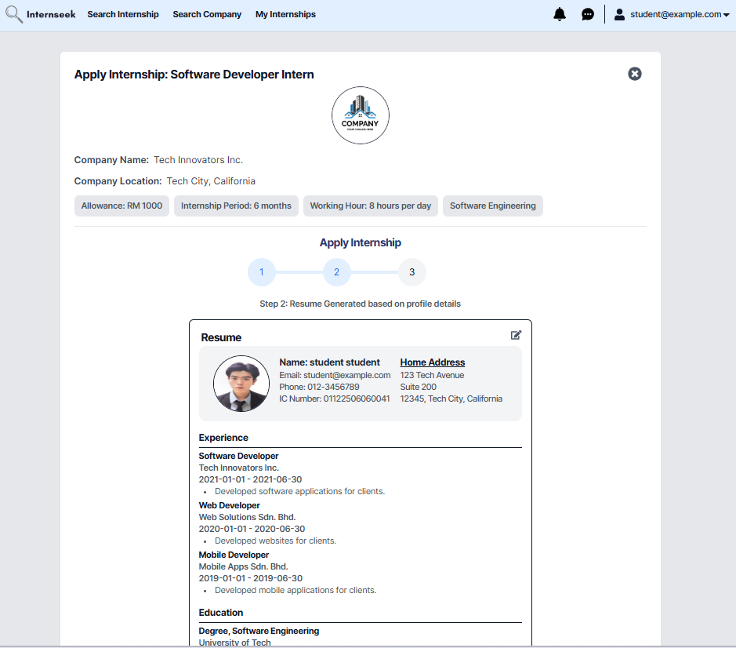

Figure 4‑24: Apply for Internship Page (2nd step for apply for internship form)

This figure displays the apply for internship page, which shows step 2 of applying for the internship. This page displays the resume generated by the system based on the profile details of the university student. If the university student finds some of the details in the resume are incorrect, they may click the edit icon button to edit the profile details. If the university student finds that all the details in the resume are correct, they may proceed to the next step by clicking the <<Next>> button. If the university student wants to return to the previous step, they may click the <<Back>> button.

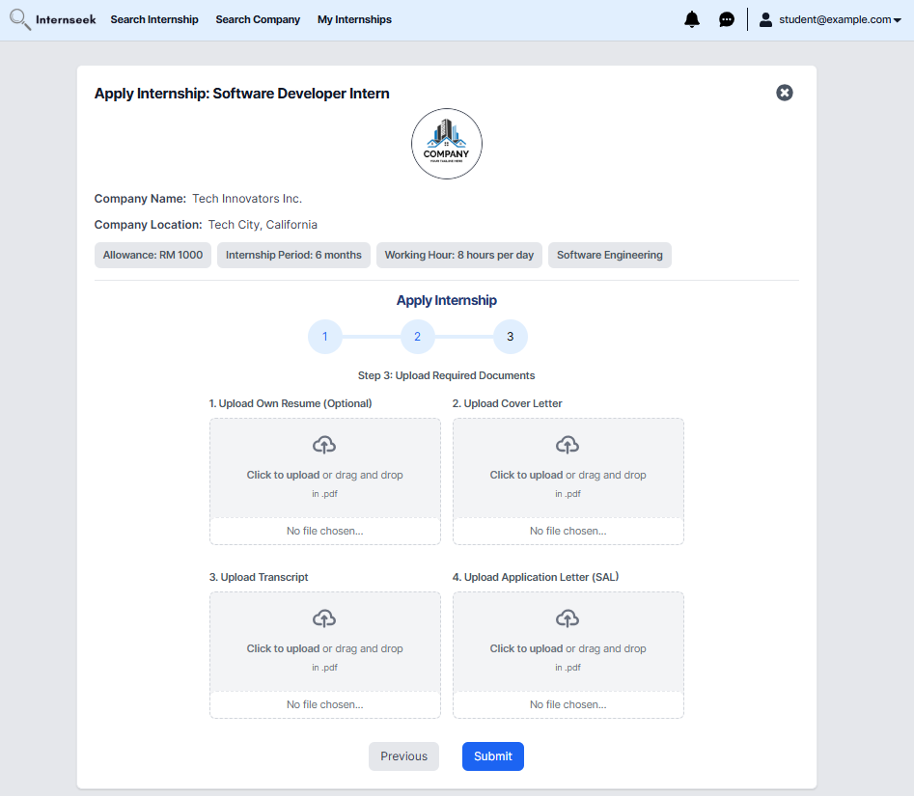

Figure 4‑25: Apply for Internship Page (3rd step for apply for internship form)

This figure displays the Apply for Internship page, highlighting step 3 of the application process. In this step, university students are required to upload a cover letter proving their need to undergo industrial training for academic purposes. In addition, the university student has the option to upload their own resume, but this is not compulsory. Once the university student uploads the cover letter, they may submit the internship application form. If the university student wants to return to the previous step, they may click the <<Back>> button.

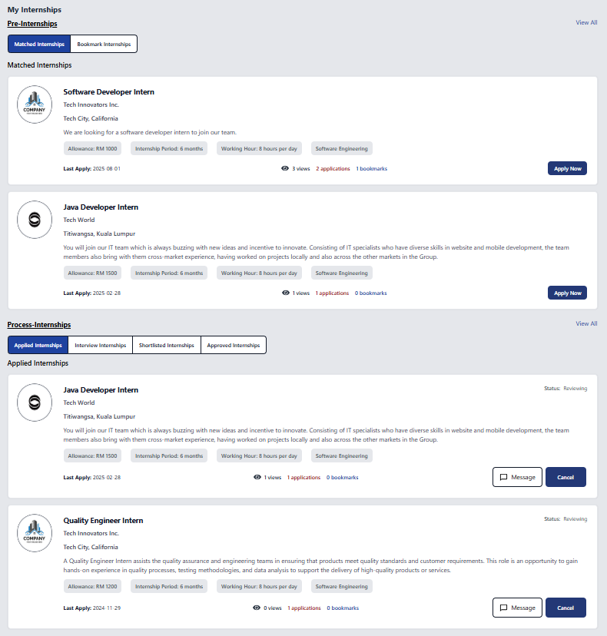

Figure 4‑26: My Internships Page (Pre-Internships and Process-Internships)

This figure shows the My Internships page once the university student clicks the <<My Internships>> link, which consists of two sections: Pre-Internships and Process-Internships. In the Pre-Internships section, there are two buttons: Matched Internships, which shows internships matched to the student's profile or preferences, and Bookmark Internships, which displays internships the student has bookmarked for later consideration. The Process-Internships section consists of three buttons: Applied Internships, listing internships to which the student has applied; Need-to-Interview Internships, showing internships where the student is required to attend an interview; Shortlisted Internships, displaying internships where the student has been shortlisted by the employer; and Approved, displaying internships where the student has been approved by the employer. University students can view up to two internships from each category within these sections.

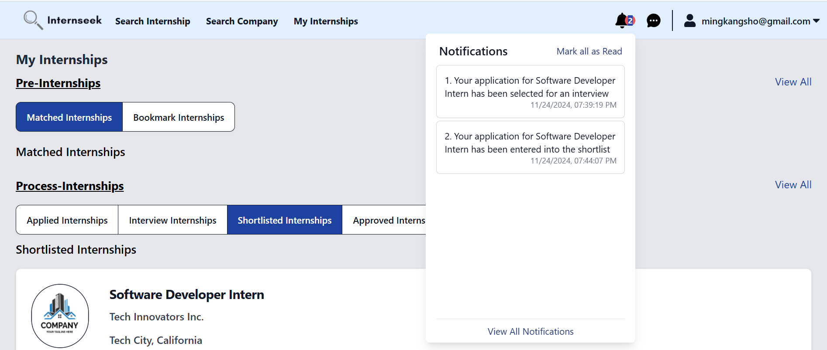

Figure 4‑27: Notifications in drop-down view

This figure shows the notifications received by a university student in a drop-down menu after clicking the bell icon. The student can view all notifications by clicking the "View All Notifications" link or mark all notifications as read by clicking the "Mark All as Read" link.

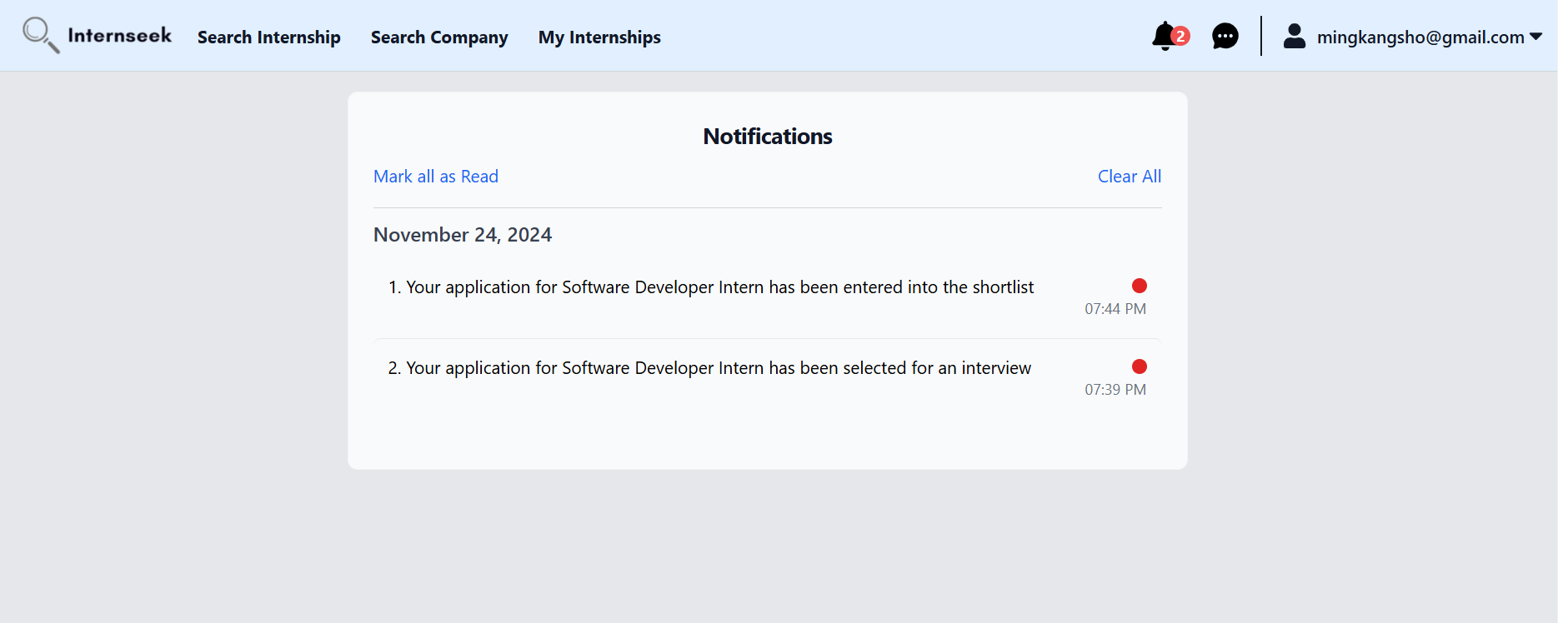

Figure 4‑28: Notifications Listing Page

This figure displays a list of all notifications received by the student, organized by daily categories. Students can either mark all notifications as read or clear all notifications.

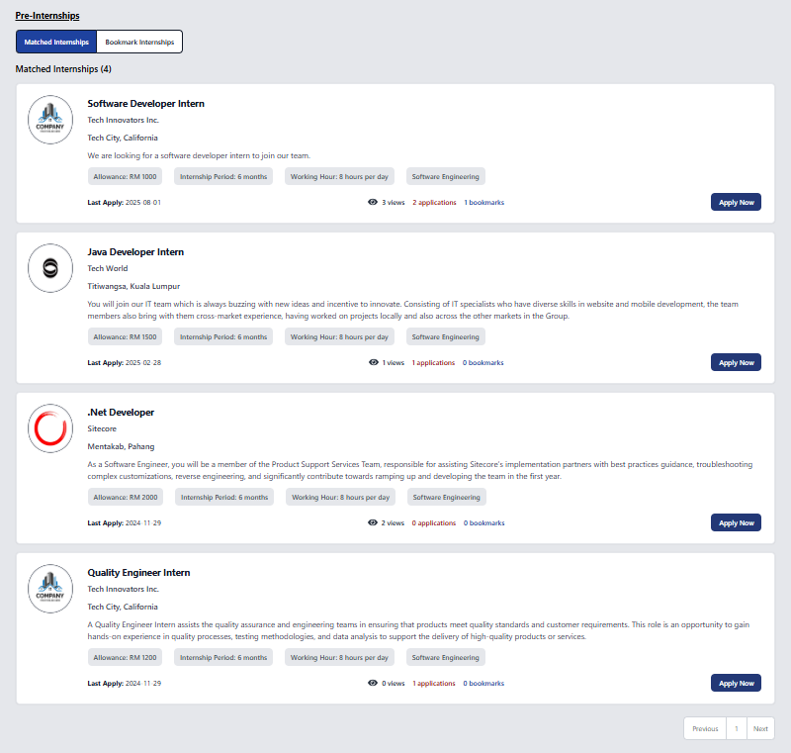

Figure 4‑29: Pre-Internships Page (Matched Internships)

This figure shows the Pre-Internships page, which displays a list of matched internships. The matched internships are retrieved based on the study field of the university student. The university student can browse through these internship opportunities to find their ideal internships that meet their career goals. This page also displays the number of views (clicks), bookmarks, and applications submitted for each internship. Each internship card includes a bookmark icon and an apply now button. If university students want to apply for the internship, they may click the <<Apply Now>> button. If university students have an interest in the internship, they may click the bookmark icon to save it to their list of internships.

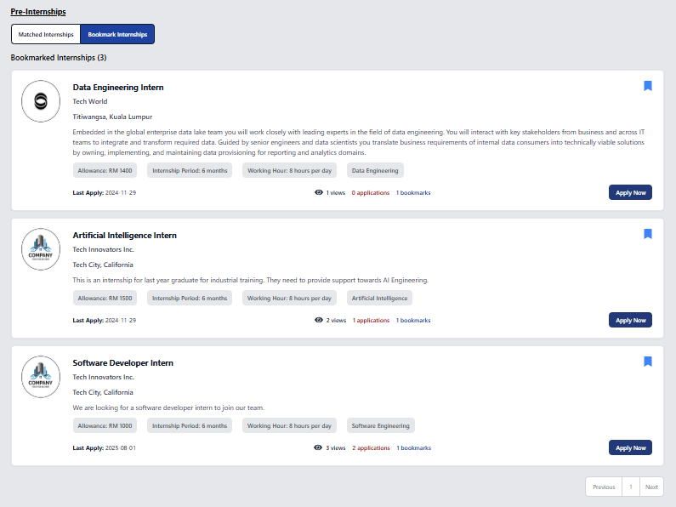

Figure 4‑30: Pre-Internships Page (Bookmark Internships)

This figure shows the My Pre-Internships page, which displays a list of internships bookmarked by the university student. The blue bookmark icon on the internship card represents that the university student has bookmarked this internship. The university student can browse through their bookmarked internship opportunities to make an informed decision about whether they want to apply for this internship or not. This page also displays the number of views (clicks), bookmarks, and applications submitted for each internship. The internship card includes an apply now button. If university students want to apply for the internship, they may click the <<Apply Now>> button.

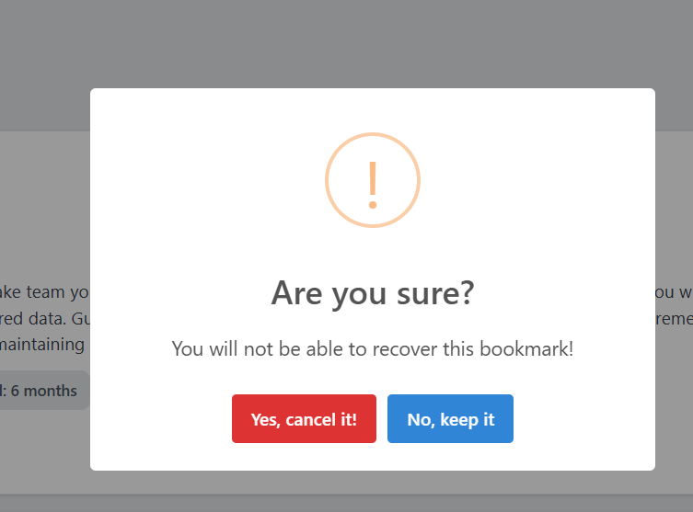

Figure 4‑31: Delete Bookmark Confirmation Message

This figure displays the delete bookmark confirmation message shown to university students after they click the bookmark icon to remove a bookmarked internship.

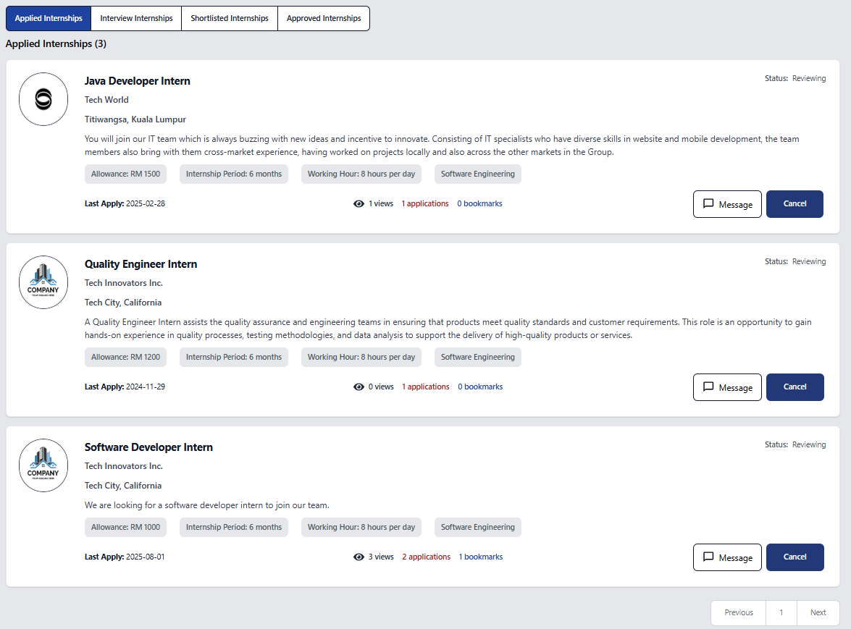

Figure 4‑32: Process-Internship Page (Applied Internships)

This figure shows the Process-Internships page, which displays a list of internships the university student has applied for. The listing includes only those internship applications that are still under review or unsuccessful. University students can cancel their applications that are still under review. University students may click the <<Message>> button to remind the employer to update the application status. This page also allows them to keep track of whether their internship applications are unsuccessful or not.

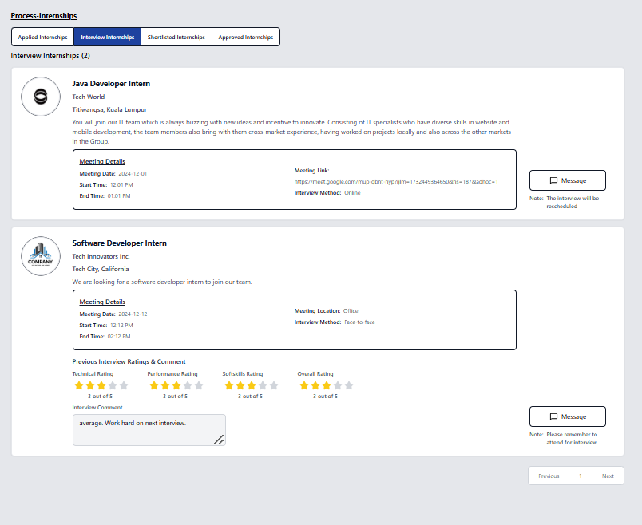

Figure 4‑33: Process-Internships Page (Need-to-Interview)

This figure illustrates the Process-Internships page, which displays a list of internships the university student has applied for, with a status of "Need-to-Interview." The list includes interview details, such as the method, date, time, and location for face-to-face interviews, or an online meeting link for virtual interviews. Additionally, it shows the results of the first interview along with details for any subsequent interviews, allowing students to stay informed about the process. On this page, university students must respond to interview invitations after the employer schedules them. Students can click the "Available" or "Not Available" button to update their status. If they select "Available," the interview will proceed as planned. If they select "Not Available," the employer will reschedule the interview.

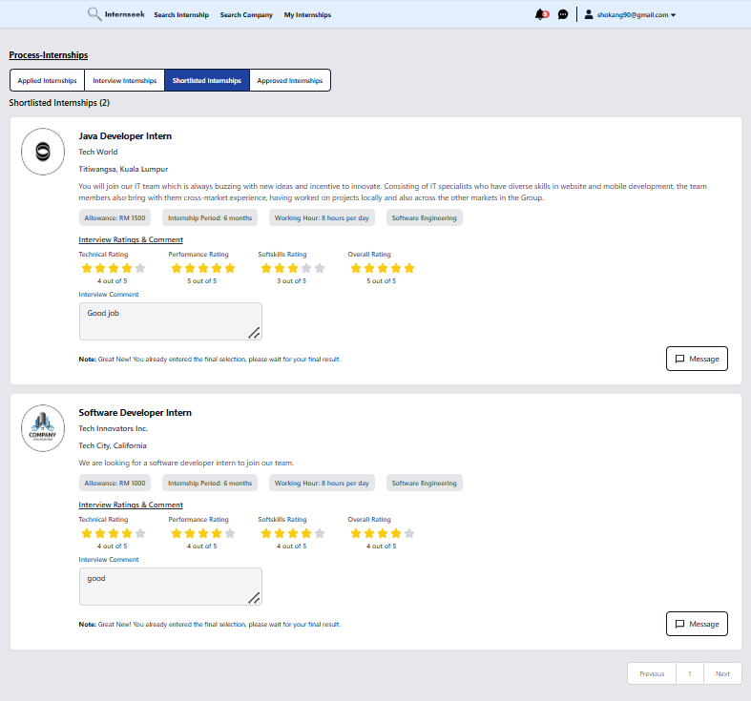

Figure 4‑34: Process-Internships Page (Shortlisted)

This figure shows the Process-Internships page, which displays a list of internships the university student has applied for with a status of "Shortlisted." Each internship card includes the interview results and indicates that the student has progressed to the final selection stage. Students can follow up on their application status by clicking the message button to contact employers.

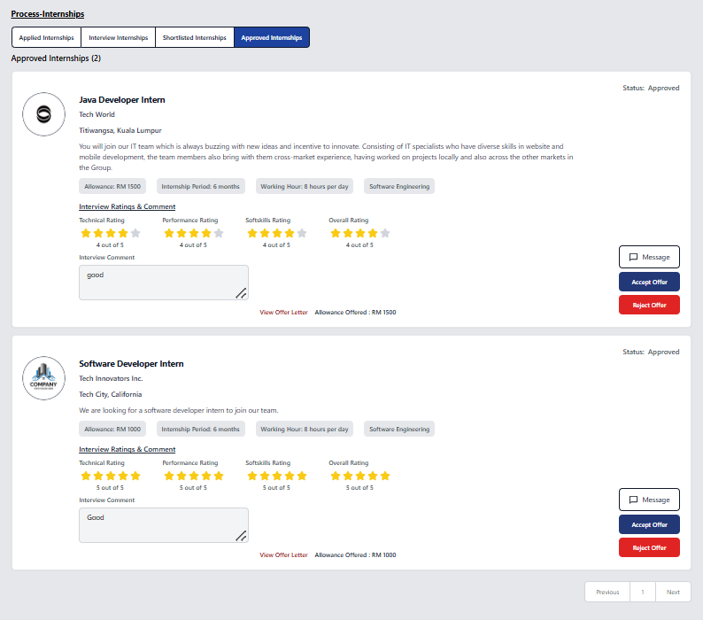

Figure 4‑35: Process-Internships Page (Approved)

This figure shows the Process-Internships page, which displays a list of internships the university student has applied for with the status of "Approved". Each approved internship card includes the allowance offered and offer letter uploaded by the employer, which the university student can view and download. The internship card includes <<Accept Offer>> and <<Reject Offer>> buttons, allowing the university student to decide whether to accept or reject the offer. The university student must provide a reason for rejecting the offer. Clicking the "Reject Offer" button will display a modal where they can enter their reason.

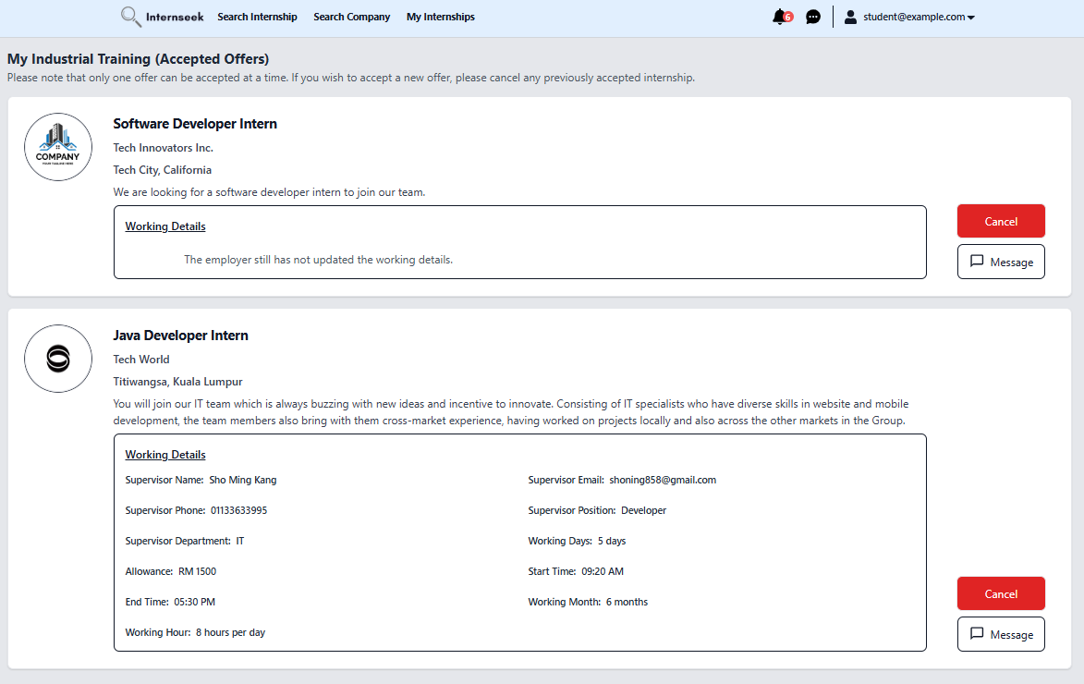

Figure 4‑36: My Industrial Training Page

This figure shows the list of internship offers accepted by the university student once they click the <<My Industrial Training>> option in the drop-down menu. On this page, university students can view details of the accepted offers, including the working start date, working end date, working day, working start time, working end time, supervisor name, supervisor email, and working location. If a university student accepts more than one offer, they need to cancel the offers they do not want by clicking the <<Cancel>> button. For more detailed information about an accepted offer, the student can message the employer by clicking the <<Message>> button. The university student must provide a reason for cancelling the offer. Clicking the "Cancel" button will display a modal where they can enter their reason.

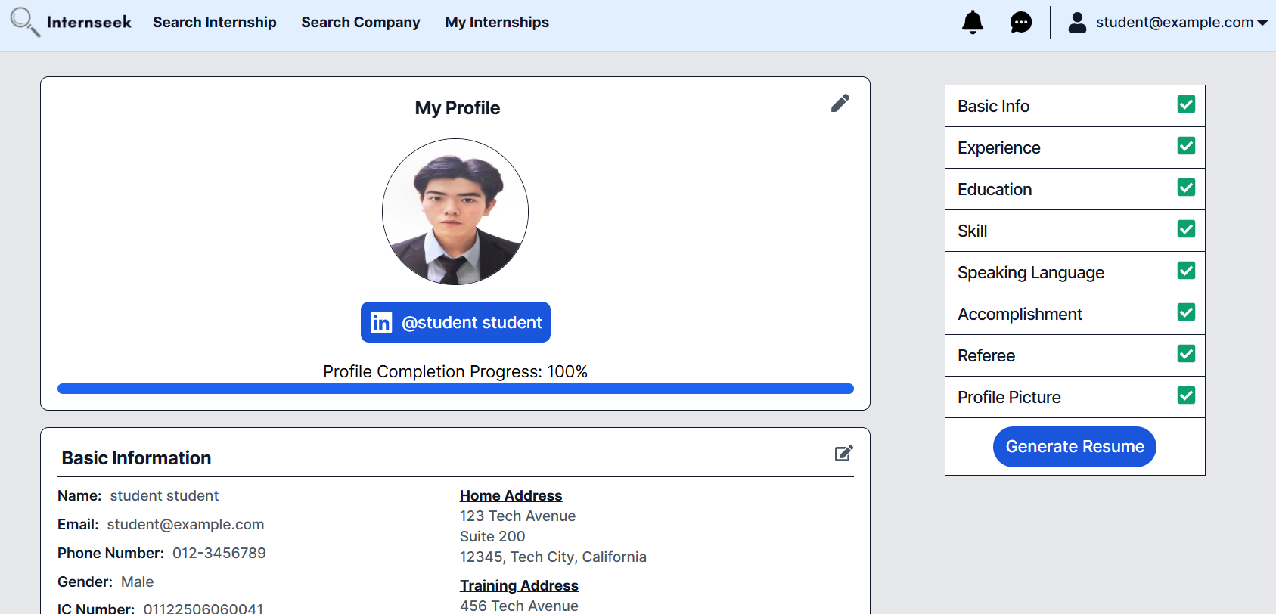

Figure 4‑37: My Profile Page (University Students)

This page shows the profile details of the university student. This page categorizes the profile details of the university student into eight sections: profile picture, basic information, experience, education, skills, speaking languages, accomplishments, and referees. University students can add, edit, and delete their profile details on this page. Once the university students fill out all the profile details required completely, they can generate a resume by pressing the <<Generate Resume>> button. The page consists of a progress bar, which represents the percentage of profile completeness.

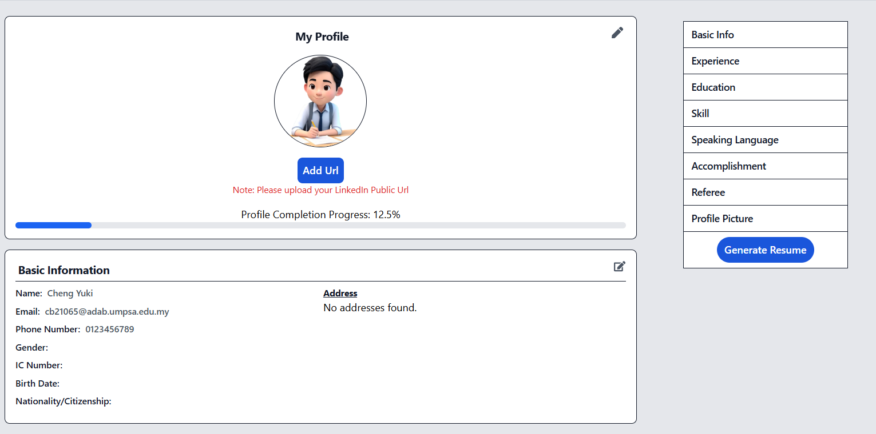

Figure 4‑38: My Profile without LinkedIn Public Profile URL

This figure displays the "My Profile" page for a newly registered university student. It includes an "Add URL" button, allowing students to add their LinkedIn public URL. Students are required to complete their profile by filling out details across eight sections: Profile Picture, Basic Information, Experience, Education, Skills, Languages, Accomplishments, and Referees.

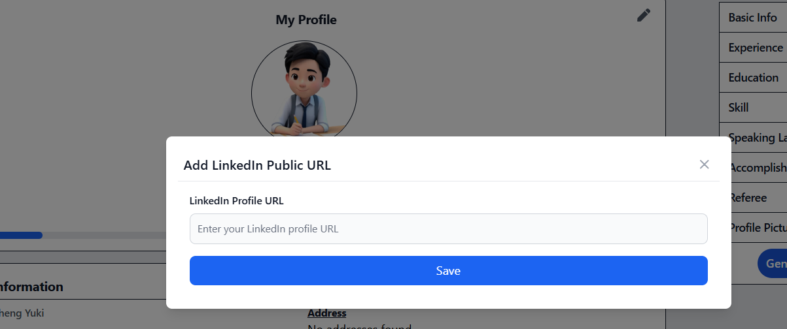

Figure 4‑39: Add LinkedIn Public Profile URL Modal

This figure illustrates the "Add LinkedIn Public URL" modal for university students, highlighting the interface for entering and saving their LinkedIn profile URL.



Figure 4‑40: My Profile Page with LinkedIn Public Profile URL

This figure shows a university student successfully adding their LinkedIn profile URL. Clicking the blue button displaying their name will redirect them to their LinkedIn profile.

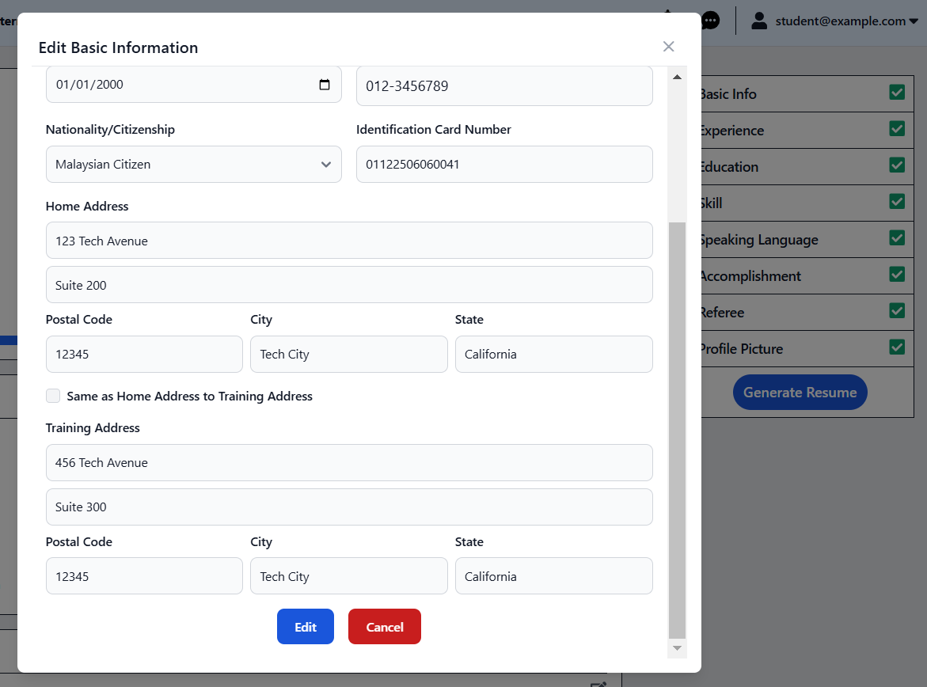

Figure 4‑41: Edit Basic Information Modal

This figure shows the edit basic information modal once the university student clicks the edit icon on the basic information section in My Profile Page. The university student can edit the basic information by entering the details they want to edit and click the <<Edit>> button. The university student can click the <<Cancel>> button and the cross icon if they do not want to edit the basic information.

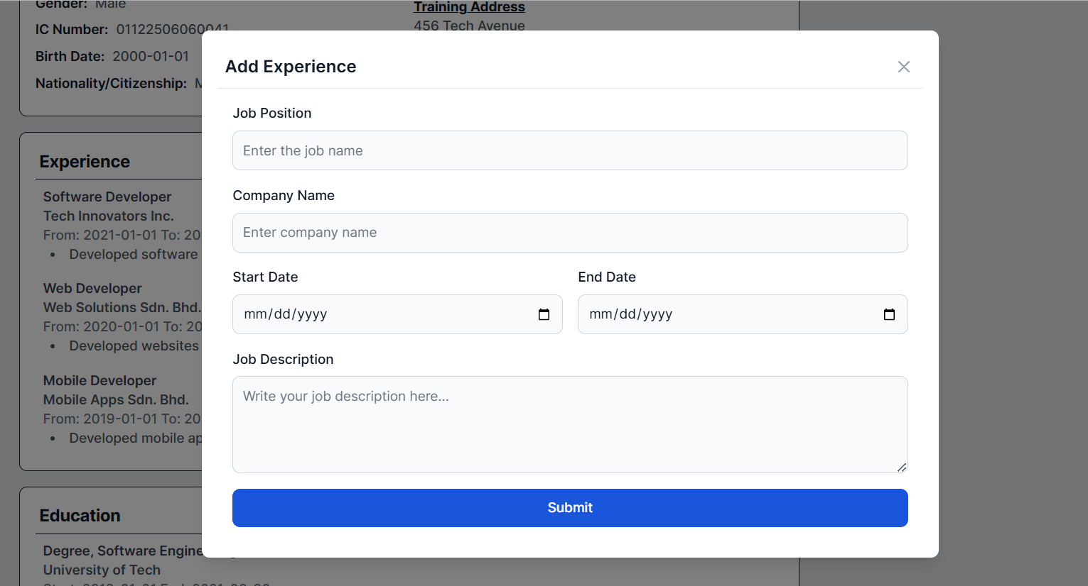

Figure 4‑42: Add Experience Modal

This figure shows the add-experience modal once the university student clicks the plus icon in the experience section of the My Profile Page. The university student enters the experience details required in the add-experience modal and click the <<Submit>> button. The university student can click the cross icon and the <<Cancel>> button if they do not want to add a new experience.

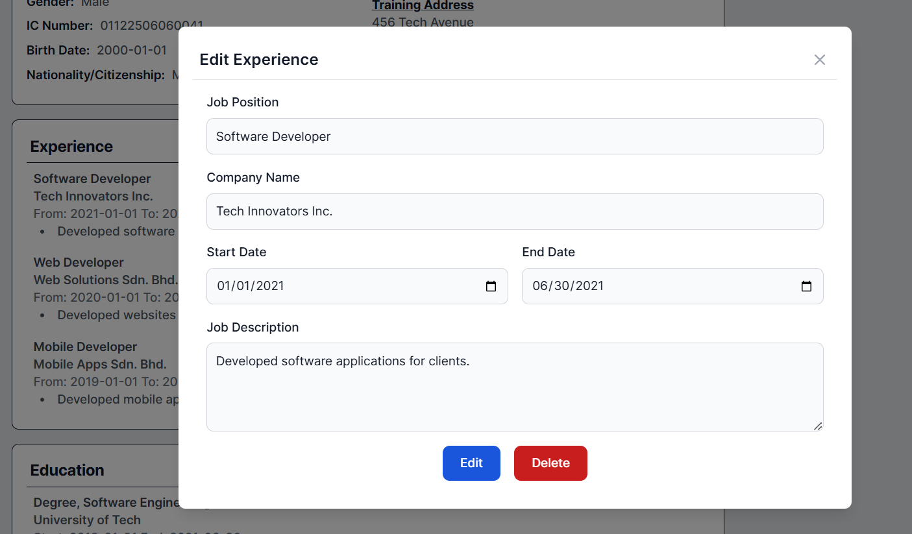

Figure 4‑43: Edit Experience Modal

This figure shows the edit experience information modal once the university student clicks the edit icon of the specific experience in the experience section of the My Profile Page. The university student can edit the specific experience details by entering the details they want to edit and clicking the <<Edit>> button. The university student can click the <<Delete>> button if they want to delete the experience. The university student can click the cross icon if they do not want to edit the specific experience details.

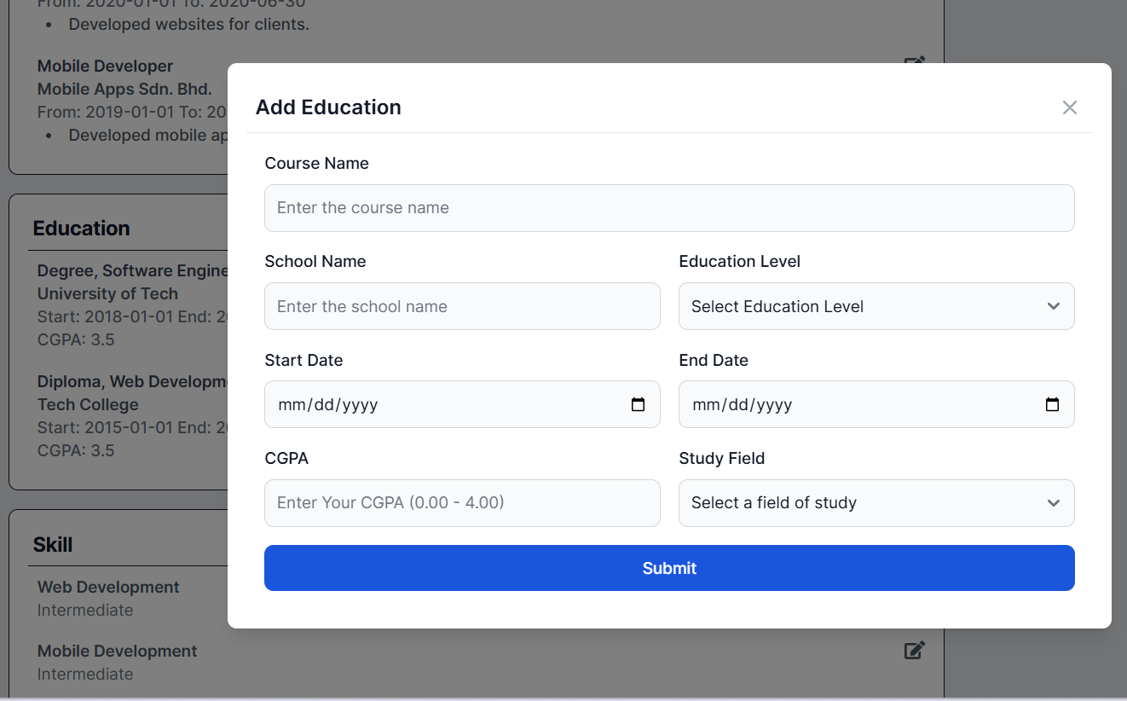

Figure 4‑44: Add Education Modal

This figure shows the add-education modal once the university student clicks the plus icon in the education section of the My Profile Page. The university student enters the education details required in the add-education modal and click the <<Submit>> button. The university student can click the cross icon and the <<Cancel>> button if they do not want to add a new education.

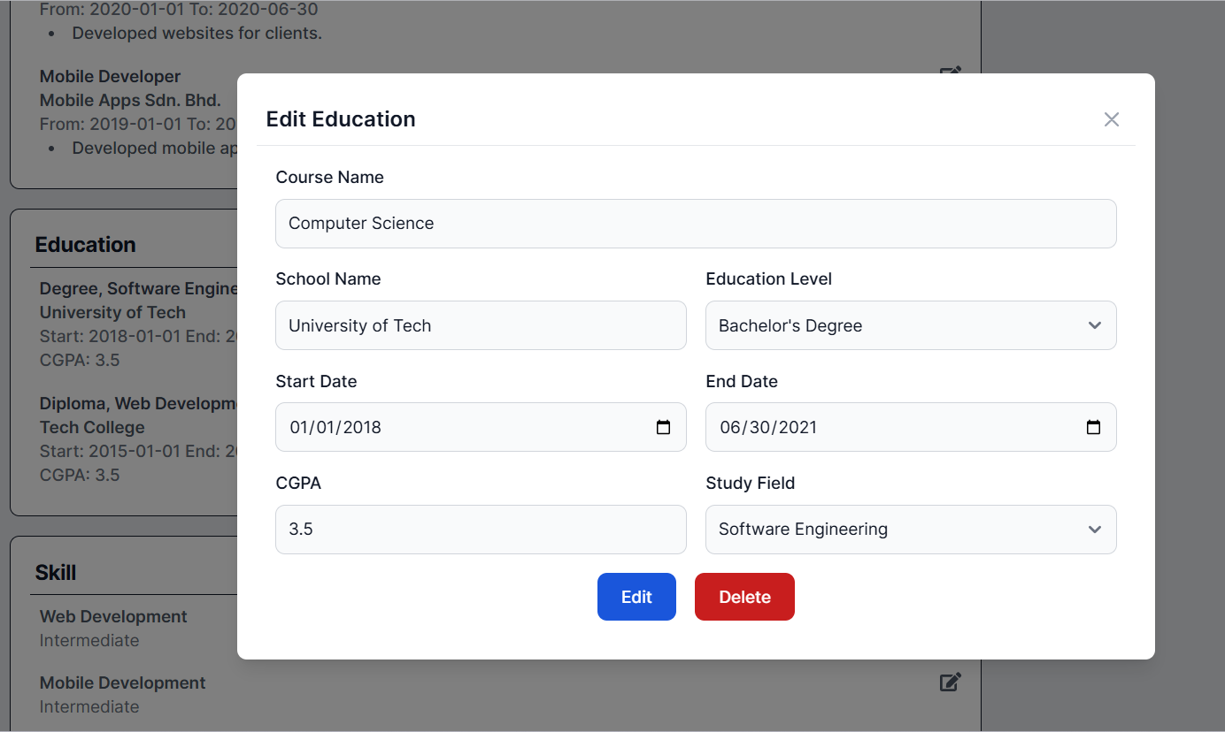

Figure 4‑45: Edit Education Modal

This figure shows the edit education information modal once the university student clicks the edit icon of the specific education in the education section of the My Profile Page. The university student can edit the specific education details by entering the details they want to edit and clicking the <<Edit>> button. The university student can click the <<Delete>> button if they want to delete the specific education. The university student can click the cross icon if they do not want to edit the specific education details.

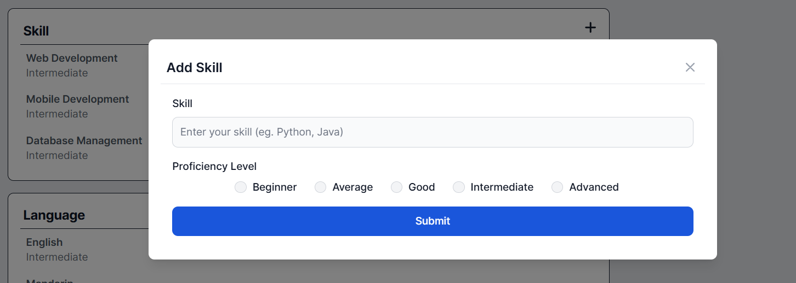

Figure 4‑46: Add Skill Modal

This figure shows the add-skill modal once the university student clicks the plus icon in the skill section of the My Profile Page. The university student enters the skill in the input field and selects the proficiency level in the add skill modal and clicks the <<Submit>> button. The university student can click the cross icon and the <<Cancel>> button if they do not want to add a new skill.

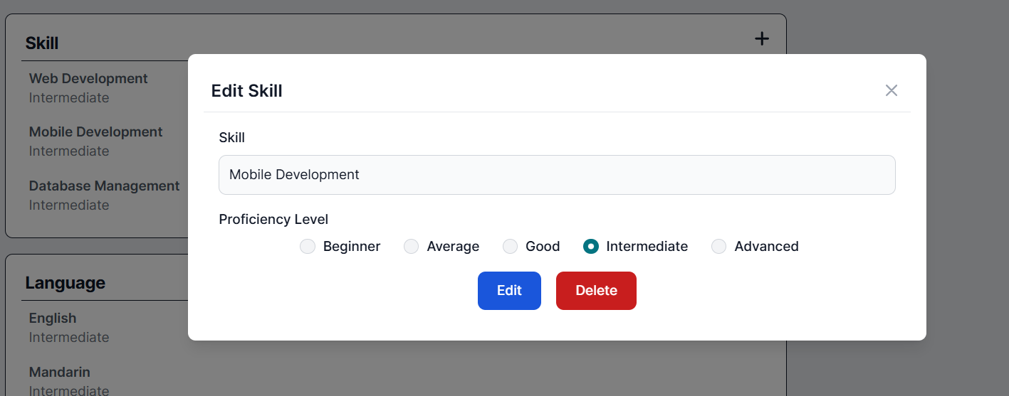

Figure 4‑47: Edit Skill Modal

This figure shows the edit skill information modal once the university student clicks the edit icon of the specific skill in the skill section of the My Profile Page. The university student can edit the specific skill details by entering the skill in the input field, selecting the proficiency level and clicking the <<Edit>> button. The university student can click the <<Delete>> button if they want to delete the specific skill. The university student can click the cross icon if they do not want to edit the specific skill details.

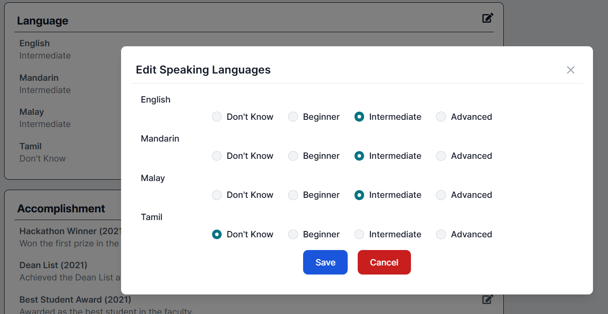

Figure 4‑48: Edit Speaking Language Modal

This figure displays the edit speaking language modal once the university student clicks the edit icon in the speaking language section of the My Profile page. The university student selects the proficiency level of Bahasa Malaysia, English, Chinese, and Tamil and clicks the <<Submit>> button. If the university student does not want to edit the proficiency level of their speaking language, they may click the <<Cancel>> button or the cross icon.

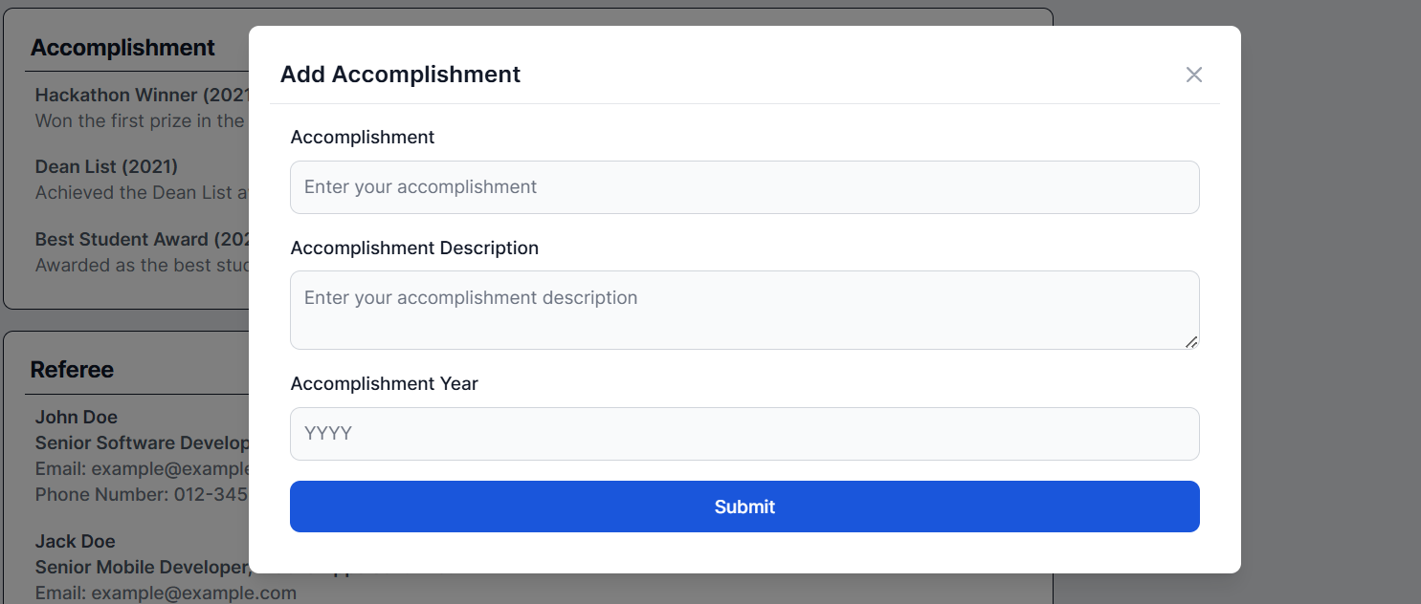

Figure 4‑49: Add Accomplishment Modal

This figure shows the add-accomplishment modal once the university student clicks the plus icon in the accomplishment section of the My Profile Page. The university student enters the accomplishment description, selects the accomplishment year, and clicks the <<Submit>> button. The university student can click the cross icon and the <<Cancel>> button if they do not want to add a new accomplishment.

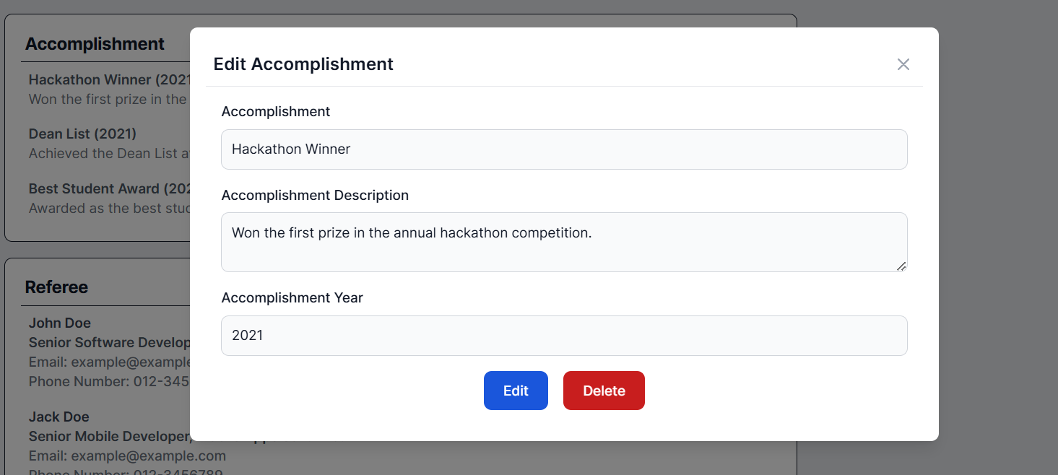

Figure 4‑50: Edit Accomplishment Modal

This figure shows the edit accomplishment modal once the university student clicks the edit icon of the specific accomplishment in the accomplishment section of the My Profile Page. The university student can edit the specific accomplishment details by entering the details they want to edit and clicking the <<Edit>> button. The university student can click the <<Delete>> button if they want to delete the specific accomplishment. The university student can click the cross icon if they do not want to edit the specific accomplishment details.

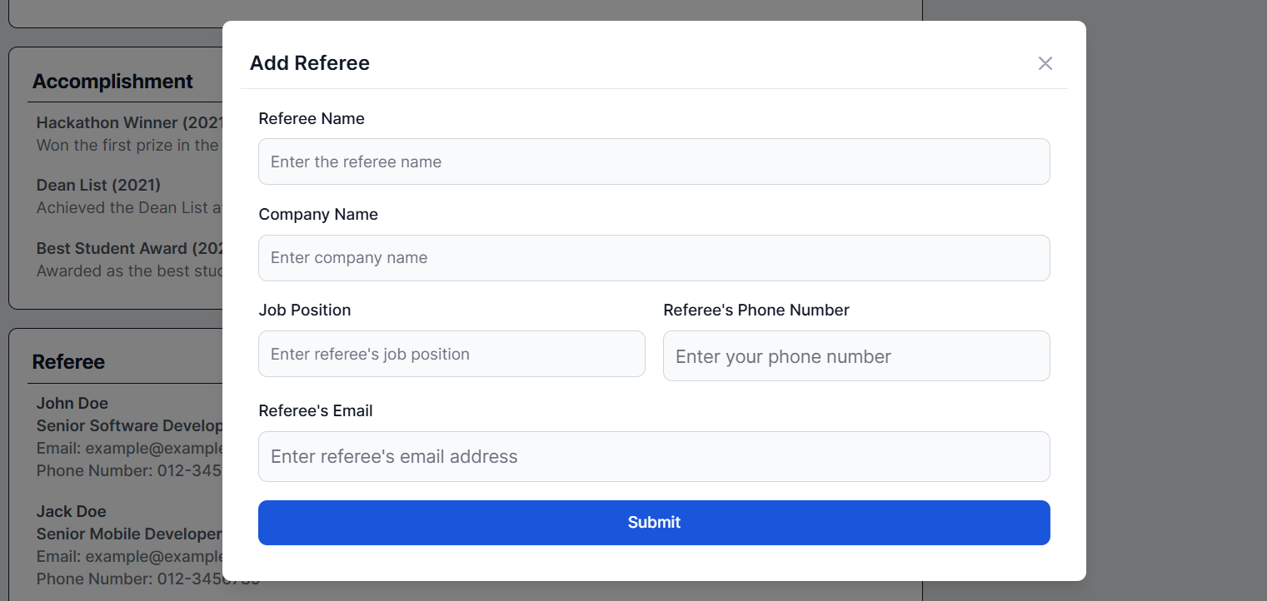

Figure 4‑51: Add Referee Modal

This figure shows the add-referee modal once the university student clicks the plus icon in the referee section of the My Profile Page. The university student enters the referee details required in the add-referee modal and clicks the <<Submit>> button. The university student can click the cross icon and the <<Cancel>> button if they do not want to add a new referee.

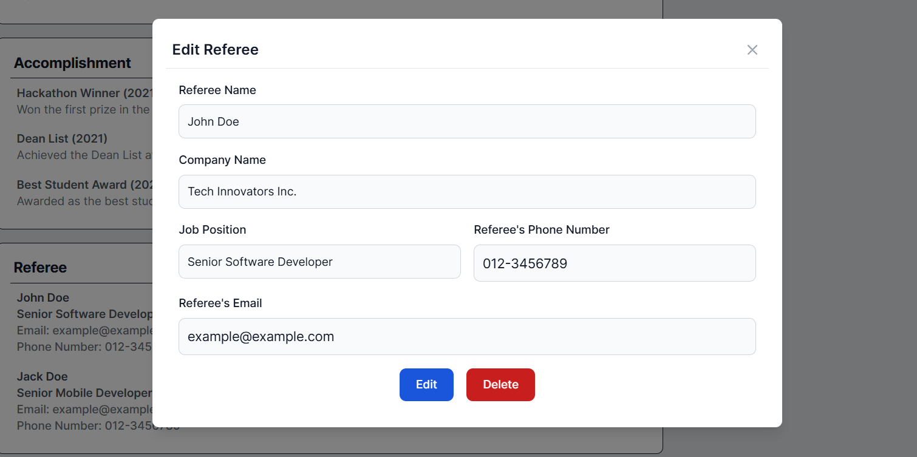

Figure 4‑52: Edit Referee Modal

This figure shows the edit referee modal once the university student clicks the edit icon of the specific referee in the referee section of the My Profile Page. The university student can edit the specific referee details by entering the details they want to edit and clicking the <<Edit>> button. The university student can click the <<Delete>> button if they want to delete the specific referee. The university student can click the cross icon if they do not want to edit the specific referee details.

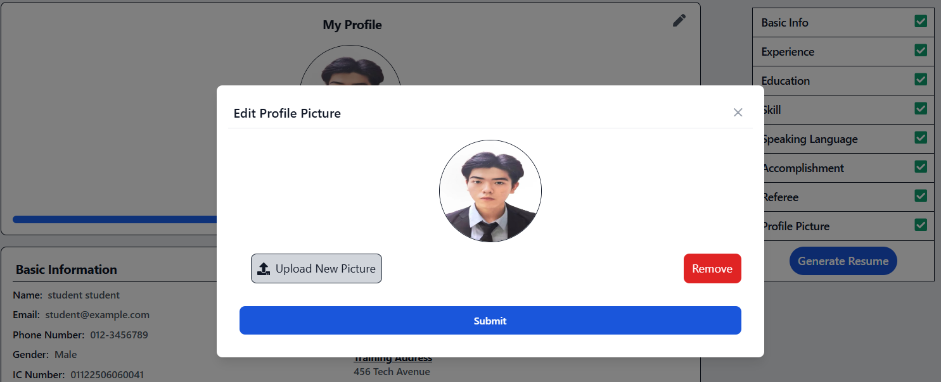

Figure 4‑53: Edit Profile Picture Modal

This figure displays the edit profile picture modal once the university student clicks the edit icon in the profile picture section of the My Profile page. They can click the <<Upload New Picture>> button and then upload the profile picture if they want to change the profile picture. Once the university student uploads the profile, the profile picture section will display the uploaded profile picture. Then, the university student clicks the <<Save>> button to successfully edit the profile picture. If the university student wants to remove the current profile picture, they may click the <<Remove>> button. If the university student does not want to edit or remove the profile picture, they may click the cross icon.

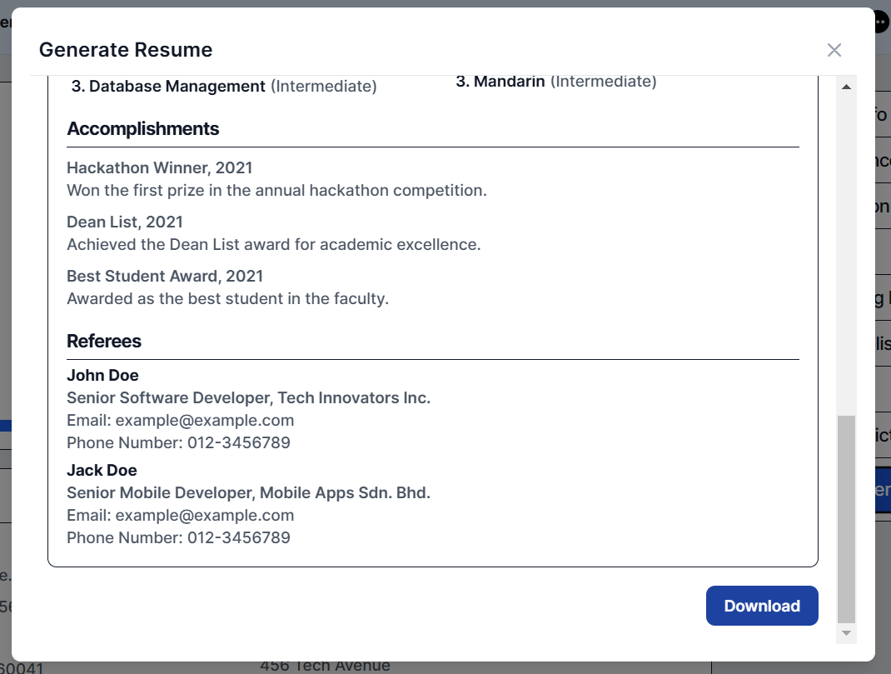

Figure 4‑54: Generate Resume Modal

This figure displays the "Generate Resume" modal, showing a preview of the resume generated based on the student's profile details after the university student clicks the Generate Resume button. To download the resume as a PDF file, the student can click the Download button.

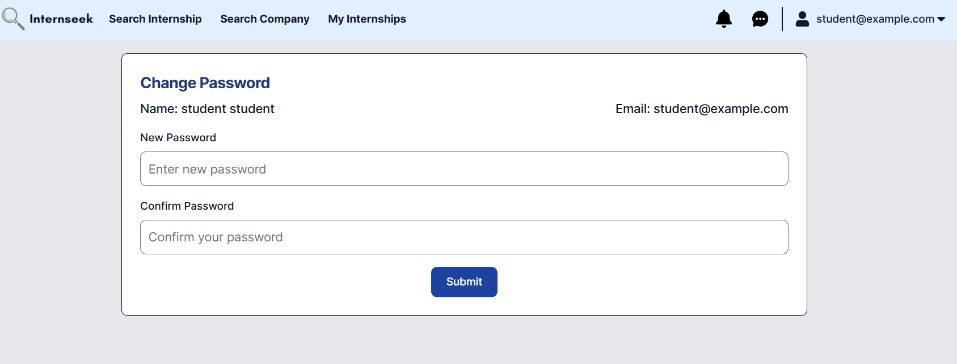

Figure 4‑55: Settings Page

This figure shows the settings page for university students. They can change their password in this page.

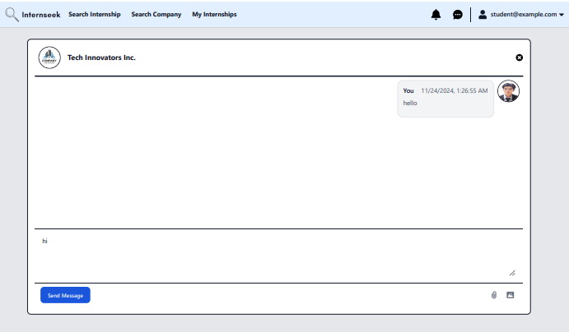

Figure 4‑56: Chatbox page

This figure shows the chatbox page where university students can send messages to employers after clicking the "Message" button on the internship details page. Students can send text messages with or without attachments, such as photos or PDF files.

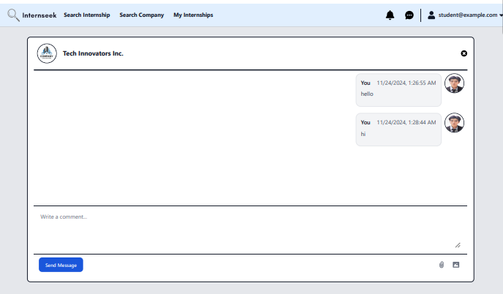

Figure 4‑57: Chatbox page after successfully sending message

This figure displays the chatbox page, showing a new message in the chatbox after the student successfully sends it.

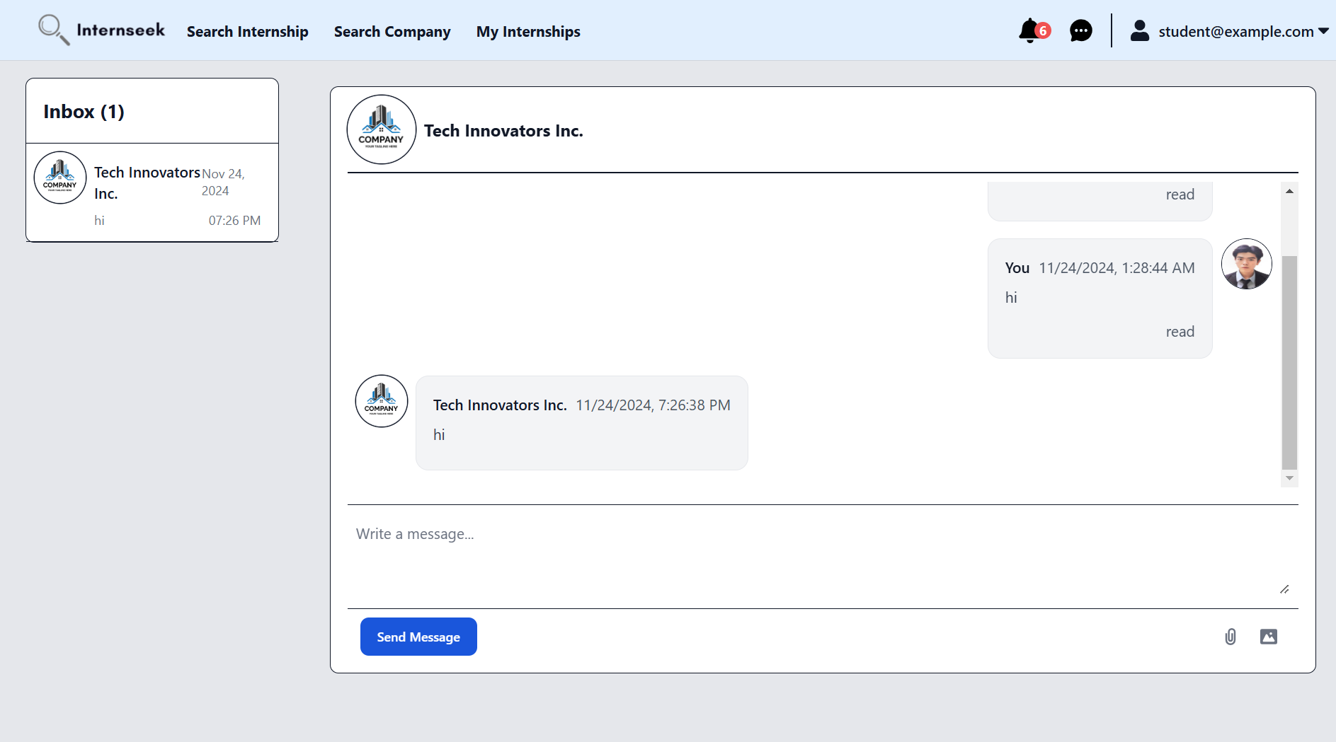

Figure 4‑58: Message Inbox and Chat-box Page

This figure displays the message inbox and chat-box page. The left-side interface represents the message inbox. The message inbox will display all the conversations with different employers. Unread messages are highlighted to differentiate them from read messages. The university student can scroll through the list to find a specific conversation. The right-side interface displays the selected conversation in detail. It shows the latest received messages and the full message history between the university student and the employer. At the bottom of the chat box, there is an input field where the university student can type a new message. After the university student types in a new message and attaches a file, they click the send button to send the message. The chat box updates in real-time, showing new messages they sent.

##### Employer

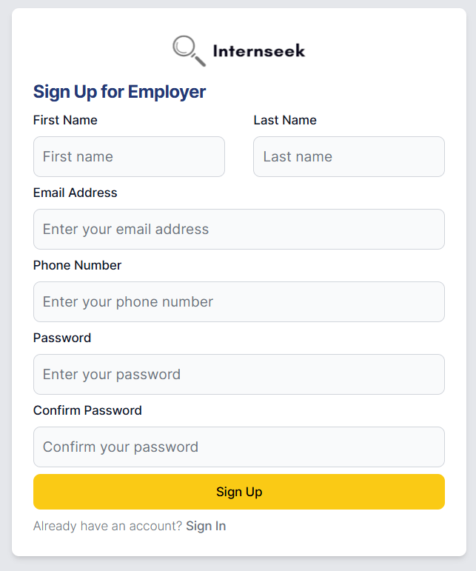

Figure 4‑59: Sign Up Form (Employers)

This figure shows the registration form for employers. To register an account, employers need to enter their first name, last name, email address, phone number, password, and confirm the password, then click the <<Sign Up>> button. If they already have an account, they can click the <<Sign In>> text to log in to the system.

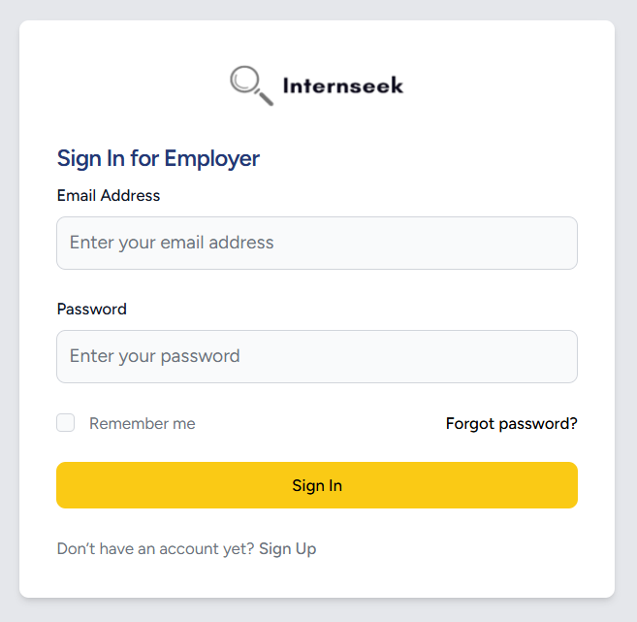

Figure 4‑60: Sign In Form (Employer)

This figure illustrates the login page for employers. The employer needs to enter their email address and password and click the <<Sign In>> button to login to the system. The employer can click the <<Sign Up>> text if they are first-time users. If the employer forgets their account password, they need to click the <<Forgot Password?>> text to reset their password. They can also select the "Remember me" checkbox to save their email address for easier sign-in next time.

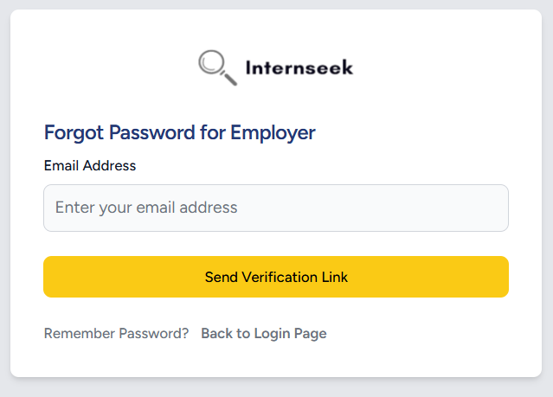

Figure 4‑61: Forgot Password Form (Employer)

This figure illustrates the forgot password page for employers if they forgot their password. The employers need to enter their email address and click the <<Send Verification Link>> button to get the password reset link. If the employers want to back to login page, they may click the <<Back to Login Page>> text.

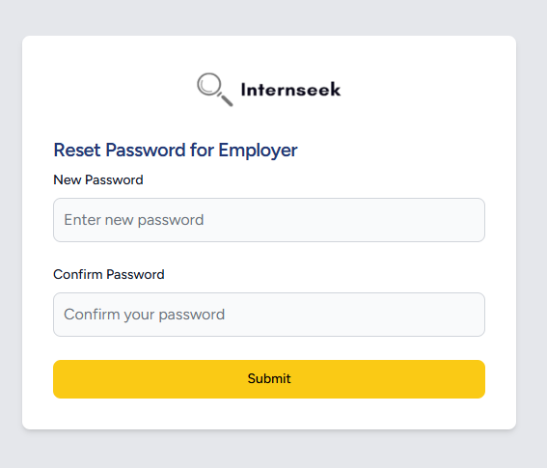

Figure 4‑62: Reset Password Form (Employer)

This figure illustrates the password reset page for employers once they click the password reset link in the email they received. The employers need to enter their new password, confirm their password, and click the <<Submit>> button to reset their password.

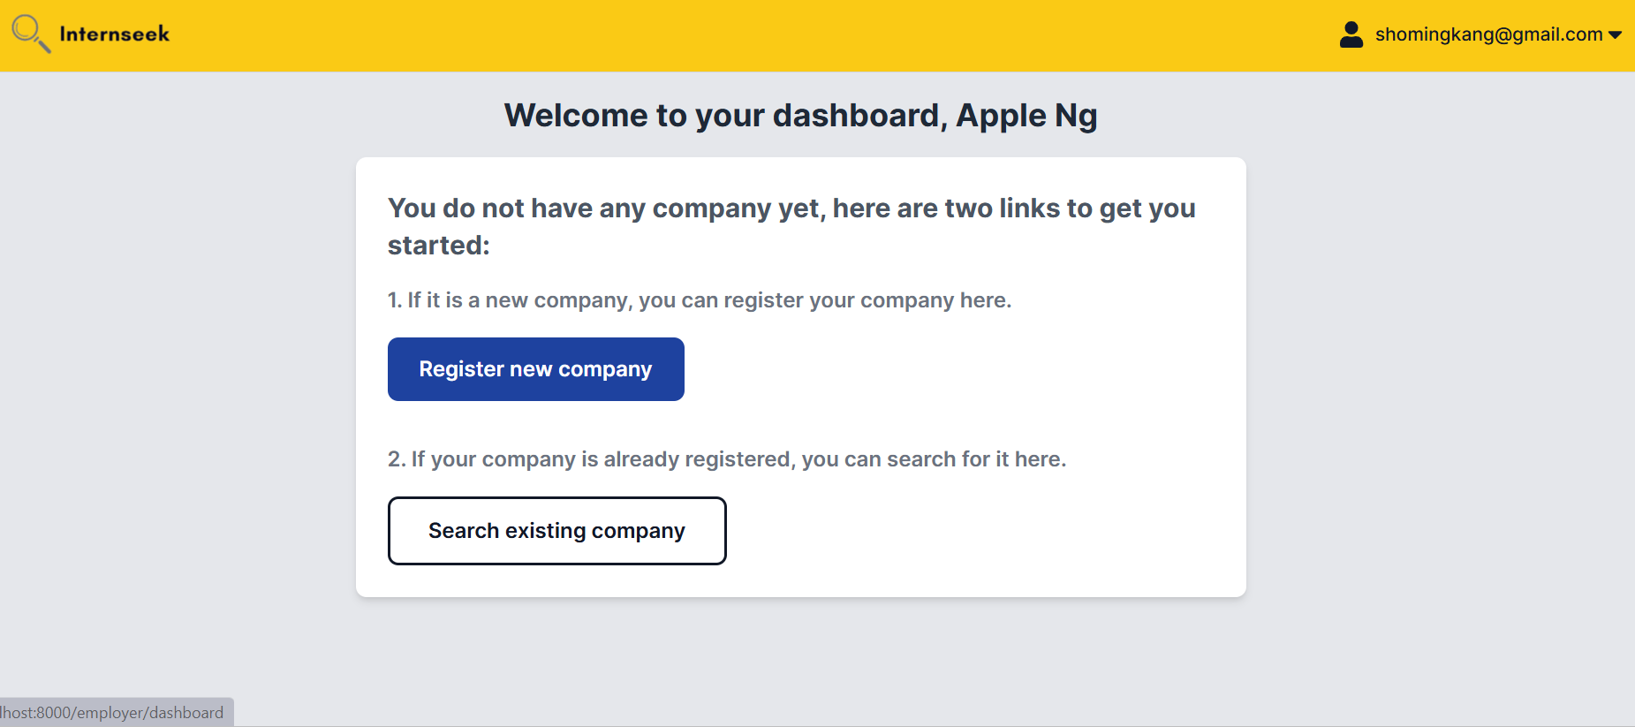

Figure 4‑63: Employer Dashboard View (Newly Registered Employer)

This figure illustrates the employer dashboard for a newly registered employer who has not provided company details. The user can choose to either register a new company or search for an existing one by clicking the "Register New Company" button or the "Search Existing Company" button.

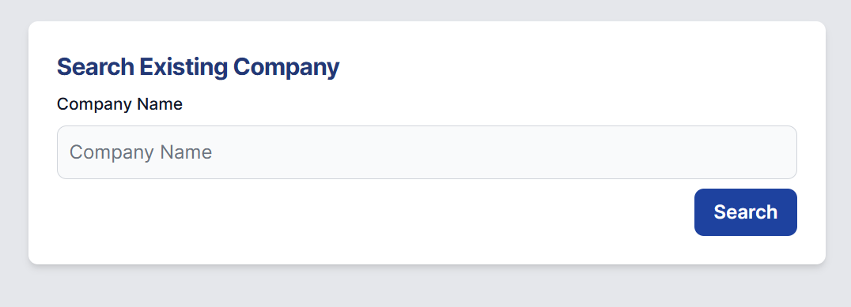

Figure 4‑64: Search for Existing Company Page

This figure shows the page where employers can search for existing companies within the system. Employers can perform a search by entering the company name into the input field and clicking the "Search" button.

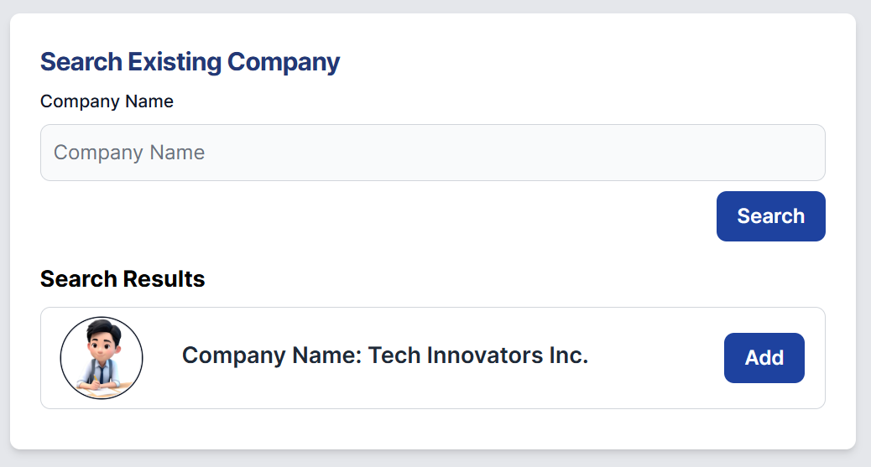

Figure 4‑65: Search For Existing Company Page (With Search Results)

This figure displays the search results for employers after entering a company name and clicking the "Search" button. Employers can proceed by selecting a row from the search results and clicking the "Add" button.

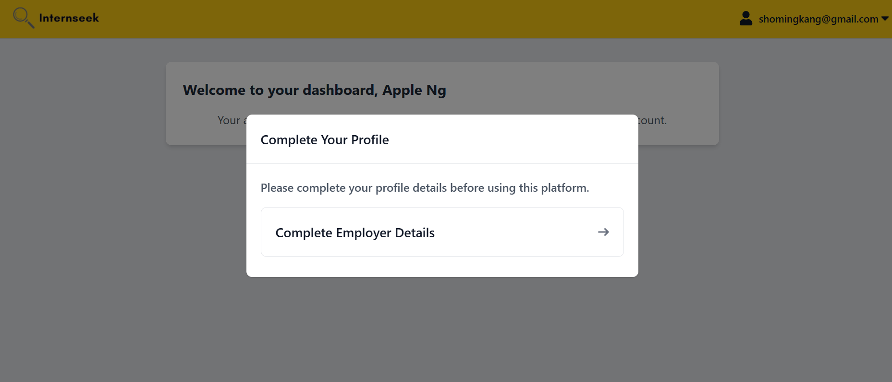

Figure 4‑66: Employer Dashboard (with Complete Your Profile Modal)

This figure displays the "Complete Your Profile" modal for employers, prompting them to provide their profile details. Completing this step is required for the company admin to approve their registration after they have added themselves to the company.

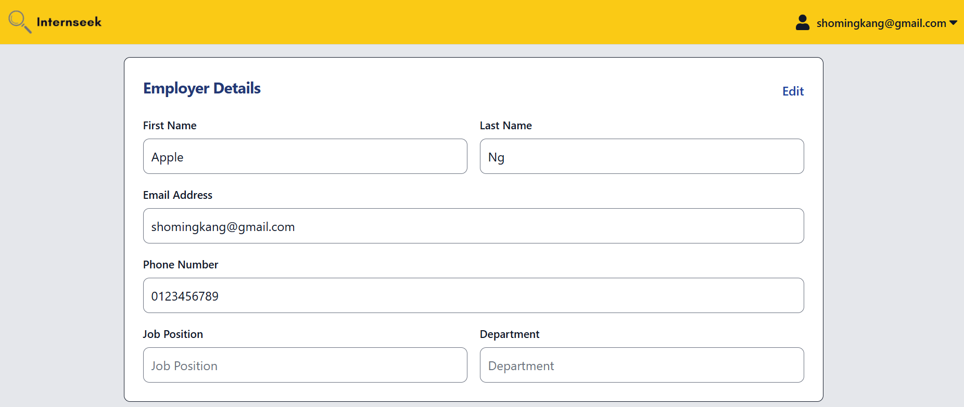

Figure 4‑67: Edit Employer Details Page

This figure displays the "Edit Employer Details" page, accessed by employers selecting the "Complete Employer Details" option from the modal. Employers must click the "Edit" text to enable the input fields for editing their details.

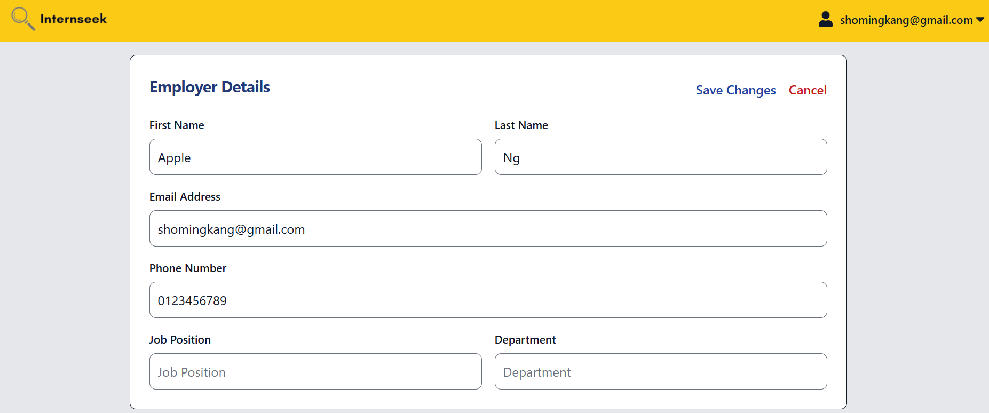

Figure 4‑68: Edit Employer Details Page (Input Fields Enabled)

This figure shows the input fields on the "Edit Employer Details" page enabled after clicking the "Edit" text. Once the employer completes filling in their details, they are required to click the "Save Changes" button to save and update their information. Alternatively, they can click the "Cancel" button to discard the changes.

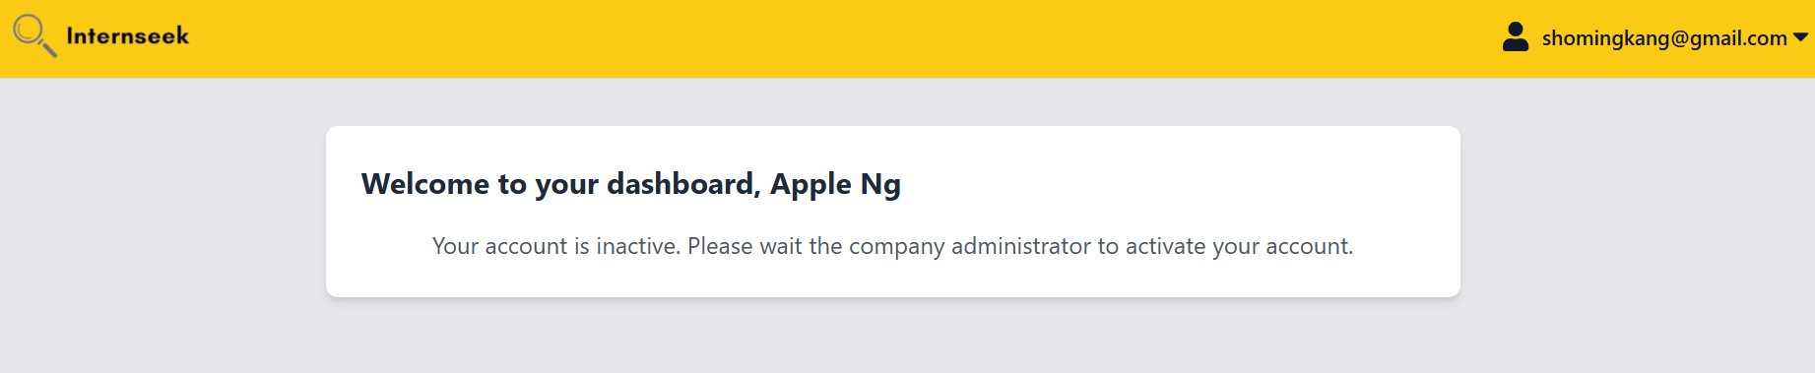

Figure 4‑69: Employer Dashboard (Employer Account Status: Inactive)

This figure shows the employer dashboard for employers who have added themselves to an existing company and completed their employer details. The "Complete Your Details" modal is no longer displayed, and the employers need to wait for the company admin's approval.

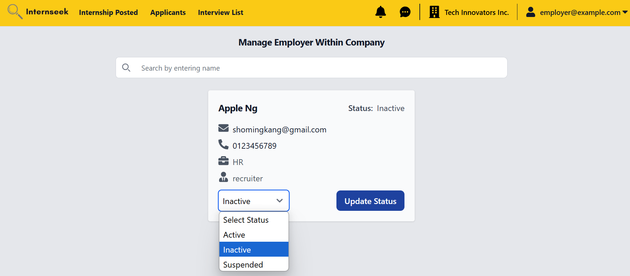

Figure 4‑70: Manage Employer within the Company Page

This figure shows the page for company admin to manage the employer within the company. The company admin can update the status of the employer adding themselves into the company with Active, Inactive, or Suspended. Only active status can access the system features. If suspicious activity is detected from an employer, the company admin can change their status to *Suspended*, restricting their access to the system's features.

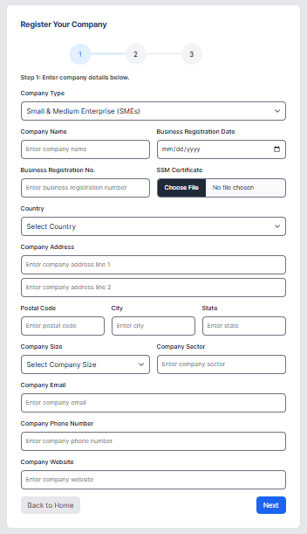

Figure 4‑71: Company Registration Form (Step 1)

This figure shows the Company Registration page that appears when an employer clicks the Register New Company button on the Employer Dashboard. It highlights the step 1 of the registration process, where the employer is required to fill in all the necessary company details.

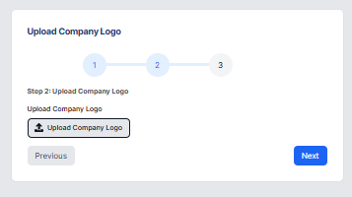

Figure 4‑72: Company Registration Form (Step 2)

This figure shows the Company Registration page at step 2 of the registration process, where the employer is required to upload the company logo.

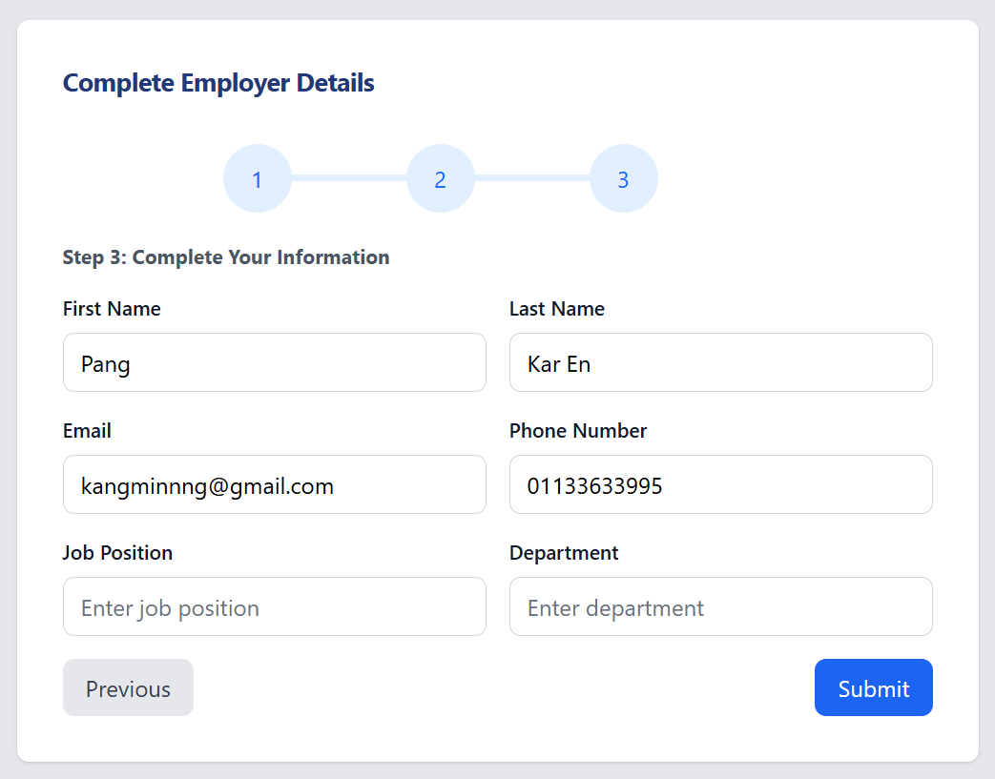

Figure 4‑73: Company Registration Form (Step 3)

This figure shows the Company Registration page at the final step of the registration process, where the employer is required to complete their personal details.

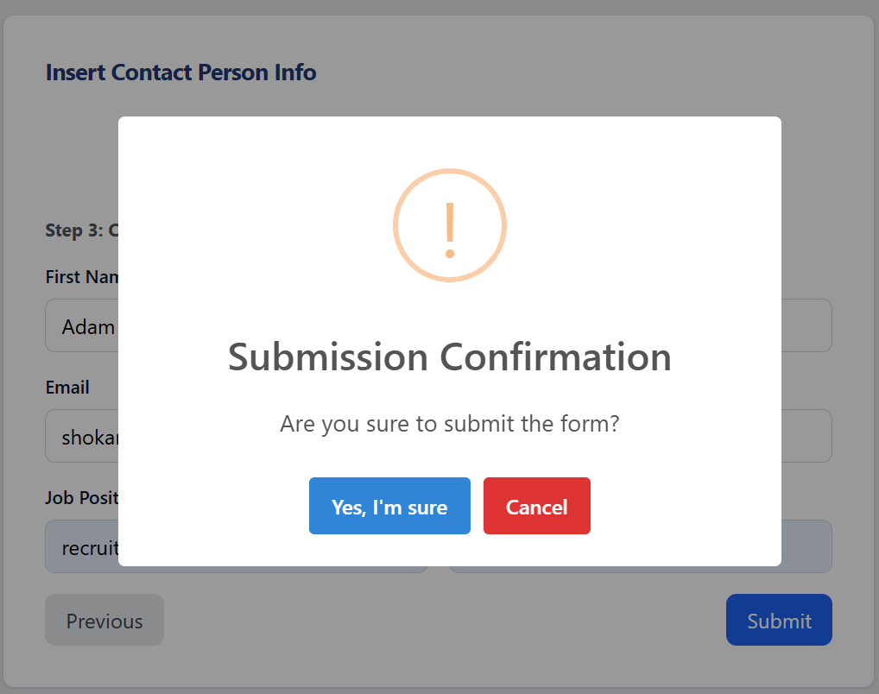

Figure 4‑74: Company Registration Submission Confirmation Message

This figure shows the submission confirmation message, prompting the employer to confirm whether they want to submit the form. The employer can proceed by clicking Yes, I’m Sure or cancel the action by clicking Cancel.

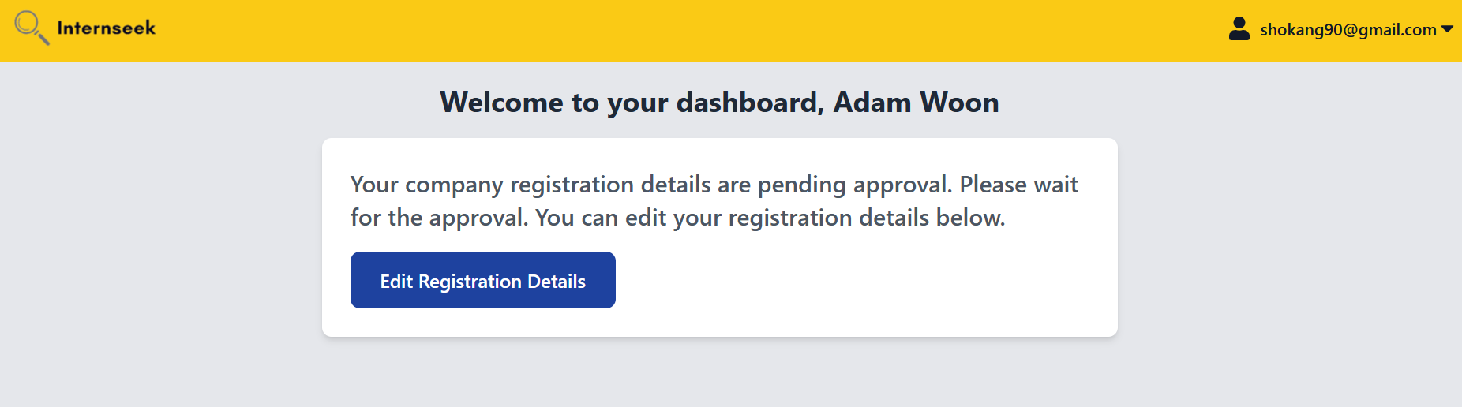

Figure 4‑75: Employer Dashboard (Pending Company Registration Status)

This figure shows the employer completing the company registration process, with the registration request currently pending approval. The employer is required to wait for approval but can edit the registration details by clicking the provided button.

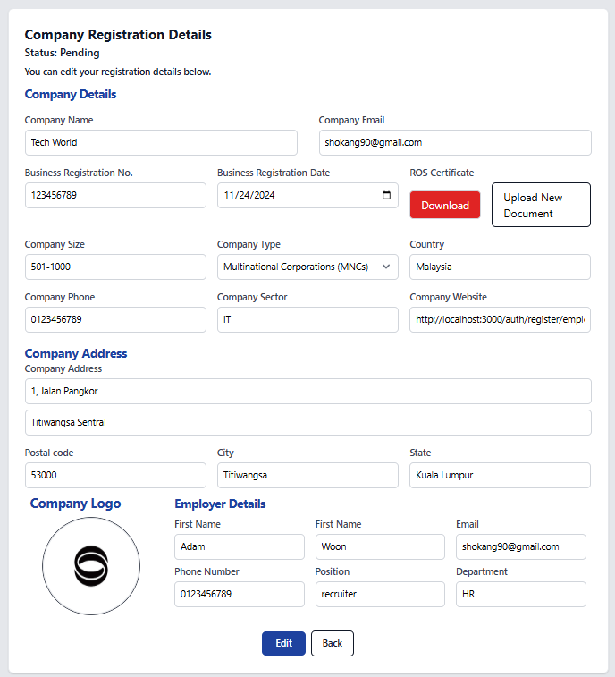

Figure 4‑76: Edit Registration Details Page (Pending Status)

This figure shows the Edit Registration Details page, where employers can modify their registration details. After making the necessary changes, they can click the Edit button to save the updates or the Back button to cancel the action.

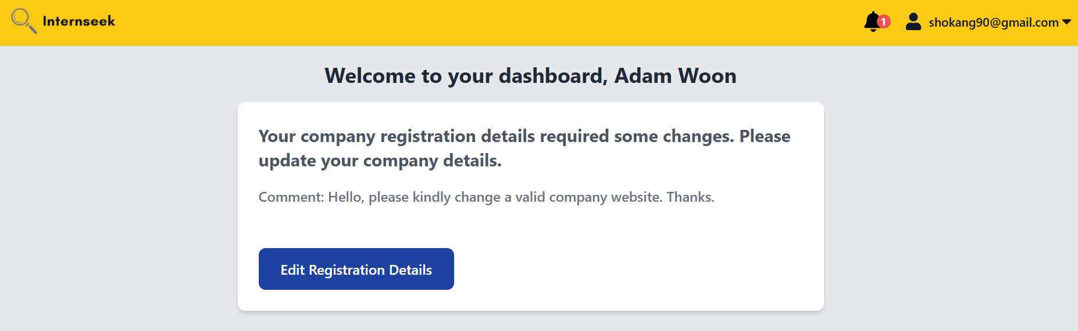

Figure 4‑77: Employer Dashboard (Inquiry Status)

This figure shows the company registration status marked as Inquiry, indicating that the employer needs to revise their information based on the admin's comments to proceed with successful registration in the system.

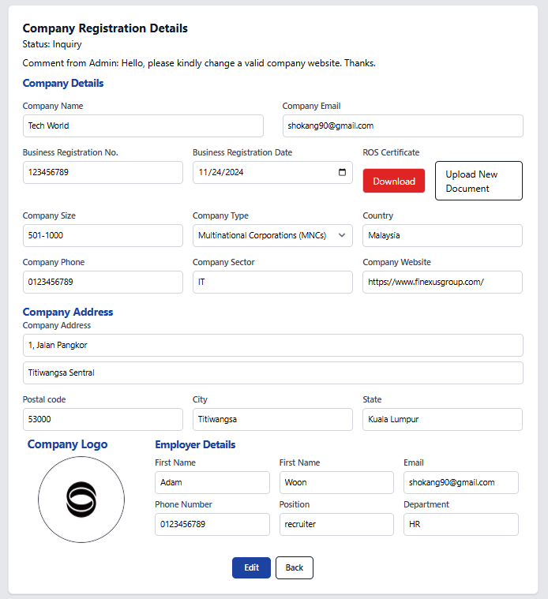

Figure 4‑78: Edit Registration Details (Inquiry Status)

This figure shows the Edit Registration Details page with the Inquiry company registration status and the admin's comments. Employers need to modify their registration details based on the comment given by admin. After making the necessary changes, they can click the Edit button to save the updates or the Back button to cancel the action.

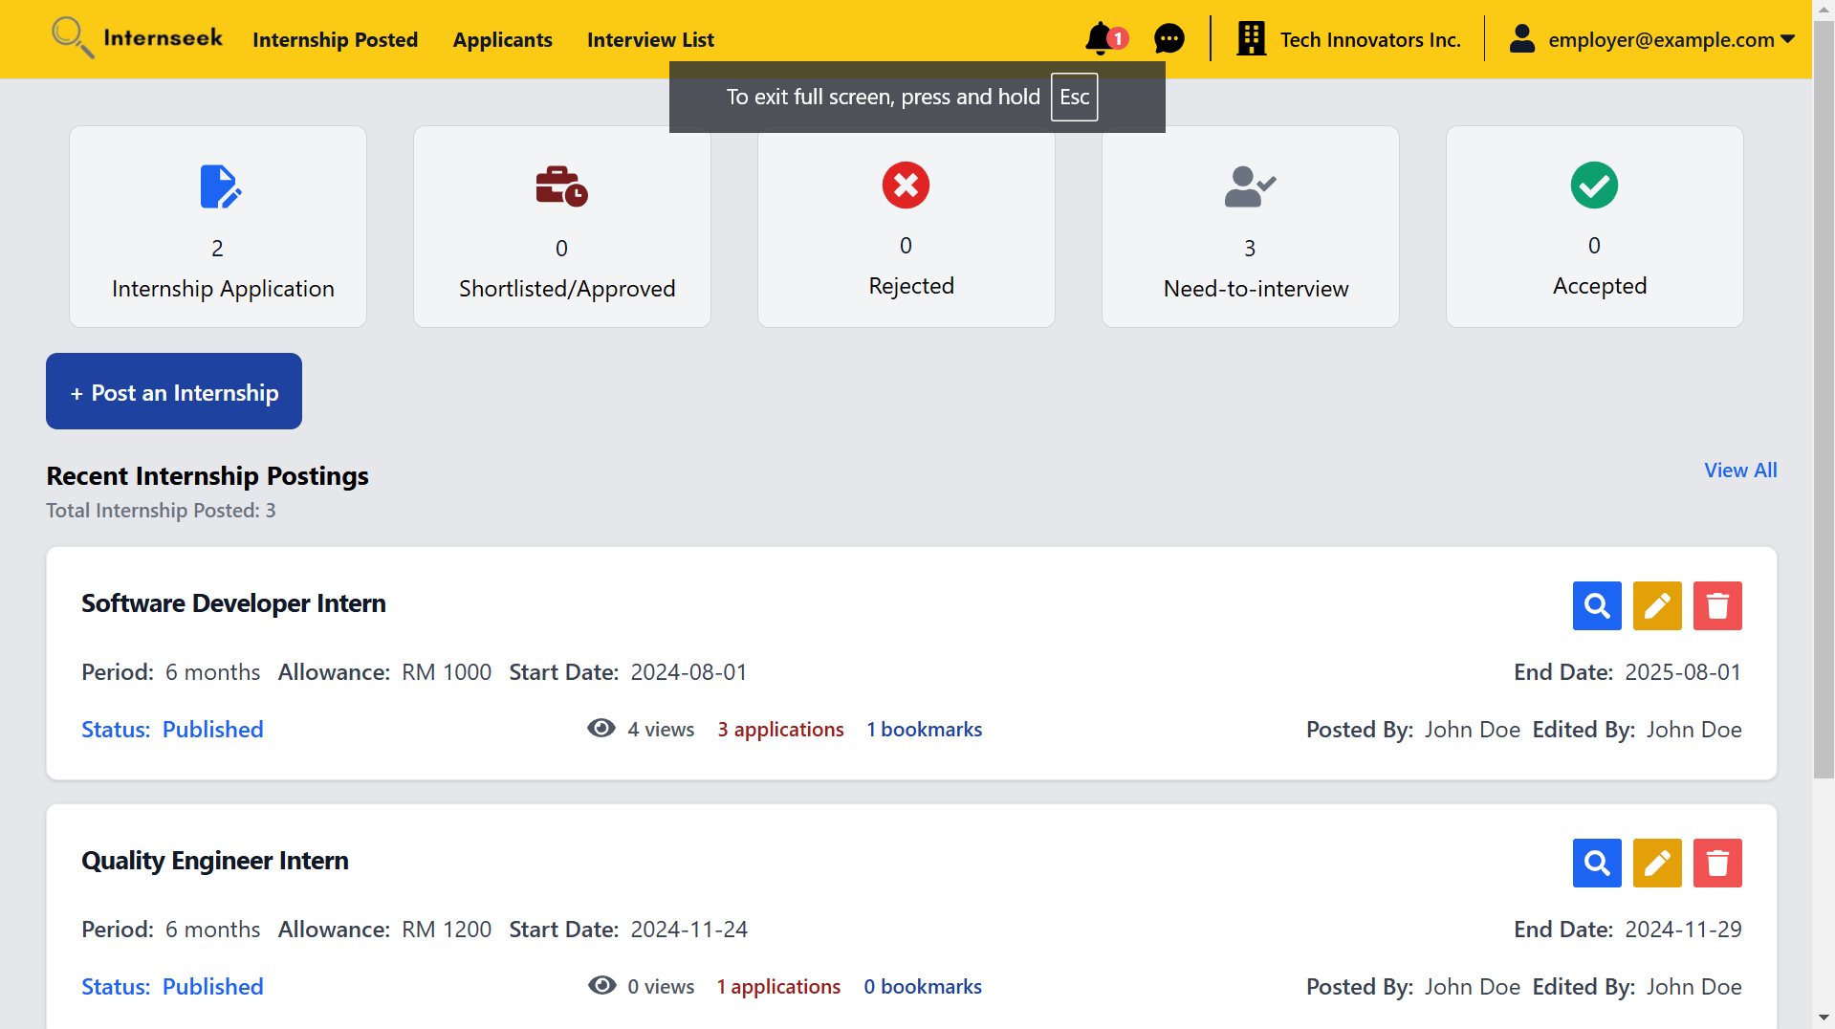

Figure 4‑79: Employer Dashboard

This figure displays the employer dashboard, which becomes accessible once the company registration status is approved by the admin or when the employer's request to join an existing company is approved by the company admin. The dashboard provides key metrics in the form of cards, including the total number of applicants, applicants who accepted the offers, applicants who rejected the offers, shortlisted or approved applicants, and those needing interviews. It also features a section displaying recent internship postings created by the employer, along with the total number of postings. Employers can click the "View All" button to access the complete internship posting listing or use the "Post an Internship" button to create a new posting. Additionally, the dashboard allows employers to view, edit, or delete specific recent internship postings directly.

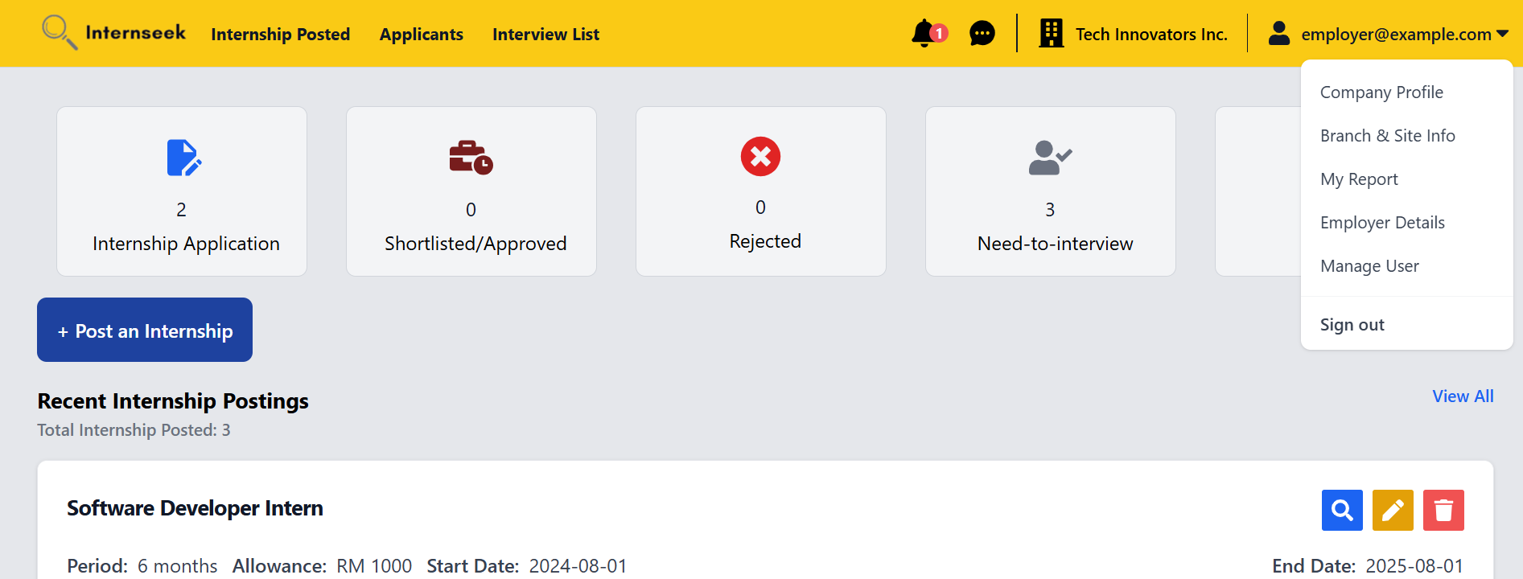

Figure 4‑80: Drop-Down Menu (Employer)

This figure displays the employer dashboard with the drop-down menu of the navigation bar, which consists of five options: Company Profile, Branch & Site Info, My Internship Posting, Employer Details, My Report, Manage User, and Log Out. Employers will be directed to the My Report page once they select the My Report option. Employers will be directed to the company profile page once they select the company profile option. Employers will be directed to the branch & site info page once they select the Branch & Site Info option. Employers will be directed to the Employer Details page once they select the Employer Details page. Employers will be directed to the Manage Employer within the Company page once they select the Manage User option. Employers will be logged out of the system once they select the Log Out option.

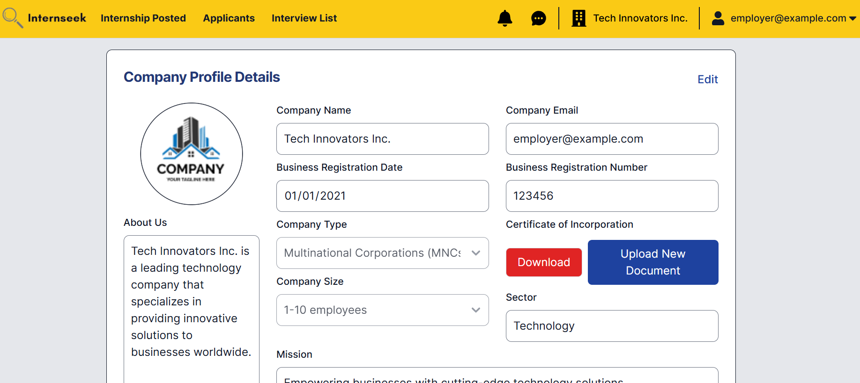

Figure 4‑81: Company Profile Details Page

This figure shows the company profile details page, where the employer can view the company details. To edit the company information, the employer can click the "Edit" text, which enables the input fields for modification.

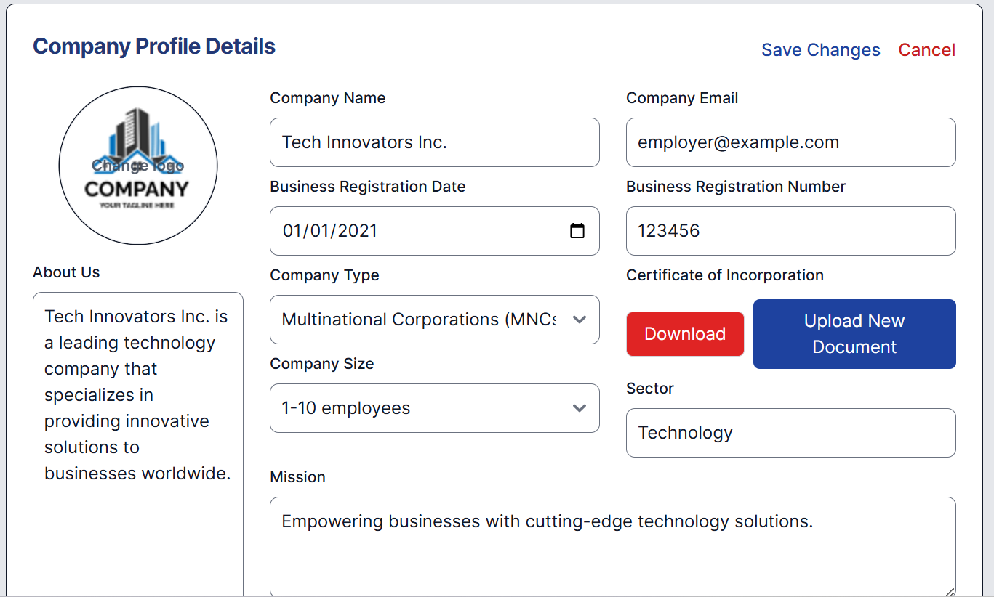

Figure 4‑82: Company Profile Details Page (Enable for Editing)

This figure shows the input fields for company details enabled for editing. The employer can modify the details they wish to change and click the "Save Changes" text to update the company information. If they decide not to make any changes, they can click the "Back" text to return without saving.

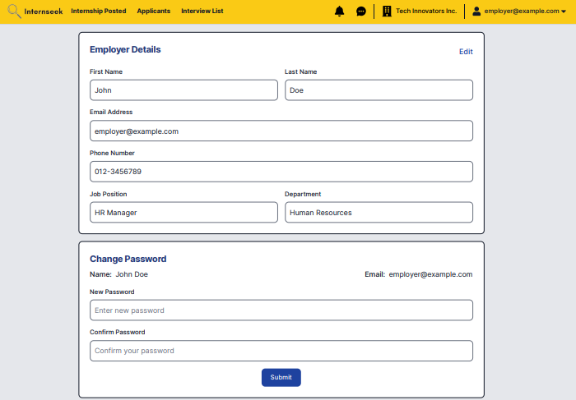

Figure 4‑83: Employer Details and Change Password Page

This figure displays the Employer Details page, which contains two forms: one for employer information and another for changing the password. The employer can view their details on this page and update their password by entering the current and new passwords, then clicking the "Submit" button in the change password form. The employer can also edit their details by clicking the "Edit" text, which enables the input fields. After making the desired changes, the employer can click "Save Changes" to update the information. If they choose not to edit the details, they can click the "Cancel" text to discard the changes.

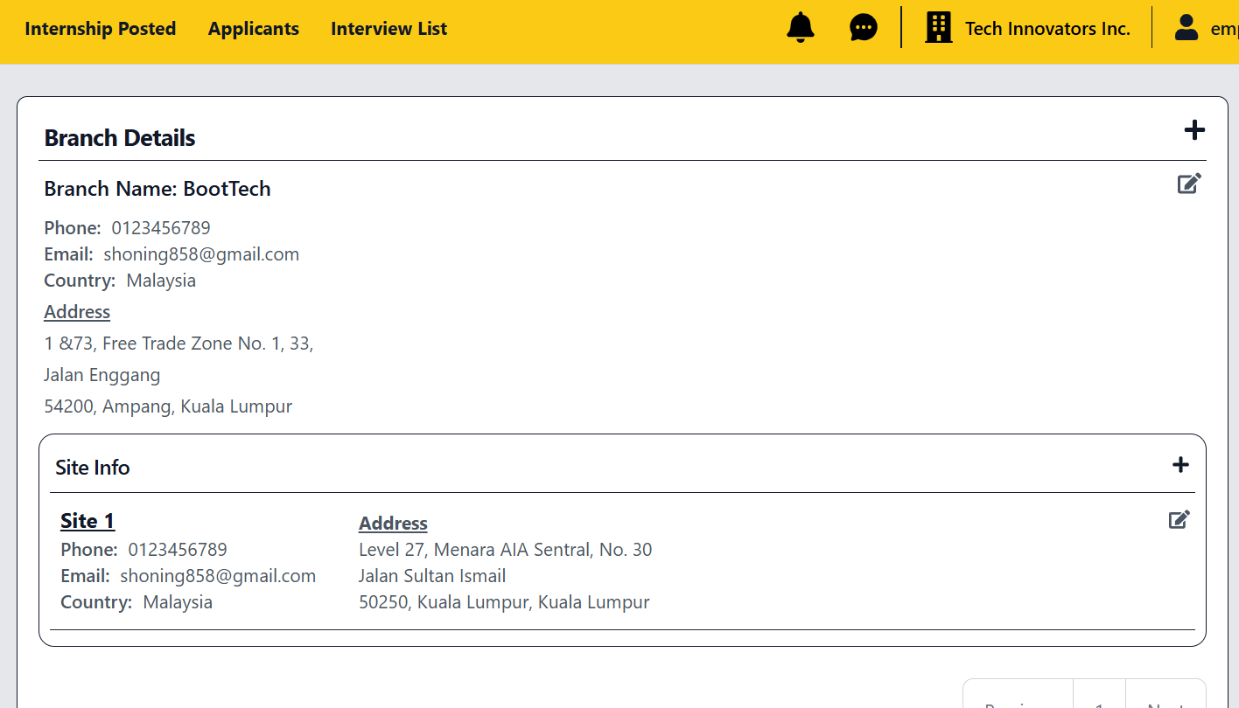

Figure 4‑84: Branch and Site Information Page

This figure displays the Branch and Site Information page, where the employer can view the branch and site details. The employer can edit these details by clicking the "Edit" icon. Additionally, the employer can add a new branch by clicking the "Add" icon in the branch section. To add a site, the employer can click the "Add" icon within the site info section or edit existing site information by clicking the "Edit" icon.

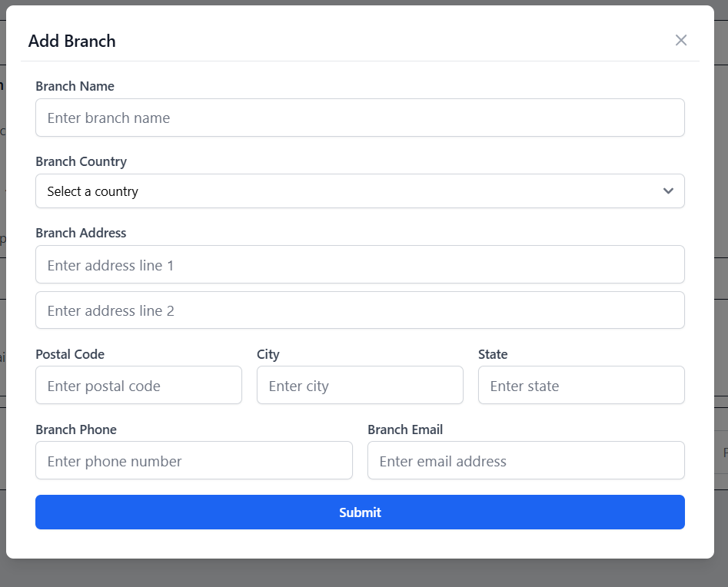

Figure 4‑85: Add Branch Modal

This figure displays the Add Branch modal, where the employer can add a new branch by entering the details in the input fields and then clicking the <<Submit>> button. If the employer does not want to add the new branch, they may click the <<Cancel>> button or cross icon.

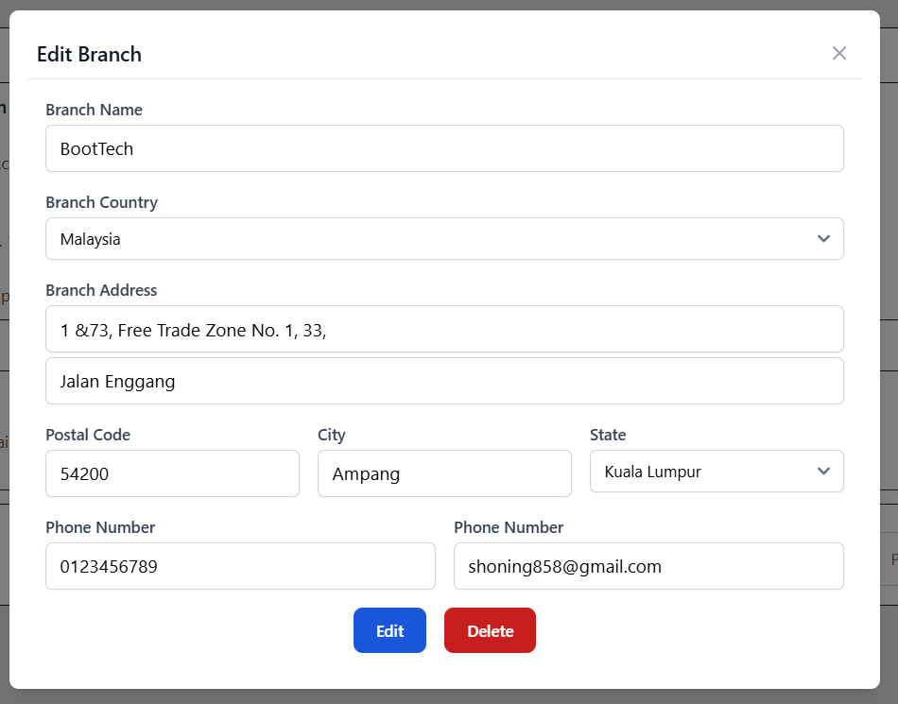

Figure 4‑86: Edit Branch Modal

This figure displays the Edit Branch modal, where the employer can modify the details of an existing branch by updating the relevant input fields and then clicking the <<Submit>> button to save the changes. If the employer wishes to delete the branch, they can click the <<Delete>> button. To close the modal without making any changes, the employer can click the cross button.

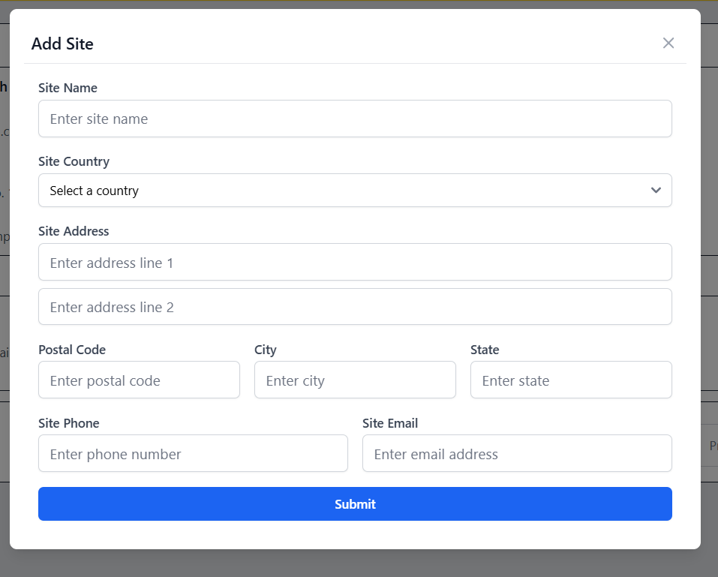

Figure 4‑87: Add Site Modal

This figure displays the Add Site modal, where the employer can add a new site by entering the details in the input fields and then clicking the <<Submit>> button. If the employer does not want to add the new site, they may click the <<Cancel>> button or cross icon.

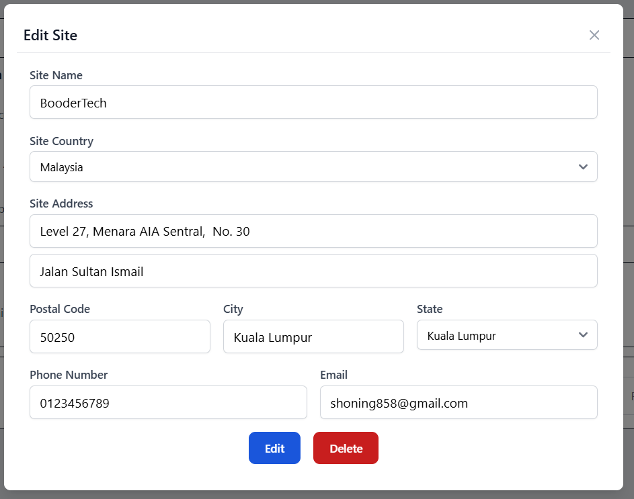

Figure 4‑88: Edit Site Modal

This figure displays the Edit Site modal, where the employer can modify the details of an existing site by updating the relevant input fields and then clicking the <<Submit>> button to save the changes. If the employer wishes to delete the site, they can click the <<Delete>> button. To close the modal without making any changes, the employer can click the cross button.

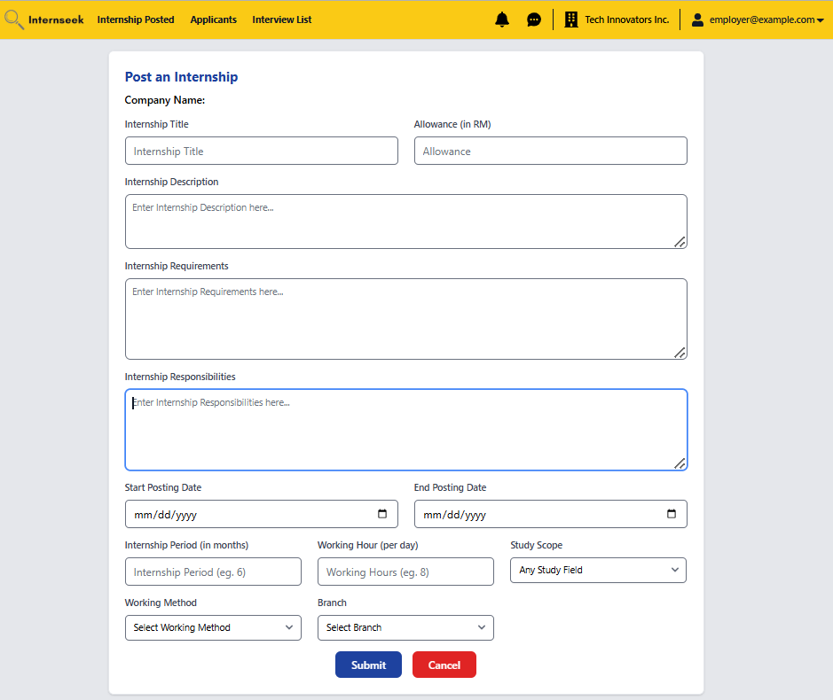

Figure 4‑89: Post an Internship Page

This figure shows the "Post an Internship" page that appears when the employer clicks the "Post an Internship" button. After entering the internship posting details, the employer can click the "Submit" button to create the internship posting. If the employer decides not to post the internship, they can click the "Cancel" button.

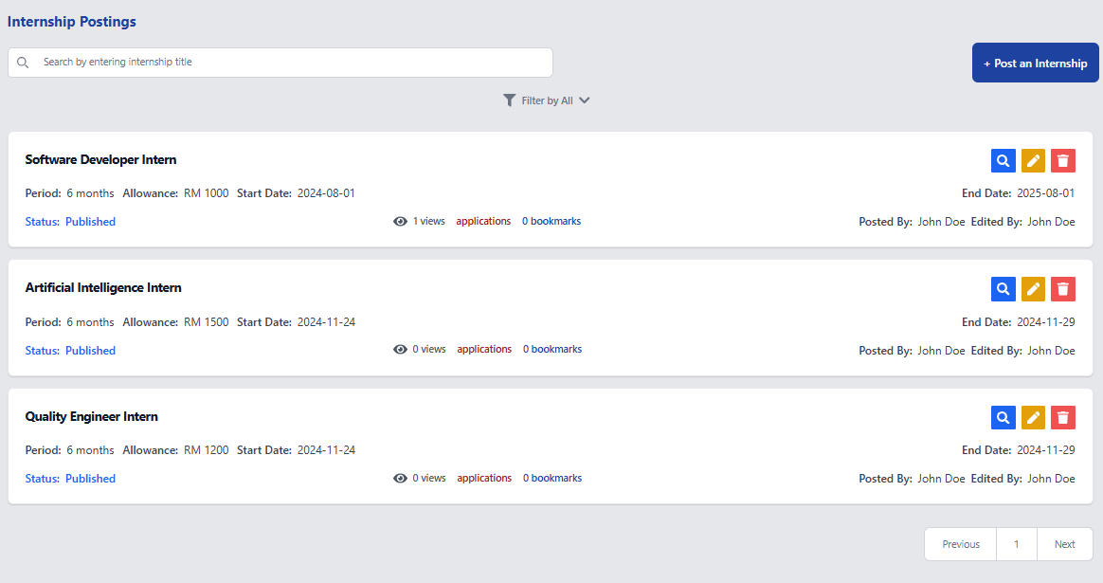

Figure 4‑90: Internship Postings List Page

This figure shows the internship postings list page, which displays all the internships posted by the employer. On this page, the employer can view the popularity of the internship they posted, such as how many people view it, how many people bookmark it, and how many people apply for it. The employer can view the internship posting details by clicking the view icon button. The employer can edit the internship posting details by clicking the edit icon button. The employer can delete the internship posting by clicking the delete icon button. The employer can create an internship posting by clicking the <<Post an internship>> button. The employer can search and sort the internship postings to find the relevant ones.

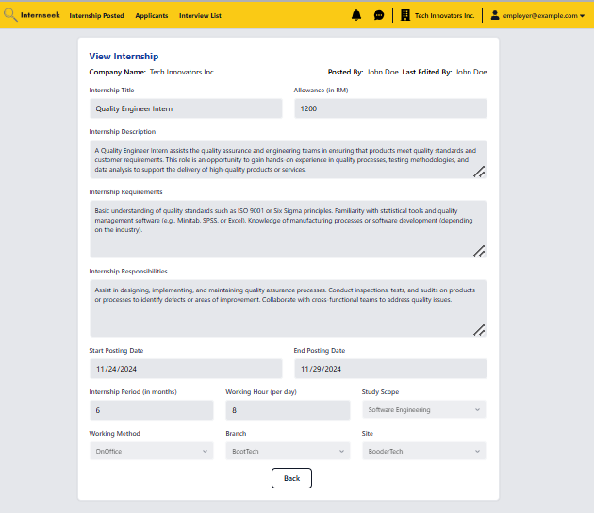

Figure 4‑91: View Internship Posting Details Page

This figure shows the View Internship Posting Details page once the employer clicks the view icon button for the specific internship posting. The employer can view the internship posting details. Once they have completely viewed the internship posting details, they may click the <<Back>> button.

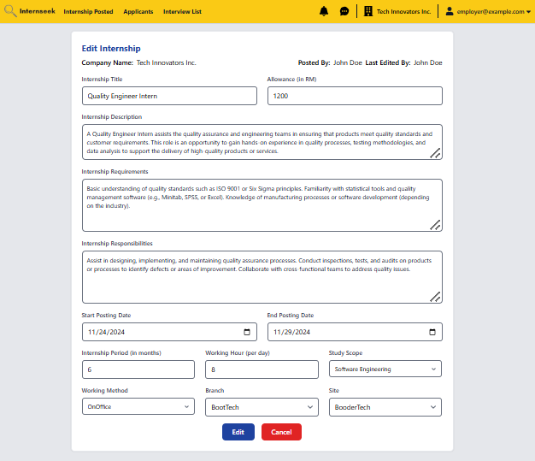

Figure 4‑92: Edit Internship Posting Details Page

This page displays the edit internship posting details page once the employer clicks the edit icon button for the specific internship posting. This page allows employers to modify the internship posting details. After making the necessary edits, employers can save the changes by clicking the <<Edit>> button. If the employer does not want to edit the internship posting details, they may click the <<Back>> button.

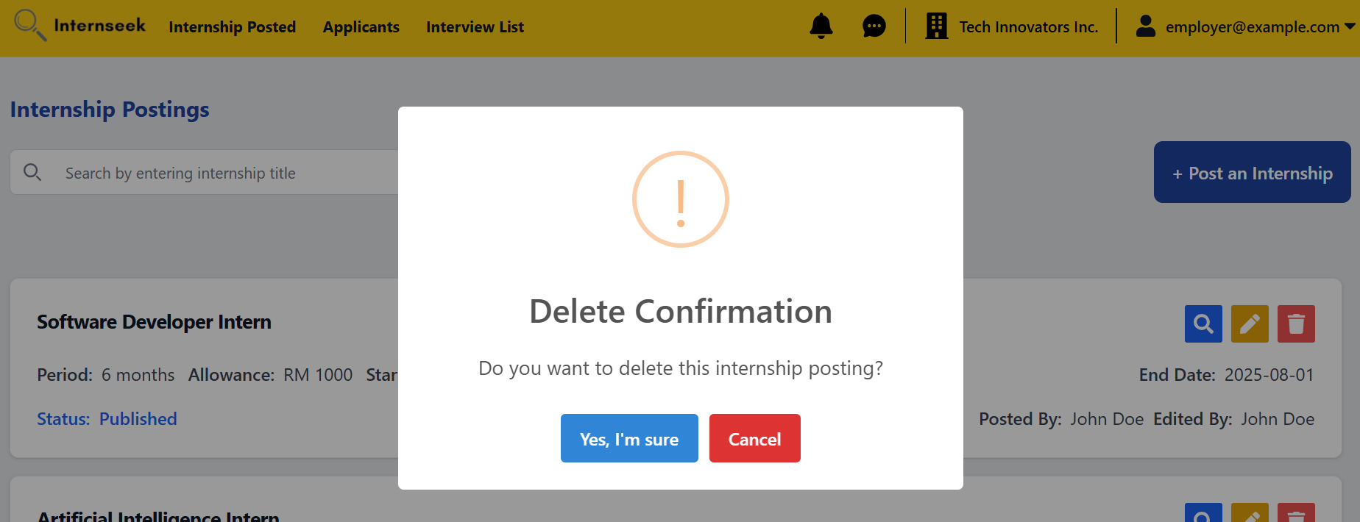

Figure 4‑93: Delete Internship Posting Confirmation Dialog

This figure displays the delete internship posting confirmation dialog to ask for confirmation of the deletion of the internship posting once the employer clicks the delete icon of the specific internship posting in the Internship Postings list page.

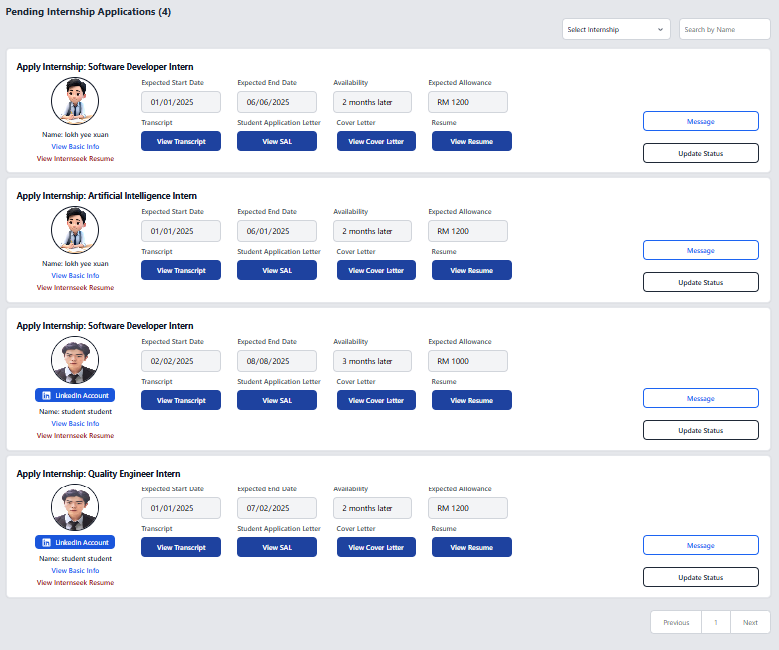

Figure 4‑94: Applicants List/ Pending Internship Application Page

This figure displays the Applicants List page with pending internship application status, where employers can review applicants' details, including the internship they applied for, expected allowance, availability, uploaded cover letter, uploaded resume, uploaded transcript, uploaded SAL ,basic information, Internseek resume, expected start date, and expected end date. After reviewing the applicant's details, the employer can update the status of the applicant by clicking the <<Update Status>> button. The employer can also message the applicant by clicking the <<Message>> button.

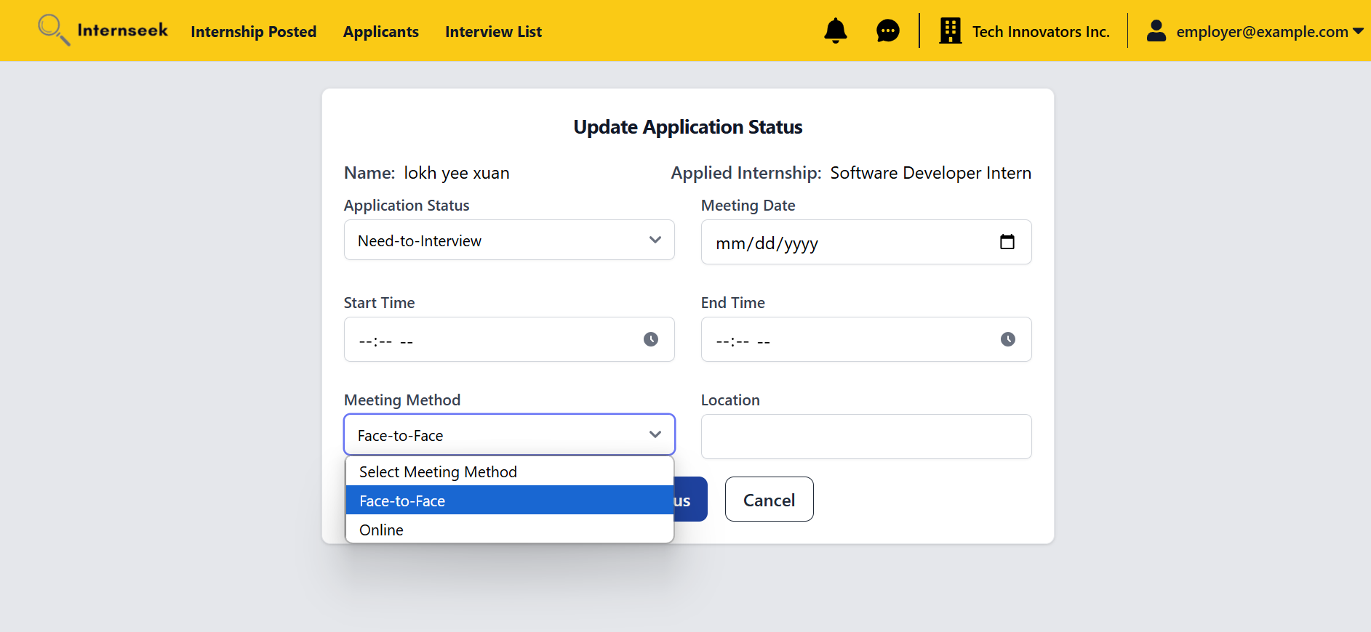

Figure 4‑95: Update Internship Application Status Page (Need-to-Interview)

This figure shows the "Update Internship Application Status" page, where the employer can update the status of an application to either "Need-to-Interview" or "Unsuccessful." In this figure, the employer selects "Need-to-Interview" and is required to input meeting details. The employer must choose the meeting method, either face-to-face or online. If face-to-face is selected, a field for the location will appear, while selecting online will display a field for the meeting link. The employer can click <<Cancel>> button if they do not want to update the application status of the applicant.

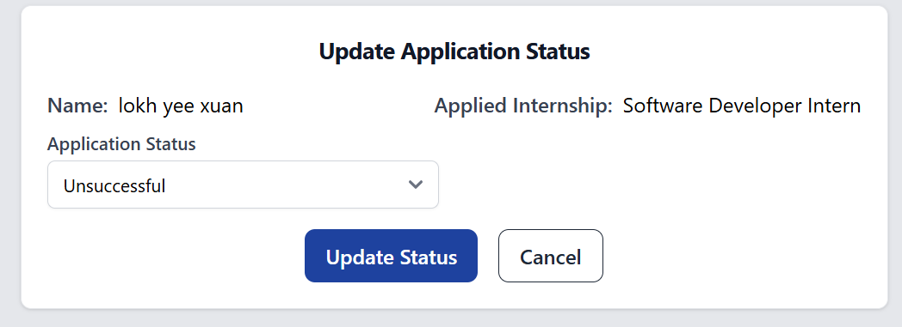

Figure 4‑96: Update Internship Application Status Page (Unsuccessful)

This figure shows the "Update Internship Application Status" page, where the employer selects the application status as "Unsuccessful" for the applicants. If the employer selects the unsuccessful status, they can directly click the <<Update>> button to update the internship application status as unsuccessful. The employer can click <<Cancel>> button if they do not want to update the application status of the applicant.

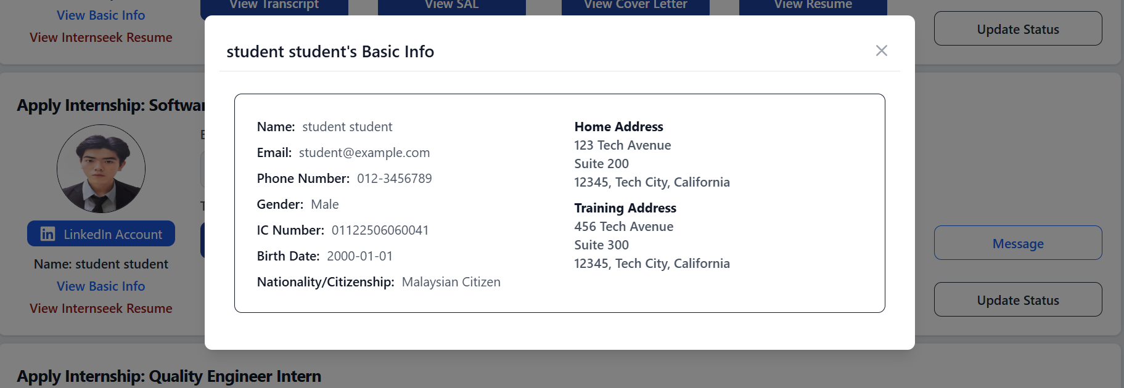

Figure 4‑97: Basic Information Modal

This figure displays a modal that display the basic information of the applicant once the employer clicks the <<View Basic Information>> link.

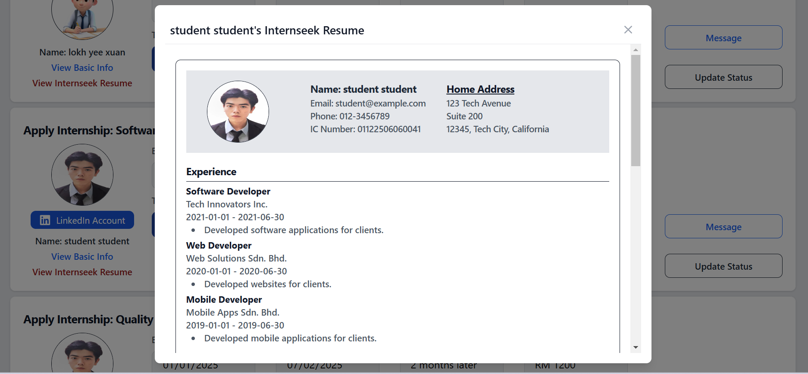

Figure 4‑98: Internseek’s Resume Modal

This figure displays a modal that displays the resume generated by Internseek based on the profile details of the applicant once the employer clicks the <<View Internseek Resume>> link.

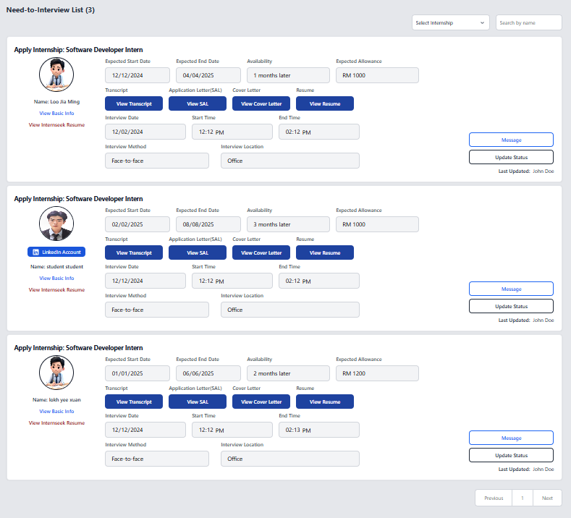

Figure 4‑99: Need-to-Interview Applicants List Page

This figure shows the Interview List page, which displays all the applicants who have the status of need-to-interview. The employer can view the applicant’s details and the interview details on this page. The employer can update the interview status once they have conducted the interview with the applicant by clicking the <<Update Status>> button. The employer can message the applicant by clicking the message button.

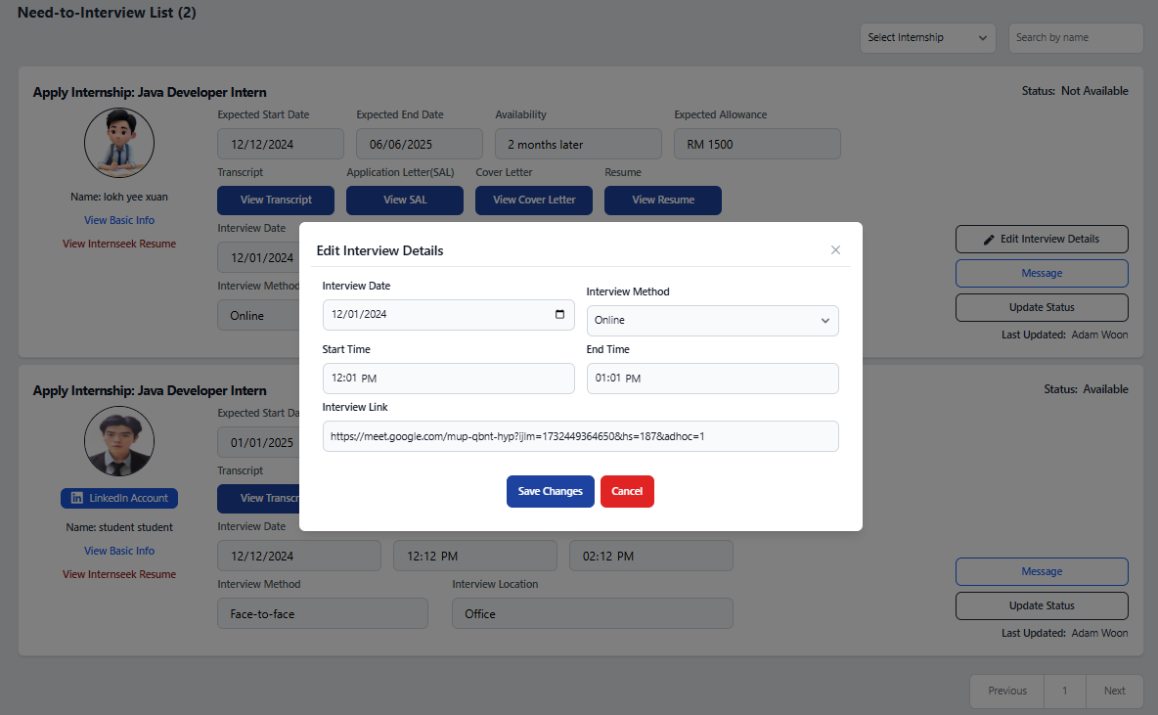

Figure 4‑100: Edit Interview Details Modal

This figure shows the "Edit Interview Details" modal that appears when the employer clicks the "Edit Interview Details" button. The button is displayed if a student cannot attend the interview, allowing the employer to reschedule it. In the card, the employer can see whether the applicant is available for the interview. The employer can modify the interview details in the modal and click the "Update" button to save the changes. If the employer does not wish to edit the details, they can click the "Cancel" button or the cross icon to close the modal.

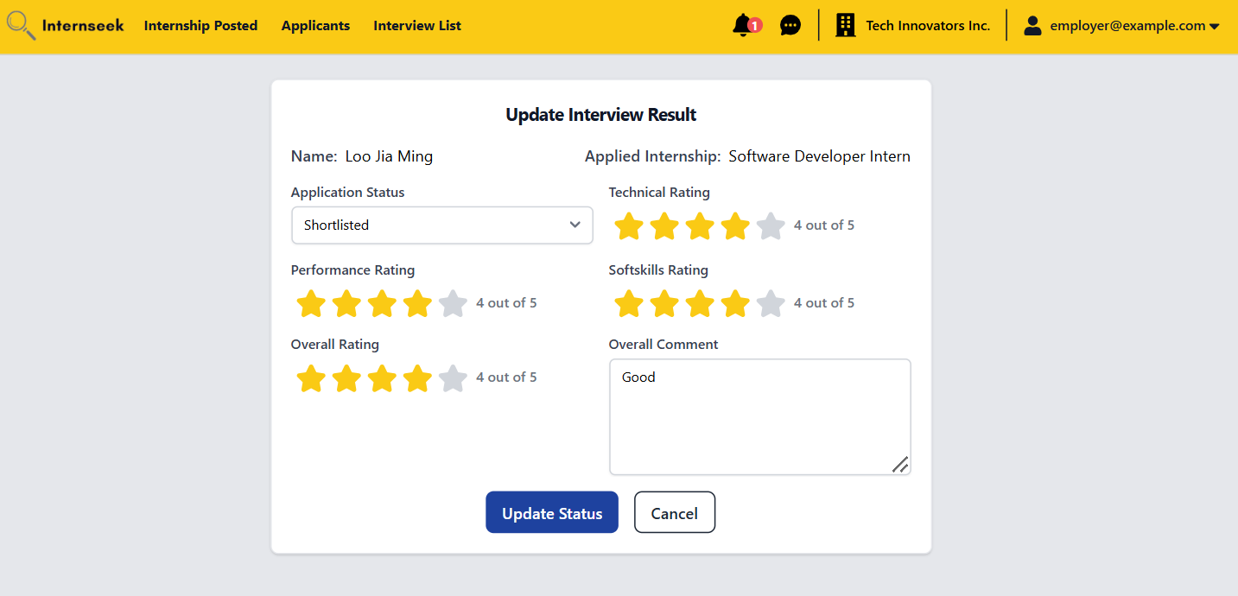

Figure 4‑101: Update Interview Result Page (Shortlisted)

This figure displays the "Update Interview Result" page, where the employer can update the interview result after the interview. The possible statuses include Shortlisted, Unsuccessful, Need-to-Interview again, or Approved. In this figure, the employer updates the interview result status to "Shortlisted" and inserts the interview result, indicating that the applicant has progressed to the final selection.

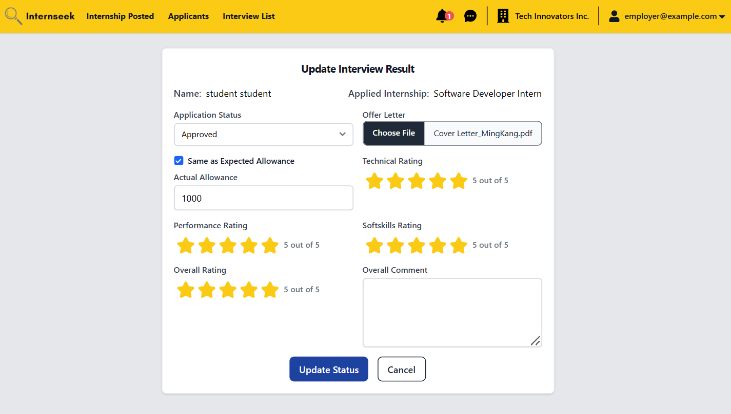

Figure 4‑102: Update Interview Result Page (Approved)

This figure displays the "Update Interview Result" page, where the employer can update the interview result after the interview. The possible statuses include Shortlisted, Unsuccessful, Need-to-Interview again, or Approved. In this figure, the employer updates the interview result status to "Approved" and inserts the interview result, indicating that the applicant get the offer.

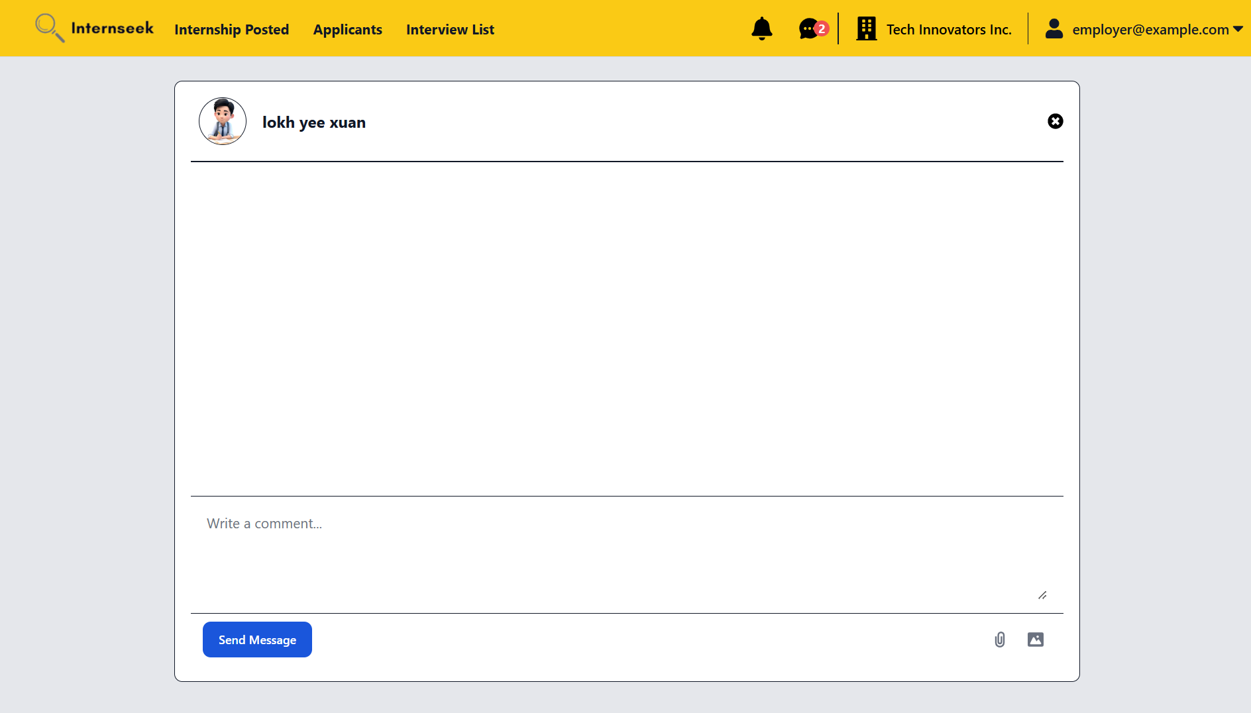

Figure 4‑103: Chatbox Page

This figure shows the chatbox for employers to contact the applicant regarding their internship application details after clicking the "Message" button on the applicant card. The employer can send messages in text, with or without attachments such as pictures and PDF files.

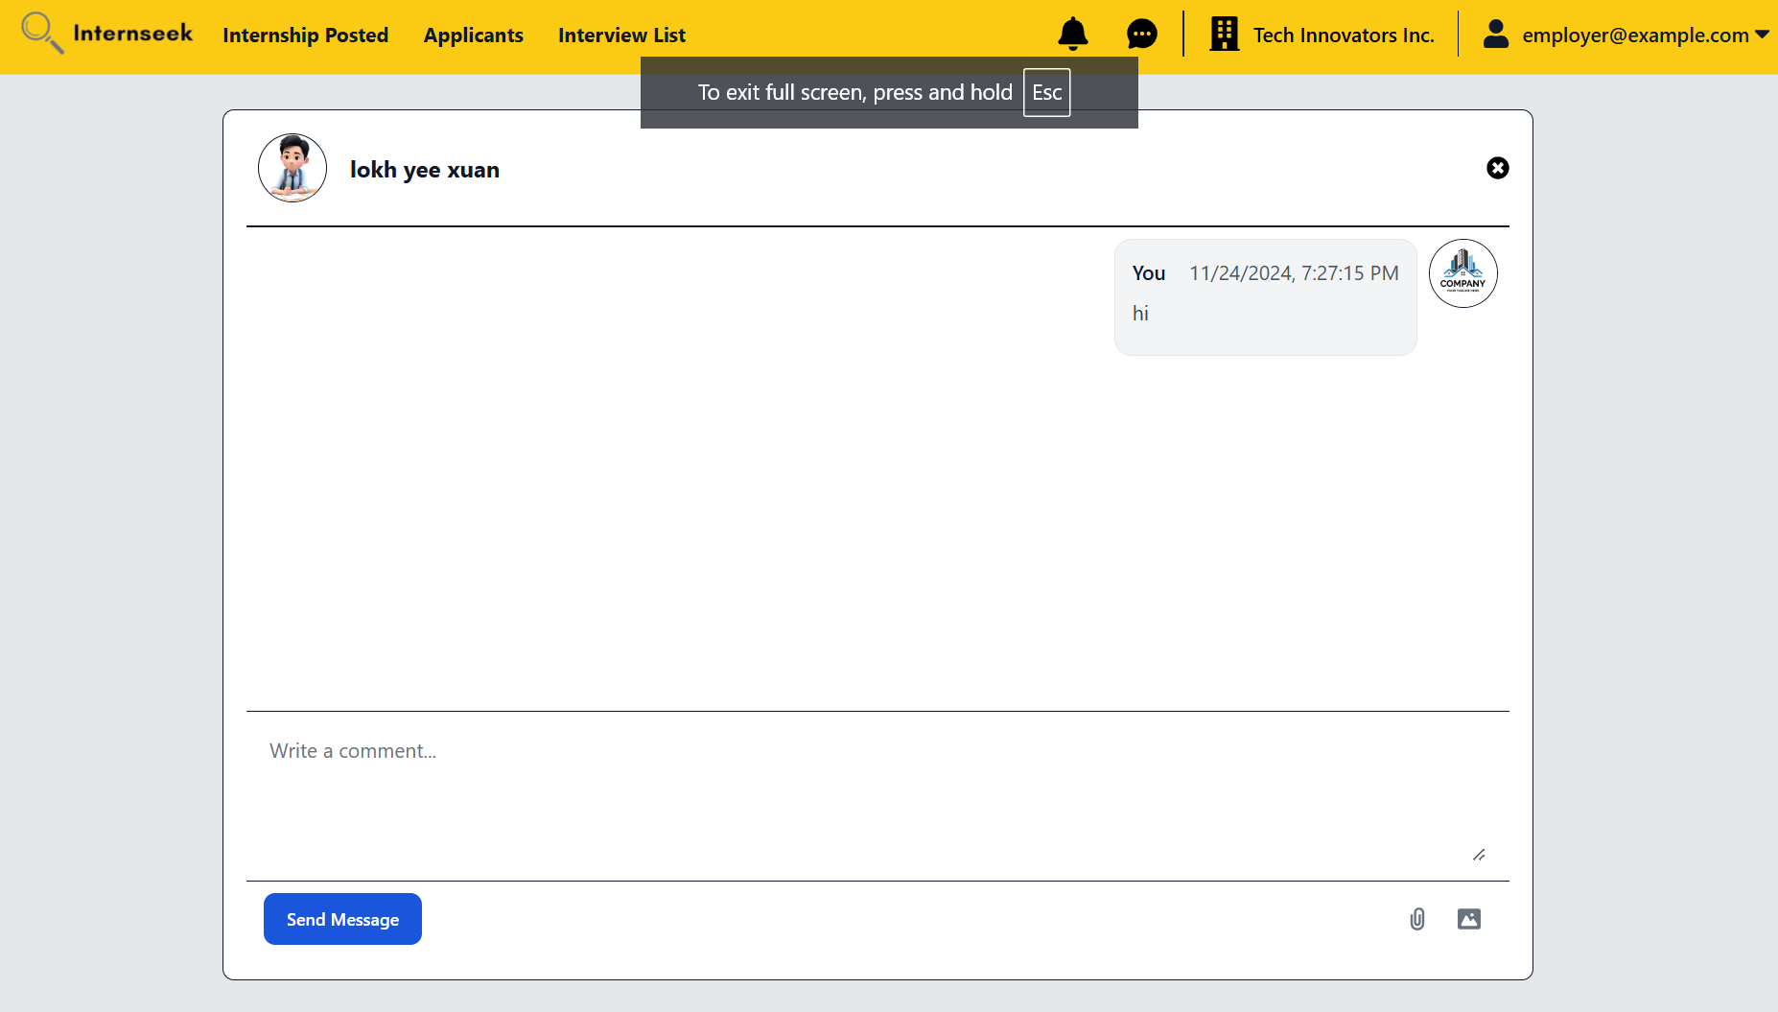

Figure 4‑104: Chatbox page (Successfully send message)

This figure displays the chatbox page, showing a new message in the chatbox after the employer successfully sends it

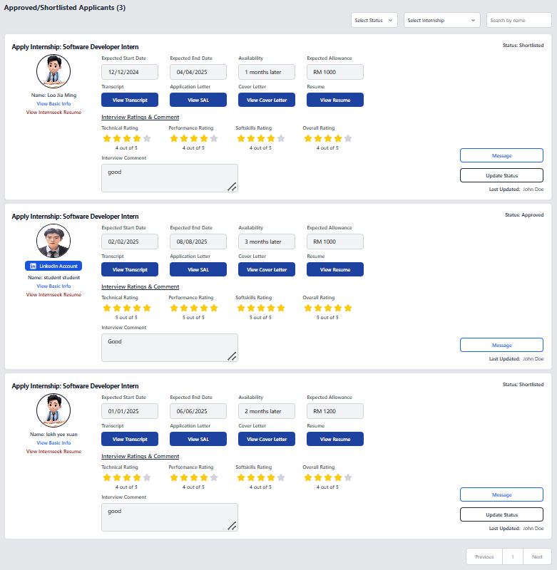

Figure 4‑105: Approved/Shortlisted Applicants List Page

This figure shows the Shortlisted or Approved Applicants List page, which displays all the applicants who have the internship application status of shortlisted or approved. The employer can view the applicant’s details on this page. The employer can message the applicant by clicking the message button. The employer can update the status of the shortlisted applicant by clicking the “Update Status” button.

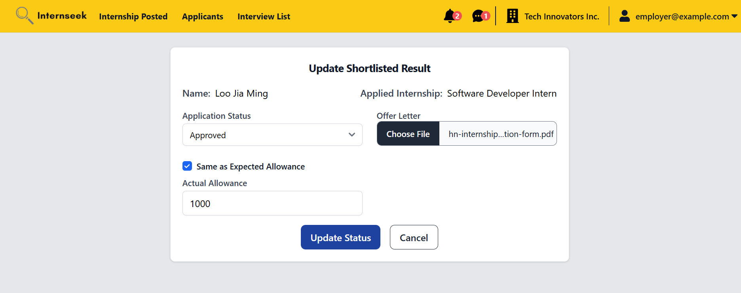

Figure 4‑106: Update Shortlisted Result (Approved)

This figure displays the "Update Shortlisted Result" page, where the employer can update the application status to Approved, Need-to-Interview Again, or Unsuccessful. In this example, the employer selects the status as Approved, uploads the offer letter, and enters the expected allowance.

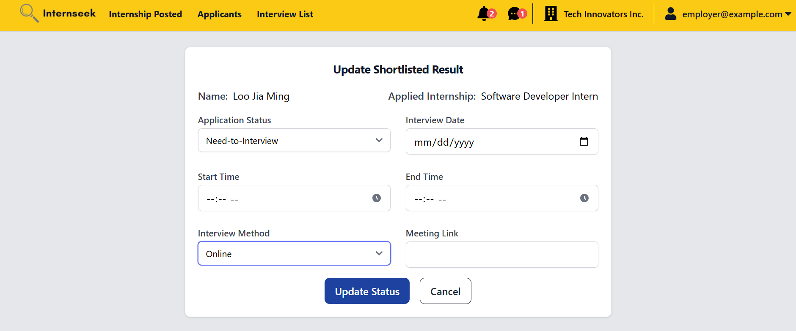

Figure 4‑107: Update Shortlisted Result (Need-to-interview)

This figure displays the "Update Shortlisted Result" page, where the employer can update the application status to Approved, Need-to-Interview Again, or Unsuccessful. In this figure, the employer selects the status as Need-to-Interview Again and schedules the next interview with the applicant.

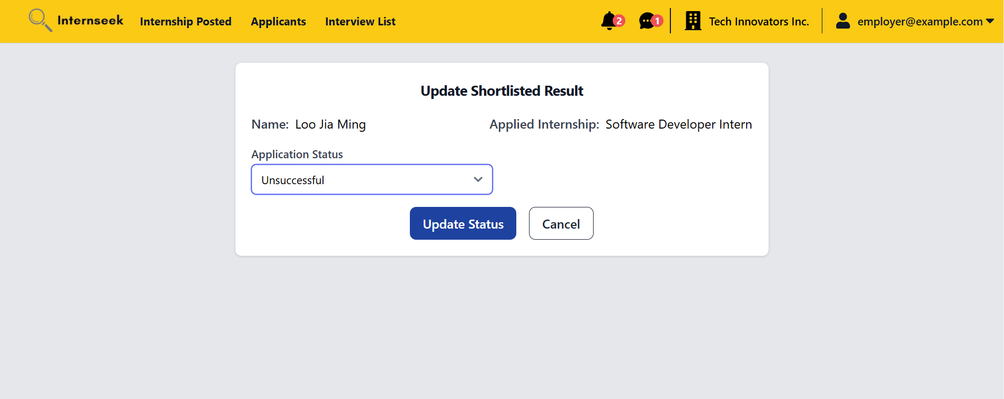

Figure 4‑108: Update Shortlisted Result (Unsuccessful)

This figure displays the "Update Shortlisted Result" page, where the employer can update the application status to Approved, Need-to-Interview Again, or Unsuccessful. In this figure, the employer selects the status as “Unsuccessful” and clicks the <<Update Status>> button.

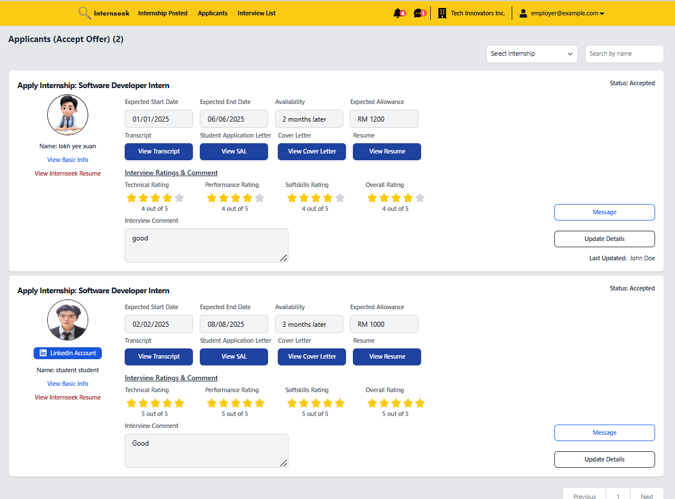

Figure 4‑109: Accepted Applicants List page

This figure shows the Accepted Applicants List page, which displays applicants who accepted the offer. The employer can view the applicant’s details on this page. The employer can message the applicant by clicking the message button. The employer can update the accepted offer details for the intern by clicking the <<Update Details>> button.

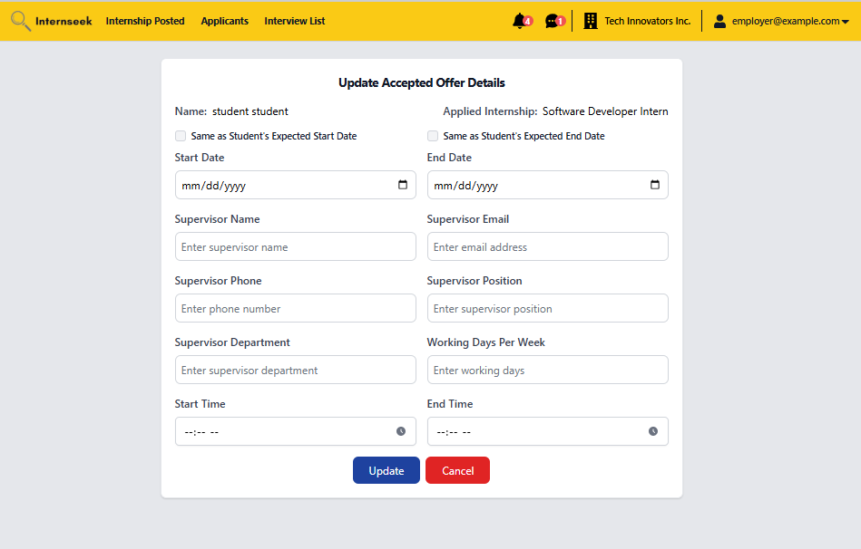

Figure 4‑110: Update Accepted Offer Details Page

This figure shows the Update Accepted Offer Details page, where the employer enters the accepted offer details and then clicks the <<Update>> button to update the industrial training information for applicants who accept the offer. If the employer does not want to update the details, they may click the <<Cancel>> button.

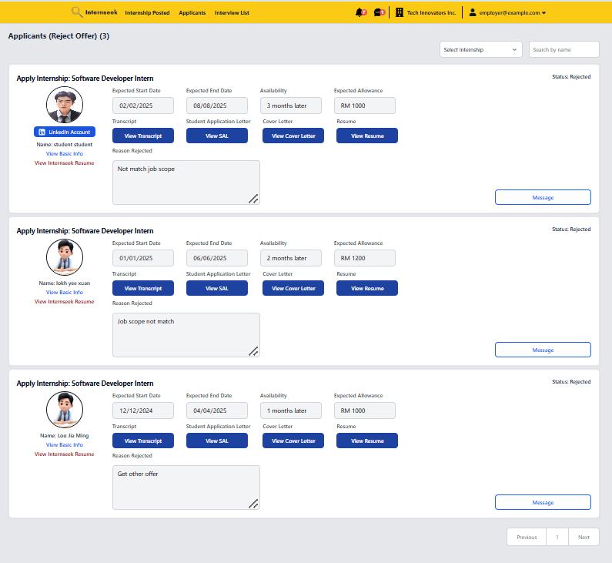

Figure 4‑111: Rejected Applicants List

This figure shows the Rejected Applicants List page, which displays applicants who rejected the offer. The employer can view the applicant’s details on this page. The employer can message the applicant by clicking the message button.

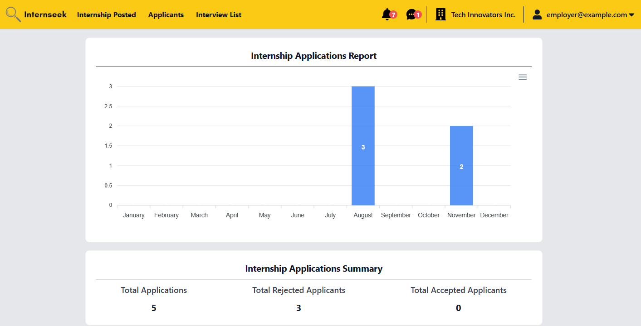

Figure 4‑112: My Reports Page

This figure displays the My Report page. This page displays a graph bar regarding the total number of internship applications per month. The employer can observe how many applicants apply for internships each month. Based on the graph bar, the employer can determine which month has the most internship applications. This page also displays the internship application summary which includes the total number of applicants, total number of rejected applicants, and total number of accepted applicants.

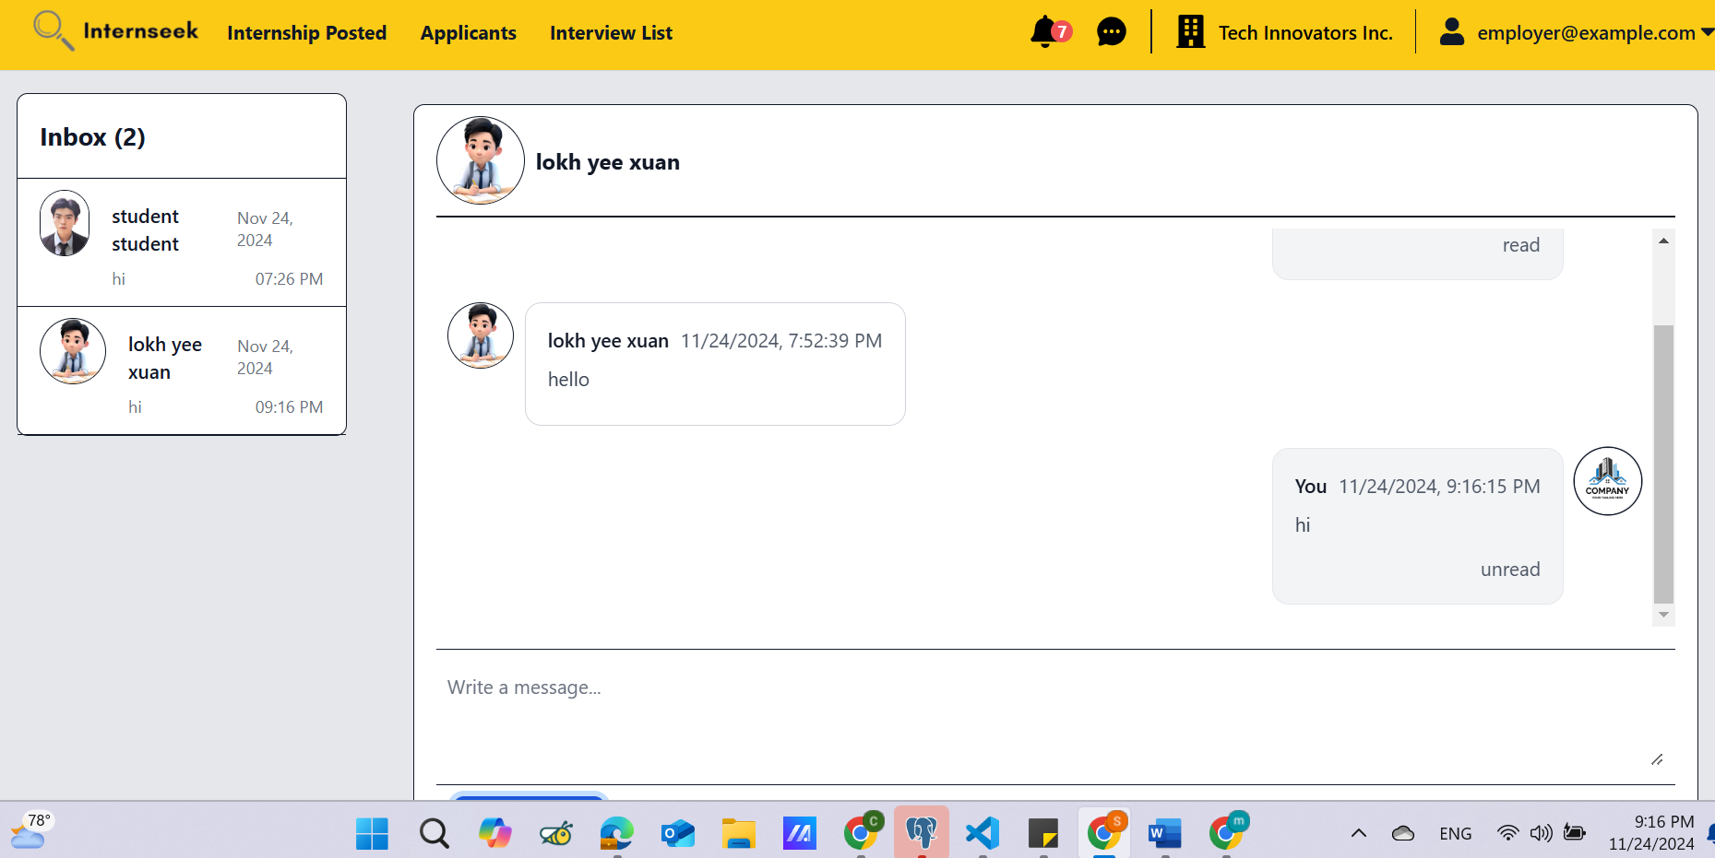

Figure 4‑113: Message Inbox and Chat-box Page

This figure displays the message inbox and chat-box page. The left-side interface represents the message inbox. The message inbox will display all the conversations with different applicants. Unread messages are highlighted to differentiate them from read messages. The employer can scroll through the list to find a specific conversation. The right-side interface displays the selected conversation in detail. It shows the latest received messages and the full message history between the employer and the university student. At the bottom of the chat box, there is an input field where the employer can type a new message. After the employer types in a new message and attaches a file, they click the send button to send the message. The chat box updates in real-time, showing new messages they sent.

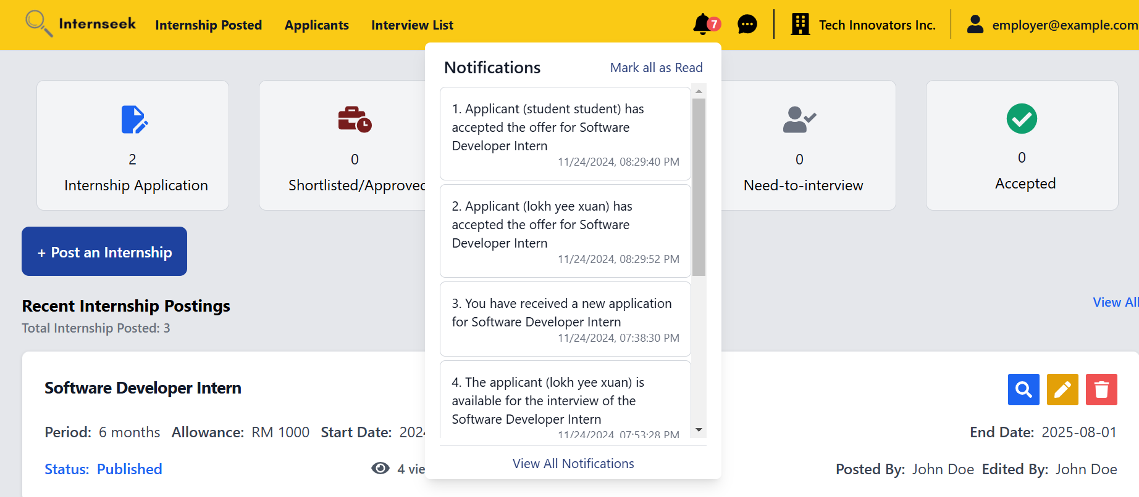

Figure 4‑114: Notifications in drop-down view (Employer)

This figure shows the notifications received by the employer in a drop-down menu after clicking the bell icon. The employer can view all notifications by clicking the "View All Notifications" link or mark all notifications as read by clicking the "Mark All as Read" link.

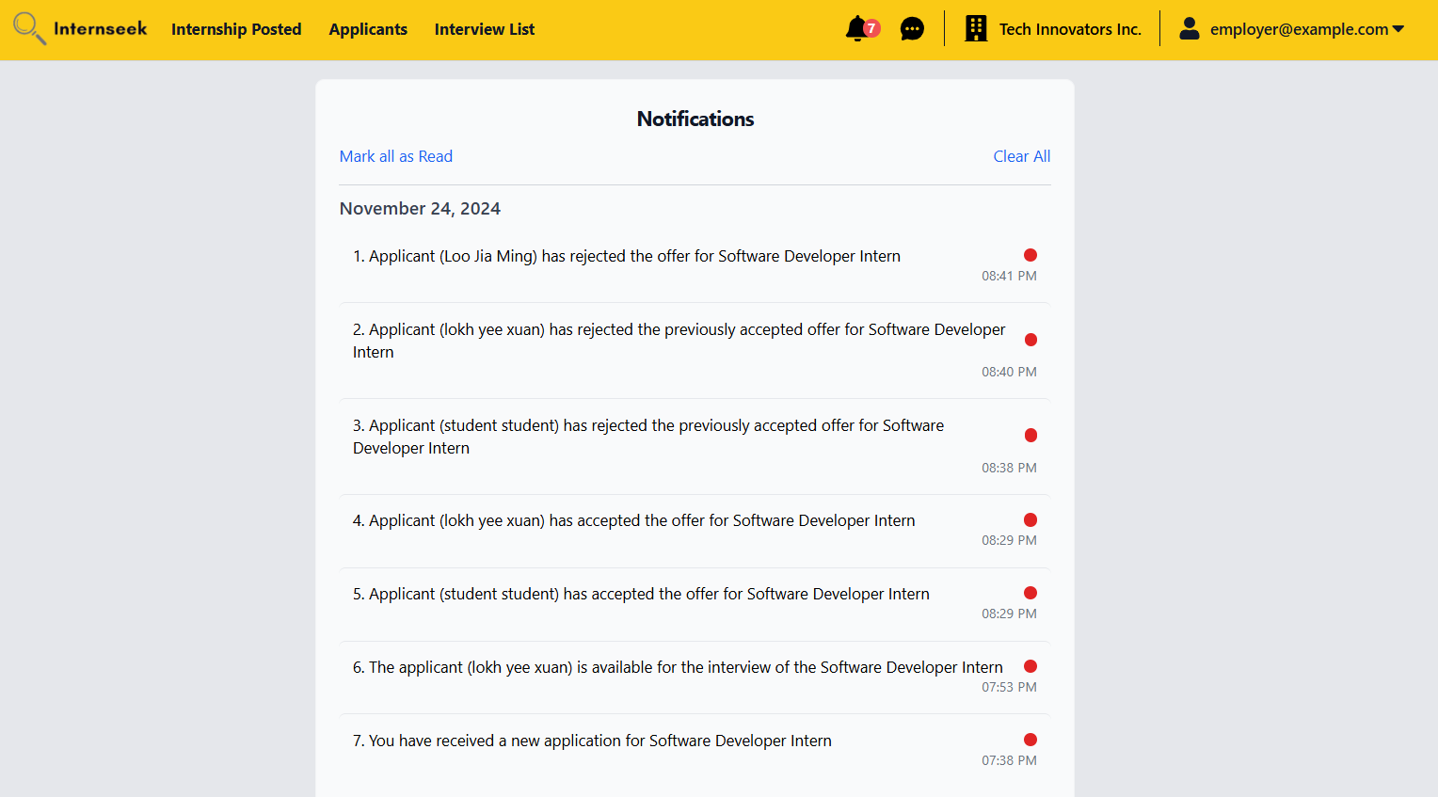

Figure 4‑115: Notifications Listing Page (Employer)

This figure displays a list of all notifications received by the employer, organized by daily categories. Employer can either mark all notifications as read or clear all notifications.

##### Administrator

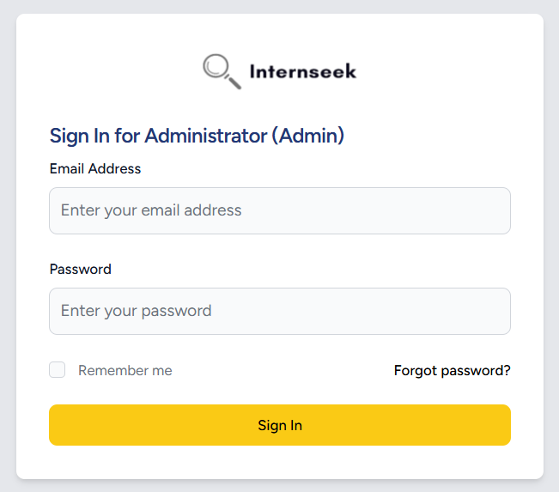

Figure 4‑116: Sign In Form (Admin)

This figure illustrates the login page for administrators. The admin needs to enter their email address and password and click the <<Sign In>> button to login to the system. The admin can click the <<Sign Up>> text if they are first-time users. If the admin forgets their account password, they need to click the <<Forgot Password?>> text to reset their password. They can also select the "Remember me" checkbox to save their email address for easier sign-in next time.

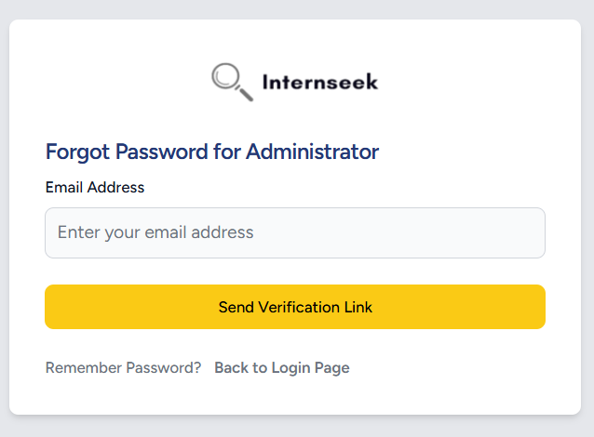

Figure 4‑117: Forgot Password Form (Admin)

This figure illustrates the forgot password page for administrators if they forgot their password. The administrators need to enter their email address and click the <<Send Verification Link>> button to get the password reset link. If the administrators want to back to login page, they may click the <<Back to Login Page>> text.

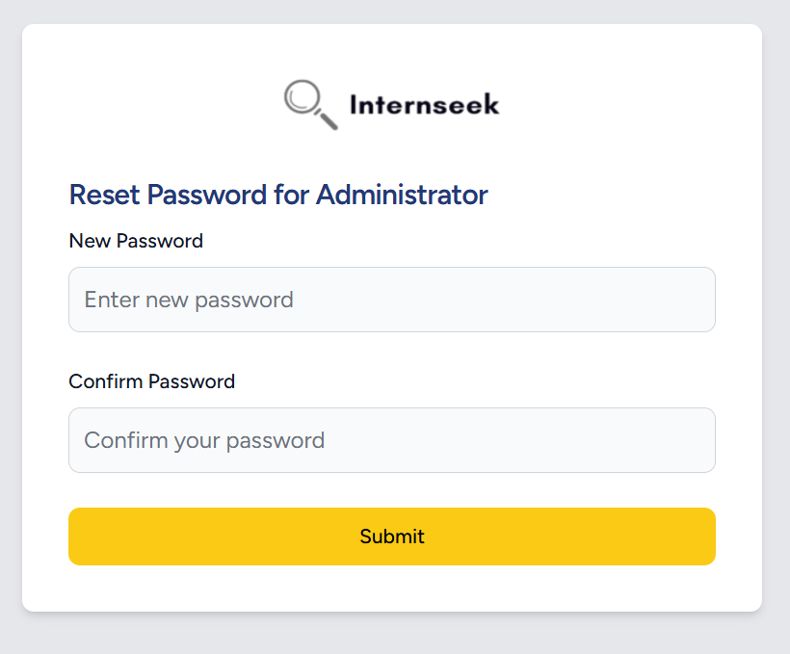

Figure 4‑118: Reset Password Form (Admin)

This figure illustrates the password reset page for administrators once they click the password reset link in the email they received. The administrators need to enter their new password, confirm their password, and click the <<Submit>> button to reset their password.

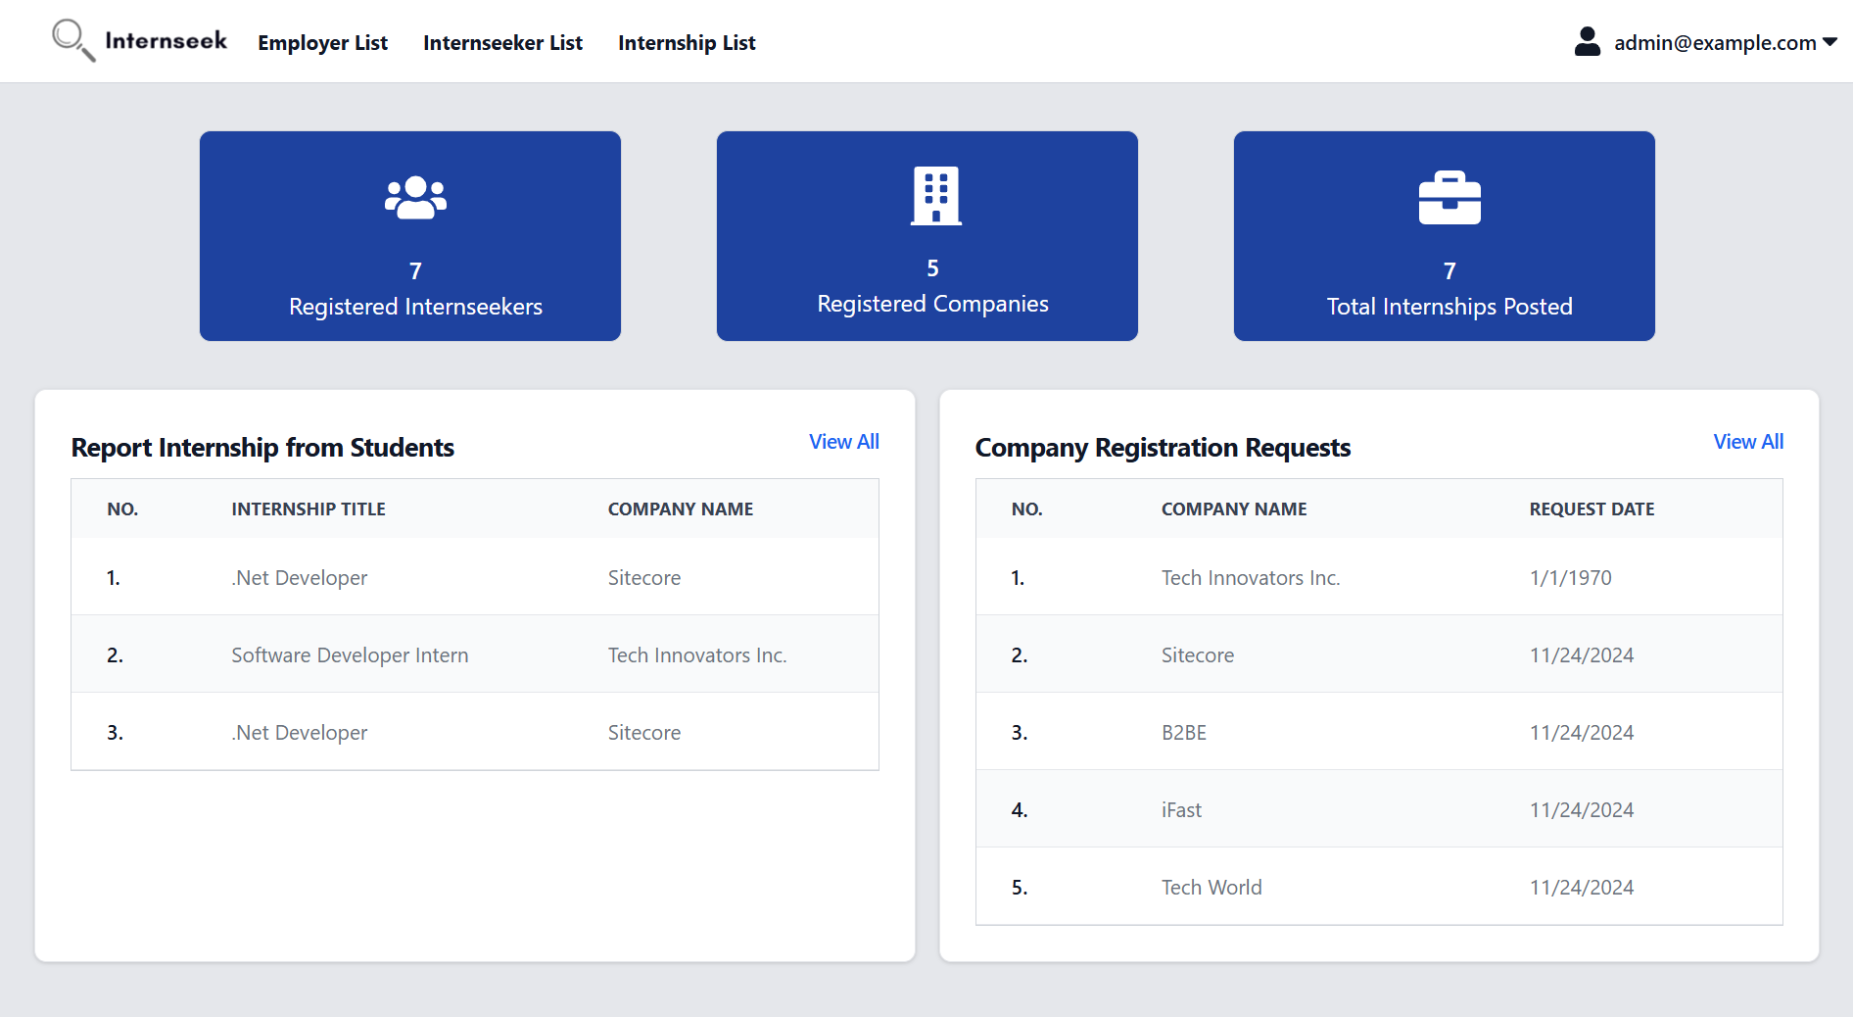

Figure 4‑119: Admin Dashboard

This figure shows the Admin Dashboard page once the administrator successfully logs into the system. The admin dashboard displays the total number of available internships, registered employers, and total internship postings. These numbers represent a card. The admin dashboard also displays the internship problem reports made by university students and the employer registration requests. The administrator can view the full list of the internship problem reports from students and the employer registration requests by clicking the <<View all>> text.

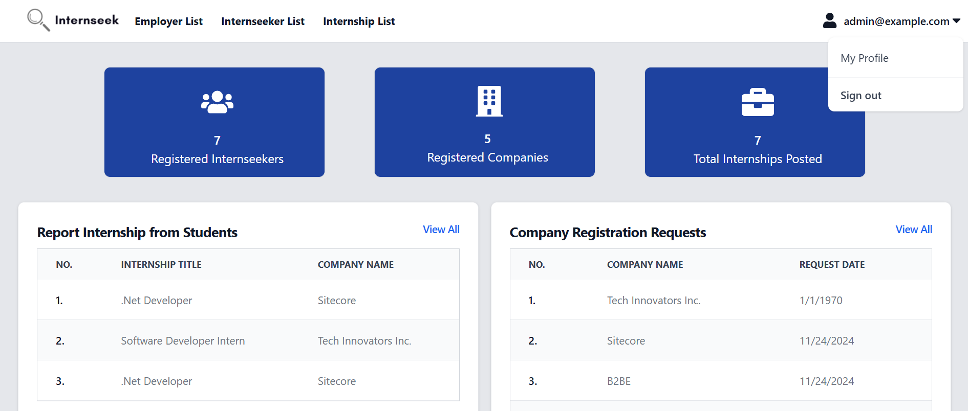

Figure 4‑120: Drop-Down Menu (Admin)

This figure shows the Admin Dashboard with the drop-down menu of the navigation bar, which consists of two options: My Profile, and Log Out. Administrators will be directed to the My Profile page once they select the My Profile option. Administrators will be logged out of the system once they select the Log Out option.

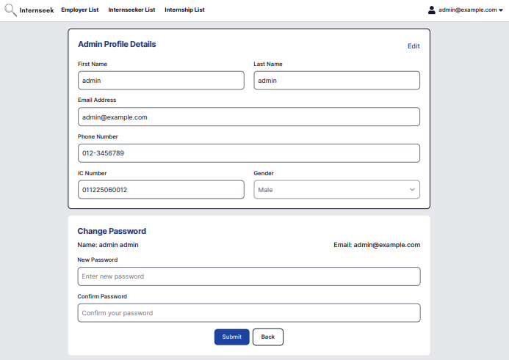

Figure 4‑121: My Profile Page (Admin)

This figure shows the My Profile page for administrators. Administrators can edit their profile details by clicking the Edit text, which activates the input fields for modification. Once the edits are complete, they can click the Save Changes text to update their profile. Additionally, administrators can change their password on this page by entering the new password and confirming it in the respective fields, then clicking the Submit button within the Change Password form.

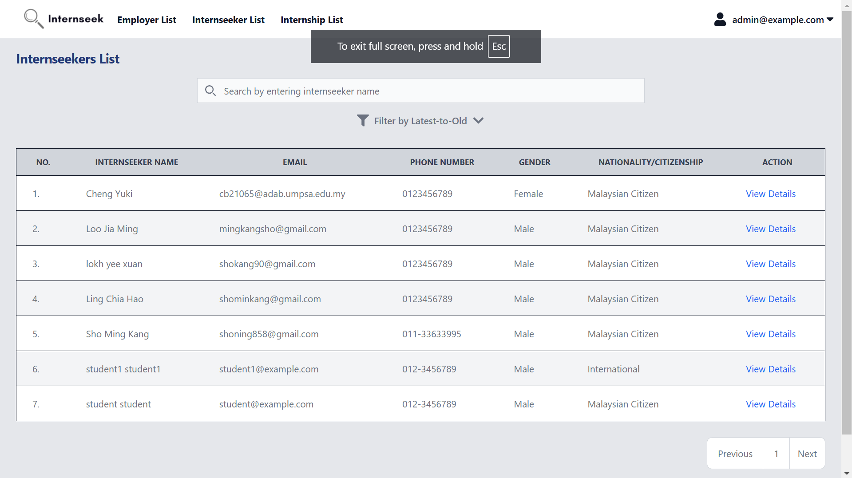

Figure 4‑122: Registered Student List Page

This figure shows the Registered Student List page once the administrator clicks the registered students card button on the Admin Dashboard. This page displays all the registered students in table form. Administrators can view the general details of registered students. If the administrator wants to view the detailed basic information about the registered student, they may click the <<View Details>> text.

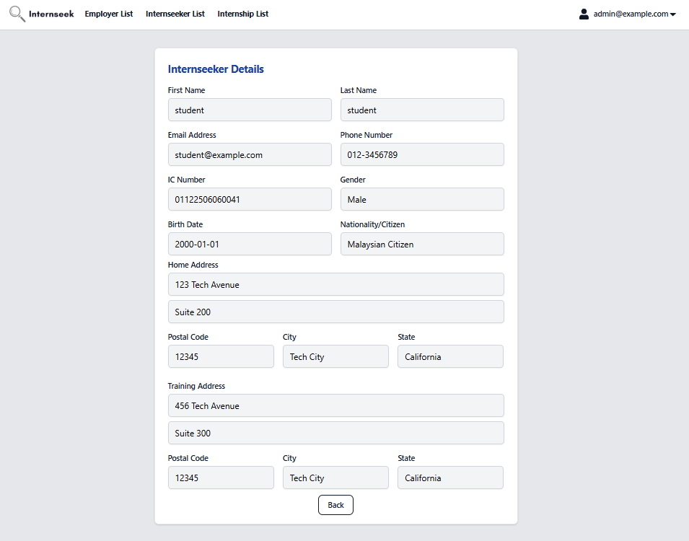

Figure 4‑123: View Registered Student Basic Information Page

This figure shows the View Registered Student Basic Information page. This page displays detailed basic information about the registered student. Once the administrator finishes viewing the basic information about the registered student, they may click the <<Back>> button.

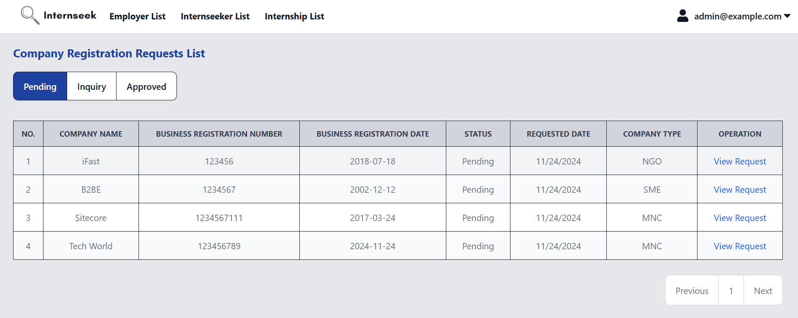

Figure 4‑124: Company Registration Request List Page (Pending)

This figure shows a list of company registration requests from employers with pending status. The page displays the general information of each company. Administrators can update the status of the company registration request by clicking the View Request text to view the details.

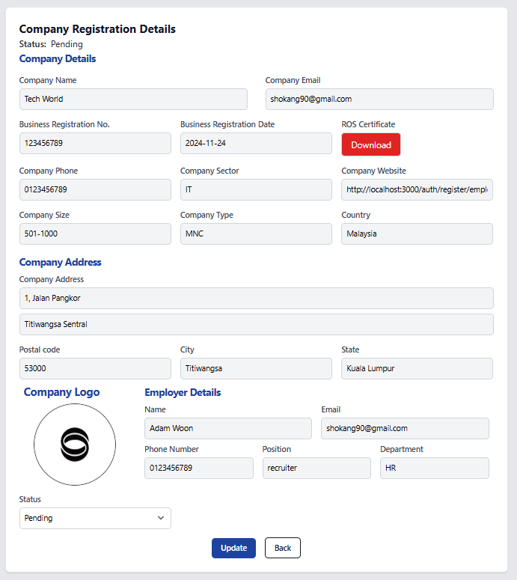

Figure 4‑125: Update Company Registration Status (Pending)

This figure shows the details of a pending company registration request from an employer. Administrators are required to review all the registration details before updating the status. The admin can update the status of the registration to either Inquiry or Approved. If Inquiry status is selected, an inquiry comment will appear beside the status field, allowing the admin to specify the information that needs to be edited by the employer. If Approved is selected, it indicates that the company has been successfully registered within the system.

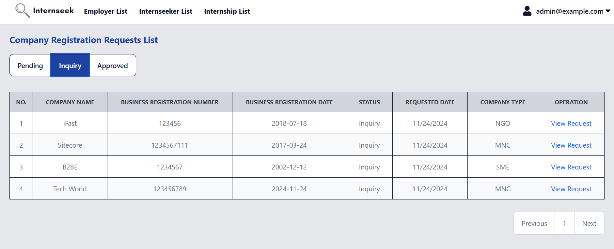

Figure 4‑126: Company Registration Request List Page (Inquiry)

This figure shows a list of company registration requests from employers with an Inquiry status. The page displays the general information of each company. Administrators can review whether the employer has edited their information based on the provided comments. To view the details and make necessary updates, the administrator can click the View Request text to review the full registration details and update the status accordingly.

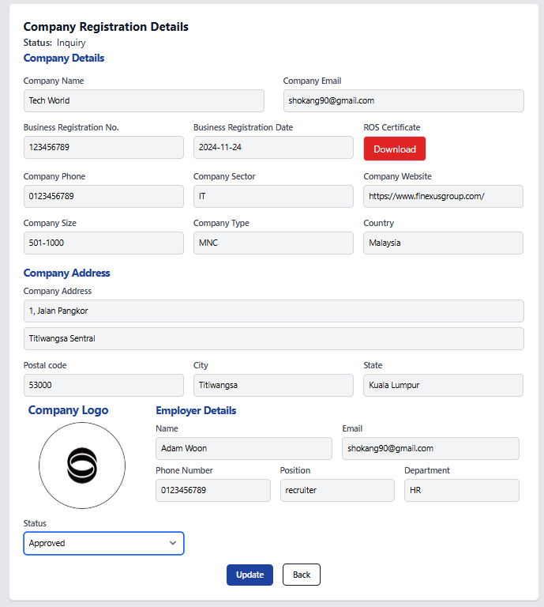

Figure 4‑127: Update Company Registration Status (Inquiry)

This figure shows the details of a company registration request with Inquiry status. Administrators are required to review the registration details updated by the employer based on the previous comments. Once the admin confirms that the required changes have been made by the employer, they can update the status of the registration to Approved to approve the company registration.

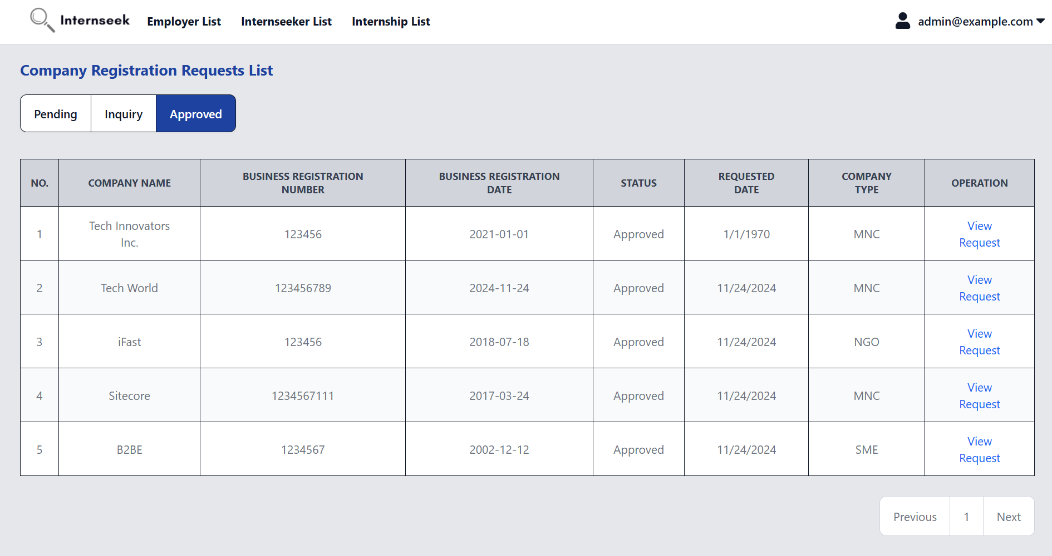

Figure 4‑128: Update Company Registration Status (Approved)

This figure shows a list of company registration requests from employers with an Approved status. The page displays the general information of each company. To view the details, the administrator can click the View Request text to review the full registration details.

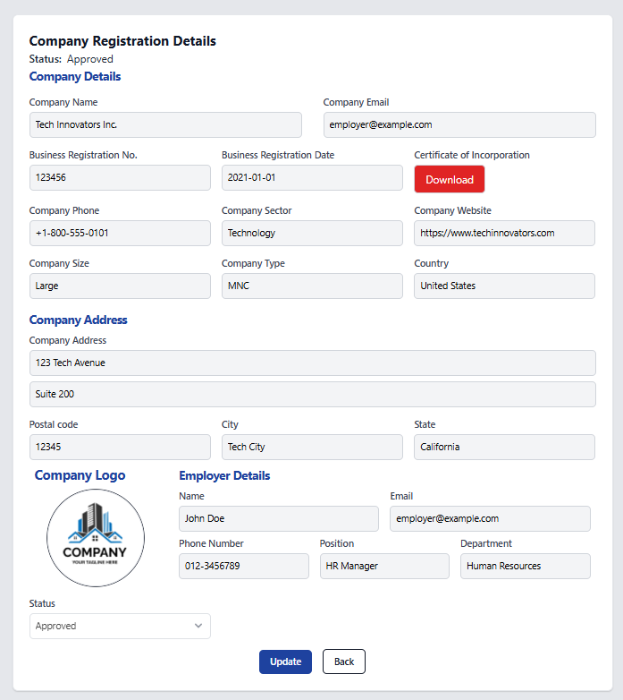

Figure 4‑129: View Company Registration Request (Approved)

This figure shows the details of a company registration request with Approved status. Administrators can review the registration details, but the status cannot be updated since the company has already been approved.

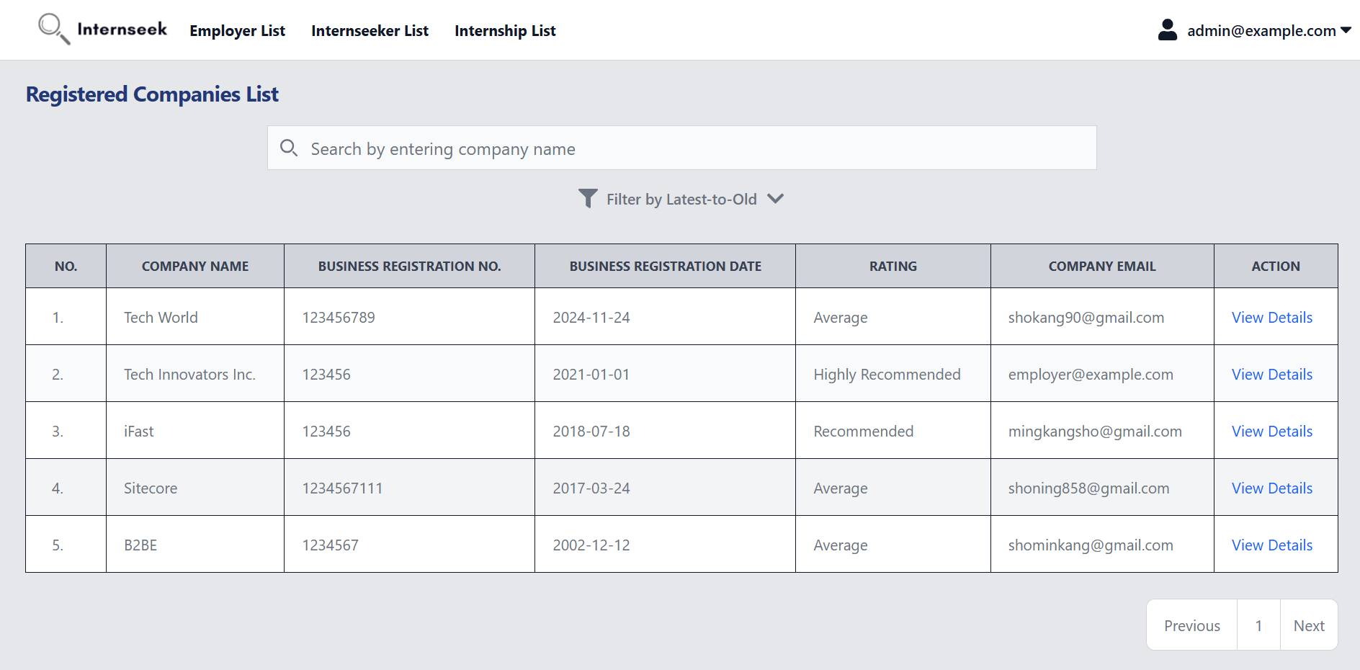

Figure 4‑130: Registered Companies List page

This figure shows the Registered Companies List page once the administrator clicks the registered companies card button on the Admin Dashboard. This page displays all the registered companies in table form. Administrators can view the general details of registered companies. If the administrator wants to view detailed information about the registered company, they may click the <<View Details>> text.

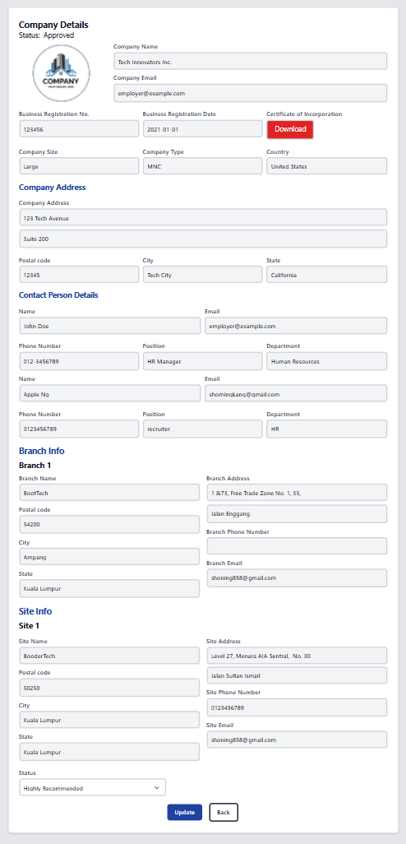

Figure 4‑131: View Registered Company Details page (Update Rating)

This figure shows the View Registered Company Details page. This page displays detailed profile information about the registered company. Administrators can update the company rating on this page by selecting the rating and clicking the <<Update>> button. Once the administrator finishes viewing the registered company profile details, they may click the <<Back>> button.

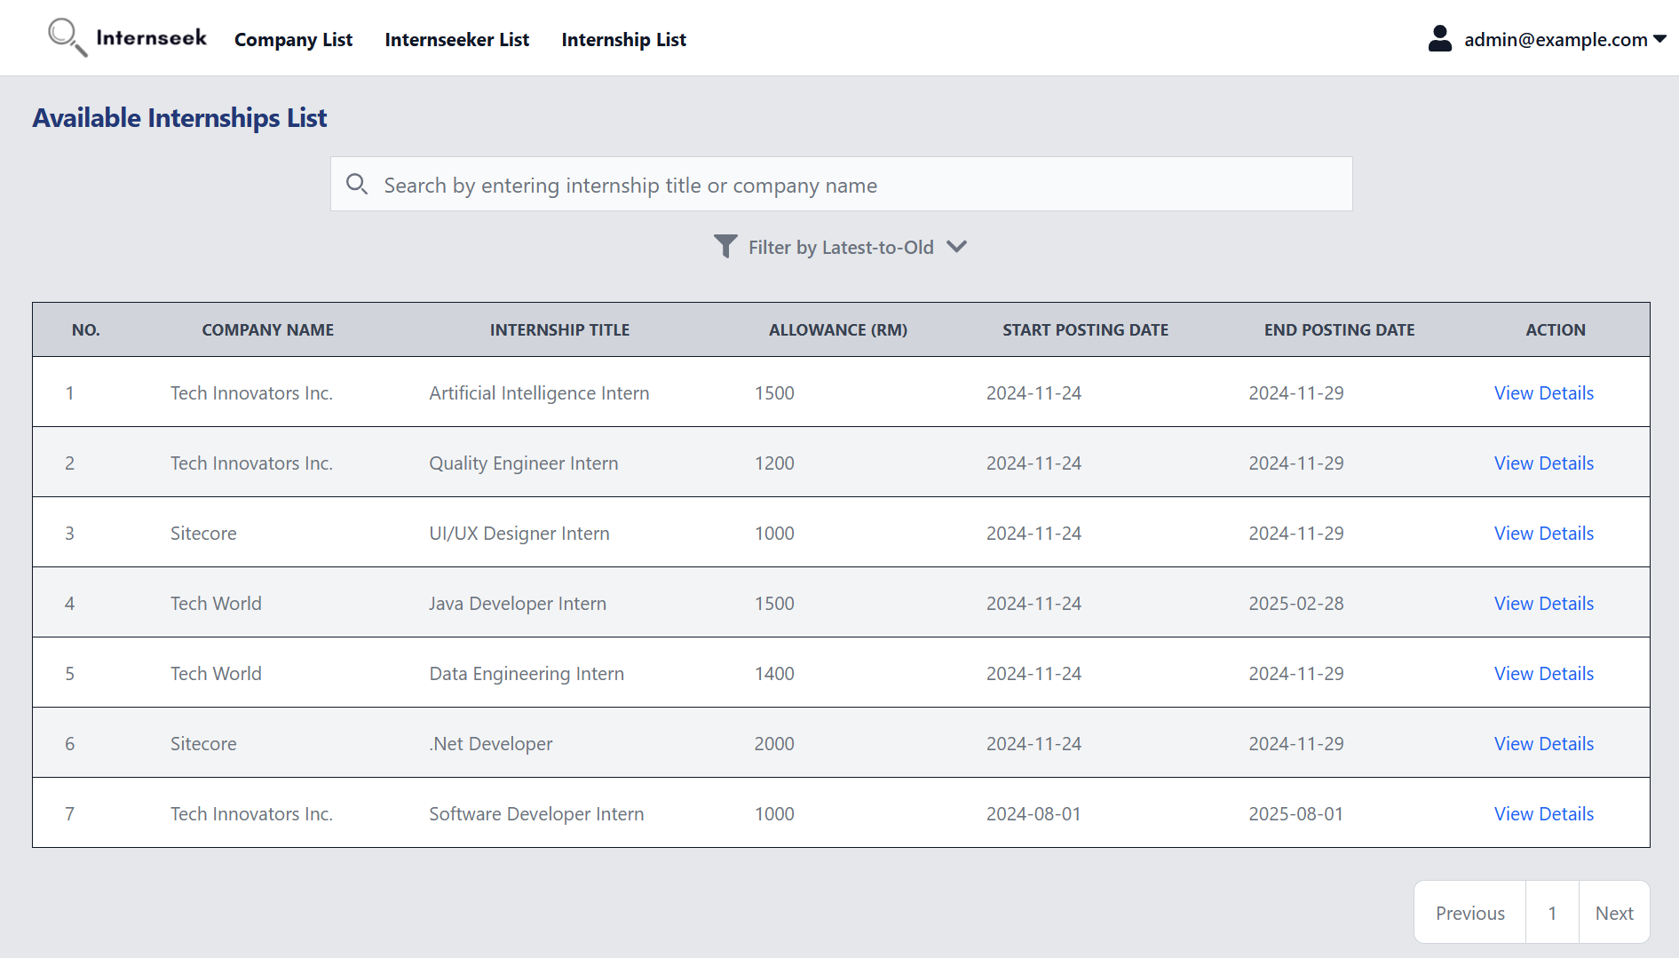

Figure 4‑132: Available Internships List page

This figure shows the Available Internships List page once the administrator clicks the available internships card button on the Admin Dashboard. This page displays all the available internships in table form. Administrators can view the general details of available internships. If the administrator wants to view detailed information about the available internship, they may click the <<View Details>> text.

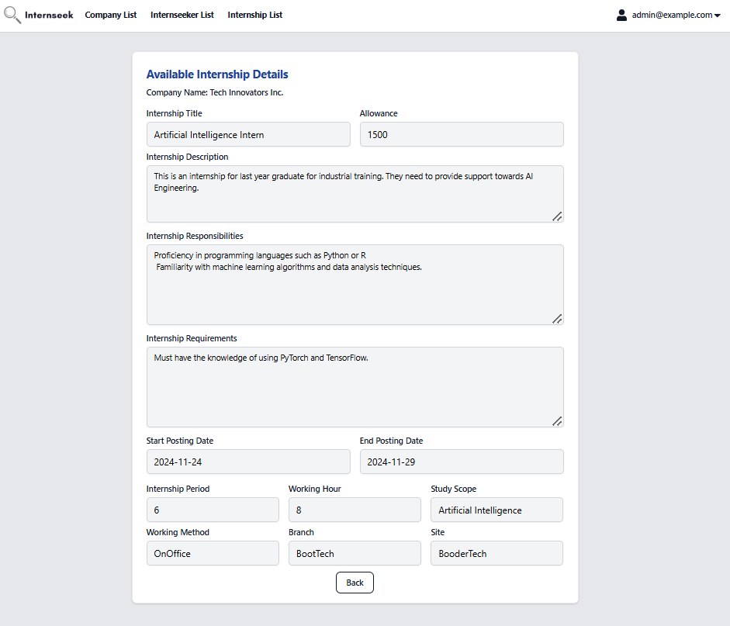

Figure 4‑133: View Available Internship Details Page

This figure shows the View Available Internship Details page. This page displays the detailed information about the available internship. Administrators can view the internship details. Once the administrator finishes viewing the registered company profile details, they may click the <<Back>> button.

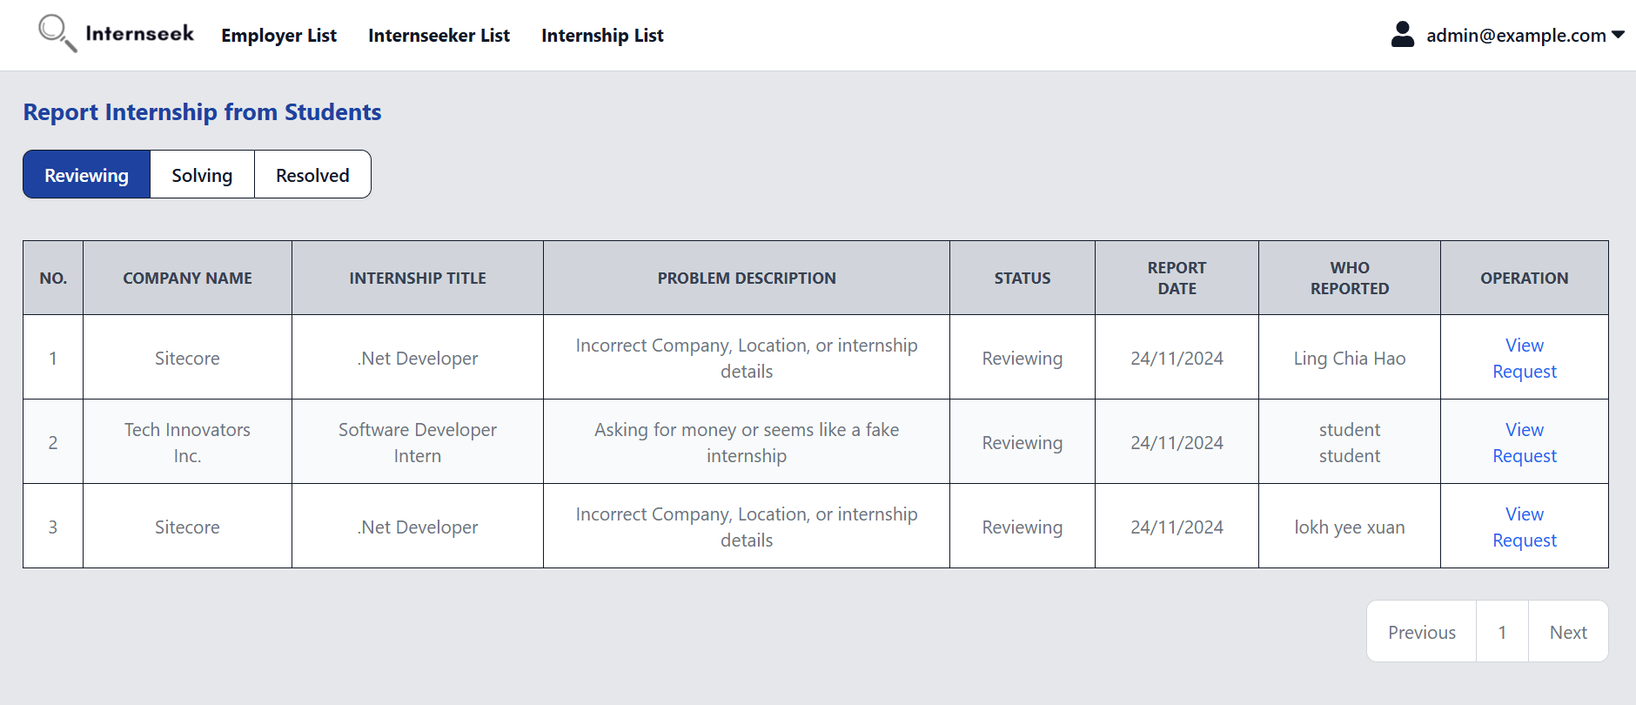

Figure 4‑134: Internship Problem Reports List page (Reviewing)

This figure shows the Internship Problem Reports List page once the administrator clicks the <<View all>> text in the internship problem reports section of the Admin Dashboard. This page displays all internship problem reports with a reviewing status in table form. Administrators can view the basic details of internship problem reports. If the administrator wants to view the detailed information about the internship problem reports, they may click the <<View Details>> text.

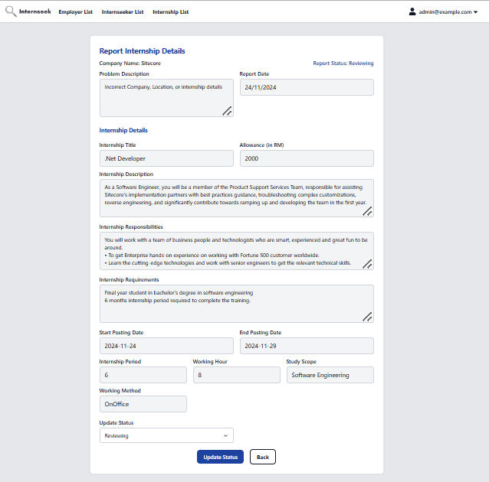

Figure 4‑135: Update Internship Report Status page (Reviewing)

This figure shows the Update Internship Report Status page with Reviewing status, which appears when the employer clicks View Details for a specific internship report. The administrator can update the status to Solving or Resolved. If Resolved is selected, the administrator enters a comment and selects an action to close the issue. If Solving is chosen and the action is Archived, a reason for archiving field appears, and the administrator provides the reason before updating the status and notifying the student. Once all required details are filled, the administrator can click the Update Status button to update the internship problem report status.

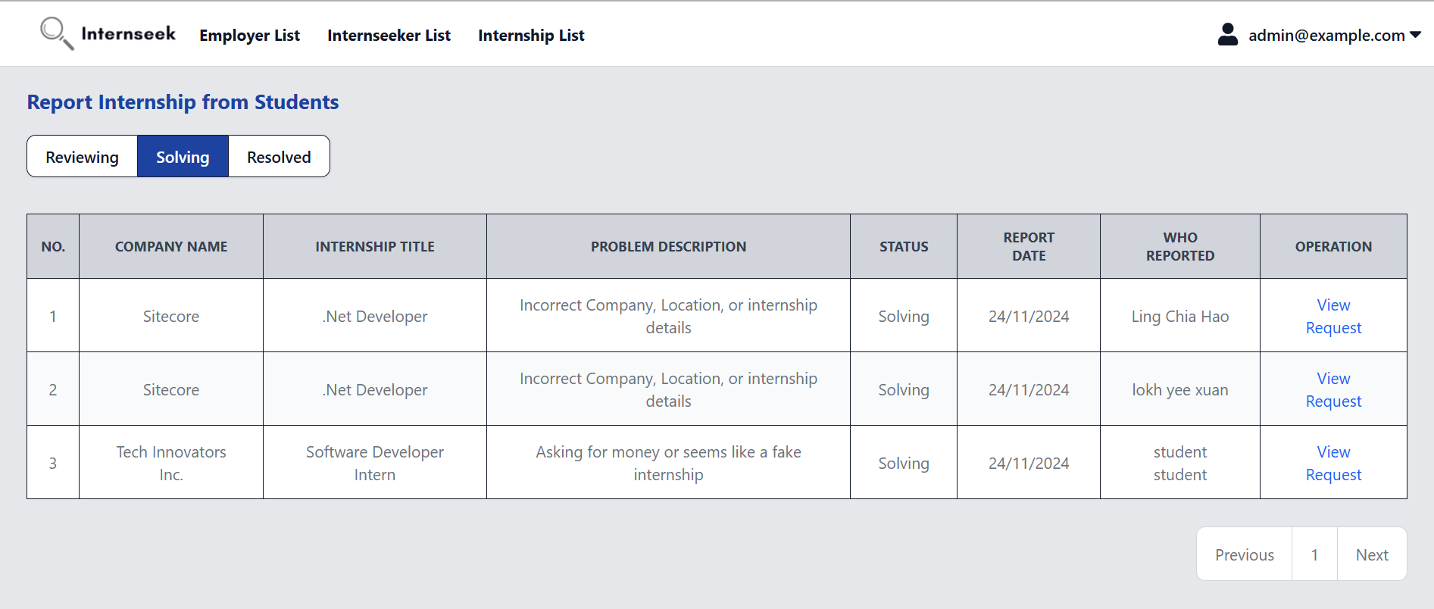

Figure 4‑136: Internship Problem Reports List page (Solving)

This figure displays all internship problem reports with a solving status in table form. Administrators can view the basic details of internship problem reports. If the administrator wants to view the detailed information about the internship problem reports, they may click the <<View Details>> text.

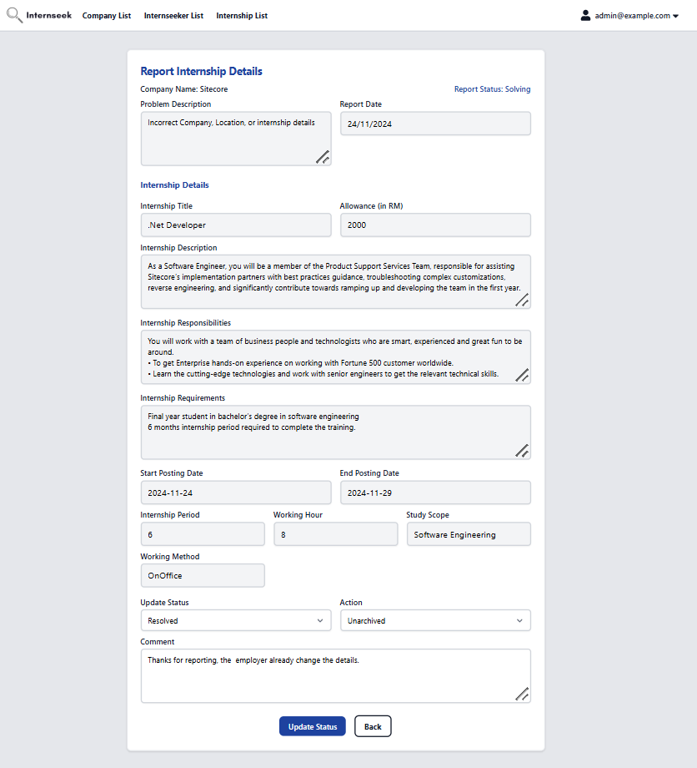

Figure 4‑137: Update Internship Report Status page (Solving)

This figure shows the Update Internship Report Status page with Solving status, which appears when the employer clicks View Details for a specific internship report with Solving status. The administrator can update the status to Resolved. If the employer updates the internship details, the administrator can close the issue by unarchiving the internship, updating the status to Resolved, and adding a comment.

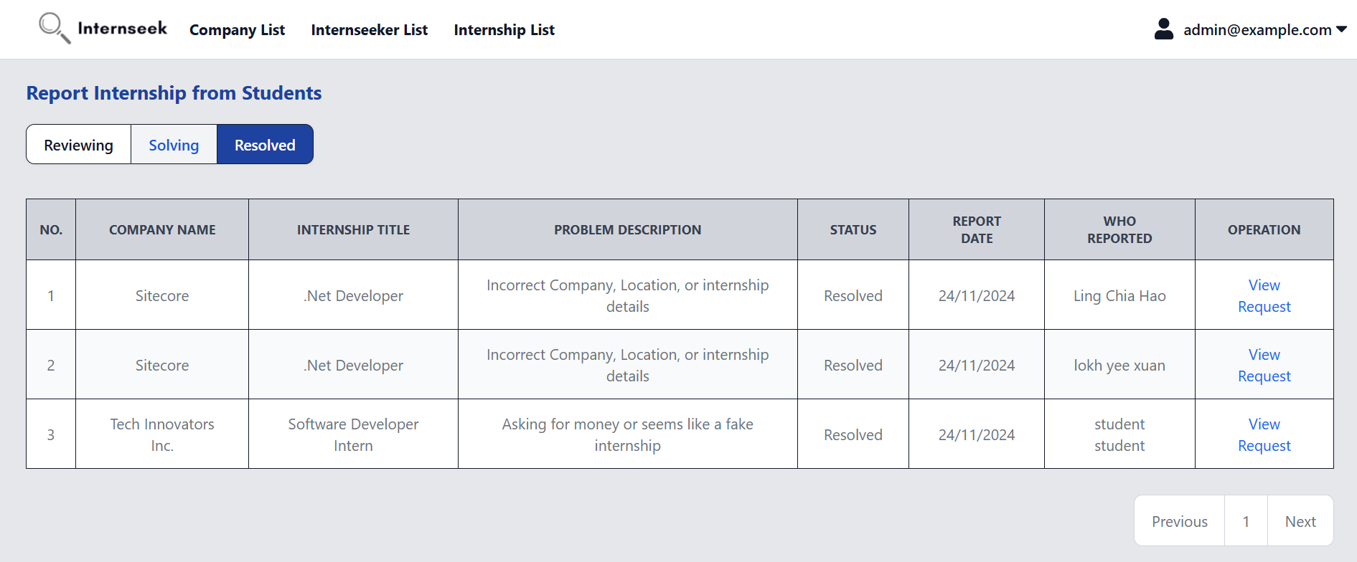

Figure 4‑138: Internship Problem Reports List page (Resolved)

This figure displays all internship problem reports with a resolved status in table form. Administrators can view the basic details of internship problem reports. If the administrator wants to view the detailed information about the internship problem reports, they may click the <<View Details>> text.

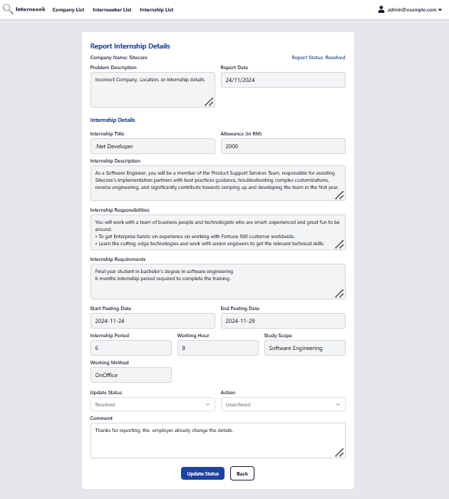

Figure 4‑139: Update Internship Report Status page (Resolved)

This figure shows the Update Internship Report Status page with Resolved status, which appears when the employer clicks View Details for a specific internship report with the Resolved status. The administrator can view the details but is not allowed to edit anything, as the issue has already been closed.

## System Deployment

The Internseek system and its database were deployed to cPanel before proceeding to UAT. The source code was uploaded to cPanel's file manager folder, as shown in Figure 4-4. Then, the database of Internseek was created in cPanel in Figure 4-5 and the SQL file was imported from local database to phpMyAdmin in Figure 4-6. Configuration adjustments were made in the .env and .htaccess files within the public folder after setting up the new domain for the system, as shown in Figure 4-7. Users can access and test the Internseek system by entering http://internseek.raegrp.com/ in their browser.

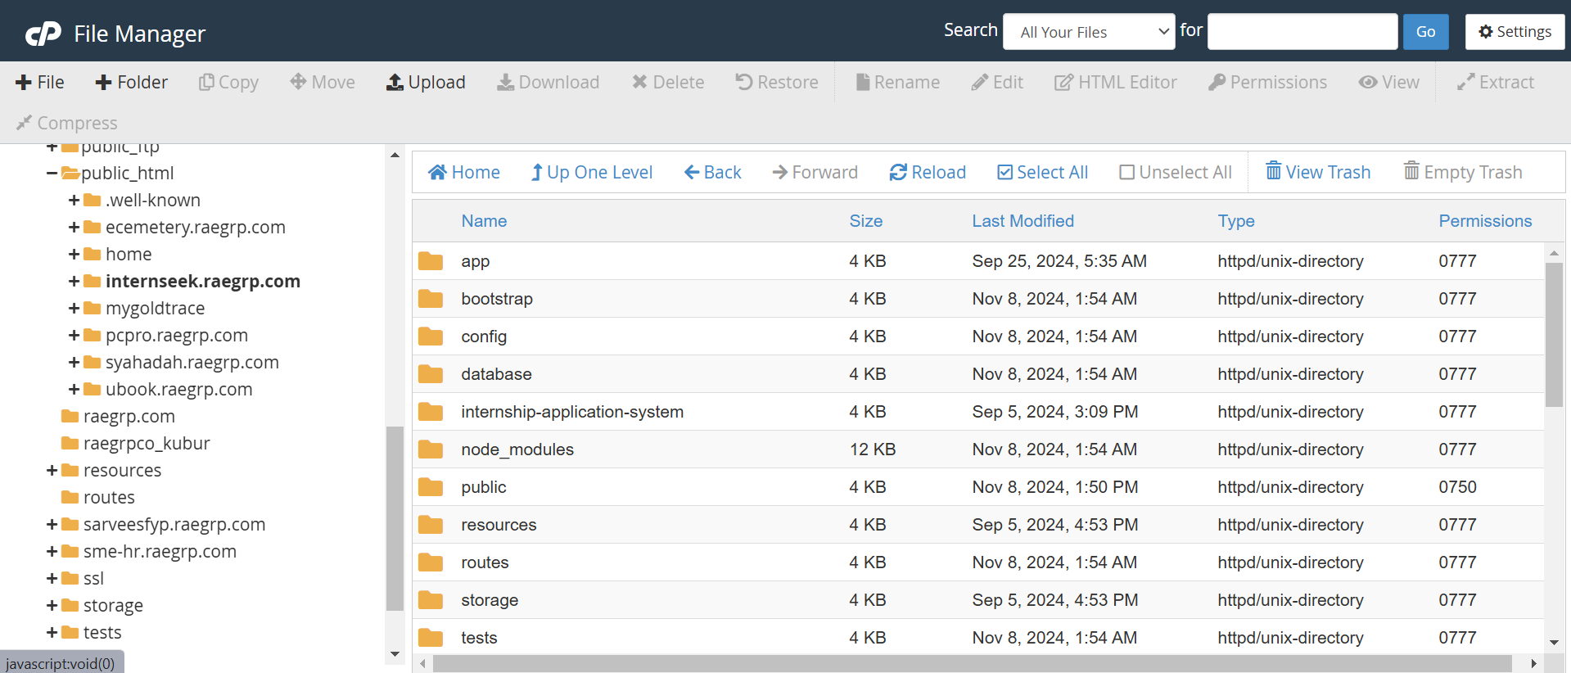

Figure 4‑141: Project Uploaded to cPanel

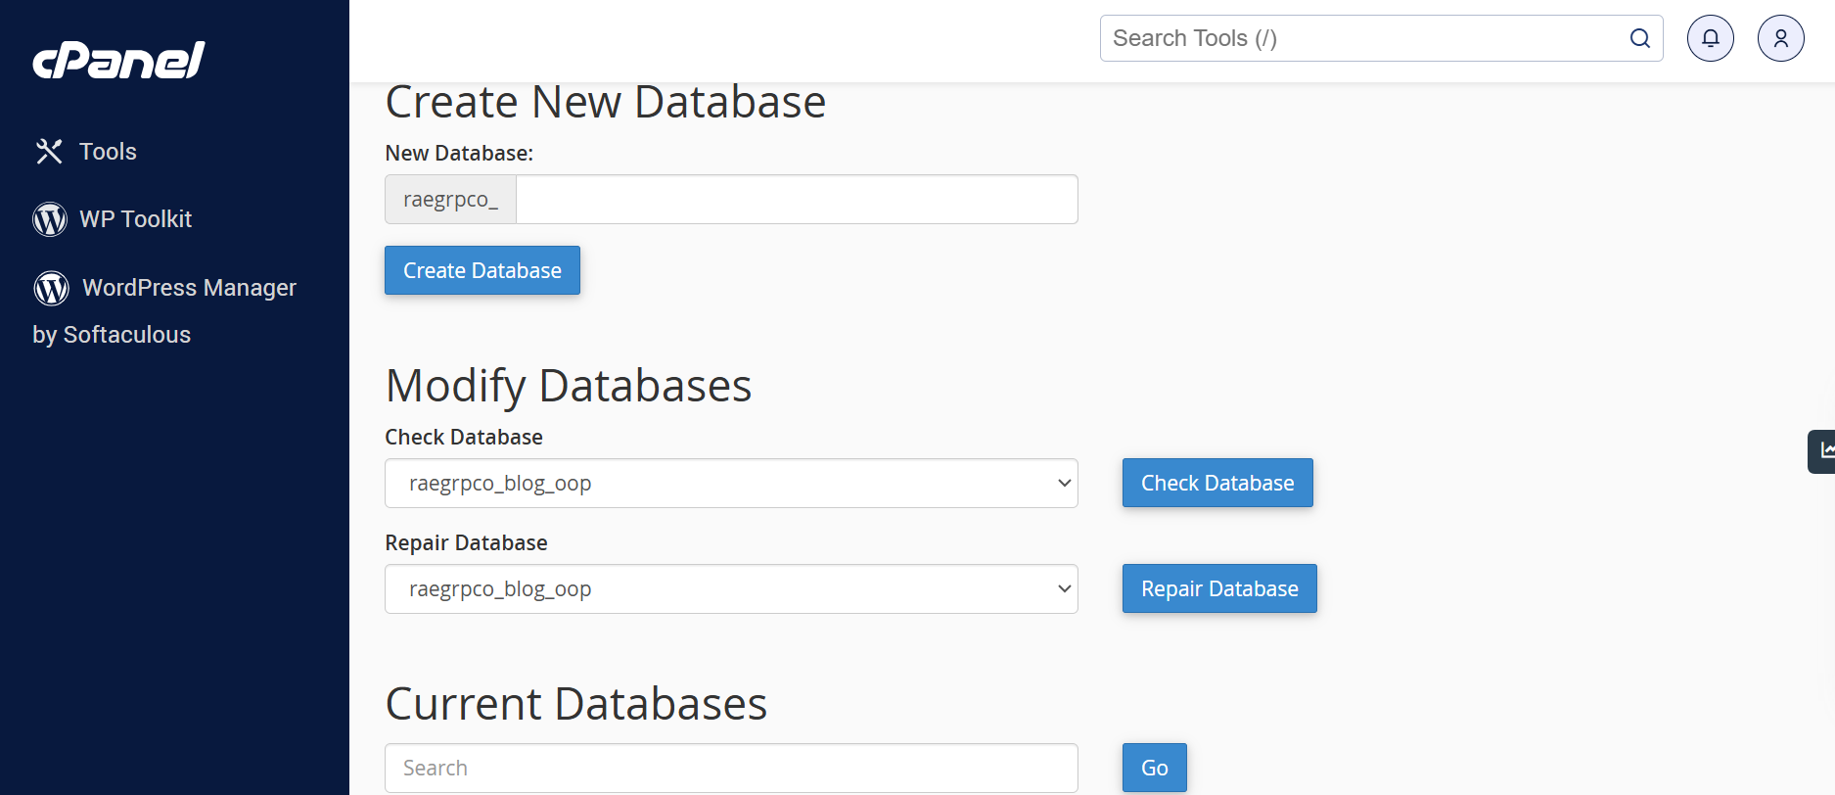

Figure 4‑142: Create New Database in cPanel

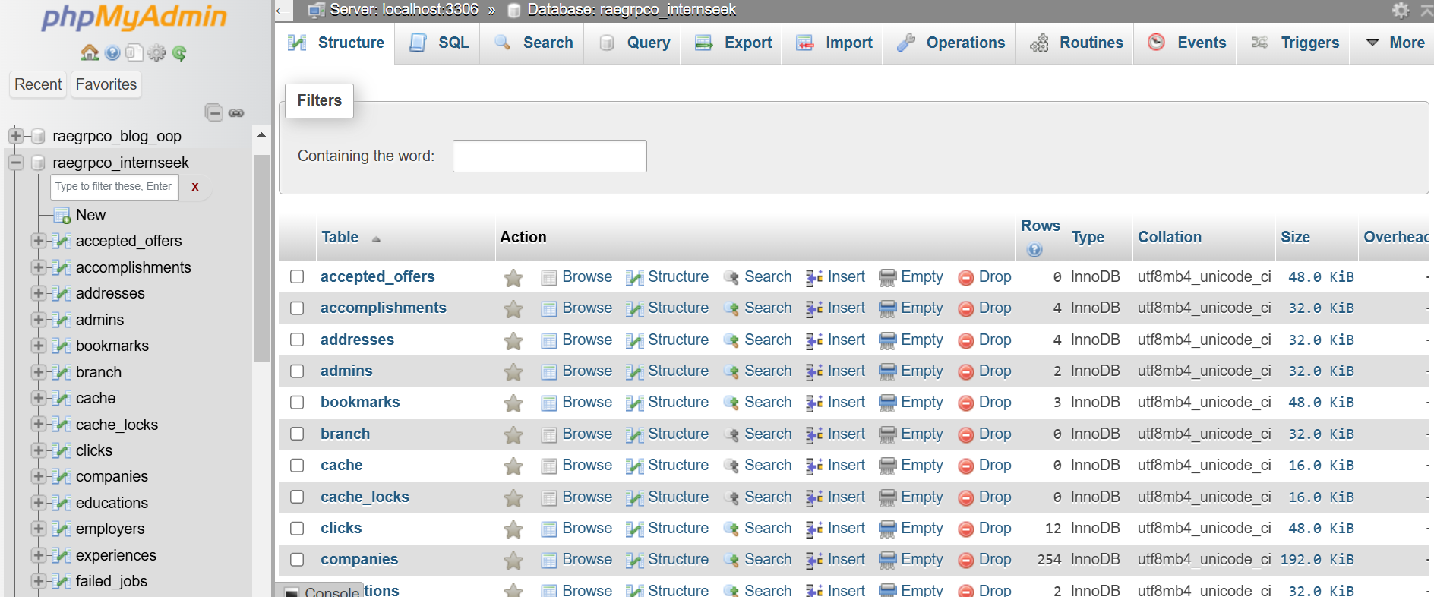

Figure 4‑143: PhpMyAdmin Interface From cPanel

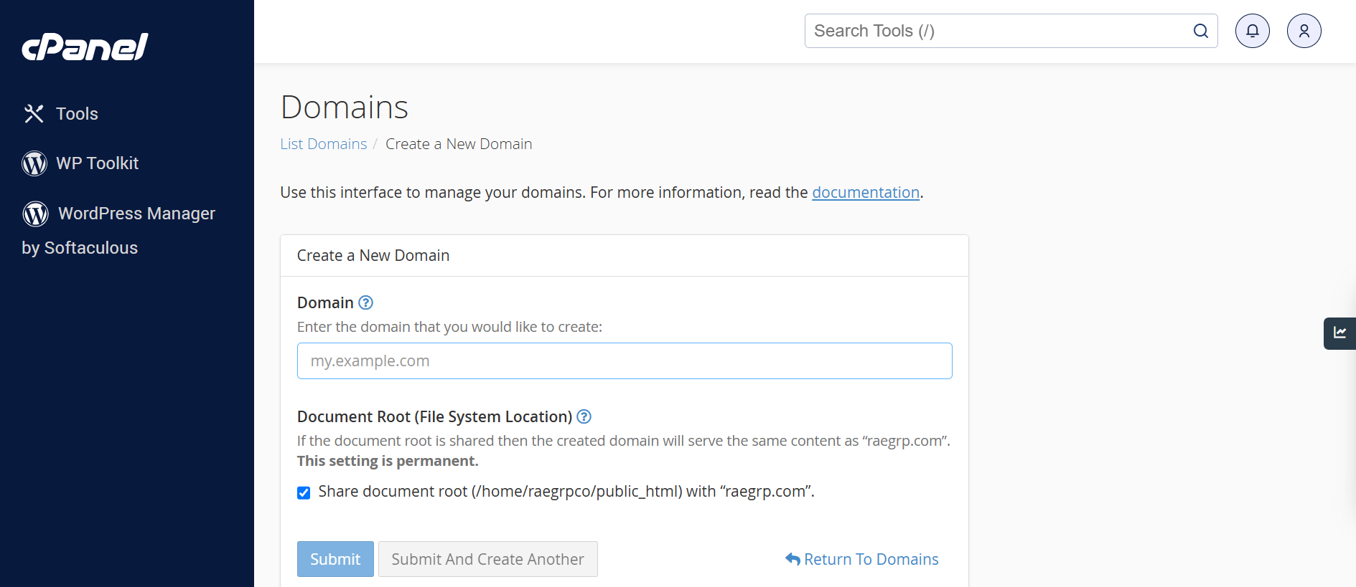

Figure 4‑144: Create New Domain in cPanel

## Test Plan Implementation

The proposed system is being developed in a sequential manner following the Waterfall methodology. User Acceptance Testing (UAT) and functional testing will be conducted after the development phase to verify and validate the system. These tests ensure that the system meets the specified requirements and user expectations. UAT will be performed with the employers and university students once the system is fully developed and ready for deployment.

### Functional Testing

Functional testing is a type of software testing that focuses on verifying that the system behaves according to the specified functional requirements. It ensures that all features of the Internseek system work as intended based on its requirements. This involves testing core functionalities like viewing internship listings, submitting applications, and updating statuses to verify they perform as expected. Each functionality is tested based on defined use cases to ensure reliability. The table below categorizes the functionalities within each module, organized by actor and aligned with the constructed use cases:

Table 4‑1: Functional Testing Results by Actor and Module

|  |  |  |  |
| --- | --- | --- | --- |
| **Actor** | **Module** | **Functionality** | **Test Result** |
| Public | View Company Listing | View Company Listing | Pass |
| View Company Details | Pass |
| View Internship Listing | View Internship Listing | Pass |
| View Internship Details | Pass |
| Manage Analytics & Reporting | Top 3 Companies | Pass |
| Student | Register Account | Register a student account | Pass |
| Manage Login | Login using password and email | Pass |
| Login using LinkedIn account | Pass |
| Forgot Password | Pass |
| Reset Password | Pass |
| Remember me | Pass |
| View Company Listing | View Company Listing | Pass |
| View Company Details | Pass |
| View Internship Listing | View Internship Listing | Pass |
| View the metrics of internships | Pass |
| View Internship Details | Pass |
| Bookmark Internships | Pass |
| Report Internships | Pass |
| View Reports | Pass |
| Manage User Profile | View Profile Details | Pass |
| Edit Basic Information | Pass |
| Edit Profile Picture | Pass |
| Remove Profile Picture | Pass |
| Add Experience | Pass |
| Edit Experience | Pass |
| Delete Experience | Pass |
| Add Education | Pass |
| Edit Education | Pass |
| Delete Education | Pass |
| Add Skill | Pass |
| Edit Skill | Pass |
| Delete Skill | Pass |
| Add Accomplishment | Pass |
| Edit Accomplishment | Pass |
| Delete Accomplishment | Pass |
| Add Referee | Pass |
| Edit Referee | Pass |
| Delete Referee | Pass |
| Edit Language | Pass |
| Add LinkedIn Public URL | Pass |
| Generate Resume | Pass |
| Change Password | Pass |
| View All Notifications | Pass |
| Clear All Notifications | Pass |
| Mark Unread Notifications as read | Pass |
| Manage Internship Application | Apply Internship | Pass |
| View Applied Internships | Pass |
| Cancel Internship Application | Pass |
| View Need-to-Interview Internships | Pass |
| Reply about the availability of interviews | Pass |
| View Shortlisted Internships | Pass |
| View Approved Internships | Pass |
| Accept Offer/Reject Offer | Pass |
| View Accepted Offers | Pass |
| Cancel Accepted Offer | Pass |
| Manage Analytics and Reporting | View Internship Metrics | Pass |
| View Bookmark Internships | Pass |
| View Matched Internships | Pass |
| Manage Messaging Features | Send Message | Pass |
| View Received Message and Reply Message | Pass |
| Employer | Register Account | Register an employer account | Pass |
| Manage Login | Login using password and email | Pass |
| Forgot Password | Pass |
| Reset Password | Pass |
| Remember me | Pass |
| Manage Company Registration | Search for Existing Company | Pass |
| Register for a New Company | Pass |
| Edit Registration Details | Pass |
| Review and Update Status of Employer Accounts | Pass |
| Manage User Profile | View Employer Details | Pass |
| Edit Employer Details | Pass |
| Change Password | Pass |
| View Company Details | Pass |
| Edit Company Details | Pass |
| View Branch & Site Details | Pass |
| Add Branch | Pass |
| Add Site | Pass |
| Edit Branch | Pass |
| Edit Site | Pass |
| Delete Branch | Pass |
| Delete Site | Pass |
| View All Notifications | Pass |
| Clear All Notifications | Pass |
| Mark Unread Notifications as read | Pass |
| Manage Internship Posting | View Internship Postings | Pass |
| View the metrics of internship postings | Pass |
| Post an internship | Pass |
| View Internship Posting Details | Pass |
| Edit Internship Posting Details | Pass |
| Delete Internship Posting | Pass |
| Handle the archived internship posting | Pass |
| Manage Internship Application | View Applicants List | Pass |
| Update Application Status | Pass |
| View Need-to-Interview Applicants List | Pass |
| Edit Interview Details | Pass |
| Update Interview Result | Pass |
| View Shortlisted/Approved Applicants List | Pass |
| Update Shortlisted Result | Pass |
| View Accepted Applicants List | Pass |
| Update Working Details | Pass |
| View Rejected Applicants List | Pass |
| Manage Analytics and Reporting | Employer Dashboard Metrics | Pass |
| Monthly Internship Applications Report (My Report) | Pass |
| Manage Messaging Features | Send Message | Pass |
| View Received Message and Reply Message | Pass |
| Admin | Manage Login | Login using password and email | Pass |
| Forgot Password | Pass |
| Reset Password | Pass |
| Remember me | Pass |
| Manage User Profile | View Admin Details | Pass |
| Edit Admin Details | Pass |
| Change Password | Pass |
| Manage Company Registration | View Company Registration List | Pass |
| Review & Update Company Registration Status | Pass |
| Manage Internship Posting | View Internship Problem Reports | Pass |
| Update action and status | Pass |
| Manage Analytics and Reporting | Overall System Metrics | Pass |
| View Available Internships | Pass |
| View Registered University Students | Pass |
| View Registered Companies | Pass |
| View Registered Student Details | Pass |
| View Registered Company Details & Update Company Rating | Pass |
| View Available Internship Details | Pass |

##### Public

This section highlights test cases designed for public users, meaning users who have not logged into the system. These test cases validate the core functionalities that are available to all users, regardless of authentication status. The goal is to ensure that features such as viewing internship listings, company listings, internship details, company details, Top 3 Companies and searching for internships and companies function properly for users who are not logged in. The table below summarizes the test cases and results for public users functionalities

Table 4‑2: Public Users Functionality Test Cases and Result Overview

|  |  |  |  |
| --- | --- | --- | --- |
| **Module** | **Functionality** | **Description** | **Test Result** |
| View Company Listing | View Company Listing | Browse available companies | Pass |
| View Company Details | View detailed information about companies | Pass |
| View Internship Listing | View Internship Listing | Browse available internships | Pass |
| View Internship Details | View detailed internship information | Pass |
| Manage Analytics & Reporting | Top 3 Companies | Display Top 3 Companies Chart based on the highest number of internship applications | Pass |

Table 4‑3: Functional Test Case for Viewing Internship Listing

|  |  |  |  |
| --- | --- | --- | --- |
| **Actor** | Public | | |
| **Module** | View Internship Listing | | |
| **Functionality** | View Internship Listing | | |
| **Objective** | To validate the system displays a list of available internships. | | |
| **Pre-condition** | - | | |
| **Testing Step** | 1. Visit Internseek website.  2. Click the Search Internship option on the navbar. | | |
| **Input** | **Expected Result** | **Actual Result** | **Test Result** |
| - | The system displays the internship listing. | The system displays the internship listing. | Pass |

Table 4‑4: Functional Test Case for Search by Keyword in Internship Listing

|  |  |  |  |
| --- | --- | --- | --- |
| **Actor** | Public | | |
| **Module** | View Internship Listing | | |
| **Functionality** | View Internship Listing (Search by keyword in internships listing) | | |
| **Objective** | To validate the system displays a list of internships based on the entered keyword. | | |
| **Pre-condition** | At the internship listing page | | |
| **Testing Step** | 1. Enter the search keyword in the input field. | | |
| **Input** | **Expected Result** | **Actual Result** | **Test Result** |
| 1. Search Keyword | The system displays internships related to the search keyword. | The system displays internships related to the search keyword. | Pass |

Table 4‑5: Functional Test Case for Search by Location in Internship Listing

|  |  |  |  |
| --- | --- | --- | --- |
| **Actor** | Public | | |
| **Module** | View Internship Listing | | |
| **Functionality** | View Internship Listing (Search by location in internships listing) | | |
| **Objective** | To validate the system displays a list of internships based on the selected location. | | |
| **Pre-condition** | At the internship listing page | | |
| **Testing Step** | 1. Locate the select field for the location.  2. Select the location from the dropdown menu.  3. Click the option. | | |
| **Input** | **Expected Result** | **Actual Result** | **Test Result** |
| 1. Location | The system displays internships related to the selected location. | The system displays internships related to the selected location. | Pass |

Table 4‑6: Functional Test Case for Search by Study Field in Internship Listing

|  |  |  |  |
| --- | --- | --- | --- |
| **Actor** | Public | | |
| **Module** | View Internship Listing | | |
| **Functionality** | View Internship Listing (Search by study field in internships listing) | | |
| **Objective** | To validate the system displays a list of internships based on the selected study field. | | |
| **Pre-condition** | At the internship listing page | | |
| **Testing Step** | 1. Locate the select field for the study field.  2. Select the study field from the dropdown menu.  3. Click the option. | | |
| **Input** | **Expected Result** | **Actual Result** | **Test Result** |
| 1. Study Field | The system displays internships related to the selected study field. | The system displays internships related to the selected study field. | Pass |

Table 4‑7: Functional Test Case for Viewing Internship Details

|  |  |  |  |  |
| --- | --- | --- | --- | --- |
| **Actor** | Public | | | |
| **Module** | View Internship Listing | | | |
| **Functionality** | View Internship Details | | | |
| **Objective** | To validate the system displays the detailed information of the selected internship. | | | |
| **Pre-condition** | At the internship listing page | | | |
| **Testing Step** | 1. Locate an internship from the list.  2. Click on the **Internship Title Heading** of the selected internship. | | | |
| **Input** | **Expected Result** | | **Actual Result** | **Test Result** |
| 1. Click the Internship Title Heading | The system displays the detailed information of the selected internship. | The system displays the detailed information of the selected internship. | | Pass |

Table 4‑8: Functional Test Case for Viewing Company Listing

|  |  |  |  |
| --- | --- | --- | --- |
| **Actor** | Public | | |
| **Module** | View Company Listing | | |
| **Functionality** | View Company Listing | | |
| **Objective** | To validate the system displays a list of registered companies. | | |
| **Pre-condition** | - | | |
| **Testing Step** | 1. Visit Internseek website.  2. Click the Search Company option on the navbar. | | |
| **Input** | **Expected Result** | **Actual Result** | **Test Result** |
| - | The system displays the company listing. | The system displays the company listing. | Pass |

Table 4‑9: Functional Test Case for Search by Keyword in Company Listing

|  |  |  |  |
| --- | --- | --- | --- |
| **Actor** | Public | | |
| **Module** | View Company Listing | | |
| **Functionality** | View Company Listing (Search by keyword) | | |
| **Objective** | To validate the system displays a list of internships based on the entered keyword. | | |
| **Pre-condition** | At the company listing page | | |
| **Testing Step** | 1. Enter the search keyword in the input field. | | |
| **Input** | **Expected Result** | **Actual Result** | **Test Result** |
| 1. Keyword | The system displays the company listing based on the inserted keyword. | The system displays the company listing based on the inserted keyword. | Pass |

Table 4‑10: Functional Test Case for Search by Location in Company Listing

|  |  |  |  |
| --- | --- | --- | --- |
| **Actor** | Public | | |
| **Module** | View Company Listing | | |
| **Functionality** | View Company Listing (Search by location) | | |
| **Objective** | To validate the system displays a list of internships based on the selected location. | | |
| **Pre-condition** | At the company listing page | | |
| **Testing Step** | 1. Locate the select field for the location.  2. Select the location from the dropdown menu.  3. Click the option. | | |
| **Input** | **Expected Result** | **Actual Result** | **Test Result** |
| 1. Location | The system displays the company listing based on the selected location. | The system displays the company listing based on the selected location. | Pass |

Table 4‑11: Functional Test Case for Viewing Company Details

|  |  |  |  |
| --- | --- | --- | --- |
| **Actor** | Public | | |
| **Module** | View Company Listing | | |
| **Functionality** | View Company Details | | |
| **Objective** | To validate the system displays the detailed information of the selected company. | | |
| **Pre-condition** | At the company listing page | | |
| **Testing Step** | 1. Locate an internship from the list.  2. Click on the **Company Name Heading** of the selected internship. | | |
| **Input** | **Expected Result** | **Actual Result** | **Test Result** |
| 1. Click the Company Name Heading | The system displays the detailed information of the selected company. | The system displays the detailed information of the selected company. | Pass |

Table 4‑12: Functional Test Case for Viewing Top 3 Companies

|  |  |  |  |
| --- | --- | --- | --- |
| **Actor** | Public | | |
| **Module** | Manage Analytics and Reporting | | |
| **Functionality** | Top 3 Companies | | |
| **Objective** | To validate that the system displays the Top 3 Companies pie chart based on the highest number of internship applications. | | |
| **Pre-condition** | - | | |
| **Testing Step** | 1. Visit Internseek website. | | |
| **Input** | **Expected Result** | **Actual Result** | **Test Result** |
| - | The system displays the homepage with the Top 3 Companies pie chart. | The system displays the homepage with the Top 3 Companies pie chart. | Pass |

##### University Students

This section outlines the test cases developed for university students to validate the core functionalities provided to them. The goal is to ensure that features such as account registration, login, viewing internship and company listings, managing user profile, applying for internships, utilizing analytics and reporting, and using messaging features are functioning correctly. The table below summarizes the test cases and results for university student functionalities.

Table 4‑13: University Students Functionality Test Cases and Result Overview

|  |  |  |  |
| --- | --- | --- | --- |
| **Module** | **Functionality** | **Description** | **Test Result** |
| Register Account | Register a student account | Register a student account | Pass |
| Manage Login | Login using password and email | Log in using valid credentials | Pass |
| Login using LinkedIn account | Log in using a LinkedIn account | Pass |
| Forgot Password | Request a password reset | Pass |
| Reset Password | Successfully reset password | Pass |
| Remember me | Remember student’s email during next login | Pass |
| View Company Listing | View Company Listing | Browse available companies | Pass |
| View Company Details | View detailed information about companies | Pass |
| View Internship Listing | View Internship Listing | Browse available internships | Pass |
| View the metrics of internships | Display internship statistics (e.g., clicks, bookmarks, and applications) | Pass |
| View Internship Details | View detailed internship information | Pass |
| Bookmark Internships | Save internships for later viewing | Pass |
| Report Internships | Report an internship for issues | Pass |
| View Reports | Access generated reports | Pass |
| Manage User Profile | View Profile Details | View personal profile information | Pass |
| Edit Basic Information | Update basic profile details | Pass |
| Edit Profile Picture | Upload a new profile picture | Pass |
| Remove Profile Picture | Delete the current profile picture | Pass |
| Add Experience | Add work experience details | Pass |
| Edit Experience | Update work experience details | Pass |
| Delete Experience | Remove work experience details | Pass |
| Add Education | Add education history | Pass |
| Edit Education | Update education history | Pass |
| Delete Education | Remove education history | Pass |
| Add Skill | Add a new skill | Pass |
| Edit Skill | Update existing skill details | Pass |
| Delete Skill | Remove an existing skill | Pass |
| Add Accomplishment | Add achievements | Pass |
| Edit Accomplishment | Update achievements | Pass |
| Delete Accomplishment | Remove achievements | Pass |
| Add Referee | Add references | Pass |
| Edit Referee | Update references | Pass |
| Delete Referee | Remove references | Pass |
| Edit Language | Update language details | Pass |
| Add LinkedIn Public URL | Add LinkedIn profile link | Pass |
| Generate Resume | Create a resume based on profile data | Pass |
| Change Password | Update account password | Pass |
| View All Notifications | See all account notifications | Pass |
| Clear All Notifications | Delete all notifications | Pass |
| Mark Unread Notifications as read | Mark unread notifications as read | Pass |
| Manage Internship Application | Apply Internship | Submit applications for internships | Pass |
| View Applied Internships | Access a list of submitted applications | Pass |
| Cancel Internship Application | Cancel the submitted application that are still reviewing. | Pass |
| View Need-to-Interview Internships | Check internships requiring interviews | Pass |
| Reply about the availability of interviews | Respond to interview invitations | Pass |
| View Shortlisted Internships | Access internships where the student is shortlisted | Pass |
| View Approved Internships | Check internships where the student has received an offer from employers | Pass |
| Accept Offer/Reject Offer | Accept or reject the offer | Pass |
| View Accepted Offers | Access a list of accepted offers | Pass |
| Cancel Accepted Offer | Cancel the accepted offer | Pass |
| Manage Analytics and Reporting | View Internship Metrics | Displays the number of applied internships, need-to-interview internships, shortlisted internships, and approved internships | Pass |
| View Bookmark Internships | Access saved internships | Pass |
| View Matched Internships | Check internships matched to the student’s study field | Pass |
| Manage Messaging Features | Send Message | Communicate with employers | Pass |
| View Received Message and Reply Message | Access and reply to incoming messages | Pass |

Table 4‑14: Functional Test Case for Student Account Registration

|  |  |  |  |
| --- | --- | --- | --- |
| **Actor** | University Student | | |
| **Module** | Register Account | | |
| **Functionality** | Register a student account | | |
| **Objective** | To validate the system can register an account for a student. | | |
| **Pre-condition** | At the homepage and not logged in. | | |
| **Testing Step** | 1. Click the Sign Up button on the navbar.  2. Click the Sign Up button located in the Student Sign Up Modal.  3. Visit the Student Registration Page.  4. Enter the registration details in the form.  5. Click the <<Sign Up>> button. | | |
| **Input** | **Expected Result** | **Actual Result** | **Test Result** |
| 1. First Name  2. Last Name  3. Email  4. Phone Number  5. Password  6. Confirm Password | The system displays register account successfully and redirect the student to the internship listing page. | The system displays register account successfully and redirect the student to the internship listing page. | Pass |

Table 4‑15: Functional Test Case Student Account Registration (Invalid Email)

|  |  |  |  |
| --- | --- | --- | --- |
| **Actor** | University Student | | |
| **Module** | Register Account | | |
| **Functionality** | Register a student account **(Invalid Email Address)** | | |
| **Objective** | To validate the system can verify the invalid email during student registration. | | |
| **Pre-condition** | At the homepage and not logged in. | | |
| **Testing Step** | 1. Click the Sign Up button on the navbar.  2. Click the Sign Up button located in the Student Sign Up Modal.  3. Visit the Student Registration Page.  4. Enter the registration details with an invalid email in the form.  5. Click the <<Sign Up>> button. | | |
| **Input** | **Expected Result** | **Actual Result** | **Test Result** |
| 1. First Name  2. Last Name  3. Invalid Email  4. Phone Number  5. Password  6. Confirm Password | The system displays invalid email address error message. | The system displays invalid email address error message. | Pass |

Table 4‑16: Functional Test Case Student Account Registration (Existing Email)

|  |  |  |  |
| --- | --- | --- | --- |
| **Actor** | University Student | | |
| **Module** | Register Account | | |
| **Functionality** | Register a student account **(Email Address already exists)** | | |
| **Objective** | To validate the system can verify the existing email during student registration. | | |
| **Pre-condition** | At the homepage and not logged in. | | |
| **Testing Step** | 1. Click the Sign Up button on the navbar.  2. Click the Sign Up button located in the Student Sign Up Modal.  3. Visit the Student Registration Page.  4. Enter the registration details using an existing email address in the form.  5. Click the <<Sign Up>> button. | | |
| **Input** | **Expected Result** | **Actual Result** | **Test Result** |
| 1. First Name  2. Last Name  3. Existing Email  4. Phone Number  5. Password  6. Confirm Password | The system displays email address already exists error message. | The system displays email address already exists error message. | Pass |

Table 4‑17: Functional Test Case Student Account Registration (Mismatch Password and Confirm Password)

|  |  |  |  |
| --- | --- | --- | --- |
| **Actor** | University Student | | |
| **Module** | Register Account | | |
| **Functionality** | Register a student account **(Password and Confirm Password Mismatch)** | | |
| **Objective** | To validate the system detects and notifies the user when the password and confirm password fields do not match. | | |
| **Pre-condition** | At the homepage and not logged in. | | |
| **Testing Step** | 1. Click the Sign Up button on the navbar.  2. Click the Sign Up button located in the Student Sign Up Modal.  3. Visit the Student Registration Page.  4. Enter registration details, ensuring the Password and Confirm Password fields are different.  5. Click the <<Sign Up>> button. | | |
| **Input** | **Expected Result** | **Actual Result** | **Test Result** |
| 1. First Name  2. Last Name  3. Email  4. Phone Number  5. Password: password123  6. Confirm Password: password321 | The system displays a password and confirm password do not match error message. | The system displays a password and confirm password do not match error message. | Pass |

Table 4‑18: Functional Test Case Student Account Registration (Invalid Password)

|  |  |  |  |
| --- | --- | --- | --- |
| **Actor** | University Student | | |
| **Module** | Register Account | | |
| **Functionality** | Register a student account **(Invalid Password)** | | |
| **Objective** | To validate the system detects and notifies the user when the password does not meet the required criteria. | | |
| **Pre-condition** | At the homepage and not logged in. | | |
| **Testing Step** | 1. Click the Sign Up button on the navbar.  2. Click the Sign Up button located in the Student Sign Up Modal.  3. Visit the Student Registration Page.  4. Enter registration details with an invalid password in the form.  5. Click the <<Sign Up>> button. | | |
| **Input** | **Expected Result** | **Actual Result** | **Test Result** |
| 1. First Name  2. Last Name  3. Email  4. Phone Number  5. Password  6. Confirm Password | The system displays an invalid password error message. | The system displays an invalid password error message. | Pass |

Table 4‑19: Functional Test Case Student Login with Email

|  |  |  |  |
| --- | --- | --- | --- |
| **Actor** | University Student | | |
| **Module** | Manage Login | | |
| **Functionality** | Login using password and email | | |
| **Objective** | To validate the system can verify student login information. | | |
| **Pre-condition** | At the homepage and not logged in. | | |
| **Testing Step** | 1. Click the Sign In button on the navbar.  2. Click the Sign In button located in the Student Login Modal.  3. Visit the Student Login Page.  4. Enter the email and password.  5. Click the Sign In button. | | |
| **Input** | **Expected Result** | **Actual Result** | **Test Result** |
| 1. Student Email  2. Password | The system displays login successfully and redirect the student to the internship listing page. | The system displays login successfully and redirect the student to the internship listing page. | Pass |

Table 4‑20: Functional Test Case Student Login with LinkedIn Account

|  |  |  |  |
| --- | --- | --- | --- |
| **Actor** | University Student | | |
| **Module** | Manage Login | | |
| **Functionality** | Login using LinkedIn account | | |
| **Objective** | To validate that university students can log in using their LinkedIn account and are redirected to the internship listing page. | | |
| **Pre-condition** | At the homepage and not logged in. | | |
| **Testing Step** | 1. Click the Sign In button on the navbar.  2. Click the Sign In button located in the Student Login Modal.  3. Visit the Student Login Page.  4. Click the Sign In with LinkedIn button.  5. Visit the LinkedIn Authentication Page.  6. Enter LinkedIn account email and password.  7. Click the Sign In button. | | |
| **Input** | **Expected Result** | **Actual Result** | **Test Result** |
| 1. LinkedIn Account Email  2. LinkedIn Account Password | The system displays login successfully and redirect the student to the internship listing page. | The system displays login successfully and redirect the student to the internship listing page. | Pass |

Table 4‑21: Functional Test Case Student Login with Email (Invalid Email)

|  |  |  |  |
| --- | --- | --- | --- |
| **Actor** | University Student | | |
| **Module** | Manage Login | | |
| **Functionality** | Login using password and email **(Invalid Email)** | | |
| **Objective** | To validate the system can verify invalid email. | | |
| **Pre-condition** | At the homepage and not logged in. | | |
| **Testing Step** | 1. Click the Sign In button on the navbar.  2. Click the Sign In button located in the Student Login Modal.  3. Visit the Student Login Page.  4. Enter the invalid email and password.  5. Click the Sign In button. | | |
| **Input** | **Expected Result** | **Actual Result** | **Test Result** |
| 1. Invalid student email. | The system displays invalid email address message. | The system displays invalid email address message. | Pass |

Table 4‑22: Functional Test Case Student Login with Email (Invalid Password)

|  |  |  |  |
| --- | --- | --- | --- |
| **Actor** | University Student | | |
| **Module** | Manage Login | | |
| **Functionality** | Login using password and email **(Invalid Password)** | | |
| **Objective** | To validate the system can verify invalid password. | | |
| **Pre-condition** | At the homepage and not logged in. | | |
| **Testing Step** | 1. Click the Sign In button on the navbar.  2. Click the Sign In button located in the Student Login Modal.  3. Visit the Student Login Page.  4. Enter the email and invalid password.  5. Click the Sign In button. | | |
| **Input** | **Expected Result** | **Actual Result** | **Test Result** |
| 1. Invalid Password | The system displays invalid login credentials message. | The system displays invalid login credentials message. | Pass |

Table 4‑23: Functional Test Case Student Login with LinkedIn Account (Invalid Login Credentials

|  |  |  |  |
| --- | --- | --- | --- |
| **Actor** | University Student | | |
| **Module** | Manage Login | | |
| **Functionality** | Login using LinkedIn account **(Invalid Login Credentials)** | | |
| **Objective** | To validate that the system properly handles invalid login credentials when a student attempts to log in via LinkedIn. | | |
| **Pre-condition** | At the homepage and not logged in. | | |
| **Testing Step** | 1. Click the Sign In button on the navbar.  2. Click the Sign In button located in the Student Login Modal.  3. Visit the Student Login Page.  4. Click the Sign In with LinkedIn button.  5. Visit the LinkedIn Authentication Page.  6. Enter incorrect LinkedIn account email and password.  7. Click the Sign In button. | | |
| **Input** | **Expected Result** | **Actual Result** | **Test Result** |
| 1. Incorrect LinkedIn Account Password  2. Incorrect LinkedIn Account Email | The LinkedIn authentication page displays invalid login credentials message. | The LinkedIn authentication page displays invalid login credentials message. | Pass |

Table 4‑24: Functional Test Case for "Remember Me" Feature in Student Login

|  |  |  |  |
| --- | --- | --- | --- |
| **Actor** | University Student | | |
| **Module** | Manage Login | | |
| **Functionality** | Remember me | | |
| **Objective** | To validate the system remembers the student's email when the "Remember Me" option is selected. | | |
| **Pre-condition** | At the student login page | | |
| **Testing Step** | 1. At the Student Login Page, enter email and password.  2. Select the Remember Me checkbox.  3. Click the Sign In button.  4. Click the Logout option in the navbar dropdown menu.  5. Close and reopen the browser.  6. Visit the student login page again. | | |
| **Input** | **Expected Result** | **Actual Result** | **Test Result** |
| 1. Student Email  2. Password | The system displays the student's email pre-filled in the **Email** input field. | The system displays the student's email pre-filled in the **Email** input field. | Pass |

Table 4‑25: Functional Test Case for "Forgot Password" Feature in Student Login

|  |  |  |  |
| --- | --- | --- | --- |
| **Actor** | University Student | | |
| **Module** | Manage Login | | |
| **Functionality** | Forgot Password | | |
| **Objective** | To validate the system can display the forgot password page. | | |
| **Pre-condition** | At the student login page | | |
| **Testing Step** | 1. Click the "Forgot Password" link. | | |
| **Input** | **Expected Result** | **Actual Result** | **Test Result** |
| - | The system redirects the student to the forgot password page. | The system redirects the student to the forgot password page. | Pass |

Table 4‑26: Functional Test Case for “Reset Password” Feature in Student Login

|  |  |  |  |
| --- | --- | --- | --- |
| **Actor** | University Student | | |
| **Module** | Manage Login | | |
| **Functionality** | Reset Password | | |
| **Objective** | To validate the system can reset the password for an student. | | |
| **Pre-condition** | At the forgot password page | | |
| **Testing Step** | 1. Enter the email address.  2. Click the "Reset Password" button.  3. Check the email inbox for the reset link.  4. Click the reset password link in the email.  5. Enter a new password in the reset password page.  6. Confirm the new password and submit. | | |
| **Input** | **Expected Result** | **Actual Result** | **Test Result** |
| 1. Student Email  2. New Password  3. Confirm Password | The system updates the password and redirects the student to the internship listing page. | The system updates the password and redirects the student to the internship listing page. | Pass |

Table 4‑27: Functional Test Case for "Reset Password" Feature in Student Login (Invalid Email)

|  |  |  |  |
| --- | --- | --- | --- |
| **Actor** | University Student | | |
| **Module** | Manage Login | | |
| **Functionality** | Reset Password **(Invalid Email)** | | |
| **Objective** | To validate the system can detect invalid email address error message during student reset password. | | |
| **Pre-condition** | At the forgot password page | | |
| **Testing Step** | 1. Enter the invalid email address.  2. Click the "Reset Password" button. | | |
| **Input** | **Expected Result** | **Actual Result** | **Test Result** |
| 1. Invalid Student Email | The system displays “Users not found” error message. | The system displays “Users not found” error message. | Pass |

Table 4‑28: Functional Test Case for "Reset Password" Feature in Student Login (Password and Confirm Password Mismatch)

|  |  |  |  |
| --- | --- | --- | --- |
| **Actor** | University Student | | |
| **Module** | Manage Login | | |
| **Functionality** | Reset Password **(Password & Confirm Password are not same)** | | |
| **Objective** | To validate the system displays an appropriate error message when the **New Password** and **Confirm Password** fields do not match. | | |
| **Pre-condition** | At the forgot password page | | |
| **Testing Step** | 1. Enter the email address.  2. Click the "Reset Password" button.  3. Check the email inbox for the reset link.  4. Click the reset password link in the email.  5. Enter a new password in the reset password page.  6. Enter an invalid password in the confirm password field and submit. | | |
| **Input** | **Expected Result** | **Actual Result** | **Test Result** |
| 1. Student Email  2. New Password  3. Invalid Confirm Password | The system displays “New Password and Confirm Password are not matched”. | The system displays “New Password and Confirm Password are not matched”. | Pass |

Table 4‑29: Functional Test Case for University Students View Internship Listing

|  |  |  |  |
| --- | --- | --- | --- |
| **Actor** | University Student | | |
| **Module** | View Internship Listing | | |
| **Functionality** | View Internship Listing | | |
| **Objective** | To validate the system displays a list of available internships for students. | | |
| **Pre-condition** | At the internship listing page and logged in. | | |
| **Testing Step** | 1. Once the student is logged into the system, they will be redirected to the internship listing page. | | |
| **Input** | **Expected Result** | **Actual Result** | **Test Result** |
| - | The system displays the **internship listing**, with each card containing an **Apply Now** button. | The system displays the **internship listing**, with each card containing an **Apply Now** button. | Pass |

Table 4‑30: Functional Test Case for University Students Searching by Keyword in Internship Listings

|  |  |  |  |
| --- | --- | --- | --- |
| **Actor** | University Student | | |
| **Module** | View Internship Listing | | |
| **Functionality** | View Internship Listing (Search by keyword in internships listing) | | |
| **Objective** | To validate the system displays a list of internships based on the entered keyword. | | |
| **Pre-condition** | At the internship listing page and logged in. | | |
| **Testing Step** | 1. Enter the search keyword in the input field. | | |
| **Input** | **Expected Result** | **Actual Result** | **Test Result** |
| 1. Search Keyword | The system displays internships related to the search keyword. | The system displays internships related to the search keyword. | Pass |

Table 4‑31: Functional Test Case for University Students Searching by Study Field in Internship Listings

|  |  |  |  |
| --- | --- | --- | --- |
| **Actor** | University Student | | |
| **Module** | View Internship Listing | | |
| **Functionality** | View Internship Listing (Search by study field in internships listing) | | |
| **Objective** | To validate the system displays a list of internships based on the selected study field. | | |
| **Pre-condition** | At the internship listing page and logged in. | | |
| **Testing Step** | 1. Locate the select field for the study field.  2. Select the study field from the dropdown menu.  3. Click the option. | | |
| **Input** | **Expected Result** | **Actual Result** | **Test Result** |
| 1. Study Field | The system displays internships related to the selected study field. | The system displays internships related to the selected study field. | Pass |

Table 4‑32: Functional Test Case for University Students Searching by Location in Internship Listings

|  |  |  |  |
| --- | --- | --- | --- |
| **Actor** | University Student | | |
| **Module** | View Internship Listing | | |
| **Functionality** | View Internship Listing (Search by location in internships listing) | | |
| **Objective** | To validate the system displays a list of internships based on the selected location. | | |
| **Pre-condition** | At the internship listing page and logged in. | | |
| **Testing Step** | 1. Locate the select field for the location.  2. Select the location from the dropdown menu.  3. Click the option. | | |
| **Input** | **Expected Result** | **Actual Result** | **Test Result** |
| 1. Location | The system displays internships related to the selected location. | The system displays internships related to the selected location. | Pass |

Table 4‑33: Functional Test Case for University Students View Internship Details

|  |  |  |  |
| --- | --- | --- | --- |
| **Actor** | University Student | | |
| **Module** | View Internship Listing | | |
| **Functionality** | View Internship Details | | |
| **Objective** | To validate the system displays the detailed information of the selected internship. | | |
| **Pre-condition** | At the internship listing page and logged in. | | |
| **Testing Step** | 1. Locate an internship from the list.  2. Click on the **Internship Title Heading** of the selected internship. | | |
| **Input** | **Expected Result** | **Actual Result** | **Test Result** |
| 1. Click the Internship Title Heading | The system displays the detailed information of the selected internship, with buttons: **apply**, **bookmark**, **message**, **report**. | The system displays the detailed information of the selected internship, with buttons: **apply**, **bookmark**, **message**, **report**. | Pass |

Table 4‑34: Functional Test Case for University Students Viewing Internship Metrics in Internship Listing

|  |  |  |  |
| --- | --- | --- | --- |
| **Actor** | University Student | | |
| **Module** | View Internship Listing | | |
| **Functionality** | View the metrics of internships | | |
| **Objective** | To validate the system displays a list of available internships with the metrics for students. | | |
| **Pre-condition** | At the internship listing page and logged in. | | |
| **Testing Step** | 1. Once the student is logged into the system, they will be redirected to the internship listing page.  2. Review the displayed internship cards for metrics such as the number of applications, views, and bookmark. | | |
| **Input** | **Expected Result** | **Actual Result** | **Test Result** |
| - | The system displays a list of internships, and each card shows metrics such as applications, views, and bookmarks for the internship. | The system displays a list of internships, and each card shows metrics such as applications, views, and bookmarks for the internship. | Pass |

Table 4‑35: Functional Test Case for University Students Bookmark Internship

|  |  |  |  |
| --- | --- | --- | --- |
| **Actor** | University Student | | |
| **Module** | View Internship Listing | | |
| **Functionality** | Bookmark Internships | | |
| **Objective** | To validate the system allows students to bookmark internships. | | |
| **Pre-condition** | At the internship listing page and logged in. | | |
| **Testing Step** | 1. Locate an internship from the list.  2. Click on the **Internship Title Heading** of the selected internship.  3. Review the detailed information of the internship.  4. Click the Bookmark button on the internship details page. | | |
| **Input** | **Expected Result** | **Actual Result** | **Test Result** |
| Click the bookmark button | The system bookmarks the internship for the student and displays an internship bookmarked successfully message. | The system bookmarks the internship for the student and displays an internship bookmarked successfully message. | Pass |

Table 4‑36: Functional Test Case for University Students Report Internship

|  |  |  |  |
| --- | --- | --- | --- |
| **Actor** | University Student | | |
| **Module** | View Internship Listing | | |
| **Functionality** | Report Internships | | |
| **Objective** | To validate the system allows students to report internships. | | |
| **Pre-condition** | At the internship listing page and logged in. | | |
| **Testing Step** | 1. Locate an internship from the list.  2. Click on the **Internship Title Heading** of the selected internship.  3. Review the detailed information of the internship.  4. Click the Report button on the internship details page.  5. In the Report Modal:   * Select an option from the predefined list. * If "Other" is selected, describe the issue in the provided text area.   6. Submit the report. | | |
| **Input** | **Expected Result** | **Actual Result** | **Test Result** |
| Select an option from the predefined list in the modal. | The system confirms the report submission with a success message and logs the report for admin review. | The system confirms the report submission with a success message and logs the report for admin review. | Pass |
| Select "Other" and provide a description of the problem. | The system confirms the report submission with the description included, logs the report for admin review, and displays a success message. | The system confirms the report submission with the description included, logs the report, and displays a success message. | Pass |

Table 4‑37: Functional Test Case for University Students Viewing Internships They Report

|  |  |  |  |
| --- | --- | --- | --- |
| **Actor** | University Student | | |
| **Module** | View Internship Listing | | |
| **Functionality** | View Reports | | |
| **Objective** | To validate the system allows students to view their submitted reports with details about the reported internships. | | |
| **Pre-condition** | At the internship listing page and logged in. | | |
| **Testing Step** | 1. Locate the User Icon (showing the student  's email and a chevron down icon) on the Navbar.  2. Click on the User Icon to display the dropdown menu.  3. Select the "My Report" option from the dropdown menu. | | |
| **Input** | **Expected Result** | **Actual Result** | **Test Result** |
| - | The system redirects the user to the My Reports page and displays a list of all submitted reports with details | The system redirects the user to the My Reports page and displays a list of all submitted reports with details. | Pass |

Table 4‑38: Functional Test Case for University Students View Company Listing

|  |  |  |  |
| --- | --- | --- | --- |
| **Actor** | University Student | | |
| **Module** | View Company Listing | | |
| **Functionality** | View Company Listing | | |
| **Objective** | To validate the system displays a list of registered companies. | | |
| **Pre-condition** | At internship listing page and logged in. | | |
| **Testing Step** | 1. Click the Search Company option on the navbar. | | |
| **Input** | **Expected Result** | **Actual Result** | **Test Result** |
| - | The system displays the company listing. | The system displays the company listing. | Pass |

Table 4‑39: Functional Test Case for University Students Searching by Keyword in Company Listing

|  |  |  |  |
| --- | --- | --- | --- |
| **Actor** | University Student | | |
| **Module** | View Company Listing | | |
| **Functionality** | View Company Listing (Search by keyword) | | |
| **Objective** | To validate the system displays a list of internships based on the entered keyword. | | |
| **Pre-condition** | At the company listing page and logged in. | | |
| **Testing Step** | 1. Enter the search keyword in the input field. | | |
| **Input** | **Expected Result** | **Actual Result** | **Test Result** |
| 1. Keyword | The system displays the company listing based on the inserted keyword. | The system displays the company listing based on the inserted keyword. | Pass |

Table 4‑40: Functional Test Case for University Students Searching by Location in Company Listing

|  |  |  |  |
| --- | --- | --- | --- |
| **Actor** | University Student | | |
| **Module** | View Company Listing | | |
| **Functionality** | View Company Listing (Search by location) | | |
| **Objective** | To validate the system displays a list of internships based on the selected location. | | |
| **Pre-condition** | At the company listing page and logged in. | | |
| **Testing Step** | 1. Locate the select field for the location.  2. Select the location from the dropdown menu.  3. Click the option. | | |
| **Input** | **Expected Result** | **Actual Result** | **Test Result** |
| 1. Location | The system displays the company listing based on the selected location. | The system displays the company listing based on the selected location. | Pass |

Table 4‑41: Functional Test Case for University Students View Company Details

|  |  |  |  |
| --- | --- | --- | --- |
| **Actor** | University Student | | |
| **Module** | View Company Listing | | |
| **Functionality** | View Company Details | | |
| **Objective** | To validate the system displays the detailed information of the selected company. | | |
| **Pre-condition** | At the company listing page and logged in. | | |
| **Testing Step** | 1. Locate an internship from the list.  2. Click on the **Company Name Heading** of the selected internship. | | |
| **Input** | **Expected Result** | **Actual Result** | **Test Result** |
| 1. Click the Company Name Heading | The system displays the detailed information of the selected company. | The system displays the detailed information of the selected company. | Pass |

Table 4‑42: Functional Test Case for University Students Viewing Profile Details

|  |  |  |  |
| --- | --- | --- | --- |
| **Actor** | University Student | | |
| **Module** | Manage User Profile | | |
| **Functionality** | View Profile Details | | |
| **Objective** | To validate the system is able to display the student’s profile details. | | |
| **Pre-condition** | The student is logged in. | | |
| **Testing Step** | 1. Locate the User Icon (showing the student's email and a chevron down icon) on the Navbar.  2. Click on the User Icon to display the dropdown menu.  3. Select the "My Profile" option from the dropdown menu. | | |
| **Input** | **Expected Result** | **Actual Result** | **Test Result** |
| Click My Profile Option | The system will display the My Profile page with the student’s profile details and the completion percentage. | The system will display the My Profile page with the student’s profile details and the completion percentage. | Pass |

Table 4‑43: Functional Test Case for University Students Editing Basic Info

|  |  |  |  |
| --- | --- | --- | --- |
| **Actor** | University Student | | |
| **Module** | Manage User Profile | | |
| **Functionality** | Edit Basic Info | | |
| **Objective** | To validate the system allows the student to edit their basic information. | | |
| **Pre-condition** | The student is logged in and is on the My Profile page. | | |
| **Testing Step** | 1. Locate the Basic Information section at My Profile page.  2. Click the Edit icon.  3. The system displays the edit basic information modal.  4. Edit Basic Information they want to edit.  5. Click the Edit button to save the changes. | | |
| **Input** | **Expected Result** | **Actual Result** | **Test Result** |
| Enter Basic Information they want to edit | The system will display a “Basic information updated successfully” message and update the information. | The system will display a "Basic information updated successfully” message and update the information. | Pass |

Table 4‑44: Functional Test Case for University Students Editing Profile Picture

|  |  |  |  |
| --- | --- | --- | --- |
| **Actor** | University Student | | |
| **Module** | Manage User Profile | | |
| **Functionality** | Edit Profile Picture | | |
| **Objective** | To validate the system allows the student to edit their profile picture. | | |
| **Pre-condition** | The student is logged in and is on the My Profile page. | | |
| **Testing Step** | 1. Locate the Profile Picture section at My Profile page.  2. Click the Edit icon.  3. The system displays the edit profile picture modal.  4. Click the Upload Image button to select a new profile picture from your device.  5. Preview the uploaded picture in the modal.  6. Click the Submit button to update the profile picture. | | |
| **Input** | **Expected Result** | **Actual Result** | **Test Result** |
| Upload a new profile picture | The system will display a “Profile picture updated successfully” message and update the profile picture. | The system will display a “Profile picture updated successfully”message and update the profile picture. | Pass |

Table 4‑45: Functional Test Case for University Students Remove Profile Picture

|  |  |  |  |
| --- | --- | --- | --- |
| **Actor** | University Student | | |
| **Module** | Manage User Profile | | |
| **Functionality** | Remove Profile Picture | | |
| **Objective** | To validate the system allows the student to remove their profile picture. | | |
| **Pre-condition** | The student is logged in and is on the My Profile page. | | |
| **Testing Step** | 1. Locate the Profile Picture section at My Profile page.  2. Click the Edit icon.  3. The system displays the edit profile picture modal.  4. Click the Remove button to remove the profile picture. | | |
| **Input** | **Expected Result** | **Actual Result** | **Test Result** |
| Click Remove button | The system successfully removes the profile picture and displays a success message confirming the removal. | The system successfully removes the profile picture and displays a success message confirming the removal. | Pass |

Table 4‑46: Functional Test Case for University Students Adding Experience

|  |  |  |  |
| --- | --- | --- | --- |
| **Actor** | University Student | | |
| **Module** | Manage User Profile | | |
| **Functionality** | Add Experience | | |
| **Objective** | To validate the system allows the student to add their working experience. | | |
| **Pre-condition** | The student is logged in and is on the My Profile page. | | |
| **Testing Step** | 1. Locate the Experience section at My Profile page.  2. Click the Add icon.  3. The system displays the add experience modal.  4. Enter the experience details required in the modal form.  5. Click the Submit button to save the details. | | |
| **Input** | **Expected Result** | **Actual Result** | **Test Result** |
| Enter the work experience details | The system successfully adds the experience, displays a success message, and updates the Experience section on the My Profile page with the new entry. | The system successfully adds the experience, displays a success message, and updates the Experience section on the My Profile page with the new entry. | Pass |

Table 4‑47: Functional Test Case for University Students Editing Experience

|  |  |  |  |
| --- | --- | --- | --- |
| **Actor** | University Student | | |
| **Module** | Manage User Profile | | |
| **Functionality** | Edit Experience | | |
| **Objective** | To validate the system allows the student to edit their working experience. | | |
| **Pre-condition** | The student is logged in and is on the My Profile page. | | |
| **Testing Step** | 1. Locate the Experience section on the My Profile page.  2. Find the specific experience they want to edit.  3. Click the Edit icon next to the selected experience.  4. The system displays the edit experience modal.  5. Modify the experience details as needed in the modal form.  6. Click the Edit button to save the changes. | | |
| **Input** | **Expected Result** | **Actual Result** | **Test Result** |
| Edit the experience details they want to edit | The system successfully updates the experience details, displays a success message, and reflects the changes in the Experience section. | The system successfully updates the experience details, displays a success message, and reflects the changes in the Experience section. | Pass |

Table 4‑48: Functional Test Case for University Students Deleting Experience

|  |  |  |  |
| --- | --- | --- | --- |
| **Actor** | University Student | | |
| **Module** | Manage User Profile | | |
| **Functionality** | Delete Experience | | |
| **Objective** | To validate the system allows the student to delete their working experience. | | |
| **Pre-condition** | The student is logged in and is on the My Profile page. | | |
| **Testing Step** | 1. Locate the Experience section on the My Profile page.  2. Find the specific experience they want to delete.  3. Click the Edit icon next to the selected experience.  4. The system displays the Edit Experience modal.  5. Click the Delete button in the modal to remove the experience. | | |
| **Input** | **Expected Result** | **Actual Result** | **Test Result** |
| Click the delete button | The system successfully removes the experience, displays a success message confirming the removal, and reflects the changes in the Experience section. | The system successfully removes the experience, displays a success message confirming the removal, and reflects the changes in the Experience section. | Pass |

Table 4‑49: Functional Test Case for University Students Adding Education

|  |  |  |  |
| --- | --- | --- | --- |
| **Actor** | University Student | | |
| **Module** | Manage User Profile | | |
| **Functionality** | Add Education | | |
| **Objective** | To validate the system allows the student to add their education details. | | |
| **Pre-condition** | The student is logged in and is on the My Profile page. | | |
| **Testing Step** | 1. Locate the Education section at My Profile page.  2. Click the Add icon.  3. The system displays the add education modal.  4. Enter the education details required in the modal form.  5. Click the Submit button to save the details. | | |
| **Input** | **Expected Result** | **Actual Result** | **Test Result** |
| Enter the education details | The system successfully adds the education, displays a success message, and updates the Education section on the My Profile page with the new entry. | The system successfully adds the education, displays a success message, and updates the Education section on the My Profile page with the new entry. | Pass |

Table 4‑50: Functional Test Case for University Students Editing Education

|  |  |  |  |
| --- | --- | --- | --- |
| **Actor** | University Student | | |
| **Module** | Manage User Profile | | |
| **Functionality** | Edit Education | | |
| **Objective** | To validate the system allows the student to edit their education details. | | |
| **Pre-condition** | The student is logged in and is on the My Profile page. | | |
| **Testing Step** | 1. Locate the Education section on the My Profile page.  2. Find the specific education they want to edit.  3. Click the Edit icon next to the selected education.  4. The system displays the edit education modal.  5. Modify the education details as needed in the modal form.  6. Click the Edit button to save the changes. | | |
| **Input** | **Expected Result** | **Actual Result** | **Test Result** |
| Edit the education details they want to edit | The system successfully updates the education details, displays a success message, and reflects the changes in the Education section. | The system successfully updates the education details, displays a success message, and reflects the changes in the Education section. | Pass |

Table 4‑51: Functional Test Case for University Students Deleting Education

|  |  |  |  |
| --- | --- | --- | --- |
| **Actor** | University Student | | |
| **Module** | Manage User Profile | | |
| **Functionality** | Delete Education | | |
| **Objective** | To validate the system allows the student to delete their education details. | | |
| **Pre-condition** | The student is logged in and is on the My Profile page. | | |
| **Testing Step** | 1. Locate the education section on the My Profile page.  2. Find the specific education they want to delete.  3. Click the Edit icon next to the selected education.  4. The system displays the Edit Education modal.  5. Click the Delete button in the modal to remove the education. | | |
| **Input** | **Expected Result** | **Actual Result** | **Test Result** |
| Click the delete button | The system successfully removes the education, displays a success message confirming the removal, and reflects the changes in the Education section. | The system successfully removes the education, displays a success message confirming the removal, and reflects the changes in the Education section. | Pass |

Table 4‑52: Functional Test Case for University Students Adding Skill

|  |  |  |  |
| --- | --- | --- | --- |
| **Actor** | University Student | | |
| **Module** | Manage User Profile | | |
| **Functionality** | Add Skill | | |
| **Objective** | To validate the system allows the student to add their skill. | | |
| **Pre-condition** | The student is logged in and is on the My Profile page. | | |
| **Testing Step** | 1. Locate the Skill section at My Profile page.  2. Click the Add icon.  3. The system displays the add skill modal.  4. Enter the skill name and proficiency level in the modal form.  5. Click the Submit button to save the details. | | |
| **Input** | **Expected Result** | **Actual Result** | **Test Result** |
| 1. Skill Name  2. Proficiency Level | The system successfully adds the skill, displays a success message, and updates the Skill section on the My Profile page with the new entry. | The system successfully adds the skill, displays a success message, and updates the Skill section on the My Profile page with the new entry. | Pass |

Table 4‑53: Functional Test Case for University Students Editing Skill

|  |  |  |  |
| --- | --- | --- | --- |
| **Actor** | University Student | | |
| **Module** | Manage User Profile | | |
| **Functionality** | Edit Skill | | |
| **Objective** | To validate the system allows the student to edit their skill details. | | |
| **Pre-condition** | The student is logged in and is on the My Profile page. | | |
| **Testing Step** | 1. Locate the Skill section on the My Profile page.  2. Find the specific skill they want to edit.  3. Click the Edit icon next to the selected skill.  4. The system displays the edit skill modal.  5. Modify the skill name and proficiency level in the modal form.  6. Click the Edit button to save the changes. | | |
| **Input** | **Expected Result** | **Actual Result** | **Test Result** |
| 1. Edit skill name and proficiency level | The system successfully updates the skill details, displays a success message, and reflects the changes in the Skill section. | The system successfully updates the skill details, displays a success message, and reflects the changes in the Skill section. | Pass |

Table 4‑54: Functional Test Case for University Students Deleting Skill

|  |  |  |  |
| --- | --- | --- | --- |
| **Actor** | University Student | | |
| **Module** | Manage User Profile | | |
| **Functionality** | Delete Skill | | |
| **Objective** | To validate the system allows the student to delete their skill. | | |
| **Pre-condition** | The student is logged in and is on the My Profile page. | | |
| **Testing Step** | 1. Locate the skill section on the My Profile page.  2. Find the specific skill they want to delete.  3. Click the Edit icon next to the selected skill.  4. The system displays the Edit Skill modal.  5. Click the Delete button in the modal to remove the skill. | | |
| **Input** | **Expected Result** | **Actual Result** | **Test Result** |
| Click the delete button | The system successfully removes the skill, displays a success message confirming the removal, and reflects the changes in the Skill section. | The system successfully removes the skill, displays a success message confirming the removal, and reflects the changes in the Skill section. | Pass |

Table 4‑55: Functional Test Case for University Students Adding Accomplishment

|  |  |  |  |
| --- | --- | --- | --- |
| **Actor** | University Student | | |
| **Module** | Manage User Profile | | |
| **Functionality** | Add Accomplishment | | |
| **Objective** | To validate the system allows the student to add their accomplishment. | | |
| **Pre-condition** | The student is logged in and is on the My Profile page. | | |
| **Testing Step** | 1. Locate the Accomplishment section at My Profile page.  2. Click the Add icon.  3. The system displays the add accomplishment modal.  4. Enter the accomplishment details required in the modal form.  5. Click the Submit button to save the details. | | |
| **Input** | **Expected Result** | **Actual Result** | **Test Result** |
| Enter the accomplishment details | The system successfully adds the accomplishment, displays a success message, and updates the Accomplishment section on the My Profile page with the new entry. | The system successfully adds the accomplishment, displays a success message, and updates the Accomplishment section on the My Profile page with the new entry. | Pass |

Table 4‑56: Functional Test Case for University Students Editing Accomplishment

|  |  |  |  |
| --- | --- | --- | --- |
| **Actor** | University Student | | |
| **Module** | Manage User Profile | | |
| **Functionality** | Edit Accomplishment | | |
| **Objective** | To validate the system allows the student to edit their accomplishment details. | | |
| **Pre-condition** | The student is logged in and is on the My Profile page. | | |
| **Testing Step** | 1. Locate the Accomplishment section on the My Profile page.  2. Find the specific accomplishment they want to edit.  3. Click the Edit icon next to the selected accomplishment.  4. The system displays the edit accomplishment modal.  5. Modify the accomplishment details as needed in the modal form.  6. Click the Edit button to save the changes. | | |
| **Input** | **Expected Result** | **Actual Result** | **Test Result** |
| Edit the accomplishment details they want to edit | The system successfully updates the accomplishment details, displays a success message, and reflects the changes in the Accomplishment section. | The system successfully updates the accomplishment details, displays a success message, and reflects the changes in the Accomplishment section. | Pass |

Table 4‑57:Functional Test Case for University Students Deleting Accomplishment

|  |  |  |  |
| --- | --- | --- | --- |
| **Actor** | University Student | | |
| **Module** | Manage User Profile | | |
| **Functionality** | Delete Accomplishment | | |
| **Objective** | To validate the system allows the student to delete their accomplishment details. | | |
| **Pre-condition** | The student is logged in and is on the My Profile page. | | |
| **Testing Step** | 1. Locate the accomplishment section on the My Profile page.  2. Find the specific accomplishment they want to delete.  3. Click the Edit icon next to the selected accomplishment.  4. The system displays the Edit Accomplishment modal.  5. Click the Delete button in the modal to remove the accomplishment. | | |
| **Input** | **Expected Result** | **Actual Result** | **Test Result** |
| Click the delete button | The system successfully removes the accomplishment, displays a success message confirming the removal, and reflects the changes in the Accomplishment section. | The system successfully removes the accomplishment, displays a success message confirming the removal, and reflects the changes in the Accomplishment section. | Pass |

Table 4‑58: Functional Test Case for University Students Adding Referee

|  |  |  |  |
| --- | --- | --- | --- |
| **Actor** | University Student | | |
| **Module** | Manage User Profile | | |
| **Functionality** | Add Referee | | |
| **Objective** | To validate the system allows the student to add their referee. | | |
| **Pre-condition** | The student is logged in and is on the My Profile page. | | |
| **Testing Step** | 1. Locate the Referee section at My Profile page.  2. Click the Add icon.  3. The system displays the add referee modal.  4. Enter the referee details required in the modal form.  5. Click the Submit button to save the details. | | |
| **Input** | **Expected Result** | **Actual Result** | **Test Result** |
| Enter the referee details | The system successfully adds the referee, displays a success message, and updates the Referee section on the My Profile page with the new entry. | The system successfully adds the referee, displays a success message, and updates the Referee section on the My Profile page with the new entry. | Pass |

Table 4‑59: Functional Test Case for University Students Editing Referee

|  |  |  |  |
| --- | --- | --- | --- |
| **Actor** | University Student | | |
| **Module** | Manage User Profile | | |
| **Functionality** | Edit Referee | | |
| **Objective** | To validate the system allows the student to edit their referee details. | | |
| **Pre-condition** | The student is logged in and is on the My Profile page. | | |
| **Testing Step** | 1. Locate the Referee section on the My Profile page.  2. Find the specific referee they want to edit.  3. Click the Edit icon next to the selected referee.  4. The system displays the edit referee modal.  5. Modify the referee details as needed in the modal form.  6. Click the Edit button to save the changes. | | |
| **Input** | **Expected Result** | **Actual Result** | **Test Result** |
| Edit the referee details they want to edit | The system successfully updates the referee details, displays a success message, and reflects the changes in the Referee section. | The system successfully updates the referee details, displays a success message, and reflects the changes in the Referee section. | Pass |

Table 4‑60: Functional Test Case for University Students Deleting Referee

|  |  |  |  |
| --- | --- | --- | --- |
| **Actor** | University Student | | |
| **Module** | Manage User Profile | | |
| **Functionality** | Delete Referee | | |
| **Objective** | To validate the system allows the student to delete their referee. | | |
| **Pre-condition** | The student is logged in and is on the My Profile page. | | |
| **Testing Step** | 1. Locate the referee section on the My Profile page.  2. Find the specific referee they want to delete.  3. Click the Edit icon next to the selected referee.  4. The system displays the Edit Referee modal.  5. Click the Delete button in the modal to remove the referee. | | |
| **Input** | **Expected Result** | **Actual Result** | **Test Result** |
| Click the delete button | The system successfully removes the referee, displays a success message confirming the removal, and reflects the changes in the Referee section. | The system successfully removes the referee, displays a success message confirming the removal, and reflects the changes in the Referee section. | Pass |

Table 4‑61: Functional Test Case for University Students Editing Language

|  |  |  |  |
| --- | --- | --- | --- |
| **Actor** | University Student | | |
| **Module** | Manage User Profile | | |
| **Functionality** | Edit Language | | |
| **Objective** | To validate the system allows the student to edit their language’s proficiency level. | | |
| **Pre-condition** | The student is logged in and is on the My Profile page. | | |
| **Testing Step** | 1. Locate the Language section on the My Profile page.  2. Click the Edit icon.  3. The system displays the Edit Language modal.  4. Modify the proficiency level of the languages listed.  5. Click the Edit button to save the changes. | | |
| **Input** | **Expected Result** | **Actual Result** | **Test Result** |
| Modify proficiency levels for the languages | The system successfully updates the proficiency level and displays a success message, reflecting the changes in the Language section on the My Profile page. | The system successfully updates the proficiency level and displays a success message, reflecting the changes in the Language section on the My Profile page. | Pass |

Table 4‑62: Functional Test Case for University Students Add LinkedIn Public URL

|  |  |  |  |
| --- | --- | --- | --- |
| **Actor** | University Student | | |
| **Module** | Manage User Profile | | |
| **Functionality** | Add LinkedIn Public URL | | |
| **Objective** | To validate the system allows the student to add their LinkedIn Public URL. | | |
| **Pre-condition** | The student is logged in and is on the My Profile page. | | |
| **Testing Step** | 1. Locate the Profile Picture section on the My Profile page.  2. Click the Add Url button (only appears when there is no record in the database).  3. The system displays the Add URL modal.  4. Enter the LinkedIn Public URL in the input field in the modal.  5. Click the Save button. | | |
| **Input** | **Expected Result** | **Actual Result** | **Test Result** |
| 1. LinkedIn Public URL | The system successfully saves the LinkedIn Public URL and displays a success message, reflecting the changes in the Profile Picture section with a tag that can redirect to the student’s LinkedIn profile on the My Profile page. | The system successfully saves the LinkedIn Public URL and displays a success message, reflecting the changes in the Profile Picture section with a tag that can redirect to the student’s LinkedIn profile on the My Profile page. | Pass |

Table 4‑63: Functional Test Case for University Students Generating Resume

|  |  |  |  |
| --- | --- | --- | --- |
| **Actor** | University Student | | |
| **Module** | Manage User Profile | | |
| **Functionality** | Generate Resume | | |
| **Objective** | To validate the system allows the student to generate a resume based on their profile details. | | |
| **Pre-condition** | The student is logged in and is on the My Profile page. | | |
| **Testing Step** | 1. Locate the progress of profile details section.  2. Locate the Generate Resume button.  3. Click the Generate Resume button.  4. The system displays a modal representing the resume with a Download button.  5. Click the Download button. | | |
| **Input** | **Expected Result** | **Actual Result** | **Test Result** |
| - | The system successfully generates the resume based on the student's profile details and provides the option to download it. Once the Download button is clicked, the system generates the resume in PDF format. | The system successfully generates the resume based on the student's profile details and provides the option to download it. Once the Download button is clicked, the system generates the resume in PDF format. | Pass |

Table 4‑64: Functional Test Case for University Students Changing Password

|  |  |  |  |
| --- | --- | --- | --- |
| **Actor** | University Student | | |
| **Module** | Manage User Profile | | |
| **Functionality** | Change Password | | |
| **Objective** | To validate the system allows students to change their password. | | |
| **Pre-condition** | The student is logged in. | | |
| **Testing Step** | 1. Locate the User Icon (showing the student's email and a chevron down icon) on the Navbar.  2. Click on the User Icon to display the dropdown menu.  3. Select the “Settings” option from the dropdown menu.  4. The system displays the Settings page.  5. Locate the change password section.  6. Enter the new password and the confirm password.  7. Click the <<Submit>> button. | | |
| **Input** | **Expected Result** | **Actual Result** | **Test Result** |
| 1. Password  2. Confirm Password | The system successfully changes the student’s password. | The system successfully changes the student’s password. | Pass |

Table 4‑65: Functional Test Case for University Students Change Password (New Password and Confirm Password are not same)

|  |  |  |  |
| --- | --- | --- | --- |
| **Actor** | University Student | | |
| **Module** | Manage User Profile | | |
| **Functionality** | Change Password **(New Password and Confirm Password not same)** | | |
| **Objective** | To validate the system displays an appropriate error message when the **New Password** and **Confirm Password** fields do not match. | | |
| **Pre-condition** | The student is logged in and at the Settings page. | | |
| **Testing Step** | 1. Locate the change password section.  2. Enter new password.  3. Enter an invalid password in the confirm password field.  4. Click the <<Submit>> button. | | |
| **Input** | **Expected Result** | **Actual Result** | **Test Result** |
| 1. Password  2. Invalid Confirm Password | The system displays an error message “New Password and Confirm Password not matched”. | The system displays an error message “New Password and Confirm Password not matched”. | Pass |

Table 4‑66: Functional Test Case for University Students Change Password (New Password is same with Current Password)

|  |  |  |  |
| --- | --- | --- | --- |
| **Actor** | University Student | | |
| **Module** | Manage User Profile | | |
| **Functionality** | Change Password **(New Password is same with current password)** | | |
| **Objective** | To validate the system displays an appropriate error message when the **New Password and Current Password are same.** | | |
| **Pre-condition** | The student is logged in and at the My Profile page. | | |
| **Testing Step** | 1. Locate the change password section.  2. Enter current password in the new password field.  3. Enter current password in the confirm password field.  4. Click the <<Submit>> button. | | |
| **Input** | **Expected Result** | **Actual Result** | **Test Result** |
| 1. Current Password | The system displays an error message “New Password cannot same as Current Password”. | The system displays an error message “New Password cannot same as Current Password”. | Pass |

Table 4‑67: Functional Test Case for University Students Viewing All Notifications

|  |  |  |  |
| --- | --- | --- | --- |
| **Actor** | University Student | | |
| **Module** | Manage User Profile | | |
| **Functionality** | View All Notifications | | |
| **Objective** | To validate that the system can display all the notifications received by the student. | | |
| **Pre-condition** | The student is logged in. | | |
| **Testing Step** | 1. Click the notifications icon in the navbar.  2. The system displays the unread notifications in a drop-down view with the View All Notifications text.  3. Click the View All Notifications text.  4. The system displays all the notifications in a list view categorized by each date. | | |
| **Input** | **Expected Result** | **Actual Result** | **Test Result** |
| - | The system should display all the notifications in a list view, categorized by each date. | The system displays all the notifications in a list view, categorized by each date. | Pass |

Table 4‑68: Functional Test Case for University Students Clear All Notifications

|  |  |  |  |
| --- | --- | --- | --- |
| **Actor** | University Student | | |
| **Module** | Manage User Profile | | |
| **Functionality** | Clear All Notifications | | |
| **Objective** | To validate that the system allows students to clear all the notifications. | | |
| **Pre-condition** | The student is logged in and on the Notifications page. | | |
| **Testing Step** | 1. Location the Clear All Notifications text.  2. Click the text. | | |
| **Input** | **Expected Result** | **Actual Result** | **Test Result** |
| - | The system updates the Notifications page by clearing all notifications and displaying an empty notifications list. | The system updates the Notifications page with empty notifications. | Pass |

Table 4‑69: Functional Test Case for University Students Mark Unread Notifications as Read

|  |  |  |  |
| --- | --- | --- | --- |
| **Actor** | University Student | | |
| **Module** | Manage User Profile | | |
| **Functionality** | Mark Unread Notifications as read | | |
| **Objective** | To validate that the system allows students to mark unread notifications as read. | | |
| **Pre-condition** | The student is logged in. | | |
| **Testing Step 1** | 1. Click the notifications icon in the navbar.  2. The system displays the unread notifications in a drop-down view with the Mark All as Read text.  3. Click the Mark All as Read text. | | |
| **Testing Step 2** | 1. Click the notifications icon in the navbar.  2. The system displays the unread notifications in a drop-down view with the View All Notifications text and Mark All as Read text.  3. Click the View All Notifications text.  4. The system displays all the notifications in a list view categorized by each date, with the Mark All as Read text.  5. Click the Mark All as Read text. | | |
| **Input** | **Expected Result** | **Actual Result** | **Test Result** |
| - | The system successfully marks all unread notifications as read, removes the red dot indicator, and updates the notifications list. | The system successfully marks the unread notifications as read and updates the notifications list without the red dot. | Pass |

Table 4‑70: Functional Test Case for University Students Applying for Internship

|  |  |  |  |
| --- | --- | --- | --- |
| **Actor** | University Student | | |
| **Module** | Manage Internship Application | | |
| **Functionality** | Apply Internship | | |
| **Objective** | To validate that the system allows students to apply the internship within the platform. | | |
| **Pre-condition** | The student is logged in.  In the Internship Details page, Internship Listing page | | |
| **Testing Step 1** | 1. Click the Apply Now button at the Internship Details page.  2. The system displays the apply internship page.  3. Fill in the required fields with internship application details.  4. Click the "Next" button to proceed.  5. The system generates and displays the resume based on the student’s profile details.  6. Review the resume content to ensure accuracy.  7. Click the "Next" button to proceed.  8. The system displays the document upload component.  9. Upload the necessary documents in the provided fields.  10. Click the "Submit" button to finalize the internship application. | | |
| **Testing Step 2** | 1. Click the Apply button at the Internship Listing page.  2. The system displays the apply internship page.  3. Fill in the required fields with internship application details.  4. Click the "Next" button to proceed.  5. The system generates and displays the resume based on the student’s profile details.  6. Review the resume content to ensure accuracy.  7. Click the "Next" button to proceed.  8. The system displays the document upload component.  9. Upload the necessary documents in the provided fields.  10. Click the "Submit" button to finalize the internship application. | | |
| **Input** | **Expected Result** | **Actual Result** | **Test Result** |
| 1. Internship application details  2. Required document uploads | The student successfully submits the internship application. A success message is displayed, confirming that the application has been recorded in the database and sent to the employer. | The student successfully submits the internship application. A success message is displayed, confirming that the application has been recorded in the database and sent to the employer. | Pass |

Table 4‑71: Functional Test Case for University Students Viewing Applied Internships

|  |  |  |  |
| --- | --- | --- | --- |
| **Actor** | University Student | | |
| **Module** | Manage Internship Application | | |
| **Functionality** | View Applied Internships | | |
| **Objective** | To validate that the system allows students to view their applied internships. | | |
| **Pre-condition** | The student is logged in. | | |
| **Testing Step** | 1. Click the My Internships option on the navbar.  2. The system displays the pre-internships and process-internships section.  3. Locate the Process-Internships section.  4. Click View All text.  5. The system displays the process-internships page.  6. Click the Applied Internships button. | | |
| **Input** | **Expected Result** | **Actual Result** | **Test Result** |
| **-** | The system displays the student’s internship application and its details with "Reviewing" or "Unsuccessful" status. | The system displays the student’s internship application and its details with "Reviewing" or "Unsuccessful" status. | Pass |

Table 4‑72: Functional Test Case for University Students Cancel Internships with Reviewing Status

|  |  |  |  |
| --- | --- | --- | --- |
| **Actor** | University Student | | |
| **Module** | Manage Internship Application | | |
| **Functionality** | Cancel Internships with Reviewing status | | |
| **Objective** | To validate that the system allows students to cancel their internship application if the status is "Reviewing." | | |
| **Pre-condition** | The student is logged in and on the process-internships page. | | |
| **Testing Step** | 1. Click the "Applied Internships" button.  2. Find the internship application card with "Reviewing" status.  3. Locate the specific internship application card that you want to cancel.  4. Click the "Cancel" button next to the application. | | |
| **Input** | **Expected Result** | **Actual Result** | **Test Result** |
| **-** | The system successfully cancels the internship application, updates the status, and removes the cancelled internship from the applied internships listing. | The system successfully cancels the internship application, updates the status, and removes the cancelled internship from the applied internships listing. | Pass |

Table 4‑73: Functional Test Case for University Students View Need-to-Interview Internships

|  |  |  |  |
| --- | --- | --- | --- |
| **Actor** | University Student | | |
| **Module** | Manage Internship Application | | |
| **Functionality** | View Need-to-Interview Internships | | |
| **Objective** | To validate that the system allows students to view the applied internship that need-to-interview. | | |
| **Pre-condition** | The student is logged in. | | |
| **Testing Step** | 1. Click the My Internships option on the navbar.  2. The system displays the pre-internships and process-internships section.  3. Locate the Process-Internships section.  4. Click View All text.  5. The system displays the process-internships page.  6. Click the Need-to-Interview button. | | |
| **Input** | **Expected Result** | **Actual Result** | **Test Result** |
| **-** | The system displays the student’s internship application and its details, along with the interview details, showing the “Interview” status. | The system displays the student’s internship application and its details, along with the interview details, showing the “Interview” status. | Pass |

Table 4‑74: Functional Test Case for University Students Update Availability of Interviews

|  |  |  |  |
| --- | --- | --- | --- |
| **Actor** | University Student | | |
| **Module** | Manage Internship Application | | |
| **Functionality** | Reply about the availability of interviews | | |
| **Objective** | To validate that the system allows students to update their availability for interviews, either marking them as available or not available. | | |
| **Pre-condition** | The student is logged in and on the process-internships page. | | |
| **Testing Step 1** | 1. Click the "Need-to-Interview" button.  2. Find the internship application card consists of “Available” and “Not Available” button.  3. Click the "Available" button. | | |
| **Testing Step 2** | 1. Click the "Need-to-Interview" button.  2. Find the internship application card consists of “Available” and “Not Available” button.  3. Click the "Not Available" button. | | |
| **Input** | **Expected Result** | **Actual Result** | **Test Result** |
| Click Available Button | The system updates the availability status to "Available," hides the buttons, and displays a note: "Please remember to attend the interview." | The system updates the availability status to "Available," hides the buttons, and displays a note: "Please remember to attend the interview." | Pass |
| Click Not Available Button | The system updates the availability status to "Not Available," hides the buttons, and displays a note: "The employer will reschedule the meeting soon." | The system updates the availability status to "Not Available," hides the buttons, and displays a note: "The employer will reschedule the meeting soon." | Pass |

Table 4‑75: Functional Test Case for University Students View Shortlisted Internships

|  |  |  |  |
| --- | --- | --- | --- |
| **Actor** | University Student | | |
| **Module** | Manage Internship Application | | |
| **Functionality** | View Shortlisted Internships | | |
| **Objective** | To validate that the system allows students to view the internships that have been shortlisted. | | |
| **Pre-condition** | The student is logged in. | | |
| **Testing Step** | 1. Click the My Internships option on the navbar.  2. The system displays the pre-internships and process-internships section.  3. Locate the Process-Internships section.  4. Click View All text.  5. The system displays the process-internships page.  6. Click the Shortlisted Internships button. | | |
| **Input** | **Expected Result** | **Actual Result** | **Test Result** |
| **-** | The system displays the student's internship applications and details with the "Shortlisted" status. | The system correctly displays the student's internship applications and details with the "Shortlisted" status. | Pass |

Table 4‑76: Functional Test Case for University Students Viewing Approved Internships

|  |  |  |  |
| --- | --- | --- | --- |
| **Actor** | University Student | | |
| **Module** | Manage Internship Application | | |
| **Functionality** | View Approved Internships | | |
| **Objective** | To validate that the system allows students to view the internships that have been approved. | | |
| **Pre-condition** | The student is logged in. | | |
| **Testing Step** | 1. Click the My Internships option on the navbar.  2. The system displays the pre-internships and process-internships section.  3. Locate the Process-Internships section.  4. Click View All text.  5. The system displays the process-internships page.  6. Click the Approve Internships button. | | |
| **Input** | **Expected Result** | **Actual Result** | **Test Result** |
| **-** | The system displays the student's internship applications and details with the “Approved” status. | The system correctly displays the student's internship applications and details with the “Approved” status. | Pass |

Table 4‑77: Functional Test Case for University Students Accept/Reject Offer

|  |  |  |  |
| --- | --- | --- | --- |
| **Actor** | University Student | | |
| **Module** | Manage Internship Application | | |
| **Functionality** | Accept Offer/Reject Offer | | |
| **Objective** | To validate that the system allows students to accept or reject the internship offer (approved internship). | | |
| **Pre-condition** | The student is logged in and on the process-internships page. | | |
| **Testing Step 1** | 1. Click the "Approved Internships" button.  2. Locate the internship application card.  3. Click the View Offer Letter to download and review the offer letter.  4. After reviewing, the student decides to reject the offer.  5. Click the “Reject Offer” button.  6. The system displays a modal for the student to input the rejection reason.  7. Insert the rejection reason in the provided text field.  8. Click the Confirm button. | | |
| **Testing Step 2** | 1. Click the "Approved Internships" button.  2. Locate the internship application card.  3. Click the View Offer Letter to download and review the offer letter.  4. After reviewing, the student decides to accept the offer.  5. Click the "Accept Offer" button. | | |
| **Input** | **Expected Result** | **Actual Result** | **Test Result** |
| 1. Click the Reject Offer Button  2. Enter Rejection Reason | The system updates the internship application status to "Rejected." | The system successfully updates the internship application status to "Rejected" and displays the success message, indicating that the student rejects the offer. | Pass |
| Click the Accept Offer Button | The system updates the internship application status to "Accepted." | The system successfully updates the internship application status to "Accepted" and displays the success message, indicating that the student accepts the offer. | Pass |

Table 4‑78: Functional Test Case for University Students View Accepted Offers

|  |  |  |  |
| --- | --- | --- | --- |
| **Actor** | University Student | | |
| **Module** | Manage Internship Application | | |
| **Functionality** | View Accepted Offers | | |
| **Objective** | To validate that the system allows students to view accepted offers. | | |
| **Pre-condition** | The student is logged in and on the process-internships page. | | |
| **Testing Step** | 1. Locate the User Icon (showing the student's email and a chevron down icon) on the Navbar.  2. Click on the User Icon to display the dropdown menu.  3. Select the “Industrial Training” option from the dropdown menu.  4. The system navigates to the “Accepted Offers” page. | | |
| **Input** | **Expected Result** | **Actual Result** | **Test Result** |
| - | The system displays the "Accepted Offers" page, listing the student’s accepted internship offers and their details. | The system displays the "Accepted Offers" page, listing the student’s accepted internship offers and their details. | Pass |

Table 4‑79: Functional Test Case for University Students Cancel Accepted Offer

|  |  |  |  |
| --- | --- | --- | --- |
| **Actor** | University Student | | |
| **Module** | Manage Internship Application | | |
| **Functionality** | Cancel Accepted Offer | | |
| **Objective** | To validate that the system allows students to cancel accepted offer. | | |
| **Pre-condition** | The student is logged in and on the Industrial Training page. | | |
| **Testing Step** | 1. Locate the accepted internship offer card.  2. Click the cancel button.  3. The system displays a modal for the student to input cancellation reason.  4. Enter cancellation reason in the text field.  5. Click the Confirm button. | | |
| **Input** | **Expected Result** | **Actual Result** | **Test Result** |
| 1. Click the Cancel Button  2. Enter Cancellation Reason | The system successfully cancels the accepted offer, displayed a success message, and removed the accepted offer from the list. | The system successfully cancels the accepted offer, displayed a success message, and removed the accepted offer from the list. | Pass |

Table 4‑80: Functional Test Case for University Students View Internship Metrics

|  |  |  |  |
| --- | --- | --- | --- |
| **Actor** | University Student | | |
| **Module** | Manage Analytics & Reporting | | |
| **Functionality** | View Internship Metrics | | |
| **Objective** | To validate that the system displays the number of internship applications categorized by status (e.g., Approved, Shortlisted, Applied - Unsuccessful & Reviewing, Need-to-Interview - Interview). | | |
| **Pre-condition** | The student is logged in.  The student is on the My-Internships page. | | |
| **Testing Step** | 1. Locate the Process-Internships section on the My Internships page.  2. Click the View All text.  3. The system displays the Process Internships page.  4. Click the Applied Internships button.  5. Observe the heading “Applied Internships (X),” showing the count of Unsuccessful and Reviewing applications.  6. Click Need-to-Interview, Shortlisted, and Approved Internships buttons to verify their respective headings with counts: "Need-to-Interview Internships (Y)," "Shortlisted Internships (Z)," and "Approved Internships (A)." | | |
| **Input** | **Expected Result** | **Actual Result** | **Test Result** |
| Navigation through buttons to view metrics categorized by application statuses. | The system displays the number of internship applications for each status:   * Approved, * Shortlisted, * Applied (Unsuccessful & Reviewing), * Need-to-Interview (Interview).   Metrics are accurate and correctly categorized. | The system accurately displays the number of internship applications for each status. | Pass |

Table 4‑81: Functional Test Case for University Students View Bookmark Internships

|  |  |  |  |
| --- | --- | --- | --- |
| **Actor** | University Student | | |
| **Module** | Manage Analytics & Reporting | | |
| **Functionality** | View Bookmark Internships | | |
| **Objective** | To validate that the system can displays the internships that have been bookmarked by the student. | | |
| **Pre-condition** | The student is logged in and on the My Internships page. | | |
| **Testing Step** | 1. Locate the Pre-Internships section.  2. Click the View All text.  3. The system displays the Pre-Internships page.  4. Click the Bookmark Internships. | | |
| **Input** | **Expected Result** | **Actual Result** | **Test Result** |
| - | The system displays the internships that have been bookmarked by the student. | The system successfully displays the bookmarked internships. | Pass |

Table 4‑82: Functional Test Case for University Students View Matched Internships

|  |  |  |  |
| --- | --- | --- | --- |
| **Actor** | University Student | | |
| **Module** | Manage Analytics & Reporting | | |
| **Functionality** | View Matched Internships | | |
| **Objective** | To validate that the system displays the internships that match the student’s study field. | | |
| **Pre-condition** | The student is logged in and on the My Internships page. | | |
| **Testing Step** | 1. Locate the Pre-Internships section.  2. Click the View All text.  3. The system displays the Pre-Internships page.  4. Click the Matched Internships. | | |
| **Input** | **Expected Result** | **Actual Result** | **Test Result** |
| - | The system displays the internships that match the student’s study field. | The system successfully displays the matched internships. | Pass |

Table 4‑83: Functional Test Case for University Students Send Message

|  |  |  |  |
| --- | --- | --- | --- |
| **Actor** | University Student | | |
| **Module** | Manage Messaging Features | | |
| **Functionality** | Send Message | | |
| **Objective** | To validate that a student can send a message to an employer to inquire about internship details. | | |
| **Pre-condition** | At the internship details page and logged in | | |
| **Testing Step** | 1. Click the Message button on the internship details page.  2. The system redirects to the Chatbox page.  3. Enter a message in the provided text area.  4. Attach an image file as an attachment.  5. Attach a PDF file as an attachment.  6. Click the Send button. | | |
| **Input** | **Expected Result** | **Actual Result** | **Test Result** |
| 1. Message  2. Image Attachment  3. PDF Attachment | The system successfully sends the message to the employer. The chatbox displays the new message with the image and PDF attachment. | The system successfully sends the message to the employer. The chatbox displays the new message with the image and PDF attachment. | Pass |

Table 4‑84: Functional Test Case for University Students Reply Message from Employers

|  |  |  |  |
| --- | --- | --- | --- |
| **Actor** | University Student | | |
| **Module** | Manage Messaging Features | | |
| **Functionality** | View Received Message and Reply Message | | |
| **Objective** | To validate that a student can view received messages and reply the message. | | |
| **Pre-condition** | The student is logged in. | | |
| **Testing Step** | 1. Click the message icon in the navbar.  2. The system displays the message inbox page.  3. Locate and click on a conversation from the inbox.  4. The system displays the entire conversation in the chatbox.  5. Enter a reply message in the text area provided.  6. Attach an image file as an attachment.  7. Attach a PDF file as an attachment.  8. Click the Send button to send the reply. | | |
| **Input** | **Expected Result** | **Actual Result** | **Test Result** |
| 1. Reply message  2. Image Attachment  3. PDF Attachment | The system displays the conversation in the chatbox and successfully sends the reply message. | The system displays the conversation in the chatbox and successfully sends the reply message. | Pass |

##### Employers

This section outlines the test cases developed for employers to validate the core functionalities available to them. The goal is to ensure that features such as employer account registration, login, company registration, user profile management, internship application and posting management, analytics and reporting, and messaging capabilities function correctly. The table below summarizes the test cases and results for employer functionalities.

Table 4‑85: Employers Functionality Test Cases and Result Overview

|  |  |  |  |
| --- | --- | --- | --- |
| **Module** | **Functionality** | **Description** | **Test Result** |
| Register Account | Register an employer account | Register a new employer account | Pass |
| Manage Login | Login using password and email | Log in using valid credentials | Pass |
| Forgot Password | Request a password reset | Pass |
| Reset Password | Successfully reset password | Pass |
| Remember me | Remember employer’s email during next login | Pass |
| Manage Company Registration | Search for Existing Company | Search for an already registered company | Pass |
| Register for a New Company | Register a new company | Pass |
| Edit Registration Details | Edit company registration details | Pass |
| Review and Update Status of Employer Accounts | Review and modify employer account status | Pass |
| Manage User Profile | View Employer Details | View detailed employer profile information | Pass |
| Edit Employer Details | Edit employer profile information | Pass |
| Change Password | Update employer account password | Pass |
| View Company Details | View company profile details | Pass |
| Edit Company Details | Update company profile information | Pass |
| View Branch & Site Details | View company branch and site details | Pass |
| Add Branch | Add a new branch | Pass |
| Add Site | Add a new site | Pass |
| Edit Branch | Edit existing branch details | Pass |
| Edit Site | Edit existing site details | Pass |
| Delete Branch | Remove a branch | Pass |
| Delete Site | Remove a site | Pass |
| View All Notifications | View all notifications | Pass |
| Clear All Notifications | Clear all notifications | Pass |
| Mark Unread Notifications as read | Mark unread notifications as read | Pass |
| Manage Internship Posting | View Internship Postings | View posted internship listings | Pass |
| View the metrics of internship postings | View metrics for internship postings (e.g. clicks, applications, and bookmarks) | Pass |
| Post an internship | Create and post a new internship | Pass |
| View Internship Posting Details | View details of a specific internship post | Pass |
| Edit Internship Posting Details | Edit internship posting details | Pass |
| Delete Internship Posting | Remove an internship posting | Pass |
| Handle the archived internship posting | Manage archived internship postings | Pass |
| Manage Internship Application | View Applicants List | View a list of applicants for a posted internship | Pass |
| Update Application Status | Update the status of internship applications | Pass |
| View Need-to-Interview Applicants List | View applicants who need to be interviewed | Pass |
| Edit Interview Details | Edit interview details | Pass |
| Update Interview Result | Update the result of an interview | Pass |
| View Shortlisted/Approved Applicants List | View applicants who are shortlisted or approved | Pass |
| Update Shortlisted Result | Update the result of shortlisted applicants | Pass |
| View Accepted Applicants List | View list of applicants who have been accepted | Pass |
| Update Working Details | Update the working details of accepted applicants | Pass |
| View Rejected Applicants List | View list of applicants who have been rejected | Pass |
| Manage Analytics and Reporting | Employer Dashboard Metrics | View key metrics on the employer dashboard | Pass |
| Monthly Internship Applications Report (My Report) | Generate and view a report of monthly internship applications | Pass |
| Manage Messaging Features | Send Message | Send messages to applicants | Pass |
| View Received Message and Reply Message | View and respond to received messages | Pass |

Table 4‑86: Functional Test Case for Employer Account Registration

|  |  |  |  |
| --- | --- | --- | --- |
| **Actor** | Employer | | |
| **Module** | Register Account | | |
| **Functionality** | Register an employer account | | |
| **Objective** | To validate the system can register an account for an employer. | | |
| **Pre-condition** | At the homepage and not logged in. | | |
| **Testing Step** | 1. Click the Sign Up button on the navbar.  2. Click the Sign Up button located in the Employer Sign Up Modal.  3. Visit the Employer Registration Page.  4. Enter the registration details in the form.  5. Click the <<Sign Up>> button. | | |
| **Input** | **Expected Result** | **Actual Result** | **Test Result** |
| 1. First Name  2. Last Name  3. Email  4. Phone Number  5. Password  6. Confirm Password | The system displays register account successfully and redirect the employer to the employer dashboard page. | The system displays register account successfully and redirect the employer to the employer dashboard page. | Pass |

Table 4‑87: Functional Test Case for Employer Account Registration (Invalid Email)

|  |  |  |  |
| --- | --- | --- | --- |
| **Actor** | Employer | | |
| **Module** | Register Account | | |
| **Functionality** | Register an employer account **(Invalid Email Address)** | | |
| **Objective** | To validate the system can verify the invalid email during employer registration. | | |
| **Pre-condition** | At the homepage and not logged in. | | |
| **Testing Step** | 1. Click the Sign Up button on the navbar.  2. Click the Sign Up button located in the Employer Sign Up Modal.  3. Visit the Employer Registration Page.  4. Enter the registration details with an invalid email in the form.  5. Click the <<Sign Up>> button. | | |
| **Input** | **Expected Result** | **Actual Result** | **Test Result** |
| 1. First Name  2. Last Name  3. Invalid Email  4. Phone Number  5. Password  6. Confirm Password | The system displays invalid email address error message. | The system displays invalid email address error message. | Pass |

Table 4‑88: Functional Test Case for Employer Account Registration (Existing Email)

|  |  |  |  |
| --- | --- | --- | --- |
| **Actor** | Employer | | |
| **Module** | Register Account | | |
| **Functionality** | Register an employer account **(Email Address already exists)** | | |
| **Objective** | To validate the system can verify the existing email during employer registration. | | |
| **Pre-condition** | At the homepage and not logged in. | | |
| **Testing Step** | 1. Click the Sign Up button on the navbar.  2. Click the Sign Up button located in the Employer Sign Up Modal.  3. Visit the Employer Registration Page.  4. Enter the registration details using an existing email address in the form.  5. Click the <<Sign Up>> button. | | |
| **Input** | **Expected Result** | **Actual Result** | **Test Result** |
| 1. First Name  2. Last Name  3. Existing Email  4. Phone Number  5. Password  6. Confirm Password | The system displays email address already exists error message. | The system displays email address already exists error message. | Pass |

Table 4‑89: Functional Test Case for Employer Account Registration (Password and Confirm Password Mismatch)

|  |  |  |  |
| --- | --- | --- | --- |
| **Actor** | Employer | | |
| **Module** | Register Account | | |
| **Functionality** | Register an employer account **(Password and Confirm Password Mismatch)** | | |
| **Objective** | To validate the system detects and notifies the user when the password and confirm password fields do not match. | | |
| **Pre-condition** | At the homepage and not logged in. | | |
| **Testing Step** | 1. Click the Sign Up button on the navbar.  2. Click the Sign Up button located in the Employer Sign Up Modal.  3. Visit the Employer Registration Page.  4. Enter registration details, ensuring the Password and Confirm Password fields are different.  5. Click the <<Sign Up>> button. | | |
| **Input** | **Expected Result** | **Actual Result** | **Test Result** |
| 1. First Name  2. Last Name  3. Email  4. Phone Number  5. Password: password123  6. Confirm Password: password321 | The system displays a password and confirm password do not match error message. | The system displays a password and confirm password do not match error message. | Pass |

Table 4‑90: Functional Test Case for Employer Account Registration (Invalid Password)

|  |  |  |  |
| --- | --- | --- | --- |
| **Actor** | Employer | | |
| **Module** | Register Account | | |
| **Functionality** | Register an employer account **(Invalid Password)** | | |
| **Objective** | To validate the system detects and notifies the user when the password does not meet the required criteria. | | |
| **Pre-condition** | At the homepage and not logged in. | | |
| **Testing Step** | 1. Click the Sign Up button on the navbar.  2. Click the Sign Up button located in the Employer Sign Up Modal.  3. Visit the Employer Registration Page.  4. Enter registration details with an invalid password in the form.  5. Click the <<Sign Up>> button. | | |
| **Input** | **Expected Result** | **Actual Result** | **Test Result** |
| 1. First Name  2. Last Name  3. Email  4. Phone Number  5. Password  6. Confirm Password | The system displays an invalid password error message. | The system displays an invalid password error message. | Pass |

Table 4‑91: Functional Test Case for Employer Login

|  |  |  |  |
| --- | --- | --- | --- |
| **Actor** | Employer | | |
| **Module** | Manage Login | | |
| **Functionality** | Login using password and email | | |
| **Objective** | To validate the system can verify employer login information. | | |
| **Pre-condition** | At the homepage and not logged in. | | |
| **Testing Step** | 1. Click the Sign In button on the navbar.  2. Click the Sign In button located in the Employer Login Modal.  3. Visit the Employer Login Page.  4. Enter the email and password.  5. Click the Sign In button. | | |
| **Input** | **Expected Result** | **Actual Result** | **Test Result** |
| 1. Employer Email  2. Password | The system displays login successfully and redirect the employer to the employer dashboard. | The system displays login successfully and redirect the employer to the employer dashboard. | Pass |

Table 4‑92: Functional Test Case for Employer Login (Invalid Email)

|  |  |  |  |
| --- | --- | --- | --- |
| **Actor** | Employer | | |
| **Module** | Manage Login | | |
| **Functionality** | Login using password and email **(Invalid Email)** | | |
| **Objective** | To validate the system can verify invalid email. | | |
| **Pre-condition** | At the homepage and not logged in. | | |
| **Testing Step** | 1. Click the Sign In button on the navbar.  2. Click the Sign In button located in the Employer Login Modal.  3. Visit the Employer Login Page.  4. Enter the invalid email and password.  5. Click the Sign In button. | | |
| **Input** | **Expected Result** | **Actual Result** | **Test Result** |
| 1. Invalid employer email. | The system displays invalid email address message. | The system displays invalid email address message. | Pass |

Table 4‑93: Functional Test Case for Employer Login (Invalid Password)

|  |  |  |  |
| --- | --- | --- | --- |
| **Actor** | Employer | | |
| **Module** | Manage Login | | |
| **Functionality** | Login using password and email **(Invalid Password)** | | |
| **Objective** | To validate the system can verify invalid password. | | |
| **Pre-condition** | At the homepage and not logged in. | | |
| **Testing Step** | 1. Click the Sign In button on the navbar.  2. Click the Sign In button located in the Employer Login Modal.  3. Visit the Employer Login Page.  4. Enter the email and invalid password.  5. Click the Sign In button. | | |
| **Input** | **Expected Result** | **Actual Result** | **Test Result** |
| 1. Invalid Password | The system displays invalid login credentials message. | The system displays invalid login credentials message. | Pass |

Table 4‑94: Functional Test Case for “Remember me” feature in Employer Login

|  |  |  |  |
| --- | --- | --- | --- |
| **Actor** | Employer | | |
| **Module** | Manage Login | | |
| **Functionality** | Remember me | | |
| **Objective** | To validate the system remembers the employer's email when the "Remember Me" option is selected. | | |
| **Pre-condition** | At the employer login page | | |
| **Testing Step** | 1. At the Employer Login Page, enter email and password.  2. Select the Remember Me checkbox.  3. Click the Sign In button.  4. Click the Logout option in the navbar dropdown menu.  5. Close and reopen the browser.  6. Visit the employer login page again. | | |
| **Input** | **Expected Result** | **Actual Result** | **Test Result** |
| 1. Employer Email  2. Password | The system displays the employer's email pre-filled in the **Email** input field. | The system displays the employer's email pre-filled in the **Email** input field. | Pass |

Table 4‑95: Functional Test Case for “Forgot Password” feature in Employer Login

|  |  |  |  |
| --- | --- | --- | --- |
| **Actor** | Employer | | |
| **Module** | Manage Login | | |
| **Functionality** | Forgot Password | | |
| **Objective** | To validate the system can display the forgot password page. | | |
| **Pre-condition** | At the employer login page | | |
| **Testing Step** | 1. Click the "Forgot Password" link. | | |
| **Input** | **Expected Result** | **Actual Result** | **Test Result** |
| - | The system redirects the employer to the forgot password page. | The system redirects the employer to the forgot password page. | Pass |

Table 4‑96: Functional Test Case for “Reset Password” feature in Employer Login

|  |  |  |  |
| --- | --- | --- | --- |
| **Actor** | Employer | | |
| **Module** | Manage Login | | |
| **Functionality** | Reset Password | | |
| **Objective** | To validate the system can reset the password for an employer. | | |
| **Pre-condition** | At the forgot password page | | |
| **Testing Step** | 1. Enter the email address.  2. Click the "Reset Password" button.  3. Check the email inbox for the reset link.  4. Click the reset password link in the email.  5. Enter a new password in the reset password page.  6. Confirm the new password and submit. | | |
| **Input** | **Expected Result** | **Actual Result** | **Test Result** |
| 1. Employer Email  2. New Password  3. Confirm Password | The system updates the password and redirects the employer to the employer dashboard. | The system updates the password and redirects the employer to the employer dashboard. | Pass |

Table 4‑97: Functional Test Case for “Reset Password” feature in Employer Login (Invalid Email)

|  |  |  |  |
| --- | --- | --- | --- |
| **Actor** | Employer | | |
| **Module** | Manage Login | | |
| **Functionality** | Reset Password **(Invalid Email)** | | |
| **Objective** | To validate the system can detect invalid email address error message during employer reset password. | | |
| **Pre-condition** | At the forgot password page | | |
| **Testing Step** | 1. Enter the invalid email address.  2. Click the "Reset Password" button. | | |
| **Input** | **Expected Result** | **Actual Result** | **Test Result** |
| 1. Invalid Employer Email | The system displays “Users not found” error message. | The system displays “Users not found” error message. | Pass |

Table 4‑98: Functional Test Case for “Reset Password” feature in Employer Login (Password & Change Password are not same)

|  |  |  |  |
| --- | --- | --- | --- |
| **Actor** | Employer | | |
| **Module** | Manage Login | | |
| **Functionality** | Reset Password **(Password & Confirm Password are not same)** | | |
| **Objective** | To validate the system displays an appropriate error message when the **New Password** and **Confirm Password** fields do not match. | | |
| **Pre-condition** | At the forgot password page | | |
| **Testing Step** | 1. Enter the email address.  2. Click the "Reset Password" button.  3. Check the email inbox for the reset link.  4. Click the reset password link in the email.  5. Enter a new password in the reset password page.  6. Enter an invalid password in the confirm password field and submit. | | |
| **Input** | **Expected Result** | **Actual Result** | **Test Result** |
| 1. Employer Email  2. New Password  3. Invalid Confirm Password | The system displays “New Password and Confirm Password are not matched”. | The system displays “New Password and Confirm Password are not matched”. | Pass |

Table 4‑99: Functional Test Case for Employer Searching for Existing Company

|  |  |  |  |
| --- | --- | --- | --- |
| **Actor** | Employer | | |
| **Module** | Manage Company Registration | | |
| **Functionality** | Search for Existing Company | | |
| **Objective** | To validate that the employer can search for an existing company within the system and add themselves to the company. | | |
| **Pre-condition** | * The employer is logged in. * The employer does not have company information linked to their profile. | | |
| **Testing Step** | 1. Click the Search Existing Company button.  2. The system should display the Search Existing Company page.  3. Enter the company name in the search field and click the Search button.  4. The system should display the search results below the search field.  5. Locate the company row in the search results and click the Add button.  6. The system should display a modal prompting the employer to complete their profile details.  7. Click the Complete Profile Details button.  8. The system should display the edit employer details page.  9. Click the Edit text to edit the details.  10. Complete the profile details and click the Save Changes text.  11. Return to the employer dashboard page and display a message indicating that the employer needs to get approval from company administrators, with the account status set to Inactive. | | |
| **Input** | **Expected Result** | **Actual Result** | **Test Result** |
| 1. Company name search for  2. Profile details to be completed and saved. | The employer successfully searches for an existing company, adds themselves to it, completes their profile details, and the system displays a message indicating that their account status is Inactive, awaiting administrator approval. | The employer successfully searches for an existing company, adds themselves to it, completes their profile details, and the system displays a message indicating that their account status is Inactive, awaiting administrator approval. | Pass |

Table 4‑100: Functional Test Case for Employer Registering a New Company

|  |  |  |  |
| --- | --- | --- | --- |
| **Actor** | Employer | | |
| **Module** | Manage Company Registration | | |
| **Functionality** | Register for a New Company | | |
| **Objective** | To validate that the system allows the employer to register a new company. | | |
| **Pre-condition** | * The employer is logged in. * The employer does not have company information linked to their profile. | | |
| **Testing Step** | 1. Click the "Register New Company" button.  2. The system displays the company registration form.  3. Enter the company details in step 1 and click "Next."  4. Upload the company logo in step 2 and click "Next."  5. Complete the employer details in step 3 and click "Submit."  6. The system displays a confirmation submission dialog.  7. Confirm the submission. | | |
| **Input** | **Expected Result** | **Actual Result** | **Test Result** |
| Company information, logo, and employer details | The system should successfully register the new company and display a success message. | The system successfully registers the new company and displays a success message. | Pass |

Table 4‑101: Functional Test Case for Employer Editing Registration Details

|  |  |  |  |
| --- | --- | --- | --- |
| **Actor** | Employer | | |
| **Module** | Manage Company Registration | | |
| **Functionality** | Edit Registration Details | | |
| **Objective** | To validate that the system allows employers to edit the company registration details. | | |
| **Pre-condition** | * The employer is logged in. * The company registration with Pending or Inquiry status. | | |
| **Testing Step** | 1. Click the Edit Registration Details button.  2. The system displays the edit form.  3. Enter the information they want to edit.  4. Click the Edit button. | | |
| **Input** | **Expected Result** | **Actual Result** | **Test Result** |
| The information they want to edit | The system should successfully update the company registration details and display a success message. | The system successfully updates the company registration details and displays a success message. | Pass |

Table 4‑102: Functional Test Case for Employer (Company Admin) Update Status of Employer Accounts

|  |  |  |  |
| --- | --- | --- | --- |
| **Actor** | Employer (Company Admin) | | |
| **Module** | Manage Company Registration | | |
| **Functionality** | Review and Update Status of Employer Accounts | | |
| **Objective** | To validate that the system allows employers with the role of company admin to review and update the status of employer accounts they are trying to add themselves into the company. | | |
| **Pre-condition** | * The role of the employer is company admin. * The employer is logged in. | | |
| **Testing Step** | 1. Locate the User Icon (showing the employer's email and a chevron-down icon) on the Navbar.  2. Click on the User Icon to display the dropdown menu.  3. Select the "Manage User" option from the dropdown menu.  4. The system displays the employers attempting to add themselves to the company along with their profile details.  5. Select the account status (Inactive, Active, or Suspended) and click the "Update Status" button. | | |
| **Input** | **Expected Result** | **Actual Result** | **Test Result** |
| 1. Select account status as Inactive, Active, or Suspended.  2. Click the "Update Status" button. | The system should update the selected employer account status and display a success message. | The system updates the selected employer account status and display a success message. | Pass |

Table 4‑103: Functional Test Case for Employer Viewing Internship Postings

|  |  |  |  |
| --- | --- | --- | --- |
| **Actor** | Employer | | |
| **Module** | Manage Internship Posting | | |
| **Functionality** | View Internship Postings | | |
| **Objective** | To validate that the system displays all internships posted by the employer. | | |
| **Pre-condition** | * The employer is logged in. * The company registration status is Approved. * The account status is Active. | | |
| **Testing Step** | 1. Once logged in, ensure the employer is on the Employer Dashboard page.  2. Locate the **Recent Internship Postings** section.  3. Click the **"View All"** text.  4. Verify that the system displays all previously posted internships. | | |
| **Input** | **Expected Result** | **Actual Result** | **Test Result** |
| - | The system displays a complete list of all internships previously posted by the employer. | The system displays a complete list of all internships previously posted by the employer. | Pass |

Table 4‑104: Functional Test Case for Employer Viewing Internship Postings’ Metrics

|  |  |  |  |
| --- | --- | --- | --- |
| **Actor** | Employer | | |
| **Module** | Manage Internship Posting | | |
| **Functionality** | View the metrics of internship postings | | |
| **Objective** | To validate that the system accurately displays metrics for each internship posting, including the number of bookmarks, applications, and views. | | |
| **Pre-condition** | * The employer is logged in. * The company registration status is Approved. * The account status is Active. * The employer is on the Internship Postings page. | | |
| **Testing Step** | 1. Locate each internship card on the Internship Postings page.  2. Review the displayed metrics for each internship, including the number of bookmarks, applications, and views. | | |
| **Input** | **Expected Result** | **Actual Result** | **Test Result** |
| - | The system should accurately display the **number of bookmarks**, **applications**, and **views** for each internship posting. | The system accurately display the number of bookmarks, applications, and views for each internship posting. | Pass |

Table 4‑105: Functional Test Case for Employer Posting an internship

|  |  |  |  |
| --- | --- | --- | --- |
| **Actor** | Employer | | |
| **Module** | Manage Internship Posting | | |
| **Functionality** | Post an internship | | |
| **Objective** | To validate that the system allows employers to post an internship. | | |
| **Pre-condition** | * The employer is logged in. * The company registration status is Approved. * The account status is Active. * The employer is on the Internship Postings page or Employer Dashboard page. | | |
| **Testing Step** | 1. Click the Post an Internship button on the Employer Dashboard page or the Internship Posting page.  2. Verify that the system displays the create internship posting form.  3. Enter the required details on the form.  4. Click the Submit button. | | |
| **Input** | **Expected Result** | **Actual Result** | **Test Result** |
| - | The system should allow the employer to submit the internship posting form, and the new internship posting should be created successfully. | The system successfully creates the internship posting and displays a success message confirming that the internship posting was created. | Pass |

Table 4‑106: Functional Test Case for Employer Viewing Internship Posting Details

|  |  |  |  |
| --- | --- | --- | --- |
| **Actor** | Employer | | |
| **Module** | Manage Internship Posting | | |
| **Functionality** | View Internship Posting Details | | |
| **Objective** | To validate that the system allows employers to view the details of the internship posting. | | |
| **Pre-condition** | * The employer is logged in. * The company registration status is Approved. * The account status is Active. * The employer is on the Internship Postings page. | | |
| **Testing Step** | 1. Locate one of the internship posting cards on the Internship Postings page.  2. Click the View icon associated with the internship posting.  3. The system displays the internship posting details. | | |
| **Input** | **Expected Result** | **Actual Result** | **Test Result** |
| - | The system should display the internship posting details. | The system successfully display the internship posting details. | Pass |

Table 4‑107: Functional Test Case for Employer Editing Internship Posting Details

|  |  |  |  |
| --- | --- | --- | --- |
| **Actor** | Employer | | |
| **Module** | Manage Internship Posting | | |
| **Functionality** | Edit Internship Posting Details | | |
| **Objective** | To validate that the system allows employers to edit the details of an internship posting. | | |
| **Pre-condition** | * The employer is logged in. * The company registration status is Approved. * The account status is Active. * The employer is on the Internship Postings page. | | |
| **Testing Step** | 1. Locate one of the internship posting cards on the Internship Postings page.  2. Click the Edit icon associated with the internship posting.  3. The system should display the edit form with the current internship posting details pre-filled.  4. Enter the details to edit (e.g., internship title, description, requirements, responsibilities, etc.).  5. Click the Edit button to save the changes. | | |
| **Input** | **Expected Result** | **Actual Result** | **Test Result** |
| Enter the details to edit (e.g., internship title, description, requirements, responsibilities, etc.). | The system should update the internship posting details and display a successful edit message confirming the changes. | The system successfully updates the internship posting details and displays a successful edit message confirming the changes. | Pass |

Table 4‑108: Functional Test Case for Employer Deleting Internship Posting Details

|  |  |  |  |
| --- | --- | --- | --- |
| **Actor** | Employer | | |
| **Module** | Manage Internship Posting | | |
| **Functionality** | Delete Internship Posting | | |
| **Objective** | To validate that the system allows employers to delete an internship posting. | | |
| **Pre-condition** | * The employer is logged in. * The company registration status is Approved. * The account status is Active. * The employer is on the Internship Postings page. | | |
| **Testing Step** | 1. Locate one of the internship posting cards on the Internship Postings page.  2. Click the Delete icon associated with the internship posting.  3. The system displays a confirmation deletion dialog.  4. Confirm the deletion by clicking the appropriate confirmation button. | | |
| **Input** | **Expected Result** | **Actual Result** | **Test Result** |
| Click the delete icon and confirm the deletion in the confirmation dialog | The system should delete the internship posting, display a successful deletion message, and update the posting list to reflect the deletion. | The system successfully deletes the internship posting, displays a successful delete message, and update the posting list to reflect the deletion. | Pass |

Table 4‑109: Functional Test Case for Employer Handling the Archived Internship Posting

|  |  |  |  |
| --- | --- | --- | --- |
| **Actor** | Employer | | |
| **Module** | Manage Internship Posting | | |
| **Functionality** | Handle the archived internship posting | | |
| **Objective** | To validates the system allows the employer to handle the archived internship posting. | | |
| **Pre-condition** | * The employer is logged in. * The company registration status is Approved. * The account status is Active. * The employer is on the Internship Postings page. | | |
| **Testing Step** | 1. Locate one of the internship posting cards with the Archived status.  2. Click the Edit icon associated with the posting card.  3. The system should display the edit internship posting form with the internship details and the reason for archiving.  4. Edit the internship details based on the reason for archiving.  5. Click the Edit button. | | |
| **Input** | **Expected Result** | **Actual Result** | **Test Result** |
| Edit the internship details based on the reason for archiving. | The system should allow the employer to handle the archived internship posting by editing the internship details and saving the changes. | The system allows the employer to handle the archived internship posting by editing the internship details. Once the Edit button is clicked, the system saves the changes and displays a success message. | Pass |

Table 4‑110: Functional Test Case for Employer Viewing Employer Details

|  |  |  |  |
| --- | --- | --- | --- |
| **Actor** | Employer | | |
| **Module** | Manage User Profile | | |
| **Functionality** | View Employer Details | | |
| **Objective** | To validate that the system can displays the employer details. | | |
| **Pre-condition** | The employer is logged in. | | |
| **Testing Step** | 1. Locate the User Icon (showing the employer's email and a chevron down icon) on the Navbar.  2. Click on the User Icon to display the dropdown menu.  3. Select the “Employer Details” option from the dropdown menu.  4. The system displays the Employer Details page. | | |
| **Input** | **Expected Result** | **Actual Result** | **Test Result** |
| - | The system displays the employer details. | The system displays the employer details. | Pass |

Table 4‑111: Functional Test Case for Employer Editing Employer Details

|  |  |  |  |
| --- | --- | --- | --- |
| **Actor** | Employer | | |
| **Module** | Manage User Profile | | |
| **Functionality** | Edit Employer Details | | |
| **Objective** | To validate that the system allows employer to edit their details. | | |
| **Pre-condition** | The employer is logged in and on the Employer Details page. | | |
| **Testing Step** | 1. Click the <<Edit>> text to enable the input fields.  2. Enter Employer Details they want to edit.  3. Click the <<Save Changes>> text. | | |
| **Input** | **Expected Result** | **Actual Result** | **Test Result** |
| Enter Employer Details they want to edit. | The system will successfully update the employer details, display a success message, and reflect the changes on the Employer Details page. | The system successfully updates the employer details and displays a success message. | Pass |

Table 4‑112: Functional Test Case for Employer Changing Password

|  |  |  |  |
| --- | --- | --- | --- |
| **Actor** | Employer | | |
| **Module** | Manage User Profile | | |
| **Functionality** | Change Password | | |
| **Objective** | To validate the system allows the employer to change password. | | |
| **Pre-condition** | Employer is logged in and at the Employer Details page. | | |
| **Testing Step** | 1. Locate the change password section.  2. Enter new password.  3. Enter the confirm password.  4. Click the <<Submit>> button. | | |
| **Input** | **Expected Result** | **Actual Result** | **Test Result** |
| 1. Password  2. Confirm Password | The system successfully changes the employer’s password. | The system successfully changes the employer’s password. | Pass |

Table 4‑113: Functional Test Case for Employer Changing Password (New Password and Confirm Password are not same)

|  |  |  |  |
| --- | --- | --- | --- |
| **Actor** | Employer | | |
| **Module** | Manage User Profile | | |
| **Functionality** | Change Password **(New Password & Confirm Password are not same)** | | |
| **Objective** | To validate the system displays an appropriate error message when the **New Password** and **Confirm Password** fields do not match. | | |
| **Pre-condition** | Employer is logged in and at the My Profile page. | | |
| **Testing Step** | 1. Locate the change password section.  2. Enter new password.  3. Enter an invalid password in the confirm password field.  4. Click the <<Submit>> button. | | |
| **Input** | **Expected Result** | **Actual Result** | **Test Result** |
| 1. Password  2. Invalid Confirm Password | The system displays an error message “New Password and Confirm Password not matched”. | The system displays an error message “New Password and Confirm Password not matched”. | Pass |

Table 4‑114: Functional Test Case for Employer Changing Password (New Password is same with current password)

|  |  |  |  |
| --- | --- | --- | --- |
| **Actor** | Employer | | |
| **Module** | Manage User Profile | | |
| **Functionality** | Change Password **(New Password is same with current password)** | | |
| **Objective** | To validate the system displays an appropriate error message when the **New Password and Current Password are same.** | | |
| **Pre-condition** | Employer is logged in and at the My Profile page. | | |
| **Testing Step** | 1. Locate the change password field.  2. Enter current password in the new password field.  3. Enter current password in the confirm password field.  4. Click the <<Submit>> button. | | |
| **Input** | **Expected Result** | **Actual Result** | **Test Result** |
| 1. Current Password | The system displays an error message “New Password cannot same as Current Password”. | The system displays an error message “New Password cannot same as Current Password”. | Pass |

Table 4‑115: Functional Test Case for Employer Viewing Company Details

|  |  |  |  |
| --- | --- | --- | --- |
| **Actor** | Employer | | |
| **Module** | Manage User Profile | | |
| **Functionality** | View Company Details | | |
| **Objective** | To validate that the system can displays the company details for the employer. | | |
| **Pre-condition** | * The employer is logged in. * The company registration status is Approved. * The account status is Active. | | |
| **Testing Step** | 1. Locate the User Icon (showing the employer's email and a chevron down icon) on the Navbar.  2. Click on the User Icon to display the dropdown menu.  3. Select the “Company Profile” option from the dropdown menu.  4. The system displays the Company Profile page. | | |
| **Input** | **Expected Result** | **Actual Result** | **Test Result** |
| - | The system displays the company profile details. | The system displays the company profile details. | Pass |

Table 4‑116: Functional Test Case for Employer Editing Company Details

|  |  |  |  |
| --- | --- | --- | --- |
| **Actor** | Employer | | |
| **Module** | Manage User Profile | | |
| **Functionality** | Edit Company Details | | |
| **Objective** | To validate that the system allows employers to edit company details. | | |
| **Pre-condition** | * The employer is logged in and on the Company Profile page. * The company registration status is Approved. * The account status is Active. | | |
| **Testing Step** | 1. Click the <<Edit>> text to enable the input fields.  2. Edit Company Profile Details they want to edit.  3. Click the <<Save Changes>> text. | | |
| **Input** | **Expected Result** | **Actual Result** | **Test Result** |
| Enter company profile details they want to edit | The system will successfully update the company details, display a success message, and reflect the changes on the Company Profile page. | The system successfully updates the company details and displays a success message. | Pass |

Table 4‑117: Functional Test Case for Employer Viewing Branch & Site Details

|  |  |  |  |
| --- | --- | --- | --- |
| **Actor** | Employer | | |
| **Module** | Manage User Profile | | |
| **Functionality** | View Branch & Site Details | | |
| **Objective** | To validate that the system can display the branch and site details of the company for employers. | | |
| **Pre-condition** | * The employer is logged in. * The company registration status is Approved. * The account status is Active. | | |
| **Testing Step** | 1. Locate the User Icon (showing the employer's email and a chevron down icon) on the Navbar.  2. Click on the User Icon to display the dropdown menu.  3. Select the “Branch & Site Info” option from the dropdown menu.  4. The system displays the Branch and Site Info page. | | |
| **Input** | **Expected Result** | **Actual Result** | **Test Result** |
| - | The system displays the branch and site details. | The system displays the branch and site details. | Pass |

Table 4‑118: Functional Test Case for Employer Adding Branch

|  |  |  |  |
| --- | --- | --- | --- |
| **Actor** | Employer | | |
| **Module** | Manage User Profile | | |
| **Functionality** | Add Branch | | |
| **Objective** | To validate that the system allows employer to add branch for the company. | | |
| **Pre-condition** | * The employer is logged in. * The employer is on the Branch & Site Info page. * The company registration status is Approved. * The account status is Active. | | |
| **Testing Step** | 1. Locate the branch section.  2. Click the add icon.  3. The system displays add branch modal.  4. Enter the branch details required in the modal form.  5. Click the Submit button. | | |
| **Input** | **Expected Result** | **Actual Result** | **Test Result** |
| 1. Branch Details required in the form | The system successfully adds the branch, displays a success message, and updates the branch section with the new entry. | The system successfully adds the branch, displays a success message, and updates the branch section with the new entry. | Pass |

Table 4‑119: Functional Test Case for Employer Adding Site

|  |  |  |  |
| --- | --- | --- | --- |
| **Actor** | Employer | | |
| **Module** | Manage User Profile | | |
| **Functionality** | Add Site | | |
| **Objective** | To validate that the system allows employer to add site for the company. | | |
| **Pre-condition** | * The employer is logged in. * The employer is on the Branch & Site Info page. * The company registration status is Approved. * The account status is Active. | | |
| **Testing Step** | 1. Locate the site section.  2. Click the add icon.  3. The system displays add site modal.  4. Enter the site details required in the modal form.  5. Click the Submit button. | | |
| **Input** | **Expected Result** | **Actual Result** | **Test Result** |
| 1. Site Details required in the form | The system successfully adds the site, displays a success message, and updates the site section with the new entry. | The system successfully adds the site, displays a success message, and updates the site section with the new entry. | Pass |

Table 4‑120: Functional Test Case for Employer Editing Branch Details

|  |  |  |  |
| --- | --- | --- | --- |
| **Actor** | Employer | | |
| **Module** | Manage User Profile | | |
| **Functionality** | Edit Branch | | |
| **Objective** | To validate that the system allows employer to edit branch details for the company. | | |
| **Pre-condition** | * The employer is logged in. * The employer is on the Branch & Site Info page. * The company registration status is Approved. * The account status is Active. | | |
| **Testing Step** | 1. Locate the branch section.  2. Find the specific branch they want to edit.  3. Click the Edit icon next to the selected branch.  4. The system displays edit branch modal.  4. Modify the branch details as needed.  5. Click the Edit button. | | |
| **Input** | **Expected Result** | **Actual Result** | **Test Result** |
| 1. Insert the branch details they want to edit. | The system successfully updates the branch details, displays a success message, and reflects the changes in the branch section. | The system successfully updates the branch details, displays a success message, and reflects the changes in the branch section. | Pass |

Table 4‑121: Functional Test Case for Employer Editing Site Details

|  |  |  |  |
| --- | --- | --- | --- |
| **Actor** | Employer | | |
| **Module** | Manage User Profile | | |
| **Functionality** | Edit Site | | |
| **Objective** | To validate that the system allows employer to edit site details for the company. | | |
| **Pre-condition** | * The employer is logged in. * The employer is on the Branch & Site Info page. * The company registration status is Approved. * The account status is Active. | | |
| **Testing Step** | 1. Locate the site section.  2. Find the specific site they want to edit.  3. Click the Edit icon next to the selected site.  4. The system displays edit site modal.  4. Modify the site details as needed.  5. Click the Edit button. | | |
| **Input** | **Expected Result** | **Actual Result** | **Test Result** |
| 1. Insert the site details they want to edit. | The system successfully updates the site details, displays a success message, and reflects the changes in the site section. | The system successfully updates the site details, displays a success message, and reflects the changes in the site section. | Pass |

Table 4‑122: Functional Test Case for Employer Deleting Branch

|  |  |  |  |
| --- | --- | --- | --- |
| **Actor** | Employer | | |
| **Module** | Manage User Profile | | |
| **Functionality** | Delete Branch | | |
| **Objective** | To validate that the system allows employer to delete branch for the company. | | |
| **Pre-condition** | * The employer is logged in. * The employer is on the Branch & Site Info page. * The company registration status is Approved. * The account status is Active. | | |
| **Testing Step** | 1. Locate the branch section.  2. Find the specific branch they want to delete.  3. Click the Edit icon next to the selected branch.  4. The system displays edit branch modal.  5. Click the Delete button. | | |
| **Input** | **Expected Result** | **Actual Result** | **Test Result** |
| 1. Click the Delete button | The system successfully deletes the branch, displays a success message, and removes the branch from the branch section. | The system successfully deletes the branch, displays a success message, and removes the branch from the branch section. | Pass |

Table 4‑123: Functional Test Case for Employer Deleting Site

|  |  |  |  |
| --- | --- | --- | --- |
| **Actor** | Employer | | |
| **Module** | Manage User Profile | | |
| **Functionality** | Delete Site | | |
| **Objective** | To validate that the system allows employer to delete site for the company. | | |
| **Pre-condition** | * The employer is logged in. * The employer is on the Branch & Site Info page. * The company registration status is Approved. * The account status is Active. | | |
| **Testing Step** | 1. Locate the site section.  2. Find the specific site they want to delete.  3. Click the Edit icon next to the selected site.  4. The system displays edit site modal.  5. Click the Delete button. | | |
| **Input** | **Expected Result** | **Actual Result** | **Test Result** |
| 1. Click the Delete button | The system successfully deletes the site, displays a success message, and removes the site from the site section. | The system successfully deletes the site, displays a success message, and removes the site from the site section. | Pass |

Table 4‑124: Functional Test Case for Employer Viewing All Notifications

|  |  |  |  |
| --- | --- | --- | --- |
| **Actor** | Employer | | |
| **Module** | Manage User Profile | | |
| **Functionality** | View All Notifications | | |
| **Objective** | To validate that the system can display all the notifications received by the employer. | | |
| **Pre-condition** | The employer is logged in. | | |
| **Testing Step** | 1. Click the notifications icon in the navbar.  2. The system displays the unread notifications in a drop-down view with the View All Notifications text.  3. Click the View All Notifications text.  4. The system displays all the notifications in a list view categorized by each date. | | |
| **Input** | **Expected Result** | **Actual Result** | **Test Result** |
| - | The system should display all the notifications in a list view, categorized by each date. | The system displays all the notifications in a list view, categorized by each date. | Pass |

Table 4‑125: Functional Test Case for Employer Clearing All Notifications

|  |  |  |  |
| --- | --- | --- | --- |
| **Actor** | Employer | | |
| **Module** | Manage User Profile | | |
| **Functionality** | Clear All Notifications | | |
| **Objective** | To validate that the system allows employers to clear all the notifications. | | |
| **Pre-condition** | The employer is logged in and on the Notifications page. | | |
| **Testing Step** | 1. Location the Clear All Notifications text.  2. Click the text. | | |
| **Input** | **Expected Result** | **Actual Result** | **Test Result** |
| - | The system updates the Notifications page by clearing all notifications and displaying an empty notifications list. | The system updates the Notifications page with empty notifications. | Pass |

Table 4‑126: Functional Test Case for Employer Marking Unread Notifications as read

|  |  |  |  |
| --- | --- | --- | --- |
| **Actor** | Employer | | |
| **Module** | Manage User Profile | | |
| **Functionality** | Mark Unread Notifications as read | | |
| **Objective** | To validate that the system allows employers to mark unread notifications as read. | | |
| **Pre-condition** | The employer is logged in. | | |
| **Testing Step 1** | 1. Click the notifications icon in the navbar.  2. The system displays the unread notifications in a drop-down view with the Mark All as Read text.  3. Click the Mark All as Read text. | | |
| **Testing Step 2** | 1. Click the notifications icon in the navbar.  2. The system displays the unread notifications in a drop-down view with the View All Notifications text and Mark All as Read text.  3. Click the View All Notifications text.  4. The system displays all the notifications in a list view categorized by each date, with the Mark All as Read text.  5. Click the Mark All as Read text. | | |
| **Input** | **Expected Result** | **Actual Result** | **Test Result** |
| - | The system successfully marks all unread notifications as read, removes the red dot indicator, and updates the notifications list. | The system successfully marks the unread notifications as read and updates the notifications list without the red dot. | Pass |

Table 4‑127: Functional Test Case for Employer Viewing Applicants List

|  |  |  |  |
| --- | --- | --- | --- |
| **Actor** | Employer | | |
| **Module** | Manage Internship Application | | |
| **Functionality** | View Applicants List | | |
| **Objective** | To validate that the system allows employers to view the applicant list. | | |
| **Pre-condition** | * The employer is logged in. * The employer is on the Employer Dashboard page. * The company registration status is Approved. * The account status is Active. | | |
| **Testing Step** | 1. Click the Internship Applications card button or select Applicant List from the navbar.  2. Verify that the system displays all internship applications with the Reviewing status. | | |
| **Input** | **Expected Result** | **Actual Result** | **Test Result** |
| - | The system displays all applicants with a Reviewing status. | The system displays all applicants with a Reviewing status. | Pass |

Table 4‑128: Functional Test Case for Employer Updating Application Status

|  |  |  |  |
| --- | --- | --- | --- |
| **Actor** | Employer | | |
| **Module** | Manage Internship Application | | |
| **Functionality** | Update Application Status | | |
| **Objective** | To validate that the system allows employers to update the status of internship application after reviewing the internship application details and applicant details. | | |
| **Pre-condition** | * The employer is logged in. * The employer is on the Internship Applications page. * The company registration status is Approved. * The account status is Active. | | |
| **Testing Step** | 1. Locate one of the Internship Application Cards.  2. Review the internship application details and applicant details.  3. Click the Update Status button.  4. Verify that the system displays the Update Application Status form.  5. Select the new status for the internship application and input any required details.  6. Click the Update button. | | |
| **Input** | **Expected Result** | **Actual Result** | **Test Result** |
| 1. Status of Internship Application  2. Any relevant details required in the form | The system should update the application status successfully, display a success message, and reflect the changes in the Internship Applications list. | The system updates the application status successfully, displays a success message, and reflects the changes in the Internship Applications list. | Pass |

Table 4‑129: Functional Test Case for Employer Viewing Need-to-Interview Applicants List

|  |  |  |  |
| --- | --- | --- | --- |
| **Actor** | Employer | | |
| **Module** | Manage Internship Application | | |
| **Functionality** | View Need-to-Interview Applicants List | | |
| **Objective** | To validate that the system allows employers to view internship applications with Interview status. | | |
| **Pre-condition** | * The employer is logged in. * The employer is on the Employer Dashboard page. * The company registration status is Approved. * The account status is Active. | | |
| **Testing Step** | 1. Click the Interview card button or select Interview List from the navbar.  2. Verify that the system displays all internship applications with the Interview status, including the applicant details and interview details. | | |
| **Input** | **Expected Result** | **Actual Result** | **Test Result** |
| - | The system displays all applicants with an Interview status, including their details and interview information. | The system displays all applicants with an Interview status, including their details and interview information. | Pass |

Table 4‑130: Functional Test Case for Employer Editing Interview Details

|  |  |  |  |
| --- | --- | --- | --- |
| **Actor** | Employer | | |
| **Module** | Manage Internship Application | | |
| **Functionality** | Edit Interview Details | | |
| **Objective** | To validate that the system allows employers to edit interview details if the applicant is unable to attend the previously assigned interview session. | | |
| **Pre-condition** | * The employer is logged in. * The employer is on the Interview List page. * The company registration status is Approved. * The account status is Active. | | |
| **Testing Step** | 1. Locate the Interview Card with the availability of the interview is not available.  2. Locate the Edit Interview Details button on the card.  3. Click the Edit Interview Details.  4. The system displays the Edit Interview Details Modal.  5. Enter the updated interview details.  6. Click the Update button. | | |
| **Input** | **Expected Result** | **Actual Result** | **Test Result** |
| 1. Updated Interview Details | The system updates the interview details and reflects the changes in the Interview List. | The system successfully updates the interview details and reflects the changes in the Interview List. | Pass |

Table 4‑131: Functional Test Case for Employer Updating Interview Result

|  |  |  |  |
| --- | --- | --- | --- |
| **Actor** | Employer | | |
| **Module** | Manage Internship Application | | |
| **Functionality** | Update Interview Result | | |
| **Objective** | To validate that the system allows employers to update the interview result of an applicant. | | |
| **Pre-condition** | * The employer is logged in. * The employer is on the Interview List page. * The company registration status is Approved. * The account status is Active. | | |
| **Testing Step** | 1. Locate one of the Interview Cards.  2. Click the Update Status button.  3. Verify that the system navigates to the Update Interview Result page.  4. Select the new status (e.g., Shortlisted, Unsuccessful, Approved, etc.).  5. Insert the interview rating and interview comment in the respective fields.  6. Click the Update button. | | |
| **Input** | **Expected Result** | **Actual Result** | **Test Result** |
| 1. New status, interview rating, and comment. | The system successfully updates the interview result, display a success message, and reflects the changes in the Interview List. | The system successfully updates the interview result, display a success message, and reflects the changes in the Interview List. | Pass |

Table 4‑132: Functional Test Case for Employer Viewing Shortlisted/Approved Applicants List

|  |  |  |  |
| --- | --- | --- | --- |
| **Actor** | Employer | | |
| **Module** | Manage Internship Application | | |
| **Functionality** | View Shortlisted/Approved Applicants List | | |
| **Objective** | To validate that the system allows employers to view the internship applications list with the Shortlisted and Approved statuses. | | |
| **Pre-condition** | * The employer is logged in. * The employer is on the Employer Dashboard page. * The company registration status is Approved. * The account status is Active. | | |
| **Testing Step** | 1. Click the Shortlisted/Approved Card button.  2. Verify that the system displays all internship applications with the Shortlisted and Approved status, including the applicant details, and interview result details. | | |
| **Input** | **Expected Result** | **Actual Result** | **Test Result** |
| - | The system displays all applicants with the Shortlisted and Approved statuses, along with their details. | The system successfully displays all applicants with the Shortlisted and Approved statuses, along with their details. | Pass |

Table 4‑133: Functional Test Case for Employer Updating Shortlisted Result

|  |  |  |  |
| --- | --- | --- | --- |
| **Actor** | Employer | | |
| **Module** | Manage Internship Application | | |
| **Functionality** | Update Shortlisted Result | | |
| **Objective** | To validate that the system allows employers to update the shortlisted result of an applicant. | | |
| **Pre-condition** | * The employer is logged in. * The employer is on the Shortlisted/Approved Applicants page. * The company registration status is Approved. * The account status is Active. | | |
| **Testing Step** | 1. Locate one of the Shortlisted Cards.  2. Click the Update Status button.  3. Verify that the system navigates to the Update Shortlisted Result page.  4. Select the new status (e.g., Unsuccessful, Approved, etc.).  5. Insert the required details.  6. Click the Update button. | | |
| **Input** | **Expected Result** | **Actual Result** | **Test Result** |
| 1. New status, any relevant details required | The system updates the shortlisted result with the new status and displays a success message. | The system successfully updates the shortlisted result with the new status and displays a success message. | Pass |

Table 4‑134: Functional Test Case for Employer Viewing Accepted Applicants List

|  |  |  |  |
| --- | --- | --- | --- |
| **Actor** | Employer | | |
| **Module** | Manage Internship Application | | |
| **Functionality** | View Accepted Applicants List | | |
| **Objective** | To validate that the system allows employers to view the applicants that accept the offer. | | |
| **Pre-condition** | * The employer is logged in. * The employer is on the Employer Dashboard page. * The company registration status is Approved. * The account status is Active. | | |
| **Testing Step** | 1. Click the Accepted Card button.  2. The system displays all internship applications with the Accepted status, including the applicant details, and interview result details. | | |
| **Input** | **Expected Result** | **Actual Result** | **Test Result** |
| - | The system displays all applicants with the Accepted status, including their details and interview result details. | The system displays all applicants with the Accepted status, including their details and interview result details. | Pass |

Table 4‑135: Functional Test Case for Employer Updating Working Details

|  |  |  |  |
| --- | --- | --- | --- |
| **Actor** | Employer | | |
| **Module** | Manage Internship Application | | |
| **Functionality** | Update Working Details | | |
| **Objective** | To validate that the system allows employers to update the working details for the applicants which accept the offer. | | |
| **Pre-condition** | * The employer is logged in. * The employer is on the Accepted Applicants page. * The company registration status is Approved. * The account status is Active. | | |
| **Testing Step** | 1. Locate one of the Accepted Applicant Card.  2. Click Update Details button.  3. Verify that the system navigates to the Update Working Details page.  4. Insert all the required working details.  5. Click the Update button. | | |
| **Input** | **Expected Result** | **Actual Result** | **Test Result** |
| 1. Required working details (e.g., work hours, supervisor name, supervisor email, etc.). | The system updates the working details for the accepted applicant and displays a success message. | The system successfully updates the working details for the accepted applicant and displays a success message. | Pass |

Table 4‑136: Functional Test Case for Employer Viewing Rejected Applicants List

|  |  |  |  |
| --- | --- | --- | --- |
| **Actor** | Employer | | |
| **Module** | Manage Internship Application | | |
| **Functionality** | View Rejected Applicants List | | |
| **Objective** | To validate that the system allows employers to view the applicants that reject the offer. | | |
| **Pre-condition** | * The employer is logged in. * The employer is on the Employer Dashboard page. * The company registration status is Approved. * The account status is Active. | | |
| **Testing Step** | 1. Click the Accepted Card button.  2. The system displays all internship applications with the Accepted status, including the applicant details and rejection reason. | | |
| **Input** | **Expected Result** | **Actual Result** | **Test Result** |
| - | The system displays all applicants with the Rejected status, including their details and rejection reason. | The system displays all applicants with the Rejected status, including their details and rejection reason. | Pass |

Table 4‑137: Functional Test Case for Employer Viewing Employer Dashboard Metrics

|  |  |  |  |
| --- | --- | --- | --- |
| **Actor** | Employer | | |
| **Module** | Manage Analytics & Reporting | | |
| **Functionality** | Employer Dashboard Metrics | | |
| **Objective** | To validate that the system accurately displays the metrics on the employer dashboard. These metrics include the number of internship applications in each of the following statuses: Reviewing, Interview, Shortlisted/Approved, Accepted, and Rejected. | | |
| **Pre-condition** | * The employer is logged in. * The company registration status is Approved. * The account status is Active. | | |
| **Testing Step** | 1. The employer is directed to the Employer Dashboard upon successful login.  2. Locate the sections or card buttons that display the metrics for internship applications. These metrics should include the number of applications with Reviewing status, Interview status, Shortlisted/Approved status, Accepted status, and Rejected status.  3. Review and verify the numbers displayed for each status. | | |
| **Input** | **Expected Result** | **Actual Result** | **Test Result** |
| - | The employer dashboard shows the correct numbers for each application status. | The employer dashboard should display accurate counts for each application status: Reviewing, Interview, Shortlisted/Approved, Accepted, and Rejected. | Pass |

Table 4‑138: Functional Test Case for Employer Viewing My Report Page

|  |  |  |  |
| --- | --- | --- | --- |
| **Actor** | Employer | | |
| **Module** | Manage Analytics & Reporting | | |
| **Functionality** | Monthly Internship Applications Report (My Report) | | |
| **Objective** | To validate that the system accurately displays the monthly internship applications report and summary, including the total applications, total accepted applicants, and total rejected applicants. | | |
| **Pre-condition** | * The employer is logged in. * The company registration status is Approved. * The account status is Active. * At employer dashboard page. | | |
| **Testing Step** | 1. Locate the User Icon (showing the employer's email and a chevron-down icon) on the Navbar.  2. Click on the User Icon to display the dropdown menu.  3. Select the "My Report" option from the dropdown menu.  4. Navigate to the Monthly Internship Applications Report page.  5. Verify that the system displays a bar chart of monthly internship applications with labelled month names.  6. Verify that the system displays the internship applications summary, including the Total Applications, Applicants that rejected the offer, and Applicants that accepted the offer. | | |
| **Input** | **Expected Result** | **Actual Result** | **Test Result** |
| - | The system displays a bar chart showing the number of internship applications per month and accurately presents the internship applications summary, including the Total Applications, Accepted Applicants, and Rejected Applicants. | The system displays a bar chart showing the number of internship applications per month and accurately presents the internship applications summary, including the Total Applications, Accepted Applicants, and Rejected Applicants. | Pass |

Table 4‑139: Functional Test Case for Employer Send Message

|  |  |  |  |
| --- | --- | --- | --- |
| **Actor** | Employer | | |
| **Module** | Manage Messaging Features | | |
| **Functionality** | Send Message | | |
| **Objective** | To validate that an employer can send a message to the applicants that apply internships | | |
| **Pre-condition** | * The employer is logged in. * The company’s registration status is Approved. * The account status is Active. * The employer is on one of the following pages:   + Internship Applications Listing page   + Interview List page   + Shortlisted/Approved Applicants Listing page   + Accepted Applicants Listing page   + Rejected Applicants Listing page | | |
| **Testing Step** | 1. Click the Message button on the applicant card.  2. The system redirects to the Chatbox page.  3. Enter a message in the provided text area.  4. Attach an image file as an attachment.  5. Attach a PDF file as an attachment.  6. Click the Send button. | | |
| **Input** | **Expected Result** | **Actual Result** | **Test Result** |
| 1. Message  2. Image Attachment  3. PDF Attachment | The system successfully sends the message to the student. The chatbox displays the new message with the image and PDF attachment. | The system successfully sends the message to the student. The chatbox displays the new message with the image and PDF attachment. | Pass |

Table 4‑140: Functional Test Case for Employer Viewing Received Message from Students

|  |  |  |  |
| --- | --- | --- | --- |
| **Actor** | Employer | | |
| **Module** | Manage Messaging Features | | |
| **Functionality** | View Received Message and Reply Message | | |
| **Objective** | To validate that employers can view received messages and reply to the message. | | |
| **Pre-condition** | * The employer is logged in. * The company’s registration status is Approved. * The account status is Active. | | |
| **Testing Step** | 1. Click the message icon in the navbar.  2. The system displays the message inbox page.  3. Locate and click on a conversation from the inbox.  4. The system displays the entire conversation in the chatbox.  5. Enter a reply message in the text area provided.  6. Attach an image file as an attachment.  7. Attach a PDF file as an attachment.  8. Click the Send button to send the reply. | | |
| **Input** | **Expected Result** | **Actual Result** | **Test Result** |
| 1. Reply message  2. Image Attachment  3. PDF Attachment | The system displays the conversation in the chatbox and successfully sends the reply message. | The system displays the conversation in the chatbox and successfully sends the reply message. | Pass |

##### Administrators

This section outlines the test cases developed for administrators to validate the core functionalities available to them. The goal is to ensure that features such as login, company registration management, user profile management, internship posting management, and analytics and reporting are functioning correctly. The table below summarizes the test cases and results for administrator functionalities.

Table 4‑141: Administrators Functionality Test Cases and Result Overview

|  |  |  |  |
| --- | --- | --- | --- |
| **Module** | **Functionality** | **Description** | **Test Result** |
| Manage Login | Login using password and email | Log in with valid credentials | Pass |
| Forgot Password | Request a password reset | Pass |
| Reset Password | Successfully reset the password | Pass |
| Remember me | Remember admin’s email during next login | Pass |
| Manage User Profile | View Admin Details | View admin profile details | Pass |
| Edit Admin Details | Edit admin profile details | Pass |
| Change Password | Update admin password | Pass |
| Manage Company Registration | View Company Registration List | View list of all company registrations | Pass |
| Review & Update Company Registration Status | Review and update company registration statuses | Pass |
| Manage Internship Posting | View Internship Problem Reports | View reports related to internship issues submitted by students | Pass |
| Update action and status | Take action and update status of internship problem reports | Pass |
| Manage Analytics and Reporting | Overall System Metrics | View overall system metrics | Pass |
| View Available Internships | View list of available internships | Pass |
| View Registered University Students | View list of registered university students | Pass |
| View Registered Companies | View list of registered companies | Pass |
| View Registered Student Details | View details of registered students | Pass |
| View Registered Company Details & Update Company Rating | View and update details of registered companies and their ratings | Pass |
| View Available Internship Details | View detailed information of available internships | Pass |

Table 4‑142: Functional Test Case for Administrators Login

|  |  |  |  |
| --- | --- | --- | --- |
| **Actor** | Admin | | |
| **Module** | Manage Login | | |
| **Functionality** | Login using password and email | | |
| **Objective** | To validate the system can verify admin login information. | | |
| **Pre-condition** | At the homepage and not logged in. | | |
| **Testing Step** | 1. Click the Sign In button on the navbar.  2. Click the Sign In button located in the Admin Login Modal.  3. Visit the Admin Login Page.  4. Enter the email and password.  5. Click the Sign In button. | | |
| **Input** | **Expected Result** | **Actual Result** | **Test Result** |
| 1. Admin Email  2. Password | The system displays login successfully and accesses the admin dashboard. | The system displays login successfully and accesses the admin dashboard. | Pass |

Table 4‑143: Functional Test Case for Administrators Login (Invalid Email)

|  |  |  |  |
| --- | --- | --- | --- |
| **Actor** | Admin | | |
| **Module** | Manage Login | | |
| **Functionality** | Login using password and email **(Invalid Email)** | | |
| **Objective** | To validate the system can verify invalid email. | | |
| **Pre-condition** | At the homepage and not logged in. | | |
| **Testing Step** | 1. Click the Sign In button on the navbar.  2. Click the Sign In button located in the Admin Login Modal.  3. Visit the Admin Login Page.  4. Enter the invalid email and password.  5. Click the Sign In button. | | |
| **Input** | **Expected Result** | **Actual Result** | **Test Result** |
| 1. Invalid admin email. | The system displays invalid email address message. | The system displays invalid email address message. | Pass |

Table 4‑144: Functional Test Case for Administrators Login (Invalid Password)

|  |  |  |  |
| --- | --- | --- | --- |
| **Actor** | Admin | | |
| **Module** | Manage Login | | |
| **Functionality** | Login using password and email **(Invalid Password)** | | |
| **Objective** | To validate the system can verify invalid password. | | |
| **Pre-condition** | At the homepage and not logged in. | | |
| **Testing Step** | 1. Click the Sign In button on the navbar.  2. Click the Sign In button located in the Admin Login Modal.  3. Visit the Admin Login Page.  4. Enter the email and invalid password.  5. Click the Sign In button. | | |
| **Input** | **Expected Result** | **Actual Result** | **Test Result** |
| 1. Invalid Password | The system displays invalid login credentials message. | The system displays invalid login credentials message. | Pass |

Table 4‑145: Functional Test Case for “Remember me” feature in Admin Login

|  |  |  |  |
| --- | --- | --- | --- |
| **Actor** | Admin | | |
| **Module** | Manage Login | | |
| **Functionality** | Remember me | | |
| **Objective** | To validate the system remembers the admin's email when the "Remember Me" option is selected. | | |
| **Pre-condition** | At the admin login page | | |
| **Testing Step** | 1. At the Admin Login Page, enter email and password.  2. Select the Remember Me checkbox.  3. Click the Sign In button.  4. Click the Logout option in the navbar dropdown menu.  5. Close and reopen the browser.  6. Visit the admin login page again. | | |
| **Input** | **Expected Result** | **Actual Result** | **Test Result** |
| 1. Admin Email  2. Password | The system displays the admin's email pre-filled in the **Email** input field. | The system displays the admin's email pre-filled in the **Email** input field. | Pass |

Table 4‑146: Functional Test Case for “Forgot Password” feature in Admin Login

|  |  |  |  |
| --- | --- | --- | --- |
| **Actor** | Admin | | |
| **Module** | Manage Login | | |
| **Functionality** | Forgot Password | | |
| **Objective** | To validate the system can display the forgot password page. | | |
| **Pre-condition** | At the admin login page | | |
| **Testing Step** | 1. Click the "Forgot Password" link. | | |
| **Input** | **Expected Result** | **Actual Result** | **Test Result** |
| - | The system redirects the admin to the forgot password page. | The system redirects the admin to the forgot password page. | Pass |

Table 4‑147: Functional Test Case for “ResetPassword” feature in Admin Login

|  |  |  |  |
| --- | --- | --- | --- |
| **Actor** | Admin | | |
| **Module** | Manage Login | | |
| **Functionality** | Reset Password | | |
| **Objective** | To validate the system can reset the password for an admin. | | |
| **Pre-condition** | At the forgot password page | | |
| **Testing Step** | 1. Enter the email address.  2. Click the "Reset Password" button.  3. Check the email inbox for the reset link.  4. Click the reset password link in the email.  5. Enter a new password in the reset password page.  6. Confirm the new password and submit. | | |
| **Input** | **Expected Result** | **Actual Result** | **Test Result** |
| 1. Admin Email  2. New Password  3. Confirm Password | The system updates the password and redirects the admin to the admin dashboard page. | The system updates the password and redirects the admin to the admin dashboard page. | Pass |

Table 4‑148: Functional Test Case for “Reset Password” feature in Admin Login (Invalid Email)

|  |  |  |  |
| --- | --- | --- | --- |
| **Actor** | Admin | | |
| **Module** | Manage Login | | |
| **Functionality** | Reset Password **(Invalid Email)** | | |
| **Objective** | To validate the system can detect invalid email address error message during admin reset password. | | |
| **Pre-condition** | At the forgot password page | | |
| **Testing Step** | 1. Enter the invalid email address.  2. Click the "Reset Password" button. | | |
| **Input** | **Expected Result** | **Actual Result** | **Test Result** |
| 1. Invalid Admin Email | The system displays “Users not found” error message. | The system displays “Users not found” error message. | Pass |

Table 4‑149: Functional Test Case for “Reset Password” feature in Admin Login (Password & Confirm Password are not same)

|  |  |  |  |
| --- | --- | --- | --- |
| **Actor** | Admin | | |
| **Module** | Manage Login | | |
| **Functionality** | Reset Password **(Password & Confirm Password are not same)** | | |
| **Objective** | To validate the system displays an appropriate error message when the **New Password** and **Confirm Password** fields do not match. | | |
| **Pre-condition** | At the forgot password page | | |
| **Testing Step** | 1. Enter the email address.  2. Click the "Reset Password" button.  3. Check the email inbox for the reset link.  4. Click the reset password link in the email.  5. Enter a new password in the reset password page.  6. Enter an invalid password in the confirm password field and submit. | | |
| **Input** | **Expected Result** | **Actual Result** | **Test Result** |
| 1. Admin Email  2. New Password  3. Invalid Confirm Password | The system displays “New Password and Confirm Password are not matched”. | The system displays “New Password and Confirm Password are not matched”. | Pass |

Table 4‑150: Functional Test Case for Administrators Viewing Profile Details

|  |  |  |  |
| --- | --- | --- | --- |
| **Actor** | Admin | | |
| **Module** | Manage User Profile | | |
| **Functionality** | View Profile Details | | |
| **Objective** | To validate the system is able to display admin’s profile details. | | |
| **Pre-condition** | Admin is logged in and at the dashboard. | | |
| **Testing Step** | 1. Locate the User Icon (showing the admin's email and a chevron down icon) on the Navbar.  2. Click on the User Icon to display the dropdown menu.  3. Select the "My Profile" option from the dropdown menu. | | |
| **Input** | **Expected Result** | **Actual Result** | **Test Result** |
| - | The system displays My Profile page with the admin’s profile details. | The system displays My Profile page with the admin’s profile details. | Pass |

Table 4‑151: Functional Test Case for Administrators Editing Profile Details

|  |  |  |  |
| --- | --- | --- | --- |
| **Actor** | Admin | | |
| **Module** | Manage User Profile | | |
| **Functionality** | Edit Profile Details | | |
| **Objective** | To validate the system allows the admin to edit profile details. | | |
| **Pre-condition** | Admin is logged in and at the My Profile page. | | |
| **Testing Step** | 1. Locate the profile details section.  2. Click the <<Edit>> text.  3. Edit Profile Details they want to edit.  4. Click the <<Save Changes>> text. | | |
| **Input** | **Expected Result** | **Actual Result** | **Test Result** |
| 1. Admin Details want to edit | The system successfully updates the admin details with a success message. | The system successfully updates the admin details with a success message. | Pass |

Table 4‑152: Functional Test Case for Administrators Changing Password

|  |  |  |  |
| --- | --- | --- | --- |
| **Actor** | Admin | | |
| **Module** | Manage User Profile | | |
| **Functionality** | Change Password | | |
| **Objective** | To validate the system allows the admin to change password. | | |
| **Pre-condition** | Admin is logged in and at the My Profile page. | | |
| **Testing Step** | 1. Locate the change password field.  2. Enter new password.  3. Enter the confirm password.  4. Click the <<Submit>> button. | | |
| **Input** | **Expected Result** | **Actual Result** | **Test Result** |
| 1. Password  2. Confirm Password | The system successfully changes the admin’s password. | The system successfully changes the admin’s password. | Pass |

Table 4‑153: Functional Test Case for Administrators Changing Password (New Password & Confirm Password not same)

|  |  |  |  |
| --- | --- | --- | --- |
| **Actor** | Admin | | |
| **Module** | Manage User Profile | | |
| **Functionality** | Change Password **(New Password and Confirm Password not same)** | | |
| **Objective** | To validate the system displays an appropriate error message when the **New Password** and **Confirm Password** fields do not match. | | |
| **Pre-condition** | Admin is logged in and at the My Profile page. | | |
| **Testing Step** | 1. Locate the change password field.  2. Enter new password.  3. Enter an invalid password in the confirm password field.  4. Click the <<Submit>> button. | | |
| **Input** | **Expected Result** | **Actual Result** | **Test Result** |
| 1. Password  2. Invalid Confirm Password | The system displays an error message “New Password and Confirm Password not matched”. | The system displays an error message “New Password and Confirm Password not matched”. | Pass |

Table 4‑154: Functional Test Case for Administrators Changing Password (New Password is same with current password)

|  |  |  |  |
| --- | --- | --- | --- |
| **Actor** | Admin | | |
| **Module** | Manage User Profile | | |
| **Functionality** | Change Password **(New Password is same with current password)** | | |
| **Objective** | To validate the system displays an appropriate error message when the **New Password and Current Password are same.** | | |
| **Pre-condition** | Admin is logged in and at the My Profile page. | | |
| **Testing Step** | 1. Locate the change password field.  2. Enter current password in the new password field.  3. Enter current password in the confirm password field.  4. Click the <<Submit>> button. | | |
| **Input** | **Expected Result** | **Actual Result** | **Test Result** |
| 1. Current Password | The system displays an error message “New Password cannot same as Current Password”. | The system displays an error message “New Password cannot same as Current Password”. | Pass |

Table 4‑155: Functional Test Case for Administrators Viewing Company Registration List

|  |  |  |  |
| --- | --- | --- | --- |
| **Actor** | Admin | | |
| **Module** | Manage Company Registration | | |
| **Functionality** | View Company Registration List | | |
| **Objective** | To validate the system allows admins to access and view the company registration list. | | |
| **Pre-condition** | Admin is logged in and at the Admin Dashboard page. | | |
| **Testing Step** | 1. Locate the Company Registration Section.  2. Click the View All.  3. Verify that the system displays the company registration list with three buttons:   * Pending Status (initial view). * Approved Status. * Rejected Status. | | |
| **Input** | **Expected Result** | **Actual Result** | **Test Result** |
| - | The system displays the company registration list with three status buttons: Pending (default view), Approved, and Rejected. Clicking each button filters the list based on the selected status. | The system successfully displays the company registration list with three status buttons: Pending (default view), Approved, and Rejected. Clicking each button filters the list based on the selected status. | Pass |

Table 4‑156: Functional Test Case for Administrators Updating Company Registration Status

|  |  |  |  |
| --- | --- | --- | --- |
| **Actor** | Admin | | |
| **Module** | Manage Company Registration | | |
| **Functionality** | Review & Update Company Registration Status | | |
| **Objective** | To validate the system allows admins to review and update the company registration status. | | |
| **Pre-condition** | Admin is logged in and at the Company Registration List page. | | |
| **Testing Step (Pending)** | 1. Locate one of the pending company registration requests from the list.  2. Click the View Details button.  3. The system displays the Update Company Registration Status form with the company registration details.  4. Select the new status and enter the required details after reviewing the company registration details.  5. Click the Update button. | | |
| **Testing Step (Inquiry)** | 1. Click the Inquiry button.  2. Locate one of the company registration requests from the list.  3. Click the View Details button.  4. The system displays the Update Company Registration Status form with the company registration details.  5. Review the company registration details.  6. Select the new status and enter the required input.  7. Click the Update button. | | |
| **Testing Step (Approved)** | 1. Click the Approved button.  2. Locate one of the company registration requests from the list.  3. Click the View Details button.  4. The system displays the Update Company Registration Status form with the company registration details.  5. Verify that the status cannot be updated, as it has already been approved by the admin. | | |
| **Input** | **Expected Result** | **Actual Result** | **Test Result** |
| Registration status, required details | The system updates the status for pending registrations. | The system successfully updates the status for pending registrations. | Pass |
| Registration status, required details | The system updates the status for registrations with the Inquiry status. | The system successfully updates the status for registrations with the Inquiry status. | Pass |
| - | The system prevents updating the status of already approved registrations. | Same as expected result | Pass |

Table 4‑157: Functional Test Case for Administrators Viewing Internship Reports

|  |  |  |  |
| --- | --- | --- | --- |
| **Actor** | Admin | | |
| **Module** | Manage Internship Posting | | |
| **Functionality** | View Internship Problem Reports | | |
| **Objective** | To validate the system allows admins to access and view the report internships from student. | | |
| **Pre-condition** | Admin is logged in and at the Admin Dashboard page. | | |
| **Testing Step** | 1. Locate the Report Internships from Students Section.  2. Click the View All text.  3. Verify that the system displays the company registration list with three buttons:   * Reviewing Status (initial view). * Solving Status. * Resolved Status. | | |
| **Input** | **Expected Result** | **Actual Result** | **Test Result** |
| - | The system displays the internship problem reports with the three status buttons: Reviewing (initial view), Solving, and Resolved. | The system successfully displays the internship problem reports with the three status buttons: Reviewing (initial view), Solving, and Resolved. | Pass |

Table 4‑158: Functional Test Case for Administrators Updating Action and Status

|  |  |  |  |
| --- | --- | --- | --- |
| **Actor** | Admin | | |
| **Module** | Manage Internship Posting | | |
| **Functionality** | Update action and status | | |
| **Objective** | To validate the system allows admins to review the internship report form the student and update the action taken and status. | | |
| **Pre-condition** | Admin is logged in and at the Internships Problem Reports page. | | |
| **Testing Step (Pending)** | 1. Locate one of the internship problem reports with the Reviewing status from the list.  2. Click the View Details button.  3. The system displays the Update Status form with the internship details and report details.  4. Select the status and action taken.  5. Enter required details.  5. Click the Update button. | | |
| **Testing Step (Inquiry)** | 1. Click the Solving button.  2. Locate one of the internship problem reports from the list.  3. Click the View Details button.  4. The system displays the Update Status form with the internship details and report details.  5. Review the internship details and report details.  6. Select the new status and action taken and enter the required input.  7. Click the Update button. | | |
| **Testing Step (Approved)** | 1. Click the Resolved button.  2. Locate one of the internship problem reports from the list.  3. Click the View Details button.  4. The system displays the Update Status form with the internship details and report details.  5. Verify that the status and action taken cannot be updated, as it has already been resolved by the admin. | | |
| **Input** | **Expected Result** | **Actual Result** | **Test Result** |
| Status, action taken and required details | The system allows the admin to update the action and status of the report as expected. | Same as expected result | Pass |
| Status, action taken and required details | The system allows the admin to update the action and status of the report as expected. | Same as expected result | Pass |
| - | The system prevents updating the status since the internship problem report has already been resolved by admin. | Same as expected result | Pass |

Table 4‑159: Functional Test Case for Administrators Viewing Overall System Metrics

|  |  |  |  |
| --- | --- | --- | --- |
| **Actor** | Admin | | |
| **Module** | Manage Analytics and Reporting | | |
| **Functionality** | Overall System Metrics | | |
| **Objective** | To validate the system allows admins to view the overall system metrics. | | |
| **Pre-condition** | Admin is logged in and at the Admin Dashboard page. | | |
| **Testing Step** | 1. Locate the overall system metrics section.  2. Verify that the section displays the metrics: Number of registered companies, Number of available internships, and Number of registered students. | | |
| **Input** | **Expected Result** | **Actual Result** | **Test Result** |
| - | The system displays the number of registered companies, available internships, and registered students. | The system correctly displays the number of registered companies, available internships, and registered students. | Pass |

Table 4‑160: Functional Test Case for Administrators Viewing Available Internships

|  |  |  |  |
| --- | --- | --- | --- |
| **Actor** | Admin | | |
| **Module** | Manage Analytics and Reporting | | |
| **Functionality** | View Available Internships | | |
| **Objective** | To validate the system allows admins to view all available internships. | | |
| **Pre-condition** | Admin is logged in and at the Admin Dashboard page. | | |
| **Testing Step** | 1. Click the Available Internships Card Button.  2. The system displays the available internships list. | | |
| **Input** | **Expected Result** | **Actual Result** | **Test Result** |
| - | The system displays all available internships in a list. | The system successfully displays all available internships in a list. | Pass |

Table 4‑161: Functional Test Case for Administrators Viewing Available Internship Details

|  |  |  |  |
| --- | --- | --- | --- |
| **Actor** | Admin | | |
| **Module** | Manage Analytics and Reporting | | |
| **Functionality** | View Available Internship Details | | |
| **Objective** | To validate the system allows admins to view the available internship details. | | |
| **Pre-condition** | Admin is logged in and at the Available Internship List page. | | |
| **Testing Step** | 1. Locate one of the available internships.  2. Click the View Details text.  3. The system displays the details of the internship. | | |
| **Input** | **Expected Result** | **Actual Result** | **Test Result** |
| - | The system displays the available internship details. | The system successfully displays the available internship details. | Pass |

Table 4‑162: Functional Test Case for Administrators Viewing Registered University Students

|  |  |  |  |
| --- | --- | --- | --- |
| **Actor** | Admin | | |
| **Module** | Manage Analytics and Reporting | | |
| **Functionality** | View Registered University Students | | |
| **Objective** | To validate the system allows admins to view all registered university students. | | |
| **Pre-condition** | Admin is logged in and at the Admin Dashboard page. | | |
| **Testing Step** | 1. Click the Registered University Student Button.  2. The system displays the registered student list. | | |
| **Input** | **Expected Result** | **Actual Result** | **Test Result** |
| - | The system displays all registered university students in a list. | The system successfully displays all registered university students in a list. | Pass |

Table 4‑163: Functional Test Case for Administrators Viewing Registered Student Details

|  |  |  |  |
| --- | --- | --- | --- |
| **Actor** | Admin | | |
| **Module** | Manage Analytics and Reporting | | |
| **Functionality** | View Registered Student Details | | |
| **Objective** | To validate the system allows admins to view the registered university student details. | | |
| **Pre-condition** | Admin is logged in and at the Registered University Students List page. | | |
| **Testing Step** | 1. Locate one of the registered university students.  2. Click the View Details text.  3. The system displays the details of the student. | | |
| **Input** | **Expected Result** | **Actual Result** | **Test Result** |
| - | The system displays the registered student details. | The system successfully displays the registered student details. | Pass |

Table 4‑164: Functional Test Case for Administrators Viewing Registered Companies

|  |  |  |  |
| --- | --- | --- | --- |
| **Actor** | Admin | | |
| **Module** | Manage Analytics and Reporting | | |
| **Functionality** | View Registered Companies | | |
| **Objective** | To validate the system allows admins to view all registered companies. | | |
| **Pre-condition** | Admin is logged in and at the Admin Dashboard page. | | |
| **Testing Step** | 1. Click the Registered Companies Button.  2. The system displays the registered companies list. | | |
| **Input** | **Expected Result** | **Actual Result** | **Test Result** |
| - | The system displays all registered companies in a list. | The system successfully displays all registered companies in a list. | Pass |

Table 4‑165: Functional Test Case for Administrators Viewing Registered Company Details and Update Company Rating

|  |  |  |  |
| --- | --- | --- | --- |
| **Actor** | Admin | | |
| **Module** | Manage Analytics and Reporting | | |
| **Functionality** | View Registered Company Details & Update Company Rating | | |
| **Objective** | To validate the system allows admins to view the registered company details and update company rating. | | |
| **Pre-condition** | Admin is logged in and at the Registered Companies List page. | | |
| **Testing Step** | 1. Locate one of the registered companies.  2. Click the View Details text.  3. The system displays the details of the company.  4. Select the rating.  5. Click the Update button. | | |
| **Input** | **Expected Result** | **Actual Result** | **Test Result** |
| - | The system displays the registered company details. | The system successfully displays the registered company details. | Pass |
| Company Rating | The system updates the company rating successfully and displays a success message. | The system successfully updates the company rating successfully and displays a success message. | Pass |

### User Acceptance Testing

This section highlights the results of the User Acceptance Testing (UAT) conducted with university students and employers for the **Internseek** platform. The UAT, conducted using a Google Form, aimed to evaluate the platform's functionality, usability, and overall user satisfaction, as well as to gather valuable suggestions for improvement.

##### Test Result (University Student)

This section presents the test results of the functionality assessment conducted for university students using the Internseek platform. The testing aimed to evaluate whether all functionalities were operational and accessible to students.

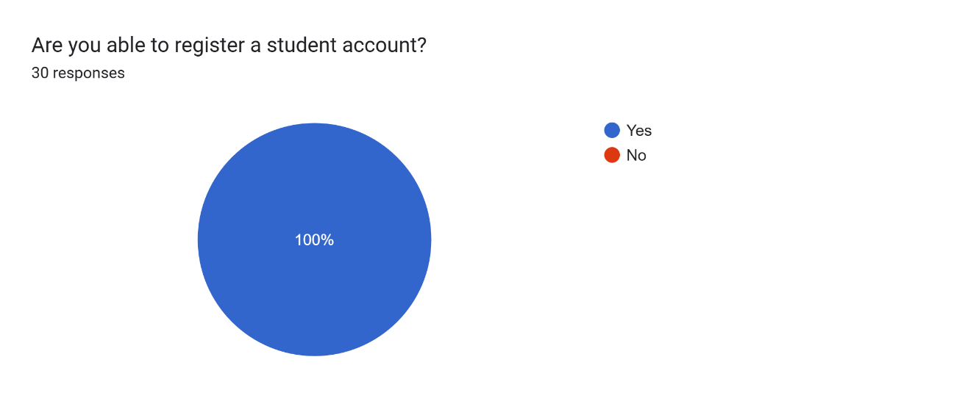

Figure 4‑145: University Student Register Test Result

The figure above illustrates that all 30 university students (100%) successfully completed the student account registration process on the Internseek platform.

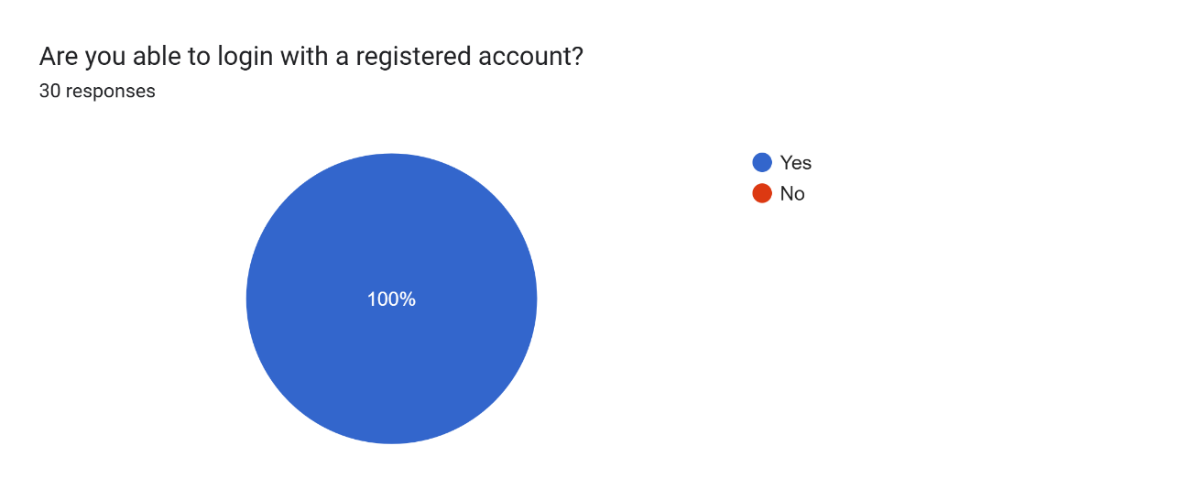

Figure 4‑146: University Student Login with Registered Account Test Result

The figure above illustrates that all 30 university students (100%) successfully logged in with their registered accounts on the Internseek platform.

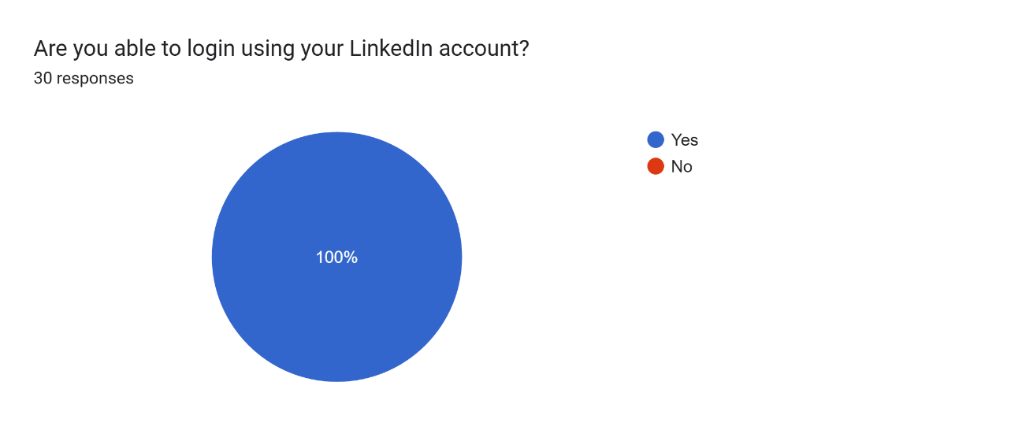

Figure 4‑147: University Student Login with LinkedIn Account Test Result

The figure above illustrates that all 30 university students (100%) successfully logged in with their LinkedIn account on the Internseek platform.

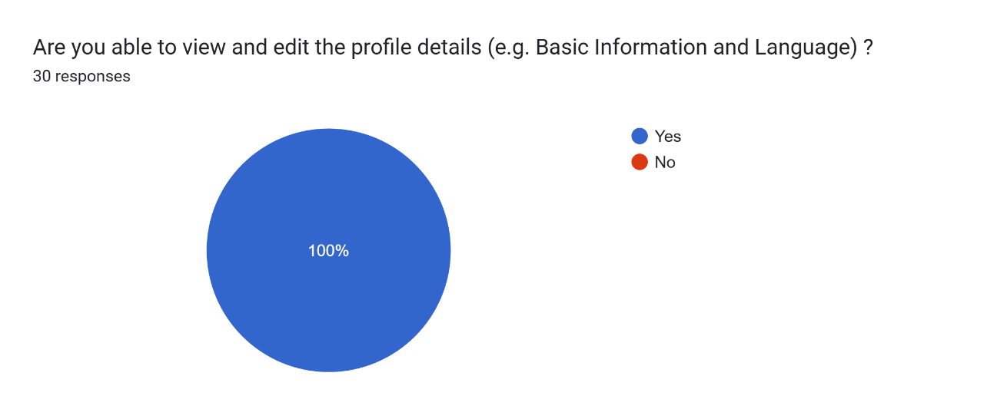

Figure 4‑148: University Student View & Edit Basic Info and Language Test Result

The figure above illustrates that all 30 university students (100%) successfully viewed & edited Basic Information and Language in the My Profile page on the Internseek platform.

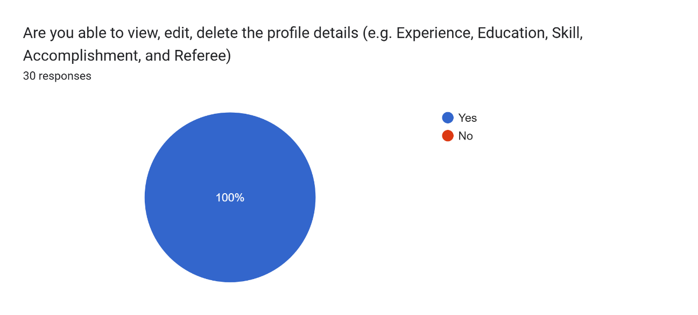

Figure 4‑149: University Student View, Edit, and Delete Experience, Education, Skill, Accomplishment, and Referee Test Result

The figure above illustrates that all 30 university students (100%) successfully viewed, edited, and deleted their Experience, Education, Skills, Accomplishments, and Referees in the My Profile page on the Internseek platform.

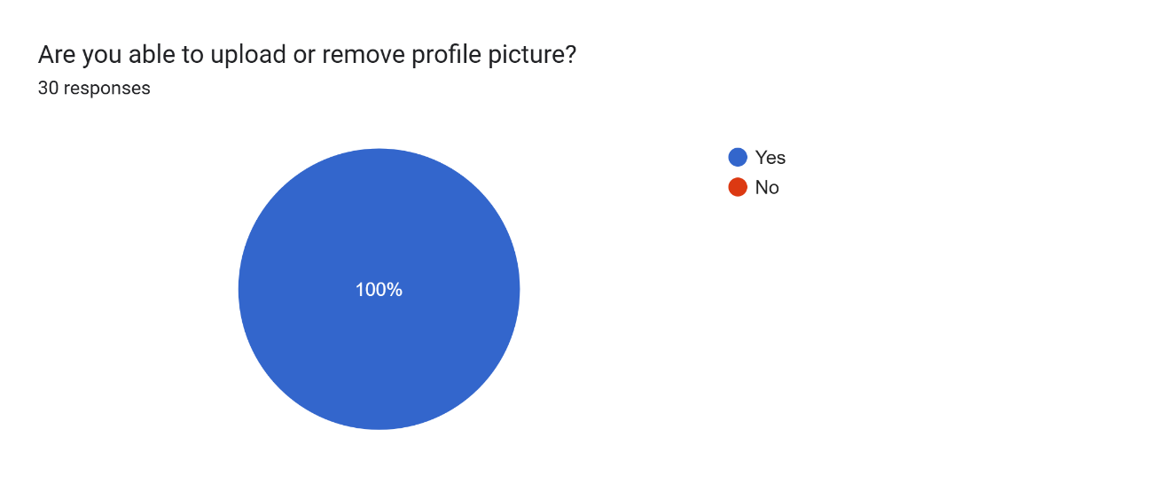

Figure 4‑150: University Student Upload and Remove Profile Picture Test Result

The figure above illustrates that all 30 university students (100%) successfully uploaded and removed profile picture in the My Profile page on the Internseek platform.

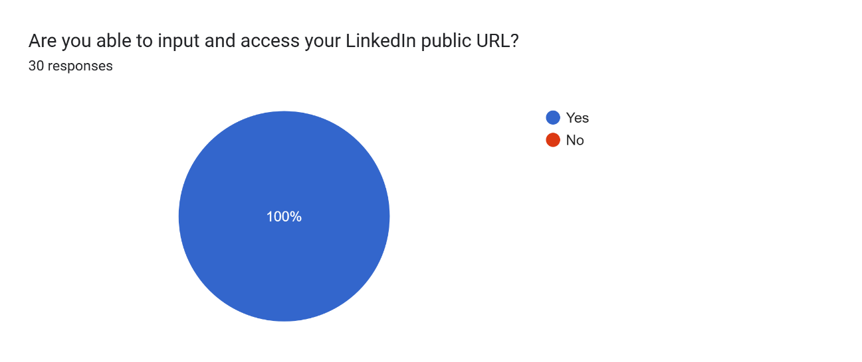

Figure 4‑151: University Student Input and Access LinkedIn Public URL Test Result

The figure above illustrates that all 30 university students (100%) successfully input and accessed LinkedIn Public URL in the My Profile page on the Internseek platform.

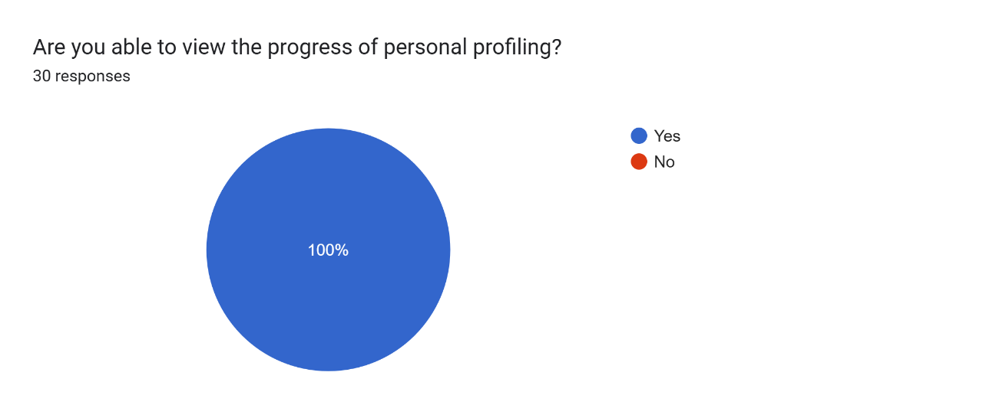

Figure 4‑152: University Student View Personal Profiling Progress Test Result

The figure above illustrates that all 30 university students (100%) successfully viewed the personal profiling progress in the My Profile page on the Internseek platform.

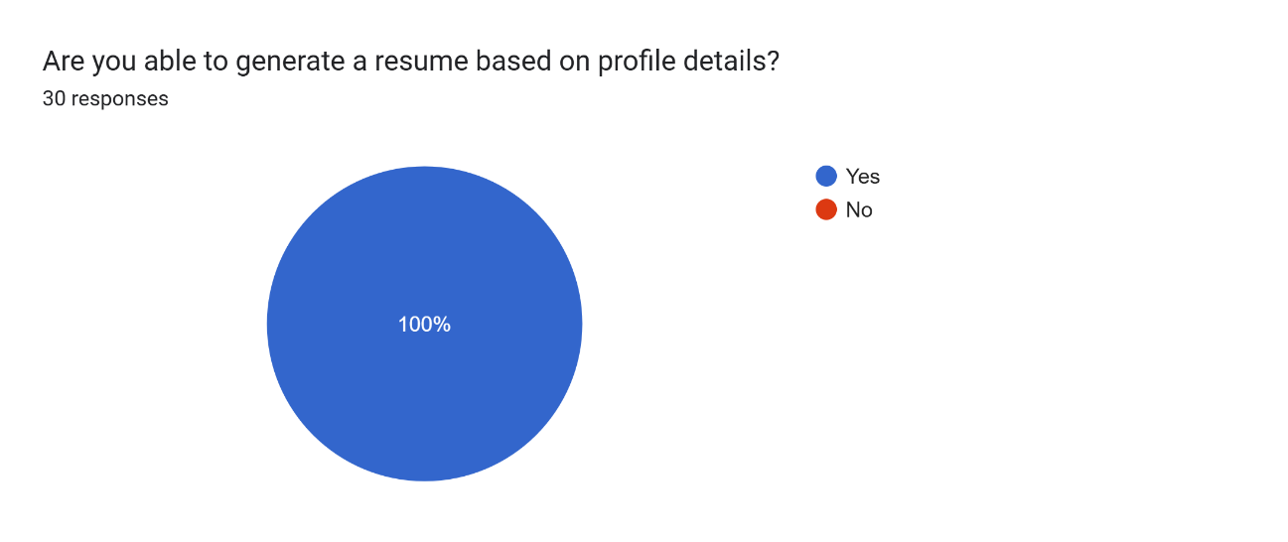

Figure 4‑153: University Student Generate a Resume Test Result

The figure above illustrates that all 30 university students (100%) successfully generated a resume based on profile details in the My Profile page.

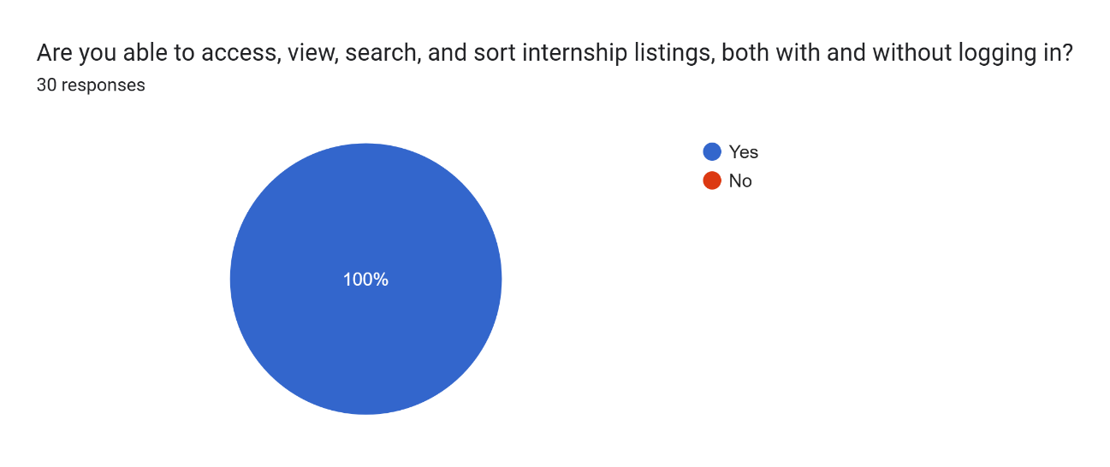

Figure 4‑154: University Student Access and View Internship Listing Test Result

The figure above illustrates that all 30 university students (100%) accessed, searched and sorted and viewed the internship listing.

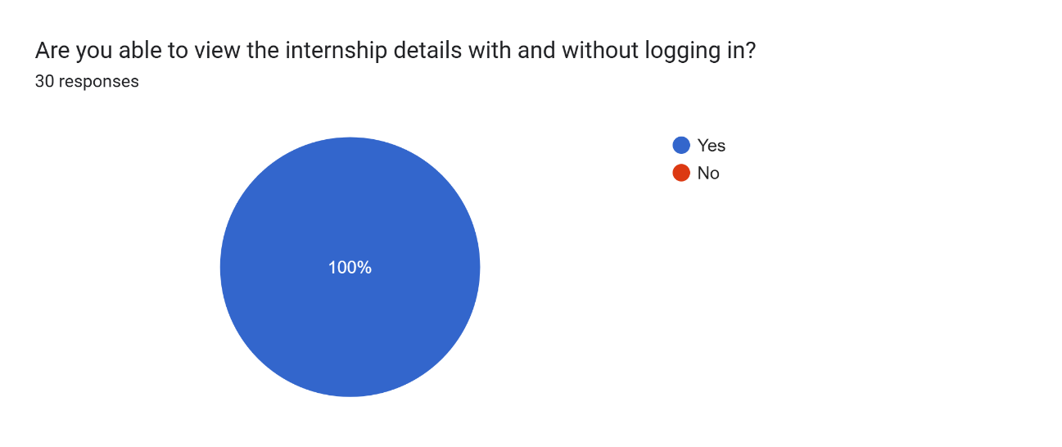

Figure 4‑155: University Student Access and View Internship Details Test Result

The figure above illustrates that all 30 university students (100%) successfully accessed and viewed internship details.

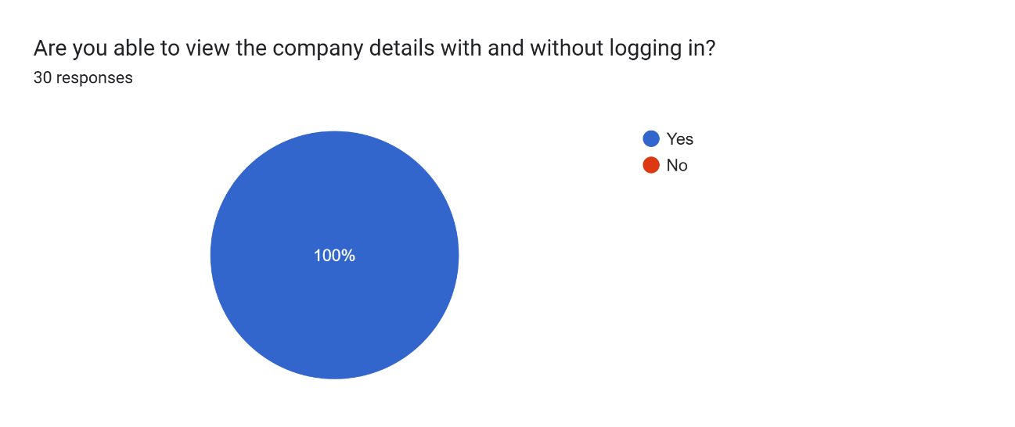

Figure 4‑156: University Student Access and View Company Listing Test Result

The figure above illustrates that all 30 university students (100%) accessed, searched and sorted and viewed the company listing.

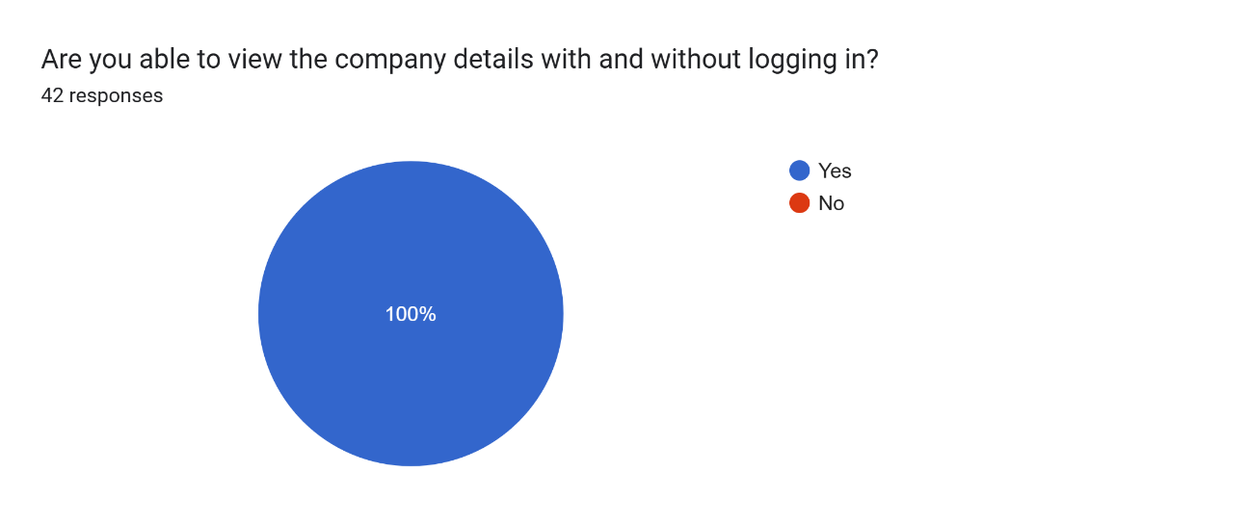

Figure 4‑157: University Student Access and View Company Details Test Result

The figure above illustrates that all 30 university students (100%) successfully accessed and viewed company details.

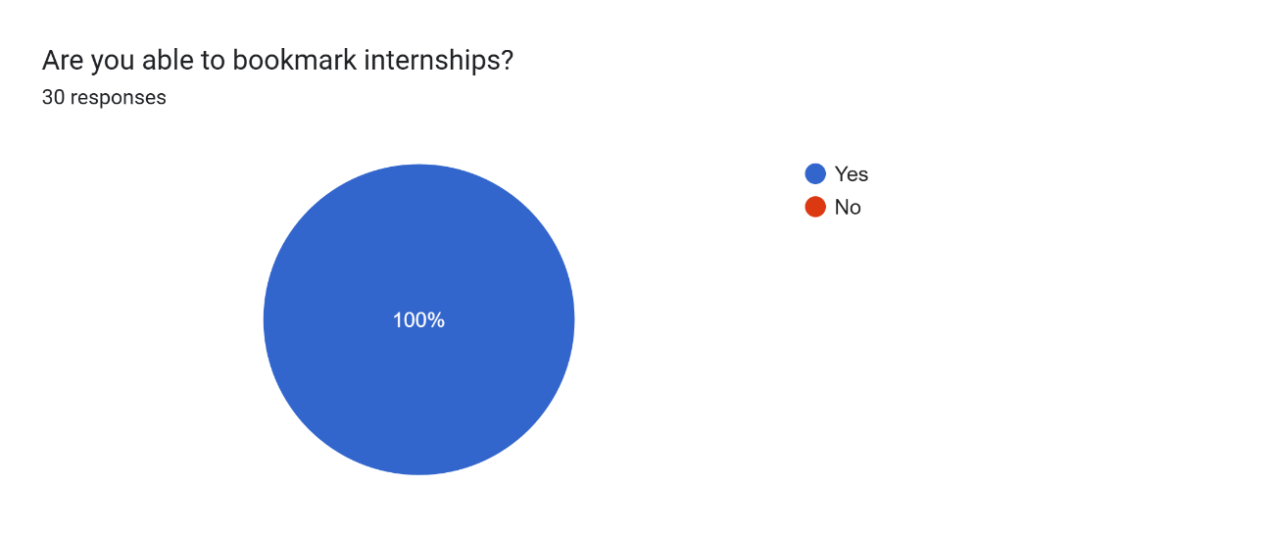

Figure 4‑158: University Student Bookmark Internships Test Result

The figure above illustrates that all 30 university students (100%) successfully bookmarked internships.

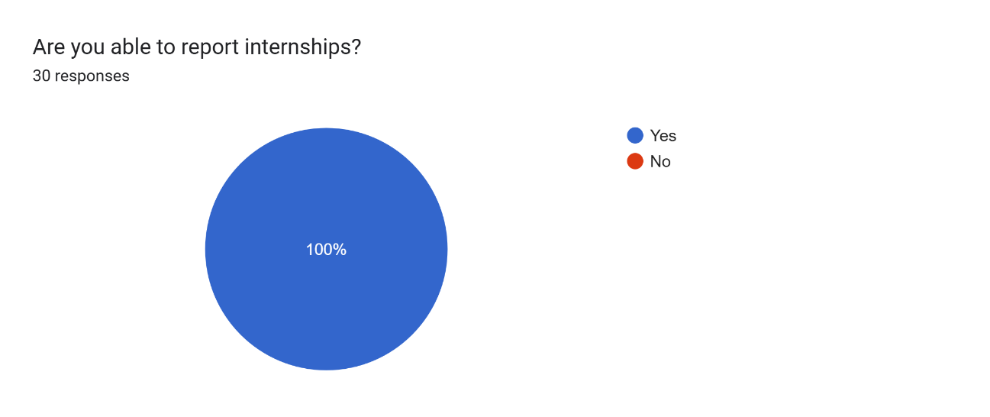

Figure 4‑159: University Student Report Internships Test Result

The figure above illustrates that all 30 university students (100%) successfully reported internships.

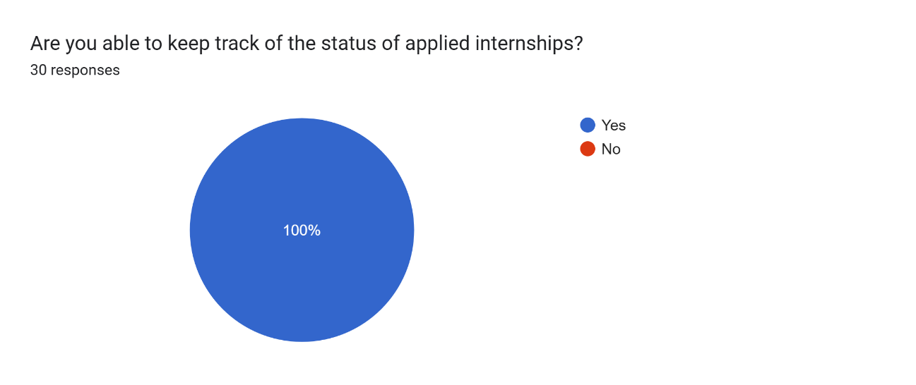

Figure 4‑160: University Student Apply for Internships Test Result

The figure above illustrates that all 30 university students (100%) successfully applied for internships.



Figure 4‑161: University Student Check Internship Application Status Test Result

The figure above illustrates that all 30 university students (100%) successfully kept track of the status of applied internships.

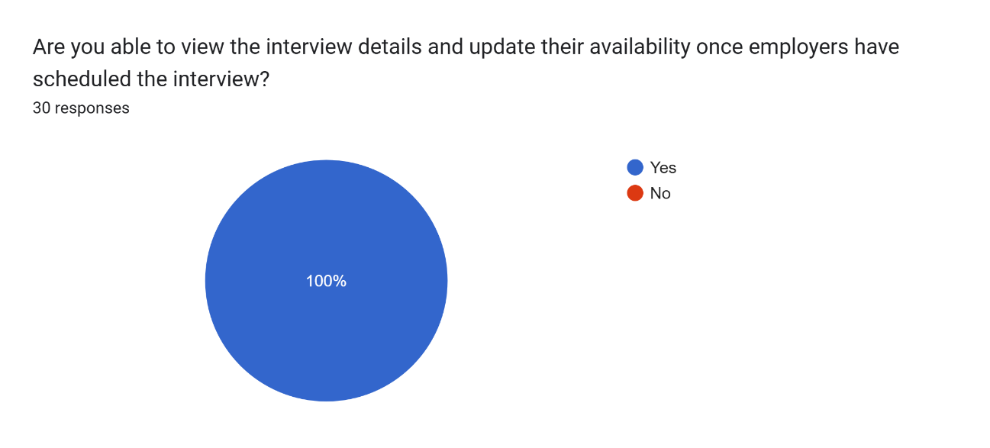

Figure 4‑162: University Student View Interview Details & Update Availability Test Result

The figure above illustrates that all 30 university students (100%) successfully viewed the interview details and updated availability of the interview scheduled by the employer.

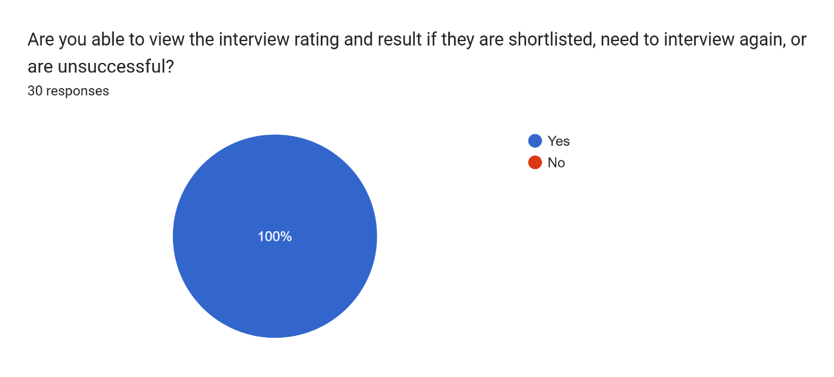

Figure 4‑163: University Student Viewing Internship Ratings on Shortlisted, Need-to-Interview, and Applied Internships Listings Test Results

The figure above illustrates that all 30 university students (100%) successfully viewed the interview ratings and results in the following categories: Shortlisted Internships, Applied Internships, and Need-to-Interview Internships listings.

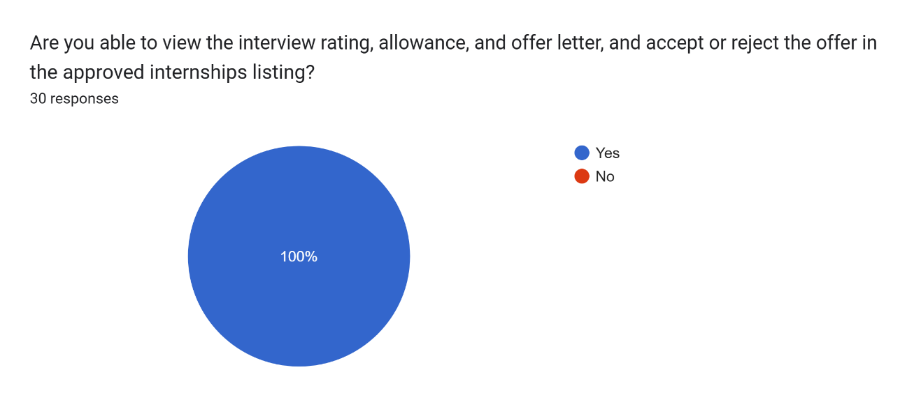

Figure 4‑164: University Students Accessing and Viewing Approved Internship Listings with Offer Acceptance or Rejection Test Result

The figure above shows that all 30 university students (100%) successfully viewed the approved internships listing and were able to accept or reject the offers.

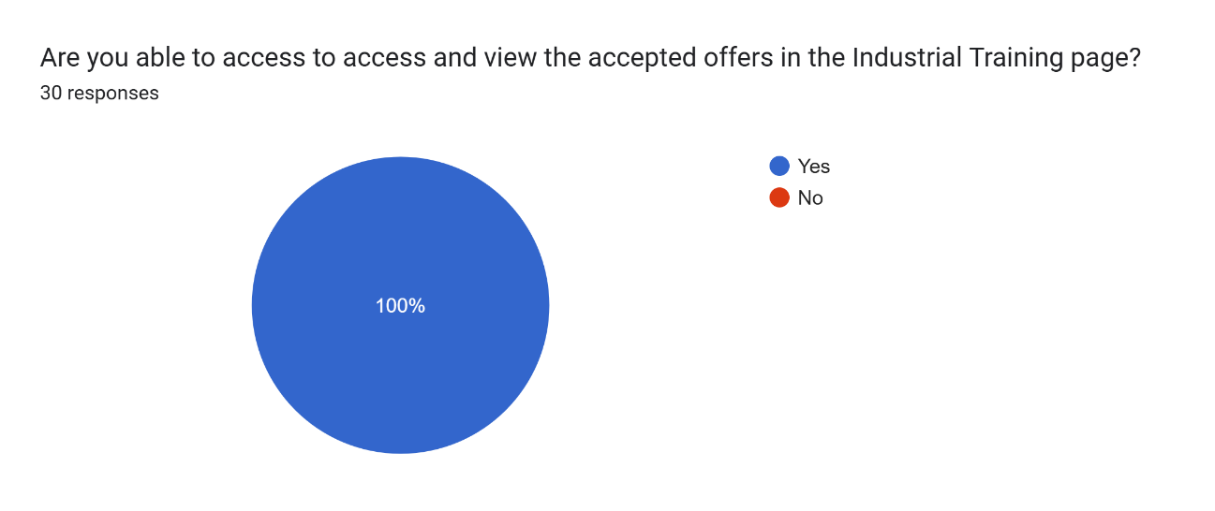

Figure 4‑165: University Students View Accepted Offers Test Result

The figure above shows that 30 university students (100%) successfully viewed accepted offers in the Industrial Training page.

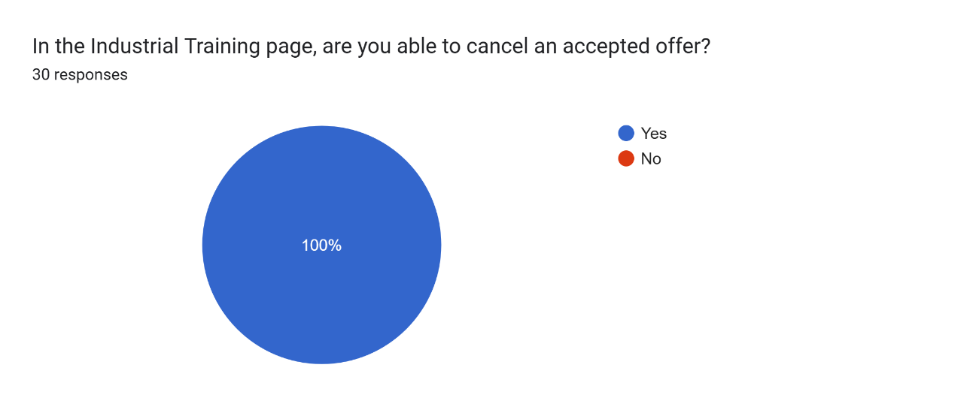

Figure 4‑166: University Students Cancel Accepted Offer Test Result

The figure above shows that 30 university students (100%) successfully cancel an accepted offer in the Industrial Training page.

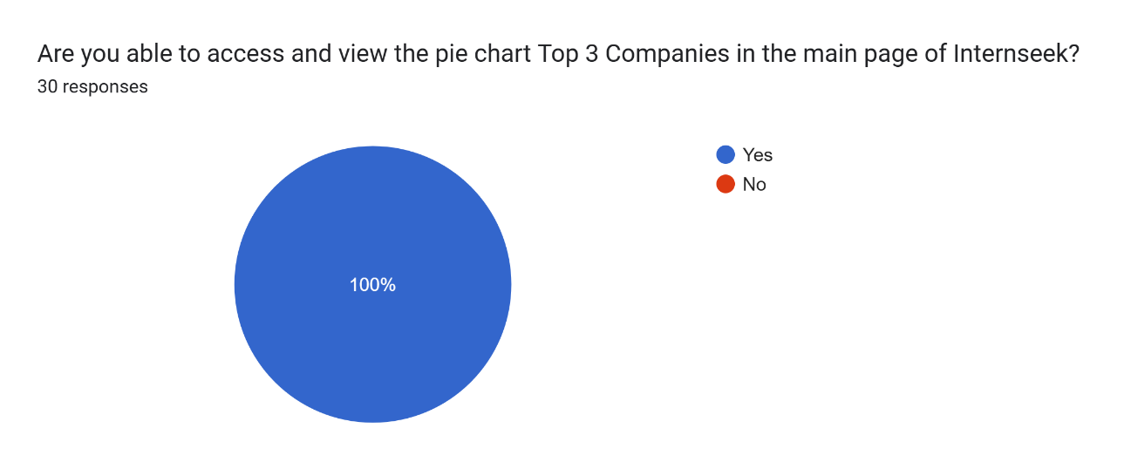

Figure 4‑167: University Students View the Top 3 Companies Chart Test Result

The figure above shows that 30 university students (100%) successfully viewed the Top 3 Companies Chart in the main page..

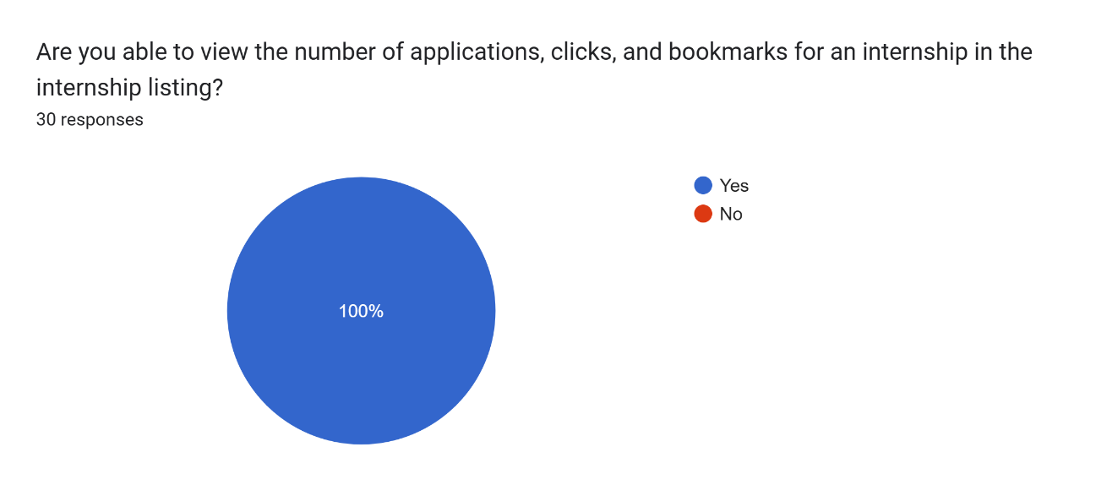

Figure 4‑168: University Students Viewing Internship Metrics (Applications, Clicks, Bookmarks) Test Result

The figure above shows that 30 university students (100%) successfully viewed internship metrics, including the number of clicks, bookmarks, and applications for each internship, displayed on the internship card in the internship listing.

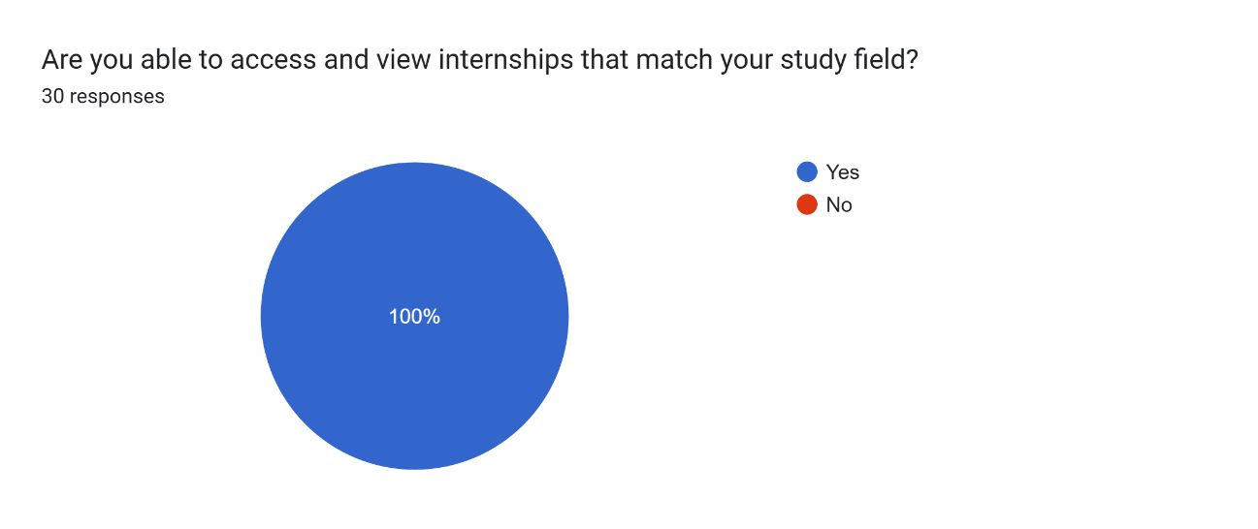

Figure 4‑169: University Students View Matched Internship Listing Test Result

The figure above shows that 30 university students (100%) successfully viewed internship listings that matched their study fields.

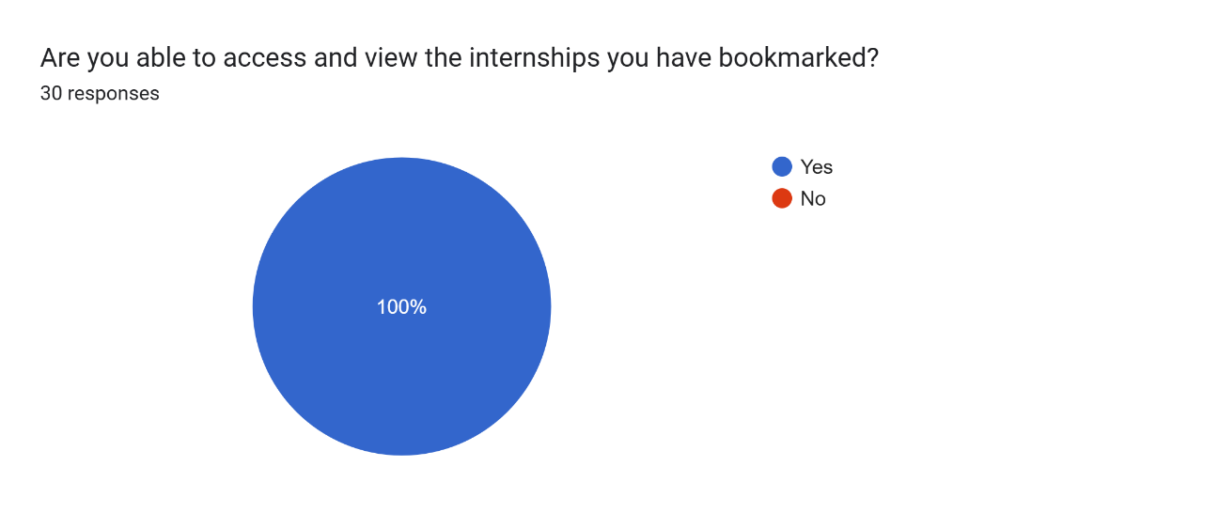

Figure 4‑170: University Students View Bookmarked Internship Listing

The figure above shows that 30 university students (100%) successfully viewed internships they have bookmarked on the Internseek platform.

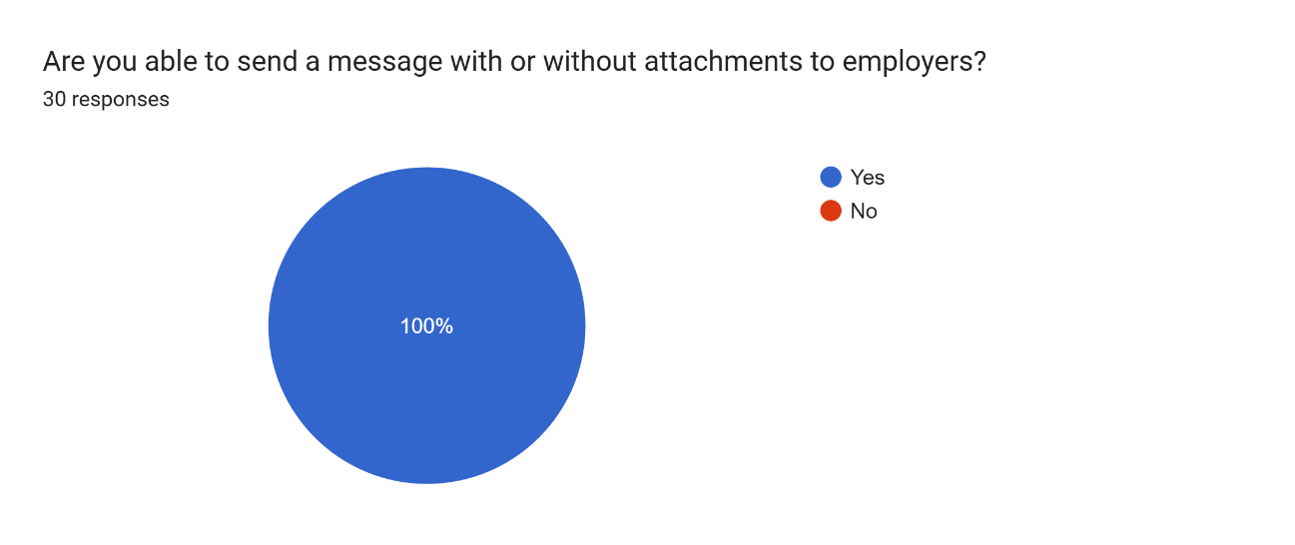

Figure 4‑171: University Students Send Message to Employers Test Result

The figure above shows that 30 university students (100%) successfully sent messages with or without attachments to employers.

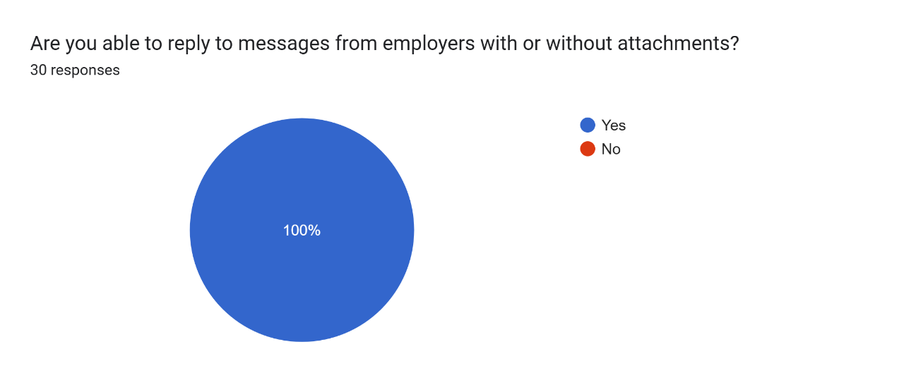

Figure 4‑172: University Students Reply to Messages from Employers Test Result

The figure above shows that 30 university students (100%) successfully replied to messages from Employers with or without attachments.

##### Test Result (Employers)

This section presents the test results of the functionality assessment conducted for employers using the Internseek platform. The testing aimed to evaluate whether all functionalities were operational and accessible to employers.

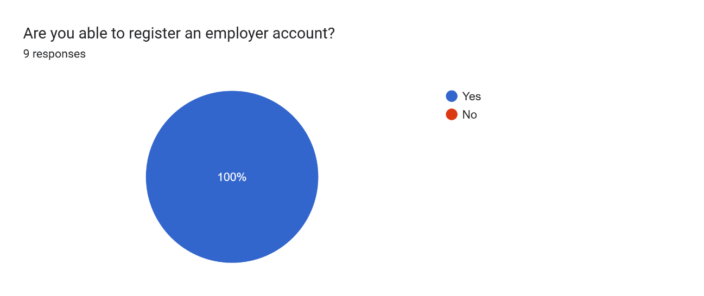

Figure 4‑173: Employers Register Test Result

The figure above illustrates that all 9 employers (100%) successfully completed the employer account registration process on the Internseek platform.

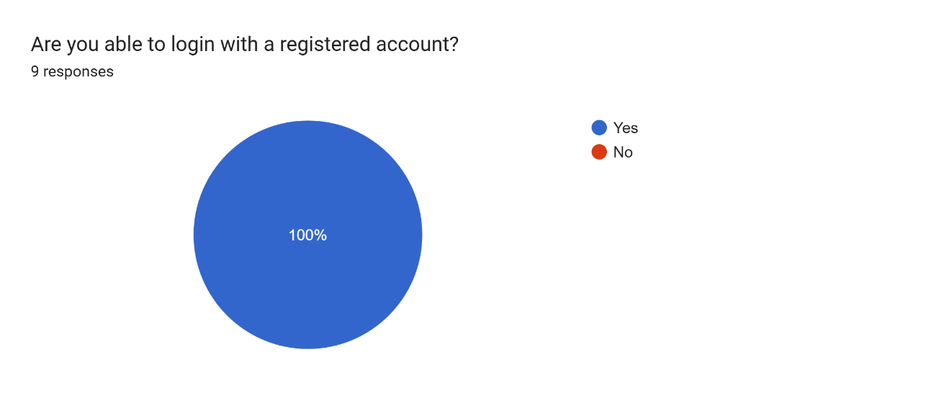

Figure 4‑174: Employers Login Test Result

The figure above illustrates that all 9 employers (100%) successfully logged in with their registered accounts on the Internseek platform.

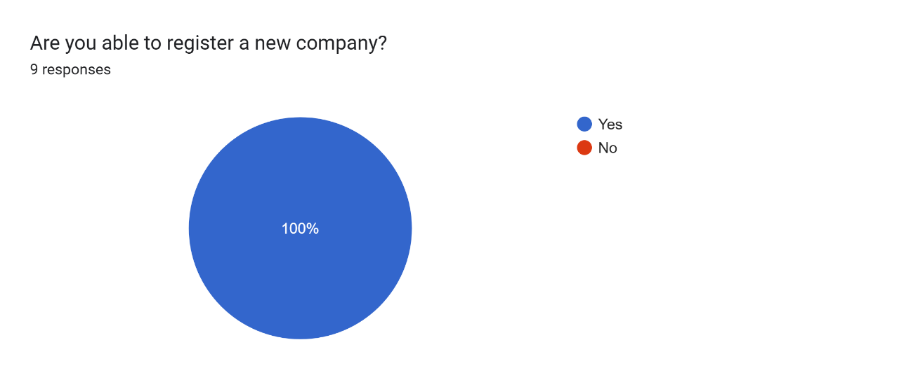

Figure 4‑175: Employers Register New Company Test Result

The figure above illustrates that all 9 employers (100%) successfully registered a new company on the Internseek platform.

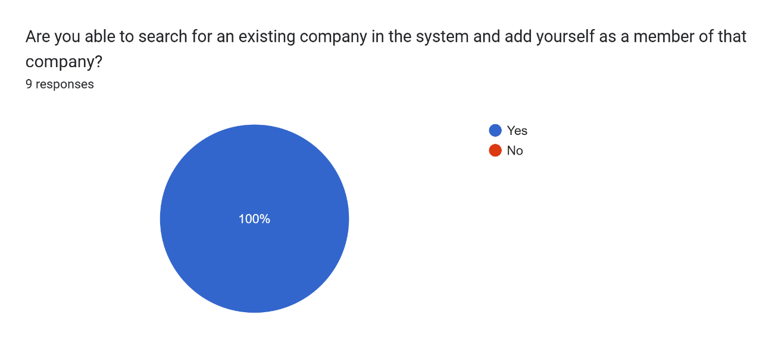

Figure 4‑176: Employers Search for Existing Company Test Result

The figure above illustrates that all 9 employers (100%) successfully searched for an existing company in the system and added themselves as members of that company.

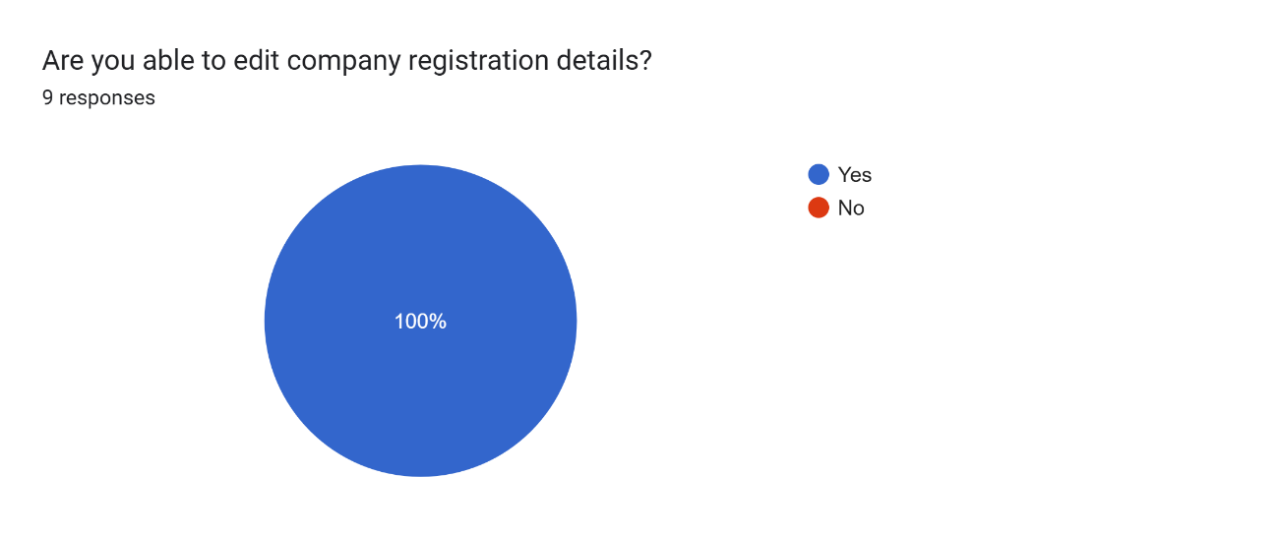

Figure 4‑177: Employers Edit Company Registration Details Test Result

The figure above illustrates that all 9 employers (100%) successfully edited company registration details.

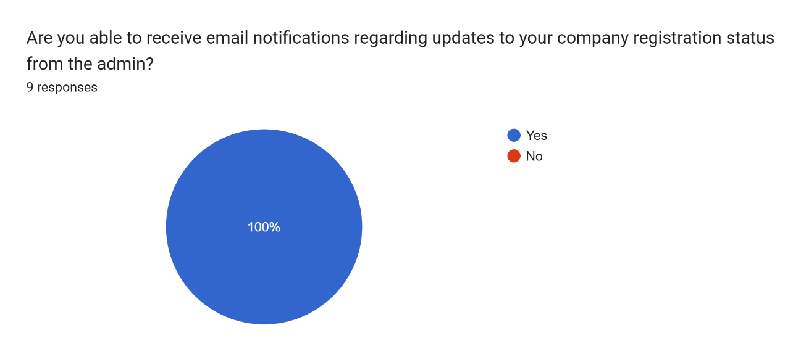

Figure 4‑178: Employers Receive Company Registration Status Email Notification Test Result

The figure above illustrates that all 9 employers (100%) successfully received company registration status email notifications from system administrators.

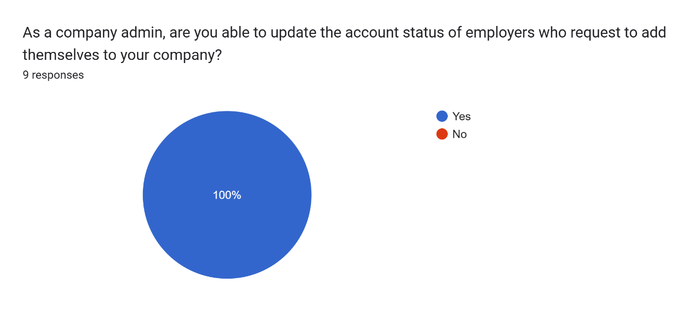

Figure 4‑179: Employers (Company Admin) Manage Employers who request to add themselves to the Company Test Result

The figure above illustrates that all 9 employers (100%) successfully received company registration status email notifications from system administrators.

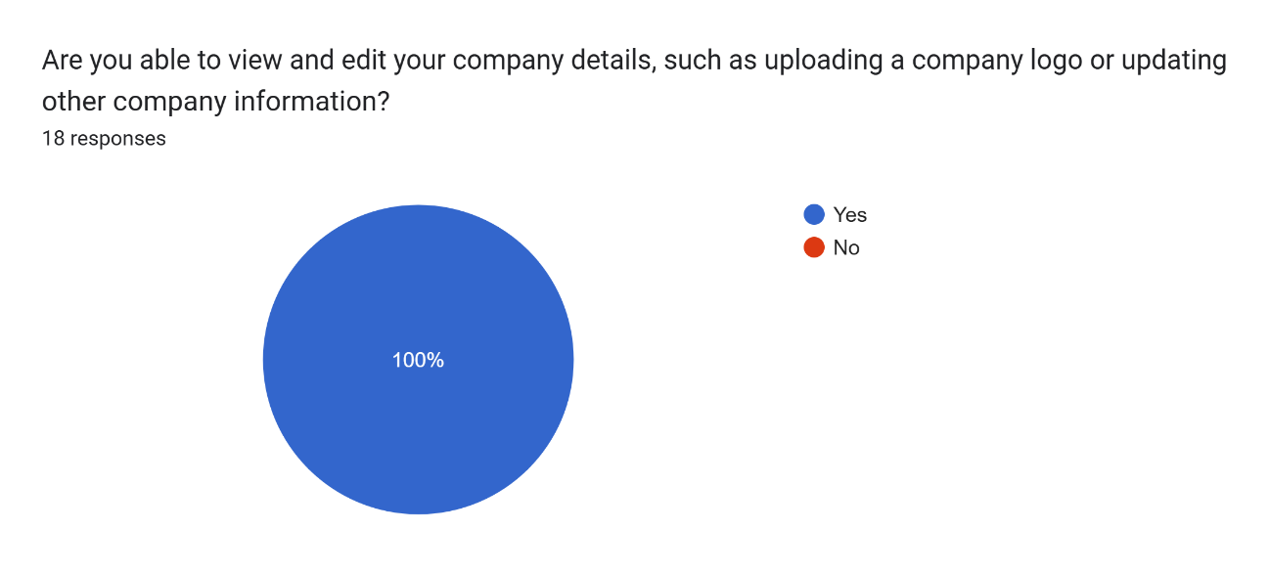

Figure 4‑180: Employers View and Edit Company Details Test Result

The figure above illustrates that all 9 employers (100%) successfully viewed and edited company details.

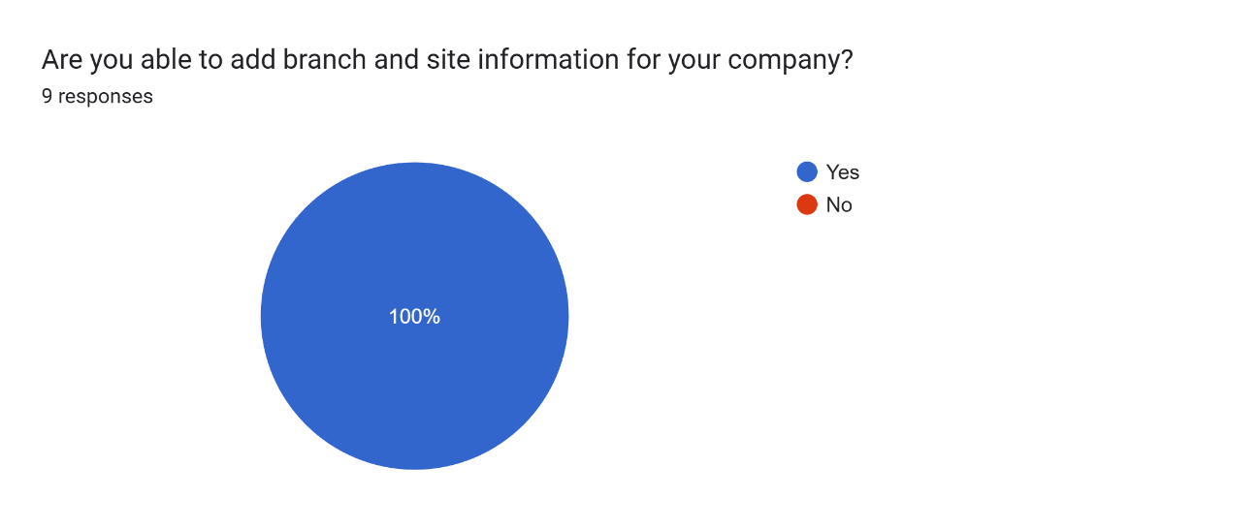

Figure 4‑181: Employers Add Branch and Site Test Result

The figure above illustrates that all 9 employers (100%) successfully added branches and sites.

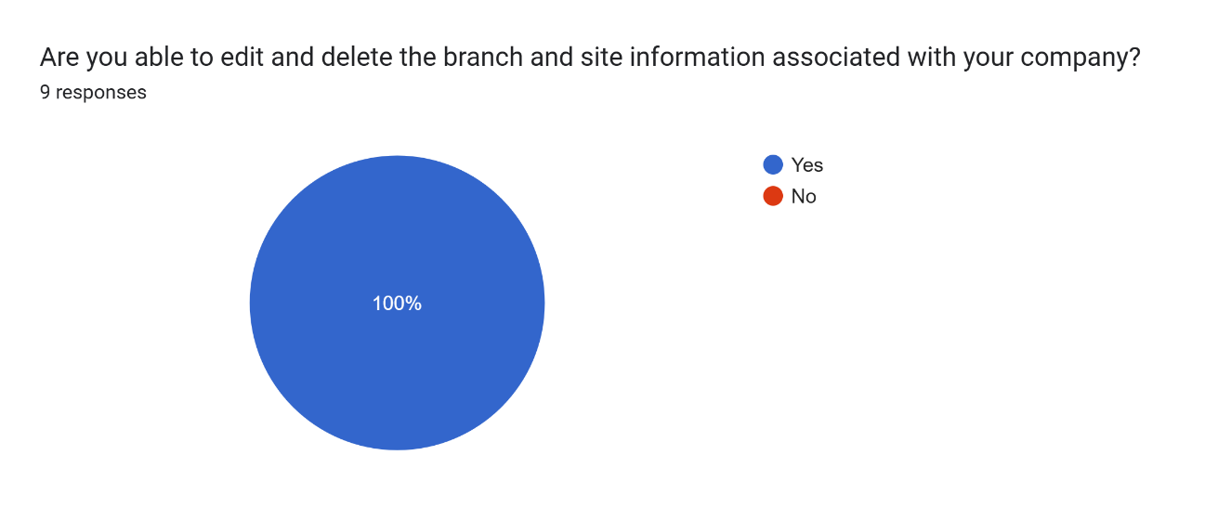

Figure 4‑182: Employers Edit and Delete Branch and Site Test Result

The figure above illustrates that all 9 employers (100%) successfully edited and deleted the branch and site information associated to their company.

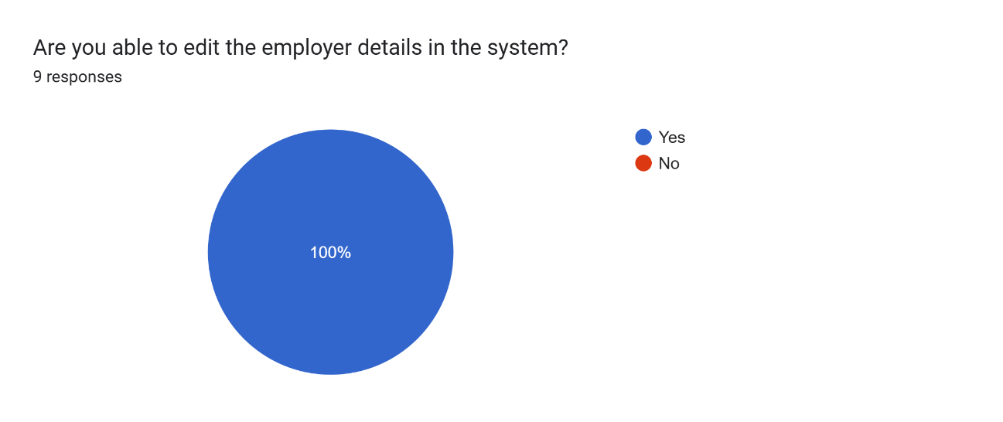

Figure 4‑183: Employers Edit Employer Details Test Result

The figure above illustrates that all 9 employers (100%) successfully edited employer details.

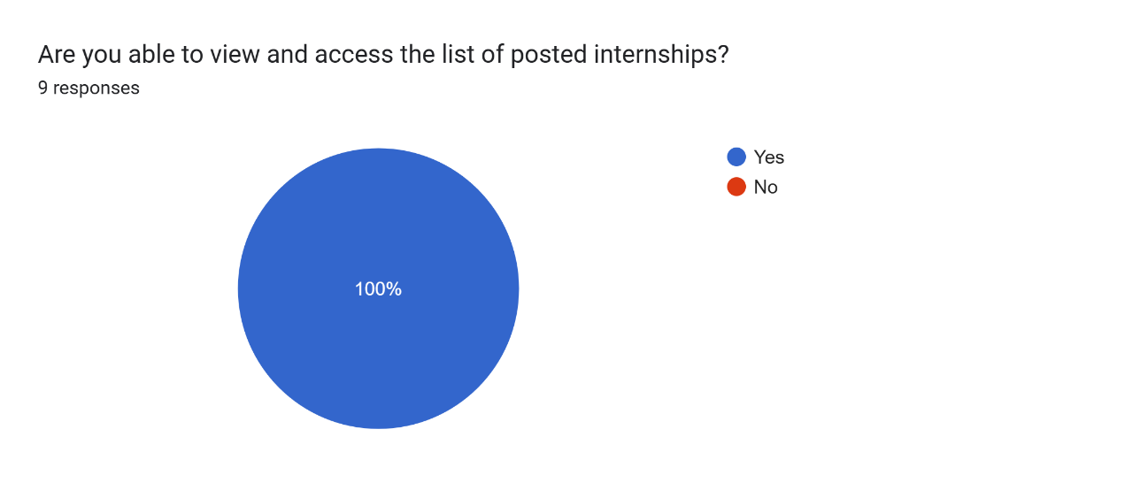

Figure 4‑184: Employers View and Access the Internship Posting List Test Result

The figure above illustrates that all 9 employers (100%) successfully viewed and accessed the Internship Posting List.

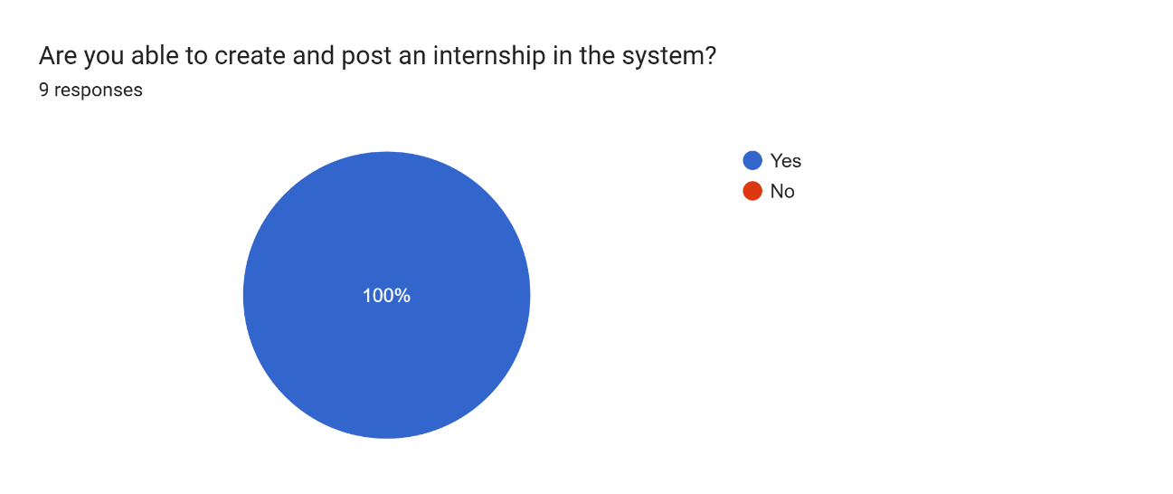

Figure 4‑185: Employers Create an Internship Posting Test Result

The figure above illustrates that all 9 employers (100%) successfully created an Internship Posting.

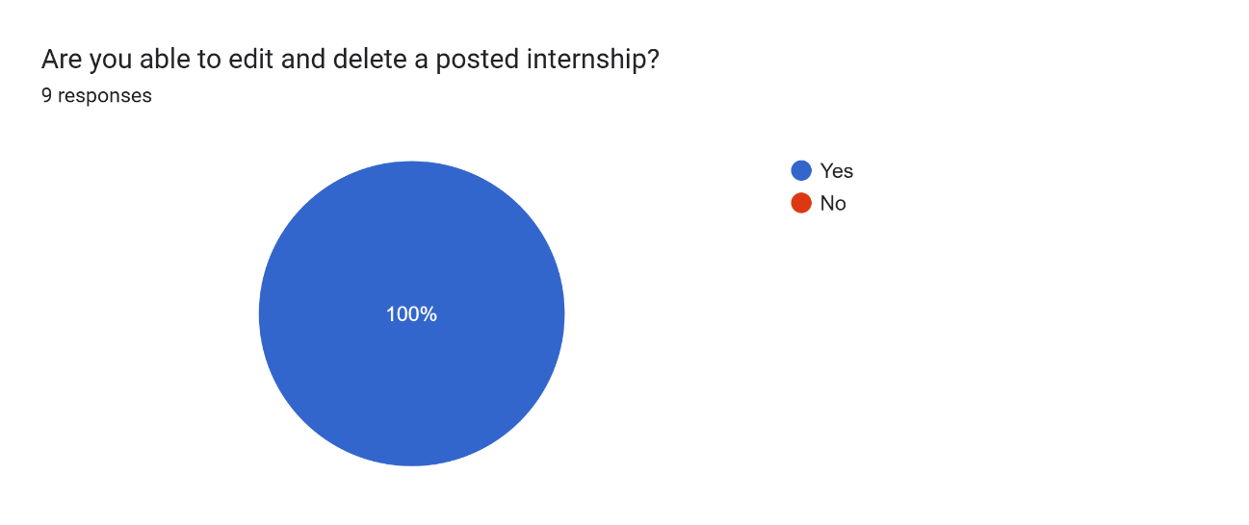

Figure 4‑186: Employers Edit and Delete the Posted Internship Test Result

The figure above illustrates that all 9 employers (100%) successfully edited and deleted the posted internship.

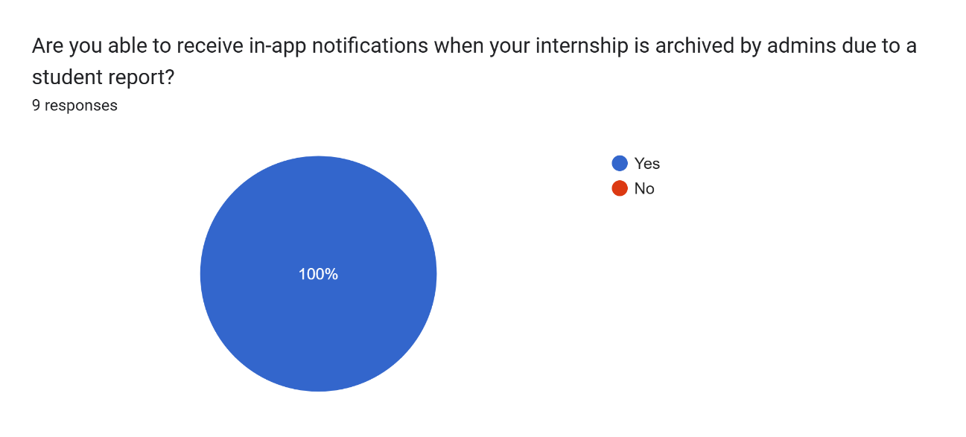

Figure 4‑187: Employers Receive Internship Posting is Archived In-App Notification Test Result

The figure above illustrates that all 9 employers (100%) successfully received internship posting is archived in-app notifications.

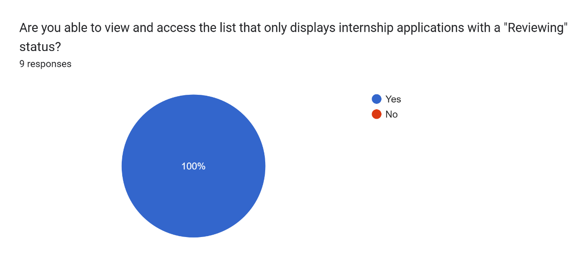

Figure 4‑188: Employers View and Access the Internship Applications List with a Reviewing Status Test Result

The figure above illustrates that all 9 employers (100%) successfully viewed and accessed internship applications list with the Reviewing Status.

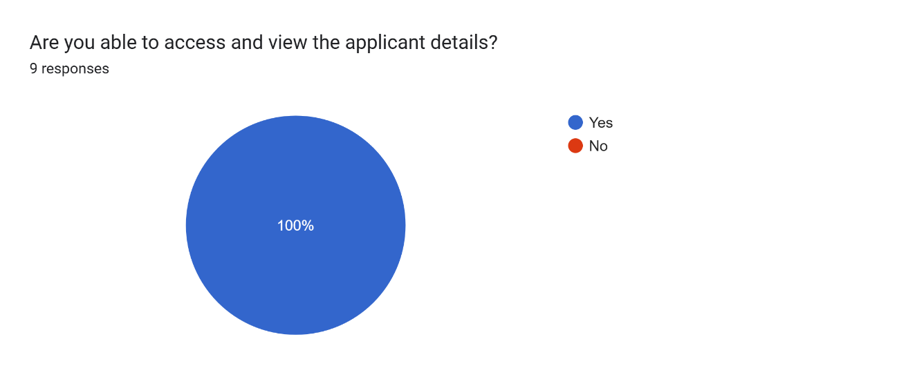

Figure 4‑189: Employers View Applicant Details Test Result

The figure above illustrates that all 9 employers (100%) successfully viewed applicant details on the Internship Application Listing.

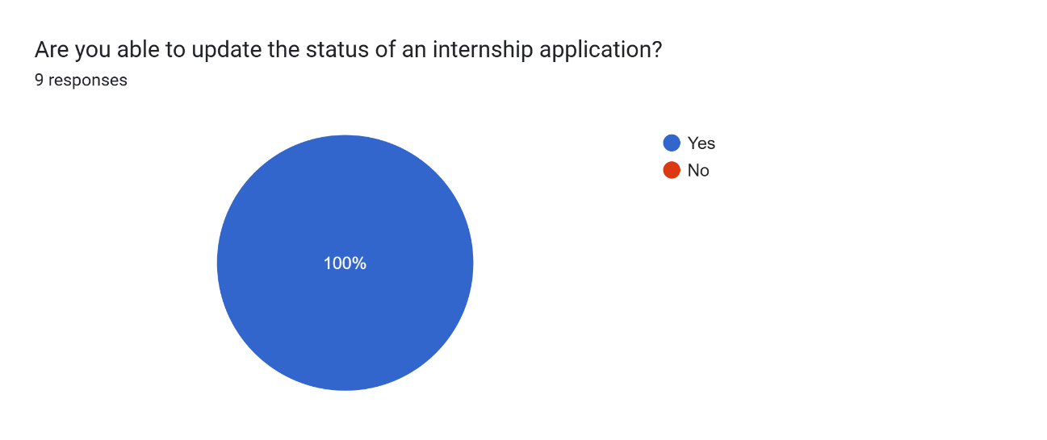

Figure 4‑190: Employers Update Internship Application Status Test Result

The figure above illustrates that all 9 employers (100%) successfully updated the internship application status of the applicant.

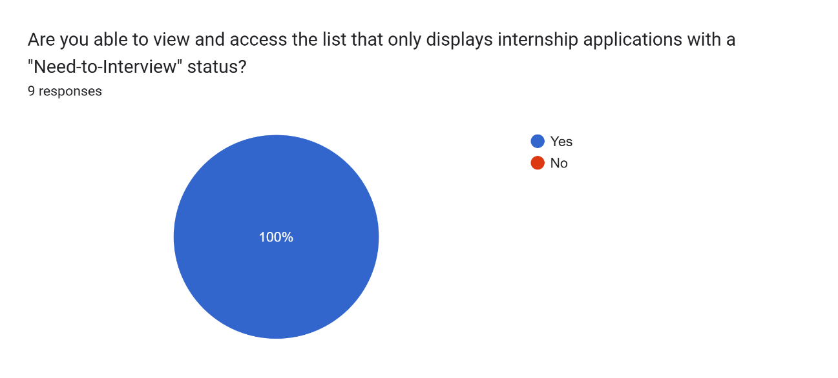

Figure 4‑191: Employers Access and View the Internship Application List with a “Need-to-Interview” Status Test Result

The figure above illustrates that all 9 employers (100%) successfully accessed and viewed the Internship Application List with the “Need-to-Interview” status.

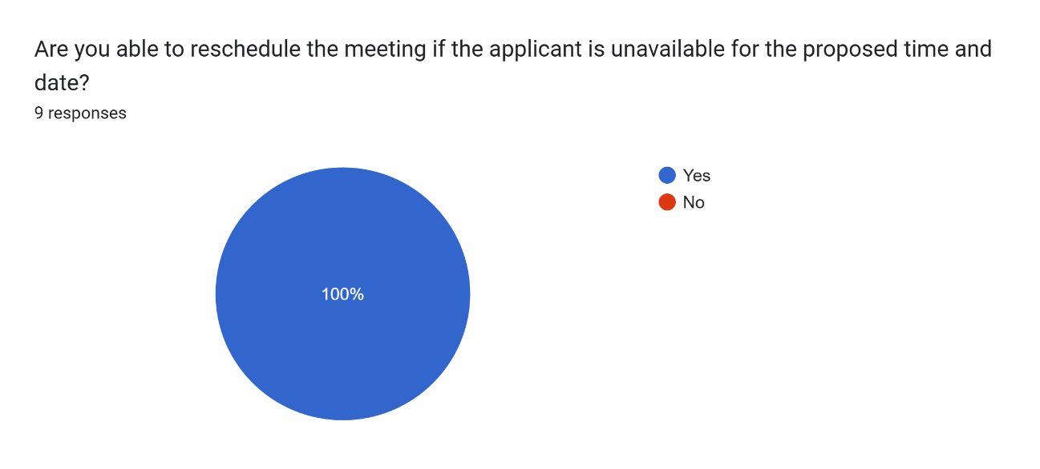

Figure 4‑192: Employers Reschedule the Interview Test Result

The figure above illustrates that all 9 employers (100%) successfully rescheduled the interview if the applicant cannot attend the interview for the proposed time and date.

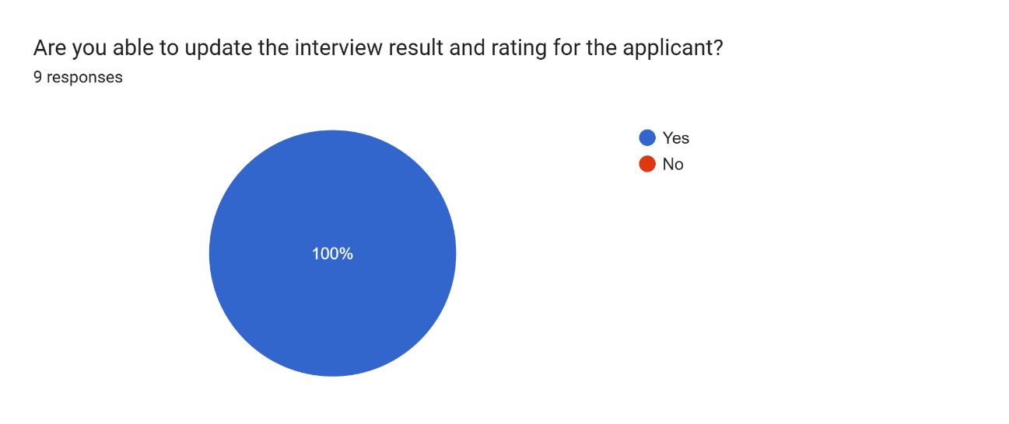

Figure 4‑193: Employers Update Interview Result and Rating Test Result

The figure above illustrates that all 9 employers (100%) successfully updated the interview result and rating of the applicant after the interview.

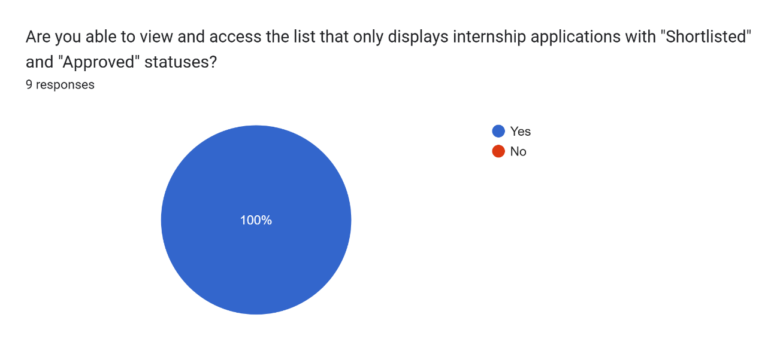

Figure 4‑194: Employers Access and View the Internship Application Listing with Shortlisted and Approved Status Test Result

The figure above illustrates that all 9 employers (100%) successfully accessed and viewed the Internship Application Listing with the Shortlisted and Approved status.

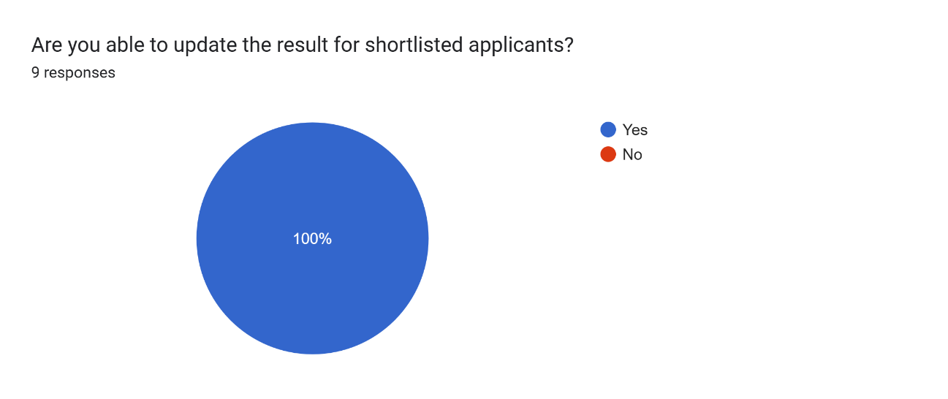

Figure 4‑195: Employers Update Shortlisted Result Test Result

The figure above illustrates that all 9 employers (100%) successfully updated the result for shortlisted applicants.

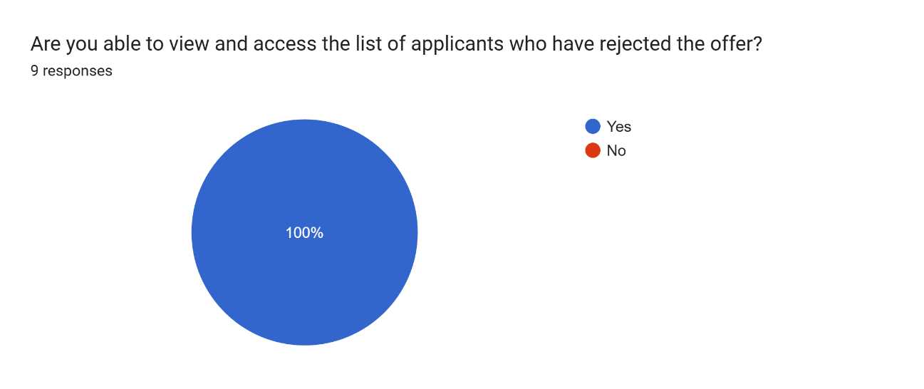

Figure 4‑196: Employers View the Applicant List who have rejected the Offer Test Result

The figure above illustrates that all 9 employers (100%) successfully accessed and viewed the list of applicants who have rejected the offer.

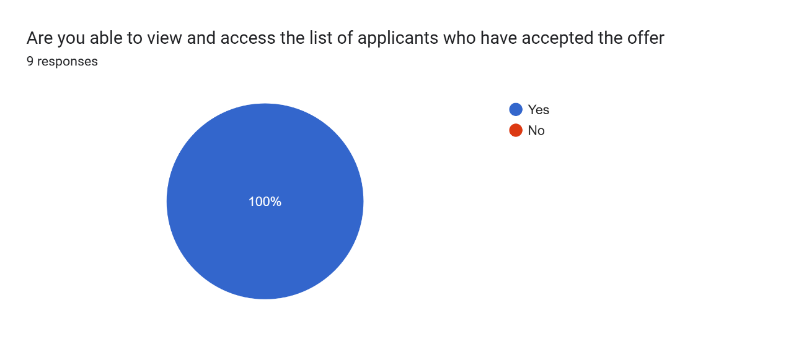

Figure 4‑197: Employers View the Applicant List who have accepted the Offer Test Result

The figure above illustrates that all 9 employers (100%) successfully accessed and viewed the list of applicants who have accepted the offer.

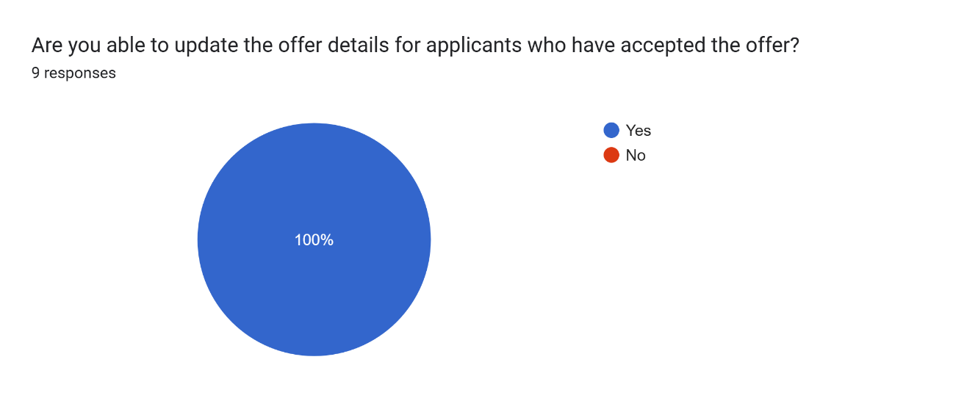

Figure 4‑198: Employers Update Offer Details Test Result

The figure above illustrates that all 9 employers (100%) successfully updated the offer details for applicants who have accepted the offer.

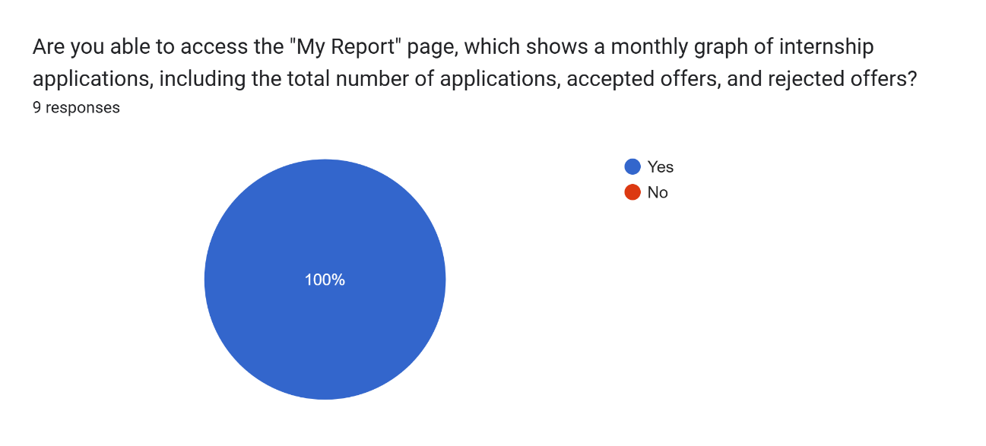

Figure 4‑199: Employers Access and View My Report Page Test Result

The figure above illustrates that all 9 employers (100%) successfully accessed the My Report page and viewed the monthly graph of internships, including the total number of applications, applicants who accepted offers, and those who rejected offers.

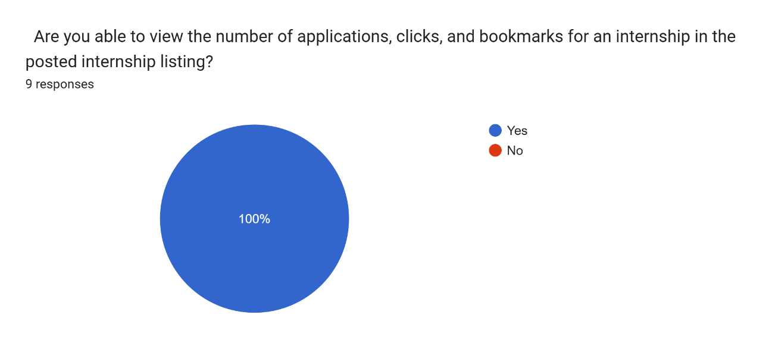

Figure 4‑200: Employers View the Internship Metrics (Applications, Clicks, Bookmarks) Internship Posting Test Result

The figure above illustrates that all 9 employers (100%) successfully viewed the internship metrics displayed on the internship posting card for their posted internships, including the number of applications, bookmarks, and clicks.

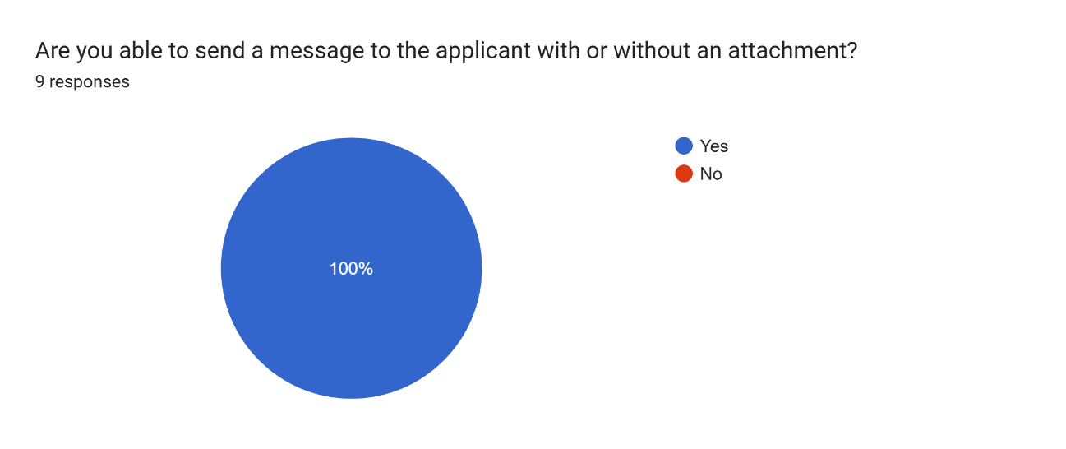

Figure 4‑201: Employers Send Message to Applicants Test Result

The figure above illustrates that all 9 employers (100%) successfully sent messages with or without attachment to applicants.

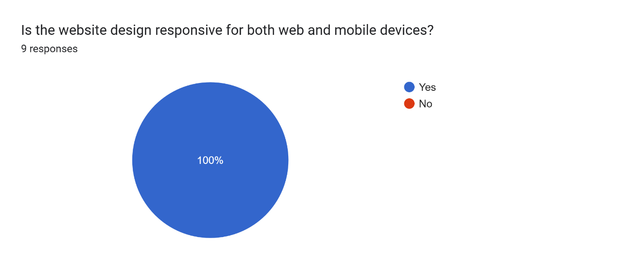

Figure 4‑202: Employers Reply Messages from Student Test Result

The figure above illustrates that all 9 employers (100%) successfully replied to messages from students with or without attachment.

##### Usability

This section describes the usability aspect of the User Acceptance Testing (UAT) conducted with university students and employers. The figures below demonstrate that 30 students (100%) and 9 employers (100%) found that the **Internseek** website is responsive and functions effectively on both mobile and laptop devices. Users specifically noted that the platform operates seamlessly across various devices, including smartphones and laptops. This responsiveness ensures the website adapts effectively to different screen sizes, delivering an optimal user experience regardless of the device used.

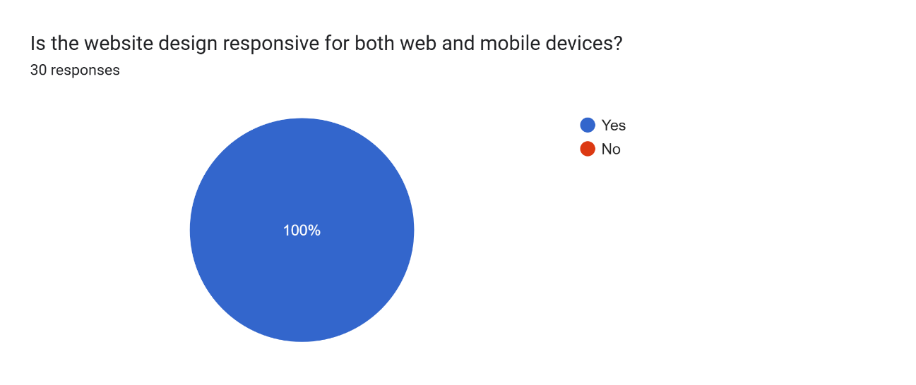

Figure 4‑203: Website Design Responsive Test Result (University Students)



Figure 4‑204: Website Design Responsive Test Result (Employers)

##### Overall Satisfaction Level

This section highlights the overall satisfaction levels provided by university students and employers during the User Acceptance Testing (UAT). Participants rated their satisfaction on a scale of 1 to 10, reflecting their experience with the **Internseek** platform. These ratings provide valuable insights into user perceptions and the platform's effectiveness in meeting their expectations.

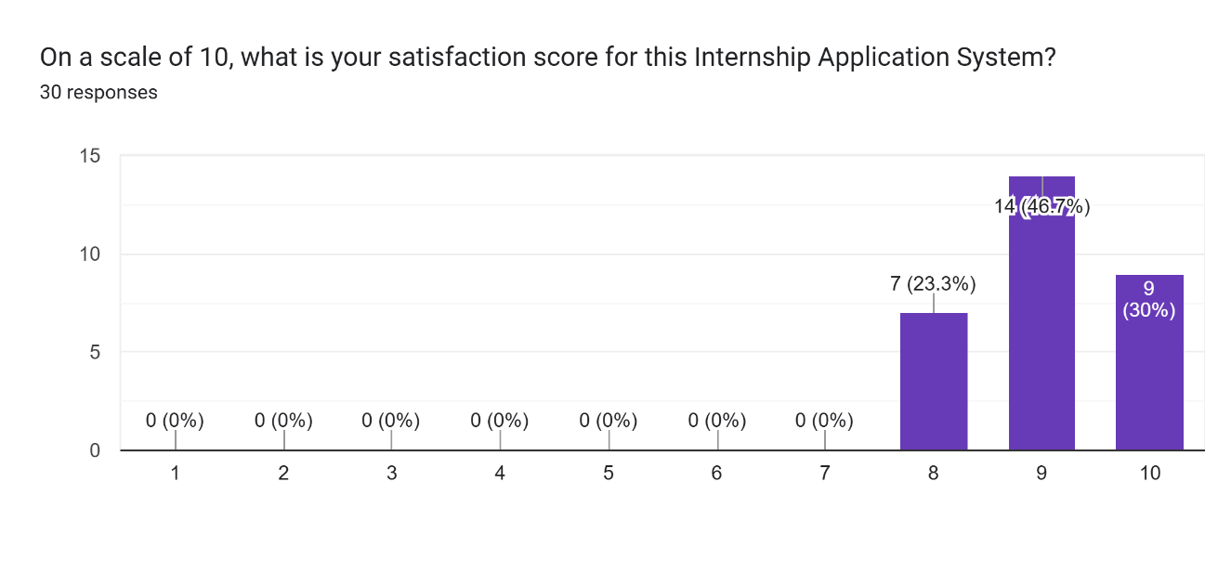

Figure 4‑205: University Students Satisfaction Level

The figure above illustrates the overall satisfaction ratings provided by 30 university students. Among the respondents:

* 7 students rated their satisfaction as 8,
* 14 students rated their satisfaction as 9, and
* 9 students gave the highest rating of 10.

Most of the respondent give score of 9 out of 10 and 9 respondents give score of 10. The average of the satisfaction level on the Internseek system is 9.07 out of 10. These results indicate a high level of satisfaction among university students with the Internseek platform.

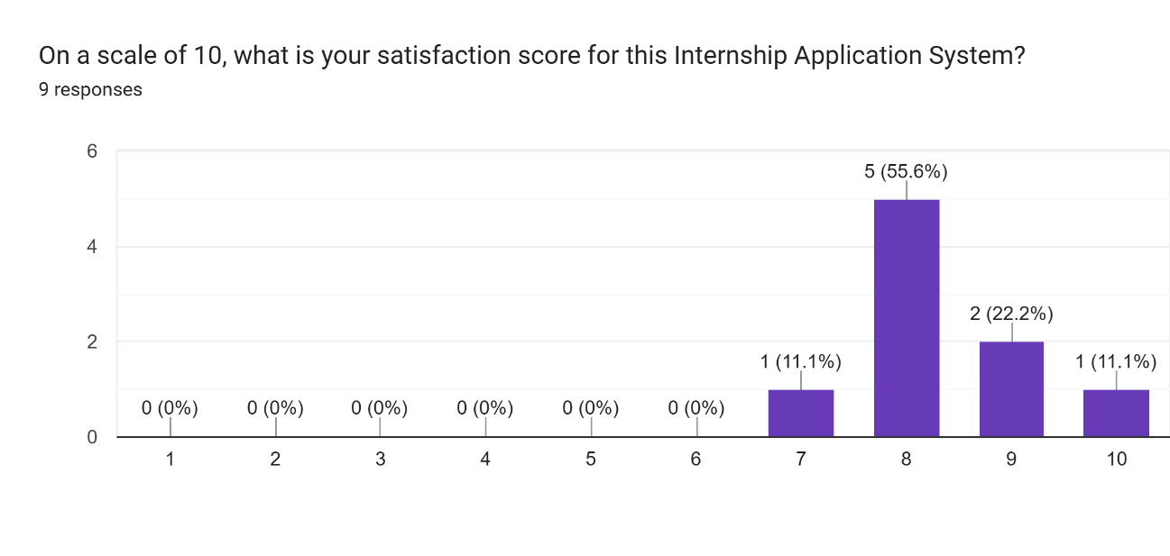

Figure 4‑206: Employers Satisfaction Level

The figure above illustrates the overall satisfaction ratings provided by 9 employers. Among the respondents:

* 1 employer rated their satisfaction as 7,
* 5 employers rated their satisfaction as 8,
* 2 employers rated their satisfaction as 9, and
* 1 employer gave the highest rating of 10.

Most of the respondent give score of 8 out of 10 and 1 respondent give score of 10. The average of the satisfaction level on the Internseek system is 8.33 out of 10. These results reflect a high level of satisfaction among employers with the Internseek platform.

##### Suggestions for Improvement

This section highlights the suggestions for improving the **Internseek** platform, as provided by university students and employers during the User Acceptance Testing (UAT). These recommendations offer valuable insights into user needs and areas where the platform can be enhanced to better serve its audience.

|  |
| --- |
|  |

Figure 4‑207: Suggestions for Improvement from University Students

The figure above shows the recommendations provided by university students to enhance the **Internseek** platform. Their suggestions include the following:

1. **Add a Company Review Feature**  
   Students propose to add a new feature where they can share their internship experiences and rate the companies. This feature would help future interns make informed decisions.
2. **Provide Customizable Resume Designs**  
   Students recommend offering a variety of resume design templates, allowing them to generate resumes that better suit their preferences and professional needs.
3. **Implement Search Suggestions**  
   Students suggest displaying relevant search suggestions below the search bar based on keywords entered. This feature should be applied across the internship listing, company listing, and the main page to enhance search efficiency and usability.
4. **Enhance Internship Application Status Notifications**  
   They propose expanding the notification system to include email updates in addition to in-app notifications, ensuring users stay informed about their application statuses through multiple channels.
5. **Improve Messaging Features for File Attachments**  
   Students highlight the need for a better file attachment display in the messaging feature. Instead of showing "Download File," they suggest displaying the file name along with an icon indicating the file format (e.g., PDF, DOCX), which would improve clarity and user experience.

|  |
| --- |
|  |

Figure 4‑208: Suggestions for Improvement from Employers

The figure above presents the suggestions provided by employers for improving the **Internseek** platform. Their recommendations focus on enhancing functionality, usability, and features to better meet their needs. The suggestions include:

1. **Enable Partial Save During Company Registration**  
   Employers recommend allowing them to save incomplete information during the registration process. This would enable them to return later to complete and submit the form, improving flexibility and convenience.
2. **Add Search and Sort Features in Internship Applications**  
   Employers suggest implementing a search and sort functionality in the internship application listing. This would allow them to filter candidates by criteria such as skills, experience, and CGPA, making it easier to identify suitable candidates.
3. **Integrate Visualization Charts for Candidate Skills**  
   They propose adding a feature that displays candidates' skills and their proficiency levels in a visual format, such as charts. This would provide a clear overview of each candidate's capabilities.
4. **Improve Messaging Features for File Attachments**  
   Similar to students' suggestions, employers recommend enhancing the file attachment display in the messaging feature. Instead of "Download File," they suggest showing the file name and a file format icon (e.g., PDF, DOCX) for improved clarity and usability.
5. **Enable Student Reviews of Internships**  
   Employers support the addition of a feature where students can leave reviews about their internship experiences. Employers would be able to view these reviews but would not have the ability to delete or edit them, ensuring transparency.
6. **Add New Status for Internship Applications**  
   Employers recommend introducing a new status in the internship application process for video or technical assessments. This status would serve as a preliminary step before proceeding to the interview stage, streamlining the recruitment workflow.

# CONCLUSION

## Introduction

This chapter provides an overview of the development of the Internseek system, which aims to help undergraduate computer science students secure their desired internships while enabling employers to find suitable candidates. Additionally, it streamlines the internship application process. The chapter also discusses the project's limitations and outlines potential future improvements and developments for the system.

## Objective Revisited

This project achieved the objectives listed below: -

1. To study the existing Internship Application Process for university students by identifying any challenges encountered during the application process.
2. To develop a web-based Internship Application System (Internseek) to help university students find and apply for their desired internship.
3. To test and evaluate the functionality of the Internship Application System (Internseek) using appropriate testing methods such as functional testing and User Acceptance Testing (UAT).

The first objective has been met, as demonstrated by a comprehensive study of existing internship application systems, including MYNext, Prosple, and Internsheeps. This study thoroughly examined the limitations and functionalities of these systems, revealing their inadequacies and revealing the groundwork for the development of a new internship application system.

The second objective has been accomplished with the design and development of an internship application system called Internseek, which enables university students to find and apply for their desired internships while streamlining the application process.

Finally, the third objective has been achieved through functional testing and user acceptance testing, which assessed the system's functionalities and user satisfaction. Feedback was collected to help developers identify areas for future improvement.

## Project Limitations

The project limitations of Internseek are stated as below:

1. Time Constraints

The limited time allocated to this project restricts the scope of security, usability, and functionality testing. Inadequate time for comprehensive testing increases the risk of releasing software with undetected issues, which may lead to post-release problems. These issues could include critical bugs, security vulnerabilities, and usability flaws that were not identified prior to deployment. Addressing such problems often requires additional development cycles and resources, impacting the overall timeline and budget. If these critical issues go undetected, they could harm users and damage the project’s reputation (Leloudas, 2023).

1. Scalability Concern

Due to time constraints, the software was not designed to accommodate increased usage and data volume effectively. This limitation affects the system's ability to handle growing workloads and user growth efficiently, potentially resulting in performance issues such as slow response times and poor user experience. Additionally, long-term maintenance may become challenging if scalability was not considered during the design phase. Addressing scalability concerns may require a complete reengineering of the software as the user base grows. Moreover, the deployment server relies on shared hosting with limited storage, which could further hinder the system's performance and capacity. This could increase maintenance costs, potentially cause disruptions, and make it more challenging for the system to adapt to changing requirements and expanding user needs (Amro Al-Said Ahmad, 2019).

1. User Engagement

During User Acceptance Testing (UAT), satisfaction scores were gathered from both students and employers, with generally positive feedback. However, several suggestions for improvement were made, demonstrating an engaged user base actively contributing to the enhancement of the system. Employers suggested allowing them to save changes during company registration and submit the form later, improving their interaction with the system by providing more flexibility. For the messaging feature, displaying file names and icons (e.g., PDF, DOC, Excel) instead of "Download File" was recommended, helping users quickly identify attachments, thus improving usability.

Students suggested adding a feature to leave reviews on internship experiences, encouraging interaction between students and employers. Employers recommended improving search and sorting within the internship application list, allowing for easier navigation and a more efficient way to evaluate candidates. Other suggestions included adding a new status for candidates undergoing assessments, enhancing clarity in the application process, and using email notifications along with in-app notifications for status updates, increasing real-time engagement and communication.

Due to time limitations, all suggestions will be implemented in the future, although some may require refinement in subsequent versions to further enhance user engagement and overall experience.

## Future Works

Based on feedback collected during User Acceptance Testing (UAT) and additional ideas for system improvements, several enhancements are proposed to further improve the Internseek system's functionality, user experience, and overall effectiveness. The suggested improvements are as follows:

1. Implement a search and sorting functionality in the internship application list to enable employers to filter candidates by skills, experiences, and CGPA.
2. Refine the messaging feature by displaying file names and icons (e.g., PDF, DOC, Excel) instead of the "Download File" text, allowing users to easily identify attachments.
3. Add a visualization chart to the applicant card in the internship application list, highlighting the candidate’s skills and proficiency levels to assist employers in the evaluation process.
4. Introduce a company review feature, enabling students to leave feedback and rate the companies they interned based on their internship experience. Employers can view the ratings but cannot delete or edit them, and they can reply to the reviews. Additionally, display the company rating scale and feedback on the Company Listing or Company Details page.
5. Provide a personalized resume design based on students' profile details, rather than using the same standard design for all.
6. Expand the notification system to include both in-app and email notifications, ensuring students are informed about the status of their internship applications.
7. Enhance the search functionality by adding keyword suggestions below the search bar on the internship listing, company listing, and the main search page, improving search accuracy and user convenience.
8. Enable users to save their progress during company registration, allowing them to complete and submit the form at their convenience rather than submitting it all at once.
9. Introduce a new internship application status to indicate candidates undergoing a video or technical assessment before the interview stage.
10. Integrate Internseek with the Google Maps API to display the company’s location on the Company Details page, allowing users to easily view the company’s geographical location.

REFERENCES

Abdullah, F. S., Seman, A. A., Ibrahim, N., Majid, N. A., Wahab, N. M. A., Mustafa, M. S., & Sani, N. F. M. (2018). Web-Based application of the internship management system. *DOAJ (DOAJ: Directory of Open Access Journals)*. https://doaj.org/article/144d8c84de104ae88505ee6cd31338f5 (Accessed on 17th April 2024)

Institute, C.-D. M. (2020, March 25). *Benefits of industrial training*. LinkedIn. https://www.linkedin.com/pulse/benefits-industrial-training-ctcdc-digital-marketing-institute/ (Accessed on 17th April 2024)

Ibrahim, A. F., Musa, N., & Jamaludin, M. N. F. (2018). Internship Application System (IAS) for University Students using Laravel. *Journal of Computing Research and Innovation*, *3*(4), 12–18. https://doi.org/10.24191/jcrinn.v3i4.85 (Accessed on 17th April 2024)

Prosple. (2014). *Prosple*. LinkedIn. https://au.linkedin.com/company/prosple?trk=public_post_follow-view-profile (Accessed on 17th April 2024)

AJobThing. (2013). *Best job posting, recruitment & hiring platform in Malaysia*. Best Job Posting, Recruitment & Hiring Platform in Malaysia. https://www.ajobthing.com/ (Accessed on 17th April 2024)

Internsheeps. (2023). *Latest intern/internship jobs (Latihan Industri) in Malaysia*. https://www.internsheeps.com/ (Accessed on 17th April 2024)

TalentCorp. (2023, December 31). *Mynext by TalentCorp Malaysia*. mynext. https://www.mynext.my/ (Accessed on 17th April 2024)

Kumar P, L. (2024, March 11). *Waterfall model in SDLC*. LinkedIn. https://www.linkedin.com/pulse/waterfall-model-sdlc-logesh-kumar-p-eol1c/ (Accessed on 17th April 2024)

Lutkevich, B., & Lewis, S. (2022, November 14). *What is the waterfall model? - definition and guide*. Software Quality. https://www.techtarget.com/searchsoftwarequality/definition/waterfall-model (Accessed on 17th April 2024)

Balaji, S., & Murugaiyan, M. S. (2012, June 29). *WATEERFALLVs V-model vs agile: A comparative study on SDLC: Performance analytics*. Scinapse. https://www.scinapse.io/papers/2337011336 (Accessed on 17th April 2024)

Editorial Team, I. (2023, February 4). *A complete guide to the waterfall methodology | indeed.com*. Career Development. https://www.indeed.com/career-advice/career-development/waterfall-methodology (Accessed on 17th April 2024)

Rana, K. (2021, May 1). *Non functional requirements*. ArtOfTesting. https://artoftesting.com/non-functional-requirements (Accessed on 17th April 2024)

Bonilla-Morales, B., Crespo, S., & Clunie, C. (2012). Reuse of Use Cases Diagrams: An Approach Based on Ontologies and Semantic Web Technologies. Journal of Software Engineering and Applications, 9(1), 24–29. (Accessed on 17th April 2024)

Hamilton, T. (2024, January 3). *What is Software Testing?* Guru99. https://www.guru99.com/software-testing-introduction-importance.html (Accessed on 23rd May 2024)

Sun, B. a. (2019). Study on the Automated Unit Testing Solution on the Linux Platform. 2019 IEEE 19th International Conference on Software Quality, Reliability and Security Companion (QRS-C), 358-361. (Accessed on 23rd May 2024)

Carpenter, A. (2024, April 9). What is integration testing? Codecademy Blog. https://www.codecademy.com/resources/blog/what-is-integration-testing/ (Accessed on 23rd May 2024)

Hada, B. (2023, November 16). System testing tutorial: a comprehensive guide with examples and best practices. https://www.lambdatest.com/learning-hub/system-testing (Accessed on 23rd May 2024)

Goericke, S. (2020). The future of software quality assurance. In *Springer eBooks*. https://doi.org/10.1007/978-3-030-29509-7 (Accessed on 31st May 2024)

Leloudas, P. (2023). Challenges and Solutions in Software Testing. In: Introduction to Software Testing. Apress, Berkeley, CA.

Amro Al-Said Ahmad, P. A. (2019). Scalability analysis comparisons of cloud-based software services. Journal of Cloud Computing.

Hamilton, T. (2022, April 30). *What is Functional Testing? Types & Examples (Complete Tutorial)*. Www.guru99.com. https://www.guru99.com/functional-testing.html

APPENDICES

Appendix A: Interview Questions for HR Personnel

1. How the current internship application process works within our organization?
2. What are some of the challenges you have observed and realized in the current internship application process?
3. Have your company used any internship/job application system to post internship opportunities? If yes, what is the app your company used before?
4. What do you think about the existing system that you used before?
5. What is your opinion on how to improve the existing system?
6. How do you currently manage and track internship applications from potential candidates?
7. What criteria do you typically use to evaluate and select candidates for internships?
8. In your opinion, what features or functionalities would be most beneficial in an internship application system?
9. Do you think an internship application system will provide convenience to your company and intern seekers?
10. How do you communicate with candidates throughout the internship application process, from initial application to final selection?

Appendix B: Interview Questions for University Student

1. Can you share with me your experience with how you applied for your internship? via email, the company website, or the job application system?
2. What are the challenges you face when applying for your internship?
3. How do you find and discover internship opportunities? Do you rely on university resources, job boards, company websites, or other methods?
4. What information do you consider essential when evaluating internship opportunities? Are there specific criteria or features you look for in an internship listing?
5. How do you prefer to submit internship applications? Do you prefer using an online platform, email, or other methods?
6. What features or functionalities would you like to see in an internship application system to make the process more efficient and user-friendly?
7. How important is it for you to have visibility into the status of your internship applications, such as knowing when they've been received, reviewed, or accepted?
8. Do you think an ideal internship application system can help you find and apply for internship opportunities effectively?

Appendix C: Survey Questions Form

